SUPPLEMENTARY FILE

This supplementary file includes 2 Appendices as follows:
- Appendix 1: Search strategies (July 4, 2020)
- Appendix 2: Risks of bias among the included studies
- Appendix 3: Results of individual studies
- Appendix 4: Funnel plots to visualize the publication bias of five outcomes

Appendix 1: Search strategies (July 4, 2020)

Pubmed: 394
(light OR phototherapy) AND (((head OR brain) AND (trauma* OR injur*)) OR concussion) AND random*

Scopus: 572
TITLE-ABS-KEY ( ( light OR phototherapy ) AND ( ( ( head OR brain ) AND ( trauma* OR injur* ) ) OR concussion ) AND random* )

Web of science: 326
You searched for: TOPIC: ((light OR phototherapy) AND (((head OR brain) AND (trauma* OR injur*)) OR concussion) AND random*)
Timespan: All years. Indexes: SCI-EXPANDED, SSCI, A&HCI, ESCI.

Cochrane CENTRAL: 179
(light OR phototherapy) AND (((head OR brain) AND (trauma* OR injur*)) OR concussion) AND random* in Title Abstract Keyword

Academic Search Complete: 160
(light OR phototherapy) AND (((head OR brain) AND (trauma* OR injur*)) OR concussion) AND random*

CINAHL Complete: 66
(light OR phototherapy) AND (((head OR brain) AND (trauma* OR injur*)) OR concussion) AND random*

Appendix 2 Risks of bias among the included studies

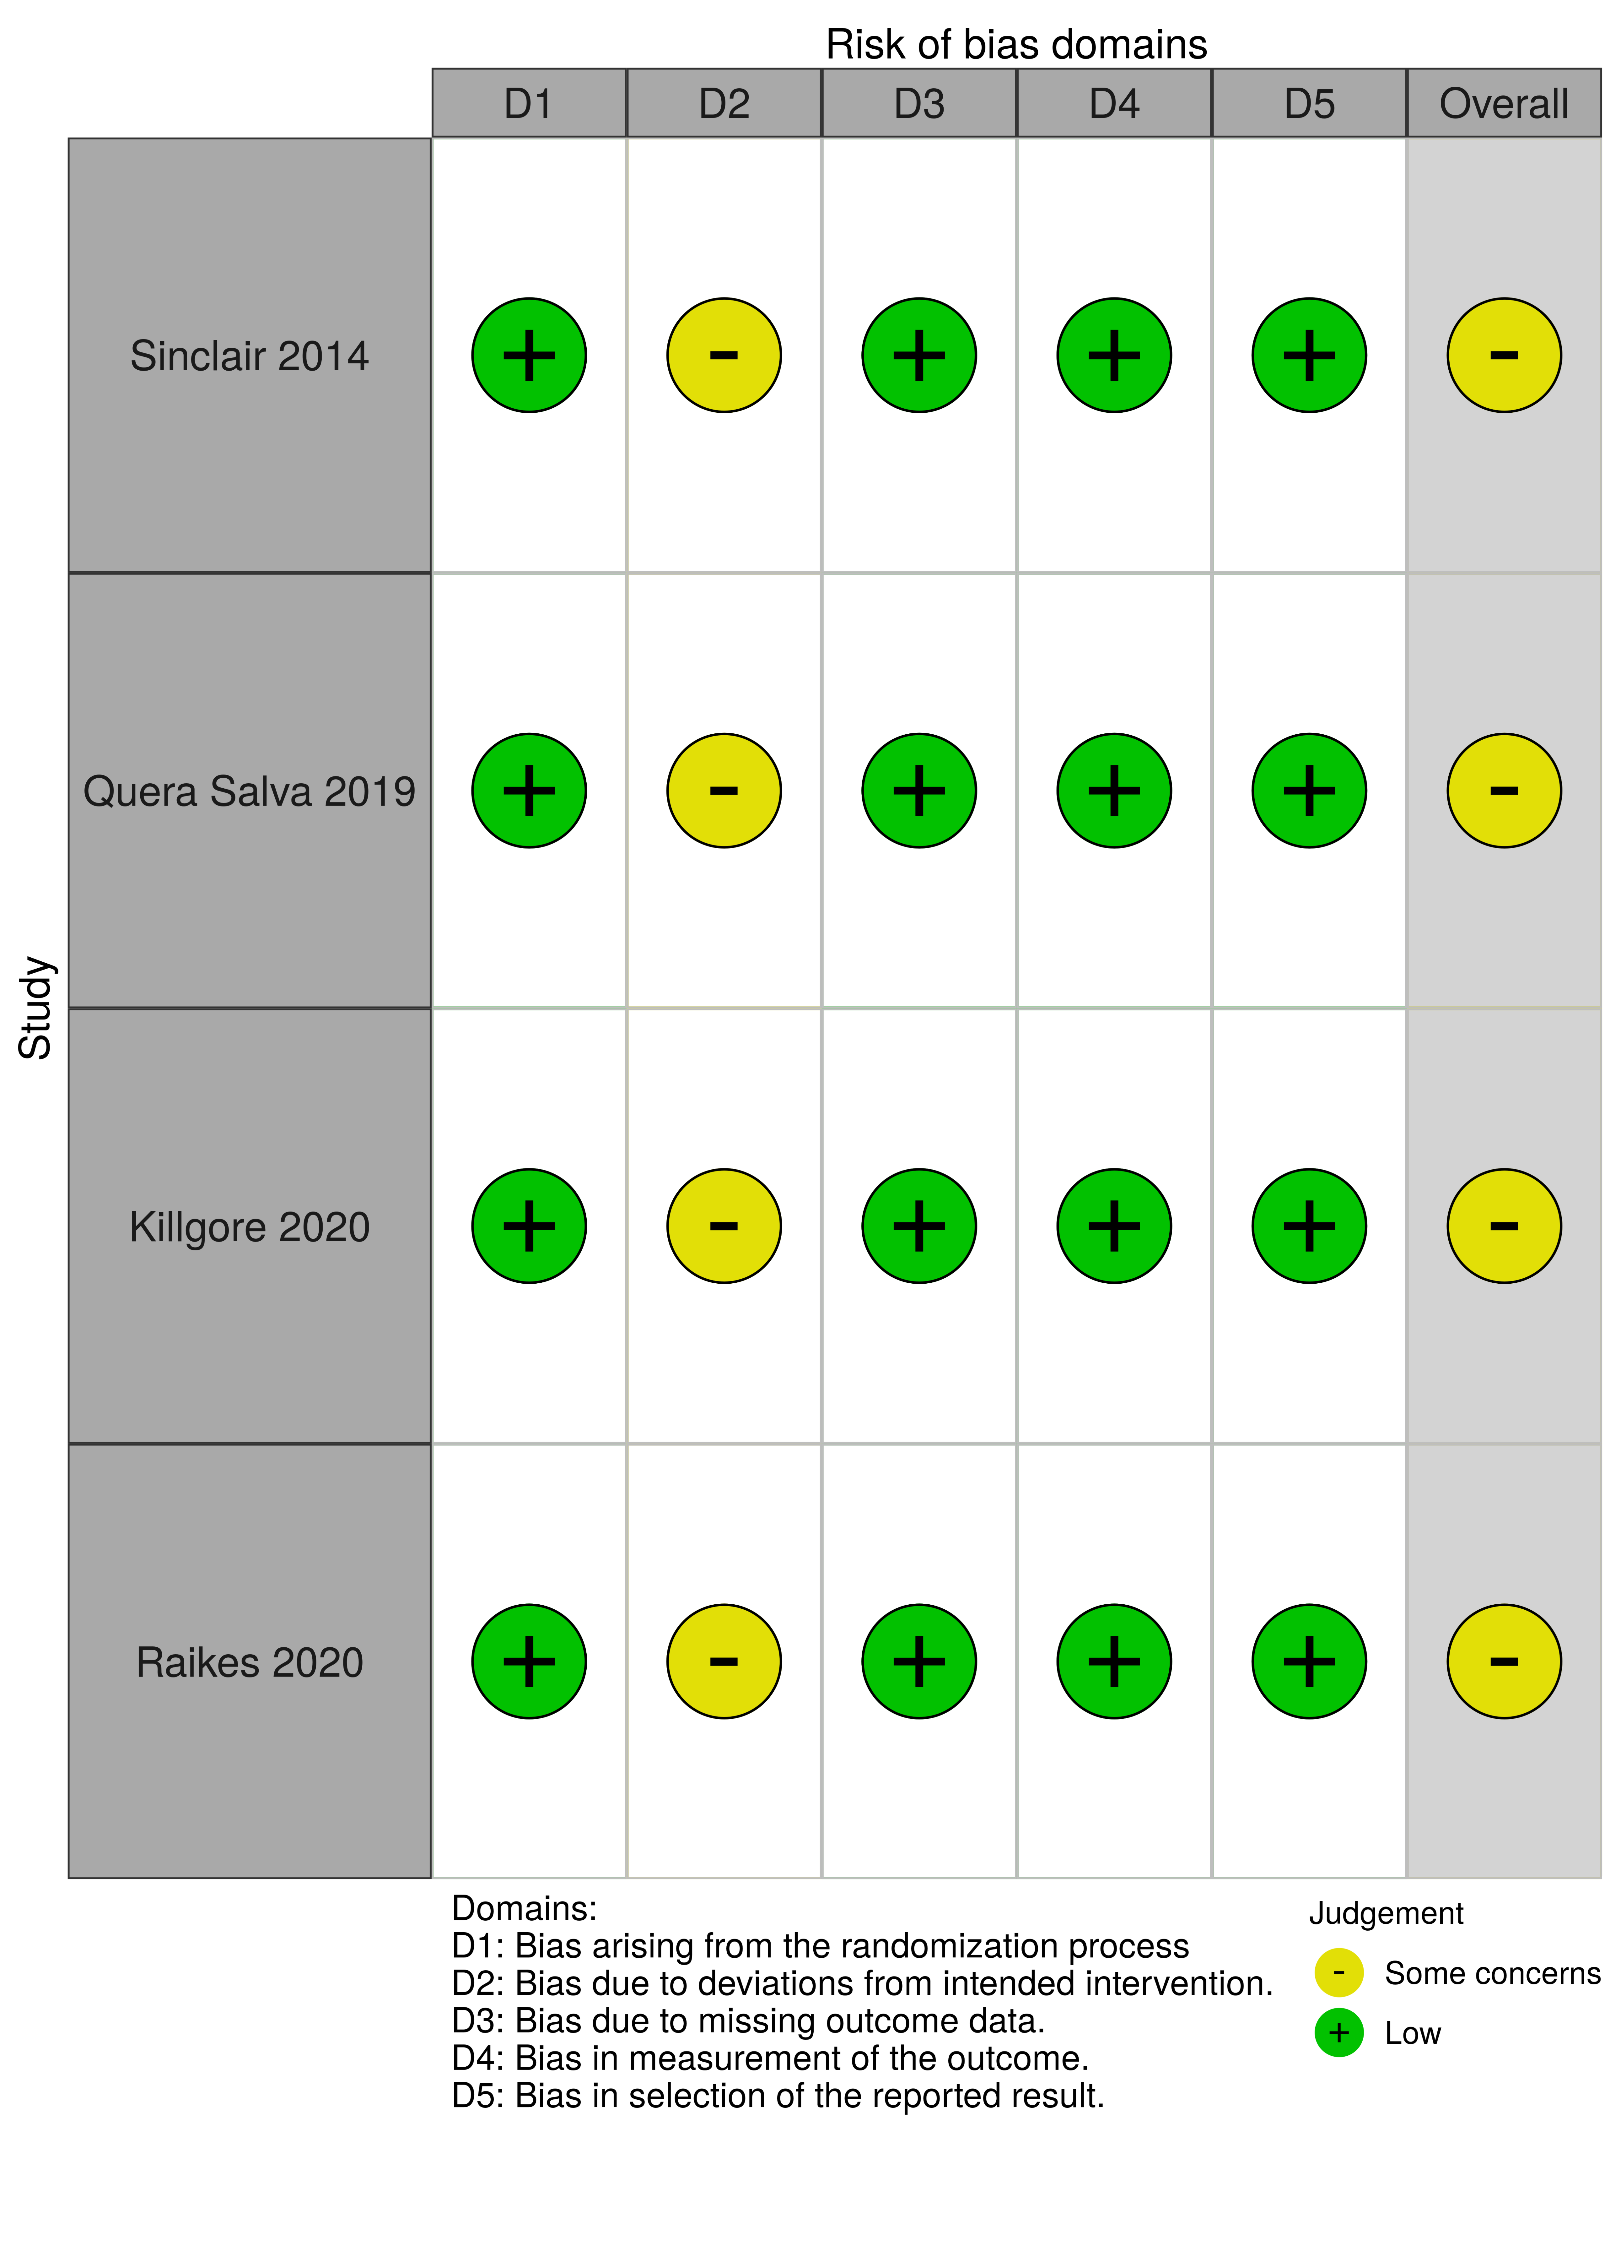

Appendix 3 Results of individual studies

study | Sinclair 2014 | Querasalva 2019 | Killgore 2020 | Raikes 2020
treatment 1 | BWLT | BWLT | BWLT | BWLT
treatment 2 | ALT | NLT | ALT | ALT
treatment 3 | NLT
n of treatment 1 | 10 | 10 | 16 | 17
n. of treatment 2 | 10 | 10 | 16 | 18
n. of treatment 3 | 10
dropouts of treatment 1 |  |  | 2 | 3
driopouts of treatment2 |  |  | 0 | 1
dropouts of treatment 3
mean of sleepiness (treatment 1) | -4.70 | -1.70 | -0.09 | -1.35
sd of sleepiness (treatment 1) | 3.10 | 2.58 | 0.10 | 2.22
mean of sleepiness (treatment 2) | -3.00 | -2.30 | 0.25 | 0.61
sd of sleepiness (treatment 2) | 3.00 | 5.06 | 0.10 | 2.22
mean of sleepiness (treatment 3) | -1.20
sd of sleepiness (treatment 3) | 3.00
mean of sleep quality (treatment 1) | -1.40 | -2.20 |  | -1.30
sd of sleep quality (treatment 1) | 4.10 | 0.90 |  | 6.48
mean of sleep quality (treatment 2) | -0.40 | 0.10 |  | -0.73
sd of sleep quality (treatment 2) | 4.80 | 1.20 |  | 6.48
mean of sleep quality (treatment 3) | -1.30
sd of sleep qualtiy (treatment 3) | 3.90
mean of depression (treatment 1) | -6.10 | -1.69 |  | -2.47
sd of depression (treatment 1) | 9.50 | 2.49 |  | 4.18
mean of depression (treatment 2) | -2.80 | 0.80 |  | 0.39
sd of depression (treatment 2) | 10.10 | 2.53 |  | 4.18
mean of depression (treatment 3) | -0.30
sd of depression (treatment 3) | 7.90
mean of fatigue (treatment 1) | -1.30 | -1.18
sd of fatigue (treatment 1) | 1.30 | 1.43
mean of fatigue (treatment 2) | -0.20 | 0.29
sd of fatigue (treatment 2) | 0.90 | 1.17
mean of fatigue (treatment 3) | -0.10
sd of fatigue (treatment 3) | 0.90

Appendix 4: Funnel plots to visualize the publication bias of five outcomes: (A) for sleepiness; (B) for sleep disturbance; (C) for depression; (D) for fatigue; and (E) for dropout rates.

(A) | (B)
(C) | (D)
(E)

