Supplementary Information

A reconfigurable piezo-ionotropic polymer membrane for sustainable multi-resonance acoustic sensing

Wu Bin Ying^{1,2†}, Joo Sung Kim^{1†}, Zhe Yu⁴, Zhengyang Kong¹, Elvis K. Boahen¹, Fenglong Li³, Chao Chen³, Ying Tian^{1,3}, Hanbin Choi¹, Jung-Yong Lee², Jin Zhu^{3*}, Do Hwan Kim^{1,5,6*}

¹Department of Chemical Engineering, Hanyang University, Seoul 04763, Republic of Korea.
²School of Electrical Engineering, Korea Advanced Institute of Science and Technology (KAIST), 291 Daehak-ro, Yuseong-gu, Daejeon 34141, Republic of Korea.
³Ningbo Institute of Materials Technology and Engineering, Chinese Academy of Sciences, Ningbo 315201, People’s Republic of China.
⁴In Situ Devices Center, School of Integrated Circuits, East China Normal University, Shanghai 200241, People’s Republic of China.
⁵Institute of Nano Science and Technology, Hanyang University, Seoul 04763, Republic of Korea.
⁶Clean-Energy Research Institute, Hanyang University, Seoul 04763, Republic of Korea.

†These authors contributed equally to this work.
*Corresponding author. E-mail: jzhu@nimte.ac.cn (J.Z.); dhkim76@hanyang.ac.kr (D.H.K.)

This PDF file includes:

Supplementary Notes 1 to 5
Supplementary Figures 1 to 30
Supplementary Tables 1 to 3
Supplementary References 1 to 34

Separate supplementary file for this manuscript: Supplementary Movie 1 to 4

Supplementary Note 1 | Structure Design and Mechanical Characterization of Self-Healing Fluorinated Polyurethanes (SFPU).
The synthesis procedures, structural design and function of each component of the SFPU are illustrated in Supplementary Fig. 1. In this design, hydroxyl-terminated polybutadiene (HTPB) is used as the soft segment, enhancing the polyurethane elastomer's stretchability, chain mobility and hydrophobicity. The hard segment is composed of isophorone diisocyanate (IPDI) combined with the F-chain extender (2,2,3,3,4,4,5,5-octafluoro-1,6-hexanediol) and the S-chain extender (4-aminophenyl disulfide), together imparting improved toughness, self-healing ability and hydrophobicity to the material. Supplementary Fig. 2 further demonstrates the uniform distribution of key elements (carbon, nitrogen, oxygen, fluorine and sulfur) within the SFPU, confirming the homogeneity of its chemical composition and molecular chain arrangement.
The successful synthesis of SFPU is verified through ¹H-NMR analysis, as depicted in Supplementary Fig. 3, where the characteristic proton peaks corresponding to each polymer unit are clearly identified. Supplementary Table 1 provides a detailed summary of the ratios of hard to soft segments as determined from the ¹H-NMR spectra, alongside the molar ratios of the various polymer components, the molecular weight and distribution of the SFPUs. As illustrated in Supplementary Fig. 4, an increase in the proportion of soft segments results in greater strain capacity of the SFPUs, attributed to the balance between the structural rigidity provided by the hard segments and the increased chain mobility provided by the soft segments. The mechanical properties, including stress, strain, modulus and toughness, are comprehensively summarized in Supplementary Table 2, with SFPU-2 and SFPU-3 demonstrating the highest toughness among the samples.

Supplementary Note 2 | Structural Design and Microstructural Characterization of Self-healing Piezo-ionotropic Polymers (ShPiP).
The ionic liquid (IL, [BMIM]⁺[TFSI]⁻) was utilized as an ion donor and combined with SFPU to fabricate a self-healing piezo-ionotropic polymer (ShPiP). Microscopic phase analysis, as shown in Supplementary Fig. 5, indicated that there was no observable phase separation within the SFPU/[BMIM]⁺[TFSI]⁻ composites, suggesting that the series SFPU-1 through SFPU-4 exhibited excellent compatibility with [BMIM]⁺[TFSI]⁻ when blended at a 60wt%/40wt% ratio. This compatibility is crucial for maintaining the homogeneous distribution of components, which enhances the material's uniform properties and overall performance.
Impedance measurements (Supplementary Fig. 6a) demonstrated that the ionic conductivities of the SFPU/[BMIM]⁺[TFSI]⁻ composites (SFPU-#-IL) gradually increased with the addition of fluorine content, reaching a maximum when SFPU-3 was used as the matrix, before decreasing. This trend can be attributed to the combined effects of SFPU's polarization and ion-dipole interactions. With an increase in fluorine content, the dielectric constant of SFPU also increased (Supplementary Fig. 6b), allowing more efficient polarization under an electric field, which enhances the migration of [BMIM]⁺[TFSI]⁻ and thus boosts the ionic conductivity. However, excessive fluorine content strengthens ion-dipole interactions, which restricts the mobility of [BMIM]⁺, leading to a reduction in ionic conductivity (Supplementary Fig. 6c). Consequently, under the competing influences of increased dielectric constant and reduced ion mobility, SFPU-3-IL demonstrated the most optimal ionic conductivity. Considering its superior toughness and other mechanical properties, SFPU-3 was selected as the primary stretchable matrix for further studies on ShPiP.
To optimize ionic conductivity further, the loading amount of [BMIM]⁺[TFSI]⁻ in SFPU-3 was varied, as shown in Supplementary Fig. 7. The results indicated that the maximum loading capacity of [BMIM]⁺[TFSI]⁻ that SFPU-3 could accommodate was 70%; beyond this point, clustering of [BMIM]⁺[TFSI]⁻ was observed. The ionic conductivity of the ShPiPs increased with a higher loading of [BMIM]⁺[TFSI]⁻, but appeared to saturate at a 60% loading level (Supplementary Fig. 8). SFPU-3-IL60% showed superior mechanical properties and a modulus closer to that of human skin tissue (Supplementary Fig. 9) compared to SFPU-3-IL70%. Therefore, SFPU-3-IL60% was chosen as the final ShPiP for subsequent studies on its applications in auditory perception.
Infrared spectroscopy and X-ray diffraction analysis were conducted to validate the findings from the Independent Gradient Model (IGM) analysis. The FTIR spectra revealed a blue shift in the asymmetric stretching bands of S=O (1346 cm⁻¹) and N-S (1051 cm⁻¹) of [TFSI]⁻ within ShPiP with increasing fluorine content, indicating a gradual weakening of Coulombic interactions between [BMIM]⁺ and [TFSI]⁻ and the formation of stronger ion-dipole interactions between [BMIM]⁺ and the C-F dipoles in SFPU (Supplementary Fig. 10a).^{1, 2} Moreover, as the fluorine group content increased, the intensity ratio between the associated carbonyl groups (1692 cm⁻¹) representing hard domains and the free carbonyl groups (1720 cm⁻¹) indicative of hard segments decreased, suggesting that more [BMIM]⁺ ions were being embedded into the hard domains, disrupting them and increasing the number of free hard segments (Supplementary Fig. 10b). X-ray diffraction spectra further supported these results, showing that the introduction of [BMIM]⁺[TFSI]⁻ led to an additional peak in the diffraction pattern, indicating partial embedding of [BMIM]⁺[TFSI]⁻ into the hard domains due to ion-dipole interactions (Supplementary Fig. 10c).³ As fluorine content increased, the intensity of this peak also increased, confirming the strengthening of these interactions (Supplementary Fig. 10d).

Supplementary Note 3 | Fabrication and Auditory Sensing Characterization of the Piezo-Ionotropic Multi-Resonance Acoustic Sensor (PiMAS).
The distribution of ShPiP and AgNW interdigitated electrodes within each sensor channel in PiMAS is shown in Figure 2b, while the detailed fabrication process is outlined in Supplementary Fig. 11, with specific steps described in the figure caption. To determine whether the electrical signal changes were due to impedance variations in the AgNW electrodes during vibration, a sound frequency sweep from 20 Hz to 4000 Hz was conducted on the electrodes alone (Supplementary Fig. 12). The electrodes exhibited stable impedance, with a resistance change of less than 3%, confirming that the signal conversion was primarily due to the ShPiP rather than variations in electrode impedance. The impedance and amplitude response curves of each PiMAS channel to sound frequencies between 20 Hz and 4000 Hz demonstrated consistent trends across all channels (Supplementary Fig. 13). As the channel thickness increased, the maximum response frequencies rose from approximately 110 Hz to 680 Hz, and the upper frequency limits extended from around 800 Hz to 3300 Hz (Supplementary Fig. 14), indicating a shift from low to high-frequency responses, consistent with the characteristics of the basilar membrane.
For calculating the gauge factor (GF) of each channel, we use Channel 1 as an example. Different sound pressure levels (91-65 dB) were played at the characteristic response frequency (110 Hz) of Channel 1, and its maximum forward vibration amplitude was measured using a laser displacement sensor (Supplementary Fig. 15a-g). For instance, at a sound pressure level of 91 dB, the maximum forward vibration amplitude was measured to be 2.26 mm (Supplementary Fig. 15h). Knowing the initial length (L₀) of each channel was 35 mm, the radius (r) of the corresponding arc was determined using the Pythagorean theorem:
$r^{2}={(\frac{L_{0}}{2})}^{2}+{(r-d)}^{2}$ (1)
Substituting the values, the radius r was calculated to be 68.9 mm. The angle θ corresponding to this arc was determined by:
$\sin{θ=}(\frac{L_{0}}{2})/r$ (2)
The value of θ was calculated to be 14.7°. The length after deformation (L₂) of the arc was computed using:
$L_{2}=2πr×\frac{2θ}{360°}$ (3)
Substituting the calculated values, L₂ was found to be 35.25 mm. Thus, the strain of Channel 1 at a 91 dB sound pressure level was calculated by:
$Strain=\frac{L_{2-}L_{0}}{L_{0}}×100\%$ (4)
The strain was determined to be 0.71%. The tensile strains of Channel 1 at different sound pressure levels were calculated similarly, and the impedance-strain plot with tensile sensitivity (GF = 53.6) was obtained, as shown in Supplementary Fig. 15i. The impedance-strain plots and their tensile sensitivities for Channels 2-8 were similarly determined and summarized in Figure 2e.

Supplementary Note 4 | Ion Migration Dynamics and Mechanical Response Mechanisms in ShPiP and Its Comparatives.
To investigate the complex ion flux pathways in ShPiP samples, in-situ Raman spectroscopy was employed for ionic intensity mapping at three distinct positions: near the anode (Position-1#), intermediate (Position-2#), and near the cathode (Position-3#). The characteristic Raman peaks corresponding to [BMIM]⁺, [TFSI]⁻ and the C=C bond in the soft segment of SFPU were identified at 1243 cm⁻¹ (Peak A), 1419 cm⁻¹ (Peak B) and 1640 cm⁻¹ (Peak C), respectively (Supplementary Fig. 16). By comparing the intensities of Peaks A and B with Peak C, the normalized relative intensities of [BMIM]⁺ and [TFSI]⁻ were determined, and Raman intensity maps were generated for these ions over a 50μm × 50μm area. In fluorine-free PU-iongel, cations ([BMIM]⁺) showed a distinct flux towards the cathode under tensile stress, influenced by the electric field and piezoionic effects. And for ShPiP containing fluorine in the hard segments, the cation flux was minimal, and their distribution remained largely unchanged after stretching, indicating stable ion behavior despite mechanical deformation. However, for the anions (TFSI⁻) in ShPiP and PU-iongel (Supplementary Fig. 17,18), the lack of a binding force from the polyurethane molecular chains resulted in their significant migration to the left when subjected to longitudinal compression and electric field drive, as demonstrated in panels A to F and A' to F'. This observation suggested that the fluorine groups in SFPU influence only the migration of cations, without binding to the anions. The overlapping areas of the anions before and after migration were quantitatively compared using Photoshop software (Supplementary Fig. 19), revealing that the migration extent of anions in ShPiP was only slightly lesser than in PU-iongel, demonstrating a strong binding effect of fluorine groups on cations but not on anions.
Further analysis of the stretch sensitivity of ShPiP compared to PU-iongel and PU-NH-iongel revealed that ShPiP demonstrated higher sensitivity due to a more pronounced ion-hitch-in-cage effect (Supplementary Fig. 20a). This effect was less evident in PU-iongel because its matrix-SPU, lacks fluorine groups and therefore cannot form ion-dipole interactions. For PU-NH-iongel, composed of SPU-NH with minimal hard domain content and no fluorine groups, the ion-hitch-in-cage effect was nearly absent. The ¹H-NMR spectra confirmed that both SPU and SPU-NH lack fluorine groups and have nearly identical chemical structures (Supplementary Fig. 20b). However, infrared spectroscopy showed that the content of H-bonded C=O in SPU-NH was significantly lower than in SPU. As shown in Supplementary Fig. 20c and 20d, SPU contained 69.8% H-bonded C=O, similar to SFPU, yet exhibited a weak ion hitching-in cage effect due to the absence of fluorine groups. While cations could be temporarily captured, they often escaped after multiple interactions. In contrast, SPU-NH had only 15.2% H-bonded C=O, indicating a very low hard domain content with mostly free hard segments.^{4, 5} As a result, the PU-NH-iongel, consisting of SPU-NH and IL, exhibited minimal ion hitching-in cage effect, with cations being scarcely trapped, and relied mainly on changes in channel geometry for its impedance response. Thus, PU-NH-iongel displayed the lowest sensitivity.
To further understand the mechanical response and strain behavior of ShPiP under external stress, we investigated the strain effects under controlled conditions. Based on the calculations from the inset of Figure 2g and Supplementary Fig. 15, the maximum strain in the channel induced by sound pressure was determined to be 0.71%. To explore the material's behavior beyond this range, we extended the ShPiP to 1% strain while simultaneously monitoring changes in the hard domains using infrared spectroscopy. From a microscopic perspective (Supplementary Fig. 21a and 21b), as the strain increased, the intensity of the H-bonded C=O peak gradually decreased, while the intensity of the free C=O peak increased, indicating that the hard domains of ShPiP were progressively opening. However, upon the removal of the external force, all peaks returned to their original positions, demonstrating the reversibility of this mechanical response even beyond this range. Even when the strain was increased to 10%, the aforementioned phenomena were still clearly observable (Supplementary Fig. 21c and 21d). From a macroscopic perspective, we conducted fatigue resistance tests on the impedance response of ShPiP to further assess its reversibility (Supplementary Fig. 22).

Supplementary Note 5 | Characterization and Mechanistic Study of Underwater Self-Healing Properties in SFPU and ShPiP.
Using SFPU-1 as a representative sample, we demonstrated self-healing under a microscope at room temperature (25°C). A notch was made in the center of the sample with a knife, and the healing process was observed over time (Supplementary Fig. 23a). The notch gradually disappeared, achieving complete self-healing after approximately 17 hours. To further investigate the effect of temperature on self-healing efficiency, the self-healing speed was calculated using the equation⁶⁻⁸:
Self-healing speed = [Scratch Depth]/[Self-healing Time] (1)
, where the scratch depth is the thickness of the film, and the self-healing time is the duration required for complete healing of the scratch. The results showed that the self-healing speed of SFPUs increased with temperature, reaching a maximum of 13.3 μm/min at 80℃ (Supplementary Fig. 23b). This temperature-dependent increase in healing speed is attributed to enhanced chain mobility and accelerated disulfide bond exchange with rising temperatures.⁶⁻⁸
To thoroughly evaluate the hydrophobic properties of SFPUs, we measured their water contact angles, which reached up to 112°, indicating strong hydrophobicity. As shown in Supplementary Fig. 24, this high contact angle remained stable even after soaking in water for up to five days, significantly outperforming commercial polyurethanes that lack hydrophobic structures and exhibit a decrease in water contact angle over time, demonstrating the superior water-resistant properties of SFPUs. Additionally, SFPUs exhibited exceptional underwater self-healing capabilities, as illustrated in Supplementary Fig. 25. This self-healing process is driven by the combined effects of dipole-dipole interactions between fluorine groups and dynamic disulfide bond exchange. When two severed SFPU films were placed on the water surface, they were initially attracted to each other due to the dipole-dipole interactions of the fluorine groups. Upon close contact, the disulfide bonds began to exchange, resulting in the successful self-healing of the films underwater. This process, further highlighted in Supplementary Movie 1, demonstrates that SFPUs can effectively self-repair in aqueous environments, showcasing their potential for applications that require both hydrophobicity and durability in wet conditions.
Further investigations into the self-healing capabilities of SFPUs in water and artificial lymph fluid revealed that its self-healing speed was comparable to that in conventional environments, demonstrating minimal impact from water molecules. For example, Supplementary Fig. 26a shows the self-healing process of SFPU-1 at room temperature. Initially, the notch appeared as a dark line under the microscope, which faded and became almost invisible after about 32 hours. The underwater self-healing speeds were summarized in Supplementary Fig. 26b, indicating that the self-healing rate in water was nearly as fast as in conventional conditions (Supplementary Fig. 23b), confirming that the self-healing process was largely unaffected by water.
Interestingly, the self-healing speed of ShPiP, created by blending an ionic liquid with SFPU, was enhanced when compared to SFPU alone (Supplementary Fig. 27). This improvement is likely due to the formation of ion-dipole interactions between [BMIM]⁺ and fluorine groups in SFPU, potentially forming a pseudo-ionic molecular chain within ShPiP that facilitates physical self-healing. Moreover, the addition of [BMIM]⁺[TFSI]⁻ exerts a plasticizing effect on ShPiP, increasing molecular chain mobility and enhancing disulfide bond exchange efficiency, thereby accelerating the self-healing process. To better mimic the inner ear environment, we tested the self-healing capability of ShPiP in artificial lymph fluid (composed of water > 99%, inorganic salts + glucose < 1%), which showed a self-healing speed comparable to that in both conventional and underwater settings.
After soaking in water for 15 days, the ionic conductivity of ShPiP decreased by only 4.6%, while the ionic conductivity of water remained almost unchanged (Supplementary Fig. 28a). This result may have been due to the transformation of hydrophobic interfaces.⁹ Although [BMIM]⁺[TFSI]⁻ is immiscible with water, slight ionic exchange effects occurred at their interface during prolonged contact, affecting their respective ionic conductivities. For fresh ShPiP, the distribution of hydrophobic SFPU molecular chains on the interface was relatively sparse, thus failing to prevent this ionic exchange effect from occurring initially. However, due to the incompatibility of hydrophobic SFPU molecular chains with water, they began to reorganize and self-assemble into hydrophobic aggregates, similar to the self-assembly process of amphiphilic block copolymers in water, leading to a reduction in the surface free energy of ShPiP (Supplementary Fig. 28b). A denser hydrophobic interface could more effectively inhibit ionic exchange.
Building upon the above exploration of underwater stability, we also examined the mechanical recovery of ShPiP under aqueous environment. The toughness of notched ShPiP after self-healing in artificial lymphatic fluid for different periods (1h-24h) reached up to 95% of its original value, as shown in Supplementary Fig. 29a. Impedance Nyquist plots confirmed the restoration of electrical properties, with no significant differences between the original and self-healed ShPiP after 24 hours of self-healing in artificial lymphatic fluid (Supplementary Fig. 29b).

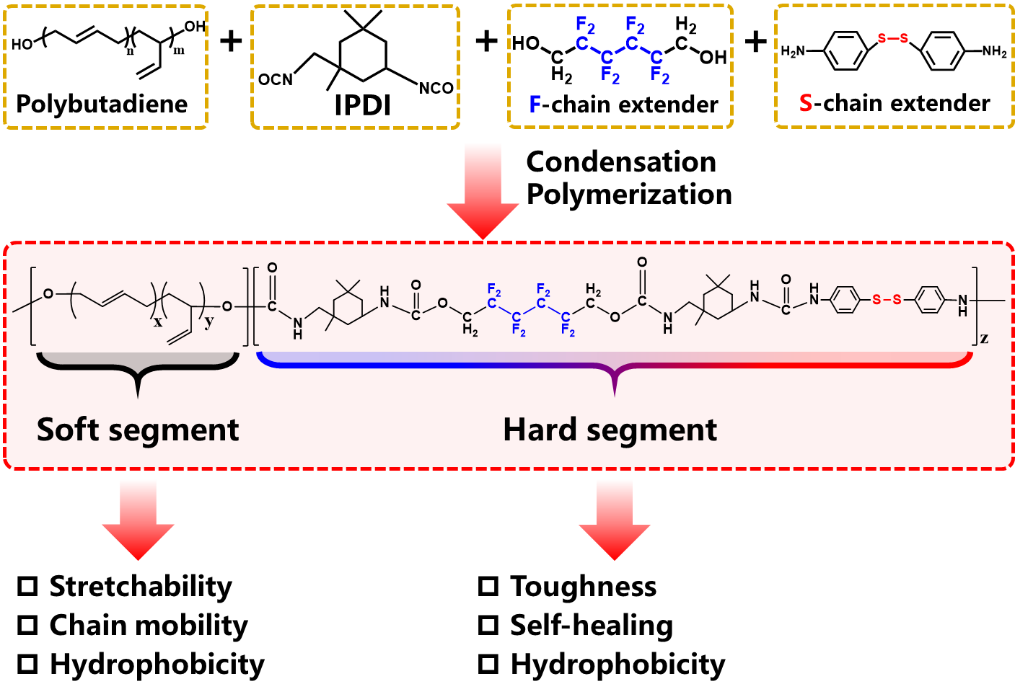
Supplementary Fig. 1 | Synthesis scheme of targeted self-healing fluorinated polyurethanes (SFPU).

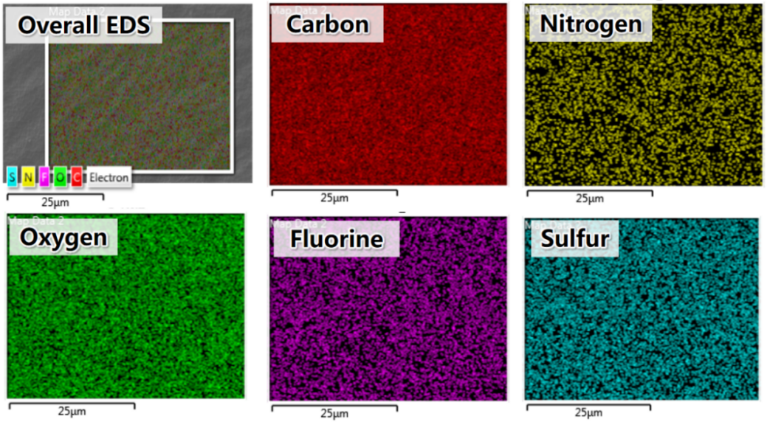
Supplementary Fig. 2 | EDS elemental maps for C, N, O, F and S in SFPU. Scale bar: 25μm.

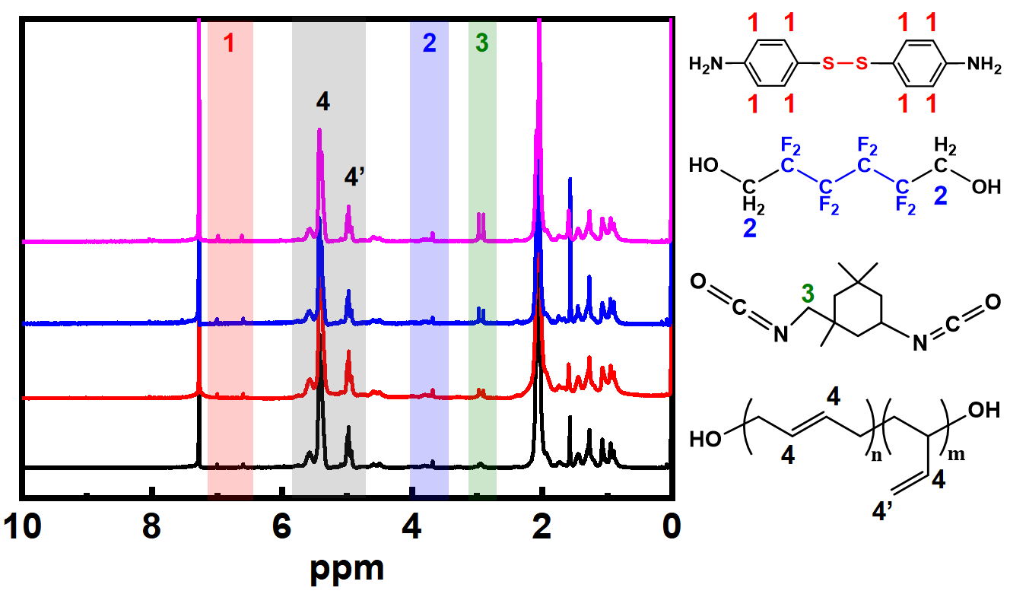
Supplementary Fig. 3 | The NMR spectra of SFPUs and the attribution of their characteristic peaks.

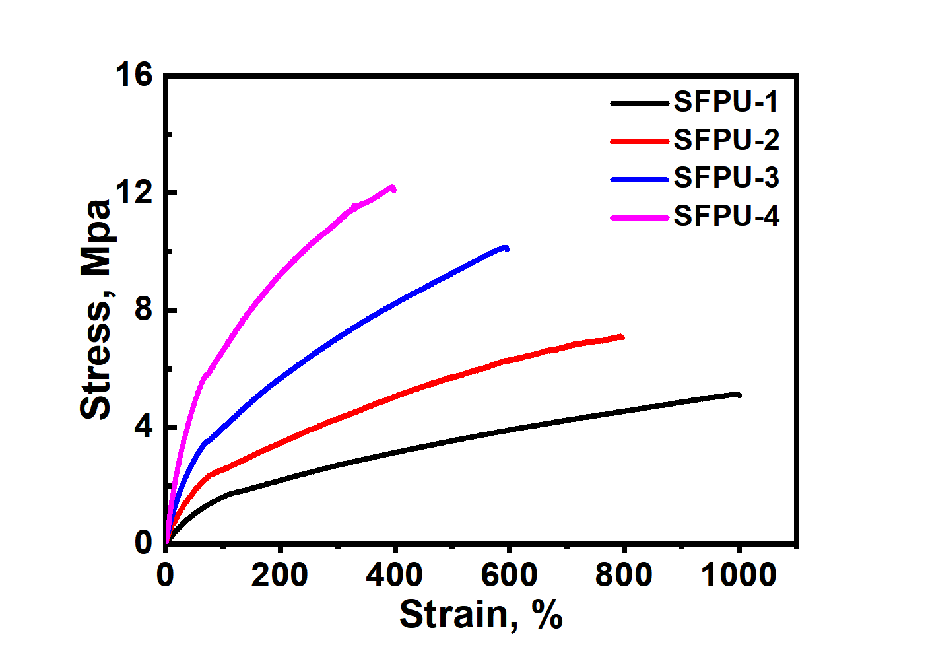
Supplementary Fig. 4 | Mechanical property curves of SFPUs.

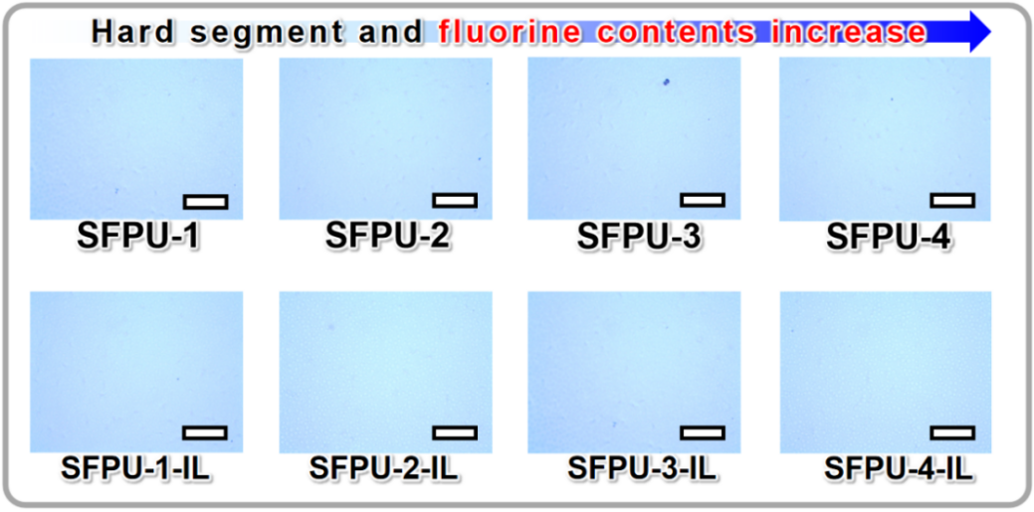
Supplementary Fig. 5 | Microscopic phase states of SFPU/[BMIM]⁺[TFSI]⁻ composites. Scale Bar: 100μm.

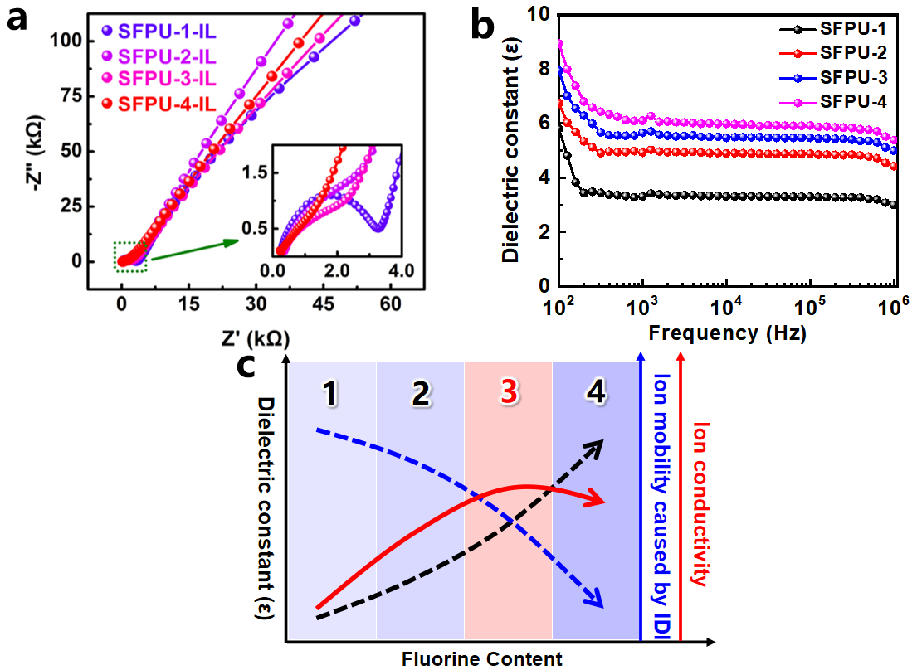
Supplementary Fig. 6 | Electrical properties of SFPU with different ionic liquid concentrations. a, Nyquist plots and ionic conductivities of SFPU/[BMIM]⁺[TFSI]⁻ composites at a ratio of 60%/40%. b, Dielectric constant-frequency curves of SFPUs. c, The predicted outcomes of the variation trends in terms of dielectric constant, ion mobility caused by ion-dipole interaction (IDI), and ion conductivity of SFPUs with different fluorine contents.

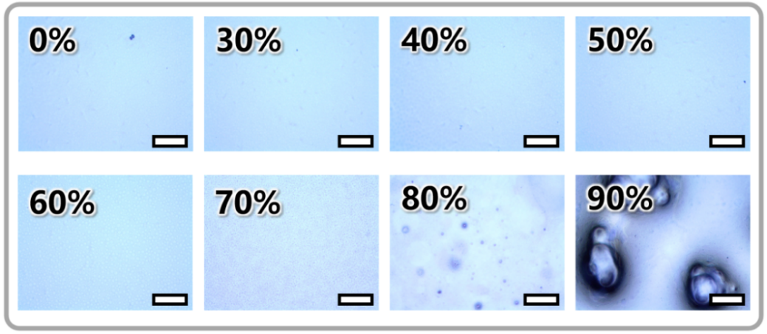
Supplementary Fig. 7 | Microscopic phase states of SFPU-3 filled with different amounts of [BMIM]⁺[TFSI]⁻. Scale Bar: 100μm.

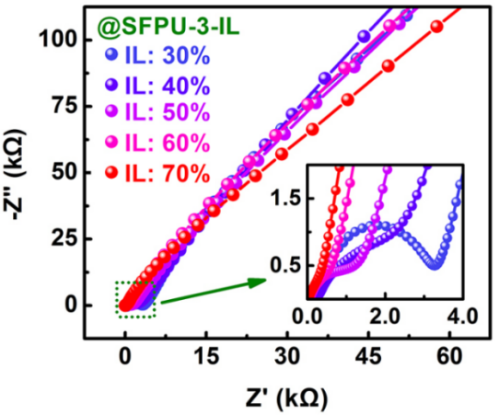
Supplementary Fig. 8 | Impedance Nyquist plots and ionic conductivities of ShPiPs composed of SFPU-3 and [BMIM]⁺[TFSI]⁻ at the ratios of 70%/30% – 30%/70%.

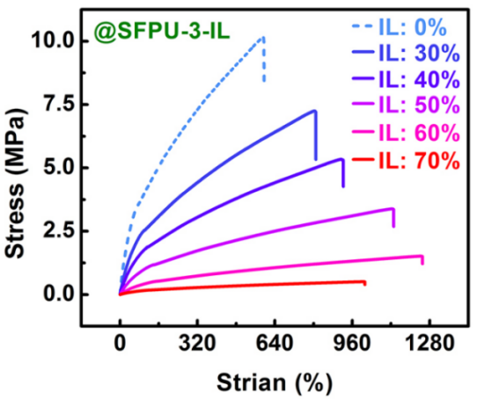
Supplementary Fig. 9 | Mechanical property curves of ShPiPs composed of SFPU-3 and [BMIM]⁺[TFSI]⁻ at the ratios of 70%/30% – 30%/70%.

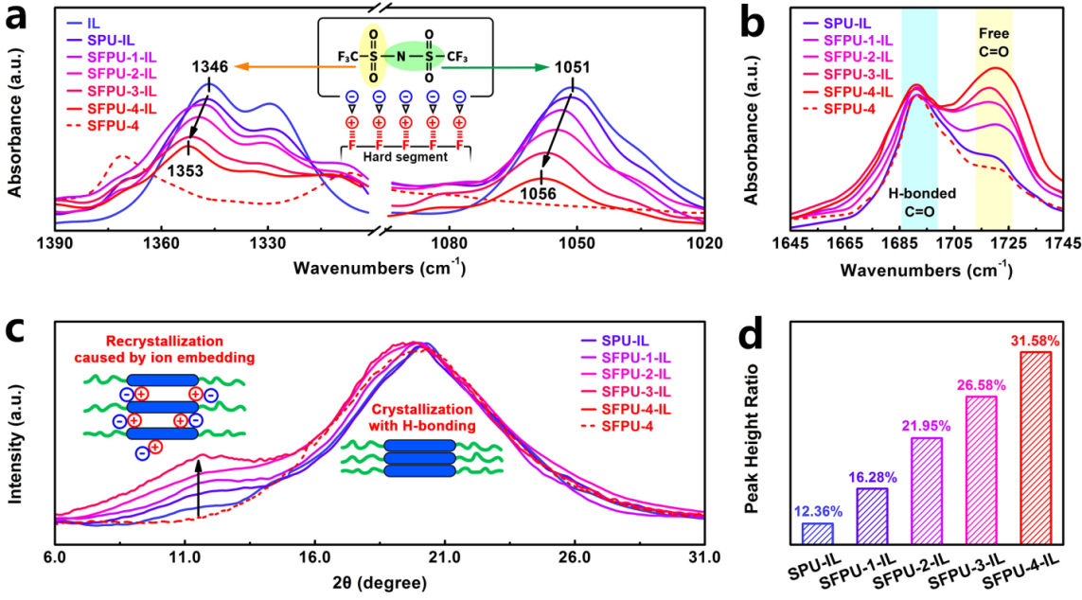
Supplementary Fig. 10 | Molecular characterization of SFPU and SFPU/[BMIM]⁺[TFSI]⁻ composites. a and b, FTIR spectra of IL ([BMIM]⁺[TFSI]⁻), SPU-IL, SFPU-1-IL, SFPU-2-IL, SFPU-3-IL, SFPU-4-IL and SFPU-4 in the range from 1390 to 1020 cm⁻¹ and 1645 to 1745 cm⁻¹. The mass ratios of polyurethane to ionic liquid (IL) were all 60%/40%. c, XRD spectra of IL ([BMIM]⁺[TFSI]⁻), SPU-IL, SFPU-1-IL, SFPU-2-IL, SFPU-3-IL, SFPU-4-IL and SFPU-4. d, Ratio comparison of ion embedding peaks and hard phase peaks in XRD spectra, analyzing by Peakfit software.

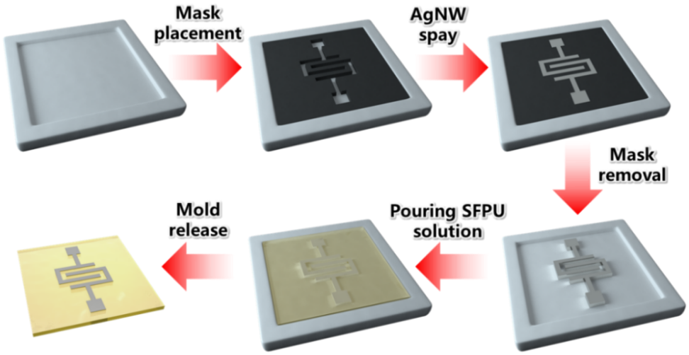
Supplementary Fig. 11 | Fabrication scheme of the sensing channels in the piezo-ionotropic multi-resonance acoustic sensor (PiMAS). (1) Positioning a mask with an interdigitated electrode pattern onto a Teflon mold; (2) Spray-coating a solution of AgNWs and allowing it to dry; (3) Pouring SFPU/[BMIM]⁺[TFSI]⁻ solution of varying concentrations to control the thickness of the sensing channels; (4) Drying and cutting to predefined dimensions.
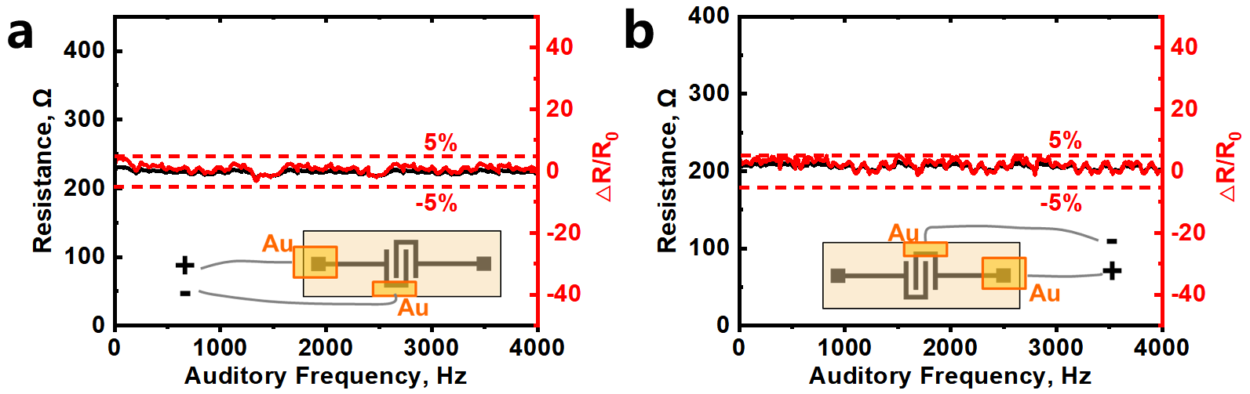
Supplementary Fig. 12 | Resistance test of AgNW electrode during auditory frequency sweeps (20 Hz – 4000 Hz). a, left electrode and b, right electrode. The AgNW electrode exhibited an extremely stable impedance during this test, with a resistance change rate of less than 3%.

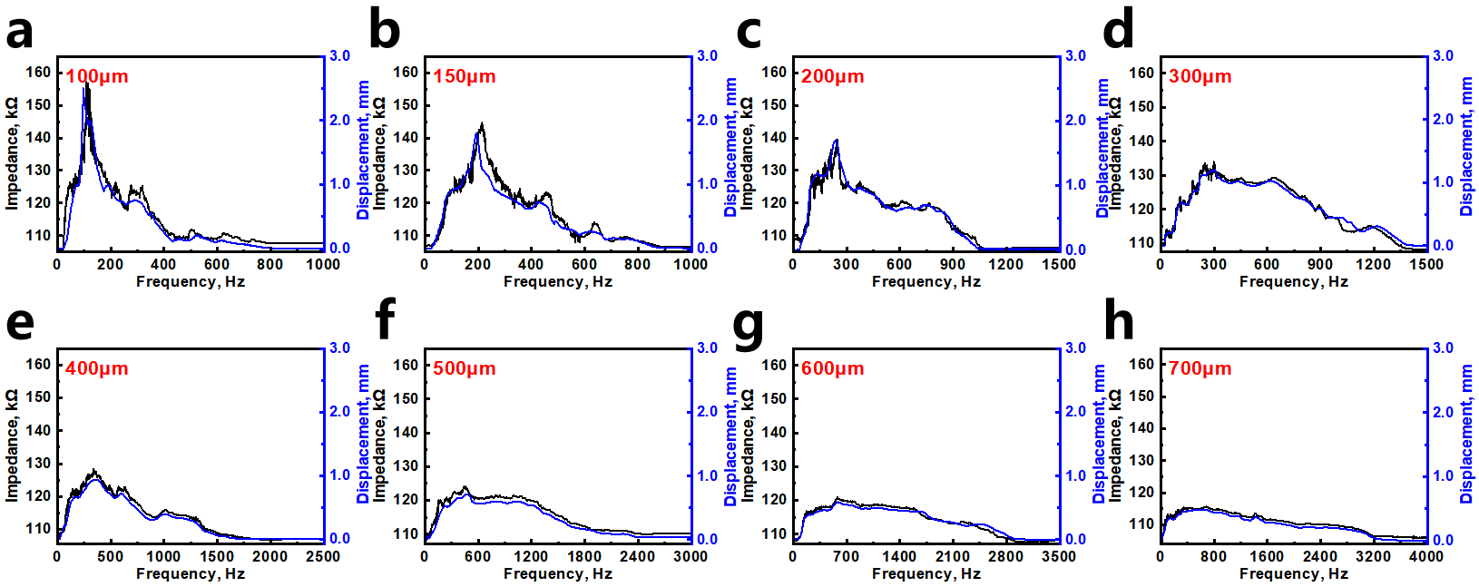
Supplementary Fig. 13 | The amplitude curve and impedance curve of each channel #1 (a) – #8 (h) in the PiMAS responding to sound sources of 20 Hz – 4000 Hz. The impedance and amplitude response curves of all sensing channels closely correspond to the characteristic response frequencies to auditory stimuli.

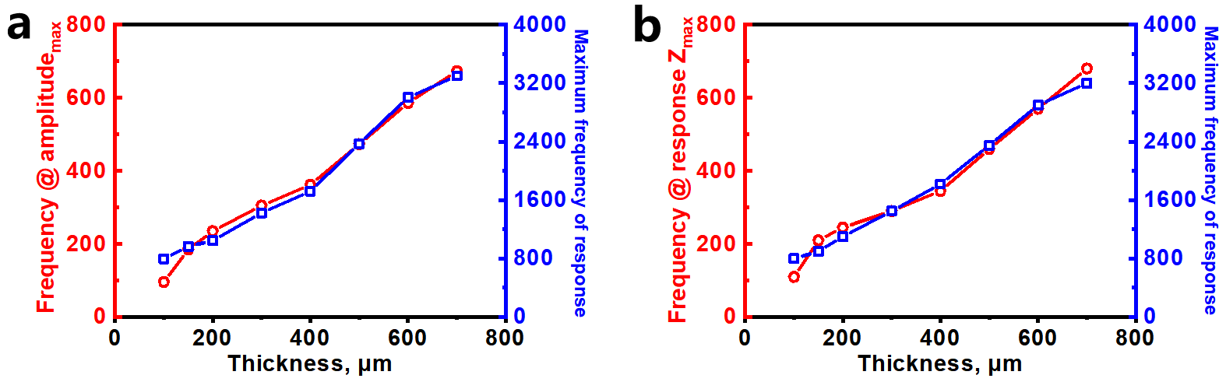
Supplementary Fig. 14 | Variations in maximum resonant frequency and maximum response frequency as a function of increasing channel thickness for a, amplitude and b, response impedance.

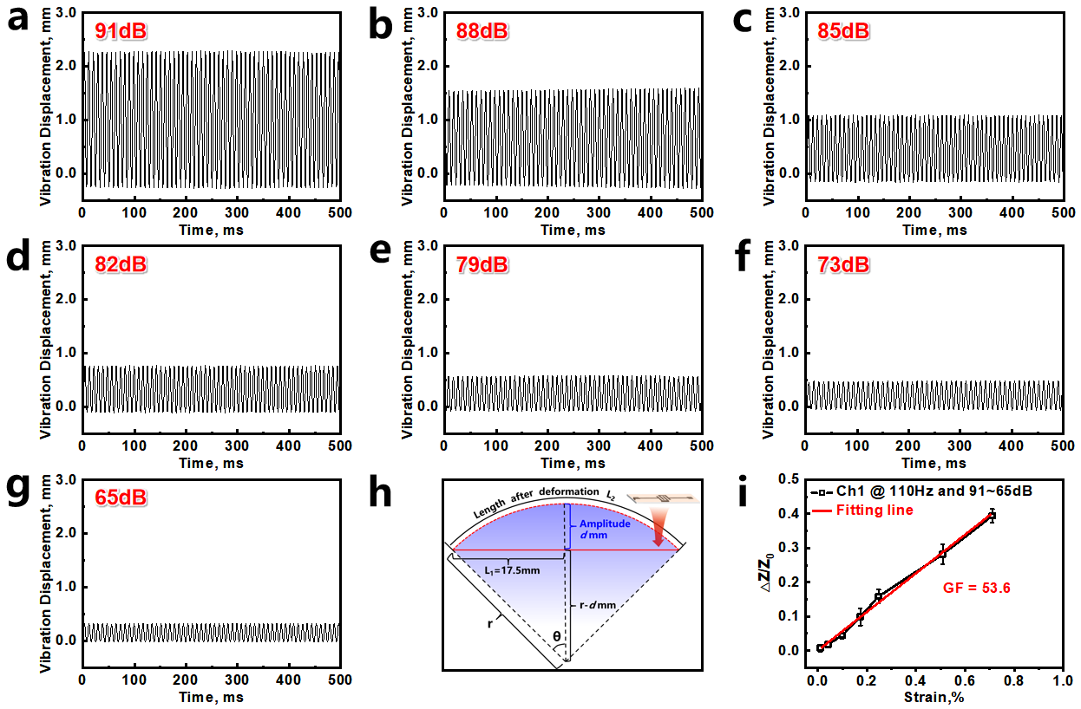
Supplementary Fig. 15 | The calculation method of the GF of each channel in the PiMAS, taking channel 1 as an example. a–g, The sounds of different sound pressure levels (91-65dB) were played at the characteristic response frequency (110Hz) of Channel 1, followed by the measurement of its maximum forward vibration amplitude by laser displacement sensor. h, After knowing the maximum forward vibration amplitude (amplitude: d mm) caused by each sound pressure level, the length after deformation and finally the strain could be both calculated. i, Impedance-strain plot at different sound pressure levels and its tensile sensitivity (GF=53.6).

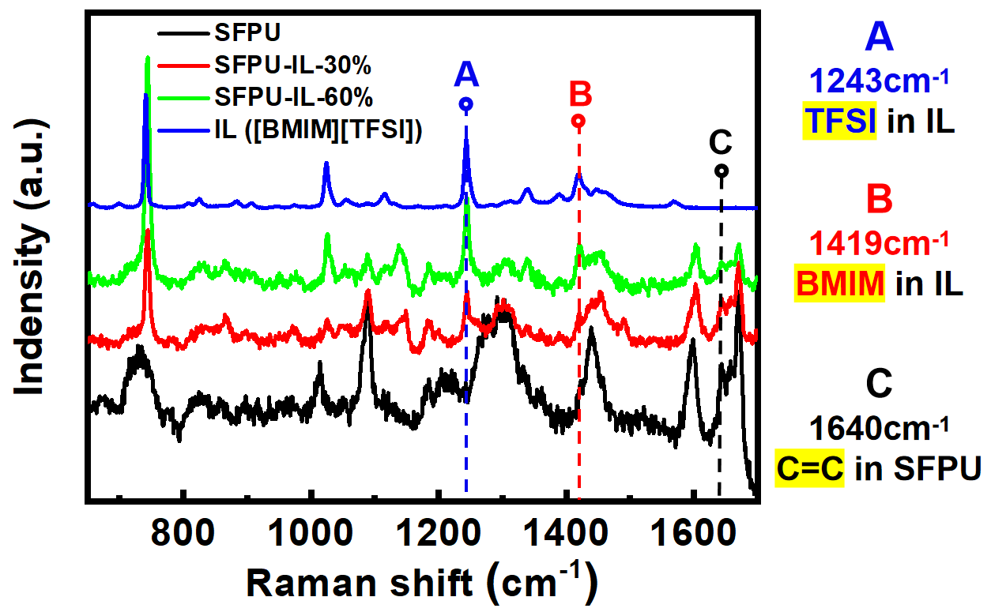
Supplementary Fig. 16 | 2D-Raman spectra of SFPU, IL ([BMIM]⁺[TFSI]⁻), SFPU-IL-30% and SFPU-IL-60%.

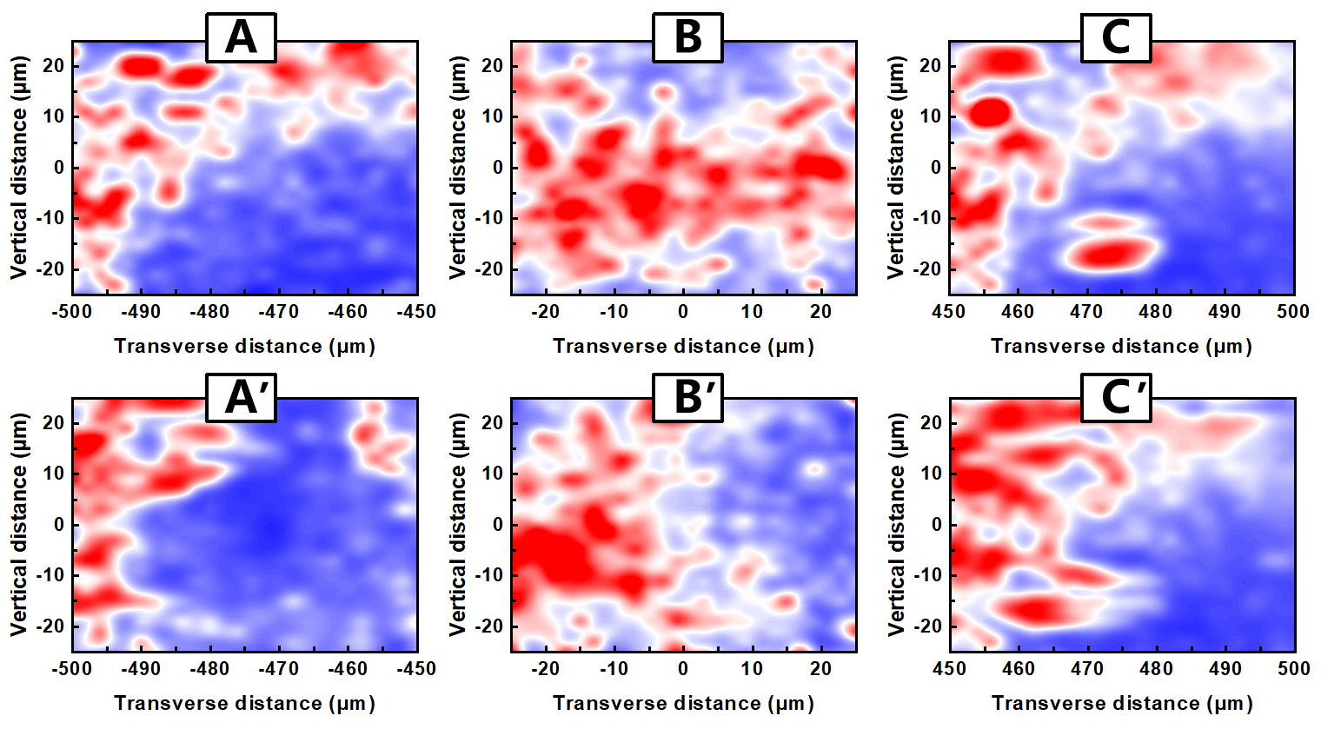
Supplementary Fig. 17 | Raman intensity mapping illustrating the migration trajectory of the anion ([TFSI]⁻) in ShPiP before and after stretching. A, B and C denote positions near the anode, middle and near the cathode before stretching. A', B' and C' represent corresponding positions near the anode, intermediate and near the cathode after stretching.
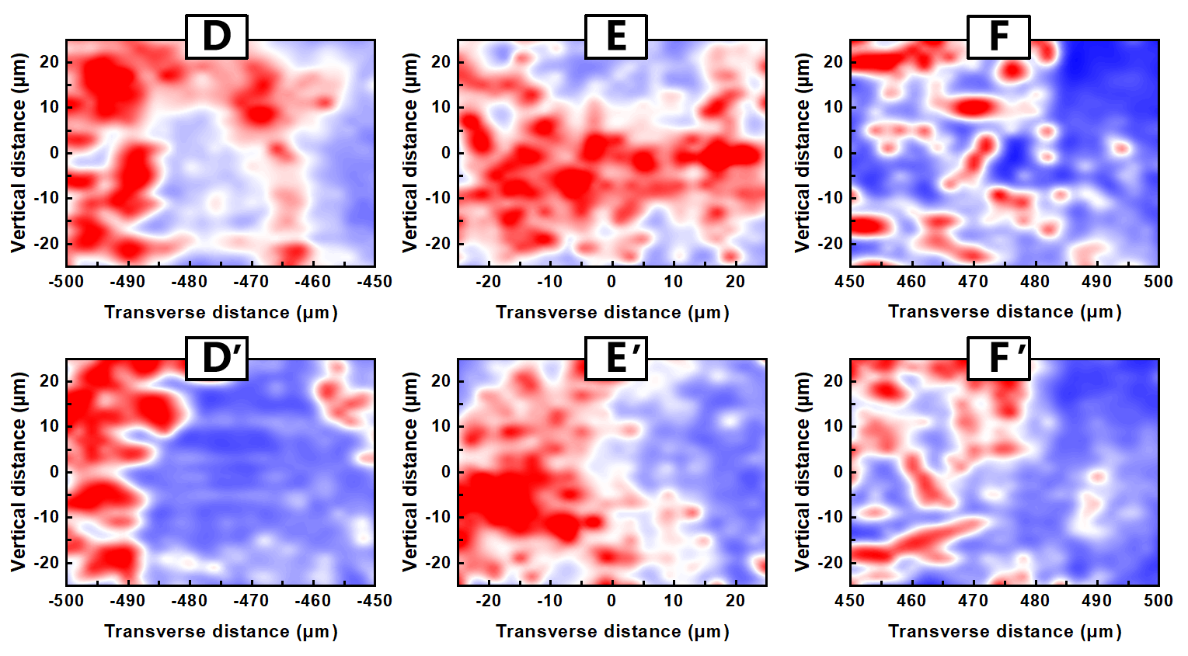
Supplementary Fig. 18 | Raman intensity mapping illustrating the migration trajectory of the anion ([TFSI]⁻) in PU-iongel before and after stretching. D, E and F denote positions near the anode, middle and near the cathode before stretching. D, E and F represent corresponding positions near the anode, intermediate and near the cathode after stretching.

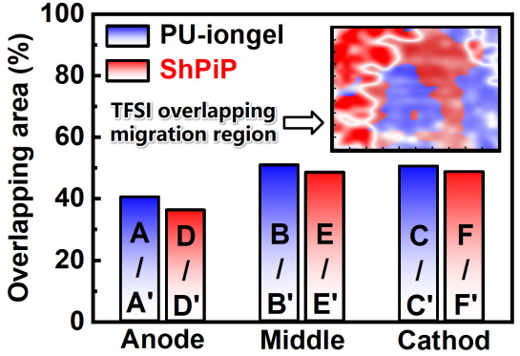
Supplementary Fig. 19 | Comparison of the overlapping areas of [TFSI]⁻ in ShPiP and PU-iongel before and after migration. The inset displays the calculation method, performed using Photoshop software.

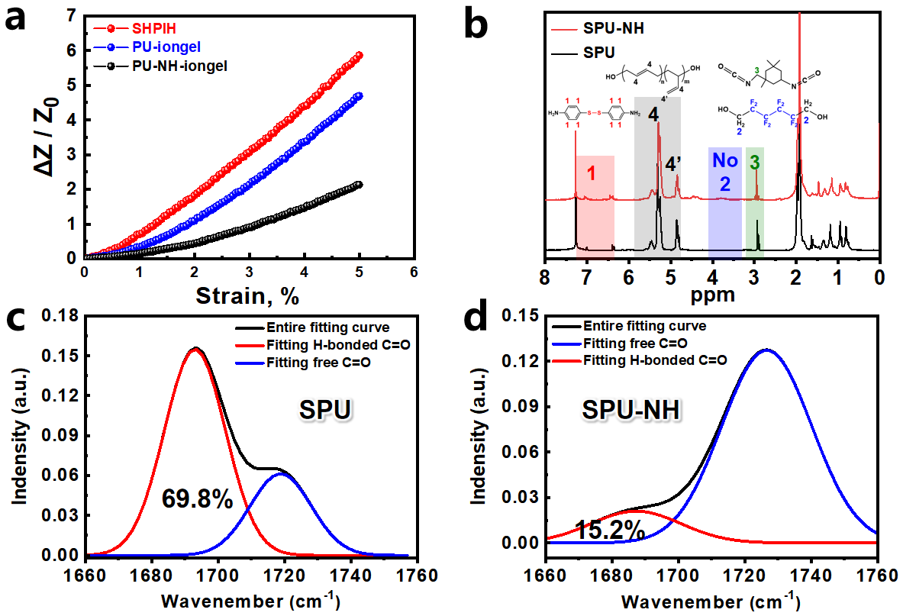
Supplementary Fig. 20 | Comparison of the impedance of PU-based iongels with varying fluorine groups and hard domains. a, Impedance changes of ShPiP, PU-iongel and PU-NH-iongel at different strains. b, ¹H-NMR spectra of SPU without fluorine groups, and SPU-NH without fluorine groups and with little hard domians. c and d, The infrared curves of carbonyl groups in SPU and SPU-NH were fitted and separated by Peakfit software, and the ratio of H-boned C=O and free C=O was calculated to be 69.8%/30.2% and 15.2%/84.8%. Note: the ratio in SFPU was 71.6%/28.4% calculated from Supplementary Fig. 10b.

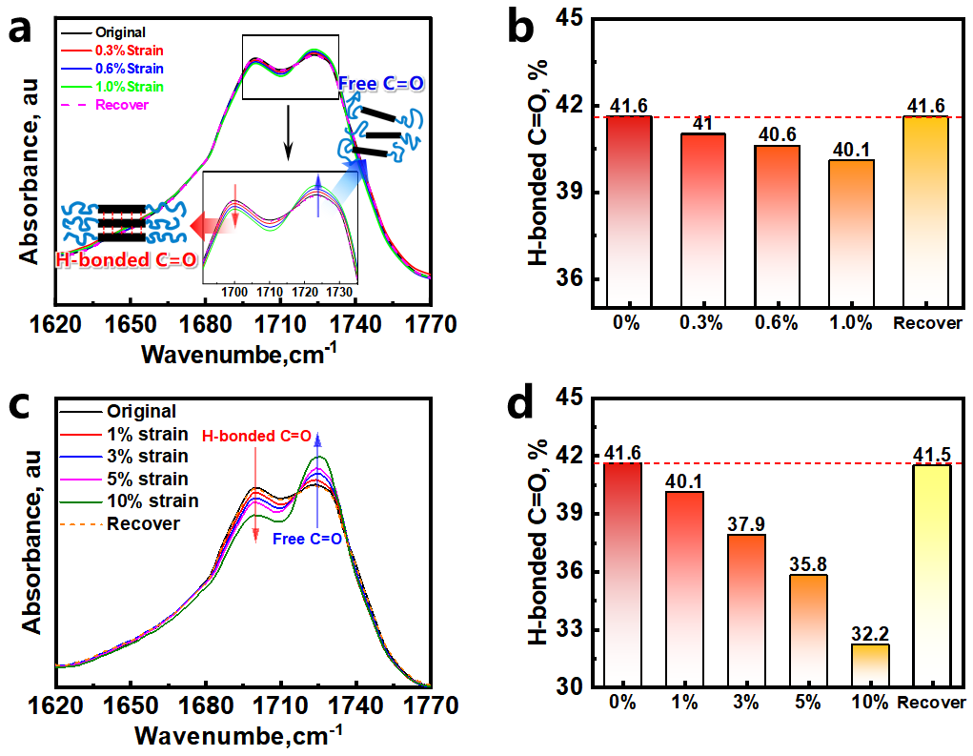
Supplementary Fig. 21 | Comparison of H-bonding C=O ratio in ShPiP with different strain. a and c, The infrared spectra of carbonyl peaks in ShPiP under 0 – 1% and 0 – 10% tensile deformation. The H-bonded carbonyl peaks gradually weakened, while the free carbonyl peaks gradually increased. b and d, Ratio comparison of H-bonded carbonyl and free carbonyl groups in infrared spectra, analyzed using Peakfit software.

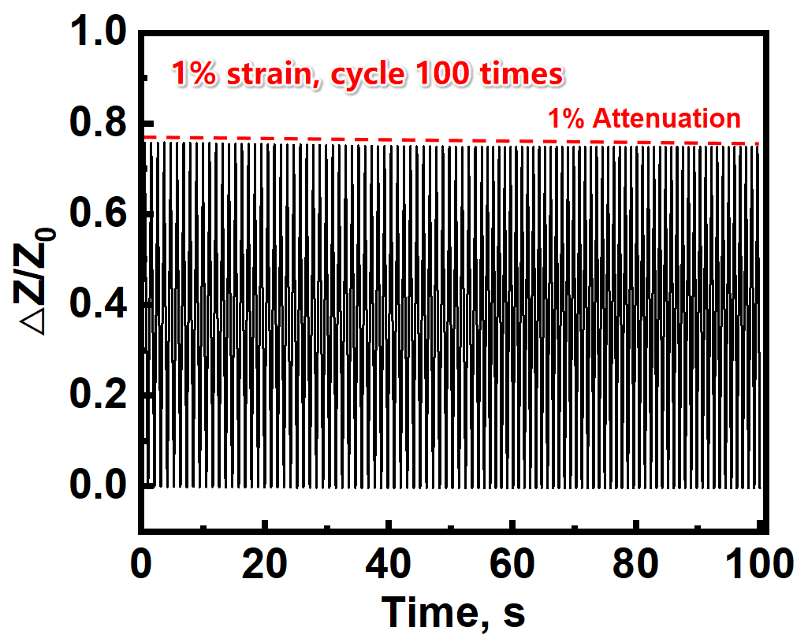
Supplementary Fig. 22 | Fatigue resistance test of the impedance response of ShPiP, subjected to 100 cycles of 1% strain cyclic stretching, showing stable numerical changes in impedance.

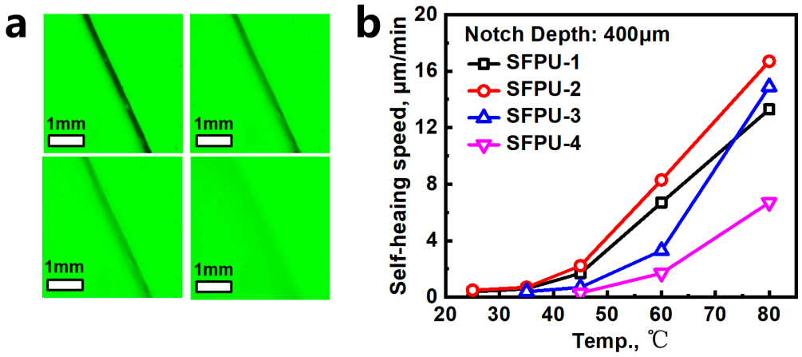
Supplementary Fig. 23 | Self-healing capabilities of SFPUs. a, Self-healing demonstration under microscope by using SFPU-1 as the example, the interval for each graph is about 250 minutes. b, Self-healing speed summary in conventional environment of SFPUs.

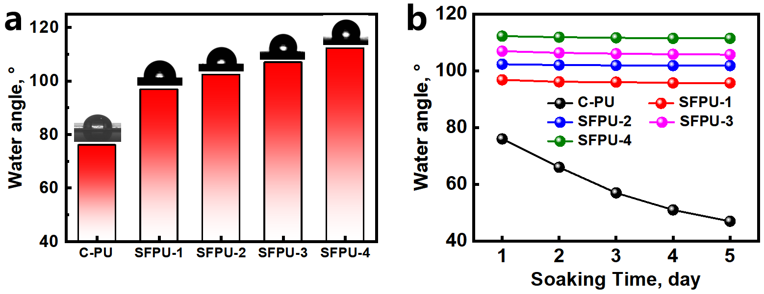
Supplementary Fig. 24 | Comparison of hydrophobicity of SFPUs. a, Water contact angles of commercial polyurethane (C-PU) and SFPUs. b, Water contact angle stability of C-PU and SFPUs after soaking in water for 1–5 days.

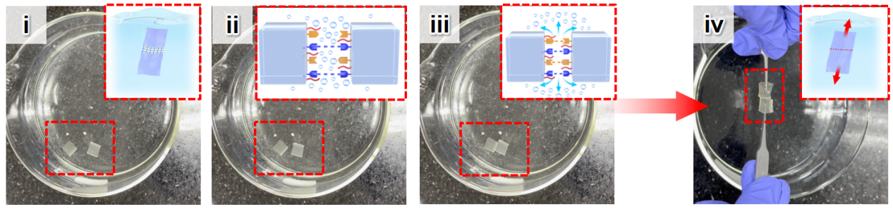
Supplementary Fig. 25 | Demonstration and mechanism of underwater self-healing for SFPU. Mutual attraction by dipole-dipole interaction (i and ii), repellency of water molecules and disulfide bonds exchange starting (iii), underwater self-healing by synergistic effect of dipole-dipole interaction and disulfide bond exchange (iv).
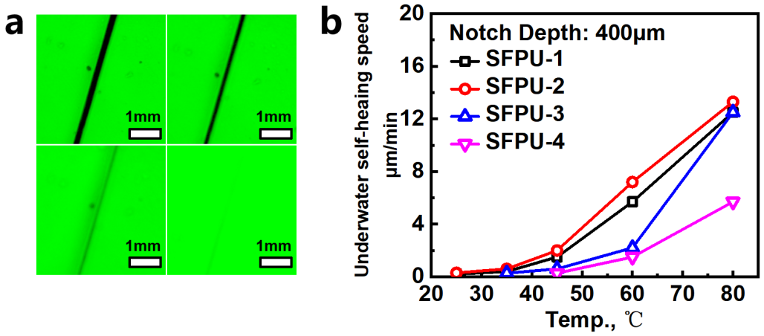
Supplementary Fig. 26 | Underwater self-healing capabilities of SFPUs. a, Underwater self-healing demonstration under microscope by using SFPU-1 as the example (the test method was illustrated in "Characterization"), the interval for each graph is about 500 minutes. b, Underwater self-healing speed summary of SFPUs.

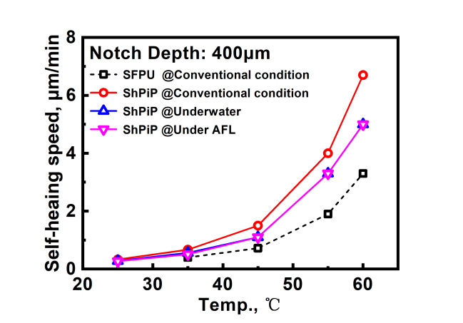
Supplementary Fig. 27 | The self-healing speed summary of SFPU (SFPU-3) and ShPiP (SFPU-3-IL60%) in conventional environment, underwater and artificial lymphatic fluid (AFL).

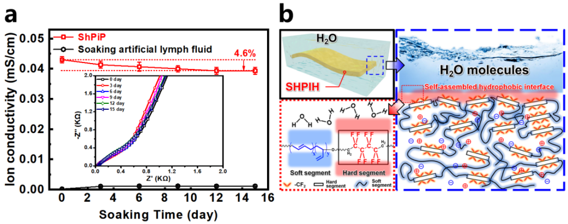
Supplementary Fig. 28 | Underwater self-healing mechanism of ShPiP. a, Ionic conductivity changes of the ShPiP and artificial lymphatic fluid during soaking process. The inset was the impedance Nyquist curve of ShPiP. b, Mechanism of ShPiP self-healing not affected by water medium: self-assembled hydrophobic aggregation of SFPU molecular chains after soaking.

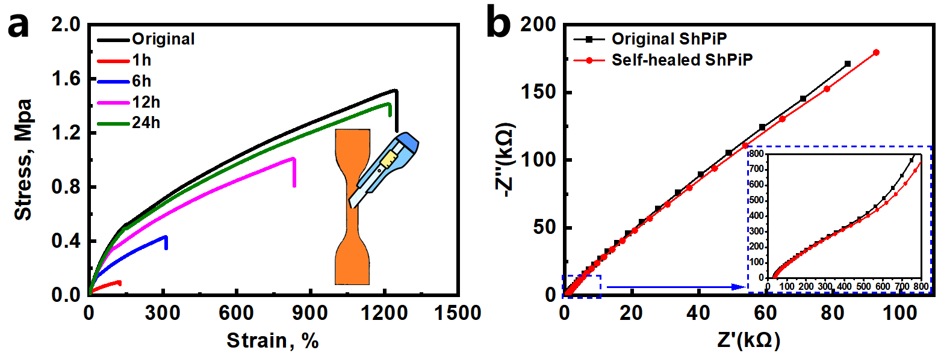
Supplementary Fig. 29 | Mechanical and electrochemical properties of ShiPiP. a, Strain-stress curves of the original ShPiP and the notched ShPiP after self-healing in artificial lymphatic fluid for different periods (1 – 24h). The toughness after completing self-healing can reach up to 95% of its original value. b, Impedance Nyquist plots of the original ShPiP and the notched ShPiP after self-healing in artificial lymphatic fluid for 24h.

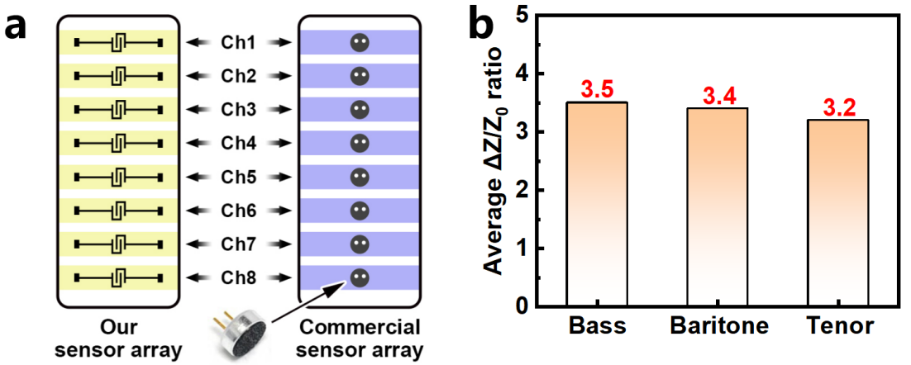
Supplementary Fig. 30 | Scheme and Comparative Analysis of Auditory Sensors for Song Response. a, Diagrammatic representation comparing the PiMAS with a commercial auditory sensor specifically designed for song sound response. b, Comparative analysis of the average ΔZ/Z₀ values exhibited by both types of auditory sensors when responding to the songs "Bass (Doubt)", "Baritone (Marechiare)" and "Tenor (Nessun dorma)", demonstrating respective enhancements of 3.5-fold, 3.4-fold, and 3.2-fold. Frequency ranges for tenor, baritone and bass were approximately 164 – 698 Hz, 123 – 493 Hz, and 82 – 392 Hz, respectively.

Supplementary Table 1 | Composition information for targeted self-healing polyurethane SFPU.
Sample  No. | [Soft]/[Hard]  (wt%/wt%) | [Bd]¹⁾ / [S]²⁾ / [F]³⁾ / [NCO]⁴⁾  (mol%) | Mw  (×10⁴ g/mol) | MWD
SFPU-1 | 78.8 / 21.2 | 94.1 / 1.0 / 1.0 / 3.9 | 6.9 | 2.6
SFPU-2 | 73.3 / 26.7 | 92.2 / 1.5 / 1.5 / 4.8 | 6.7 | 2.6
SFPU-3 | 68.5 / 31.5 | 90.3 / 2.0 / 2.0 / 5.7 | 6.9 | 2.7
SFPU-4 | 64.3 / 35.7 | 88.4 / 2.5 / 2.5 / 6.6 | 7.1 | 2.6

Note: 1) Bd: Butadiene units in polybutadiene
2) S: 4-Aminophenyl disulfide
3) F: 2,2,3,3,4,4,5,5-Octafluoro-1,6-hexanediol
4) NCO: Isophorone diisocyanate

Supplementary Table 2 | Mechanical property data of SFPU-1~5.
Sample  No. | Stress  (MPa) | Strain  (%) | Modulus  (MPa) | Toughness  (MJ/m³)
SFPU-1 | 5.1 | 1000 | 2.8 | 27.0
SFPU-2 | 7.1 | 796 | 4.9 | 31.1
SFPU-3 | 10.0 | 595 | 7.7 | 30.9
SFPU-4 | 12.1 | 397 | 13.1 | 25.4

Supplementary Table 3 | Performance Comparison of PiMAS and Other Iontronic/Non-Iontronic Sensors.
No. | Matrix | Sensing mode | Sensitivity |  | Self-healing
No. | Matrix | Sensing mode | kPa⁻¹ | GF | Self-healing
1 | Ionic hydrogel¹⁰ | Ionic system | 0.20 | 8.0 | ✔
2 | Ionic hydrogel/CNT¹¹ | Ionic system | 1.30 | 6.3 | ✔
3 | Polyurethane/polypyrrole¹² | Non-ionic system | 0.83 | 6.7 | ✖
4 | Ionic hydrogel¹³ | Ionic system | 0.40 | 0.8 | ✖
5 | Polyurethane/[EMIM][TFSI]¹⁴ | Ionic system | 52.40 | 0.9 | ✔
6 | Ionic hydrogel¹⁵ | Ionic system | 0.56 | 4.6 | ✔
7 | Polyvinylalcohol/cellulose/MXene¹⁶ | Non-ionic system | 1.53 | 0.57 | ✖
8 | Ionic hydrogel¹⁷ | Ionic system | 116.13 | 1.4 | ✔
9 | PDMS/Nafion¹⁸ | Non-ionic system | 0.78 | 4.0 | ✔
10 | Ionic eutectogel¹⁹ | Ionic system | 0.75 | 10.0 | ✔
11 | Polyaniline/polyacrylate²⁰ | Non-ionic system | 0.18 | 2.4 | ✔
12 | Ionic hydrogel²¹ | Ionic system | 0.75 | 2.0 | ✔
13 | Polyurethane/[EMIM][PF₆]²² | Ionic system | 90.98 | 3.5 | ✔
14 | PDMS/Liquid metal²³ | Non-ionic system | 49 | 124 | ✖
15 | Polyaniline/polymer(vinyl alcohol) /phytic acid²⁴ | Non-ionic system | 3.60 | 7.4 | ✖
16 | Ionic hydrogel²⁵ | Ionic system | 0.02 | 8.0 | ✔
17 | Poly(styrene-co-ethylmethacrylate) /[EMIM][TFSI]²⁶ | Ionic system | 0.22 | 3.6 | ✖
18 | Polyacrylate/AlCl₃²⁷ | Non-ionic system | 0.49 | 0.4 | ✖
19 | Poly(vinylidene fluoride) copolymer /[EMIM][TFSI]²⁸ | Ionic system | 0.20 | 0.5 | ✖
20 | Polyurethane /[EMIM][TFSI] /nanofiller²⁹ | Ionic system | 0.38 | 2.3 | ✔
21 | Polyacrylamide/Poly(vinyl alcohol) /MXene /PEDOT:PSS³⁰ | Non-ionic system | 0.44 | 5.2 | ✖
22 | Polyacrylamide /rGO /sodium carboxy cellulose³¹ | Ionic system | 0.31 | 8.2 | ✖
23 | Ionic hydrogel /microcrystalline cellulos³² | Ionic system | 0.80 | 2.4 | ✔
24 | PDMS/CNT³³ | Non-ionic system | 0.15 | 3.4 | ✖
25 | Ionic hydrogel³⁴ | Ionic system | 0.01 | 3.2 | ✖
26 | Polyurethane/[BMIM][TFSI] | Ionic system | 530 | 53.6 | ✔

Supplementary References

1. Chen, T. et al. Highly Conductive and Underwater Stable Ionic Skin for All‐Day Epidermal Biopotential Monitoring. Adv. Funct. Mater. 32, 2206424 (2022).
2. Cao, Y. et al. Self-healing electronic skins for aquatic environments. Nat. Electron. 2, 75-82 (2019).
3. Amoli, V. et al. A bioinspired hydrogen bond-triggered ultrasensitive ionic mechanoreceptor skin. Nat. Commun. 10, 4019 (2019).
4. Zhang, L. et al. Origin of highly recoverable shape memory polyurethanes (SMPUs) with non-planar ring structures: a single molecule force spectroscopy investigation. J. Mater. Chem. A 2, 20010-20016 (2014).
5. Ying, W.B. et al. An anti-stress relaxation, anti-fatigue, mildew proof and self-healing poly(thiourethane-urethane) for durably stretchable electronics. Chem. Eng. J. 420, 127691 (2021).
6. Ying, W.B. et al. Waterproof, Highly Tough, and Fast Self-Healing Polyurethane for Durable Electronic Skin. ACS Appl. Mater. Interfaces 12, 11072-11083 (2020).
7. Boahen, E.K. et al. Ultrafast, autonomous self-healable iontronic skin exhibiting piezo-ionic dynamics. Nat. Commun. 13, 7699 (2022).
8. Ying, W.B. et al. A Biologically Muscle‐Inspired Polyurethane with Super‐Tough, Thermal Reparable and Self‐Healing Capabilities for Stretchable Electronics. Adv. Funct. Mater. 31, 2009869 (2021).
9. Wei, J., Zheng, Y. & Chen, T. A fully hydrophobic ionogel enables highly efficient wearable underwater sensors and communicators. Mater. Horiz. 8, 2761-2770 (2021).
10. Zhang, W., Wu, B., Sun, S. & Wu, P. Skin-like mechanoresponsive self-healing ionic elastomer from supramolecular zwitterionic network. Nat. Commun. 12, 4082 (2021).
11. Wei, J. et al. Bioinspired 3D Printable, Self-Healable, and Stretchable Hydrogels with Multiple Conductivities for Skin-like Wearable Strain Sensors. ACS Appl. Mater. Interfaces 13, 2952-2960 (2021).
12. Ren, X. et al. Multi-scale closure piezoresistive sensor with high sensitivity derived from polyurethane foam and polypyrrole nanofibers. Chem. Eng. J. 474, 145926 (2023).
13. Sun, Y. et al. Biomimetic Chromotropic Photonic‐Ionic Skin with Robust Resilience, Adhesion, and Stability. Adv. Funct. Mater. 32, 2204467 (2022).
14. Chen, C. et al. A Self‐Healing and Ionic Liquid Affiliative Polyurethane toward a Piezo 2 Protein Inspired Ionic Skin. Adv. Funct. Mater. 32, 2106341 (2021).
15. Yu, J. et al. Highly stretchable, transparent and conductive double-network ionic hydrogels for strain and pressure sensors with ultrahigh sensitivity. J. Mater. Chem. C 9, 3635-3641 (2021).
16. Hao, S., Fu, Q., Meng, L., Xu, F. & Yang, J. A biomimetic laminated strategy enabled strain-interference free and durable flexible thermistor electronics. Nat. Commun. 13, 6472 (2022).
17. Zhu, X., Qi, P., Fan, W., Wang, H. & Sui, K. Bioinspired multifunctional self-powered ionic receptors derived by gradient polyelectrolyte hydrogels. Chem. Eng. J. 438, 135610 (2022).
18. Wang, M. et al. Composite Flexible Sensor Based on Bionic Microstructure to Simultaneously Monitor Pressure and Strain. Adv. Healthc. Mater. 12, e2301005 (2023).
19. Sun, H. et al. d-gluconic acetal gelator-based supramolecular – Polymer dual network eutectogels for high performance temperature, strain, and pressure sensors. Chem. Eng. J. 451, 139051 (2023).
20. Yu, X. et al. Highly Stretchable, Ultra‐Soft, and Fast Self‐Healable Conductive Hydrogels Based on Polyaniline Nanoparticles for Sensitive Flexible Sensors. Adv. Funct. Mater. 32, 2204366 (2022).
21. Li, S., Pan, H., Wang, Y. & Sun, J. Polyelectrolyte complex-based self-healing, fatigue-resistant and anti-freezing hydrogels as highly sensitive ionic skins. J. Mater. Chem. A 8, 3667-3675 (2020).
22. Chen, C. et al. Transmembrane Inspired Mechano‐Responsive Elastomers with Synergized Traction‐Assisted Healing and Dual‐Channel Sensing. Adv. Funct. Mater., 2402380 (2024).
23. Yao, B. et al. Ultrasensitive, Highly Stable, and Stretchable Strain Sensor Using Gated Liquid Metal Channel. Adv. Funct. Mater. 34, 2314298 (2024).
24. Zhou, H. et al. Robust and sensitive pressure/strain sensors from solution processable composite hydrogels enhanced by hollow-structured conducting polymers. Chem. Eng. J. 403, 126307 (2021).
25. Shen, K. et al. Multiple hydrogen bonds reinforced conductive hydrogels with robust elasticity and ultra-durability as multifunctional ionic skins. Chem. Eng. J. 451, 138525 (2023).
26. Kim, Y.M., Yu, K.S. & Moon, H.C. Regulating the π–π interactions of copolymer gelators: Effective molecular design of highly stretchable and tough ionogels for wearable ionotronics. Chem. Eng. J. 480, 147947 (2024).
27. Wu, Z., Wang, X. & Zhang, L. Biomass and Transparent Supramolecular Elastomers for Green Electronics Enabled by the Controlled Growth and Self-Assembly of Dynamic Polymer Networks. Small, e2404484 (2024).
28. Lv, D. et al. Microphase-Separated Elastic and Ultrastretchable Ionogel for Reliable Ionic Skin with Multimodal Sensation. Adv. Mater. 36, e2309821 (2024).
29. Ma, L. et al. Ultra-sensitive, durable and stretchable ionic skins with biomimetic micronanostructures for multi-signal detection, high-precision motion monitoring, and underwater sensing. J. Mater. Chem. A 9, 26949-26962 (2021).
30. Bi, D. et al. Tough and Strain-Sensitive Organohydrogels Based on MXene and PEDOT/PSS and Their Effects on Mechanical Properties and Strain-Sensing Performance. ACS Appl. Mater. Interfaces 16, 11914-11929 (2024).
31. Li, W. et al. Wearable one-handed keyboard using hydrogel-based mechanical sensors for human-machine interaction. J. Mater. Sci. Technol. 201, 130-138 (2024).
32. Wu, Q. et al. 3D Printed Sensors for Wearable Electronics and Smart Gesture Recognition. Adv. Mater. Technol. 9, 2302048 (2024).
33. Zhang, Y. et al. Highly stable flexible pressure sensors with a quasi-homogeneous composition and interlinked interfaces. Nat. Commun. 13, 1317 (2022).
34. Zhang, Y., Wang, Y., Guan, Y. & Zhang, Y. Peptide-enhanced tough, resilient and adhesive eutectogels for highly reliable strain/pressure sensing under extreme conditions. Nat. Commun. 13, 6671 (2022).

