Sequencing-based Spatial Transcriptomics with scRNA-seq Sensitivity

Renjie Liao¹, Defeng Fu¹, Zaoxu Xu¹, Han Liang¹, Xiaoran Zhou¹, Yiling Chen¹, Xueqi Liu¹, Jiajun Cheng¹, Ruidong Guo¹, Chen Li¹, Huihua Xia¹, Gailing Li¹, Diewen Feng¹, Wei Chen¹, Yang Chen¹, Longchao Chen¹, Yang Zhou¹, Qingbin Chen¹, Yuanye Bao¹, Luyang Zhao¹, Erkai Liu¹, and Gufeng Wang¹*

1. Shenzhen Salus BioMed Inc. Ltd., Shenzhen, Guangdong, China,
*Corresponding Author: Gufeng Wang, wanggf@salus-bio.com

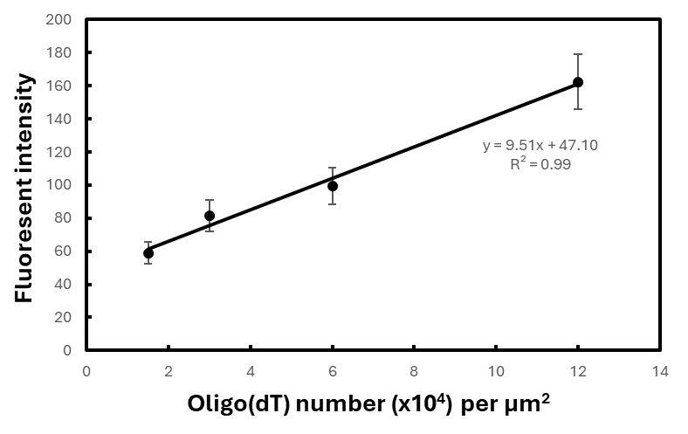

Fig. S1. Standard curve of fluorescent intensity of cy5 vs Oligo(dT) number of chip surface area.

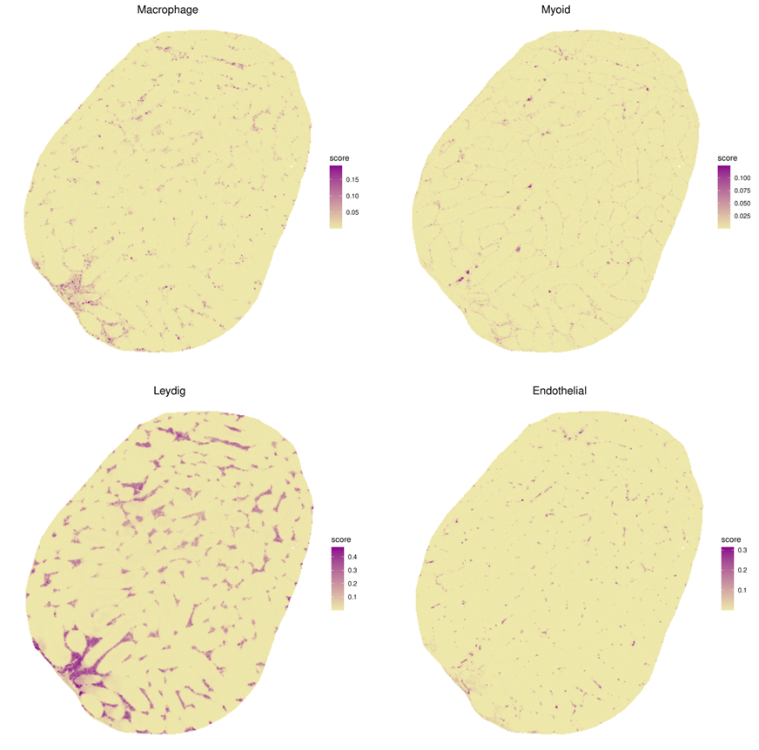

Fig. S2. Spatial distributions of different cell types resolved by RCTD.

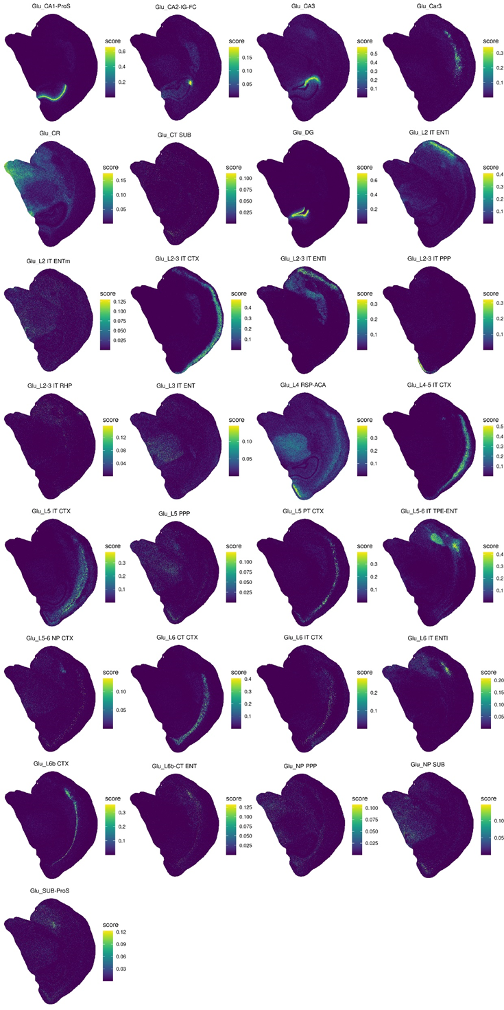
Fig. S3. Spatial distributions of RCTD annotated Glutamatergic neurons.

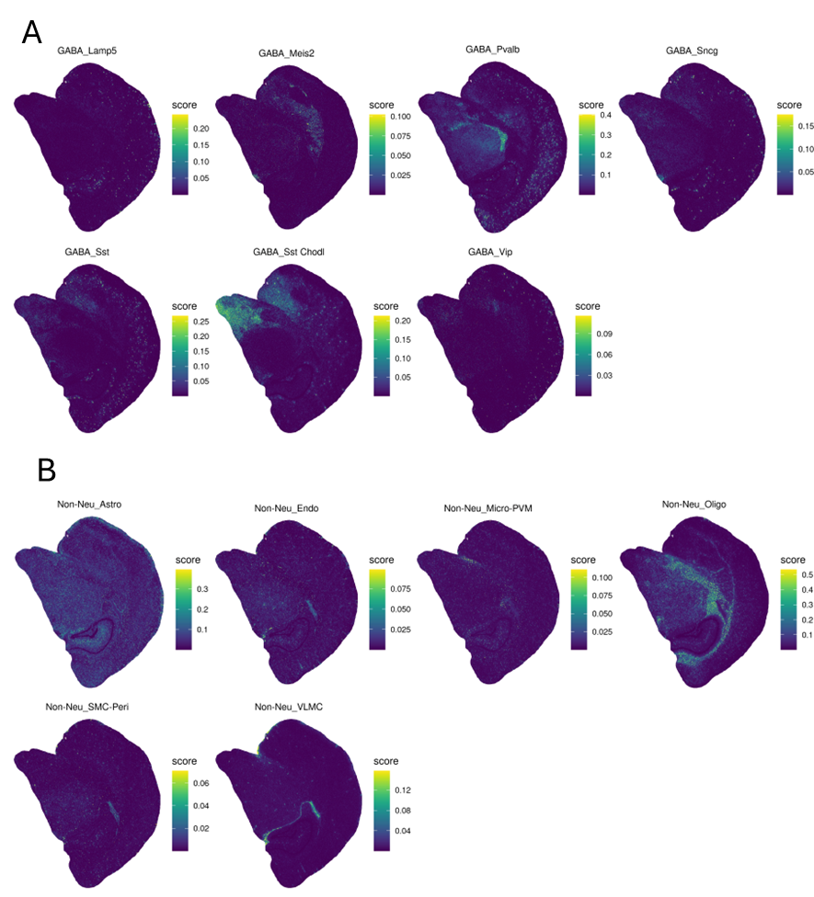

Fig. S4. Spatial distributions of RCTD annotated (A) GABAergic neurons and (B) non-neuron cells.

