Supporting Information
For
High Value Utilization of fern extracts of Diaplazium esulentum for fabrication of copper nanoparticles: A potent and affordable candidate for water treatment, water disinfection, antioxidant activity and theranostic agent
Tanur Sinha*$, Partha Pradip Adhikari #and Vinay M Bhandari§
$ School Of Chemistry, University of Bristol, Cantock’s Close, Bristol-BS81TS, United Kingdom.
§Department of Chemical engineering and process development division,
CSIR- National Chemical Laboratory, Pune, Maharashtra- 411008, India
#Assam University Silchar, Assam−788011, India
E-mail: tanur1287@gmail.com (T. Sinha)

S1 Evaluation of the photocatalytic activity of the synthesized Cu NPs:
The spectra of the photocatalytic activity of both the dye solution under dark condition is shown in (Fig. S1 (a) and (c)). While the controlled absorption spectra of both the dyes degradation in absence of Cu NPs is represented by ( Fig. S1 (b) and (d)).

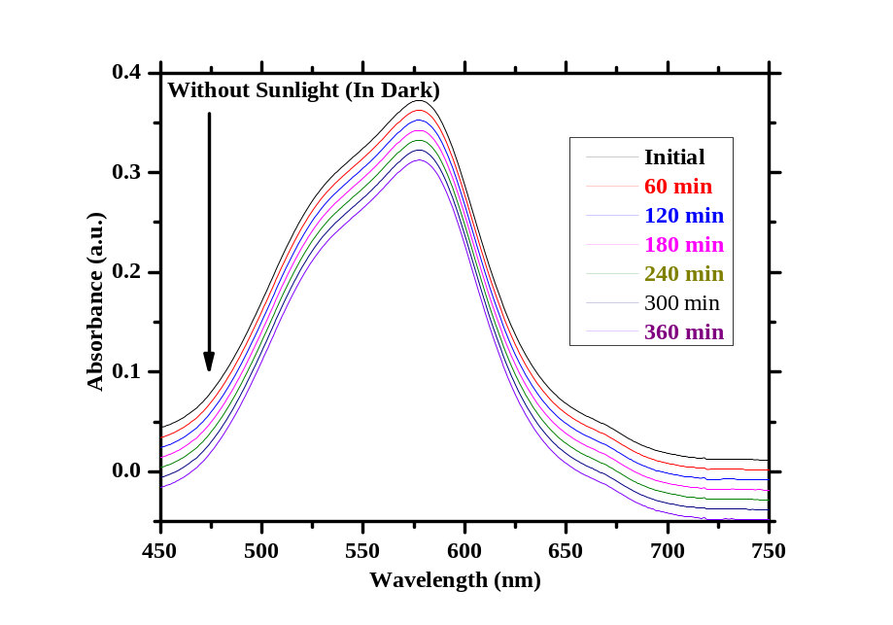
Fig. S1 (a) represented the absorption spectra for photocatalytic degradation of MV6B under dark reaction conditions.

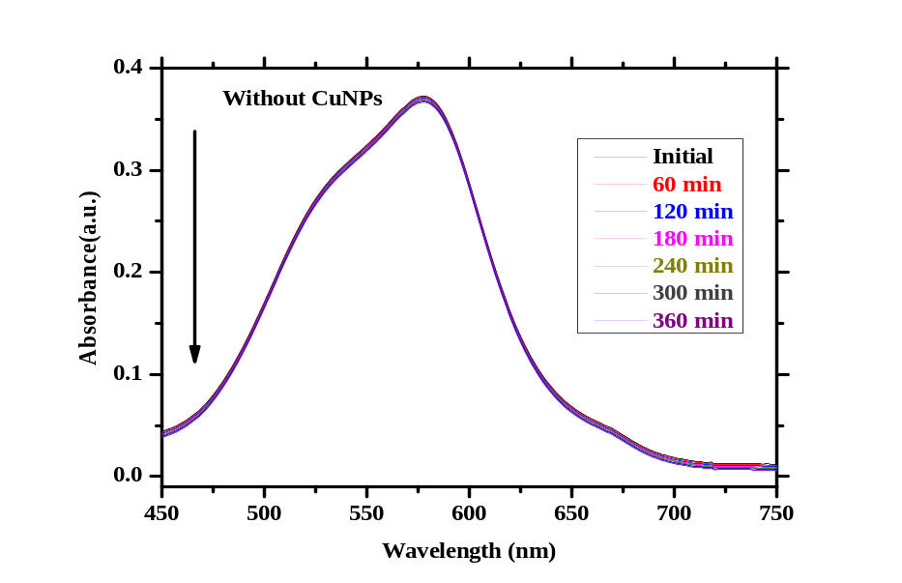
Fig. S1 (b) represented the absorption spectra for photocatalytic degradation of MV6B in absence of Cu NPs.

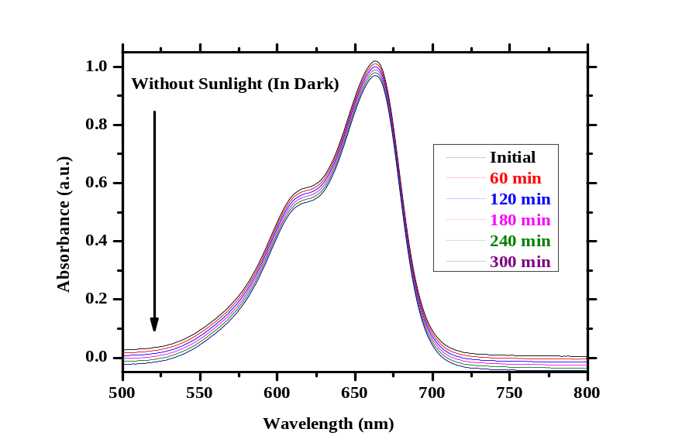
Fig. S1 (c) represented the absorption spectra for photocatalytic degradation of MB under dark reaction conditions.

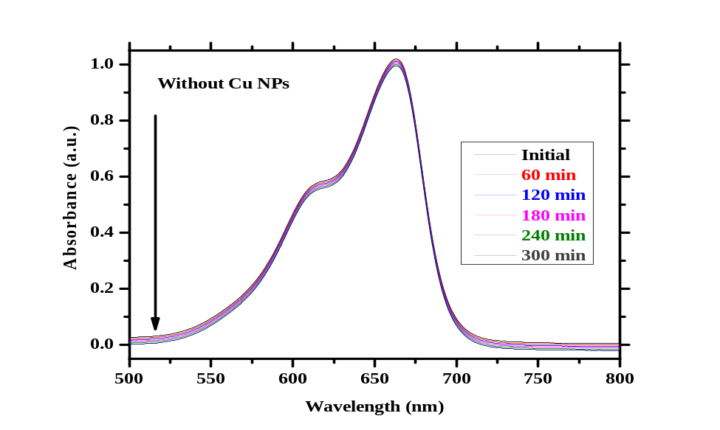
Fig. S1 (d) represented the absorption spectra for photocatalytic degradation of MB in absence of Cu NPs.

S2 Photostability of the Cu NPs as catalyst:
(Fig. S2 (a) and (b)) represented the TEM image of the spent catalyst recovered after 3 cycles of photodegradation of MV6B and MB respectively. The TEM images revealed that the NPs morphology is almost similar instead the NPs morphology has been slightly increased (30-32nm) in case of MV6B (as revealed from the histogram in the inset of Fig. S2 (a)) and (32-34 nm) in case of MB (revealed from the histogram depicted in the inset of Fig. S2 (b)).

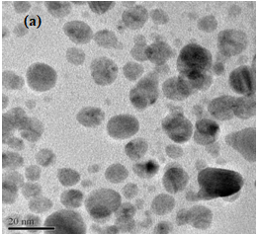 | 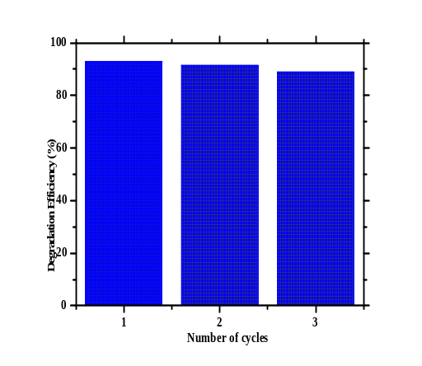
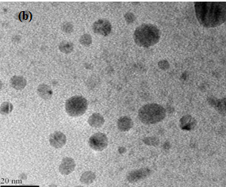 | 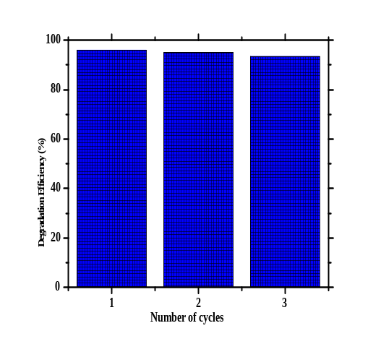
(Fig. S2 (a) and (b)) corresponded to the TEM images of the spent Cu NPs as catalyst recovered after 3 cycles of photodegradation of MV6B and MB respectively. Recyclability tests of Cu NPs as catalyst for degradation of MV6B and MB are respectively depicted in the inset of (Fig. S2 (a) and (b)) respectively.

S3. Identification of the intermediate products of dye degradation:
410 Prostar Binary LC (Variant, USA) fitted with 500 MS IT PDA detector was utilized for carrying out the chromatographic experiment and identification of the degraded products.
SB-C 18 column (150 mm × 4.6 mm packed with 5 µm particle size) was used for the separation of the degraded products and diode array detector (Variant, USA) was employed for the detection (200-700 nm). HP Chemstation software was used to record the signal from the detector. The mobile phase composed of two solutions namely A and B. 0.1 M ammonium acetate and acetic acid (pH 5.3) and acetonitrile marked the Solution A and B respectively (Gradient elution: 5-95%, 30 min, flow rate: 0.8 ml/min and injection volume: 100 ml). The gradient LC separation was coupled with, ion trap mass spectrometer (Variant Technologies). The mass spectrometer was equipped with an electro spray ionization source and operated in positive polarity (Capillary voltage: 3.5 kV, endplate offset: 500 V; skimmer: 40 V; trap drive: 53 V; nebulizer pressure: 70 psi; drying gas flow: 12 Lmin⁻¹, drying temperature : 350 ◦C with mass range : 50-700 m/z). Tandem MS experiment was done using the Auto MSn mode wherein Helium gas was used as a collision gas.
The intermediates generated during the degradation process were identified by comparison with commercial standards and by interpretation of their fragment ions in the mass spectra.
Fig. S3 (a) depicted the LC-MS of MV6B dye solution with Cu NPs initially. The figure clearly displayed a prominent peak at m/z =344 which is very close to the formula mass of MV6B dye. Noticeably, no signals corresponding to the formation of reaction intermediates were observed. Fig. S3 (b) represented the LC-MS of MV6B dye solution with Cu NPs after complete degradation. Here, it was found that the multiple mass signals corresponding to reaction intermediates have appeared. The molecular structures of the possible reaction intermediates from fragmentation of the main skeleton of MV6B dye were shown in Fig. S3 (c). It was supposed that the formation of the reaction intermediates take place by cleavage of one or more of the methylene groups substituent on the amine group. For example, the formation of N-methyl-N"-methyl-N"-methyl pararosaniline, N-methyl-N"-methyl pararosaniline, N-methyl-methyl pararosaniline and pararosaniline (Fig. S3 (d)) occurred through the demethylation cleavage during the photocatalytic degradation has been reported in the literature [1]. The pararosaniline then undergoes cleavage to form 4, 4'-bis-amino benophenone and 4-amino phenol which then undergoes fragmentation to furnish 4-amino benzoic acid and amino benzene (Fig.S3 (d)). These then produces acetic acid and 1-hydroxy -2- propanone which then produces the mineralization products [1].
Fig. S3 (e) depicted the LC-MS of MB dye solution with Cu NPs initially. The figure clearly displayed a prominent peak at m/z =284 which is very close to the formula mass of MB dye and no other signals were found. Fig. S3 (f) represented the LC-MS of MB dye solution with Cu NPs after 135 min (complete degradation). Here, it was found that the signal at m/z = 284 is weakened and multiple mass signals corresponding to various degradation products have been appeared. The molecular structures of the degradation products from fragmentation of the main skeleton of MB dye were shown in Fig. S3 (g). It was supposed that the formation of the degradation products took place by cleavage of one or more of the methyl groups on the amine group. For example, the formation of azure A, B and C and thionin (Fig. S3 (g)) through the demethylation cleavage during the photocatalytic degradation has been observed [2]. It is then predicted from the LC-MS (Fig. S3 (b)) that the Azure C undergone fragmentation to give intermediate degraded products at m/z =186, 142 and 123 (Fig. S3 (h)).
Henceforth, it could be concluded that the synthesized NPs showed marvellous photocatalytic activity because of high surface area to volume ratio, which provided maximum exposure for the reactant to the active surface.

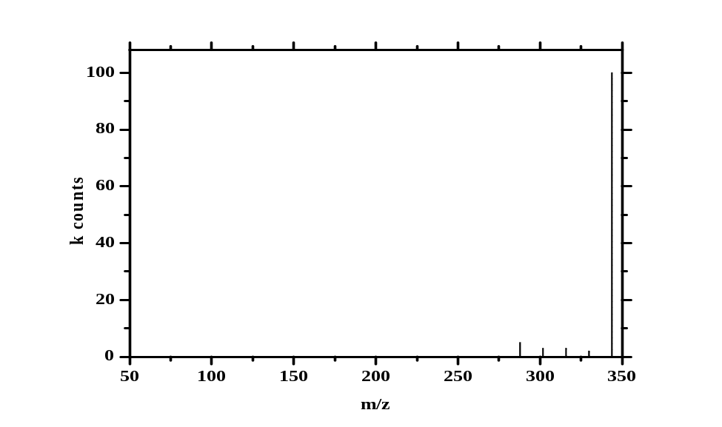
Fig. S3(a) Showed the LC-MS of MV6B dye solution with Cu NPs after 0 min.

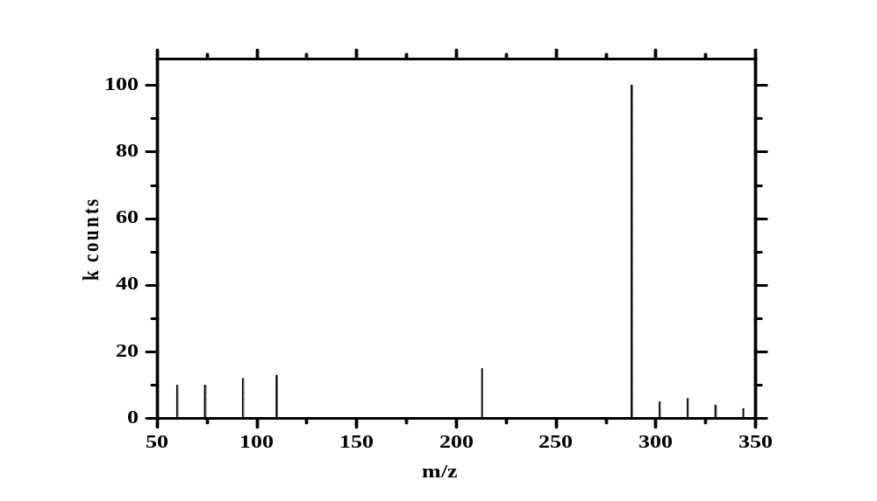
Fig. S3 (b) Depicted the LC-MS of MV6B dye solution with Cu NPs after 150 min.

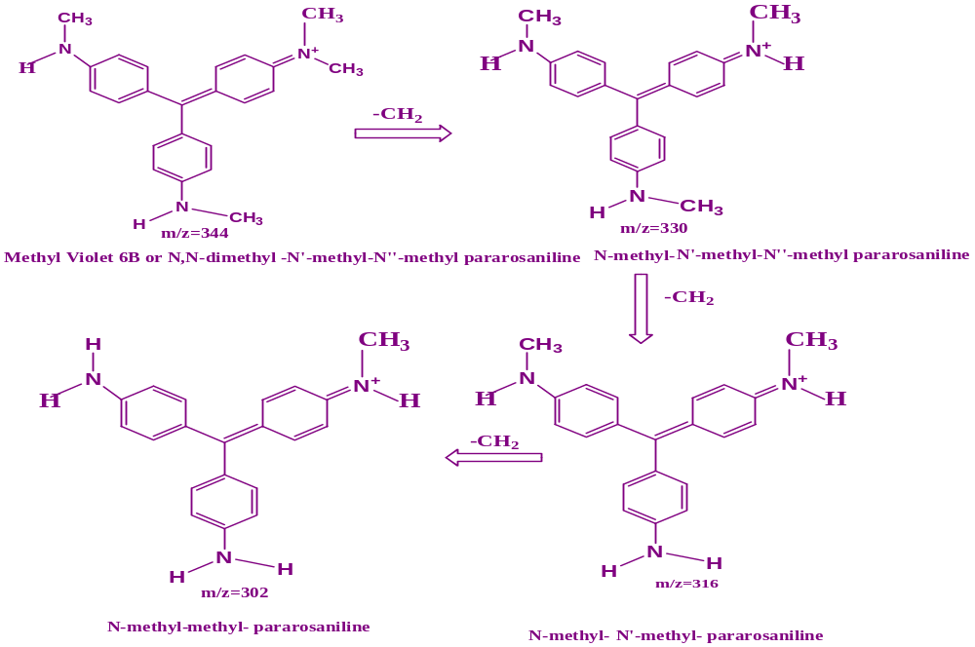
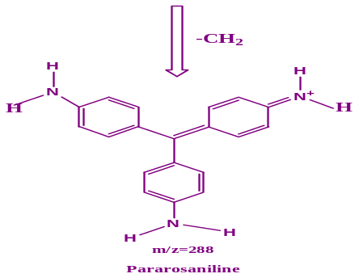
Fig. S3 (c) Depicted the molecular structures of the possible degradation products from fragmentation of the main skeleton of MV6B dye.

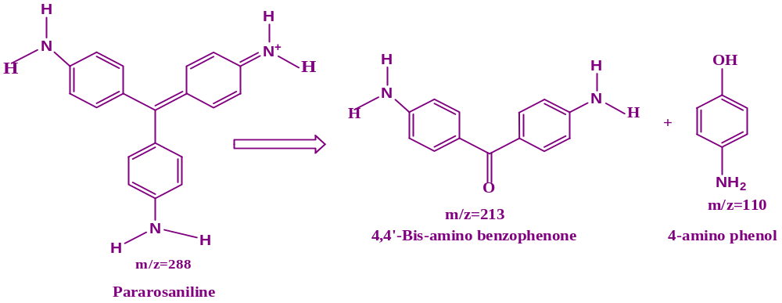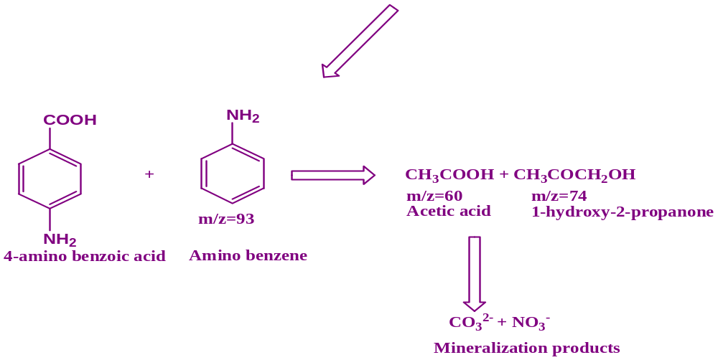
Fig. S3 (d) Showed the mass spectra of MV6B intermediate degradation product ion at m/z = 288.

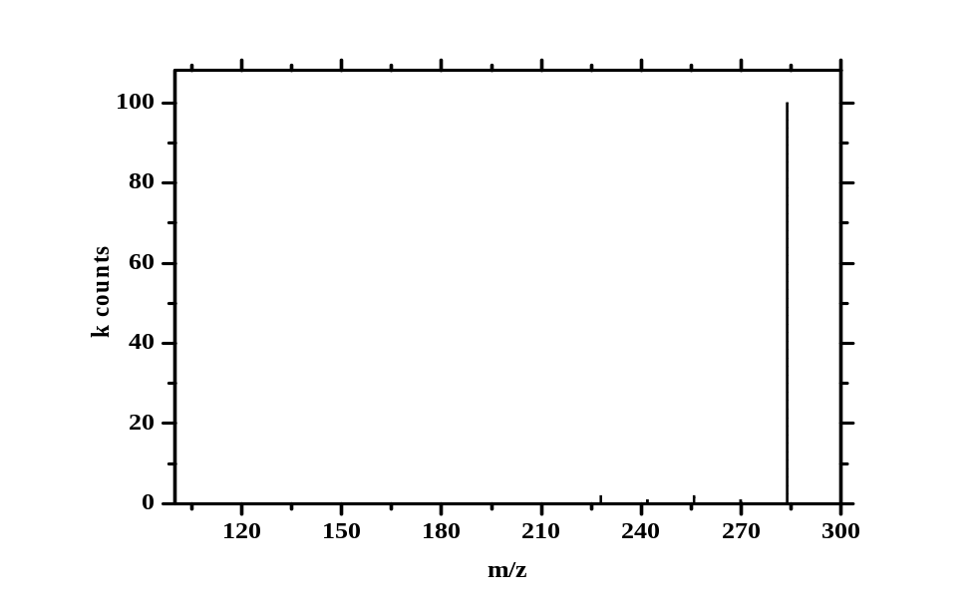
Fig. S3(e) Showed the LC-MS of MB dye solution with Cu NPs after 0 min.

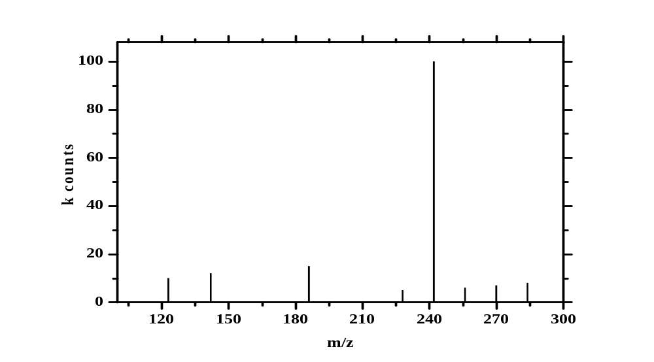
Fig. S3(f) Showed the LC-MS of MB dye solution with Cu NPs after 135 min.

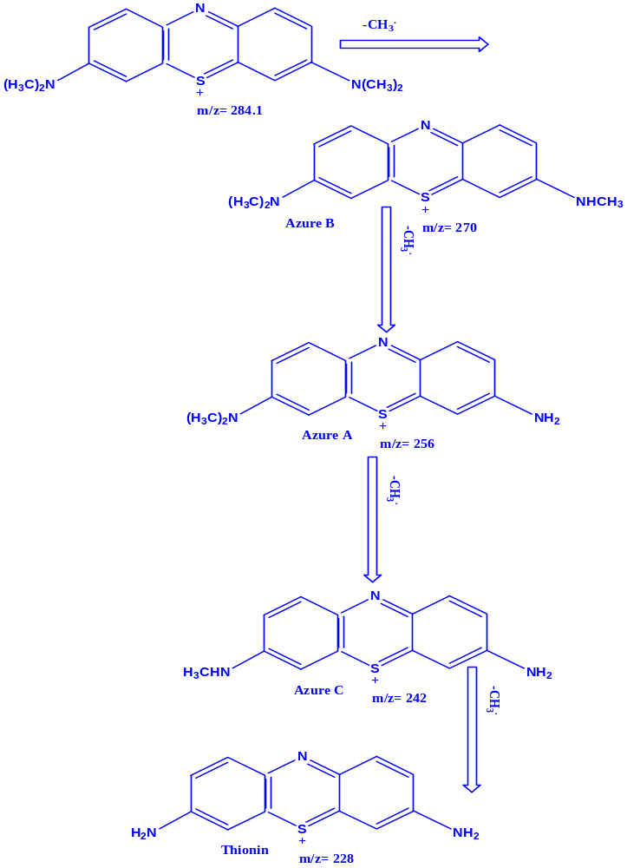
Fig. S3(g) Depicted the molecular structures of the possible degradation products from fragmentation of the main skeleton of MB dye.

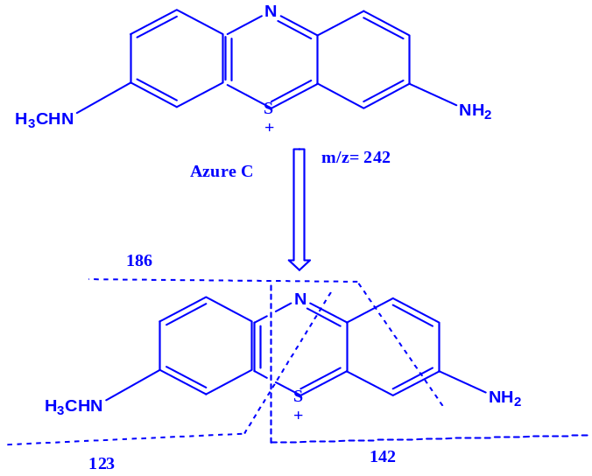
Fig. S3(h) Represented the mass spectra of MB intermediate degradation production at m/z = 242.

References:
[1] H. J. Fan, S. T Huang, W.H. Chung, J.L. Jan, W.Y. Lin, C.C. Chen, Degradation pathways of crystal violet by Fenton and Fenton-like systems: condition optimization and intermediate separation and identification, J. Hazard.Mater., 2009, 171, 1032-1044.
[2] T. Sinha and M. Ahmaruzzaman,Photocatalytic decomposition behavior and reaction pathways of organic compounds using Cu nanoparticles synthesized via a green route, Photochem. Photobiol. Sci., 2016, 15, 1272-1281.

