Environmental Monitoring and Assessment
Health risks assessment for trace elements accumulation in Amaranthaceae family cultivars and their correlation with macro-minerals
Pooja Sharma¹, Sophayo Mahongnao¹ and Sarita Nanda^{1*}
¹Department of Biochemistry, Daulat Ram College for Women, University of Delhi, Delhi - 110007, India.
*Correspondence:
Department of Biochemistry, Daulat Ram College for Women, University of Delhi,
4, Patel Marg, Maurice Nagar, Delhi- 110007, India.
Mob.- (+91) 9999680604
saritananda123@gmail.com

(f)
(e)
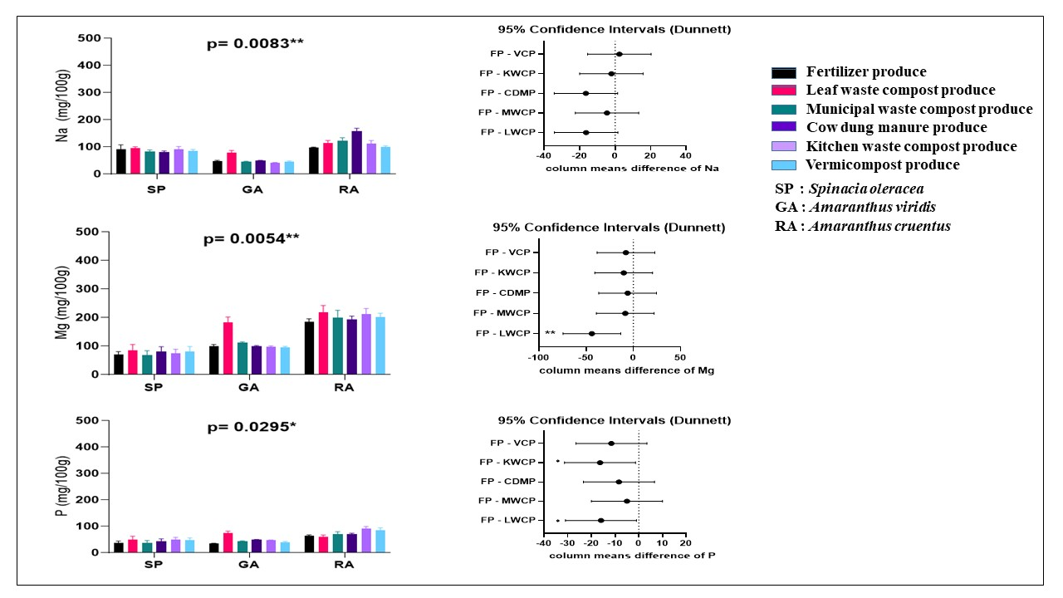
(b)
(a)
(d)
(f)
(e)
(c)
Fig. S1 Macro-minerals (mean ± standard error) of garden cultivars (n=3): These graphs show (a) Sodium (Na) content. (b) Dunette for Na (c) Magnesium (Mg) content. (d) Dunette for Mg (e) Phosphorus (P) content. (f) Dunette for P. Asterisk (*) indicates statistical significance
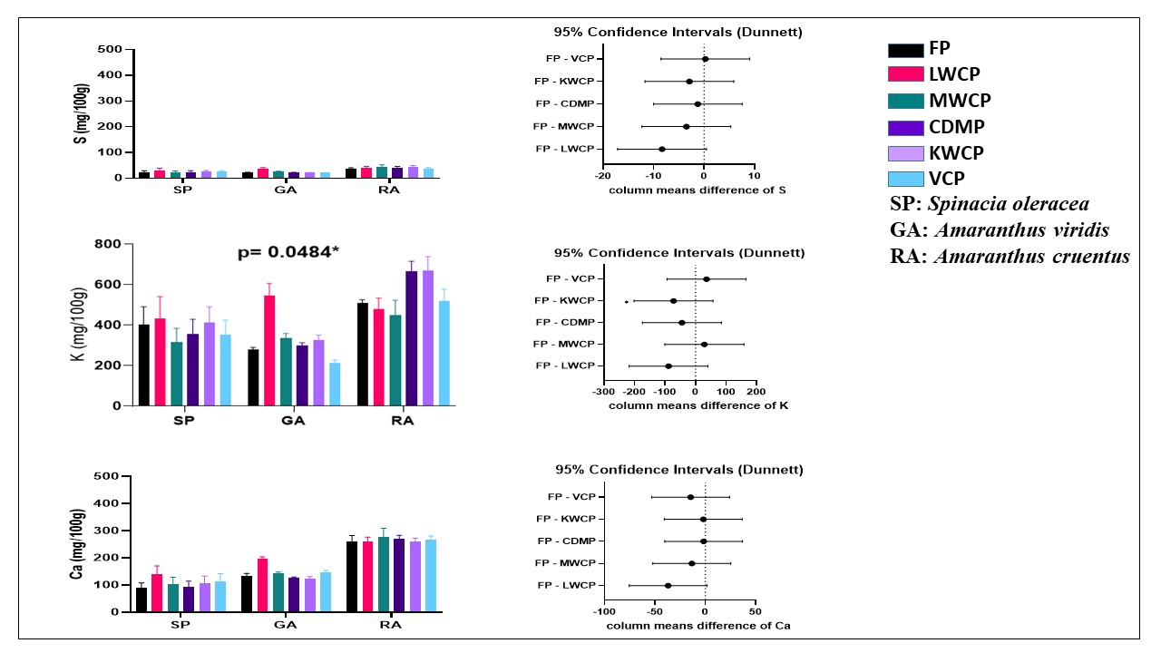
(c)
(d)
(f)
(e)
(b)
(a)
Fig. S2 Macro-minerals (mean ± standard error) of garden cultivars (n=3): These graphs show (a) Sulphur (S) content. (b) Dunette for S. (c) Potassium (K) content. (d) Dunette for K. (e) Calcium (Ca) content. (f) Dunette for Ca. Asterisk (*) indicates statistical significance
(h)
(f)
(d)
(g)
(c)
(e)
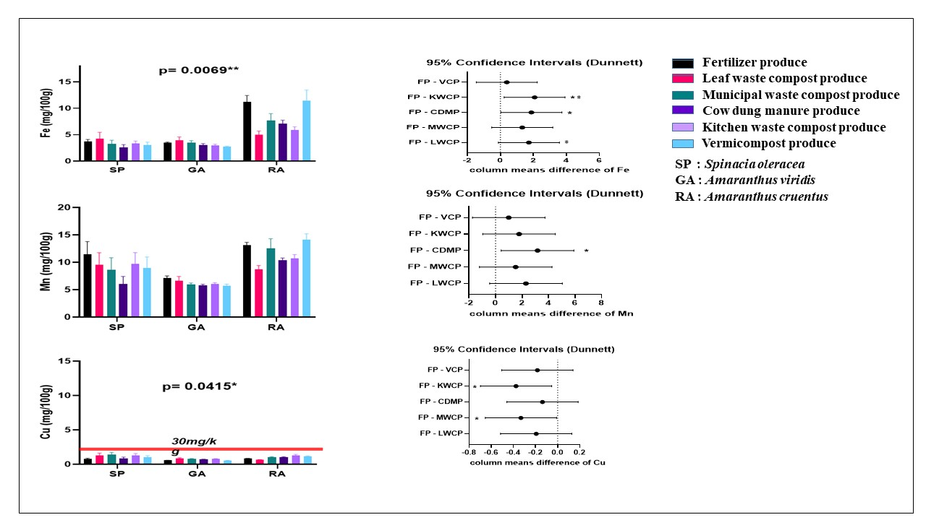Fig. S3 Trace elements (mean ± standard error) of garden cultivars (n=3): These graphs show (a) Iron (Fe) content. (b) Dunette for Fe (c) Manganese (Mn) content. (d) Dunette for Mn (e) Copper (Cu) content. (f) Dunette for Cu. Asterisk (*) indicates statistical significance
(a)
(b)
(d)
(f)
(e)
(c)

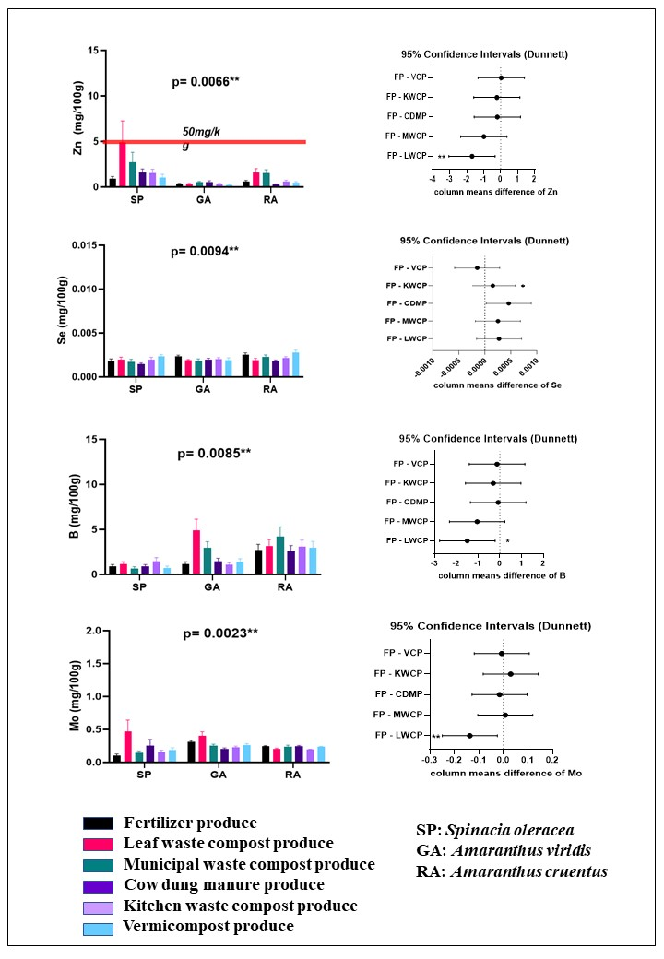
(h)
(f)
(d)
(b)
(g)
(c)
(e)
(a)
Fig. S4 Trace elements (mean ± standard error) of garden cultivars (n=3): These graphs show (a) Zinc (Zn) content. (b) Dunette for Zn (c) Selenium (Se) content. (d) Dunette for Se (e) Boron (B) content. (f) Dunette for B (g) Molybdenum (Mo) content. (h) Dunette for Mo. Asterisk (*) indicates statistical significance

