Table S1 C concentration, mass proportion of intra-microaggregate particulate organic carbon (iPOC) and the mineral-associated organic carbon (MAOC) in bulk soil at different sampling times.
Sampling days (d) | Treatments | C concentration |  |  | Mass proportion in bulk soil
Sampling days (d) | Treatments | (g C kg⁻¹ fraction) |  |  | (%)
 |  | iPOC | MAOC |  | iPOC | MAOC
81 | MR-SM | 13.17±0.75 ab | 12.56±0.56 a |  | 68.55±1.01 b | 15.20±1.73 g
81 | RR-ER | 14.25±1.27 a | 12.01±0.28 ab |  | 66.81±1.14 bc | 16.43±0.87 fg
340 | MR-SM | 12.24±0.49 bcd | 11.37±0.34 bc |  | 63.43±2.60 cde | 19.62±1.84 de
340 | RR-ER | 12.60±0.43 bc | 11.49±1.01 bc |  | 63.18±2.19 de | 20.19±2.18 de
448 | MR-SM | 12.01±0.45 cde | 11.25±0.25 bc |  | 64.58±0.96 cde | 21.72±0.87 cd
448 | RR-ER | 11.76±0.27 cde | 11.30±0.28 bc |  | 62.10±1.56 e | 27.76±2.17 a
709 | MR-SM | 10.92±0.32 ef | 10.61±0.24 cd |  | 66.16±1.48 bcd | 21.17±1.81 de
709 | RR-ER | 11.27±0.25 def | 11.09±0.65 cd |  | 65.89±2.64 bcd | 26.01±1.99 ab
816 | MR-SM | 10.26±0.15 f | 10.30±0.18 d |  | 74.23±2.08 a | 18.33±1.30 ef
816 | RR-ER | 10.61±0.11 f | 10.25±0.34 d |  | 68.70±1.51 b | 24.40±0.44 bc
Incubation time (T) |  | ** | ** |  | ** | **
Cropping system (C) |  | ns | ns |  | * | **
T×C |  | ns | ns |  | ns | ns

MR-SM, the incubation tube with ¹³C-enriched spring maize straw; RR-ER, the incubation tube with ¹³C-enriched early rice straw. Different lowercase letters for the same item mean significant variations among sampling time and straw types (p< 0.05).

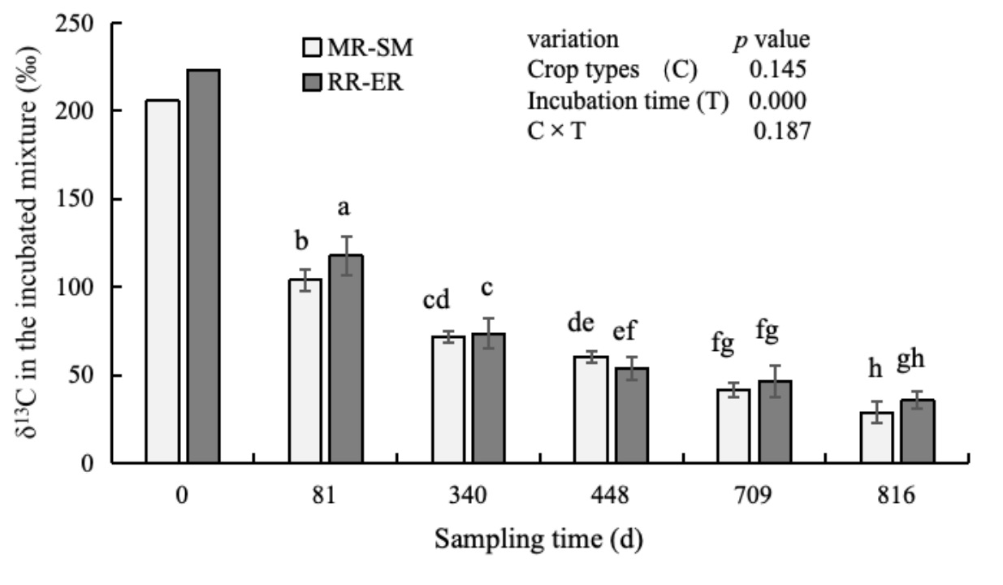
Fig. S1 Changes in δ¹³C value of the incubated mixture in buried tubes at different sampling days. MR-SM, the incubation tube with ¹³C-enriched spring maize straw; RR-ER, the incubation tube with ¹³C-enriched early rice straw. Different lowercase letters above the column mean significant variations for MR-SM and RR-ER treatments among sampling time (p< 0.05). ns, no significant difference (p > 0.05); * and ** represent significant differences at p<0.05 and p<0.01.

