Species | KU_C | KU_N | KU 70/80 beta barrel | VWF_A | KU_pk_bind
Strongylocentrotus purpuratus |XP_030843748.1 | 468-562 | 8-171 | 245-453 |  | 588-703
Nematostella vecentsis |XP_001628737.1 | 277-372 |  | 64-241
Hydra vulgaris |XP_012555181.1 | 460-533 | 8-194 | 241-440 |  | 575-689
Monodelphus domestica| XP_016280585.1 | 363-456 | 1-129 | 139-338 |  | 480-592
Homo sapiens |P13010 | 477-569 |  | 253-452 | 7-249 | 595-705
a.
Species | VWF_A | Ku_N | KU 70/80 beta barrel | KU_pk_bind
Ustilago maydis 521 |XP_011391495.1 | 8-193 |  | 269-499 | 711-821
Lacaria bicoloris | XP_001873673.1 |  |  | 74-290 | 508-626
Puccinia graminis f. sp. Tritici |KAA1113434.1 |  | 8-151 | 367-515
Mortierlla alpine | BAU24610.1 |  | 6-166 | 242-453 | 655-808
Schizosaccharmyces pombe |NP_596791.1 |  |  | 240-453 | 589-687
Neurospora crassa OR74A |XP_956387.3 | 53-214 |  | 291-496 | 651-772
Aspergillus oryzae RIB40 |Q2MHH2.1 |  | 6-189 | 241-452 | 600-717
Talaromyces marneffei PM1 |KFX43477.1|2| |  | 6-107 | 211-421 | 563-680
Talaromyces marneffei ATCC 18224 |XP_002151653.1|1| |  | 6-160 | 241-449 | 593-713
Sphaeroforma arctica JP610 |XP_014153316.1 |  | 2-95 | 165-379 | 527-645
Saccharomyces cerevisiae |Q04437 |  | 5-231 | 242-455
b.
Species | Ku_N | KU70/KU80 beta barrel | KU_pk_bind
Paramecium tetraurelia strain d4-2|XP_001426860.1 | 6-133 | 250-440 | 600-711
c.
Species | VWF_A | Ku_N | Ku70/Ku80 beta barrel
Acanthamoeba castellanii str. Neff |XP_004345889.1 | 8-232 | 268-467 | 268-467
Dictyostelium discoideum AX4| XP_637846.1 | 10-169 | 646-748 | 240-471
d.
Species | Ku_C | Ku_N | KU70/KU80 beta barrel | KU_pk_bind
Arbidopsis thalina AAF79532.1 F21D18.26 | 489-557 | 45-175 | 240-444 | 585-698
Volvox carteri f. nagariensis| XP_002954094.1 |  |  | 498-653 | 900-997
e.
Table supp. 1: Domain specifications of the predicted Ku80 protein sequences of (a) Animalia (b) Fungi (c) Ciliophora (d) Amoebozoa (e) Archaeplastidae. The sequences were obtained using NCBI BLASTP against Homo sapiens Ku80 query sequence. Domain specifications was obtained from InterPro.

Species | KU_N | KU_C | KU 70/80 beta barrel | VWF_A | SAP-dom
Strongylocentrotus purpurat|XP_030845410.1 | 38-253 | 471-505 | 262-458 | 38-244
Branchiostoma floridae| XP002597564.1 | 44-263 | 480-559 | 272-468 |  | 575-610
Nematostella vectensis| XP_001641354.1 | 39-253 | 470-554 | 261-457 |  | 571-604
Hydra Vulgaris| XP_002160929.2 | 35-250 | 467-548 | 260-455 | 35-241
Monodelphis domestica| XP_001378778.1 | 37-255 | 472-557 | 264-460 | 37-246
Homo sapiens KU70|P12956 | 37-255 | 473-557 | 265-454 |  | 573-607
Monosiga brevicolis| EDQ89450.1 | 774-891 | 1104-1180 | 901-1082 |  | 1200-1234
a.
Species | Ku_N | Ku_C | Ku70/80 Beta barrel | SAP_dom
Malassezia globosa|XP_001731438.1 | 43-164 |  | 246-446
Ustilago maydis| XP_011388207.1 | 42-229 | 574-641 | 351-559 | 673-707
Laccaria bicolor| XP_001878299.1 | 31-270 | 522-601 | 284-499 | 616-650
Puccinia graminis| KAA1090412.1|1| | 63-265 | 517-587 | 290-492
Puccinia graminis| XP_003335612.2|2| |  | 143-213 | 3-118
Schizosaccharomyces pombe| NP_001342782.1 | 19-236 | 457-543 | 244-436 | 570-604
Aspergillus oryzae| Q2MHH4.1 | 31-239 | 500-591 | 287-479 | 618-652
Talaromyces marneffei| XP_002145509.1 |  |  | 1-651
Saccharomyces cerevisiae |A6ZN00 | 31-267 | 277-482 | 493-599
b.
Species | Ku_N | Ku_C | Ku70/80 beta barrel | SAP_Dom | PGBD | VWF_A
Oxytricha trifallax| EJY72241.1 | 43-267 | 499-564 | 277-468 |  |  | 43-258
Stylonychia lemnae| CDW84185.1 | 43-267 | 499-569 | 277-468
Tetrahymena thermophila| XP_001470738.1|1| | 42-256 | 477-564 | 265-454 | 674-708
Tetrahymena thermophila| XP_001025145.2|2| | 35-255 |  | 265-465
Tetrahymena thermophila| DAA80465.1|3| |  |  | 233-442 |  | 905-1287
Paramecium tetraurelia| XP_001440829.1 | 40-253 | 471-522 | 262-450
c.
Species | Ku_N | Ku_C | Ku70/80 beta barrel | APLF_PBZ
Dictyostelium discoideum| XP_637925.1 | 72-302 | 597-660 | 325-585 | 886-909
d.
Species | Ku_N | Ku_C | Ku70/80 beta barrel | PGDB
Arabidopsis thaliana| NP_564012.1 | 30-266 | 487-572 | 275-473 | 585-619
Volvox carteri|XP_002947132.1 |  | 215-294 | 40-195 | 325-359
Ostreococcus lucimarinus|XP_001419207.1 |  | 173-212 | 3-154 | 298-332
e.
Table 2: Domain specifications of predicted Ku70 protein sequences of (a) Animalia (b) Fungi (c) Ciliophora (d) Amoebozoa (e) Archaeplastidae. The sequences were obtained using NCBI BLASTP against Homo sapiens Ku70 query sequence. Domain specifications was obtained from InterPro.
Animalia
S.No. | Organism | Genome Sequenced
1. | Hydra magnipapillata | None
2. | Buddenbrockia plumatellae | None
3. | Branchiostoma floridae | Partial
4. | Strongylocentrotus purpurat | Partial
5. | Nematostella vectensis | Partial
6. | Homo sapiens | Partial
7. | Monodelphis domestica | Partial
Fungi
S.No. | Organism | Genome Sequenced
1. | Malassezia globosa | Partial
2. | Candida albicans | Partial
3. | Moniliopthora perniciosa | None
4. | Neurospora crassa | Partial
6. | Mortierella alpina | Partial
7. | Ustilago maydis | Partial
8. | Laccaria bicolor | Partial
9. | Puccinia graminis | Partial
10. | Schizosaccharomyces pombe | Partial
11. | Penicillium marneffei | Partial
12. | Saccharomyces cerevisiae | Complete
13. | Sphaeroforma arctica | Partial
14. | Aspergillus oryzae | Partial
Amoebozoa
S.No. | Organism | Genome Sequenced
1. | Entamoeba invadens | Partial
2. | Entamoeba histolytica | Partial
3. | Physarum polycephalum | Partial
4. | Hyperamoeba dachnya | None
5. | Mastigamoeba balamuthi | Partial
6. | Acanthamoeba castellanii | Partial
7. | Dictyostelium discoideum | Partial
Ciliophora
S.No. | Organism | Genome Sequenced
1. | Oxytricha trifallax | Partial
2. | Euplotes crassus | Partial
3. | Euplotes octocarinatus | None
4. | Anophryoides haemophila | None
5. | Stylonychia lemnae | Partial
6. | Tetrahymena thermophila | Partial
7. | Paramecium caudatum | Partial
8. | Paramecium tetraurelia | Partial
Archaeplastidae
S.No. | Organism | Genome Sequenced
1. | Griffithsia japonica | None
2. | Cyanidioschyzon merolae | Complete
3. | Chlamydomonas reinhardtii | Partial
4. | Scenedesmus obliquus | Partial
5. | Acetabularia acetabulum | None
6. | Micromonas | Partial
7. | Glaucocystis nostochinearum | None
8. | Cyanophora paradoxa | Partial
9. | Ostreococcus lucimarinus | Complete
10. | Arabidopsis thaliana | Partial
11. | Volvox carteri | Partial
Eozoa
S.No. | Organism | Genome Sequenced
1. | Trypanosoma cruzi | Partial
2. | Trypanosoma brucei | Partial
3. | Leishmania infantum | Partial
4. | Leishmania major | Complete
5. | Diplonema papillatum | Partial
6. | Giardia lamblia | Partial
7. | Spironucleus vortens | None
8. | Streblomastix strix | Partial
9. | Euglena gracilis | Partial
10. | Sawyeria marylandensis | None
11. | Trichomonas vaginalis | Partial
12. | Reclinomonas americana | None
Table 3: Genome sequencing status of all 59 selected eukaryotes. Absence of Ku sequence during BLASTP in some eukaryotes might be due to its incompletely sequenced genome.
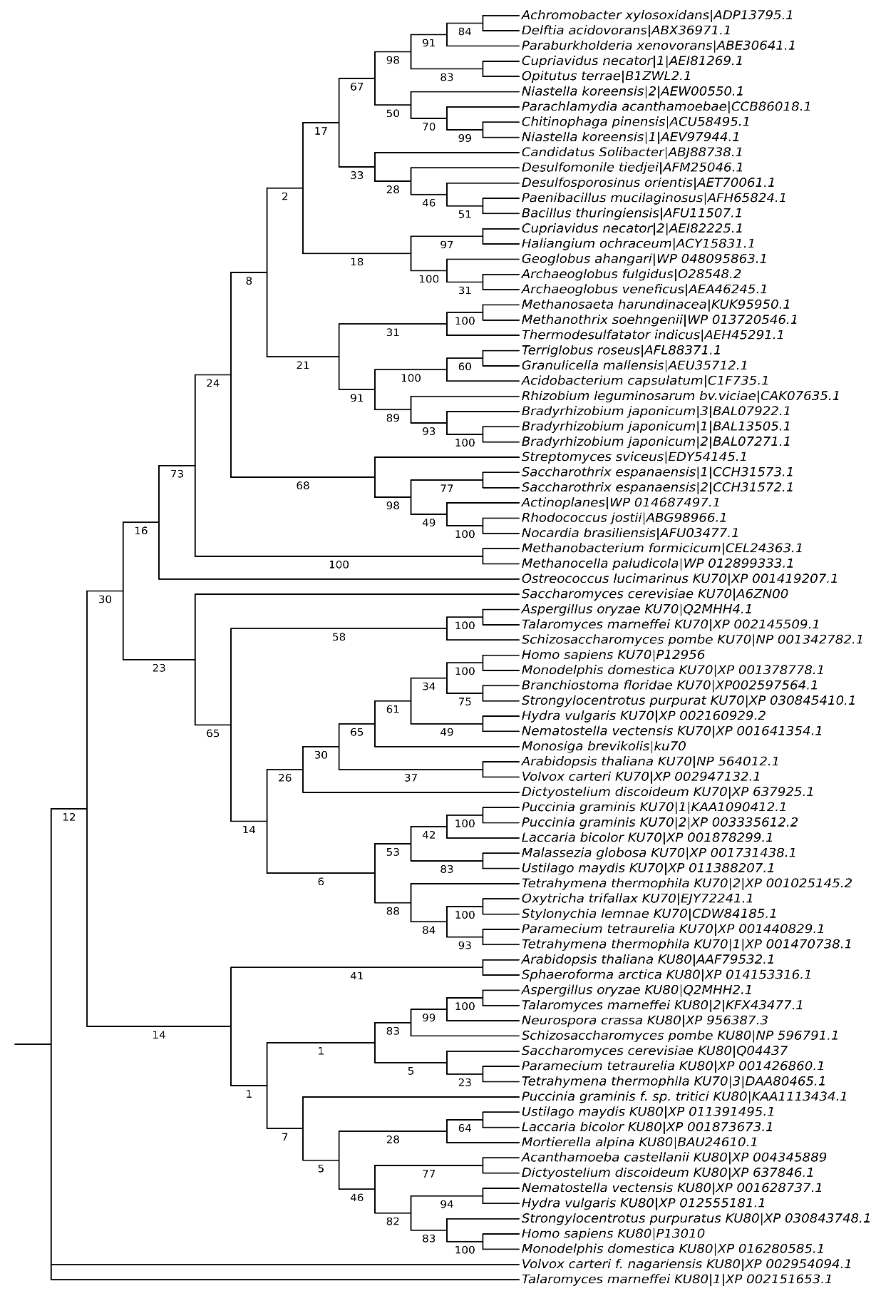
Bacteriodetes
Acidobacteria

Archaeplastidae
Delta-epsilon proteobacteria

Verrucomicrobia
Fungi
Ciliophora
Amoeboza
Fungi
Animalia
Archaeplastidae
Fungi
Archaeplastidae
Bacteriodetes
Ciliophora
Archaeplastidae
Choanoflagellates
Fungi
Amoeboza
Fungi
Animalia
Euyarchaeota
Fungi
Actinoplanes
Alphaproteobacteria
Thermodesulfobacter
Euyarchaeota
Betaproteobacteria

Delta-epsilon proteobacteria

Firmicutes

Euyarchaeota
Acidobacteria

Verrucomicrobia
Betaproteobacteria

Figure 1: Phylogenetic tree inferred using Neighbor-Joining method(N. & M., 1987). The percentage of replicate trees in which the associated taxa clustered together in the bootstrap test (500 replicates) are shown next to the branches(Felsenstein, 1985). This analysis involved 84 amino acid sequences. All ambiguous positions were removed for each sequence pair (pairwise deletion option). Evolutionary analyses were conducted in MEGA X(Kumar et al., 2018). Organisms are labelled according to their respective phyla/kingdoms on the left of the tree.
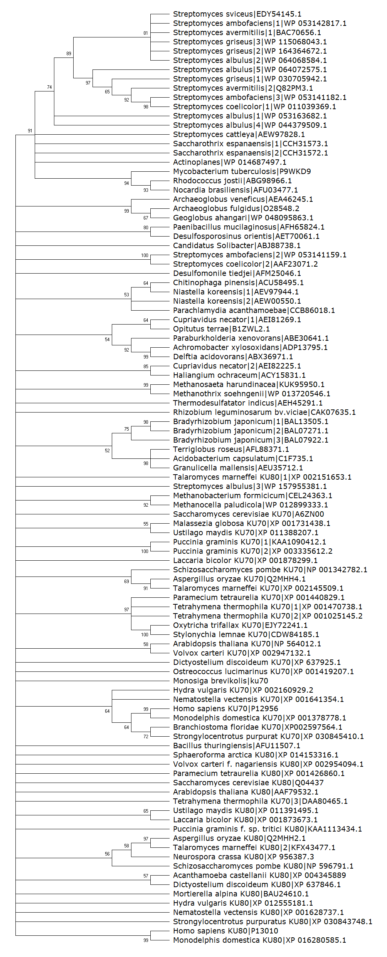
Acidobacteria

Alphaproteobacteria
Thermodesulfobacter
Euyarchaeota
Delta-epsilon proteobacteria

Betaproteobacteria

Verrucomicrobia
Betaproteobacteria

Verrucomicrobia
Bacteriodetes
Delta-epsilon proteobacteria

Actinobacteria
Acidobacteria

Firmicutes

Euyarchaeota
Actinobacteria
Animalia
Fungi
Fungi
Amoeboza
Archaeplastidae
Firmicutes

Archaeplastidae
Fungi
Ciliophora
Fungi
Ciliophora
Actinobacteria
Choanoflagellates
Archaeplastidae
Amoeboza
Animalia
Archaeplastidae
Ciliophora
Fungi
Euyarchaeota
Fungi
Figure 2. Streptomyces species; S. ambofaciens, S. griseus, S. cattleya, S. coelicolor, S. albulus and S. avermitilis (Hoff et al., 2016) and Mycobacterium tuberculosis Ku sequences were added and phylogenetic tree was inferred by using the Maximum Likelihood method and Whelan And Goldman model(Whelan & Goldman, 2001) in MEGA-X. The bootstrap consensus tree inferred from 500 replicates (Felsenstein, 1985) is taken to represent the evolutionary history of the taxa analyzed. Branches corresponding to partitions reproduced in less than 50% bootstrap replicates are collapsed. Substitution model used was WAG model. Gamma Distributed with Invariant sites (G+I) rates was used with 5 number of discrete gamma categories. Partial deletion was used for Gaps/Missing data treatment with 95% site coverage cutoff. Nearest-Neighbor-Interchange (NNI) ML Heuristic method was used and Make initial tree automatically (Default – NJ/BioNJ) was chosen for Initial Tree for ML. Branch Swap filter was none and Number of threads selected was 3 (Hall, 2013). Corresponding phyla/kingdoms are labelled at left of the tree.

References
Felsenstein, J. (1985). Confidence Limits on Phylogenies: An Approach Using the Bootstrap. Evolution. https://doi.org/10.2307/2408678
Hall, B. G. (2013). Building phylogenetic trees from molecular data with MEGA. Molecular Biology and Evolution. https://doi.org/10.1093/molbev/mst012
Hoff, G., Bertrand, C., Zhang, L., Piotrowski, E., Chipot, L., Bontemps, C., Confalonieri, F., McGovern, S., Lecointe, F., Thibessard, A., & Leblond, P. (2016). Multiple and variable NHEJ-like genes are involved in resistance to DNA damage in Streptomyces ambofaciens. Frontiers in Microbiology. https://doi.org/10.3389/fmicb.2016.01901
Kumar, S., Stecher, G., Li, M., Knyaz, C., & Tamura, K. (2018). MEGA X: Molecular evolutionary genetics analysis across computing platforms. Molecular Biology and Evolution. https://doi.org/10.1093/molbev/msy096
N., S., & M., N. (1987). The neighbor-joining method: a new method for reconstructing phylogenetic trees. Molecular Biology and Evolution. https://doi.org/10.1093/oxfordjournals.molbev.a040454
Whelan, S., & Goldman, N. (2001). A general empirical model of protein evolution derived from multiple protein families using a maximum-likelihood approach. Molecular Biology and Evolution. https://doi.org/10.1093/oxfordjournals.molbev.a003851

