Figure S1
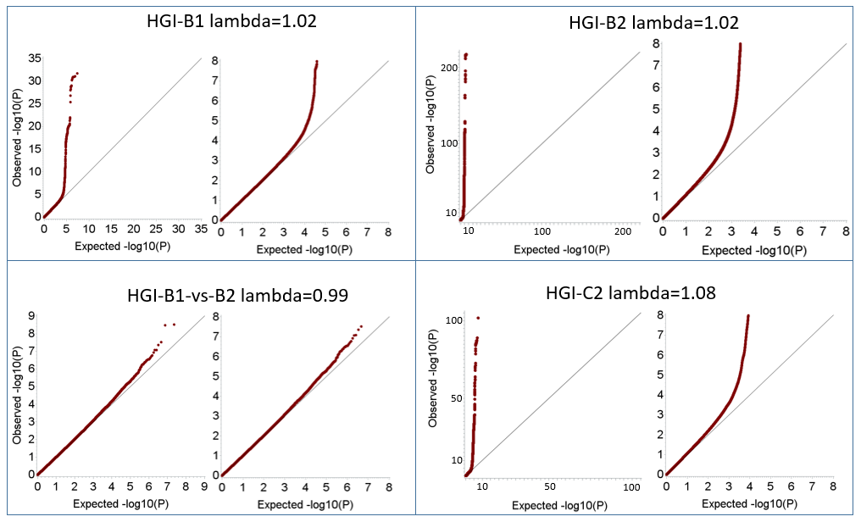
Figure S1. QQ plots for four COVID-19 GWASs from HGI
Figure S2
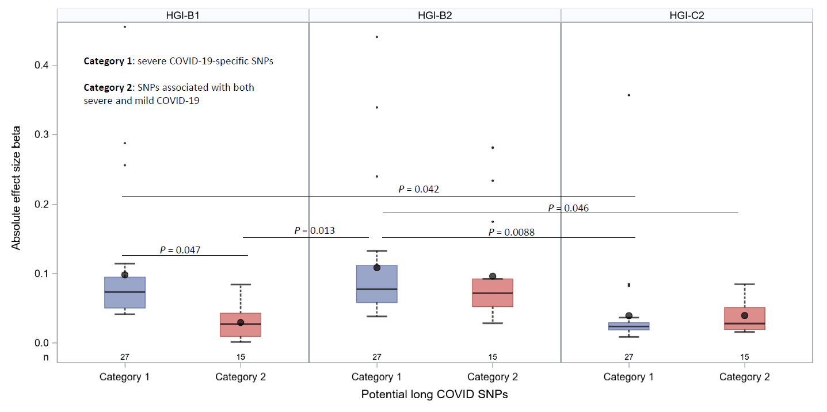
Figure S2. Differential effect size analysis for candidate long COVID SNPs by SNP categories and GWAS
Figure S3
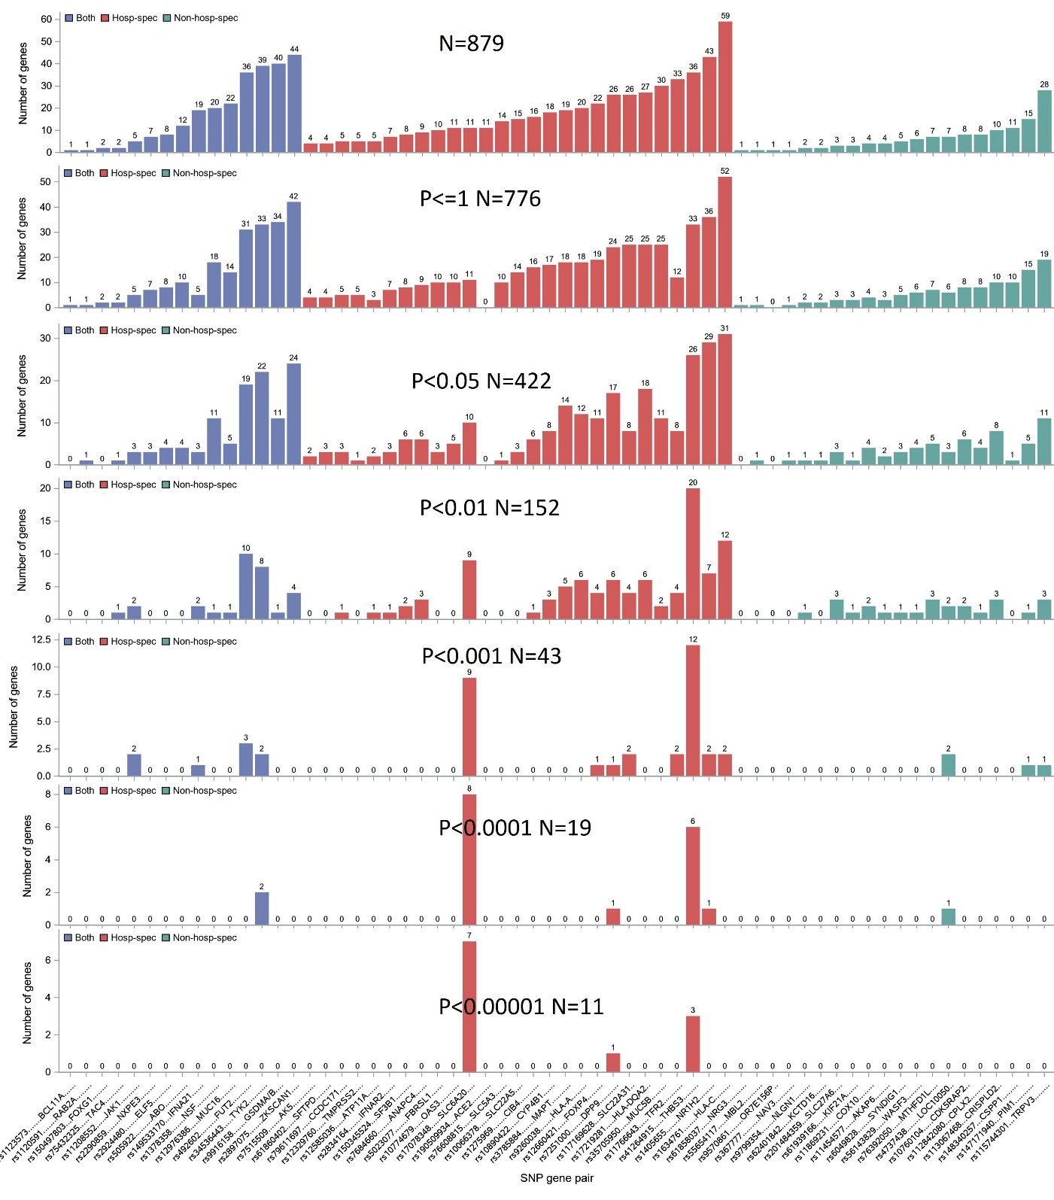

Figure S3. Summary of number of genes adjacent to prioritized long COVID risk SNPs (n=62) in COVID-19 transcriptome-wide association studies (TWASs)
Bar plots illustrating the number of genes adjacent to prioritized long COVID risk SNPs (n=62) as well as number of TWASs out of 4 COVID-19 related GWAS across 48 GTEx tissues passed different association P threshold. Note the 62 SNPs are colored according to its corresponding long COVID SNP category as depicted in Figure 1.

Figure S4
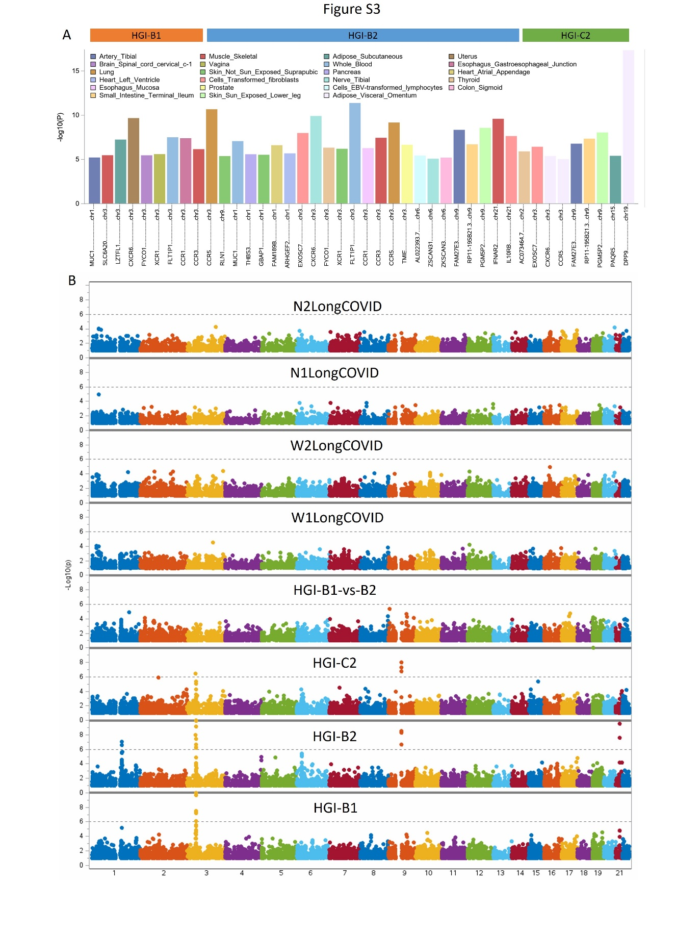
Figure S4. Transcriptome-wide association studies (TWAS) for COVID-19 susceptibility, hospitalization, and long COVID
(A) Top genome-wide significant TWAS-identified genes associated with COVID-19 susceptibility and hospitalization, annotated by their best significant tissue expression association (based on 48 GTEx tissues). No genes reached genome-wide significance in TWAS analyses of long COVID-related GWASs. (B) Manhattan plots depicting TWAS results for COVID-19 susceptibility and hospitalization (HGI datasets), as well as long COVID GWASs derived from four distinct case-control designs. Each dot represents a gene, with its genomic position along the x-axis and -log10(P) on the y-axis.

Figure S5
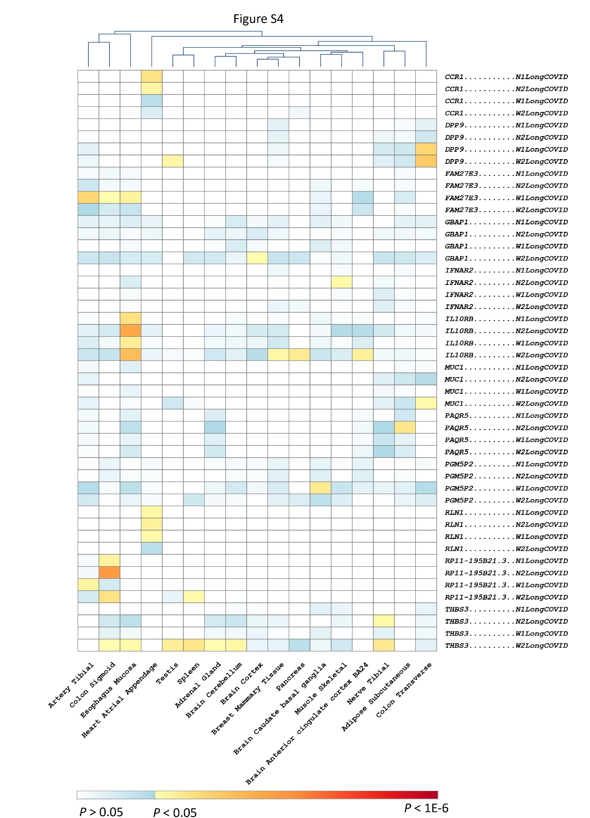
Figure S5. Evaluation of top genes identified from transcriptome-wide association studies (TWAS) of COVID-19 susceptibility and hospitalization in corresponding long COVID-related TWASs
Heatmap displaying the significance (P) of top genes identified in TWAS analyses of COVID-19 susceptibility and hospitalization across multiple tissues in long COVID-related TWASs. Each cell represents the P for the association of a gene with long COVID in a specific tissue from GTEx database. The color gradient denotes statistical significance: blue (P > 0.05), yellow (P < 0.05), and red (P < 1E-6). Rows are sorted by genes, and columns represent tissues, allowing visualization of tissue-specific patterns of gene expression relevance.
Figure S6
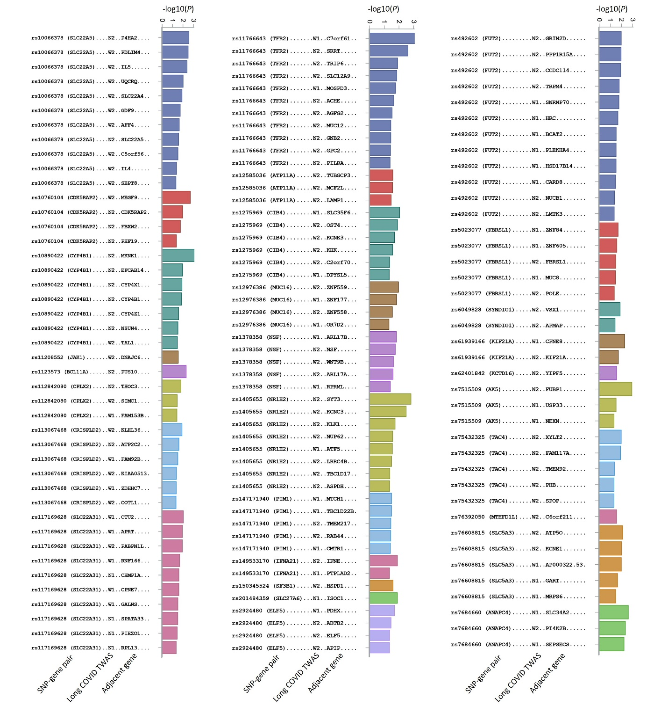
Figure S6. Other top genes adjacent to prioritized long COVID risk SNPs (n=29) in long COVID-19 transcriptome-wide association studies (TWASs)
Bar plots illustrating the best P for genes adjacent to prioritized long COVID risk SNPs (n=29) in 4 long COVID TWASs across 48 GTEx tissues.
Figure S7
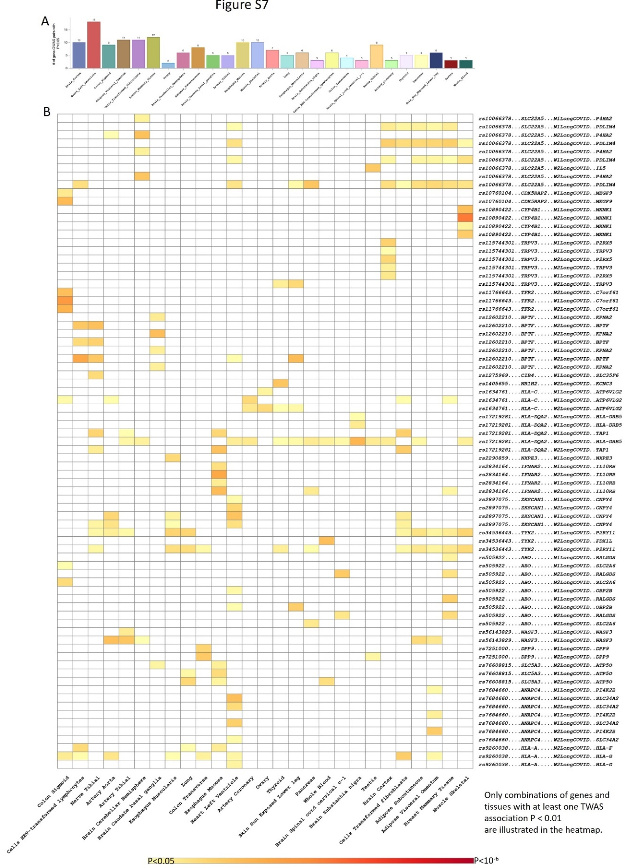
Figure S7. Evaluation of top genes adjacent to prioritized long COVID risk SNPs (n=62) in transcriptome-wide association studies (TWAS) of long COVID across 48 GTEx tissues
(A) Bar plot showing the number of SNP-gene pairs passed the nominal TWAS association threshold in GTEx tissues. Note SNP-gene pair is defined by combining prioritized long COVID risk SNPs with its adjacent genes. (B) Heatmap depicting the significance (P) of SNP-gene pairs across 48 GTEx tissues in long COVID TWASs. Each cell represents the P for a specific gene in a given tissue, with a color gradient indicating statistical significance: white (P > 0.05), yellow (P < 0.05), and red (P < 1E-6). Genes are sorted by SNP-gene pair and TWAS names.

Figure S8
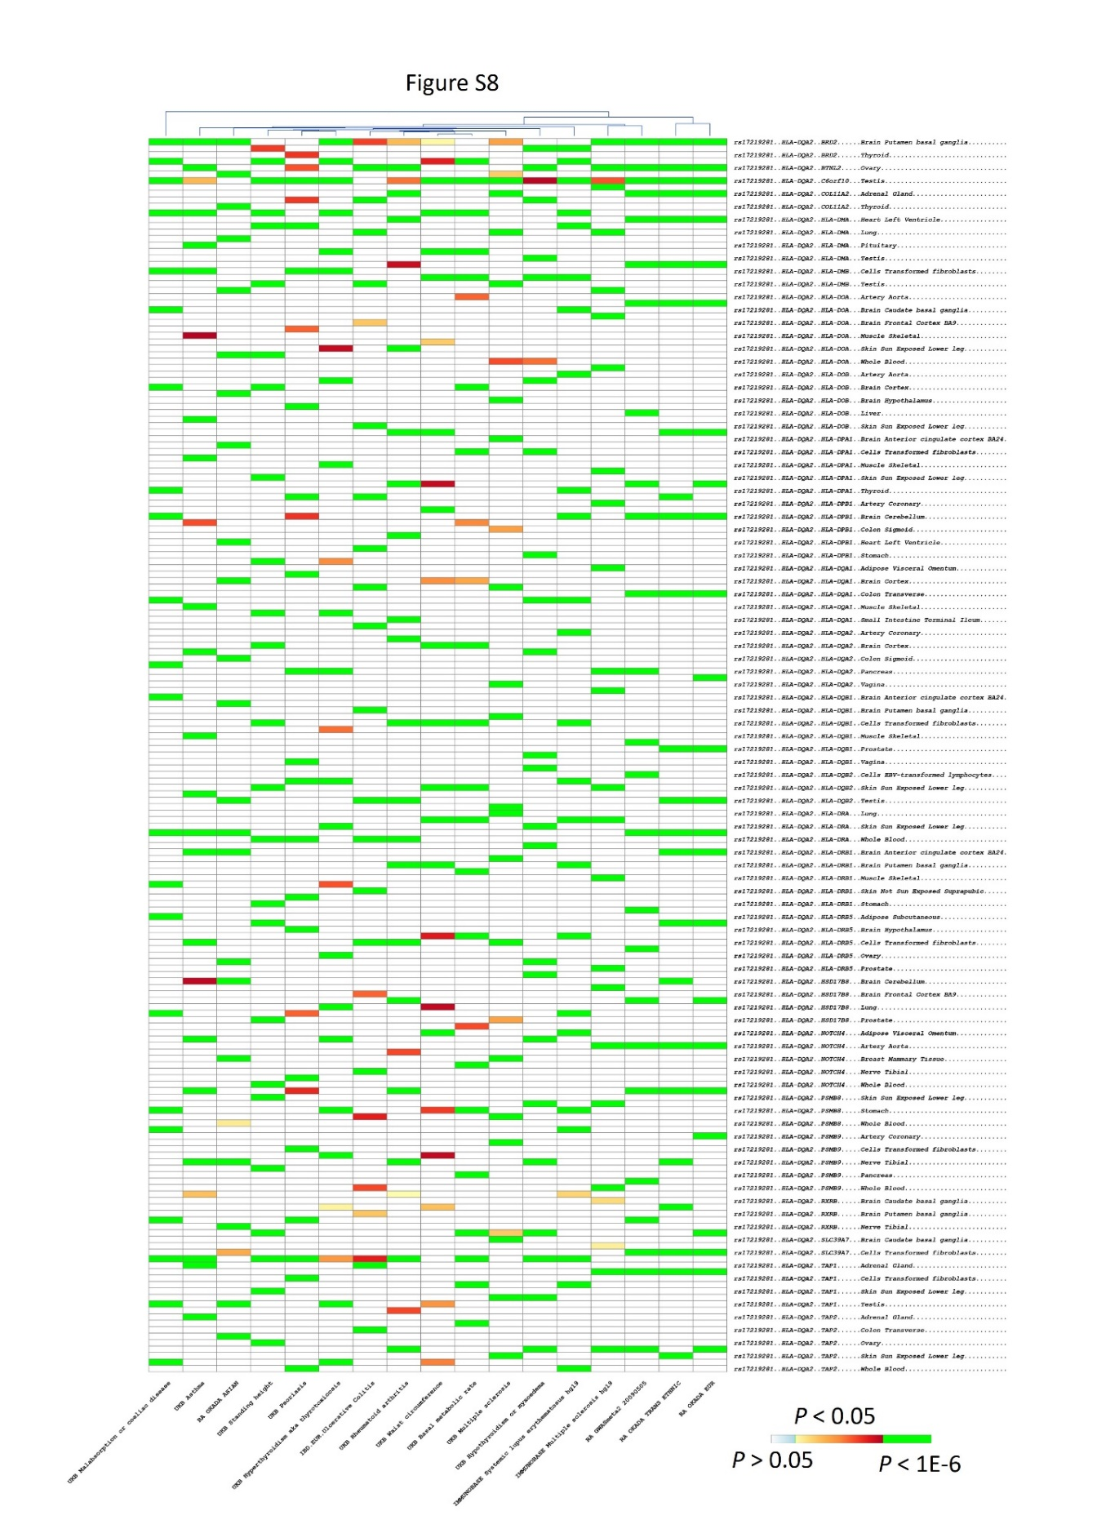
Figure S8. Evaluation of genes adjacent to prioritized long COVID risk SNP rs17219281 (HLA-DQA1) in phenome-transcriptome-wide association studies (pheno-TWAS) across 48 GTEx tissues
Figure S9
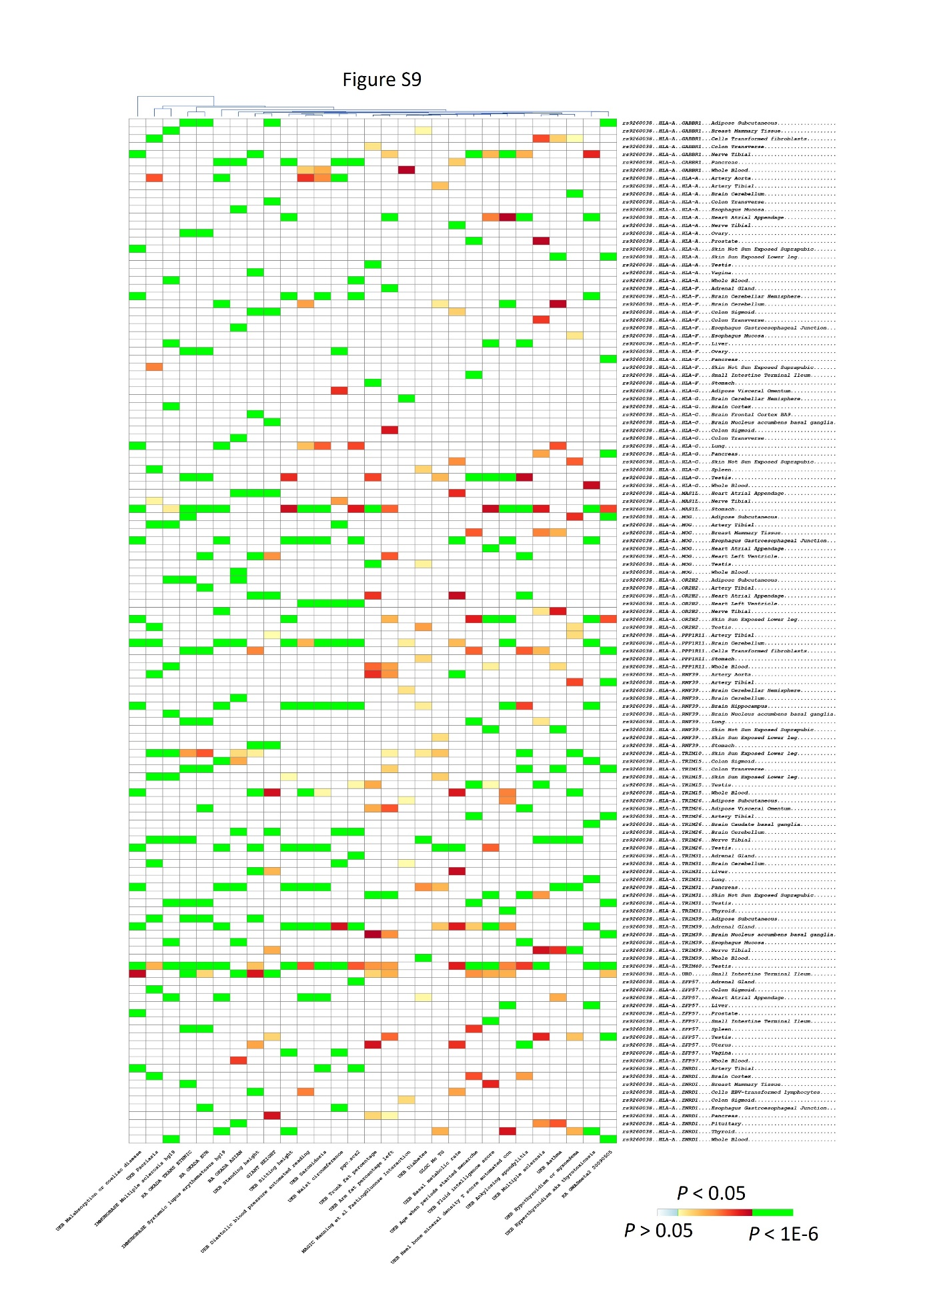
Figure S9. Evaluation of genes adjacent to prioritized long COVID risk SNP rs9260038 (HLA-A) in phenome-transcriptome-wide association studies (pheno-TWAS) across 48 GTEx tissues
Figure S10
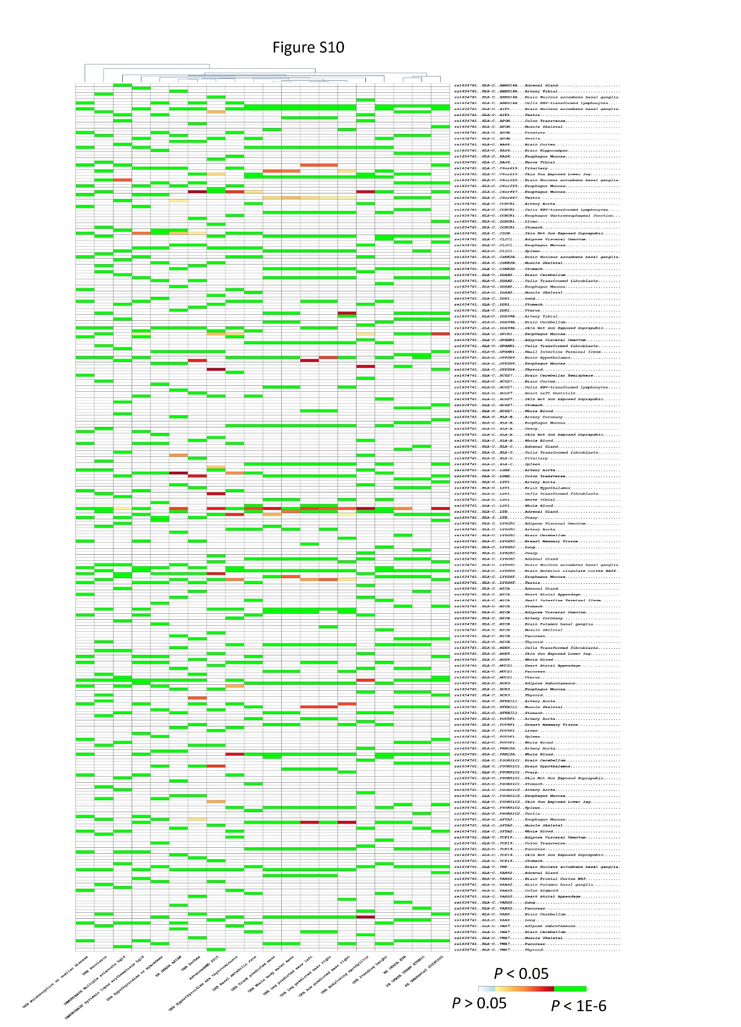
Figure S10. Evaluation of genes adjacent to prioritized long COVID risk SNP rs1634761 (HLA-C) in phenome-transcriptome-wide association studies (pheno-TWAS) across 48 GTEx tissues
Figure S11
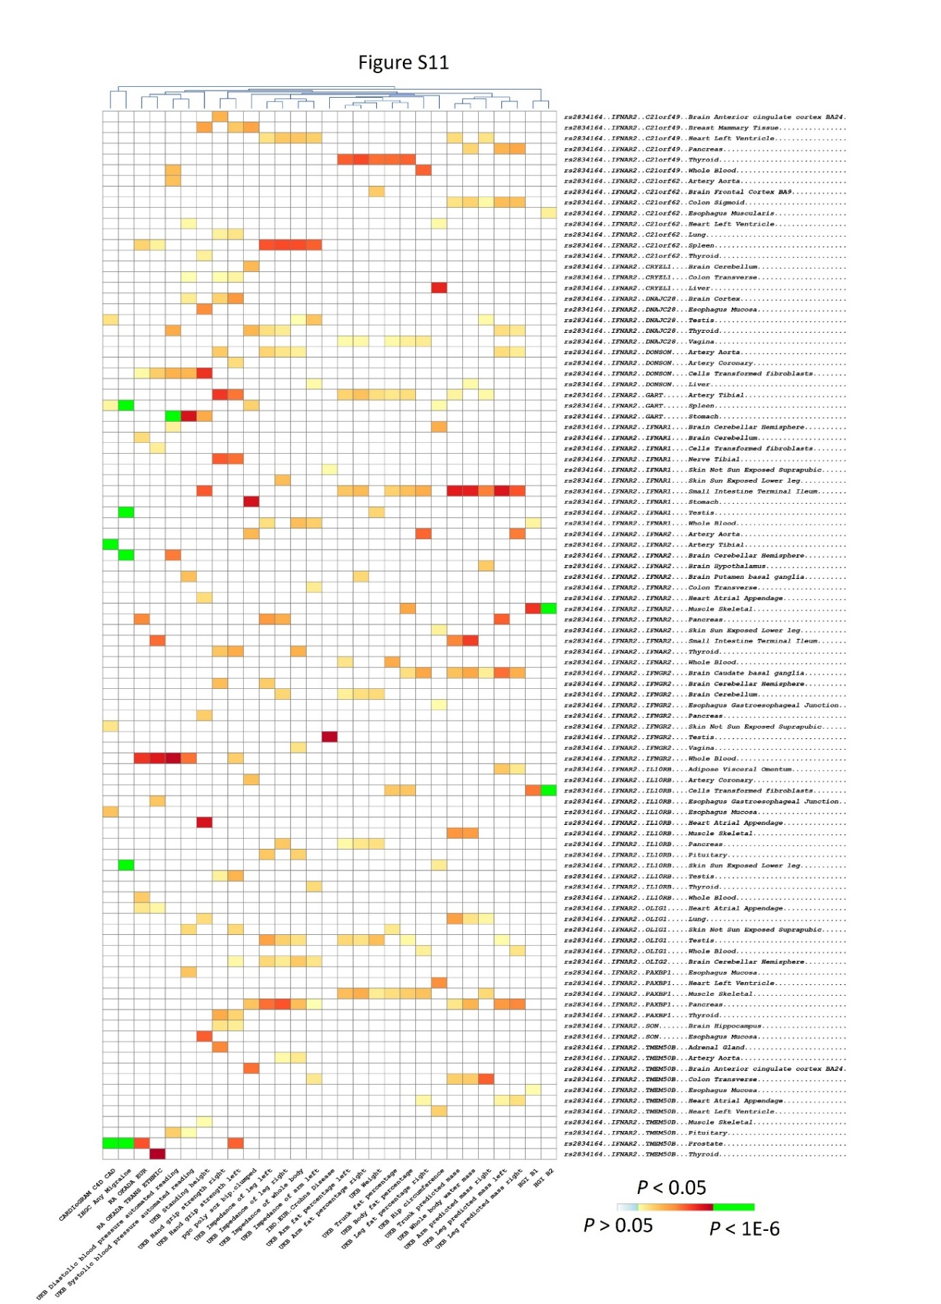
Figure S11. Evaluation of genes adjacent to prioritized long COVID risk SNP rs2834164 (IFNAR2) in phenome-transcriptome-wide association studies (pheno-TWAS) across 48 GTEx tissues

Figure S12
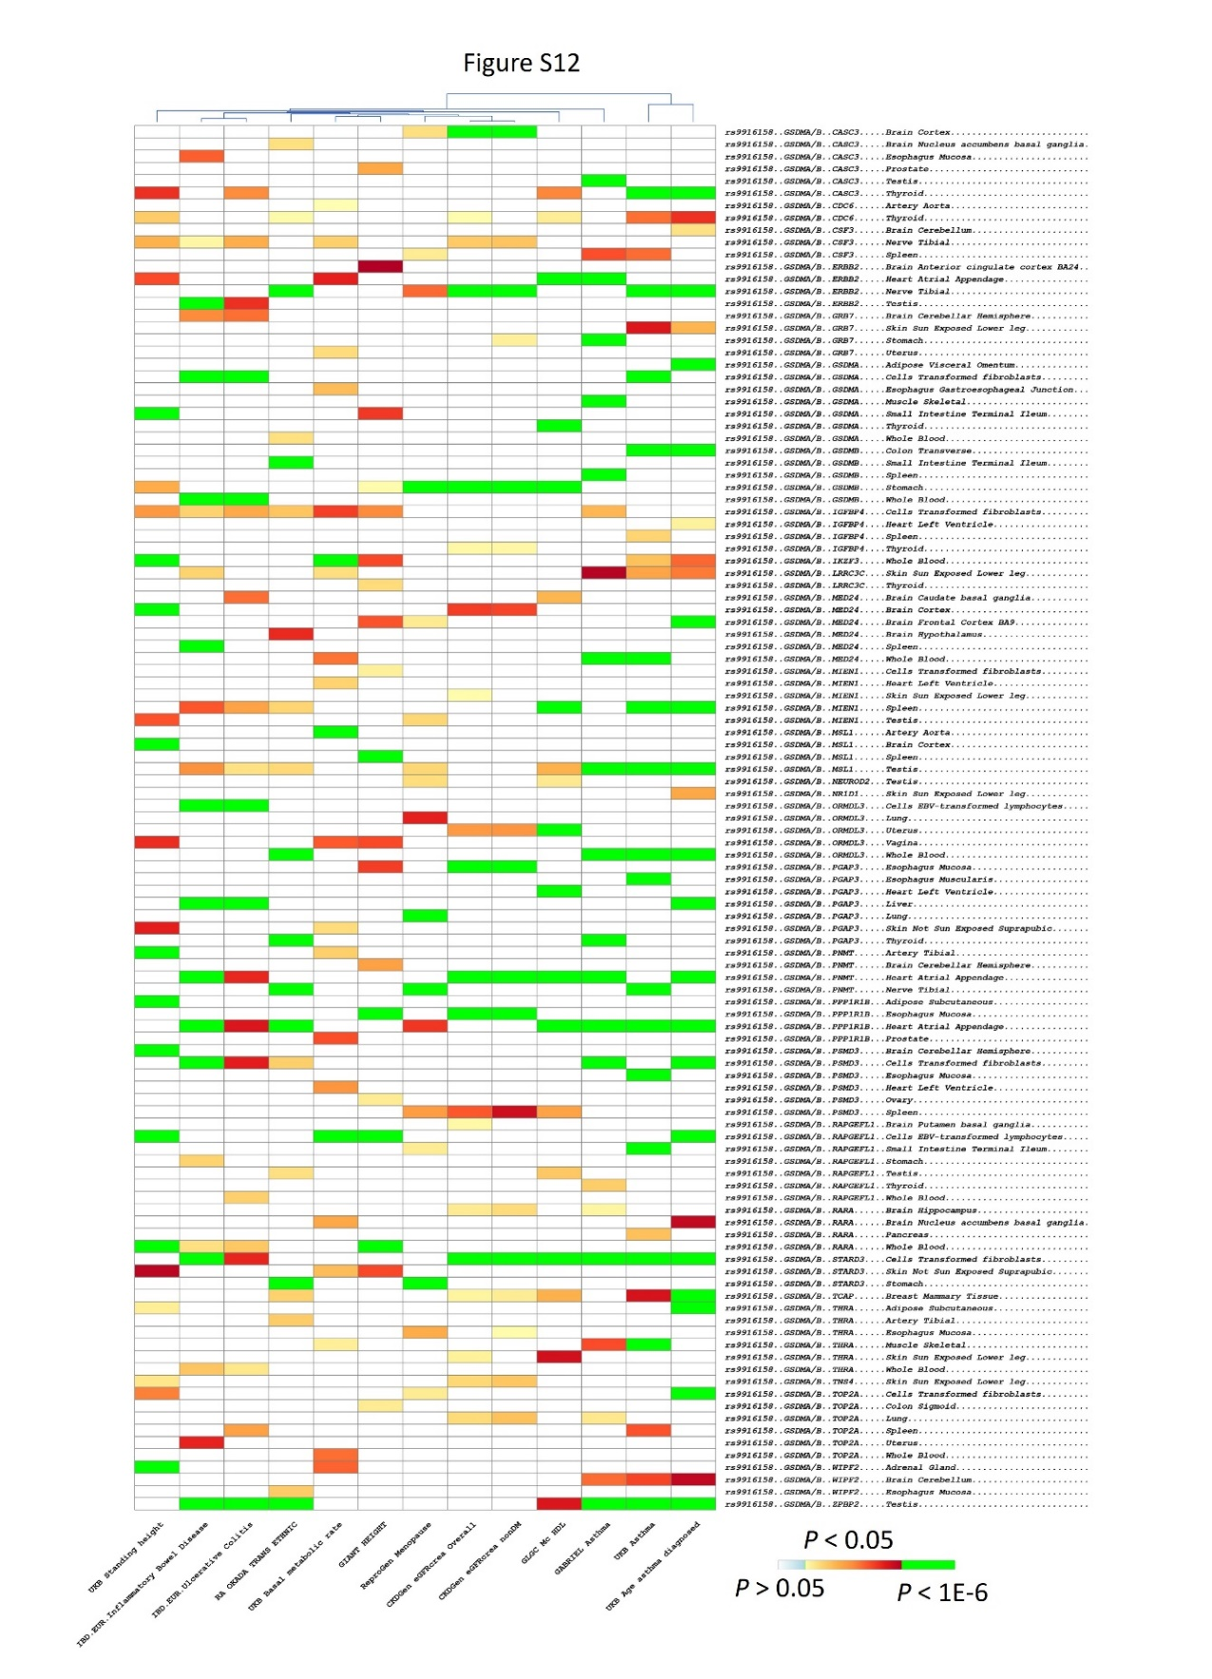
Figure S12. Evaluation of genes adjacent to prioritized long COVID risk SNP rs9916158 (GSDMA/B) in phenome-transcriptome-wide association studies (pheno-TWAS) across 48 GTEx tissues
Figure S13
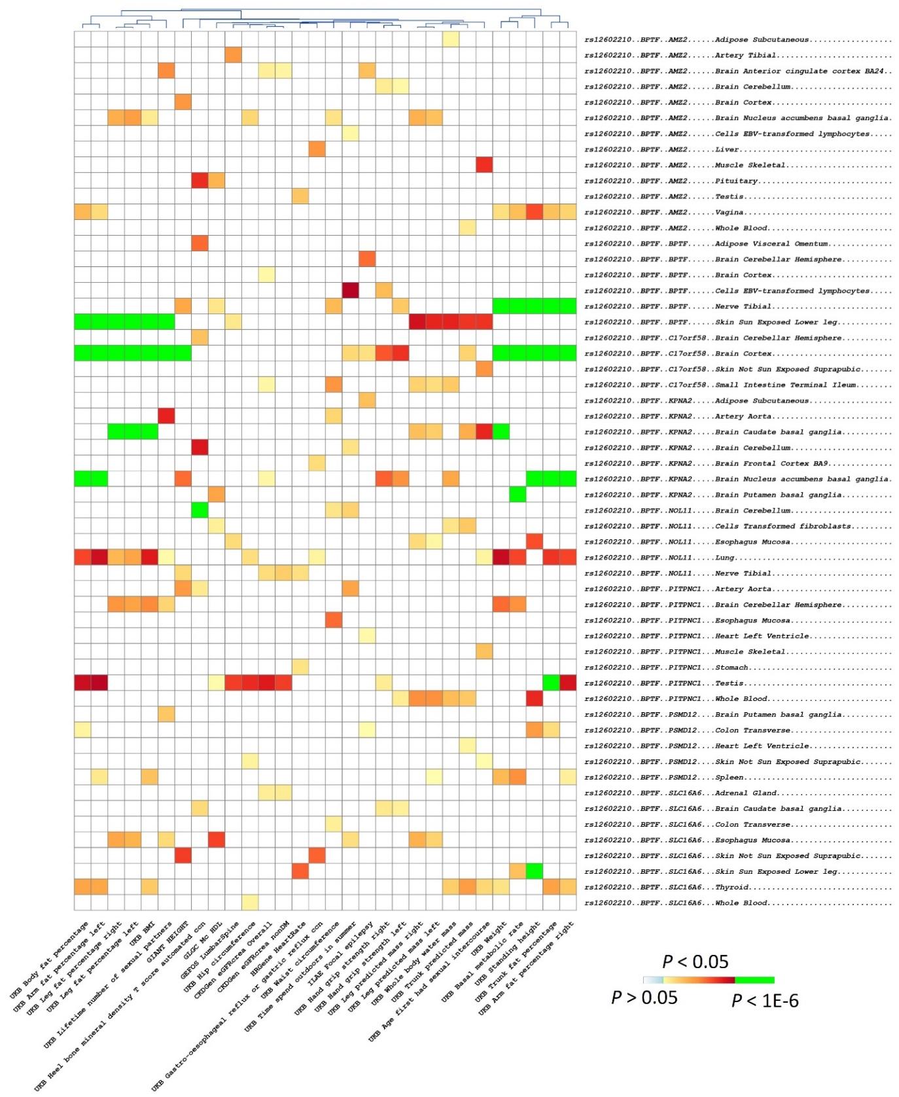
Figure S13. Evaluation of genes adjacent to prioritized long COVID risk SNP rs12602210 (BPTF) in phenome-transcriptome-wide association studies (pheno-TWAS) across 48 GTEx tissues

Figure S14
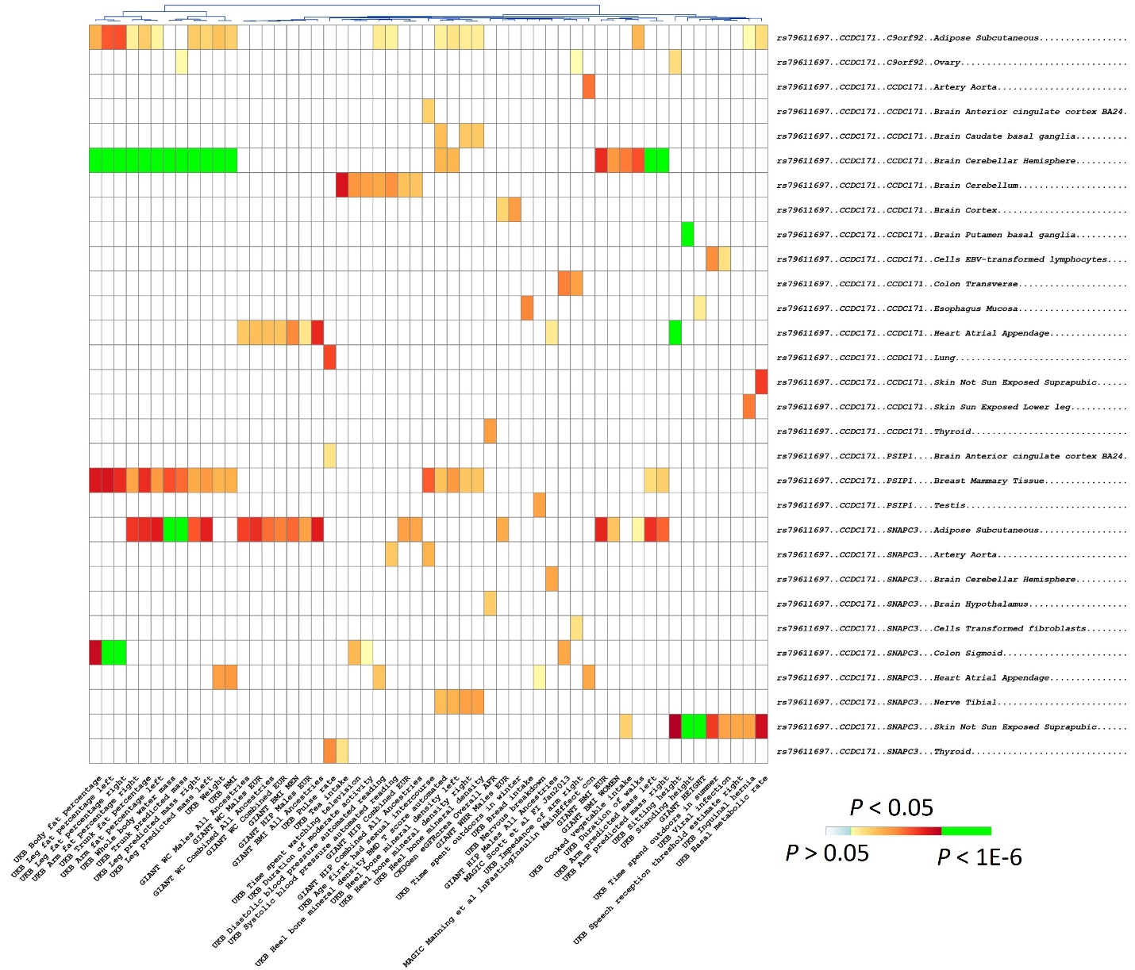
Figure S14. Evaluation of genes adjacent to prioritized long COVID risk SNP rs79611697 (CCDC171) in phenome-transcriptome-wide association studies (pheno-TWAS) across 48 GTEx tissues

Figure S15
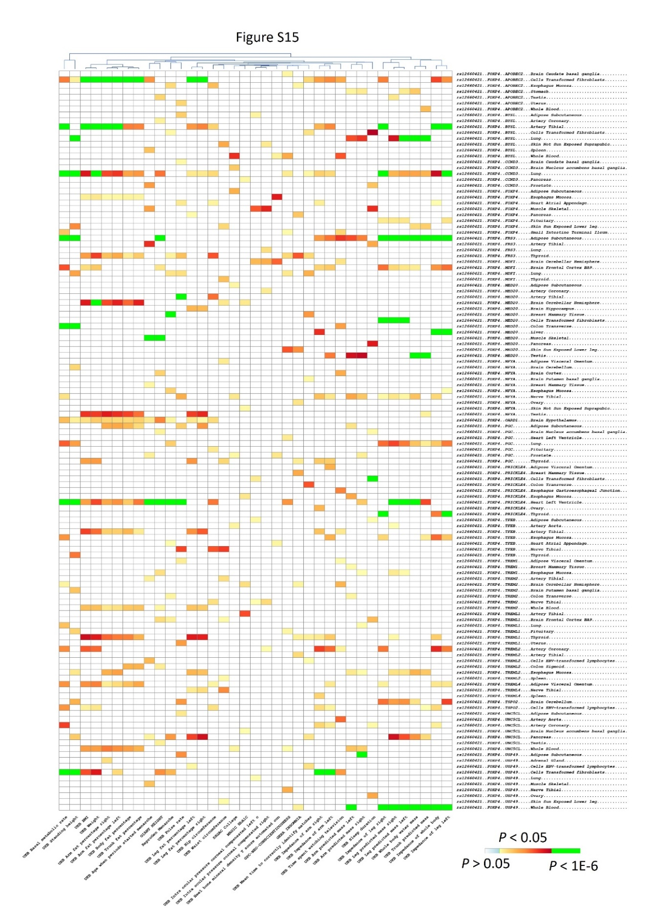
Figure S15. Evaluation of genes adjacent to prioritized long COVID risk SNP rs12660421 (FOXP4) in phenome-transcriptome-wide association studies (pheno-TWAS) across 48 GTEx tissues

