Supplementary Materials for

Influenza A(H5N1) viruses isolated from dairy cattle demonstrate high virulence in laboratory models, but retain avian virus-like properties

AUTHORS: Thomas P. Fabrizio¹, Ahmed Kandeil^{1,2}, Walter Harrington¹, Jeremy C. Jones¹, Trushar Jeevan¹, Konstantin Andreev¹, Patrick Seiler¹, Jonathan Fogo¹, Morgan L. Davis¹, Jeri Carol Crumpton¹, John Franks¹, Jennifer DeBeauchamp¹, Peter Vogel³, C. Scanlon Daniels⁴, Rebecca L. Poulson⁵, Andrew S. Bowman⁶, Elena A. Govorkova¹, Richard J. Webby¹

Correspondence to: richard.webby@stjude.org

This file includes:
Supplementary Figures 1 and 2
Supplementary Tables 1 to 5
Supplementary Methods
Supplementary Results

SUPPLEMENTARY FIGURES
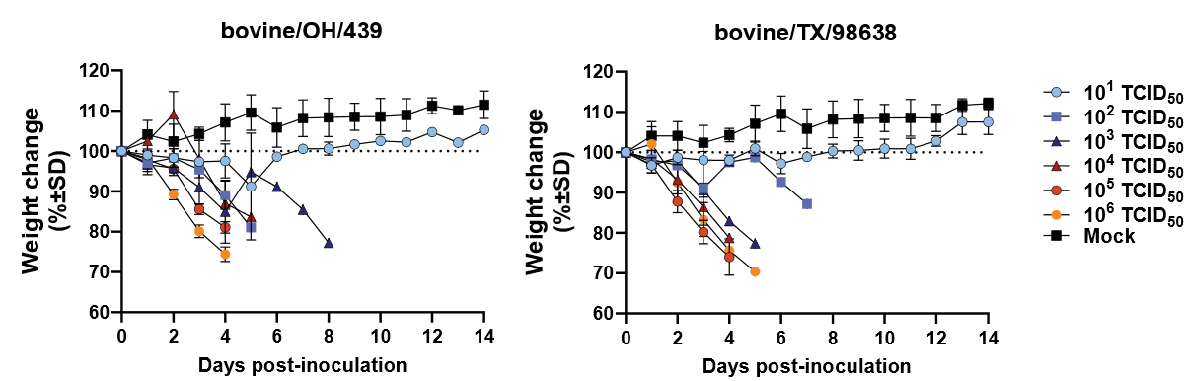
Supplementary Fig. 1. Weight loss in mice inoculated with bovine A(H5N1) 2.3.4.4b viruses. Female 6- to 8-week-old BALB/c mice were lightly anesthetized with isoflurane and inoculated IN with 10¹ to 10⁶ TCID₅₀/mouse of a, bovine/OH/439 (H5N1) and b, bovine/TX/98638 (H5N1) viruses (n = 3/virus dose). Control mock-inoculated mice received sterile PBS. Mice were weighed daily, and the loss or gain of weight was calculated for each mouse as the percentage change in the initial mean weight at 0 dpi. Values are the average ± SE for each group.

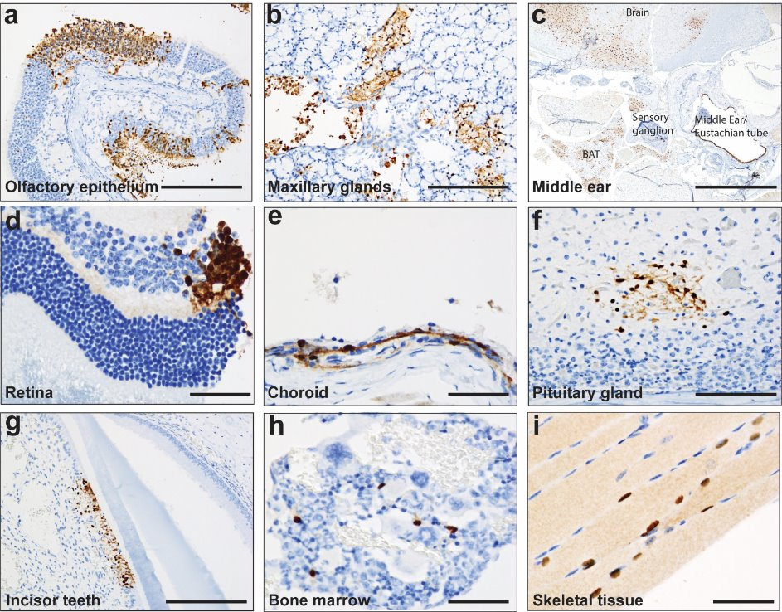
Supplementary Fig. 2. Histopathology of disseminated infection in mice inoculated with bovine A(H5N1) 2.3.4.4b viruses. Immunohistochemistry of fixed tissues from A(H5N1) virus-infected mice showed massive virus antigens detected systemically in olfactory epithelium (scale bar, 200 µm) (a), maxillary glands (scale bar, 200 µm) (b), middle ear/eustachian tube (scale bar,1 mm) (c), retina (scale bar, 50 µm) (d), choroid (scale bar, 50 µm) (e), pituitary gland (scale bar, 100 µm) (f), developing incisor teeth (odontoblasts only, scale bar, 200 µm) (g), bone marrow (scale bar, 50 µm) (h) and skeletal muscle (scale bar, 50 µm) (i).

SUPPLEMENTARY TABLES
Supplementary Table 1. Amino acid differences between bovine and avian A(H5N1) 2.3.4.4b viruses and WHO-recommended CVVs​
Influenza A(H5N1) virus | Amino acid position in HA1ª |  |  |  |  |  |  |  |  | Amino acid position in HA2ª |  | Fold-change to Astrakhan/3212
Influenza A(H5N1) virus | 71 | 83^{b} | 104 | 115 | 156^{c} | 185^{d} | 195 | 199 | 210 | 493 | 510 | Fold-change to Astrakhan/3212
Astrakhan/3212 | I | A | L | L | A | E | T | S | V | E | I
wigeon/SC/345 |  |  | M |  |  |  |  |  | A |  | V | 2
eagle/FL/22 | T |  | M |  |  |  |  |  | A |  | V | 2
bovine/OH/302 |  |  | M | Q |  |  | I |  | A | G | V | 8
bovine/OH/342 |  |  | M | Q |  |  | I |  | A |  | V | 2
bovine/OH/358 |  |  | M | Q |  |  | I |  | A | G | V | 2
bovine/OH/368 |  |  | M | Q |  | G | I |  | A | G | V | 16
bovine/OH/432 |  |  | M | Q |  |  | I |  | A |  | V | 2
bovine/OH/439 |  |  | M | Q |  |  | I |  | A |  | V | 0
bovine/OH/497 |  |  | M | Q |  |  | I |  | A |  | V | 2
bovine/OH/541 |  |  | M | Q |  |  | I |  | A |  | V | 2
bovine/TX/3301 |  |  | M | Q |  |  | I |  | A |  | V | 2
bovine/TX/38161 |  |  | M | Q | T |  | I |  | A |  | V | 2
bovine/TX/40106 |  |  | M | Q |  |  | I |  | A |  | V | 0
bovine/TX/42041 |  |  | M | Q | T |  | I |  | A |  | V | 4
bovine/TX/43134 |  |  | M | Q | T |  | I |  | A |  | V | 2
bovine/TX/97794 |  |  | M | Q | T |  | I |  | A |  | V | 4
bovine/TX/98638 |  |  | M | Q |  |  | I |  | A |  | V
goose/KS/930F |  | S | M | Q |  |  | I | T | A |  | V | 8
goose/LA/957 |  |  | M | Q |  |  | I |  | A |  | V | 4
ªAmino acid residue in the HA 1 and HA2 regions of HA protein are indicated by H5 influenza A virus numbering.
^{b}Antigenic site E.
^{c}Antigenic site B, HA-A156T is predicted to add a glycosylation motif.
^{d}Antigenic site B.

Supplementary Table 2. Bovine influenza A(H5N1) viruses with genetic markers of RI/HRI by NAIs and CENI with GISAID accession numbers
Bovine influenza A(H5N1) virus | Amino acid substitution | GISAID  isolate IDª
Viruses carrying NAI RI marker
A/dairy cow/Texas/24_009367-001/2024 | NA-T438I^{b} | EPI_ISL_19094612
Viruses carrying CENI RI markers
A/dairy cow/Texas/UTMB11/2024 | PA-A36T^{b} | EPI_ISL_19184044
A/dairy cow/USA/24_025747-008/2024 | PA-A36T | EPI_ISL_19444922
A/dairy cow/Idaho/24_011573-013/2024 | PA-A37T | EPI_ISL_19228203
ªRetrieved from the Global Initiative on Sharing All Influenza Data (GISAID) and the National Center for Biotechnology (NCBI) Influenza Virus Resource databases, accessed November 8, 2024. Overall, 1489 NA and 1406 PA sequences were analyzed.
^{b}Amino acid residue substitutions in the NA protein are indicated by N1 numbering and in the PA protein by influenza A virus numbering.

Supplementary Table 3. Reactivity of bovine and avian A(H5N1) 2.3.4.4b viruses with ferret antisera against clade 2.3.4.4c and 2.3.4.4b CVVsa
CVV and influenza A(H5Nx) virus | Subtype | HA clade | HI titer with ferret antiserum against A(H5Nx) influenza virusª
CVV and influenza A(H5Nx) virus | Subtype | HA clade | Astrakhan/3212  (H5N8) 2.3.4.4b | ck/Ghana/39  (H5N1) 2.3.4.4b | wigeon/SC/345  (H5N1) 2.3.4.4b | eagle/FL/W22  (H5N1) 2.3.4.4b | gyrfalcon/41088  (H5N8) 2.3.4.4c
Reference CVV
Astrakhan/3212 | H5N8 | 2.3.4.4b | 160 | 80 | 160 | 80 | 160
ck/Ghana/39 | H5N1 | 2.3.4.4b | 40 | 80 | 160 | 10 | <
wigeon/SC/345 | H5N1 | 2.3.4.4b | 80 | 80 | 160 | 160 | 80
eagle/FL/W22 | H5N1 | 2.3.4.4b | 80 | 80 | 160 | 160 | 80
gyrfalcon/41088 | H5N8 | 2.3.4.4c | 160 | < | 80 | 160 | 320
Bovine and avian influenza virus
bovine/OH/302 | H5N1 | 2.3.4.4b | 20 | 80 | 160 | 160 | 10
bovine/OH/342 | H5N1 | 2.3.4.4b | 80 | 80 | 160 | 160 | 80
bovine/OH/358 | H5N1 | 2.3.4.4b | 80 | 80 | 160 | 160 | 80
bovine/OH/368 | H5N1 | 2.3.4.4b | 10 | 40 | 80 | 80 | <
bovine/OH/432 | H5N1 | 2.3.4.4b | 80 | 160 | 160 | 160 | 160
bovine/OH/439 | H5N1 | 2.3.4.4b | 160 | 160 | 320 | 320 | 160
bovine/OH/497 | H5N1 | 2.3.4.4b | 80 | 160 | 160 | 160 | 40
bovine/OH/541 | H5N1 | 2.3.4.4b | 80 | 80 | 160 | 160 | 80
bovine/TX/3301 | H5N1 | 2.3.4.4b | 80 | 80 | 160 | 160 | 40
bovine/TX/38161 | H5N1 | 2.3.4.4b | 80 | 160 | 160 | 20 | <
bovine/TX/97794 | H5N1 | 2.3.4.4b | 40 | 80 | 160 | 20 | <
bovine/TX/43134 | H5N1 | 2.3.4.4b | 80 | 160 | 320 | 40 | <
bovine/TX/40106 | H5N1 | 2.3.4.4b | 160 | 80 | 160 | 160 | 320
bovine/TX/42041 | H5N1 | 2.3.4.4b | 40 | 80 | 160 | 20 | <
goose/KS/930F | H5N1 | 2.3.4.4b | 20 | 40 | 40 | 40 | <
goose/LA/957 | H5N1 | 2.3.4.4b | 40 | 80 | 80 | 80 | 10
ªExpressed as the reciprocal of the highest serum dilution that inhibited 4 HAU units of virus. Results are the arithmetic mean titer of positive sera (HI titer >10). < indicates HI titer < 10. HI tests used 0.5% chicken RBCs. Homologous titers are typed in bold and underlined.

Supplementary Table 4. Individual cross-reactive HA antibodies in human sera against bovine A(H5N1) 2.3.4.4b viruses

No. human sera | HI titer with human serum against A(H5Nx) influenza virusª
No. human sera | gyrfalcon/41088 (H5N8) 2.3.4.4c | bovine/OH/342 (H5N1) 2.3.4.4b | bovine/TX/97794 (H5N1) 2.3.4.4b | bovine/TX/40106 (H5N1) 2.3.4.4b | bovine/OH/368 (H5N1) 2.3.4.4b
1 | 640 | 80 | 80 | 80 | 40
2 | 320 | 80 | 40 | 80 | 20
3 | 320 | 320 | 160 | 320 | 160
4 | 160 | 80 | 40 | 40 | 40
5 | 1280 | 640 | 320 | 640 | 640
6 | 160 | 40 | 40 | 80 | 40
7 | 160 | 80 | 80 | 80 | 80
8 | 160 | 160 | 80 | 160 | 80
9 | 80 | 80 | 40 | 40 | 40
10 | 640 | 320 | 160 | 320 | 160
11 | 80 | 80 | 80 | 80 | 40
12 | 160 | 80 | 40 | 80 | 40
13 | 80 | 80 | 40 | 40 | 20
14 | 40 | 40 | 20 | 20 | 20
15 | 80 | 40 | 20 | 10 | 10
16 | 80 | 80 | 80 | 80 | 80
17 | 80 | 40 | 20 | 40 | 20
18 | 80 | 80 | 40 | 80 | 80
19 | 40 | 40 | 20 | 40 | 20
20 | 160 | 80 | 20 | 80 | 20
ªExpressed as the reciprocal of the highest serum dilution that inhibited 4 HAU units of virus. Results are the arithmetic mean titer of positive sera (HI titer >10). HI tests used 0.5% chicken RBCs.

Supplementary Table 5. Viral load in chickens infected with bovine A(H5N1) 2.3.4.4b viruses.
Influenza A(H5N1) virus | Experimental group | Virus titers, log₁₀EID₅₀/mL (number of virus-positive/total number of chickens) |  |  | Mean survival day ± SE
Influenza A(H5N1) virus | Experimental group | 2 dpi | 4 dpi | 6 dpi | Mean survival day ± SE
bovine/OH/439 | Donor | 5.5 (1/1) | -- | -- | 2 ± 0.0
bovine/OH/439 | DC | 1.5 (3/9) | (0/2) | 7.5 (1/2) | 3.4 ± 0.2
goose/KS/930F | Donor | -- | -- | -- | 2 ± 0.0
goose/KS/930F | DC | 2.1(6/8) | 6.25 (1/1) | -- | 4.3 ± 0.4
--, all chicken in the group died.

SUPPLEMENTARY METHODS
Ethic statement and laboratory facilities
Animal experiments were approved by the St. Jude Children’s Research Hospital Institutional Animal Care and Use Committee (IACUC) and complied with the policies of the National Institutes of Health and the Animal Welfare Act. Experiments utilizing select agents were performed in USDA-inspected Animal Biosafety Level 3+ animal facilities following regulations of Division of Agricultural Select Agents and Toxins at USDA APHIS, and defined by U.S. Federal Select Agent Program regulations (7 CFR Part 331, 9 CFR Part 121.3, 42 CFR Part 73.3). Human sera samples were obtained from the U.S. National Institutes of Health, National Institute of Allergy and Infectious Diseases, and Division of Microbiology and Infectious Diseases; they played no role in our study design. The samples were not specifically collected for the current study, nor did we have access to subject identifiers or protected health information related to individual samples

A(H5N1) viral load in experimentally infected chickens
The oropharyngeal swabs were collected at 1, 3, and 5 dpc from each surviving contact chicken and 2 dpi from a single surviving donor chicken. Virus load was determined by injecting serial dilutions into 10-day-old eggs. After incubation for 48 h at 35°C, virus titers (log₁₀EID₅₀/mL) in swabs were estimated by the Reed and Muench⁴⁶ method from hemagglutinin test using chicken red blood cells (0.5% in PBS).

SUPPLEMENTARY RESULTS
Histopathological changes in lower respiratory tract and extrapulmonary tissues of mice infected with bovine HPAI A(H5N1) 2.3.4.4b viruses
In addition to extensive A(H5N1) antigens detection in nasal epithelium, lung, brain, spinal cord, liver, and brown adipose tissue, small, scattered foci of infection were detected in sensory ganglia, maxillary glands, pituitary gland, middle ear, eustachian tube, developing incisor teeth (odontoblasts only), bone marrow and skeletal muscle, and retina (Supplementary Fig. 2a-i). Lesions in the liver consisted of scattered small foci of hepatocellular necrosis and inflammation, including virus-positive hepatocytes, stellate cells, and Kupffer cells. Bile duct and gall bladder epithelium were negative for viral antigen in all mice. Multifocal randomly distributed virus-positive areas in the brain showed intracytoplasmic, intranuclear, and axonal immunolabeling of neurons and glial cells. Virus-positive cells were also present in the ependyma, choroid plexus, and meninges. The other major site of virus replication in these mice was in the brown (but not white) adipose tissue. At this point, bovine HPAI A(H5N1) 2.3.4.4b infection of brown fat was not associated with any obvious degenerative changes or inflammation. Lastly, small numbers of viral antigen-positive cells were detected in sensory ganglionic neurons, the pituitary gland, and incisor teeth (odontoblasts).

Viral load in chickens infected with bovine HPAI A(H5N1) 2.3.4.4b viruses
Due to the high virulence of both A(H5N1) viruses used, few chickens were available for determination of virus load in the course of infection. Oropharyngeal were taken from one donor chicken, 17 contact chickens at 2 dpi (1 dpc) and only two of those birds survived beyond 4 dpi. One swab sample was collected on 6 dpi. Except for the contact chickens at 2 dpi there were not enough samples to conduct meaningful analysis or comparisons, and there were large variations among those samples (Supplementary Table 5). Higher virus titers (mean 0.6 log₁₀EID₅₀/mL for, or approximately one-half log) were found in goose/KS/903F (H5N1) virus-infected contact chickens compared to bovine/OH/439 (H5N1) contact chickens at 2 dpi (1 dpc). Birds sampled on the day of death or euthanasia shed virus at much higher titers than asymptomatic birds.

