An automated pipeline to generate initial estimates for population pharmacokinetic models

Zhonghui Huang¹, Matthew Fidler², Minshi Lan¹, lek Leng Cheng^{1,4}, Frank Kloprogge³, Joseph F Standing^{1,4}
¹Great Ormond Street Institute of Child Health, University College London, London, UK
²Novartis Pharmaceuticals Corporation, Fort Worth, Texas, USA
³Institute for Global Health, University College London, London, UK
⁴Great Ormond Street Hospital for Children, London, UK

Corresponding author: Zhonghui Huang
Affiliation: Great Ormond Street Institute of Child Health, University College London, London, UK
E-mail: zhonghui.huang.20@ucl.ac.uk

Supplementary Figures
Supplementary Figure 1. Plasma concentration plots for data collected from nlmixr2data package 2
Supplementary Figure 2. Plasma concentration plots for ten real-life datasets collected from publications 3
Supplementary Figure 3. Comparison of re-estimated clearance (up) and volume of distribution (bottom) across different strategies of setting initial estimates run by FOCEI 4
Supplementary Figure 4. Model run time on 13 real-life datasets (SAEM) 5
Supplementary Figure 5. Model run time on 13 real-life datasets (FOCEI) 6

Supplementary Tables
Supplementary Table 1. Summary of study characteristics of 10 real-life datasets 7
Supplementary Table 2. Parameter re-estimates of 21 simulated datasets using different initial estimate strategies (SAEM) 8
Supplementary Table 3. Parameter re-estimates of 21 simulated datasets using different initial estimate strategies (FOCEI) 12
Supplementary Table 4. Statistics of final parameter estimates within 20% and 30% of original values across five initial estimate strategies in simulated datasets (SAEM) 16
Supplementary Table 5. Statistics of final parameter estimates within 20% and 30% of original values across five initial estimate strategies in simulated datasets (FOCEI) 17
Supplementary Table 6. Initial estimates recommended by the pipeline for 13 real-life datasets 18
Supplementary Table 7. Comparison of parameter estimation results using initial estimates set to 1 vs. pipeline recommendations for one- and two-compartment models (run by SAEM) 19

Supplementary Figure 1. Plasma concentration plots for data collected from nlmixr2data package
Open circles represent the observed data

Supplementary Figure 2. Plasma concentration plots for ten real-life datasets collected from publications
Open circles represent the observed data

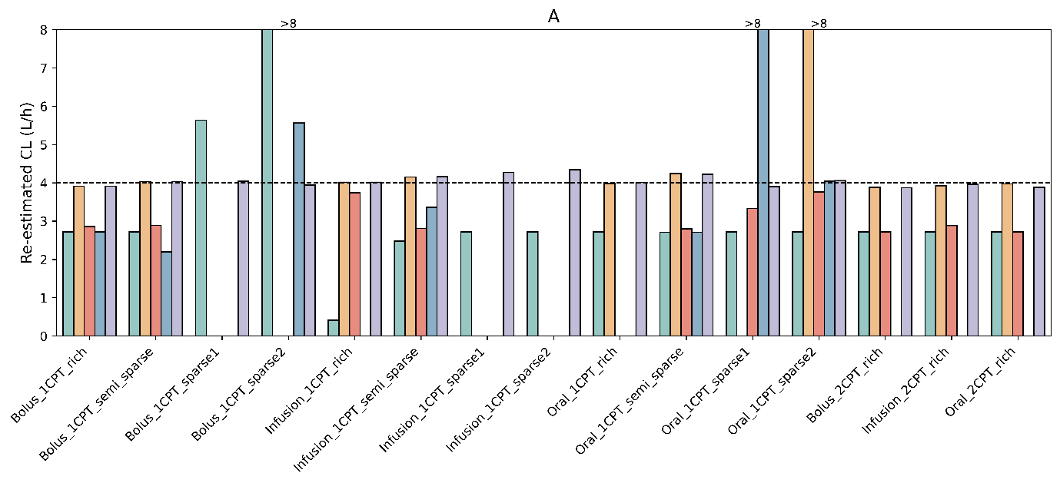
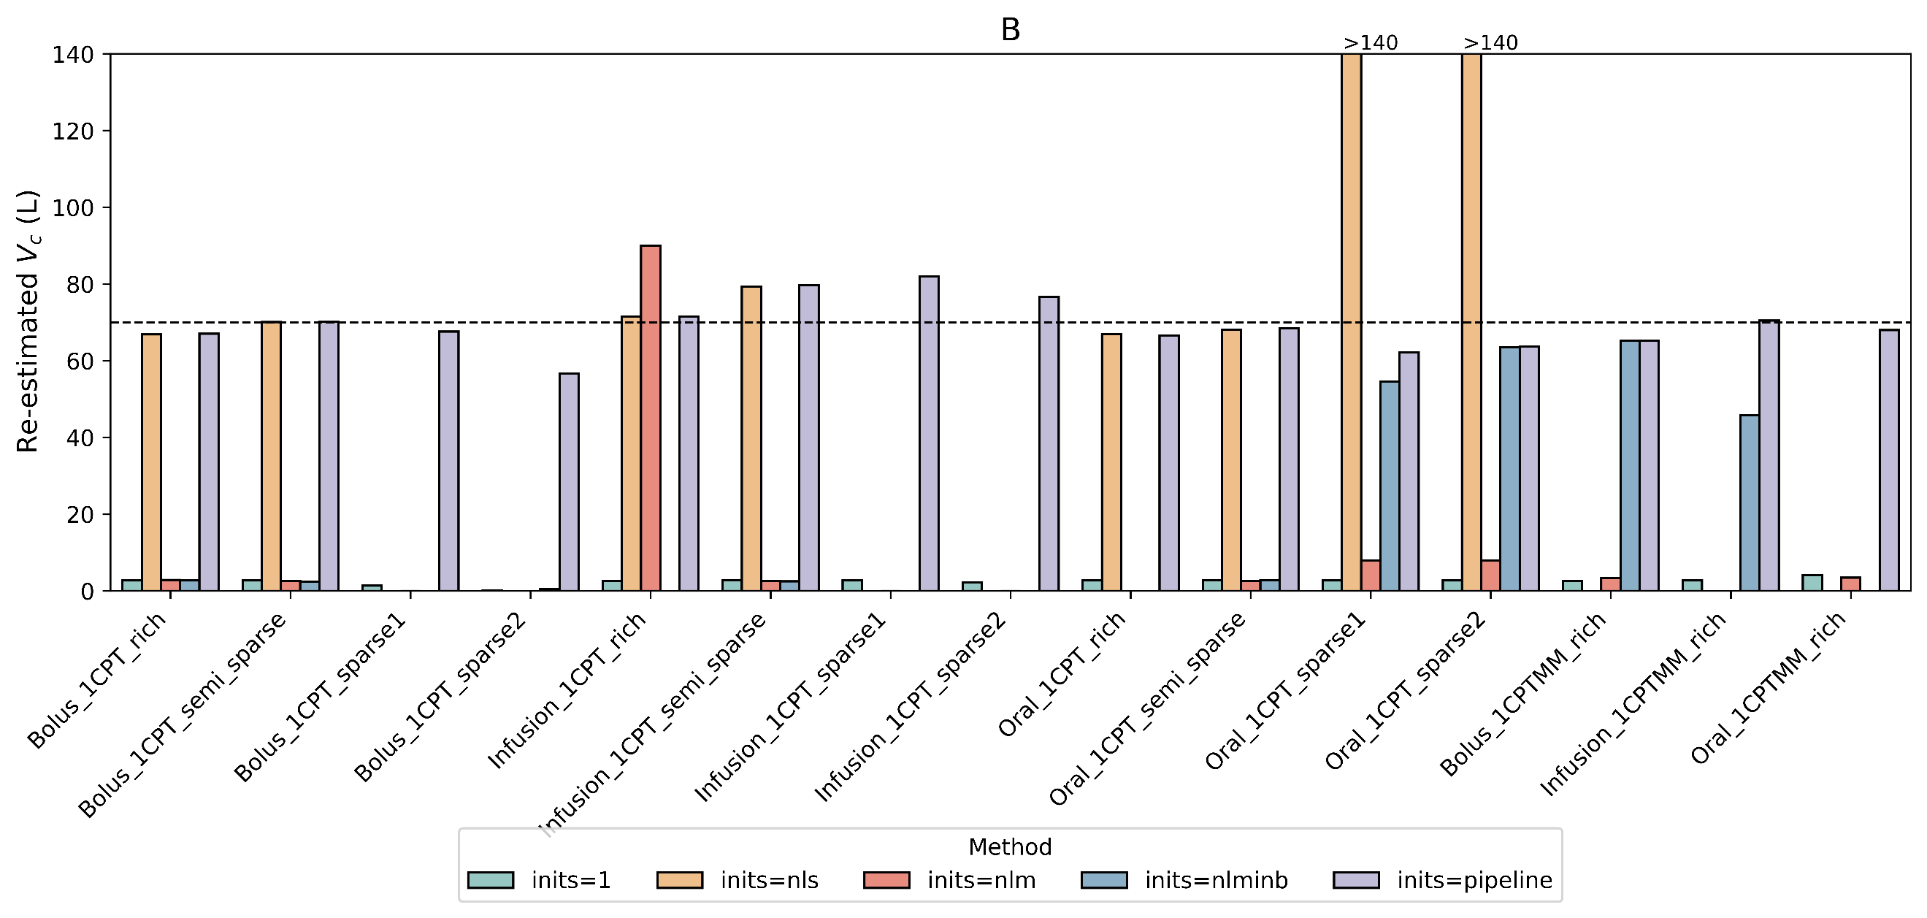
Supplementary Figure 3. Comparison of re-estimated clearance (up) and volume of distribution (bottom) across different strategies of setting initial estimates run by FOCEI

This figure contained re-estimation of clearance and volume of distribution in simulated datasets using five different initial estimate strategies, represented by distinct colors. "inits = 1" sets all initial estimates to 1, while "inits = nls," "inits = nlm," and "inits = nlminb" used parameter estimates from respective algorithms as initial values. "inits = pipeline" referred to pipeline-specific recommendations. To address excessively large initial estimates, the y-axis is capped at 2-fold the original values. Bars exceeding this limit are truncated at the 2-fold value and annotated with ">2-fold" to indicate their magnitude

Supplementary Figure 4. Model run time on 13 real-life datasets (SAEM)
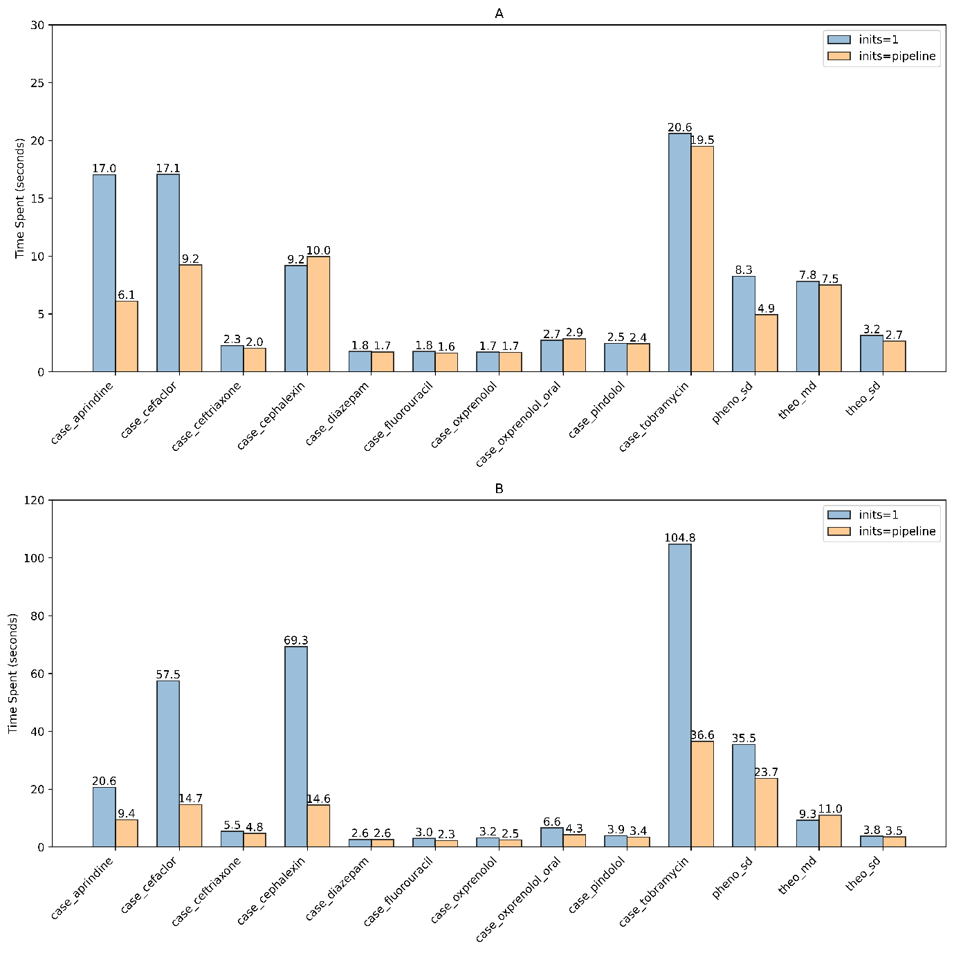
"inits = 1" sets all initial estimates to 1. "inits = pipeline" referred to pipeline-specific recommendations.
A. one-compartment model with first-order elimination (and first-order absorption for oral administration). B. two-compartment model with first-order elimination (and first-order absorption for oral administration).

Supplementary Figure 5. Model run time on 13 real-life datasets (FOCEI)
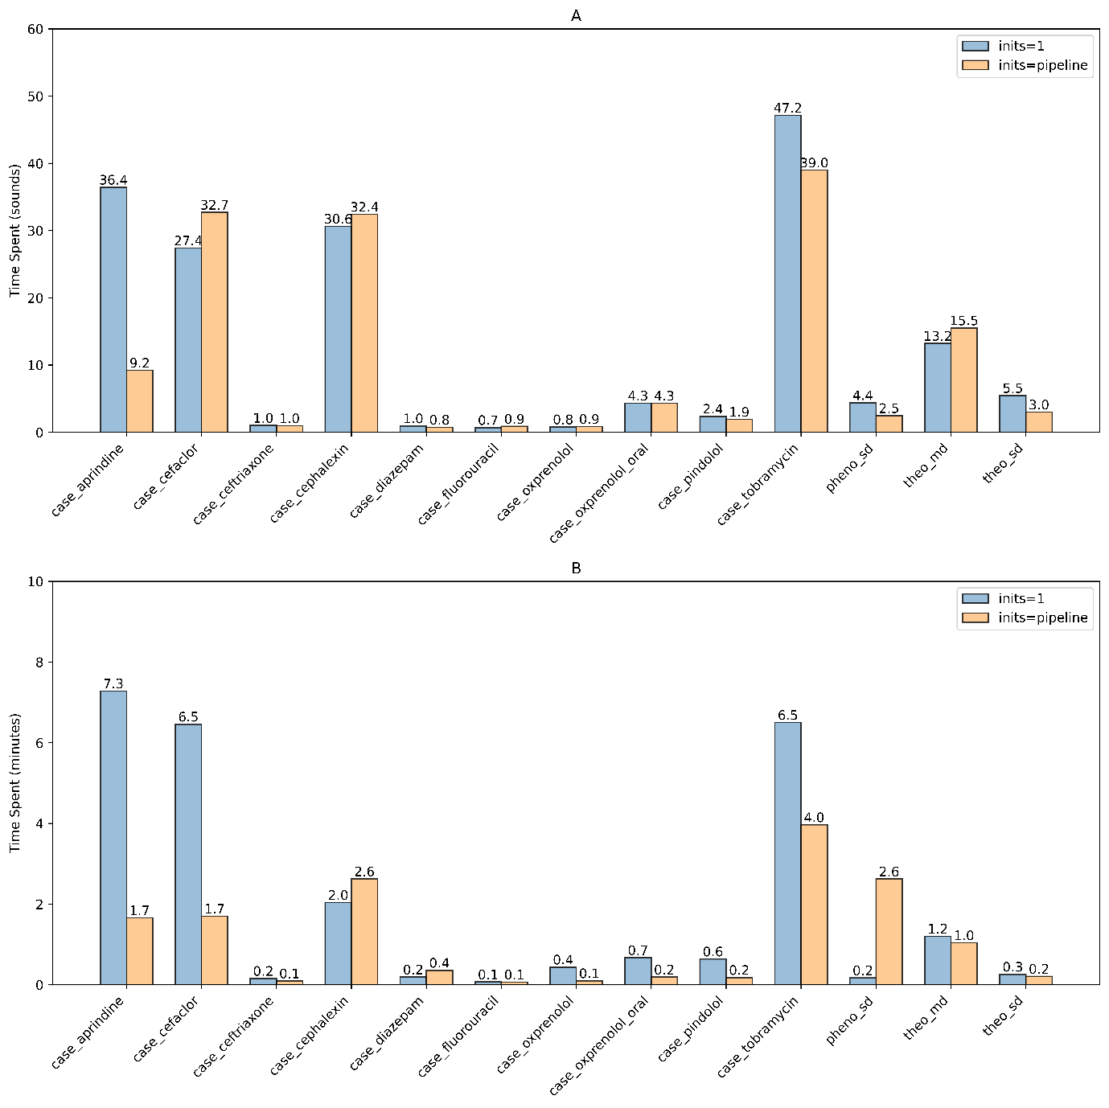
"inits = 1" sets all initial estimates to 1. "inits = pipeline" referred to pipeline-specific recommendations.
A. one-compartment model with first-order elimination (and first-order absorption for oral administration). B. two-compartment model with first-order elimination (and first-order absorption for oral administration).

Supplementary Table 1. Summary of study characteristics of 10 real-life datasets
Dataset name | No. of subjects (samples) | Population | Route | Dosing information | Sampling information
Aprindine [1] | 21 (251)ª | Patients | Oral | Multiple doses (200mg at 0h, 100mg at 2h, 100mg at every 12h ) | 0.5, 1, 1.5, 2, 2.5, 3.0, 6.0, 12 h after the initial dose; 0, 1.0, 3.0, 6.0, 12.0, 24.0, 48.0 h, after the last dose (at 60 hours)
Cefaclor [2] | 20 (199) | Healthy volunteers | Oral | 250 mg at every 6 hours | 0.5, 0.75, 1.0, 1.5, 2.0, 3.0, 4.0 after initial dose; 72.5, 73.0, 73.5, 74.0, 75.0, 76.0 on day 4
Ceftriaxone [3] | 20 (64) | Neonates | Infusion | 50 mg/kg or 100 mg/kg (infused over 5 minutes) | 1, 12, 24 h (after termination of the infusion)^{b}
Cephalexin [2] | 20 (264) | Healthy volunteers | Oral | 250 mg at every 6 hours | 0.5, 0.75, 1.0, 1.5, 2.0, 3.0, 4.0 after initial dose; 72.5, 73.0, 73.5, 74.0, 75.0, 76.0 h on day 4
Diazepam [4, 5] | 14 (149) | Healthy volunteers | Injection | Single injection (10 or 20 mg) | Intensive sampling after dosing (11 samples or 19 samples for a subject)
Fluorouracil [6, 7] | 13 (66) | Patients | Injection | Single injection (varied doses) | 5, 10 15, 20, 30, 45, 60, 90, 120 min after initial dose or 5, 10, 20, 30, 60 min after initial dose
Oxprenolol (iv) [8] | 6 (102) | Healthy volunteers | Infusion | Single infusion (10 or 20 mg over a 10-min infusion) | 10 (min), 25 (min), 40 (min), 1, 2, 3, 4, 6, 8h ( from the time the  infusion was begun)
Oxprenolol (oral) [8] | 6 (203) | Healthy volunteers | Oral | Single dose (20, 40, 80, 160mg) | 0.25, 0.5 1, 2, 4, 6, 8 h
Pindolol (iv) [9] | 12 (104) | Healthy volunteers | Oral | Single dose (5mg) | 0.5, 1.0, 2.0, 3.0, 4.0, 6.0, 8.0, 12.0, 24.0 h
Tobramycin [10] | 97 (322) | Patients | Bolus/short Infusion | Multiple doses (varied doses) | Sparse sampling (varied time)
ª The number of subjects (samples) is the actual count in the analysis dataset, excluding those with BQLs.

Supplementary Table 2. Parameter re-estimates of 21 simulated datasets using different initial estimate strategies (SAEM)
Run cases | k_{a} | CL | V_{c} | V_{p} | Q | V_{max} | K_{m}
Inits=1 ª
Bolus_1CPT_rich |  | 3.9 [3.0] ^{b} | 66.8 [5.0]
Bolus_1CPT_semi_sparse |  | 3.94 [2.0] | 71.7 [2.0]
Bolus_1CPT_sparse1 |  | 1.42 [64.0] | 10.9 [84.0]
Bolus_1CPT_sparse2 |  | 1.39 [65.0] | 9.26 [87.0]
Bolus_1CPTMM_rich |  |  | 65.4 [7.0] |  |  | 994 [1.0] | 254 [2.0]
Bolus_2CPT_rich |  | 3.8 [5.0] | 53.9 [23.0] | 49.8 [24.0] | 3.99 [0.0]
Bolus_2CPTMM_rich |  |  | 74 [6.0] | 358 [795.0] | 3.69 [8.0] | 31.1 [97.0] | 2.55 [99.0]
Infusion_1CPT_rich |  | 4 [0.0] | 71.6 [2.0]
Infusion_1CPT_semi_sparse |  | 4.02 [0.0] | 80.9 [16.0]
Infusion_1CPT_sparse1 |  | 1.48 [63.0] | 11.6 [83.0]
Infusion_1CPT_sparse2 |  | 1.38 [66.0] | 9.03 [87.0]
Infusion_1CPTMM_rich |  |  | 70.4 [1.0] |  |  | 997 [0.0] | 242 [3.0]
Infusion_2CPT_rich |  | 3.92 [2.0] | 67.9 [3.0] | 50.2 [26.0] | 3.92 [2.0]
Infusion_2CPTMM_rich |  |  | 72.7 [4.0] | 257 [542.0] | 3.7 [7.0] | 45.9 [95.0] | 2.52 [99.0]
Oral_1CPT_rich | 0.0595 [94.0] | 4.96e+03 [1.24e+05] | 4.75e+03 [6.7e+03]
Oral_1CPT_semi_sparse | 4.51 [351.0] | 3.94 [2.0] | 72.2 [3.0]
Oral_1CPT_sparse1 | 0.512 [49.0] | 3.19 [20.0] | 38.7 [45.0]
Oral_1CPT_sparse2 | 0.39 [61.0] | 3.32 [17.0] | 30 [57.0]
Oral_1CPTMM_rich | 1 [0.0] |  | 68.8 [2.0] |  |  | 979 [2.0] | 239 [4.0]
Oral_2CPT_rich | 0.833 [17.0] | 3.85 [4.0] | 58.6 [16.0] | 51.2 [28.0] | 5.03 [26.0]
Oral_2CPTMM_rich | 1.12 [12.0] |  | 76.6 [9.0] | 380 [850.0] | 3.82 [5.0] | 4.24 [100.0] | 2.42 [99.0]
Inits=nls
Bolus_1CPT_rich |  | 3.9 [3.0] | 66.8 [5.0]
Bolus_1CPT_semi_sparse |  | 3.94 [2.0] | 71.9 [3.0]
Bolus_2CPT_rich |  | 3.87 [3.0] | 65.7 [6.0] | 49.5 [24.0] | 4.04 [1.0]
Infusion_1CPT_rich |  | 4 [0.0] | 71.6 [2.0]
Infusion_1CPT_semi_sparse |  | 4.02 [0.0] | 81.2 [16.0]
Infusion_2CPT_rich |  | 3.92 [2.0] | 68 [3.0] | 50.1 [25.0] | 3.9 [3.0]
Oral_1CPT_rich | 1.01 [1.0] | 4.01 [0.0] | 66.9 [4.0]
Oral_1CPT_semi_sparse | 2.19 [119.0] | 4 [0.0] | 72.2 [3.0]
Oral_1CPT_sparse1 | 2.72 [172.0] | 2.78e-74 [100.0] | 1.26e+22 [1.8e+22]
Oral_1CPT_sparse2 | 2.72 [172.0] | 2.59e-74 [100.0] | 1.14e+22 [1.63e+22]
Oral_2CPT_rich | 1.67 [67.0] | 3.77 [6.0] | 105 [50.0] | 1e+11 [2.5e+11] | 4.06e-11 [100.0]
Inits=nlm
Bolus_1CPT_rich |  | 3.9 [3.0] | 66.8 [5.0]
Bolus_1CPT_semi_sparse |  | 3.94 [2.0] | 72 [3.0]
Bolus_1CPT_sparse1 |  | 0.00227 [100.0] | 0 [100.0]
Bolus_1CPTMM_rich |  |  | 65.4 [7.0] |  |  | 999 [0.0] | 257 [3.0]
Bolus_2CPT_rich |  | 3.8 [5.0] | 53.9 [23.0] | 49.8 [24.0] | 3.99 [0.0]
Infusion_1CPT_rich |  | 4 [0.0] | 71.6 [2.0]
Infusion_1CPT_semi_sparse |  | 4.02 [0.0] | 81.1 [16.0]
Infusion_1CPT_sparse1 |  | 3.58e-07 [100.0] | 5.09e-11 [100.0]
Infusion_1CPT_sparse2 |  | 7.16e-07 [100.0] | 0 [100.0]
Infusion_1CPTMM_rich |  |  | 70.4 [1.0] |  |  | 1e+03 [0.0] | 246 [2.0]
Infusion_2CPT_rich |  | 3.92 [2.0] | 68 [3.0] | 50.2 [26.0] | 3.9 [3.0]
Oral_1CPT_semi_sparse | 3.98 [298.0] | 3.95 [1.0] | 72.1 [3.0]
Oral_1CPT_sparse1 | 0.593 [41.0] | 3.36 [16.0] | 44.8 [36.0]
Oral_1CPT_sparse2 | 0.416 [58.0] | 3.38 [16.0] | 31.9 [54.0]
Oral_1CPTMM_rich | 0.999 [0.0] |  | 68.8 [2.0] |  |  | 987 [1.0] | 245 [2.0]
Oral_2CPT_rich | 1.42 [42.0] | 4.32 [8.0] | 3.09 [96.0] | 83.6 [109.0] | 8.64 [116.0]
Oral_2CPTMM_rich | 0.895 [10.0] |  | 66 [6.0] | 316 [690.0] | 3.59 [10.0] | 43.4 [96.0] | 3.53 [99.0]
Inits=nlminb
Bolus_1CPT_rich |  | 3.9 [3.0] | 66.8 [5.0]
Bolus_1CPT_semi_sparse |  | 3.95 [1.0] | 71.3 [2.0]
Bolus_1CPT_sparse2 |  | 1.41 [65.0] | 9.42 [87.0]
Bolus_1CPTMM_rich |  |  | 65.3 [7.0] |  |  | 1e+03 [0.0] | 258 [3.0]
Infusion_1CPT_rich |  | 5.95e-12 [100.0] | 274 [291.0]
Infusion_1CPT_semi_sparse |  | 4.02 [0.0] | 81.2 [16.0]
Infusion_1CPTMM_rich |  |  | 9.53e+04 [1.36e+05] |  |  | 3.34e+07 [3.34e+06] | 0.00112 [100.0]
Infusion_2CPT_rich |  | 7.21e-12 [100.0] | 88.3 [26.0] | 1.78e+05 [4.45e+05] | 3.79 [5.0]
Oral_1CPT_rich | 5.66 [466.0] | 1.51e-09 [100.0] | 320 [357.0]
Oral_1CPT_semi_sparse | 4.51 [351.0] | 3.94 [2.0] | 72.2 [3.0]
Oral_1CPT_sparse1 | 2.72 [172.0] | 9.69e+15 [2.42e+17] | 54.6 [22.0]
Oral_1CPT_sparse2 | 1.01 [1.0] | 3.93 [2.0] | 68.5 [2.0]
Oral_2CPTMM_rich | 1.7 [70.0] |  | 102 [46.0] | 1.38e+29 [3.45e+29] | 0.735 [82.0] | 230 [77.0] | 23.9 [90.0]
Inits=pipeline
Bolus_1CPT_rich |  | 3.9 [3.0] | 66.8 [5.0]
Bolus_1CPT_semi_sparse |  | 3.93 [2.0] | 72.7 [4.0]
Bolus_1CPT_sparse1 |  | 4.01 [0.0] | 69.9 [0.0]
Bolus_1CPT_sparse2 |  | 3.84 [4.0] | 55.6 [21.0]
Bolus_1CPTMM_rich |  |  | 65.3 [7.0] |  |  | 997 [0.0] | 257 [3.0]
Bolus_2CPT_rich |  | 3.87 [3.0] | 65.7 [6.0] | 49.5 [24.0] | 4.03 [1.0]
Bolus_2CPTMM_rich |  |  | 70.3 [0.0] | 51.5 [29.0] | 3.94 [2.0] | 1e+03 [0.0] | 251 [0.0]
Infusion_1CPT_rich |  | 4 [0.0] | 71.6 [2.0]
Infusion_1CPT_semi_sparse |  | 4.02 [0.0] | 81.3 [16.0]
Infusion_1CPT_sparse1 |  | 3.98 [1.0] | 71.9 [3.0]
Infusion_1CPT_sparse2 |  | 3.92 [2.0] | 72.6 [4.0]
Infusion_1CPTMM_rich |  |  | 70.3 [0.0] |  |  | 1.01e+03 [1.0] | 248 [1.0]
Infusion_2CPT_rich |  | 3.92 [2.0] | 67.9 [3.0] | 50.2 [26.0] | 3.9 [3.0]
Infusion_2CPTMM_rich |  |  | 70.2 [0.0] | 50.6 [26.0] | 3.92 [2.0] | 1.01e+03 [1.0] | 249 [0.0]
Oral_1CPT_rich | 1.01 [1.0] | 4.01 [0.0] | 66.9 [4.0]
Oral_1CPT_semi_sparse | 1.48 [48.0] | 4.05 [1.0] | 71.5 [2.0]
Oral_1CPT_sparse1 | 1.19 [19.0] | 4.09 [2.0] | 76.8 [10.0]
Oral_1CPT_sparse2 | 0.911 [9.0] | 3.92 [2.0] | 63.2 [10.0]
Oral_1CPTMM_rich | 0.985 [2.0] |  | 68 [3.0] |  |  | 1.02e+03 [2.0] | 260 [4.0]
Oral_2CPT_rich | 0.926 [7.0] | 3.87 [3.0] | 67.6 [3.0] | 47.2 [18.0] | 4.24 [6.0]
Oral_2CPTMM_rich | 0.957 [4.0] |  | 68.2 [3.0] | 51.2 [28.0] | 4.31 [8.0] | 1.03e+03 [3.0] | 276 [10.0]
Cases those failed to get parameter estimates were not listed in the table.
ª "inits = 1" sets all initial estimates to 1, while "inits = nls," "inits = nlm," and "inits = nlminb" used parameter estimates from respective algorithms as initial values. "inits = pipeline" referred to pipeline-specific recommendations.
^{b} Values represent the estimated value, along with its relative error compared to original values in the simulated dataset. The original values using for generating simulated dataset are as follows: k_{a} = 1 h⁻¹, CL = 4 L/h, V_{c} = 70 L, V_{p} = 40 L, Q = 4 L/h, V_{max} = 1000 mg/h, and K_{m} = 250 mg/L.

Supplementary Table 3. Parameter re-estimates of 21 simulated datasets using different initial estimate strategies (FOCEI)
Dataset | Ka | CL | V_{c} | V_{p} | Q | V_{max} | K_{m}
Inits=1
Bolus_1CPT_rich |  | 2.72 [32.0] | 2.72 [96.0]
Bolus_1CPT_semi_sparse |  | 2.72 [32.0] | 2.72 [96.0]
Bolus_1CPT_sparse1 |  | 5.64 [41.0] | 1.37 [98.0]
Bolus_1CPT_sparse2 |  | 103 [2475.0] | 0.0879 [100.0]
Bolus_1CPTMM_rich |  |  | 2.56 [96.0] |  |  | 2.72 [100.0] | 2.73 [99.0]
Bolus_2CPT_rich |  | 2.72 [32.0] | 2.72 [96.0] | 2.72 [93.0] | 2.72 [32.0]
Bolus_2CPTMM_rich |  |  | 72.9 [4.0] | 479 [1098.0] | 3.54 [12.0] | 1.17 [100.0] | 14.5 [94.0]
Infusion_1CPT_rich |  | 0.41 [90.0] | 2.6 [96.0]
Infusion_1CPT_semi_sparse |  | 2.48 [38.0] | 2.74 [96.0]
Infusion_1CPT_sparse1 |  | 2.72 [32.0] | 2.72 [96.0]
Infusion_1CPT_sparse2 |  | 2.72 [32.0] | 2.23 [97.0]
Infusion_1CPTMM_rich |  |  | 2.72 [96.0] |  |  | 2.72 [100.0] | 2.72 [99.0]
Infusion_2CPT_rich |  | 2.72 [32.0] | 2.72 [96.0] | 2.72 [93.0] | 2.72 [32.0]
Infusion_2CPTMM_rich |  |  | 70.6 [1.0] | 50.7 [27.0] | 3.85 [4.0] | 954 [5.0] | 213 [15.0]
Oral_1CPT_rich | 2.72 [172.0] | 2.72 [32.0] | 2.72 [96.0]
Oral_1CPT_semi_sparse | 2.27 [127.0] | 2.71 [32.0] | 2.75 [96.0]
Oral_1CPT_sparse1 | 1 [0.0] | 2.72 [32.0] | 2.72 [96.0]
Oral_1CPT_sparse2 | 1 [0.0] | 2.72 [32.0] | 2.72 [96.0]
Oral_1CPTMM_rich | 3.06 [206.0] |  | 4.11 [94.0] |  |  | 2.95 [100.0] | 6.64 [97.0]
Oral_2CPT_rich | 2.72 [172.0] | 2.72 [32.0] | 2.72 [96.0] | 2.72 [93.0] | 2.72 [32.0]
Inits=nls
Bolus_1CPT_rich |  | 3.91 [2.0] | 66.9 [4.0]
Bolus_1CPT_semi_sparse |  | 4.03 [1.0] | 70.1 [0.0]
Bolus_2CPT_rich |  | 3.88 [3.0] | 66.1 [6.0] | 49.2 [23.0] | 4.01 [0.0]
Infusion_1CPT_rich |  | 4.02 [0.0] | 71.5 [2.0]
Infusion_1CPT_semi_sparse |  | 4.15 [4.0] | 79.4 [13.0]
Infusion_2CPT_rich |  | 3.93 [2.0] | 68.1 [3.0] | 49.5 [24.0] | 3.88 [3.0]
Oral_1CPT_rich | 0.992 [1.0] | 3.99 [0.0] | 67 [4.0]
Oral_1CPT_semi_sparse | 0.968 [3.0] | 4.24 [6.0] | 68.1 [3.0]
Oral_1CPT_sparse1 | 2.72 [172.0] | 7.03e-73 [100.0] | 9e+27 [1.29e+28]
Oral_1CPT_sparse2 | 2.72 [172.0] | inf [inf] | 1.14e+22 [1.63e+22]
Oral_2CPT_rich | 2.72 [172.0] | 3.97 [1.0] | 111 [59.0] | 4.8e+09 [1.20e+10] | 7.25e-12 [100.0]
Inits=nlm
Bolus_1CPT_rich |  | 2.86 [29.0] | 2.86 [96.0]
Bolus_1CPT_semi_sparse |  | 2.89 [28.0] | 2.59 [96.0]
Bolus_1CPT_sparse1 |  | 2.29e-07 [100.0] | 0 [100.0]
Bolus_1CPTMM_rich |  |  | 3.38 [95.0] |  |  | 2.65 [100.0] | 2.8 [99.0]
Bolus_2CPT_rich |  | 2.72 [32.0] | 2.72 [96.0] | 2.72 [93.0] | 2.72 [32.0]
Infusion_1CPT_rich |  | 3.74 [6.0] | 90 [29.0]
Infusion_1CPT_semi_sparse |  | 2.81 [30.0] | 2.54 [96.0]
Infusion_1CPT_sparse1 |  | 3.7e-07 [100.0] | 5.13e-10 [100.0]
Infusion_1CPT_sparse2 |  | 6.82e-07 [100.0] | 0 [100.0]
Infusion_2CPT_rich |  | 2.89 [28.0] | 3 [96.0] | 2.72 [93.0] | 2.75 [31.0]
Oral_1CPT_semi_sparse | 2.01 [101.0] | 2.8 [30.0] | 2.55 [96.0]
Oral_1CPT_sparse1 | 0.0864 [91.0] | 3.33 [17.0] | 7.92 [89.0]
Oral_1CPT_sparse2 | 0.092 [91.0] | 3.77 [6.0] | 7.92 [89.0]
Oral_1CPTMM_rich | 3.01 [201.0] |  | 3.46 [95.0] |  |  | 3.37 [100.0] | 2.58 [99.0]
Oral_2CPT_rich | 2.72 [172.0] | 2.72 [32.0] | 2.66 [96.0] | 2.72 [93.0] | 2.72 [32.0]
Oral_2CPTMM_rich | 0.997 [0.0] |  | 70.5 [1.0] | 47.1 [18.0] | 4.08 [2.0] | 971 [3.0] | 240 [4.0]
Inits=nlminb
Bolus_1CPT_rich |  | 2.72 [32.0] | 2.72 [96.0]
Bolus_1CPT_semi_sparse |  | 2.2 [45.0] | 2.42 [97.0]
Bolus_1CPT_sparse2 |  | 5.56 [39.0] | 0.516 [99.0]
Bolus_1CPTMM_rich |  |  | 65.2 [7.0] |  |  | 996 [0.0] | 254 [2.0]
Infusion_1CPT_semi_sparse |  | 3.37 [16.0] | 2.51 [96.0]
Infusion_1CPTMM_rich |  |  | 45.7 [35.0] |  |  | 8e+04 [7.9e+03] | 7.1 [97.0]
Infusion_2CPT_rich |  | 8.91e-12 [100.0] | 79.8 [14.0] | 12.9 [68.0] | 699 [17375.0]
Oral_1CPT_semi_sparse | 2.27 [127.0] | 2.71 [32.0] | 2.75 [96.0]
Oral_1CPT_sparse1 | 2.72 [172.0] | 9.69e+15 [2.42e+17] | 54.6 [22.0]
Oral_1CPT_sparse2 | 0.86 [14.0] | 4.05 [1.0] | 63.5 [9.0]
Oral_2CPTMM_rich | 2.72 [172.0] |  | 81.5 [16.0] | 1.53e+29 [3.825e+29] | 14.9 [272.0] | 4.57 [100.0] | 2.72 [99.0]
Inits=pipeline
Bolus_1CPT_rich |  | 3.91 [2.0] | 67.1 [4.0]
Bolus_1CPT_semi_sparse |  | 4.03 [1.0] | 70.2 [0.0]
Bolus_1CPT_sparse1 |  | 4.04 [1.0] | 67.6 [3.0]
Bolus_1CPT_sparse2 |  | 3.95 [1.0] | 56.7 [19.0]
Bolus_1CPTMM_rich |  |  | 65.2 [7.0] |  |  | 994 [1.0] | 254 [2.0]
Bolus_2CPT_rich |  | 3.87 [3.0] | 65.8 [6.0] | 49.2 [23.0] | 4.04 [1.0]
Bolus_2CPTMM_rich |  |  | 70.6 [1.0] | 50.3 [26.0] | 3.91 [2.0] | 987 [1.0] | 231 [8.0]
Infusion_1CPT_rich |  | 4.02 [0.0] | 71.6 [2.0]
Infusion_1CPT_semi_sparse |  | 4.16 [4.0] | 79.7 [14.0]
Infusion_1CPT_sparse1 |  | 4.27 [7.0] | 82 [17.0]
Infusion_1CPT_sparse2 |  | 4.35 [9.0] | 76.7 [10.0]
Infusion_1CPTMM_rich |  |  | 70.5 [1.0] |  |  | 1.01e+03 [1.0] | 245 [2.0]
Infusion_2CPT_rich |  | 3.96 [1.0] | 68.1 [3.0] | 49.5 [24.0] | 3.9 [3.0]
Infusion_2CPTMM_rich |  |  | 70.7 [1.0] | 49.7 [24.0] | 3.91 [2.0] | 1.01e+03 [1.0] | 238 [5.0]
Oral_1CPT_rich | 0.99 [1.0] | 4.01 [0.0] | 66.6 [5.0]
Oral_1CPT_semi_sparse | 0.984 [2.0] | 4.23 [6.0] | 68.5 [2.0]
Oral_1CPT_sparse1 | 0.879 [12.0] | 3.9 [3.0] | 62.2 [11.0]
Oral_1CPT_sparse2 | 0.862 [14.0] | 4.06 [1.0] | 63.7 [9.0]
Oral_1CPTMM_rich | 0.972 [3.0] |  | 68 [3.0] |  |  | 992 [1.0] | 243 [3.0]
Oral_2CPT_rich | 0.931 [7.0] | 3.89 [3.0] | 68.5 [2.0] | 46.2 [16.0] | 4.21 [5.0]
Oral_2CPTMM_rich | 0.983 [2.0] |  | 70.6 [1.0] | 48.8 [22.0] | 4.01 [0.0] | 990 [1.0] | 252 [1.0]
Cases those failed to get parameter estimates were not listed in the table.
ª "inits = 1" sets all initial estimates to 1, while "inits = nls," "inits = nlm," and "inits = nlminb" used parameter estimates from respective algorithms as initial values. "inits = pipeline" referred to pipeline-specific recommendations.
^{b} Values represent the estimated value, along with its relative error compared to original values in the simulated dataset. The original values using for generating simulated dataset are as follows: k_{a} = 1 h⁻¹, CL = 4 L/h, V_{c} = 70 L, V_{p} = 40 L, Q = 4 L/h, V_{max} = 1000 mg/h, and K_{m} = 250 mg/L.

Supplementary Table 4. Statistics of final parameter estimates within 20% and 30% of original values across five initial estimate strategies in simulated datasets (SAEM)
Dataset | K_{a} | CL | Vc | Vp | Q | V_{max} | K_{m} | V_{c} (1CPT) | V_{c} (2CPT) | All ^{b}
Count of Estimates with Deviation ≤ 20% [% of all ] ª
Inits=1 | 3 [42.86] | 10 [66.67] | 13 [61.90] | 0 [0.00] | 5 [83.33] | 3 [50.00] | 3 [50.00] | 8 [53.33] | 5 [83.33] | 7 [33.33]
Inits=nls | 1 [14.29] | 9 [60.00] | 8 [38.10] | 0 [0.00] | 2 [33.33] | 0 [0.00] | 0 [0.00] | 6 [40.00] | 2 [33.33] | 5 [23.81]
Inits=nlm | 2 [28.57] | 10 [66.67] | 10 [47.62] | 0 [0.00] | 3 [50.00] | 3 [50.00] | 3 [50.00] | 8 [53.33] | 2 [33.33] | 7 [33.33]
Inits=nlminb | 1 [14.29] | 5 [33.33] | 6 [28.57] | 0 [0.00] | 1 [16.67] | 1 [16.67] | 1 [16.67] | 6 [40.00] | 0 [0.00] | 5 [23.81]
Inits=pipeline | 6 [85.71] | 15 [100.00] | 20 [95.24] | 1 [16.67] | 6 [100.00] | 6 [100.00] | 6 [100.00] | 14 [93.33] | 6 [100.00] | 14 [66.67]
Count of Estimates with Deviation ≤ 30% [% of all ]
Inits=1 | 3 [42.86] | 10 [66.67] | 14 [66.67] | 3 [50.00] | 6 [100.00] | 3 [50.00] | 3 [50.00] | 8 [53.33] | 6 [100.00] | 10 [47.62]
Inits=nls | 1 [14.29] | 9 [60.00] | 8 [38.10] | 2 [33.33] | 2 [33.33] | 0 [0.00] | 0 [0.00] | 6 [40.00] | 2 [33.33] | 7 [33.33]
Inits=nlm | 2 [28.57] | 10 [66.67] | 11 [52.38] | 2 [33.33] | 3 [50.00] | 3 [50.00] | 3 [50.00] | 8 [53.33] | 3 [50.00] | 9 [42.86]
Inits=nlminb | 1 [14.29] | 5 [33.33] | 8 [38.10] | 0 [0.00] | 1 [16.67] | 1 [16.67] | 1 [16.67] | 7 [46.67] | 1 [16.67] | 5 [23.81]
Inits=pipeline | 6 [85.71] | 15 [100.00] | 21 [100.00] | 6 [100.00] | 6 [100.00] | 6 [100.00] | 6 [100.00] | 15 [100.00] | 6 [100.00] | 20 [95.2%]
ª Count [percentage] represents the number of cases within the specified deviation threshold for each parameter and the proportion of cases where the estimates fall within the specified threshold, relative to the total number of cases where that parameter was estimated.
^{b} Values in “All” column represent the count and percentage of cases where all parameters satisfy the specified deviation threshold.
.

Supplementary Table 5. Statistics of final parameter estimates within 20% and 30% of original values across five initial estimate strategies in simulated datasets (FOCEI)
Dataset | Ka | CL | Vc | Vp | Q | Vmax | Km | V_{c} (1CMPT) | V_{c} (2CMPT) | All ^{b}
Count of Estimates with Deviation ≤ 20% [% of all ] ª
Inits=1 | 2 [28.57] | 0 [0.00] | 2 [9.52] | 0 [0.00] | 2 [33.33] | 1 [16.67] | 1 [16.67] | 0 [0.00] | 2 [33.33] | 0 [0.00]
Inits=nls | 2 [28.57] | 9 [60.00] | 8 [38.10] | 0 [0.00] | 2 [33.33] | 0 [0.00] | 0 [0.00] | 6 [40.00] | 2 [33.33] | 6 [28.57]
Inits=nlm | 1 [14.29] | 3 [20.00] | 1 [4.76] | 1 [16.67] | 1 [16.67] | 1 [16.67] | 1 [16.67] | 0 [0.00] | 1 [16.67] | 1 [4.77]
Inits=nlminb | 1 [14.29] | 2 [13.33] | 4 [19.05] | 0 [0.00] | 0 [0.00] | 1 [16.67] | 1 [16.67] | 2 [13.33] | 2 [33.33] | 2 [9.52]
Inits=pipeline | 7 [100.00] | 15 [100.00] | 21 [100.00] | 1 [16.67] | 6 [100.00] | 6 [100.00] | 6 [100.00] | 15 [100.00] | 6 [100.00] | 16 [76.19]
Count of Estimates with Deviation ≤ 30% [% of all ]
Inits=1 | 2 [28.57] | 0 [0.00] | 2 [9.52] | 1 [16.67] | 2 [33.33] | 1 [16.67] | 1 [16.67] | 0 [0.00] | 2 [33.33] | 1 [4.76]
Inits=nls | 2 [28.57] | 9 [60.00] | 8 [38.10] | 2 [33.33] | 2 [33.33] | 0 [0.00] | 0 [0.00] | 6 [40.00] | 2 [33.33] | 8 [38.10]
Inits=nlm | 1 [14.29] | 8 [53.33] | 2 [9.52] | 1 [16.67] | 1 [16.67] | 1 [16.67] | 1 [16.67] | 1 [6.67] | 1 [16.67] | 2 [9.52]
Inits=nlminb | 1 [14.29] | 2 [13.33] | 5 [23.81] | 0 [0.00] | 0 [0.00] | 1 [16.67] | 1 [16.67] | 3 [20.00] | 2 [33.33] | 2 [9.52]
Inits=pipeline | 7 [100.00] | 15 [100.00] | 21 [100.00] | 6 [100.00] | 6 [100.00] | 6 [100.00] | 6 [100.00] | 15 [100.00] | 6 [100.00] | 21 [100.00]
ª Count [percentage] represents the number of cases within the specified deviation threshold for each parameter and the proportion of cases where the estimates fall within the specified threshold, relative to the total number of cases where that parameter was estimated.
^{b} Values in “All” column represent the count and percentage of cases where all parameters satisfy the specified deviation threshold.

Supplementary Table 6. Initial estimates recommended by the pipeline for 13 real-life datasets
Datasets | Methods for 1CMPT parameters | k_{a} | CL | V_{c} (1CMPT) | V_{c} (2CMPT) | V_{p} | Q
pheno_sd | Adaptive single-point method |  | 0.00966 | 1.31 | 1.31 | 0.131 | 1
theo_sd | NCA (only first dose) | 0.986 | 2.95 | 30.9 | 30.9 | 3.09 | 1
theo_md | Adaptive single-point method | 1.25 | 2.38 | 30 | 30 | 30 | 2.38
aprindine | Adaptive single-point method | 0.278 | 3.12 | 326 | 326 | 32.6 | 1
cefaclor | Adaptive single-point method | 1.38 | 15.5 | 72.2 | 66.7 | 667 | 15.5
ceftriaxone | NCA (only first dose) |  | 0.16 | 1.14 | 1.14 | 0.57 | 0.16
cephalexin | Graphic analysis | 3.93 | 12 | 14.6 | 14.6 | 73 | 1
diazepam | NCA (only first dose) |  | 3.07 | 56 | 19 | 38 | 10
fluorouracil | NCA (only first dose) |  | 93.2 | 22.9 | 22.9 | 114 | 10
oxprenolol (iv) | NCA (only first dose) |  | 23 | 63.7 | 37.8 | 18.9 | 10
oxprenolol (oral) | Graphic analysis | 1.48 | 65.7 | 191 | 191 | 382 | 1
pindolol | Graphic analysis | 2.57 | 23.3 | 140 | 140 | 70 | 1
tobramycin | NCA (data exclude first-dose part) |  | 5.12 | 20.9 | 20.9 | 10.4 | 1
1CMPT: one-compartment model; 2CMPT: two-compartment model
Except for the pheno_sd case, where the unit of CL is L/h/kg and the unit of V is L/kg, the units of CL and V in all other cases are L/h and L, respectively.

Supplementary Table 7. Comparison of parameter estimation results using initial estimates set to 1 vs. pipeline recommendations for one- and two-compartment models (run by SAEM)
Dataset | inits = 1 (1cmpt_fo) | inits = 1 (2cmpt_fo) | inits = pipeline (1cmpt_fo) | inits = pipeline (2cmpt_fo)
pheno_sd | CL = 0.00562 [2.21] ª  V_{c} = 1.51 [17]  add = 4.29  prop = 0.165  AIC = 2959  Run_time = 0.138 mins | CL = 0.00546 [2.31]  V_{c} = 0.0863 [35.2]  V_{p} = 1.27 [33.8]  Q = 5.26 [136]  add = 4.34  prop = 0.172  AIC = 6213  Run_time = 0.591 mins | CL = 0.00579 [2.14]  V_{c} = 1.5 [17.3]  add = 4.34  prop = 0.17  AIC = 1124  Run_time = 0.0824 mins | CL = 0.00592 [2.05]  V_{c} = 1.15 [194]  V_{p} = 0.315 [77.7]  Q = 2.15 [664]  add = 4.64  prop = 0.176  AIC = 1131  Run_time = 0.395 mins
theo_sd | ka = 1.42 [52.6]  CL/F = 2.8 [7.9]  V_{c}/F = 31.3 [1.18]  add = 0.273  prop = 0.167  AIC = 368  Run_time = 0.0525 mins | ka = 0.166 [18.5]  CL/F = 2.77 [8.3]  V_{c}/F = 3.52 [30]  V_{p}/F = 14.2 [12.3]  Q/F = 2.33 [76.5]  add = 0.265  prop = 0.156  AIC = 484  Run_time = 0.063 mins | ka = 1.43 [51.6]  CL/F = 2.8 [7.96]  V_{c}/F = 31.4 [1.18]  add = 0.273  prop = 0.167  AIC = 384  Run_time = 0.0442 mins | ka = 1.35 [116]  CL/F = 2.8 [8.12]  V_{c}/F = 29.9 [9.3]  V_{p}/F = 1.14 [5.69e+03]  Q/F = 1.48 [2.74e+03]  add = 0.283  prop = 0.166  AIC = 459  Run_time = 0.0579 mins
theo_md | ka = 1.31 [55.5]  CL/F = 2.91 [6.26]  V_{c}/F = 31.2 [1.19]  add = 0.68  prop = 0.163  AIC = 889  Run_time = 0.131 mins | ka = 0.158 [18.2]  CL/F = 2.89 [6.29]  V_{c}/F = 3.63 [28.3]  Vp/F = 12.1 [15.8]  Q = 1.97 [108]  add = 0.641  prop = 0.159  AIC = 991  Run_time = 0.155 mins | ka = 1.33 [52.8]  CL/F = 2.9 [6.21]  V_{c}/F = 31.5 [1.19]  add = 0.665  prop = 0.166  AIC = 901  Run_time = 0.125 mins | ka = 1.24 [72.7]  CL/F = 2.63 [34.4]  V_{c}/F = 30.3 [1.51]  Vp/F = 79.8 [91.8]  Q/F = 0.56 [253]  add = 0.727  prop = 0.152  AIC = 916  Run_time = 0.184 mins
aprindine | k_{a} = 11 [3.97e+03]  CL/F = 102 [9.15e+03]  V_{c}/F = 0.0149 [6.47e+03]  add = 1.75  prop = 0.00159  AIC = 1004  Run_time = 0.284 mins | k_{a} = 60.9 [8.14e+03]  CL/F = 0.0184 [837]  V_{c}/F = 0.454 [8.62e+03]  Vp/F = 424 [5.01]  Q/F = 27.5 [5.7e+03]  add = 0.225  prop = 0.419  AIC = 873  Run_time = 0.344 mins | k_{a} = 0.401 [32.5]  CL/F = 1.29 [142]  V_{c}/F = 276 [1.38]  add = 0.16  prop = 0.349  AIC = 333  Run_time = 0.102 mins | k_{a} = 0.383 [30.5]  CL/F = 1.01 [8.6e+03]  V_{c}/F = 262 [1.75]  V_{p}/F = 188 [26.4]  Q/F = 0.0512 [109]  add = 0.162  prop = 0.315  AIC = 338  Run_time = 0.157 mins
cefaclor | CL = 3.35e+03 [143]  V_{c}/F = 508 [1.36e+03]  ka = 0.721 [6.37e+03]  add = 0.001  prop = 144  AIC = 1339  Run_time = 0.284 mins | k_{a} = 253 [285]  CL/F = 9.99 [32.9]  V_{c}/F = 0.216 [430]  Vp/F = 5.66 [89.2]  Q = 7.07 [107]  add = 0.001  prop = 0.497  AIC = 1083  Run_time = 0.958 mins | k_{a} = 1.51 [122]  CL/F = 30.9 [1.88]  V_{c}/F = 23.1 [14.2]  add = 0.001  prop = 0.448  AIC = 690  Run_time = 0.154 mins | k_{a} = 1.44 [138]  CL/F = 30 [8.53]  V_{c}/F = 21.9 [16.5]  Vp/F = 4.6e+03 [2.08e+03]  Q/F = 0.881 [7.5e+03]  add = 0.001  prop = 0.45  AIC = 707  Run_time = 0.245 mins
ceftriaxone | CL/F = 225 [3.78e+03]  V_{c}/F = 252 [1.84e+04]  add = 55.2  prop = 447  AIC = 1475  Run_time = 0.0379 mins | CL/F = 290 [9.94e+06]  V_{c}/F = 0.553 [3.48e+07]  V_{p}/F = 0.364 [1.34e+07]  Q/F = 0.0855 [2.46e+07]  add = 51.2  prop = 3.36e+06  AIC = 11011  Run_time = 0.0915 mins | CL/F = 0.319 [22.6]  V_{c}/F = 1.49 [48.7]  add = 40.8  prop = 0.439  AIC = 724  Run_time = 0.034 mins | CL/F = 0.416 [110]  V_{c}/F = 1.03 [2.05e+04]  V_{p}/F = 0.433 [2.03e+03]  Q/F = 3.89 [8.29e+03]  add = 48.8  prop = 0.471  AIC = 732  Run_time = 0.0794 mins
cephalexin | k_{a} = 0.869 [51]  CL/F = 16.2 [1.36]  V_{c}/F = 8.16 [8.54]  add = 0.001  prop = 0.425  AIC = 968  Run_time = 0.153 mins | k_{a} = 814 [229]  CL/F = 7.79 [31.3]  V_{c}/F = 0.0134 [210]  V_{p}/F = 6.73 [67.5]  Q/F = 11.2 [91.5]  add = 0.001  prop = 0.45  AIC = 1320  Run_time = 1.16 mins | k_{a} = 1.97 [27]  CL/F = 16.4 [1.25]  V_{c}/F = 19.1 [2.82]  add = 0.001  prop = 0.435  AIC = 1017  Run_time = 0.166 mins | k_{a} = 1.63 [56.7]  CL/F = 14.6 [2.15]  V_{c}/F = 15.7 [7.13]  V_{p}/F = 125 [17.8]  Q/F = 2.43 [41.8]  add = 0.001  prop = 0.419  AIC = 1004  Run_time = 0.243 mins
diazepam | CL = 4.2 [13.7]  V_{c} = 27.7 [3.16]  add = 0.0311  prop = 0.338  AIC = -256  Run_time = 0.0293 mins | CL = 2.44 [17.7]  V_{c} = 15.6 [6.53]  V_{p} = 27.1 [7.24]  Q = 10.4 [9.28]  add = 0.0065  prop = 0.191  AIC = -419  Run_time = 0.0439 mins | CL = 4.22 [13.7]  V_{c} = 27.5 [3.17]  add = 0.0316  prop = 0.335  AIC = -253  Run_time = 0.0287 mins | CL = 2.42 [18.2]  V_{c} = 15.8 [6.4]  V_{p} = 27.3 [7.2]  Q = 10.1 [9.76]  add = 0.0068  prop = 0.192  AIC = -409  Run_time = 0.0438 mins
fluorouracil | CL = 64.2 [3.17]  V_{c} = 11.8 [6.58]  add = 0.229  prop = 0.339  AIC = 351  Run_time = 0.0293 mins | CL = 38.3 [2.59]  V_{c} = 1.74 [83.5]  V_{p} = 2.13 [25.5]  Q = 18.3 [9.81]  add = 0.269  prop = 0.302  AIC = 320  Run_time = 0.0497 mins | CL = 64.1 [3.11]  V_{c} = 11.7 [6.48]  add = 0.239  prop = 0.343  AIC = 356  Run_time = 0.0272 mins | CL = 43.5 [14.1]  V_{c} = 10.2 [6.24]  V_{p} = 148 [52.3]  Q = 17.8 [42.7]  add = 0.0892  prop = 0.376  AIC = 356  Run_time = 0.0377 mins
oxprenolol (iv) | CL = 24.5 [1.69]  V_{c} = 43.2 [0.899]  add = 9.13  prop = 0.164  AIC = 1673  Run_time = 0.0284 mins | CL = 12.6 [2.7]  V_{c} = 1.49 [42.6]  V_{p} = 13 [4.99]  Q = 10 [7.67]  add = 0.0232  prop = 0.389  AIC = 1712  Run_time = 0.0531 mins | CL = 24.5 [1.69]  V_{c} = 43.2 [0.899]  add = 9.18  prop = 0.163  AIC = 986  Run_time = 0.0279 mins | CL = 23 [1.52]  V_{c} = 33.1 [0.867]  V_{p} = 19.1 [4.66]  Q = 20 [6.62]  add = 3.07  prop = 0.0792  AIC = 844  Run_time = 0.0411 mins
oxprenolol (oral) | k_{a} = 0.437 [5.28]  CL/F = 58.8 [1.53]  V_{c}/F = 24.6 [5.2]  add = 0.142  prop = 0.34  AIC = 2190  Run_time = 0.0456 mins | k_{a} = 66.8 [463]  CL = 11.8 [32.8]  V_{c}/F = 0.0632 [433]  V_{p}/F = 6.54 [86.1]  Q/F = 3.18 [158]  add = 0.0113  prop = 0.39  AIC = 2292  Run_time = 0.11 mins | k_{a} = 2.11 [21]  CL = 61.3 [1.5]  V_{c} = 132 [1.76]  add = 6.29  prop = 0.368  AIC = 2275  Run_time = 0.0478 mins | k_{a} = 1.6 [47.1]  CL/F = 56.5 [2.08]  V_{c}/F = 100 [3.38]  V_{p}/F = 46.6 [19.5]  Q/F = 13.1 [13.4]  add = 0.0737  prop = 0.331  AIC = 2321  Run_time = 0.0713 mins
pindolol | k_{a} = 1.32 [110]  CL/F = 24.7 [4.5]  V_{c}/F = 106 [2.38]  add = 1.44  prop = 0.223  AIC = 651  Run_time = 0.0412 mins | k_{a} = 58.6 [1.18e+03]  CL/F = 6.78 [36.5]  V_{c}/F = 0.203 [853]  V_{p}/F = 11.8 [52.2]  Q/F = 2.78 [153]  add = 0.775  prop = 0.339  AIC = 643  Run_time = 0.0655 mins | k_{a} = 1.37 [95.3]  CL/F = 24.6 [4.46]  V_{c}/F = 109 [2.46]  add = 1.38  prop = 0.225  AIC = 668  Run_time = 0.0404 mins | k_{a} = 1.32 [145]  CL/F = 24.5 [4.52]  V_{c}/F = 108 [5.64]  V_{p}/F = 1.13 [1.2e+04]  Q/F = 0.463 [4.18e+03]  add = 1.4  prop = 0.224  AIC = 680  Run_time = 0.0568 mins
tobramycin | CL = 3.89 [4.52]  V_{c}/F = 25 [1.51]  add = 0.001  prop = 0.259  AIC = 755  Run_time = 0.344 mins | CL = 29.8 [2.8e+03]  V_{c}/F = 3.78 [7.98e+03]  V_{p}/F = 5.9 [1.1e+04]  Q/F = 0.795 [8.44e+04]  add = 0.001  prop = 327  AIC = 1494  Run_time = 1.75 mins | CL = 3.9 [4.52]  V_{c}/F = 25.2 [1.52]  add = 0.001  prop = 0.259  AIC = 773  Run_time = 0.325 mins | CL = 3.75 [4.59]  V_{c}/F = 20.5 [1.98]  V_{p}/F = 7.72 [9.76]  Q/F = 0.883 [376]  add = 0.001  prop = 0.249  AIC = 784  Run_time = 0.61 mins
Abbreviations: 1cmpt_fo, a one-compartment model with first-order elimination (or first-order absorption and elimination in oral cases); 2cmpt_fo, a two-compartment model with first-order elimination (or first-order absorption and elimination in oral cases); Run_time: computational running time; CL, clearance; V_{c}, central volume of distribution; V_{p}, peripheral volume of distribution; Q, inter-compartmental clearance; k_{a}, absorption constant rate; add, additive residual error; prop, proportional residual error
^{a.} Parameter estimates are presented as typical population estimates with their corresponding relative standard errors (RSE%) indicated in brackets. Except for the pheno_sd case, where the unit of CL is L/h/kg and the unit of V is L/kg, the units of CL and V in all other cases are L/h and L, respectively.

Reference
1. Hagemeijer F (1975) Absorption, half-life, and toxicity of oral aprindine in patients with acute myocardial infarction. Eur J Clin Pharmacol 9:21–25. https://doi.org/10.1007/BF00613425
2. Korzeniowski OM, Scheld WM, Sande MA (1977) Comparative Pharmacology of Cefaclor and Cephalexin. Antimicrob Agents Chemother 12:157–162. https://doi.org/10.1128/aac.12.2.157
3. Martin E, Koup JR, Paravicini U, Stoeckel K (1984) Pharmacokinetics of ceftriaxone in neonates and infants with meningitis. J Pediatr 105:475–481. https://doi.org/10.1016/S0022-3476(84)80032-3
4. Ghoneim MM, Mewaldt SP, Ambre J (1975) Plasma Levels of Diazepam and Mood Ratings. Anesth Analg 54:173
5. Kaplan SA, Jack ML, Alexander K, Weinfeld RE (1973) Pharmacokinetic profile of diazepam in man following single intravenous and oral and chronic oral administrations. J Pharm Sci 62:1789–1796. https://doi.org/10.1002/jps.2600621111
6. MacMillan WE, Wolberg WH, Welling PG (1978) Pharmacokinetics of Fluorouracil in Humans1. Cancer Res 38:3479–3482
7. Phillips TA, Howell A, Grieve RJ, Welling PG (1980) Pharmacokinetics of oral and intravenous fluorouracil in humans. J Pharm Sci 69:1428–1431. https://doi.org/10.1002/jps.2600691220
8. Mason WD, Winer N (1976) Pharmacokinetics of oxprenolol in normal subjects. Clin Pharmacol Ther 20:401–412. https://doi.org/10.1002/cpt1976204401
9. Gugler R, Herold W, Dengler HJ (1974) Pharmacokinetics of pindolol in man. Eur J Clin Pharmacol 7:17–24. https://doi.org/10.1007/BF00614385
10. Aarons L, Vozeh S, Wenk M, et al (1989) Population pharmacokinetics of tobramycin. Br J Clin Pharmacol 28:305–314. https://doi.org/10.1111/j.1365-2125.1989.tb05431.x

