Table 1 Description of the materials and of the experiments performed on them.
Material code | Origin/species | Shape/Appearance / Preservation Condition | Context | Dating | Experiments | Images
WA | felled trunk, Valais Switzerland, Betula pendula | Compact, slightly bent, undecayed reference material | dry | Contemporary (6 years) | sorption isotherm at 25 °C
C | Container by First Nations peoples in Canada, probably Betula papyrifera | Compact, strongly bent with the cambium side out and remains of the phelloderm and the phloem, the material is stiff but not brittle and shows slight delamination | dry | Ethnographic (≈40 years) | sorption isotherm at 25 °C, swelling, shrinkage and deformation
P | Ceiling of a tumulus, Pazyryk culture, Berel, Altai region, Republic Kazakhstan, excavated in 2018 in permafrost soil, probably Betula pubescens | flat and stable, no major brittleness but the material shows a heavy delamination | dry | 5th to 3rd century BC (Iron age) | sorption isotherm at 25 °C, swelling and shrinkage
B | Trunks from the lake dwelling site Burgäschisee north, Switzerland, Cortaillod culture, excavated in 2017, probably Betula pendula | Fragile / bent with the outer side out (same orientation as on the tree), the material is very brittle but shows no delamination | Water-logged | 2800 BC (Neolithic) | sorption isotherm at 25 °C, swelling | 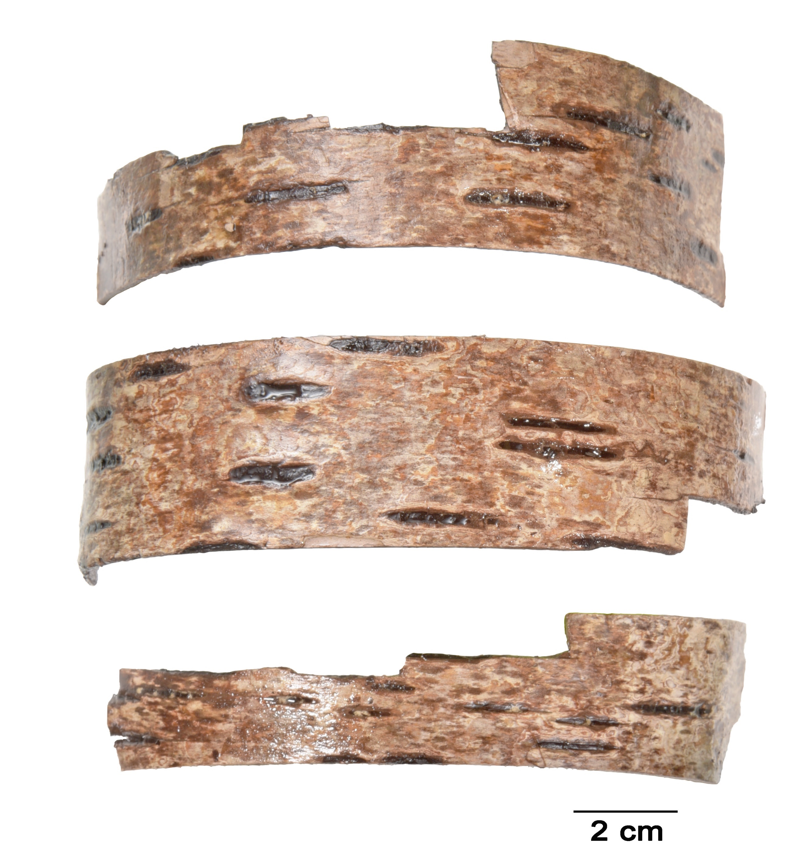
S cover | Schnidejoch bow case cover, preserved in alpine ice, species unknown | Found in 2003, in 2008 treated in several alcohol solutions, the material is stiff and slightly brittle, delamination is present | dry | 2800 BC (Neolithic) | sorption isotherm at 25 °C | 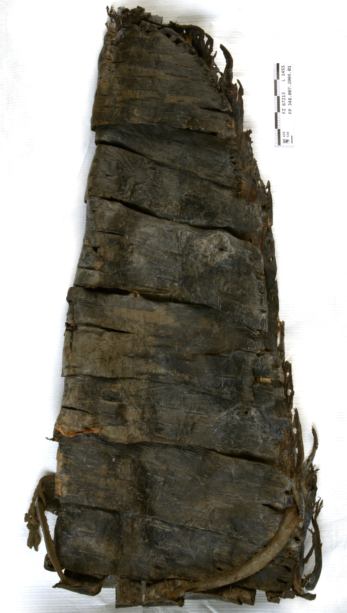
S middle part | Schnidejoch bow case middle part, preserved in alpine ice, species unknown | Found in 2005, untreated and stored frozen, the sample used for the sorption isotherm shows delamination and slight brittleness | damp and frozen | 2800 BC (Neolithic) | sorption isotherm at 25, 0 and -20 °C
S lower part | Schnidejoch bow case lower part, preserved in alpine ice, species unknown | Found in 2005, untreated and stored frozen, the sample used for the sorption measurement is compact, no delamination, no brittleness | damp and frozen | 2800 BC (Neolithic) | sorption isotherm at 25, 0 and -20 °C

