Appendix
Header numbers refer to respective text sections

1.2 Elemental analyses of red chalk and red ocher
Table A1: XRD-results of five red chalk specimens (after Mayhew et al. 2014, 103)
Arizona red chalk | French red chalk from Burgundy | German red chalk (Taunus) | German red chalk (Theley) | German red chalk
90% silica  6% hematite  4% cronstedtite | 90.8% silica  3.3% hematite3.2% aluminum silicate hydrate  2.7% iron silicate hydroxide | 84% silica  13% illite  3% iron silicate hydroxide | 72.5% silica  22.5% hematite  3% iron silicate hydroxide | 87% silica  8% flusston  5% iron silicate hydroxide

3.1 XRD: Mineral composition of red chalks
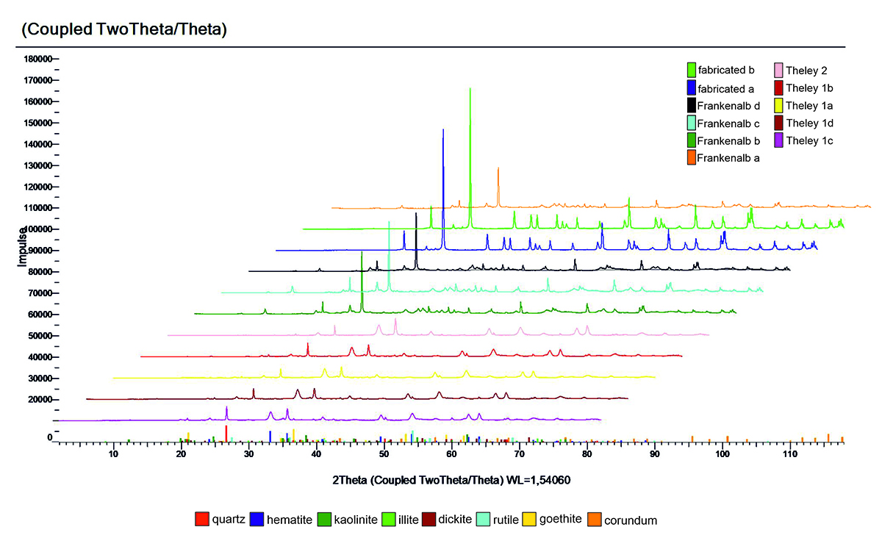
Figure 3b: XRD spectra

3.3 FORS: Spectral features of the red chalk drawing mockups
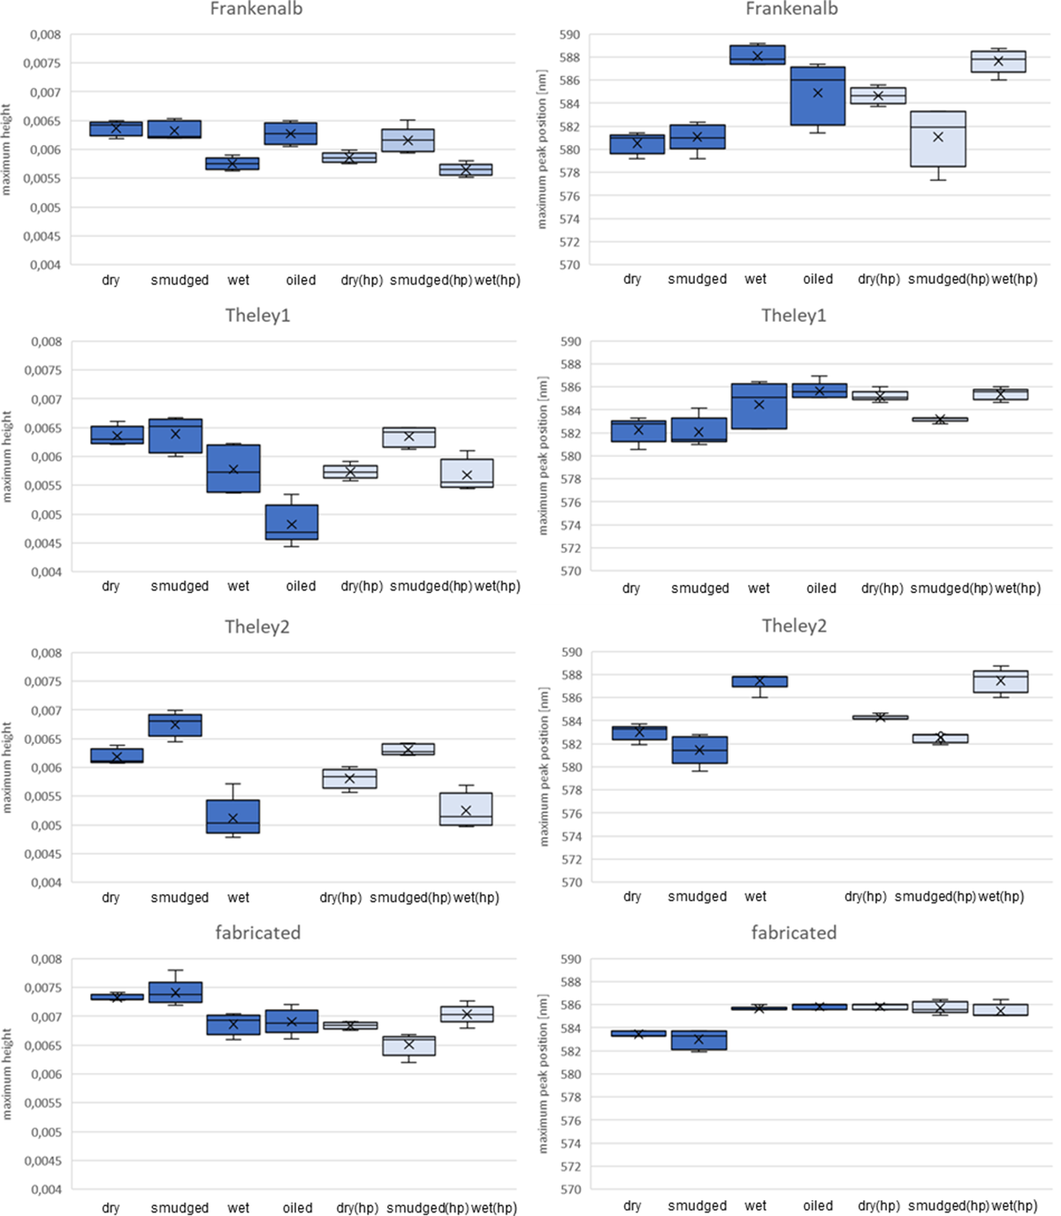
Figure 8b: Box plots of the peak height and position of the first derivative within a single chalk type. The lower peaks tend to be found more often in higher-wavelength regions than higher peaks are.
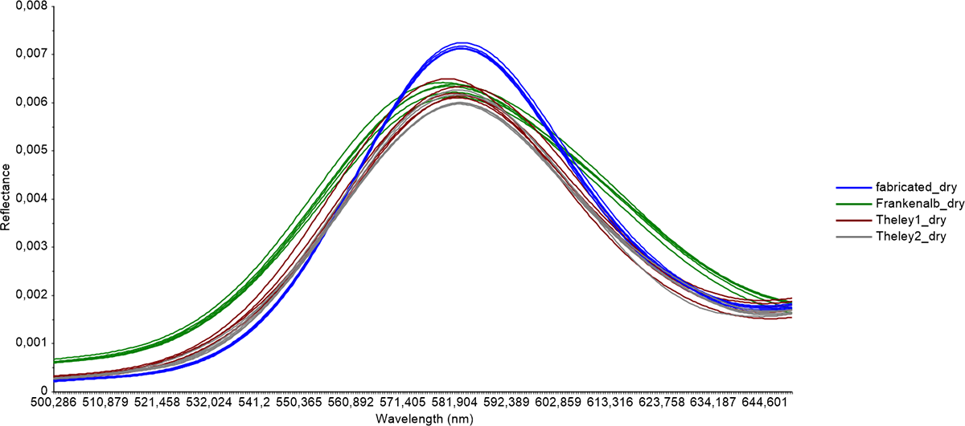Figure 9b: Dry chalks on modern paper, 1st derivative 500–650 nm.
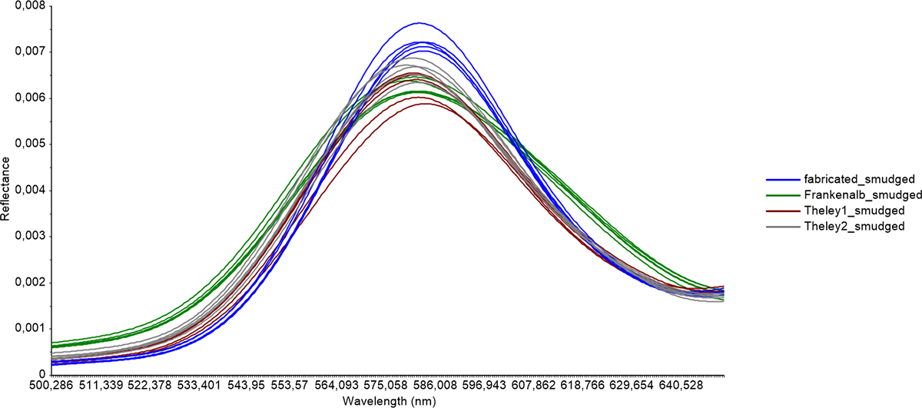Figure 9c: Smudged chalks on modern paper, 1st derivative 500–650 nm.
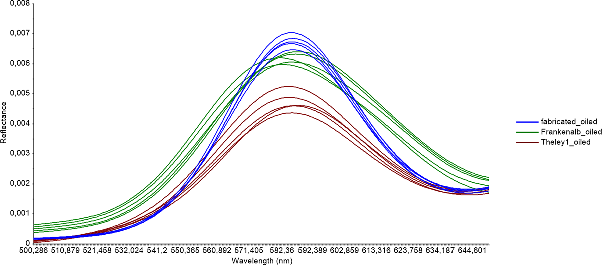Figure 9d: Oiled chalks on modern paper, 1st derivative 500–650 nm.

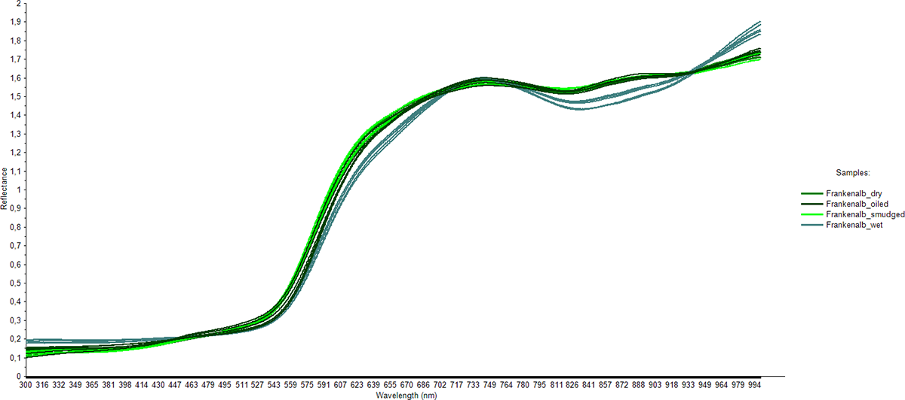Figure 10b: Effect of the application technique on the reflectance curve for the samples of Frankenalb chalk on modern paper.
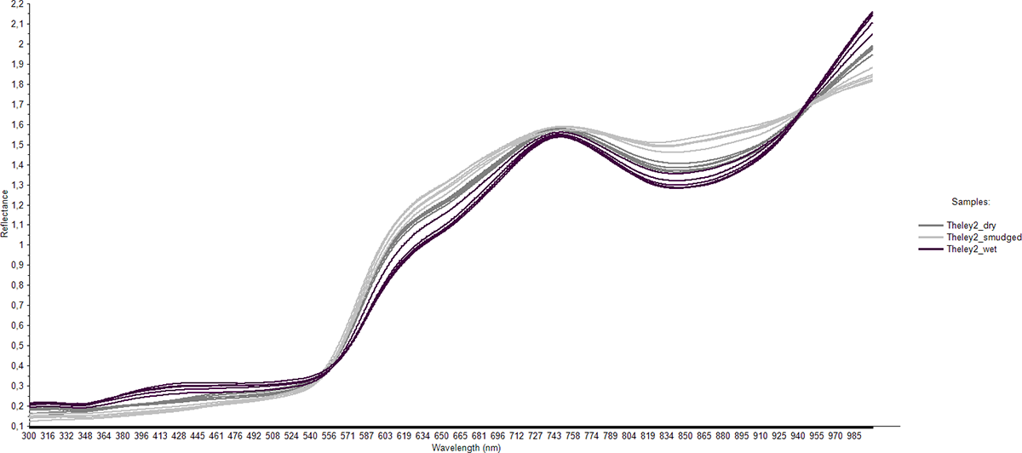Figure 10c: Effect of the application technique on the reflectance curve for the samples of Theley2 on modern paper.
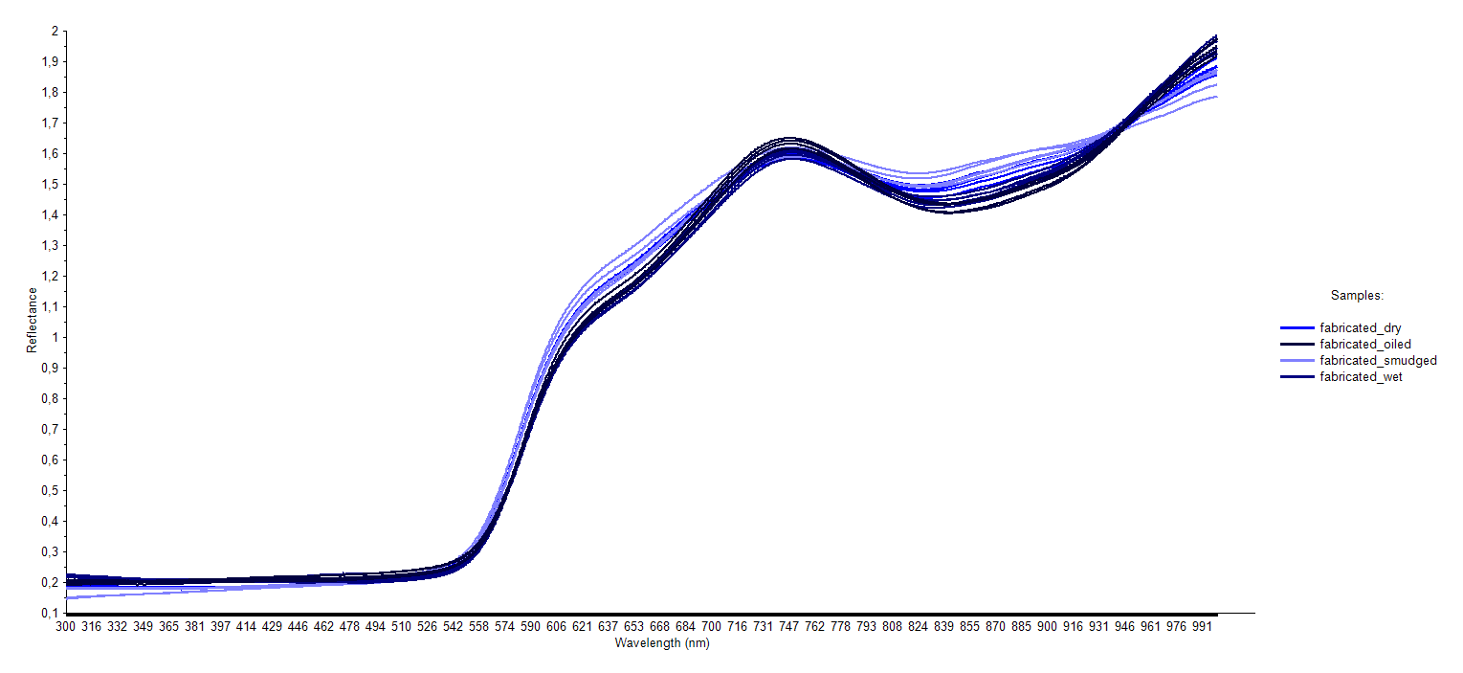
Figure 10d: Effect of the application technique on the reflectance curve for the samples of fabricated chalk on modern paper.

3.5 Principal component analysis of red chalk mockups
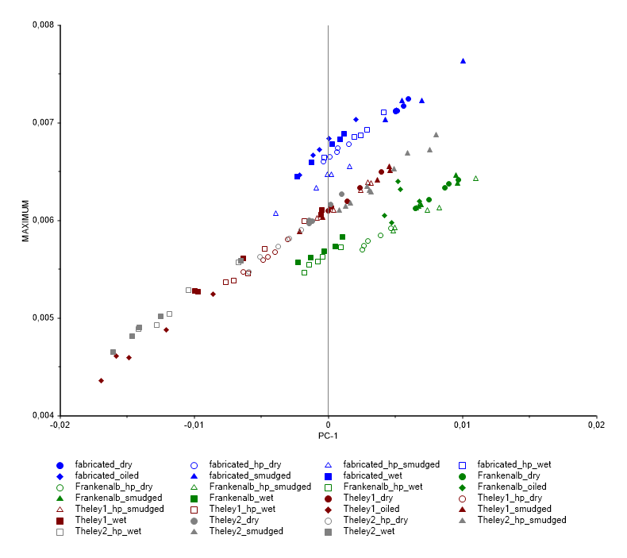
Figure 14b: The maxima of the first derivative spectra of the mockups correlate to PC-1, as also expressed in the loadings plot.
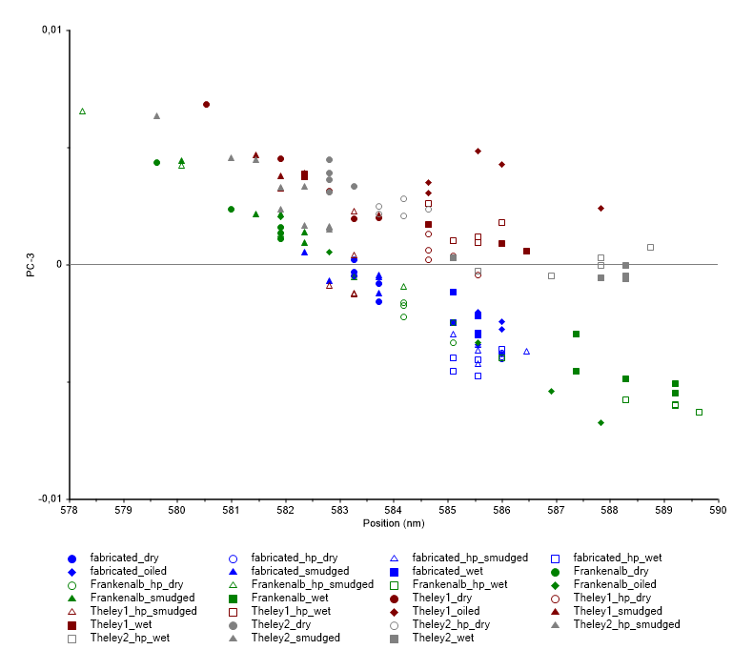
Figure 14c: Peak positions of the first derivative spectra of the mockups correlate negatively to PC-3.
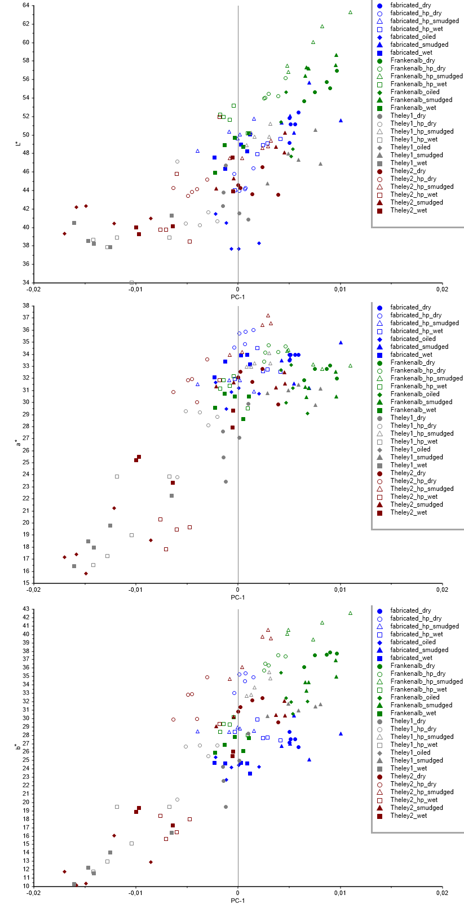
Figure 14d: Correlation of L*, a*, and b* values of the mockups to PC-1.
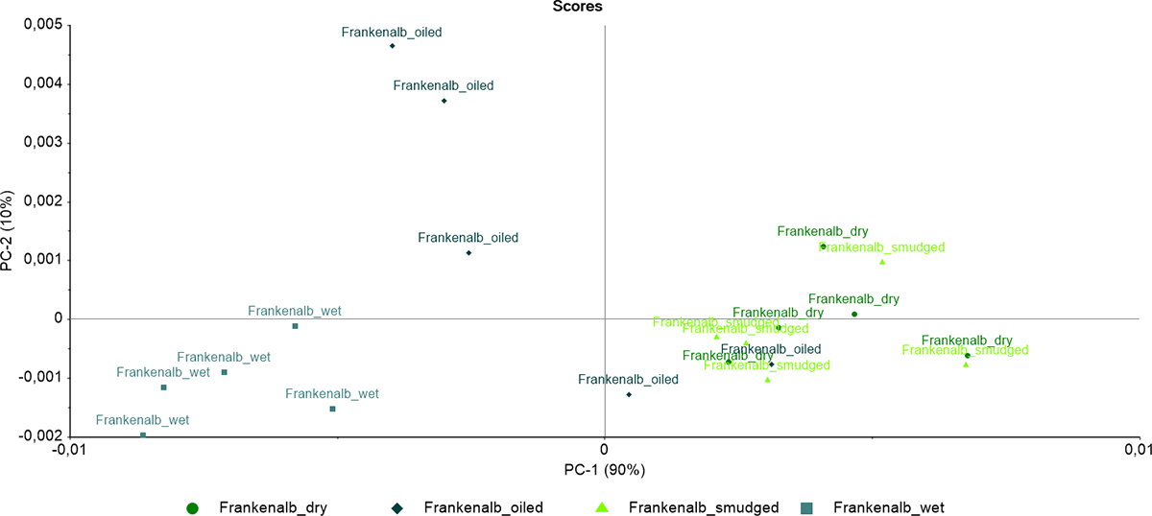
Figure 15b: Scores plot for the different application techniques for Frankenalb red chalk on modern paper.
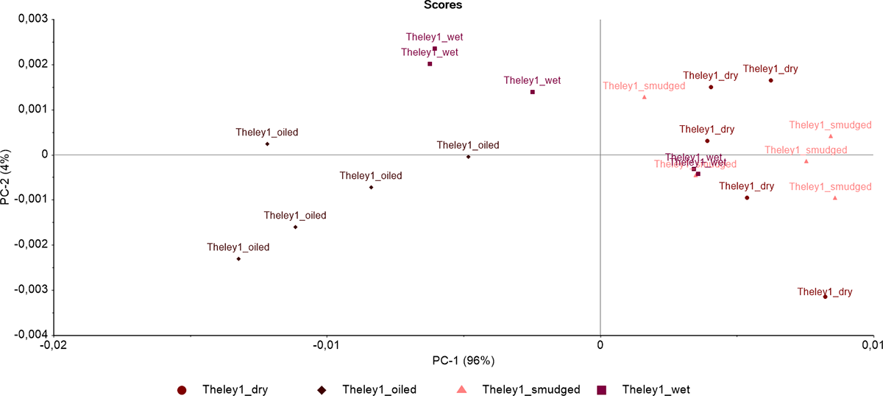
Figure 15c: Scores plot for the different application techniques for Theley1 red chalk on modern paper.
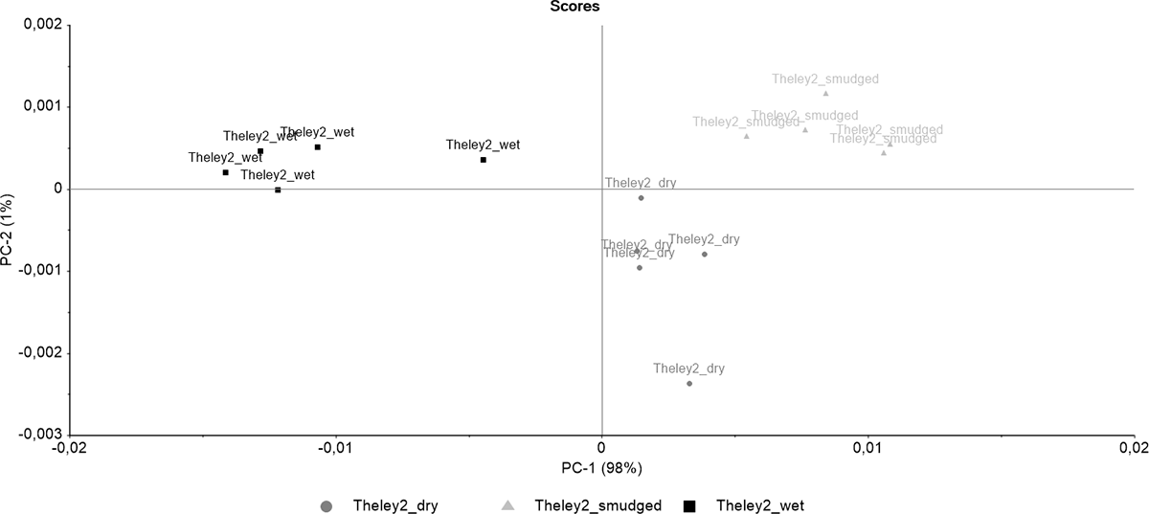
Figure 15d: Scores plot for the different application techniques for Theley2 red chalk on modern paper.

3.6 Differentiation of the red chalks in the Karlsruhe group of drawings
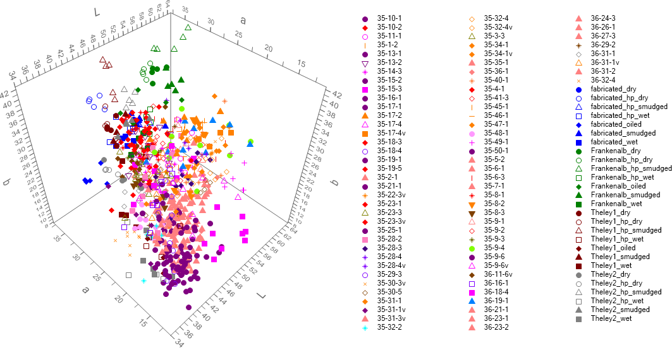
Figure 17b: Scatter plot of the CIE L*a*b* values of original drawings and drawing mockups combined. Identical colors and symbols interpret the measurements with regard to groups of similar red chalks.
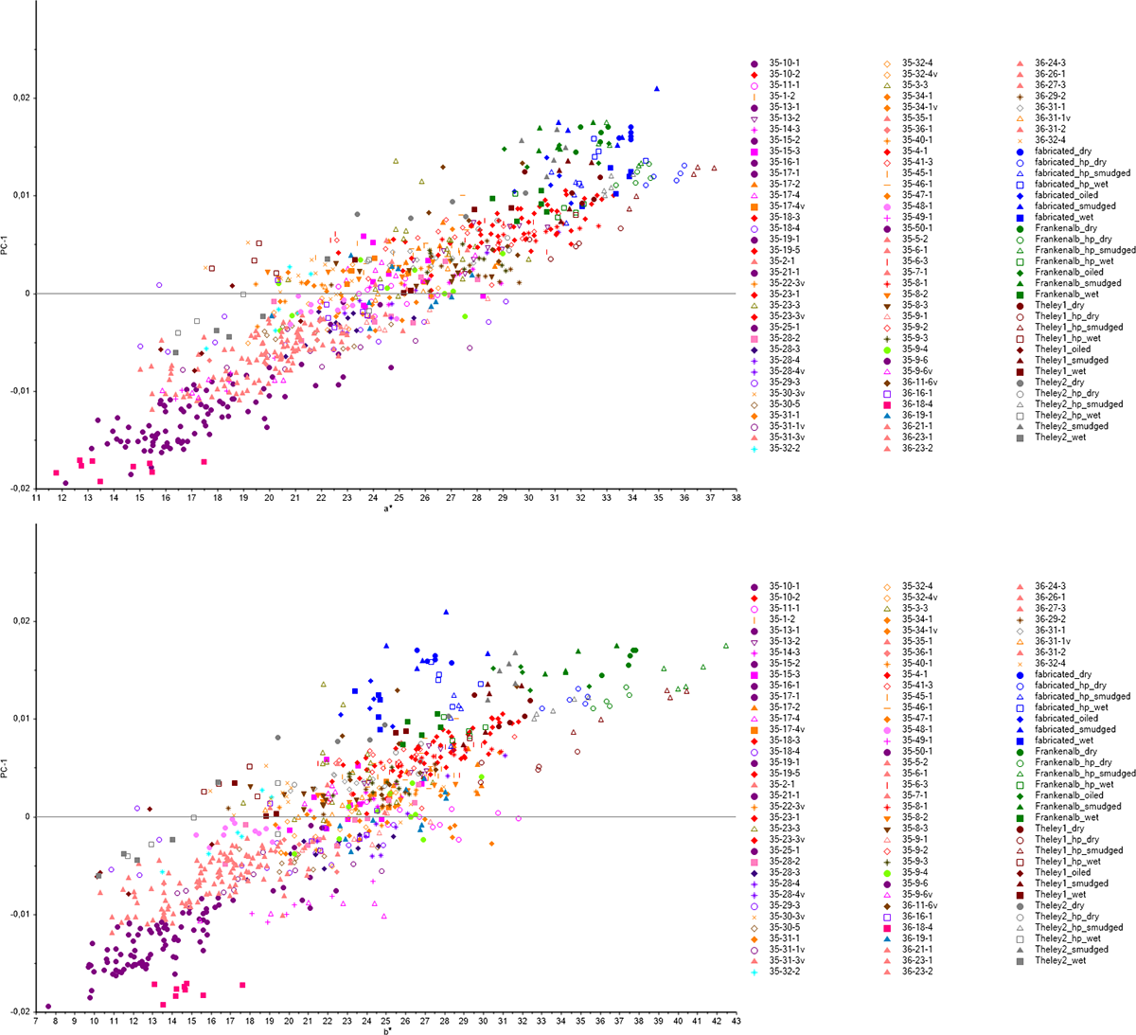
Figure 17c: Correlation of PC-1 with CIE a*and b* values of original drawings and drawing mockups.
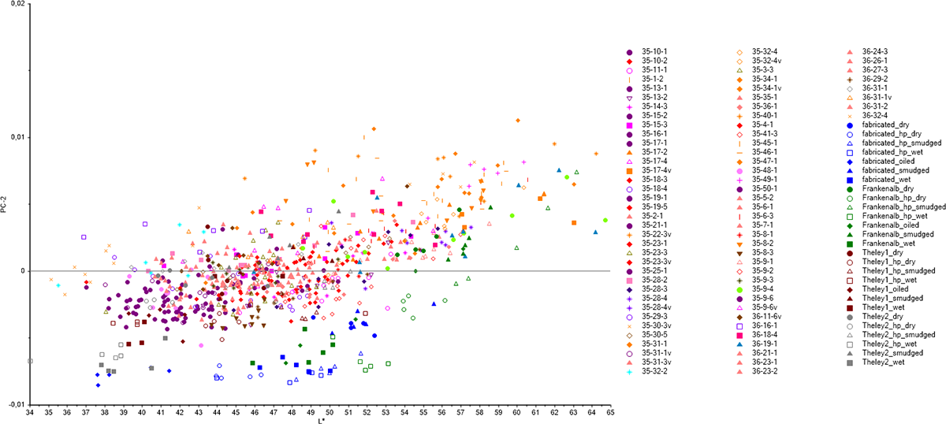
Figure 17d: Weak correlation of CIE L* values with PC-2.
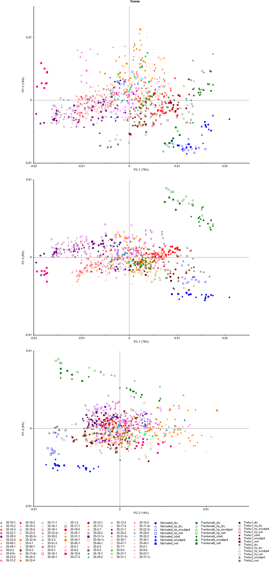
Fig. 18d–f: 2D scatter plots of the PCA of original drawings and drawing mockups. Identical colors and symbols interpret the measurements with regard to groups of similar red chalks.

