Evaluating Earthquake Impacts in Oslo, Norway: A Multi-Method Approach
Federica Ghione^{1,2*}, Sergio Molina-Palacios³, Anita Torabi², Volker Oye^{1,2}
* Corresponding author (federica.ghione@norsar.no)
Sergio Molina Palacios (sergio.molina@gcloud.ua.es)
Anita Torabi (anita.torabi@geo.uio.no)
Volker Oye (volker.oye@norsar.no)
¹NORSAR, Department of Applied Seismology, Kjeller, Norway
²University of Oslo, Department of Geosciences, Oslo, Norway
³University of Alicante, Department of Applied Physics, Alicante, Spain

Supplementary Information
Figures
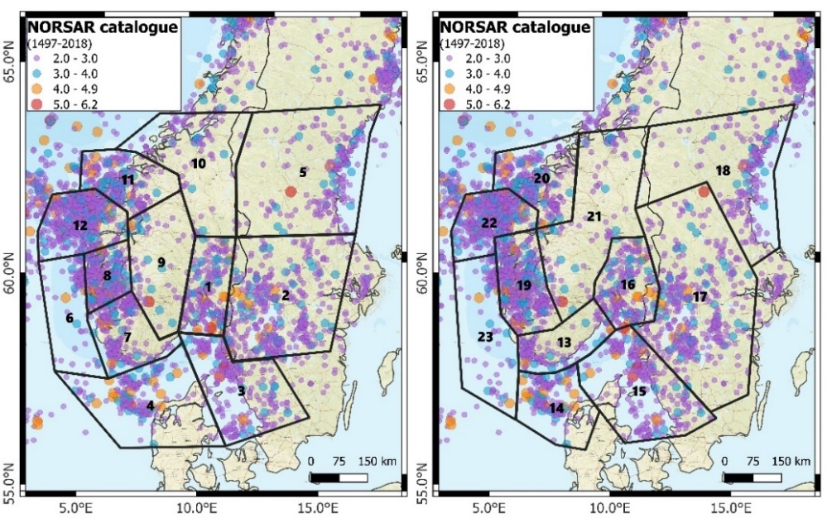
Figure SM1 Seismic zonation of Oslo area, based on NORSAR Catalogue. The left map shows zonation based on seismicity patterns, with zones numbered from 1 to 12. The right map presents zonation based on mapped geological structures, with zones numbered from 13 to 23. Each colored dot represents an earthquake event, categorized by magnitude range from 2.0 to 6.2.

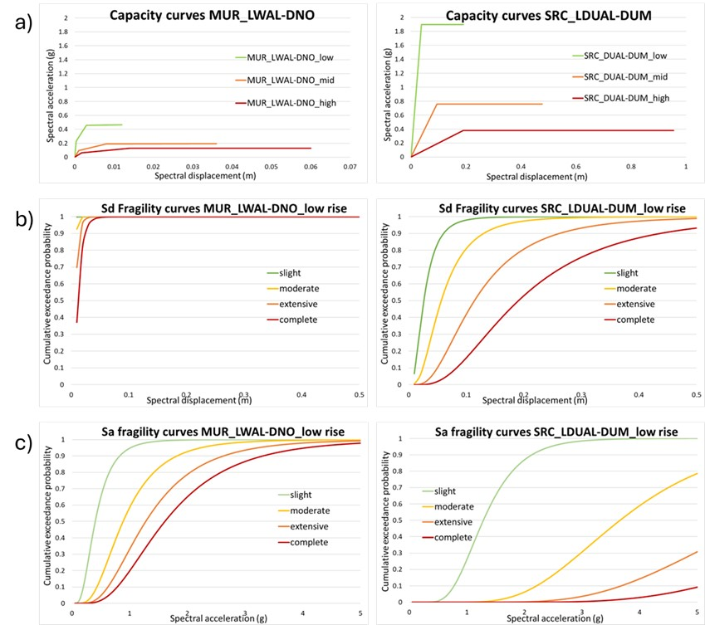
Figure SM2 a) A capacity curve shows the level of ground motion that a building or structure can withstand without sustaining significant damage. The capacity spectrum shows the spectral displacement (in m) on the horizontal axis versus spectral acceleration (in g) on the vertical one. Capacity curves for all the Unreinforced Masonry (MUR) on the left and for all the Steel-Reinforced Concrete typologies (SRC) in the right. Comparison of two fragility curves: b) The corresponding Sd fragility curve showing the cumulative damage probability corresponding to each value of the performance point in meters. Fragility curves for the spectral displacement method for Unreinforced Masonry low rise (MUR_LWAL-DNO_low rise) on the left and Steel-Reinforced Concrete low rise (SRC_LDUAL-DUM_low rise) on the right. c) Fragility curves for the spectral acceleration method showing the cumulative exceedance probability of damage or failure on the vertical axis against the level of ground motion on the horizontal axis (typically measured in terms of Sa) for MUR (left) and SRC (right). Please note that the scale for the different plots is different.
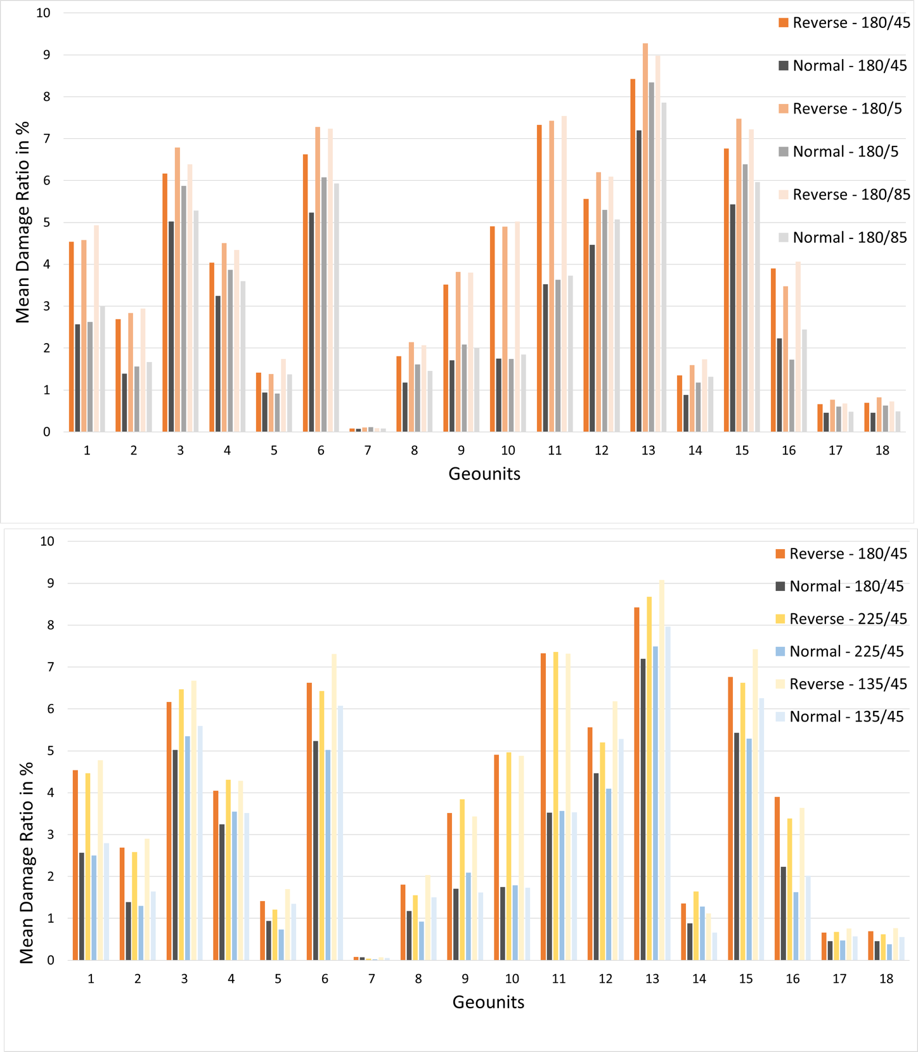
Figure SM3 Sensitivity analysis on fault type, strike and dip angle using the Østmarka scenario with Sd method. Top: median MDR in percentage for the different geounits using reverse and normal mechanisms, with 180° strike and varying the dip angle (45°, 5° and 85°). Bottom: median MDR in percentage for the different geounits using reverse and normal mechanisms, varying the strike directions (180°, 135° and 225°) with 45° dip angle.

Tables
Table SM1 Recurrence parameters for all zones used in the seismic hazard assessment model. The b-value (0.927) was derived from a larger area encompassing the spatial distribution of all zones and applied uniformly across the zones. The a-values were calculated individually for each seismic zone based on local seismicity rates, as shown in the table.
Zone | a-value | Zone | a-value
1 | 2.452557 | 13 | 2.156257
2 | 2.591078 | 14 | 2.530211
3 | 2.303054 | 15 | 2.470094
4 | 2.569535 | 16 | 2.452557
5 | 1.965841 | 17 | 2.5471
6 | 2.319579 | 18 | 1.940563
7 | 2.186157 | 19 | 2.817605
8 | 2.641135 | 20 | 2.585098
9 | 1.758354 | 21 | 1.848458
10 | 0.994219 | 22 | 2.964164
11 | 2.572621 | 23 | 2.325123
12 | 2.975958

Table SM2 The table presents PGA values (in g) for all the 18 geounits and the three deterministic scenarios (1904, Østmarka and Nesodden events), using average (avg), minimum (min) and maximum (max) Vs30 values. The results are presented for the four different GMPEs, where GM1 is Akkar et al. (2014), GM2 is Bindi et al. (2017), GM3 is Cauzzi et al. (2015) and GM4 is Yenier and Atkinson (2015).
 |  |  | 1904 |  |  |  | Østmarka |  |  |  |  | Nesodden
 |  |  | PGA |  |  |  | PGA |  |  |  |  | PGA
 | Geounit | Vs30  [m/s] | GM1 | GM2 | GM3 | GM4 | GM1 | GM2 | GM3 | GM4 | GM1 |  | GM2 | GM3 | GM4
avg Vs30 | 1 | 706 | 0.0027 | 0.0033 | 0.0003 | 0.0351 | 0.4744 | 0.635 | 0.2029 | 0.3075 | 0.1161 |  | 0.1287 | 0.0566 | 0.3308
avg Vs30 | 2 | 683 | 0.0027 | 0.0033 | 0.0003 | 0.0354 | 0.4018 | 0.5296 | 0.1606 | 0.3732 | 0.1257 |  | 0.1378 | 0.0646 | 0.3617
avg Vs30 | 3 | 545 | 0.0031 | 0.0034 | 0.0004 | 0.0416 | 0.2601 | 0.3172 | 0.0925 | 0.3913 | 0.2379 |  | 0.2474 | 0.1968 | 0.6702
avg Vs30 | 4 | 521 | 0.0032 | 0.0035 | 0.0005 | 0.0433 | 0.3361 | 0.4128 | 0.1237 | 0.4671 | 0.2343 |  | 0.2408 | 0.1875 | 0.655
avg Vs30 | 5 | 897 | 0.0023 | 0.0023 | 0.0003 | 0.0292 | 0.3362 | 0.3515 | 0.1946 | 0.4338 | 0.0843 |  | 0.0739 | 0.0344 | 0.2287
avg Vs30 | 6 | 603 | 0.0029 | 0.0033 | 0.0004 | 0.0386 | 0.3717 | 0.4732 | 0.1354 | 0.4122 | 0.1636 |  | 0.1727 | 0.0994 | 0.4745
avg Vs30 | 7 | 1086 | 0.002 | 0.002 | 0.0002 | 0.0239 | 0.114 | 0.1226 | 0.04 | 0.2135 | 0.0673 |  | 0.0616 | 0.0248 | 0.1774
avg Vs30 | 8 | 740 | 0.0025 | 0.0032 | 0.0003 | 0.0331 | 0.2761 | 0.3689 | 0.1054 | 0.4279 | 0.1282 |  | 0.1449 | 0.0644 | 0.3601
avg Vs30 | 9 | 726 | 0.0029 | 0.0036 | 0.0004 | 0.0371 | 0.3536 | 0.4723 | 0.1192 | 0.3809 | 0.2202 |  | 0.2494 | 0.1489 | 0.5814
avg Vs30 | 10 | 1140 | 0.0025 | 0.0026 | 0.0003 | 0.0282 | 0.4408 | 0.4869 | 0.1768 | 0.2235 | 0.1198 |  | 0.1104 | 0.0486 | 0.2823
avg Vs30 | 11 | 758 | 0.0028 | 0.0035 | 0.0004 | 0.0353 | 0.4693 | 0.6414 | 0.1579 | 0.2658 | 0.1553 |  | 0.1777 | 0.0857 | 0.431
avg Vs30 | 12 | 583 | 0.0029 | 0.0033 | 0.0004 | 0.0387 | 0.3331 | 0.4184 | 0.1294 | 0.4855 | 0.1552 |  | 0.1618 | 0.0911 | 0.4493
avg Vs30 | 13 | 446 | 0.0034 | 0.0034 | 0.0005 | 0.0463 | 0.3386 | 0.4084 | 0.1376 | 0.4813 | 0.2199 |  | 0.2179 | 0.1763 | 0.6198
avg Vs30 | 14 | 978 | 0.0028 | 0.0028 | 0.0003 | 0.0325 | 0.2871 | 0.3104 | 0.1198 | 0.4188 | 0.1792 |  | 0.1645 | 0.0854 | 0.4093
avg Vs30 | 15 | 619 | 0.0029 | 0.0033 | 0.0004 | 0.0379 | 0.3049 | 0.3871 | 0.109 | 0.4387 | 0.1737 |  | 0.1853 | 0.1068 | 0.4951
avg Vs30 | 16 | 704 | 0.0026 | 0.0032 | 0.0003 | 0.034 | 0.3907 | 0.5188 | 0.3635 | 0.5156 | 0.0868 |  | 0.0958 | 0.0365 | 0.2431
avg Vs30 | 17 | 631 | 0.0028 | 0.0033 | 0.0004 | 0.0375 | 0.2127 | 0.2682 | 0.072 | 0.3348 | 0.2 |  | 0.2155 | 0.1445 | 0.5819
avg Vs30 | 18 | 725 | 0.0026 | 0.0032 | 0.0003 | 0.0335 | 0.1922 | 0.2533 | 0.0678 | 0.3212 | 0.1468 |  | 0.165 | 0.0875 | 0.438
min Vs30 | 1 | 100 | 0.0053 | 0.0037 | 0.0013 | 0.0823 | 0.2881 | 0.7021 | 0.8008 | 0.229 | 0.1008 |  | 0.1423 | 0.2233 | 0.2354
min Vs30 | 2 | 100 | 0.0052 | 0.0036 | 0.0013 | 0.0817 | 0.2522 | 0.5856 | 0.6192 | 0.2402 | 0.1059 |  | 0.1523 | 0.249 | 0.2397
min Vs30 | 3 | 140 | 0.0052 | 0.0038 | 0.0011 | 0.0743 | 0.2035 | 0.3507 | 0.2404 | 0.2874 | 0.1899 |  | 0.2736 | 0.5112 | 0.3589
min Vs30 | 4 | 100 | 0.0055 | 0.0039 | 0.0014 | 0.0847 | 0.2101 | 0.4564 | 0.3943 | 0.2482 | 0.1587 |  | 0.2662 | 0.5977 | 0.2659
min Vs30 | 5 | 100 | 0.005 | 0.0035 | 0.0012 | 0.0801 | 0.238 | 0.5411 | 0.9088 | 0.2567 | 0.0856 |  | 0.1137 | 0.1604 | 0.2215
min Vs30 | 6 | 180 | 0.0047 | 0.0037 | 0.0009 | 0.0669 | 0.3067 | 0.5232 | 0.3165 | 0.348 | 0.1614 |  | 0.1909 | 0.2324 | 0.3774
min Vs30 | 7 | 180 | 0.004 | 0.0031 | 0.0007 | 0.0598 | 0.1421 | 0.1888 | 0.1415 | 0.2874 | 0.094 |  | 0.0948 | 0.0875 | 0.2573
min Vs30 | 8 | 100 | 0.0051 | 0.0035 | 0.0012 | 0.0806 | 0.1936 | 0.4079 | 0.4301 | 0.251 | 0.1098 |  | 0.1602 | 0.2625 | 0.2416
min Vs30 | 9 | 140 | 0.0055 | 0.004 | 0.0012 | 0.0772 | 0.273 | 0.5223 | 0.3787 | 0.2987 | 0.191 |  | 0.2757 | 0.4732 | 0.3543
min Vs30 | 10 | 180 | 0.0051 | 0.004 | 0.001 | 0.0705 | 0.4013 | 0.7496 | 0.6467 | 0.2986 | 0.1477 |  | 0.1699 | 0.1778 | 0.3434
min Vs30 | 11 | 100 | 0.0056 | 0.0039 | 0.0015 | 0.0852 | 0.2902 | 0.7092 | 0.655 | 0.2224 | 0.1273 |  | 0.1965 | 0.3555 | 0.2521
min Vs30 | 12 | 100 | 0.0052 | 0.0036 | 0.0013 | 0.0818 | 0.2122 | 0.4626 | 0.4464 | 0.2522 | 0.119 |  | 0.1789 | 0.3144 | 0.248
min Vs30 | 13 | 140 | 0.0052 | 0.0038 | 0.0011 | 0.0743 | 0.2452 | 0.4516 | 0.3104 | 0.3081 | 0.173 |  | 0.241 | 0.398 | 0.3431
min Vs30 | 14 | 140 | 0.0058 | 0.0043 | 0.0014 | 0.0799 | 0.2556 | 0.4778 | 0.4692 | 0.3337 | 0.1794 |  | 0.2533 | 0.3344 | 0.3309
min Vs30 | 15 | 180 | 0.0047 | 0.0037 | 0.0009 | 0.0666 | 0.2639 | 0.428 | 0.2595 | 0.3633 | 0.1702 |  | 0.2049 | 0.2542 | 0.3887
min Vs30 | 16 | 100 | 0.0051 | 0.0035 | 0.0012 | 0.0804 | 0.2484 | 0.5736 | 1.4318 | 0.2581 | 0.0813 |  | 0.1059 | 0.1437 | 0.2165
min Vs30 | 17 | 100 | 0.0053 | 0.0037 | 0.0013 | 0.0824 | 0.1534 | 0.2965 | 0.2628 | 0.233 | 0.1465 |  | 0.2383 | 0.5269 | 0.263
min Vs30 | 18 | 100 | 0.0051 | 0.0035 | 0.0012 | 0.0805 | 0.1472 | 0.28 | 0.2724 | 0.2345 | 0.1207 |  | 0.1824 | 0.3518 | 0.2517
max Vs30 | 1 | 1200 | 0.0023 | 0.0024 | 0.0002 | 0.0255 | 0.4138 | 0.4561 | 0.1398 | 0.2247 | 0.1005 |  | 0.0924 | 0.039 | 0.2418
max Vs30 | 2 | 1200 | 0.0023 | 0.0023 | 0.0002 | 0.0252 | 0.3469 | 0.3804 | 0.1081 | 0.2686 | 0.1076 |  | 0.0989 | 0.0435 | 0.2603
max Vs30 | 3 | 760 | 0.0027 | 0.0034 | 0.0003 | 0.0344 | 0.2357 | 0.3172 | 0.0733 | 0.3381 | 0.2149 |  | 0.2474 | 0.1558 | 0.588
max Vs30 | 4 | 1200 | 0.0025 | 0.0025 | 0.0003 | 0.0265 | 0.272 | 0.2965 | 0.0688 | 0.3037 | 0.1865 |  | 0.1729 | 0.1043 | 0.431
max Vs30 | 5 | 1200 | 0.0022 | 0.0023 | 0.0002 | 0.0245 | 0.3212 | 0.3515 | 0.1586 | 0.3639 | 0.0805 |  | 0.0739 | 0.028 | 0.1919
max Vs30 | 6 | 760 | 0.0026 | 0.0033 | 0.0003 | 0.0338 | 0.3488 | 0.4732 | 0.1151 | 0.3703 | 0.1509 |  | 0.1727 | 0.0845 | 0.4272
max Vs30 | 7 | 1200 | 0.002 | 0.002 | 0.0002 | 0.0225 | 0.114 | 0.1226 | 0.0373 | 0.201 | 0.0673 |  | 0.0616 | 0.0231 | 0.167
max Vs30 | 8 | 1200 | 0.0022 | 0.0023 | 0.0002 | 0.0248 | 0.2436 | 0.2649 | 0.0751 | 0.3204 | 0.113 |  | 0.104 | 0.0458 | 0.2696
max Vs30 | 9 | 1200 | 0.0026 | 0.0026 | 0.0003 | 0.0274 | 0.3103 | 0.3392 | 0.0837 | 0.2824 | 0.193 |  | 0.1791 | 0.1046 | 0.4315
max Vs30 | 10 | 1200 | 0.0025 | 0.0026 | 0.0003 | 0.0273 | 0.4408 | 0.4869 | 0.1706 | 0.2167 | 0.1198 |  | 0.1104 | 0.0469 | 0.2737
max Vs30 | 11 | 1200 | 0.0025 | 0.0025 | 0.0003 | 0.0267 | 0.4178 | 0.4606 | 0.1143 | 0.2014 | 0.1383 |  | 0.1276 | 0.062 | 0.3267
max Vs30 | 12 | 760 | 0.0026 | 0.0033 | 0.0003 | 0.0333 | 0.3093 | 0.4184 | 0.1074 | 0.4318 | 0.1415 |  | 0.1618 | 0.0756 | 0.399
max Vs30 | 13 | 760 | 0.0027 | 0.0034 | 0.0003 | 0.0344 | 0.3021 | 0.4084 | 0.0946 | 0.3993 | 0.1897 |  | 0.2179 | 0.1213 | 0.5231
max Vs30 | 14 | 1200 | 0.0027 | 0.0028 | 0.0003 | 0.0287 | 0.2845 | 0.3104 | 0.1037 | 0.3701 | 0.1775 |  | 0.1645 | 0.0739 | 0.3618
max Vs30 | 15 | 760 | 0.0026 | 0.0033 | 0.0003 | 0.0336 | 0.2866 | 0.3871 | 0.0944 | 0.3987 | 0.1617 |  | 0.1853 | 0.0924 | 0.4507
max Vs30 | 16 | 1200 | 0.0022 | 0.0023 | 0.0002 | 0.0247 | 0.34 | 0.3726 | 0.2499 | 0.377 | 0.0751 |  | 0.0688 | 0.0251 | 0.1773
max Vs30 | 17 | 760 | 0.0026 | 0.0033 | 0.0003 | 0.0337 | 0.1998 | 0.2682 | 0.0632 | 0.3058 | 0.1877 |  | 0.2155 | 0.1268 | 0.5349
max Vs30 | 18 | 1200 | 0.0022 | 0.0023 | 0.0002 | 0.0247 | 0.1683 | 0.1819 | 0.0476 | 0.2379 | 0.1285 |  | 0.1185 | 0.0614 | 0.3247

