SUPPLEMENTARY MATERIAL
Appendix A: EXPLORE R Package
The original EXPLORE algorithm already uses techniques to reduce the search space such as minimal rule instantiation based on decision rule characteristics (e.g. repetitions and permutations of feature-operator pairs within a term are irrelevant) and branch-and-bound optimization (i.e. to remove subspaces that cannot contain the optimal decision rule).
Table S1 shows the number of feature-operator pairs and number of fully instantiated rules for different rule lengths. For example, for a rule with maximum length of 3 there are 6 possible term tuples. A term tuples of length m can be denoted by an ordered list of term sizes {t₁ … t_{m}}, hence we obtain the following list of possible term tuples: {1}, {2}, {1 1}, {3}, {2 1}, {1 1 1}. Each term tuple is subsequently initiated with feature-operators. As each feature operator can only occur once in a single term, the total number of feature operator pairs equals 790 (= 10 + 45 + 45 + 120 + 450 + 120) for a dataset with 10 binary predictors. Next, the total number of rules can be obtained by multiplying the above with the number of possible threshold values (2 for binary data). This leads to a total number of fully instantiated rules of 5540 (= 20 + 180 + 180 + 960 + 3240 + 960).

Table S1: Counts for EXPLORE with different rule lengths for dataset 10 binary predictors.
Rule length | Term tuple | Number of feature-operator pairs original version | Number of feature-operator pairs with binary optimization | Number of rules with binary optimization | Change in number of rules with binary optimization compared to original version
1 | {1} | $$\left({10 \atop 1}\right)=10$$ | idem | 20 | -
2 | {2} | $$\left({10 \atop 2}\right)=45$$ |  | 180 | -
2 | {11} | $$\left({10 \atop 2}\right)=45$$ | idem | 180 | -
3 | {3} | $$\left({10 \atop 3}\right)=120$$ | idem | 960 | -7.0%
3 | {2 1} | $$\left({10 \atop 2}\right)*\left({10 \atop 1}\right)=450$$ | $$\left({10 \atop 2}\right)*\left({10-2 \atop 1}\right)$$  $$=360$$ | 3240 | -7.0%
3 | {1 1 1} | $$\left({10 \atop 3}\right)=120$$ | idem | 960 | -7.0%
4 | {4} | $$\left({10 \atop 4}\right)=210$$ | idem | 3360 | -13.4%
4 | {3 1} | $$\left({10 \atop 3}\right)*\left({10 \atop 1}\right)=1200$$ | $$\left({10 \atop 3}\right)*\left({10-3 \atop 1}\right)$$  $$=840$$ | 16320 | -13.4%
4 | {2 2} | $$\left({2+\left({10 \atop 2}\right)-1 \atop 2}\right)=1035$$ | idem | 16560 | -13.4%
4 | {2 1 1} | $$\left({10 \atop 2}\right)*\left({10 \atop 2}\right)=2025$$ | $$\left({10 \atop 2}\right)*\left({10-2 \atop 2}\right)$$  $$=1260$$ | 26100 | -13.4%
4 | {1 1 1 1} | $$\left({10 \atop 4}\right)=210$$ | idem | 3360 | -13.4%
5 | {5} | $$\left({10 \atop 5}\right)=252$$ | idem | 8064 | -20.5%
5 | {4 1} | $$\left({10 \atop 4}\right)*\left({10 \atop 1}\right)=2100$$ | $$\left({10 \atop 4}\right)*\left({10-4 \atop 1}\right)$$  $$=1260$$ | 40320 | -20.5%
5 | {3 2} | $$\left({10 \atop 3}\right)*\left({10 \atop 2}\right)=5400$$ | idem | 172800 | -20.5%
5 | {3 1 1} | $$\left({10 \atop 3}\right)*\left({10 \atop 2}\right)=5400$$ | $$\left({10 \atop 3}\right)*\left({10-3 \atop 2}\right)$$  $$=2520$$ | 80640 | -20.5%
5 | {2 2 1} | $$\left({2+\left({10 \atop 2}\right)-1 \atop 2}\right)*\left({10 \atop 1}\right) =10350$$ | $$\left({10 \atop 2}\right)*\left({10-2 \atop 1}\right)+$$  $$\left({10 \atop 3}\right)*3*\left({10-3 \atop 1}\right)+$$  $$\left({10 \atop 4}\right)*3*\left({10-4 \atop 1}\right)+$$  $$=6660$$ | 213120 | -20.5%
5 | {2 1 1 1} | $$\left({10 \atop 2}\right)*\left({10 \atop 3}\right)=5400$$ | $$\left({10 \atop 2}\right)*\left({10-2 \atop 3}\right)$$  $$=2520$$ | 80640 | -20.5%
5 | {1 1 1 1 1} | $$\left({10 \atop 5}\right)=252$$ | idem | 8064 | -20.5%

A.1. Binary optimization
A special case occurs when EXPLORE generates feature-operator pairs for binary data. As binary features have only two possible values (TRUE or FALSE), we can apply Boolean algebra to reduce the number of rules that need to be instantiated. We can show using the redundancy law that we do not have to allow repetitions of feature-operator pairs across terms including a term of size 1 as these term tuples reduce to another term tuple with unique feature-operator pairs (see Table S2). Note this does not apply to continuous features as the complement of a continuous feature is not necessarily equivalent to the feature-operator-value triad in the other conjunction. The total number of rules with binary optimization is reduced to 5180 (= 20 + 180 + 180 + 960 + 2880 + 960).

Table S2: Equivalances in term tuples for binary data in case of repeated features.
Term tuple | Simplification | Proof
{2 1} | {1 1} | (A and B) or A’ = (A or A’) and (B or A’) =  B or A’
{3 1} | {2 1} | (A and B and C) or A’ =  (B and C) or A’
{2 1 1} | {1 1 1} | (A and B) or A’ or C =  ((A or A’) and (B or A’)) or C =  B or A’ or C
{4 1} | {3 1} | (A and B and C and D) or A’ =  (B and C and D) or A’
{3 1 1} | {2 1 1} | (A and B and C) or A’ or D =  (B and C) or A’ or D
{2 2 1} | {2 1} or {2 1 1} | (C and D) or (A and B) or A =  (C and D) or A  (C and D) or (A and B) or A’ =  (C and D) or ((A or A’) and (B or A’)) =  (C and D) or B or A’
{2 1 1 1} | {1 1 1 1} | (A and B) or A’ or C or D =  ((A or A’) and (B or A’)) or C or D =  B or A’ or C or D

There are other features in EXPLORE that could be used to speed up if desired, but these do no longer guarantee optimality:
- Enforcing global constraints, e.g. including certain features.
- Subsumption pruning, i.e. remove feature values from the set of possible values if there exists another value that covers a superset of the outcomes and a subset of the non-outcomes.
A.2. Computation time
We compared the computation time of original EXPLORE with the improved version including binary optimization and parallelization for rule lengths 4 (see Table S3). All experiments were run using 56 cores of an Intel® Xeon® Processor E5-2680 v4. The improved version of EXPLORE has lead to an average reduction of computation time by 92.2% for rule length 4 across prediction tasks.

Table S3: Computation time to train EXPLORE across rule lengths (in minutes).
Task | Rule length 4
 | Original | Improved
Hospital readmission | 42.40 | 3.00
End-of-life care | 105.29 | 6.97
Asthma exacerbations | 2.63 | 0.77
Mortality in COPD | 2.54 | 0.76
Cardiovascular disease in T2DM | 3.47 | 0.75
 | 31.3 | 2.5

Appendix B: Model algorithms
Table S4: Overview of model algorithms. The table reports the most important parameters per model algorithm, for other parameters default values of the PatientLevelPrediction R package [2] were used.
Model algorithm | Motivation | Model library / package | Hyperparameter settings | Measure model interpretability
DecisionTree [3] | A relatively fast, greedy algorithm based on an optimized version of CART to find simple decision trees. | Run using the python library scikit-learn | maxDepth = 2, 4  maxFeatures = 25 | Number of nodes in tree
Exhaustive Procedure for Logic-Rule Extraction (EXPLORE) [4] | An algorithm that creates simple decision rules while allowing users to specify global constraints on the model or its performance. | Run using R package Explore | maximize = BalancedAccuracy  endRuleLength = 3, 4, 5 | Rule length
Generalized and Scalable Optimal Sparse Decision Trees with Guesses (GOSDT-G) [5] | A method that finds globally optimal trees while enforcing sparsity. This version adds guessing of lower bounds to the original GOSDT algorithm for more efficient computation. | Run using the python library gosdt | objective = bacc  maxDepth = 2, 4, 8  regularization = 0.025, 0.05, 0.1 | Number of nodes in tree
Iterative Hard Thresholding (IHT) [6] | A method that uses a combination of gradient descent and a hard thresholding operator to fit a sparse model in an iterative fashion. | Run using R package IterativeHardThresholding and Cyclops | K=10  penalty = bic  fitBestSubset = True | Number of non-zero coefficients
Least Absolute Shrinkage and Selection Operator (LASSO) [7] | A regression-based alternative that is often used to develop clinical prediction models as it efficiently combines variable selection and model fitting, which makes it an efficient algorithm to deal with high-dimensional datasets. | Run using R package Cyclops | variance = 0.01 – 20 | Number of non-zero coefficients
RandomForest [8] | An ensemble tree-based alternative that is popular due to its flexibility and ability to model complex relations by allowing for non-linearity between features. | Run using the python library scikit-learn | criterion = Gini  nTrees = 10, 50, 100, 300  maxDepth = 2, 4, 8 | Total number of nodes in all trees
Repeated Incremental Pruning to Produce Error Reduction (RIPPER) [9] | A rule-based alternative for EXPLORE based on incremental reduced error pruning that has shown to obtain second-best performance in standard UCI datasets [4]. | Run using R package RWeka | none | Sum of rule lengths
XGBoost [10] | Another ensemble tree-based alternative, but using boosting instead of bagging of trees. | Run using R package xgboost | nTrees = 10, 50, 100, 300  maxDepth = 2, 4, 8  learnRate = 0.05, 0.1, 0.3 | Total number of nodes in all trees
Appendix C: Evaluating EXPLORE
For model algorithms that predict probabilities, the area under the receiver operating characteristics (AUROC) curve visualizes the sensitivity versus specificity of a given model for different risk thresholds and is a commonly used metric to summarize the ability of the model to distinguish between the classes. To translate the predicted probability of such a model to classes, one selects a risk threshold above which predictions are classified as outcomes. This results in type 1 (‘false positives’) and type 2 errors (‘false negatives’). Computing the resulting errors for different risk thresholds, leads to the traditional AUROC curve visualizing the sensitivity versus specificity of a given model (Figure S1).
Figure S1: Traditional ROC curve – one model, set different probability risk thresholds.
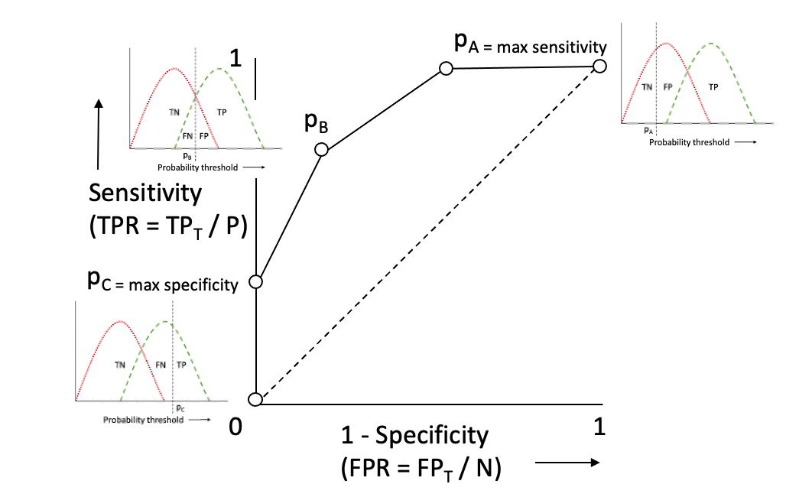
For EXPLORE, we train different models by varying sensitivity versus specificity in a similar way. This is possible because of EXPLORE’s ability to learn under constraints. Hence, we repeatedly find the optimal decision rule that maximizes sensitivity, while imposing constraints on minimum specificity level (e.g. 0.05, 0.1, … , 0.95). As each of these models leads to different combinations of type 1 and type 2 errors, we can construct the ROC curve for EXPLORE (Figure S2).
Figure S2: EXPLORE ROC curve – many models, no probability risk thresholds.
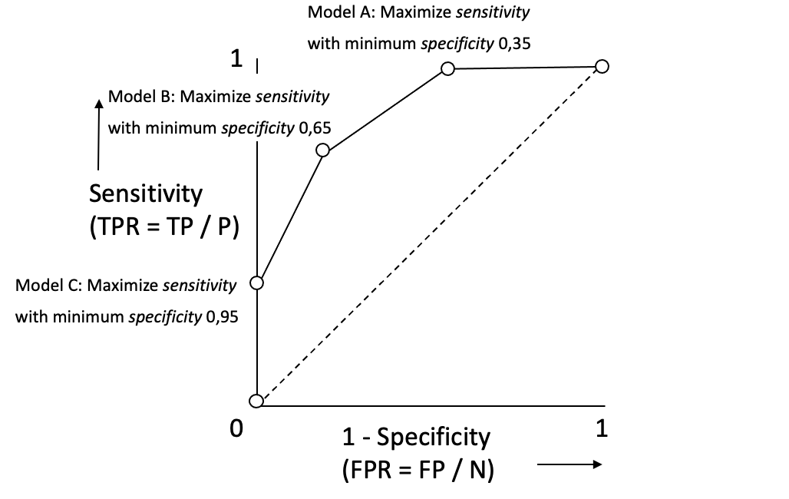
Appendix D: Additional results
Table S5: Baseline characteristics (at index date) of the target populations. Values indicate the percentage of the population with each characteristic any time prior. Characteristics with * are zero because these people were excluded from the target population.
History of: | Hospital readmission | End-of-life care | Asthma exacerbations | Mortality in COPD | Cardiovascular disease in T2DM
Acetaminophen Exposure | 11.1 | 5.8 | 6.2 | 11.0 | 7.9
Acute Gastrointestinal Bleeding | 2.5 | 1.3 | 1.1 | 1.8 | 1.3
Alcoholism | 0.4 | 0.2 | 0.2 | 0.8 | 0.2
Anemia | 9.9 | 6.6 | 5.6 | 7.3 | 3.9
Angina | 1.9 | 1.7 | 1.2 | 3.2 | 2.1
Antibiotic Exposure | 18.2 | 18.5 | 15.7 | 16.2 | 12.5
Antiepileptic Exposure | 8 | 3.9 | 3.3 | 6.1 | 3.1
Anxiety | 11.3 | 9.6 | 12.4 | 10.9 | 8.5
Any Cancer (excl. Prostate Cancer and Benign Cancer) | 26.0 | 18.7 | 8.0 | 17.7 | 9.0
Aspirin Exposure | 12.7 | 10.2 | 4.9 | 16.1 | 10.4
Asthma | 6.0 | 5.6 | 100.0 | 12.0 | 6.7
Atrial Fibrillation | 7.1 | 4.9 | 1.7 | 5.3 | 2.1
Chronic Hepatitis | 0.7 | 0.3 | 0.3 | 0.7 | 0.5
Chronic Kidney Disease or End Stage Renal Disease | 1.6 | 2.5 | 0.4 | 1.2 | 0.3
Chronic Obstructive Pulmonary Disease | 7.4 | 5.1 | 0.0* | 100.0 | 5.0
Coronary Artery Disease | 7.7 | 5.7 | 3.0 | 7.5 | 4.7
Deep Vein Thrombosis | 0.4 | 0.3 | 0.2 | 0.4 | 0.4
Dyspnea | 5.7 | 2.7 | 17.3 | 23.7 | 3.0
Edema | 3.3 | 2.7 | 1.3 | 4.3 | 2.3
Gastroesophageal Reflux Disease | 1.6 | 1.8 | 1.6 | 1.7 | 1.6
Heart Failure | 6.8 | 3.2 | 1.6 | 7.7 | 0.0*
Heart Valve Disorder | 3.5 | 2.5 | 1.2 | 2.9 | 0.9
Hormonal Contraceptive exposure | 1.4 | 0.1 | 3.6 | 0.9 | 1.3
Hyperlipidemia | 5.7 | 10.9 | 5.4 | 9.2 | 10.9
Hypertension | 22.4 | 30.5 | 16.2 | 30.1 | 35.1
Hypothyroidism | 3.4 | 4.5 | 3.7 | 3.4 | 3.3
Inflammatory Bowel Disease | 1.4 | 0.9 | 1.0 | 1.0 | 0.8
Low Back Pain | 17.2 | 17.8 | 16 | 18.3 | 15.6
Major Depressive Disorder (excl. Psychiatric Disorder) | 4.3 | 2.3 | 4.0 | 3.5 | 2.8
Neuropathy | 11.1 | 10.1 | 7.5 | 9.8 | 7.4
Obesity | 20.7 | 20.5 | 16.1 | 18.3 | 30.0
Opioid Exposure | 27.4 | 15.9 | 19.7 | 25.9 | 16.6
Osteoarthritis | 16.1 | 17.3 | 7.7 | 13.2 | 9.8
Osteoporosis | 3.2 | 4.1 | 1.6 | 4.5 | 1.6
Peripheral Vascular Disease | 4.3 | 2.9 | 1.0 | 4.9 | 1.1
Pneumonia | 5.2 | 2.5 | 5.7 | 12.5 | 2.3
Psychotic Disorder | 1.7 | 0.9 | 0.6 | 2.1 | 1.3
Rheumatoid Arthritis | 1.6 | 1.7 | 1.1 | 2.5 | 1.4
Seizure | 0.6 | 0.2 | 0.3 | 0.3 | 0.2
Skin Ulcer | 1.4 | 0.6 | 0.3 | 1.2 | 0.4
Sleep Apnea | 2.8 | 2.6 | 2.7 | 3.1 | 2.7
Smoking | 7.4 | 5.3 | 5.9 | 20.8 | 6.7
Steroid Exposure | 34.8 | 27.8 | 34.3 | 42.7 | 28.6
Stroke or Transient Ischemic Attack | 10.2 | 7.1 | 2.6 | 7.5 | 2.2
Type 1 Diabetes Mellitus | 0.4 | 0.1 | 0.3 | 0.3 | 0.0*
Type 2 Diabetes Mellitus (excl. Type 1 Diabetes Mellitus) | 12.2 | 12.2 | 5.9 | 12.7 | 100.0
Urinary Tract Infections | 20.9 | 17.9 | 14.3 | 15.7 | 10.9
Figure S3: AUROC curves for prediction tasks on test set. Each curve corresponds to a prediction model and different colors represent different model algorithms.
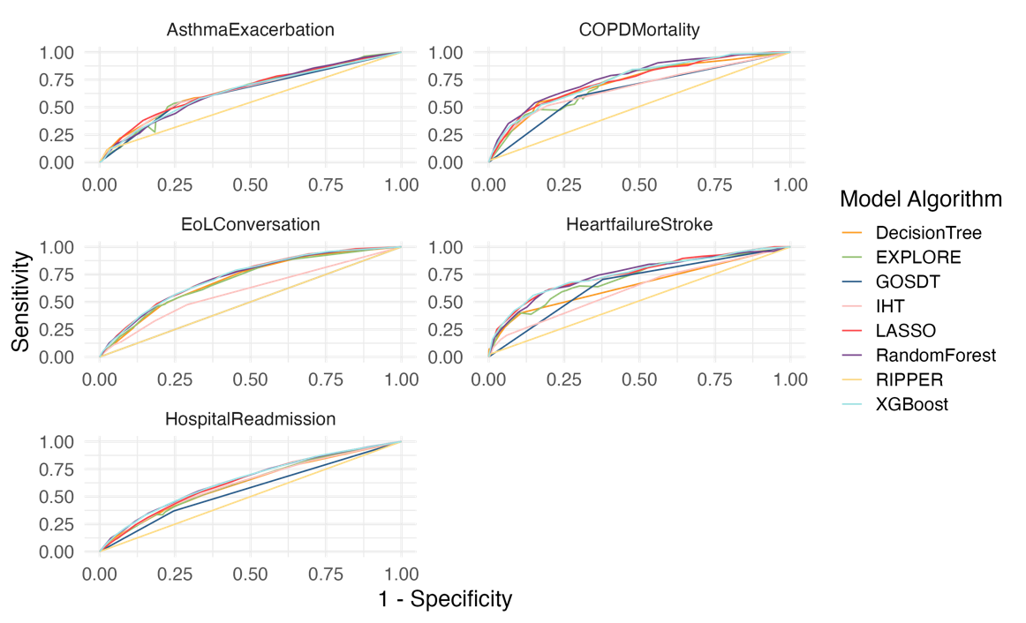

Table S6: AUROC values for prediction tasks on training and test set. Bold values indicate best performing models.
Model algorithm | Hospital readmission |  | End-of-life care |  | Asthma exacerbations |  | Mortality in COPD |  | Cardiovascular disease in T2DM
Model algorithm | Training | Test | Training | Test | Training | Test | Training | Test | Training | Test
DecisionTree | 0.62 | 0.62 | 0.72 | 0.70 | 0.65 | 0.66 | 0.75 | 0.73 | 0.67 | 0.65
EXPLORE | 0.62 | 0.61 | 0.69 | 0.69 | 0.64 | 0.64 | 0.73 | 0.70 | 0.73 | 0.71
GOSDT | 0.57 | 0.56 | 0.50 | 0.50 | 0.60 | 0.64 | 0.68 | 0.65 | 0.69 | 0.66
IHT | 0.62 | 0.62 | 0.61 | 0.60 | 0.61 | 0.65 | 0.67 | 0.68 | 0.59 | 0.62
LASSO | 0.64 | 0.64 | 0.74 | 0.73 | 0.66 | 0.66 | 0.80 | 0.74 | 0.78 | 0.75
RandomForest | 0.68 | 0.65 | 0.77 | 0.72 | 0.70 | 0.65 | 0.81 | 0.77 | 0.79 | 0.75
RIPPER | 0.50 | 0.50 | 0.50 | 0.50 | 0.54 | 0.54 | 0.54 | 0.51 | 0.54 | 0.51
XGBoost | 0.67 | 0.65 | 0.74 | 0.72 | 0.66 | 0.65 | 0.79 | 0.75 | 0.79 | 0.75

Table S7: Model sizes (number of computations) for prediction tasks.
Model algorithm | Hospital readmission | End-of-life care | Asthma exacerbations | Mortality in COPD | Cardiovascular disease in T2DM
DecisionTree | 31 | 31 | 21 | 23 | 27
EXPLORE | 5 | 4 | 5 | 5 | 4
GOSDT | 3 | 1* | 3 | 3 | 3
IHT | 9 | 7 | 4 | 4 | 4
LASSO | 39 | 31 | 24 | 39 | 31
RandomForest | 35028 | 32170 | 7158 | 7418 | 628
RIPPER | 0* | 0* | 5 | 21 | 17
XGBoost | 3935 | 364 | 315 | 259 | 684
Models with * are always predicting the majority class.

Table S8: Model sizes (number of unique features) for prediction tasks.
Model algorithm | Hospital readmission | End-of-life care | Asthma exacerbations | Mortality in COPD | Cardiovascular disease in T2DM
DecisionTree | 11 | 8 | 8 | 7 | 8
EXPLORE | 5 | 4 | 5 | 5 | 4
GOSDT | 1 | 0* | 1 | 1 | 1
IHT | 9 | 7 | 4 | 4 | 4
LASSO | 39 | 31 | 24 | 39 | 31
RandomForest | 50 | 49 | 40 | 47 | 40
RIPPER | 0* | 0* | 4 | 12 | 11
XGBoost | 49 | 39 | 26 | 34 | 29
Models with * are always predicting the majority class.

Figure S4: Model interpretability (number of unique features) versus performance for prediction tasks on test set. Each dot corresponds to a prediction model; colors represent different model algorithms and shapes represent different prediction tasks. The lines (fitted using a linear model) indicate the observed relation between interpretability and performance across the different models for each prediction task.
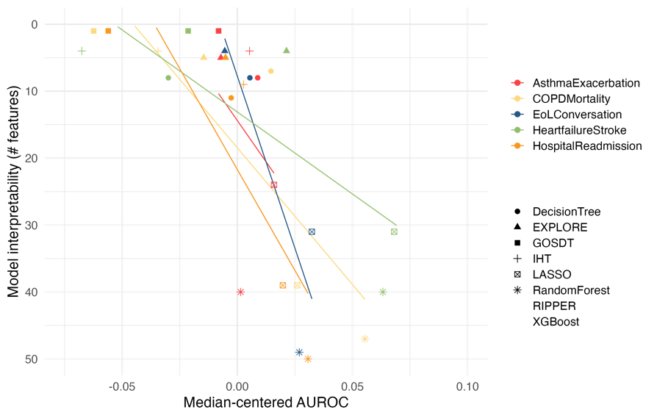

Table S9: Rashomon set and value for EXPLORE across prediction tasks.
 |  | Hospital readmission | End-of-life care | Asthma exacerbations | Mortality in COPD | Cardiovascular disease in T2DM
Length 4 | Size of Rashomon set | 675 | 465 | 394 | 153 | 590
Length 4 | Rashomon value | 6.81e-06 | 6.08e-06 | 4.44e-06 | 1.81e-06 | 7.16e-06
Length 4 | Model stability | 0.49 | 0.41 | 0.48 | 0.58 | 0.44
Length 4 | Percentage of features included:  < 10% | 86% | 86% | 90% | 90% | 90%
Length 4 | 10%-25% | 10% | 8% | 0% | 4% | 2%
Length 4 | 25%-75% | 0% | 4% | 6% | 2% | 6%
Length 4 | 75%-90% | 0% | 0% | 2% | 0% | 0%
Length 4 | >90% | 4%  (Cancer, Heart Failure) | 2%  (Age) | 2%  (Steroids) | 4%  (Cancer, Age) | 2%  (Age)
Length 5 | Size of Rashomon set | 13,544 | 20,320 | 1,588 | 1,381 | 13,169
Length 5 | Rashomon value | 4.26e-06 | 1.80e-05 | 7.17e-07 | 7.43e-07 | 8.10e-06
Length 5 | Model stability | 0.41 | 0.36 | 0.49 | 0.58 | 0.42
Length 5 | Percentage of features included:  < 10% | 88% | 88% | 84% | 90% | 88%
Length 5 | 10%-25% | 4% | 8% | 6% | 4% | 4%
Length 5 | 25%-75% | 4% | 0% | 6% | 0% | 4%
Length 5 | 75%-90% | 0% | 2% | 2% | 0% | 2%
Length 5 | >90% | 4%  (Cancer, Heart Failure) | 2%  (Age) | 2%  (Steroids) | 6%  (Age, Cancer, Heart Failure) | 2%  (Age)

Table S10: AUROC and balanced accuracy values for CHADS₂ score and improved versions with EXPLORE (bold values indicate best performing model).
 | AUROC |  | Balanced accuracy
 | Training | Test | Training | Test
CHADS₂ score | 0.80 | 0.79 | 0.74 | 0.73
EXPLORE –  retrain CHADS₂ | 0.82 | 0.80 | 0.79 | 0.79
EXPLORE –  CHADS₂ as feature | 0.84 | 0.83 | 0.80 | 0.78

References
1. Liang W, Liang H, Ou L, et al. Development and Validation of a Clinical Risk Score to Predict the Occurrence of Critical Illness in Hospitalized Patients With COVID-19. JAMA Internal Medicine 2020 https://doi.org/10.1001/jamainternmed.2020.2033.
2. Reps JM, Schuemie MJ, Suchard MA, Ryan PB, Rijnbeek PR. Design and implementation of a standardized framework to generate and evaluate patient-level prediction models using observational healthcare data. J. Am. Med. Inform. Assoc. 2018;25(8):969-75 https://doi.org/10.1093/jamia/ocy032.
3. Breiman L, Friedman J, Olshen R, Stone C. CART: Classification and Regression Trees, 1984.
4. Rijnbeek PR, Kors JA. Finding a short and accurate decision rule in disjunctive normal form by exhaustive search. Machine Learning 2010;80(1):33-62 https://doi.org/10.1007/s10994-010-5168-9.
5. McTavish H, Zhong C, Achermann R, et al. Fast Sparse Decision Tree Optimization via Reference Ensembles. Proc AAAI Conf Artif Intell 2022;36(9):9604-13 https://doi.org/10.1609/aaai.v36i9.21194.
6. Blumensath T, Davies ME. Iterative hard thresholding for compressed sensing. Applied and Computational Harmonic Analysis 2009;27(3):265-74 https://doi.org/10.1016/j.acha.2009.04.002.
7. Suchard MA, Simpson SE, Zorych I, Ryan P, Madigan D. Massive parallelization of serial inference algorithms for a complex generalized linear model. ACM Transactions on Modeling and Computer Simulation (TOMACS) 2013;23(1):1-17 https://doi.org/10.1145%2F2414416.2414791.
8. Breiman L. Random forests. Machine Learning 2001;45(1):5-32 https://doi.org/10.1023/A:1010933404324.
9. Cohen WW. Fast effective rule induction. Machine Learning Proceedings 1995; Elsevier:115-23 https://doi.org/10.1016/B978-1-55860-377-6.50023-2.
10. Chen T, Guestrin C. Xgboost: A scalable tree boosting system. Proceedings of the 22nd ACM SIGKDD International Conference on Knowledge Discovery and Data Mining 2016:785-94 https://doi.org/10.1145/2939672.2939785.

