Figure Legends.

Figure 1. Venn diagram of DEHP and RCC.
Figure 2. The PPI network of potential targets.
Figure 3. The PPI network of core targets.

Figure 4. GO enrichment analysis for potential targets.
(A) Histogram showing the top 10 enriched terms for each GO category (Biological Process, Cellular Component, Molecular Function). Bar height indicates gene count for each term. (B) Bubble plot illustrating enrichment across GO terms. Bubble size reflects gene count, while color saturation represents enrichment significance (-log10(FDR)).

Figure 5. KEGG enrichment analysis of potential targets.
(A)Bubble plot of the top 20 enriched KEGG pathways, ranked by FDR. Bubble size represents the number of enriched genes, and color intensity indicates significance. (B) Histogram showing the gene counts for each enriched pathway. Bar length represents gene count, and colors denote pathway categories.

Figure 6. Sankey plot showing KEGG enrichment analysis.
This figure shows the top 10 KEGG pathways by FDR. Overlapping genes are linked by grey lines in the Sankey plot on the left. The bubble plot on the right shows gene counts (bubble size) and enrichment levels (color intensity, with deeper colors indicating higher -log10(P-value)).

Figure 7. Molecular docking results of the lowest binding energy in each target protein with the DEHP.
(A)CASP3 and DEHP, (B)BCL2 and DEHP, (C)MMP9 and DEHP,
(D)BCL2L1 and DEHP, (E)CTSS and DEHP, (F)APP and DEHP.

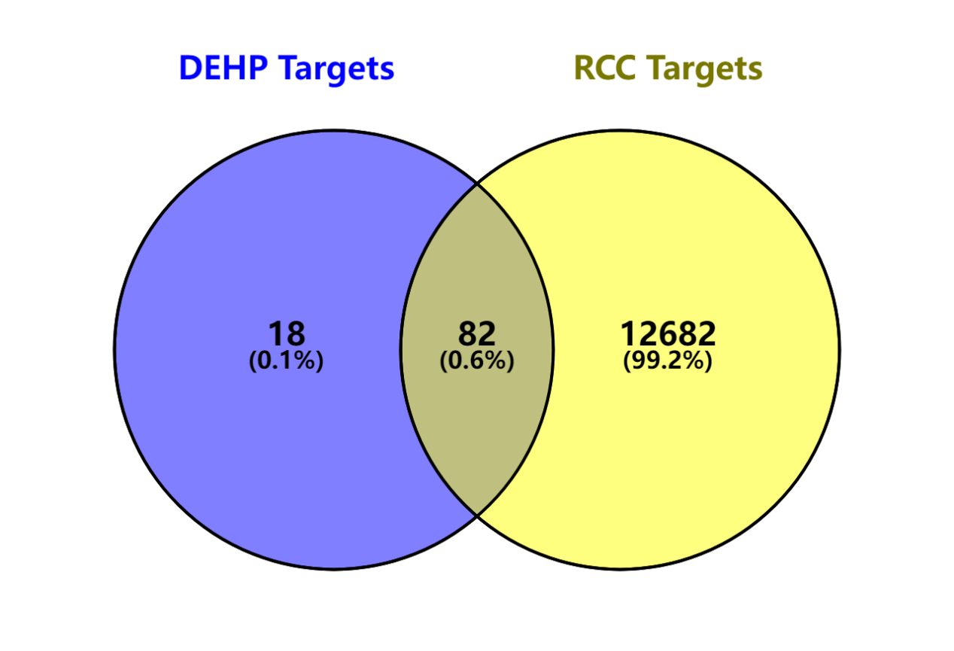
Figure Legends.
Figure 1. Venn diagram of the targets of DEHP and RCC.
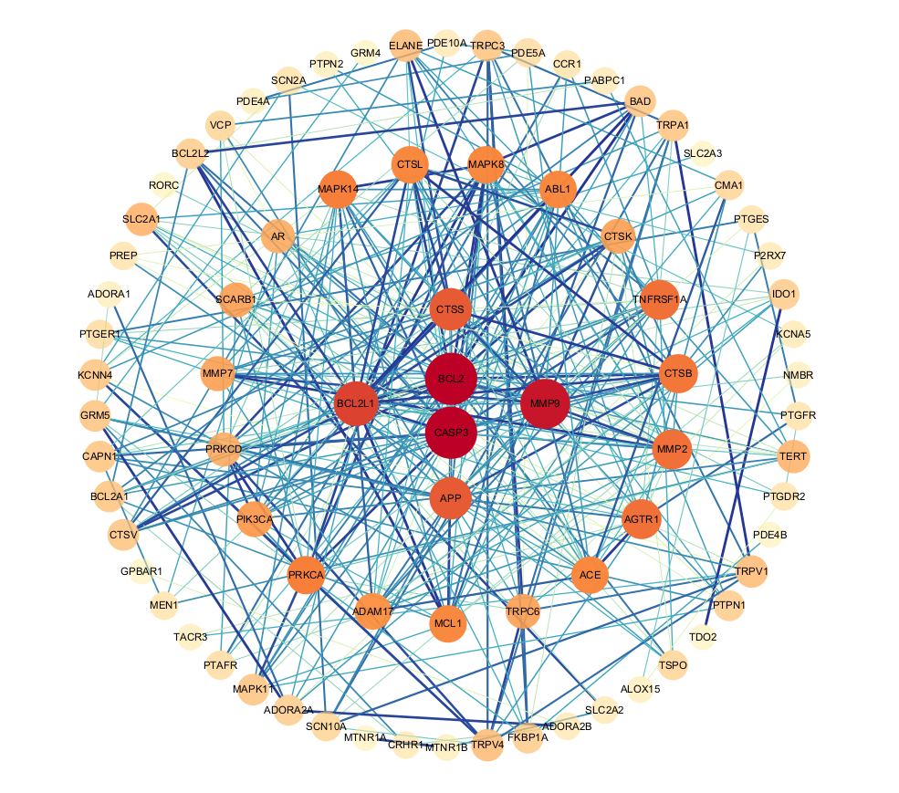
Figure 2. The PPI network of potential targets.
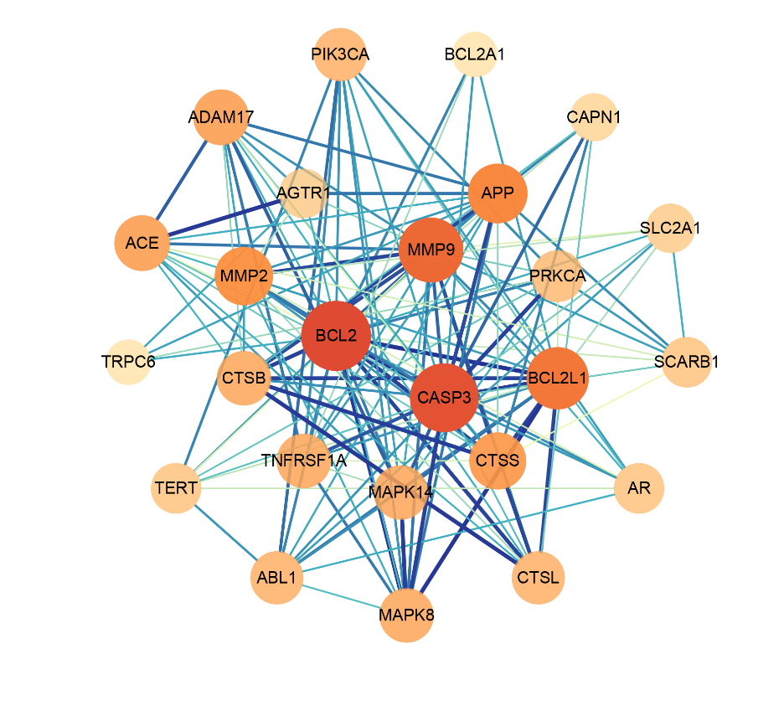
Figure 3. The PPI network of core targets.

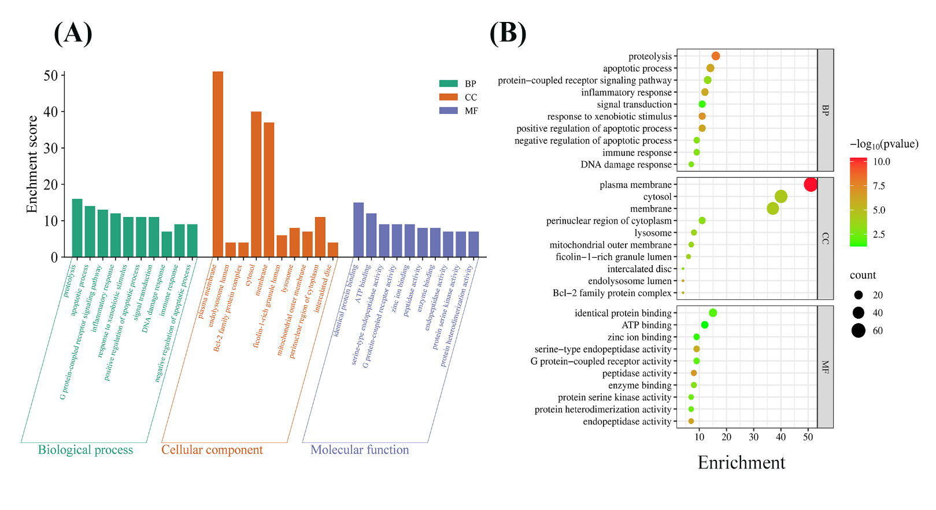
Figure 4. GO enrichment analysis for potential targets.
(A) Histogram showing the top 10 enriched terms for each GO category (Biological Process, Cellular Component, Molecular Function). Bar height indicates gene count for each term. (B) Bubble plot illustrating enrichment across GO terms. Bubble size reflects gene count, while color saturation represents enrichment significance (-log10(FDR)).

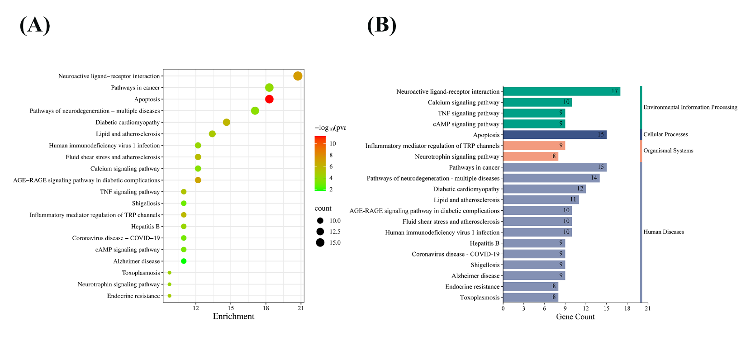
Figure 5. KEGG enrichment analysis of potential targets.
(A)Bubble plot of the top 20 enriched KEGG pathways, ranked by FDR. Bubble size represents the number of enriched genes, and color intensity indicates significance. (B) Histogram showing the gene counts for each enriched pathway. Bar length represents gene count, and colors denote pathway categories.
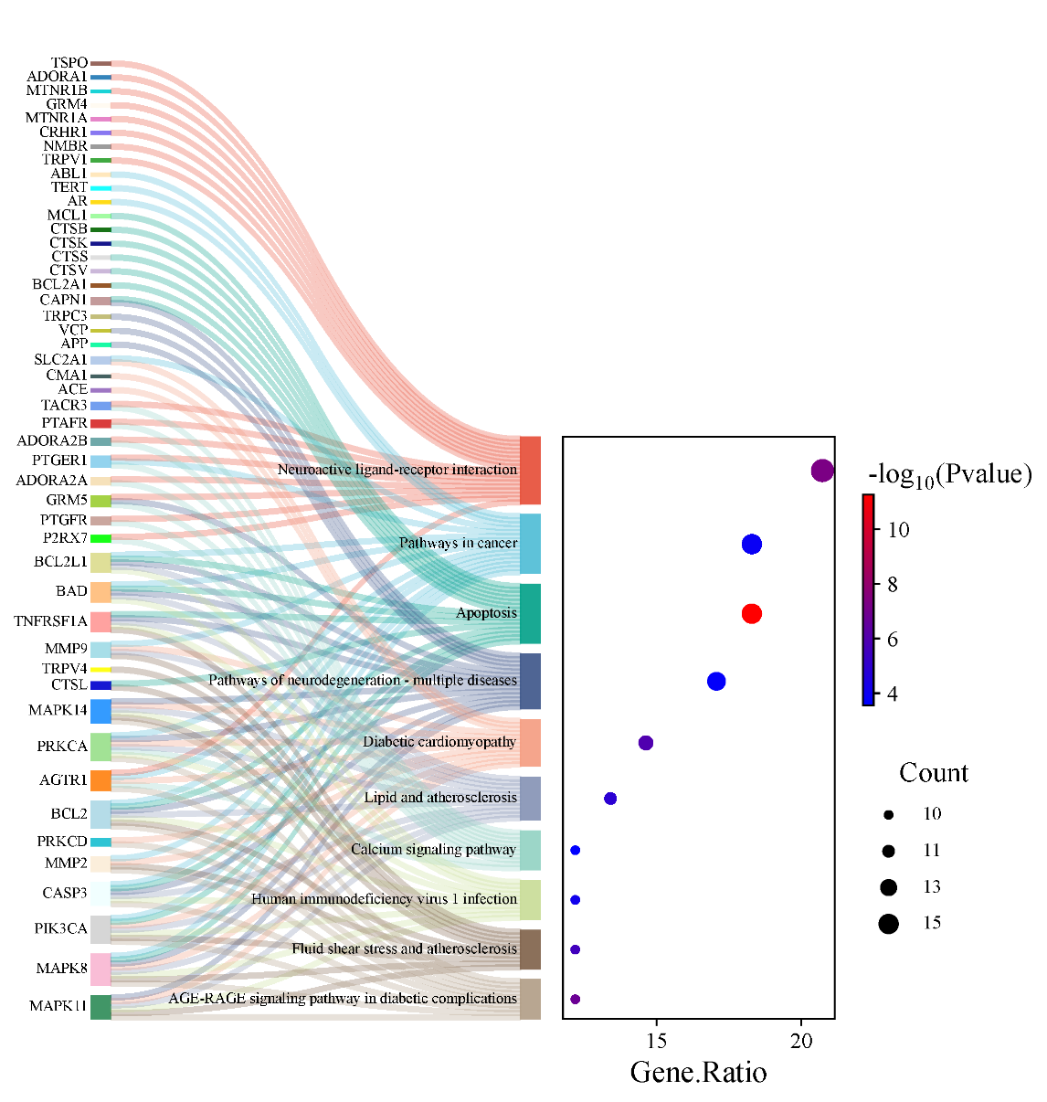
Figure 6. Sankey plot showing KEGG enrichment analysis.
This figure shows the top 10 KEGG pathways by FDR. Overlapping genes are linked by grey lines in the Sankey plot on the left. The bubble plot on the right shows gene counts (bubble size) and enrichment levels (color intensity, with deeper colors indicating higher -log10(P-value)).

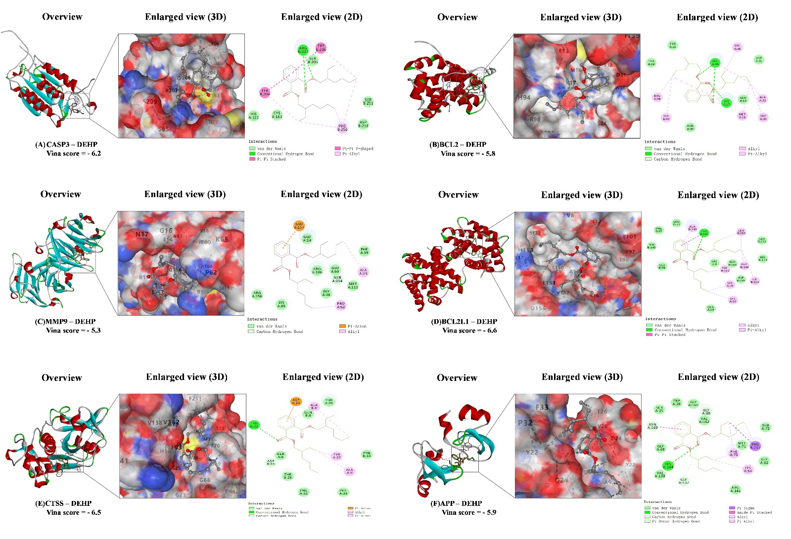
Figure 7. Molecular docking results of the lowest binding energy in each target protein with the DEHP.
(A)CASP3 and DEHP, (B)BCL2 and DEHP, (C)MMP9 and DEHP,
(D)BCL2L1 and DEHP, (E)CTSS and DEHP, (F)APP and DEHP.

