Green Synthesis, Characterization, In Silico Molecular Docking and Biological Evaluation of Imidazolylchalcones as Promising Fungicide/s and Nematicide/s
Rakesh Kumar^{1,2,3}, Parshant Kaushik¹, Kailashpati Tripathi^{1,4}, Rajni Godara¹,, Sameer Ranjan Misra¹, Vijay Kumar¹, Patha Chandra Mondal¹,Jeetram¹, Pankaj⁵, Virendra Singh Rana¹, V. Shanmugam⁶, Dilip Khatri⁷ and Najam Akhtar Shakil¹*
¹Division of Agricultural Chemicals, ICAR-Indian Agricultural Research Institute, New Delhi, India
²The Graduate School, ICAR-Indian Agricultural Research Institute, New Delhi, India
³ICAR-Central Inland Fisheries Research Institute, RC, Guwahati, Assam, India
⁴ICAR- National Research Centre on Seed Spices, Ajmer, Rajasthan. India
⁵Division of Nematology, ICAR-Indian Agricultural Research Institute, New Delhi, India
⁶Division of Plant Pathology, ICAR-Indian Agricultural Research Institute, New Delhi, India
⁷PI Industries, Udaipur, India
*Corresponding author’s E-mail address: iamshakil@gmail.com

Supporting Information
¹H-NMR, ¹³C-NMR and HRMS spectra of most effective compounds IC-1, IC-4, IC-6 and IC-8 (imidazolylchalcone derivatives)

IC-1:
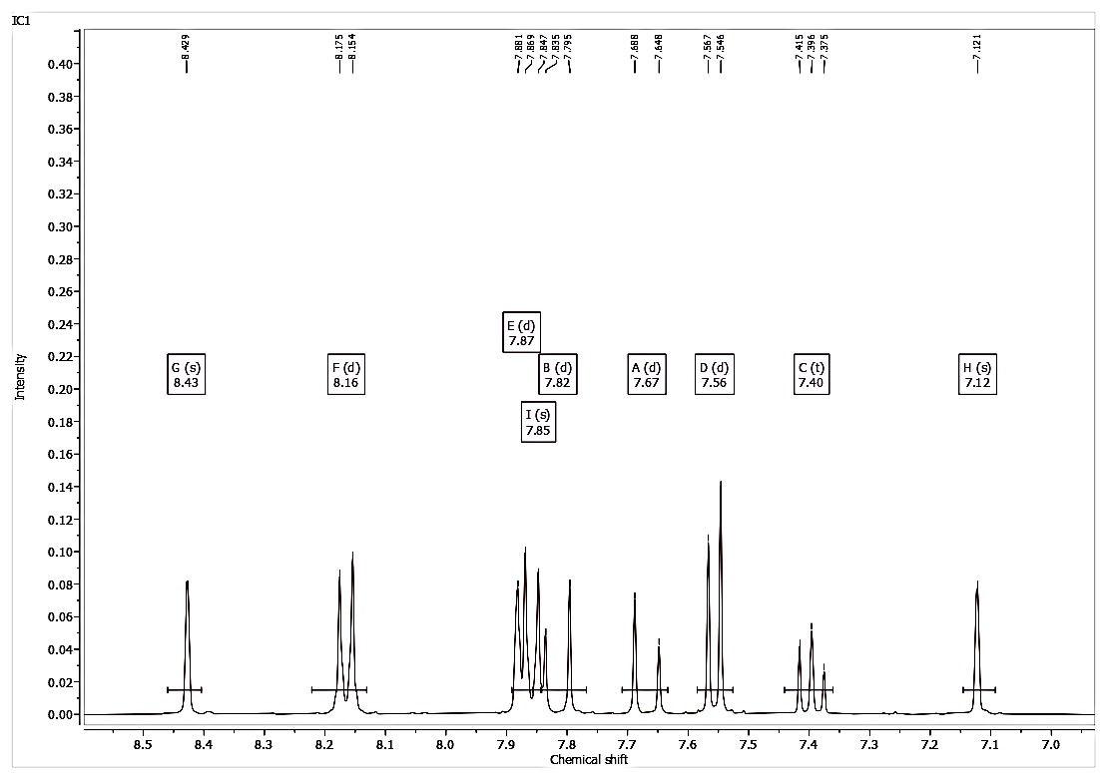Fig 1: ¹H-NMR spectrum of IC-1
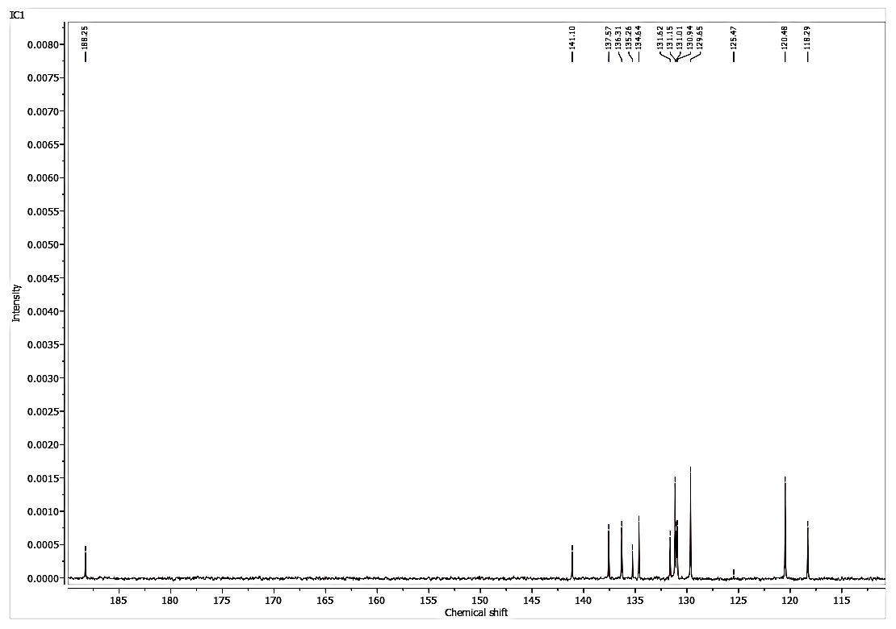Fig 2: ¹³C-NMR spectrum of IC-1
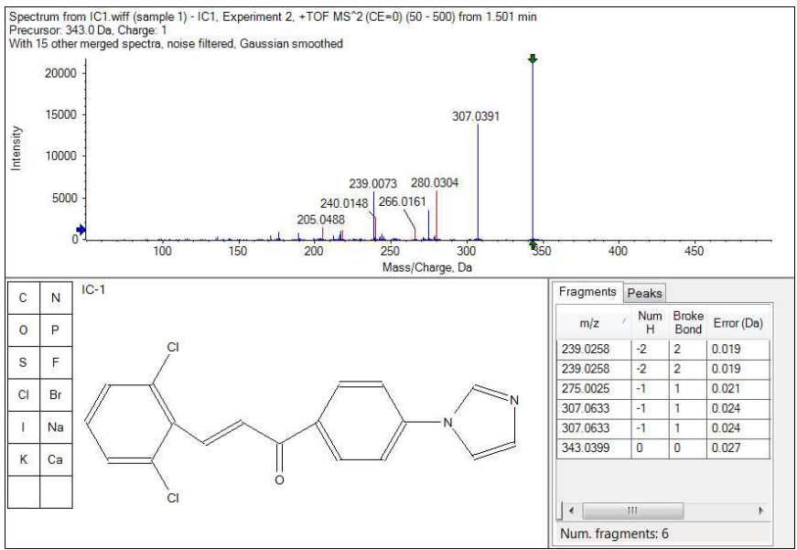
Fig 3: HRMS spectrum of IC-1

IC-4:
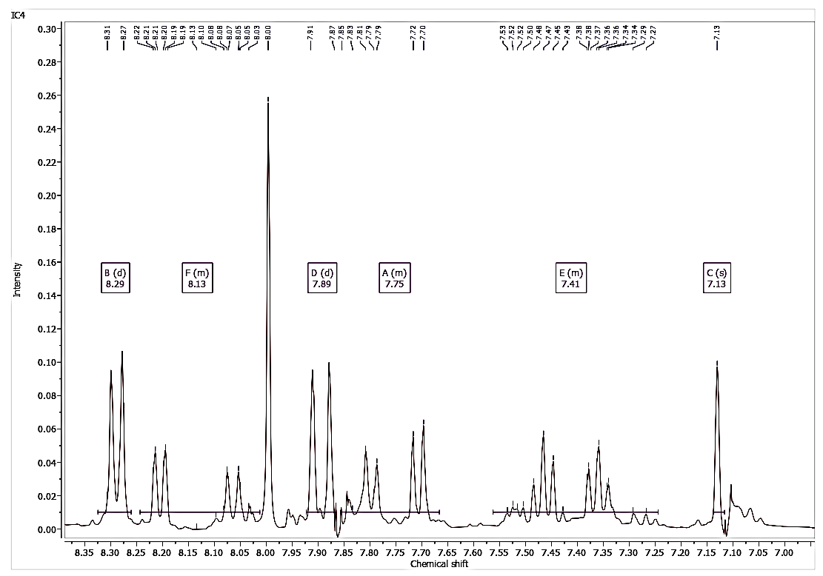
Fig 4: ¹H-NMR spectrum of IC-4
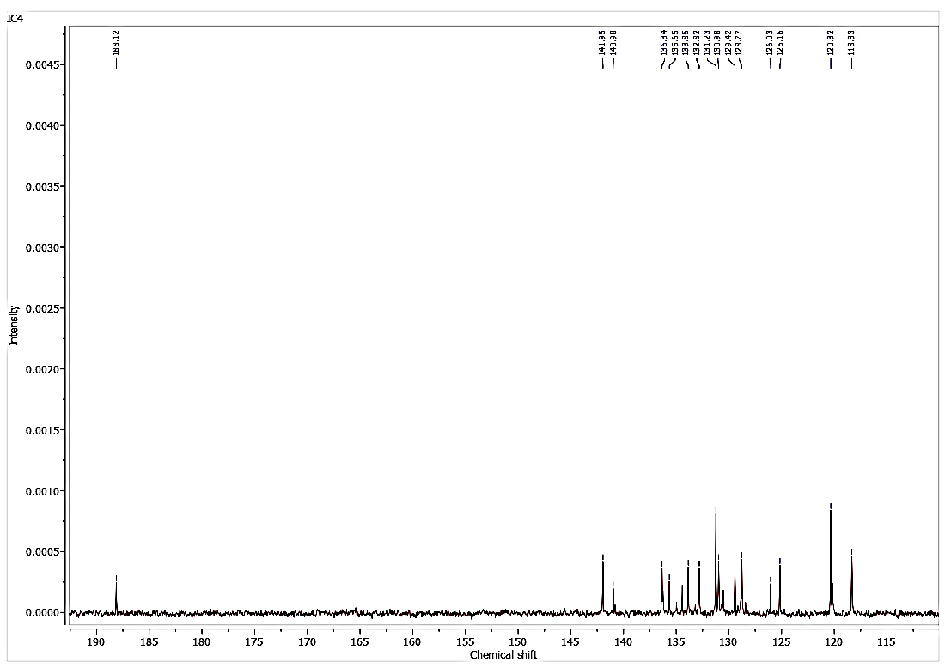
Fig 5: ¹³C-NMR spectrum of IC-4
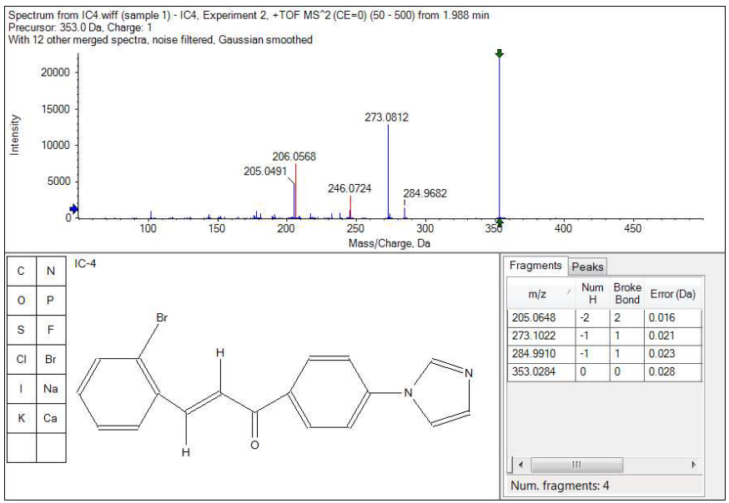
Fig 6: HRMS spectrum of IC-4

IC-6:
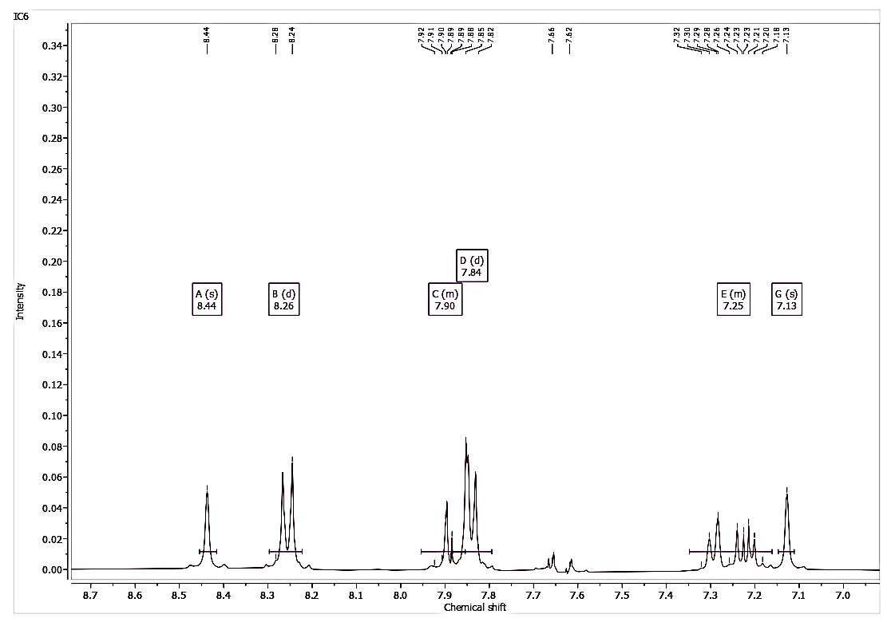Fig 7: ¹H-NMR spectrum of IC-6
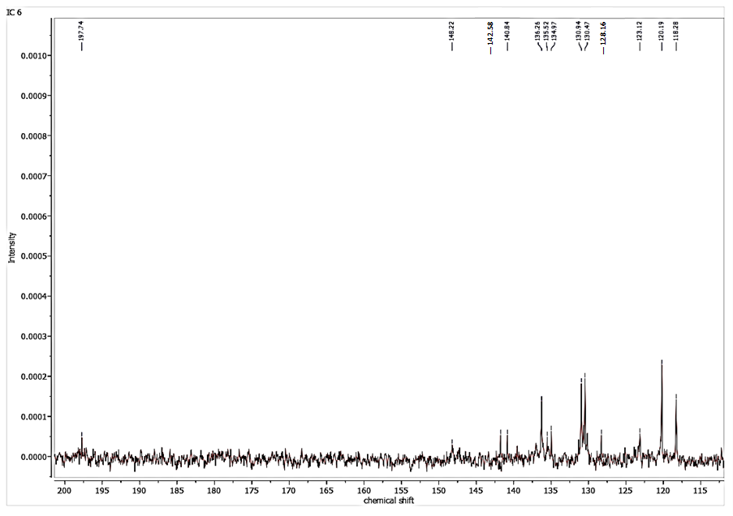Fig 8: ¹³C-NMR spectrum of IC-6
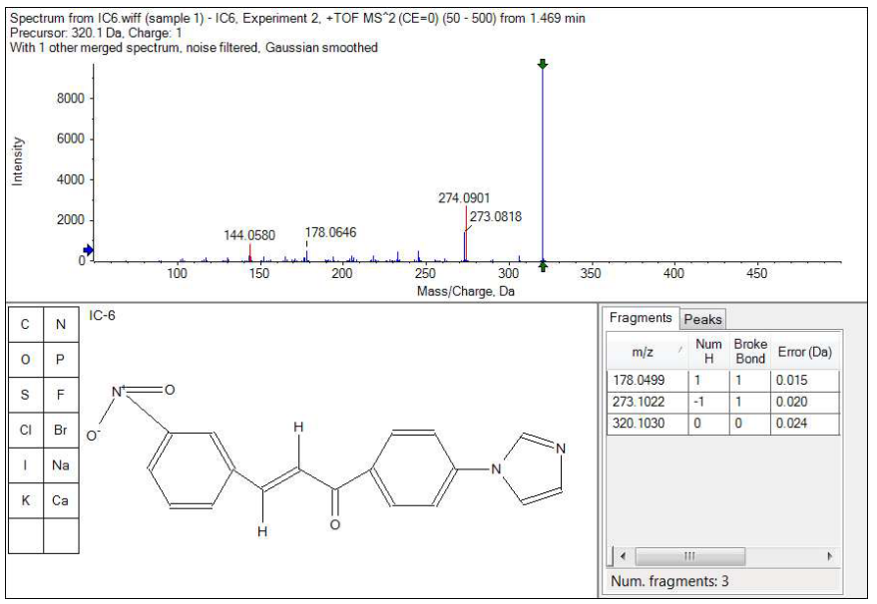
Fig 9: HRMS spectrum of IC-6
IC-8:
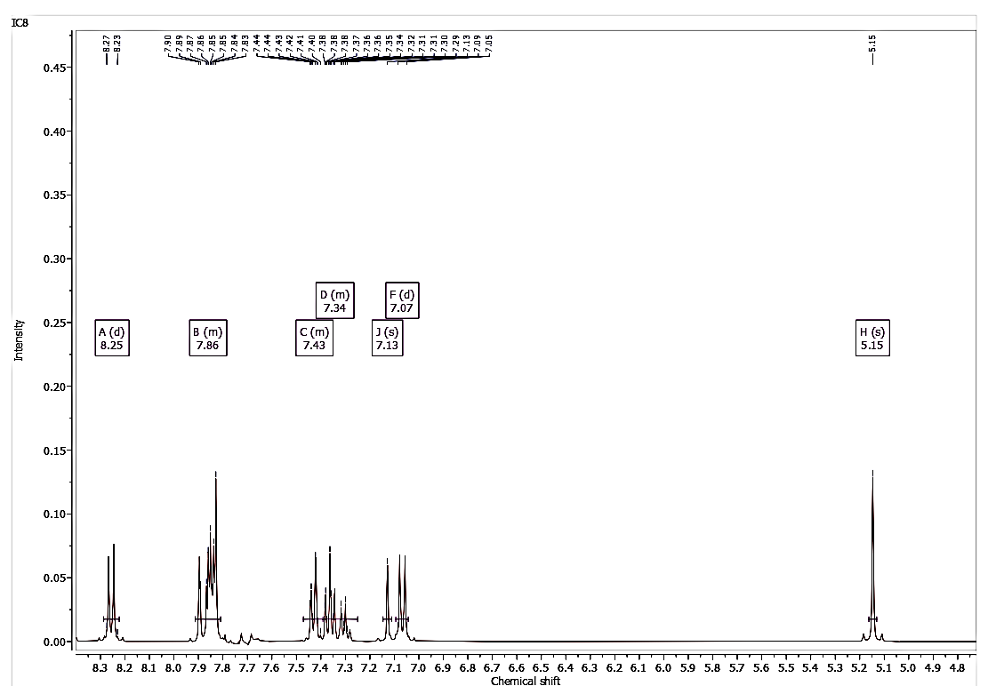Fig 10: ¹H-NMR spectrum of IC-8
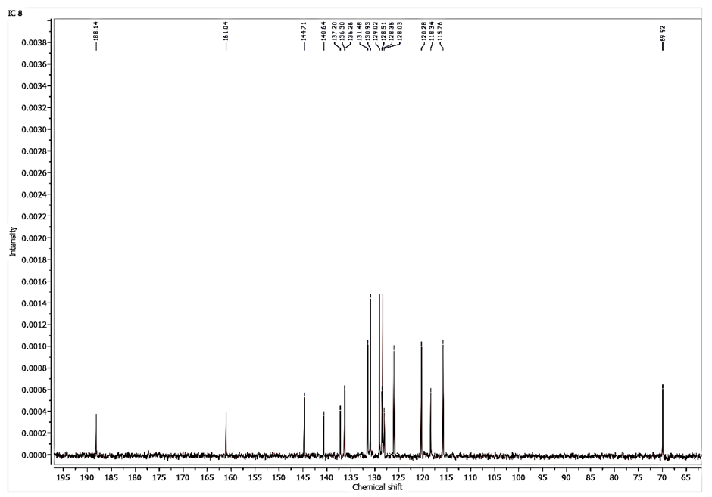Fig 11: ¹³C-NMR spectrum of IC-8
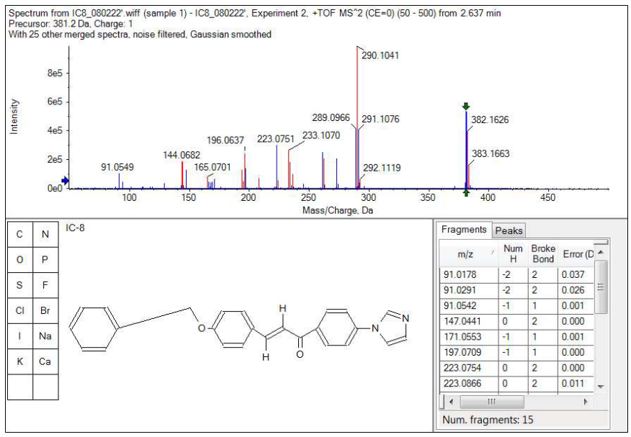
Fig 12: HRMS spectrum of IC-8

