Marine Furanocembranoids-Inspired Macrocycles Enabled by Pd-catalyzed Unactivated C(sp³)-H Insertion Reaction of Donor/Donor Carbenes

Jiping Hao,¹⁺ Xueying Guo,⁴⁺ Shijun He,¹⁺ Zhongliang Xu,¹ Lu Chen,¹ Zhongyu Li,¹ Bichao Song,¹ Jianping Zuo,¹ Zhenyang Lin*,⁴ and Weibo Yang*^{1,2,3}
1 Chinese Academy of Sciences Key Laboratory of Receptor Research, Shanghai Institute of Materia Medica (SIMM), Chinese Academy of Sciences, Shanghai, China
2 University of Chinese Academy of Sciences, Beijing 100049, China
3 School of Pharmaceutical Science and Technology, Hangzhou Institute for Advanced Study, University of Chinese Academy of Sciences, Hangzhou 310024, China.
4 Department of Chemistry, The Hong Kong University of Science and Technology, Clear Water Bay, Kowloon, Hong Kong, China

Contents:

Page 3: General comments
Page 4: General Procedure for the Synthesis of the starting materials
Page 8: Procedure for the Gram-Scale reaction for 3ba and the transformation
Page 9: The preparation of the macrolactams
Page 17: X-ray molecular structure and Crystallographic Data
Page 41: The DFT calculated details
Page 105: Bioactivity test
Page 107: Characterization data of compounds
Page 132: NMR Spectra
Page 174: References

General comments:
NMR spectra were recorded at room temperature on the following spectrometers: Bruker Avance III 400 Spectrometer (400 MHz) and Bruker Avance III 500 (Cryo) Spectrometer (500 MHz). Chemical shifts are given in ppm and coupling constants in Hz. ¹H spectra were calibrated in relation to the reference measurement of TMS (0.00 ppm). ¹³C spectra were calibrated in relation to deuterated solvents. The following abbreviations were used for ¹H NMR spectra to indicate the signal multiplicity: s (singlet), d (doublet), t (triplet), q (quartet) and m (multiplet) as well as combinations of them. For HRMS data, the ESI-positive method was applied on the Agilent G6520 Q-TOF. Chemicals were purchased from commercial suppliers. Unless stated otherwise, all the substrates and solvents were purified and dried according to standard methods prior to use.

General Procedure for the Synthesis of the starting materials
  - Synthesis of 1-Bromo-2-tert-butylbenzenes
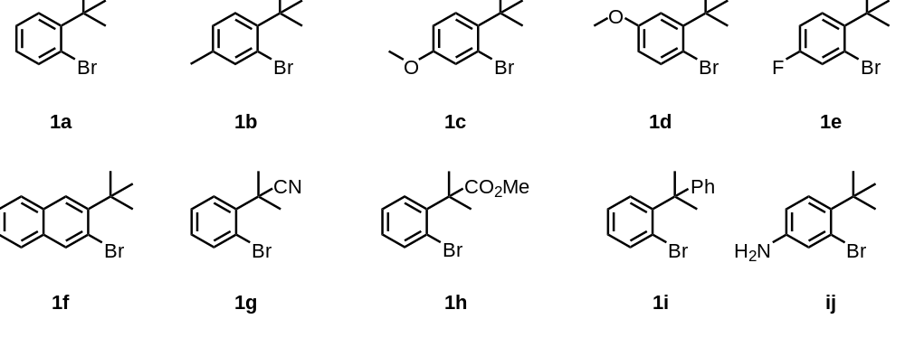
1a was prepared by following method A ^{[1]}. 1b, 1c, 1d, 1e, 1f, and 1i were prepared by following method B ^{[2]}. 1g and 1i have commercial sources. 1h were prepared by following method C^{[3]}.
Method A:
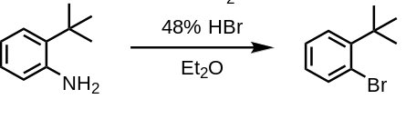
2-tert-Butylaniline (2.50 g, 16.7 mmol) was added to 13 mL 48% w/w hydrobromic acid. The thus formed pale pink suspension was cooled to -56 ℃. Then, sodium nitrite (1.68 g, 24.4 mmol) was added portion-wise. After stirring for 1 hour, 20 mL Et₂O was added slowly. The temperature was adjusted to -8 ℃ over 2 hours and kept at -8 ℃ for an additional 2 hours. Next, the system was cooled to -40 ℃ again. 3.06 g Na₂CO₃ was added. The reaction was then warming up slowly to room temperature over 3 hours and stirred overnight. The reaction was diluted with water and extracted with EtOAc. The organic layer was washed with water, NaHCO₃ (aq.), brine, dried over Na₂SO₄, concentrated in vacuo, and purified by silica gel column chromatography with petroleum ether to afford 1-bromo-2-(tert-butyl)benzene as a colorless oil.(1.49 g, 42% yield)

Method B:
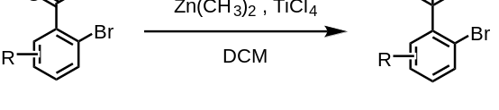
Under nitrogen atmosphere, TiCl₄ (1 M in CH₂Cl₂, 2.2 equiv.) was added to anhydrous CH₂Cl₂ (0.3 M) and cooled to - 40 ℃. Then, a solution of Me₂Zn (1 M in hexane, 2.2 equiv.) was added dropwise. After stirring for 15 minutes, a solution of aryl ketone in anhydrous CH₂Cl₂ (1 M) was added dropwise. The reaction was warm to 0 ℃ slowly (over 3 hours), stirred at 0 ℃ overnight, and poured into ice water. The aqueous phase was extracted with CH₂Cl₂. The combined organic layers were washed with NaHCO₃ (aq.), brine, dried over Na₂SO₄, filtered and concentrated in vacuo. (If necessary, the crude product was dissolved in CH₂Cl₂, treated with 3-chloroperoxybenzoic acid (m-CPMA) and stirred at room temperature to remove the aryl propene, a by-product of the reaction, which is not easy to be separated from the desired product by silica gel column chromatography). The crude product was purified by silica gel column chromatography with petroleum ether/ethyl acetate to afford the corresponding aryl bromide. (45-67% yield)
Method C:
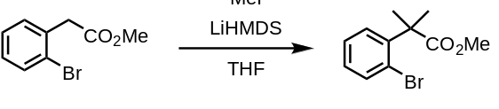
To a stirred solution of HMDS (4.25 mL, 20.0 mmol) in THF (36.8 mL) was added n-BuLi (1.60 M in hexane, 12.5 mL, 20.0 mmol) at 0 °C. After the mixture was stirred for 1.5 h, a solution of methyl 2-(2-bromophenyl)acetate (1.2 g, 5.0 mmol) in THF (25.0 mL) was added, and the mixture was stirred for 2 h at room temperature. Then CH₃I (1.20 mL, 20.0 mmol) was added at 0 °C, and the mixture was stirred for 12 h at room temperature. Then the reaction was quenched by addition of 1 M HCl at 0 °C. The crude mixture was extracted with EtOAc (x4) and the combined organic extracts were washed with brine, dried (Na₂SO₄) and concentrated in vacuo. The crude product was purified by silica gel column chromatography with petroleum ether/ethyl acetate to afford the corresponding product as a colorless oil. (1g, 78% yield)
  - Synthesis of complex 1-Bromo-2-tert-butylbenzenes from drug molecules
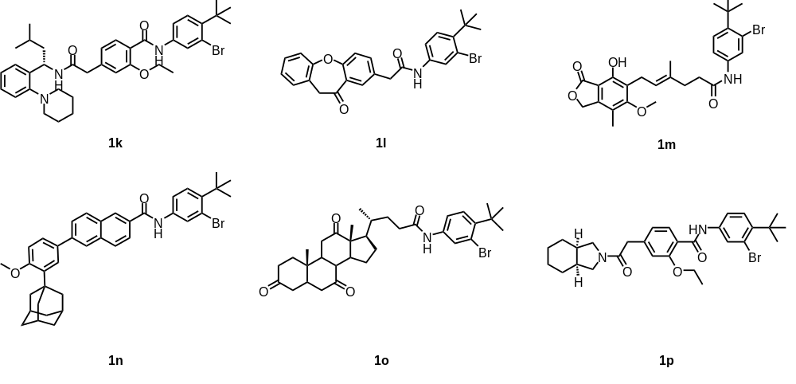
These compounds were all prepared by the following method.
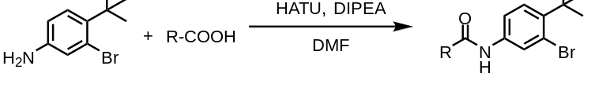
3-bromo-4-(tert-butyl)aniline(70 mg, 0.3 mmol), and the corresponding complex acids(0.36 mmol), and HATU(171 mg, 0.45 mmol), DIPEA(156 mg, 1.2 mmol) were in 5 mL DMF. The mixture was stirred at rt for 12 h. The reaction was diluted with water and extracted with EtOAc. The organic layer was washed with brine, dried over Na₂SO₄, concentrated in vacuo, and purified by silica gel column chromatography with PE and EA (PE = petroleumether, EA = ethyl acetate) to afford corresponding products.
  - Synthesis of Ene-Yne-Ketones
The ene-yne-ketones used in this study were prepared by two steps starting from terminal alkynes and 1,3-dicarbonyl compounds.
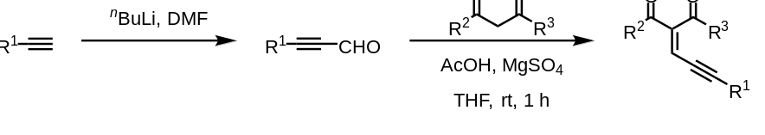
The alkyne (10 mmol) was dissolved in dry THF (15 mL) and the solution was cooled to -40 °C under nitrogen, n-butyllithium (1.6 M in hexanes, 6.8 mL, 11 mmol) was added dropwise over 2 minutes while maintaining the temperature between -35 and -40 °C. After completion of the addition, anhydrous DMF (1.55 mL, 20 mmol) was added in one portion and the cold bath was removed. The reaction mixture was warm to room temperature and aged for 30 minutes. The THF solution was poured into a vigorously stirred biphasic solution prepared from aqueous solution of KH₂PO₄ (50 mL, 30 mmol) and Et₂O (30 mL) cooled over ice to about 5 °C. Layers were separated and the organic extract was washed with water (2 x 30 mL). Combined aqueous layers were back extracted with Et₂O (30 mL). Combined organic layers were dried over Na₂SO₄ and filtered. Then solvent was removed in vacuo carefully under 0 °C to leave a crude acetylenic aldehyde.
The crude product was then dissolved in THF (8 mL), and 1,3-dicarbonyl compounds (10 mmol) was added into the solution. Then AcOH (2 mmol) and MgSO₄ (2 mmol) was added to the reaction mixture. The mixture was stirred at room temperature for about one hour. When the reaction was completed as monitored by TLC, filtration through celite and removal of the solvent by rotary evaporation gave the crude product. The ene-yne-ketones was purified by chromatography on silica gel with the appropriate mixture of PE and EA (PE = petroleumether, EA = ethyl acetate) with about 50-70% yields (two steps). ^{[4]}
  - Synthesis of Allenes
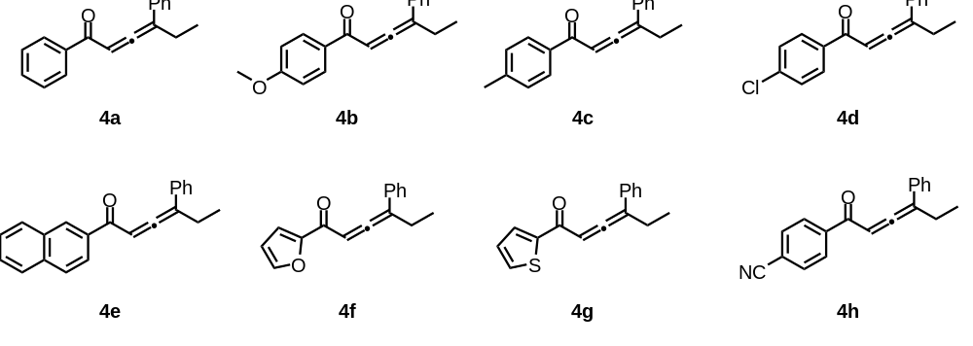
These compounds were all prepared by the following method.
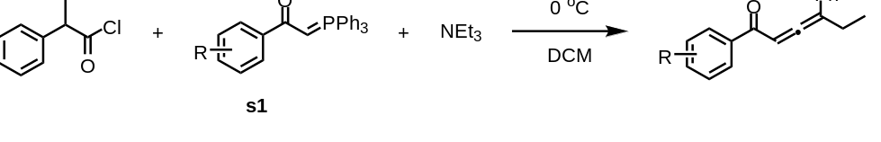
To an ice-cooled (0°C) solution of s1(7.89 mmol) and triethylamine (1.1 ml, 7.89 mmol) in 23 ml of dry dichloromethane stirred under argon was added dropwise a solution of 2-phenylbutanoyl chloride (2.02 g, 7.89 mmol) in 8 ml of dry dichloromethane. The resulting bright yellow solution was stirred for 2 h. After removal of half of the solvent, the residue was diluted with diethyl ether to precipitate triphenylphosphine oxide. After filtration, silica gel was added to adsorb the reaction products and the solvent was evaporated in vacuo. Flash Silica column chromatography (1:10 EtOAc/hexanes) gave the corresponding products^{[5]}.(21-50% yield)

Procedure for the Gram-Scale reaction for 3ba and the transformation
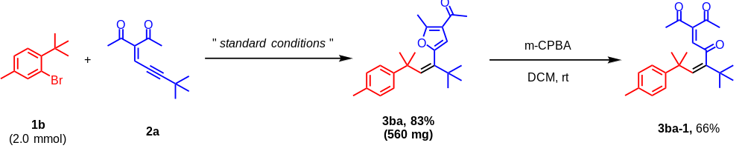
A screw-capped vial was charged with 2-bromo-1-(tert-butyl)-4-methylbenzene 1b (2.0 mmol, 454 mg, 1.0 equiv.), the respective 3-(4,4-dimethylpent-2-yn-1-ylidene)pentane-2,4-dione 2a (4.0 mmol, 770 mg, 2.0 equiv.), [Pd(Cl(allyl)]₂ (5 mol%), ^{t}BuXphos (30 mol%), NaOAc (3.0 equiv.), DMF (5.0 mL). The reaction mixture was stirred at 100 ºC under N₂ for 4 h, and then quenched with saturated aqueous NaCl and extracted with ethyl acetate. After drying over Na₂SO₄ for 30 min, the combined organic phase was concentrated, and the residue was purified by silica gel column chromatography with petroleum ether/ethyl acetate to afford the product 3ba as a yellow oil. (560 mg, 83% yield)
The product 3ba (0.1 mmol, 34 mg, 1.0 equiv.) was dissolved in DCM (2.0 mL), and m-CPBA (0.2 mmol, 35 mg, 2.0 equiv.) was added into the solution. The mixture was stirred at rt. When the reaction was completed as monitored by TLC, filtration through celite and removal of the solvent by rotary evaporation gave the crude product. The residue was purified by chromatography on silica gel with the appropriate mixture of PE and EA (PE = petroleumether, EA = ethyl acetate) to afford the product 3ba-1 as a colorless oil. (23.5 mg, 66% yield)

4. The preparation of the macrolactams
4.1 Synthesis of 6a
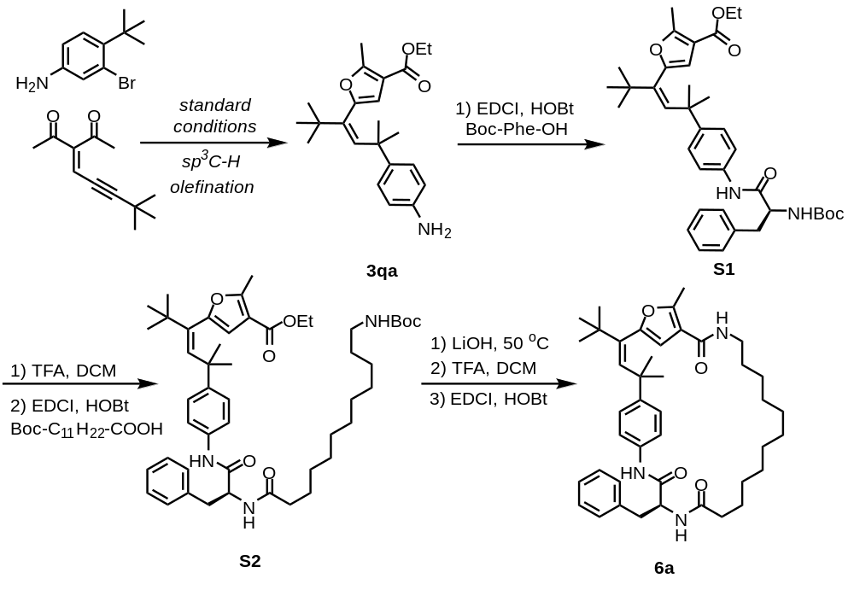Synthesis of 3qa:
Please refer to 3ba
From 3qa to S1:
To a solution of 3qa (50 mg, 0.14 mmol) in DCM (2 mL) were added EDCI (51.5 mg, 0.27 mmol), HOBt (36.6 mg, 0.27 mmol), Boc-Phe-OH (42.4 mg, 0.16 mmol). The stirring of the solution was continued at r.t. for 18 h. Then the solution was washed with water, and the organic phase was evaporated under reduced pressure and the residue was purified by FCC to get the desired product S1 (54.9 mg, Yield: 66%).
From S1 to S2:
The S1 (54.9 mg, 0.09 mmol) was dissolved in DCM (2 mL) and TFA (0.2 mL) were added slowly. The stirring of the solution was continued at r.t. for 4 h. Then the solution was evaporating under reduced pressure. And the residue was used in the next step without further purification.
The residue was dissolved in DCM (5 mL). And EDCI (51.5 mg, 0.27 mmol), HOBt (36.6 mg, 0.27 mmol), Boc-NH-(CH₂)₁₁-COOH (56.7 mg, 0.18 mmol) were added. The stirring of the solution was continued at r.t. for 24 h. Then the solution was washed with water, and the organic phase was evaporated under reduced pressure and the residue was purified by FCC to get the desired product S2 (54.2 mg, 74% yield in two steps from S1).
From S2 to 6a:
The S2 (54.2 mg, 0.07 mmol) was dissolved in DCM (2 mL) and TFA (0.2 mL) were added slowly. The stirring of the solution was continued at r.t. for 4 h. Then the solution was evaporating under reduced pressure. And the residue was used in the next step without further purification.
The residue was dissolved in MeOH (2 mL) and the solution of NaOH (100 mg) in H₂O were added slowly. The stirring of the solution was continued at 50 ºC for 4 h. Then the solution was acidified by HCl, followed by evaporating under reduced pressure. And the residue was used in the next step without further purification.
The residue was dissolved in DCM (40 mL). And EDCI (76.4 mg, 0.4 mmol), HOBt (54.0 mg, 0.4 mmol) were added. The stirring of the solution was continued at r.t. for 24 h. Then the solution was washed with water, and the organic phase was evaporated under reduced pressure and the residue was purified by FCC to get the desired product 6a as a white solid (11.8 mg, 27.2% yield in three steps from S2).
4.2 Synthesis of 6b
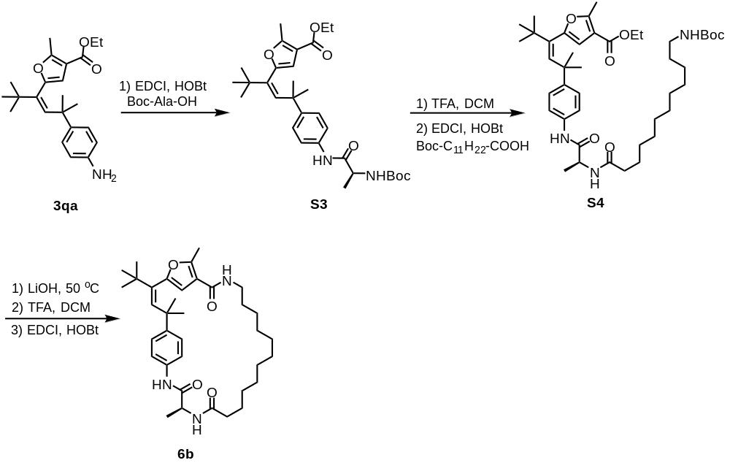 Synthesis of 6b:
This compound was prepared form 3qa and Boc-Ala-OH using the procedure described for 6b and was isolated as a white solid, 2.5 mg, 2.9% yield in six steps from 3qa.
4.3 Synthesis of 6c
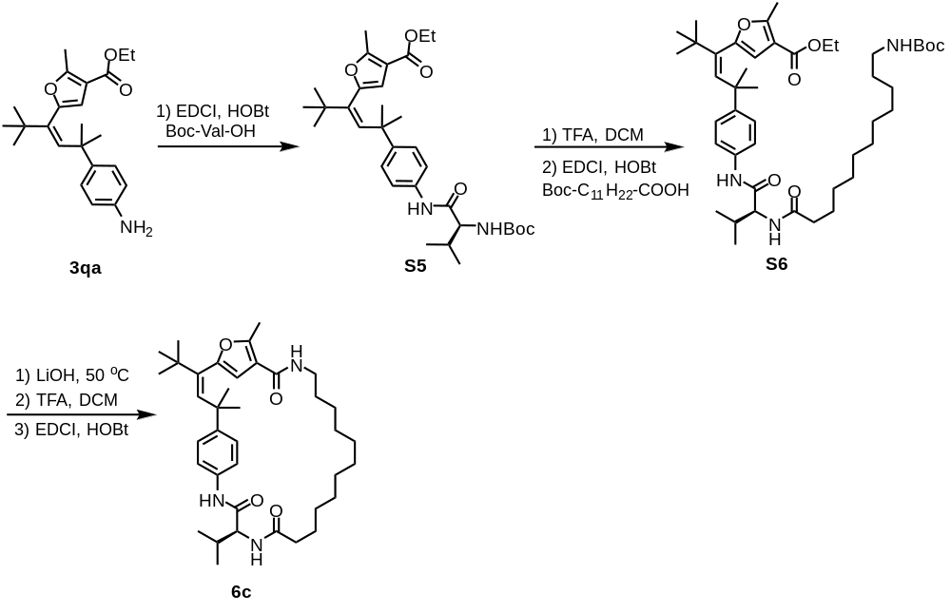
Synthesis of 6c:
This compound was prepared form 3qa and Boc-Val-OH using the procedure described for 6c and was isolated as a white solid, 4.6 mg, 5.5% yield in six steps from 3qa.
4.4 Synthesis of 6d
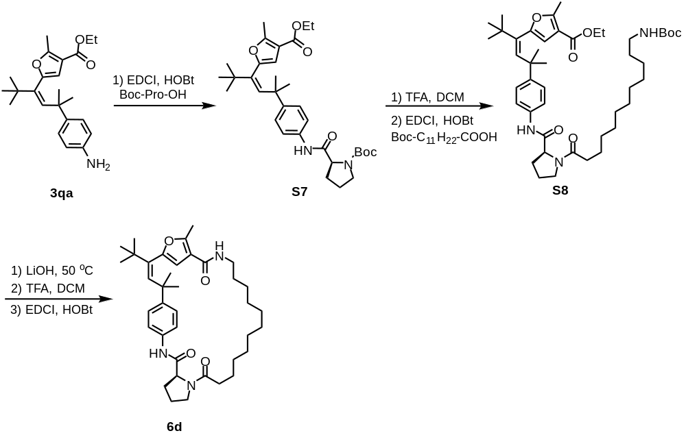 Synthesis of 6d:
This compound was prepared form 3qa and Boc-Pro-OH using the procedure described for 6d and was isolated as a white solid, 9.1 mg, 10.9% yield in six steps from 3qa.
4.5 Synthesis of 6e
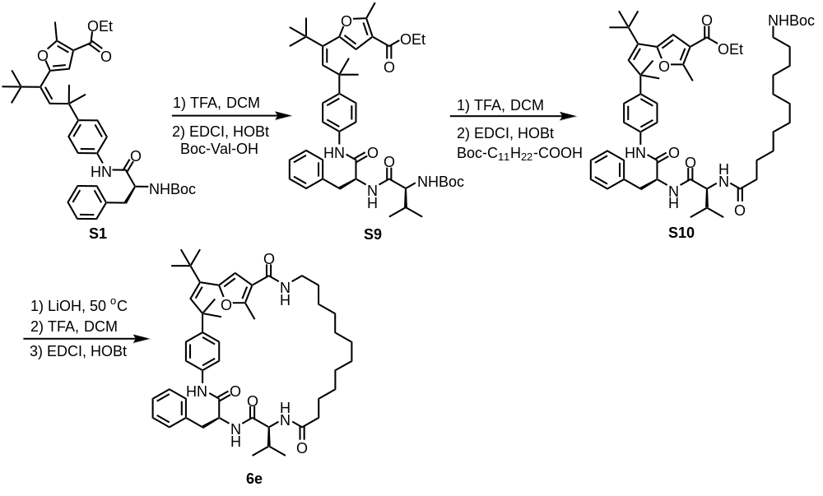
Synthesis of 6e:
This compound was prepared form S1 and Boc-Val-OH using the procedure described for 6e and was isolated as a white solid, 4.1 mg, 6.1% yield in seven steps from S1.
4.6 Synthesis of 6f
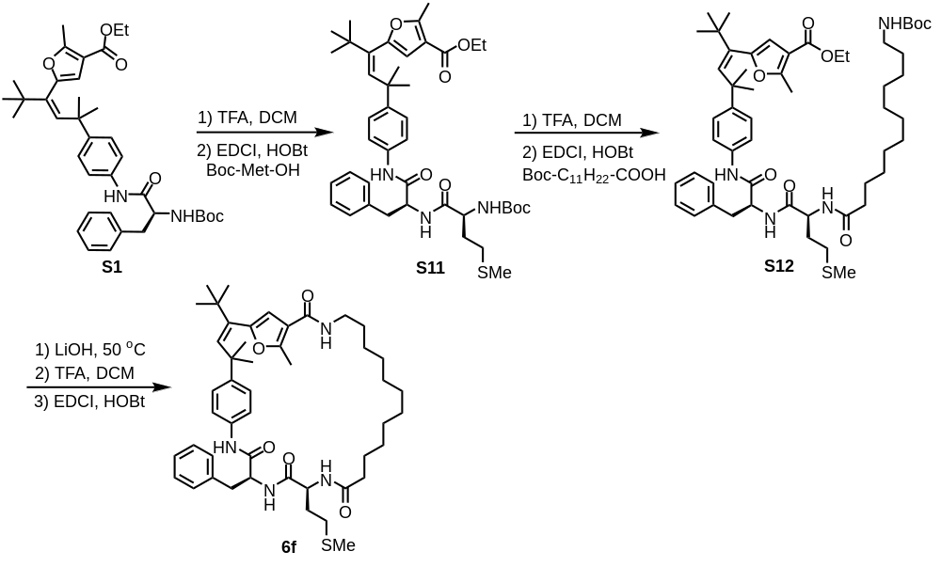Synthesis of 6f:
This compound was prepared form S1 and Boc-Met-OH using the procedure described for 6f and was isolated as a white solid, 2.8 mg, 3.6% yield in seven steps from S1.
4.7 Synthesis of 6g
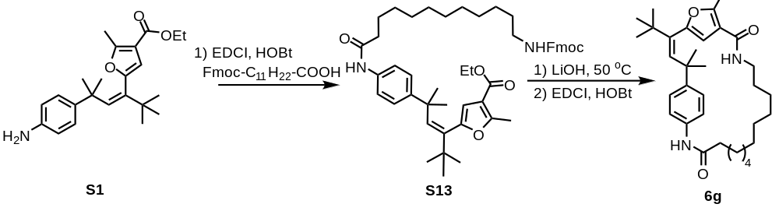
From S1 to S13:
To a solution of S1 (100 mg, 0.27 mmol) in DCM (2 mL) were added EDCI (103 mg, 0.54 mmol), HOBt (73.2 mg, 0.54 mmol), Fmoc-NH-(CH₂)₁₁-COOH (141.6 mg, 0.32 mmol). The stirring of the solution was continued at r.t. for 18 h. Then the solution was washed with water, and the organic phase was evaporated under reduced pressure and the residue was purified by FCC to get the desired product S13 (131.2 mg, Yield: 64%).

From S13 to 6g:
The S13 (100 mg) was dissolved in MeOH (2 mL) and the solution of NaOH (100 mg) in H₂O were added slowly. The stirring of the solution was continued at 50 ºC for 4 h. Then the solution was acidified by HCl, followed by evaporating under reduced pressure. And the residue was used in the next step without further purification.
The residue was dissolved in DCM (40 mL). And EDCI (95.5 mg, 0.5 mmol), HOBt (67.5 mg, 0.5 mmol) were added. The stirring of the solution was continued at r.t. for 24 h. Then the solution was washed with water, and the organic phase was evaporated under reduced pressure and the residue was purified by FCC to get the desired product 6g (17.8 mg, Yield: 27%).
4.8 Synthesis of 6h

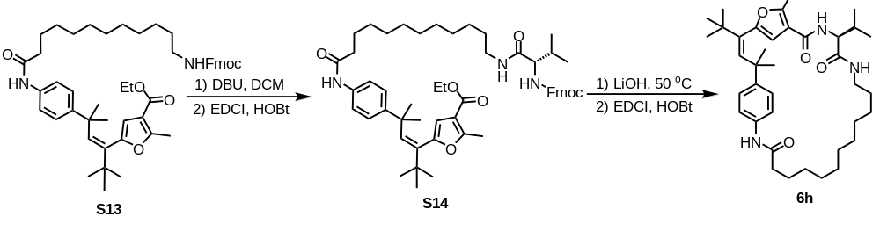

From S13 to S14:
To a solution of S13 in DCM were added DBU (10 eq) slowly and stirring of the solution was continued at r.t. for 1 h. Then the solution was washed with water and extracted by EtOAc. Then the organic phase was evaporated under reduced pressure and the residue was purified by FCC (DCM/EtOH = 2:1).
The product purified was dissolved in DCM. And EDCI (3 eq), HOBt (3 eq) were added followed by (((9H-fluoren-9-yl)methoxy)carbonyl)valine. The stirring of the solution was continued at r.t. for 18 h. Then the solution was washed with water, and the organic phase was evaporated under reduced pressure and the residue was purified by FCC (DCM/MeOH = 1% - 5%) to get the desired product S14.

From S14 to 6h:
The S14 was dissolved in MeOH and the solution of 10% LiOH in H₂O were added. The stirring of the solution was continued at 50 ºC for 4 h. Then the pH of solution was adjusted to 7-8. Then the solvent was evaporated under reduced pressure. And the residue was used in the next step without further purification.
The residue was dissolved in DCM. And EDCI (3 eq), HOBt (3 eq) were added. The stirring of the solution was continued at r.t. for 24 h. Then the solution was washed with water and extracted by EtOAc. Then the organic phase was evaporated under reduced pressure and the residue was purified by FCC to get the desired product 6h.

X-ray molecular structure and Crystallographic Data
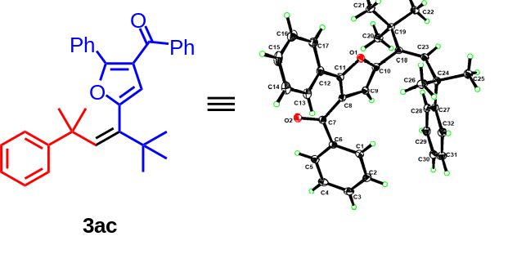
Figure 1. X-ray structure of 3ac
Table 1 Fractional Atomic Coordinates (×10⁴) and Equivalent Isotropic Displacement Parameters (Å²×10³) for 22019145_0m. U_{eq} is defined as 1/3 of the trace of the orthogonalised U_{IJ} tensor.
Atom | x | y | z | U(eq)
O² | 3554.0(12) | 820.8(12) | 5518.8(9) | 28.5(3)
O¹ | 4524.0(11) | 2334.2(11) | 2149.5(9) | 24.0(3)
C⁷ | 4501.7(16) | 1666.3(16) | 4958.0(13) | 22.2(3)
C⁸ | 4775.9(16) | 2086.4(16) | 3785.1(13) | 21.7(3)
C¹⁰ | 5952.4(16) | 2543.3(16) | 2041.0(13) | 22.7(3)
C⁹ | 6138.6(17) | 2406.7(16) | 3013.2(13) | 23.3(3)
C⁶ | 5432.8(16) | 2283.4(16) | 5459.0(13) | 23.1(3)
C¹⁸ | 6945.7(16) | 2864.9(16) | 945.2(12) | 21.9(3)
C¹² | 2279.6(17) | 1812.5(16) | 3493.5(13) | 24.6(3)
C¹ | 6080.9(18) | 3600.4(17) | 5012.1(14) | 27.8(4)
C¹⁹ | 7420.6(17) | 1623.6(16) | 453.9(13) | 24.0(3)
C²³ | 7452.3(17) | 4159.5(16) | 469.8(13) | 23.9(3)
C²⁷ | 7866.9(17) | 5643.5(16) | 1665.2(13) | 24.0(3)
C¹¹ | 3818.7(17) | 2062.1(16) | 3216.7(13) | 23.0(3)
C²⁸ | 8924.1(18) | 4772.4(17) | 1895.2(14) | 26.9(4)
C¹³ | 1368.4(18) | 2182.7(17) | 4382.1(14) | 28.5(4)
C³² | 7549.3(19) | 6727.9(18) | 2180.3(14) | 30.2(4)
C⁵ | 5577.6(18) | 1538.7(18) | 6436.3(13) | 27.2(4)
C²⁴ | 7092.0(17) | 5488.1(16) | 851.6(13) | 24.6(3)
C¹⁷ | 1702.1(19) | 1180.0(18) | 2873.4(15) | 31.4(4)
C²⁹ | 9630.0(18) | 4960.1(18) | 2615.6(14) | 31.3(4)
C²⁵ | 7599(2) | 6698.9(18) | -142.3(14) | 33.9(4)
C³ | 6967.7(18) | 3422(2) | 6525.0(15) | 33.4(4)
C² | 6829.4(19) | 4167(2) | 5560.1(15) | 33.9(4)
C²⁶ | 5474.9(18) | 5592.5(19) | 1312.9(15) | 31.8(4)
C²² | 8342(2) | 2064.3(18) | -704.4(14) | 32.1(4)
C¹⁴ | -76.8(19) | 1900.8(19) | 4656.3(16) | 35.3(4)
C³¹ | 8256.5(19) | 6923.1(19) | 2897.6(15) | 34.0(4)
C²¹ | 6115.7(19) | 795.0(19) | 476.7(15) | 33.0(4)
C⁴ | 6359.7(19) | 2098.6(19) | 6961.1(15) | 32.1(4)
C¹⁶ | 249(2) | 893.5(19) | 3162.5(16) | 38.0(5)
C³⁰ | 9299.5(19) | 6038.8(19) | 3116.5(14) | 33.4(4)
C²⁰ | 8281(2) | 693.8(18) | 1111.3(15) | 33.0(4)
C¹⁵ | -636.2(19) | 1247(2) | 4055.7(17) | 39.0(5)

Table 2 Anisotropic Displacement Parameters (Å²×10³) for 22019145_0m. The Anisotropic displacement factor exponent takes the form: -2π²[h²a*²U₁₁+2hka*b*U₁₂+…].
Atom | U₁₁ | U₂₂ | U₃₃ | U₂₃ | U₁₃ | U₁₂
O² | 27.5(6) | 30.3(6) | 25.1(6) | -3.4(5) | -5.4(5) | -4.1(5)
O¹ | 20.9(5) | 29.5(6) | 20.6(6) | -4.2(5) | -5.7(5) | -2.2(5)
C⁷ | 20.5(8) | 22.9(8) | 22.5(8) | -5.9(6) | -4.5(6) | 1.8(6)
C⁸ | 20.9(8) | 21.2(7) | 22.5(8) | -4.7(6) | -5.5(6) | -0.3(6)
C¹⁰ | 20.7(8) | 23.3(8) | 24.1(8) | -5.0(6) | -6.9(7) | 0.2(6)
C⁹ | 22.5(8) | 23.9(8) | 23.4(8) | -5.7(6) | -6.4(7) | -0.3(6)
C⁶ | 21.4(8) | 25.8(8) | 22.3(8) | -8.6(6) | -4.6(6) | 3.7(6)
C¹⁸ | 21.1(8) | 25.7(8) | 20.7(8) | -6.1(6) | -8.1(6) | -0.4(6)
C¹² | 23.1(8) | 22.3(8) | 26.4(9) | 0.5(6) | -8.7(7) | -0.7(6)
C¹ | 29.8(9) | 28.9(9) | 23.8(9) | -7.2(7) | -5.5(7) | 0.0(7)
C¹⁹ | 26.3(8) | 23.4(8) | 22.6(8) | -6.1(6) | -6.5(7) | -2.1(7)
C²³ | 24.1(8) | 26.5(8) | 20.2(8) | -6.2(6) | -4.3(7) | 0.9(7)
C²⁷ | 22.9(8) | 22.5(8) | 23.5(8) | -4.2(6) | -2.6(7) | -2.8(6)
C¹¹ | 24.9(8) | 22.5(8) | 20.4(8) | -4.6(6) | -4.8(7) | -0.5(6)
C²⁸ | 26.8(8) | 21.9(8) | 30.3(9) | -5.2(7) | -5.9(7) | -1.7(7)
C¹³ | 25.1(8) | 26.5(8) | 30.8(9) | -2.3(7) | -6.5(7) | 1.2(7)
C³² | 28.3(9) | 30.4(9) | 32.2(10) | -10.4(7) | -6.8(8) | 3.2(7)
C⁵ | 30.1(9) | 27.2(8) | 25.3(9) | -7.8(7) | -8.4(7) | 4.1(7)
C²⁴ | 26.7(8) | 22.9(8) | 24.1(8) | -6.2(7) | -6.4(7) | 1.7(7)
C¹⁷ | 33.4(9) | 33.2(9) | 29.5(9) | -2.9(7) | -15.0(8) | -3.1(8)
C²⁹ | 25.5(9) | 31.8(9) | 32.9(10) | -0.5(7) | -8.0(7) | -3.3(7)
C²⁵ | 47.3(11) | 24.5(9) | 27.5(9) | -4.6(7) | -8.3(8) | 4.1(8)
C³ | 26.0(9) | 46.8(11) | 32.9(10) | -20.9(9) | -7.6(8) | 0.5(8)
C² | 31.9(10) | 35.3(10) | 33.9(10) | -14.1(8) | -2.8(8) | -7.1(8)
C²⁶ | 29.0(9) | 34.0(9) | 37.0(10) | -15.1(8) | -11.8(8) | 7.2(8)
C²² | 39.5(10) | 29.3(9) | 26.6(9) | -12.2(7) | -3.3(8) | -0.8(8)
C¹⁴ | 25.4(9) | 32.6(9) | 38.8(11) | 2.0(8) | -3.4(8) | 5.4(8)
C³¹ | 33.9(10) | 37.0(10) | 32.7(10) | -16.7(8) | -5.1(8) | -1.1(8)
C²¹ | 31.9(9) | 32.3(9) | 38.1(11) | -14.0(8) | -10.0(8) | -3.5(8)
C⁴ | 33.3(9) | 40.3(10) | 27.4(9) | -12.4(8) | -13.1(8) | 9.0(8)
C¹⁶ | 36.7(10) | 35.9(10) | 43.7(12) | 2.7(9) | -24.3(9) | -7.6(8)
C³⁰ | 31.0(9) | 41.1(10) | 27.5(9) | -6.7(8) | -7.7(8) | -7.2(8)
C²⁰ | 37.7(10) | 29.7(9) | 34.3(10) | -9.6(8) | -13.1(8) | 6.5(8)
C¹⁵ | 21.4(9) | 36.2(10) | 50.4(12) | 11.2(9) | -12.9(9) | -3.4(8)

Table 3 Bond Lengths for 22019145_0m.
Atom | Atom | Length/Å | Atom | Atom | Length/Å
O² | C⁷ | 1.2216(19) | C¹⁹ | C²⁰ | 1.535(2)
O¹ | C¹⁰ | 1.3862(18) | C²³ | C²⁴ | 1.526(2)
O¹ | C¹¹ | 1.3703(19) | C²⁷ | C²⁸ | 1.392(2)
C⁷ | C⁸ | 1.481(2) | C²⁷ | C³² | 1.397(2)
C⁷ | C⁶ | 1.497(2) | C²⁷ | C²⁴ | 1.536(2)
C⁸ | C⁹ | 1.433(2) | C²⁸ | C²⁹ | 1.388(2)
C⁸ | C¹¹ | 1.374(2) | C¹³ | C¹⁴ | 1.382(2)
C¹⁰ | C⁹ | 1.346(2) | C³² | C³¹ | 1.388(2)
C¹⁰ | C¹⁸ | 1.486(2) | C⁵ | C⁴ | 1.384(2)
C⁶ | C¹ | 1.395(2) | C²⁴ | C²⁵ | 1.546(2)
C⁶ | C⁵ | 1.394(2) | C²⁴ | C²⁶ | 1.544(2)
C¹⁸ | C¹⁹ | 1.536(2) | C¹⁷ | C¹⁶ | 1.389(3)
C¹⁸ | C²³ | 1.337(2) | C²⁹ | C³⁰ | 1.381(3)
C¹² | C¹¹ | 1.465(2)

Table 4 Bond Angles for 22019145_0m.
Atom | Atom | Atom | Angle/˚ | Atom | Atom | Atom | Angle/˚
C¹¹ | O¹ | C¹⁰ | 107.59(12) | C¹⁸ | C²³ | C²⁴ | 129.59(15)
O² | C⁷ | C⁸ | 121.73(14) | C²⁸ | C²⁷ | C³² | 117.42(15)
O² | C⁷ | C⁶ | 119.62(14) | C²⁸ | C²⁷ | C²⁴ | 122.91(14)
C⁸ | C⁷ | C⁶ | 118.65(14) | C³² | C²⁷ | C²⁴ | 119.63(14)
C⁹ | C⁸ | C⁷ | 126.15(14) | O¹ | C¹¹ | C⁸ | 109.33(14)
C¹¹ | C⁸ | C⁷ | 127.13(15) | O¹ | C¹¹ | C¹² | 115.68(13)
C¹¹ | C⁸ | C⁹ | 106.16(14) | C⁸ | C¹¹ | C¹² | 134.99(15)
O¹ | C¹⁰ | C¹⁸ | 117.79(13) | C²⁹ | C²⁸ | C²⁷ | 121.56(16)
C⁹ | C¹⁰ | O¹ | 109.25(14) | C¹⁴ | C¹³ | C¹² | 120.58(17)
C⁹ | C¹⁰ | C¹⁸ | 132.96(15) | C³¹ | C³² | C²⁷ | 121.21(16)
C¹⁰ | C⁹ | C⁸ | 107.67(14) | C⁴ | C⁵ | C⁶ | 120.35(16)
C¹ | C⁶ | C⁷ | 122.16(15) | C²³ | C²⁴ | C²⁷ | 112.03(13)
C⁵ | C⁶ | C⁷ | 118.15(15) | C²³ | C²⁴ | C²⁵ | 106.67(13)
C⁵ | C⁶ | C¹ | 119.57(15) | C²³ | C²⁴ | C²⁶ | 111.74(13)
C¹⁰ | C¹⁸ | C¹⁹ | 116.09(13) | C²⁷ | C²⁴ | C²⁵ | 108.26(13)
C²³ | C¹⁸ | C¹⁰ | 120.30(14) | C²⁷ | C²⁴ | C²⁶ | 110.51(13)
C²³ | C¹⁸ | C¹⁹ | 123.44(14) | C²⁶ | C²⁴ | C²⁵ | 107.38(14)
C¹³ | C¹² | C¹¹ | 121.06(15) | C¹⁶ | C¹⁷ | C¹² | 119.98(18)
C¹⁷ | C¹² | C¹¹ | 120.11(16) | C³⁰ | C²⁹ | C²⁸ | 120.09(17)
C¹⁷ | C¹² | C¹³ | 118.82(16) | C² | C³ | C⁴ | 120.40(16)
C² | C¹ | C⁶ | 119.56(16) | C³ | C² | C¹ | 120.41(17)
C²² | C¹⁹ | C¹⁸ | 112.29(13) | C¹⁵ | C¹⁴ | C¹³ | 120.30(18)
C²² | C¹⁹ | C²¹ | 108.11(14) | C³⁰ | C³¹ | C³² | 120.27(16)
C²² | C¹⁹ | C²⁰ | 108.59(14) | C⁵ | C⁴ | C³ | 119.66(17)
C²¹ | C¹⁹ | C¹⁸ | 109.75(13) | C¹⁵ | C¹⁶ | C¹⁷ | 120.41(18)
C²¹ | C¹⁹ | C²⁰ | 109.17(14) | C²⁹ | C³⁰ | C³¹ | 119.44(16)
C²⁰ | C¹⁹ | C¹⁸ | 108.88(13) | C¹⁴ | C¹⁵ | C¹⁶ | 119.87(17)

Table 5 Hydrogen Atom Coordinates (Å×10⁴) and Isotropic Displacement Parameters (Å²×10³) for 22019145_0m.
Atom | x | y | z | U(eq)
H⁹ | 7015.39 | 2504.88 | 3160.77 | 28
H¹ | 6010.49 | 4105.94 | 4337.13 | 33
H²³ | 8138.3 | 4268.48 | -205.92 | 29
H²⁸ | 9168.49 | 4031.96 | 1551.01 | 32
H¹³ | 1745.13 | 2632.44 | 4802.26 | 34
H³² | 6836.32 | 7342.99 | 2036.87 | 36
H⁵ | 5136.78 | 642.02 | 6743.73 | 33
H¹⁷ | 2302.92 | 945.42 | 2253.57 | 38
H²⁹ | 10341.2 | 4345.86 | 2764.2 | 38
H^{25A} | 8626.34 | 6666.45 | -452.73 | 51
H^{25B} | 7380.82 | 7577.57 | 65.89 | 51
H^{25C} | 7111.88 | 6620.14 | -670.21 | 51
H³ | 7482.96 | 3818.71 | 6893.74 | 40
H² | 7248.86 | 5074.38 | 5267.87 | 41
H^{26A} | 4984.8 | 5344.29 | 835.89 | 48
H^{26B} | 5264.07 | 6541.2 | 1377.06 | 48
H^{26C} | 5149.69 | 4958.2 | 2018.6 | 48
H^{22A} | 7817.23 | 2685.37 | -1129.06 | 48
H^{22B} | 8586.08 | 1244.73 | -994.1 | 48
H^{22C} | 9214.06 | 2545.22 | -732.02 | 48
H¹⁴ | -687.22 | 2159.25 | 5262.14 | 42
H³¹ | 8023.64 | 7666.56 | 3239.73 | 41
H^{21A} | 5548.91 | 438.11 | 1217.98 | 50
H^{21B} | 6423.73 | 20.98 | 142.17 | 50
H^{21C} | 5540.07 | 1396 | 84.62 | 50
H⁴ | 6479.47 | 1578.28 | 7616.94 | 39
H¹⁶ | -140.02 | 451.87 | 2744.01 | 46
H³⁰ | 9783.96 | 6172.5 | 3607.17 | 40
H^{20A} | 9140.13 | 1205.8 | 1071.39 | 50
H^{20B} | 8547.9 | -125.72 | 825.45 | 50
H^{20C} | 7704.56 | 407.41 | 1856.81 | 50
H¹⁵ | -1628.36 | 1039.28 | 4254.47 | 47
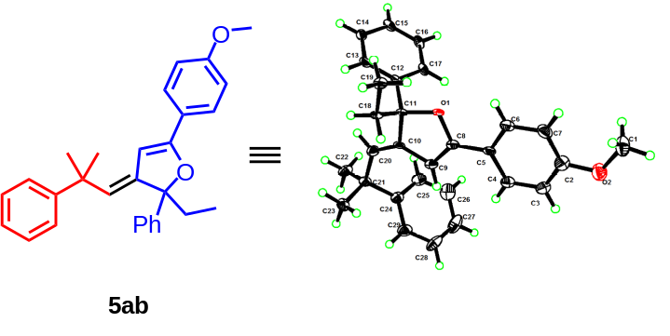
Figure 2. X-ray structure of 5ab
Table 6 Fractional Atomic Coordinates (×10⁴) and Equivalent Isotropic Displacement Parameters (Å²×10³) for ZZ. U_{eq} is defined as 1/3 of of the trace of the orthogonalised U_{IJ} tensor.
Atom | x | y | z | U(eq)
O1 | 4698(2) | 4620.4(7) | 4662(4) | 18.4(8)
O002 | -226(2) | 5363.6(7) | -731(4) | 18.0(8)
O003 | 6347(3) | 1657.6(10) | 10473(5) | 32.5(10)
O004 | 11314(3) | 1685.6(10) | 10542(5) | 33.2(10)
C15 | 6546(3) | 4068.7(10) | 3863(5) | 20.5(11)
C006 | -119(3) | 5215.4(11) | 403(5) | 16.2(10)
C8 | 4851(3) | 4781.9(11) | 5787(5) | 18.4(10)
C4 | 4706(4) | 5243.0(12) | 6438(6) | 24.5(12)
C009 | 731(3) | 5980.4(10) | -869(5) | 19.7(10)
C14 | 6011(3) | 3890.1(10) | 3943(5) | 19.1(10)
C00B | 13(3) | 5636.0(10) | -234(5) | 15.5(10)
O00C | -1324(3) | 4176.0(11) | -752(5) | 34.5(10)
C00D | 2067(3) | 5462.4(11) | 4352(5) | 22.8(11)
C13 | 5487(3) | 3984.3(10) | 4357(5) | 18.1(10)
C00F | 1503(3) | 5580.5(11) | 4594(6) | 21.6(11)
C00G | -767(3) | 5802.3(9) | -993(5) | 12.8(9)
C6 | 4117(3) | 5128.9(12) | 3965(6) | 24.3(12)
C19 | 3573(3) | 4187.2(10) | 3048(5) | 19.1(10)
C18 | 4168(3) | 4197.3(9) | 4706(4) | 14.1(9)
C00K | -855(3) | 4851.1(12) | -1347(5) | 21.8(11)
C11 | 4949(3) | 4355.1(10) | 5213(5) | 16.6(10)
C00M | -290(4) | 4770.9(13) | 1148(6) | 25.1(12)
O2 | 3748(3) | 5831.0(10) | 4359(5) | 35.1(10)
C00O | 232(3) | 5352.8(11) | 1628(5) | 18.6(11)
C9 | 5266(3) | 4661.2(11) | 7073(6) | 22.1(11)
C12 | 5491(3) | 4246.6(10) | 4708(5) | 16.3(10)
C00R | -1460(3) | 5698.1(10) | -787(5) | 20.0(10)
C5 | 4553(3) | 5053.4(11) | 5387(5) | 18.0(11)
C16 | 6551(3) | 4326.9(11) | 4213(6) | 21.0(11)
C24 | 6605(3) | 4453.4(11) | 10061(6) | 22.9(11)
C00V | 385(3) | 5622.0(11) | 1381(5) | 18.8(11)
C00W | 1876(3) | 5862.6(11) | -1061(6) | 29.4(12)
C7 | 3835(4) | 5389.8(13) | 3577(6) | 28.8(13)
C17 | 6041(3) | 4419.4(11) | 4652(6) | 19.0(11)
C00Z | 656(3) | 5723.9(11) | -567(5) | 16.5(10)
C010 | -422(3) | 4944.6(11) | 65(5) | 18.7(11)
C011 | 1339(3) | 6058.2(12) | -1110(6) | 27.7(12)
C22 | 7006(3) | 3985.1(12) | 9995(5) | 27.4(12)
C013 | -1166(4) | 4594.9(13) | -1665(6) | 28.7(13)
C23 | 5642(3) | 4072.7(11) | 9664(5) | 26.0(12)
C015 | 1107(3) | 5844.9(10) | 3854(5) | 18.3(10)
C016 | 748(3) | 5826.8(11) | 2239(5) | 18.8(10)
C017 | 420(3) | 5927.8(11) | 4081(5) | 22.1(11)
C20 | 5869(3) | 4193.4(11) | 7767(5) | 23.7(11)
C019 | 1771(3) | 6059.6(11) | 4492(6) | 25.9(12)
O01A | 10295(3) | 2887.7(9) | 10340(5) | 46.5(12)
O01B | 5305(3) | 2851.9(9) | 10351(5) | 46.3(12)
C10 | 5436(3) | 4388.8(10) | 6871(5) | 16.1(10)
C28 | 6644(4) | 4831.5(13) | 11450(7) | 35.9(15)
C01E | 2236(4) | 5098.5(12) | 5877(7) | 32.2(14)
C25 | 7146(4) | 4583.3(12) | 9812(6) | 29.3(13)
C01G | 2442(4) | 5224.1(12) | 4983(6) | 29.3(13)
C01H | 1204(3) | 5530.1(11) | -504(6) | 22.1(11)
C01I | 1693(4) | 5212.2(12) | 6144(6) | 30.1(13)
C01J | 1317(4) | 5456.1(12) | 5496(6) | 26.5(13)
C29 | 6361(4) | 4577.8(13) | 10899(6) | 29.0(13)
C01L | 1817(3) | 5604.0(12) | -753(6) | 29.5(13)
C21 | 6282(3) | 4179.7(11) | 9387(5) | 20.3(11)
C01N | 6089(4) | 1913.8(12) | 10272(7) | 25.9(12)
C27 | 7171(4) | 4958.9(13) | 11177(8) | 41.4(16)
C2 | 3999(4) | 5570.3(14) | 4627(7) | 29.3(13)
C01Q | -603(4) | 4519.4(13) | 834(7) | 27.7(13)
C01R | 5619(4) | 1995.3(14) | 8843(7) | 32.1(14)
C3 | 4432(4) | 5498.7(13) | 6047(6) | 26.9(13)
C01T | -1043(4) | 4432.0(13) | -570(7) | 29.1(13)
C01U | 11059(4) | 1943.3(13) | 10320(7) | 29.2(13)
C01V | 10617(4) | 2025.7(14) | 8883(7) | 33.0(14)
C01W | 6835(5) | 1566.2(15) | 11916(8) | 41.1(16)
C26 | 7438(4) | 4836.9(14) | 10352(7) | 39.9(16)
C01Y | 8697(4) | 2950.9(14) | 4104(7) | 38.4(15)
C01Z | 11782(5) | 1595.6(15) | 11988(8) | 40.9(16)
C020 | 9637(4) | 3132.8(13) | 8204(8) | 39.2(15)
C021 | 9223(4) | 3335.5(13) | 7269(7) | 35.6(14)
C022 | 3685(4) | 2922.7(15) | 4106(8) | 43.8(16)
C023 | 5476(4) | 2429.7(14) | 9591(7) | 37.6(15)
C024 | 6227(4) | 2090.1(13) | 11346(7) | 31.2(14)
C025 | 10465(4) | 2464.6(14) | 9594(7) | 36.6(15)
C026 | 8915(5) | 3075.0(14) | 10236(7) | 45.3(17)
C027 | 3923(5) | 3043.7(16) | 10243(8) | 50.7(18)
C028 | -1840(4) | 4079.8(14) | -2166(7) | 37.6(16)
C029 | 4651(4) | 3100.4(14) | 8231(8) | 45.1(16)
C02A | 11182(4) | 2121.1(13) | 11370(7) | 32.0(14)
C02B | 10881(4) | 2378.1(14) | 10994(7) | 36.3(14)
C02C | 4800(4) | 2832.2(14) | 7973(8) | 39.0(15)
C02D | 8843(4) | 3344.9(14) | 5690(8) | 42.5(15)
C02E | 4245(4) | 3305.8(14) | 7309(8) | 42.2(15)
C02F | 7590(5) | 2713.3(15) | 4613(9) | 51.3(18)
C02G | 5327(4) | 2251.9(14) | 8509(7) | 33.5(14)
C02H | 10337(4) | 2281.7(14) | 8528(7) | 33.6(14)
C02I | 3846(4) | 3314.2(14) | 5708(8) | 45.1(16)
C02J | 8483(4) | 3082.1(13) | 4970(7) | 36.2(14)
C02K | 9790(4) | 2864.7(14) | 7949(8) | 38.9(15)
C02L | 8374(5) | 2708.9(16) | 3514(8) | 49.0(18)
C02M | 4479(5) | 3218.9(14) | 10237(7) | 49.9(17)
C02N | 9472(4) | 3251.3(14) | 10236(7) | 48.1(17)
C1 | 3309(5) | 5919.2(14) | 2917(8) | 40.0(16)
C02P | 8373(5) | 3149.5(15) | 10611(8) | 51.2(18)
C02Q | 5921(4) | 2345.4(14) | 10990(7) | 34.9(14)
C02R | 10174(4) | 2737.2(14) | 9200(8) | 41.3(15)
C02S | 7910(4) | 2955.8(15) | 5199(8) | 46.8(17)
C02T | 8160(5) | 3556.0(15) | 5057(8) | 52.4(19)
C02U | 9510(5) | 3446.6(15) | 5416(9) | 55(2)
C02V | 3359(5) | 3124.6(17) | 10555(8) | 60(2)
C02W | 5175(4) | 2702.0(14) | 9212(8) | 40.6(15)
C02X | 10048(4) | 3160.9(13) | 9802(8) | 47.6(17)
C02Y | 3358(5) | 2680.1(18) | 3521(9) | 57(2)
C02Z | 3486(4) | 3050.9(15) | 5006(8) | 43.2(16)
C030 | 3159(5) | 3525.2(15) | 5110(9) | 57(2)
C031 | 2602(5) | 2682.1(17) | 4662(10) | 59(2)
C032 | 4499(5) | 3416.2(16) | 5409(10) | 59(2)
C033 | 2924(5) | 2924.3(16) | 5259(9) | 52.6(19)
C034 | 7815(5) | 2586.9(17) | 3778(10) | 57(2)
C035 | 5056(4) | 3125.1(14) | 9837(8) | 52.4(18)
C036 | 2821(5) | 2555.6(18) | 3824(10) | 63(2)
C037 | 9439(5) | 3515.6(15) | 10591(8) | 55.3(19)
C038 | 8887(5) | 3591.4(18) | 10959(9) | 66(2)
C039 | 4428(6) | 3485.9(16) | 10530(9) | 70(2)
C03A | 8368(6) | 3416.1(17) | 10986(8) | 64(2)
C03B | 10846(5) | 3321.6(16) | 10451(10) | 79(2)
C03C | 3852(6) | 3563.2(19) | 10834(10) | 82(3)
C03D | 3325(6) | 3394(2) | 10845(10) | 78(3)
C03E | 5860(6) | 3281.5(17) | 10466(12) | 92(3)
C0AA | 6450(9) | 3292(3) | 11756(16) | 62(4)
C1AA | 11454(9) | 3326(3) | 11753(16) | 64(4)
C2AA | 11470(9) | 3214(3) | 10516(17) | 61(4)
C3AA | 6492(9) | 3181(3) | 10596(17) | 62(4)

Table 7 Anisotropic Displacement Parameters (Å²×10³) for ZZ. The Anisotropic displacement factor exponent takes the form: -2π²[h²a*²U₁₁+2hka*b*U₁₂+…].
Atom | U₁₁ | U₂₂ | U₃₃ | U₂₃ | U₁₃ | U₁₂
O1 | 29.8(19) | 20.0(18) | 12.0(16) | -0.1(14) | 15.7(15) | 2.4(14)
O002 | 25.6(18) | 20.6(18) | 15.7(16) | -0.1(14) | 16.3(15) | -0.8(14)
O003 | 40(3) | 20(2) | 36(2) | 2.3(19) | 19(2) | 10.7(19)
O004 | 38(3) | 21(2) | 36(2) | 2.2(19) | 16(2) | 11.5(19)
C15 | 15(2) | 29(2) | 23(2) | 4.7(19) | 13.6(19) | -4.6(19)
C006 | 22(2) | 21(2) | 13(2) | 5.7(18) | 14.0(19) | 3.2(19)
C8 | 20(2) | 22(2) | 17(2) | -2.2(19) | 12.6(19) | -0.3(19)
C4 | 27(3) | 28(3) | 19(2) | -2(2) | 13(2) | 0(2)
C009 | 21(2) | 23(2) | 25(2) | -3.5(19) | 18(2) | -4.4(19)
C14 | 22(2) | 17(2) | 23(2) | 2.6(18) | 15.7(19) | 2.9(18)
C00B | 19(2) | 19(2) | 14(2) | -1.5(17) | 13.2(18) | -1.8(18)
O00C | 37(2) | 32(2) | 29(2) | -3(2) | 14(2) | -3(2)
C00D | 20(2) | 27(3) | 16(2) | 0(2) | 5(2) | -4(2)
C13 | 20(2) | 21(2) | 19(2) | 1.9(18) | 14.3(19) | -3.3(18)
C00F | 23(2) | 18(2) | 16(2) | 0.3(19) | 6(2) | -5.0(19)
C00G | 13(2) | 15(2) | 12.1(19) | 2.6(16) | 8.1(17) | 4.5(16)
C6 | 26(3) | 30(3) | 20(2) | 1(2) | 15(2) | 2(2)
C19 | 13(2) | 26(2) | 14(2) | -6.7(19) | 4.1(18) | -7.3(19)
C18 | 12(2) | 21(2) | 12.4(19) | -0.2(16) | 8.6(16) | 2.2(16)
C00K | 28(3) | 26(3) | 15(2) | 3(2) | 14(2) | 1(2)
C11 | 25(2) | 19(2) | 13(2) | -1.0(17) | 14.5(19) | 0.8(18)
C00M | 28(3) | 31(3) | 16(2) | 3(2) | 12(2) | -1(2)
O2 | 38(3) | 30(2) | 32(2) | 4(2) | 15(2) | 2(2)
C00O | 24(2) | 23(2) | 11(2) | -0.4(18) | 10.6(19) | -3.0(19)
C9 | 27(3) | 25(2) | 16(2) | -2.8(19) | 13(2) | 0(2)
C12 | 17(2) | 21(2) | 15(2) | 4.7(18) | 10.9(18) | 1.0(18)
C00R | 10(2) | 23(2) | 26(2) | 3(2) | 8.8(19) | -0.2(19)
C5 | 21(2) | 23(2) | 17(2) | -1.8(19) | 15(2) | -2.0(19)
C16 | 16(2) | 23(2) | 26(2) | 6(2) | 13(2) | -4.1(19)
C24 | 24(2) | 25(2) | 15(2) | 0.9(19) | 7(2) | 5(2)
C00V | 21(2) | 26(2) | 15(2) | -0.2(18) | 13.1(19) | 2.1(19)
C00W | 22(2) | 42(3) | 34(3) | -7(2) | 23(2) | -8(2)
C7 | 34(3) | 32(3) | 20(2) | 4(2) | 13(2) | -1(2)
C17 | 18(2) | 19(2) | 23(2) | 2.6(19) | 13(2) | -6.9(19)
C00Z | 16(2) | 26(2) | 14(2) | -0.9(18) | 12.8(18) | 4.9(18)
C010 | 20(2) | 22(2) | 17(2) | -3.4(19) | 12(2) | -0.4(19)
C011 | 29(3) | 29(3) | 34(3) | -3(2) | 23(2) | -2(2)
C22 | 31(3) | 29(3) | 13(2) | -2(2) | 6(2) | 7(2)
C013 | 33(3) | 28(3) | 23(3) | -6(2) | 14(2) | 3(2)
C23 | 32(3) | 27(3) | 13(2) | 1(2) | 8(2) | -5(2)
C015 | 26(2) | 18(2) | 10(2) | 3.6(18) | 8.9(19) | 1.6(19)
C016 | 26(2) | 21(2) | 11(2) | 1.4(18) | 10.4(19) | 1.2(19)
C017 | 28(3) | 21(2) | 13(2) | -1.4(19) | 8(2) | 3(2)
C20 | 30(3) | 22(2) | 17(2) | -0.8(19) | 12(2) | 3(2)
C019 | 28(3) | 21(3) | 18(2) | 1(2) | 4(2) | -6(2)
O01A | 42(2) | 24(2) | 49(3) | 2(2) | 8(2) | 5.6(19)
O01B | 38(2) | 26(2) | 56(3) | 1(2) | 12(2) | 4.2(19)
C10 | 21(2) | 22(2) | 7.6(19) | -1.4(17) | 8.8(18) | -2.7(18)
C28 | 28(3) | 31(3) | 37(3) | -11(2) | 10(2) | 10(2)
C01E | 26(3) | 21(3) | 35(3) | 7(2) | 6(2) | -2(2)
C25 | 27(3) | 34(3) | 26(3) | -4(2) | 13(2) | 0(2)
C01G | 24(3) | 26(3) | 30(3) | -1(2) | 8(2) | -1(2)
C01H | 21(2) | 26(3) | 23(2) | -6(2) | 15(2) | 1(2)
C01I | 33(3) | 27(3) | 25(3) | 8(2) | 11(2) | -4(2)
C01J | 28(3) | 28(3) | 20(2) | 4(2) | 10(2) | -1(2)
C29 | 33(3) | 33(3) | 19(2) | -3(2) | 12(2) | 3(2)
C01L | 22(2) | 40(3) | 33(3) | -10(2) | 19(2) | 3(2)
C21 | 24(2) | 24(2) | 8(2) | 1.7(18) | 5.2(18) | 3(2)
C01N | 28(3) | 15(2) | 36(3) | 3(2) | 18(2) | 3(2)
C27 | 28(3) | 28(3) | 47(3) | -10(2) | 6(2) | 2(2)
C2 | 27(3) | 30(3) | 29(3) | 0(2) | 14(2) | 1(2)
C01Q | 32(3) | 26(3) | 27(3) | 6(2) | 17(2) | -3(2)
C01R | 32(3) | 28(3) | 36(3) | -1(2) | 18(2) | -1(2)
C3 | 28(3) | 28(3) | 25(3) | -4(2) | 15(2) | 2(2)
C01T | 30(3) | 28(3) | 30(3) | 1(2) | 17(2) | 0(2)
C01U | 23(3) | 24(3) | 40(3) | 1(2) | 15(2) | -2(2)
C01V | 34(3) | 27(3) | 37(3) | 1(2) | 18(2) | 1(2)
C01W | 48(4) | 38(4) | 35(3) | 6(3) | 20(3) | 7(3)
C26 | 29(3) | 41(3) | 43(3) | 0(3) | 14(3) | -3(2)
C01Y | 30(3) | 33(3) | 43(3) | 4(3) | 13(3) | 6(2)
C01Z | 44(4) | 35(4) | 36(3) | 2(3) | 15(3) | 8(3)
C020 | 32(3) | 28(3) | 54(3) | -2(2) | 21(3) | -2(2)
C021 | 30(3) | 29(3) | 48(3) | -1(2) | 21(2) | 0(2)
C022 | 32(3) | 39(3) | 52(4) | 8(3) | 17(3) | 4(3)
C023 | 29(3) | 30(3) | 45(3) | -1(2) | 15(3) | 0(2)
C024 | 27(3) | 30(3) | 34(3) | 1(2) | 15(2) | 4(2)
C025 | 30(3) | 32(3) | 41(3) | -3(2) | 14(3) | 2(2)
C026 | 51(4) | 36(3) | 35(3) | -2(3) | 13(3) | 13(3)
C027 | 51(4) | 46(4) | 40(3) | -3(3) | 15(3) | 17(3)
C028 | 36(3) | 32(3) | 36(3) | -10(3) | 14(3) | -8(3)
C029 | 33(3) | 35(3) | 61(4) | 7(3) | 21(3) | 3(2)
C02A | 27(3) | 28(3) | 34(3) | -5(2) | 11(2) | 3(2)
C02B | 34(3) | 28(3) | 37(3) | -6(2) | 12(2) | -3(2)
C02C | 31(3) | 32(3) | 51(3) | 2(3) | 20(3) | 5(2)
C02D | 40(3) | 34(3) | 55(3) | 3(3) | 27(3) | 5(2)
C02E | 32(3) | 34(3) | 59(3) | 2(3) | 24(3) | 2(2)
C02F | 35(3) | 40(3) | 69(4) | 9(3) | 21(3) | -1(3)
C02G | 31(3) | 30(3) | 36(3) | 4(2) | 16(2) | -2(2)
C02H | 32(3) | 31(3) | 38(3) | 4(2) | 19(2) | 2(2)
C02I | 37(3) | 35(3) | 66(4) | 10(3) | 30(3) | 10(2)
C02J | 31(3) | 31(3) | 41(3) | 8(2) | 16(2) | 4(2)
C02K | 34(3) | 32(3) | 45(3) | 0(2) | 17(3) | 1(2)
C02L | 40(3) | 46(4) | 45(3) | -1(3) | 12(3) | 7(3)
C02M | 52(3) | 32(3) | 38(3) | -7(3) | 5(3) | 12(3)
C02N | 51(3) | 36(3) | 38(3) | -2(3) | 11(3) | 10(3)
C1 | 41(4) | 28(3) | 41(4) | 9(3) | 15(3) | 6(3)
C02P | 53(4) | 48(3) | 41(3) | 4(3) | 17(3) | 12(3)
C02Q | 33(3) | 29(3) | 39(3) | -3(2) | 16(2) | 0(2)
C02R | 28(3) | 33(3) | 52(3) | -2(3) | 14(3) | 1(2)
C02S | 35(3) | 40(3) | 60(4) | 10(3) | 22(3) | 6(3)
C02T | 63(4) | 37(4) | 59(4) | 10(3) | 34(4) | 9(3)
C02U | 61(4) | 39(4) | 86(5) | -4(4) | 52(4) | -6(3)
C02V | 67(4) | 64(4) | 43(3) | 3(3) | 27(3) | 23(3)
C02W | 32(3) | 32(3) | 48(3) | -3(3) | 15(3) | 1(2)
C02X | 42(3) | 22(3) | 57(3) | 0(3) | 12(3) | 1(2)
C02Y | 43(4) | 54(4) | 57(4) | 4(3) | 15(3) | 8(3)
C02Z | 34(3) | 42(3) | 51(3) | 16(3) | 21(3) | 4(3)
C030 | 58(4) | 44(4) | 81(5) | 24(4) | 45(4) | 15(3)
C031 | 40(3) | 53(4) | 74(4) | 17(3) | 24(3) | -4(3)
C032 | 59(4) | 43(4) | 96(6) | 4(4) | 57(4) | 5(3)
C033 | 38(3) | 48(4) | 66(4) | 19(3) | 24(3) | 3(3)
C034 | 40(3) | 39(3) | 63(4) | -2(3) | 9(3) | -3(3)
C035 | 42(3) | 27(3) | 63(4) | 3(3) | 11(3) | 6(3)
C036 | 45(4) | 50(4) | 67(4) | 5(3) | 11(3) | -6(3)
C037 | 59(4) | 37(3) | 50(4) | -6(3) | 15(3) | 9(3)
C038 | 77(4) | 51(4) | 49(4) | -6(3) | 20(3) | 22(3)
C039 | 78(4) | 42(4) | 59(4) | -10(3) | 16(3) | 14(3)
C03A | 78(4) | 60(4) | 44(4) | -1(3) | 26(3) | 23(3)
C03B | 56(4) | 51(4) | 97(5) | -2(4) | 19(3) | -5(3)
C03C | 102(5) | 61(4) | 56(4) | -14(3) | 24(4) | 32(4)
C03D | 89(5) | 82(5) | 58(4) | -2(4) | 35(4) | 45(4)
C03E | 61(4) | 50(4) | 117(6) | 2(4) | 14(4) | -1(3)
C0AA | 64(7) | 68(8) | 57(7) | -10(6) | 34(6) | -12(6)
C1AA | 59(7) | 78(9) | 50(7) | 12(7) | 26(5) | 9(7)
C2AA | 62(7) | 58(8) | 64(8) | -5(6) | 34(7) | -6(6)
C3AA | 62(7) | 69(8) | 66(8) | 11(7) | 42(7) | -12(6)

Table 8 Anisotropic Displacement Parameters (Å²×10³) for ZZ. The Anisotropic displacement factor exponent takes the form: -2π²[h²a*²U₁₁+2hka*b*U₁₂+…].
Atom | U₁₁ | U₂₂ | U₃₃ | U₂₃ | U₁₃ | U₁₂
O1 | 29.8(19) | 20.0(18) | 12.0(16) | -0.1(14) | 15.7(15) | 2.4(14)
O002 | 25.6(18) | 20.6(18) | 15.7(16) | -0.1(14) | 16.3(15) | -0.8(14)
O003 | 40(3) | 20(2) | 36(2) | 2.3(19) | 19(2) | 10.7(19)
O004 | 38(3) | 21(2) | 36(2) | 2.2(19) | 16(2) | 11.5(19)
C15 | 15(2) | 29(2) | 23(2) | 4.7(19) | 13.6(19) | -4.6(19)
C006 | 22(2) | 21(2) | 13(2) | 5.7(18) | 14.0(19) | 3.2(19)
C8 | 20(2) | 22(2) | 17(2) | -2.2(19) | 12.6(19) | -0.3(19)
C4 | 27(3) | 28(3) | 19(2) | -2(2) | 13(2) | 0(2)
C009 | 21(2) | 23(2) | 25(2) | -3.5(19) | 18(2) | -4.4(19)
C14 | 22(2) | 17(2) | 23(2) | 2.6(18) | 15.7(19) | 2.9(18)
C00B | 19(2) | 19(2) | 14(2) | -1.5(17) | 13.2(18) | -1.8(18)
O00C | 37(2) | 32(2) | 29(2) | -3(2) | 14(2) | -3(2)
C00D | 20(2) | 27(3) | 16(2) | 0(2) | 5(2) | -4(2)
C13 | 20(2) | 21(2) | 19(2) | 1.9(18) | 14.3(19) | -3.3(18)
C00F | 23(2) | 18(2) | 16(2) | 0.3(19) | 6(2) | -5.0(19)
C00G | 13(2) | 15(2) | 12.1(19) | 2.6(16) | 8.1(17) | 4.5(16)
C6 | 26(3) | 30(3) | 20(2) | 1(2) | 15(2) | 2(2)
C19 | 13(2) | 26(2) | 14(2) | -6.7(19) | 4.1(18) | -7.3(19)
C18 | 12(2) | 21(2) | 12.4(19) | -0.2(16) | 8.6(16) | 2.2(16)
C00K | 28(3) | 26(3) | 15(2) | 3(2) | 14(2) | 1(2)
C11 | 25(2) | 19(2) | 13(2) | -1.0(17) | 14.5(19) | 0.8(18)
C00M | 28(3) | 31(3) | 16(2) | 3(2) | 12(2) | -1(2)
O2 | 38(3) | 30(2) | 32(2) | 4(2) | 15(2) | 2(2)
C00O | 24(2) | 23(2) | 11(2) | -0.4(18) | 10.6(19) | -3.0(19)
C9 | 27(3) | 25(2) | 16(2) | -2.8(19) | 13(2) | 0(2)
C12 | 17(2) | 21(2) | 15(2) | 4.7(18) | 10.9(18) | 1.0(18)
C00R | 10(2) | 23(2) | 26(2) | 3(2) | 8.8(19) | -0.2(19)
C5 | 21(2) | 23(2) | 17(2) | -1.8(19) | 15(2) | -2.0(19)
C16 | 16(2) | 23(2) | 26(2) | 6(2) | 13(2) | -4.1(19)
C24 | 24(2) | 25(2) | 15(2) | 0.9(19) | 7(2) | 5(2)
C00V | 21(2) | 26(2) | 15(2) | -0.2(18) | 13.1(19) | 2.1(19)
C00W | 22(2) | 42(3) | 34(3) | -7(2) | 23(2) | -8(2)
C7 | 34(3) | 32(3) | 20(2) | 4(2) | 13(2) | -1(2)
C17 | 18(2) | 19(2) | 23(2) | 2.6(19) | 13(2) | -6.9(19)
C00Z | 16(2) | 26(2) | 14(2) | -0.9(18) | 12.8(18) | 4.9(18)
C010 | 20(2) | 22(2) | 17(2) | -3.4(19) | 12(2) | -0.4(19)
C011 | 29(3) | 29(3) | 34(3) | -3(2) | 23(2) | -2(2)
C22 | 31(3) | 29(3) | 13(2) | -2(2) | 6(2) | 7(2)
C013 | 33(3) | 28(3) | 23(3) | -6(2) | 14(2) | 3(2)
C23 | 32(3) | 27(3) | 13(2) | 1(2) | 8(2) | -5(2)
C015 | 26(2) | 18(2) | 10(2) | 3.6(18) | 8.9(19) | 1.6(19)
C016 | 26(2) | 21(2) | 11(2) | 1.4(18) | 10.4(19) | 1.2(19)
C017 | 28(3) | 21(2) | 13(2) | -1.4(19) | 8(2) | 3(2)
C20 | 30(3) | 22(2) | 17(2) | -0.8(19) | 12(2) | 3(2)
C019 | 28(3) | 21(3) | 18(2) | 1(2) | 4(2) | -6(2)
O01A | 42(2) | 24(2) | 49(3) | 2(2) | 8(2) | 5.6(19)
O01B | 38(2) | 26(2) | 56(3) | 1(2) | 12(2) | 4.2(19)
C10 | 21(2) | 22(2) | 7.6(19) | -1.4(17) | 8.8(18) | -2.7(18)
C28 | 28(3) | 31(3) | 37(3) | -11(2) | 10(2) | 10(2)
C01E | 26(3) | 21(3) | 35(3) | 7(2) | 6(2) | -2(2)
C25 | 27(3) | 34(3) | 26(3) | -4(2) | 13(2) | 0(2)
C01G | 24(3) | 26(3) | 30(3) | -1(2) | 8(2) | -1(2)
C01H | 21(2) | 26(3) | 23(2) | -6(2) | 15(2) | 1(2)
C01I | 33(3) | 27(3) | 25(3) | 8(2) | 11(2) | -4(2)
C01J | 28(3) | 28(3) | 20(2) | 4(2) | 10(2) | -1(2)
C29 | 33(3) | 33(3) | 19(2) | -3(2) | 12(2) | 3(2)
C01L | 22(2) | 40(3) | 33(3) | -10(2) | 19(2) | 3(2)
C21 | 24(2) | 24(2) | 8(2) | 1.7(18) | 5.2(18) | 3(2)
C01N | 28(3) | 15(2) | 36(3) | 3(2) | 18(2) | 3(2)
C27 | 28(3) | 28(3) | 47(3) | -10(2) | 6(2) | 2(2)
C2 | 27(3) | 30(3) | 29(3) | 0(2) | 14(2) | 1(2)
C01Q | 32(3) | 26(3) | 27(3) | 6(2) | 17(2) | -3(2)
C01R | 32(3) | 28(3) | 36(3) | -1(2) | 18(2) | -1(2)
C3 | 28(3) | 28(3) | 25(3) | -4(2) | 15(2) | 2(2)
C01T | 30(3) | 28(3) | 30(3) | 1(2) | 17(2) | 0(2)
C01U | 23(3) | 24(3) | 40(3) | 1(2) | 15(2) | -2(2)
C01V | 34(3) | 27(3) | 37(3) | 1(2) | 18(2) | 1(2)
C01W | 48(4) | 38(4) | 35(3) | 6(3) | 20(3) | 7(3)
C26 | 29(3) | 41(3) | 43(3) | 0(3) | 14(3) | -3(2)
C01Y | 30(3) | 33(3) | 43(3) | 4(3) | 13(3) | 6(2)
C01Z | 44(4) | 35(4) | 36(3) | 2(3) | 15(3) | 8(3)
C020 | 32(3) | 28(3) | 54(3) | -2(2) | 21(3) | -2(2)
C021 | 30(3) | 29(3) | 48(3) | -1(2) | 21(2) | 0(2)
C022 | 32(3) | 39(3) | 52(4) | 8(3) | 17(3) | 4(3)
C023 | 29(3) | 30(3) | 45(3) | -1(2) | 15(3) | 0(2)
C024 | 27(3) | 30(3) | 34(3) | 1(2) | 15(2) | 4(2)
C025 | 30(3) | 32(3) | 41(3) | -3(2) | 14(3) | 2(2)
C026 | 51(4) | 36(3) | 35(3) | -2(3) | 13(3) | 13(3)
C027 | 51(4) | 46(4) | 40(3) | -3(3) | 15(3) | 17(3)
C028 | 36(3) | 32(3) | 36(3) | -10(3) | 14(3) | -8(3)
C029 | 33(3) | 35(3) | 61(4) | 7(3) | 21(3) | 3(2)
C02A | 27(3) | 28(3) | 34(3) | -5(2) | 11(2) | 3(2)
C02B | 34(3) | 28(3) | 37(3) | -6(2) | 12(2) | -3(2)
C02C | 31(3) | 32(3) | 51(3) | 2(3) | 20(3) | 5(2)
C02D | 40(3) | 34(3) | 55(3) | 3(3) | 27(3) | 5(2)
C02E | 32(3) | 34(3) | 59(3) | 2(3) | 24(3) | 2(2)
C02F | 35(3) | 40(3) | 69(4) | 9(3) | 21(3) | -1(3)
C02G | 31(3) | 30(3) | 36(3) | 4(2) | 16(2) | -2(2)
C02H | 32(3) | 31(3) | 38(3) | 4(2) | 19(2) | 2(2)
C02I | 37(3) | 35(3) | 66(4) | 10(3) | 30(3) | 10(2)
C02J | 31(3) | 31(3) | 41(3) | 8(2) | 16(2) | 4(2)
C02K | 34(3) | 32(3) | 45(3) | 0(2) | 17(3) | 1(2)
C02L | 40(3) | 46(4) | 45(3) | -1(3) | 12(3) | 7(3)
C02M | 52(3) | 32(3) | 38(3) | -7(3) | 5(3) | 12(3)
C02N | 51(3) | 36(3) | 38(3) | -2(3) | 11(3) | 10(3)
C1 | 41(4) | 28(3) | 41(4) | 9(3) | 15(3) | 6(3)
C02P | 53(4) | 48(3) | 41(3) | 4(3) | 17(3) | 12(3)
C02Q | 33(3) | 29(3) | 39(3) | -3(2) | 16(2) | 0(2)
C02R | 28(3) | 33(3) | 52(3) | -2(3) | 14(3) | 1(2)
C02S | 35(3) | 40(3) | 60(4) | 10(3) | 22(3) | 6(3)
C02T | 63(4) | 37(4) | 59(4) | 10(3) | 34(4) | 9(3)
C02U | 61(4) | 39(4) | 86(5) | -4(4) | 52(4) | -6(3)
C02V | 67(4) | 64(4) | 43(3) | 3(3) | 27(3) | 23(3)
C02W | 32(3) | 32(3) | 48(3) | -3(3) | 15(3) | 1(2)
C02X | 42(3) | 22(3) | 57(3) | 0(3) | 12(3) | 1(2)
C02Y | 43(4) | 54(4) | 57(4) | 4(3) | 15(3) | 8(3)
C02Z | 34(3) | 42(3) | 51(3) | 16(3) | 21(3) | 4(3)
C030 | 58(4) | 44(4) | 81(5) | 24(4) | 45(4) | 15(3)
C031 | 40(3) | 53(4) | 74(4) | 17(3) | 24(3) | -4(3)
C032 | 59(4) | 43(4) | 96(6) | 4(4) | 57(4) | 5(3)
C033 | 38(3) | 48(4) | 66(4) | 19(3) | 24(3) | 3(3)
C034 | 40(3) | 39(3) | 63(4) | -2(3) | 9(3) | -3(3)
C035 | 42(3) | 27(3) | 63(4) | 3(3) | 11(3) | 6(3)
C036 | 45(4) | 50(4) | 67(4) | 5(3) | 11(3) | -6(3)
C037 | 59(4) | 37(3) | 50(4) | -6(3) | 15(3) | 9(3)
C038 | 77(4) | 51(4) | 49(4) | -6(3) | 20(3) | 22(3)
C039 | 78(4) | 42(4) | 59(4) | -10(3) | 16(3) | 14(3)
C03A | 78(4) | 60(4) | 44(4) | -1(3) | 26(3) | 23(3)
C03B | 56(4) | 51(4) | 97(5) | -2(4) | 19(3) | -5(3)
C03C | 102(5) | 61(4) | 56(4) | -14(3) | 24(4) | 32(4)
C03D | 89(5) | 82(5) | 58(4) | -2(4) | 35(4) | 45(4)
C03E | 61(4) | 50(4) | 117(6) | 2(4) | 14(4) | -1(3)
C0AA | 64(7) | 68(8) | 57(7) | -10(6) | 34(6) | -12(6)
C1AA | 59(7) | 78(9) | 50(7) | 12(7) | 26(5) | 9(7)
C2AA | 62(7) | 58(8) | 64(8) | -5(6) | 34(7) | -6(6)
C3AA | 62(7) | 69(8) | 66(8) | 11(7) | 42(7) | -12(6)

Table 9 Bond Angles for ZZ.
Atom | Atom | Atom | Angle/˚ | Atom | Atom | Atom | Angle/˚
C8 | O1 | C11 | 107.9(4) | C00M | C01Q | C01T | 120.3(5)
C006 | O002 | C00B | 107.8(4) | C02G | C01R | C01N | 120.2(6)
C01N | O003 | C01W | 117.1(5) | C2 | C3 | C4 | 120.2(6)
C01U | O004 | C01Z | 117.2(5) | O00C | C01T | C013 | 124.4(6)
C16 | C15 | C14 | 119.5(4) | O00C | C01T | C01Q | 115.0(5)
O002 | C006 | C010 | 115.7(4) | C013 | C01T | C01Q | 120.6(6)
C00O | C006 | O002 | 112.7(5) | O004 | C01U | C01V | 115.4(6)
C00O | C006 | C010 | 131.6(5) | O004 | C01U | C02A | 125.7(6)
O1 | C8 | C5 | 115.0(4) | C02A | C01U | C01V | 118.9(6)
C9 | C8 | O1 | 113.7(5) | C02H | C01V | C01U | 120.7(6)
C9 | C8 | C5 | 131.3(5) | C25 | C26 | C27 | 118.3(6)
C3 | C4 | C5 | 120.3(5) | C02L | C01Y | C02J | 121.6(7)
C00Z | C009 | C011 | 121.7(5) | C021 | C020 | C02K | 130.7(7)
C13 | C14 | C15 | 119.0(5) | C021 | C020 | C02X | 122.9(6)
O002 | C00B | C00G | 107.0(4) | C02K | C020 | C02X | 106.4(6)
O002 | C00B | C00V | 104.6(4) | C020 | C021 | C02D | 129.2(6)
O002 | C00B | C00Z | 108.3(4) | C02Y | C022 | C02Z | 121.0(7)
C00G | C00B | C00V | 112.2(4) | C02G | C023 | C02W | 119.3(6)
C00G | C00B | C00Z | 113.3(4) | C02Q | C023 | C02G | 118.8(6)
C00V | C00B | C00Z | 110.9(4) | C02Q | C023 | C02W | 121.8(6)
C01T | O00C | C028 | 118.3(5) | C02Q | C024 | C01N | 119.7(6)
C01G | C00D | C00F | 122.0(5) | C02B | C025 | C02H | 117.8(6)
C12 | C13 | C14 | 121.5(4) | C02B | C025 | C02R | 122.2(6)
C00D | C00F | C015 | 119.3(4) | C02H | C025 | C02R | 120.0(6)
C01J | C00F | C00D | 118.5(5) | C02P | C026 | C02N | 122.5(7)
C01J | C00F | C015 | 122.2(5) | C02V | C027 | C02M | 122.0(7)
C00B | C00G | C00R | 113.8(4) | C02C | C029 | C035 | 106.0(6)
C5 | C6 | C7 | 120.6(5) | C02E | C029 | C02C | 131.3(7)
C11 | C18 | C19 | 114.3(4) | C02E | C029 | C035 | 122.7(7)
C013 | C00K | C010 | 121.0(5) | C01U | C02A | C02B | 119.9(6)
O1 | C11 | C18 | 106.7(4) | C025 | C02B | C02A | 122.0(6)
O1 | C11 | C12 | 108.7(4) | C02W | C02C | C029 | 108.5(6)
O1 | C11 | C10 | 104.5(4) | C021 | C02D | C02J | 112.9(6)
C18 | C11 | C12 | 114.5(4) | C021 | C02D | C02T | 108.6(6)
C18 | C11 | C10 | 110.3(3) | C021 | C02D | C02U | 107.3(6)
C12 | C11 | C10 | 111.6(4) | C02J | C02D | C02T | 109.1(6)
C01Q | C00M | C010 | 120.9(5) | C02J | C02D | C02U | 112.5(6)
C2 | O2 | C1 | 118.2(5) | C02T | C02D | C02U | 106.2(6)
C006 | C00O | C00V | 110.0(4) | C029 | C02E | C02I | 128.7(7)
C8 | C9 | C10 | 108.7(4) | C02S | C02F | C034 | 120.7(7)
C13 | C12 | C11 | 123.1(4) | C01R | C02G | C023 | 120.4(6)
C13 | C12 | C17 | 118.5(4) | C01V | C02H | C025 | 120.7(6)
C17 | C12 | C11 | 118.4(4) | C02E | C02I | C02Z | 112.6(6)
C4 | C5 | C8 | 120.9(5) | C02E | C02I | C030 | 107.7(6)
C6 | C5 | C8 | 120.3(5) | C02E | C02I | C032 | 107.2(6)
C6 | C5 | C4 | 118.8(5) | C02Z | C02I | C030 | 109.4(6)
C15 | C16 | C17 | 121.5(4) | C02Z | C02I | C032 | 112.8(6)
C25 | C24 | C29 | 118.5(5) | C030 | C02I | C032 | 106.7(6)
C25 | C24 | C21 | 119.1(5) | C01Y | C02J | C02D | 123.8(6)
C29 | C24 | C21 | 122.4(5) | C01Y | C02J | C02S | 117.1(7)
C00O | C00V | C00B | 104.3(4) | C02S | C02J | C02D | 119.2(6)
C016 | C00V | C00B | 122.6(5) | C02R | C02K | C020 | 108.0(6)
C016 | C00V | C00O | 133.1(5) | C01Y | C02L | C034 | 120.0(7)
C01L | C00W | C011 | 121.4(5) | C027 | C02M | C035 | 120.2(6)
C2 | C7 | C6 | 119.3(6) | C027 | C02M | C039 | 117.4(7)
C16 | C17 | C12 | 120.0(5) | C039 | C02M | C035 | 122.3(8)
C009 | C00Z | C00B | 122.5(4) | C026 | C02N | C02X | 120.5(6)
C009 | C00Z | C01H | 119.7(4) | C026 | C02N | C037 | 117.3(7)
C01H | C00Z | C00B | 117.8(5) | C037 | C02N | C02X | 122.1(7)
C00K | C010 | C006 | 121.4(5) | C026 | C02P | C03A | 118.6(8)
C00M | C010 | C006 | 120.5(5) | C023 | C02Q | C024 | 121.6(6)
C00M | C010 | C00K | 118.1(5) | O01A | C02R | C025 | 113.3(6)
C009 | C011 | C00W | 118.1(5) | C02K | C02R | O01A | 114.1(6)
C01T | C013 | C00K | 119.1(6) | C02K | C02R | C025 | 132.5(7)
C016 | C015 | C00F | 110.7(4) | C02F | C02S | C02J | 121.2(7)
C016 | C015 | C019 | 108.9(4) | C027 | C02V | C03D | 119.1(9)
C017 | C015 | C00F | 112.2(4) | O01B | C02W | C023 | 113.9(6)
C017 | C015 | C016 | 108.3(4) | C02C | C02W | O01B | 113.7(6)
C017 | C015 | C019 | 108.4(4) | C02C | C02W | C023 | 132.3(7)
C019 | C015 | C00F | 108.3(4) | O01A | C02X | C020 | 103.8(5)
C00V | C016 | C015 | 128.1(5) | O01A | C02X | C02N | 106.9(6)
C10 | C20 | C21 | 129.4(5) | O01A | C02X | C03B | 106.1(6)
C02R | O01A | C02X | 106.7(5) | C020 | C02X | C03B | 111.4(7)
C02W | O01B | C035 | 107.5(5) | C02N | C02X | C020 | 112.8(6)
C9 | C10 | C11 | 103.8(4) | C02N | C02X | C03B | 114.8(6)
C20 | C10 | C11 | 122.6(5) | C022 | C02Y | C036 | 120.2(8)
C20 | C10 | C9 | 133.6(5) | C022 | C02Z | C02I | 123.1(6)
C27 | C28 | C29 | 119.9(6) | C022 | C02Z | C033 | 117.6(7)
C01I | C01E | C01G | 120.3(6) | C033 | C02Z | C02I | 119.4(7)
C24 | C25 | C26 | 121.7(5) | C036 | C031 | C033 | 121.3(8)
C00D | C01G | C01E | 118.8(6) | C031 | C033 | C02Z | 120.6(8)
C01L | C01H | C00Z | 119.5(5) | C02F | C034 | C02L | 119.4(7)
C01E | C01I | C01J | 120.3(5) | O01B | C035 | C029 | 103.4(6)
C00F | C01J | C01I | 120.2(6) | O01B | C035 | C02M | 109.1(6)
C24 | C29 | C28 | 120.8(6) | O01B | C035 | C03E | 105.4(6)
C00W | C01L | C01H | 119.6(5) | C029 | C035 | C03E | 109.7(7)
C24 | C21 | C22 | 109.0(4) | C02M | C035 | C029 | 112.1(6)
C23 | C21 | C24 | 112.7(4) | C02M | C035 | C03E | 116.0(7)
C23 | C21 | C22 | 109.3(5) | C031 | C036 | C02Y | 119.3(8)
C23 | C21 | C20 | 106.3(4) | C038 | C037 | C02N | 120.2(8)
C20 | C21 | C24 | 110.5(4) | C03A | C038 | C037 | 121.5(8)
C20 | C21 | C22 | 109.0(4) | C03C | C039 | C02M | 119.6(9)
O003 | C01N | C01R | 115.1(6) | C038 | C03A | C02P | 119.9(8)
O003 | C01N | C024 | 125.6(6) | C1AA | C03B | C02X | 128.3(11)
C024 | C01N | C01R | 119.2(6) | C2AA | C03B | C02X | 118.5(10)
C28 | C27 | C26 | 120.7(6) | C03D | C03C | C039 | 122.6(8)
C7 | C2 | O2 | 123.8(6) | C03C | C03D | C02V | 119.3(8)
C7 | C2 | C3 | 121.0(6) | C0AA | C03E | C035 | 128.0(11)
C3 | C2 | O2 | 115.2(6) | C3AA | C03E | C035 | 121.8(10)

Table 10 Hydrogen Atom Coordinates (Å×10⁴) and Isotropic Displacement Parameters (Å²×10³) for ZZ.
Atom | x | y | z | U(eq)
H15 | 6899.93 | 4009.19 | 3567.18 | 25
H4 | 4998.9 | 5193.97 | 7419.6 | 29
H009 | 357.95 | 6109.01 | -916.49 | 24
H14 | 6007.09 | 3708.33 | 3719.11 | 23
H00D | 2200.72 | 5547.34 | 3734.93 | 27
H13 | 5119.02 | 3864.99 | 4397.92 | 22
H00A | -977.14 | 5806.52 | -2029.83 | 15
H00B | -630.12 | 5986.21 | -631.08 | 15
H6 | 4007.89 | 5003.16 | 3244.26 | 29
H19A | 3841.45 | 4096.04 | 2621.91 | 29
H19B | 3430.75 | 4367.85 | 2669.73 | 29
H19C | 3074.13 | 4091.38 | 2809 | 29
H18A | 3874.08 | 4275.82 | 5129.36 | 17
H18B | 4319.84 | 4013.95 | 5071.13 | 17
H00K | -936.58 | 4964.35 | -2099.55 | 26
H00M | 21.66 | 4827.57 | 2117.15 | 30
H00O | 362.44 | 5283.85 | 2525.47 | 22
H9 | 5421.39 | 4740.3 | 7963.37 | 27
H00C | -1948 | 5809.57 | -1330.39 | 30
H00E | -1270.95 | 5704.02 | 231.26 | 30
H00F | -1596.12 | 5515.26 | -1131.59 | 30
H16 | 6911.44 | 4446.89 | 4155.02 | 25
H00W | 2286.41 | 5911.2 | -1245.89 | 35
H7 | 3534.79 | 5441.08 | 2598.05 | 35
H17 | 6066 | 4599.78 | 4915.2 | 23
H011 | 1391.37 | 6237.93 | -1302.02 | 33
H22A | 7406.31 | 4048.95 | 9775.71 | 41
H22B | 6805.52 | 3810.32 | 9562.44 | 41
H22C | 7266.37 | 3972.01 | 11035.5 | 41
H013 | -1460.14 | 4533.33 | -2625.92 | 34
H23A | 5890.85 | 4047.21 | 10695.33 | 39
H23B | 5434.12 | 3903.01 | 9170.02 | 39
H23C | 5188.14 | 4199.07 | 9305.93 | 39
H016 | 791.4 | 5982.14 | 1799.2 | 23
H01G | -0.73 | 5789.54 | 3710.83 | 33
H01H | 175.7 | 6093.92 | 3570.64 | 33
H01I | 646.44 | 5953.07 | 5105.18 | 33
H20 | 5929.49 | 4040.12 | 7333.14 | 28
H01J | 1959.42 | 6086.83 | 5500.58 | 39
H01K | 1544.93 | 6225.37 | 3964.1 | 39
H01L | 2233.96 | 6003.71 | 4418.46 | 39
H28 | 6469.1 | 4915.08 | 12013.23 | 43
H01M | 2477.68 | 4932.93 | 6299.26 | 39
H25 | 7325.57 | 4498.2 | 9259.23 | 35
H01N | 2831.4 | 5147.48 | 4811.4 | 35
H01O | 1156.41 | 5351.13 | -294.84 | 27
H01P | 1565.21 | 5127.58 | 6769.52 | 36
H01Q | 935.31 | 5534.13 | 5682.82 | 32
H29 | 5999.07 | 4489.4 | 11099.71 | 35
H01S | 2189.59 | 5475.65 | -707.6 | 35
H27 | 7358.93 | 5131.59 | 11548.58 | 50
H01T | -518.85 | 4404.67 | 1582.11 | 33
H01R | 5499.48 | 1873.95 | 8098.59 | 39
H3 | 4541.38 | 5626.17 | 6760.68 | 32
H01V | 10511.21 | 1903.41 | 8150.16 | 40
H01A | 6952.02 | 1377.3 | 11921.08 | 62
H01B | 6537.59 | 1593.45 | 12399.03 | 62
H01C | 7351.8 | 1665.23 | 12419.69 | 62
H26 | 7807.99 | 4924.52 | 10166.78 | 48
H01Y | 9076.32 | 3031.49 | 3918.99 | 46
H01D | 11912.55 | 1407.67 | 12005.54 | 61
H01E | 11463.77 | 1619.46 | 12436.5 | 61
H01F | 12291.14 | 1697.81 | 12516.84 | 61
H021 | 9169.96 | 3492.53 | 7686.91 | 43
H022 | 4053.12 | 3005.08 | 3898.68 | 53
H024 | 6530.3 | 2035.65 | 12319.41 | 37
H026 | 8911.64 | 2896.42 | 9963.82 | 54
H027 | 3935.56 | 2862.59 | 10024.36 | 61
H02R | -2343.77 | 4185.07 | -2661.95 | 56
H02T | -1976.58 | 3894.14 | -2134.94 | 56
H02U | -1555.41 | 4093.52 | -2680.7 | 56
H02A | 11469.99 | 2067.89 | 12344.83 | 38
H02B | 10966.04 | 2497.67 | 11725.14 | 44
H02C | 4653.26 | 2760.66 | 7071.46 | 47
H02E | 4209.97 | 3464.24 | 7736.87 | 51
H02F | 7207.56 | 2631.8 | 4787.08 | 62
H02G | 5023.53 | 2307.68 | 7537.77 | 40
H02H | 10054.01 | 2335.85 | 7554.31 | 40
H02K | 9643.27 | 2792.1 | 7049.42 | 47
H02L | 8528.97 | 2623.77 | 2926.72 | 59
H1A | 2791.34 | 5821.69 | 2372.42 | 60
H1B | 3637.6 | 5887.87 | 2494.07 | 60
H1C | 3194.61 | 6108.84 | 2887.07 | 60
H02P | 8008.29 | 3024.36 | 10619.43 | 61
H02Q | 6021.46 | 2465.07 | 11730.03 | 42
H02S | 7743.13 | 3040.6 | 5770.85 | 56
H02D | 7732.26 | 3504.66 | 5235.96 | 79
H02I | 7922.22 | 3570.2 | 4023.52 | 79
H02J | 8391.04 | 3727.32 | 5510.86 | 79
H02M | 9705.79 | 3620.6 | 5863.59 | 83
H02N | 9274.67 | 3461.48 | 4382.85 | 83
H02O | 9969.9 | 3321.8 | 5828.65 | 83
H02V | 2994.96 | 3000.76 | 10575.43 | 72
H02Y | 3497.77 | 2596.59 | 2908.14 | 69
H03A | 2719.85 | 3464.63 | 5237.6 | 86
H03B | 2939.69 | 3552.28 | 4088.59 | 86
H03C | 3383.66 | 3692.26 | 5624.58 | 86
H031 | 2218.58 | 2600.8 | 4835.83 | 71
H03D | 4730.17 | 3582.89 | 5923.8 | 88
H03E | 4242.12 | 3445.83 | 4379.6 | 88
H03F | 4936.15 | 3284.52 | 5736.3 | 88
H033 | 2766.35 | 3007.54 | 5847.83 | 63
H034 | 7594.76 | 2417.97 | 3380.95 | 68
H036 | 2609.92 | 2384.68 | 3449.97 | 76
H037 | 9797.64 | 3642.85 | 10577.55 | 66
H038 | 8872.53 | 3771 | 11199.21 | 79
H039 | 4788.11 | 3612.66 | 10517.7 | 84
H03M | 7998.99 | 3472.11 | 11256.84 | 77
H03P | 11083.63 | 3273.42 | 9878.12 | 95
H03Q | 10669.16 | 3508.37 | 10211.67 | 95
H03N | 10719.58 | 3487.35 | 9893.02 | 95
H03O | 11011.2 | 3372.16 | 11435.95 | 95
H03G | 3829.79 | 3744.16 | 11044.59 | 98
H03H | 2930.64 | 3454.41 | 11045.9 | 94
H03I | 6104.87 | 3222.55 | 9920.08 | 111
H03J | 5691.48 | 3467.72 | 10181.74 | 111
H03K | 5733.45 | 3442.64 | 9873.41 | 111
H03L | 6010.89 | 3341.47 | 11430.56 | 111
H0AA | 6279.17 | 3389.29 | 12321.83 | 93
H0AB | 6914.84 | 3382.48 | 11811.3 | 93
H0AC | 6611.92 | 3111.87 | 12134.61 | 93
H1AA | 11259.22 | 3372.31 | 12383.94 | 96
H1AB | 11854.63 | 3457.39 | 11855.24 | 96
H1AC | 11711.81 | 3150.66 | 12015.63 | 96
H2AA | 11595.9 | 3045.43 | 11031.64 | 92
H2AB | 11943.8 | 3332.45 | 11022 | 92
H2AC | 11346.16 | 3182.05 | 9544.8 | 92
H3AA | 6622.79 | 3015.32 | 11139.38 | 93
H3AB | 6951.5 | 3304.29 | 11104.7 | 93
H3AC | 6393.48 | 3143.91 | 9645.57 | 93

The DFT calculated details
Density functional theory (DFT) calculations were carried out at the M06 level of theory.^{[6]}All the molecular geometries were fully optimized without constraints in DMF (n, n-dimethylformamide) solvent by employing the SMD model.^{[7]} Frequency calculations at the same level of theory have also been performed to identify all the stationary points as minima (zero imaginary frequencies) or transition states (one imaginary frequency) and to provide free energies at 298.15K, which include entropic contributions. Transition states were located using the Berny algorithm. Intrinsic reaction coordinates (IRC) analysis ^{[8]} were calculated at the same level of theory as geometry optimization to confirm these transition states indeed connect two relevant minima. The Stuttgart-Dresden-Bonn basis set^{[9]} was used to describe Pd, Br and P atoms, with polarization functions for Pd (_{f} = 1.472), Br (_{d} = 0.428) and P (_{d} = 0.387) being added.^{[10]} The 6-31G** basis set was used for the other atoms. All calculations were performed using Gaussian 09 package.^{[11]}

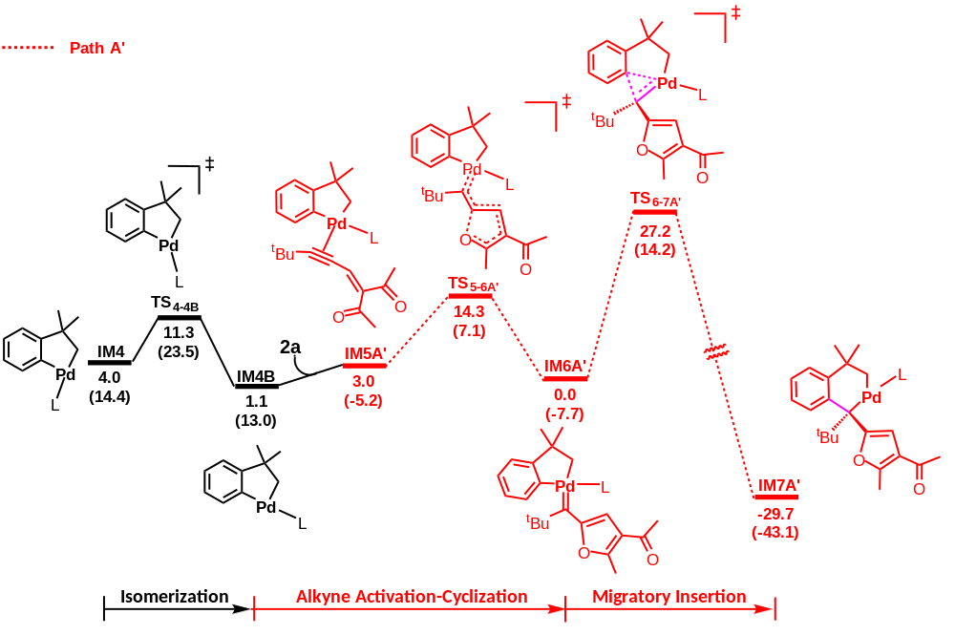
Figure S1. Energy profiles calculated for the path A′ which is similar with Path A starting from IM4B. The solvation-corrected relative free energies and electronic energies (in parentheses) are given in kcal/mol.

Cartesian coordinates
HOAc
E = -228.968030265 a.u.
C -0.132881000 0.129496000 -0.000048000
C 1.361524000 0.020260000 0.000049000
H 1.810156000 1.014396000 -0.000240000
H 1.702655000 -0.531616000 0.883566000
H 1.702806000 -0.531940000 -0.883234000
O -0.795191000 -1.045016000 0.000118000
H -0.169411000 -1.785538000 -0.000802000
O -0.757067000 1.162036000 -0.000030000
NaOAc
E = -390.726344967 a.u.
C 0.273209000 -0.103252000 -0.012419000
C -0.889961000 0.864109000 0.103784000
H -0.574975000 1.798089000 0.579864000
H -1.244064000 1.117223000 -0.903471000
H -1.724712000 0.424103000 0.656850000
O 0.036253000 -1.334275000 0.136222000
O 1.408210000 0.381174000 -0.282551000
Na 2.223064000 -1.720208000 -0.293587000
NaBr
E = -175.731840086 a.u.
Na 0.000000000 0.000000000 -2.043067000
Br 0.000000000 0.000000000 0.642107000
1a
E = -401.952278900 a.u.
C -0.409963000 3.015272000 -0.000044000
C -1.193946000 1.870212000 -0.000010000
C -0.599256000 0.609384000 0.000000000
C 0.796399000 0.423323000 -0.000018000
C 1.542790000 1.613952000 -0.000056000
C 0.970561000 2.879949000 -0.000070000
H -0.881049000 3.995097000 -0.000050000
H -2.277594000 1.952817000 0.000007000
H 2.626148000 1.553322000 -0.000077000
H 1.612675000 3.757650000 -0.000100000
Br -1.890903000 -0.827972000 0.000030000
C 1.523634000 -0.931828000 0.000004000
C 1.176096000 -1.728811000 1.263835000
H 0.113228000 -1.974602000 1.338829000
H 1.736755000 -2.672844000 1.268146000
H 1.458896000 -1.167547000 2.164073000
C 3.044988000 -0.761105000 -0.000018000
H 3.507954000 -1.755202000 0.000008000
H 3.405799000 -0.231691000 -0.890650000
H 3.405818000 -0.231636000 0.890573000
C 1.176065000 -1.728871000 -1.263781000
H 0.113197000 -1.974679000 -1.338729000
H 1.458828000 -1.167644000 -2.164053000
H 1.736733000 -2.672899000 -1.268068000
2a
E = -616.878068635 a.u.
C 1.733992000 -0.582752000 -0.022901000
C 0.553991000 -0.874479000 -0.027375000
C 3.145592000 -0.185104000 -0.009975000
C 3.750980000 -0.438702000 -1.394390000
H 3.226983000 0.134974000 -2.168271000
H 4.805062000 -0.133047000 -1.394462000
H 3.701940000 -1.501302000 -1.660229000
C 3.234117000 1.305064000 0.333644000
H 2.800257000 1.508167000 1.320255000
H 4.285123000 1.620759000 0.347841000
H 2.701529000 1.913540000 -0.407692000
C 3.894274000 -1.008557000 1.042314000
H 3.472325000 -0.852212000 2.042302000
H 3.849429000 -2.079952000 0.813407000
H 4.948854000 -0.705446000 1.062687000
C -0.827283000 -1.178271000 -0.037944000
H -1.109814000 -2.228230000 -0.129105000
C -1.780764000 -0.227733000 0.047841000
C -3.231774000 -0.509053000 0.004188000
O -4.015633000 0.431122000 0.034747000
C -1.409867000 1.227371000 0.201654000
O -1.184074000 1.691004000 1.300905000
C -3.699169000 -1.931013000 -0.075917000
H -3.327043000 -2.414306000 -0.986873000
H -3.328298000 -2.512999000 0.775843000
H -4.791287000 -1.949927000 -0.079279000
C -1.321003000 2.012084000 -1.066968000
H -0.539487000 1.577167000 -1.704957000
H -2.264823000 1.931473000 -1.619971000
H -1.091607000 3.061192000 -0.861731000
A
E = -1531.22346166 a.u.
C 2.858852000 -1.655932000 -0.148698000
C 3.502706000 -2.856564000 -0.468833000
C 4.714569000 -2.868039000 -1.153043000
C 5.308137000 -1.668362000 -1.526903000
C 4.679735000 -0.467937000 -1.215459000
C 3.457571000 -0.438848000 -0.536520000
H 3.062149000 -3.808761000 -0.182642000
H 5.192593000 -3.816456000 -1.388705000
H 6.255962000 -1.664656000 -2.060648000
H 5.136516000 0.478445000 -1.505359000
C 2.849436000 0.890130000 -0.241244000
C 3.213793000 1.589226000 0.920088000
C 1.953485000 1.471051000 -1.161095000
C 2.617106000 2.826585000 1.184557000
C 1.398945000 2.716050000 -0.872885000
C 1.703124000 3.402560000 0.305586000
H 2.893705000 3.362056000 2.094284000
H 0.702509000 3.161036000 -1.587258000
P 1.253157000 -1.664847000 0.782434000
P -0.558536000 -0.323878000 0.206182000
C 0.805104000 -3.450556000 0.860580000
C 1.802145000 -1.414696000 2.529883000
C 1.068364000 4.728319000 0.597503000
H 1.418259000 5.140490000 1.550136000
H 1.290660000 5.461243000 -0.188489000
H -0.025762000 4.646635000 0.648899000
C 4.268702000 1.066562000 1.850795000
H 5.273211000 1.306597000 1.474775000
H 4.177378000 1.520594000 2.843833000
H 4.231865000 -0.022136000 1.966748000
C 1.602152000 0.769398000 -2.438613000
H 0.957392000 1.394707000 -3.065351000
H 2.495410000 0.510812000 -3.022068000
H 1.062695000 -0.169355000 -2.242981000
H -0.120645000 -3.516035000 1.444550000
H 1.572152000 -4.058404000 1.355007000
H 0.605916000 -3.845649000 -0.141148000
H 0.958942000 -1.678889000 3.179680000
H 2.049133000 -0.362871000 2.705059000
H 2.662076000 -2.050638000 2.774742000
C -1.934871000 1.976323000 1.937712000
C -1.787208000 1.775048000 0.563057000
C -2.442189000 0.696019000 -0.082825000
C -3.198231000 -0.267452000 0.661272000
C -3.322640000 0.008775000 2.034342000
C -2.738011000 1.107574000 2.661191000
H -1.452096000 2.829444000 2.410055000
H -1.266469000 2.514380000 -0.042429000
H -3.913147000 -0.664849000 2.647710000
H -2.901499000 1.264126000 3.724847000
B -2.602184000 0.955864000 -2.012007000
C -3.949359000 -1.466068000 0.060233000
C -5.247521000 -0.964974000 -0.587180000
H -5.058074000 -0.277030000 -1.418779000
H -5.823343000 -1.814112000 -0.978285000
H -5.871789000 -0.444415000 0.150703000
C -4.333626000 -2.480260000 1.143109000
H -4.780771000 -3.359503000 0.663723000
H -3.456201000 -2.819263000 1.711188000
H -5.076509000 -2.093493000 1.850358000
C -3.112196000 -2.244591000 -0.962648000
H -2.821284000 -1.651994000 -1.833648000
H -2.193580000 -2.630224000 -0.496578000
H -3.694068000 -3.102032000 -1.326366000
TS1
E = -1531.21625798 a.u.
C -2.531952000 0.955076000 -2.862246000
C -2.129378000 -0.210733000 -2.219292000
C -2.296324000 -0.345162000 -0.828971000
C -2.931045000 0.648867000 -0.036739000
C -3.349574000 1.781485000 -0.748991000
C -3.158970000 1.947377000 -2.119961000
H -2.378104000 1.065623000 -3.933621000
H -1.706013000 -1.034637000 -2.790469000
H -3.838718000 2.587910000 -0.208486000
H -3.511793000 2.857242000 -2.600796000
Br -2.495165000 -2.502829000 -0.346609000
C -3.204215000 0.562982000 1.473433000
C -3.416323000 1.953797000 2.081733000
H -2.561235000 2.615572000 1.887091000
H -3.523597000 1.854300000 3.168907000
H -4.325394000 2.446536000 1.718329000
C -4.491844000 -0.241303000 1.700483000
H -4.724025000 -0.283599000 2.773313000
H -4.405248000 -1.268962000 1.329492000
H -5.339694000 0.235154000 1.190380000
C -2.050056000 -0.072769000 2.259125000
H -2.283203000 -0.045512000 3.332822000
H -1.113816000 0.486182000 2.106139000
H -1.876323000 -1.120519000 1.992804000
C 3.314100000 -0.873507000 0.049693000
C 4.429860000 -1.701597000 -0.116514000
C 5.644677000 -1.194487000 -0.567070000
C 5.763924000 0.160681000 -0.853575000
C 4.664800000 0.995604000 -0.686278000
C 3.434485000 0.499610000 -0.244173000
H 4.360759000 -2.764699000 0.104226000
H 6.495014000 -1.861307000 -0.691694000
H 6.708680000 0.567639000 -1.207393000
H 4.747223000 2.059758000 -0.907805000
C 2.301628000 1.458805000 -0.101437000
C 1.446570000 1.699212000 -1.195950000
C 2.124347000 2.168602000 1.097244000
C 0.417703000 2.630179000 -1.059853000
C 1.067398000 3.077852000 1.200324000
C 0.208599000 3.328439000 0.131839000
H -0.239251000 2.819522000 -1.911230000
H 0.931028000 3.624096000 2.135396000
P 1.694894000 -1.569529000 0.618824000
Pd -0.420807000 -0.906546000 -0.221946000
C 1.775712000 -1.363312000 2.454858000
C 1.941876000 -3.392091000 0.512477000
C -0.876976000 4.356467000 0.235531000
H -0.556833000 5.312440000 -0.200903000
H -1.149046000 4.553413000 1.278947000
H -1.779707000 4.046564000 -0.306332000
C 1.645476000 0.988493000 -2.501970000
H 2.643123000 1.176822000 -2.919914000
H 0.903840000 1.313612000 -3.240033000
H 1.548528000 -0.101179000 -2.388245000
C 3.085631000 2.019898000 2.240372000
H 3.987016000 2.626003000 2.071953000
H 3.427319000 0.987536000 2.376652000
H 2.636572000 2.359944000 3.180189000
H 2.759387000 -3.752985000 1.147575000
H 2.113813000 -3.696435000 -0.525285000
H 1.006230000 -3.852577000 0.851889000
H 0.992189000 -1.993163000 2.894252000
H 2.751627000 -1.682379000 2.841611000
H 1.583365000 -0.325637000 2.744137000
IM1
E = -1531.2558971 a.u.
C 3.090533000 -2.721236000 -1.737651000
C 2.071482000 -1.789522000 -1.591323000
C 1.996093000 -0.961323000 -0.462922000
C 2.977717000 -1.018065000 0.539581000
C 3.988429000 -1.985751000 0.362135000
C 4.053412000 -2.827447000 -0.737913000
H 3.126313000 -3.357509000 -2.620261000
H 1.309706000 -1.709274000 -2.366652000
H 4.766457000 -2.073482000 1.119463000
H 4.859092000 -3.554544000 -0.817662000
Br 1.871548000 1.869916000 -1.819086000
C 3.108835000 -0.133004000 1.793624000
C 3.121784000 -1.020248000 3.045939000
H 3.959686000 -1.726767000 3.052396000
H 3.207837000 -0.399177000 3.947725000
H 2.193852000 -1.603814000 3.128550000
C 2.009593000 0.910839000 1.984627000
H 2.226065000 1.483540000 2.897608000
H 1.967189000 1.621083000 1.149302000
H 1.017190000 0.460861000 2.114137000
C 4.436971000 0.634033000 1.709645000
H 4.559578000 1.273035000 2.594836000
H 5.304516000 -0.034428000 1.661382000
H 4.458997000 1.278994000 0.820977000
C -2.567981000 -1.663331000 -0.034370000
C -3.156883000 -2.895815000 -0.329760000
C -4.496295000 -2.967751000 -0.703945000
C -5.260698000 -1.809063000 -0.785239000
C -4.681560000 -0.576578000 -0.498516000
C -3.339784000 -0.490389000 -0.129296000
H -2.578903000 -3.815042000 -0.271529000
H -4.940475000 -3.934698000 -0.929072000
H -6.307105000 -1.862323000 -1.076878000
H -5.268904000 0.338489000 -0.567645000
C -2.701535000 0.820071000 0.146269000
C -1.951446000 1.440374000 -0.885117000
C -2.798011000 1.411626000 1.409925000
C -1.239944000 2.604751000 -0.580636000
C -2.068345000 2.580526000 1.666961000
C -1.268439000 3.175099000 0.700066000
H -0.672922000 3.096638000 -1.369540000
H -2.127388000 3.028345000 2.660202000
P -0.803013000 -1.522326000 0.498625000
Pd 0.399740000 0.252236000 -0.506052000
C -0.906298000 -1.439833000 2.334230000
C -0.147106000 -3.221246000 0.290041000
C -0.458165000 4.399334000 0.989984000
H -0.722822000 5.225127000 0.317674000
H -0.599722000 4.742230000 2.020274000
H 0.612134000 4.202639000 0.840524000
C -2.052480000 0.965467000 -2.309491000
H -3.041036000 1.210051000 -2.723075000
H -1.297107000 1.451845000 -2.935689000
H -1.928987000 -0.119900000 -2.405061000
C -3.669261000 0.830009000 2.484268000
H -4.727119000 1.066666000 2.306734000
H -3.597916000 -0.262581000 2.537321000
H -3.403343000 1.237008000 3.465820000
H -0.739428000 -3.926881000 0.882904000
H -0.152864000 -3.520332000 -0.762492000
H 0.884699000 -3.238498000 0.656479000
H 0.086255000 -1.669575000 2.739059000
H -1.620566000 -2.187960000 2.697775000
H -1.203724000 -0.443954000 2.674729000
IM2
E = -1746.23806745 a.u.
C 0.634050000 1.959398000 2.914276000
C 0.929153000 0.888559000 2.071034000
C 1.641158000 1.061081000 0.877513000
C 2.106297000 2.350128000 0.514459000
C 1.776414000 3.408237000 1.375594000
C 1.046767000 3.231937000 2.549027000
H 0.071307000 1.792905000 3.831802000
H 0.573104000 -0.105993000 2.346528000
H 2.102099000 4.416738000 1.133114000
H 0.813930000 4.092484000 3.173193000
C 3.003467000 2.617820000 -0.707076000
C 3.293028000 4.106488000 -0.907965000
H 3.852028000 4.541873000 -0.070281000
H 3.909221000 4.230427000 -1.807520000
H 2.376243000 4.692415000 -1.053879000
C 2.378125000 2.114245000 -2.011125000
H 3.083601000 2.260100000 -2.840569000
H 2.131408000 1.043653000 -1.967486000
H 1.464465000 2.673146000 -2.255072000
C 4.350536000 1.918458000 -0.488155000
H 5.030585000 2.136327000 -1.323717000
H 4.827488000 2.277194000 0.434441000
H 4.241921000 0.829788000 -0.409096000
C -1.225928000 -1.584606000 0.360679000
C -0.506726000 -2.666567000 0.890518000
C -1.108248000 -3.603087000 1.721371000
C -2.452141000 -3.462997000 2.049162000
C -3.176640000 -2.398887000 1.527660000
C -2.593014000 -1.452813000 0.676136000
H 0.552272000 -2.772447000 0.648798000
H -0.524807000 -4.432054000 2.114911000
H -2.936806000 -4.180698000 2.707105000
H -4.232460000 -2.286768000 1.773292000
C -3.478274000 -0.380712000 0.141739000
C -4.182029000 -0.593455000 -1.057873000
C -3.643213000 0.816687000 0.854562000
C -4.997812000 0.424518000 -1.550906000
C -4.473652000 1.808852000 0.330719000
C -5.153760000 1.635393000 -0.873137000
H -5.532368000 0.264878000 -2.489167000
H -4.586736000 2.746636000 0.876905000
P -0.228061000 -0.497591000 -0.755971000
Pd 1.969533000 -0.629138000 -0.154280000
C -0.392690000 -1.259869000 -2.415738000
C -1.000200000 1.141940000 -0.985026000
C -6.043772000 2.706997000 -1.425159000
H -7.094780000 2.390230000 -1.427544000
H -5.976580000 3.628722000 -0.837397000
H -5.786197000 2.947913000 -2.463910000
C -4.100217000 -1.902835000 -1.785774000
H -4.733860000 -2.659749000 -1.302601000
H -4.444916000 -1.801663000 -2.820559000
H -3.084838000 -2.315468000 -1.800124000
C -2.934323000 1.045190000 2.155952000
H -3.420720000 0.502444000 2.978487000
H -1.894810000 0.697658000 2.121688000
H -2.928460000 2.108487000 2.421158000
H -1.978904000 1.046196000 -1.463116000
H -1.089405000 1.681541000 -0.037382000
H -0.334631000 1.702018000 -1.650878000
H 0.314595000 -0.773395000 -3.097233000
H -1.410787000 -1.128127000 -2.800328000
H -0.155974000 -2.327237000 -2.357408000
C 3.817983000 -2.379186000 -0.406622000
O 2.718515000 -2.528327000 -1.022852000
O 4.017297000 -1.357657000 0.320937000
C 4.874841000 -3.434024000 -0.508826000
H 5.872429000 -2.999579000 -0.401721000
H 4.734753000 -4.158034000 0.302628000
H 4.797392000 -3.971780000 -1.457439000
TS₂₋₃
E = -1746.19643043 a.u.
C -1.001089000 -3.703639000 0.096287000
C -0.851277000 -2.326645000 0.265832000
C -1.901510000 -1.435937000 0.011511000
C -3.150870000 -1.967403000 -0.379426000
C -3.282582000 -3.347002000 -0.565817000
C -2.218298000 -4.214944000 -0.337579000
H -0.162599000 -4.367646000 0.302914000
H 0.113043000 -1.959286000 0.618062000
H -4.240576000 -3.756436000 -0.886461000
H -2.346735000 -5.285617000 -0.485135000
C -4.316160000 -1.020450000 -0.590892000
C -5.650644000 -1.642944000 -0.174208000
H -5.626028000 -1.975124000 0.872407000
H -6.451917000 -0.897845000 -0.271089000
H -5.934266000 -2.502001000 -0.796118000
C -4.396443000 -0.638806000 -2.073156000
H -5.196467000 0.095986000 -2.244058000
H -3.452533000 -0.199103000 -2.422454000
H -4.609610000 -1.519943000 -2.693793000
C -4.060329000 0.228409000 0.259465000
H -4.971754000 0.850392000 0.279929000
H -3.920706000 -0.038319000 1.319476000
H -3.613085000 1.374940000 -0.409800000
C 1.449610000 0.093682000 1.396189000
C 0.720102000 0.052992000 2.592705000
C 1.311983000 -0.327857000 3.791265000
C 2.654556000 -0.688704000 3.805430000
C 3.389113000 -0.653001000 2.626257000
C 2.813692000 -0.260531000 1.412652000
H -0.339112000 0.316947000 2.573665000
H 0.723303000 -0.348236000 4.705389000
H 3.131910000 -0.996747000 4.733051000
H 4.443158000 -0.929801000 2.632535000
C 3.695269000 -0.213339000 0.212363000
C 4.407772000 0.961312000 -0.078340000
C 3.858713000 -1.355462000 -0.593489000
C 5.208960000 1.002196000 -1.222645000
C 4.675274000 -1.277032000 -1.720026000
C 5.349709000 -0.102201000 -2.059647000
H 5.746725000 1.922245000 -1.457556000
H 4.789374000 -2.159173000 -2.352151000
P 0.477784000 0.697905000 -0.057625000
Pd -1.833253000 0.573118000 0.210891000
C 1.027774000 2.428606000 -0.319804000
C 1.014545000 -0.080856000 -1.629031000
C 6.229608000 -0.051174000 -3.271459000
H 5.756024000 -0.536070000 -4.133368000
H 6.472116000 0.980363000 -3.549112000
H 7.178317000 -0.575408000 -3.095568000
C 4.371472000 2.148806000 0.838941000
H 5.055482000 2.004457000 1.686889000
H 4.688234000 3.058714000 0.317354000
H 3.378837000 2.326997000 1.267122000
C 3.174508000 -2.646567000 -0.255474000
H 3.482966000 -3.019958000 0.729905000
H 2.081778000 -2.542708000 -0.218955000
H 3.410497000 -3.420008000 -0.993803000
H 2.041847000 0.188698000 -1.892421000
H 0.900787000 -1.167876000 -1.599145000
H 0.333515000 0.312481000 -2.394031000
H 0.415277000 2.863873000 -1.116973000
H 2.080282000 2.446401000 -0.624112000
H 0.885548000 3.016104000 0.591263000
C -2.769653000 3.254318000 -0.316310000
O -3.637328000 2.562856000 -0.938863000
O -1.884802000 2.745668000 0.422496000
C -2.821285000 4.745820000 -0.444202000
H -1.810302000 5.150771000 -0.549159000
H -3.440147000 5.053780000 -1.289391000
H -3.248382000 5.164092000 0.474663000
IM3
E = -1746.22365022 a.u.
C -2.549941000 -3.476233000 -0.774121000
C -1.760054000 -2.536605000 -0.107718000
C -2.162807000 -1.199941000 0.015831000
C -3.401301000 -0.826422000 -0.554557000
C -4.185147000 -1.769583000 -1.221315000
C -3.765524000 -3.093975000 -1.331335000
H -2.208753000 -4.507318000 -0.856545000
H -0.803748000 -2.869076000 0.297403000
H -5.137750000 -1.467886000 -1.659508000
H -4.385719000 -3.822646000 -1.850388000
C -3.770800000 0.632743000 -0.437262000
C -5.267660000 0.861539000 -0.221045000
H -5.637481000 0.289949000 0.640656000
H -5.458729000 1.925948000 -0.024987000
H -5.868648000 0.580099000 -1.096955000
C -3.348359000 1.359692000 -1.718282000
H -3.558482000 2.437052000 -1.642772000
H -2.273524000 1.231488000 -1.913571000
H -3.890388000 0.972290000 -2.592003000
C -2.973213000 1.159763000 0.757709000
H -2.950617000 2.262551000 0.777937000
H -3.453055000 0.839217000 1.698264000
H -1.046504000 2.387363000 -0.255697000
C 1.955841000 -2.016925000 0.443824000
C 2.124787000 -3.385794000 0.680569000
C 2.889855000 -4.176119000 -0.172033000
C 3.504937000 -3.603538000 -1.278947000
C 3.341018000 -2.244767000 -1.528058000
C 2.566010000 -1.439673000 -0.689685000
H 1.652879000 -3.854621000 1.541423000
H 3.004614000 -5.237972000 0.034520000
H 4.109377000 -4.211243000 -1.948750000
H 3.815343000 -1.787029000 -2.396347000
C 2.409663000 0.002814000 -1.030878000
C 3.331468000 0.948210000 -0.555921000
C 1.362111000 0.406094000 -1.884864000
C 3.142836000 2.298626000 -0.870372000
C 1.221289000 1.757667000 -2.191039000
C 2.094599000 2.722977000 -1.682120000
H 3.853704000 3.033011000 -0.486926000
H 0.405549000 2.069706000 -2.846926000
P 0.899029000 -0.994747000 1.571653000
Pd -1.106187000 0.259071000 0.921629000
C 0.413933000 -2.170007000 2.905979000
C 2.108392000 0.012563000 2.539800000
C 1.908133000 4.169725000 -2.023658000
H 2.064655000 4.348201000 -3.095581000
H 0.888370000 4.503801000 -1.792639000
H 2.610896000 4.808299000 -1.476925000
C 4.548150000 0.536734000 0.220031000
H 5.342055000 0.197947000 -0.460337000
H 4.950990000 1.376080000 0.797799000
H 4.353213000 -0.292090000 0.908292000
C 0.442131000 -0.604740000 -2.501683000
H 0.978613000 -1.237284000 -3.222248000
H 0.001745000 -1.279284000 -1.756329000
H -0.378555000 -0.114780000 -3.038192000
H 2.951237000 -0.606878000 2.867638000
H 2.469988000 0.871827000 1.967455000
H 1.578272000 0.385718000 3.423052000
H -0.124262000 -1.579190000 3.656495000
H 1.284909000 -2.633115000 3.384943000
H -0.265301000 -2.946319000 2.539974000
C -0.030844000 3.118150000 1.129605000
O -0.608125000 3.246640000 -0.051079000
O -0.116321000 2.090074000 1.799861000
C 0.751709000 4.304113000 1.564034000
H 0.633207000 4.456984000 2.639253000
H 1.811833000 4.094076000 1.370509000
H 0.467521000 5.202799000 1.013113000
IM4
E = -1517.22702662 a.u.
C 3.674470000 -2.235229000 -1.928068000
C 2.476223000 -1.583687000 -1.619631000
C 2.399554000 -0.695478000 -0.542425000
C 3.570868000 -0.428925000 0.196590000
C 4.759886000 -1.090787000 -0.107374000
C 4.812814000 -1.999163000 -1.164395000
H 3.711663000 -2.927813000 -2.767811000
H 1.601165000 -1.780779000 -2.240044000
H 5.660130000 -0.885394000 0.473530000
H 5.745053000 -2.510277000 -1.398390000
C 3.406590000 0.598358000 1.285740000
C 4.670224000 1.420124000 1.536026000
H 5.042599000 1.873111000 0.607340000
H 4.456976000 2.232888000 2.244238000
H 5.481701000 0.815784000 1.965886000
C 3.009321000 -0.097253000 2.592397000
H 2.844569000 0.641263000 3.390888000
H 2.079836000 -0.671289000 2.467734000
H 3.795854000 -0.787685000 2.928190000
C 2.259904000 1.495958000 0.800422000
H 1.867675000 2.107137000 1.629754000
H 2.617667000 2.184332000 0.016380000
C -2.497008000 -1.459404000 0.337129000
C -3.130158000 -2.622744000 0.782414000
C -4.359112000 -2.558086000 1.434080000
C -4.972048000 -1.327257000 1.645414000
C -4.353233000 -0.161973000 1.203654000
C -3.120151000 -0.216467000 0.553765000
H -2.669275000 -3.596014000 0.624230000
H -4.836746000 -3.473652000 1.776070000
H -5.931373000 -1.273241000 2.155356000
H -4.823480000 0.807731000 1.365695000
C -2.434685000 1.010893000 0.079962000
C -2.732567000 1.553255000 -1.170981000
C -1.402078000 1.563971000 0.881155000
C -1.944708000 2.608442000 -1.659654000
C -0.638931000 2.608575000 0.350815000
C -0.887401000 3.130286000 -0.932323000
H -2.167908000 3.018863000 -2.645539000
H 0.108473000 3.091478000 0.978466000
P -0.869303000 -1.492370000 -0.554952000
Pd 0.731968000 0.312414000 0.007545000
C -0.217694000 -3.158279000 -0.121925000
C -1.414225000 -1.770654000 -2.299255000
C -0.013828000 4.218361000 -1.472037000
H -0.414528000 4.636912000 -2.401311000
H 0.104988000 5.035432000 -0.749876000
H 0.994583000 3.836931000 -1.685800000
C -3.866322000 1.025622000 -1.999445000
H -4.835808000 1.371201000 -1.615715000
H -3.785641000 1.366580000 -3.037140000
H -3.902936000 -0.070508000 -2.001440000
C -1.231545000 1.141959000 2.315362000
H -2.101033000 1.447677000 2.913848000
H -1.139588000 0.054320000 2.426810000
H -0.342310000 1.604255000 2.757877000
H -2.198280000 -2.536661000 -2.335560000
H -1.789356000 -0.838737000 -2.734407000
H -0.556472000 -2.108909000 -2.891730000
H 0.750243000 -3.287545000 -0.617328000
H -0.884439000 -3.964142000 -0.448279000
H -0.059934000 -3.221251000 0.960797000
IM5A
E = -2134.12749392 a.u.
C -0.944337000 4.354327000 -0.308412000
C -0.694749000 3.008387000 -0.588750000
C 0.593310000 2.469690000 -0.494056000
C 1.648847000 3.333355000 -0.122682000
C 1.396590000 4.675098000 0.164467000
C 0.102091000 5.187283000 0.074761000
H -1.957885000 4.746576000 -0.389565000
H -1.531621000 2.377325000 -0.889587000
H 2.216965000 5.333315000 0.454564000
H -0.085818000 6.236338000 0.297142000
C 3.009700000 2.683336000 -0.046807000
C 3.260303000 2.193770000 1.384070000
H 2.483555000 1.484800000 1.705451000
H 4.232756000 1.683871000 1.455516000
H 3.267492000 3.033651000 2.093119000
C 4.150722000 3.621121000 -0.442395000
H 5.096513000 3.063144000 -0.485454000
H 3.979096000 4.068179000 -1.430844000
H 4.289217000 4.438939000 0.278752000
C 2.935670000 1.491514000 -1.009354000
H 2.995204000 1.848901000 -2.051163000
H 3.746580000 0.764501000 -0.842119000
C -1.849760000 -0.073768000 1.244021000
C -0.847948000 0.245066000 2.169208000
C -1.143984000 0.515051000 3.500981000
C -2.467346000 0.485080000 3.925503000
C -3.472194000 0.183114000 3.013771000
C -3.189523000 -0.103676000 1.672757000
H 0.187258000 0.297938000 1.826142000
H -0.343926000 0.757940000 4.197394000
H -2.719448000 0.701809000 4.961263000
H -4.513180000 0.163947000 3.336334000
C -4.336867000 -0.413877000 0.775748000
C -4.802867000 -1.732388000 0.656001000
C -4.986330000 0.629218000 0.089820000
C -5.862128000 -1.999981000 -0.215894000
C -6.047941000 0.323780000 -0.758907000
C -6.494077000 -0.987897000 -0.934915000
H -6.211023000 -3.028465000 -0.322382000
H -6.543270000 1.132270000 -1.299789000
P -1.177756000 -0.475727000 -0.474403000
Pd 1.114108000 0.526026000 -0.818916000
C -1.241767000 -2.349067000 -0.527232000
C -2.454371000 -0.091340000 -1.790795000
C -7.638813000 -1.284531000 -1.854617000
H -7.782954000 -2.362574000 -1.983383000
H -8.578213000 -0.868169000 -1.468113000
H -7.483300000 -0.841363000 -2.845970000
C -4.228658000 -2.844992000 1.483528000
H -4.651306000 -2.832248000 2.498068000
H -4.462480000 -3.822198000 1.046751000
H -3.141767000 -2.773463000 1.600792000
C -4.563760000 2.056847000 0.273112000
H -3.473841000 2.179440000 0.236663000
H -5.006423000 2.700552000 -0.494905000
H -4.883848000 2.442792000 1.250946000
C 1.944282000 -1.477180000 -1.804556000
C 2.129455000 -1.568137000 -0.591973000
C 1.948498000 -1.643727000 -3.269483000
C 0.646403000 -1.139932000 -3.890848000
H 0.496670000 -0.072148000 -3.682477000
H 0.683117000 -1.278481000 -4.978944000
H -0.219349000 -1.694809000 -3.506783000
C 3.138313000 -0.873591000 -3.850405000
H 4.078780000 -1.192017000 -3.383911000
H 3.203558000 -1.063744000 -4.929275000
H 3.024369000 0.206500000 -3.698923000
C 2.116817000 -3.142093000 -3.553396000
H 3.058653000 -3.519615000 -3.137115000
H 1.291217000 -3.722713000 -3.124341000
H 2.128112000 -3.307730000 -4.638177000
C 2.286015000 -1.693424000 0.808534000
H 1.354140000 -1.626485000 1.373743000
C 3.444169000 -1.906069000 1.481336000
C 3.455048000 -1.946368000 2.967113000
O 4.505464000 -2.107030000 3.572395000
C 4.727947000 -2.098675000 0.729015000
O 4.993274000 -1.398660000 -0.233651000
C 2.168963000 -1.719632000 3.712757000
H 1.790229000 -0.708036000 3.516973000
H 1.386396000 -2.427340000 3.416416000
H 2.363877000 -1.823528000 4.782429000
C 5.637630000 -3.210268000 1.157607000
H 6.252075000 -2.873216000 1.998849000
H 5.076486000 -4.084384000 1.504816000
H 6.287969000 -3.480807000 0.321207000
H -0.826387000 -2.676790000 -1.486931000
H -0.640513000 -2.771702000 0.284113000
H -2.274725000 -2.703807000 -0.449348000
H -1.937875000 -0.208392000 -2.751071000
H -3.299002000 -0.785084000 -1.746765000
H -2.814770000 0.938278000 -1.715688000
TS_{5-6A}
E = -2134.11201306 a.u.
C -1.519795000 -4.348102000 -2.551284000
C -1.083777000 -3.152504000 -1.973338000
C -1.821396000 -2.492722000 -0.980527000
C -3.044423000 -3.088058000 -0.586011000
C -3.475977000 -4.287382000 -1.155298000
C -2.717808000 -4.920543000 -2.139509000
H -0.918791000 -4.829199000 -3.322351000
H -0.139788000 -2.733069000 -2.318696000
H -4.417382000 -4.735665000 -0.833673000
H -3.064954000 -5.853163000 -2.581545000
C -3.803692000 -2.365011000 0.501537000
C -3.394363000 -2.942221000 1.861307000
H -2.310239000 -2.854864000 2.019819000
H -3.901628000 -2.410482000 2.680106000
H -3.661437000 -4.005911000 1.934581000
C -5.323103000 -2.482912000 0.367278000
H -5.814516000 -1.842233000 1.112830000
H -5.664007000 -2.163400000 -0.626864000
H -5.682355000 -3.507960000 0.534801000
C -3.376159000 -0.899406000 0.403124000
H -3.873422000 -0.415074000 -0.456376000
H -3.671804000 -0.339284000 1.305037000
C 2.163220000 -1.563087000 0.252509000
C 1.553693000 -2.734804000 0.725302000
C 2.270409000 -3.710294000 1.409685000
C 3.626324000 -3.520973000 1.647902000
C 4.244900000 -2.362623000 1.192673000
C 3.541200000 -1.376217000 0.492013000
H 0.485599000 -2.877223000 0.553368000
H 1.766549000 -4.608682000 1.759216000
H 4.202334000 -4.270138000 2.186677000
H 5.308260000 -2.206264000 1.374731000
C 4.312490000 -0.183923000 0.040187000
C 4.452239000 0.922553000 0.894789000
C 4.947789000 -0.191268000 -1.213642000
C 5.169215000 2.035029000 0.453274000
C 5.646020000 0.945252000 -1.624325000
C 5.763005000 2.070955000 -0.808304000
H 5.262037000 2.900081000 1.111672000
H 6.123487000 0.946240000 -2.605938000
P 1.005723000 -0.448890000 -0.685712000
Pd -1.345753000 -0.712758000 -0.029318000
C 1.544176000 1.303476000 -0.504560000
C 1.493731000 -0.693905000 -2.452817000
C 6.536131000 3.269292000 -1.267909000
H 6.319945000 4.148674000 -0.651686000
H 7.617901000 3.088844000 -1.215214000
H 6.308340000 3.518206000 -2.311196000
C 3.836604000 0.919678000 2.262029000
H 4.327363000 0.191033000 2.921407000
H 3.919309000 1.904306000 2.735422000
H 2.774410000 0.641324000 2.234701000
C 4.935597000 -1.411615000 -2.086954000
H 3.976970000 -1.940527000 -2.060533000
H 5.159794000 -1.156040000 -3.128551000
H 5.696703000 -2.132278000 -1.756214000
C -1.270134000 1.020865000 1.251140000
C -1.747551000 1.963341000 0.499945000
C -0.893758000 0.962640000 2.706648000
C -0.191974000 -0.344209000 3.067086000
H 0.749874000 -0.458769000 2.513917000
H 0.044236000 -0.353261000 4.139556000
H -0.825146000 -1.214073000 2.847568000
C 0.025994000 2.136215000 3.069873000
H -0.456058000 3.100258000 2.884988000
H 0.284563000 2.070851000 4.135117000
H 0.964513000 2.103280000 2.500841000
C -2.196043000 1.070714000 3.516164000
H -2.721288000 2.010252000 3.309830000
H -2.873976000 0.236289000 3.295867000
H -1.954808000 1.034140000 4.586778000
C -2.204688000 2.418380000 -0.739673000
H -2.208132000 1.707598000 -1.565288000
C -2.614327000 3.720362000 -0.866877000
C -3.118617000 4.322746000 -2.112721000
O -3.453381000 5.498569000 -2.154463000
C -2.484492000 4.407930000 0.406107000
O -2.044128000 3.707607000 1.343613000
C -3.206049000 3.440450000 -3.325252000
H -2.212955000 3.072706000 -3.611364000
H -3.833438000 2.562700000 -3.129617000
H -3.630269000 4.010924000 -4.154474000
C -2.828624000 5.831837000 0.637960000
H -2.245445000 6.473945000 -0.030328000
H -3.880453000 6.013423000 0.394222000
H -2.631873000 6.093867000 1.680076000
H 0.811212000 1.905121000 -1.056939000
H 1.524053000 1.620861000 0.542667000
H 2.535120000 1.482648000 -0.930509000
H 0.725703000 -0.234990000 -3.087167000
H 2.456260000 -0.208548000 -2.652054000
H 1.572585000 -1.755291000 -2.705288000
IM6A
E = -2134.13686299 a.u.
C -1.538434000 -4.385088000 -2.553051000
C -1.077697000 -3.193847000 -1.984966000
C -1.782882000 -2.512215000 -0.980921000
C -3.008219000 -3.093914000 -0.567541000
C -3.467132000 -4.289777000 -1.123902000
C -2.737036000 -4.939015000 -2.118984000
H -0.957696000 -4.877162000 -3.333071000
H -0.132387000 -2.793289000 -2.350576000
H -4.408767000 -4.724626000 -0.784261000
H -3.106150000 -5.868317000 -2.550535000
C -3.748681000 -2.366442000 0.533199000
C -3.323513000 -2.947557000 1.886401000
H -2.236406000 -2.870120000 2.028197000
H -3.813186000 -2.412526000 2.713958000
H -3.598387000 -4.009061000 1.963411000
C -5.270989000 -2.482051000 0.421347000
H -5.750993000 -1.841096000 1.174143000
H -5.626234000 -2.161576000 -0.567519000
H -5.630392000 -3.506202000 0.593979000
C -3.331093000 -0.897824000 0.436969000
H -3.818695000 -0.421911000 -0.432415000
H -3.660716000 -0.343379000 1.329542000
C 2.194813000 -1.545599000 0.253780000
C 1.601057000 -2.724158000 0.730075000
C 2.326497000 -3.677377000 1.435780000
C 3.674098000 -3.456956000 1.694179000
C 4.276104000 -2.291049000 1.236449000
C 3.564147000 -1.326756000 0.513118000
H 0.538492000 -2.888993000 0.543715000
H 1.835762000 -4.582259000 1.787191000
H 4.256679000 -4.187856000 2.250680000
H 5.332940000 -2.110994000 1.433776000
C 4.319455000 -0.126593000 0.054801000
C 4.422502000 0.997834000 0.890894000
C 4.974824000 -0.143338000 -1.188767000
C 5.125332000 2.116038000 0.440583000
C 5.659145000 0.998387000 -1.607956000
C 5.740666000 2.140619000 -0.810747000
H 5.190465000 2.994584000 1.084306000
H 6.153204000 0.990499000 -2.581276000
P 1.027893000 -0.469131000 -0.715227000
Pd -1.287277000 -0.713791000 -0.008535000
C 1.553665000 1.291638000 -0.606909000
C 1.502407000 -0.780384000 -2.474889000
C 6.499535000 3.344681000 -1.279090000
H 6.270520000 4.226570000 -0.671138000
H 7.583359000 3.178456000 -1.222776000
H 6.270982000 3.581768000 -2.325028000
C 3.786884000 1.008157000 2.249007000
H 4.262467000 0.279992000 2.919844000
H 3.870223000 1.995276000 2.717116000
H 2.722481000 0.739500000 2.210200000
C 4.996542000 -1.376754000 -2.043451000
H 4.041732000 -1.913675000 -2.037795000
H 5.247368000 -1.133401000 -3.081890000
H 5.753490000 -2.087100000 -1.682118000
C -1.290369000 0.991374000 1.132277000
C -1.829037000 2.132057000 0.526062000
C -0.918415000 1.010770000 2.602411000
C -0.203773000 -0.279520000 3.004120000
H 0.740004000 -0.399221000 2.455216000
H 0.030896000 -0.260867000 4.077115000
H -0.824914000 -1.162863000 2.805678000
C 0.009079000 2.186961000 2.957232000
H -0.487142000 3.156942000 2.874598000
H 0.350511000 2.068237000 3.994102000
H 0.903613000 2.203706000 2.320786000
C -2.210629000 1.118872000 3.433837000
H -2.767439000 2.037917000 3.222585000
H -2.872713000 0.262844000 3.252648000
H -1.946659000 1.116995000 4.499792000
C -2.235705000 2.337081000 -0.788212000
H -2.179425000 1.578019000 -1.562658000
C -2.701884000 3.653266000 -0.911797000
C -3.242983000 4.342686000 -2.094505000
O -3.584119000 5.514315000 -2.028996000
C -2.571950000 4.221749000 0.355816000
O -2.063701000 3.345591000 1.207598000
C -3.352009000 3.538658000 -3.353222000
H -2.360226000 3.195601000 -3.673941000
H -3.960021000 2.641733000 -3.183219000
H -3.801267000 4.143996000 -4.143543000
C -2.902703000 5.561861000 0.863208000
H -2.385160000 6.329354000 0.278687000
H -3.975376000 5.756435000 0.751228000
H -2.626121000 5.651474000 1.916342000
H 0.804877000 1.863759000 -1.169321000
H 1.540216000 1.642586000 0.429348000
H 2.536605000 1.468650000 -1.052027000
H 0.723479000 -0.361040000 -3.123053000
H 2.453781000 -0.284614000 -2.700253000
H 1.601546000 -1.849493000 -2.683370000
TS_{6-7A}
E = -2134.11506541 a.u.
C -2.164982000 -4.005035000 -2.650891000
C -1.248353000 -3.017306000 -2.285334000
C -1.233923000 -2.513199000 -0.990260000
C -2.145935000 -2.979047000 -0.000350000
C -3.063918000 -3.952959000 -0.415755000
C -3.074992000 -4.466119000 -1.712221000
H -2.165685000 -4.396015000 -3.666772000
H -0.559524000 -2.637749000 -3.035502000
H -3.796773000 -4.338701000 0.287832000
H -3.802630000 -5.229978000 -1.978531000
C -2.135037000 -2.465763000 1.467373000
C -0.776295000 -2.808967000 2.097530000
H 0.060214000 -2.240494000 1.667762000
H -0.790725000 -2.613900000 3.176616000
H -0.560634000 -3.876479000 1.949673000
C -3.177618000 -3.222329000 2.299280000
H -3.110311000 -2.893190000 3.343680000
H -4.203838000 -3.032320000 1.960197000
H -3.003477000 -4.305359000 2.286304000
C -2.573751000 -0.936557000 1.624483000
H -3.524306000 -0.892711000 1.076894000
H -2.852797000 -0.853631000 2.686030000
C 2.649382000 -1.461230000 -0.554823000
C 2.470427000 -2.853333000 -0.562279000
C 3.420988000 -3.708856000 -0.024139000
C 4.575280000 -3.178761000 0.544879000
C 4.756152000 -1.802731000 0.569910000
C 3.809300000 -0.921307000 0.031002000
H 1.560714000 -3.275580000 -0.991207000
H 3.257349000 -4.783595000 -0.046882000
H 5.329477000 -3.835282000 0.972649000
H 5.653689000 -1.379008000 1.020127000
C 4.087790000 0.536910000 0.141898000
C 3.696679000 1.226365000 1.302583000
C 4.770014000 1.208624000 -0.882985000
C 3.931091000 2.598339000 1.386158000
C 4.996832000 2.580905000 -0.758825000
C 4.575250000 3.295190000 0.361690000
H 3.608172000 3.136211000 2.279855000
H 5.514687000 3.106067000 -1.562982000
P 1.259282000 -0.547490000 -1.359576000
Pd -0.635031000 -0.812270000 -0.178721000
C 1.571084000 1.250133000 -1.525050000
C 1.409116000 -1.068280000 -3.112711000
C 4.829513000 4.766772000 0.484777000
H 3.923972000 5.307032000 0.786283000
H 5.590366000 4.976523000 1.247895000
H 5.182937000 5.194077000 -0.459717000
C 3.056803000 0.499827000 2.447219000
H 3.778559000 -0.158159000 2.950623000
H 2.671059000 1.201283000 3.195133000
H 2.230100000 -0.144082000 2.117616000
C 5.231933000 0.473714000 -2.104876000
H 4.397078000 -0.010885000 -2.630030000
H 5.724984000 1.150141000 -2.810593000
H 5.940768000 -0.325154000 -1.850456000
C -1.737366000 0.360705000 1.266954000
C -2.546510000 1.256556000 0.407740000
C -1.215627000 1.130126000 2.524865000
C -0.525285000 0.202035000 3.523216000
H 0.293556000 -0.357279000 3.053593000
H -0.099252000 0.792104000 4.347228000
H -1.214998000 -0.523353000 3.973889000
C -0.191875000 2.190978000 2.112102000
H -0.618021000 2.924037000 1.416143000
H 0.169632000 2.743719000 2.992620000
H 0.675150000 1.727773000 1.619179000
C -2.357293000 1.848356000 3.260700000
H -2.808377000 2.630195000 2.634579000
H -3.156359000 1.154288000 3.555269000
H -1.989055000 2.332000000 4.176835000
C -2.243626000 2.206508000 -0.524823000
H -1.247586000 2.410205000 -0.901752000
C -3.463313000 2.864228000 -0.911209000
C -3.627845000 3.941597000 -1.890260000
O -4.716638000 4.442482000 -2.151349000
C -4.463471000 2.245497000 -0.199232000
O -3.931921000 1.294053000 0.593100000
C -2.374184000 4.417407000 -2.572316000
H -1.656536000 4.799590000 -1.835493000
H -1.879539000 3.590278000 -3.097313000
H -2.618439000 5.208714000 -3.285231000
C -5.931804000 2.390349000 -0.165497000
H -6.289026000 2.549809000 0.859508000
H -6.228463000 3.237017000 -0.786472000
H -6.425267000 1.484741000 -0.542283000
H 0.713659000 1.642011000 -2.087073000
H 1.612864000 1.741936000 -0.548901000
H 2.488432000 1.449065000 -2.089387000
H 0.577269000 -0.645984000 -3.687233000
H 2.353731000 -0.675266000 -3.508025000
H 1.416082000 -2.156187000 -3.214523000
IM7A
E = -2134.18010177 a.u.
C -2.013825000 3.083849000 2.474965000
C -1.500478000 1.870298000 2.015495000
C -1.301093000 1.637274000 0.650600000
C -1.688257000 2.613596000 -0.286809000
C -2.172188000 3.837177000 0.196044000
C -2.327280000 4.080406000 1.559286000
H -2.159123000 3.244658000 3.542322000
H -1.244170000 1.099568000 2.743015000
H -2.450208000 4.624340000 -0.501983000
H -2.708935000 5.041872000 1.898014000
C -1.606714000 2.316632000 -1.779833000
C -0.142463000 2.276133000 -2.232110000
H 0.447530000 1.532813000 -1.679116000
H -0.073189000 2.046914000 -3.304727000
H 0.324295000 3.258203000 -2.069369000
C -2.293627000 3.388632000 -2.626994000
H -2.268169000 3.092942000 -3.683921000
H -3.346281000 3.525982000 -2.346824000
H -1.789305000 4.360406000 -2.551610000
C -2.378108000 0.993480000 -2.056720000
H -3.435572000 1.244921000 -1.893849000
H -2.296442000 0.801660000 -3.136361000
C 2.724863000 1.300937000 0.681801000
C 2.269184000 2.629487000 0.691819000
C 2.979111000 3.647472000 0.070158000
C 4.166232000 3.350318000 -0.593648000
C 4.622299000 2.039550000 -0.619783000
C 3.920903000 0.998988000 0.005732000
H 1.328196000 2.873221000 1.187873000
H 2.601410000 4.667159000 0.098827000
H 4.731426000 4.134997000 -1.091544000
H 5.548745000 1.796092000 -1.139909000
C 4.498948000 -0.370425000 -0.096637000
C 4.023713000 -1.264718000 -1.071777000
C 5.533989000 -0.757739000 0.768060000
C 4.590135000 -2.534913000 -1.163223000
C 6.072625000 -2.041112000 0.649978000
C 5.618426000 -2.942654000 -0.310217000
H 4.215922000 -3.228160000 -1.918918000
H 6.869380000 -2.343839000 1.331154000
P 1.548763000 0.112462000 1.479883000
Pd -0.426450000 -0.082149000 0.080212000
C 2.387258000 -1.482366000 1.855669000
C 1.470509000 0.794879000 3.192245000
C 6.210557000 -4.313505000 -0.435067000
H 5.445657000 -5.092689000 -0.326546000
H 6.670670000 -4.460560000 -1.420627000
H 6.981176000 -4.489656000 0.323038000
C 2.884807000 -0.880316000 -1.966750000
H 3.102845000 0.021874000 -2.555399000
H 2.638807000 -1.689497000 -2.663699000
H 1.977246000 -0.655940000 -1.382578000
C 6.033596000 0.167264000 1.837884000
H 5.215241000 0.519013000 2.481788000
H 6.771343000 -0.332040000 2.474626000
H 6.507346000 1.065219000 1.420540000
C -2.037457000 -0.276418000 -1.260727000
C -3.202259000 -0.730935000 -0.449781000
C -1.487327000 -1.477772000 -2.127166000
C -0.518034000 -1.020724000 -3.219623000
H 0.272870000 -0.371720000 -2.828871000
H -0.037859000 -1.899526000 -3.672098000
H -1.024235000 -0.485076000 -4.031656000
C -0.724926000 -2.443576000 -1.205261000
H -1.359174000 -2.842305000 -0.405401000
H -0.337308000 -3.297169000 -1.780672000
H 0.187735000 -1.998740000 -0.746176000
C -2.610933000 -2.261412000 -2.812272000
H -3.270137000 -2.762095000 -2.090884000
H -3.231757000 -1.608373000 -3.439969000
H -2.183300000 -3.038454000 -3.462067000
C -3.352980000 -1.364149000 0.745876000
H -2.550530000 -1.585351000 1.441517000
C -4.751602000 -1.661923000 0.913786000
C -5.396563000 -2.329185000 2.048698000
O -6.602787000 -2.545381000 2.091475000
C -5.376240000 -1.167826000 -0.206080000
O -4.461343000 -0.611789000 -1.024374000
C -4.492901000 -2.744316000 3.176210000
H -3.727760000 -3.444288000 2.817548000
H -3.962501000 -1.875413000 3.585285000
H -5.078169000 -3.219889000 3.966955000
C -6.782992000 -1.111473000 -0.647896000
H -7.412548000 -1.612464000 0.089388000
H -7.119450000 -0.072725000 -0.759023000
H -6.909543000 -1.599509000 -1.622460000
H 1.691303000 -2.026285000 2.506735000
H 2.551438000 -2.080933000 0.955349000
H 3.334146000 -1.344929000 2.388916000
H 0.855071000 0.127712000 3.806617000
H 2.482099000 0.839319000 3.614000000
H 1.028601000 1.794499000 3.212362000
TS_{4-4B}
E = -1517.21253785 a.u.
C 5.882736000 -0.715721000 0.580184000
C 4.845830000 0.168885000 0.307504000
C 3.640043000 -0.237772000 -0.297503000
C 3.482366000 -1.620047000 -0.569181000
C 4.540574000 -2.499081000 -0.311300000
C 5.735464000 -2.057831000 0.244306000
H 6.803205000 -0.356880000 1.036852000
H 4.993590000 1.224017000 0.538463000
H 4.418814000 -3.561182000 -0.524368000
H 6.542035000 -2.764631000 0.429946000
C 2.131502000 -2.190747000 -0.969210000
C 1.591776000 -3.003458000 0.215884000
H 1.506515000 -2.380511000 1.116989000
H 0.593008000 -3.399517000 -0.018487000
H 2.242808000 -3.853770000 0.455529000
C 2.226498000 -3.106658000 -2.193787000
H 1.223944000 -3.448526000 -2.486444000
H 2.666318000 -2.579111000 -3.050249000
H 2.831992000 -4.001294000 -1.998397000
C 1.145455000 -1.062676000 -1.270887000
H 1.287738000 -0.661692000 -2.290226000
H 0.114952000 -1.439057000 -1.204138000
C -1.432616000 -0.134581000 1.328296000
C -0.543991000 -0.432230000 2.371439000
C -0.931605000 -1.203980000 3.460059000
C -2.226937000 -1.707252000 3.514406000
C -3.116861000 -1.421647000 2.486246000
C -2.747811000 -0.633279000 1.390050000
H 0.479184000 -0.053527000 2.320685000
H -0.220892000 -1.415831000 4.255434000
H -2.544388000 -2.321158000 4.354351000
H -4.134818000 -1.809541000 2.521731000
C -3.780450000 -0.367482000 0.351934000
C -3.927103000 -1.254971000 -0.729743000
C -4.633449000 0.739191000 0.477983000
C -4.889911000 -0.985952000 -1.699542000
C -5.583047000 0.978533000 -0.519506000
C -5.722907000 0.132515000 -1.617477000
H -4.993643000 -1.668320000 -2.544941000
H -6.236139000 1.847919000 -0.429123000
P -0.703846000 0.970437000 0.036647000
Pd 1.561691000 0.587757000 -0.158461000
C -1.614157000 0.889663000 -1.552600000
C -1.111846000 2.663178000 0.615881000
C -6.752550000 0.391705000 -2.675051000
H -6.314497000 0.353312000 -3.679820000
H -7.546742000 -0.365779000 -2.648994000
H -7.224807000 1.371720000 -2.547043000
C -3.062120000 -2.474792000 -0.841338000
H -3.284116000 -3.196814000 -0.043873000
H -3.212166000 -2.980692000 -1.801034000
H -1.994553000 -2.232781000 -0.746442000
C -4.576585000 1.637937000 1.678526000
H -3.551572000 1.830483000 2.016769000
H -5.057465000 2.600844000 1.474012000
H -5.102792000 1.185538000 2.530843000
H -1.030410000 1.493342000 -2.258216000
H -1.672765000 -0.132774000 -1.935635000
H -2.618651000 1.314921000 -1.468168000
H -0.655887000 3.387136000 -0.068042000
H -0.709682000 2.820479000 1.621720000
H -2.197538000 2.812829000 0.621195000
C 3.108397000 2.976574000 -0.279846000
C 3.642506000 4.374125000 -0.176658000
H 3.127028000 4.942030000 0.600541000
H 4.712677000 4.330996000 0.056613000
H 3.543589000 4.886137000 -1.139175000
O 3.560978000 2.256623000 -1.234428000
H 3.338536000 0.978617000 -0.920219000
O 2.274310000 2.567979000 0.568985000
IM4B
E = -1517.22919094 a.u.
C 4.172824000 1.925026000 -0.592661000
C 2.833743000 1.542281000 -0.719501000
C 2.393596000 0.267634000 -0.345307000
C 3.371300000 -0.648009000 0.106274000
C 4.706434000 -0.268525000 0.244915000
C 5.108475000 1.023772000 -0.094899000
H 4.480138000 2.929071000 -0.886368000
H 2.123258000 2.267179000 -1.117009000
H 5.446433000 -0.983105000 0.609291000
H 6.151848000 1.316571000 0.011757000
C 2.849147000 -2.035321000 0.397216000
C 2.437002000 -2.149923000 1.868654000
H 1.696462000 -1.381533000 2.134185000
H 1.991657000 -3.135426000 2.071376000
H 3.305657000 -2.029014000 2.530678000
C 3.856878000 -3.142192000 0.084096000
H 3.383170000 -4.128003000 0.189840000
H 4.239186000 -3.057716000 -0.941716000
H 4.715998000 -3.122137000 0.768269000
C 1.626972000 -2.195700000 -0.509180000
H 1.925100000 -2.268646000 -1.566001000
H 1.046876000 -3.093681000 -0.250700000
C -3.009754000 -0.804746000 -0.010142000
C -4.277484000 -1.392732000 0.053945000
C -5.399528000 -0.630095000 0.348261000
C -5.257177000 0.735522000 0.585441000
C -4.000761000 1.323958000 0.520951000
C -2.857895000 0.568005000 0.220785000
H -4.386839000 -2.462090000 -0.126519000
H -6.380486000 -1.097386000 0.396413000
H -6.127696000 1.343573000 0.821661000
H -3.889766000 2.392958000 0.702777000
C -1.565585000 1.325322000 0.163711000
C -1.247442000 2.045012000 -1.012166000
C -0.873909000 1.615285000 1.363492000
C -0.307455000 3.073948000 -0.948505000
C 0.069570000 2.643124000 1.375929000
C 0.338421000 3.408429000 0.242033000
H -0.079696000 3.635636000 -1.856013000
H 0.593043000 2.864358000 2.307557000
P -1.510368000 -1.798528000 -0.359624000
Pd 0.462938000 -0.506095000 -0.364351000
C -1.610384000 -3.149809000 0.885996000
C -1.907010000 -2.689530000 -1.917325000
C 1.313410000 4.544020000 0.300570000
H 1.687639000 4.806223000 -0.695827000
H 0.848444000 5.445145000 0.722174000
H 2.173069000 4.301403000 0.937125000
C -1.965972000 1.758190000 -2.296635000
H -3.013739000 2.085254000 -2.253538000
H -1.489625000 2.276546000 -3.135321000
H -1.977982000 0.683547000 -2.521446000
C -1.203047000 0.885783000 2.631470000
H -1.268068000 -0.198865000 2.478121000
H -0.444414000 1.074000000 3.398777000
H -2.173657000 1.206168000 3.034747000
H -0.815006000 -3.879152000 0.696666000
H -1.472930000 -2.733815000 1.890259000
H -2.576522000 -3.664708000 0.831562000
H -1.066759000 -3.349094000 -2.165204000
H -2.033288000 -1.965364000 -2.729366000
H -2.817362000 -3.292007000 -1.818196000
TS_{4-5B}
E = -1746.19288372 a.u.
C 5.882736000 -0.715721000 0.580184000
C 4.845830000 0.168885000 0.307504000
C 3.640043000 -0.237772000 -0.297503000
C 3.482366000 -1.620047000 -0.569181000
C 4.540574000 -2.499081000 -0.311300000
C 5.735464000 -2.057831000 0.244306000
H 6.803205000 -0.356880000 1.036852000
H 4.993590000 1.224017000 0.538463000
H 4.418814000 -3.561182000 -0.524368000
H 6.542035000 -2.764631000 0.429946000
C 2.131502000 -2.190747000 -0.969210000
C 1.591776000 -3.003458000 0.215884000
H 1.506515000 -2.380511000 1.116989000
H 0.593008000 -3.399517000 -0.018487000
H 2.242808000 -3.853770000 0.455529000
C 2.226498000 -3.106658000 -2.193787000
H 1.223944000 -3.448526000 -2.486444000
H 2.666318000 -2.579111000 -3.050249000
H 2.831992000 -4.001294000 -1.998397000
C 1.145455000 -1.062676000 -1.270887000
H 1.287738000 -0.661692000 -2.290226000
H 0.114952000 -1.439057000 -1.204138000
C -1.432616000 -0.134581000 1.328296000
C -0.543991000 -0.432230000 2.371439000
C -0.931605000 -1.203980000 3.460059000
C -2.226937000 -1.707252000 3.514406000
C -3.116861000 -1.421647000 2.486246000
C -2.747811000 -0.633279000 1.390050000
H 0.479184000 -0.053527000 2.320685000
H -0.220892000 -1.415831000 4.255434000
H -2.544388000 -2.321158000 4.354351000
H -4.134818000 -1.809541000 2.521731000
C -3.780450000 -0.367482000 0.351934000
C -3.927103000 -1.254971000 -0.729743000
C -4.633449000 0.739191000 0.477983000
C -4.889911000 -0.985952000 -1.699542000
C -5.583047000 0.978533000 -0.519506000
C -5.722907000 0.132515000 -1.617477000
H -4.993643000 -1.668320000 -2.544941000
H -6.236139000 1.847919000 -0.429123000
P -0.703846000 0.970437000 0.036647000
Pd 1.561691000 0.587757000 -0.158461000
C -1.614157000 0.889663000 -1.552600000
C -1.111846000 2.663178000 0.615881000
C -6.752550000 0.391705000 -2.675051000
H -6.314497000 0.353312000 -3.679820000
H -7.546742000 -0.365779000 -2.648994000
H -7.224807000 1.371720000 -2.547043000
C -3.062120000 -2.474792000 -0.841338000
H -3.284116000 -3.196814000 -0.043873000
H -3.212166000 -2.980692000 -1.801034000
H -1.994553000 -2.232781000 -0.746442000
C -4.576585000 1.637937000 1.678526000
H -3.551572000 1.830483000 2.016769000
H -5.057465000 2.600844000 1.474012000
H -5.102792000 1.185538000 2.530843000
H -1.030410000 1.493342000 -2.258216000
H -1.672765000 -0.132774000 -1.935635000
H -2.618651000 1.314921000 -1.468168000
H -0.655887000 3.387136000 -0.068042000
H -0.709682000 2.820479000 1.621720000
H -2.197538000 2.812829000 0.621195000
C 3.108397000 2.976574000 -0.279846000
C 3.642506000 4.374125000 -0.176658000
H 3.127028000 4.942030000 0.600541000
H 4.712677000 4.330996000 0.056613000
H 3.543589000 4.886137000 -1.139175000
O 3.560978000 2.256623000 -1.234428000
H 3.338536000 0.978617000 -0.920219000
O 2.274310000 2.567979000 0.568985000
IM5B
E = -1746.24190784 a.u.
C 6.019734000 -1.288875000 -1.122210000
C 4.936373000 -1.841944000 -0.441767000
C 3.868657000 -1.040213000 -0.058510000
C 3.846704000 0.336465000 -0.334973000
C 4.937742000 0.871202000 -1.026204000
C 6.011988000 0.069899000 -1.413430000
H 6.860061000 -1.912082000 -1.420811000
H 4.922423000 -2.904752000 -0.205015000
H 4.967785000 1.930986000 -1.267444000
H 6.848998000 0.519424000 -1.944682000
C 2.646144000 1.179896000 0.112178000
C 2.862997000 2.667477000 -0.155090000
H 2.964205000 2.878891000 -1.228057000
H 2.004856000 3.237254000 0.218651000
H 3.762529000 3.040995000 0.352863000
C 2.439108000 0.975656000 1.617018000
H 1.578665000 1.557677000 1.968977000
H 2.257740000 -0.076909000 1.865580000
H 3.328133000 1.304194000 2.173389000
C 1.443531000 0.674318000 -0.702629000
H 1.617796000 0.879217000 -1.772401000
H 1.338441000 -0.412634000 -0.590427000
C -2.827042000 -0.627576000 -0.997531000
C -4.081774000 -0.250165000 -1.490343000
C -5.252135000 -0.788727000 -0.964832000
C -5.181883000 -1.718725000 0.064645000
C -3.940536000 -2.094714000 0.567179000
C -2.753987000 -1.555702000 0.064032000
H -4.160961000 0.472440000 -2.298750000
H -6.214546000 -0.479792000 -1.365940000
H -6.089954000 -2.150385000 0.479563000
H -3.877671000 -2.820898000 1.377414000
C -1.469927000 -1.996772000 0.682380000
C -0.976481000 -1.329372000 1.819676000
C -0.796461000 -3.124864000 0.181839000
C 0.221146000 -1.761449000 2.390286000
C 0.410303000 -3.512398000 0.769016000
C 0.937955000 -2.841207000 1.871775000
H 0.605716000 -1.237313000 3.267173000
H 0.942294000 -4.373869000 0.361626000
P -1.318386000 0.161614000 -1.706950000
Pd -0.351460000 1.538008000 -0.205233000
C -0.395258000 -1.138099000 -2.607589000
C -1.909912000 1.207201000 -3.088290000
C 2.222613000 -3.285679000 2.503841000
H 2.740571000 -2.452128000 2.993236000
H 2.044597000 -4.048863000 3.273390000
H 2.903818000 -3.727774000 1.766564000
C -1.735922000 -0.196578000 2.444987000
H -2.624870000 -0.563208000 2.977290000
H -1.113268000 0.338462000 3.171813000
H -2.085124000 0.528053000 1.698510000
C -1.377034000 -3.949093000 -0.929301000
H -1.893302000 -3.342345000 -1.680639000
H -0.600892000 -4.535503000 -1.433549000
H -2.118996000 -4.658423000 -0.536275000
H 0.376371000 -0.646404000 -3.209761000
H 0.084218000 -1.841742000 -1.921753000
H -1.082481000 -1.672190000 -3.272779000
H -1.018043000 1.626119000 -3.567988000
H -2.520235000 2.035586000 -2.714976000
H -2.473094000 0.625739000 -3.827286000
C -1.308517000 3.410835000 1.286288000
C -1.834859000 4.516167000 2.150508000
H -2.901148000 4.385433000 2.352103000
H -1.277928000 4.572916000 3.089903000
H -1.700744000 5.470425000 1.626736000
O -0.063682000 3.153924000 1.303344000
H 3.029464000 -1.498911000 0.465731000
O -2.094077000 2.768320000 0.529820000
IM6B
E = -2363.13259573 a.u.
C -2.337660000 6.369689000 0.338013000
C -3.204201000 5.437572000 -0.228830000
C -2.987455000 4.076249000 -0.046527000
C -1.905147000 3.602217000 0.709688000
C -1.044744000 4.553317000 1.269697000
C -1.256891000 5.918774000 1.087347000
H -2.505118000 7.435297000 0.196173000
H -4.056541000 5.771540000 -0.817737000
H -0.187499000 4.235571000 1.859416000
H -0.567960000 6.631686000 1.537599000
C -1.664312000 2.094029000 0.843695000
C -2.967931000 1.412122000 1.266808000
H -3.745598000 1.450921000 0.494581000
H -2.800444000 0.356368000 1.500039000
H -3.371211000 1.885649000 2.172625000
C -0.624467000 1.784877000 1.919623000
H -0.555745000 0.698181000 2.052992000
H 0.378139000 2.150342000 1.662406000
H -0.912575000 2.220012000 2.886792000
C -1.182673000 1.638598000 -0.553973000
H -2.033337000 1.649241000 -1.252469000
H -0.468015000 2.385659000 -0.919788000
C 2.489445000 1.833555000 -0.182886000
C 2.157626000 3.195743000 -0.171433000
C 2.621974000 4.046479000 0.825821000
C 3.425841000 3.540344000 1.840324000
C 3.782300000 2.196655000 1.825247000
C 3.334681000 1.323487000 0.827558000
H 1.521622000 3.607989000 -0.952722000
H 2.346886000 5.099124000 0.808100000
H 3.789438000 4.190523000 2.632783000
H 4.438615000 1.800015000 2.599538000
C 3.860337000 -0.074161000 0.856268000
C 5.124833000 -0.324353000 0.291409000
C 3.144385000 -1.122207000 1.461540000
C 5.625930000 -1.627014000 0.293365000
C 3.680964000 -2.409746000 1.443449000
C 4.915687000 -2.686020000 0.855716000
H 6.598570000 -1.818755000 -0.162333000
H 3.117064000 -3.222631000 1.905627000
P 1.651632000 0.775599000 -1.438760000
Pd -0.335559000 -0.253498000 -0.792737000
C 1.385115000 1.858845000 -2.894499000
C 2.876655000 -0.397896000 -2.128489000
C 5.458255000 -4.082428000 0.846195000
H 6.387170000 -4.149256000 0.269805000
H 5.670291000 -4.435536000 1.863593000
H 4.738079000 -4.787502000 0.411948000
C 5.931156000 0.777043000 -0.331665000
H 6.316404000 1.476243000 0.422630000
H 6.792064000 0.371599000 -0.873697000
H 5.338062000 1.377076000 -1.033829000
C 1.808991000 -0.890625000 2.099154000
H 1.038685000 -0.710952000 1.332999000
H 1.496299000 -1.767800000 2.678041000
H 1.812999000 -0.021572000 2.769547000
H 1.057665000 1.207099000 -3.713208000
H 0.610306000 2.611499000 -2.727519000
H 2.321039000 2.351956000 -3.181962000
H 2.384319000 -0.899437000 -2.969156000
H 3.162110000 -1.147632000 -1.389963000
H 3.761329000 0.144475000 -2.481051000
C 0.711915000 -2.774181000 -2.035608000
C 1.463043000 -4.092324000 -2.007732000
H 1.183935000 -4.696358000 -1.138167000
H 1.300490000 -4.663283000 -2.926271000
H 2.537259000 -3.878988000 -1.921771000
O 0.335288000 -2.302802000 -3.119881000
H -3.677873000 3.368646000 -0.504326000
O 0.579432000 -2.222186000 -0.885424000
C -2.409620000 -1.101244000 -1.271861000
C -2.119649000 -1.510161000 -0.142365000
C -3.072852000 -0.875630000 -2.575409000
C -4.387967000 -0.132542000 -2.321148000
H -4.202134000 0.880263000 -1.940717000
H -4.948368000 -0.046004000 -3.260971000
H -5.011229000 -0.668281000 -1.592769000
C -2.199198000 -0.104362000 -3.564597000
H -1.249604000 -0.630797000 -3.715334000
H -2.729677000 -0.034062000 -4.523421000
H -1.990224000 0.915266000 -3.218601000
C -3.358041000 -2.271168000 -3.150798000
H -2.418949000 -2.812021000 -3.319354000
H -3.991481000 -2.862193000 -2.477275000
H -3.879815000 -2.167014000 -4.110804000
C -1.960499000 -2.098366000 1.140612000
H -0.938381000 -2.238554000 1.495670000
C -3.013468000 -2.471428000 1.895992000
C -2.876697000 -3.095270000 3.232749000
O -3.881398000 -3.498792000 3.801655000
C -4.428924000 -2.259647000 1.416428000
O -5.030163000 -1.246184000 1.711313000
C -1.512232000 -3.203358000 3.843978000
H -0.848204000 -3.810658000 3.217104000
H -1.053470000 -2.211527000 3.942935000
H -1.596590000 -3.664647000 4.830506000
C -5.005218000 -3.355900000 0.581918000
H -4.350410000 -3.557461000 -0.276482000
H -5.036031000 -4.279964000 1.174413000
H -6.012099000 -3.100111000 0.241174000
TS_{6-7B}
E = -2363.11956029 a.u.
C -3.413027000 6.231543000 -1.242209000
C -3.996768000 5.379033000 -0.307939000
C -3.696824000 4.021271000 -0.312529000
C -2.808750000 3.470248000 -1.248128000
C -2.225799000 4.343943000 -2.173292000
C -2.525369000 5.705114000 -2.173756000
H -3.648883000 7.293569000 -1.242736000
H -4.694250000 5.772916000 0.429193000
H -1.524054000 3.967484000 -2.914674000
H -2.059181000 6.355491000 -2.911744000
C -2.454894000 1.980198000 -1.187671000
C -1.800595000 1.508927000 -2.486905000
H -0.837682000 1.992389000 -2.683303000
H -1.616749000 0.427663000 -2.437277000
H -2.453733000 1.700312000 -3.350152000
C -3.740869000 1.161768000 -1.019349000
H -3.546229000 0.092753000 -1.165623000
H -4.198731000 1.276485000 -0.028935000
H -4.484653000 1.461144000 -1.770238000
C -1.501619000 1.836269000 0.023478000
H -0.772059000 2.656783000 -0.012056000
H -2.081478000 1.977698000 0.947784000
C 2.617022000 1.415456000 0.778601000
C 2.029109000 2.350255000 1.647526000
C 2.673295000 2.788521000 2.795541000
C 3.934795000 2.288208000 3.104700000
C 4.525185000 1.360870000 2.257892000
C 3.890979000 0.906580000 1.091979000
H 1.035092000 2.738472000 1.422631000
H 2.190047000 3.514744000 3.445272000
H 4.456188000 2.617959000 4.000465000
H 5.513000000 0.963183000 2.490416000
C 4.636397000 -0.086495000 0.267792000
C 5.463786000 0.350272000 -0.778351000
C 4.569061000 -1.454114000 0.590485000
C 6.160642000 -0.595055000 -1.534197000
C 5.283441000 -2.366986000 -0.186037000
C 6.075631000 -1.958598000 -1.260930000
H 6.793720000 -0.253391000 -2.354541000
H 5.228835000 -3.428922000 0.062615000
P 1.529336000 1.034565000 -0.674738000
Pd -0.427573000 0.064337000 0.216951000
C 1.546235000 2.655762000 -1.550862000
C 2.382624000 -0.017813000 -1.910205000
C 6.822532000 -2.966204000 -2.080666000
H 7.466891000 -2.482938000 -2.822807000
H 7.452686000 -3.606046000 -1.450346000
H 6.135551000 -3.632509000 -2.617938000
C 5.609622000 1.809911000 -1.088366000
H 6.061100000 2.355154000 -0.248638000
H 6.243818000 1.965189000 -1.967338000
H 4.641002000 2.289147000 -1.282142000
C 3.735750000 -1.934813000 1.740250000
H 2.663589000 -1.793248000 1.536592000
H 3.902979000 -3.002299000 1.923840000
H 3.970258000 -1.392373000 2.664875000
H 1.169799000 2.514021000 -2.569708000
H 0.925915000 3.399675000 -1.042272000
H 2.574885000 3.029680000 -1.608478000
H 1.652443000 -0.181164000 -2.712043000
H 2.663671000 -0.987852000 -1.491284000
H 3.264315000 0.483594000 -2.321801000
C 0.694074000 -2.558502000 -0.648252000
C 1.643058000 -3.737087000 -0.562260000
H 1.590242000 -4.213654000 0.422390000
H 1.433173000 -4.472462000 -1.343611000
H 2.672863000 -3.373968000 -0.691536000
O 0.009739000 -2.393539000 -1.673195000
H -4.165878000 3.377918000 0.430694000
O 0.709019000 -1.788997000 0.377933000
C -1.918145000 -0.684788000 1.519068000
C -2.591816000 -1.506593000 0.782031000
C -1.991323000 -0.304611000 2.971267000
C -3.332023000 0.387601000 3.245549000
H -4.176297000 -0.250653000 2.963267000
H -3.407486000 0.614212000 4.317295000
H -3.411026000 1.335297000 2.697562000
C -1.896832000 -1.602464000 3.788424000
H -0.966403000 -2.141269000 3.564122000
H -1.894475000 -1.356829000 4.858416000
H -2.740617000 -2.268080000 3.583692000
C -0.844424000 0.612104000 3.395307000
H 0.128930000 0.129384000 3.229800000
H -0.855618000 1.564212000 2.851847000
H -0.931614000 0.833149000 4.467673000
C -2.740930000 -2.219027000 -0.412206000
H -1.961473000 -2.086533000 -1.168804000
C -3.794681000 -3.080691000 -0.536842000
C -4.062138000 -3.880520000 -1.744436000
O -5.007695000 -4.654220000 -1.797827000
C -4.602237000 -3.066873000 0.672294000
O -4.172029000 -2.333879000 1.589466000
C -3.128736000 -3.688957000 -2.905939000
H -3.184148000 -2.654772000 -3.270829000
H -2.086269000 -3.866337000 -2.613987000
H -3.408139000 -4.370771000 -3.712395000
C -5.857298000 -3.834627000 0.850800000
H -6.574644000 -3.571374000 0.066359000
H -5.659885000 -4.905376000 0.734040000
H -6.282133000 -3.633945000 1.836756000
IM7B
E = -2363.14544585 a.u.
C 1.737075000 6.088406000 -0.148241000
C 1.524353000 5.530778000 1.112420000
C 0.608706000 4.499113000 1.276315000
C -0.126113000 3.988729000 0.194900000
C 0.096095000 4.564704000 -1.059573000
C 1.017312000 5.599703000 -1.231637000
H 2.455605000 6.894620000 -0.280334000
H 2.078564000 5.900646000 1.973164000
H -0.449141000 4.208412000 -1.930759000
H 1.166830000 6.023474000 -2.223159000
C -1.077639000 2.810675000 0.417808000
C -1.854423000 2.479528000 -0.857363000
H -1.227118000 2.072981000 -1.658949000
H -2.624890000 1.735720000 -0.632864000
H -2.371756000 3.368456000 -1.244900000
C -2.127831000 3.207649000 1.465306000
H -2.797891000 2.359797000 1.667134000
H -1.674493000 3.506364000 2.418563000
H -2.744374000 4.044686000 1.109098000
C -0.232050000 1.616198000 0.960711000
H 0.834169000 1.825073000 0.807673000
H -0.370569000 1.545113000 2.049397000
C 2.988700000 0.884657000 -0.643459000
C 3.052960000 2.283309000 -0.727389000
C 4.154236000 2.992208000 -0.258847000
C 5.227369000 2.309614000 0.301255000
C 5.172121000 0.925038000 0.406097000
C 4.062642000 0.197581000 -0.038943000
H 2.227982000 2.847823000 -1.161107000
H 4.165121000 4.078025000 -0.336513000
H 6.099301000 2.850125000 0.662883000
H 5.998740000 0.379080000 0.860508000
C 4.057692000 -1.273402000 0.193419000
C 4.769037000 -2.141786000 -0.650111000
C 3.365514000 -1.784503000 1.306396000
C 4.703911000 -3.516869000 -0.415627000
C 3.318784000 -3.164294000 1.504595000
C 3.967927000 -4.049720000 0.641798000
H 5.244012000 -4.191489000 -1.081890000
H 2.777974000 -3.556316000 2.368340000
P 1.449096000 0.055025000 -1.276562000
Pd -0.451460000 -0.328381000 0.201864000
C 1.025590000 1.115620000 -2.723523000
C 2.006646000 -1.435498000 -2.203183000
C 3.874547000 -5.530125000 0.851226000
H 4.695002000 -6.060236000 0.355175000
H 3.893225000 -5.788109000 1.916596000
H 2.935793000 -5.929666000 0.444618000
C 5.596246000 -1.622227000 -1.788316000
H 6.555901000 -1.220929000 -1.434566000
H 5.822087000 -2.419051000 -2.505330000
H 5.099247000 -0.807035000 -2.327913000
C 2.716593000 -0.859932000 2.291998000
H 1.822249000 -0.381037000 1.866310000
H 2.408160000 -1.402364000 3.192125000
H 3.398248000 -0.055317000 2.595903000
H 0.180887000 0.634326000 -3.228354000
H 0.727160000 2.126131000 -2.430591000
H 1.878021000 1.173420000 -3.411159000
H 1.195516000 -1.668918000 -2.900455000
H 2.168325000 -2.291569000 -1.545045000
H 2.914887000 -1.219205000 -2.775932000
C -0.946173000 -2.544674000 -1.708096000
C -0.917872000 -3.978218000 -2.198729000
H -1.491077000 -4.091398000 -3.122936000
H 0.122983000 -4.263534000 -2.400521000
H -1.299062000 -4.666296000 -1.437416000
O -1.283540000 -1.635222000 -2.488460000
H 0.472903000 4.068711000 2.268218000
O -0.565259000 -2.388461000 -0.495878000
C -2.092081000 -0.629410000 1.351633000
C -3.309913000 -0.595505000 0.677668000
C -2.038544000 -0.990862000 2.820817000
C -2.672376000 0.130291000 3.661226000
H -3.727939000 0.292941000 3.421927000
H -2.602870000 -0.144429000 4.722251000
H -2.134825000 1.077533000 3.525077000
C -2.779098000 -2.319242000 3.059258000
H -2.381491000 -3.109396000 2.408037000
H -2.620295000 -2.633575000 4.098696000
H -3.855625000 -2.240966000 2.888826000
C -0.599396000 -1.184677000 3.294154000
H -0.096555000 -1.975143000 2.720227000
H -0.016342000 -0.263166000 3.196156000
H -0.593748000 -1.478607000 4.352709000
C -3.576426000 -0.547613000 -0.689041000
H -2.803263000 -0.534592000 -1.456573000
C -4.962394000 -0.604871000 -0.868975000
C -5.714209000 -0.589535000 -2.135233000
O -6.934993000 -0.635449000 -2.143389000
C -5.514547000 -0.669240000 0.412268000
O -4.560824000 -0.683014000 1.328933000
C -4.896086000 -0.504068000 -3.387378000
H -4.312663000 0.426218000 -3.392410000
H -4.173706000 -1.328573000 -3.434454000
H -5.547345000 -0.530441000 -4.263756000
C -6.909191000 -0.701858000 0.873015000
H -7.502778000 -1.357867000 0.230930000
H -6.965139000 -1.026331000 1.914771000
H -7.352476000 0.299198000 0.791913000
TS_{7-8B}
E = -2363.13214114 a.u.
C -0.181001000 6.127864000 -1.009579000
C -0.690096000 5.706181000 0.218251000
C -1.325320000 4.475416000 0.326229000
C -1.472034000 3.625324000 -0.781759000
C -0.969663000 4.072174000 -2.007435000
C -0.328090000 5.306733000 -2.120401000
H 0.320717000 7.089207000 -1.097079000
H -0.590798000 6.339739000 1.097606000
H -1.064214000 3.454708000 -2.897743000
H 0.057217000 5.622763000 -3.088002000
C -2.137994000 2.257581000 -0.597649000
C -2.195263000 1.479679000 -1.911461000
H -1.202718000 1.239321000 -2.309239000
H -2.732790000 0.536769000 -1.765334000
H -2.743661000 2.045884000 -2.676594000
C -3.590959000 2.480445000 -0.147647000
H -4.100963000 1.519181000 0.004987000
H -3.650270000 3.043799000 0.791966000
H -4.152222000 3.037309000 -0.909563000
C -1.357299000 1.530857000 0.535848000
H -0.389610000 2.006120000 0.745226000
H -1.912135000 1.695712000 1.470757000
C 2.639111000 1.303218000 -0.085160000
C 2.167627000 2.602100000 0.169331000
C 2.779757000 3.432413000 1.098551000
C 3.889672000 2.973702000 1.802462000
C 4.367862000 1.692406000 1.560006000
C 3.758471000 0.838373000 0.630263000
H 1.294746000 2.977200000 -0.367803000
H 2.387233000 4.433679000 1.266009000
H 4.381909000 3.610391000 2.534152000
H 5.240037000 1.326031000 2.101532000
C 4.354259000 -0.515999000 0.443364000
C 5.421436000 -0.684280000 -0.452931000
C 3.865070000 -1.615034000 1.171520000
C 5.963697000 -1.958820000 -0.632812000
C 4.432310000 -2.871660000 0.965234000
C 5.480154000 -3.065599000 0.062336000
H 6.782294000 -2.090144000 -1.342142000
H 4.047020000 -3.724923000 1.526910000
P 1.564487000 0.318693000 -1.227682000
Pd -0.362722000 -0.345061000 0.096091000
C 1.480894000 1.422389000 -2.704254000
C 2.522117000 -1.061849000 -1.978715000
C 6.060767000 -4.431327000 -0.145089000
H 6.480405000 -4.834445000 0.785345000
H 5.295024000 -5.143092000 -0.479097000
H 6.857965000 -4.419227000 -0.895899000
C 5.952281000 0.475228000 -1.242130000
H 6.421026000 1.229019000 -0.595731000
H 6.702536000 0.146983000 -1.969271000
H 5.152758000 0.993804000 -1.789402000
C 2.720512000 -1.452740000 2.124420000
H 1.791780000 -1.228763000 1.576845000
H 2.548723000 -2.370113000 2.698892000
H 2.891185000 -0.630912000 2.831839000
H 0.911226000 0.905252000 -3.485737000
H 0.982655000 2.370264000 -2.481490000
H 2.493411000 1.623301000 -3.075704000
H 1.891352000 -1.448869000 -2.789045000
H 2.698016000 -1.866313000 -1.261894000
H 3.470228000 -0.714652000 -2.403210000
C -0.055246000 -2.923157000 -1.236415000
C 0.524680000 -4.307929000 -1.442815000
H 0.159706000 -4.758938000 -2.369413000
H 1.619825000 -4.243062000 -1.481084000
H 0.274310000 -4.957868000 -0.597157000
O -0.773519000 -2.410033000 -2.110270000
H -1.704549000 4.160523000 1.298043000
O 0.286840000 -2.377650000 -0.125454000
C -1.887752000 -0.375171000 1.354136000
C -3.110587000 -0.853359000 0.800839000
C -1.696049000 -0.306366000 2.863168000
C -2.851392000 0.326036000 3.652325000
H -3.753458000 -0.289149000 3.650213000
H -2.536391000 0.455153000 4.695871000
H -3.115334000 1.318134000 3.260807000
C -1.553492000 -1.784063000 3.281175000
H -0.691060000 -2.255143000 2.791746000
H -1.399586000 -1.829739000 4.367080000
H -2.449870000 -2.369895000 3.043547000
C -0.409128000 0.419384000 3.264396000
H 0.455040000 0.065191000 2.690803000
H -0.488898000 1.505222000 3.129646000
H -0.211526000 0.237742000 4.328646000
C -3.330710000 -1.485795000 -0.401660000
H -2.551596000 -1.697290000 -1.134023000
C -4.700449000 -1.835735000 -0.461148000
C -5.392813000 -2.523959000 -1.564284000
O -6.574177000 -2.832492000 -1.495971000
C -5.260307000 -1.384283000 0.723900000
O -4.325758000 -0.812531000 1.487025000
C -4.564613000 -2.809304000 -2.782350000
H -4.192851000 -1.869685000 -3.212530000
H -3.680897000 -3.407060000 -2.526994000
H -5.164991000 -3.337458000 -3.526404000
C -6.632311000 -1.414858000 1.256327000
H -7.302513000 -1.856299000 0.517420000
H -6.673509000 -2.006902000 2.178920000
H -6.969751000 -0.401688000 1.504866000
IM8B
E = -2363.19118587 a.u.
C 2.602188000 4.608603000 0.026987000
C 1.932861000 4.643684000 1.247827000
C 0.668010000 4.076788000 1.374103000
C 0.031125000 3.466886000 0.285556000
C 0.713205000 3.453048000 -0.937243000
C 1.981583000 4.015340000 -1.066733000
H 3.592862000 5.047688000 -0.072322000
H 2.399434000 5.111072000 2.112928000
H 0.254687000 3.001206000 -1.814999000
H 2.481386000 3.987735000 -2.033489000
C -1.306209000 2.732354000 0.460468000
C -2.035416000 2.612696000 -0.877081000
H -1.561075000 1.892363000 -1.556500000
H -3.074058000 2.298998000 -0.736308000
H -2.056731000 3.590007000 -1.375691000
C -2.220081000 3.474474000 1.439480000
H -3.180117000 2.954278000 1.529490000
H -1.793848000 3.556632000 2.444929000
H -2.416038000 4.490154000 1.072059000
C -0.918646000 1.353464000 1.082656000
H 0.014954000 1.113222000 0.339686000
H -0.346728000 1.546715000 1.999129000
C 3.000088000 0.294883000 -1.773123000
C 3.292458000 1.182554000 -2.815415000
C 4.470702000 1.923421000 -2.825016000
C 5.381247000 1.788629000 -1.783592000
C 5.106140000 0.905930000 -0.745091000
C 3.927880000 0.155225000 -0.719621000
H 2.593635000 1.312745000 -3.638685000
H 4.670622000 2.606797000 -3.647585000
H 6.304358000 2.363910000 -1.779846000
H 5.816518000 0.786489000 0.072962000
C 3.700557000 -0.770727000 0.424620000
C 4.108724000 -2.111654000 0.345961000
C 3.129355000 -0.276023000 1.614448000
C 3.839224000 -2.967027000 1.419236000
C 2.904691000 -1.154055000 2.671677000
C 3.228269000 -2.510254000 2.584032000
H 4.135308000 -4.014740000 1.345821000
H 2.454404000 -0.773396000 3.590511000
P 1.407527000 -0.656591000 -1.776120000
Pd -0.240127000 -0.544682000 -0.011126000
C 0.513106000 -0.013964000 -3.248938000
C 1.869239000 -2.336137000 -2.383263000
C 2.931847000 -3.430338000 3.728251000
H 3.486718000 -3.141380000 4.630060000
H 1.866208000 -3.402326000 3.992053000
H 3.193293000 -4.467091000 3.490795000
C 4.893424000 -2.625957000 -0.825237000
H 5.961792000 -2.401872000 -0.695781000
H 4.800231000 -3.713720000 -0.918839000
H 4.593490000 -2.170958000 -1.774426000
C 2.781714000 1.175806000 1.754574000
H 2.138208000 1.524752000 0.934991000
H 2.263329000 1.366043000 2.702029000
H 3.678039000 1.810565000 1.737269000
H -0.429902000 -0.572196000 -3.287188000
H 0.292074000 1.053062000 -3.133962000
H 1.068546000 -0.180093000 -4.179652000
H 0.953642000 -2.787608000 -2.780382000
H 2.243887000 -2.959738000 -1.565999000
H 2.617800000 -2.269085000 -3.180954000
C -1.056140000 -3.162550000 -1.078791000
C -1.126291000 -4.672316000 -1.028411000
H -1.434957000 -5.024223000 -0.039153000
H -1.805832000 -5.059519000 -1.792183000
H -0.123494000 -5.075149000 -1.222230000
O -1.387722000 -2.555331000 -2.108287000
H 0.180638000 4.104060000 2.347064000
O -0.593492000 -2.623708000 -0.007305000
C -1.785897000 0.162737000 1.250937000
C -3.052228000 0.087633000 0.484481000
C -1.840153000 -0.494867000 2.654449000
C -2.476602000 0.469612000 3.664709000
H -3.493497000 0.757172000 3.375029000
H -2.531647000 -0.010738000 4.651424000
H -1.880315000 1.385292000 3.774638000
C -2.668096000 -1.780224000 2.602055000
H -2.266771000 -2.474780000 1.852952000
H -2.636649000 -2.275657000 3.581393000
H -3.722996000 -1.588260000 2.368291000
C -0.444199000 -0.863984000 3.159771000
H 0.037278000 -1.591956000 2.493124000
H 0.219422000 0.005390000 3.254394000
H -0.523326000 -1.315617000 4.158739000
C -3.442733000 -0.535635000 -0.654805000
H -2.806628000 -1.151144000 -1.286961000
C -4.831157000 -0.215166000 -0.855665000
C -5.690553000 -0.637649000 -1.968493000
O -6.871993000 -0.321819000 -2.043608000
C -5.198219000 0.585821000 0.198781000
O -4.137402000 0.767276000 1.014964000
C -5.040759000 -1.483185000 -3.027206000
H -4.184879000 -0.957719000 -3.469584000
H -4.650988000 -2.412919000 -2.594183000
H -5.767436000 -1.720562000 -3.807887000
C -6.449481000 1.258297000 0.594937000
H -6.290988000 2.338479000 0.705519000
H -7.213684000 1.081336000 -0.162931000
H -6.811019000 0.882113000 1.560300000
TS_{8B-PD}
E = -2363.18451049 a.u.
C 2.668388000 4.593476000 0.209285000
C 2.020519000 4.469018000 1.435903000
C 0.763170000 3.879113000 1.509121000
C 0.110323000 3.404304000 0.363669000
C 0.771712000 3.547070000 -0.861360000
C 2.034700000 4.132590000 -0.938873000
H 3.652698000 5.053063000 0.149006000
H 2.498029000 4.828124000 2.345559000
H 0.303818000 3.200900000 -1.780325000
H 2.518027000 4.232794000 -1.909142000
C -1.244537000 2.691438000 0.481520000
C -1.951274000 2.620094000 -0.870827000
H -1.460180000 1.927571000 -1.566362000
H -2.990056000 2.295613000 -0.759046000
H -1.970232000 3.616496000 -1.329856000
C -2.159669000 3.466972000 1.446225000
H -3.141179000 2.984292000 1.508424000
H -1.756554000 3.524518000 2.463010000
H -2.301832000 4.492026000 1.080810000
C -0.975828000 1.322387000 1.137926000
H 0.297983000 1.056767000 -0.013972000
H -0.271767000 1.441452000 1.967457000
C 2.981356000 0.321615000 -1.760450000
C 3.269996000 1.249783000 -2.767783000
C 4.452901000 1.983363000 -2.753804000
C 5.368534000 1.800304000 -1.724782000
C 5.094684000 0.877914000 -0.720733000
C 3.913012000 0.132959000 -0.717858000
H 2.567620000 1.416373000 -3.581099000
H 4.651418000 2.699102000 -3.548597000
H 6.295198000 2.369391000 -1.703780000
H 5.809170000 0.721943000 0.087359000
C 3.685950000 -0.839834000 0.387502000
C 4.064856000 -2.184064000 0.242937000
C 3.142006000 -0.389482000 1.606935000
C 3.779202000 -3.084191000 1.274937000
C 2.899900000 -1.311947000 2.621521000
C 3.182177000 -2.670708000 2.462903000
H 4.049094000 -4.133917000 1.148022000
H 2.468906000 -0.964894000 3.562692000
P 1.382111000 -0.607507000 -1.799284000
Pd -0.191683000 -0.422805000 -0.045341000
C 0.516149000 0.018466000 -3.291110000
C 1.803130000 -2.310774000 -2.355498000
C 2.856445000 -3.638134000 3.558995000
H 3.395204000 -3.393461000 4.483349000
H 1.785705000 -3.610332000 3.802070000
H 3.113576000 -4.666092000 3.281964000
C 4.834948000 -2.659048000 -0.954364000
H 5.910054000 -2.483555000 -0.807067000
H 4.701443000 -3.735238000 -1.112266000
H 4.558178000 -2.138310000 -1.876376000
C 2.849829000 1.063844000 1.826178000
H 2.230660000 1.486269000 1.023309000
H 2.328418000 1.221648000 2.777996000
H 3.772556000 1.659939000 1.853308000
H -0.428144000 -0.536999000 -3.335046000
H 0.298548000 1.088106000 -3.206885000
H 1.092811000 -0.172962000 -4.203835000
H 0.876614000 -2.749763000 -2.741019000
H 2.169529000 -2.924575000 -1.528166000
H 2.550666000 -2.270468000 -3.155732000
C -1.088051000 -3.082574000 -1.051385000
C -1.207631000 -4.588037000 -0.957595000
H -1.549617000 -4.897995000 0.035324000
H -1.881608000 -4.980017000 -1.723939000
H -0.214102000 -5.029539000 -1.111933000
O -1.411750000 -2.498351000 -2.099331000
H 0.293281000 3.777635000 2.486320000
O -0.600176000 -2.523966000 -0.005610000
C -1.838610000 0.206051000 1.288732000
C -3.088031000 0.124254000 0.495709000
C -1.865809000 -0.549641000 2.644829000
C -2.511142000 0.363087000 3.697019000
H -3.520951000 0.673804000 3.404869000
H -2.587119000 -0.166581000 4.656772000
H -1.910184000 1.267960000 3.860548000
C -2.689308000 -1.833407000 2.531040000
H -2.288268000 -2.490629000 1.749506000
H -2.656366000 -2.372494000 3.486983000
H -3.745161000 -1.631339000 2.308877000
C -0.467549000 -0.927683000 3.132584000
H 0.028609000 -1.614429000 2.434135000
H 0.180806000 -0.054087000 3.276967000
H -0.544663000 -1.431308000 4.106489000
C -3.459917000 -0.497620000 -0.649593000
H -2.811731000 -1.105663000 -1.277005000
C -4.848656000 -0.185816000 -0.863700000
C -5.694301000 -0.609092000 -1.986948000
O -6.877562000 -0.302472000 -2.071288000
C -5.233130000 0.606604000 0.191135000
O -4.181803000 0.793809000 1.018522000
C -5.028435000 -1.444455000 -3.043631000
H -4.165987000 -0.915301000 -3.468231000
H -4.645187000 -2.377658000 -2.612211000
H -5.743583000 -1.675959000 -3.836645000
C -6.494886000 1.263798000 0.579307000
H -6.349110000 2.344443000 0.700434000
H -7.249115000 1.084928000 -0.187824000
H -6.862578000 0.875930000 1.537708000
IM9
E = -2363.18620363 a.u.
C 2.624865000 4.582813000 0.387373000
C 1.978490000 4.403149000 1.607770000
C 0.720538000 3.810902000 1.655561000
C 0.065701000 3.388423000 0.491240000
C 0.724717000 3.589823000 -0.727264000
C 1.988479000 4.176374000 -0.779903000
H 3.609334000 5.044196000 0.347382000
H 2.457566000 4.720216000 2.532158000
H 0.257673000 3.282166000 -1.660441000
H 2.471810000 4.316855000 -1.745299000
C -1.292841000 2.679455000 0.579425000
C -1.990972000 2.647743000 -0.779526000
H -1.491256000 1.985475000 -1.497217000
H -3.028586000 2.314419000 -0.684781000
H -2.015251000 3.660232000 -1.202049000
C -2.213384000 3.453990000 1.545324000
H -3.197073000 2.972794000 1.593665000
H -1.816838000 3.500537000 2.565391000
H -2.348280000 4.483408000 1.189134000
C -1.064985000 1.309945000 1.236294000
H 0.449532000 1.091254000 -0.295784000
H -0.338129000 1.391638000 2.049513000
C 2.980713000 0.392834000 -1.751428000
C 3.268301000 1.364626000 -2.716453000
C 4.448486000 2.101091000 -2.663395000
C 5.359042000 1.876585000 -1.638266000
C 5.085550000 0.908814000 -0.677104000
C 3.907216000 0.160278000 -0.713101000
H 2.568948000 1.564504000 -3.524829000
H 4.648002000 2.852286000 -3.424412000
H 6.282653000 2.448720000 -1.587181000
H 5.795862000 0.721505000 0.127983000
C 3.667384000 -0.859802000 0.346430000
C 4.051935000 -2.195978000 0.149960000
C 3.085845000 -0.467900000 1.567866000
C 3.731456000 -3.144792000 1.126307000
C 2.802792000 -1.439674000 2.524778000
C 3.086218000 -2.789619000 2.308451000
H 4.005201000 -4.187557000 0.957396000
H 2.338446000 -1.137137000 3.465288000
P 1.378148000 -0.521902000 -1.823413000
Pd -0.128774000 -0.319296000 -0.053176000
C 0.513433000 0.138722000 -3.297687000
C 1.781340000 -2.223225000 -2.386820000
C 2.711850000 -3.811929000 3.337303000
H 3.194352000 -3.607626000 4.301631000
H 1.628633000 -3.806401000 3.520354000
H 2.996015000 -4.822802000 3.026103000
C 4.851243000 -2.610247000 -1.050726000
H 5.912546000 -2.363108000 -0.907498000
H 4.787822000 -3.691623000 -1.215645000
H 4.536165000 -2.104709000 -1.969525000
C 2.798455000 0.974874000 1.852828000
H 2.203401000 1.440630000 1.055919000
H 2.252965000 1.088207000 2.797461000
H 3.725310000 1.559964000 1.933371000
H -0.437467000 -0.403537000 -3.363391000
H 0.304060000 1.207429000 -3.185698000
H 1.091194000 -0.034995000 -4.213007000
H 0.837423000 -2.678537000 -2.704792000
H 2.211598000 -2.818858000 -1.577535000
H 2.480850000 -2.173306000 -3.229098000
C -0.951938000 -3.080092000 -0.878454000
C -0.992860000 -4.584375000 -0.714687000
H -1.245323000 -4.869484000 0.311783000
H -1.699259000 -5.038408000 -1.414895000
H 0.006723000 -4.985345000 -0.929742000
O -1.312265000 -2.568371000 -1.953260000
H 0.250585000 3.668449000 2.627793000
O -0.488517000 -2.444975000 0.132182000
C -1.900862000 0.198279000 1.322863000
C -3.107133000 0.101619000 0.468652000
C -1.943972000 -0.632080000 2.632408000
C -2.659822000 0.219118000 3.692436000
H -3.664770000 0.515326000 3.367999000
H -2.763570000 -0.353837000 4.624326000
H -2.093352000 1.131980000 3.920155000
C -2.731624000 -1.929134000 2.441484000
H -2.285701000 -2.548206000 1.655004000
H -2.723568000 -2.500353000 3.379100000
H -3.782791000 -1.740697000 2.186388000
C -0.553327000 -0.983187000 3.157661000
H 0.001131000 -1.606130000 2.445119000
H 0.049027000 -0.093731000 3.381537000
H -0.649632000 -1.544393000 4.097678000
C -3.407816000 -0.525094000 -0.693794000
H -2.720945000 -1.132369000 -1.279496000
C -4.785872000 -0.227330000 -0.982438000
C -5.562716000 -0.651718000 -2.154245000
O -6.743410000 -0.359001000 -2.301212000
C -5.236151000 0.558919000 0.050749000
O -4.232920000 0.757105000 0.935042000
C -4.827350000 -1.469296000 -3.178132000
H -3.940926000 -0.932118000 -3.538679000
H -4.468939000 -2.406186000 -2.733455000
H -5.488016000 -1.694849000 -4.018638000
C -6.527693000 1.197593000 0.365404000
H -6.410895000 2.282890000 0.475787000
H -7.236584000 0.990049000 -0.437775000
H -6.935791000 0.816259000 1.309849000
TS₉₋₁₀
E = -1358.21915701 a.u.
H 1.751021000 -2.061744000 0.162084000
C -2.473644000 -0.602625000 -0.029875000
C -3.789632000 -1.069214000 -0.117866000
C -4.845048000 -0.189823000 -0.324612000
C -4.589419000 1.173454000 -0.448296000
C -3.286203000 1.645079000 -0.355742000
C -2.211165000 0.772387000 -0.143221000
H -3.997059000 -2.134654000 -0.022786000
H -5.862918000 -0.567178000 -0.391462000
H -5.406768000 1.871584000 -0.614887000
H -3.084979000 2.712388000 -0.446323000
C -0.851162000 1.383467000 -0.029175000
C -0.090738000 1.645247000 -1.188584000
C -0.419422000 1.883582000 1.220325000
C 1.080092000 2.404897000 -1.076435000
C 0.754396000 2.631156000 1.284243000
C 1.514746000 2.909818000 0.145010000
H 1.661325000 2.606105000 -1.977684000
H 1.081559000 3.016502000 2.251427000
P -1.075985000 -1.777644000 0.210424000
Pd 0.913710000 -0.726340000 -0.055988000
C -1.440015000 -2.561300000 1.831633000
C -1.438082000 -3.142657000 -0.961847000
C 2.789353000 3.689398000 0.245883000
H 3.033337000 4.186909000 -0.699420000
H 2.736578000 4.451184000 1.032117000
H 3.632941000 3.030290000 0.492203000
C -0.560376000 1.193704000 -2.540953000
H 0.261659000 1.212498000 -3.264872000
H -0.972913000 0.177706000 -2.519638000
H -1.353867000 1.849685000 -2.925419000
C -1.217038000 1.617482000 2.460765000
H -1.351656000 0.539299000 2.626331000
H -0.722933000 2.035976000 3.343565000
H -2.223432000 2.051948000 2.398747000
H -0.714951000 -3.364138000 2.004976000
H -1.339162000 -1.819115000 2.630585000
H -2.453459000 -2.979473000 1.845131000
H -0.650902000 -3.897946000 -0.860706000
H -1.420743000 -2.758120000 -1.987267000
H -2.407766000 -3.611643000 -0.760416000
C 3.716785000 -1.276978000 -0.068505000
C 5.207510000 -1.113235000 -0.181297000
H 5.537327000 -0.262550000 0.423320000
H 5.738124000 -2.016184000 0.127627000
H 5.463457000 -0.886607000 -1.222421000
O 3.248656000 -2.420334000 0.183438000
O 3.010054000 -0.238344000 -0.252740000
IM10
E = -1358.22879118 a.u.
H -0.582902000 -2.626035000 0.703480000
C 2.546270000 -0.023235000 -0.171887000
C 3.923739000 -0.007037000 -0.408261000
C 4.562130000 1.177521000 -0.751160000
C 3.820105000 2.352101000 -0.856254000
C 2.450808000 2.337128000 -0.620827000
C 1.789960000 1.150565000 -0.277088000
H 4.500468000 -0.927869000 -0.325763000
H 5.633578000 1.186120000 -0.936551000
H 4.311374000 3.285176000 -1.123286000
H 1.872990000 3.257623000 -0.702504000
C 0.311236000 1.233177000 -0.035285000
C -0.154178000 1.668955000 1.238485000
C -0.575436000 1.256143000 -1.141324000
C -1.467503000 2.100307000 1.371079000
C -1.887403000 1.702358000 -0.955689000
C -2.347253000 2.131570000 0.283240000
H -1.816924000 2.433091000 2.349663000
H -2.562836000 1.710527000 -1.812456000
P 1.681475000 -1.569350000 0.281083000
Pd -0.515000000 -1.116489000 0.350652000
C 2.212854000 -2.808360000 -0.953424000
C 2.480510000 -2.142690000 1.823035000
C -3.761129000 2.582338000 0.471830000
H -3.815170000 3.496178000 1.075695000
H -4.256699000 2.773318000 -0.486357000
H -4.343511000 1.816247000 1.001799000
C 0.778538000 1.720434000 2.409480000
H 0.232097000 1.930463000 3.334618000
H 1.322379000 0.776112000 2.540868000
H 1.536565000 2.505272000 2.282723000
C -0.097843000 0.899237000 -2.516866000
H 0.514759000 -0.010700000 -2.520396000
H -0.944455000 0.740121000 -3.192562000
H 0.522294000 1.701764000 -2.939408000
H 1.767349000 -3.773935000 -0.691910000
H 1.862571000 -2.512514000 -1.947481000
H 3.304756000 -2.902997000 -0.958774000
H 2.054410000 -3.113717000 2.097471000
H 2.287212000 -1.429303000 2.630706000
H 3.561397000 -2.248352000 1.675523000
C -3.244977000 -1.251082000 -0.538476000
C -4.733166000 -0.966113000 -0.480013000
H -4.911266000 0.052730000 -0.849351000
H -5.283575000 -1.652595000 -1.130399000
H -5.124057000 -1.025168000 0.540204000
O -2.747168000 -1.701238000 -1.576504000
O -2.605148000 -0.951600000 0.538334000
3a
E = -1004.92768663 a.u.
C -5.645370000 -1.150564000 -0.896734000
C -5.398009000 -0.368199000 0.228299000
C -4.104027000 -0.236287000 0.719924000
C -3.020186000 -0.882228000 0.109594000
C -3.286511000 -1.656111000 -1.023863000
C -4.581605000 -1.790667000 -1.521200000
H -6.656888000 -1.256743000 -1.282873000
H -6.217550000 0.143123000 0.729767000
H -2.478625000 -2.169919000 -1.538677000
H -4.754856000 -2.402370000 -2.404481000
C -1.596210000 -0.696604000 0.659046000
C -0.666163000 -1.781773000 0.114100000
H -0.471067000 -1.675531000 -0.958743000
H 0.297081000 -1.780411000 0.632905000
H -1.117050000 -2.768045000 0.283161000
C -1.606955000 -0.828642000 2.193403000
H -0.581649000 -0.752519000 2.575114000
H -2.197670000 -0.044881000 2.680079000
H -2.018655000 -1.801762000 2.492757000
C -1.188049000 0.730581000 0.322536000
H -2.033580000 1.417331000 0.379188000
H -3.940535000 0.388333000 1.596595000
C 0.001799000 1.274072000 0.021100000
C 1.244541000 0.482218000 0.022960000
C 0.184912000 2.770141000 -0.269956000
C 1.242128000 3.338450000 0.683127000
H 2.217837000 2.853505000 0.550680000
H 1.379060000 4.411991000 0.497496000
H 0.940784000 3.211328000 1.731448000
C 0.661198000 2.957352000 -1.714599000
H -0.055848000 2.526029000 -2.425778000
H 0.760091000 4.027471000 -1.940765000
H 1.639105000 2.494255000 -1.890341000
C -1.102353000 3.567472000 -0.089789000
H -1.888513000 3.245046000 -0.784570000
H -1.494218000 3.493888000 0.932884000
H -0.902587000 4.627401000 -0.291560000
C 2.106503000 0.038323000 -0.924781000
H 1.998734000 0.176754000 -1.993915000
C 3.146205000 -0.683985000 -0.242111000
C 4.303051000 -1.364449000 -0.838393000
O 5.141197000 -1.948196000 -0.162082000
C 2.842904000 -0.611865000 1.097142000
O 1.703872000 0.094079000 1.264135000
C 4.407905000 -1.309112000 -2.335896000
H 3.520286000 -1.756406000 -2.800330000
H 4.455104000 -0.268474000 -2.679828000
H 5.301695000 -1.843762000 -2.666109000
C 3.485846000 -1.118435000 2.323923000
H 2.788729000 -1.737795000 2.902013000
H 4.361372000 -1.712525000 2.058275000
H 3.799536000 -0.290511000 2.972196000
TS₁₀₋₁₁
E = -1358.21916130 a.u.
H 1.746632000 -2.065623000 0.140901000
C -2.474700000 -0.601515000 -0.024195000
C -3.792145000 -1.065781000 -0.102992000
C -4.848260000 -0.183545000 -0.293313000
C -4.592036000 1.180281000 -0.409529000
C -3.287354000 1.649479000 -0.326415000
C -2.211448000 0.773813000 -0.130840000
H -4.000355000 -2.131538000 -0.013264000
H -5.867262000 -0.559044000 -0.352929000
H -5.409969000 1.880741000 -0.562935000
H -3.085564000 2.717164000 -0.411033000
C -0.849755000 1.382824000 -0.026366000
C -0.097955000 1.646003000 -1.191085000
C -0.408580000 1.880898000 1.220670000
C 1.074046000 2.405029000 -1.086421000
C 0.765004000 2.629411000 1.276750000
C 1.516832000 2.909578000 0.132273000
H 1.648372000 2.607821000 -1.991754000
H 1.099116000 3.013992000 2.241876000
P -1.076247000 -1.779056000 0.198140000
Pd 0.912988000 -0.727852000 -0.071466000
C -1.428193000 -2.568484000 1.819198000
C -1.449135000 -3.139105000 -0.976336000
C 2.790613000 3.691559000 0.224506000
H 3.028643000 4.186945000 -0.723420000
H 2.740245000 4.455457000 1.008855000
H 3.636683000 3.034884000 0.468504000
C -0.578940000 1.198112000 -2.540662000
H 0.235951000 1.222564000 -3.272424000
H -0.988085000 0.180721000 -2.519589000
H -1.378353000 1.852992000 -2.914617000
C -1.195661000 1.610595000 2.466946000
H -1.323823000 0.531548000 2.632387000
H -0.696659000 2.030494000 3.346302000
H -2.204520000 2.040280000 2.412883000
H -0.701240000 -3.371097000 1.985501000
H -1.322680000 -1.828312000 2.619484000
H -2.441168000 -2.987600000 1.838489000
H -0.660982000 -3.894701000 -0.885590000
H -1.441846000 -2.750808000 -2.000421000
H -2.416704000 -3.608910000 -0.767016000
C 3.716139000 -1.280157000 -0.066838000
C 5.209321000 -1.107148000 -0.115893000
H 5.522972000 -0.468852000 0.717713000
H 5.728751000 -2.065208000 -0.047776000
H 5.497059000 -0.594761000 -1.039366000
O 3.245513000 -2.425838000 0.168801000
O 3.011271000 -0.240808000 -0.255321000
IM11
E = -1358.24006035 a.u.
H 2.822347000 -2.273957000 0.111119000
C -2.406107000 -0.823048000 -0.025347000
C -3.629824000 -1.505253000 -0.054143000
C -4.838157000 -0.827245000 -0.143707000
C -4.840009000 0.562873000 -0.208967000
C -3.635553000 1.252105000 -0.176172000
C -2.406799000 0.582449000 -0.081110000
H -3.644690000 -2.593325000 -0.002318000
H -5.773346000 -1.382535000 -0.163249000
H -5.777751000 1.109427000 -0.282491000
H -3.631027000 2.341066000 -0.221771000
C -1.184506000 1.438240000 -0.029439000
C -0.550138000 1.838124000 -1.220568000
C -0.745872000 1.946684000 1.204475000
C 0.517860000 2.732780000 -1.153673000
C 0.330028000 2.837697000 1.230265000
C 0.974247000 3.244447000 0.063069000
H 1.003251000 3.045950000 -2.080033000
H 0.664584000 3.233742000 2.190526000
P -0.844817000 -1.819579000 0.100438000
Pd 1.144797000 -0.772008000 -0.029886000
C -1.155407000 -2.796073000 1.635958000
C -1.109887000 -3.115058000 -1.188376000
C 2.134465000 4.192167000 0.104062000
H 2.025532000 4.993864000 -0.636557000
H 2.243664000 4.652797000 1.091967000
H 3.076702000 3.676875000 -0.125375000
C -1.017310000 1.317504000 -2.546947000
H -0.397884000 1.704652000 -3.362918000
H -0.974355000 0.219938000 -2.583390000
H -2.058740000 1.598288000 -2.752310000
C -1.422984000 1.550789000 2.482767000
H -1.414237000 0.461419000 2.626850000
H -0.929629000 2.007846000 3.347051000
H -2.477227000 1.857076000 2.496042000
H -0.339735000 -3.517748000 1.757217000
H -1.157950000 -2.128505000 2.504065000
H -2.108259000 -3.336938000 1.589241000
H -0.292339000 -3.841148000 -1.114200000
H -1.072961000 -2.657195000 -2.182592000
H -2.062874000 -3.642626000 -1.063742000
C 4.107492000 -0.928221000 -0.018214000
C 5.561543000 -0.631820000 -0.045002000
H 5.731072000 0.445001000 -0.013630000
H 6.062754000 -1.119903000 0.796039000
H 5.994803000 -1.041261000 -0.964507000
O 3.817369000 -2.209376000 0.118100000
O 3.232803000 -0.068321000 -0.126406000
IM5A′
E = -2134.13628807 a.u.
C -4.198121000 -2.504855000 -2.125047000
C -3.105023000 -2.071465000 -1.369282000
C -2.968926000 -0.731698000 -0.983054000
C -3.975191000 0.175433000 -1.382758000
C -5.069673000 -0.259633000 -2.131897000
C -5.182559000 -1.598323000 -2.505929000
H -4.278476000 -3.552379000 -2.414019000
H -2.351326000 -2.806496000 -1.078483000
H -5.843757000 0.448901000 -2.431022000
H -6.036318000 -1.929934000 -3.094745000
C -3.800400000 1.596081000 -0.902257000
C -4.591149000 1.786384000 0.397142000
H -4.247879000 1.092039000 1.176491000
H -4.470720000 2.810665000 0.779624000
H -5.663928000 1.610227000 0.236704000
C -4.274912000 2.638816000 -1.915506000
H -4.023020000 3.649017000 -1.563798000
H -3.794980000 2.493481000 -2.892723000
H -5.363017000 2.609981000 -2.066039000
C -2.302154000 1.783159000 -0.628868000
H -1.759084000 1.960925000 -1.572962000
H -2.131918000 2.658963000 0.015290000
C 0.708857000 2.975542000 0.632104000
C -0.086333000 4.111322000 0.850791000
C 0.172146000 5.317866000 0.210451000
C 1.240919000 5.414335000 -0.672558000
C 2.046594000 4.303214000 -0.888079000
C 1.800589000 3.079821000 -0.253602000
H -0.928418000 4.063388000 1.537484000
H -0.462489000 6.178990000 0.407380000
H 1.453639000 6.350568000 -1.183866000
H 2.900166000 4.371151000 -1.562445000
C 2.763913000 1.972390000 -0.512040000
C 2.511375000 1.005181000 -1.498565000
C 3.969465000 1.938843000 0.213864000
C 3.453579000 -0.003149000 -1.712530000
C 4.873246000 0.902249000 -0.014930000
C 4.628059000 -0.087126000 -0.966778000
H 3.272377000 -0.735535000 -2.501702000
H 5.796524000 0.868250000 0.565659000
P 0.153070000 1.389810000 1.410588000
Pd -1.427195000 0.071805000 0.131769000
C 1.643472000 0.539579000 2.077316000
C -0.621997000 1.971082000 2.979923000
C 5.580534000 -1.224174000 -1.163320000
H 5.601933000 -1.557501000 -2.207552000
H 6.600035000 -0.955254000 -0.864421000
H 5.272710000 -2.089338000 -0.560555000
C 1.247923000 1.023207000 -2.306155000
H 0.979190000 2.036937000 -2.628984000
H 1.342175000 0.395439000 -3.199683000
H 0.394192000 0.639252000 -1.719534000
C 4.286791000 2.991575000 1.234569000
H 3.454335000 3.151992000 1.932110000
H 5.171763000 2.718095000 1.819278000
H 4.488174000 3.964252000 0.765928000
H 1.281736000 -0.219743000 2.781376000
H 2.204723000 0.029486000 1.289139000
H 2.295158000 1.235777000 2.617624000
H -0.754448000 1.095450000 3.625608000
H -1.610213000 2.408260000 2.800036000
H 0.016433000 2.699225000 3.493958000
C -0.991746000 -1.902477000 1.368409000
C -0.286517000 -1.994140000 0.361584000
C -1.704788000 -2.212580000 2.628249000
C -2.228971000 -3.649322000 2.496020000
H -1.408106000 -4.361434000 2.347417000
H -2.763037000 -3.927319000 3.413790000
H -2.924647000 -3.741126000 1.652677000
C -0.703721000 -2.137851000 3.786136000
H -0.347739000 -1.111922000 3.942776000
H -1.190119000 -2.472255000 4.711284000
H 0.166004000 -2.781501000 3.600530000
C -2.876917000 -1.267576000 2.886640000
H -2.545890000 -0.222857000 2.936549000
H -3.637943000 -1.350822000 2.100909000
H -3.344242000 -1.527393000 3.845294000
C 0.529420000 -2.298643000 -0.758698000
H 0.125443000 -2.054770000 -1.743324000
C 1.727875000 -2.907529000 -0.643660000
C 2.538732000 -3.344868000 -1.802873000
O 3.603052000 -3.914361000 -1.596500000
C 2.311600000 -3.225562000 0.710817000
O 2.997591000 -2.411792000 1.297136000
C 2.013143000 -3.135319000 -3.191583000
H 1.193749000 -3.840068000 -3.382876000
H 1.614776000 -2.126377000 -3.346220000
H 2.815201000 -3.326666000 -3.908736000
C 1.977023000 -4.574791000 1.258694000
H 0.887031000 -4.707121000 1.282186000
H 2.369152000 -5.348161000 0.585677000
H 2.397923000 -4.705692000 2.259181000
TS_{5-6A′}
E = -2134.11670943 a.u.
C 5.707496000 -0.921160000 -0.335452000
C 4.404161000 -0.482620000 -0.082962000
C 3.288545000 -1.259460000 -0.424539000
C 3.521578000 -2.510435000 -1.040102000
C 4.823454000 -2.950255000 -1.285453000
C 5.917412000 -2.158079000 -0.936368000
H 6.556605000 -0.295974000 -0.060391000
H 4.265975000 0.492611000 0.390280000
H 4.992398000 -3.919889000 -1.756900000
H 6.929381000 -2.506805000 -1.136590000
C 2.287660000 -3.325431000 -1.356615000
C 1.999850000 -4.264192000 -0.178987000
H 1.866482000 -3.702363000 0.755896000
H 1.083689000 -4.846683000 -0.358572000
H 2.825330000 -4.974262000 -0.028596000
C 2.435531000 -4.173525000 -2.621177000
H 1.478912000 -4.657359000 -2.863840000
H 2.728473000 -3.558529000 -3.483045000
H 3.182465000 -4.972226000 -2.508855000
C 1.137353000 -2.321801000 -1.525340000
H 1.203484000 -1.852525000 -2.522793000
H 0.164263000 -2.838335000 -1.475740000
C -2.122288000 -1.557391000 0.567502000
C -1.401819000 -2.598379000 1.168590000
C -2.032799000 -3.626228000 1.861625000
C -3.417486000 -3.624011000 1.970499000
C -4.149104000 -2.596710000 1.383823000
C -3.529627000 -1.559261000 0.679290000
H -0.314890000 -2.597368000 1.080219000
H -1.441326000 -4.420303000 2.312391000
H -3.930816000 -4.417915000 2.508573000
H -5.236040000 -2.587923000 1.465553000
C -4.408494000 -0.512844000 0.085521000
C -4.917094000 -0.676287000 -1.212632000
C -4.775975000 0.610767000 0.849303000
C -5.720080000 0.328749000 -1.758946000
C -5.584715000 1.587718000 0.271522000
C -6.055319000 1.472625000 -1.037995000
H -6.098373000 0.207840000 -2.775197000
H -5.854434000 2.466496000 0.860117000
P -1.059315000 -0.319664000 -0.320956000
Pd 1.303519000 -0.743588000 -0.169887000
C -1.581922000 -0.327391000 -2.086527000
C -1.609498000 1.371115000 0.159493000
C -6.900098000 2.553827000 -1.640029000
H -7.268786000 2.271018000 -2.631721000
H -7.767456000 2.782813000 -1.008375000
H -6.334187000 3.488238000 -1.747156000
C -4.648499000 -1.922130000 -2.004329000
H -5.293363000 -2.746250000 -1.668711000
H -4.850831000 -1.761938000 -3.069147000
H -3.615113000 -2.272235000 -1.902265000
C -4.324154000 0.764249000 2.271200000
H -3.271206000 0.489304000 2.406741000
H -4.455095000 1.795649000 2.615994000
H -4.904781000 0.116925000 2.942999000
C 1.669697000 0.767132000 1.329942000
C 1.762203000 1.866832000 0.647032000
C 1.719065000 0.469488000 2.801347000
C 1.828690000 -1.026994000 3.089075000
H 2.752184000 -1.448799000 2.671833000
H 1.844397000 -1.191079000 4.174956000
H 0.976678000 -1.581001000 2.675219000
C 2.924351000 1.179048000 3.431024000
H 2.859050000 2.265183000 3.318981000
H 2.968813000 0.936828000 4.501039000
H 3.861377000 0.838276000 2.970885000
C 0.416621000 0.997264000 3.420298000
H 0.303491000 2.075540000 3.261919000
H -0.458587000 0.486007000 2.995485000
H 0.426758000 0.802645000 4.500819000
C 1.780048000 2.507449000 -0.595772000
H 1.714430000 1.882343000 -1.485884000
C 1.875013000 3.874537000 -0.633219000
C 1.885633000 4.687755000 -1.860931000
O 1.965578000 5.907306000 -1.808693000
C 1.938560000 4.397730000 0.719347000
O 1.919586000 3.531202000 1.622690000
C 1.788354000 3.964314000 -3.173421000
H 2.625285000 3.267072000 -3.300252000
H 0.863954000 3.375930000 -3.228366000
H 1.800800000 4.693612000 -3.986492000
C 2.011112000 5.836539000 1.068765000
H 2.887874000 6.295682000 0.600542000
H 1.141085000 6.365539000 0.665230000
H 2.054744000 5.953171000 2.153908000
H -0.916074000 0.370806000 -2.610824000
H -1.452144000 -1.321276000 -2.525968000
H -2.617531000 0.007476000 -2.213557000
H -0.954910000 2.077452000 -0.366553000
H -2.643644000 1.569550000 -0.138996000
H -1.492749000 1.533653000 1.236000000
IM6A′
E = -2134.14020520 a.u.
C 5.785975000 -0.674846000 -0.165669000
C 4.455737000 -0.305517000 0.054251000
C 3.387914000 -1.132565000 -0.324395000
C 3.701724000 -2.364497000 -0.944352000
C 5.031043000 -2.734461000 -1.156297000
C 6.074977000 -1.893460000 -0.770178000
H 6.593274000 -0.008990000 0.138152000
H 4.255279000 0.658303000 0.527585000
H 5.260145000 -3.688666000 -1.633747000
H 7.108165000 -2.189053000 -0.945984000
C 2.522875000 -3.240099000 -1.309071000
C 2.234106000 -4.184541000 -0.135864000
H 2.033469000 -3.622692000 0.787177000
H 1.355918000 -4.813213000 -0.347197000
H 3.086581000 -4.851854000 0.055823000
C 2.770707000 -4.089386000 -2.556565000
H 1.849396000 -4.619382000 -2.837099000
H 3.070375000 -3.466591000 -3.410749000
H 3.548881000 -4.852058000 -2.408114000
C 1.334771000 -2.291052000 -1.527599000
H 1.429316000 -1.824557000 -2.525785000
H 0.391841000 -2.865640000 -1.539788000
C -2.073779000 -1.686824000 0.493247000
C -1.327082000 -2.722987000 1.065854000
C -1.939114000 -3.775102000 1.739141000
C -3.323660000 -3.797559000 1.854902000
C -4.075953000 -2.770032000 1.296213000
C -3.476869000 -1.707160000 0.610701000
H -0.240330000 -2.696108000 0.976322000
H -1.332913000 -4.568606000 2.170885000
H -3.820692000 -4.610992000 2.378921000
H -5.162284000 -2.780383000 1.385294000
C -4.368698000 -0.655051000 0.049654000
C -4.875040000 -0.781759000 -1.252694000
C -4.746537000 0.439163000 0.850608000
C -5.682992000 0.236179000 -1.767975000
C -5.563474000 1.426868000 0.305114000
C -6.028671000 1.352351000 -1.009832000
H -6.060193000 0.145092000 -2.787783000
H -5.843360000 2.282728000 0.921958000
P -1.029808000 -0.398425000 -0.403585000
Pd 1.377749000 -0.710906000 -0.129069000
C -1.483649000 -0.508650000 -2.215244000
C -1.699024000 1.310516000 -0.044250000
C -6.881609000 2.446042000 -1.576915000
H -7.250609000 2.191210000 -2.576038000
H -7.748640000 2.649850000 -0.936339000
H -6.321713000 3.386761000 -1.657193000
C -4.608016000 -2.005649000 -2.078746000
H -5.261095000 -2.833786000 -1.769703000
H -4.803527000 -1.814562000 -3.139748000
H -3.578297000 -2.367074000 -1.981199000
C -4.290399000 0.546316000 2.274932000
H -3.206554000 0.406822000 2.376579000
H -4.550169000 1.522348000 2.697976000
H -4.759480000 -0.223907000 2.902049000
C 1.560411000 0.817237000 1.233674000
C 1.625270000 2.110618000 0.705721000
C 1.523634000 0.598944000 2.730370000
C 1.633138000 -0.886971000 3.078819000
H 2.585562000 -1.308701000 2.732668000
H 1.582579000 -1.019788000 4.168321000
H 0.817833000 -1.468008000 2.628999000
C 2.679173000 1.326659000 3.435660000
H 2.605264000 2.414153000 3.356366000
H 2.672959000 1.062493000 4.501330000
H 3.647766000 1.013486000 3.023486000
C 0.172473000 1.108068000 3.264067000
H 0.033168000 2.181728000 3.099170000
H -0.661658000 0.570649000 2.791176000
H 0.120905000 0.918294000 4.344330000
C 1.721942000 2.523152000 -0.618540000
H 1.795757000 1.837247000 -1.457227000
C 1.697588000 3.924205000 -0.654703000
C 1.751147000 4.824638000 -1.818079000
O 1.719669000 6.037175000 -1.668991000
C 1.580652000 4.334958000 0.674254000
O 1.547945000 3.287902000 1.483177000
C 1.839208000 4.177456000 -3.166347000
H 2.751916000 3.572705000 -3.238235000
H 0.993099000 3.496079000 -3.321221000
H 1.844270000 4.940718000 -3.947548000
C 1.488954000 5.673686000 1.276108000
H 2.394182000 6.251535000 1.058053000
H 0.653715000 6.230317000 0.838644000
H 1.356589000 5.599576000 2.358137000
H -0.808514000 0.171229000 -2.749069000
H -1.330760000 -1.524827000 -2.588887000
H -2.519141000 -0.193451000 -2.381360000
H -1.030937000 2.016381000 -0.552394000
H -2.712458000 1.432409000 -0.437844000
H -1.678258000 1.524891000 1.028454000
TS_{6-7A′}
E = -2134.10530373 a.u.
C 4.669273000 2.531686000 -0.432750000
C 3.382457000 2.063138000 -0.185107000
C 3.011852000 0.708566000 -0.269314000
C 4.001305000 -0.193108000 -0.823997000
C 5.294499000 0.307029000 -1.022181000
C 5.652210000 1.631638000 -0.799911000
H 4.889583000 3.589441000 -0.305180000
H 2.661951000 2.799890000 0.158128000
H 6.058793000 -0.362870000 -1.406300000
H 6.679606000 1.952263000 -0.959052000
C 3.715155000 -1.608700000 -1.390332000
C 3.771290000 -2.693774000 -0.304506000
H 2.970569000 -2.593119000 0.436642000
H 3.663822000 -3.682398000 -0.773501000
H 4.735865000 -2.676844000 0.222226000
C 4.746322000 -2.019922000 -2.455232000
H 4.395694000 -2.941605000 -2.936448000
H 4.861244000 -1.257019000 -3.235576000
H 5.737829000 -2.238055000 -2.035429000
C 2.333994000 -1.617463000 -2.072130000
H 2.323004000 -0.955327000 -2.953518000
H 2.089557000 -2.636523000 -2.400593000
C -1.523118000 -2.549949000 0.631211000
C -0.880955000 -3.487633000 1.455676000
C -1.456237000 -3.932114000 2.637492000
C -2.698787000 -3.436760000 3.023692000
C -3.338168000 -2.499109000 2.223992000
C -2.770490000 -2.033421000 1.030432000
H 0.098983000 -3.872095000 1.169405000
H -0.935912000 -4.662216000 3.253186000
H -3.164881000 -3.775376000 3.946207000
H -4.306094000 -2.097365000 2.523990000
C -3.511504000 -0.980883000 0.279473000
C -4.464728000 -1.325090000 -0.694853000
C -3.273438000 0.368163000 0.583327000
C -5.105312000 -0.309293000 -1.403935000
C -3.930819000 1.357963000 -0.151182000
C -4.838059000 1.040204000 -1.160083000
H -5.830136000 -0.578619000 -2.174356000
H -3.730627000 2.406696000 0.080582000
P -0.527960000 -2.087319000 -0.862021000
Pd 1.274753000 -0.748395000 -0.521348000
C -0.240417000 -3.742798000 -1.615054000
C -1.575525000 -1.300887000 -2.145972000
C -5.511877000 2.115389000 -1.957650000
H -5.303903000 2.006877000 -3.029895000
H -6.602719000 2.079437000 -1.842929000
H -5.173125000 3.111627000 -1.649898000
C -4.779550000 -2.762054000 -0.985618000
H -5.190145000 -3.270277000 -0.103152000
H -5.512442000 -2.850222000 -1.794417000
H -3.884832000 -3.328744000 -1.278392000
C -2.322753000 0.749717000 1.675162000
H -1.305572000 0.400988000 1.454609000
H -2.290485000 1.838223000 1.803033000
H -2.608171000 0.305482000 2.638035000
C 1.540838000 0.658468000 0.912167000
C 0.702751000 1.816116000 0.609383000
C 2.055358000 0.471644000 2.351985000
C 2.875420000 -0.808490000 2.490492000
H 3.770898000 -0.795385000 1.857175000
H 3.209589000 -0.918232000 3.531168000
H 2.281035000 -1.695531000 2.234779000
C 2.920435000 1.620379000 2.894528000
H 2.427043000 2.593536000 2.814930000
H 3.138647000 1.441118000 3.956287000
H 3.882369000 1.678804000 2.369382000
C 0.835271000 0.302746000 3.275636000
H 0.223408000 1.207287000 3.339319000
H 0.195283000 -0.527363000 2.944910000
H 1.185637000 0.068240000 4.290036000
C 0.010244000 2.176695000 -0.517455000
H -0.000151000 1.616210000 -1.447179000
C -0.707482000 3.378354000 -0.229806000
C -1.658543000 4.080711000 -1.102094000
O -2.260076000 5.086594000 -0.743837000
C -0.408112000 3.694230000 1.077525000
O 0.454998000 2.786004000 1.574438000
C -1.884851000 3.478082000 -2.459738000
H -0.939810000 3.371623000 -3.006223000
H -2.307233000 2.468573000 -2.353119000
H -2.573509000 4.101449000 -3.035675000
C -0.861980000 4.750916000 2.000628000
H -0.015537000 5.334999000 2.382674000
H -1.551454000 5.416174000 1.478186000
H -1.373236000 4.314145000 2.868983000
H 0.081120000 -3.597368000 -2.651706000
H 0.542494000 -4.290384000 -1.080841000
H -1.168183000 -4.326136000 -1.606378000
H -0.915211000 -1.165970000 -3.011977000
H -2.419965000 -1.935926000 -2.434175000
H -1.935112000 -0.319244000 -1.823859000
IM7A′
E = -2134.19667262 a.u.
C 5.660120000 0.660804000 1.056030000
C 4.459026000 1.053206000 0.483626000
C 3.510449000 0.131975000 0.004402000
C 3.762739000 -1.254273000 0.160856000
C 5.000530000 -1.619914000 0.714589000
C 5.942232000 -0.696892000 1.149635000
H 6.369750000 1.405895000 1.409802000
H 4.239927000 2.115848000 0.380931000
H 5.234046000 -2.676505000 0.832697000
H 6.882980000 -1.042151000 1.573962000
C 2.775139000 -2.408850000 -0.124233000
C 2.473961000 -3.066660000 1.233902000
H 2.059651000 -2.335353000 1.940488000
H 1.741363000 -3.877205000 1.109866000
H 3.370875000 -3.500865000 1.692363000
C 3.441691000 -3.466236000 -1.023376000
H 2.733185000 -4.282944000 -1.215960000
H 3.735017000 -3.041547000 -1.992117000
H 4.336612000 -3.911664000 -0.569819000
C 1.436623000 -2.032147000 -0.778348000
H 1.551329000 -1.884382000 -1.859924000
H 0.737826000 -2.873108000 -0.648397000
C -2.312170000 -2.370973000 0.567929000
C -2.130413000 -3.733759000 0.839193000
C -2.913169000 -4.706706000 0.225859000
C -3.902202000 -4.330957000 -0.675121000
C -4.091033000 -2.982906000 -0.957825000
C -3.304509000 -1.992360000 -0.361956000
H -1.367936000 -4.053707000 1.546036000
H -2.748639000 -5.756311000 0.459308000
H -4.523839000 -5.081808000 -1.157653000
H -4.860230000 -2.675818000 -1.666344000
C -3.547986000 -0.573035000 -0.746151000
C -2.768283000 0.014733000 -1.755714000
C -4.574753000 0.164618000 -0.128934000
C -2.960399000 1.364638000 -2.064657000
C -4.746993000 1.503993000 -0.475066000
C -3.939046000 2.127810000 -1.427909000
H -2.352371000 1.819580000 -2.849619000
H -5.537170000 2.079081000 0.010981000
P -1.162139000 -1.152122000 1.362775000
Pd 0.669225000 -0.304607000 0.120539000
C -2.239005000 0.134090000 2.136535000
C -0.642600000 -2.015296000 2.905882000
C -4.166330000 3.564645000 -1.787898000
H -3.430067000 3.920856000 -2.517247000
H -5.162863000 3.708789000 -2.225559000
H -4.114295000 4.215597000 -0.905978000
C -1.771563000 -0.800623000 -2.522938000
H -1.393327000 -0.241950000 -3.385526000
H -0.909597000 -1.079384000 -1.895286000
H -2.219060000 -1.732498000 -2.891775000
C -5.487987000 -0.465503000 0.880139000
H -6.020827000 0.297812000 1.457532000
H -6.245795000 -1.094677000 0.393221000
H -4.950383000 -1.113521000 1.582074000
C 2.339946000 0.697727000 -0.754665000
C 1.581732000 1.722509000 -0.062754000
C 2.619837000 0.912120000 -2.277062000
C 3.565588000 -0.148999000 -2.848252000
H 3.158367000 -1.161976000 -2.769751000
H 3.721131000 0.057699000 -3.915611000
H 4.550504000 -0.136886000 -2.364684000
C 1.343559000 0.876830000 -3.120063000
H 0.569855000 1.556037000 -2.747059000
H 1.576281000 1.168073000 -4.154022000
H 0.925940000 -0.135805000 -3.150406000
C 3.326521000 2.262878000 -2.483815000
H 2.700326000 3.114400000 -2.200778000
H 4.260331000 2.316395000 -1.909538000
H 3.588706000 2.381799000 -3.544047000
C 1.156120000 1.764305000 1.270687000
H 1.640289000 1.259725000 2.100880000
C 0.204703000 2.846803000 1.370361000
C -0.473014000 3.320536000 2.583110000
O -1.376904000 4.146758000 2.550114000
C 0.068796000 3.355972000 0.107399000
O 0.888539000 2.699962000 -0.752534000
C 0.026834000 2.759824000 3.885371000
H 0.087470000 1.664356000 3.862560000
H 1.045961000 3.124008000 4.072214000
H -0.623250000 3.079105000 4.703476000
C -0.739045000 4.439135000 -0.478329000
H -0.096243000 5.222616000 -0.899480000
H -1.360698000 4.054861000 -1.298500000
H -1.382278000 4.873054000 0.289079000
H -1.622551000 0.642847000 2.887431000
H -2.588492000 0.873285000 1.409974000
H -3.094910000 -0.322425000 2.646944000
H -0.061369000 -1.290384000 3.489406000
H -1.512735000 -2.333172000 3.492647000
H 0.001962000 -2.874061000 2.701510000

Bioactivity test
Methods and Materials
Cell culture. RAW264.7 cell, a murine macrophage cell line, was purchased form American Type Culture Collection (ATCC, Manassas, VA, USA). Cells were grown in DMEM containing 10% FBS, 2 mM L-glutamine, 100 U/mL penicillin, and 100 μg/mL streptomycin and were maintained at 37 °C in a humidified incubator of 5% CO₂.
Cell viability assay. RAW264.7 cells (1 × 10⁵ /well) were seeded into 96-well plates in triplicate and were treated with DMEM media or indicated concentrations of compounds for 24 h. MTT solution was added to each well at a final concentration of 0.5mg/ml, and incubated for 4 h before the end of culture. The quantity of formazan is measured at 570 nm with a microplate reader (Molecular Devices, Sunnyvale, CA, USA) and the cell viability was calculated.
Cytokines production assays. RAW264.7 cells (1 × 10⁵ /well) were seeded into 96-well plates in triplicate and were treated with DMEM media only or 5 μg/mL of lipopolysaccharide (LPS) or with indicated concentrations of compounds for 24 h. Supernatants were collected and then quantified with the mouse TNF-α, IL-6 and IL-1β ELISA kits following the manufacturer's instructions.
NO production assays. A standard Griess methods was carried out to measure NO production. Briefly, 50 µl standard substance or supernatant of RAW264.7 cells culture was mixed with 100 µl Griess reagent (Solution A: 0.2% N-[naphthyl]ethylene diamine dihydrochloride dissolved in ddH₂O, Solution B: 2% sulfanilamide dissolved in 5% H₃PO₄; Mix A and B solution at 1:1 volume) at room temperature for 10 min. Absorbance was measured at 540 nm in a microplate reader (Molecular Devices Corporation, Sunnyvale, CA, USA).
Western blotting. RAW264.7 cells (6 × 10⁵ /well) were seeded into 24-well plates and treated with DMEM media only or 5 μg/mL of LPS or with indicated concentrations of compounds for 24 h. Cells were then lysed in sodium dodecyl sulfate (SDS) sample buffer containing protease inhibitor cocktail (Roche Life Science, Mannheim, Germany), and the protein concentrations were measured using a BCA protein assay kit (Pierce, Rockford, IL, USA). Then the proteins were resolved by SDS-polyacrylamide gel electrophoresis (PAGE) and transferred to a nitrocellulose membrane (Merck Millipore Ltd, MA, USA) for immunoblotting. After blocking, the membranes were incubated with anti-phospho-IκB-α, anti-NF-κB p65 and anti- phospho- NF-κB p65 (Cell Signaling Technology, Beverly, MA). Proteins were visualized using HRP-conjugated anti-rabbit or anti-mouse IgG and the ECL system (Amersham Biosciences, Buckinghamshire, UK). HRP-conjugated monoclonal mouse anti-GAPDH (Kangcheng, Shanghai, China) was used as a control for normalization.

Table 11 Cytotoxicity (CC₅₀, µM) and anti-inflammatory effects (IC₅₀, µM) of selected compounds.
Compds | IC₅₀(µM) |  |  | CC₅₀(µM)
Compds | TNF-α | IL-6 | IL-1β |  | ----
6a | >250 | 53.59 | 12.84 |  | 152.2
6b | 2.15 | 7.28 | 3.40 |  | 39.67
6c | 11.5 | 10.52 | 4.38 |  | 154
6d | 107.1 | 195.7 | 17.55 |  | 27.67
6e | >250 | 80.78 | 3.05 |  | >250
6f | 10.03 | 29.46 | 8.61 |  | 214.5
6g | 0.45 | 1.59 | 0.59 |  | >250
6h | 56.43 | 0.95 | 0.0041 |  | 56.43
DEX | 0.008 | 10.54 | 0.0004 |  | 152.2

Characterization data of compounds

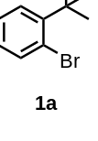
1-bromo-2-(tert-butyl)benzene (1a): Colorless oil.
¹H NMR (400 MHz, CDCl₃) δ 7.58 (d, J = 7.9 Hz, 1H), 7.43 (d, J = 8.1 Hz, 1H), 7.23 (t, J = 7.6 Hz, 1H), 7.01 (t, J = 7.6 Hz, 1H), 1.51 (s, 9H).
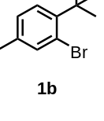
2-bromo-1-(tert-butyl)-4-methylbenzene (1b): Colorless oil.
¹H NMR (400 MHz, CDCl₃) δ 7.45 (s, 1H), 7.34 (d, J = 8.0 Hz, 1H), 7.06 (d, J = 8.0 Hz, 1H), 2.30 (s, 3H), 1.51 (s, 9H).
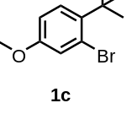
2-bromo-1-(tert-butyl)-4-methoxybenzene (1c): Colorless oil.
¹H NMR (400 MHz, CDCl₃) δ 7.35 (d, J = 8.8 Hz, 1H), 7.17 (d, J = 2.7 Hz, 1H), 6.79 (dd, J = 8.8, 2.7 Hz, 1H), 3.78 (s, 3H), 1.49 (s, 9H).
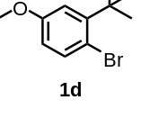
1-bromo-2-(tert-butyl)-4-methoxybenzene (1d): Colorless oil.
¹H NMR (500 MHz, CDCl₃) δ 7.47 (d, J = 8.6 Hz, 1H), 7.01 (d, J = 3.1 Hz, 1H), 6.59 (dd, J = 8.7, 3.1 Hz, 1H), 3.78 (s, 3H), 1.49 (s, 9H).
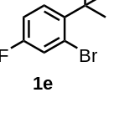
2-bromo-1-(tert-butyl)-4-fluorobenzene (1e): Colorless oil.
¹H NMR (400 MHz, CDCl₃) δ 7.40 (dd, J = 9.0, 6.3 Hz, 1H), 7.34 (dd, J = 8.3, 2.7 Hz, 1H), 6.96 (ddd, J = 9.0, 7.8, 2.7 Hz, 1H), 1.50 (s, 9H).
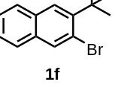
2-bromo-3-(tert-butyl)naphthalene (1f): Colorless oil.
¹H NMR (400 MHz, CDCl₃) δ 8.55 (dt, J = 8.7, 0.9 Hz, 1H), 7.79 (dd, J = 10.0, 8.2 Hz, 2H), 7.67 (d, J = 8.8 Hz, 1H), 7.59 (ddd, J = 8.5, 6.8, 1.4 Hz, 1H), 7.50 (ddd, J = 7.9, 6.8, 1.2 Hz, 1H), 1.69 (s, 9H).
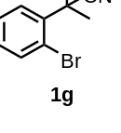
2-(2-bromophenyl)-2-methylpropanenitrile (1g): Yellow oil.
¹H NMR (300 MHz, CDCl₃) δ 7.67 (dd, J₁ = 8.1 Hz, J₂ = 1.5 Hz, 1H), 7.48 (dd, J₁ = 7.8 Hz, J₂ = 1.5 Hz, 1H), 7.35 (td, J₁ = 7.5 Hz, J₂ = 1.2 Hz, 1H), 7.19 (td, J₁ = 7.8 Hz, J₂ = 1.8 Hz, 1H), 1.90 (s, 6H).
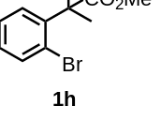
methyl 2-(2-bromophenyl)-2-methylpropanoate (1h): Colorless oil.
¹H NMR (500 MHz, CDCl₃) δ 7.56 (dd, J = 7.9, 1.4 Hz, 1H), 7.42 (dd, J = 7.8, 1.7 Hz, 1H), 7.32 (td, J = 7.6, 1.4 Hz, 1H), 7.12 (td, J = 7.6, 1.7 Hz, 1H), 3.68 (s, 3H), 1.64 (s, 6H).
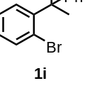
1-bromo-2-(2-phenylpropan-2-yl)benzene (1i): Colorless oil.
¹H NMR (400 MHz, CDCl₃) δ 7.70 (dd, J = 7.9, 1.6 Hz, 1H), 7.54 (dd, J = 7.9, 1.4 Hz, 1H), 7.39 (td, J = 7.6, 1.4 Hz, 1H), 7.29 (td, J = 7.1, 6.3, 1.3 Hz, 2H), 7.24 – 7.19 (m, 1H), 7.19 – 7.10 (m, 3H), 1.80 (s, 6H).
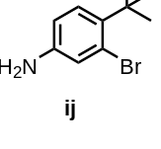
3-bromo-4-(tert-butyl)aniline (ij): Colorless oil.
¹H NMR (400 MHz, CDCl₃) δ 7. 16 (d, J= 8.6 Hz, 1H), 6.97 (d, J= 3.0 Hz, 1H), 6.59 (dd, J= 8.4, 2.8 Hz, 1H), 1.43 (s, 9H).

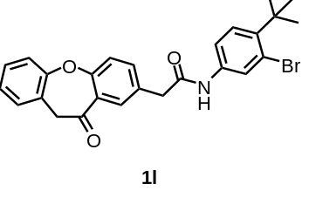
N-(3-bromo-4-(tert-butyl)phenyl)-2-(11-oxo-10,11-dihydrodibenzo[b,f]oxepin-2-yl)acetamide (1l): White solid.
¹H NMR (400 MHz, CDCl₃) δ 8.18 (d, J = 2.4 Hz, 1H), 7.93 (dd, J = 7.7, 1.4 Hz, 1H), 7.68 (d, J = 2.3 Hz, 1H), 7.61 (td, J = 7.4, 1.4 Hz, 1H), 7.52 (ddd, J = 8.2, 5.8, 1.9 Hz, 2H), 7.42 (td, J = 5.3, 4.8, 2.3 Hz, 2H), 7.36 (d, J = 8.7 Hz, 1H), 7.12 (d, J = 8.4 Hz, 1H), 7.08 (s, 1H), 5.25 (s, 2H), 3.75 (s, 2H), 1.48 (s, 9H).
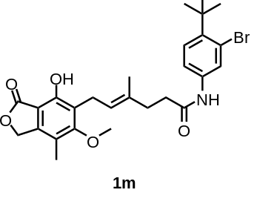
(E)-N-(3-bromo-4-(tert-butyl)phenyl)-6-(4-hydroxy-6-methoxy-7-methyl-3-oxo-1,3-dihydroisobenzofuran-5-yl)-4-methylhex-4-enamide (1m): White solid.
¹H NMR (400 MHz, CDCl₃) δ 7.70 (s, 1H), 7.64 (d, J = 2.0 Hz, 1H), 7.34 – 7.31 (m, 2H), 7.16 (s, 1H), 5.36 (t, J = 7.1 Hz, 1H), 5.20 (s, 2H), 3.77 (s, 3H), 3.44 (d, J = 7.0 Hz, 2H), 2.45 (dd, J = 15.5, 6.1 Hz, 4H), 2.14 (s, 3H), 1.87 (s, 3H), 1.50 (s, 9H).
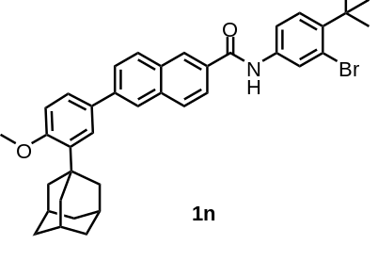
6-(3-((3r,5r,7r)-adamantan-1-yl)-4-methoxyphenyl)-N-(3-bromo-4-(tert-butyl)phenyl)-2-naphthamide (1n): White solid.
¹H NMR (400 MHz, CDCl₃) δ 8.41 – 8.37 (m, 1H), 8.06 (d, J = 1.7 Hz, 1H), 8.01 (dd, J = 8.6, 2.7 Hz, 2H), 7.97 – 7.91 (m, 3H), 7.85 (dd, J = 8.6, 1.8 Hz, 1H), 7.68 (dd, J = 8.6, 2.4 Hz, 1H), 7.63 (d, J = 2.4 Hz, 1H), 7.58 (dd, J = 8.4, 2.3 Hz, 1H), 7.48 (d, J = 8.7 Hz, 1H), 7.03 (d, J = 8.5 Hz, 1H), 3.94 (s, 3H), 2.22 (d, J = 2.9 Hz, 6H), 2.13 (s, 3H), 1.84 (d, J = 3.0 Hz, 6H), 1.55 (s, 9H).

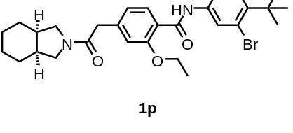
N-(3-bromo-4-(tert-butyl)phenyl)-2-ethoxy-4-(2-((3aR,7aS)-octahydro-2H-isoindol-2-yl)-2-oxoethyl)benzamide (1p): Yellow solid.
¹H NMR (400 MHz, Chloroform-d) δ 10.07 (s, 1H), 8.23 (d, J = 8.0 Hz, 1H), 8.04 (s, 1H), 7.96 (d, J = 2.3 Hz, 1H), 7.56 (dd, J = 8.7, 2.4 Hz, 1H), 7.42 (d, J = 8.7 Hz, 1H), 7.07 (d, J = 1.5 Hz, 1H), 7.00 (dd, J = 8.1, 1.5 Hz, 1H), 4.31 (q, J = 6.9 Hz, 2H), 3.69 (s, 2H), 3.53 – 3.39 (m, 3H), 3.33 (dd, J = 9.9, 5.8 Hz, 1H), 2.98 (s, 2H), 2.90 (d, J = 0.6 Hz, 2H), 2.25 (ddd, J = 26.0, 12.1, 6.1 Hz, 2H), 1.68 (s, 3H), 1.63 (t, J = 6.9 Hz, 3H), 1.52 (s, 9H).
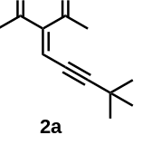
3-(4,4-dimethylpent-2-yn-1-ylidene)pentane-2,4-dione (2a): Yellow oil.
¹ H NMR (400 MHz, CDCl3) δ 6.72 (s, 1H), 2.49 (s, 3H), 2.31 (s, 3H), 1.27 (s, 9H).
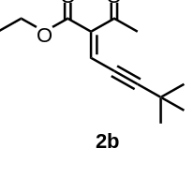
ethyl (E)-2-acetyl-6,6-dimethylhept-2-en-4-ynoate (2b): Colorless oil.
¹H NMR (400 MHz, CDCl₃) δ 6.81 (s, 1H), 4.34 (q, J = 7.1, 2H), 2.46 (s, 3H), 1.38 (t, J = 7.1, 3H), 1.29 (s, 9H).
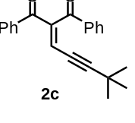
2-(4,4-dimethylpent-2-yn-1-ylidene)-1,3-diphenylpropane-1,3-dione (2c): White solid.
¹H NMR (400 MHz, CDCl₃) δ 8.05 – 7.97 (m, 2H), 7.84 – 7.77 (m, 2H), 7.67 – 7.40 (m, 6H), 6.76 (s, 1H), 0.97 (s, 9H).
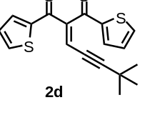
2-(4,4-dimethylpent-2-yn-1-ylidene)-1,3-di(thiophen-2-yl)propane-1,3-dione (2d): Yellow solid.
¹H NMR (500 MHz, CDCl₃) δ 7.77 – 7.72 (m, 2H), 7.68 – 7.64 (m, 2H), 7.15 (dd, J = 4.8, 4.0 Hz, 1H), 7.08 (dd, J = 4.9, 3.9 Hz, 1H), 6.89 (s, 1H), 1.04 (s, 9H).
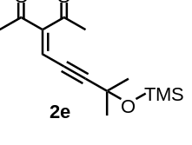
3-(4-methyl-4-((trimethylsilyl)oxy)pent-2-yn-1-ylidene)pentane-2,4-dione (2e): Colorless oil.
¹H NMR (400 MHz, CDCl₃) δ 6.73 (s, 1H), 2.49 (s, 3H), 2.34 (s, 3H), 1.54 (s, 6H), 0.19 (s, 9H).
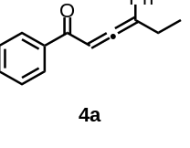
1,4-diphenylhexa-2,3-dien-1-one (4a): Yellow oil.
¹H NMR (500 MHz, CDCl₃) δ 7.91 – 7.82 (m, 2H), 7.54 – 7.45 (m, 1H), 7.44 – 7.32 (m, 6H), 7.31 – 7.26 (m, 1H), 6.71 (t, J = 3.3 Hz, 1H), 2.64 – 2.52 (m, 2H), 1.15 (t, J = 7.4 Hz, 3H).
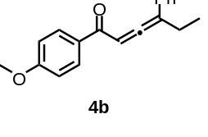
1-(4-methoxyphenyl)-4-phenylhexa-2,3-dien-1-one (4b): Yellow oil.
¹H NMR (400 MHz, CDCl₃) δ 7.96 – 7.92 (m, 2H), 7.47 – 7.29 (m, 6H), 6.91 – 6.86 (m, 2H), 6.73 (t, J = 3.4 Hz, 1H), 3.86 (s, 3H), 2.65 – 2.56 (m, 2H), 1.20 (t, J = 7.3 Hz, 3H).
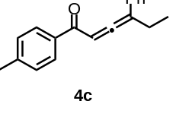
4-phenyl-1-(p-tolyl)hexa-2,3-dien-1-one (4c): Yellow oil.
¹H NMR (400 MHz, CDCl₃) δ 7.96 – 7.92 (m, 2H), 7.47 – 7.29 (m, 6H), 6.91 – 6.86 (m, 2H), 6.73 (t, J = 3.4 Hz, 1H), 2.65 – 2.56 (m, 2H), 2.38 (s, 3H), 1.20 (t, J = 7.3 Hz, 3H).
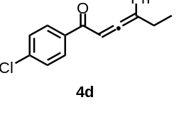
1-(4-chlorophenyl)-4-phenylhexa-2,3-dien-1-one (4d): Yellow oil.
¹H NMR (400 MHz, CDCl₃) δ 7.88 – 7.74 (m, 2H), 7.42 – 7.38 (m, 3H), 7.37 (d, J = 2.1 Hz, 1H), 7.35 – 7.29 (m, 3H), 6.68 (t, J = 3.4 Hz, 1H), 2.65 – 2.56 (m, 2H), 1.17 (t, J = 7.3 Hz, 3H).
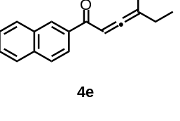
1-(naphthalen-2-yl)-4-phenylhexa-2,3-dien-1-one (4e): Yellow oil.
¹H NMR (400 MHz, CDCl₃) δ 8.39 (t, J = 1.1 Hz, 1H), 7.97 (dd, J = 8.6, 1.8 Hz, 1H), 7.86 (d, J = 8.5 Hz, 2H), 7.64 (d, J = 8.1 Hz, 1H), 7.58 (ddd, J = 8.2, 6.8, 1.3 Hz, 1H), 7.52 – 7.39 (m, 5H), 7.38 – 7.31 (m, 1H), 6.80 (t, J = 3.3 Hz,1H), 2.65 – 2.56 (m, 2H),1.18 (t, J = 7.3 Hz, 3H).
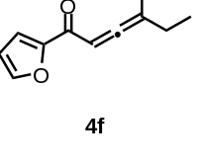
1-(furan-2-yl)-4-phenylhexa-2,3-dien-1-one (4f): Yellow oil.
¹H NMR (400 MHz, CDCl₃) δ 7.61 (dd, J = 1.7, 0.8 Hz, 1H), 7.48 – 7.44 (m, 2H), 7.42 – 7.36 (m, 2H), 7.36 – 7.29 (m, 1H), 7.23 (dd, J = 3.6, 0.8 Hz, 1H), 6.69 (t, J = 3.5 Hz, 1H), 6.51 (dd, J = 3.6, 1.7 Hz, 1H), 2.65 – 2.56 (m, 2H), 1.23 (t, J = 7.3 Hz,3H).
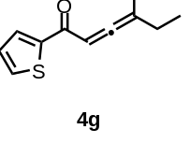
4-phenyl-1-(thiophen-2-yl)hexa-2,3-dien-1-one (4g): Yellow oil.
¹H NMR (400 MHz, CDCl₃) δ 7.85 (dd, J = 3.8, 1.2 Hz, 1H), 7.60 (dd, J = 5.0, 1.2 Hz, 1H), 7.51 – 7.46 (m, 2H), 7.44 – 7.36 (m, 2H), 7.36 – 7.28 (m, 1H), 7.09 (dd, J = 5.0, 3.8 Hz, 1H), 6.65 (t, J = 3.6 Hz, 1H), 2.65 – 2.56 (m, 2H),1.24 (t, J = 7.3 Hz, 3H).
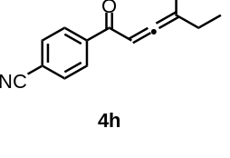
4-(4-phenylhexa-2,3-dienoyl)benzonitrile (4h): Yellow oil.
¹H NMR (400 MHz, CDCl₃) δ 7.92 – 7.86 (m, 2H), 7.69 – 7.64 (m, 2H), 7.47 – 7.30 (m, 5H), 6.66 (t, J = 3.4 Hz, 1H), 2.64 – 2.52 (m, 2H), 1.14 (t, J = 7.3 Hz, 3H).

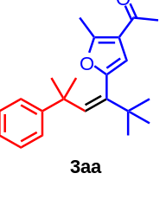
(Z)-1-(2-methyl-5-(2,2,5-trimethyl-5-phenylhex-3-en-3-yl)furan-3-yl)ethan-1-one (3aa): Yellow oil, 24.6 mg.
¹H NMR (400 MHz, CDCl₃) δ 7.22 – 7.06 (m,5H), 6.12 (s, 1H), 5.64 (s, 1H), 2.44 (s, 3H), 2.22 (s, 3H), 1.32 (s, 6H), 1.07 (s, 9H).
¹³C NMR (101 MHz, CDCl₃) δ 194.34, 156.32, 150.13, 148.68, 141.68, 138.89, 127.58, 126.17, 125.03, 121.59, 109.99, 40.19, 36.38, 30.91, 29.62, 28.92, 14.29
HRMS (ESI): C₂₂H₂₉O₂⁺, calcd. 325.2162, found 325.2171.
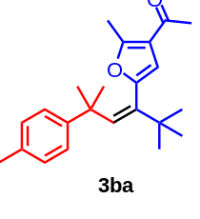
(Z)-1-(2-methyl-5-(2,2,5-trimethyl-5-(p-tolyl)hex-3-en-3-yl)furan-3-yl)ethan-1-one (3ba) Yellow oil, 27.7 mg.
¹H NMR (400 MHz, CDCl₃) δ 7.02 (q, J = 8.3 Hz, 4H), 6.09 (s, 1H), 5.65 (s, 1H), 2.45 (s,3H), 2.29 (s, 3H), 2.23 (s, 3H), 1.30 (s, 6H), 1.06 (s, 9H)
¹³C NMR (126 MHz, CDCl₃) δ 194.41, 156.42, 148.74, 147.18, 141.77, 138.61, 134.51, 128.30, 126.10, 121.57, 109.97, 39.90, 36.38, 30.85, 29.62, 28.86, 20.84, 14.29
HRMS (ESI): C₂₃H₃₁O₂⁺, calcd. 339.2319, found 339.2321.
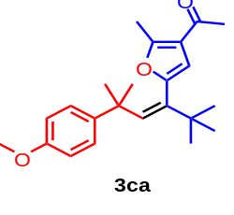
(Z)-1-(5-(5-(4-methoxyphenyl)-2,2,5-trimethylhex-3-en-3-yl)-2-methylfuran-3-yl)ethan-1-one (3ca) Yellow solid, 32.9 mg.
¹H NMR (400 MHz, CDCl₃) δ 7.05 (d, J = 8.8 Hz, 2H), 6.72 (d, J = 8.8 Hz, 2H), 6.07 (s, 1H), 5.68 (s, 1H), 3.76 (s, 3H), 2.46 (s, 3H), 2.24 (s, 3H), 1.30 (s, 6H), 1.06 (s, 9H).
¹³C NMR (126 MHz, CDCl₃) δ 194.40, 157.21, 156.37, 148.76, 142.15, 141.84, 138.57, 127.14, 121.68, 112.87, 109.82, 55.14, 39.62, 36.36, 30.95, 29.60, 28.88, 14.29
HRMS (ESI): C₂₃H₃₁O₃⁺, calcd. 355.2268, found 355.227.
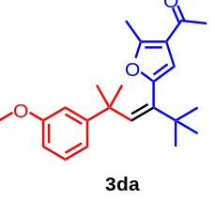
(Z)-1-(5-(5-(3-methoxyphenyl)-2,2,5-trimethylhex-3-en-3-yl)-2-methylfuran-3-yl)ethan-1-one (3da) Yellow solid, 34.3 mg.
¹H NMR (400 MHz, CDCl₃) δ 7.10 (t, J = 7.9 Hz, 1H), 6.76 (ddd, J = 7.8, 1.7, 0.9 Hz, 1H), 6.69 (t, J = 2.2 Hz, 1H), 6.66 – 6.61 (m, 1H), 6.08 (s, 1H), 5.68 (s, 1H), 3.76 (s, 3H), 2.45 (s, 3H), 2.23 (s, 3H), 1.31 (s, 6H), 1.07 (s, 9H).
¹³C NMR (101 MHz, CDCl₃) δ 194.28, 159.00, 156.36, 151.70, 148.65, 141.46, 138.81, 128.44, 121.61, 118.89, 112.73, 110.05, 109.74, 55.00, 40.29, 36.37, 30.84, 29.62, 28.86, 14.27
HRMS (ESI): C₂₃H₃₁O₃⁺, calcd. 355.2268, found 355.2274.
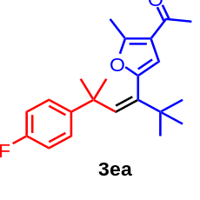
(Z)-1-(5-(5-(4-fluorophenyl)-2,2,5-trimethylhex-3-en-3-yl)-2-methylfuran-3-yl)ethan-1-one (3ea) Yellow solid, 30.4 mg.
¹H NMR (400 MHz, CDCl₃) δ 7.08 (dd, J = 8.8, 5.4 Hz, 2H), 6.85 (t, J = 8.8 Hz, 2H), 6.08 (s, 1H), 5.69 (s, 1H), 2.44 (s, 3H), 2.25 (s, 3H), 1.31 (s, 6H), 1.05 (s, 9H).
¹³C NMR (126 MHz, CDCl₃) δ 194.25, 160.74 (J_{C-F} = 256.4 Hz), 156.42, 148.60, 145.68 (J_{C-F} = 2.8 Hz), 141.50, 139.21, 127.65 (J_{C-F} = 8.1 Hz), 121.66, 114.12(J_{C-F} = 21.2 Hz), 109.82, 39.78, 36.40, 31.09, 29.55, 28.88, 14.26
HRMS (ESI): C₂₂H₂₈FO₂⁺, calcd. 343.2068, found 343.2074.
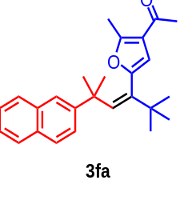
(Z)-1-(2-methyl-5-(2,2,5-trimethyl-5-(naphthalen-2-yl)hex-3-en-3-yl)furan-3-yl)ethan-1-one (3fa) Yellow solid, 19.8 mg.
¹H NMR (400 MHz, CDCl₃) δ 7.79 – 7.72 (m, 1H), 7.67 (dd, J = 8.5, 5.3 Hz, 2H), 7.45 – 7.32 (m, 4H), 6.16 (s, 1H), 5.50 (s, 1H), 2.17 (s, 3H), 1.79 (s, 3H), 1.47 (s, 6H), 1.06 (s, 9H).
¹³C NMR (126 MHz, CDCl₃) δ 193.95, 156.18, 148.31, 146.90, 141.55, 139.68, 133.13, 131.45, 127.50, 127.18, 126.90, 126.51, 125.78, 125.19, 123.33, 121.50, 109.81, 40.22, 36.35, 30.92, 29.53, 28.32, 13.98
HRMS (ESI): C₂₆H₃₁O₂⁺, calcd. 375.2319, found 375.2311.
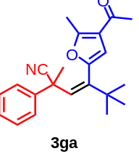
(Z)-4-(4-acetyl-5-methylfuran-2-yl)-2,5,5-trimethyl-2-phenylhex-3-enenitrile (3ga) White oil, 17.42 mg.
¹H NMR (400 MHz, CDCl₃) δ 7.36 – 7.23 (m, 5H), 5.98 (d, J = 6.7 Hz, 2H), 2.45 (s, 3H), 2.25 (s, 3H), 1.81 (s, 3H), 1.14 (s, 9H)
¹³C NMR (126 MHz, CDCl₃) δ 194.10, 157.83, 146.43, 145.25, 142.63, 131.53, 128.65, 127.22, 125.56, 122.06, 121.53, 112.08, 41.62, 36.77, 31.97, 29.35, 28.99, 14.23
HRMS (ESI): C₂₂H₂₆NO₂⁺, calcd. 336.1958, found 336.195.
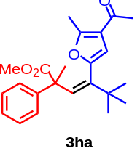
Methyl-(Z)-4-(4-acetyl-5-methylfuran-2-yl)-2,5,5-trimethyl-2-phenylhex-3-enoate (3ha) White solid, 19.2 mg.
¹H NMR (400 MHz, CDCl₃) δ 7.23 (d, J = 2.7 Hz, 5H), 6.56 (s, 1H), 5.84 (s, 1H), 3.53 (s, 3H), 2.48 (s, 3H), 2.27 (s, 3H), 1.59 (s, 3H), 1.11 (s, 9H).
¹³C NMR (101 MHz, CDCl₃) δ 194.17, 175.47, 156.82, 148.19, 143.99, 140.56, 135.68, 127.97, 126.87, 126.41, 121.67, 110.27, 52.30, 51.98, 36.84, 29.58, 28.99, 24.62, 14.31.
HRMS (ESI): C₂₃H₂₉O₄⁺, calcd. 369.206, found 369.2062.
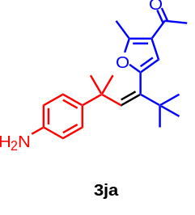
(Z)-1-(5-(5-(4-aminophenyl)-2,2,5-trimethylhex-3-en-3-yl)-2-methylfuran-3-yl)ethan-1-one (3ja) Yellow solid, 21.0 mg.
¹H NMR (400 MHz, CDCl₃) δ 6.93 (d, J = 8.5 Hz, 2H), 6.53 (d, J = 8.5 Hz, 2H), 6.05 (s, 1H), 5.73 (s, 1H), 2.49 (s, 3H), 2.29 (s, 3H), 1.25 (s, 6H), 1.05 (s, 9H).
¹³C NMR (126 MHz, CDCl₃) δ 194.71, 156.50, 148.90, 143.71, 141.97, 140.40, 138.17, 126.96, 121.65, 114.49, 109.82, 39.54, 36.36, 30.78, 29.62, 29.00, 14.36.
HRMS (ESI): C₂₂H₃₀NO₂⁺, calcd. 339.2198, found 339.2194.
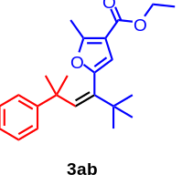
Ethyl-(Z)-2-methyl-5-(2,2,5-trimethyl-5-phenylhex-3-en-3-yl)furan-3-carboxylate (3ab) Yellow solid, 27.3 mg.
¹H NMR (400 MHz, CDCl₃) δ 7.19 (d, J = 6.1 Hz, 4H), 7.11 (ddd, J = 6.1, 5.1, 2.6 Hz, 1H), 6.06 (s, 1H), 5.92 (s, 1H), 4.26 (q, J = 7.1 Hz, 2H), 2.42 (s, 3H), 1.35 (t, J = 7.1 Hz, 3H), 1.31 (s, 6H), 1.07 (s, 9H).
¹³C NMR (126 MHz, CDCl₃) δ 164.37, 157.12, 149.93, 148.80, 141.22, 138.45, 127.64, 126.13, 125.09, 113.61, 110.11, 59.83, 40.46, 36.46, 30.52, 29.62, 14.40, 13.70.
HRMS (ESI): C₂₃H₃₁O₃⁺, calcd. 355.2268, found 355.2267.
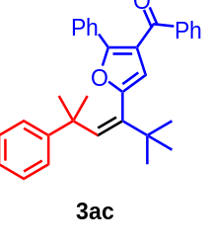
(Z)-phenyl(2-phenyl-5-(2,2,5-trimethyl-5-phenylhex-3-en-3-yl)furan-3-yl)methanone (3ac) Yellow solid, 38.1 mg.
¹H NMR (400 MHz, CDCl₃) δ 7.75 – 7.69 (m, 2H), 7.62 – 7.57 (m, 2H), 7.55 – 7.48 (m, 1H), 7.38 (t, J = 7.7 Hz, 2H), 7.31 – 7.26 (m, 5H), 7.21 (dd, J = 8.5, 6.9 Hz, 2H), 7.11 – 7.04 (m, 1H), 6.18 (s, 1H), 5.99 (s, 1H), 1.41 (s, 6H), 1.16 (s, 9H).
¹³C NMR (101 MHz, CDCl₃) δ 191.67, 154.34, 150.10, 149.85, 141.48, 138.41, 138.27, 132.51, 130.00, 129.64, 128.56, 128.16, 128.12, 127.83, 127.41, 126.12, 125.37, 121.16, 113.34, 40.57, 36.71, 31.08, 29.75.
HRMS (ESI): C₃₂H₃₃O₂⁺, calcd. 449.2475, found 449.2474.
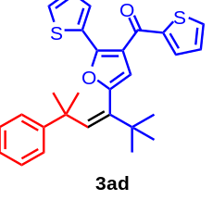
(Z)-thiophen-2-yl(2-(thiophen-2-yl)-5-(2,2,5-trimethyl-5-phenylhex-3-en-3-yl)furan-3-yl)methanone (3ad) Yellow solid, 41.8 mg.
¹H NMR (400 MHz, CDCl₃) δ 7.83 (dd, J = 3.8, 1.2 Hz, 1H), 7.65 (dd, J = 4.9, 1.1 Hz, 1H), 7.39 (dd, J = 5.0, 1.2 Hz, 1H), 7.35 (dd, J = 3.8, 1.2 Hz, 1H), 7.30 – 7.25 (m, 2H), 7.21 (dd, J = 8.6, 6.9 Hz, 2H), 7.12 – 7.04 (m, 3H), 6.22 (s, 1H), 6.10 (s, 1H), 1.42 (s, 6H), 1.17 (s, 9H).
¹³C NMR (126 MHz, CDCl₃) δ 181.49, 150.89, 149.93, 149.65, 144.94, 141.98, 138.37, 133.43, 133.34, 132.05, 127.95, 127.89, 127.78, 127.41, 127.37, 126.16, 125.45, 119.43, 112.52, 40.51, 36.65, 31.26, 29.73.
HRMS (ESI): C₂₈H₂₉O₂S₂⁺, calcd. 461.1603, found 461.1603.
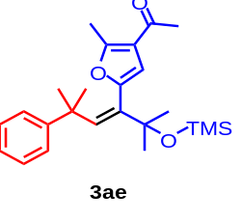
(E)-1-(5-(2,5-dimethyl-5-phenyl-2-((trimethylsilyl)oxy)hex-3-en-3-yl)-2-methylfuran-3-yl)ethan-1-one (3ae) Yellow oil, 21.1 mg.
¹H NMR (500 MHz, CDCl₃) δ 7.17 – 7.12 (m, 4H), 7.07 (ddd, J = 6.1, 5.1, 2.6 Hz, 1H), 6.36 (s, 1H), 5.71 (s, 1H), 2.40 (s, 3H), 2.19 (s, 3H), 1.33 (s, 6H), 1.31 (s, 6H), 0.15 (s, 9H).
¹³C NMR (126 MHz, CDCl₃) δ 194.33, 156.65, 149.75, 147.94, 142.06, 137.15, 127.59, 126.21, 125.12, 121.70, 110.49, 75.96, 40.05, 30.77, 30.40, 28.92, 14.29, 2.54.
HRMS (ESI): C₂₄H₃₅O₃Si⁺, calcd. 399.235, found 399.2349.
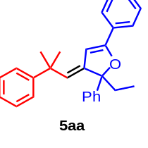
(E)-2-ethyl-3-(2-methyl-2-phenylpropylidene)-2,5-diphenyl-2,3-dihydrofuran (5aa) Yellow oil, 18.24 mg.
¹H NMR (400 MHz, CDCl₃) δ 7.58 – 7.53 (m, 2H), 7.49 (dd, J = 7.7, 1.7 Hz, 2H), 7.39 – 7.29 (m, 10H), 7.23 – 7.17 (m, 1H), 5.50 (s, 1H), 5.17 (d, J = 1.0 Hz, 1H), 2.30 (dq, J = 14.3, 7.2 Hz, 1H), 2.09 (dq, J = 14.3, 7.2 Hz, 1H), 1.53 (s, 3H), 1.48 (s, 3H), 0.97 (t, J = 7.2 Hz, 3H).
¹³C NMR (126 MHz, CDCl₃) δ 160.09, 150.36, 145.73, 144.82, 130.59, 128.92, 128.32, 128.20, 128.11, 127.17, 126.53, 125.58, 125.48, 125.41, 125.02, 98.83, 92.84, 40.84, 33.58, 31.36, 31.15, 7.92.
HRMS (ESI): C₂₈H₂₉O⁺, calcd. 381.2213, found 381.2226.
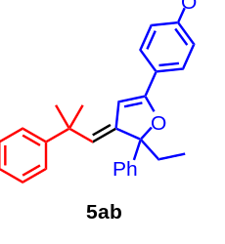
(E)-2-ethyl-5-(4-methoxyphenyl)-3-(2-methyl-2-phenylpropylidene)-2-phenyl-2,3-dihydrofuran (5ab) Yellow solid, 27.9 mg.
¹H NMR (400 MHz, CDCl₃) δ 7.54 – 7.47 (m, 3H), 7.38 (ddt, J = 8.0, 6.0, 1.5 Hz, 3H), 7.34 – 7.29 (m, 3H), 7.24 – 7.18 (m, 1H), 6.88 (d, J = 8.8 Hz, 2H), 5.40 (d, J = 0.9 Hz, 1H), 5.13 (d, J = 1.0 Hz, 1H), 3.84 (s, 3H), 2.30 (dq, J = 14.4, 7.2 Hz, 1H), 2.10 (dq, J = 14.4, 7.2 Hz, 1H), 1.54 (s, 3H), 1.49 (s, 3H), 0.98 (t, J = 7.2 Hz, 3H).
¹³C NMR (101 MHz, CDCl₃) δ 160.28, 160.07, 150.49, 145.94, 144.94, 128.16, 128.06, 127.10, 126.99, 126.53, 125.50, 125.02, 124.22, 123.40, 113.77, 97.18, 92.78, 55.34, 40.76, 33.52, 31.38, 31.15, 7.92.
HRMS (ESI): C₂₉H₃₁O₂⁺, calcd. 411.2319, found 411.233.
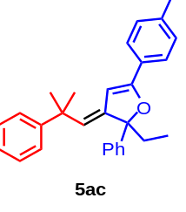
(E)-2-ethyl-3-(2-methyl-2-phenylpropylidene)-2-phenyl-5-(p-tolyl)-2,3-dihydrofuran Yellow solid, 27.6 mg.
¹H NMR (400 MHz, CDCl₃) δ 7.50 (ddd, J = 11.2, 7.7, 1.7 Hz, 4H), 7.42 – 7.36 (m, 4H), 7.32 (ddt, J = 9.0, 7.3, 2.4 Hz, 3H), 7.25 – 7.15 (m, 3H), 5.49 (d, J = 0.9 Hz, 1H), 5.17 (d, J = 1.0 Hz, 1H), 2.39 (s, 3H), 2.31 (dq, J = 14.3, 7.2 Hz, 1H), 2.10 (dq, J = 14.3, 7.2 Hz, 1H), 1.55 (s, 3H), 1.50 (s, 3H), 0.99 (t, J = 7.2 Hz, 3H).
¹³C NMR (101 MHz, CDCl₃) δ 160.32, 150.44, 145.89, 144.93, 139.04, 129.03, 128.17, 128.09, 127.85, 127.12, 126.52, 125.54, 125.45, 125.01, 124.76, 98.10, 92.76, 40.81, 33.56, 31.38, 31.17, 21.44, 7.93.
HRMS (ESI): C₂₉H₃₁O⁺, calcd. 395.2369, found 395.2381.
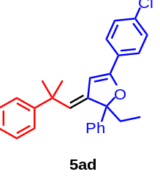
(E)-5-(4-chlorophenyl)-2-ethyl-3-(2-methyl-2-phenylpropylidene)-2-phenyl-2,3-dihydrofuran (5ad) Yellow oil, 10.4 mg.
¹H NMR (400 MHz, CDCl₃) δ 7.48 – 7.43 (m, 4H), 7.40 – 7.29 (m, 9H), 7.23 – 7.18 (m, 1H), 5.45 (d, J = 1.0 Hz, 1H), 5.19 (d, J = 1.1 Hz, 1H), 2.28 (dp, J = 13.1, 6.9 Hz, 1H), 2.03 (dp, J = 13.1, 6.9 Hz, 1H), 1.53 (s, 3H), 1.48 (s, 3H), 0.95 (t, J = 7.2 Hz, 3H).
¹³C NMR (126 MHz, CDCl₃) δ 158.96, 150.21, 145.41, 144.59, 134.63, 129.06, 128.54, 128.24, 128.14, 127.27, 126.71, 126.52, 126.11, 125.64, 124.98, 99.23, 93.08, 40.88, 33.57, 31.31, 31.12, 7.90.
HRMS (ESI): C₂₈H₂₈ClO⁺, calcd. 415.1823, found 415.1828.
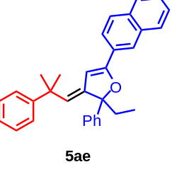
(E)-2-ethyl-3-(2-methyl-2-phenylpropylidene)-5-(naphthalen-2-yl)-2-phenyl-2,3-dihydrofuran (5ae) Yellow solid, 24.5 mg.
¹H NMR (400 MHz, CDCl₃) δ 8.16 (s, 1H), 7.91 – 7.84 (m, 1H), 7.84 – 7.80 (m, 1H), 7.77 (d, J = 8.6 Hz, 1H), 7.57 – 7.47 (m, 5H), 7.40 (dt, J = 7.7, 3.7 Hz, 4H), 7.34 (t, J = 7.5 Hz, 3H), 7.24 (t, J = 7.2 Hz, 1H), 5.66 (s, 1H), 5.23 (s, 1H), 2.37 (dq, J = 14.2, 6.8 Hz, 1H), 2.16 (dq, J = 14.4, 7.3 Hz, 1H), 1.58 (s, 3H), 1.52 (s, 3H), 1.03 (t, J = 7.2 Hz, 3H).
¹³C NMR (101 MHz, CDCl₃) δ 160.13, 150.35, 145.75, 144.85, 133.52, 133.19, 128.53, 128.25, 128.15, 127.86, 127.77, 127.66, 127.23, 126.55, 126.51, 126.43, 125.77, 125.63, 125.05, 124.46, 123.39, 99.69, 92.95, 40.93, 33.55, 31.38, 31.16, 7.96.
HRMS (ESI): C₃₂H₃₁O⁺, calcd. 431.2369, found 431.2364.
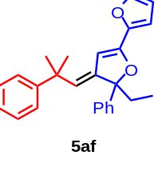
(E)-5-ethyl-4-(2-methyl-2-phenylpropylidene)-5-phenyl-4,5-dihydro-2,2'-bifuran (5af) Yellow oil, 7.5 mg.
¹H NMR (400 MHz, CDCl₃) δ 7.49 – 7.43 (m, 2H), 7.43 – 7.26 (m, 8H), 7.22 – 7.16 (m, 1H), 6.63 (d, J = 3.4 Hz, 1H), 6.43 (dd, J = 3.4, 1.8 Hz, 1H), 5.51 (d, J = 1.0 Hz, 1H), 5.15 (d, J = 1.1 Hz, 1H), 2.27 (dq, J = 14.4, 7.3 Hz, 1H), 2.07 (dq, J = 14.4, 7.3 Hz, 1H), 1.52 (s, 3H), 1.47 (s, 3H), 0.96 (t, J = 7.2 Hz, 3H).
¹³C NMR (126 MHz, CDCl₃) δ 152.15, 150.38, 146.50, 144.89, 144.56, 143.35, 128.21, 128.11, 127.29, 126.39, 125.80, 125.57, 125.07, 111.46, 109.04, 98.59, 93.34, 40.81, 33.31, 31.36, 30.98, 7.83.
HRMS (ESI): C₂₆H₂₇O₂⁺, calcd. 371.2006, found 371.1996.
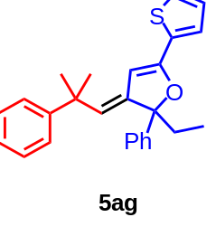
(E)-2-ethyl-3-(2-methyl-2-phenylpropylidene)-2-phenyl-5-(thiophen-2-yl)-2,3-dihydrofuran (5ag) Yellow oil, 12.0 mg.
¹H NMR (400 MHz, CDCl₃) δ 7.51 – 7.45 (m, 2H), 7.40 – 7.27 (m, 8H),7.25 (dd, J = 3.7, 1.2 Hz, 1H), 7.23 – 7.18 (m, 1H), 7.02 (dd, J = 5.0, 3.7 Hz, 1H), 5.36 (d, J = 1.0 Hz, 1H), 5.15 (d, J = 1.1 Hz, 1H), 2.27 (dq, J = 14.4, 7.3 Hz, 1H), 2.09 (dq, J = 14.4, 7.3 Hz, 1H), 1.52 (s, 3H), 1.47 (s, 3H), 0.97 (t, J = 7.2 Hz, 3H).
¹³C NMR (126 MHz, CDCl₃) δ 155.34, 150.23, 145.26, 144.59, 133.81, 128.17, 128.08, 127.54, 127.21, 126.46, 126.24, 125.57, 125.40, 125.35, 125.00, 98.50, 93.40, 40.82, 33.44, 31.26, 31.04, 7.86.
HRMS (ESI): C₂₆H₂₇OS⁺, calcd. 386.1704, found 386.1710.
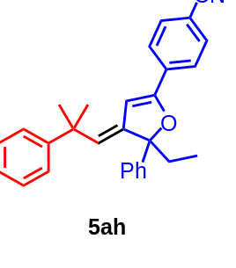
(E)-4-(5-ethyl-4-(2-methyl-2-phenylpropylidene)-5-phenyl-4,5-dihydrofuran-2-yl)benzonitrile (5ah) Yellow solid, 7.3 mg.
¹H NMR (400 MHz, CDCl₃) δ 7.64 – 7.54 (m, 4H), 7.47 – 7.42 (m, 2H), 7.40 – 7.29 (m, 7H), 7.26 – 7.20 (m, 1H), 5.53 (d, J = 1.1 Hz, 1H), 5.29 (d, J = 1.2 Hz, 1H), 2.37 – 2.22 (m, 1H), 2.15 – 2.00 (m, 1H), 1.53 (s, 3H), 1.48 (s, 3H), 0.95 (t, J = 7.2 Hz, 3H).
¹³C NMR (126 MHz, CDCl₃) δ 157.84, 149.86, 144.87, 144.19, 134.61, 132.08, 128.42, 128.30, 128.21, 127.44, 126.52, 125.78, 125.73, 124.93, 118.82, 111.69, 101.93, 93.38, 41.03, 33.60, 31.24, 31.08, 7.87.
HRMS (ESI): C₂₉H₂₈NO⁺, calcd. 405.2093, found 405.2090.
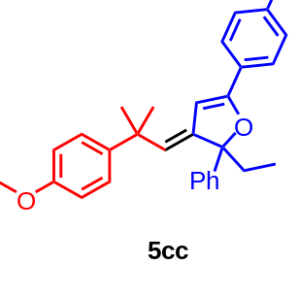
(E)-2-ethyl-3-(2-(4-methoxyphenyl)-2-methylpropylidene)-2-phenyl-5-(p-tolyl)-2,3-dihydrofuran (5cc) Yellow solid, 21.6mg.
¹H NMR (400 MHz, CDCl₃) δ 7.48 (dd, J = 8.4, 1.7 Hz, 4H), 7.43 – 7.30 (m, 3H), 7.28 – 7.24 (m, 2H), 7.16 (d, J = 8.0 Hz, 2H), 6.87 – 6.81 (m, 2H), 5.53 (d, J = 1.1 Hz, 1H), 5.13 (d, J = 1.0 Hz, 1H), 3.82 (s, 3H), 2.38 (s, 3H), 2.28 (dq, J = 14.3, 7.2 Hz, 1H), 2.09 (dq, J = 14.4, 7.2 Hz, 1H), 1.50 (s, 3H), 1.45 (s, 3H), 0.97 (t, J = 7.2 Hz, 3H).
¹³C NMR (126 MHz, CDCl₃) δ 160.20, 157.34, 145.67, 144.94, 142.62, 139.00, 129.00, 128.14, 127.83, 127.43, 127.07, 125.43, 124.96, 124.93, 113.34, 98.13, 92.70, 55.21, 40.13, 33.51, 31.57, 31.26, 21.40, 7.89.
HRMS (ESI): C₃₀H₃₃O₂⁺, calcd. 425.2475, found 425.2473.
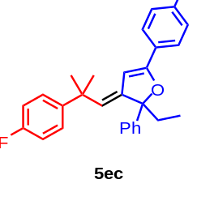
(E)-2-ethyl-3-(2-(4-fluorophenyl)-2-methylpropylidene)-2-phenyl-5-(p-tolyl)-2,3-dihydrofuran (5ec) Yellow solid, 27.2 mg.
¹H NMR (400 MHz, CDCl₃) δ 7.51 – 7.45 (m, 4H), 7.40 – 7.34 (m, 2H), 7.33 – 7.26 (m, 3H), 7.17 (d, J = 8.0 Hz, 2H), 7.01 – 6.94 (m, 2H), 5.46 (d, J = 1.0 Hz, 1H), 5.12 (d, J = 1.0 Hz, 1H), 2.38 (s, 3H), 2.30 (dq, J = 14.4, 7.2 Hz, 1H), 2.10 (dq, J = 14.4, 7.2 Hz, 1H), 1.52 (s, 3H), 1.45 (s, 3H), 0.97 (t, J = 7.2 Hz, 3H).
¹³C NMR (126 MHz, CDCl₃) δ 160.92 (J_{C-F} = 244.4 Hz), 160.65, 159.95, 146.23, 146.19, 144.83, 139.24, 129.09, 127.97 (J_{C-F} = 8.1 Hz), 127.94, 127.71, 127.18, 125.49, 124.93, 124.30, 114.69 (J_{C-F} = 20.5 Hz), 97.84, 92.77, 40.35, 33.48, 31.66, 31.28, 21.45, 7.91.
HRMS (ESI): C₂₉H₃₀FO⁺, calcd. 413.2275, found 413.2262.
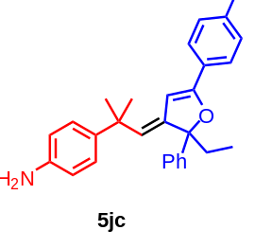
(E)-4-(1-(2-ethyl-2-phenyl-5-(p-tolyl)furan-3(2H)-ylidene)-2-methylpropan-2-yl)aniline (5jc) Yellow oil, 15.6 mg.
¹H NMR (400 MHz, CDCl₃) δ 7.47 (td, J = 5.9, 2.7 Hz, 4H), 7.38 – 7.31 (m, 2H), 7.30 – 7.24 (m, 1H), 7.19 – 7.12 (m, 4H), 6.69 (d, J = 8.5 Hz, 2H), 5.54 (d, J = 1.0 Hz, 1H), 5.10 (d, J = 1.1 Hz, 1H), 2.36 (s, 3H), 2.26 (dq, J = 14.4, 7.2 Hz, 1H), 2.05 (dq, J = 14.4, 7.2 Hz, 1H), 1.47 (s, 3H), 1.42 (s, 3H), 0.95 (t, J = 7.2 Hz, 3H).
¹³C NMR (126 MHz, CDCl₃) δ 160.19, 145.59, 144.97, 139.02, 129.06, 128.15, 127.86, 127.38, 127.08, 125.47, 125.06, 124.98, 116.15, 98.18, 92.71, 40.15, 33.56, 31.52, 31.20, 21.43, 7.91.
HRMS (ESI): C₂₉H₃₂NO⁺, calcd. 410.2478, found 410.2484.
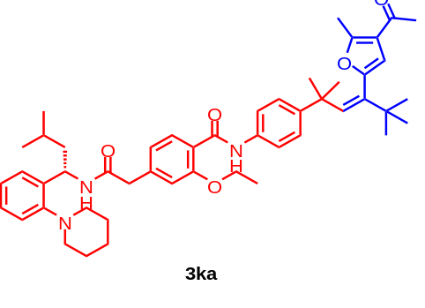
(S,Z)-N-(4-(4-(4-acetyl-5-methylfuran-2-yl)-2,5,5-trimethylhex-3-en-2-yl)phenyl)-2-ethoxy-4-(2-((3-methyl-1-(2-(piperidin-1-yl)phenyl)butyl)amino)-2-oxoethyl)benzamide (3ka) Yellow solid, 71.2 mg.
¹H NMR (400 MHz, CDCl₃) δ 10.00 (s, 1H), 8.21 (d, J = 7.9 Hz, 1H), 7.50 – 7.45 (m, 2H), 7.25 – 7.17 (m, 2H), 7.13 (td, J = 6.5, 6.0, 3.3 Hz, 3H), 7.06 (ddd, J = 7.9, 6.3, 2.2 Hz, 1H), 6.96 (ddd, J = 11.6, 6.4, 3.0 Hz, 3H), 6.08 (s, 1H), 5.73 (s, 1H), 5.40 (td, J = 8.7, 6.4 Hz, 1H), 4.23 – 4.07 (m, 2H), 3.57 (s, 2H), 2.92 (d, J = 28.4 Hz, 2H), 2.61 (q, J = 11.0, 9.9 Hz, 2H), 2.45 (s, 3H), 2.21 (s, 3H), 1.99 (s, 2H), 1.78 – 1.68 (m, 2H), 1.67 – 1.58 (m, 4H), 1.57 – 1.41 (m, 4H), 1.31 (s, 6H), 1.05 (s, 9H), 0.93 (dd, J = 6.5, 2.0 Hz, 6H).
¹³C NMR (126 MHz, CDCl₃) δ 192.63, 167.00, 160.93, 154.95, 154.55, 150.65, 146.84, 143.98, 139.73, 139.24, 136.99, 136.90, 133.95, 130.86, 126.04, 125.84, 124.92, 123.17, 120.89, 120.33, 119.85, 118.48, 117.35, 111.17, 108.08, 63.18, 47.90, 44.81, 42.13, 38.04, 34.52, 28.97, 27.71, 27.07, 24.91, 23.49, 22.29, 20.96, 20.67, 12.99, 12.47.
HRMS (ESI): C₄₉H₆₄N₃O₅⁺, calcd. 774.484, found 774.4839.
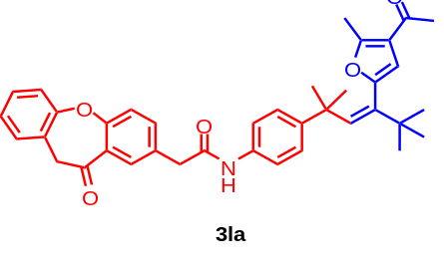
(Z)-N-(4-(4-(4-acetyl-5-methylfuran-2-yl)-2,5,5-trimethylhex-3-en-2-yl)phenyl)-2-(11-oxo-10,11-dihydrodibenzo[b,f]oxepin-2-yl)acetamide (3la) Yellow solid, 49 mg.
¹H NMR (400 MHz, CDCl₃) δ 8.17 (d, J = 2.4 Hz, 1H), 7.89 (dd, J = 7.7, 1.3 Hz, 1H), 7.74 (s, 1H), 7.60 – 7.45 (m, 3H),7.38 (dd, J = 7.5, 1.2 Hz, 1H), 7.31 (d, J = 2.0 Hz, 1H), 7.10 – 7.00 (m, 3H), 6.03 (s, 1H), 5.68 (s, 1H), 5.20 (s, 2H), 3.71 (s, 2H), 2.42 (s, 3H), 2.20 (s, 3H), 2.10 (s, 1H), 1.27 (s, 6H), 1.03 (s, 9H).
¹³C NMR (126 MHz, CDCl₃) δ 194.70, 190.93, 168.86, 160.68, 156.48, 148.69, 146.06, 141.48, 140.34, 138.73, 136.40, 135.56, 135.15, 132.92, 132.40, 129.50, 129.33, 128.63, 127.90, 126.64, 125.27, 121.76, 121.57, 119.16, 109.91, 73.65, 43.52, 39.91, 36.37, 30.78, 29.56, 28.98, 14.37.
HRMS (ESI): C₃₈H₄₀NO₅⁺, calcd. 590.2901, found 590.2905.
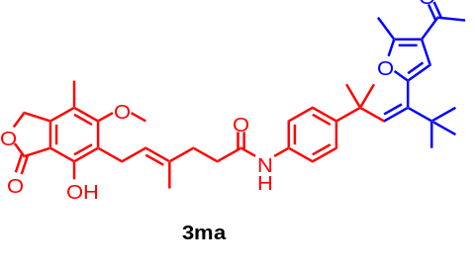
(E)-N-(4-((Z)-4-(4-acetyl-5-methylfuran-2-yl)-2,5,5-trimethylhex-3-en-2-yl)phenyl)-6-(4-hydroxy-6-methoxy-7-methyl-3-oxo-1,3-dihydroisobenzofuran-5-yl)-4-methylhex-4-enamide (3ma) Yellow solid, 33.3 mg.
¹H NMR (400 MHz, CDCl₃) δ 7.72 (s, 1H), 7.38 (s, 1H), 7.24 (d, J = 8.5 Hz, 2H), 7.07 – 7.00 (m, 2H), 6.04 (s, 1H), 5.70 (s, 1H), 5.36 – 5.27 (m, 1H), 5.20 (s, 2H), 3.76 (s, 3H), 3.42 (d, J = 6.9 Hz, 2H), 2.47 – 2.38 (m, 7H), 2.22 (s, 3H), 2.14 (s, 3H), 1.85 (s, 3H), 1.28 (s, 6H), 1.04 (s, 9H).
¹³C NMR (101 MHz, CDCl₃) δ 194.57, 172.89, 170.80, 163.64, 156.41, 153.57, 148.66, 145.70, 144.07, 141.44, 138.66, 135.24, 134.55, 126.58, 123.08, 122.04, 121.71, 119.02, 116.79, 109.91, 106.38, 70.05, 61.02, 39.91, 36.36, 36.07, 35.14, 30.78, 29.56, 28.95, 22.65, 16.24, 14.33, 11.57.
HRMS (ESI): C₃₉H₄₈NO₇⁺, calcd. 642.3425, found 642.3409.
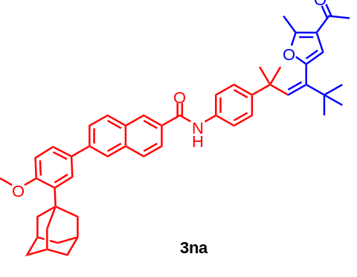
N-(4-((Z)-4-(4-acetyl-5-methylfuran-2-yl)-2,5,5-trimethylhex-3-en-2-yl)phenyl)-6-(3-((3r,5r,7r)-adamantan-1-yl)-4-methoxyphenyl)-2-naphthamide (3na) Yellow solid, 50.6 mg.
¹H NMR (400 MHz, CDCl₃) δ 8.33 (d, J = 39.0 Hz, 2H), 8.04 – 8.01 (m, 1H), 7.99 – 7.92 (m, 3H), 7.81 (dd, J = 8.6, 1.8 Hz, 1H), 7.63 (d, J = 2.3 Hz, 1H), 7.58 – 7.52 (m, 3H), 7.16 (d, J = 8.6 Hz, 2H), 7.01 (d, J = 8.5 Hz, 1H), 6.10 (s, 1H), 5.76 (s, 1H), 3.92 (s, 3H), 2.49 (s, 3H), 2.26 (s, 3H), 2.22 (d, J = 2.9 Hz, 6H), 2.14 (t, J = 3.4 Hz, 3H), 1.84 (d, J = 3.0 Hz, 6H), 1.35 (s, 6H), 1.08 (s, 9H).
¹³C NMR (101 MHz, CDCl₃) δ 194.68, 165.77, 158.89, 156.47, 148.73, 146.10, 141.54, 140.95, 139.00, 138.80, 135.47, 135.25, 132.53, 131.75, 131.36, 129.34, 128.73, 127.32, 126.83, 126.68, 125.94, 125.71, 124.71, 123.93, 121.85, 119.48, 112.13, 109.98, 55.18, 40.63, 40.00, 37.23, 37.15, 36.40, 30.88, 29.59, 29.13, 29.02, 14.43.
HRMS (ESI): C₅₀H₅₆NO₄⁺, calcd. 734.4204, found 734.4192.
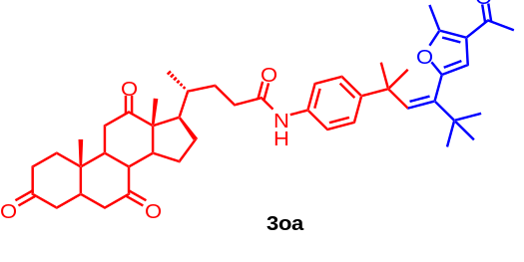
(4R)-N-(4-((Z)-4-(4-acetyl-5-methylfuran-2-yl)-2,5,5-trimethylhex-3-en-2-yl)phenyl)-4-((10S,13R,17R)-10,13-dimethyl-3,7,12-trioxohexadecahydro-1H-cyclopenta[a]phenanthren-17-yl)pentanamide (3oa) Yellow solid, 65.8 mg.
¹H NMR (400 MHz, Chloroform-d) δ 7.68 (s, 1H), 7.31 (d, J = 8.6 Hz, 2H), 7.07 – 7.00 (m, 2H), 6.03 (s, 1H), 5.68 (s, 1H), 2.97 – 2.80 (m, 3H), 2.48 – 2.43 (m, 1H), 2.42 (s, 3H), 2.38 – 2.22 (m, 6H), 2.21 (s, 3H), 2.17 – 2.09 (m, 3H), 2.06 – 2.02 (m, 3H), 1.99 – 1.89 (m, 2H), 1.84 (td, J = 11.4, 7.1 Hz, 1H), 1.61 (td, J = 14.5, 4.4 Hz, 1H), 1.48 (dtd, J = 14.2, 9.1, 5.3 Hz, 1H), 1.40 (s, 3H), 1.38 – 1.30 (m, 3H), 1.27 (s, 6H), 1.07 (s, 3H), 1.02 (s, 9H), 0.86 (d, J = 6.6 Hz, 3H).
¹³C NMR (126 MHz, CDCl₃) δ 210.34, 207.43, 207.08, 192.72, 169.68, 154.52, 146.79, 143.68, 139.63, 136.78, 133.58, 124.73, 119.78, 117.02, 107.98, 55.01, 49.88, 47.07, 44.91, 43.61, 43.51, 43.09, 40.88, 37.96, 36.76, 34.56, 34.44, 34.10, 33.48, 33.34, 32.39, 29.04, 28.95, 28.87, 27.64, 27.06, 25.73, 23.25, 19.96, 16.85, 12.43, 9.98.
HRMS (ESI): C₄₆H₆₀NO₆⁻, calcd. 722.4426, found 722.4422.
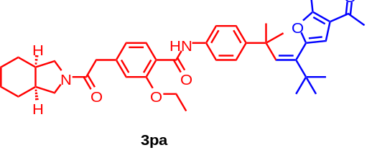
N-(4-((Z)-4-(4-acetyl-5-methylfuran-2-yl)-2,5,5-trimethylhex-3-en-2-yl)phenyl)-2-ethoxy-4-(2-((3aR,7aS)-octahydro-2H-isoindol-2-yl)-2-oxoethyl)benzamide (3pa) Yellow solid, 49.6 mg.
¹H NMR (400 MHz, CDCl₃) δ 10.02 (s, 1H), 8.22 (d, J = 8.0 Hz, 1H), 7.47 (d, J = 8.6 Hz, 2H), 7.14 – 7.08 (m, 2H), 7.04 (d, J = 1.5 Hz, 1H), 6.98 (dd, J = 8.0, 1.5 Hz, 1H), 6.07 (s, 1H), 5.71 (s, 1H), 4.29 (q, J = 7.0 Hz, 2H), 3.68 (s, 2H), 3.51 – 3.37 (m, 3H), 3.32 (dd, J = 9.9, 5.8 Hz, 1H), 2.44 (s, 3H), 2.26 (td, J = 14.0, 12.8, 6.7 Hz, 2H), 2.20 (s, 3H), 2.20 – 2.14 (m, 1H), 1.62 (t, J = 6.9 Hz, 3H), 1.58 – 1.34 (m, 8H), 1.31 (s, 6H), 1.04 (s, 9H).
¹³C NMR (101 MHz, CDCl₃) δ 194.49, 169.39, 162.88, 156.81, 156.39, 148.68, 145.75, 141.60, 140.63, 138.84, 135.88, 132.52, 126.76, 122.26, 121.71, 120.27, 119.20, 113.04, 109.95, 65.13, 51.04, 49.83, 41.98, 39.89, 37.65, 36.37, 35.89, 30.83, 29.57, 28.93, 25.70, 22.72, 22.52, 14.89, 14.33.
HRMS (ESI): C₄₁H₅₁N₂O₅⁻, calcd. 651.3803, found 651.3798.
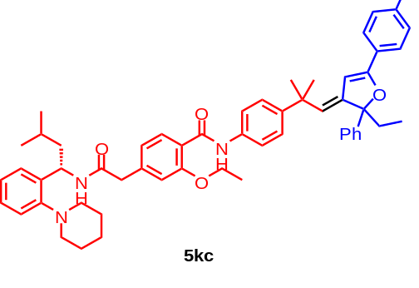
2-ethoxy-N-(4-((E)-1-(2-ethyl-2-phenyl-5-(p-tolyl)furan-3(2H)-ylidene)-2-methylpropan-2-yl)phenyl)-4-(2-(((S)-3-methyl-1-(2-(piperidin-1-yl)phenyl)butyl)amino)-2-oxoethyl)benzamide (5kc) Yellow solid, 49.7 mg.
¹H NMR (400 MHz, CDCl₃) δ 10.06 (s, 1H), 8.26 (d, J = 8.0 Hz, 1H), 7.61 – 7.56 (m, 2H), 7.48 (d, J = 8.0 Hz, 4H), 7.40 – 7.30 (m, 5H), 7.23 (dd, J = 6.5, 1.9 Hz, 2H), 7.17 – 7.06 (m, 4H), 7.01 – 6.93 (m, 2H), 6.87 (d, J = 8.8 Hz, 1H), 5.58 (s, 1H), 5.44 – 5.35 (m, 1H), 5.14 (d, J = 1.0 Hz, 1H), 4.25 – 4.07 (m, 2H), 3.59 (s, 2H), 2.96 (d, J = 11.4 Hz, 2H), 2.64 (d, J = 9.9 Hz, 2H), 2.35 (s, 3H), 2.28 (dt, J = 14.0, 7.0 Hz, 1H), 2.10 (dt, J = 14.1, 7.1 Hz, 1H), 1.74 (s, 3H), 1.67 – 1.55 (m, 9H), 1.52 (s, 3H), 1.46 (s, 3H), 1.01 – 0.91 (m, 9H).
¹³C NMR (126 MHz, CDCl₃) δ 168.85, 162.83, 160.45, 156.86, 152.57, 146.41, 146.08, 144.92, 140.91, 139.07, 138.65, 136.09, 132.87, 129.03, 128.19, 127.97, 127.88, 127.79, 127.12, 127.05, 125.51, 125.15, 124.98, 124.55, 122.97, 122.23, 120.56, 119.67, 113.04, 98.14, 92.74, 65.08, 50.08, 46.67, 44.11, 40.43, 33.55, 31.59, 31.17, 26.80, 25.37, 24.15, 22.80, 22.58, 21.42, 14.90, 7.93.
HRMS (ESI): C₅₆H₆₅ClN₃O₄⁻, calcd. 878.4669, found 878.4663.
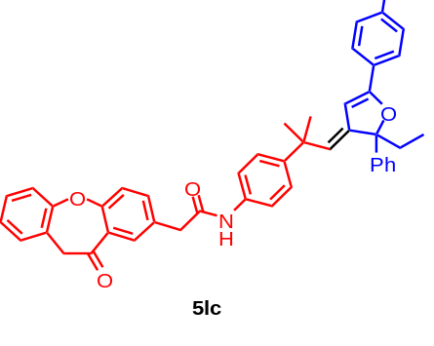
(E)-N-(4-(1-(2-ethyl-2-phenyl-5-(p-tolyl)furan-3(2H)-ylidene)-2-methylpropan-2-yl)phenyl)-2-(11-oxo-10,11-dihydrodibenzo[b,f]oxepin-2-yl)acetamide (5lc) Yellow solid, 48.8 mg.
¹H NMR (400 MHz, CDCl₃) δ 8.19 (d, J = 2.4 Hz, 1H), 7.92 (dd, J = 7.7, 1.4 Hz, 1H), 7.60 (td, J = 7.4, 1.4 Hz, 1H), 7.52 (ddd, J = 7.6, 6.1, 1.9 Hz, 2H), 7.49 – 7.42 (m, 4H), 7.40 (d, J = 7.4 Hz, 1H), 7.38 – 7.30 (m, 4H), 7.25 (t, J = 7.5 Hz, 3H), 7.18 (s, 1H), 7.12 (dd, J = 15.6, 8.2 Hz, 3H), 5.51 (s, 1H), 5.23 (s, 2H), 5.10 (s, 1H), 3.75 (s, 2H), 2.36 (s, 3H), 2.26 (dq, J = 14.3, 7.2 Hz, 1H), 2.07 (dq, J = 14.2, 7.1 Hz, 1H), 1.47 (s, 3H), 1.41 (s, 3H), 0.94 (t, J = 7.2 Hz, 3H).
¹³C NMR (101 MHz, CDCl₃) δ 190.83, 168.71, 160.74, 160.51, 147.04, 146.19, 144.84, 140.37, 139.09, 136.42, 135.47, 134.98, 132.92, 132.56, 129.52, 129.34, 129.01, 128.31, 128.16, 127.88, 127.72, 127.10, 126.92, 125.49, 125.36, 124.90, 124.34, 121.75, 119.67, 98.01, 92.70, 73.66, 43.72, 40.34, 33.45, 31.54, 31.06, 21.41, 7.87.
HRMS (ESI): C₄₅H₄₀NO₄⁻, calcd. 658.2963, found 658.2949.

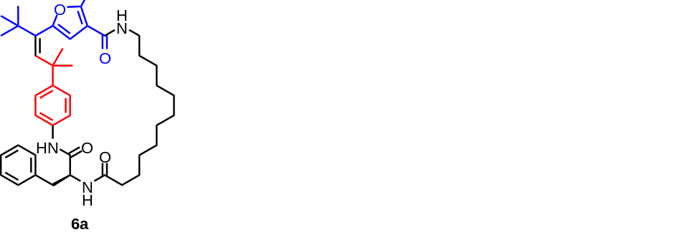
6a: White solid.
¹H NMR (500 MHz, CDCl₃) δ7.87 (s, 1H), 7.36 – 7.31 (m, 2H), 7.29 – 7.22 (m, 3H), 7.10 (dd, J = 23.0, 8.7 Hz, 4H), 6.38 (d, J = 7.4 Hz, 1H), 6.10 (s, 1H), 5.68 (t, J = 5.5 Hz, 1H), 5.31 (s, 1H), 4.85 (dd, J = 13.9, 7.7 Hz, 1H), 3.32 (dd, J = 13.5, 7.0 Hz, 2H), 3.23 (dd, J = 13.6, 6.0 Hz, 1H), 3.10 (dd, J = 13.7, 8.1 Hz, 1H), 2.41 (s, 3H), 2.35 – 2.19 (m, 2H), 1.68 (dt, J = 15.2, 7.0 Hz, 2H), 1.57 (m, 2H), 1.38 – 1.31 (m, 14H), 1.28 (d, J = 3.4 Hz, 6H), 1.09 (s, 9H).
¹³C NMR (126 MHz, CDCl₃) δ 173.40, 169.13, 167.04, 164.28, 154.10, 148.54, 147.40, 141.11, 136.57, 134.00, 129.36, 128.85, 127.22, 126.82, 120.16, 115.97, 108.12, 55.17, 39.69, 39.47, 38.75, 36.41, 36.22, 31.39, 30.96, 29.70, 29.48, 28.12, 28.00, 27.66, 27.61, 27.39, 27.25, 26.43, 24.68, 13.40.
MS (ESI): C₄₂H₅₈N₃O₄⁺, calcd. 668.4422, found 668.4425.
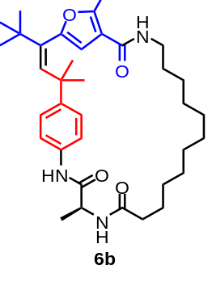
6b: White solid.
¹H NMR (500 MHz, CDCl₃) δ 8.43 (s, 1H), 7.33 (d, J = 7.9 Hz, 2H), 7.12 (d, J = 8.1 Hz, 2H), 6.25 (d, J = 6.9 Hz, 1H), 6.09 (s, 1H), 5.63 (t, J = 5.9 Hz, 1H), 5.38 (s, 2H), 4.67 (dd, J = 14.3, 7.4 Hz, 1H), 3.33 (dd, J = 13.1, 6.6 Hz, 2H), 2.43 (s, 3H), 2.26 – 2.21 (m, 2H), 2.09 – 2.00 (m, 2H), 1.72 – 1.67 (m, 2H), 1.49 (d, J = 6.8 Hz, 3H), 1.37 – 1.32 (m, 14H), 1.28 (s, 6H), 1.07 (s, 9H).
¹³C NMR (126 MHz, CDCl₃) δ173.63, 170.35, 164.28, 154.28, 148.63, 141.05, 139.54, 134.65, 129.74, 126.82, 119.84, 115.91, 108.03, 49.44, 39.82, 39.36, 36.42, 36.21, 31.39, 30.79, 29.70, 29.36, 28.17, 28.06, 27.77, 27.56, 27.48, 27.23, 26.32, 24.76, 22.69, 17.97, 14.11, 13.36.
MS (ESI): C₃₆H₅₄N₃O₄⁺, calcd. 592.4109, found 592.4106.

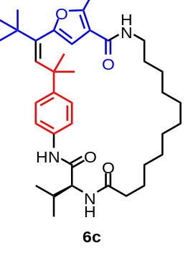
6c: White solid.
¹H NMR (500 MHz, CDCl₃) δ 7.98 (s, 1H), 7.32 (d, J = 8.5 Hz, 2H), 7.13 (d, J = 8.5 Hz, 2H), 6.18 (d, J = 8.6 Hz, 1H), 6.09 (s, 1H), 5.72 (t, J = 5.9 Hz, 1H), 5.47 (s, 1H), 5.33 (s, 1H), 4.38 (t, J = 8.0 Hz, 1H), 3.75 (q, J = 6.9 Hz, 1H), 3.41 – 3.28 (m, 2H), 2.42 (s, 3H), 2.39 – 2.19 (m, 4H), 2.07 – 2.00 (m, 1H), 1.77 – 1.69 (m, 4H), 1.37 – 1.32 (m, 14H), 1.28 (s, 6H), 1.07 (s, 9H), 1.05 (d, J = 8.1 Hz, 6H).
¹³C NMR (126 MHz, CDCl₃) δ 173.62, 169.86, 164.37, 154.15, 147.00, 140.96, 129.42, 127.94, 126.80, 124.41, 120.22, 116.00, 108.14, 59.09, 39.82, 39.37, 36.43, 36.37, 31.94, 31.35, 29.71, 29.67, 29.37, 28.04, 27.79, 27.35, 26.30, 24.77, 22.70, 19.32, 18.45, 14.13, 13.37.
HRMS (ESI): C₃₈H₅₈N₃O₄⁺, calcd. 620.4422, found 620.4419.

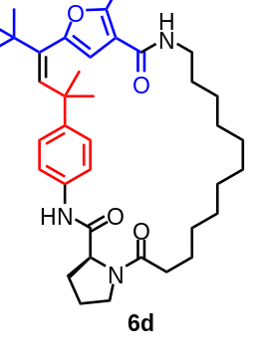
6d: White solid.
¹H NMR (500 MHz, CDCl₃) δ 9.63 (s, 1H), 7.67 (t, J = 7.8 Hz, 1H), 7.39 (d, J = 8.6 Hz, 2H), 7.14 (d, J = 8.6 Hz, 2H), 6.05 (s, 1H), 5.60 – 5.54 (m, 1H), 5.49 (s, 1H), 4.79 (d, J = 7.6 Hz, 1H), 3.57 (dd, J = 13.0, 5.0 Hz, 1H), 3.51 – 3.45 (m, 1H), 3.40 – 3.28 (m, 2H), 2.63 – 2.56 (m, 1H), 2.49 (s, 3H), 2.40 – 2.30 (m, 2H), 2.25 – 2.14 (m, 2H), 2.08 – 1.99 (m, 2H), 1.90 – 1.77 (m, 1H), 1.74 – 1.66 (m, 2H), 1.64 – 1.53 (m, 2H), 1.38 – 1.33 (m, 14H), 1.29 (s, 6H), 1.07 (s, 9H).
¹³C NMR (126 MHz, CDCl₃) δ 174.46, 169.19, 164.22, 154.82, 148.86, 140.76, 135.60, 127.90, 126.52, 120.08, 119.57, 115.66, 107.73, 60.46, 47.71, 40.04, 39.28, 36.50, 34.34, 31.94, 30.83, 30.73, 29.72, 29.23, 28.28, 27.88, 27.55, 26.27, 25.13, 23.87, 22.70, 15.55, 14.13, 13.41.
MS (ESI): C₃₈H₅₆N₃O₄⁺, calcd. 618.4265, found 618.4270.

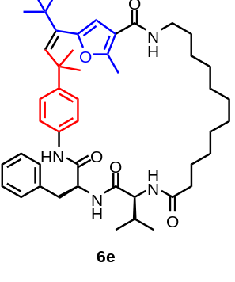
6e: White solid.
¹H NMR (500 MHz, CDCl₃) δ 8.33 (s, 1H), 7.44 – 7.32 (m, 5H), 7.27 (d, J = 7.2 Hz, 2H), 7.11 (d, J = 8.6 Hz, 2H), 6.49 – 6.08 (m, 1H), 6.08 (d, J = 7.0 Hz, 1H), 6.06 (s, 1H), 5.62 (s, 1H), 5.48 (s, 1H), 4.90 (dd, J = 15.3, 6.9 Hz, 1H), 3.88 (t, J = 7.6 Hz, 1H), 3.49 – 3.40 (m, 1H), 3.33 – 3.22 (m, 3H), 2.43 (s, 3H), 2.33 – 2.16 (m, 4H), 2.06 – 1.97 (m, 1H), 1.60 – 1.55 (m, 2H), 1.35 (s, 6H), 1.31 – 1.26 (m, 14H), 1.07 (s, 9H), 0.94 (d, J = 6.7 Hz, 3H), 0.78 (d, J = 6.7 Hz, 3H).
¹³C NMR (126 MHz, CDCl₃) δ 174.58, 171.61, 168.91, 164.30, 163.61, 154.72, 148.72, 146.81, 141.04, 138.93, 136.66, 129.35, 128.87, 127.17, 126.54, 120.35, 115.65, 107.82, 60.35, 54.75, 41.36, 40.00, 39.11, 36.43, 36.16, 34.68, 31.60, 29.68, 29.07, 28.39, 27.68, 26.92, 25.29, 22.67, 20.45, 18.98, 18.70, 14.13, 11.44.
MS (ESI): C₄₇H₆₇N₄O₅⁺, calcd. 767.5106, found 767.5106.

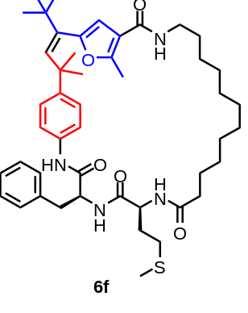
6f: White solid.
¹H NMR (500 MHz, CDCl₃) δ 8.34 (s, 1H), 7.38 – 7.33 (m, 5H), 7.31 (d, J = 8.2 Hz, 2H), 7.10 (d, J = 8.2 Hz, 2H), 6.77 – 6.68 (m, 1H), 6.52 – 6.45 (m, 1H), 6.06 (s, 1H), 5.66 – 5.58 (m, 1H), 5.48 (s, 1H), 4.88 (dd, J = 15.0, 8.2 Hz, 1H), 4.61 (dd, J = 17.3, 9.2 Hz, 1H), 4.42 (dd, J = 14.3, 8.6 Hz, 1H), 3.44 – 3.28 (m, 3H), 3.18 (dd, J = 14.0, 8.1 Hz, 1H), 2.69 – 2.48 (m, 2H), 2.45 – 2.37 (m, 3H), 2.33 – 2.23 (m, 2H), 2.08 (s, 3H), 1.97 – 1.73 (m, 2H), 1.68 – 1.51 (m, 6H), 1.43 – 1.30 (m, 14H), 1.29 (s, 6H), 1.06 (s, 9H).
¹³C NMR (126 MHz, CDCl₃) δ 174.42, 173.50, 171.57, 171.24, 168.82, 148.68, 141.10, 138.93, 136.64, 134.72, 130.03, 129.28, 128.86, 127.16, 126.62, 120.23, 115.58, 107.80, 54.82, 53.06, 52.35, 39.99, 39.11, 37.55, 36.41, 36.08, 31.91, 31.37, 30.42, 29.69, 29.32, 28.24, 27.22, 26.97, 26.17, 25.13, 24.69, 22.69, 15.15, 14.11, 13.39.
MS (ESI): C₄₇H₆₇N₄O₅S⁺, calcd. 799.4844, found 799.4827.

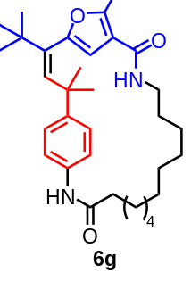
6g: White solid.
¹H NMR (400 MHz, CDCl₃) δ 7.31 (s, 1H), 7.21 (d, J = 8.5 Hz, 2H), 7.04 (d, J = 8.5 Hz, 2H), 6.13 (s, 1H), 5.84 (m, 1H), 5.24 (s, 1H), 3.31 (dd, J = 14.3, 6.4 Hz, 2H), 2.42 – 2.31 (m, 5H), 1.80 – 1.73 (m, 2H), 1.62 – 1.50 (m, 2H), 1.48 – 1.34 (m, 14H), 1.32 (s, 6H), 1.05 (s, J = 13.3 Hz, 9H).
¹³C NMR (126 MHz, CDCl₃) δ 171.65, 164.49, 153.32, 148.41, 147.00, 141.74, 140.43, 134.42, 126.98, 120.38, 116.32, 108.47, 77.26, 39.57, 39.34, 36.87, 36.30, 31.51, 29.63, 29.21, 27.18, 27.12, 26.88, 26.65, 26.22, 25.87, 25.50, 24.28, 13.35.
HRMS (ESI): C₃₃H₄₉N₂O₃⁺, calcd. 520.2135, found 520.2128.

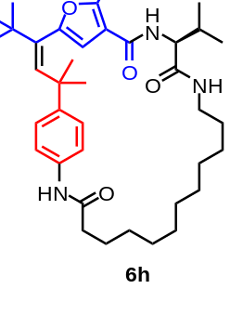

6h: White solid.
¹H NMR (500 MHz, CDCl₃) δ 9.50 (s, 1H), 7.35 (d, J = 8.6 Hz, 2H), 7.00 (d, J = 8.6 Hz, 2H), 6.23 (s, 1H), 6.13 (dd, J = 7.9, 3.9 Hz, 1H), 5.42 (d, J = 9.3 Hz, 1H), 4.39 (s, 1H), 4.11 (t, J = 9.1 Hz, 1H), 3.75 (dq, J = 15.9, 7.9 Hz, 1H), 3.07 – 2.99 (m, 1H), 2.48 (s, 3H), 2.42 (ddd, J = 14.0, 10.0, 6.7 Hz, 1H), 2.36 – 2.27 (m, 1H), 1.96 (td, J = 13.4, 6.7 Hz, 1H), 1.88 – 1.73 (m, 2H), 1.61 – 1.55 (m, 2H), 1.46 – 1.24 (m, 20H), 1.01 (d, J = 6.7 Hz, 3H), 0.99 (s, 9H), 0.94 (d, J = 6.7 Hz, 3H).
¹³C NMR (126 MHz, CDCl₃) δ 172.29, 171.84, 164.10, 155.13, 148.56, 148.07, 143.10, 140.87, 135.57, 126.94, 120.22, 114.87, 107.33, 77.22, 59.07, 38.83, 38.55, 37.09, 36.28, 33.96, 31.19, 29.56, 28.63, 28.50, 28.34, 27.65, 27.37, 27.10, 26.83, 25.11, 24.82, 19.30, 19.04, 13.46.
HRMS (ESI): C₃₈H₅₈N₃O₄⁺, calcd. 620.2195, found 620.2191.

NMR Spectra
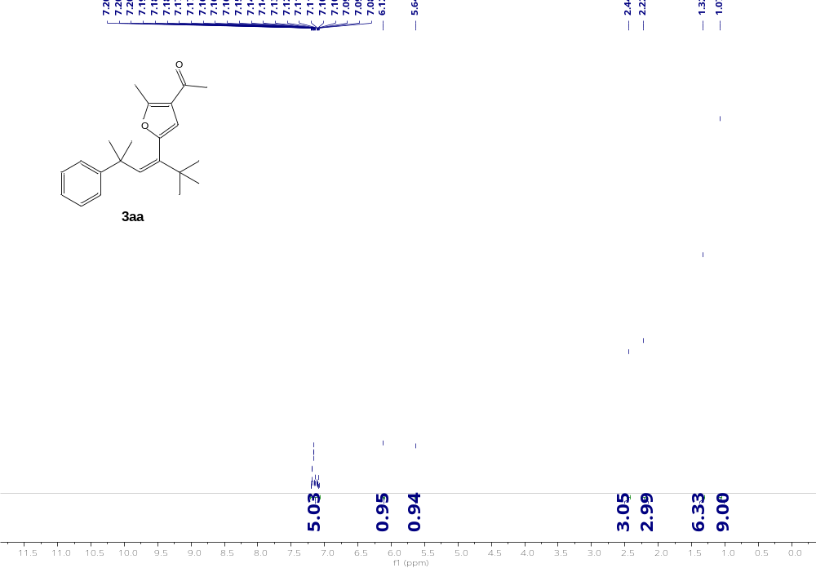
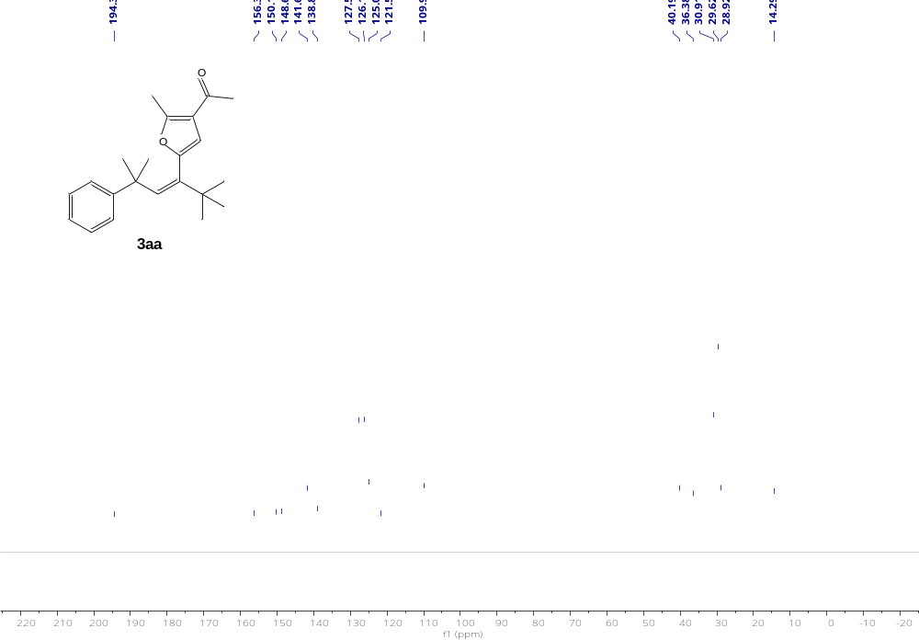
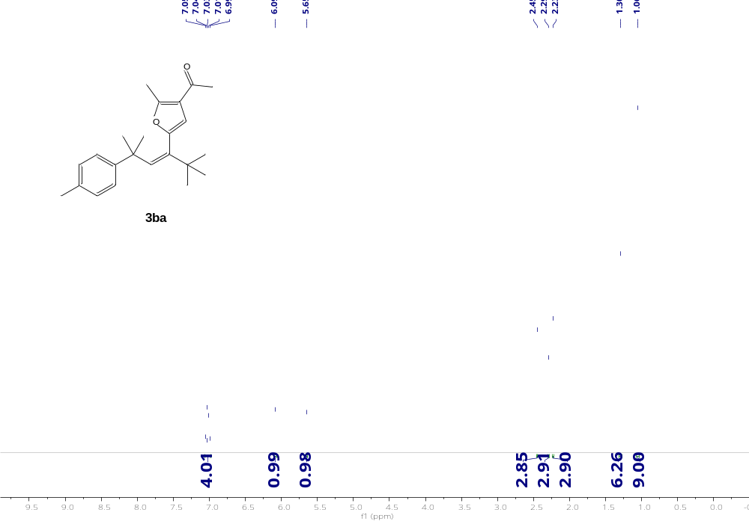
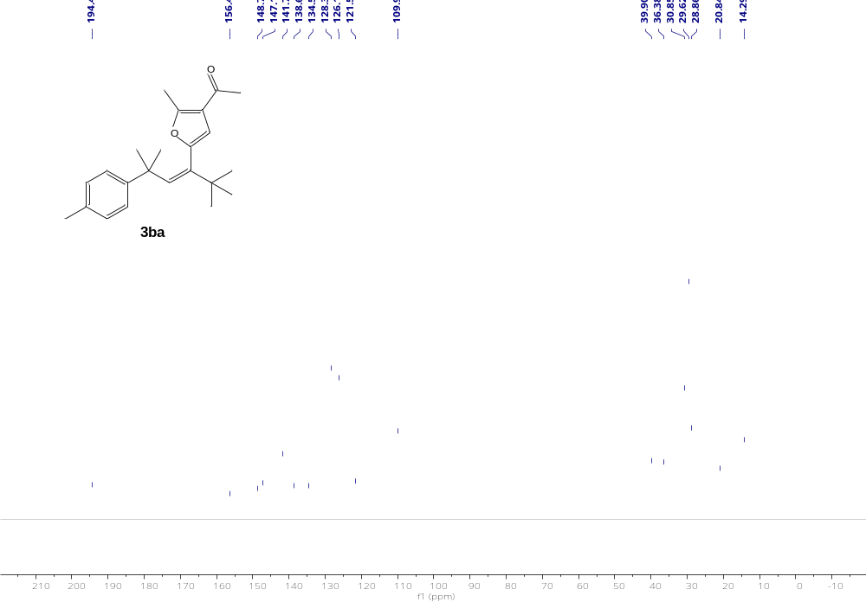
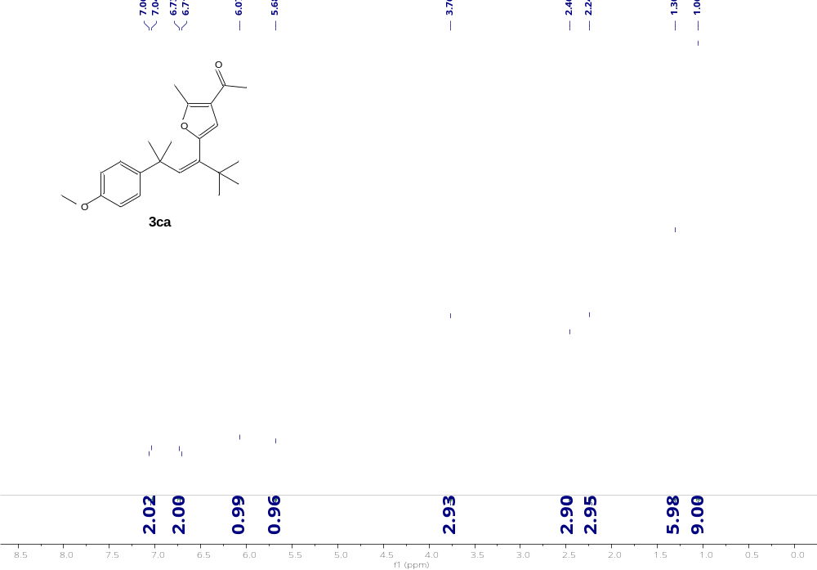
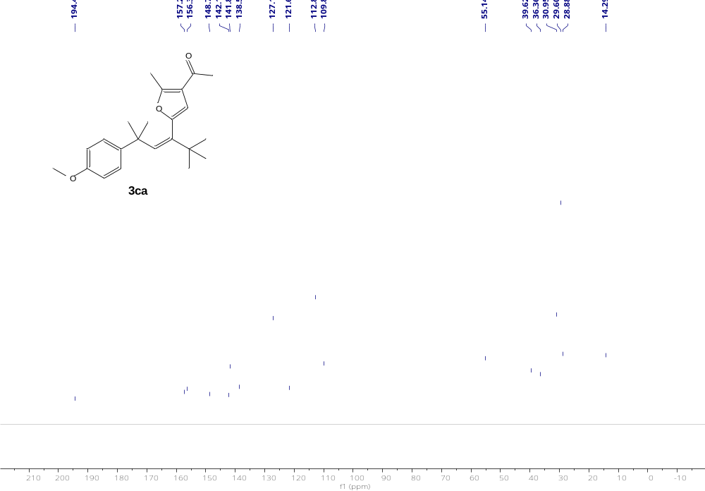
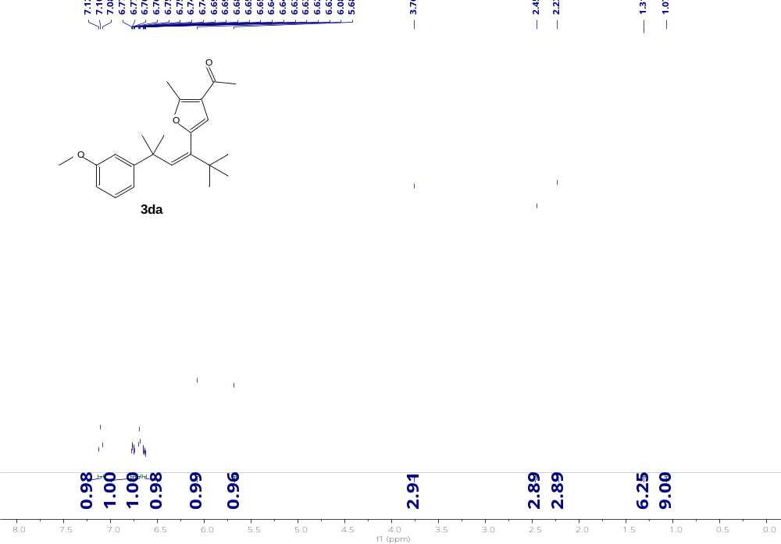
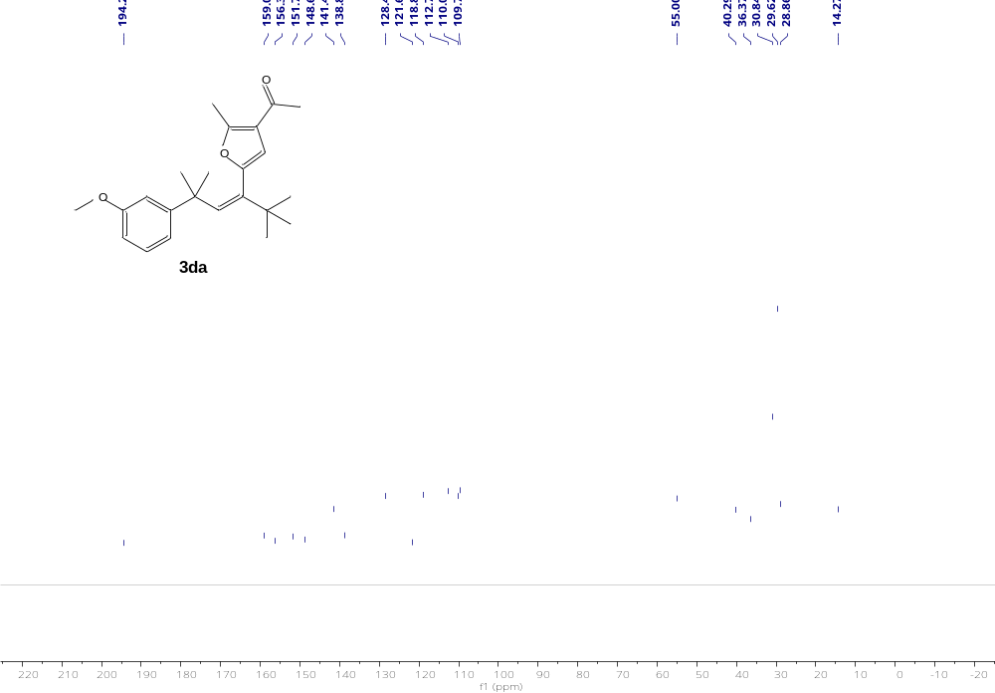
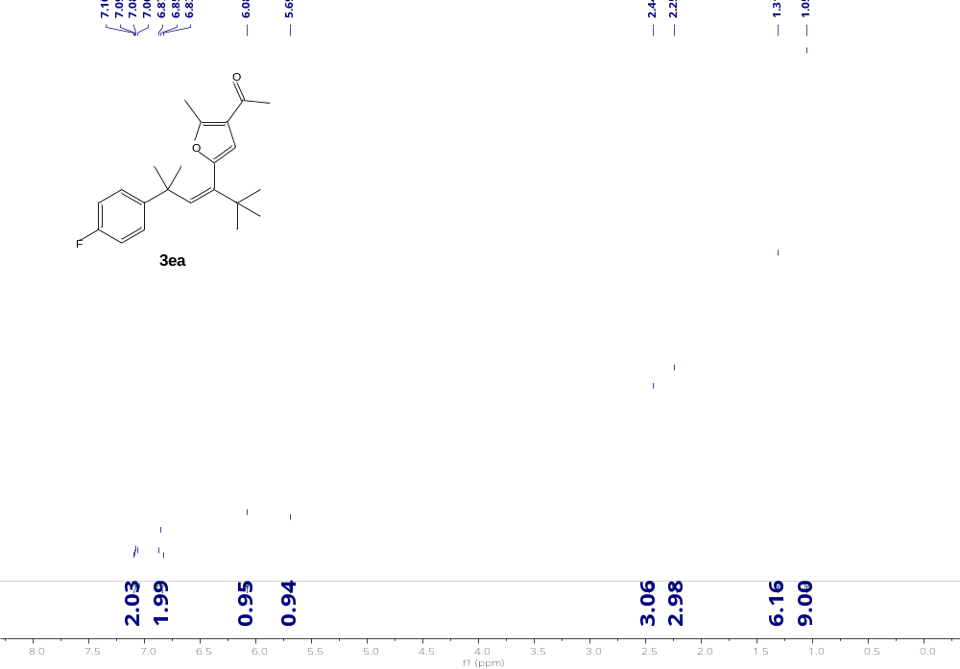
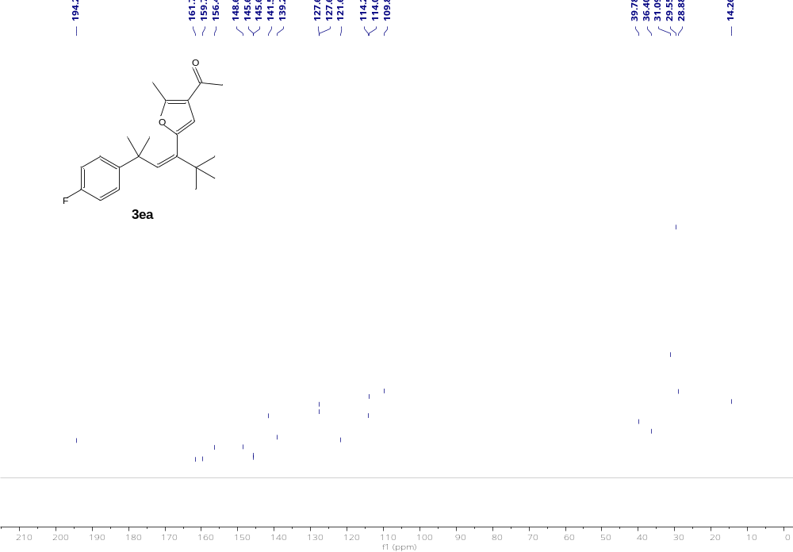
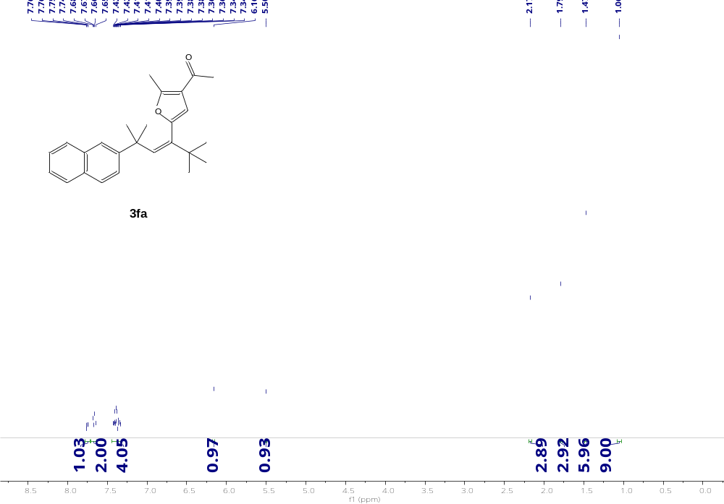
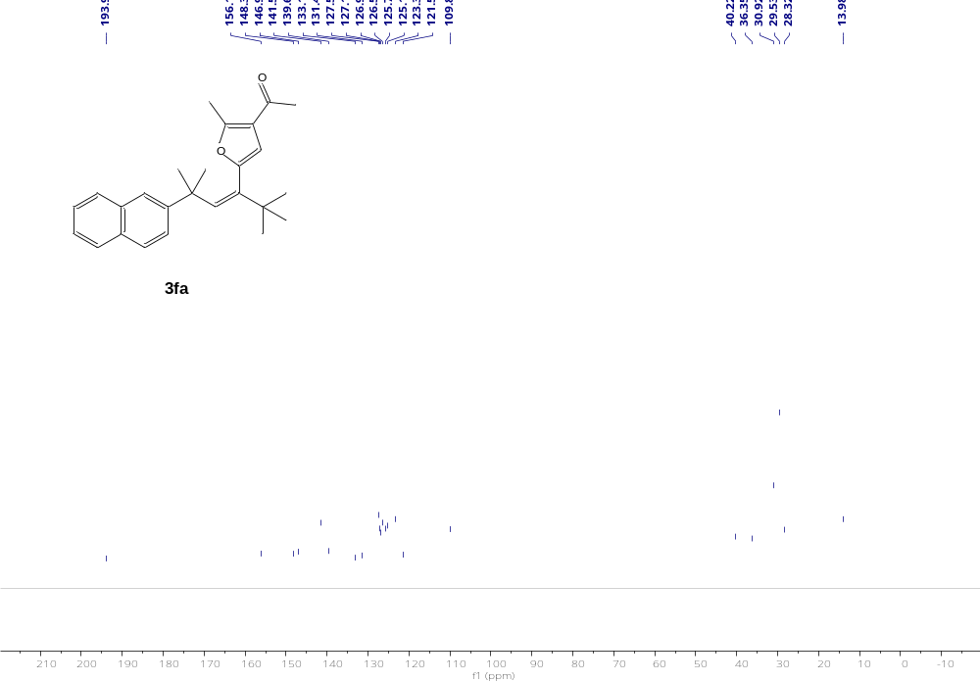
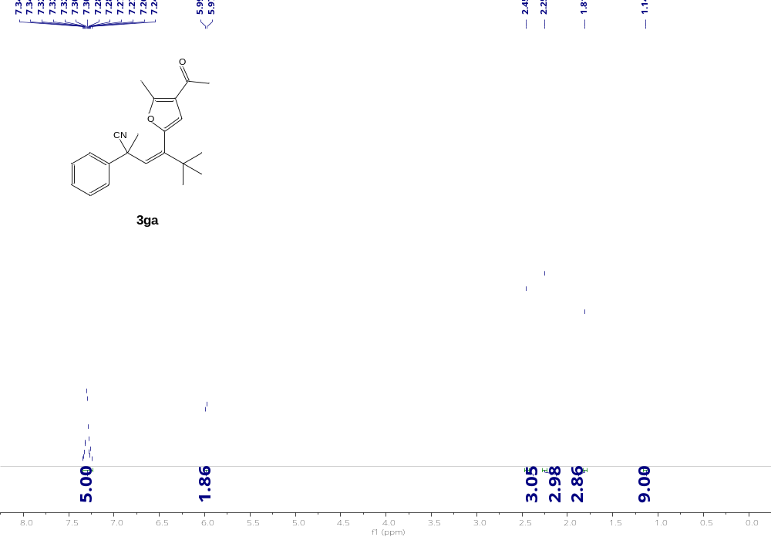
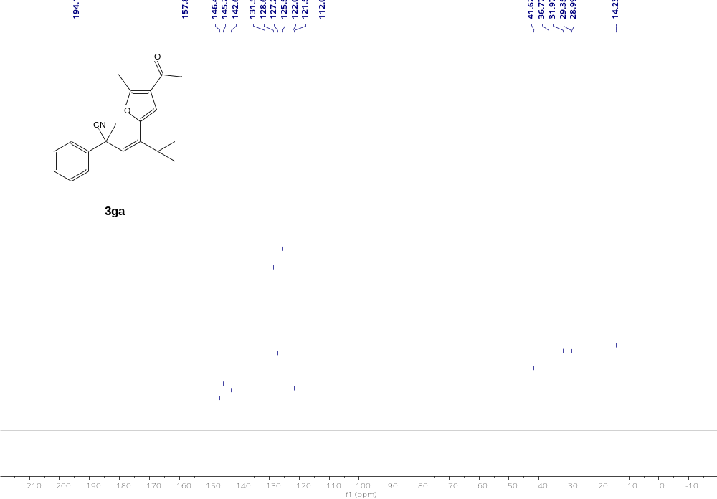
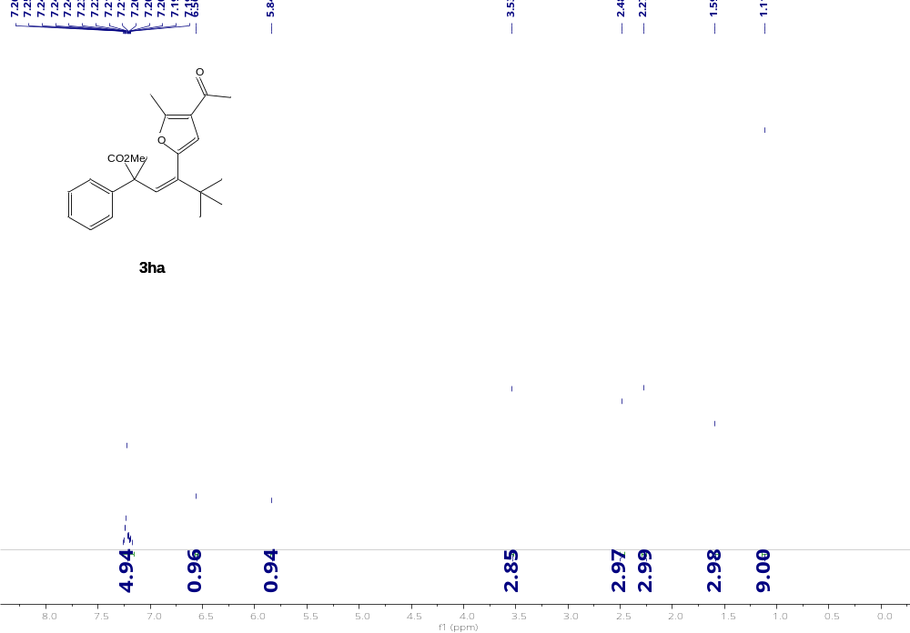
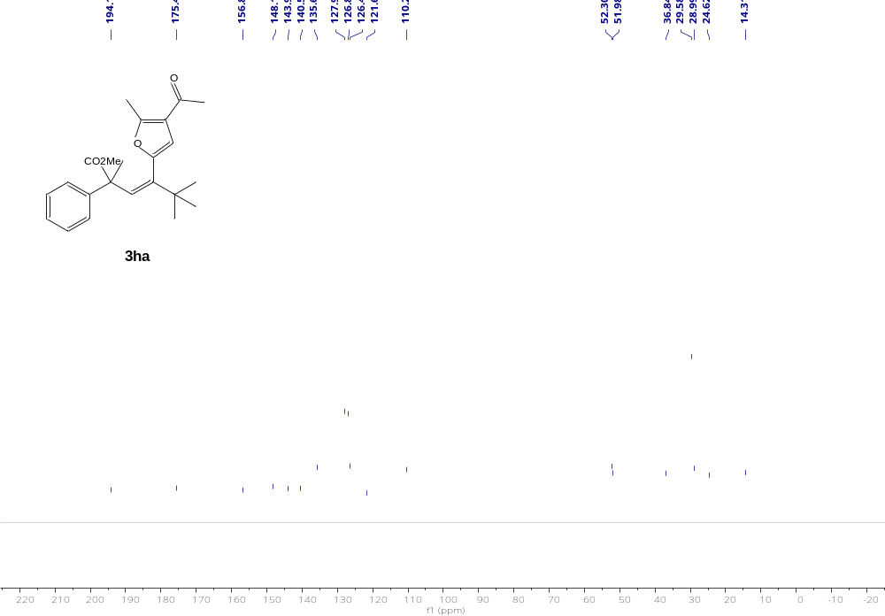
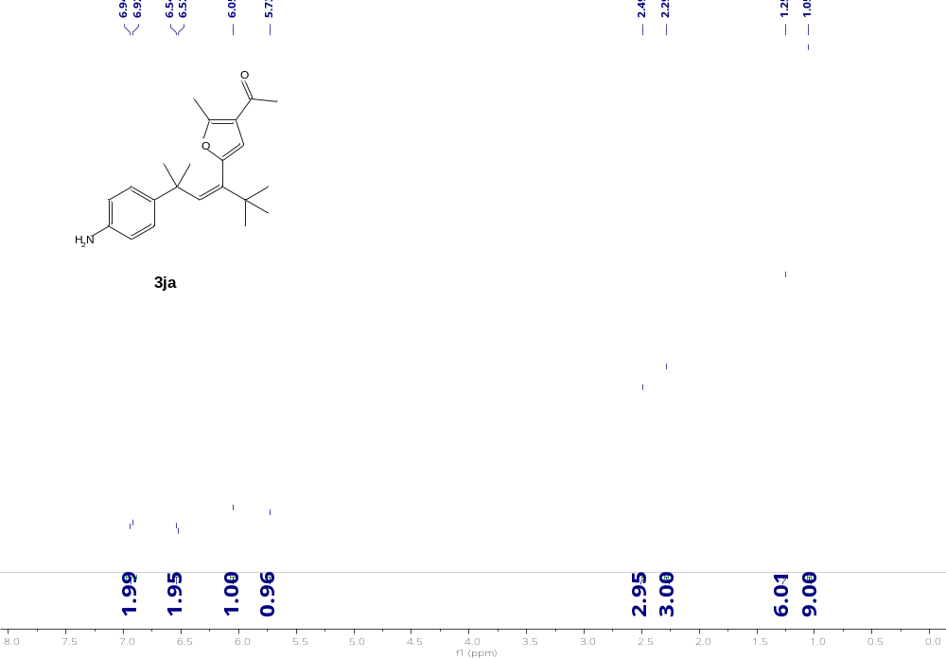
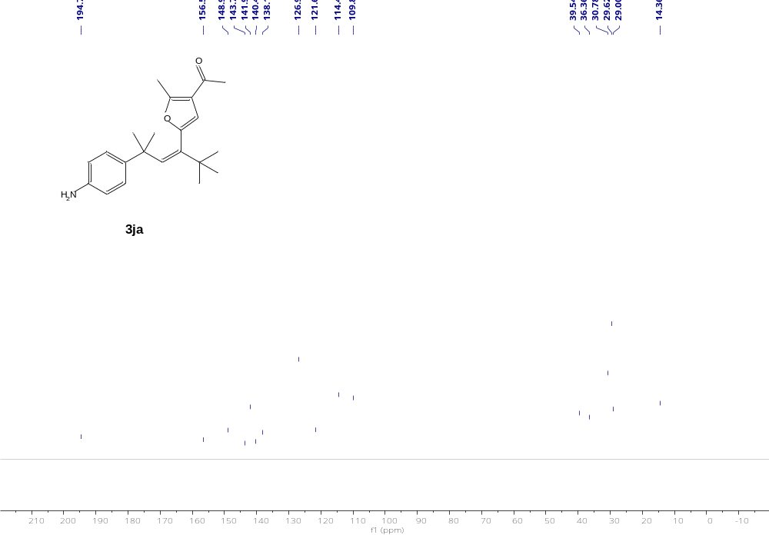
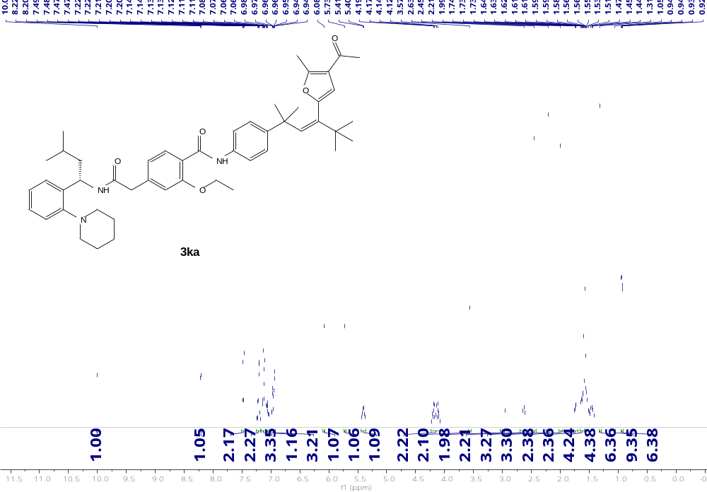
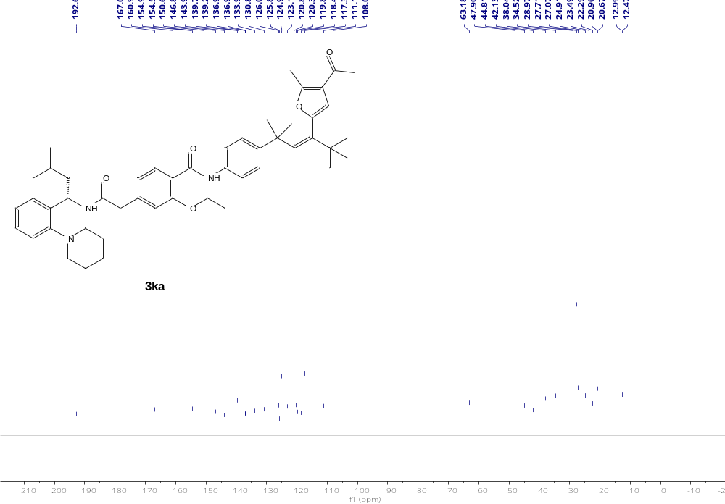
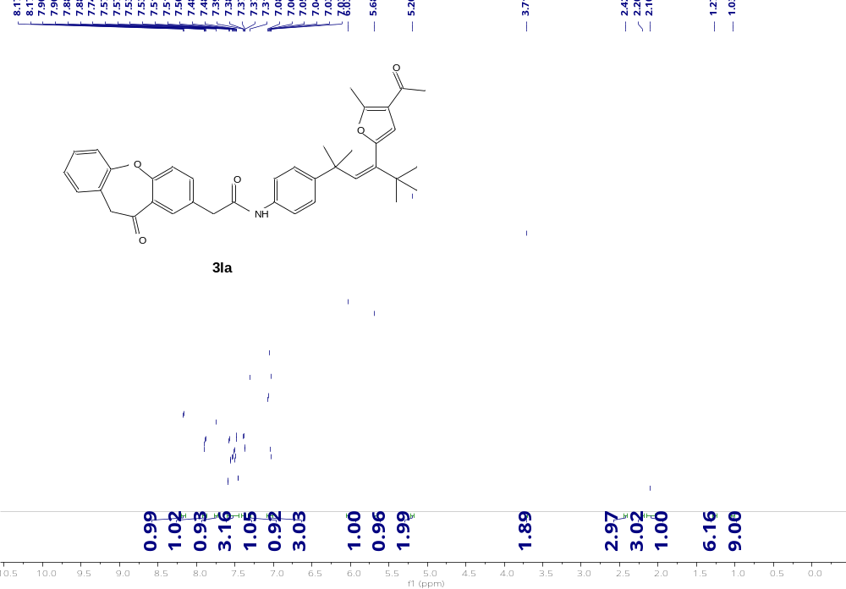
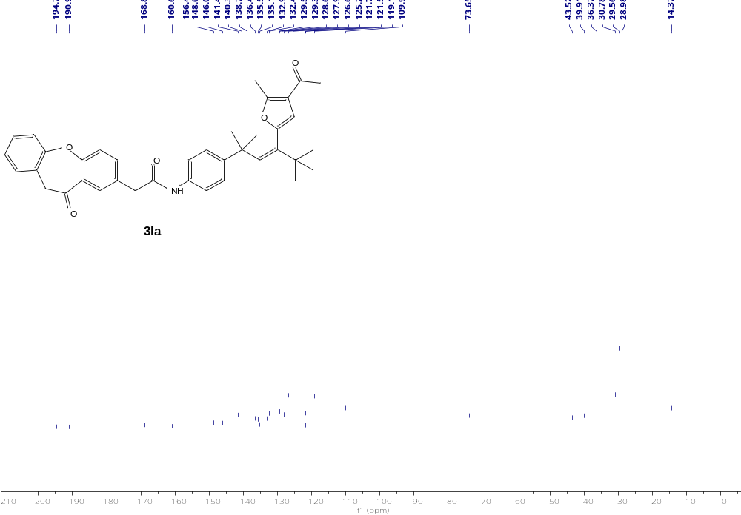
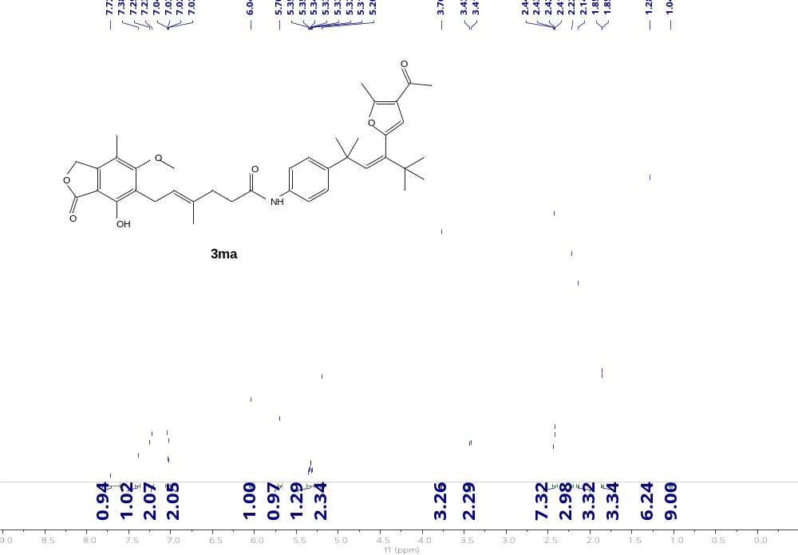
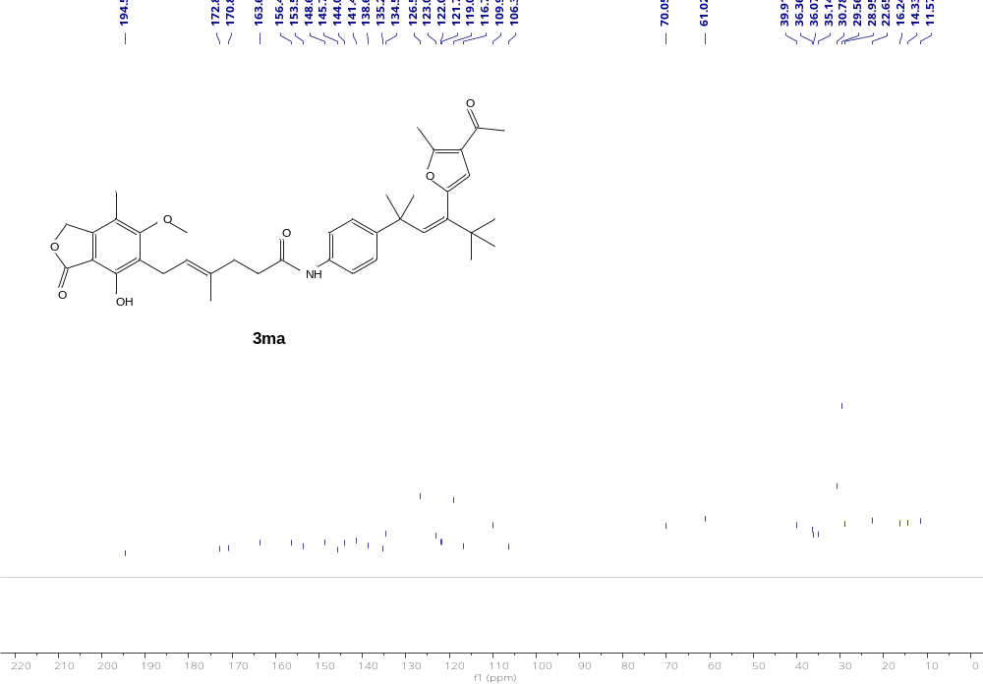
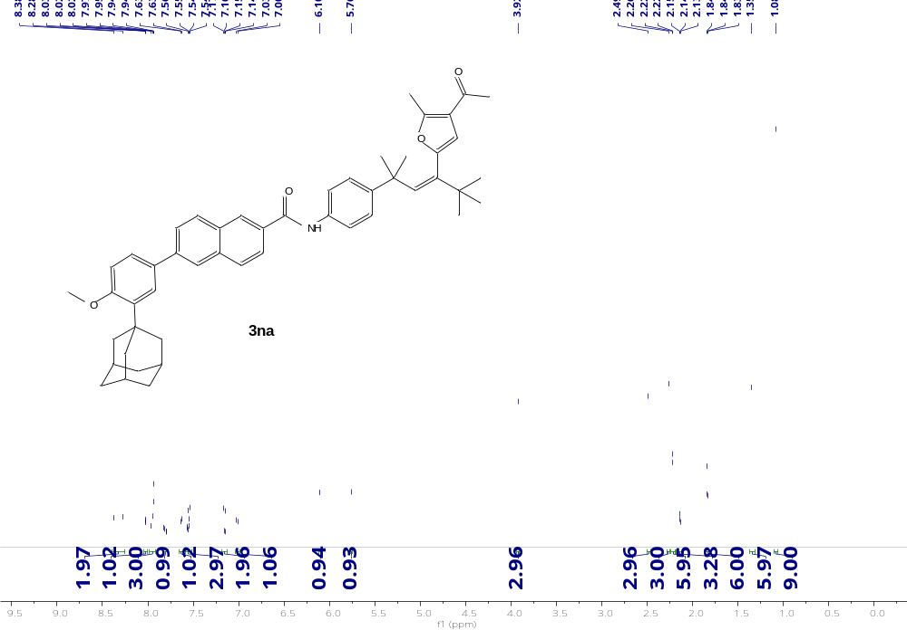
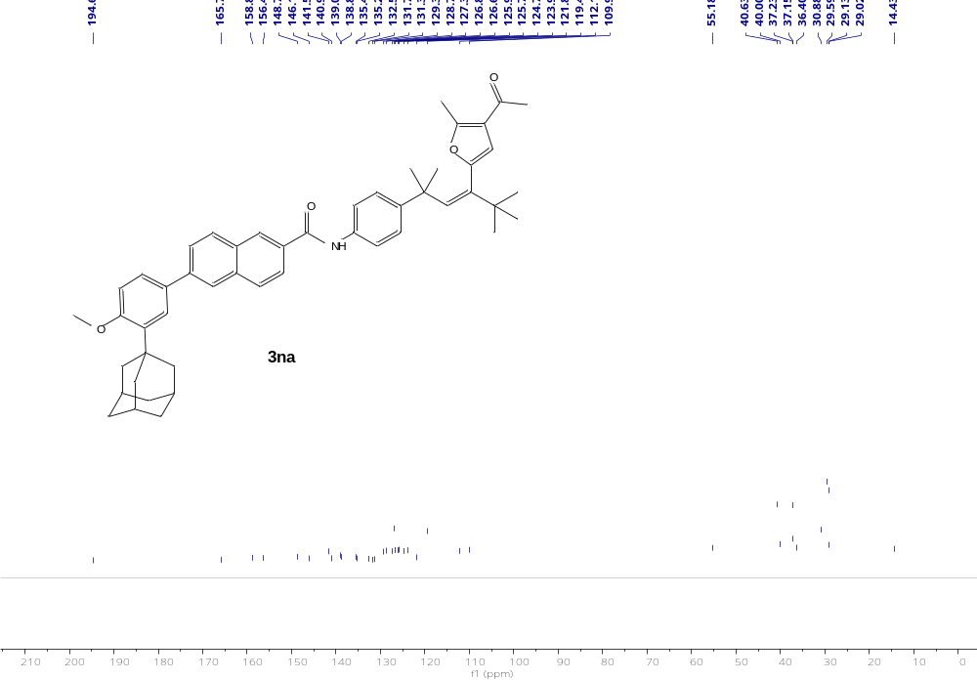
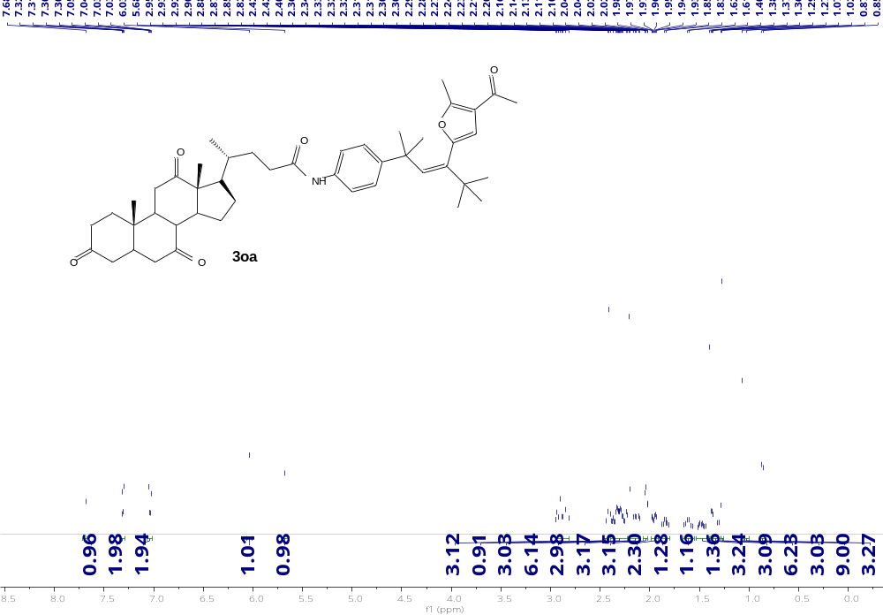
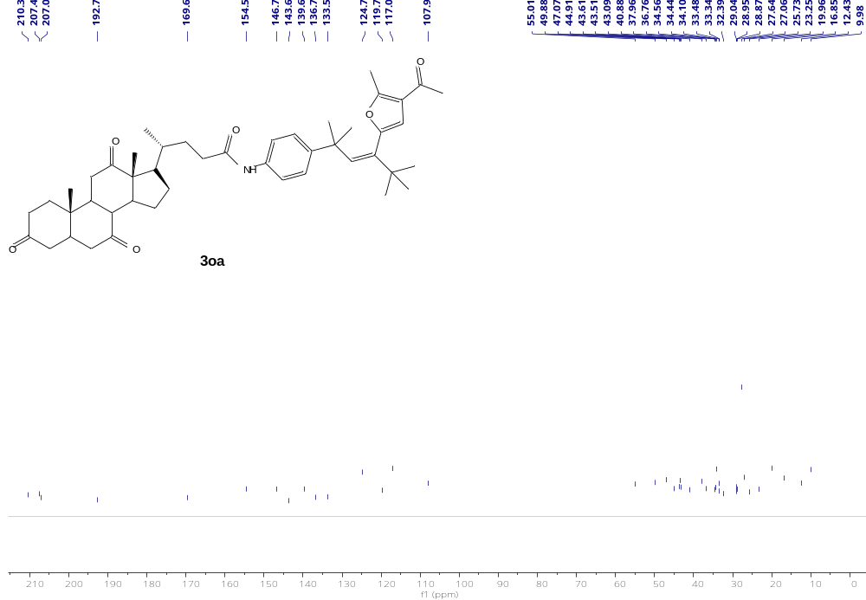
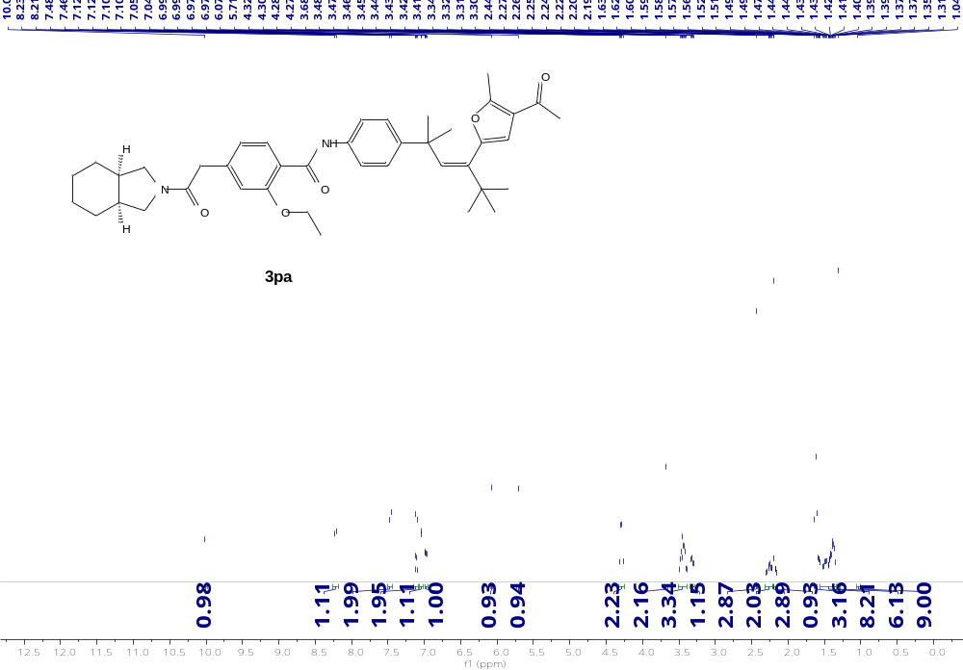
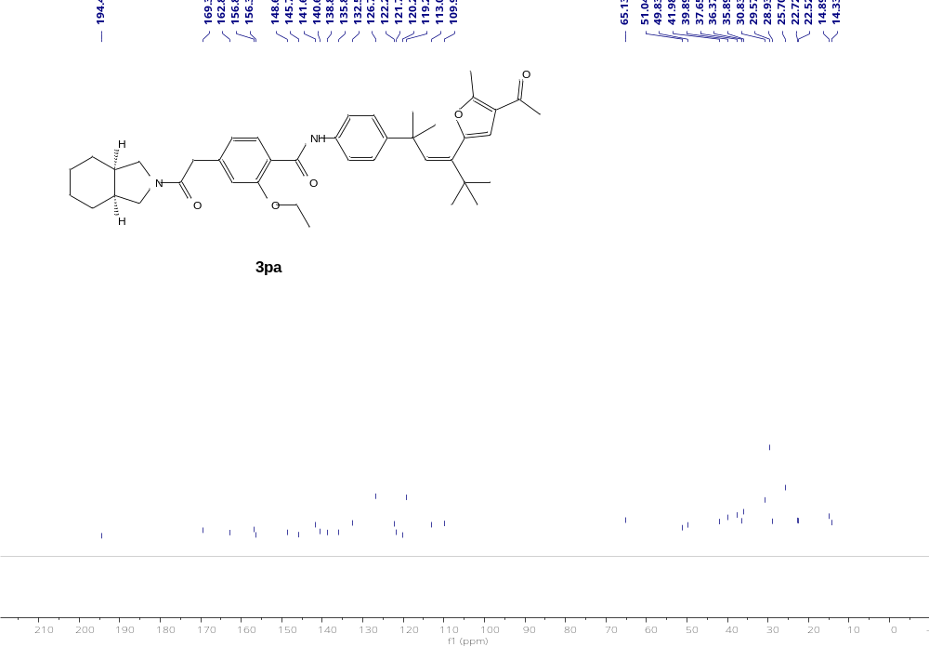
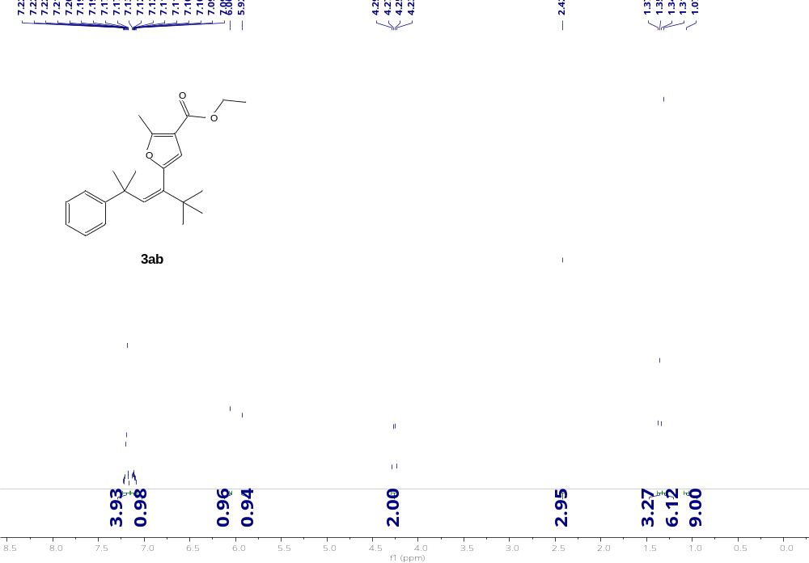
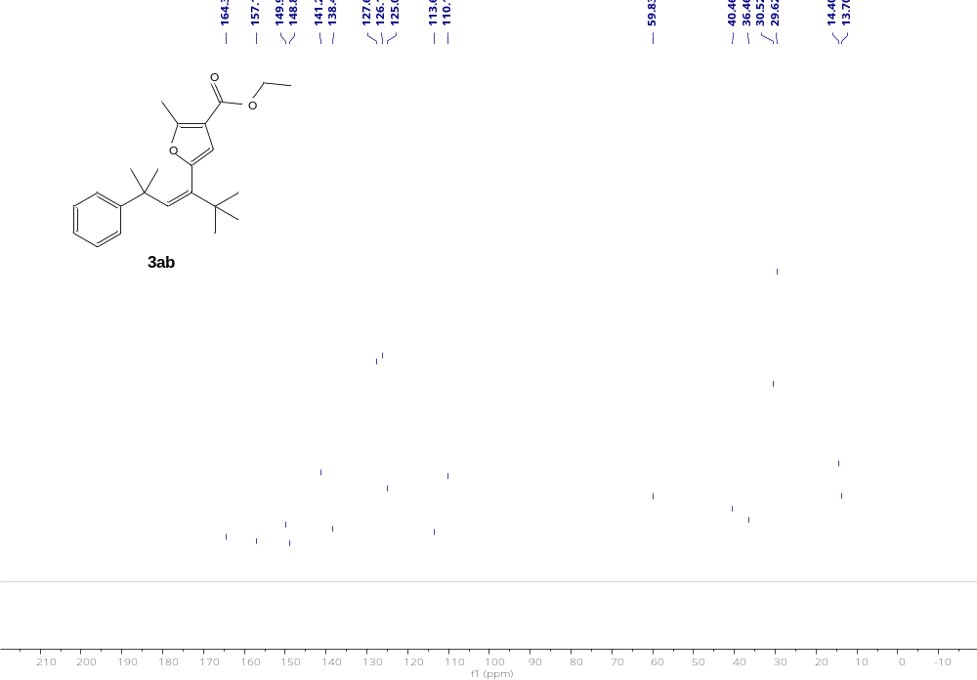
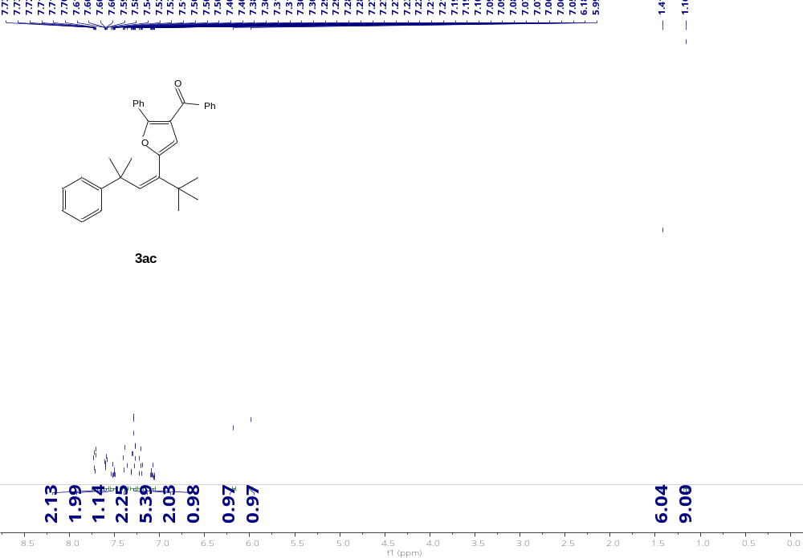
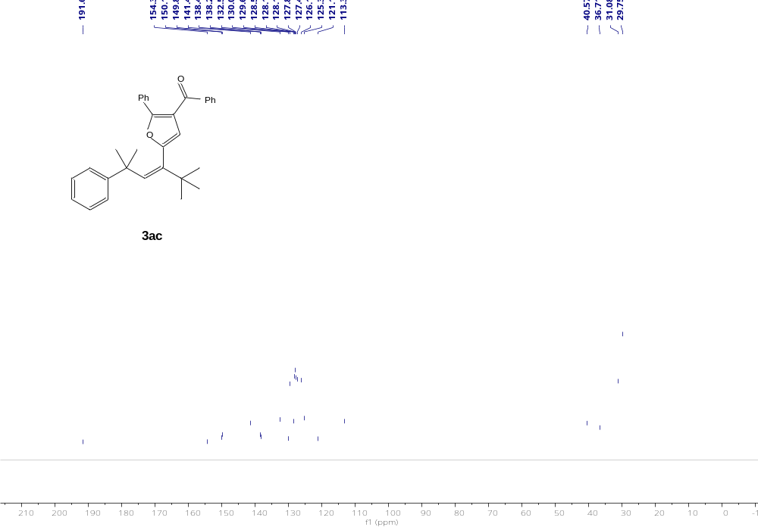
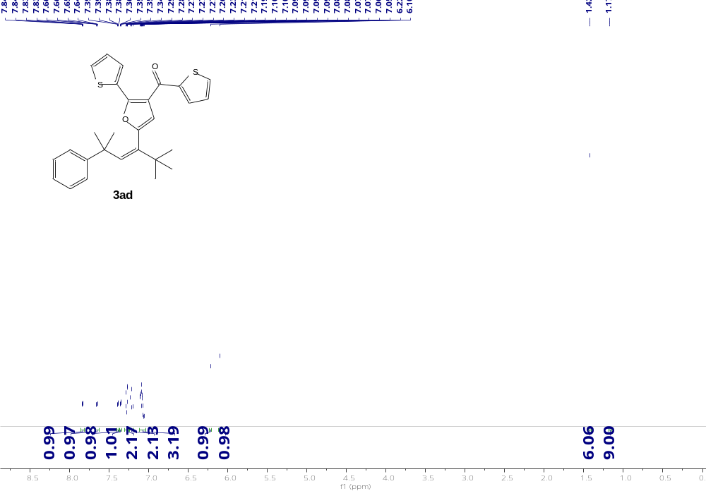
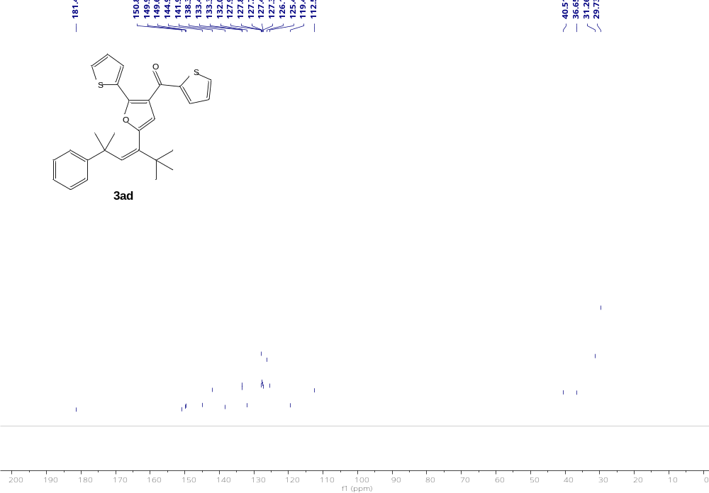
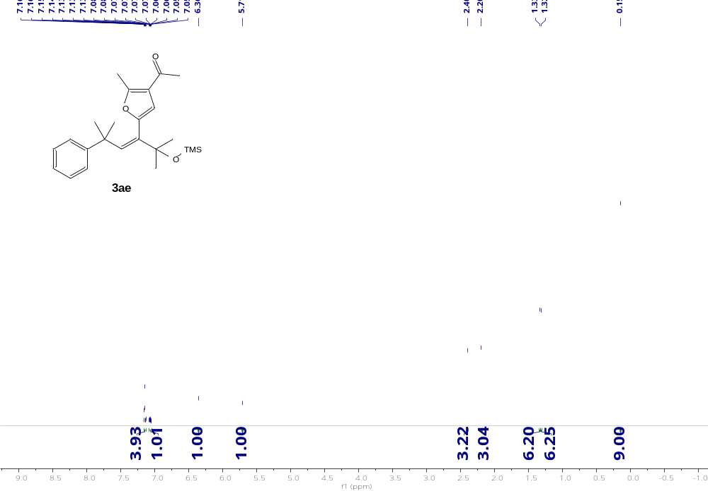
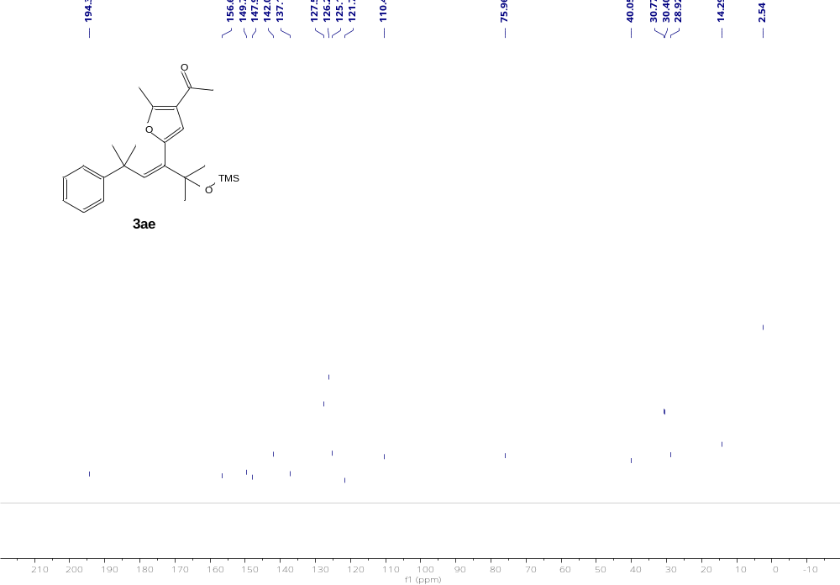
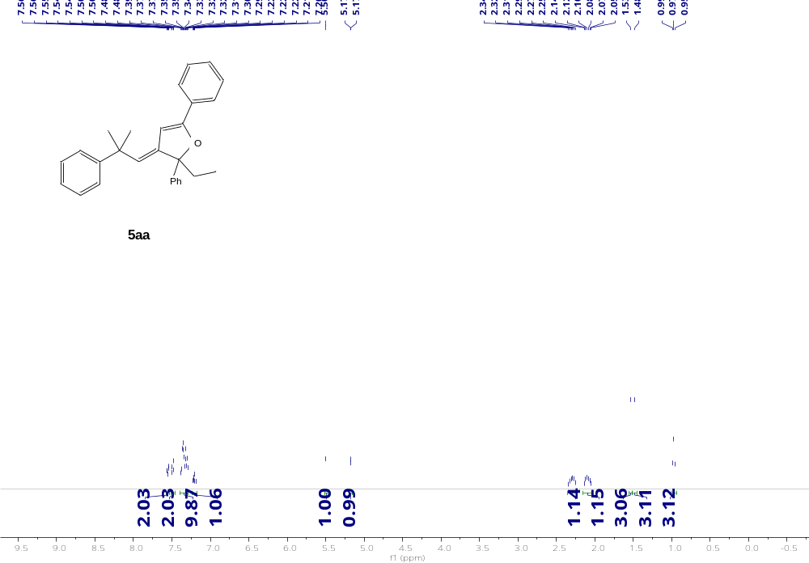
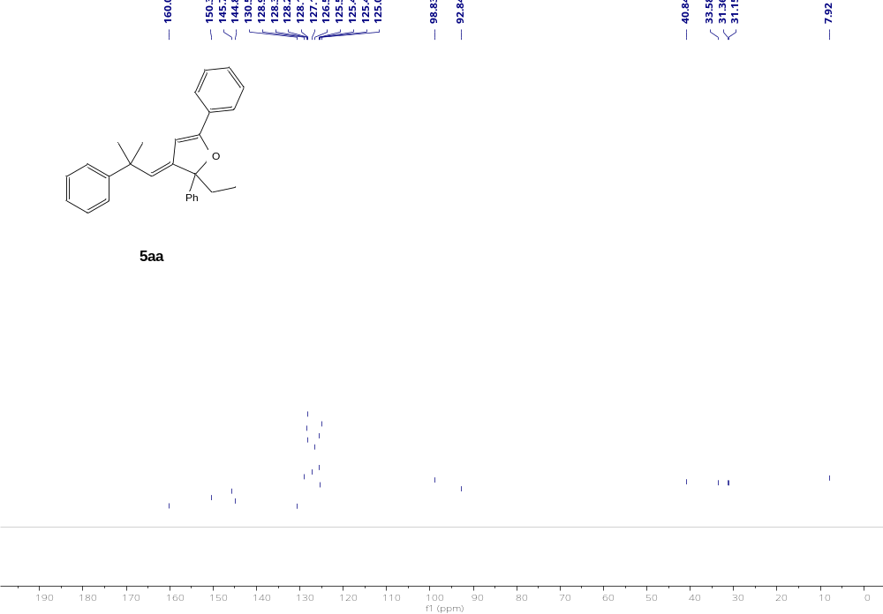
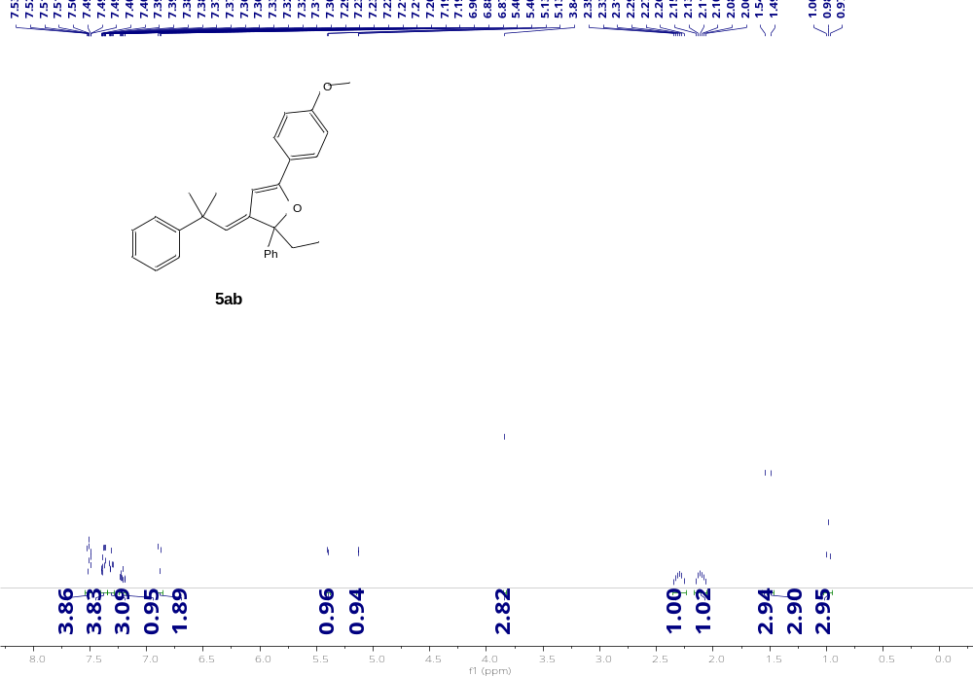
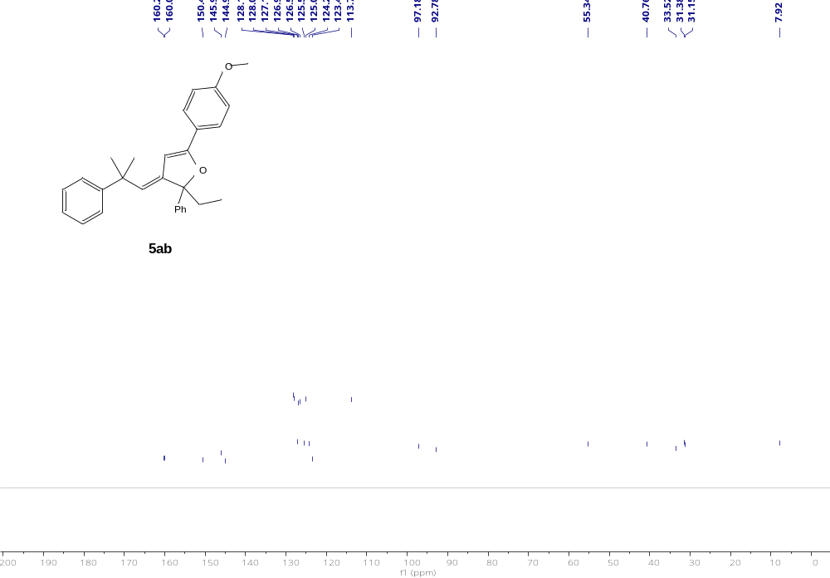
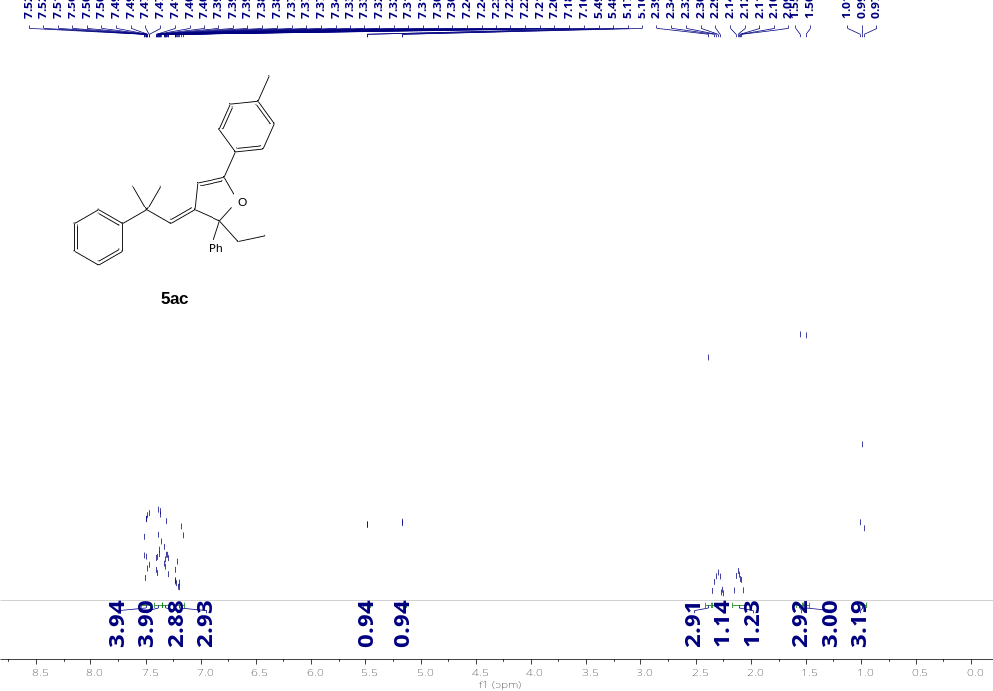
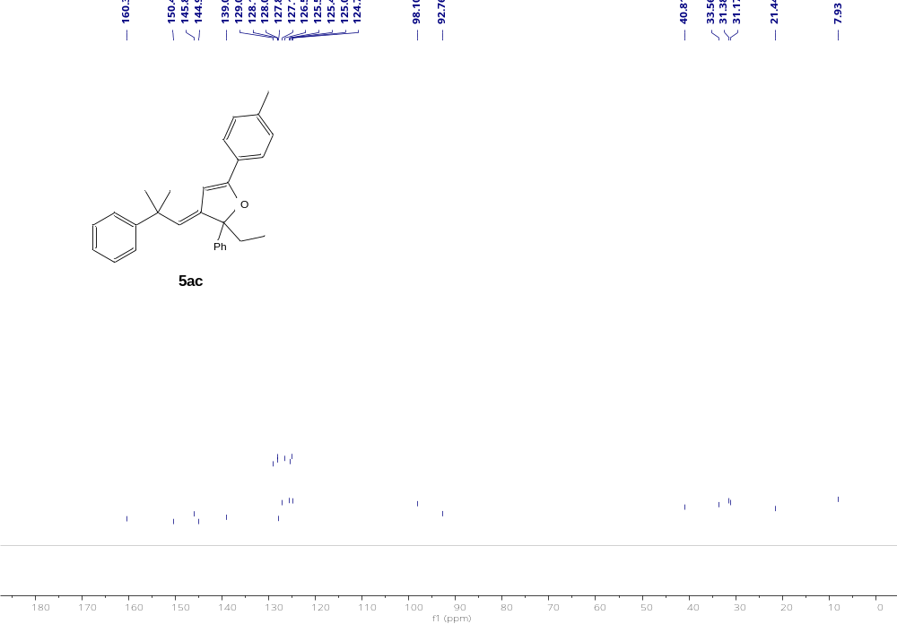
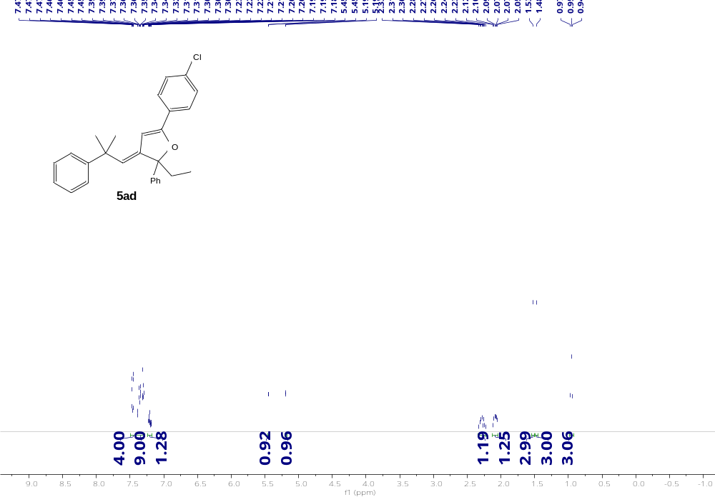
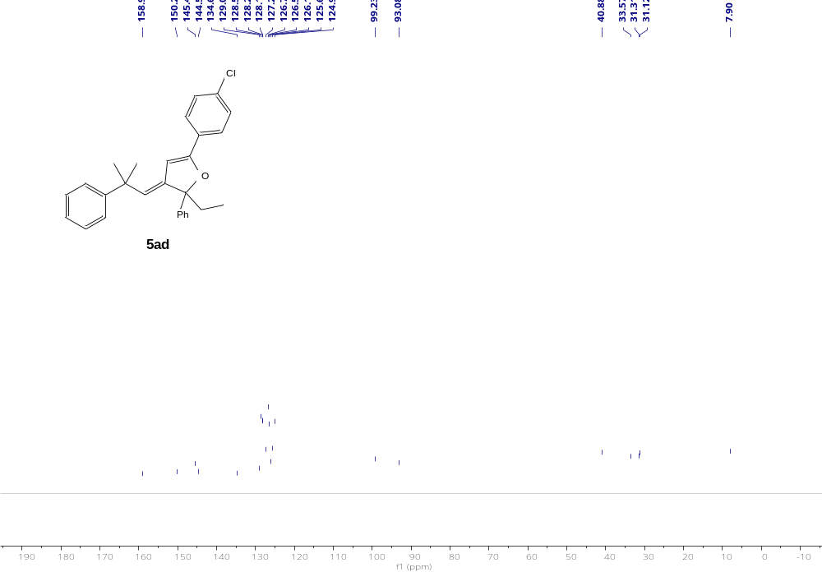
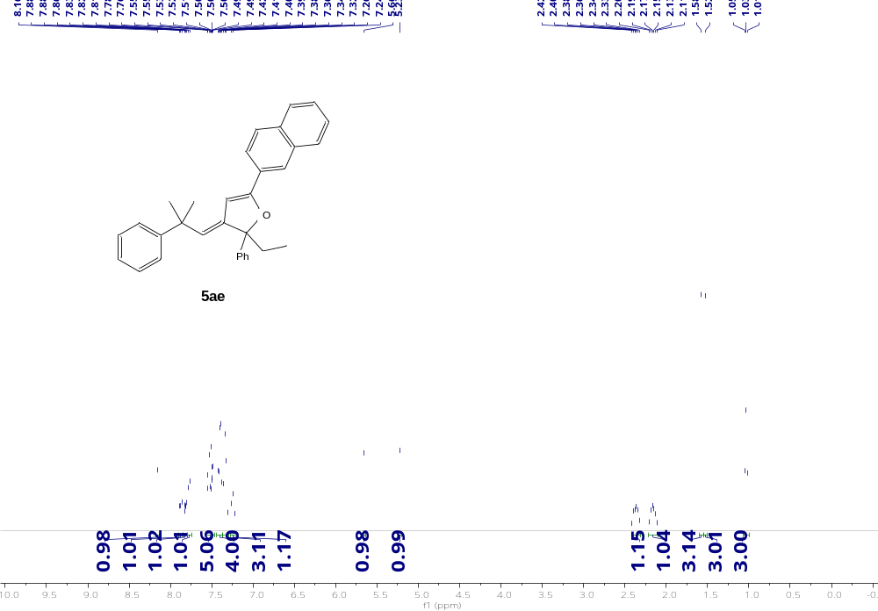
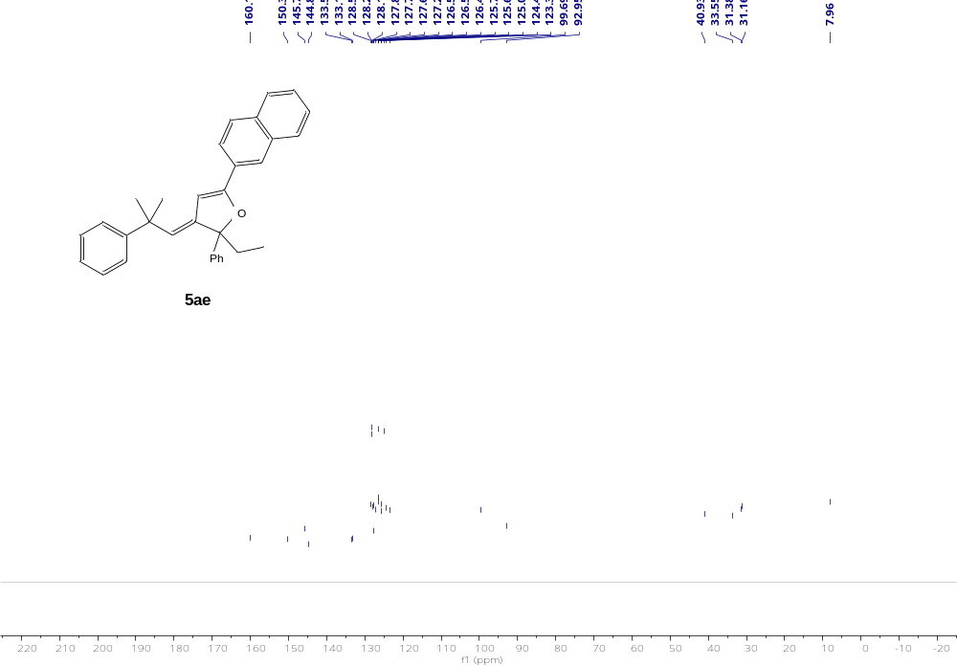
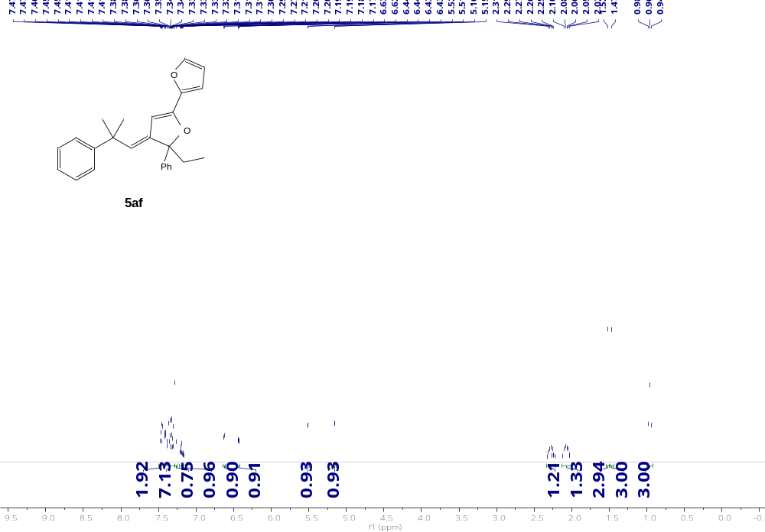
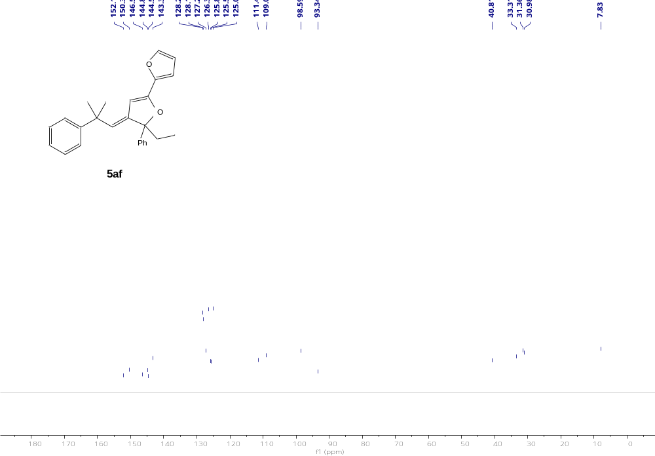
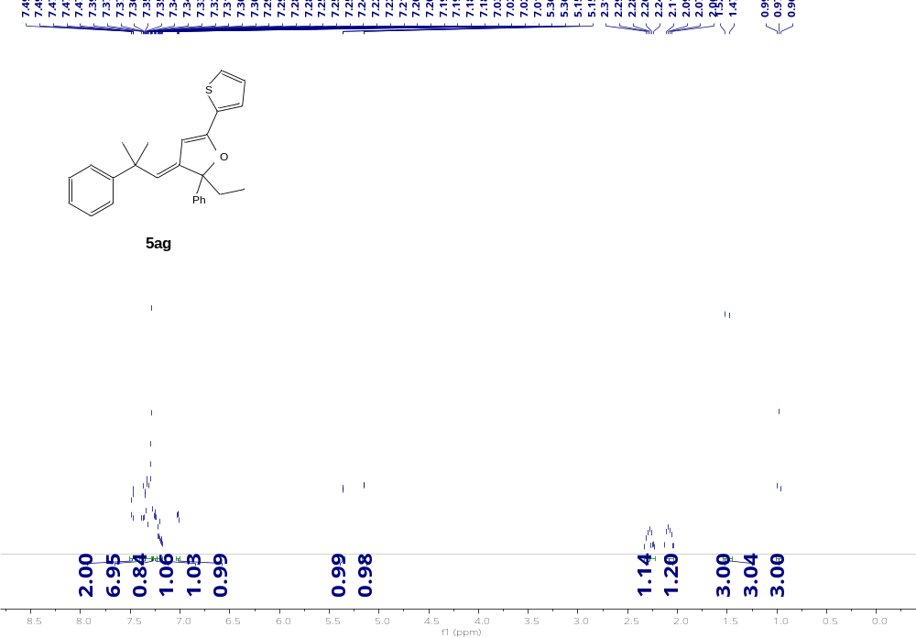
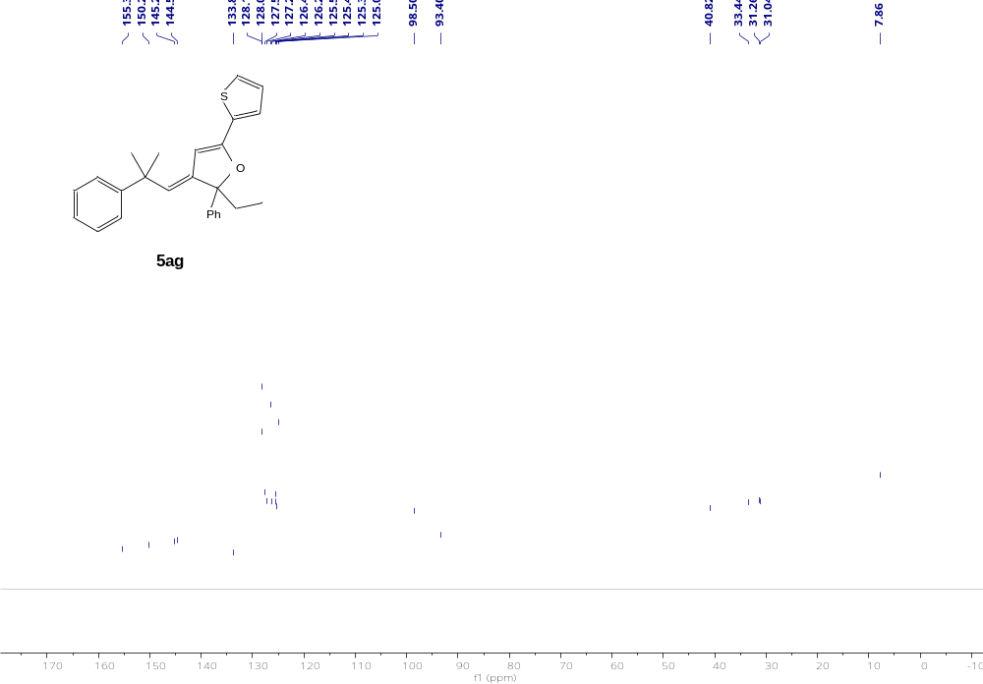
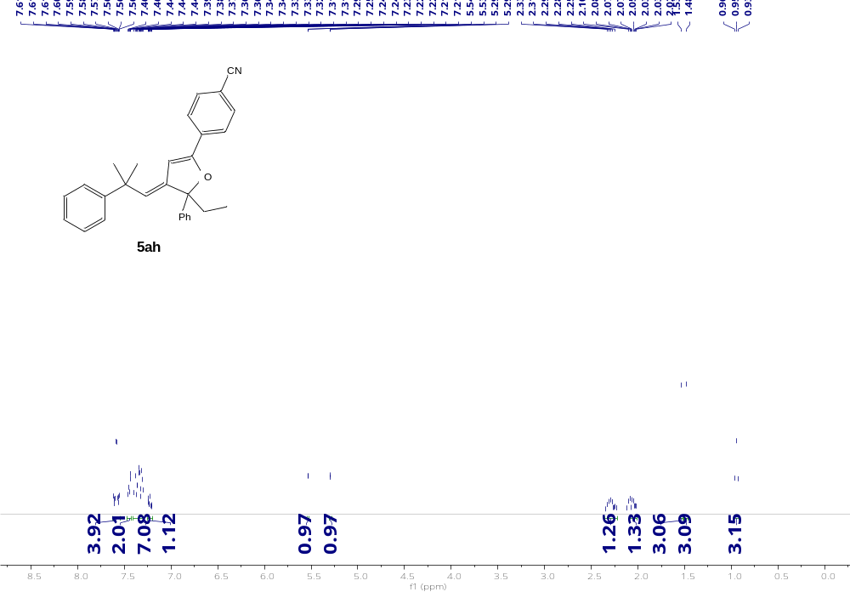
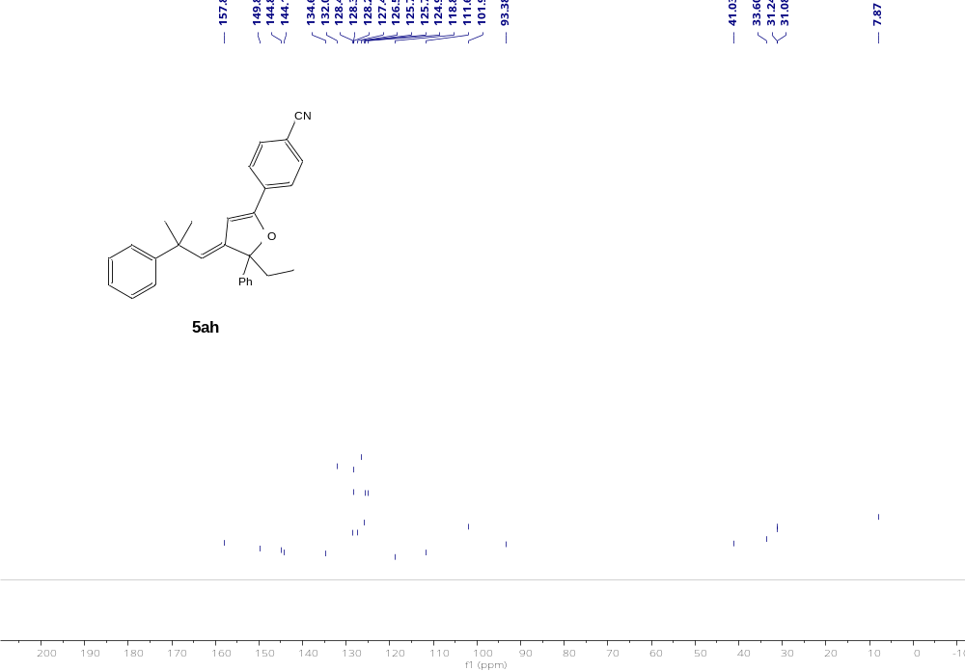
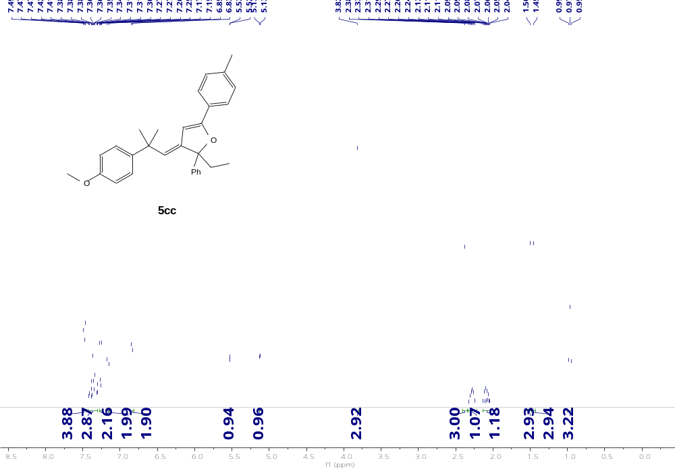
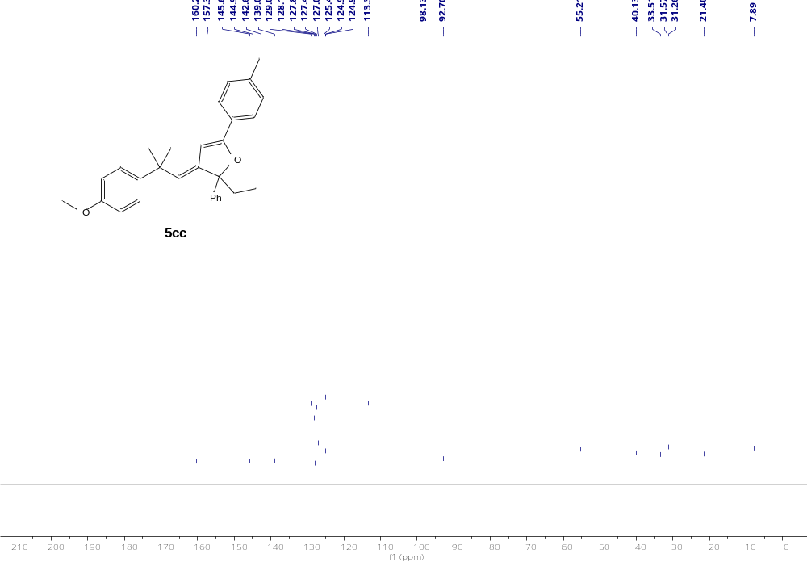
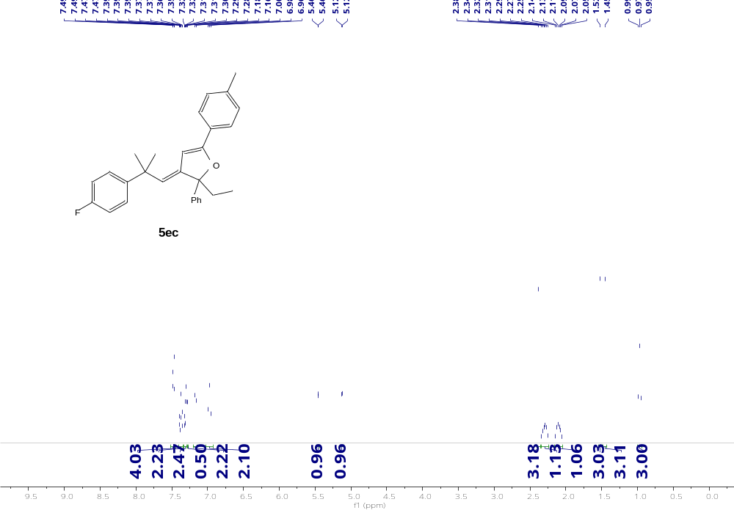
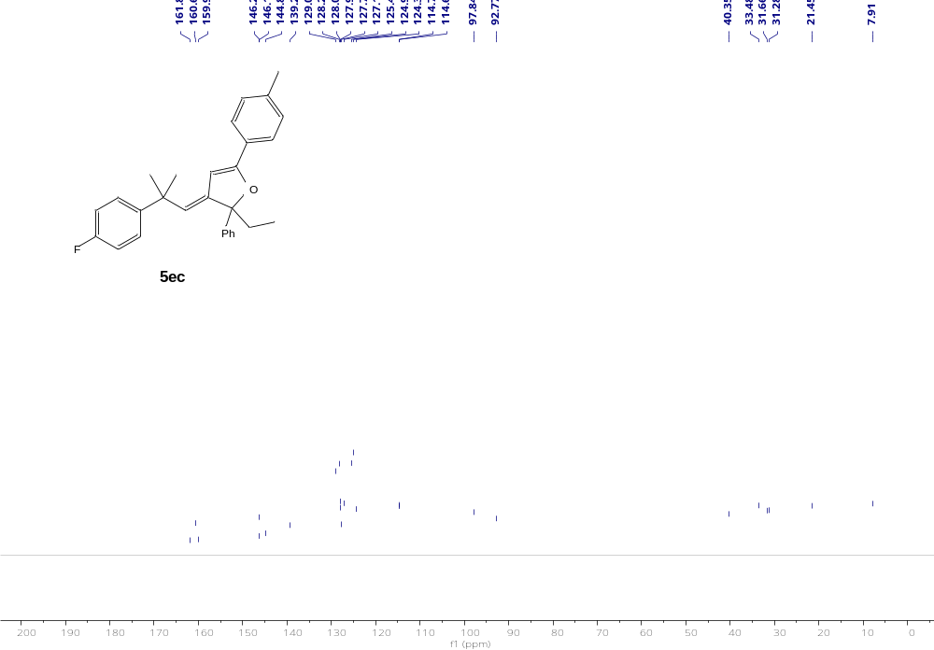
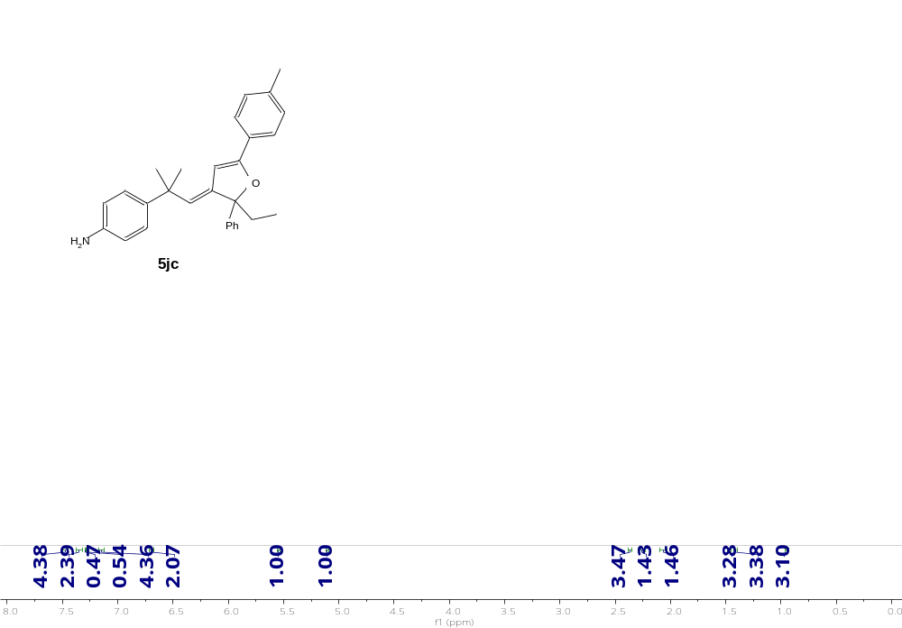
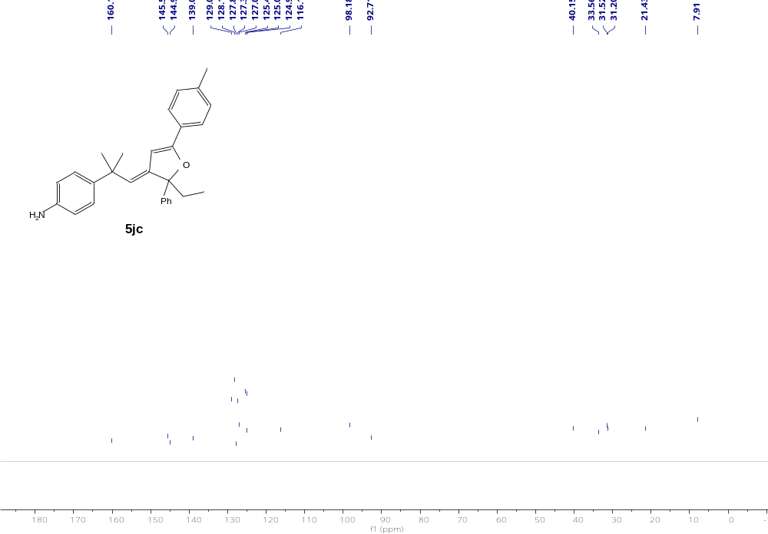
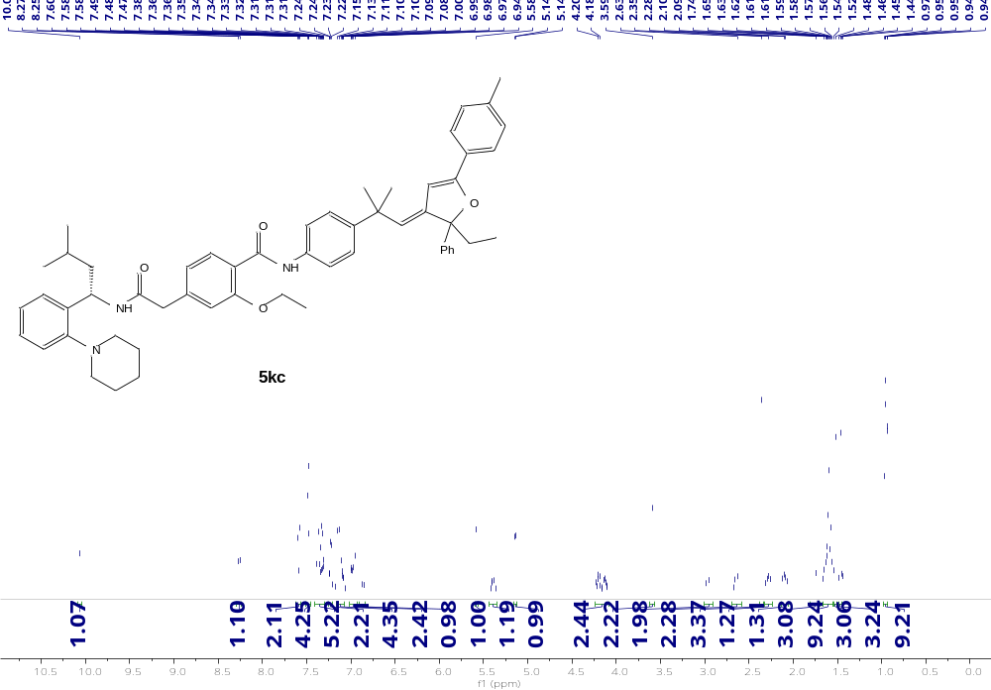
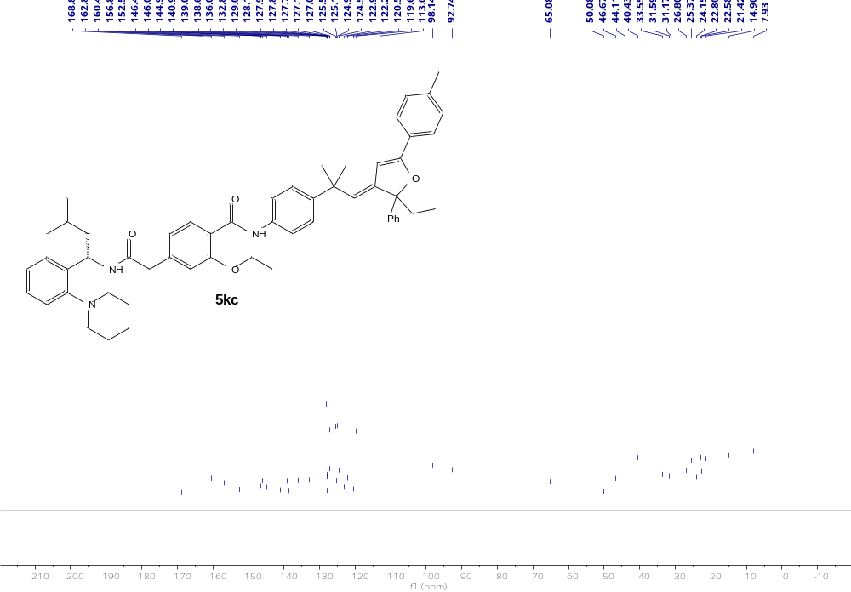
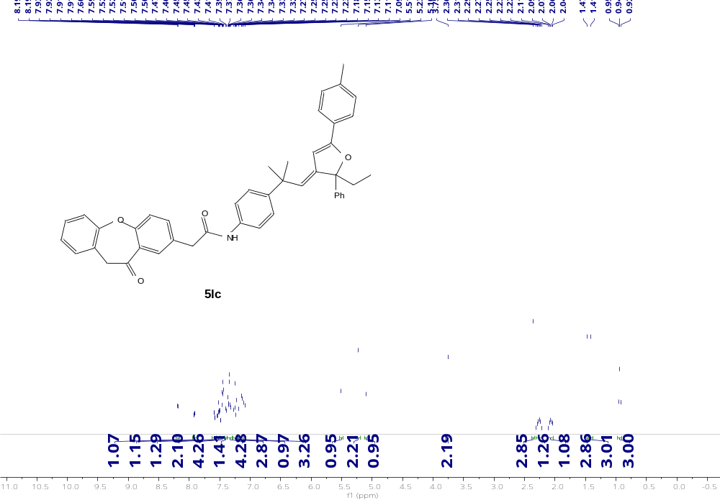
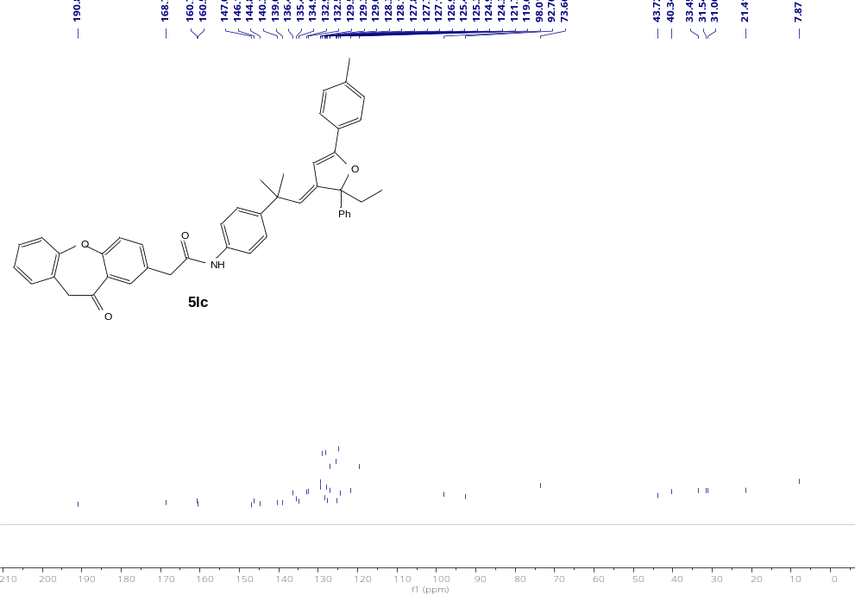
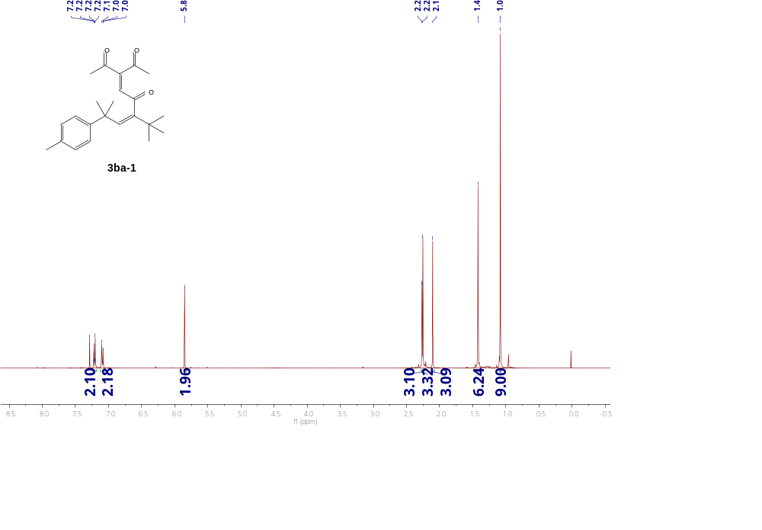
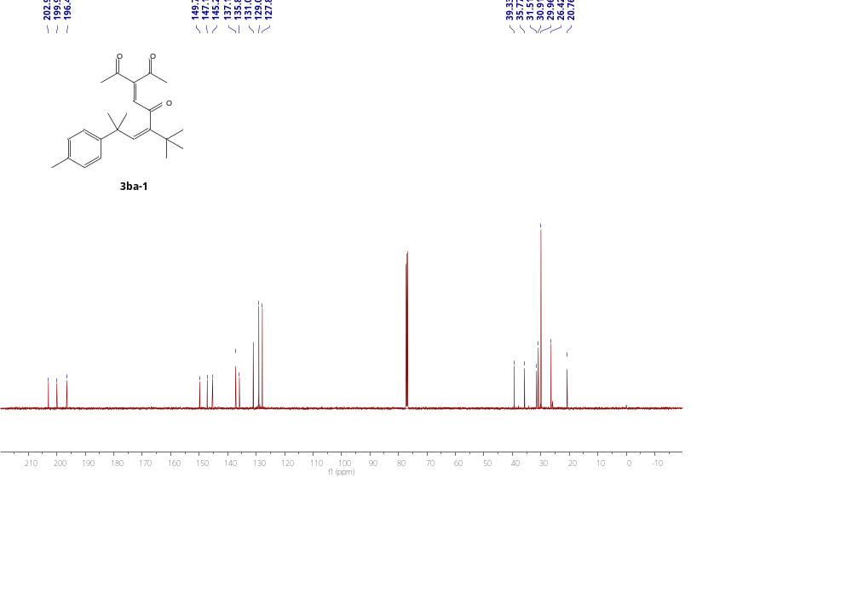

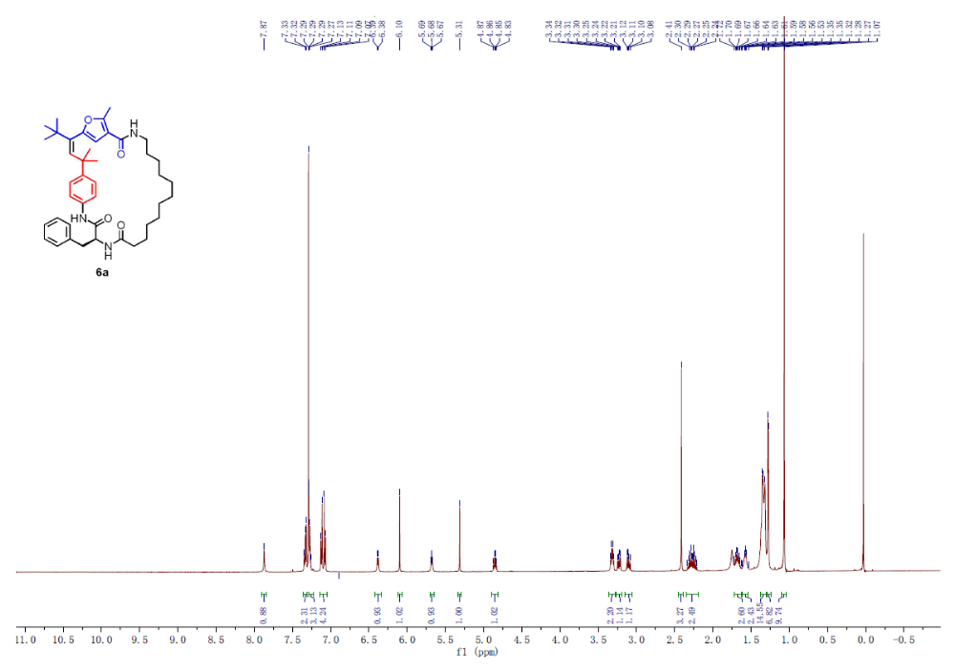

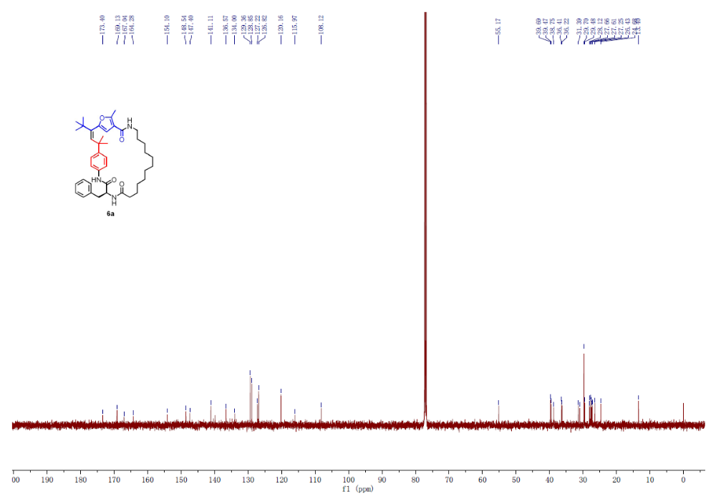

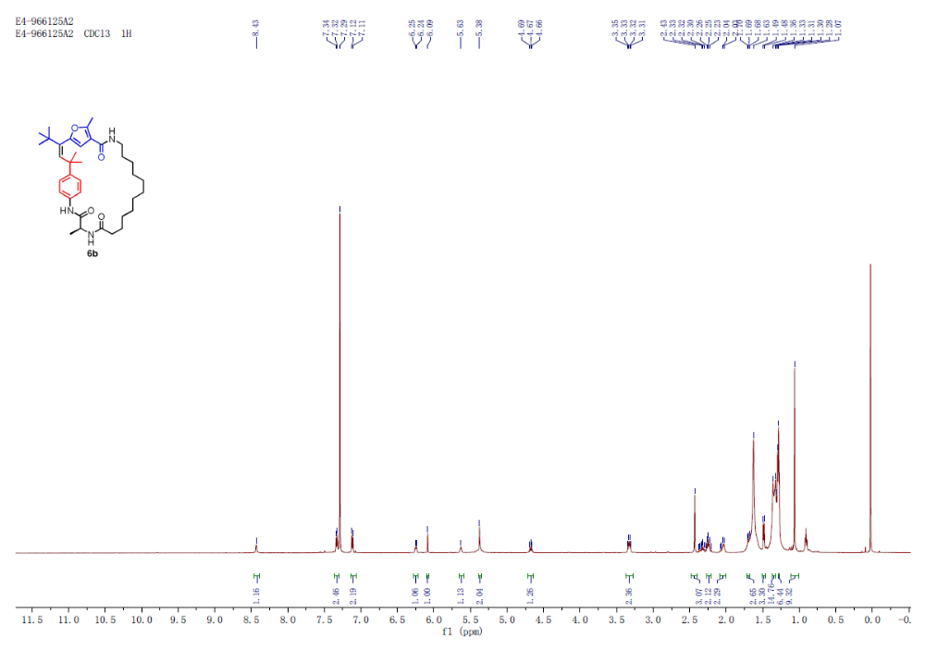

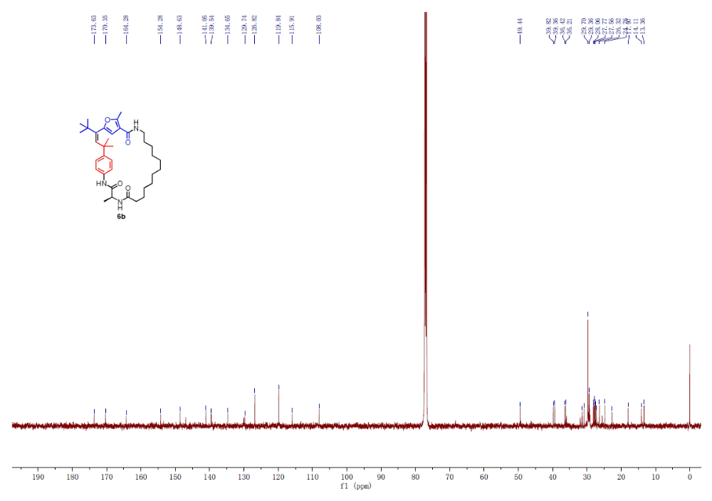

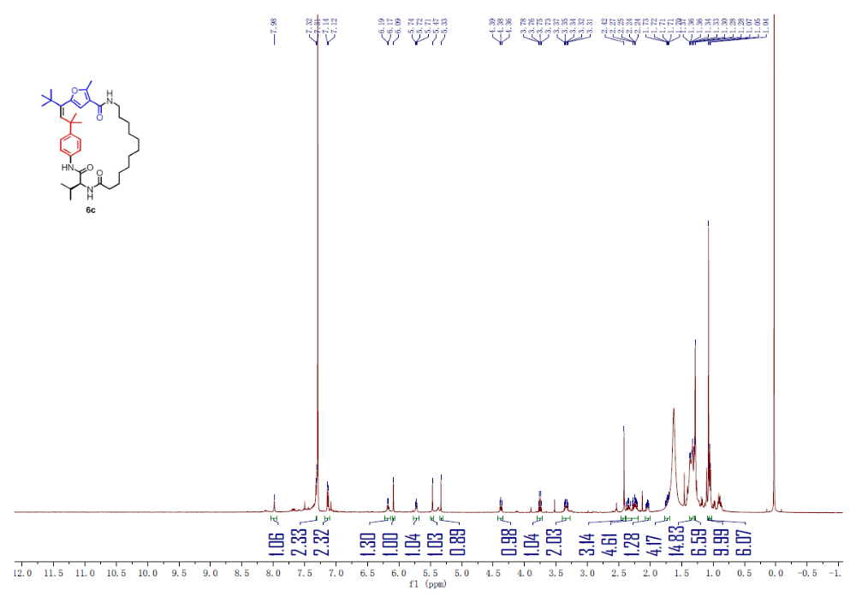

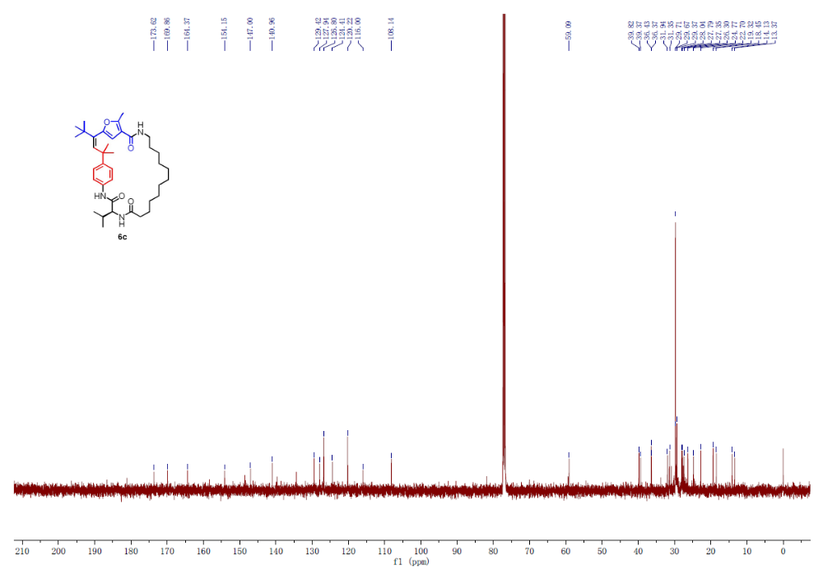

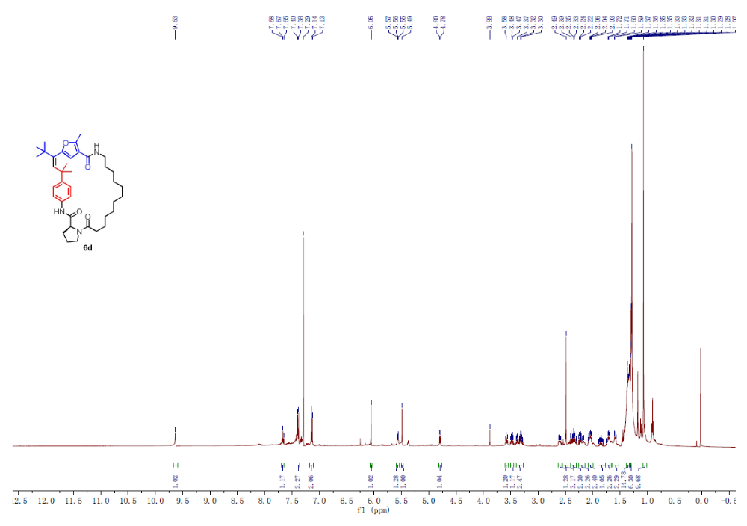

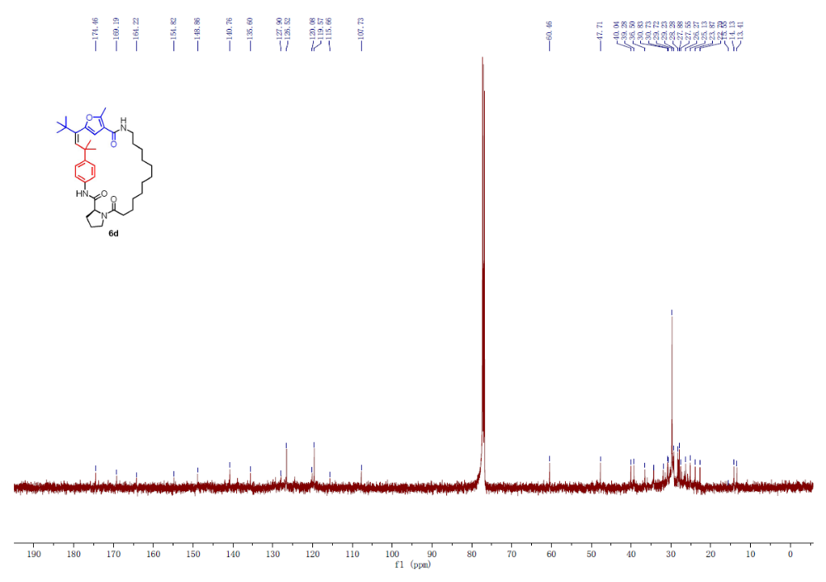

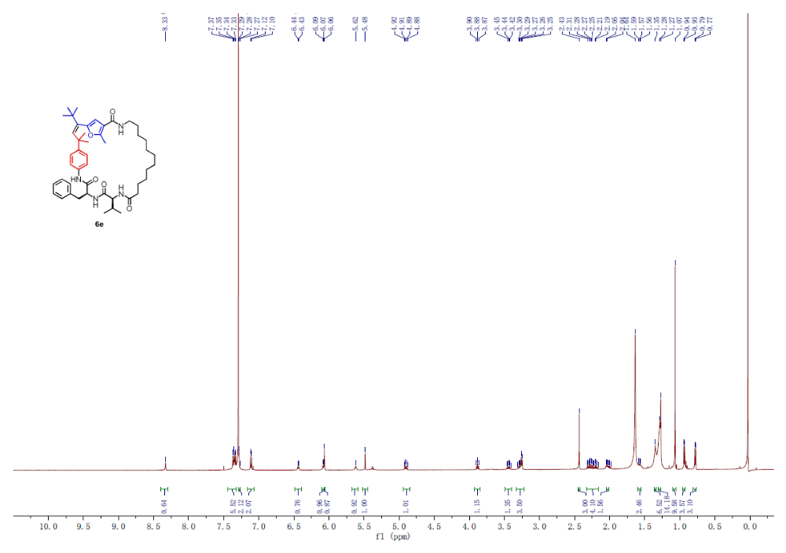

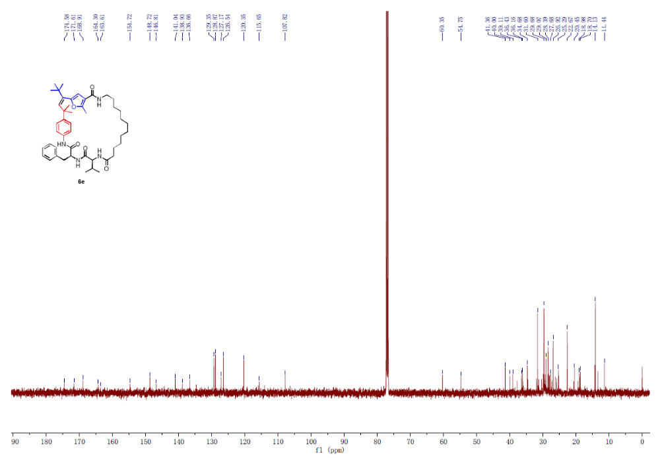

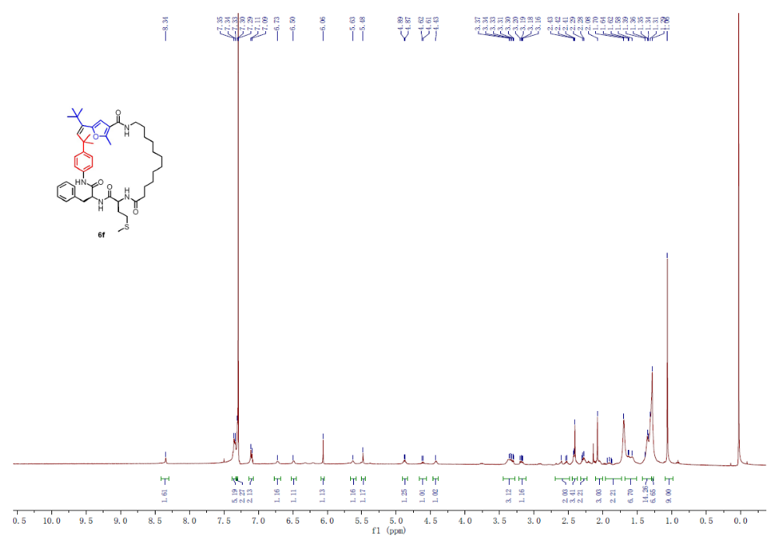

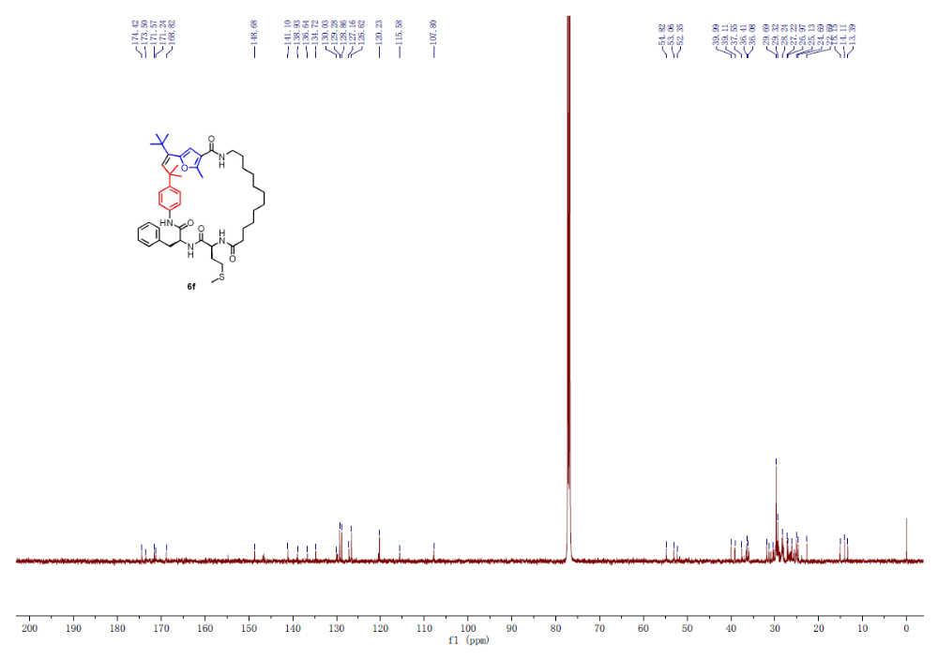
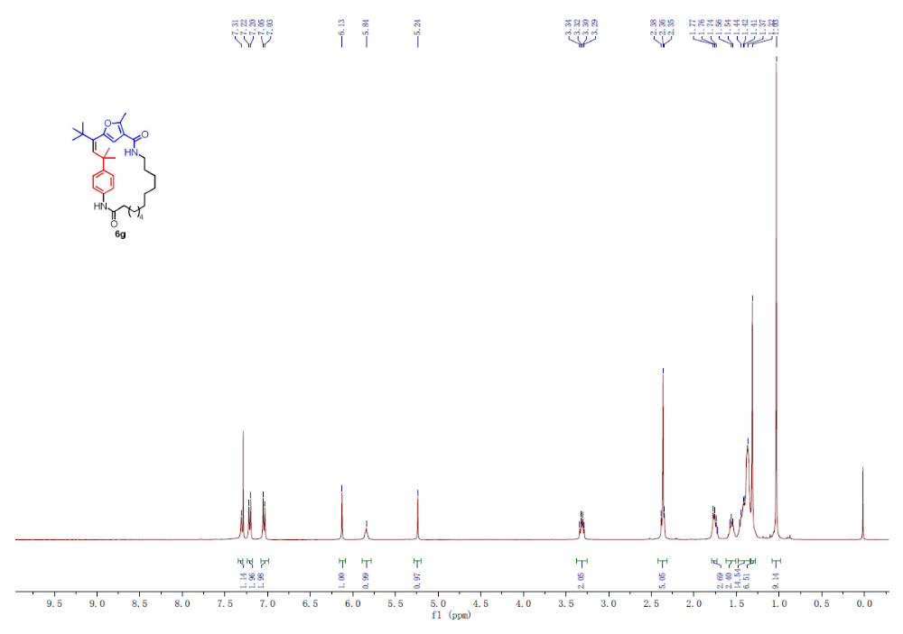

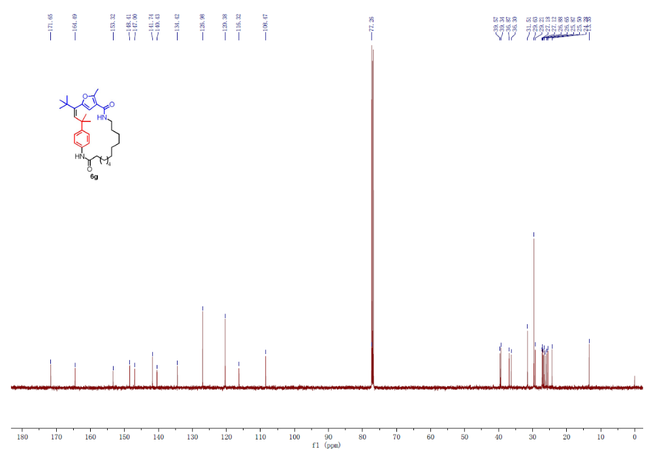

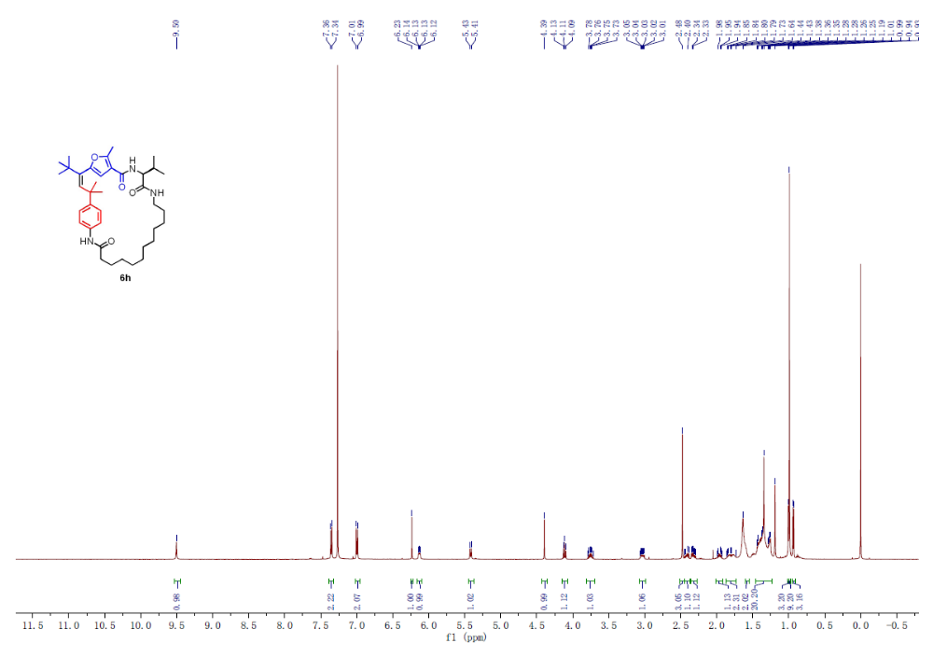

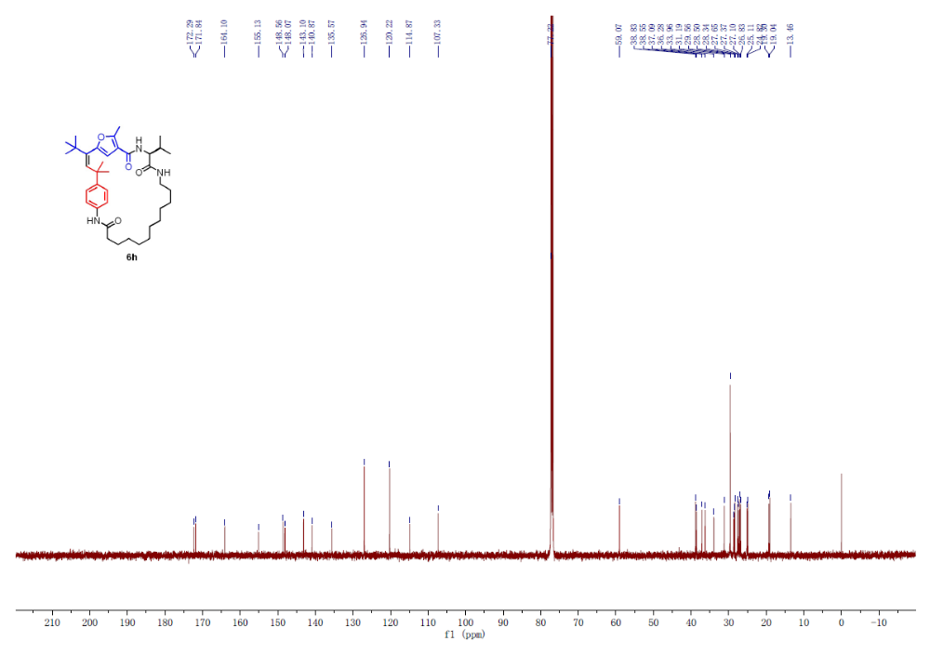

References
[1] Z. Wu, D. Ma, B. Zhou, X. Ji, X. Ma, X. Wang, Y. Zhang, Angew. Chem., int. Ed 2017, 56, 12288-12291.
[2] A. Gutierrez-Bonet, F. Julia-Hernandez, B. de Luis, R. Martin, J Am Chem Soc 2016, 138, 6384-6387.
[3] K. Mori, R. Isogai, Y. Kamei, M. Yamanaka, T. Akiyama, J. Am. Chem. Soc. 2018, 140, 6203-6207.
[4] Y. Xia, S. Qu, Q. Xiao, Z. X. Wang, P. Qu, L. Chen, Z. Liu, L. Tian, Z. Huang, Y. Zhang, J. Wang, J. Am. Chem. Soc. 2013, 135, 13502-13511.
[5] A. S. Dudnik, A. W. Sromek, M. Rubina, J. T. Kim, A. V. Kel'in, V. Gevorgyan, J. Am. Chem. Soc. 2008, 130, 1440-1452.
[6] Zhao, Y.; Truhlar, D. G.; “The M06 suite of density functionals for main group thermochemistry, thermochemical kinetics, noncovalent interactions, excited states, and transition elements: two new functionals and systematic testing of four M06-class functionals and 12 other functionals,” Theor. Chem. Acc., 2008, 120, 215-41.
[7] Marenich, A. V.; Cramer, C. J.; Truhlar, D. G. “Universal solvation model based on solute electron density and a continuum model of the solvent defined by the bulk dielectric constant and atomic surface tensions,” J. Phys. Chem. B, 2009, 113, 6378-96.
[8] (a) Fukui, K. A formulation of the reaction coordinate. J. Phys. Chem 1970, 74, 4161– 4163. (b) Fukui, K. The path of chemical reactions - the IRC approach. Acc. Chem. Res. 1981, 13, 363–368.
[9] (a) Stoll, H.; Fuentealba, P.; Schwerdtfeger, P.; Flad, J.; Szentpály, L. V.; Preuss, H. Cu and Ag as one‐valence‐electron atoms: CI results and quadrupole corrections for Cu2, Ag2, CuH, and AgH. The Journal of Chemical Physics. 1984, 81, 2732-2736. (b), Schwerdtfeger, P.; Dolg, M.; Schwarz, W. H. E.; Bowmaker, G. A.; Boyd, P. D. W. Relativistic effects in gold chemistry. I. Diatomic gold compounds. J. Chem. Phys. 1989, 91, 1762-1774. (c) Andrae, D.; Huermann, U.; Dolg, M.; Stoll, H.; Preu, H. Energy-adjusted ab initio pseudopotentials for the second and third row transition elements. Theoretica Chimica Acta 1990, 77, 123-141. (d) Nicklass, A.; Dolg, M.; Stoll, H.; Preuss, H. Ab initio energy‐adjusted pseudopotentials for the noble gases Ne through Xe: Calculation of atomic dipole and quadrupole polarizabilities. The Journal of Chemical Physics 1995, S14 (102) 8942-8952. (e) Igel-Mann, G.; Stoll, H.; Preuss, H. Pseudopotentials for main group elements (IIIa through VIIa). Molecular Physics 2006, 65, 1321-1328. (f) Bergner, A.; Dolg, M.; Küchle, W.; Stoll, H.; Preuß, H. Ab initio energy-adjusted pseudopotentials for elements of groups 13–17. Molecular Physics 2006, 80, 1431-1441.
[10] (a) Hollwarth, A.; Bohme, M.; Dapprich, S.; Ehlers, A.W.; Gobbi, A.; Jonas, V.; Kohler, K.F.; Stegmann, R.; Veldkamp, A.; Frenking, G. A set of d-polarization functions for pseudo-potential basis sets of the main group elements Al-Bi and f-type polarization functions for Zn, Cd, Hg. Chem. Phys. Lett. 1993, 208, 237-240. (b) Ehlers, A. W.; Böhme, M.; Dapprich, S.; Gobbi, A.; Höllwarth, A.; Jonas, V.; Köhler, K. F.; Stegmann, R.; Veldkamp, A.; Frenking, G., A set of f-polarization functions for pseudo-potential basis sets of the transition metals Sc-Cu, Y-Ag and La-Au. Chem. Phys. Lett. 1993, 208, 111-114.
[11] Frisch, M. J.; Trucks, G. W.; Schlegel, H. B.; Scuseria, G. E.; Robb, M. A.; Cheeseman, J. R.; Scalmani, G.; Barone, V.; Mennucci, B.; Petersson, G. A.; Nakatsuji, H.; Caricato, M.; Li, X.; Hratchian, H. P.; Izmaylov, A. F.; Bloino, J.; Zheng, G.; Sonnenberg, J. L.; Hada, M.; Ehara, M.; Toyota, K.; Fukuda, R.; Hasegawa, J.; Ishida, M.; Nakajima, T.; Honda, Y.; Kitao, O.; Nakai, H.; Vreven, T.; Montgomery, J. A., Jr.; Peralta, J. E.; Ogliaro, F.; Bearpark, M.; Heyd, J. J.; Brothers, E.; Kudin, K. N.; Staroverov, V. N.; Kobayashi, R.; Normand, J.; Raghavachari, K.; Rendell, A.; Burant, J. C.; Iyengar, S. S.; Tomasi, J.; Cossi, M.; Rega, N.; Millam, J. M.; Klene, M.; Knox, J. E.; Cross, J. B.; Bakken, V.; Adamo, C.; Jaramillo, J.; Gomperts, R.; Stratmann, R. E.; Yazyev, O.; Austin, A. J.; Cammi, R.; Pomelli, C.; Ochterski, J. W.; Martin, R. L.; Morokuma, K.; Zakrzewski, V. G.; Voth, G. A.; Salvador, P.; Dannenberg, J. J.; Dapprich, S.; Daniels, A. D.; Farkas, O.; Foresman, J. B.; Ortiz, J. V.; Cioslowski, J.; Fox, D. J. Gaussian 09, revision D.01; Gaussian, Inc.: Wallingford, CT, 2009.

