Table 1 Catalyst screening and optimization of the reaction conditions
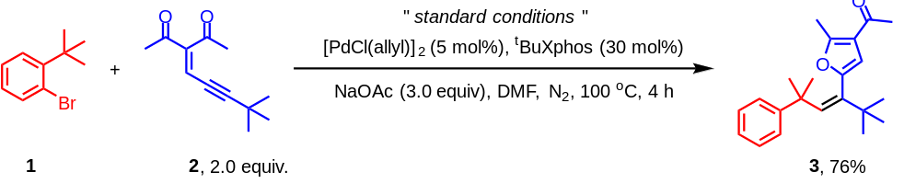
entry | deviation from standard conditions | yield(%)ª
1 | None | 76 (76)^{b}
2 | DIPEA instead of NaOAc | 68
3 | KOAc instead of NaOAc | 53
4 | CsOPiv instead of NaOAc | trace
5 | Without base | trace
6 | Xphos instead of tBuXphos | 54
7 | Brettphos instead of tBuXphos | 39
8 | Without ligand | -
9 | Pd(MeCN)₄(OTf)₂ instead of [PdCl(allyl)]₂ | 53
10 | Pd(OAc)₂ instead of [PdCl(allyl)]₂ | 45
11 | DMA instead of DMF | 68
12 | NMP instead of DMF | 63
13 | THF instead of DMF | trace
14 | MeCN instead of DMF | -

[a] NMR yields were reported using CH₂Br₂ as the internal standard. [b] The yield of isolated.
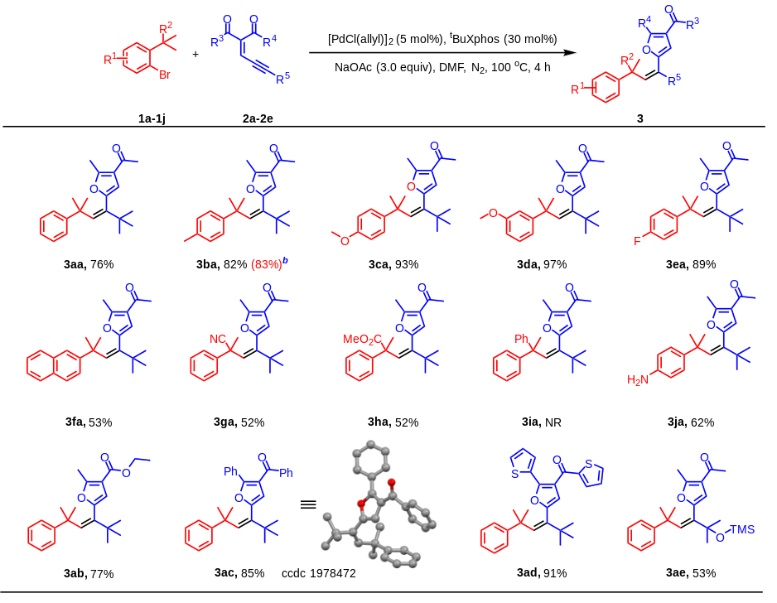
Table 2. Substrate scopes of aryl bromides and ene-yne-ketonesª [a] Reaction conditions: 1 (0.1 mmol, 1.0 equiv), 2 (0.2 mmol, 2.0 equiv), [Pd(Cl(allyl)]₂ (5 mol%), ^{t}BuXphos (30 mol%), NaOAc (3.0 equiv), DMF (1 mL), under N₂, 100 ℃, 4 h. Yields of isolated products. [b] The reaction was run in 2.0 mmol scale.

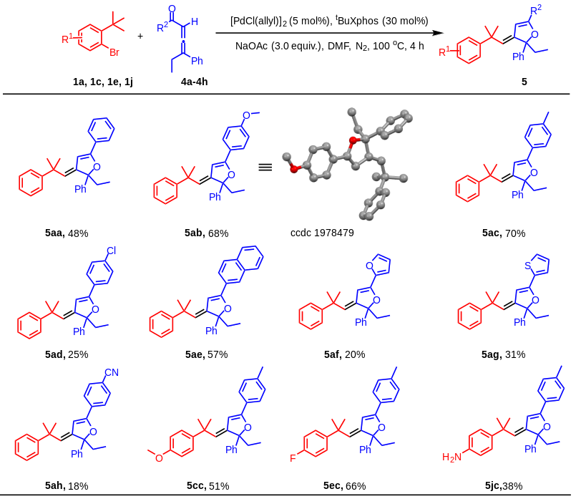
Table 3. Substrate scopes of aryl bromides and allenesª [a] Reaction conditions: 1 (0.1 mmol, 1.0 equiv), 4 (0.2 mmol, 2.0 equiv), [Pd(Cl(allyl)]₂ (5 mol%), ^{t}BuXphos (30 mol%), NaOAc (3.0 equiv), DMF (1 mL), under N₂, 100 ℃, 4 h. Yields of isolated products.

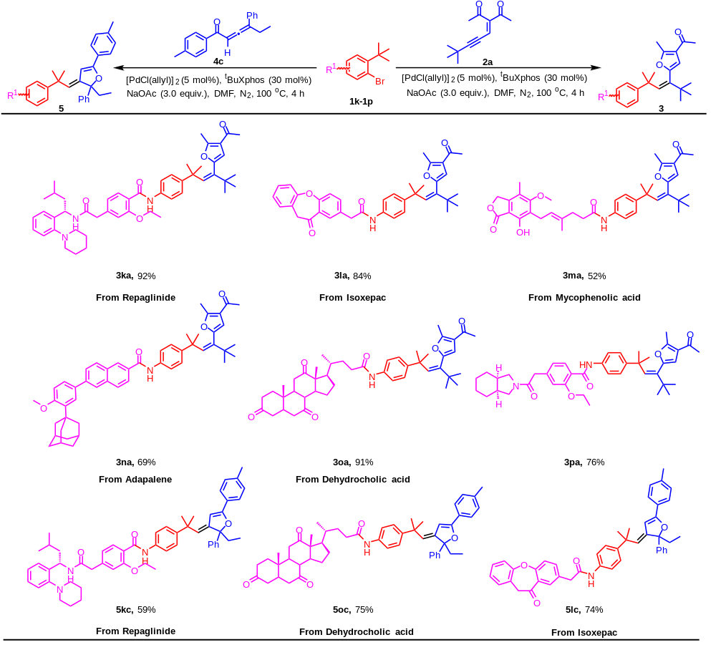
Table 4. Substrate scopes of complex aryl bromides from drug moleculesª [a] Reaction conditions: 1k-1p (0.1 mmol, 1.0 equiv), 2a or 4c (0.2 mmol, 2.0 equiv), [Pd(Cl(allyl)]₂ (5 mol%), ^{t}BuXphos (30 mol%), NaOAc (3.0 equiv), DMF (1 mL), under N₂, 100 ℃, 4 h. Yields of isolated products.

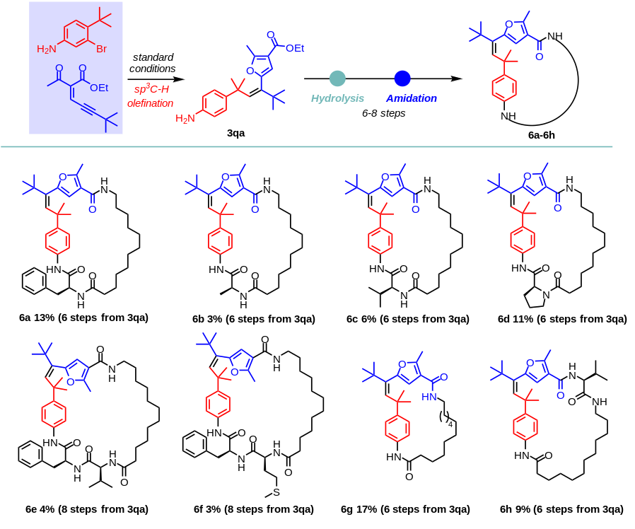
Scheme 1. Construction of novel macrolactams using polysubstituted alkenes and natural or unnatural amino acids as building blocks. Reaction conditions: please see the SI.
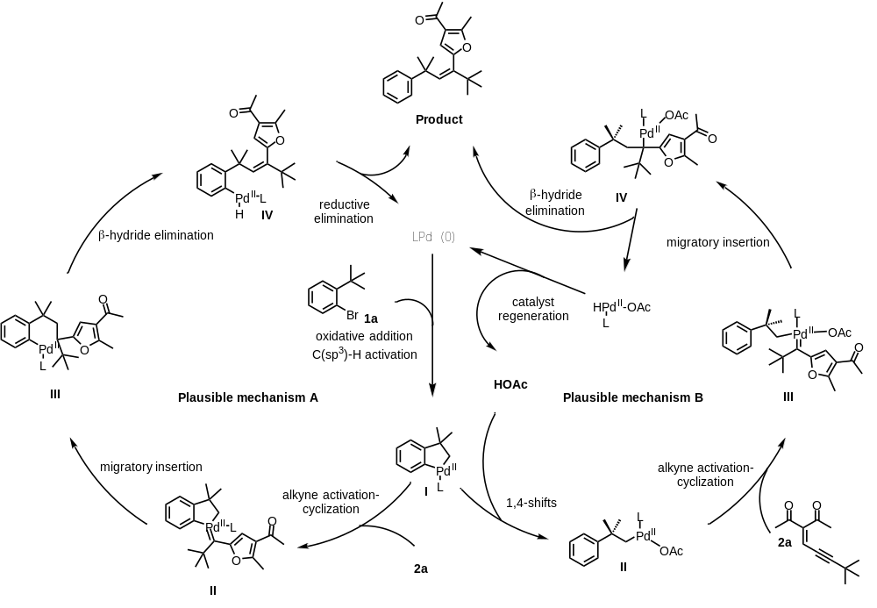
Scheme 2. Two possible catalytic cycles for the reaction

