Supplementary information for-

Forest-savanna stability in India under human interventions and changing climate
Nivedita Dubey¹, Tejasvi A Chauhan^{1,2}, Subimal Ghosh^{1,3*}
¹Department of Civil Engineering, Indian Institute of Technology Bombay, Mumbai 400076, India.
² Biosphere Theory and Modelling Group, Max Planck Institute for Biogeochemistry, 07745 Jena, Germany
³Centre for Climate Studies, Indian Institute of Technology Bombay, Mumbai 400076, India.
*e-mail: subimal@iitb.ac.in

Contents:
Supplementary table 1-2
Supplementary figures 1-15

Table S1. Details of the CMIP6 models used in the study.
Model | Institute | Atmospheric Resolution (lon. x lat.)
CAS-ESM2-0 | Chinese Academy of Sciences, China | 1.4° x 1.4°
CESM2-WACCM | National Center for Atmospheric Research, USA | 1.25° x 0.9°
E3SM-1-0 | Lawrence Livermore National Laboratory, USA | 1° x 1°
FGOALS-f3-L | Chinese Academy of Sciences, China | 1° x 1°
INM-CM5-0 | Institute for Numerical Mathematics, Russian Academy of Science, Russia | 2° x 1.5°
IPSL-CM6A-LR | Institut Pierre Simon Laplace, France | 2.5° x 1.3°
MIROC6 | Japan Agency for Marine-Earth Science and Technology, Japan | 1.4° x 1.4°
NESM3 | Nanjing University of Information Science and Technology, China | 1.9° x 1.9°

Table S2: The R-squared value for the fitted GLM model for 2001 and 2020 tree cover using 1971-2000 and 1990-2020 MAP, COV and MSI respectively.
 | Fitted R-squared (2001) | Fitted R-squared (2020)
Shrubs | 0.7959 | 0.7595
Savanna | 0.5897 | 0.6334
Forest | 0.8286 | 0.8104

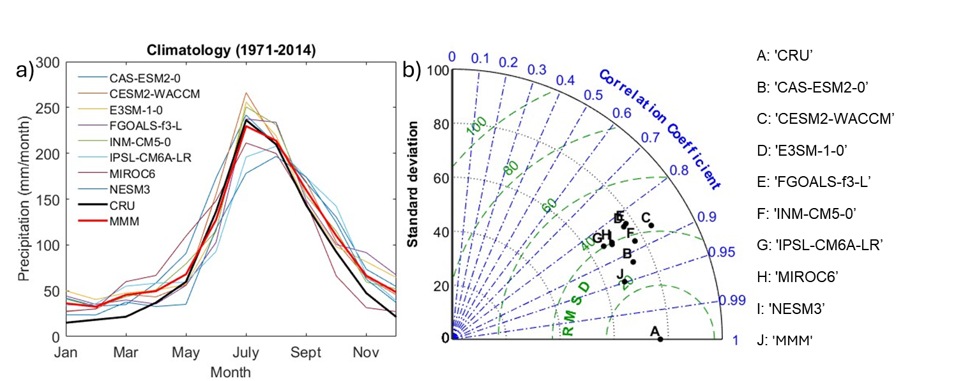
Figure S1. Performance of CMIP6 climate models used in this study. (a) Mean annual cycle of precipitation from each model (1971-2014), their multimodel means (MMM, red), and corresponding mean annual cycle from CRU dataset (black) for the same time period. (b) Shows a comparison of correlation and standard deviation of monthly precipitation from each climate model with CRU dataset in the form of Taylor diagram.

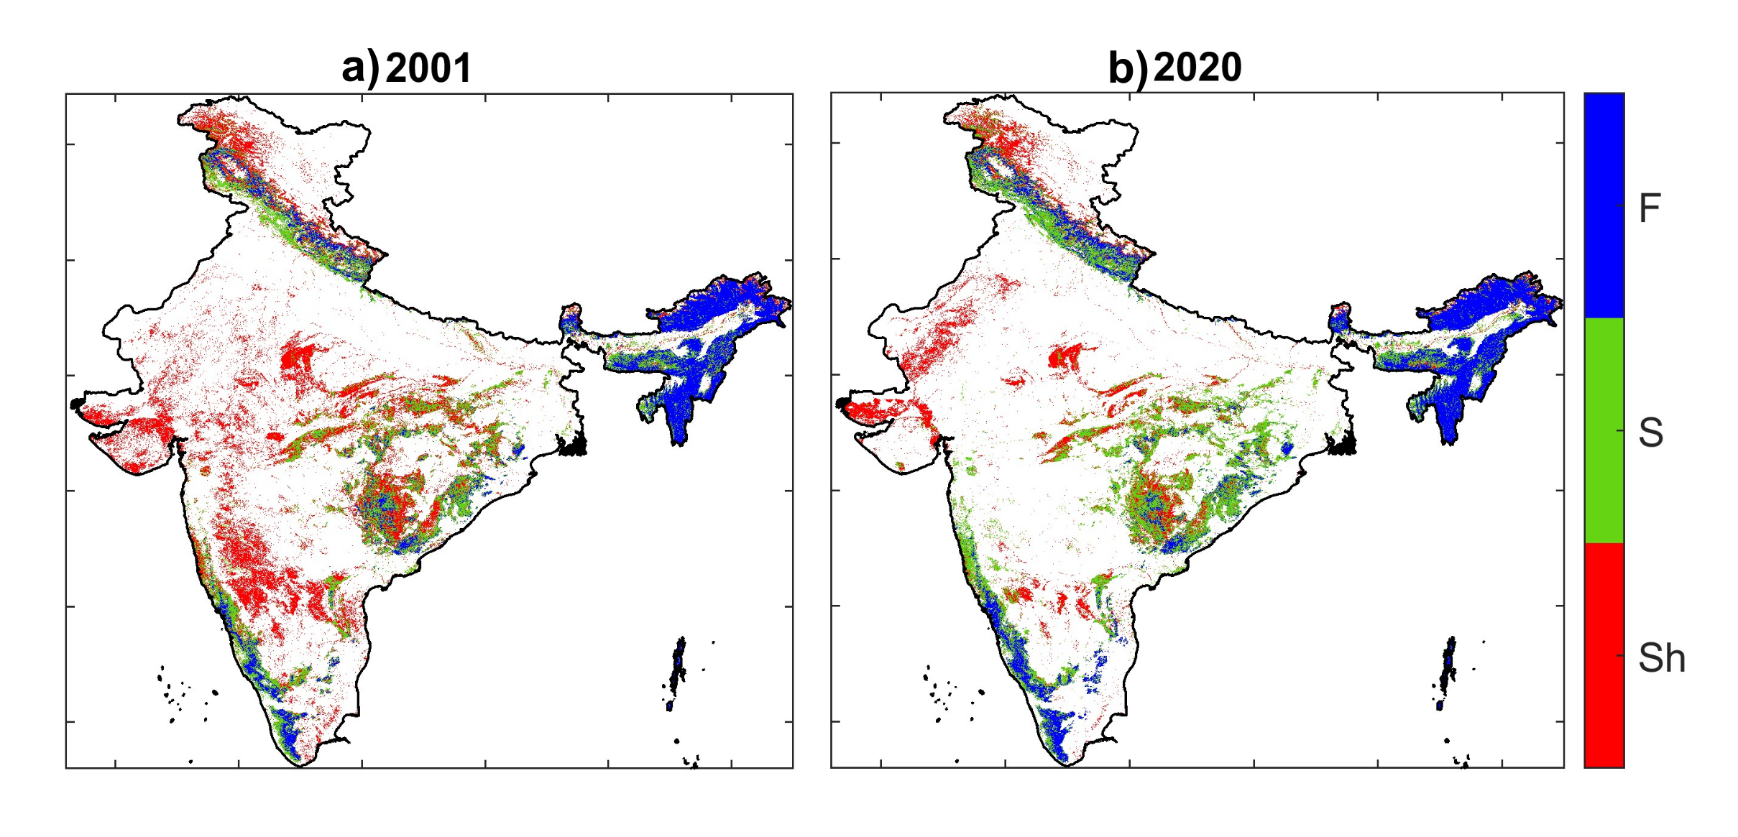
Figure S2. Tree cover classification in India for 2001 (a) and 2020 (b). Here, color shows the tree cover class: Sh-shrubs, S-savanna and F-forest.

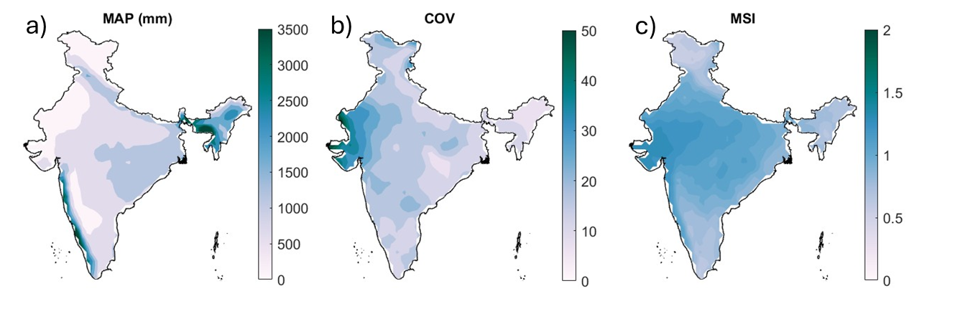
Figure S3. Mean annual precipitation (MAP), variability of mean annual precipitation (COV) and mean seasonality index (MSI) for the period 1971-2020 using CRU precipitation data.
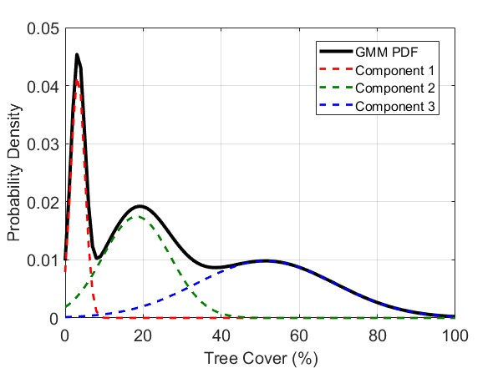

Figure S4. Fitted gaussian mixture model (GMM) on tree cover (2020) over India. Black line shows the GMM pdf and red, blue and green lines show the individual component of the three modes of the GMM.
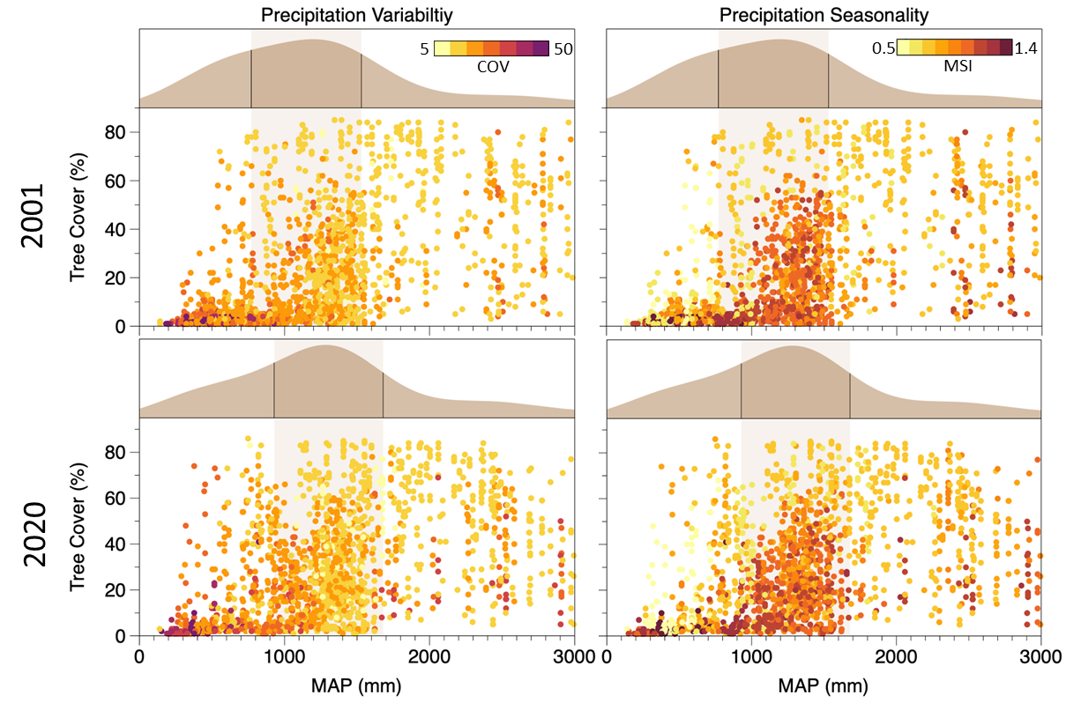

Figure S5. The tree cover and probability distribution of tree cover with respect to mean annual precipitation (MAP) for 2001 (1st row) and 2020 (2nd row). The color map shows the MAP COV, and MSI.

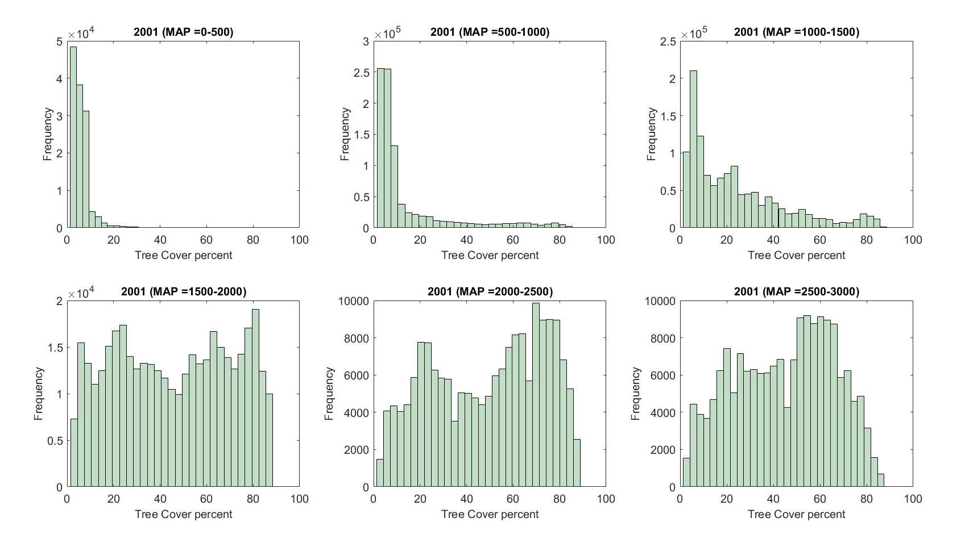
Figure S6. The frequency distribution of Indian tree cover distribution at different MAP values.
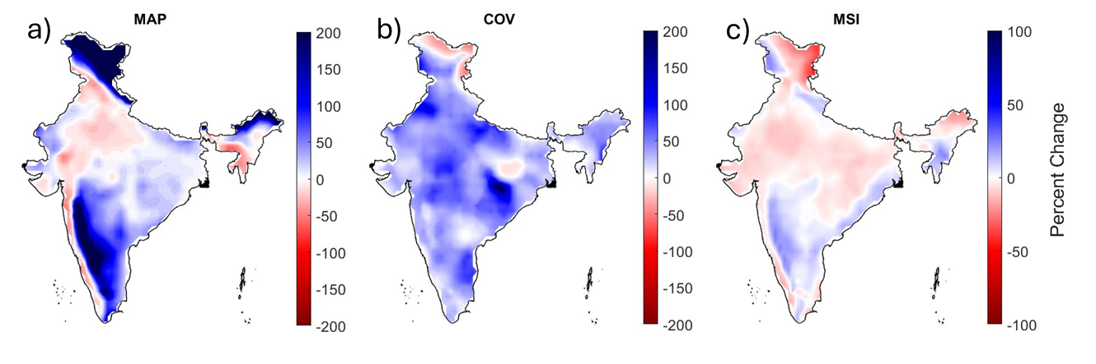
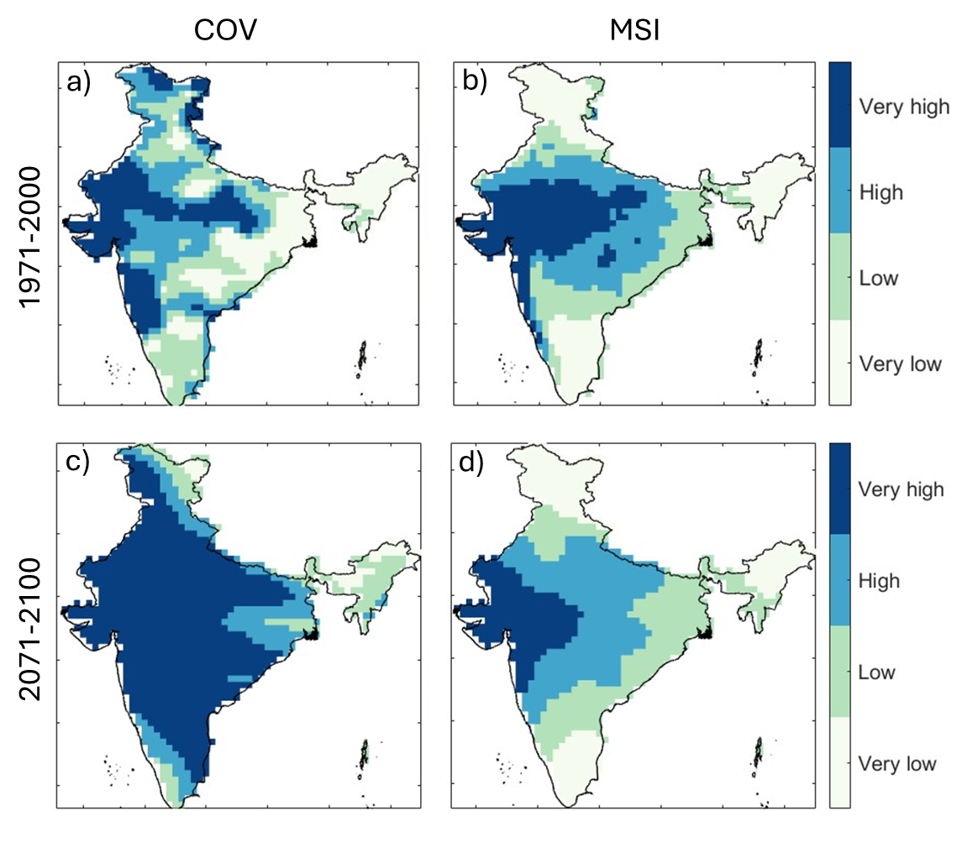
Figure S7. Percent change in the a) MAP, b) COV, and c) MSI for the period 2071-2100 compared to 1971-2000 in SSP585 scenario from CMIP6 model output and present climate.

Figure S8. The spatial distribution of variability and seasonality zones for present climate (a and b) for the period 1971-2000 and for the SSP585 scenario (c and d) using CMIP6 model outputs for the period 2071-2100.

