Supplementary Materials

Supplementary Tables
Table S1. The characteristics of 165 SNPs identified as instrumental variables for television watching and their genetic associations with television watching and the risk of type 2 diabetes.
Table S2. The characteristics of 45 SNPs identified as instrumental variables for computer use and their genetic associations with computer use and the risk of type 2 diabetes.
Table S3. The characteristics of 4 SNPs identified as instrumental variables for driving behavior and their genetic associations with driving behavior and the risk of type 2 diabetes.
Table S4. The characteristics of 238 SNPs identified as instrumental variables for type 2 diabetes and their genetic associations with type 2 diabetes and sedentary behaviors.
Table S5. Power calculation for the primary analyses of association between sedentary behaviors and the risk of type 2 diabetes.
Table S6. Mendelian randomization analyses of association between of sedentary behaviors and potential confounding or mediating traits.

Supplementary Figures
Figure S1. Leave-one-out analysis of the association between television watching and the risk of type 2 diabetes.
Figure S2. Leave-one-out analysis of the association between computer use and the risk of type 2 diabetes.
Figure S3. Leave-one-out analysis of the association between driving behavior and the risk of type 2 diabetes.
Figure S4. Funnel plot of the Mendelian randomization estimate for the association between television watching and the risk of type 2 diabetes.
Figure S5. Funnel plot of the Mendelian randomization estimate for the association between computer use and the risk of type 2 diabetes.
Figure S6. Funnel plot of the Mendelian randomization estimate for the association between driving behavior and the risk of type 2 diabetes.

Table S1. The characteristics of 165 SNPs identified as instrumental variables for television watching and their genetic associations with television watching and the risk of type 2 diabetes.
SNP | CHR | Position | EA | OA | EAF | F | Television watching |  | Type 2 diabetes
 |  |  |  |  |  |  | Beta | SE | Beta | SE
rs1278847 | 1 | 110037483 | C | A | 0.69 | 44 | 0.016 | 0.002 | 0.005 | 0.007
rs141425667 | 1 | 114930465 | G | A | 0.93 | 29 | -0.024 | 0.004 | -0.020 | 0.013
rs4845364 | 1 | 154141908 | A | G | 0.50 | 48 | -0.015 | 0.002 | -0.003 | 0.006
rs6673341 | 1 | 184655649 | T | G | 0.47 | 43 | -0.015 | 0.002 | -0.019 | 0.006
rs72725224 | 1 | 188115858 | A | C | 0.98 | 34 | -0.046 | 0.008 | -0.054 | 0.024
rs10737620 | 1 | 193057971 | T | A | 0.27 | 34 | 0.014 | 0.002 | 0.012 | 0.007
rs11810109 | 1 | 44186812 | A | T | 0.70 | 45 | 0.016 | 0.002 | 0.001 | 0.007
rs112632642 | 1 | 51115634 | G | A | 0.93 | 29 | -0.024 | 0.004 | 0.001 | 0.013
rs12725114 | 1 | 62432641 | G | A | 0.80 | 30 | 0.015 | 0.003 | 0.019 | 0.008
rs984409 | 1 | 67020440 | G | A | 0.36 | 42 | -0.015 | 0.002 | -0.020 | 0.007
rs10890123 | 1 | 74802123 | C | T | 0.77 | 29 | 0.014 | 0.003 | 0.005 | 0.008
rs71658797 | 1 | 77967507 | T | A | 0.88 | 37 | -0.020 | 0.003 | 0.009 | 0.010
rs114328297 | 1 | 91190854 | T | G | 0.78 | 29 | 0.014 | 0.003 | -0.002 | 0.008
rs631130 | 1 | 96043010 | T | A | 0.37 | 36 | -0.014 | 0.002 | -0.010 | 0.007
rs17379561 | 1 | 98340139 | A | T | 0.86 | 66 | -0.025 | 0.003 | -0.019 | 0.009
rs11689199 | 2 | 100820421 | A | G | 0.60 | 67 | 0.018 | 0.002 | 0.025 | 0.007
rs1451533 | 2 | 105466005 | G | A | 0.72 | 40 | -0.016 | 0.002 | -0.025 | 0.007
rs2971640 | 2 | 107624618 | G | A | 0.51 | 33 | -0.013 | 0.002 | -0.017 | 0.006
rs374722 | 2 | 147839830 | G | A | 0.15 | 63 | 0.024 | 0.003 | 0.045 | 0.009
rs3754970 | 2 | 162091836 | T | C | 0.50 | 46 | -0.015 | 0.002 | -0.016 | 0.006
rs1913808 | 2 | 162804678 | G | A | 0.71 | 37 | 0.015 | 0.002 | -0.012 | 0.007
rs11896615 | 2 | 17407744 | G | A | 0.85 | 29 | 0.017 | 0.003 | 0.011 | 0.009
rs263771 | 2 | 185921692 | C | A | 0.77 | 42 | -0.017 | 0.003 | -0.013 | 0.008
rs4577309 | 2 | 191288833 | A | G | 0.47 | 52 | 0.016 | 0.002 | -0.005 | 0.006
rs4675246 | 2 | 202864487 | G | T | 0.80 | 29 | -0.015 | 0.003 | 0.004 | 0.008
rs13029509 | 2 | 215374209 | G | A | 0.52 | 69 | -0.018 | 0.002 | 0.005 | 0.006
rs10932837 | 2 | 221044785 | C | T | 0.49 | 35 | -0.013 | 0.002 | -0.002 | 0.006
rs4973576 | 2 | 233806771 | C | A | 0.30 | 36 | -0.015 | 0.002 | 0.005 | 0.007
rs72781699 | 2 | 24277709 | G | A | 0.80 | 46 | -0.019 | 0.003 | -0.013 | 0.008
rs12105701 | 2 | 41737200 | C | T | 0.40 | 32 | -0.013 | 0.002 | -0.002 | 0.007
rs7564130 | 2 | 50606642 | T | C | 0.64 | 42 | -0.015 | 0.002 | -0.001 | 0.007
rs11125515 | 2 | 53886799 | C | A | 0.73 | 30 | -0.014 | 0.002 | 0.008 | 0.007
rs183566425 | 2 | 59325356 | A | T | 0.98 | 31 | 0.046 | 0.008 | 0.000 | 0.027
rs10189857 | 2 | 60713235 | A | G | 0.57 | 84 | -0.020 | 0.002 | -0.023 | 0.006
rs62641636 | 2 | 68425427 | A | G | 0.69 | 36 | 0.014 | 0.002 | 0.005 | 0.007
rs59210467 | 2 | 97097291 | C | T | 0.69 | 31 | -0.013 | 0.002 | 0.010 | 0.007
rs12632778 | 3 | 106452359 | T | G | 0.95 | 29 | -0.028 | 0.005 | -0.014 | 0.015
rs9867121 | 3 | 114631548 | C | A | 0.82 | 46 | 0.019 | 0.003 | -0.005 | 0.008
rs138256022 | 3 | 11603090 | C | T | 0.96 | 32 | -0.031 | 0.006 | -0.038 | 0.017
rs12491503 | 3 | 165706855 | G | A | 0.67 | 37 | -0.014 | 0.002 | -0.010 | 0.007
rs114600294 | 3 | 181419367 | G | C | 0.79 | 36 | -0.016 | 0.003 | -0.011 | 0.009
rs9834970 | 3 | 36856030 | T | C | 0.50 | 33 | 0.013 | 0.002 | 0.022 | 0.006
rs1352890 | 3 | 49652156 | C | T | 0.48 | 31 | -0.012 | 0.002 | -0.006 | 0.006
rs3796386 | 3 | 49899795 | G | A | 0.57 | 137 | -0.026 | 0.002 | -0.022 | 0.006
rs182355396 | 3 | 50920457 | C | A | 0.99 | 41 | -0.080 | 0.013 | -0.036 | 0.040
rs11917871 | 3 | 54233476 | T | C | 0.42 | 55 | -0.017 | 0.002 | 0.003 | 0.006
rs11130793 | 3 | 60884659 | C | T | 0.60 | 33 | 0.013 | 0.002 | 0.007 | 0.007
rs11714337 | 3 | 71582521 | G | A | 0.57 | 42 | 0.014 | 0.002 | 0.025 | 0.006
rs6797840 | 3 | 85656569 | A | C | 0.46 | 53 | -0.016 | 0.002 | -0.010 | 0.006
rs56398417 | 3 | 88024986 | C | T | 0.69 | 37 | 0.014 | 0.002 | 0.023 | 0.007
rs2034768 | 3 | 93986371 | A | G | 0.49 | 44 | 0.015 | 0.002 | 0.028 | 0.006
rs13107325 | 4 | 103188709 | C | T | 0.93 | 48 | -0.029 | 0.004 | -0.048 | 0.013
rs62332760 | 4 | 106135316 | G | T | 0.61 | 40 | -0.014 | 0.002 | 0.000 | 0.007
rs7693703 | 4 | 118357405 | G | A | 0.91 | 35 | 0.023 | 0.004 | 0.017 | 0.011
rs4334769 | 4 | 130245233 | G | T | 0.47 | 30 | 0.012 | 0.002 | 0.001 | 0.006
rs6825241 | 4 | 152543783 | C | A | 0.54 | 58 | -0.017 | 0.002 | -0.003 | 0.006
rs7693082 | 4 | 159857819 | G | C | 0.30 | 39 | 0.015 | 0.002 | -0.003 | 0.007
rs7700107 | 4 | 17880416 | A | C | 0.86 | 43 | -0.021 | 0.003 | -0.021 | 0.010
rs34811474 | 4 | 25408838 | G | A | 0.77 | 34 | 0.015 | 0.003 | 0.026 | 0.008
rs77215114 | 4 | 45187658 | A | T | 0.93 | 32 | 0.024 | 0.004 | 0.030 | 0.013
rs6850494 | 4 | 82291771 | A | C | 0.62 | 40 | -0.014 | 0.002 | -0.014 | 0.007
rs57585211 | 5 | 107197725 | T | G | 0.83 | 33 | -0.017 | 0.003 | -0.015 | 0.009
rs10041724 | 5 | 124273520 | T | C | 0.81 | 42 | 0.018 | 0.003 | -0.004 | 0.008
rs10057545 | 5 | 138431008 | G | A | 0.56 | 39 | -0.014 | 0.002 | 0.005 | 0.006
rs62379379 | 5 | 141082015 | G | T | 0.93 | 37 | -0.026 | 0.004 | -0.001 | 0.012
rs10054327 | 5 | 147871137 | G | A | 0.58 | 59 | 0.017 | 0.002 | 0.011 | 0.006
rs42210 | 5 | 166408788 | G | C | 0.29 | 32 | -0.014 | 0.002 | -0.007 | 0.007
rs2336895 | 5 | 166990695 | G | A | 0.36 | 29 | 0.012 | 0.002 | 0.007 | 0.007
rs72828890 | 5 | 167806836 | C | T | 0.87 | 35 | 0.019 | 0.003 | -0.003 | 0.010
rs255292 | 5 | 172580866 | C | A | 0.40 | 30 | -0.012 | 0.002 | 0.004 | 0.006
rs10940659 | 5 | 59360341 | A | G | 0.53 | 33 | -0.013 | 0.002 | -0.017 | 0.006
rs262890 | 5 | 62930015 | A | G | 0.70 | 59 | -0.019 | 0.002 | -0.013 | 0.007
rs1031423 | 5 | 93276883 | T | C | 0.22 | 47 | -0.019 | 0.003 | -0.006 | 0.008
rs17789218 | 6 | 100600097 | T | C | 0.76 | 52 | 0.019 | 0.003 | 0.002 | 0.008
rs78394231 | 6 | 107649123 | T | C | 0.90 | 32 | -0.021 | 0.004 | -0.006 | 0.011
rs9718104 | 6 | 166170539 | T | G | 0.94 | 75 | -0.041 | 0.005 | -0.007 | 0.014
rs72834698 | 6 | 26176517 | G | A | 0.86 | 51 | 0.023 | 0.003 | 0.027 | 0.009
rs10947452 | 6 | 33803752 | T | C | 0.35 | 37 | 0.014 | 0.002 | 0.017 | 0.007
rs9471333 | 6 | 40362023 | C | T | 0.45 | 35 | 0.013 | 0.002 | 0.031 | 0.006
rs4523073 | 6 | 67550288 | A | G | 0.59 | 37 | -0.014 | 0.002 | -0.013 | 0.007
rs6905544 | 6 | 98411631 | A | G | 0.40 | 71 | -0.019 | 0.002 | -0.029 | 0.007
rs2694151 | 7 | 101902180 | C | T | 0.06 | 30 | 0.026 | 0.005 | 0.006 | 0.013
rs7788008 | 7 | 112972483 | G | A | 0.57 | 32 | 0.013 | 0.002 | 0.020 | 0.006
rs10246289 | 7 | 115544763 | A | G | 0.11 | 31 | 0.019 | 0.003 | -0.014 | 0.010
rs11763734 | 7 | 126400910 | A | C | 0.51 | 32 | -0.012 | 0.002 | 0.000 | 0.007
rs10234444 | 7 | 41828527 | G | A | 0.82 | 30 | 0.016 | 0.003 | 0.001 | 0.009
rs6973656 | 7 | 77422583 | A | G | 0.60 | 35 | -0.013 | 0.002 | 0.008 | 0.007
rs973734 | 7 | 89387578 | C | A | 0.15 | 31 | 0.017 | 0.003 | 0.007 | 0.009
rs3137 | 7 | 99130875 | G | A | 0.85 | 31 | 0.017 | 0.003 | 0.025 | 0.009
rs12541615 | 8 | 118870151 | T | C | 0.82 | 37 | -0.018 | 0.003 | -0.015 | 0.008
rs2717559 | 8 | 143882420 | A | G | 0.56 | 31 | 0.012 | 0.002 | 0.010 | 0.007
rs1421334 | 8 | 30865733 | A | C | 0.45 | 61 | 0.017 | 0.002 | 0.024 | 0.006
rs6996198 | 8 | 65463442 | C | T | 0.84 | 29 | -0.016 | 0.003 | -0.010 | 0.009
rs6472942 | 8 | 76827190 | T | C | 0.57 | 35 | -0.013 | 0.002 | 0.008 | 0.006
rs72671494 | 8 | 93195457 | T | C | 0.86 | 30 | -0.017 | 0.003 | -0.024 | 0.009
rs2787374 | 9 | 103054951 | T | C | 0.41 | 31 | 0.012 | 0.002 | 0.005 | 0.006
rs10739499 | 9 | 120514261 | C | G | 0.34 | 35 | 0.014 | 0.002 | 0.006 | 0.007
rs12342024 | 9 | 126134232 | G | T | 0.89 | 35 | -0.021 | 0.003 | -0.042 | 0.010
rs4382592 | 9 | 134870755 | T | G | 0.30 | 32 | 0.014 | 0.002 | 0.027 | 0.007
rs2073869 | 9 | 135763816 | C | T | 0.83 | 39 | 0.019 | 0.003 | -0.011 | 0.009
rs2291681 | 9 | 14790841 | G | T | 0.58 | 32 | 0.013 | 0.002 | 0.023 | 0.006
rs2616830 | 9 | 1721385 | G | A | 0.46 | 55 | 0.016 | 0.002 | -0.005 | 0.006
rs34864022 | 9 | 22609110 | A | G | 0.93 | 35 | -0.026 | 0.004 | -0.008 | 0.013
rs12554512 | 9 | 23352293 | T | C | 0.58 | 85 | 0.021 | 0.002 | -0.023 | 0.006
rs2791574 | 9 | 82212094 | T | G | 0.66 | 29 | -0.013 | 0.002 | -0.015 | 0.006
rs7089973 | 10 | 116569565 | C | A | 0.62 | 34 | -0.013 | 0.002 | 0.005 | 0.007
rs11245482 | 10 | 126733546 | T | C | 0.61 | 34 | -0.013 | 0.002 | -0.006 | 0.007
rs17727474 | 10 | 127182959 | C | T | 0.83 | 35 | 0.018 | 0.003 | -0.004 | 0.008
rs1243182 | 10 | 21916728 | C | T | 0.69 | 60 | -0.019 | 0.002 | -0.003 | 0.007
rs2045147 | 10 | 56660437 | A | G | 0.45 | 32 | 0.013 | 0.002 | 0.017 | 0.006
rs10994943 | 10 | 63591413 | T | G | 0.58 | 34 | 0.013 | 0.002 | 0.021 | 0.007
rs11201422 | 10 | 86924483 | T | C | 0.67 | 29 | 0.013 | 0.002 | 0.015 | 0.007
rs10791546 | 11 | 101830126 | C | T | 0.59 | 29 | 0.012 | 0.002 | 0.003 | 0.007
rs328277 | 11 | 110414195 | C | A | 0.40 | 29 | 0.012 | 0.002 | 0.001 | 0.007
rs648044 | 11 | 114030799 | A | G | 0.40 | 37 | -0.014 | 0.002 | -0.017 | 0.007
rs11218575 | 11 | 122154576 | C | T | 0.57 | 47 | 0.015 | 0.002 | 0.015 | 0.006
rs12289262 | 11 | 12894758 | C | T | 0.73 | 30 | -0.014 | 0.002 | -0.007 | 0.007
rs74802478 | 11 | 131966907 | G | A | 0.82 | 34 | 0.017 | 0.003 | 0.023 | 0.009
rs4937842 | 11 | 133734542 | G | C | 0.63 | 31 | -0.013 | 0.002 | 0.001 | 0.007
rs801733 | 11 | 65934549 | A | C | 0.64 | 53 | 0.017 | 0.002 | 0.008 | 0.007
rs12272012 | 11 | 84861286 | G | C | 0.96 | 30 | -0.030 | 0.005 | -0.034 | 0.015
rs17207890 | 11 | 95490754 | G | A | 0.66 | 45 | 0.016 | 0.002 | 0.013 | 0.007
rs2164744 | 12 | 109872039 | T | C | 0.64 | 31 | -0.013 | 0.002 | -0.002 | 0.007
rs2173650 | 12 | 117525235 | G | T | 0.85 | 33 | 0.018 | 0.003 | 0.004 | 0.009
rs1790135 | 12 | 123669235 | C | T | 0.24 | 30 | -0.014 | 0.003 | -0.041 | 0.007
rs10772643 | 12 | 13415288 | C | T | 0.11 | 48 | 0.025 | 0.003 | 0.008 | 0.010
rs74996610 | 12 | 24075007 | C | G | 0.95 | 33 | -0.031 | 0.005 | -0.004 | 0.016
rs10771746 | 12 | 30791864 | C | T | 0.72 | 34 | -0.014 | 0.002 | 0.011 | 0.007
rs10876864 | 12 | 56401085 | G | A | 0.43 | 36 | -0.013 | 0.002 | -0.007 | 0.006
rs8756 | 12 | 66359752 | C | A | 0.48 | 37 | -0.013 | 0.002 | -0.053 | 0.006
rs11179838 | 12 | 74321123 | C | G | 0.64 | 30 | 0.013 | 0.002 | -0.001 | 0.007
rs9563168 | 13 | 54247827 | G | A | 0.79 | 42 | 0.018 | 0.003 | 0.002 | 0.008
rs9528023 | 13 | 60226991 | C | T | 0.72 | 29 | 0.013 | 0.002 | -0.009 | 0.007
rs56858768 | 13 | 86511730 | G | A | 0.70 | 38 | -0.015 | 0.002 | -0.015 | 0.007
rs11629120 | 14 | 23458457 | T | C | 0.59 | 32 | -0.013 | 0.002 | 0.002 | 0.007
rs1022785 | 14 | 29571653 | G | A | 0.14 | 32 | 0.018 | 0.003 | 0.004 | 0.009
rs10145592 | 14 | 94287215 | C | G | 0.41 | 44 | -0.015 | 0.002 | 0.003 | 0.007
rs7157001 | 14 | 99749484 | A | G | 0.74 | 30 | -0.014 | 0.002 | -0.023 | 0.007
rs8043253 | 15 | 41503730 | C | T | 0.57 | 29 | -0.012 | 0.002 | -0.009 | 0.006
rs2460 | 15 | 53073084 | G | A | 0.74 | 37 | -0.015 | 0.002 | -0.037 | 0.007
rs4775373 | 15 | 61476936 | T | C | 0.36 | 33 | 0.013 | 0.002 | 0.004 | 0.007
rs35574015 | 16 | 15146061 | T | C | 0.71 | 29 | -0.013 | 0.002 | 0.001 | 0.007
rs7189927 | 16 | 28913787 | T | C | 0.36 | 42 | 0.015 | 0.002 | 0.037 | 0.007
rs749671 | 16 | 31088347 | G | A | 0.63 | 47 | 0.016 | 0.002 | 0.021 | 0.006
rs7184800 | 16 | 53509131 | G | A | 0.70 | 49 | 0.017 | 0.002 | 0.025 | 0.007
rs2447098 | 17 | 2277720 | C | A | 0.48 | 46 | -0.015 | 0.002 | 0.013 | 0.006
rs11654952 | 17 | 4813799 | T | G | 0.86 | 29 | -0.017 | 0.003 | -0.012 | 0.009
rs9902312 | 17 | 65070304 | T | C | 0.68 | 42 | 0.015 | 0.002 | -0.007 | 0.007
rs11657730 | 17 | 79372489 | C | T | 0.64 | 32 | 0.013 | 0.002 | 0.016 | 0.008
rs303753 | 18 | 21074922 | G | A | 0.65 | 39 | -0.014 | 0.002 | -0.030 | 0.007
rs11081851 | 18 | 31783262 | G | A | 0.44 | 32 | -0.013 | 0.002 | -0.013 | 0.006
rs9964724 | 18 | 35159124 | C | T | 0.32 | 55 | 0.018 | 0.002 | 0.013 | 0.007
rs1156541 | 18 | 39952989 | C | T | 0.22 | 30 | 0.014 | 0.003 | 0.024 | 0.008
rs148544378 | 18 | 40323567 | C | T | 0.98 | 47 | 0.053 | 0.008 | 0.006 | 0.026
rs17512836 | 18 | 53194961 | T | C | 0.97 | 36 | 0.042 | 0.007 | 0.003 | 0.020
rs7248205 | 19 | 10770305 | C | T | 0.40 | 38 | 0.014 | 0.002 | 0.005 | 0.007
rs6131281 | 20 | 11891724 | C | T | 0.60 | 51 | 0.016 | 0.002 | 0.007 | 0.007
rs6141814 | 20 | 31368960 | C | A | 0.61 | 35 | -0.014 | 0.002 | -0.011 | 0.007
rs6124476 | 20 | 41202830 | T | C | 0.59 | 30 | 0.012 | 0.002 | 0.011 | 0.006
rs6031440 | 20 | 42809317 | A | T | 0.40 | 30 | 0.012 | 0.002 | -0.013 | 0.007
rs55700114 | 20 | 43717080 | G | A | 0.71 | 34 | -0.014 | 0.002 | -0.003 | 0.007
rs6125906 | 20 | 48729803 | C | A | 0.91 | 29 | -0.021 | 0.004 | -0.001 | 0.011
rs56103247 | 20 | 62483184 | C | T | 0.94 | 38 | 0.030 | 0.005 | -0.013 | 0.015
rs10427502 | 21 | 40654840 | G | A | 0.62 | 36 | 0.014 | 0.002 | 0.014 | 0.007
rs7609 | 22 | 29951650 | A | T | 0.23 | 33 | 0.015 | 0.003 | 0.008 | 0.008
SNP, single-nucleotide polymorphism; CHR, chromosome; EA, effect allele; OA, other allele; EAF, frequency of effect allele; SE, standard error.

Table S2. The characteristics of 45 SNPs identified as instrumental variables for computer use and their genetic associations with computer use and the risk of type 2 diabetes.
SNP | CHR | Position | EA | OA | EAF | F | Computer use |  | Type 2 diabetes
 |  |  |  |  |  |  | Beta | SE | Beta | SE
rs12145677 | 1 | 110023610 | G | A | 0.70 | 50 | -0.017 | 0.002 | 0.006 | 0.007
rs2748985 | 1 | 1853184 | T | C | 0.45 | 48 | -0.015 | 0.002 | -0.002 | 0.006
rs10754920 | 2 | 146456888 | C | G | 0.11 | 33 | 0.020 | 0.003 | -0.011 | 0.010
rs6744254 | 2 | 155986195 | C | T | 0.47 | 52 | -0.016 | 0.002 | 0.005 | 0.006
rs10208088 | 2 | 221055873 | C | T | 0.42 | 34 | 0.013 | 0.002 | -0.008 | 0.007
rs78082503 | 3 | 116556913 | G | C | 0.79 | 32 | -0.015 | 0.003 | 0.013 | 0.008
rs6774533 | 3 | 62471086 | C | T | 0.29 | 38 | -0.015 | 0.002 | -0.016 | 0.007
rs2068625 | 4 | 159856739 | T | C | 0.30 | 43 | -0.016 | 0.002 | -0.004 | 0.007
rs6857629 | 4 | 39684977 | G | A | 0.76 | 36 | 0.015 | 0.003 | -0.013 | 0.007
rs1469249 | 5 | 113837198 | G | A | 0.79 | 33 | 0.016 | 0.003 | -0.020 | 0.008
rs162894 | 5 | 131611872 | T | G | 0.33 | 32 | 0.013 | 0.002 | 0.012 | 0.007
rs2220599 | 5 | 7378854 | C | G | 0.63 | 49 | -0.016 | 0.002 | 0.017 | 0.007
rs11749912 | 5 | 88065628 | A | G | 0.42 | 39 | 0.014 | 0.002 | -0.002 | 0.006
rs17789218 | 6 | 100600097 | T | C | 0.76 | 34 | -0.015 | 0.003 | 0.002 | 0.008
rs6935828 | 6 | 140811367 | C | T | 0.45 | 30 | -0.012 | 0.002 | -0.018 | 0.006
rs9477970 | 6 | 19082663 | T | A | 0.81 | 33 | -0.016 | 0.003 | 0.008 | 0.008
rs9372625 | 6 | 98344031 | G | A | 0.62 | 65 | -0.018 | 0.002 | 0.021 | 0.006
rs12706626 | 7 | 124531370 | G | A | 0.62 | 32 | -0.013 | 0.002 | 0.004 | 0.007
rs3944151 | 7 | 126970005 | A | G | 0.28 | 30 | 0.014 | 0.002 | 0.005 | 0.007
rs2345941 | 7 | 133337635 | A | G | 0.55 | 43 | 0.015 | 0.002 | -0.003 | 0.006
rs55772938 | 7 | 70025113 | A | G | 0.70 | 39 | -0.015 | 0.002 | -0.004 | 0.007
rs13262595 | 8 | 143316970 | A | G | 0.44 | 50 | -0.016 | 0.002 | -0.015 | 0.006
rs7020477 | 9 | 116827760 | A | G | 0.73 | 32 | 0.014 | 0.002 | -0.005 | 0.007
rs73578186 | 9 | 126334485 | C | T | 0.68 | 40 | 0.015 | 0.002 | -0.013 | 0.007
rs4977839 | 9 | 23355310 | G | A | 0.58 | 79 | -0.020 | 0.002 | -0.023 | 0.006
rs113851275 | 9 | 98297220 | G | A | 0.89 | 35 | -0.021 | 0.004 | 0.020 | 0.010
rs2734849 | 11 | 113270160 | A | G | 0.49 | 37 | -0.014 | 0.002 | 0.018 | 0.006
rs1448355 | 11 | 131286685 | C | T | 0.38 | 41 | -0.015 | 0.002 | 0.010 | 0.007
rs206965 | 12 | 120856332 | T | C | 0.21 | 33 | 0.016 | 0.003 | -0.011 | 0.008
rs35933007 | 12 | 38929341 | G | A | 0.77 | 33 | -0.015 | 0.003 | 0.000 | 0.008
rs1319734 | 12 | 40367517 | A | G | 0.60 | 32 | 0.013 | 0.002 | 0.008 | 0.007
rs198262 | 14 | 57283283 | C | T | 0.04 | 31 | 0.030 | 0.005 | -0.004 | 0.016
rs166835 | 15 | 47716037 | C | T | 0.44 | 35 | 0.013 | 0.002 | -0.004 | 0.006
rs4702 | 15 | 91426560 | G | A | 0.44 | 30 | 0.012 | 0.002 | -0.001 | 0.007
rs6498759 | 16 | 18020295 | T | C | 0.31 | 31 | 0.013 | 0.002 | -0.006 | 0.007
rs3730399 | 16 | 67229019 | A | G | 0.93 | 30 | 0.025 | 0.004 | -0.008 | 0.013
rs4073003 | 17 | 19148305 | A | G | 0.87 | 37 | 0.020 | 0.003 | 0.004 | 0.010
rs7209653 | 17 | 19882084 | T | C | 0.70 | 42 | 0.016 | 0.002 | 0.016 | 0.007
rs12603813 | 17 | 43196584 | T | C | 0.75 | 32 | 0.014 | 0.003 | -0.014 | 0.007
rs66643547 | 17 | 79375315 | C | T | 0.65 | 44 | -0.015 | 0.002 | 0.014 | 0.007
rs784256 | 18 | 53398626 | G | A | 0.19 | 43 | 0.019 | 0.003 | -0.004 | 0.008
rs6129084 | 20 | 59828857 | A | T | 0.36 | 37 | -0.014 | 0.002 | -0.009 | 0.007
rs9608249 | 22 | 24613952 | G | A | 0.85 | 31 | 0.017 | 0.003 | 0.008 | 0.009
rs136553 | 22 | 27255675 | C | T | 0.62 | 44 | -0.015 | 0.002 | 0.001 | 0.007
rs7288455 | 22 | 39966547 | A | G | 0.44 | 35 | 0.013 | 0.002 | -0.018 | 0.006
SNP, single-nucleotide polymorphism; CHR, chromosome; EA, effect allele; OA, other allele; EAF, frequency of effect allele; SE, standard error.

Table S3. The characteristics of 4 SNPs identified as instrumental variables for driving behavior and their genetic associations with driving behavior and the risk of type 2 diabetes.
SNP | CHR | Position | EA | OA | EAF | F | Driving behavior |  | Type 2 diabetes
 |  |  |  |  |  |  | Beta | SE | Beta | SE
rs1198575 | 1 | 98562260 | T | C | 0.19 | 46 | 0.019 | 0.003 | 0.017 | 0.008
rs10186876 | 2 | 44241155 | A | G | 0.36 | 39 | 0.014 | 0.002 | -0.022 | 0.007
rs4765541 | 12 | 124465995 | T | C | 0.66 | 35 | 0.014 | 0.002 | 0.033 | 0.007
rs6012558 | 20 | 47531286 | G | A | 0.58 | 42 | 0.014 | 0.002 | 0.013 | 0.006
SNP, single-nucleotide polymorphism; CHR, chromosome; EA, effect allele; OA, other allele; EAF, frequency of effect allele; SE, standard error.

Table S4. The characteristics of 238 SNPs identified as instrumental variables for type 2 diabetes and their genetic associations with type 2 diabetes and sedentary behaviors.
SNP | CHR | Position | EA | OA | EAF | F | Type 2 diabetes |  | Television watching |  | Computer use |  | Driving behavior
 |  |  |  |  |  |  | Beta | SE | Beta | SE | Beta | SE | Beta | SE
rs3768321 | 1 | 40035928 | T | G | 0.20 | 2139 | 0.086 | 0.007 | 0.003 | 0.003 | 0.004 | 0.003 | 0.004 | 0.003
rs58432198 | 1 | 51256091 | C | T | 0.88 | 863 | 0.068 | 0.010 | -0.004 | 0.003 | -0.003 | 0.003 | -0.001 | 0.003
rs12140153 | 1 | 62579891 | G | T | 0.91 | 708 | 0.068 | 0.012 | 0.014 | 0.004 | -0.004 | 0.004 | -0.002 | 0.004
rs1127215 | 1 | 117532790 | C | T | 0.58 | 1040 | 0.049 | 0.005 | 0.001 | 0.002 | -0.004 | 0.002 | -0.001 | 0.002
rs1493694 | 1 | 120526982 | T | C | 0.11 | 1297 | 0.086 | 0.009 | 0.005 | 0.003 | -0.010 | 0.004 | -0.004 | 0.004
rs145904381 | 1 | 151017991 | T | C | 0.99 | 698 | 0.174 | 0.030 | -0.010 | 0.010 | 0.024 | 0.010 | -0.011 | 0.010
rs539515 | 1 | 177889025 | C | A | 0.20 | 680 | 0.049 | 0.007 | 0.005 | 0.003 | -0.002 | 0.003 | -0.001 | 0.003
rs12048743 | 1 | 205114873 | G | C | 0.44 | 682 | 0.039 | 0.005 | -0.005 | 0.002 | 0.002 | 0.002 | 0.000 | 0.002
rs9430095 | 1 | 206593900 | C | G | 0.49 | 691 | 0.039 | 0.007 | -0.002 | 0.002 | -0.004 | 0.002 | 0.000 | 0.002
rs340874 | 1 | 214159256 | C | T | 0.56 | 2034 | 0.068 | 0.007 | -0.002 | 0.002 | 0.002 | 0.002 | 0.005 | 0.002
rs2820446 | 1 | 219748818 | C | G | 0.71 | 1268 | 0.058 | 0.007 | -0.002 | 0.002 | 0.000 | 0.002 | -0.001 | 0.002
rs348330 | 1 | 229672955 | G | A | 0.36 | 987 | 0.049 | 0.007 | -0.004 | 0.002 | 0.003 | 0.002 | 0.003 | 0.002
rs291367 | 1 | 235690800 | G | A | 0.63 | 643 | 0.039 | 0.007 | -0.002 | 0.002 | 0.002 | 0.002 | -0.004 | 0.002
rs62107261 | 2 | 422144 | T | C | 0.95 | 1014 | 0.113 | 0.016 | -0.007 | 0.005 | 0.010 | 0.005 | -0.011 | 0.005
rs11680058 | 2 | 16574669 | A | G | 0.86 | 722 | 0.058 | 0.010 | 0.003 | 0.003 | -0.005 | 0.004 | 0.000 | 0.004
rs17802463 | 2 | 25643221 | G | T | 0.73 | 544 | 0.039 | 0.005 | 0.004 | 0.002 | 0.001 | 0.002 | -0.006 | 0.003
rs1260326 | 2 | 27730940 | C | T | 0.61 | 1966 | 0.068 | 0.005 | -0.006 | 0.002 | 0.001 | 0.002 | -0.003 | 0.002
rs80147536 | 2 | 43698028 | A | T | 0.90 | 2335 | 0.122 | 0.011 | -0.002 | 0.004 | -0.008 | 0.004 | 0.001 | 0.004
rs6545714 | 2 | 59307725 | G | A | 0.39 | 659 | 0.039 | 0.007 | 0.006 | 0.002 | -0.001 | 0.002 | 0.000 | 0.002
rs243024 | 2 | 60583665 | A | G | 0.46 | 1517 | 0.058 | 0.005 | 0.011 | 0.002 | 0.001 | 0.002 | 0.005 | 0.002
rs2249105 | 2 | 65287896 | A | G | 0.63 | 3802 | 0.095 | 0.012 | 0.002 | 0.002 | -0.003 | 0.002 | -0.004 | 0.002
rs11688682 | 2 | 121347612 | G | C | 0.73 | 848 | 0.049 | 0.007 | 0.005 | 0.003 | 0.001 | 0.003 | 0.001 | 0.003
rs35999103 | 2 | 147861633 | T | C | 0.16 | 560 | 0.049 | 0.010 | 0.023 | 0.003 | 0.004 | 0.003 | 0.005 | 0.003
rs13426680 | 2 | 158339550 | A | G | 0.94 | 788 | 0.086 | 0.012 | -0.013 | 0.004 | 0.007 | 0.004 | 0.003 | 0.005
rs3772071 | 2 | 161135544 | T | C | 0.71 | 874 | 0.049 | 0.007 | 0.004 | 0.002 | 0.004 | 0.002 | 0.003 | 0.002
rs10195252 | 2 | 165513091 | T | C | 0.59 | 1999 | 0.068 | 0.005 | 0.003 | 0.002 | 0.000 | 0.002 | 0.002 | 0.002
rs113414093 | 2 | 219859171 | A | G | 0.05 | 1126 | 0.113 | 0.020 | 0.002 | 0.006 | -0.001 | 0.006 | -0.001 | 0.006
rs2972144 | 2 | 227101411 | G | A | 0.64 | 3780 | 0.095 | 0.007 | 0.003 | 0.002 | -0.001 | 0.002 | 0.000 | 0.002
rs11709077 | 3 | 12336507 | G | A | 0.88 | 3339 | 0.131 | 0.011 | -0.005 | 0.003 | -0.001 | 0.003 | 0.003 | 0.003
rs35352848 | 3 | 23455582 | T | C | 0.79 | 1376 | 0.068 | 0.010 | -0.005 | 0.003 | 0.002 | 0.003 | 0.002 | 0.003
rs11926707 | 3 | 46925539 | C | T | 0.63 | 24686 | 0.239 | 0.042 | -0.001 | 0.002 | 0.006 | 0.002 | 0.004 | 0.002
rs4688760 | 3 | 49980596 | T | C | 0.68 | 598 | 0.039 | 0.007 | 0.015 | 0.002 | -0.003 | 0.002 | 0.005 | 0.002
rs2581787 | 3 | 53127677 | T | G | 0.56 | 680 | 0.039 | 0.007 | 0.009 | 0.002 | -0.005 | 0.002 | -0.002 | 0.002
rs76263492 | 3 | 54828827 | T | G | 0.05 | 576 | 0.086 | 0.016 | 0.006 | 0.005 | 0.004 | 0.005 | -0.004 | 0.006
rs3774723 | 3 | 63962339 | G | A | 0.84 | 1084 | 0.068 | 0.010 | -0.009 | 0.003 | 0.007 | 0.003 | 0.004 | 0.003
rs9860730 | 3 | 64701146 | A | G | 0.70 | 1273 | 0.058 | 0.007 | 0.002 | 0.002 | -0.004 | 0.002 | 0.001 | 0.002
rs13085136 | 3 | 72865183 | C | T | 0.93 | 711 | 0.077 | 0.012 | 0.005 | 0.004 | -0.002 | 0.004 | -0.004 | 0.004
rs2272163 | 3 | 77671721 | C | A | 0.62 | 653 | 0.039 | 0.007 | -0.004 | 0.002 | 0.004 | 0.002 | -0.001 | 0.002
rs11708067 | 3 | 123065778 | A | G | 0.77 | 2354 | 0.086 | 0.007 | -0.001 | 0.003 | 0.001 | 0.003 | 0.002 | 0.003
rs649961 | 3 | 124926637 | T | C | 0.47 | 688 | 0.039 | 0.005 | 0.005 | 0.002 | -0.004 | 0.002 | 0.001 | 0.002
rs9828772 | 3 | 129333182 | C | G | 0.90 | 559 | 0.058 | 0.010 | -0.007 | 0.004 | -0.002 | 0.004 | -0.008 | 0.004
rs62271373 | 3 | 150066540 | A | T | 0.06 | 697 | 0.086 | 0.014 | 0.004 | 0.005 | 0.002 | 0.005 | -0.002 | 0.005
rs13065698 | 3 | 152086533 | A | G | 0.60 | 1027 | 0.049 | 0.007 | 0.002 | 0.002 | 0.000 | 0.002 | 0.000 | 0.002
rs7629630 | 3 | 168218841 | A | T | 0.86 | 524 | 0.049 | 0.010 | 0.000 | 0.003 | -0.005 | 0.003 | 0.001 | 0.003
rs9873618 | 3 | 170733076 | G | A | 0.71 | 1696 | 0.068 | 0.007 | -0.007 | 0.002 | -0.001 | 0.002 | 0.003 | 0.002
rs2872246 | 3 | 183738460 | A | C | 0.45 | 685 | 0.039 | 0.007 | -0.001 | 0.002 | -0.002 | 0.002 | -0.004 | 0.002
rs6780171 | 3 | 185503456 | A | T | 0.31 | 6692 | 0.131 | 0.009 | 0.006 | 0.002 | 0.002 | 0.002 | 0.001 | 0.002
rs3887925 | 3 | 186665645 | T | C | 0.55 | 2042 | 0.068 | 0.007 | -0.004 | 0.002 | -0.004 | 0.002 | -0.004 | 0.002
rs4686471 | 3 | 187740899 | C | T | 0.61 | 1453 | 0.058 | 0.007 | 0.001 | 0.002 | -0.003 | 0.002 | 0.002 | 0.002
rs1531583 | 4 | 744972 | T | G | 0.05 | 1174 | 0.122 | 0.016 | -0.010 | 0.006 | 0.004 | 0.006 | 0.000 | 0.006
rs56337234 | 4 | 1784403 | C | T | 0.50 | 1527 | 0.058 | 0.007 | -0.001 | 0.002 | -0.002 | 0.002 | -0.003 | 0.002
rs362307 | 4 | 3241845 | T | C | 0.08 | 755 | 0.077 | 0.012 | 0.026 | 0.004 | -0.010 | 0.004 | 0.000 | 0.004
rs10937721 | 4 | 6306763 | C | G | 0.59 | 1480 | 0.058 | 0.010 | 0.005 | 0.002 | -0.002 | 0.002 | 0.001 | 0.002
rs12640250 | 4 | 17792869 | C | A | 0.72 | 563 | 0.039 | 0.005 | 0.009 | 0.002 | -0.005 | 0.002 | -0.001 | 0.002
rs10938398 | 4 | 45186139 | A | G | 0.43 | 1049 | 0.049 | 0.007 | 0.011 | 0.002 | -0.006 | 0.002 | -0.004 | 0.002
rs2102278 | 4 | 52818664 | G | A | 0.32 | 601 | 0.039 | 0.007 | 0.013 | 0.002 | -0.005 | 0.002 | -0.003 | 0.002
rs12642790 | 4 | 83578271 | A | G | 0.34 | 619 | 0.039 | 0.007 | -0.003 | 0.002 | -0.001 | 0.002 | 0.003 | 0.002
rs1903002 | 4 | 89740894 | G | C | 0.50 | 691 | 0.039 | 0.007 | -0.001 | 0.002 | -0.001 | 0.002 | 0.001 | 0.002
rs6821438 | 4 | 95091911 | A | G | 0.53 | 688 | 0.039 | 0.007 | 0.002 | 0.002 | -0.004 | 0.002 | -0.005 | 0.002
rs1580278 | 4 | 104140848 | C | A | 0.47 | 689 | 0.039 | 0.005 | -0.002 | 0.002 | -0.001 | 0.002 | 0.000 | 0.002
rs1296328 | 4 | 137083193 | A | C | 0.45 | 683 | 0.039 | 0.007 | 0.006 | 0.002 | -0.002 | 0.002 | 0.002 | 0.002
rs7669833 | 4 | 153513369 | T | A | 0.71 | 1270 | 0.058 | 0.007 | -0.006 | 0.002 | 0.002 | 0.002 | 0.000 | 0.002
rs28819812 | 4 | 157652753 | C | A | 0.68 | 605 | 0.039 | 0.007 | 0.008 | 0.002 | -0.002 | 0.002 | -0.001 | 0.002
rs58730668 | 4 | 185717759 | T | C | 0.86 | 1003 | 0.068 | 0.010 | 0.001 | 0.003 | 0.003 | 0.003 | -0.001 | 0.003
rs6884702 | 5 | 44682589 | G | A | 0.39 | 660 | 0.039 | 0.007 | -0.003 | 0.002 | 0.006 | 0.002 | -0.002 | 0.002
rs3811978 | 5 | 52100489 | G | A | 0.17 | 849 | 0.058 | 0.007 | 0.000 | 0.003 | -0.001 | 0.003 | 0.002 | 0.003
rs702634 | 5 | 53271420 | A | G | 0.69 | 916 | 0.049 | 0.007 | 0.000 | 0.002 | -0.001 | 0.002 | -0.004 | 0.002
rs465002 | 5 | 55808475 | T | C | 0.74 | 3761 | 0.104 | 0.007 | 0.001 | 0.003 | 0.000 | 0.003 | 0.001 | 0.003
rs4976033 | 5 | 67714246 | G | A | 0.41 | 1036 | 0.049 | 0.007 | -0.006 | 0.002 | 0.005 | 0.002 | -0.001 | 0.002
rs2307111 | 5 | 75003678 | T | C | 0.61 | 1023 | 0.049 | 0.007 | 0.007 | 0.002 | -0.005 | 0.002 | -0.001 | 0.002
rs4457053 | 5 | 76424949 | G | A | 0.30 | 1292 | 0.058 | 0.007 | -0.004 | 0.002 | -0.007 | 0.002 | -0.004 | 0.002
rs1316776 | 5 | 78430607 | C | A | 0.65 | 976 | 0.049 | 0.007 | 0.006 | 0.002 | 0.003 | 0.002 | 0.001 | 0.002
rs7719891 | 5 | 86577352 | G | A | 0.26 | 531 | 0.039 | 0.007 | 0.000 | 0.003 | -0.006 | 0.003 | -0.001 | 0.003
rs138337556 | 5 | 101232944 | G | A | 0.00 | 1276 | 0.445 | 0.077 | 0.008 | 0.019 | -0.025 | 0.020 | -0.019 | 0.020
rs78408340 | 5 | 14751305 | C | T | 0.99 | 1266 | 0.344 | 0.049 | -0.002 | 0.011 | 0.001 | 0.011 | 0.000 | 0.011
rs115505614 | 5 | 102422968 | T | C | 0.05 | 2584 | 0.174 | 0.015 | 0.003 | 0.005 | 0.023 | 0.005 | 0.001 | 0.005
rs329122 | 5 | 133864599 | A | G | 0.43 | 677 | 0.039 | 0.005 | -0.012 | 0.002 | 0.005 | 0.002 | 0.004 | 0.002
rs3934712 | 5 | 157928196 | C | T | 0.21 | 700 | 0.049 | 0.010 | -0.007 | 0.003 | 0.000 | 0.003 | -0.003 | 0.003
rs9379084 | 6 | 7231843 | G | A | 0.89 | 1965 | 0.104 | 0.012 | -0.002 | 0.003 | -0.002 | 0.004 | 0.002 | 0.004
rs7756992 | 6 | 20679709 | G | A | 0.27 | 7034 | 0.140 | 0.009 | 0.000 | 0.002 | 0.005 | 0.002 | -0.003 | 0.003
rs601945 | 6 | 32573415 | G | A | 0.18 | 893 | 0.058 | 0.010 | 0.013 | 0.003 | 0.001 | 0.003 | -0.002 | 0.003
rs77136196 | 6 | 34247047 | T | C | 0.04 | 788 | 0.104 | 0.021 | 0.008 | 0.005 | 0.006 | 0.005 | 0.009 | 0.005
rs34298980 | 6 | 40409243 | T | C | 0.50 | 691 | 0.039 | 0.005 | 0.009 | 0.002 | -0.004 | 0.002 | 0.001 | 0.002
rs6458354 | 6 | 43814190 | C | T | 0.29 | 879 | 0.049 | 0.007 | 0.003 | 0.002 | 0.000 | 0.002 | 0.000 | 0.002
rs3798519 | 6 | 50788778 | C | A | 0.18 | 917 | 0.058 | 0.010 | 0.002 | 0.003 | 0.002 | 0.003 | 0.005 | 0.003
rs4946812 | 6 | 107431688 | G | A | 0.67 | 608 | 0.039 | 0.005 | -0.003 | 0.002 | 0.002 | 0.002 | 0.005 | 0.002
rs11759026 | 6 | 126792095 | G | A | 0.23 | 1467 | 0.068 | 0.007 | -0.009 | 0.003 | 0.005 | 0.003 | 0.004 | 0.003
rs2800733 | 6 | 127416930 | A | G | 0.72 | 868 | 0.049 | 0.007 | -0.003 | 0.002 | 0.002 | 0.002 | -0.003 | 0.002
rs9494624 | 6 | 137300960 | A | G | 0.29 | 569 | 0.039 | 0.007 | 0.003 | 0.002 | -0.005 | 0.002 | -0.001 | 0.002
rs2982521 | 6 | 139835329 | A | T | 0.38 | 1009 | 0.049 | 0.007 | -0.004 | 0.002 | -0.003 | 0.002 | -0.002 | 0.002
rs474513 | 6 | 160770312 | A | G | 0.52 | 691 | 0.039 | 0.005 | 0.000 | 0.002 | -0.002 | 0.002 | 0.000 | 0.002
rs4709746 | 6 | 164133001 | C | T | 0.87 | 699 | 0.058 | 0.010 | 0.000 | 0.003 | -0.002 | 0.003 | 0.004 | 0.003
rs10228066 | 7 | 15063569 | T | C | 0.54 | 2049 | 0.068 | 0.007 | 0.001 | 0.002 | 0.003 | 0.002 | 0.003 | 0.002
rs4279506 | 7 | 23512896 | G | C | 0.61 | 1453 | 0.058 | 0.010 | 0.006 | 0.002 | -0.003 | 0.002 | -0.002 | 0.002
rs1708302 | 7 | 28198677 | C | T | 0.51 | 4096 | 0.095 | 0.007 | -0.002 | 0.002 | 0.006 | 0.002 | 0.004 | 0.002
rs917195 | 7 | 30728452 | C | T | 0.77 | 758 | 0.049 | 0.007 | 0.003 | 0.003 | 0.001 | 0.003 | 0.002 | 0.003
rs878521 | 7 | 44255643 | A | G | 0.25 | 1130 | 0.058 | 0.007 | 0.003 | 0.002 | 0.001 | 0.003 | -0.005 | 0.003
rs11496066 | 7 | 102486254 | T | C | 0.82 | 1587 | 0.077 | 0.014 | 0.002 | 0.003 | 0.006 | 0.003 | -0.001 | 0.003
rs39328 | 7 | 103444978 | T | C | 0.43 | 679 | 0.039 | 0.007 | -0.003 | 0.002 | 0.006 | 0.002 | 0.005 | 0.002
rs6976111 | 7 | 117495667 | A | C | 0.31 | 595 | 0.039 | 0.007 | 0.004 | 0.002 | 0.006 | 0.002 | 0.001 | 0.002
rs1562396 | 7 | 130457914 | G | A | 0.32 | 1327 | 0.058 | 0.007 | -0.001 | 0.002 | -0.003 | 0.002 | -0.001 | 0.002
rs62492368 | 7 | 150537635 | A | G | 0.31 | 912 | 0.049 | 0.007 | -0.004 | 0.002 | 0.005 | 0.002 | 0.001 | 0.002
rs6459733 | 7 | 156930550 | G | C | 0.67 | 1344 | 0.058 | 0.005 | -0.002 | 0.002 | 0.002 | 0.002 | -0.001 | 0.002
rs17689007 | 8 | 9974824 | G | A | 0.53 | 688 | 0.039 | 0.005 | -0.004 | 0.002 | 0.002 | 0.002 | 0.004 | 0.002
rs57327348 | 8 | 10808687 | A | T | 0.78 | 471 | 0.039 | 0.010 | -0.011 | 0.003 | 0.003 | 0.003 | 0.001 | 0.003
rs10096633 | 8 | 19830921 | C | T | 0.88 | 888 | 0.068 | 0.010 | 0.002 | 0.003 | 0.000 | 0.003 | 0.003 | 0.003
rs10954772 | 8 | 30863938 | T | C | 0.31 | 596 | 0.039 | 0.007 | 0.018 | 0.002 | -0.003 | 0.002 | -0.003 | 0.002
rs13262861 | 8 | 41508577 | C | A | 0.83 | 1167 | 0.068 | 0.010 | -0.001 | 0.003 | 0.000 | 0.003 | 0.006 | 0.003
rs10097617 | 8 | 95961626 | T | C | 0.49 | 691 | 0.039 | 0.007 | 0.004 | 0.002 | 0.000 | 0.002 | 0.000 | 0.002
rs149364428 | 8 | 97737741 | A | G | 0.01 | 1057 | 0.239 | 0.034 | 0.009 | 0.012 | 0.013 | 0.012 | 0.009 | 0.012
rs12680028 | 8 | 110123183 | C | G | 0.53 | 688 | 0.039 | 0.007 | 0.006 | 0.002 | -0.001 | 0.002 | -0.002 | 0.002
rs3802177 | 8 | 118185025 | G | A | 0.69 | 4241 | 0.104 | 0.007 | 0.000 | 0.002 | 0.005 | 0.002 | 0.003 | 0.002
rs17772814 | 8 | 128711742 | G | A | 0.92 | 828 | 0.077 | 0.014 | 0.000 | 0.004 | -0.002 | 0.004 | 0.007 | 0.004
rs1561927 | 8 | 129568078 | C | T | 0.27 | 544 | 0.039 | 0.007 | 0.000 | 0.002 | 0.002 | 0.002 | -0.001 | 0.003
rs4977213 | 8 | 145507304 | C | T | 0.38 | 1003 | 0.049 | 0.007 | -0.007 | 0.002 | -0.001 | 0.002 | -0.002 | 0.002
rs10974438 | 9 | 4291928 | C | A | 0.36 | 983 | 0.049 | 0.007 | -0.002 | 0.002 | 0.001 | 0.002 | -0.003 | 0.002
rs7022807 | 9 | 19067833 | G | A | 0.40 | 664 | 0.039 | 0.005 | 0.000 | 0.002 | -0.003 | 0.002 | 0.001 | 0.002
rs7867635 | 9 | 20241069 | C | T | 0.41 | 670 | 0.039 | 0.007 | 0.007 | 0.002 | 0.001 | 0.002 | 0.002 | 0.002
rs10811660 | 9 | 22134068 | G | A | 0.83 | 14856 | 0.239 | 0.010 | -0.001 | 0.003 | -0.004 | 0.003 | -0.002 | 0.003
rs1412234 | 9 | 28410683 | C | T | 0.32 | 605 | 0.039 | 0.007 | 0.004 | 0.002 | 0.005 | 0.002 | 0.000 | 0.002
rs12001437 | 9 | 34074476 | C | T | 0.37 | 646 | 0.039 | 0.007 | -0.005 | 0.002 | 0.000 | 0.002 | 0.000 | 0.002
rs11137820 | 9 | 81359113 | C | G | 0.58 | 676 | 0.039 | 0.007 | 0.000 | 0.002 | -0.001 | 0.002 | 0.010 | 0.002
rs17791513 | 9 | 81905590 | A | G | 0.93 | 1035 | 0.095 | 0.012 | 0.013 | 0.004 | 0.000 | 0.005 | -0.001 | 0.005
rs2796441 | 9 | 84308948 | G | A | 0.59 | 1990 | 0.068 | 0.007 | -0.001 | 0.002 | -0.002 | 0.002 | -0.002 | 0.002
rs55653563 | 9 | 97001682 | A | C | 0.73 | 542 | 0.039 | 0.007 | 0.008 | 0.002 | 0.000 | 0.003 | 0.003 | 0.003
rs505922 | 9 | 136149229 | C | T | 0.33 | 949 | 0.049 | 0.007 | 0.011 | 0.002 | 0.004 | 0.002 | 0.001 | 0.002
rs28505901 | 9 | 139241030 | G | A | 0.75 | 2495 | 0.086 | 0.009 | 0.001 | 0.003 | 0.000 | 0.003 | 0.001 | 0.003
rs11257655 | 10 | 12307894 | T | C | 0.22 | 2280 | 0.086 | 0.007 | 0.001 | 0.003 | 0.003 | 0.003 | -0.002 | 0.003
rs2642588 | 10 | 71466578 | G | T | 0.70 | 895 | 0.049 | 0.007 | 0.001 | 0.002 | -0.001 | 0.002 | 0.001 | 0.002
rs703972 | 10 | 80952826 | G | C | 0.53 | 2051 | 0.068 | 0.007 | 0.001 | 0.002 | -0.001 | 0.002 | -0.002 | 0.002
rs11202627 | 10 | 89769340 | T | C | 0.15 | 787 | 0.058 | 0.010 | 0.007 | 0.003 | -0.001 | 0.003 | 0.004 | 0.003
rs10882101 | 10 | 94462427 | T | C | 0.59 | 1481 | 0.058 | 0.010 | -0.003 | 0.002 | 0.004 | 0.002 | 0.002 | 0.002
rs7903146 | 10 | 114758349 | C | T | 0.71 | 38536 | 0.315 | 0.007 | 0.000 | 0.002 | 0.000 | 0.002 | 0.003 | 0.002
rs72631105 | 10 | 122915345 | A | G | 0.19 | 940 | 0.058 | 0.010 | -0.001 | 0.003 | 0.001 | 0.003 | 0.002 | 0.003
rs2280141 | 10 | 124193181 | T | G | 0.52 | 1069 | 0.049 | 0.007 | 0.004 | 0.002 | -0.003 | 0.002 | 0.004 | 0.002
rs4929965 | 11 | 2197286 | A | G | 0.38 | 1947 | 0.068 | 0.007 | -0.005 | 0.002 | 0.001 | 0.002 | 0.003 | 0.002
rs2237895 | 11 | 2857194 | C | A | 0.43 | 5677 | 0.113 | 0.007 | -0.001 | 0.002 | 0.001 | 0.002 | 0.001 | 0.002
rs141521721 | 11 | 14763828 | A | C | 0.02 | 619 | 0.122 | 0.020 | 0.006 | 0.007 | -0.008 | 0.007 | 0.004 | 0.007
rs5213 | 11 | 17408404 | C | T | 0.36 | 1903 | 0.068 | 0.007 | -0.001 | 0.002 | -0.001 | 0.002 | 0.000 | 0.002
rs4923543 | 11 | 28534898 | A | G | 0.33 | 613 | 0.039 | 0.007 | 0.001 | 0.002 | -0.007 | 0.002 | 0.000 | 0.002
rs145678014 | 11 | 32927778 | G | T | 0.96 | 806 | 0.104 | 0.016 | 0.009 | 0.005 | -0.002 | 0.005 | 0.014 | 0.005
rs2767036 | 11 | 34982148 | C | A | 0.29 | 570 | 0.039 | 0.007 | 0.004 | 0.002 | 0.005 | 0.002 | 0.000 | 0.002
rs1061810 | 11 | 43877934 | A | C | 0.29 | 878 | 0.049 | 0.007 | -0.002 | 0.002 | -0.002 | 0.002 | 0.009 | 0.002
rs7115753 | 11 | 45912013 | A | G | 0.45 | 684 | 0.039 | 0.005 | 0.003 | 0.002 | 0.000 | 0.002 | -0.007 | 0.002
rs7124681 | 11 | 47529947 | A | C | 0.41 | 669 | 0.039 | 0.005 | 0.004 | 0.002 | 0.009 | 0.002 | 0.005 | 0.002
rs1783541 | 11 | 65294799 | T | C | 0.20 | 991 | 0.058 | 0.007 | 0.009 | 0.003 | 0.006 | 0.003 | -0.001 | 0.003
rs11820019 | 11 | 69448758 | T | C | 0.97 | 1041 | 0.148 | 0.020 | -0.001 | 0.007 | -0.002 | 0.007 | -0.001 | 0.007
rs77464186 | 11 | 72460398 | A | C | 0.84 | 2690 | 0.104 | 0.009 | -0.014 | 0.003 | 0.007 | 0.003 | 0.000 | 0.003
rs10830963 | 11 | 92708710 | G | C | 0.28 | 3280 | 0.095 | 0.007 | -0.001 | 0.002 | -0.004 | 0.002 | -0.002 | 0.002
rs67232546 | 11 | 128398938 | T | C | 0.21 | 1002 | 0.058 | 0.007 | 0.000 | 0.003 | 0.000 | 0.003 | -0.002 | 0.003
rs76895963 | 12 | 4384844 | T | G | 0.98 | 8269 | 0.482 | 0.027 | 0.011 | 0.008 | -0.018 | 0.009 | -0.005 | 0.009
rs2066827 | 12 | 12871099 | G | T | 0.24 | 769 | 0.049 | 0.007 | 0.008 | 0.003 | -0.007 | 0.003 | -0.002 | 0.003
rs718314 | 12 | 26453283 | G | A | 0.25 | 809 | 0.049 | 0.007 | -0.006 | 0.003 | 0.005 | 0.003 | -0.001 | 0.003
rs10842994 | 12 | 27965150 | C | T | 0.81 | 1673 | 0.077 | 0.007 | -0.003 | 0.003 | 0.004 | 0.003 | 0.006 | 0.003
rs2258238 | 12 | 66221060 | T | A | 0.10 | 1523 | 0.095 | 0.012 | 0.016 | 0.004 | -0.009 | 0.004 | 0.000 | 0.004
rs1796330 | 12 | 71522953 | G | C | 0.57 | 1049 | 0.049 | 0.005 | 0.000 | 0.002 | -0.002 | 0.002 | 0.000 | 0.002
rs2197973 | 12 | 95928560 | T | C | 0.54 | 687 | 0.039 | 0.007 | 0.004 | 0.002 | 0.003 | 0.002 | 0.001 | 0.002
rs77864822 | 12 | 97848775 | A | G | 0.93 | 675 | 0.077 | 0.014 | 0.009 | 0.004 | -0.008 | 0.005 | -0.006 | 0.005
rs1426371 | 12 | 108629780 | G | A | 0.74 | 826 | 0.049 | 0.007 | 0.008 | 0.002 | -0.001 | 0.003 | 0.009 | 0.003
rs34965774 | 12 | 118412373 | A | G | 0.14 | 752 | 0.058 | 0.010 | 0.002 | 0.003 | -0.001 | 0.003 | -0.003 | 0.003
rs56348580 | 12 | 121432117 | G | C | 0.69 | 917 | 0.049 | 0.007 | 0.006 | 0.002 | -0.005 | 0.002 | 0.004 | 0.002
rs4148856 | 12 | 123450765 | C | G | 0.78 | 732 | 0.049 | 0.010 | 0.013 | 0.003 | -0.001 | 0.003 | 0.006 | 0.003
rs7978610 | 12 | 124468572 | G | C | 0.67 | 23422 | 0.239 | 0.042 | 0.009 | 0.002 | 0.001 | 0.002 | 0.013 | 0.002
rs12811407 | 12 | 133069698 | A | G | 0.33 | 948 | 0.049 | 0.007 | 0.002 | 0.002 | 0.000 | 0.002 | -0.001 | 0.002
rs34584161 | 13 | 26776999 | A | G | 0.76 | 781 | 0.049 | 0.007 | -0.005 | 0.003 | 0.005 | 0.003 | -0.003 | 0.003
rs11842871 | 13 | 31042452 | G | T | 0.74 | 539 | 0.039 | 0.007 | 0.011 | 0.002 | -0.009 | 0.003 | 0.004 | 0.003
rs576674 | 13 | 33554302 | G | A | 0.17 | 601 | 0.049 | 0.007 | -0.004 | 0.003 | -0.003 | 0.003 | 0.005 | 0.003
rs963740 | 13 | 51096095 | A | T | 0.71 | 566 | 0.039 | 0.005 | 0.001 | 0.002 | 0.000 | 0.002 | 0.000 | 0.002
rs9537803 | 13 | 58366634 | C | T | 0.28 | 554 | 0.039 | 0.007 | 0.010 | 0.002 | -0.007 | 0.002 | 0.001 | 0.002
rs9563615 | 13 | 59077406 | A | T | 0.71 | 881 | 0.049 | 0.007 | 0.005 | 0.002 | 0.000 | 0.002 | 0.006 | 0.002
rs1359790 | 13 | 80717156 | G | A | 0.72 | 2697 | 0.086 | 0.007 | -0.002 | 0.002 | -0.001 | 0.002 | 0.003 | 0.002
rs7987740 | 13 | 109947213 | T | C | 0.61 | 658 | 0.039 | 0.007 | 0.003 | 0.002 | 0.004 | 0.002 | -0.004 | 0.002
rs17122772 | 14 | 23288935 | G | C | 0.23 | 487 | 0.039 | 0.007 | 0.000 | 0.003 | 0.001 | 0.003 | -0.002 | 0.003
rs17522122 | 14 | 33302882 | T | G | 0.47 | 689 | 0.039 | 0.005 | 0.011 | 0.002 | -0.001 | 0.002 | 0.009 | 0.002
rs8017808 | 14 | 38848419 | G | T | 0.74 | 528 | 0.039 | 0.007 | -0.006 | 0.003 | -0.001 | 0.003 | 0.003 | 0.003
rs17836088 | 14 | 79932041 | C | G | 0.22 | 1037 | 0.058 | 0.010 | 0.000 | 0.003 | -0.007 | 0.003 | -0.001 | 0.003
rs8010382 | 14 | 91963722 | G | A | 0.42 | 674 | 0.039 | 0.005 | -0.003 | 0.002 | -0.001 | 0.002 | -0.006 | 0.002
rs62007683 | 14 | 103894071 | G | T | 0.65 | 627 | 0.039 | 0.007 | 0.005 | 0.002 | -0.006 | 0.002 | 0.007 | 0.002
rs34715063 | 15 | 38873115 | C | T | 0.12 | 1776 | 0.095 | 0.012 | 0.002 | 0.003 | -0.006 | 0.003 | 0.000 | 0.003
rs11070332 | 15 | 41809205 | A | G | 0.36 | 984 | 0.049 | 0.005 | 0.003 | 0.002 | 0.000 | 0.002 | -0.001 | 0.002
rs2456530 | 15 | 53091553 | T | C | 0.13 | 677 | 0.058 | 0.010 | 0.013 | 0.003 | 0.001 | 0.003 | 0.003 | 0.003
rs528350911 | 15 | 53747228 | G | C | 0.01 | 694 | 0.239 | 0.042 | -0.007 | 0.014 | 0.008 | 0.015 | 0.015 | 0.015
rs117483894 | 15 | 57456802 | G | A | 0.04 | 580 | 0.095 | 0.016 | 0.010 | 0.006 | 0.002 | 0.006 | 0.011 | 0.006
rs8037894 | 15 | 62394264 | G | C | 0.57 | 1052 | 0.049 | 0.007 | -0.005 | 0.002 | 0.001 | 0.002 | 0.002 | 0.002
rs7178762 | 15 | 63871292 | C | T | 0.46 | 687 | 0.039 | 0.005 | -0.003 | 0.002 | 0.002 | 0.002 | -0.003 | 0.002
rs4776970 | 15 | 68080886 | A | T | 0.64 | 636 | 0.039 | 0.005 | 0.007 | 0.002 | -0.005 | 0.002 | 0.000 | 0.002
rs13737 | 15 | 75932129 | G | T | 0.76 | 783 | 0.049 | 0.007 | 0.009 | 0.003 | -0.007 | 0.003 | 0.001 | 0.003
rs1005752 | 15 | 77818128 | A | C | 0.72 | 2173 | 0.077 | 0.007 | 0.002 | 0.002 | 0.004 | 0.002 | -0.006 | 0.002
rs4932265 | 15 | 90423293 | T | C | 0.27 | 1612 | 0.068 | 0.007 | 0.003 | 0.002 | -0.002 | 0.002 | 0.002 | 0.003
rs12910825 | 15 | 91511260 | G | A | 0.36 | 987 | 0.049 | 0.007 | 0.003 | 0.002 | 0.006 | 0.002 | 0.001 | 0.002
rs6600191 | 16 | 295795 | T | C | 0.83 | 881 | 0.058 | 0.007 | 0.005 | 0.003 | -0.003 | 0.003 | -0.002 | 0.003
rs3751837 | 16 | 3583173 | T | C | 0.22 | 474 | 0.039 | 0.007 | -0.004 | 0.003 | 0.007 | 0.003 | 0.004 | 0.003
rs8046545 | 16 | 28915217 | G | A | 0.36 | 636 | 0.039 | 0.007 | 0.015 | 0.002 | -0.004 | 0.002 | 0.004 | 0.002
rs11642430 | 16 | 30045789 | G | C | 0.40 | 663 | 0.039 | 0.005 | -0.005 | 0.002 | 0.001 | 0.002 | 0.009 | 0.002
rs1421085 | 16 | 53800954 | C | T | 0.42 | 6561 | 0.122 | 0.007 | 0.001 | 0.002 | -0.005 | 0.002 | -0.002 | 0.002
rs862320 | 16 | 69651866 | C | T | 0.58 | 674 | 0.039 | 0.007 | 0.002 | 0.002 | 0.001 | 0.002 | 0.000 | 0.002
rs72802342 | 16 | 75234872 | C | A | 0.92 | 3158 | 0.157 | 0.013 | 0.000 | 0.004 | -0.010 | 0.004 | -0.001 | 0.004
rs2925979 | 16 | 81534790 | T | C | 0.30 | 899 | 0.049 | 0.007 | 0.004 | 0.002 | -0.003 | 0.002 | -0.001 | 0.002
rs12920022 | 16 | 89564055 | A | T | 0.16 | 569 | 0.049 | 0.007 | 0.003 | 0.003 | 0.004 | 0.003 | 0.001 | 0.003
rs1377807 | 17 | 4045440 | C | G | 0.31 | 919 | 0.049 | 0.007 | -0.001 | 0.002 | 0.006 | 0.002 | 0.001 | 0.002
rs1641523 | 17 | 7549681 | C | T | 0.43 | 1048 | 0.049 | 0.007 | -0.002 | 0.002 | -0.006 | 0.002 | -0.001 | 0.002
rs7222481 | 17 | 9785187 | C | G | 0.32 | 606 | 0.039 | 0.005 | 0.004 | 0.002 | -0.001 | 0.002 | 0.004 | 0.002
rs4925109 | 17 | 17661802 | A | G | 0.32 | 925 | 0.049 | 0.007 | 0.002 | 0.002 | -0.006 | 0.002 | -0.003 | 0.002
rs71372253 | 17 | 29413019 | C | T | 0.06 | 640 | 0.077 | 0.012 | 0.000 | 0.004 | 0.002 | 0.005 | 0.004 | 0.005
rs10908278 | 17 | 36099952 | T | A | 0.48 | 2664 | 0.077 | 0.007 | 0.002 | 0.002 | 0.002 | 0.002 | 0.004 | 0.002
rs34855406 | 17 | 40731411 | C | G | 0.28 | 857 | 0.049 | 0.007 | 0.010 | 0.002 | 0.000 | 0.002 | 0.003 | 0.002
rs35895680 | 17 | 47060322 | C | A | 0.68 | 1333 | 0.058 | 0.007 | 0.009 | 0.002 | -0.005 | 0.002 | -0.001 | 0.002
rs60276348 | 17 | 62203304 | T | C | 0.14 | 515 | 0.049 | 0.010 | -0.002 | 0.003 | 0.000 | 0.003 | -0.004 | 0.003
rs61676547 | 17 | 65892507 | C | G | 0.19 | 947 | 0.058 | 0.007 | 0.011 | 0.003 | 0.003 | 0.003 | 0.003 | 0.003
rs7240767 | 18 | 7070642 | C | T | 0.38 | 649 | 0.039 | 0.007 | -0.002 | 0.002 | 0.001 | 0.002 | 0.001 | 0.002
rs62080313 | 18 | 36278709 | C | T | 0.12 | 658 | 0.058 | 0.010 | 0.001 | 0.003 | 0.005 | 0.003 | 0.001 | 0.003
rs72926932 | 18 | 53050646 | C | A | 0.08 | 1027 | 0.086 | 0.012 | 0.007 | 0.004 | -0.016 | 0.004 | 0.004 | 0.004
rs17684074 | 18 | 54675384 | G | C | 0.74 | 532 | 0.039 | 0.007 | -0.002 | 0.003 | 0.000 | 0.003 | 0.010 | 0.003
rs9957145 | 18 | 56876228 | G | A | 0.83 | 607 | 0.049 | 0.010 | -0.005 | 0.003 | 0.002 | 0.003 | 0.001 | 0.003
rs523288 | 18 | 57848369 | T | A | 0.24 | 776 | 0.049 | 0.007 | -0.006 | 0.003 | 0.003 | 0.003 | -0.001 | 0.003
rs12454712 | 18 | 60845884 | T | C | 0.61 | 1015 | 0.049 | 0.005 | 0.003 | 0.002 | -0.003 | 0.002 | -0.001 | 0.002
rs7249758 | 19 | 4948862 | A | G | 0.20 | 695 | 0.049 | 0.010 | 0.005 | 0.003 | -0.010 | 0.003 | 0.000 | 0.003
rs75253922 | 19 | 7240848 | C | T | 0.19 | 661 | 0.049 | 0.007 | -0.004 | 0.003 | 0.002 | 0.003 | -0.001 | 0.003
rs4804833 | 19 | 7970635 | A | G | 0.39 | 1018 | 0.049 | 0.007 | -0.003 | 0.002 | -0.001 | 0.002 | 0.002 | 0.002
rs3111316 | 19 | 13038415 | A | G | 0.59 | 1036 | 0.049 | 0.007 | 0.007 | 0.002 | 0.004 | 0.002 | 0.000 | 0.002
rs8107974 | 19 | 19388500 | T | A | 0.08 | 1160 | 0.095 | 0.012 | 0.006 | 0.004 | -0.002 | 0.004 | -0.001 | 0.004
rs10406327 | 19 | 33890838 | C | G | 0.52 | 690 | 0.039 | 0.007 | -0.001 | 0.002 | 0.005 | 0.002 | 0.004 | 0.002
rs429358 | 19 | 45411941 | T | C | 0.85 | 1388 | 0.077 | 0.009 | 0.014 | 0.003 | 0.011 | 0.003 | -0.004 | 0.003
rs10406431 | 19 | 46157019 | A | G | 0.56 | 1053 | 0.049 | 0.005 | 0.008 | 0.002 | 0.000 | 0.002 | -0.004 | 0.002
rs3810291 | 19 | 47569003 | A | G | 0.67 | 942 | 0.049 | 0.007 | -0.003 | 0.002 | 0.004 | 0.002 | 0.003 | 0.002
rs13041756 | 20 | 21466795 | C | T | 0.11 | 583 | 0.058 | 0.010 | -0.010 | 0.004 | 0.007 | 0.004 | -0.003 | 0.004
rs2268078 | 20 | 32596704 | A | G | 0.66 | 623 | 0.039 | 0.007 | -0.003 | 0.002 | 0.001 | 0.002 | 0.004 | 0.002
rs1800961 | 20 | 43042364 | T | C | 0.04 | 1679 | 0.166 | 0.017 | -0.002 | 0.006 | 0.004 | 0.006 | -0.003 | 0.006
rs6063048 | 20 | 45598564 | G | A | 0.73 | 853 | 0.049 | 0.007 | 0.004 | 0.002 | 0.001 | 0.002 | -0.002 | 0.002
rs11699802 | 20 | 48832135 | C | T | 0.54 | 688 | 0.039 | 0.007 | 0.001 | 0.002 | 0.000 | 0.002 | -0.003 | 0.002
rs34454109 | 20 | 51223594 | A | T | 0.77 | 488 | 0.039 | 0.007 | 0.009 | 0.003 | 0.005 | 0.003 | 0.004 | 0.003
rs6070625 | 20 | 57394628 | G | C | 0.52 | 1069 | 0.049 | 0.005 | 0.002 | 0.002 | -0.001 | 0.002 | -0.002 | 0.002
rs59944054 | 20 | 62693175 | A | G | 0.24 | 1107 | 0.058 | 0.010 | -0.006 | 0.003 | 0.003 | 0.003 | -0.002 | 0.003
rs6518681 | 22 | 30609554 | G | A | 0.91 | 1050 | 0.086 | 0.012 | 0.004 | 0.004 | -0.002 | 0.004 | -0.004 | 0.004
rs117001013 | 22 | 32348841 | C | T | 0.91 | 660 | 0.068 | 0.012 | 0.008 | 0.004 | -0.008 | 0.004 | -0.002 | 0.004
rs5758223 | 22 | 41489920 | A | G | 0.72 | 561 | 0.039 | 0.005 | 0.011 | 0.002 | 0.003 | 0.002 | 0.003 | 0.002
rs738408 | 22 | 44324730 | T | C | 0.23 | 749 | 0.049 | 0.010 | 0.006 | 0.003 | 0.000 | 0.003 | 0.002 | 0.003
rs1801645 | 22 | 50356850 | C | T | 0.28 | 551 | 0.039 | 0.007 | -0.005 | 0.002 | 0.008 | 0.003 | 0.003 | 0.003
SNP, single-nucleotide polymorphism; CHR, chromosome; EA, effect allele; OA, other allele; EAF, frequency of effect allele; SE, standard error.

Table S5. Power calculation for the primary analyses of association between sedentary behaviors and the risk of type 2 diabetes.
Parameters | Television watching | Computer use | Driving behavior
Sample size | 898,130 | 898,130 | 898,130
Type-I error rate | 0.05 | 0.05 | 0.05
Proportion of type 2 diabetes cases | 0.0825 | 0.0825 | 0.0825
OR of type 2 diabetes per SD increased of sedentary behavior | 1.82 | 0.84 | 1.88
Variance of sedentary behavior explained by the selected SNPs | 0.0159 | 0.0043 | 0.0004
Statistical power | 1.00 | 0.79 | 0.99
OR, odds ratio; SD, standard error; SNP, single nucleotide polymorphism.

Table S6. Mendelian randomization analyses of association between of sedentary behaviors and potential confounding or mediating traits.
Confounder/mediator | Television watching |  | Computer use |  | Driving behavior
Confounder/mediator | Beta (95%CI) | p value | Beta (95%CI) | p value | Beta (95%CI) | p value
Physical activity | -0.11 (-0.16, -0.05) | 2.51E-04 | -0.18 (-0.31, -0.05) | 8.67E-03 | 0.56 (0.29,0.84) | 6.31E-05
Body mass index | 0.39 (0.32, 0.46) | 1.28E-26 | 0.06 (-0.07,0.19) | 0.35 | 0.10 (-0.47,0.67) | 0.73
Waist-to-hip ratio | 0.27 (0.23, 0.32) | 6.87E-30 | -0.02 (-0.13,0.09) | 0.71 | 0.53 (-0.41,1.48) | 0.27
Educational attainment | -0.53 (-0.58, -0.48) | 4.95E-106 | 0.56 (0.45, 0.67) | 4.12E-23 | -0.38 (-0.74, -0.02) | 0.04
Systolic blood pressure | 1.54 (0.62,2.45) | 1.01E-03 | -3.76 (-6.09, -1.43) | 1.58E-03 | 1.16 (-5.85,8.17) | 0.75
Smoking | -0.12 (-0.17, -0.06) | 3.93E-05 | 0.00 (-0.09,0.10) | 0.94 | -0.20 (-0.47,0.07) | 0.15
Drinking | 0.05 (0.01,0.09) | 3.00E-02 | -0.04 (-0.13,0.05) | 0.35 | -0.08 (-0.29,0.13) | 0.44
CI, confidence interval.

Figure S1. Leave-one-out analysis of the association between television watching and the risk of type 2 diabetes. The black dots and bars indicate the causal estimates and 95% CIs when specific SNP is removed. The red dot and line indicate the overall estimate and 95% CIs using the IVW method. CI, confidence interval; SNP, single nucleotide polymorphism; IVW, inverse variance-weighted.
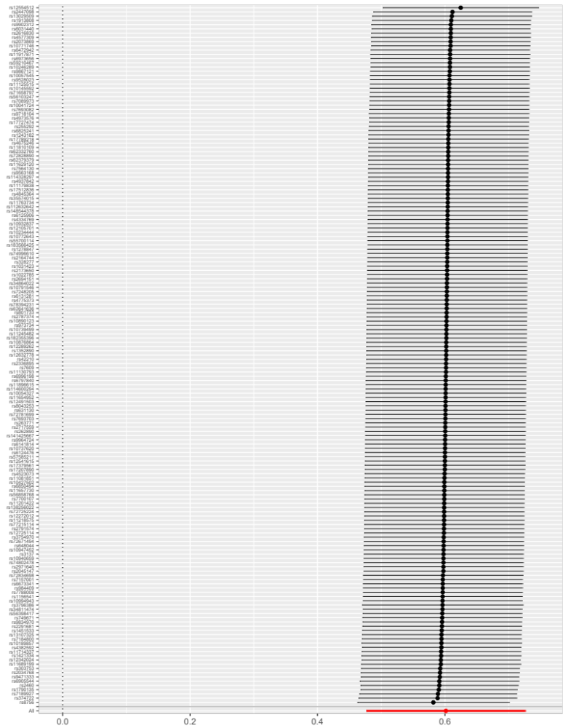

Figure S2. Leave-one-out analysis of the association between computer use and the risk of type 2 diabetes. The black dots and bars indicate the causal estimates and 95% CIs when specific SNP is removed. The red dot and line indicate the overall estimate and 95% CIs using the IVW method. CI, confidence interval; SNP, single nucleotide polymorphism; IVW, inverse variance-weighted.
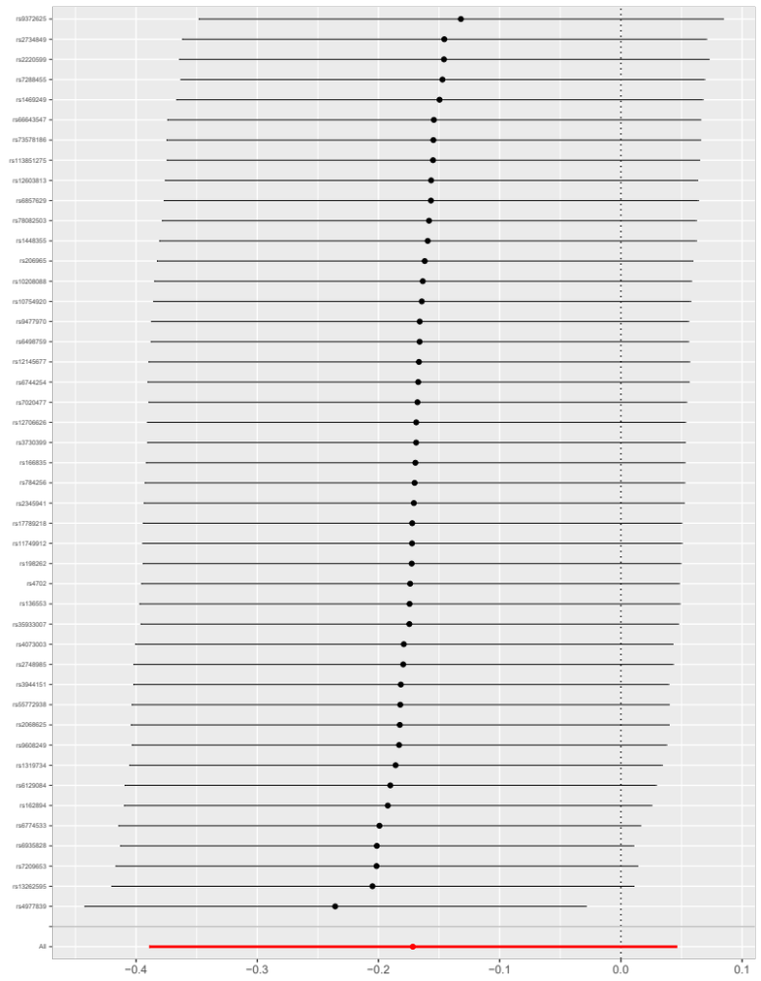

Figure S3. Leave-one-out analysis of the association between driving behavior and the risk of type 2 diabetes. The black dots and bars indicate the causal estimates and 95% CIs when specific SNP is removed. The red dot and line indicate the overall estimate and 95% CIs using the IVW method. CI, confidence interval; SNP, single nucleotide polymorphism; IVW, inverse variance-weighted.
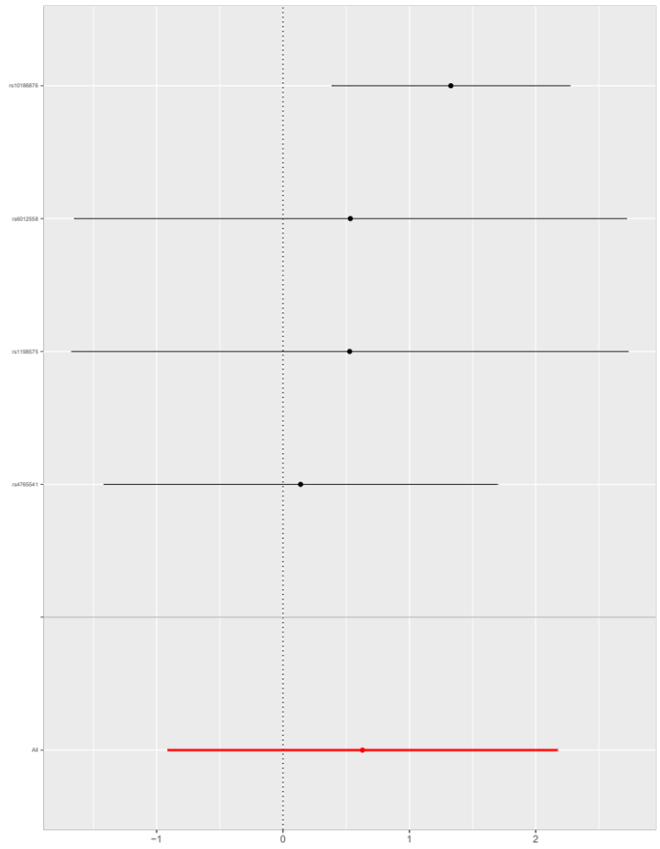

Figure S4. Funnel plot of the Mendelian randomization estimate for the association between television watching and the risk of type 2 diabetes. X axis presents the estimate and Y axis presents the relevant inverse SE. The dots indicate each SNP, and the line indicates the overall estimate using the IVW method and MR-Egger method. SE, standard error; SNP, single nucleotide polymorphism; IVW, inverse variance-weighted; MR, Mendelian randomization.
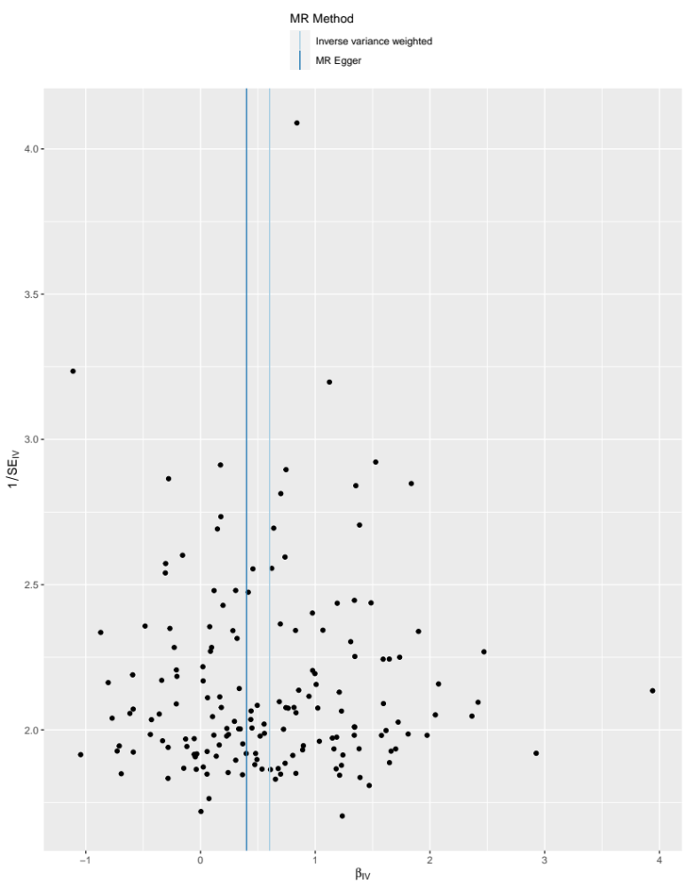

Figure S5. Funnel plot of the Mendelian randomization estimate for the association between computer use and the risk of type 2 diabetes. X axis presents the estimate and Y axis presents the relevant inverse SE. The dots indicate each SNP, and the line indicates the overall estimate using the IVW method and MR-Egger method. SE, standard error; SNP, single nucleotide polymorphism; IVW, inverse variance-weighted; MR, Mendelian randomization.
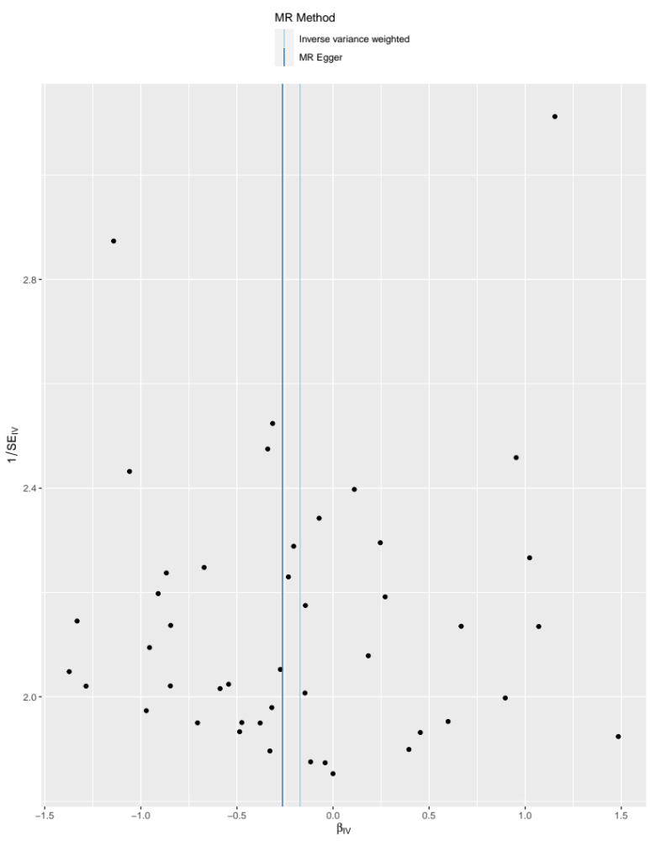

Figure S6. Funnel plot of the Mendelian randomization estimate for the association between driving behavior and the risk of type 2 diabetes. X axis presents the estimate and Y axis presents the relevant inverse SE. The dots indicate each SNP, and the line indicates the overall estimate using the IVW method and MR-Egger method. SE, standard error; SNP, single nucleotide polymorphism; IVW, inverse variance-weighted; MR, Mendelian randomization.
