Discovery of a novel antibiotic, Transitmycin, from Streptomyces sp unveils highly efficient activities against tuberculosis and human immunodeficiency virus
Vanaja Kumar*^{1,4}, Balagurunathan Ramasamy², Mukesh Doble^{$3,5}, Radhakrishnan Manikkam⁴, Luke Elizabeth Hanna¹, K R Uma devi¹, Gandarvakottai Senthilkumar Arumugam ^{3,7}, Kannan Damodharan^{3,7}, Suresh Ganesan³, Azger Dusthakeer¹, Precilla Lucia¹, Shainaba A Saadhali¹, Shanthi John², Poongothai Eswaran², , Jaleel UCA⁶, Rakhila M⁶, Ayisha Safeeda⁶ and Sathish S⁶ , Selvakumar Nagamiah¹
¹National Institute for Research in Tuberculosis, Chennai – 600031, Tamilnadu, India
²Department of Microbiology, Periyar University, Salem – 636011, Tamilnadu, India
³Department of Biotechnology, Indian Institute of Technology, Madras – 600036, Tamilnadu, India
⁴Centre for Drug Discovery and Development, Sathyabama Institute of Science and Technology
(Deemed to be University), Chennai – 600119, Tamilnadu. India
⁵ Saveetha Dental College and Hospitals, 62, Poonamallee High Rd, Chennai, 600077, India
⁶ Open Source Pharma Foundation-National Institute of Advanced Studies Drug Discovery Lab, NIAS, IISc Campus, Bangalore, Karnataka, India
⁷SSS International Drug Discovery & Development Research Private Limited, Innovation & Entrepreneurship, Sudha & Shankar innovation hub, IIT Madras, Chennai-600036, India
Email: *vanaja_kumar51@yahoo.co.in; $ mukeshdoble.sdc@saveetha.com

Corresponding Author:
Dr. Vanaja Kumar
Former Scientist G & Head
Department of Bacteriology
¹National Institute for Research in Tuberculosis,
Chennai – 600 031. Tamil Nadu. India
Email: vanaja_kumar51@yahoo.co.in

Supplementary Information
zTable/Figure | Title | Page Number
S-Table 1. | Phenotypic characteristics of Streptomyces sp. R2 | S10
S-Table 2. | Effect of solvents on the extraction of Transitmycin | S11
Figure S1 | Characteristic microbial strain and its morphological arrangement | S12
Figure S1a | (a) TLC of Ethyl acetate extract of Streptomyces sp R2 in UV light (b) Long UV (c) Short UV | S13
Figure S2. | Purification of EA extract of Streptomyces sp. R2 by Preparative Thin-Layer Chromatography | S14
Figure S3. | Scheme of purification of EA extract of Streptomyces sp. R2 by Column Chromatograph | S15
Figure S4. | RP HPLC of the ethyl acetate extract of Streptomyces sp. R2 (Batch II) | S16
Figure S5. | Purity of Transitmycin R1, R2, R3 were checked by RP HPLC method | S17
S-Table 3. | HPLC Retention time of R1, R2, R3 | S17
Figure S6. | UV/Vis Spectrum of R2 in methanol | S18
Figure S7. | UV/Vis Spectrum of R3 in methanol | S19
Figure S8. | Circular Dichroism Spectrum of Transitmycin (R1) in methanol | S20
Figure S9. | Circular Dichroism Spectrum of R2 in methanol | S21
Figure S10. | Circular Dichroism Spectrum of R3 in methanol | S22
Figure S11. | FT-IR Spectrum of Transitmycin (R1), R2, R3 | S23
Figure S12. | FT-IR Spectrum of R2 | S24
Figure S13. | FT-IR Spectrum of R3 | S25
Table S4. | IR Absorption Frequencies of Functional Groups Present in R1, R2, R3 | S26
Figure S14. | ¹H-NMR (500 MHz, CDCl₃) Spectrum of Transitmycin (R1) | S27
Figure S15. | Expansion of ¹H-NMR (500 MHz, CDCl₃) Spectrum of Transitmycin (R1) | S28
Figure S16. | Expansion of ¹H-NMR (500 MHz, CDCl₃) Spectrum of Transitmycin (R1) | S29
Figure S17. | Expansion of ¹H-NMR (500 MHz, CDCl₃) Spectrum of Transitmycin (R1) | S30
Figure S18. | Expansion of ¹H-NMR (500 MHz, CDCl₃) Spectrum of Transitmycin (R1) | S31
Figure S19. | ¹³C-NMR (125 MHz, CDCl₃) Spectrum of Transitmycin (R1) | S32
Figure S20. | ¹³C-NMR (125 MHz, CDCl₃) Spectrum of Transitmycin (R1) | S33
Figure S21. | ¹³C-NMR (125 MHz, CDCl₃) Spectrum of Transitmycin (R1) | S34
Figure S22. | ¹³C-NMR (125 MHz, CDCl₃) Spectrum of Transitmycin (R1) | S35
Figure S23 | ¹³C-NMR (125 MHz, CDCl₃) Spectrum of Transitmycin (R1) | S36
Figure S24. | ¹³C-NMR (125 MHz, CDCl₃) Spectrum of Transitmycin (R1) | S37
Figure S25. | ¹³C-NMR (125 MHz, CDCl₃) Spectrum of Transitmycin (R1) | S38
Figure S26. | DEPT135 (125 MHz CDCl₃) Spectrum of Transitmycin (R1) | S39
Figure S27. | COSY (500 MHz) Spectrum of Transitmycin (R1) | S40
Figure S28. | DQF-COSY (500 MHz) Spectrum of Transitmycin (R1) | S41
Figure S29. | Expansion of DQF-COSY (500 MHz) Spectrum of Transitmycin (R1) | S42
Figure S30. | Expansion of DQF-COSY (500 MHz) Spectrum of Transitmycin (R1 | S43
Figure S31. | Expansion of DQF-COSY (500 MHz) Spectrum of Transitmycin (R1) | S44
Figure S32. | Expansion of DQF-COSY (500 MHz) Spectrum of Transitmycin (R1) | S45
Figure S33. | HMBC (500 MHz) Spectrum of Transitmycin (R1) | S46
Figure S34. | Expansion of HMBC (500 MHz, CDCl₃) Spectrum of Transitmycin (R1) | S47
Figure S35. | Expansion of HMBC (500 MHz, CDCl₃) Spectrum of Transitmycin (R1) | S48
Figure S36. | Expansion of HMBC (500 MHz, CDCl₃) Spectrum of Transitmycin (R1 | S49
Figure S37. | Expansion of HMBC (500 MHz, CDCl₃) Spectrum of Transitmycin (R1) | S50
Figure S38. | Expansion of HMBC (500 MHz, CDCl₃) Spectrum of Transitmycin (R1) | S51
Figure S39. | Expansion of HMBC (500 MHz, CDCl₃) Spectrum of Transitmycin (R1) | S52
Figure S40. | Expansion of HMBC (500 MHz, CDCl₃) Spectrum of Transitmycin (R1) | S53
Figure S41. | HSQC (500 MHz, CDCl₃) Spectrum of Transitmycin (R1) | S54
Figure S42. | TOCSY (500 MHz) Spectrum of Transitmycin (R1) | S55
Figure S43. | Expansion of TOCSY (500 MHz, CDCl₃) Spectrum of Transitmycin (R1) | S56
Figure S44. | Expansion of TOCSY (500 MHz, CDCl₃) Spectrum of Transitmycin (R1) | S57
Figure S45. | Expansion of TOCSY (500 MHz, CDCl₃) Spectrum of Transitmycin (R1) | S58
Figure S46. | NOESY (500 MHz, CDCl₃) Spectrum of Transitmycin (R1) | S59
Figure S47. | Expansion of NOESY (500 MHz, CDCl₃) Spectrum of Transitmycin (R1) | S60
Figure S48. | Expansion of NOESY (500 MHz, CDCl₃) Spectrum of Transitmycin (R1) | S61
Figure S49. | Expansion of NOESY (500 MHz, CDCl₃) Spectrum of Transitmycin (R1) | S62
Figure S50. | Expansion of NOESY (500 MHz, CDCl₃) Spectrum of Transitmycin (R1) | S63
Figure S51. | Expansion of NOESY (500 MHz, CDCl₃) Spectrum of Transitmycin (R1) | S64
Figure S52. | ROESY (500 MHz) Spectrum of Transitmycin (R1) | S65
Table S5. | NMR data of Transitmycin (R1) in CDCl₃ (¹H: 500 MHz ¹³C: 125 MHz) | S66-72
Figure S53. | ¹H-NMR (500 MHz, CDCl₃) Spectrum of Compound R2 | S73
Figure S54. | ¹³C NMR (125 MHz, CDCl₃) Spectrum of Compound R 2 | S74
Figure S55. | DEPT135&90 (125 MHz CDCl₃) Spectrum of Compound R2 | S75
Figure S56. | Expansion of DEPT135 & 90 (125 MHz, CDCl₃) Spectrum of Compound R2 | S76
Figure S57. | Expansion of DEPT135 & 90 (125 MHz, CDCl₃) Spectrum of Compound R2 | S77
Figure S58. | COSY (500 MHz) Spectrum of Compound R2 | S78
Figure S59. | DQF-COSY (500 MHz) Spectrum of Compound R2 | S79
Figure S60. | HMBC (500 MHz) Spectrum Compound of R2 | S80
Figure S61. | HSQC (500 MHz) Spectrum of Compound R2 | S81
Figure S62. | TOCSY (500 MHz) Spectrum of Compound R2 | S82
Figure S63. | NOESY (500 MHz) Spectrum of Compound R2 | S83
Figure S64. | ¹H-NMR (500 MHz, CDCl₃) Spectrum of Compound R3 | S84
Figure S65. | DQF-COSY (500 MHz) Spectrum of Compound R₃ | S85
Figure S66. | HMBC (500 MHz) Spectrum of Compound R3 | S86
Figure S67. | HSQC (500 MHz) Spectrum of Compound R3 | S87
Figure S68. | TOCSY (500 MHz) Spectrum of Compound R3 | S88
Figure S69. | NOESY (500 MHz) Spectrum of Compound R3 | S89
Figure S70. | MALDI-TOF MS Spectrum of Transitmycin (R1) (Molecular ion peak) (positive mode) | S90
Figure S71. | Expansion of MALDI-TOF MS Spectrum of Transitmycin (R1) (Molecular ion peak) | S91
Figure S72. | Expansion of MALDI-TOF MS Spectrum of Transitmycin (R1) (Molecular ion peak | S92
Figure S73. | MALDI-TOF MS Spectrum of R2 (Molecular ion peak) (positive mode) | S93
Figure S74. | Expansion of MALDI-TOF MS Spectrum of R2 (Molecular ion peak) (positive mode) | S94
Figure S75. | Expansion of MALDI-TOF MS Spectrum of R2 (Molecular ion peak) (Negative mode) | S95
Figure S76. | MALDI-TOF MS Spectrum of R3 (Molecular ion peak) (positive mode) | S96
Figure S77. | MALDI-TOF MS Spectrum of R3 (Molecular ion peak) (Negative mode) | S97
Figure S78. | MALDI-TOF MS Spectrum of Transitmycin (R1) (Positive mode) | S98
Figure S79. | MALDI-TOF MS Spectrum of Transitmycin A (Negative mode) | S99
Table S6. | MALDI-TOF MS Spectral Fragmentation of Transitmycin (R1) (Positive mode) | S100
Figure S80. | MALDI-TOF MS Spectrum of R2 (Positive mode | S101
Figure S81. | MALDI-TOF MS Spectrum of R2 (Negative mode) | S102
Figure S82. | MALDI-TOF MS Spectrum of R3 (Positive mode) | S103
Figure S83. | MALDI-TOF MS Spectrum of R3 (Negative mode) | S104
Figure S84. | QTRAP MS/MS Transitmycin (R1) (Molecular ion peak) (Positive mode) | S105
Figure S85. | QTRAP MS/MS Transitmycin (R1) (Molecular ion peak [M+H]²⁺ (Positive mode) | S106
Figure S86. | QTRAP MS/MS of Transitmycin (R1) (Molecular ion peak) (Negative mode) | S107
Figure S87. | QTRAP MS/MS of R2 (Molecular ion peak) ((Positive mode) | S108
Figure S88. | QTRAP MS/MS of R2 [M+H]²⁺ ion peak (Positive mode) | S109
Figure S89. | QTRAP MS/MS of R2 (Molecular ion peak (Positive mode) | S100
Figure S90. | QTRAP MS/MS of R3 Molecular ion peak (Positive mode) | S111
Figure S91. | QTRAP MS/MS of R3 (Molecular ion peak (Negative mode) | S112
Figure S92. | HR-ESI-MS Spectrum of Transitmycin (R1) (Positive mode) | S113
Figure S93. | HR-ESI-MS Spectrum of Transitmycin (R1) (Molecular ion Peak) (Positive mode) | S114
Figure S94. | HR-ESI-MS Spectrum of R2 (Positive mode) | S115
Figure S95. | HR-ESI-MS Spectrum of R2 (Molecular ion Peak) (Positive mode) | S116
Figure S96. | HR-ESI-MS Spectrum of R3 (Positive mode) | S117
Figure S97. | HR-ESI-MS Spectrum of R3 (Molecular ion Peak) (Positive mode) | S118
Figure S98. | LC-ESI-MS Spectrum of Transitmycin (R1) (Molecular ion peak) (Positive mode) | S119
Figure S99. | LC-ESI-MS Spectrum of Transitmycin (R1) (Positive mode). | S120
Figure S100. | LC-ESI-MS Spectrum of Trasitmycin (R1) (Positive mode) | S121
Figure S101. | LC-ESI-MS Spectrum of Trasitmycin (R1) (Positive mode) | S122
Figure S102. | LC-ESI-MS Spectrum of R2 (Positive mode) | S123
Figure S103. | LC-ESI-MS Spectrum of R2 (Molecular ion) (Positive mode) | S124
Figure S104. | LC-ESI-MS Spectrum of R3 (Positive mode). | S125
Figure S105. | LC-ESI-MS Spectrum of R3 (Positive mode) | S126
Figure S106. | EI-MS Spectrum of Transitmycin (R1) (Positive mode) | S127
Figure S107. | EI-MS Spectrum of (R1) (molecular ion peak) (Positive mode) | S128
Figure S108. | EI-MS Spectrum of (R2) (Positive mode) | S129
Figure S109. | EI-MS Spectrum of (R3) (Positive mode) | S130
Figure S110. | CHN analysis data of Transitmycin (R1), R2, R3 | S131
Figure S111. | 3200 QTRAP LC/MS/MS Spectrum of Transitmycin (R1) (Negative mode) | S132
Figure S112. | 3200 QTRAP LC/MS/MS Spectrum of Transitmycin (R1) (positive mode) | S133
Figure S113. | 3200 QTRAP LC/MS/MS Spectrum of Transitmycin (R1) (positive mode) | S134
Figure S114. | 3200 QTRAP LC/MS/MS Spectrum of Transitmycin (R1) (positive mode) | S135
Figure S115. | 3200 QTRAP LC/MS/MS Spectrum of Transitmycin (R1) (positive mode) | S136
Figure S115 a, b | Structural characterisation of Transitmycin (R1) obtained by QTRAP LC-MS/MS | S137
Table S7a. | Structural characterisation of Transitmycin (R1) [M+H]⁺ obtained by QTRAP LCMS/MS | S138
Table S7b. | Structural characterisation of Transitmycin (R1) [M+Na]⁺ obtained by QTRAP LCMS/MS | S139
Figure S116. | Hydrolysis of amino acid residue of Transitmycin (R1), R2, R3 | S140
Figure S117a. | HPLC analysis of standard L-FDAA-D/L-Valine | S141a
Figure S117b. | HPLC analysis of standard L-FDAA-D-Valine | S141b
Figure S117c. | HPLC analysis of standard L-FDAA-L-Valine | S141c
Figure S118 a. | HPLC analysis of standard L-FDAA-D/L-Proline | S142a
Figure S118 b. | HPLC analysis of standard L-FDAA-D-Proline | S142b
Figure S118c. | HPLC analysis of standard L-FDAA-L-Proline | S142c
Figure S119a. | HPLC analysis of standard L-FDAA-D/L-Threonine | S143a
Figure S119b. | HPLC analysis of standard L-FDAA-D-Threonine | S143b
Figure S119c. | HPLC analysis of standard L-FDAA-D-Threonine | S143c
Figure S120a. | HPLC analysis of standard L-FDAA-D/L-N-Methyl Valine | S144a
Figure S120b. | HPLC analysis of standard L-FDAA-D-N-Methyl Valine | S144b
Figure S120c. | HPLC analysis of standard L-FDAA-D-N-Methyl Valine | S144c
Figure S121a. | HPLC analysis of standard L-FDAA-D-Valine | S145a
Figure S121b. | HPLC analysis of standard L-FDAA-L-Valine | S145b
Figure S121c. | HPLC Analysis of L-FDAA Derivatives of acid hydrolysates of Transitmycin (R1) | S143a
Figure 122a. | HPLC analysis of standard L-FDAA-D-Valine | S143b
Figure S122b. | HPLC analysis of standard L-FDAA-L-Valine | S143c
Figure S122c. | HPLC Analysis of L-FDAA Derivatives of acid hydrolysates of R2 | S144a
Figure S123a. | HPLC analysis of standard L-FDAA-D-Valine | S144b
Figure S123b. | HPLC analysis of standard L-FDAA-L-Valine | S144c
Figure S123c. | HPLC Analysis of L-FDAA Derivatives of acid hydrolysates of R3 | S145
Figure S124. | HPLC Analysis of L-FDAA Derivatives of acid hydrolysates of R2 | S148
Figure S125. | HPLC Analysis of L-FDAA Derivatives of acid hydrolysates of R3 | S149
Table 8a. | Analysis of L-FDAA derivates of acid hydrolysate of R2 by HPLC | S150
Table 8b. | Analysis of L-FDAA derivatives of acid hydrolysate of R3 by HPLC | S150
Figure S126. | ESI- MS Spectrum of Marfey’s Derivatives of Transitmycin (R1) (Positive mode) | S151
Figure S127. | ESI- MS Spectrum of Marfey’s Derivatives of Transitmycin (R1) (Positive mode) | S152
Figure S128. | LCMS analysis of Standard L-FDAA-D-Proline (Positive mode) | S153
Figure S129. | LCMS analysis of Standard L-FDAA-D-Proline (Negative mode) | S154
Figure S130. | LCMS analysis of Standard L-FDAA-L-Proline (Positive mode | S155
Figure S131. | LCMS analysis of Standard L-FDAA-L-Proline (Negative mode) | S156
Figure S132. | LCMS analysis of Standard L-FDAA-D/L-Proline (Positive mode) | S157
Figure S133. | LCMS analysis of Standard L-FDAA-D/L-Proline (Negative mode) | S158
Figure S134. | LCMS analysis of Standard L-FDAA-D-Valine (Positive mode) | S159
Figure S135. | LCMS analysis of Standard L-FDAA-D-Valine (Negative mode) | S160
Figure S136. | LCMS analysis of Standard L-FDAA-L-Valine (Positive mode) | S161
Figure S137. | LCMS analysis of Standard L-FDAA-L-Valine (Negative mode) | S162
Figure S138. | LCMS analysis of Standard L-FDAA-D/L-Valine (Positive mode) | S163
Figure S139. | LCMS analysis of Standard L-FDAA-D/L-Valine (Negative mode) | S164
Figure S140. | LCMS analysis of Standard L-FDAA-D/L-Valine (Positive mode) | S165
Figure S141. | LCMS analysis of Standard L-FDAA-D/L-Valine (Negative mode) | S166
Figure S142. | LCMS analysis of Standard L-FDAA-D-Threonine (Positive mode) | S167
Figure S143. | LCMS analysis of Standard L-FDAA-D-Threonine (Negative mode) | S168
Figure S144. | LCMS analysis of Standard L-FDAA-D/L Threonine (Positive mode) | S169
Figure S 145. | LCMS analysis of Standard L-FDAA-D/L Threonine (Negative mode) | S170
Figure S146. | LCMS analysis of Standard L-FDAA-D/L N-Methyl valine (Positive mode). | S171
Figure S147. | LCMS analysis of Standard L-FDAA-D/L N-Methyl Valine (Positive mode) | S172
Figure S148. | LCMS analysis of Standard L-FDAA-L N-Methyl valine (Positive mode) | S173
Figure S149. | LCMS analysis of Standard L-FDAA-L- N-Methyl valine (Positive mode) | S174
Figure S150. | LCMS analysis of Standard L-FDAA-L N-Methyl Valine (Positive mode) | S175
Figure S151. | LCMS analysis of Standard L-FDAA-L N-Methyl Valine (Positive mode) | S176
Figure S152. | LCMS analysis of Standard L-FDAA-L N-Methyl Valine (Negative mode) | S177
Figure S153. | LCMS analysis of Standard L-FDAA-D/L N-Methyl Valine (Positive mode) | S178
Figure S154. | LCMS analysis of Standard L-FDAA-L N-Methyl Valine (Positive mode) | S179
Figure S155. | LCMS analysis of Standard L-FDAA-D/L N-Methyl Valine (Positive mode) | S180
Figure S156. | LCMS analysis of Standard L-FDAA-D/L N-Methyl Valine (Negative mode). | S181
Figure S157. | LCMS analysis of Standard L-FDAA-D/L N-Methyl Valine (Negative mode) | S182
Figure S158. | LCMS analysis of Standard L-FDAA-D/L N-Methyl Valine (Negative mode). | S183
Figure S159. | LCMS analysis of L-FDAA derivatives of Transitmycin (R1) (Positive mode) | S184
Figure S160. | LCMS analysis of L-FDAA derivatives of Transitmycin (R1) (Negative mode) | S185
Figure S161. | LCMS analysis of L-FDAA derivatives of R3 (Positive mode) | S186
Table S9a. | Analysis of L-FDAA derivates of acid hydrolysate of Transitmycin R1 by HPLC-MS | S187
Table S9b. | Analysis of L-FDAA derivates of acid hydrolysate of R3 by HPLCMS | S187
Table S10. | Physico-chemical properties of R2 | S188-89
Table S11. | Physico-chemical properties of R3 | S190-91
Table S12 | Drug resistant profile of the clinical isolates of Mycobacterium tuberculosis used to determine the anti TB activity of Transitmycin | S192-194
Table S13 | Anti-HIV activity of Transitmycin on various HIV-1 subtypes | S195

S-Table 1. Phenotypic characteristics of Streptomyces sp. R2
Characteristics | Results
Micromorphology
Aerial mycelium | Present
Substrate mycelium | Present
Spore chain morphology | Rectus flexibile, non fragmented
Spore surface | Hairy
Cultural characteristics
Colony consistency | Powdery
Aerial mass colour | Ash white
Reverse side pigment | Yellow
Soluble pigment | Yellow
Melanoid pigment | Absent
Growth on Different media
ISP1 | Moderate
ISP2 | Good
ISP3 | Good
ISP4 | Good
ISP5 | Moderate
ISP6 | Moderate
ISP7 | Good
Carbon utilization
Glucose | Good
Arabinose | Poor
Sucrose | Poor
Xylose | Moderate
Inositol | Poor
Mannitol | Good
Fructose | Moderate
Rhamnose | Moderate
Raffinose | No Growth
Cellulose | No Growth
pH tolerance
5 | No growth
7 | Good
9 | Good
11 | Moderate
Growth at
20⁰C | Poor
30⁰C | Good
40⁰C | Good
50⁰C | Moderate
NaCl tolerance (%)
0 | Poor
1 | Good
2.5 | Good
5 | Good
7.5 | Poor
10 | No growth
Susceptibility to | Tetracycline, chloramphenicol, erythromycin, gentamicin, vancomycin
Resistant to | Penicillin, nystatin, nalidixic acid

S-Table 2. Effect of solvents on the extraction of Transitmycin

Solvents | Quantity of extracts | Antibacterial activity against S. aureus MTCC 96 | Anti TB activity  (% reduction in RLU)
Methanol | 40 | 14 | 58.31
Chloroform | 41 | 9 | 18.07
Dichloromethane | 40 | 13 | 22.71
Diethyl ether | 10 | 14 | 74.23
Ethyl acetate | 9 | 19 | 83.40
n-hexane | - | - | -

Fig. S1. Characteristic microbial strain and its morphological arrangement. a Cultural morphology and microscopic visualization. b SEM image (3,500X) of Streptomyces variabilis R2 on ISP2 agar medium. c Phylogenetic dendrogram obtained by distance matrix analysis of 16s rRNA gene sequences, showing the position of strain R2 among its phylogenetic neighbours.

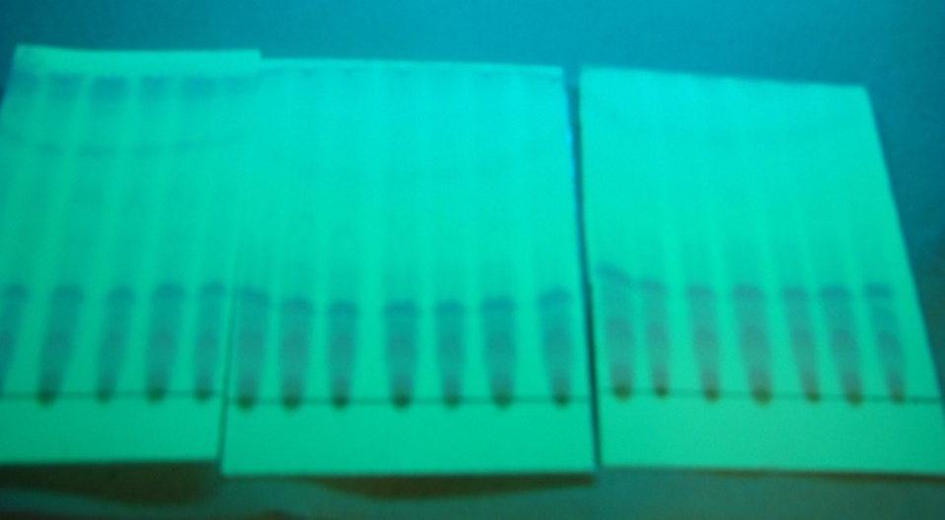
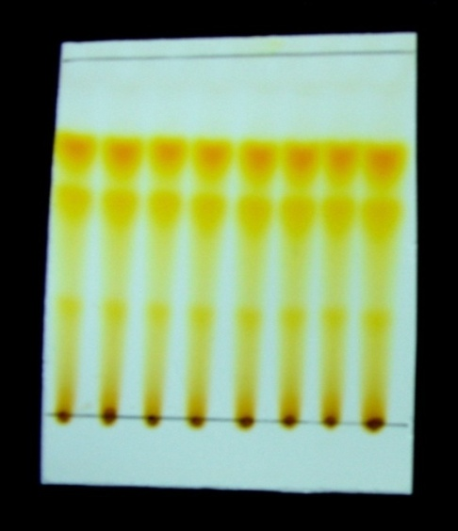
(a)
(b)
R2

Transitmycin (R1)
R3

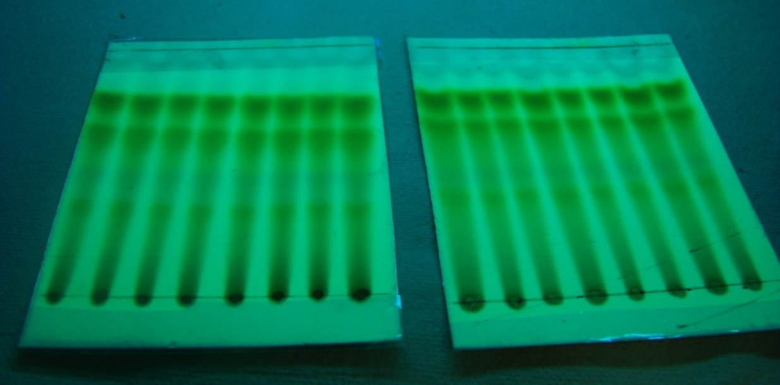
Solvent system for TLC: Ethyl acetate /Methanol, (9.5:0.5)
Rf value of Transitmycin (R1) = 0.8
(c)
Rf value of R2 = 0.6
Rf value of R3 = 0.3
Solvent system for TLC: Ethyl acetate/Methanol, (9.5:0.5) (a) TLC of Ethyl acetate extract of Streptomyces sp. R2 in UV light (b) Long UV (c) Short UV
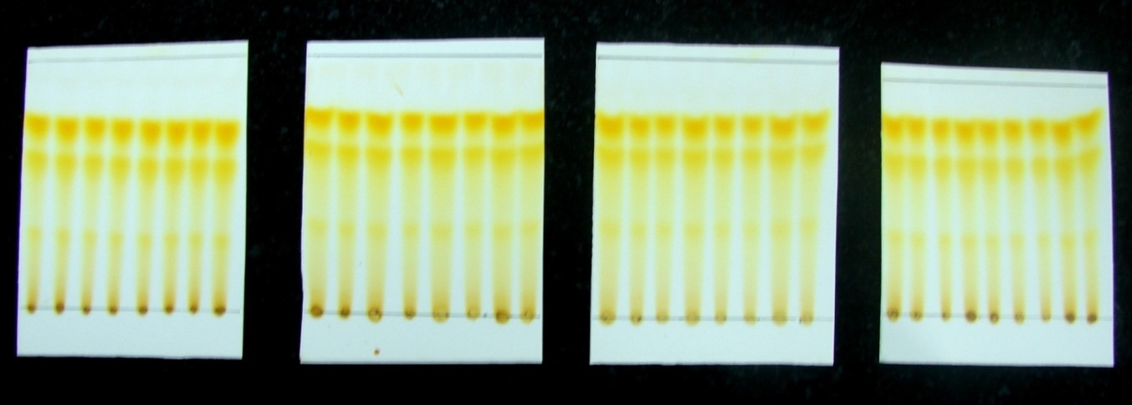

Solvent used for Preparative TLC: Ethylacetate:methanol, (9.5:0.5)
Figure S2. Purification of EA extract of Streptomyces sp. R2 by Preparative Thin-Layer Chromatography
Extraction and Isolation
Purification of compounds were performed by preparative thin layer chromatography (TLC) using Merck silica gel 60 (GF254) pre coated aluminium (6x8 cm size) plates.The crude pigment was purified by using preparative thin layer chromatography commercially available pre coated silica gel chromatography sheets (6×8 cm size) were used. To find out the best solvent system to separate the crude compound, the solvents were used in different proportions, among all solvent systems used, Ethylacetate: methanol (9.5:0.5) showed good separation. The crude pigment (2 g) was dissolved in 5 mL of ethyl acetate. With the help of capillary tube, the sample was spotted at the bottom of silica gel coated sheet (6 x 8 cm) and then it was placed in the developing 100 mL beaker containing mobile phase (Ethyl acetate/ Methanol, 9.5:0.5) 5 mL, covered with the watch glass in order to prevent the evaporation of the solvents. The solvent was allowed to run till it reaches about half a centimetre below the top of the plate. After running, the 200 sheets were kept at room temperature for the complete drying of the plate. Spots on TLC were detected under UV light (254 and 365 nm) and by spraying with concentrated H₂SO₄ followed by heating at 105 ºC for 5 min. After drying, the yellow pigment spot was scrapped, mixed with ethyl acetate and filtered using funnel fitted with what man filtered paper and Ethyl acetate was evaporated to dryness under vacuum to afford the pure compound Transitmucin R1 (10 mg), R 2 (10 mg), R3 (5 mg). Rf value of the spot separated on the TLC plate was determined. The solvent system Ethyl acetate: methanol (9.5:0.5) was found to have good separation with single spot when compared to all the solvent systems used for TLC.
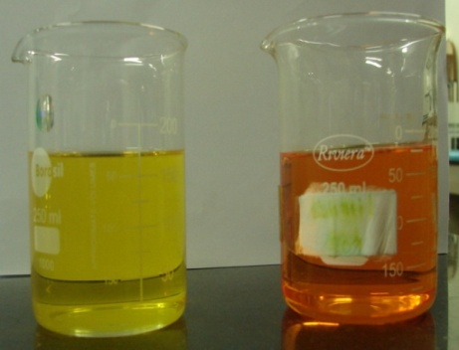
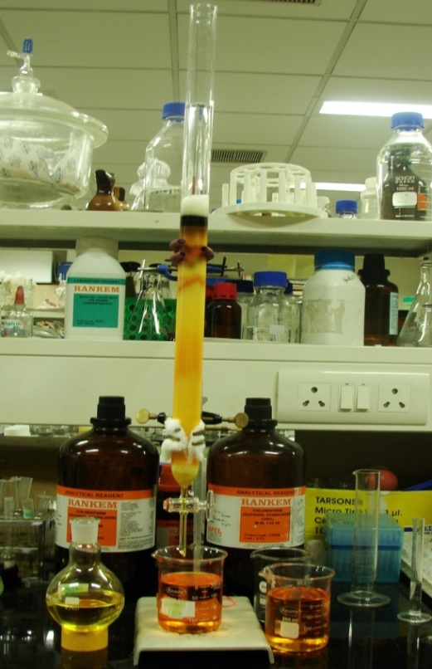
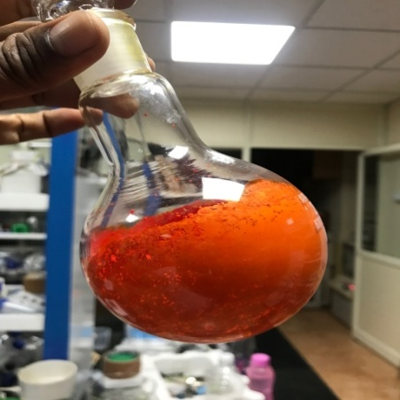
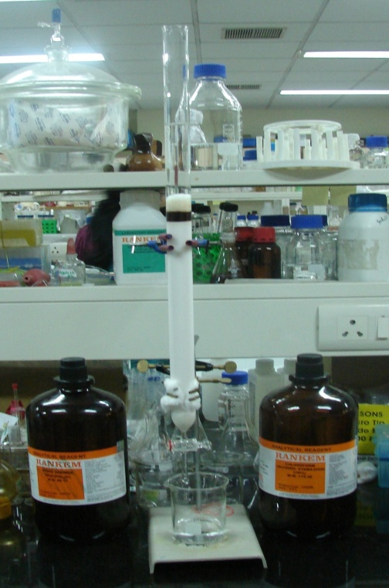
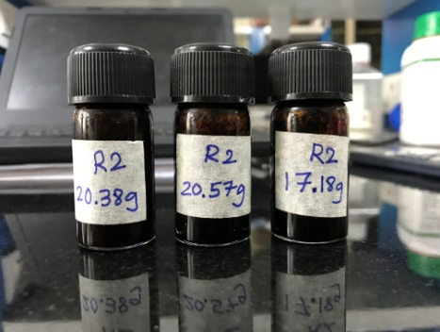
(c)
(d)
(e)
(f)
(a)

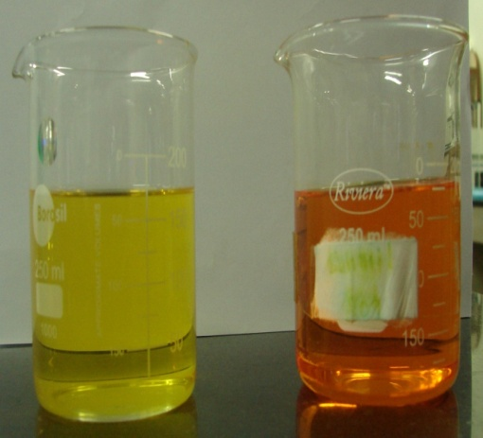
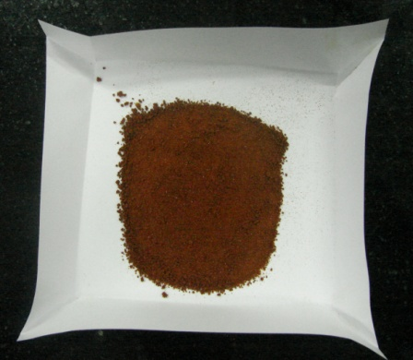
(b)
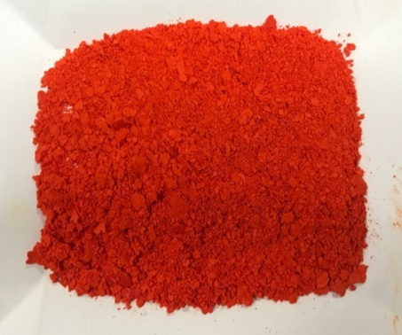
(g)

Column chromatography was carried out on Neutral Alumina (230-400 mesh) and Column size: (id 30m × 90 cm).The crude ethyl acetate extract Streptomyces sp (R2) was purified using column chromatography packed with neutral alumina using a gradient of 1% Methanol/Chloroform mixture (CH₃OH/ CHCl₃) was used as the eluent. Fractions were collected and concentrated under vacuum to afford pure compounds. The desired product was monitored in a TLC with pre coated alumina sheet silica. The isolated compounds were obtained Transitmycin (R1) (200 mg), R2 (100 mg), R3 (50 mg).

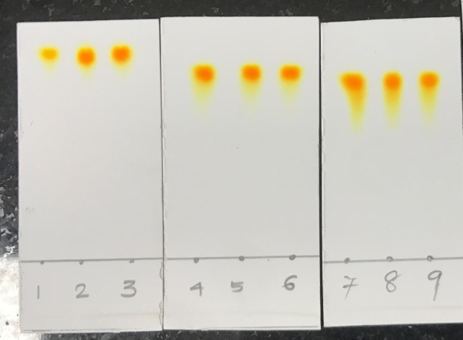
(i)
Transitmycin (R1)
(h)

Figure S3. Scheme of purification of EA extract of Streptomyces sp. R2 by column chromatography
Figure S3 (a) Crude (b) Crude with alumina (c) Before elution (d) After elution (e) solution form (f) solid form (g) After drying (h) TLC (i) RP-HPLC
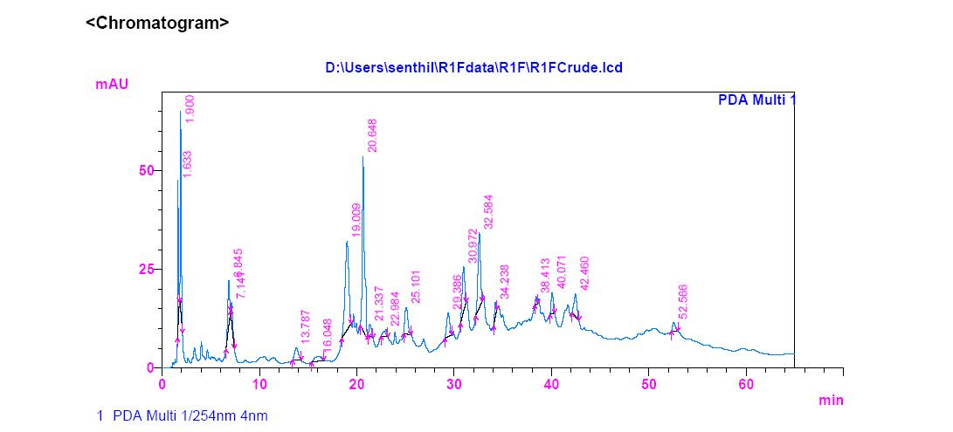

Figure S4. RP HPLC of the crude ethyl acetate extract of Streptomyces sp. R2 (Batch II)Analytical HPLC condition: Luna 5u C₁₈ (2) 100 (150 X 4.6 mm) Solvent system: A: B (35: 65 v/v); flow rate 2 ml/min, 254 nm Solvent A: Acetonitrile; Solvent B: Water, Detection: PDA, Injection volume: 20µl, Column Temperature: 30 ⁰C
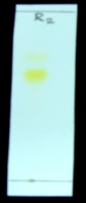
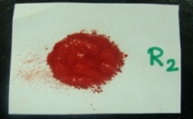
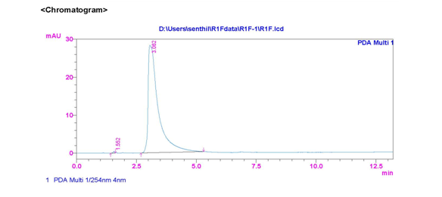
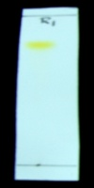
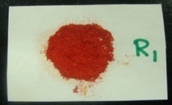
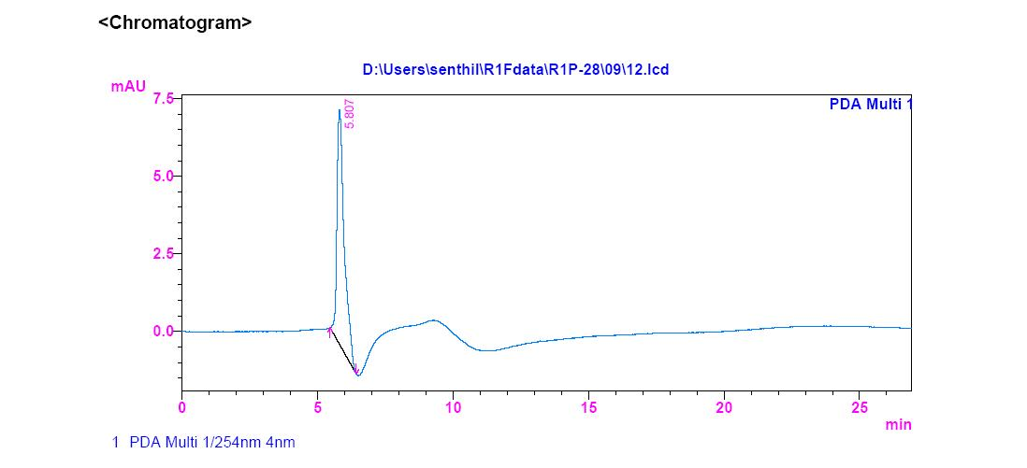
(b)
(a)

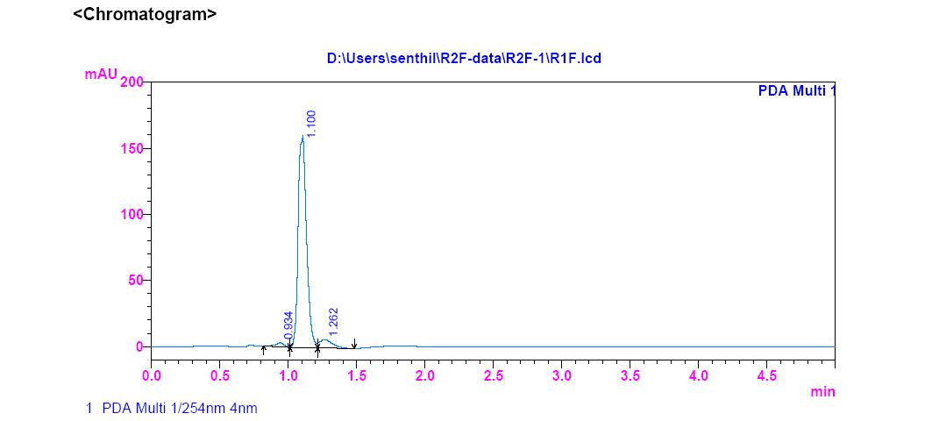
S-Table 3. RP-HPLC Retention time of R1, R2, R3

(c)
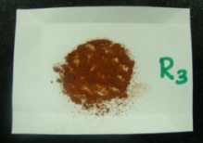
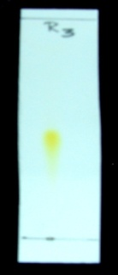
a | Ret. Time of R1 | 5.807 min
b | Ret. Time of R1 | 3.062 min
c | Ret. Time of R2 | 1.100 min

Figure S5. Purity of Transitmycin R1, R2, R3 were checked by RP HPLC method

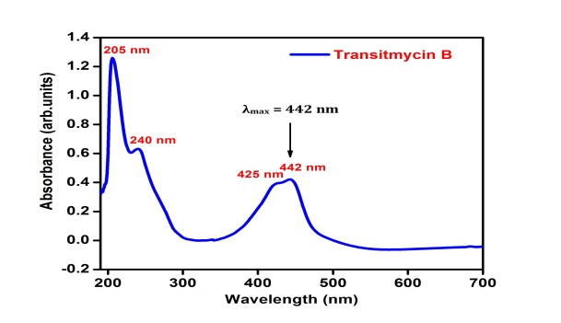

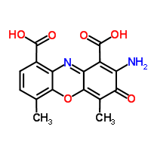

Figure S6: UV/Vis Spectrum of R2 in methanol [UV: (MeOH) λ _{max,} (log ε) 205, (1.25), 240 (0.63), 425 (0.39), 442(0.42) nm]

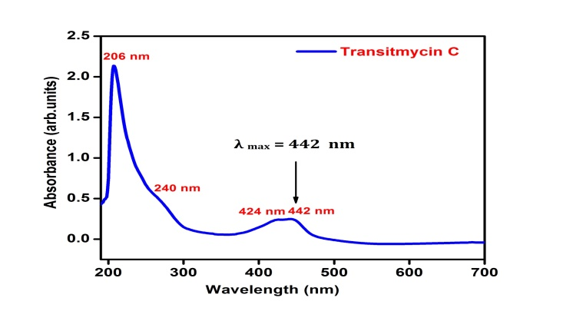

Figure S7. UV/Vis Spectrum of R3 in methanol [UV (MeOH) λ _{max} (log ε) 206 (1.90), 240 (0.69) 424 (0.191), 442.2 (0.19) nm]

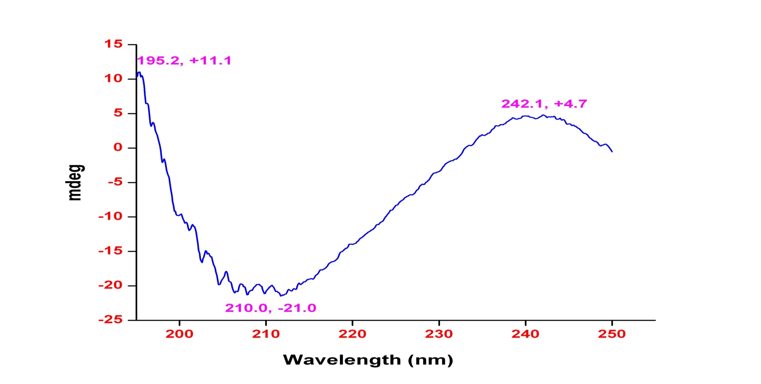

Figure S8. Circular Dichroism Spectrum of Transitmycin (R1) in methanol CD: [MeOH, [nm], (mdeg)]: λ_{max}(Δε) 195 (+11.1), 210 (-21.0), 242 (+4.7)
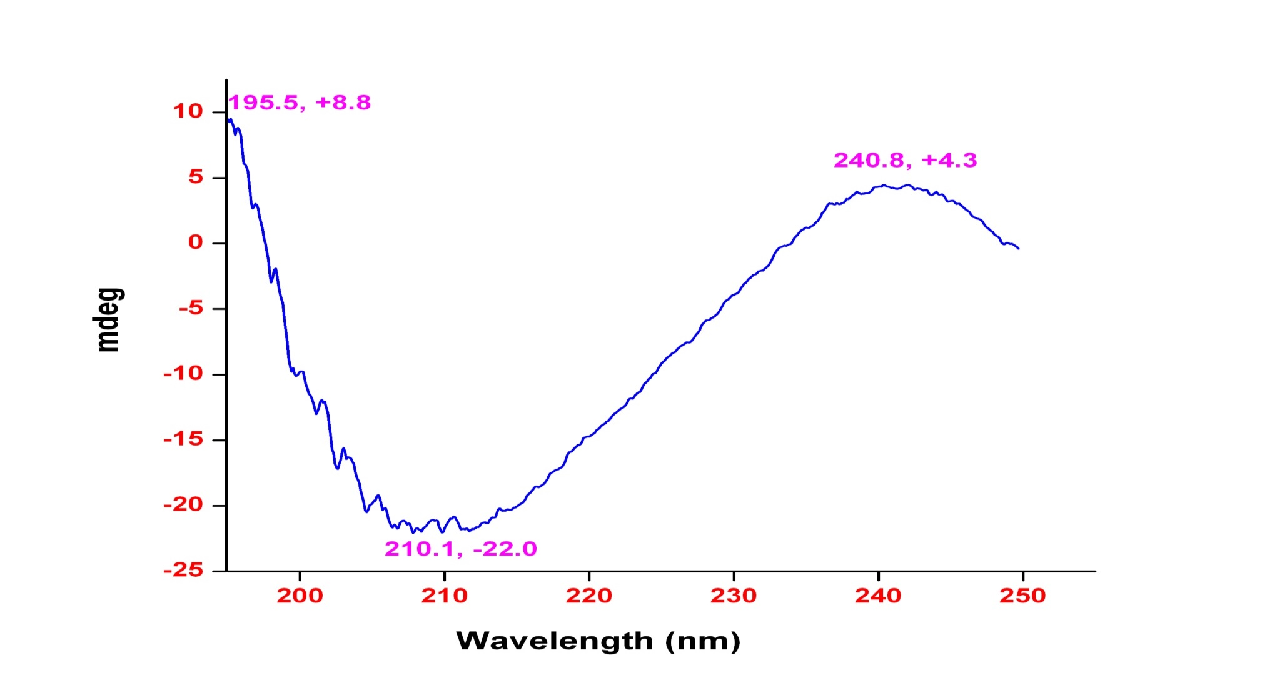

Figure S9. Circular Dichroism Spectrum of R2 in methanol CD: [MeOH, [nm], (mdeg)]: λ_{max,} (Δε) 195 (+8.8), 210 (-22.0), 240 (+4.3) nm

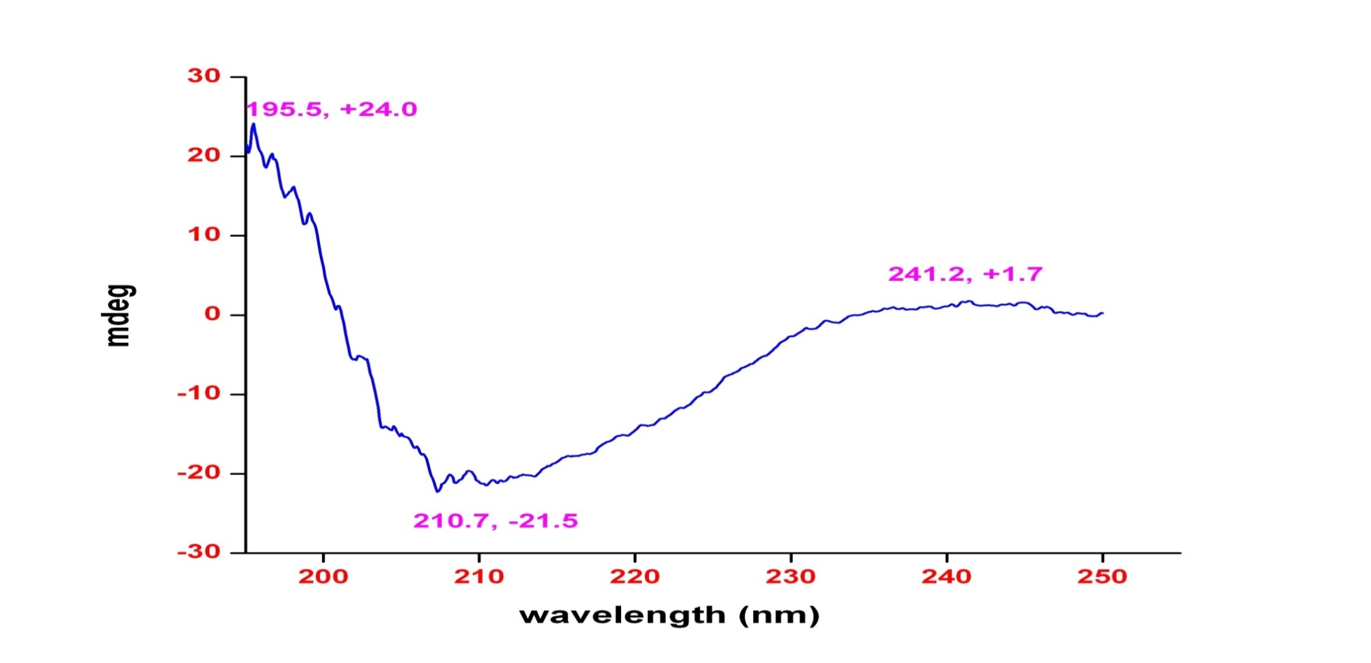

Figure S10. Circular Dichroism Spectrum of R3 in methanol CD: [MeOH, [nm], (mdeg)] λ_{max}(Δε) 195 (+24.0), 210 (-21.5), 241 (+1.7)

Figure S11. FT-IR Spectrum of Transitmycin (R1), R2, R3
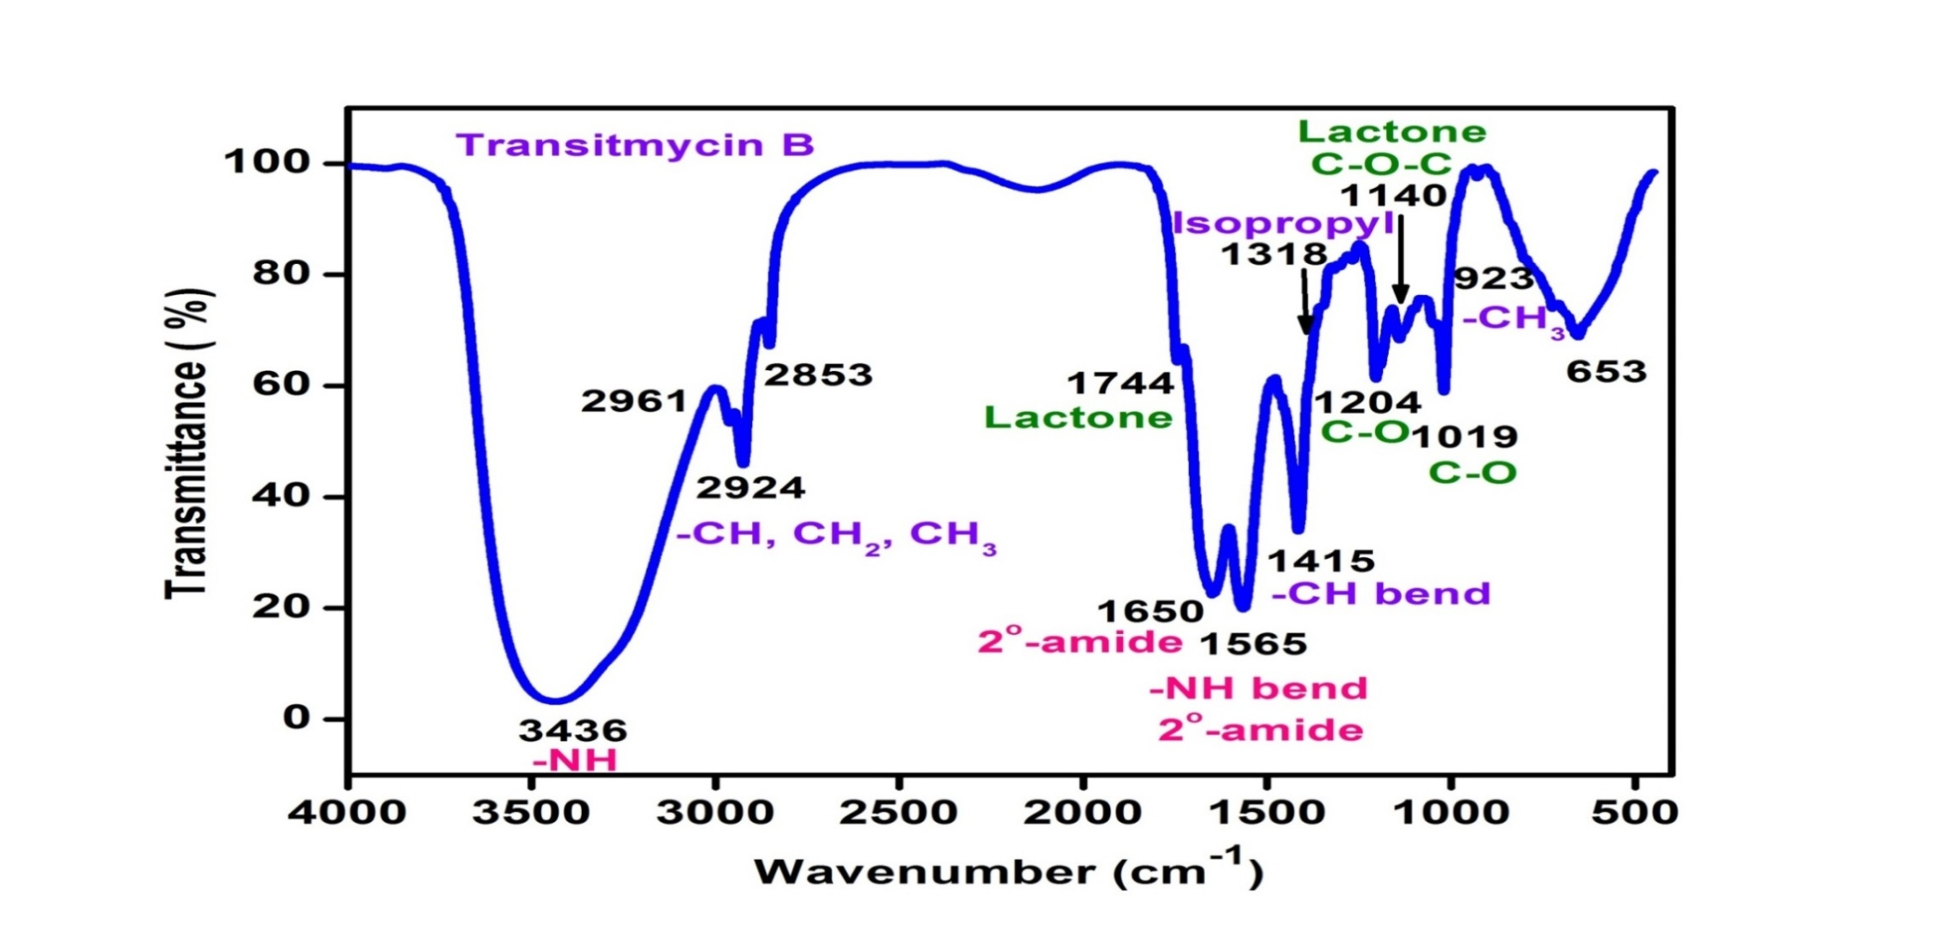

Figure S12. FT-IR Spectrum of R2

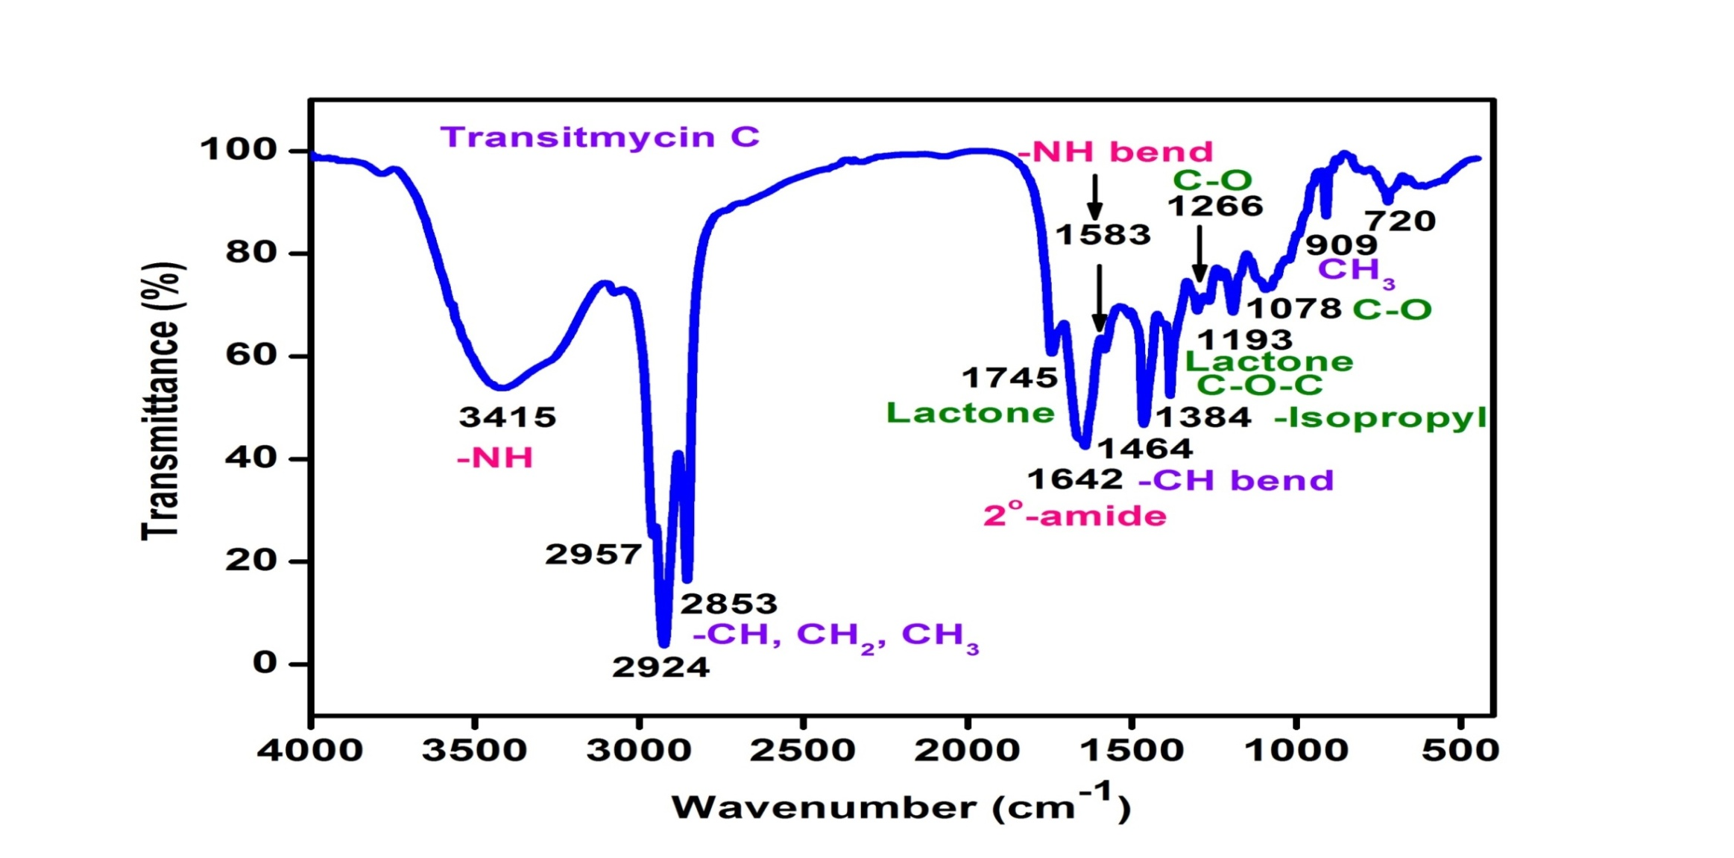

Figure S13. FT-IR Spectrum of R3
R1 | IR (KBr cm⁻¹), 3435 cm⁻¹ for NH, 2958, 2924 cm⁻¹ (m, -CH str, asym, CH₃ and CH₂), 2872 cm⁻¹, 2853 cm⁻¹ (m, -CH str, sym, CH₃ and CH₂),1746 cm⁻¹ (s, C=O str, lactone ring ), 1642 cm⁻¹(s, -C=O str, 2⁰ amide), 1524, 1503 (m, -NH bend, 2⁰ amide), 1466 (m, CH bend (scissoring), CH₂), 1379 cm⁻¹ (s, -CH bend, isopropyl group), 1268 (s, C-O str, ester), 1194 ( C-O-C of lactone ) 1099, 1059, 1017 (s, C-O or C-N ), 720, 712, 694, 689 (s, -CH bend, oop, aromatic ring), 909 (w, CH₃ rocking).
R2 | IR (KBr cm⁻¹), 3436 cm⁻¹ for NH, 2961, 2924 cm⁻¹ (m, -CH str, asym, CH₃ and CH₂), 2872 cm⁻¹, 2853 cm⁻¹ (m, -CH str, sym, CH₃ and CH₂),1744 cm⁻¹ (s, C=O str, lactone ring ), 1650 cm⁻¹ (s, -C=O str, 2⁰ amide),1565, 1503 (m, -NH bend, 2⁰ amide), 1415 (m, CH bend (scissoring), CH₂), 1318 cm⁻¹ (s, -CH bend, isopropyl group), 1268, 1204 (s, C-O str, ester),1140 ( C-O-C of lactone ), 1045, 1019 (s, C-O or C-N ), 720, 712, 653 (s, -CH bend, oop, aromatic ring), 929 (w, CH₃ rocking).
R3 | IR (KBr cm⁻¹), 3415 cm⁻¹ for NH, 2957, 2924 cm⁻¹ (m, -CH str, asym, CH₃ and CH₂), 2872 cm⁻¹, 2853 cm⁻¹ (m, -CH str, sym, CH₃ and CH₂),1745 cm⁻¹ (s, C=O str, lactone ring ), 1642 cm⁻¹(s, -C=O str, 2⁰ amide), 1583, 1507 (m, -NH bend, 2⁰ amide), 1464 (m, CH bend (scissoring), CH₂), 1384, 1301 cm⁻¹ (s, -CH bend, isopropyl group), 1266, 1228 (s, C-O str, ester),1193 ( C-O-C of lactone ) ,1093, 1078, 1017 (s, C-O or C-N), 909 (w, CH₃ rocking) 720, 712, 694, 689 (s, -CH bend, oop, aromatic ring).

Table S4. IR Absorption Frequencies of Functional Groups Present in Transitmycin (R1), R2, R3
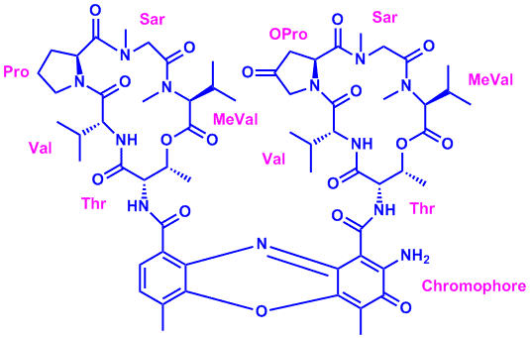

Figure S14. ¹H-NMR (500 MHz, CDCl₃) Spectrum of Transitmycin (R1)

7-H, 8-H of Chromophore
NH of β-Thr

NH of α- L- Val
NH of β-L- Val
NH of α-Thr
2H-β-Oxo-Pro
2H-α-Pro

Figure S15. Expansion of ¹H-NMR (500 MHz, CDCl₃) Spectrum of Transitmycin (R1)
3H-α-Thr
3H-β-Thr

2H-H_{b}-β-Sar
2H-β-Thr
2H-α-Thr
2H_{a}-α-Sar

Figure S16. Expansion of ¹H-NMR (500 MHz, CDCl₃) Spectrum of Transitmycin (R1)
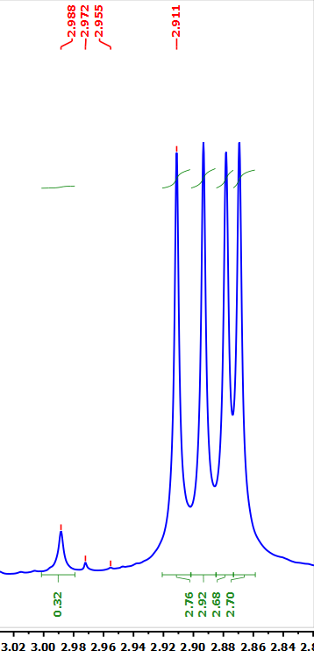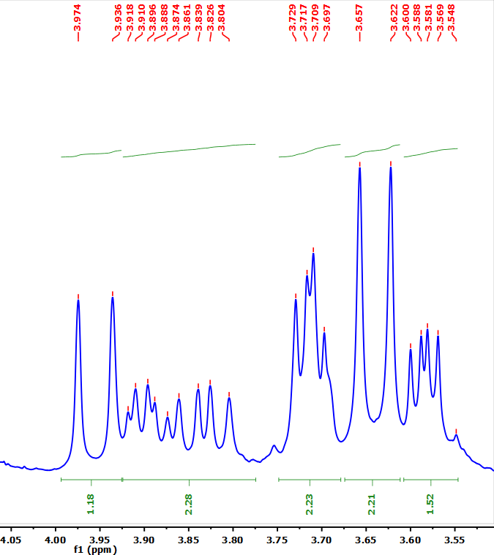
2H_{b}-β-Sar
2-H_{b}-α-Sar
4X N-Methyl of Val and N-Methyl of Sar
Expansion of ¹H-NMR (500 MHz, CDCl₃) Spectrum of Transitmycin (R1)

11-C-Methyl
3-α-Pro
2-α-Me Val
2-β-Me-Val
12-C-Methyl
3-β-Pro
4-β-Pro
3a-α-Pro

Figure S17. Expansion of ¹H-NMR (500 MHz, CDCl₃) Spectrum of Transitmycin (R1)

5-β-Val
5-α-Val
4-α-Thr
4-α-MeVal
4-β-MeVal
4-α and 4-β- Val
5-β and 5α- Me Val

Figure S18. Expansion of ¹H-NMR (500 MHz, CDCl₃) Spectrum of Transitmycin (R1)

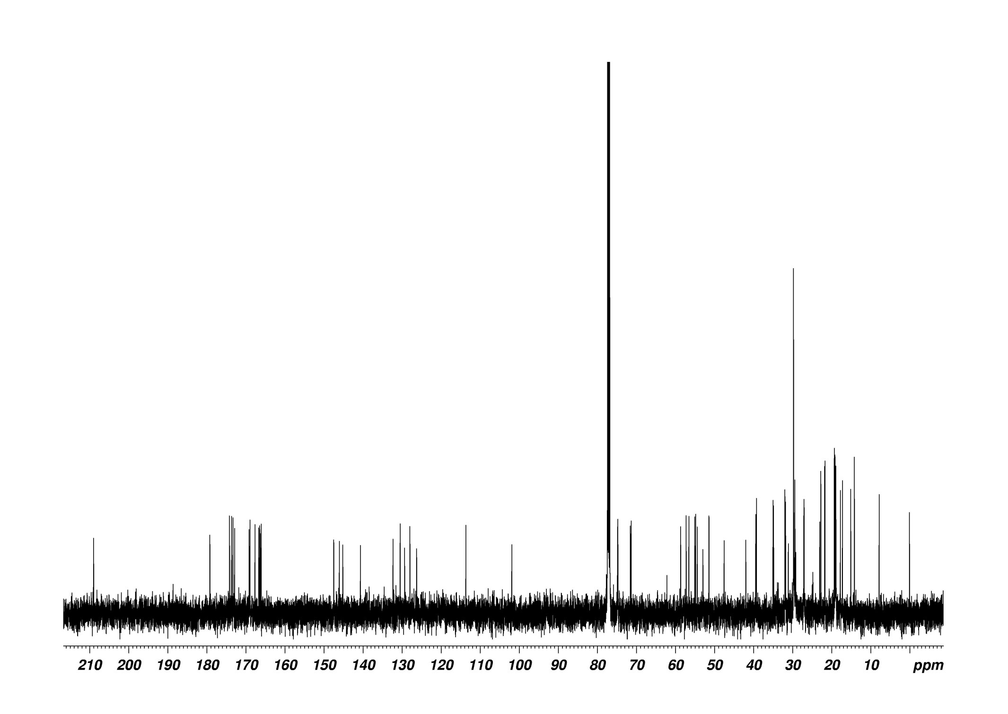
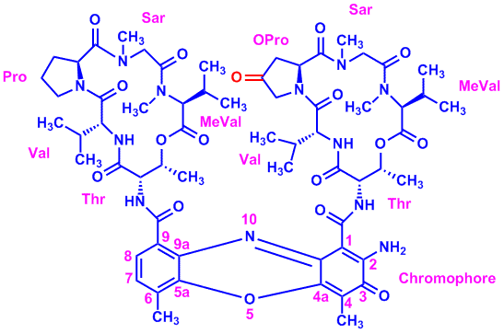
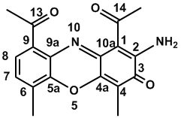
CDCl₃
C-1 of ChromophoreC-1 of Chromophore
C-4 of ChromophoreC-4 of Chromophore
C4-of ketoProlineC4-of ketoProline
C-3 of ChromophoreC-3 of Chromophore
10 amides and 2 esters10 amides and 2 esters
C-11 of ChromophoreC-11 of Chromophore
C-12 of ChromophoreC-12 of Chromophore
C-3 of ThreonineC-3 of Threonine
C-2 of methyl ValineC-2 of methyl Valine
N- Methyl methylValineN- Methyl methylValine
N- Methyl SarcosineN- Methyl Sarcosine
C3-of ketoProlineC3-of ketoProline

Chromophore

Figure S19. ¹³C-NMR (125 MHz, CDCl₃) Spectrum of Transitmycin (R1)

Figure S20. ¹³C-NMR (125 MHz, CDCl₃) Spectrum of Transitmycin (R1)

3-Chromophore
1-β-Oxo-Pro
1-β-Thr
1-α-Thr
1-α, 1-β-MeVal
1-α-Pro
1-α-Val
1-β-Val

Figure S21. ¹³C-NMR (125 MHz, CDCl₃) Spectrum of Transitmycin (R1)

7-Chromophore
9-Chromophore
2-Chromophore
1-Chromophore
4-Chromophore
5a Chromophore
4a-Chromophore
8-Chromophore
6-Chromophore
9a-Chromophore

Figure S22. ¹³C-NMR (125 MHz, CDCl₃) Spectrum of Transitmycin (R1)
3-α, 3β-Thr
2α, 2β- MeVal
2α-Val
2β-Val
2-β-Thr
2-α-Thr
2-β-Oxo-Pro
2α, 2β-Sar
5-Pro

2-α-Pro

Figure S23. ¹³C-NMR (125 MHz, CDCl₃) Spectrum of Transitmycin (R1)
3--β-Oxo-Proline
α, β,-NMe of MeVal
α , β-N-Me of Sar
3-β-, 3α-Val

Figure S24. ¹³C-NMR (125 MHz, CDCl₃) Spectrum of Transitmycin (R1)
3-α, 3β-Meval
3-α-Pro
4α, 4β-MeVal
5α, 5β-MeVal
4α, 4β-Val
5α, 5β-Val
4β-Thr
4-α-Thr
11-Chromophore
12-Chromophore

Figure S25. ¹³C-NMR (125 MHz, CDCl₃) Spectrum of Transitmycin (R1)
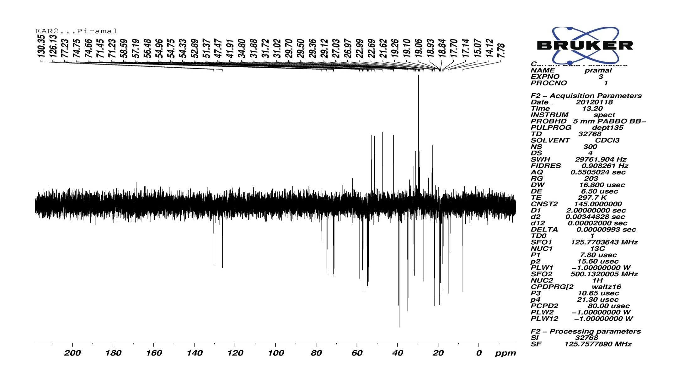

Figure S26. DEPT135 (125 MHz, CDCl₃) Spectrum of Transitmycin (R1)
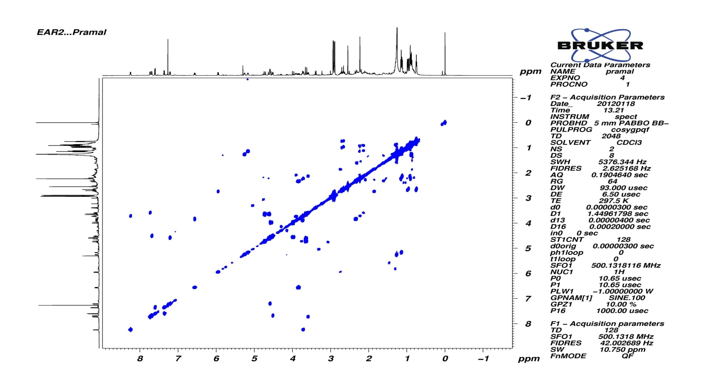
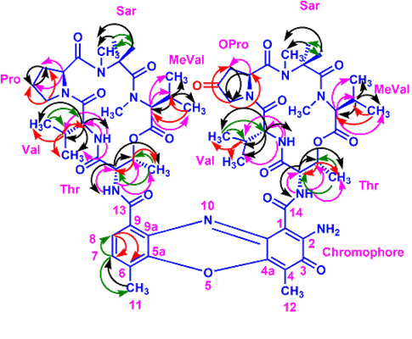

Figure S27. COSY (500 MHz, CDCl₃) Spectrum of Transitmycin (R1)
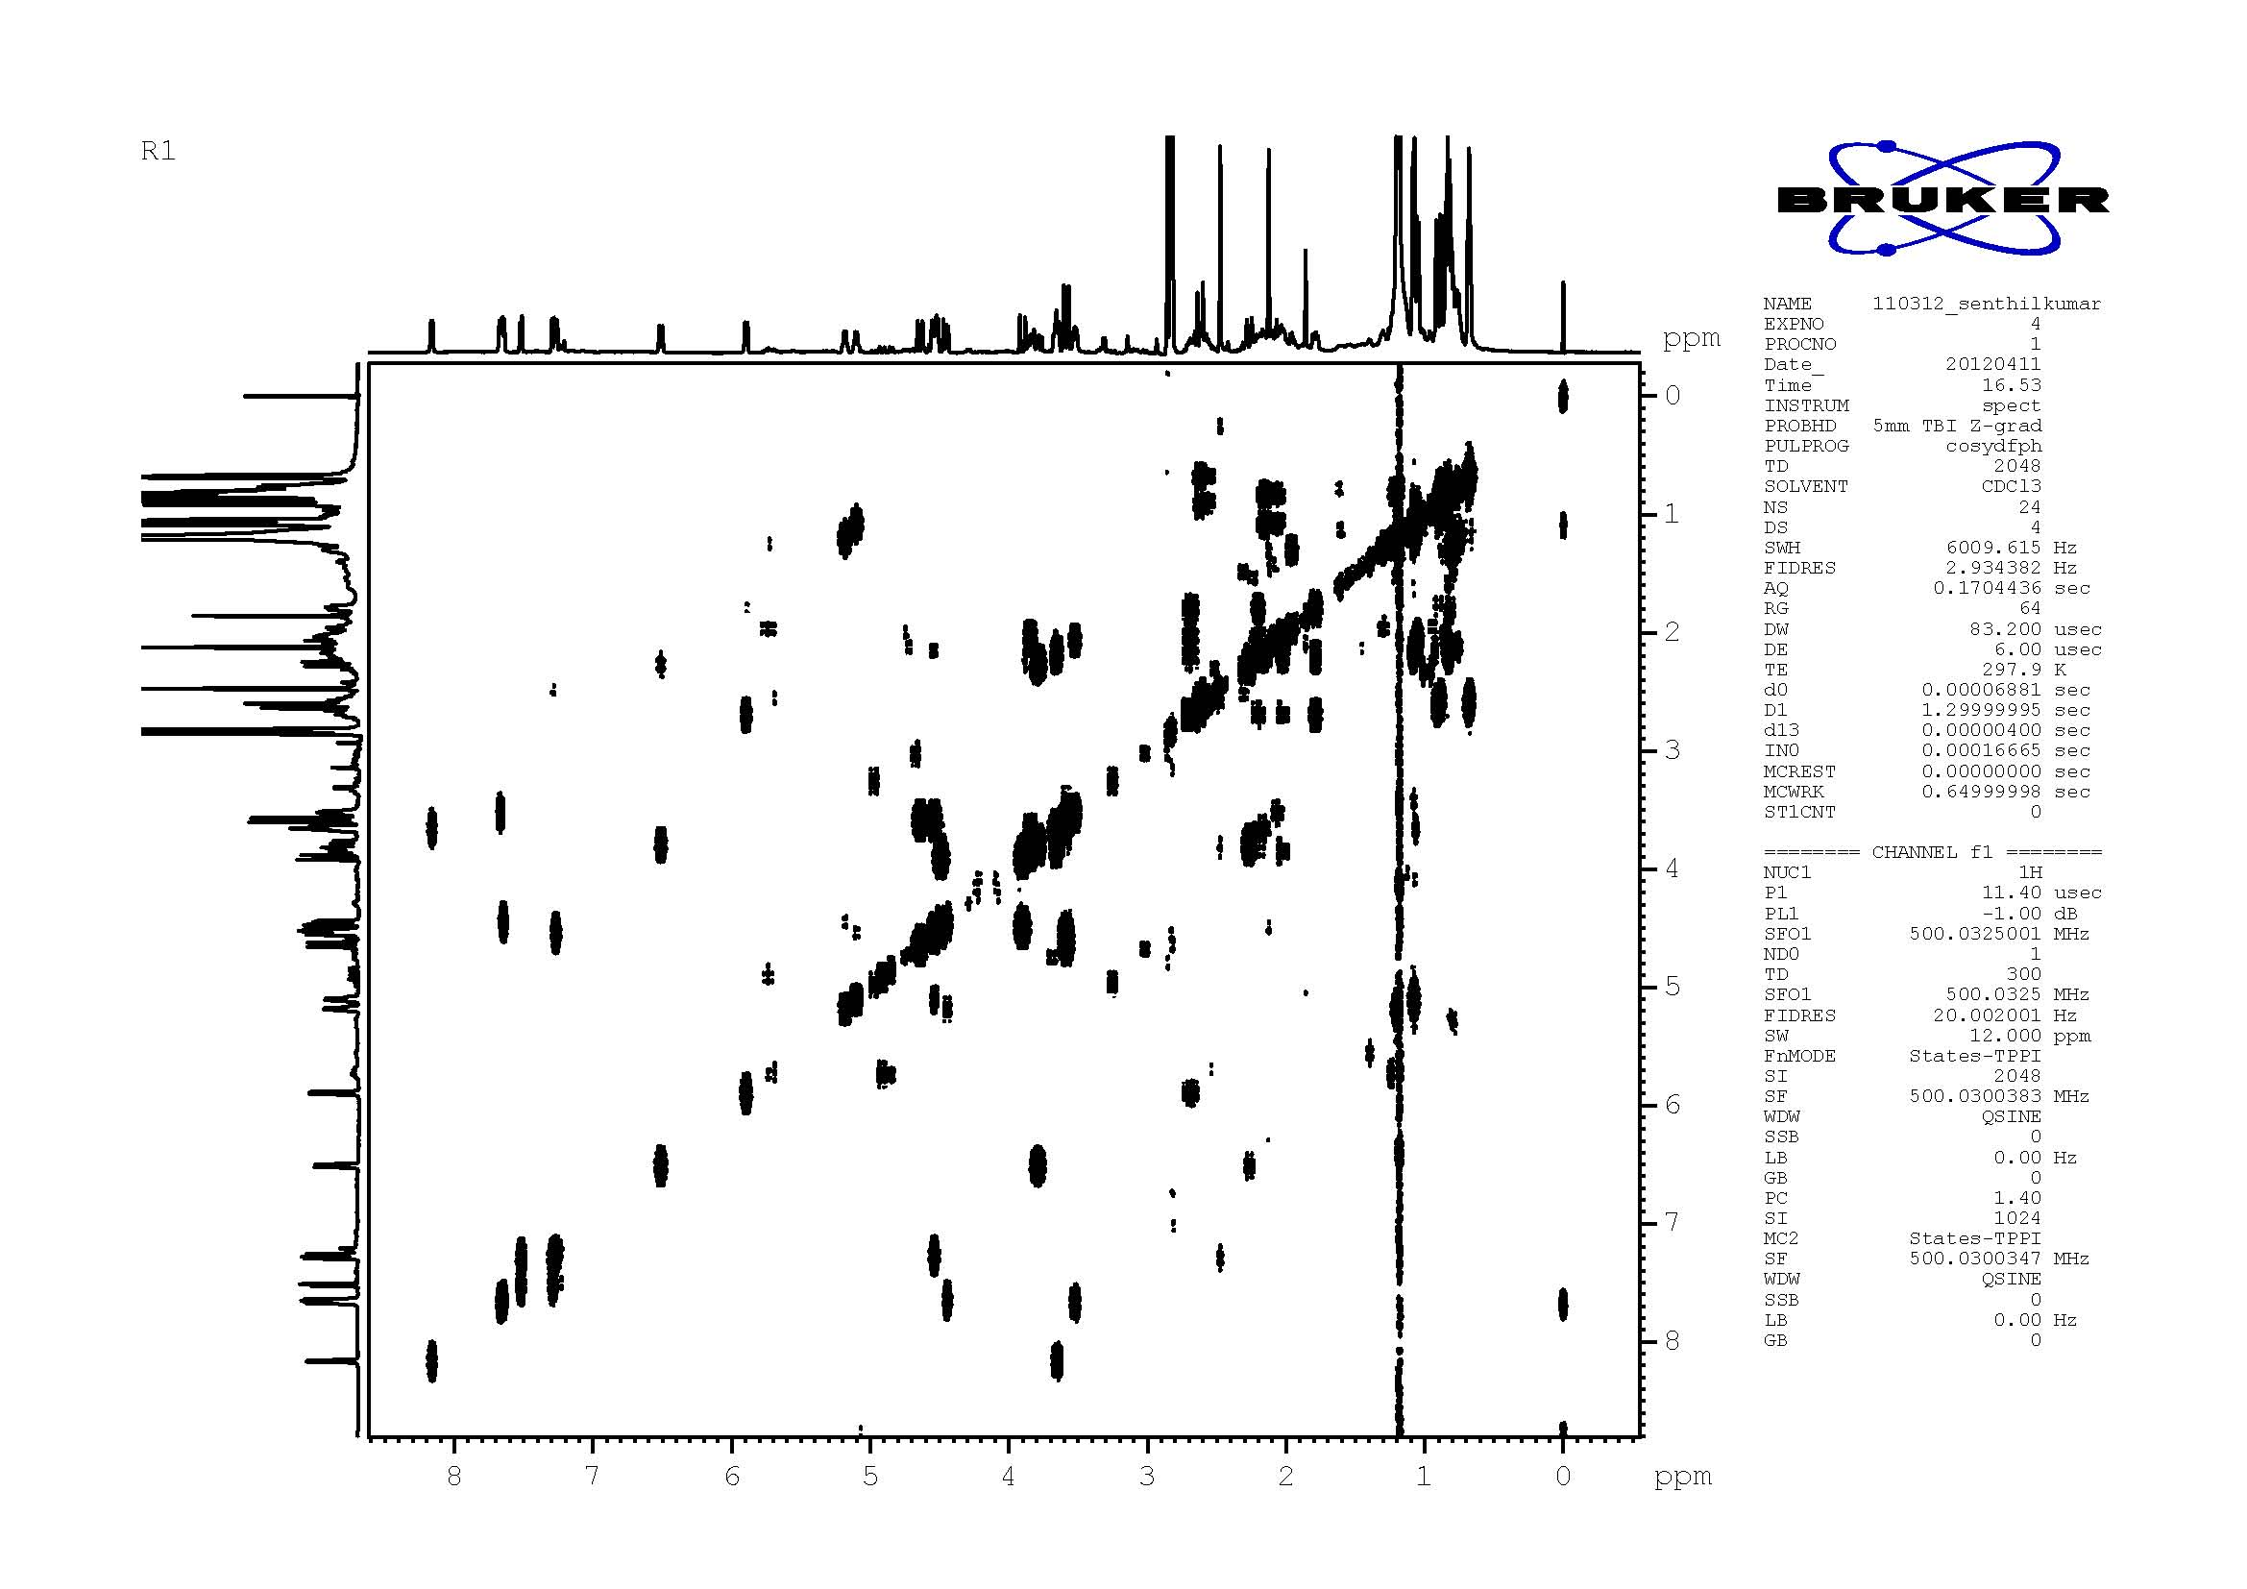
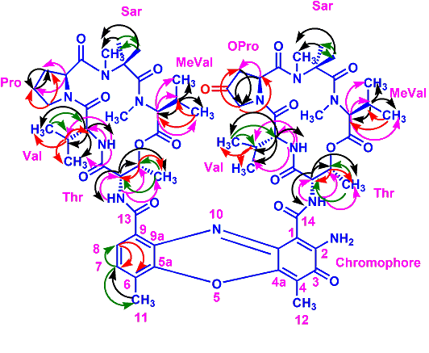

Figure S28. DQF-COSY (500 MHz, CDCl₃) Spectrum of Transitmycin (R1)

Figure S29. Expansion of DQF-COSY (500 MHz) Spectrum of Transitmycin (R1)

Figure S30. Expansion of DQF-COSY (500 MHz) Spectrum of Transitmycin (R1)

Figure S31. Expansion of DQF-COSY (500 MHz) Spectrum of Transitmycin (R1)

Figure S32. Expansion of DQF-COSY (500 MHz) Spectrum of Transitmycin (R1)

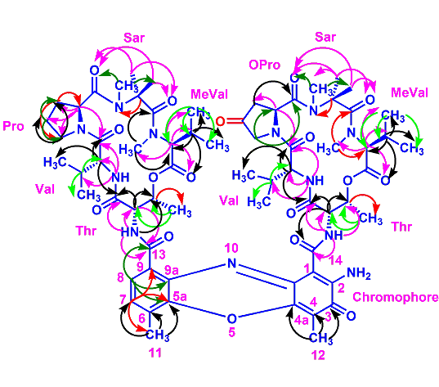
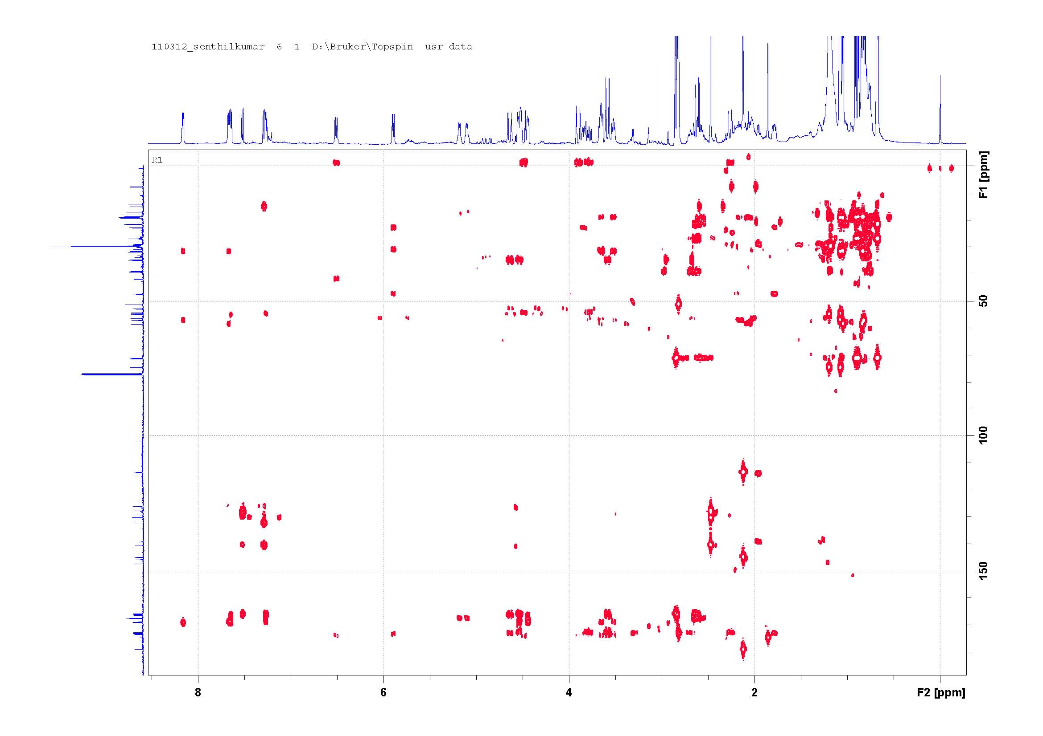

Figure 33. HMBC (500 MHz) Spectrum of Transitmycin (R1)

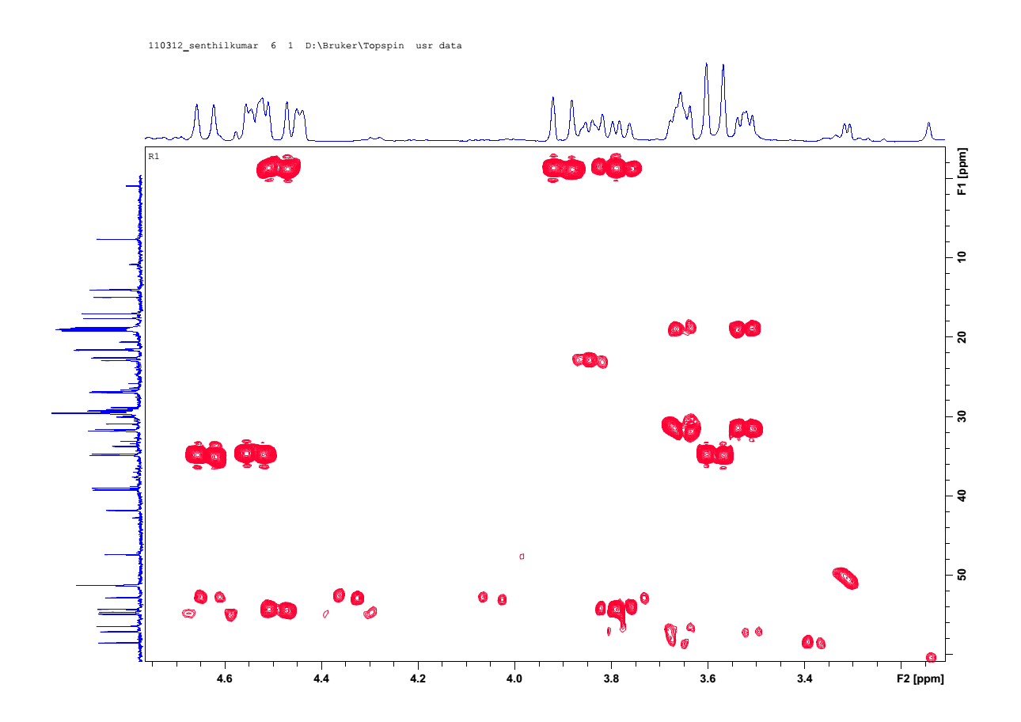

Figure S34. Expansion of HMBC (500 MHz, CDCl₃) Spectrum of Transitmycin (R1)

Figure S35. Expansion of HMBC (500 MHz, CDCl₃) Spectrum of Transitmycin (R1)

Figure S36. Expansion of HMBC (500 MHz, CDCl₃) Spectrum of Transitmycin (R1)

Figure S37. Expansion of HMBC (500 MHz, CDCl₃) Spectrum of Transitmycin (R1)

Figure S38. Expansion of HMBC (500 MHz, CDCl₃) Spectrum of Transitmycin (R1)

Figure S39. Expansion of HMBC (500 MHz, CDCl₃) Spectrum of Transitmycin (R1)

Figure S40. Expansion of HMBC (500 MHz, CDCl₃) Spectrum of Transitmycin (R1)
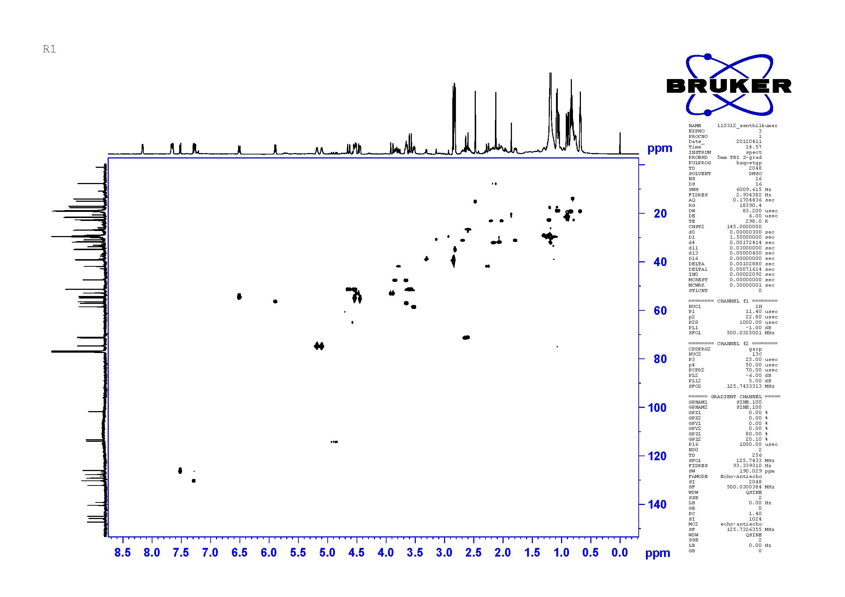

Figure S41. HSQC (500 MHz, CDCl₃) Spectrum of Transitmycin (R1)

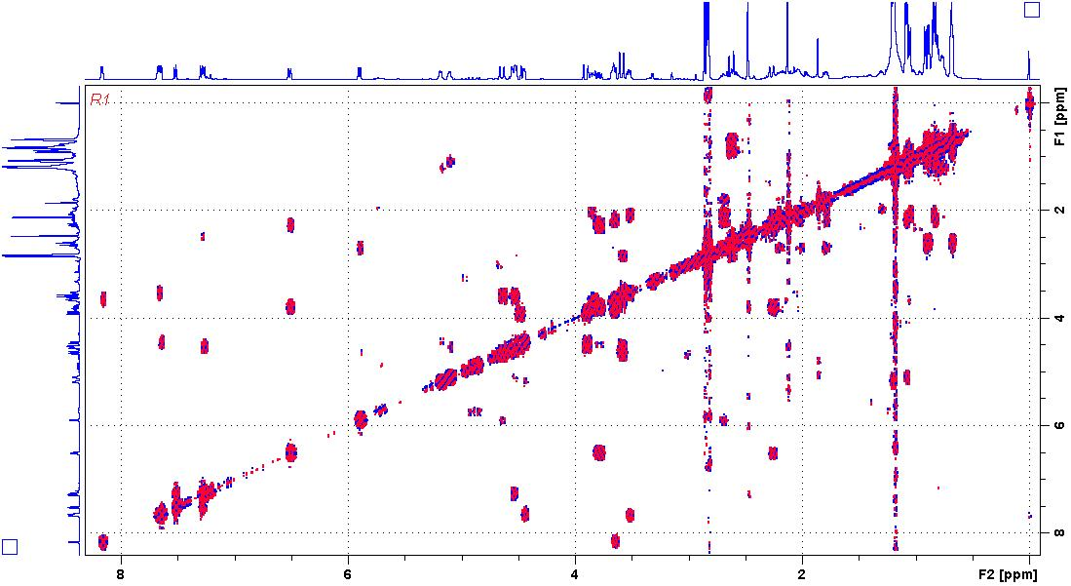
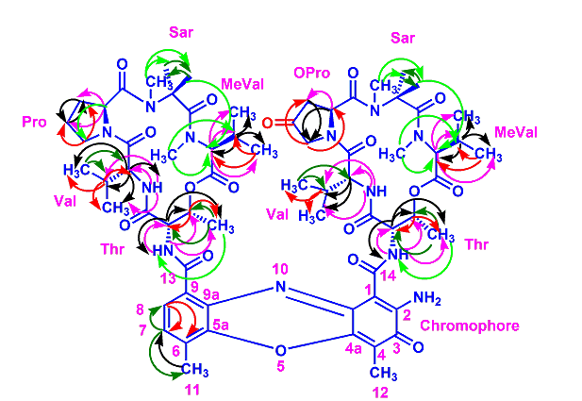
Figure S42. TOCSY (500 MHz, CDCl₃) Spectrum of Transitmycin (R1)

Figure S43. Expansion of TOCSY (500 MHz, CDCl₃) Spectrum of Transitmycin (R1)

Figure S44. Expansion of TOCSY (500 MHz, CDCl₃) Spectrum of Transitmycin (R1)

Figure S45. Expansion of TOCSY (500 MHz, CDCl₃) Spectrum of Transitmycin (R1)

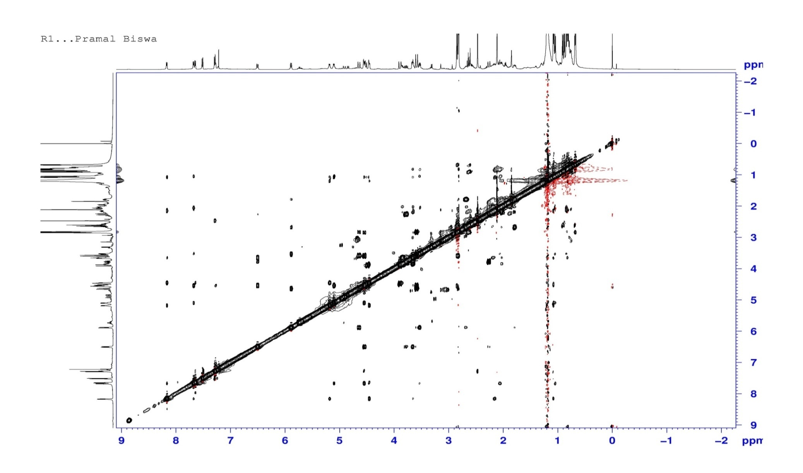

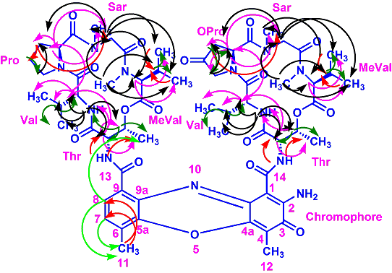
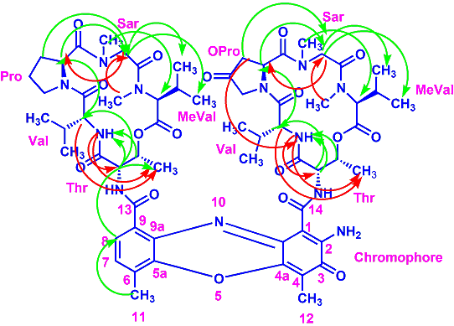

Figure S46. NOESY (500 MHz, CDCl₃) Spectrum of Transitmycin (R1)

Figure S47. Expansion of NOESY (500 MHz, CDCl₃) Spectrum of Transitmycin (R1)

Figure S48. Expansion of NOESY (500 MHz, CDCl₃) Spectrum of Transitmycin (R1)

Figure S49. Expansion of NOESY (500 MHz, CDCl₃) Spectrum of Transitmycin (R1)

Figure S50. Expansion of NOESY (500 MHz, CDCl₃) Spectrum of Transitmycin (R1)

Figure S51. Expansion of NOESY (500 MHz, CDCl₃) Spectrum of Transitmycin (R1)
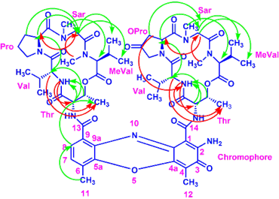
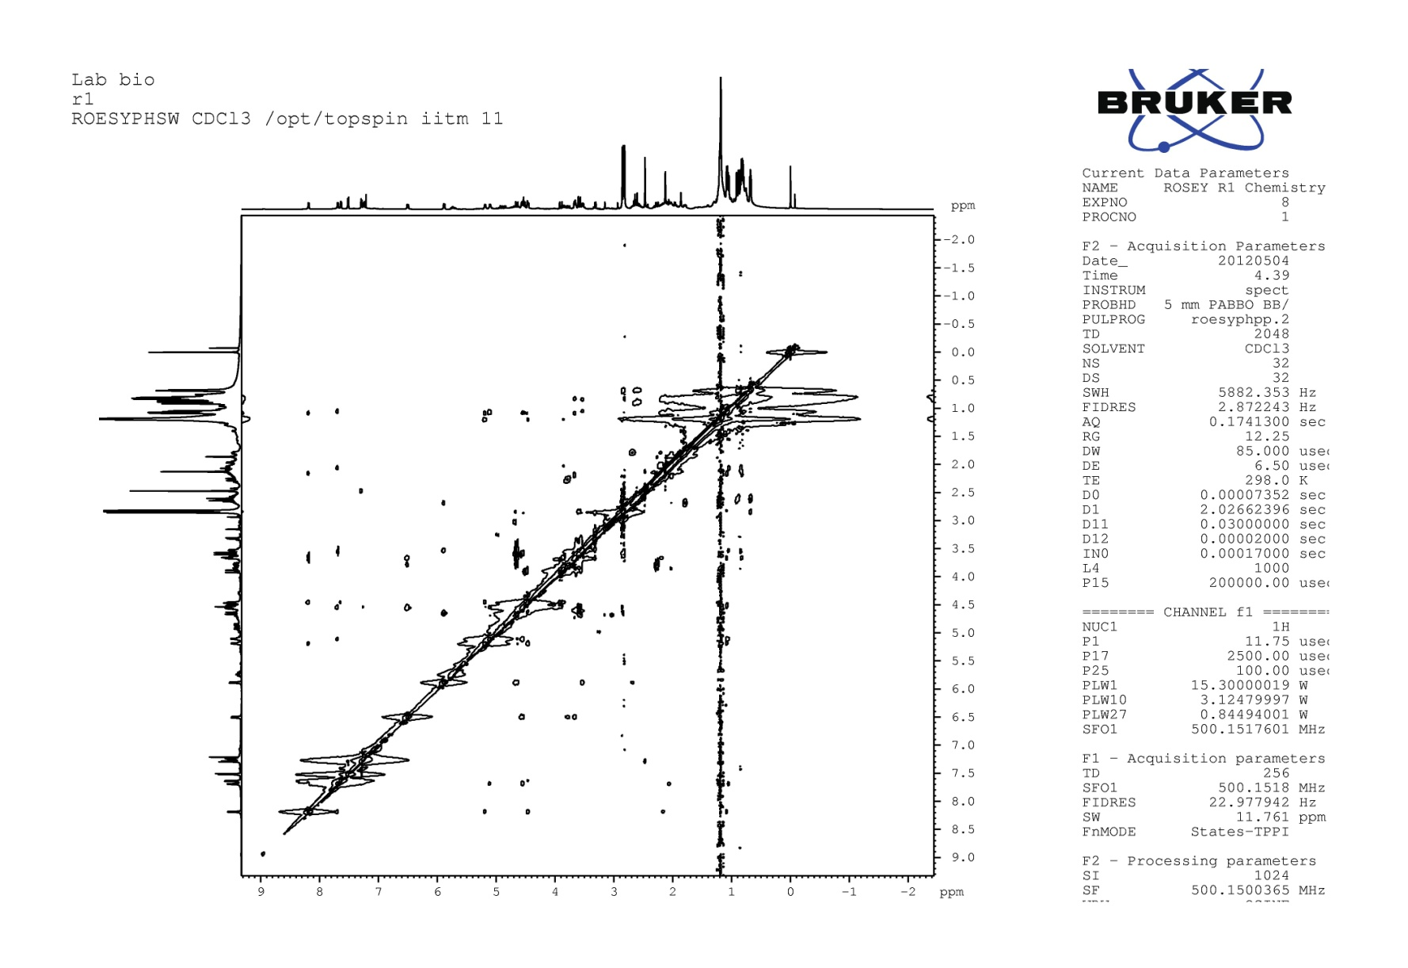

Figure S52. ROESY (500 MHz) Spectrum of Transitmycin (R1)

Table S5: NMR data of Trasitmycin (R1) in CDCl₃ (¹H: 500 MHz ¹³C: 125 MHz)
α- ring | position | δC | δH | J (Hz) | COSY | TOCSY | HMBC | ROSEY
Thr | 1 | 168.8 | -
 | 2 | 54.6 | 4.60 | d , 10.0 | 3, 4, -NH | 3, 4 | 1, 3, 13 | 3, 4, 2-Val, Val-NH
 | 3 | 74.7 | 5.13 | m | 2, 4,- NH | 2, 4, | 4 | 2, 4, Val-NH
 | 4 | 17.0 | 1.10 | d, 6.5 | 2, 3 | 2, 3, -NH | 2, 3 | 2, 3, Val-NH
 | NH | - | 7.29 | d, 7.0 | 2, 3, 4 | 2, 3, 4 | 1, 3, 13 | 2, 4
L-Val | 1 | 173.4
 | 2 | 58.7 | 3.58 | dd, 10.5,6.5 | 3, 4, 5, -NH | 3, 4, 5, -NH | 1, 5, 1-Thr | 3, 4, 5, 2-Pro
 | 3 | 31.7 | 2.08 | m | 2, 4, 5 | 2, 4, 5 | 2,5 | 4, 5, 4-Thr
 | 4 | 19.0 | 0.89 | d, 7.0 | 2, 3 | 2, 3, -NH | 2,3,5 | 2, 3, 5
 | 5 | 18.9 | 1.13 | d, 6.5 | 2, 3 | 2, 3, -NH | 2,3,4 | 2, 3, 2-Val, Val-NH
 | NH | - | 7.74 | d, 5.5 | 2, 3, 4, 5 | 2, 3, 4, 5 | 2, 3, 1-Thr | 2, 3, 4, 5  2- Thr, 3-Thr
Pro | 1 | 173.1 | -
 | 2 | 56.4 | 5.93 | d, 9.5 | 3a,3b,4a,4b | 3a,3b 4a, 4b | 3, 4, 5,  1-Val | 3a, 3b,  2a-Sar,2b-Sar, Sar-NMe
 | 3 | 31.6 | 2.73  1.84 | dd, 17.5,7.0  dd, 19.5, 6.5 | 3b, 4a, 4b  3a, 4a, | 3b, 4a, 4b  3a, 4a, | 1, 2, 4  1, 4, 5 | 3b, 2a-Sar, 2b-Sar  3a, 4a, 4b
 | 4 | 23.3 | 2.26  2.01 | d, 16.5  d, 8.0 | 3a, 3b, 4b  3b, 4a | 3a, 3b, 4b  3b, 4a | 3, 5  3, 5 | 4b, 5a, 5b  4a, 5a
 | 5a  5b | 47.8 | 3.86  3.67 | d, 18.5  d, 18.5 | 3a, 4a, 4b  3a, 4a, 4b | 3a, 4a, 4b  3a, 4a, 4b | 4, 1-Val | 5b
Sar | 1 | 166.2 | -
 | 2 | 51.2 | 2a, 4.70  2b, 3.64 | d, 17.5  d, 17.5 | 2b  2a | 2b, NMe  2a, NMe | 1, NMe,1-pro  1, NMe,1-Pro | 2b, NMe, 2-Pro  4-MeVal,  5-MeVal, NMe
 | N-Me | 34.9 | 2.87 | s |  | 2a, 2b | 2, 1-Pro | 2b, 3-MeVal
MeVal | 1 | 167.4 | -
 | 2 | 71.3 | 2.70 | d, 9.0 | 3, 4, 5 | 3, 4, 5 | 1, 3,4,NMe | 4, 5
 | 3 | 26.9 | 2.62 | d, 7.0 | 2, 4, 5 | 2, 4, 5 | 1, 3, 4, 5, NMe | 4, 5
 | 4 | 21.6 | 0.96 | d, 6.0 | 2, 3 | 2, 3, 5 | 2, 3, 5 | 3
 | 5 | 19.2 | 0.72 | d, 6.5 | 2, 3 | 2, 3, 4 | 2, 3, 4 | 3
 | N-Me | 39.2 | 2.89 | s | - | 2, 3 | 2, 1-Sar | 2, 3, 5, 2a-Sar,  2b-Sar

β- ring | position | δC | δH | J (Hz) | COSY | TOCSY | HMBC | NOESY
Thr | 1 | 168.9 | -
 | 2 | 54.9 | 4.50 | d, 9.0 | 3,4, -NH | 3, 4 | 1, 3, 14 | 3, 4, 2-Val, Val-NH
 | 3 | 74.6 | 5.23 | m | 2,4,- NH | 2, 4 | 4 | 2,4, Val-NH
 | 4 | 17.6 | 1.20 | d, 6.0 | 2, 3 | 2, 3, - NH | 2, 3 | 2,3, Val-NH
 | NH | - | 7.68 | d, 6.0 | 2, 3, 4 | 2, 3, 4 | 1, 3, 14 | 2, 4
L-Val | 1 | 173.9 | -
 | 2 | 57.1 | 3.71 | dd, 10.5, 6.5 | 3, 4, 5, -NH | 3, 4, 5, -NH | 1, 3, 5, 1-Thr, | 3, 4, 5, 2-Oxo pro
 | 3 | 31.8 | 2.20 | m | 2, 4, 5 | 2, 4, 5 | 2, 5 | 4, 5, 4-Thr
 | 4 | 19.0 | 0.86 | d, 7.0 | 2, 3 | 2, 3, -NH | 2, 3, 5 | 2, 3, 5
 | 5 | 18.8 | 1.14 | d, 7.0 | 2, 3 | 2, 3, -NH | 2, 3, 4 | 2, 3, 2-Val, Val-NH
 | NH |  | 8.23 | d, 6.0 | 2, 3, 4, 5 | 2, 3, 4, 5 | 2, 3, 1-Thr | 2, 3, 4, 5  2-Thr, 3-Thr
Oxo-Pro | 1 | 172.7 | -
 | 2 | 54.2 | 6.55 | dd, 10.0, 2.0 | 3, 5 | 3, 5 | 3, 1-Val | 3, 5  2a-Sar, 2b-sar  NMe
 | 3 | 41.8 | 2.32  2.13 | d , 18.5  d, 13.0 | 2, 5  2, 5 | 2, 5  2, 5 | 1  1 | 2, 5  2, 5
 | 4 | 208.0 | - | - |  |  | -
 | 5 | 53.7 | 3.83  3.90 | d, 18.5  dd, 18.5 12.0 | 2, 3  2, 3 | 2, 3  2, 3 | 1, 2  1, 2 | 2, 3  2, 3
Sar | 1 | 166.4
 | 2 | 51.28 | 2a, 4.54  2b, 3.95 | d, 19.5  d, 19.0 | 2b  2a | 2b, NMe  2a, NMe | 1, NMe, 1-Pro  1, NMe, 1-Pro | 2b, NMe, 2- oxopro  4-MeVal , 5-MeVal, NMe
 | N-Me | 34.7 | 2.88 | s |  | 2a, 2b | 2, 1-Pro | 2b, 2MeVal
MeVal | 1 | 167.4 | - | -
 | 2 | 71.1 | 2.67 | d, 8.5 | 3, 4, 5 | 3, 4, 5 | 1, 3, 4, 5, NMe | 4, 5
 | 3 | 26.8 | 2.60 | d, 8.0 | 2, 4, 5 | 2, 4, 5 | 1, 3, 4, 5, NMe | 4, 5
 | 4 | 21.5 | 0.93 | d, 6.0 | 2, 3 | 2, 3, 5 | 2, 3, 5 | 3
 | 5 | 19.1 | 0.73 | d, 6.0 | 2, 3 | 2, 3, 4 | 2, 3, 4 | 3
 | N-Me | 39.0 | 2.91 | s | - | 2, 3 | 2, 1- Sar | 2, 5, 2a-Sar, 2b-Sar
^{Chromophore}
Position | δC | δH | J (Hz) | COSY | TOCSY | HMBC | NOESY
1 | 101.8 | -
2 | 147.3 | -
3 | 179.0 | -
4  4a | 113.4  144.9 | -
5  5a | -  140.3
6 | 127.6 | -
7 | 130.2 | 7.34 | d, 8.0 | 8, 11 | 8, 11 | 5a, 9, 11-Me | 11
8 | 126.0 | 7.56 | d, 7.5 | 7, 11 | 7, 11 | 9a, 5a, 13 | 11
9  9a | 132.1  128.4 | -  -
10 | - | -
11 | 14.9 | 2.52 | s | 7, 8 | 7, 8 | 5a, 6, 7 | 7, 8
12 | 7.6 | 2.18 | s | - | - | 3, 4, 4a | -
13 | 166.0 | -
14 | 165.8 | -

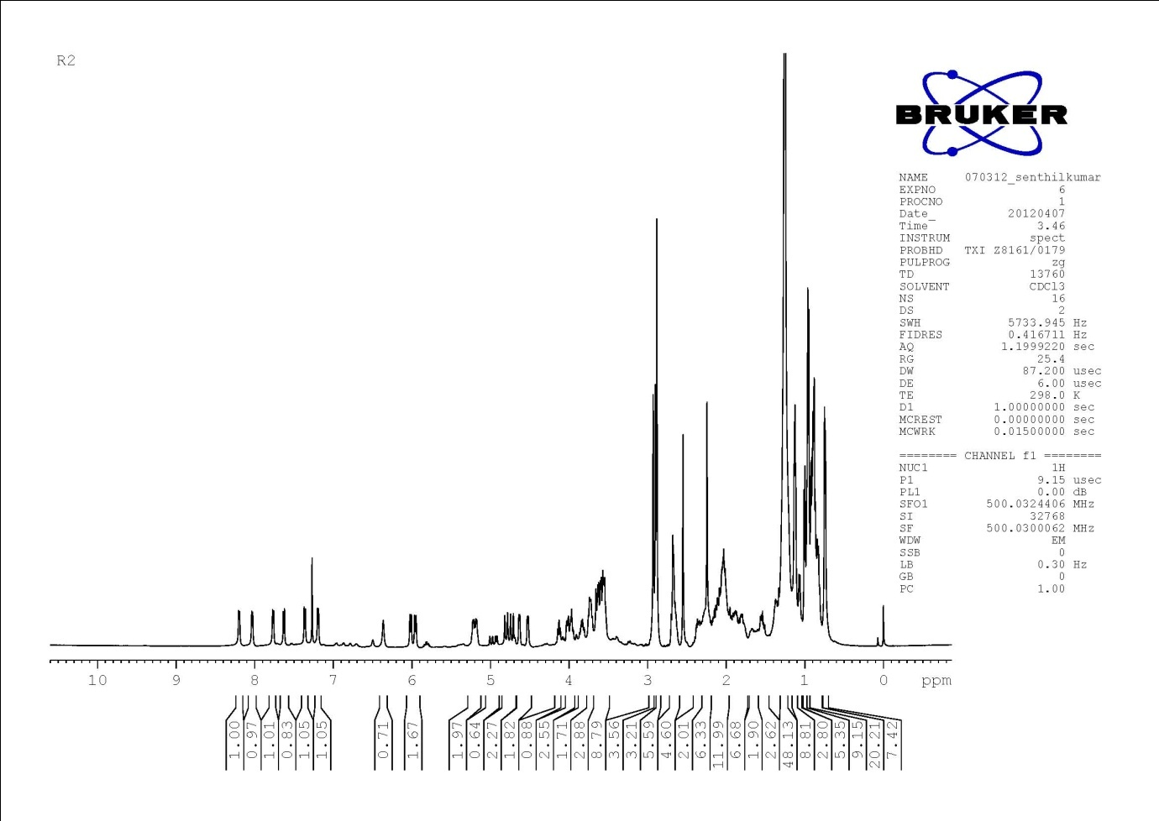
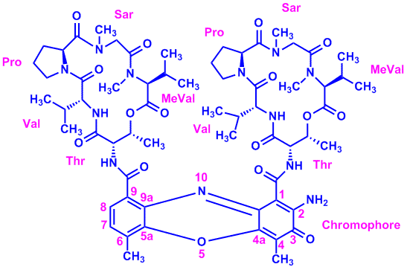

Figure S53. ^{1H}-NMR (500 MHz, CDCl₃) Spectrum Of Compound R2
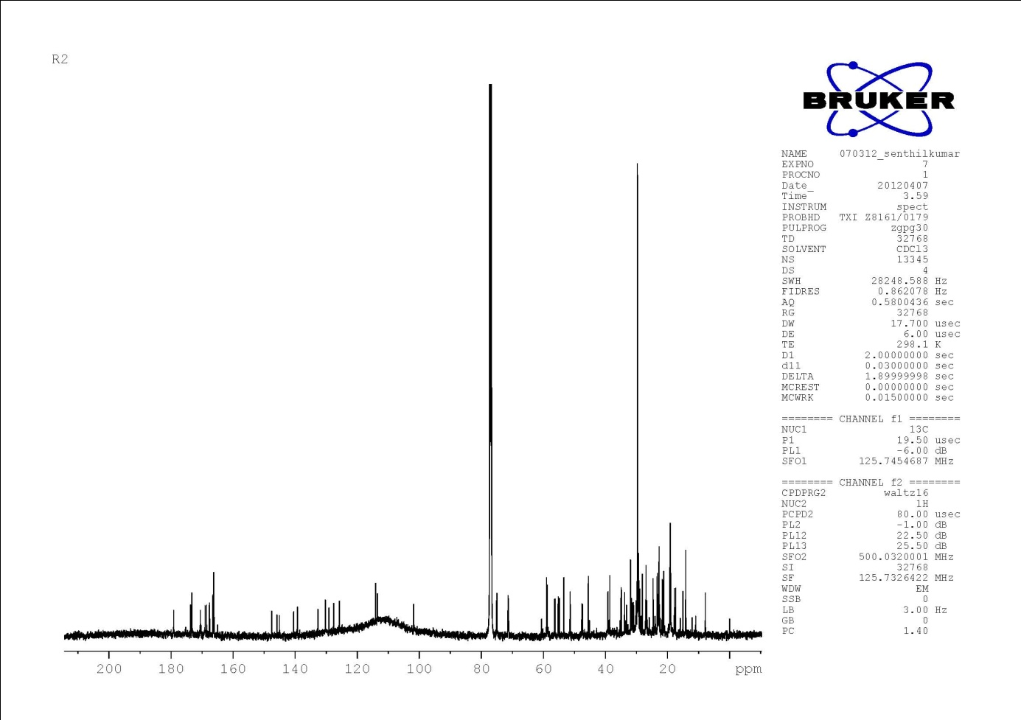

Figure S54. ¹³ C NMR (125 MHz, CDCl₃) Spectrum Of Compound R2

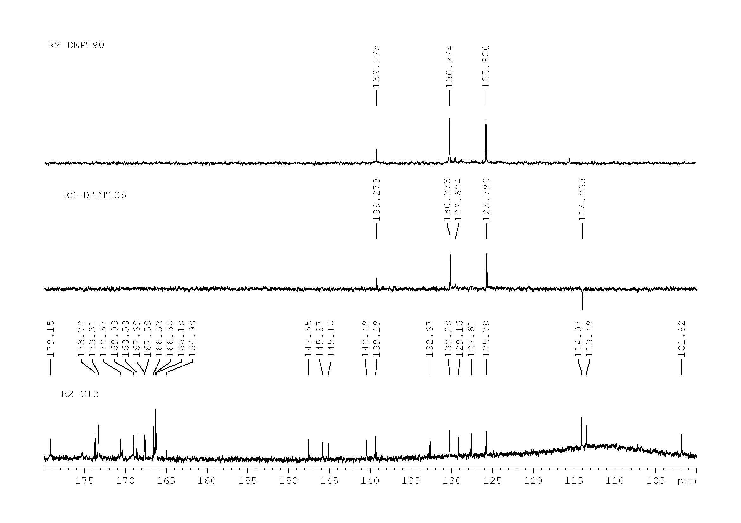

Figure S55. DEPT135&90 (125 MHz, CDCl₃) Spectrum of Compound R2

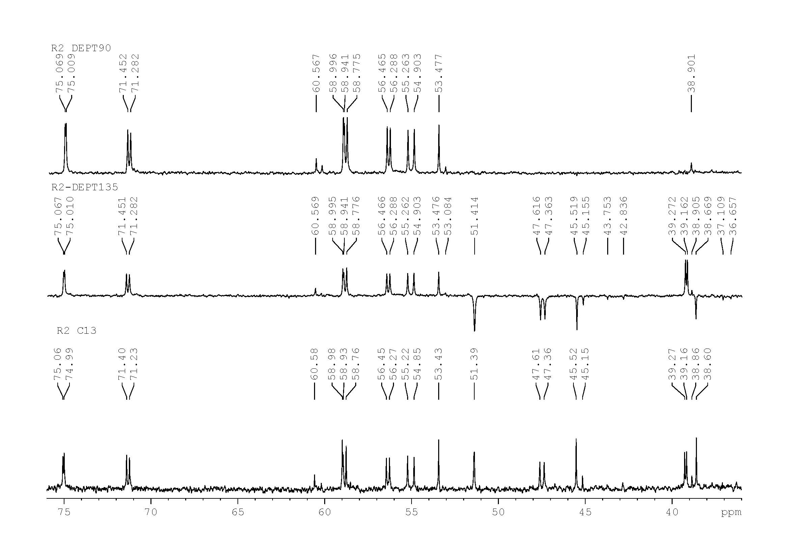

Figure S56. Expansion of DEPT135 &90 (125 MHz, CDCl₃) Spectrum of Compound R2

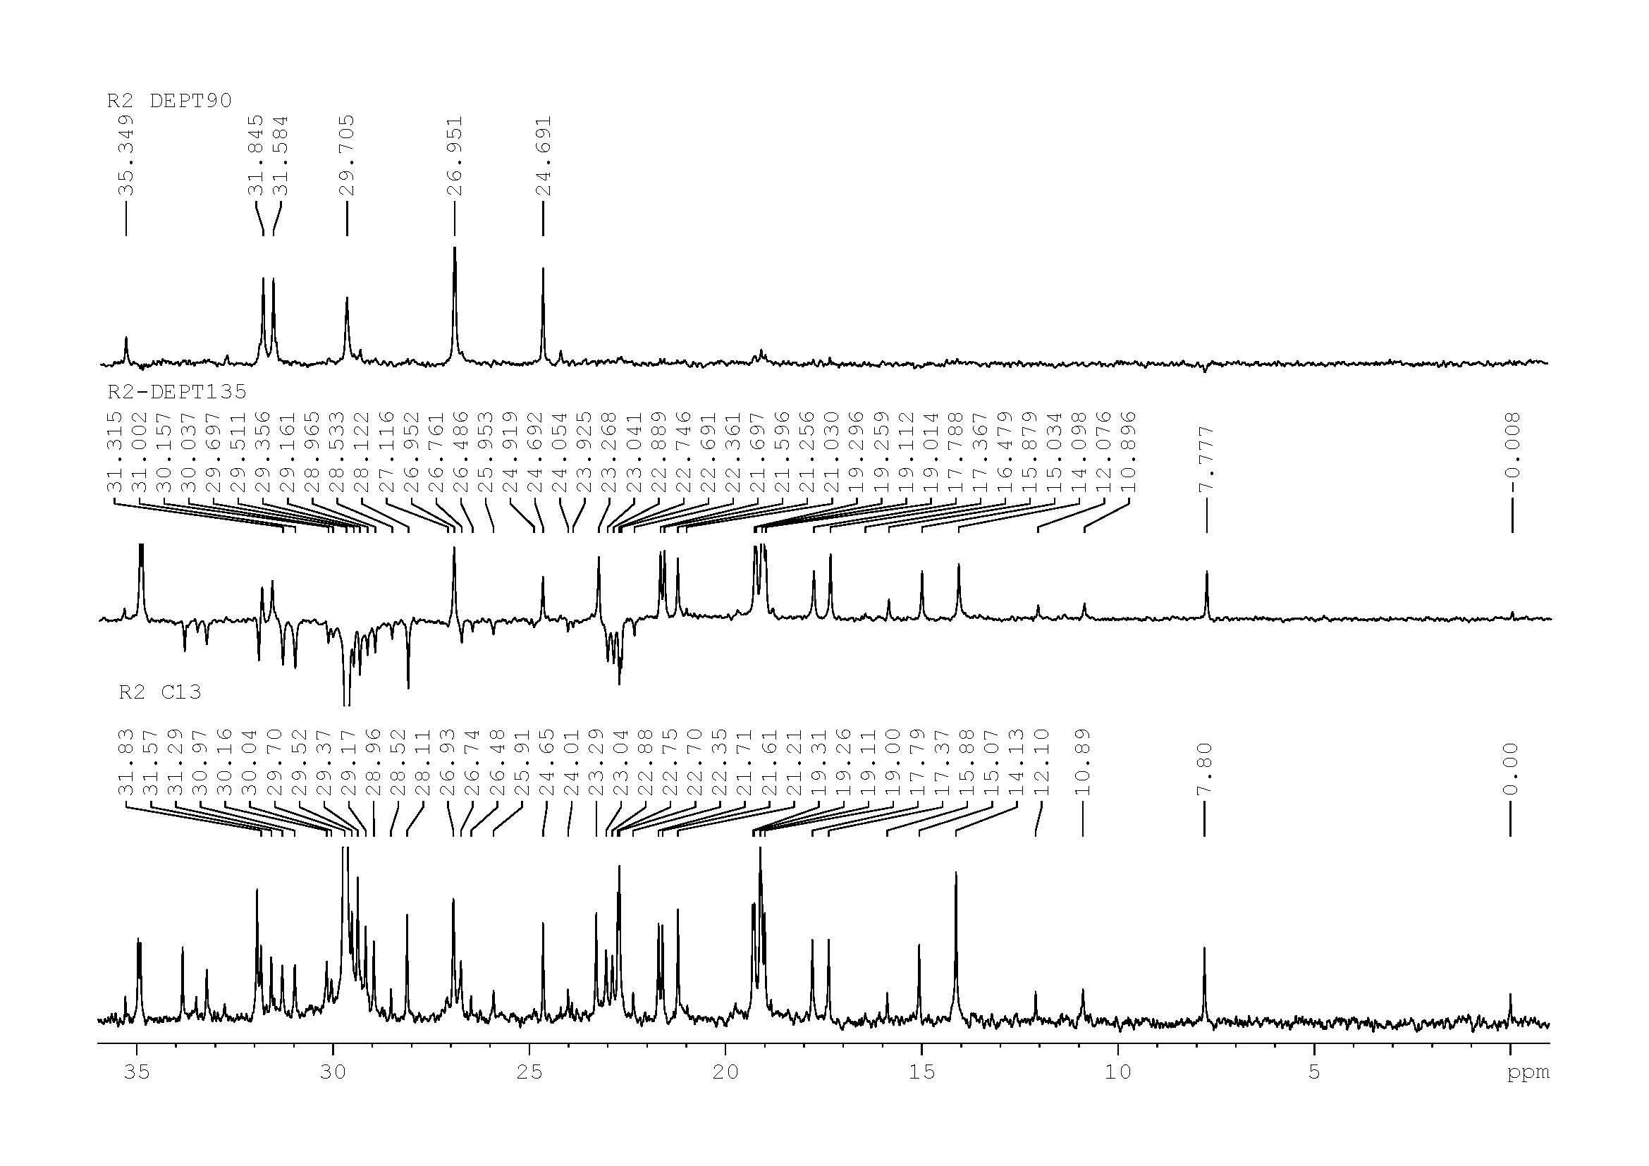

Figure S57. Expansion of DEPT135 &90 (125 MHz, CDCl₃) Spectrum of Compound R2

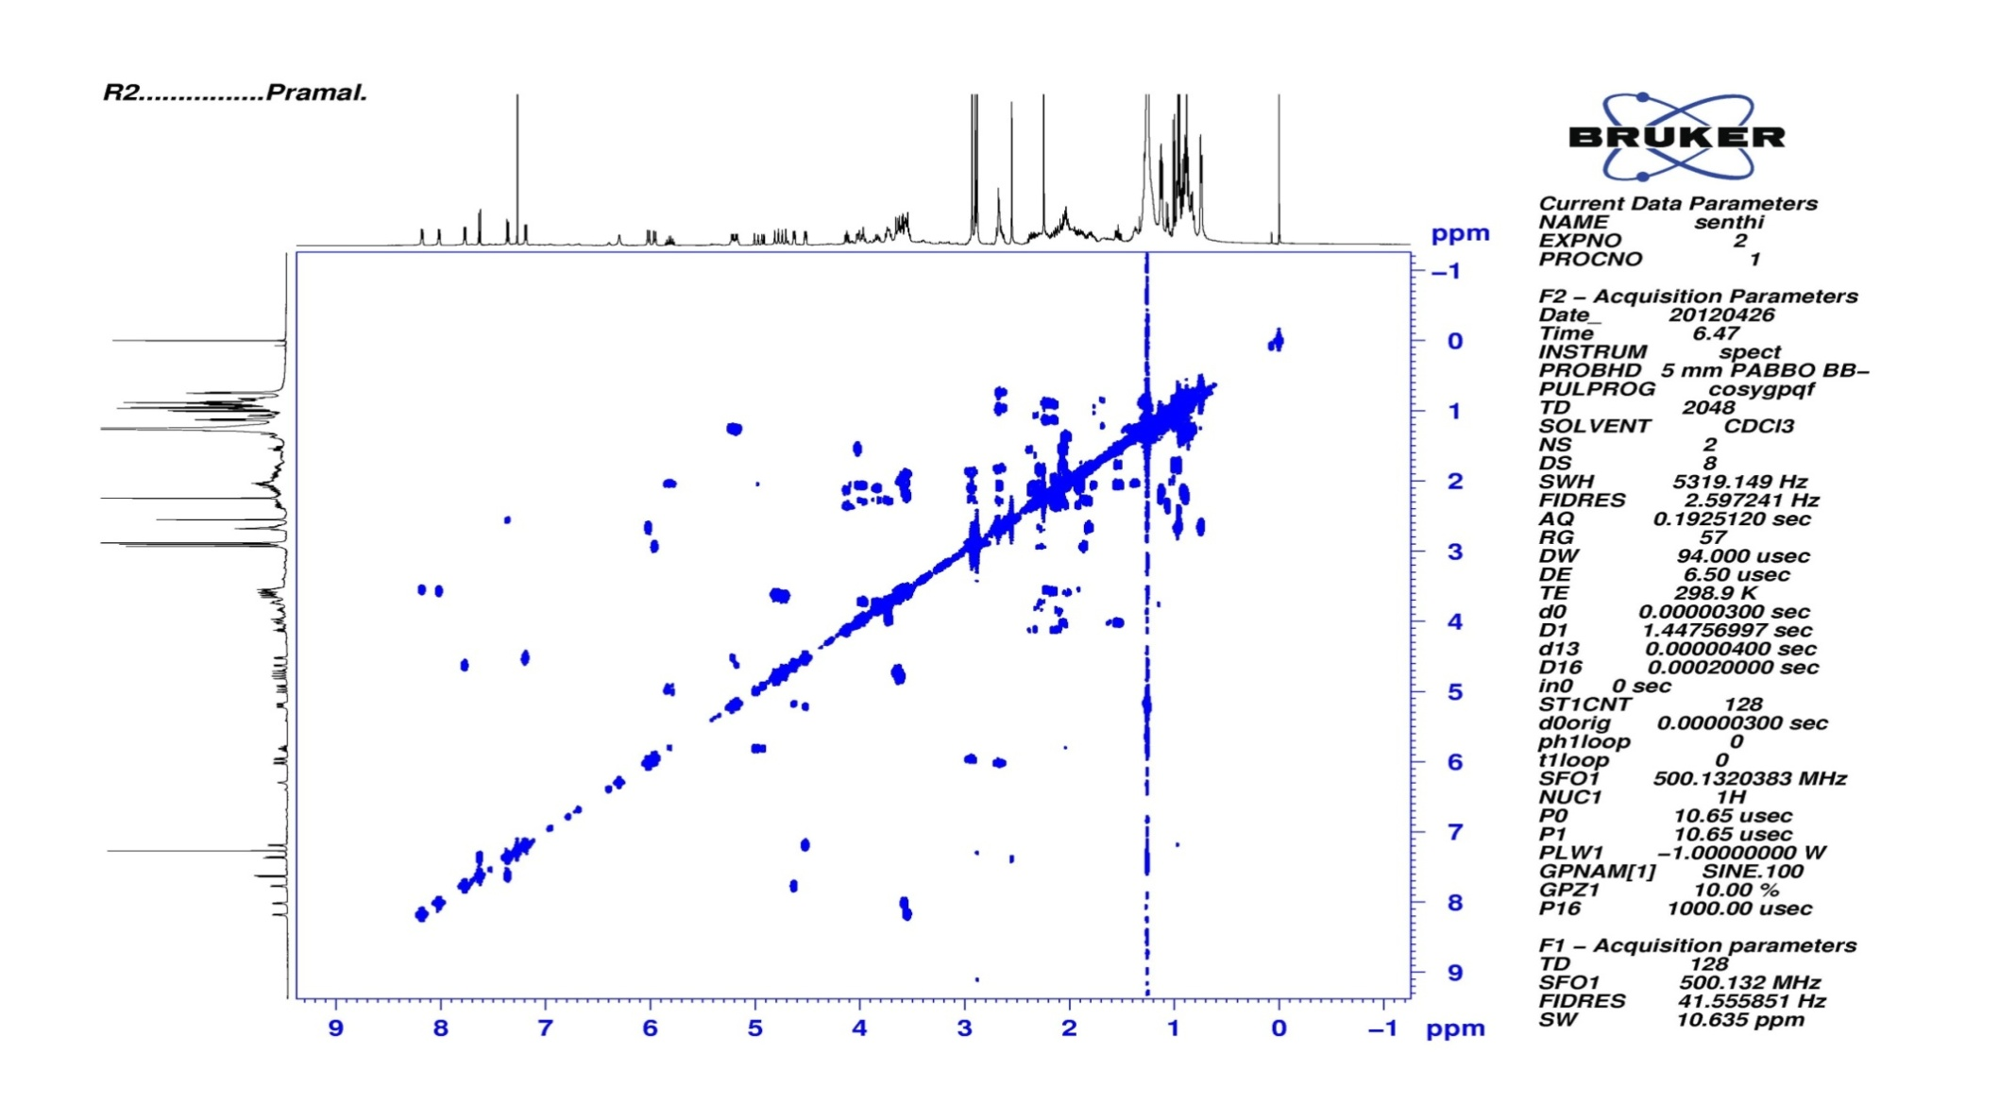

Figure S58. COSY (500 MHz) Spectrum of Compound R2

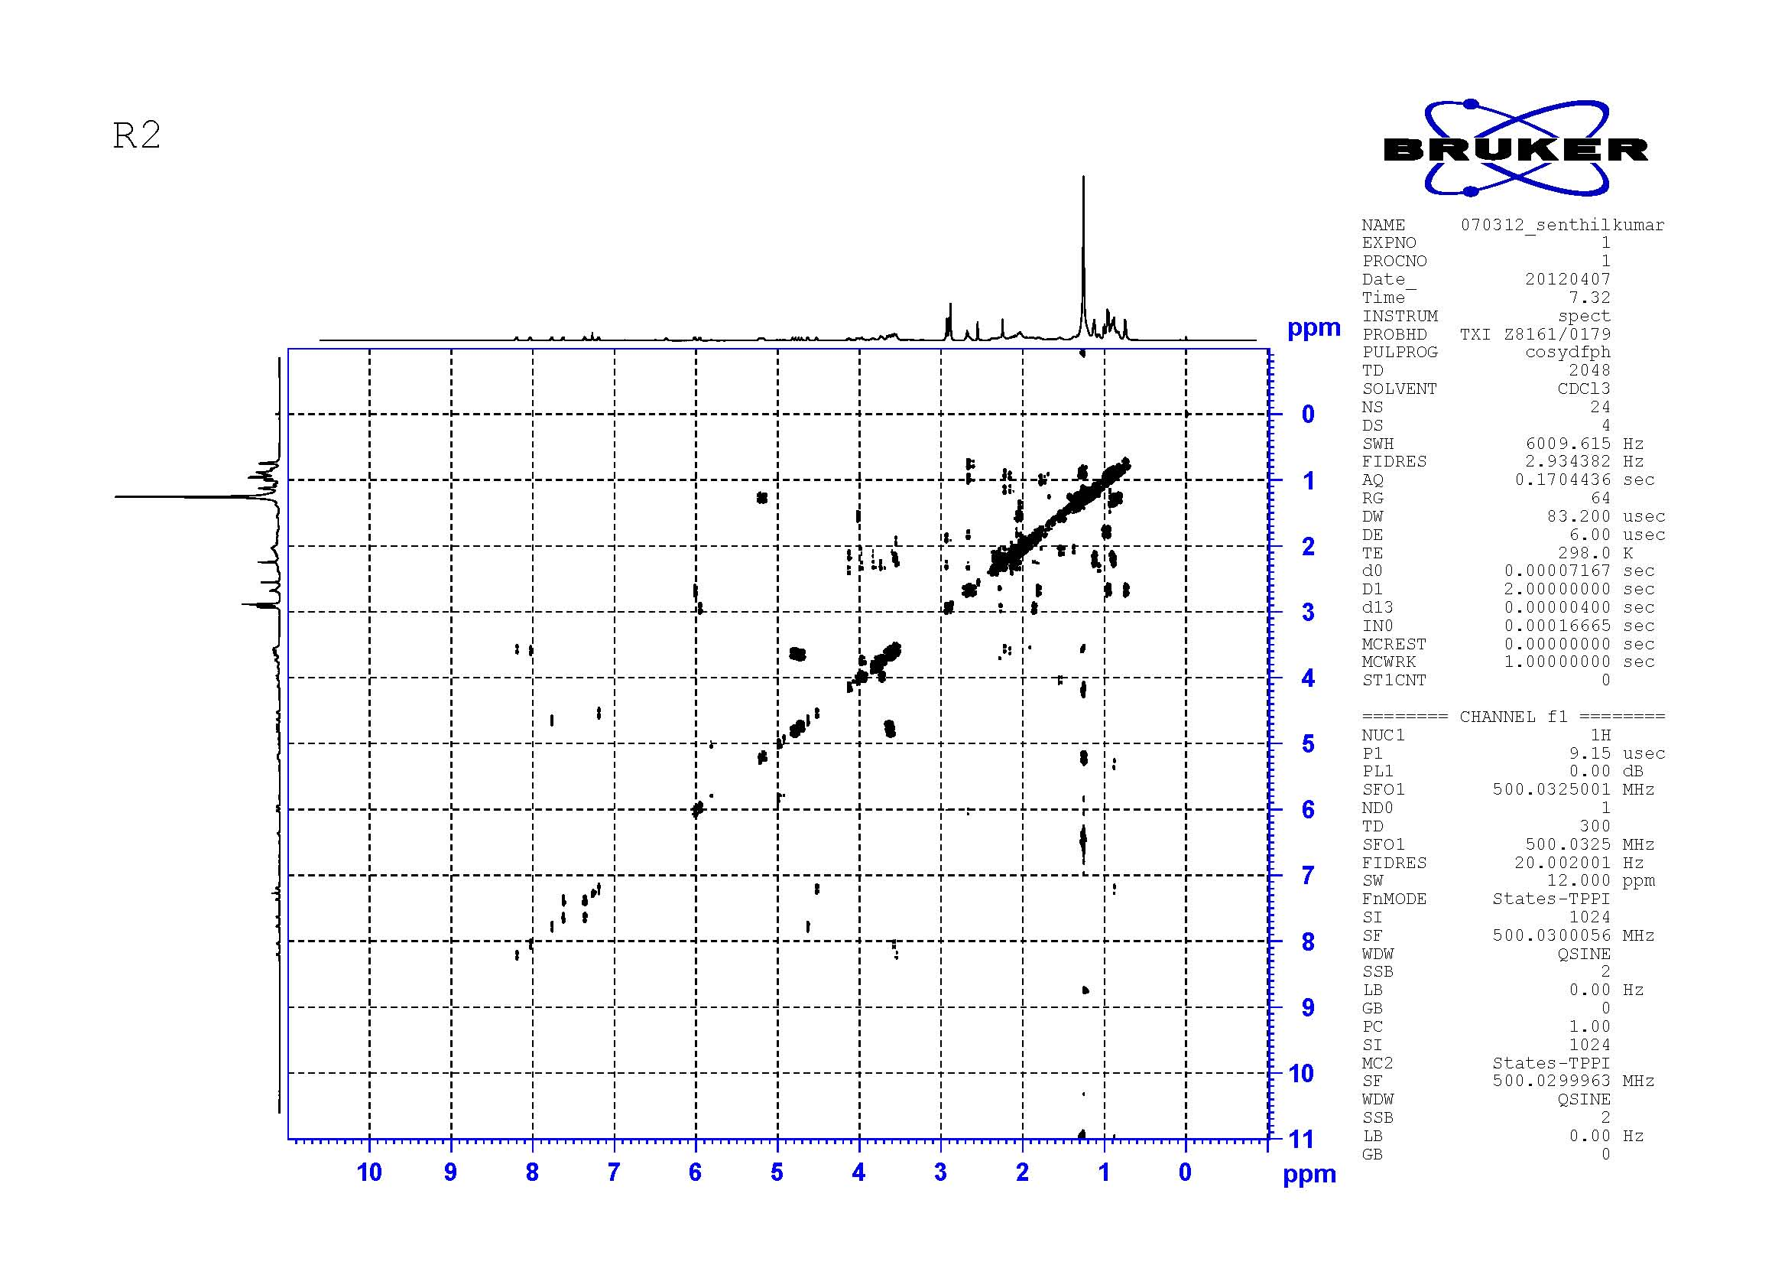

Figure S59. DQF-COSY (500 MHz) Spectrum of Compound R2

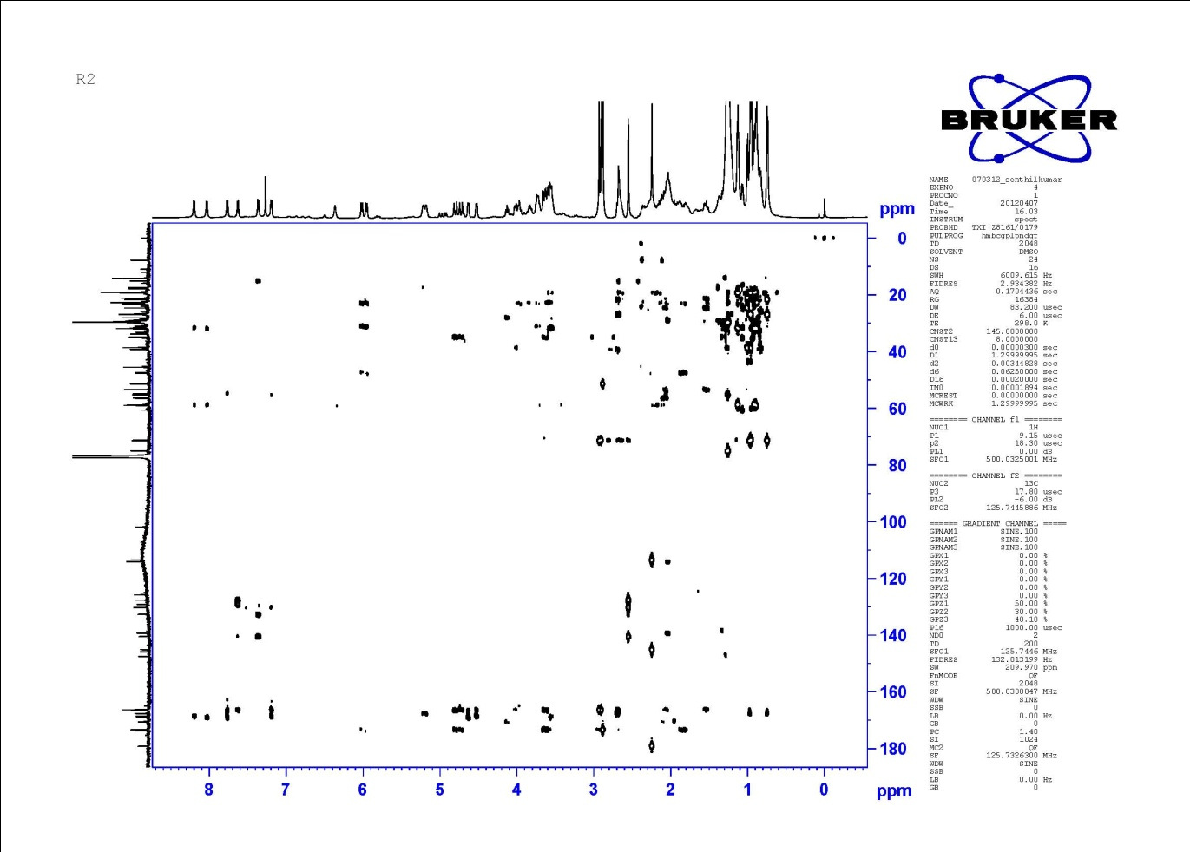
Figure S60. HMBC (500 MHz) Spectrum Compound of R2
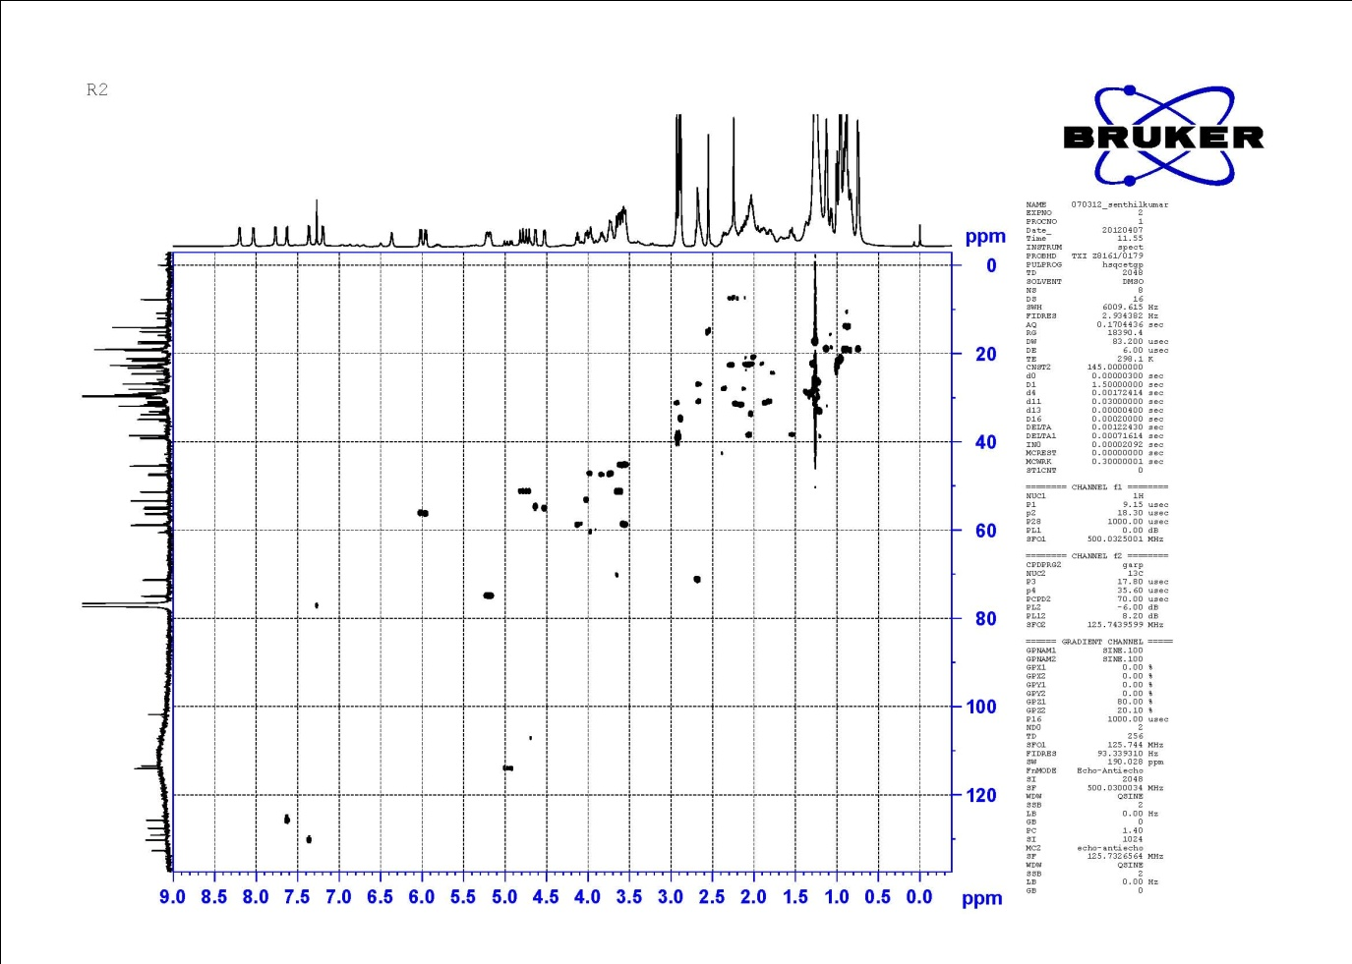

Figure S61. HSQC (500 MHz) Spectrum of Compound R2
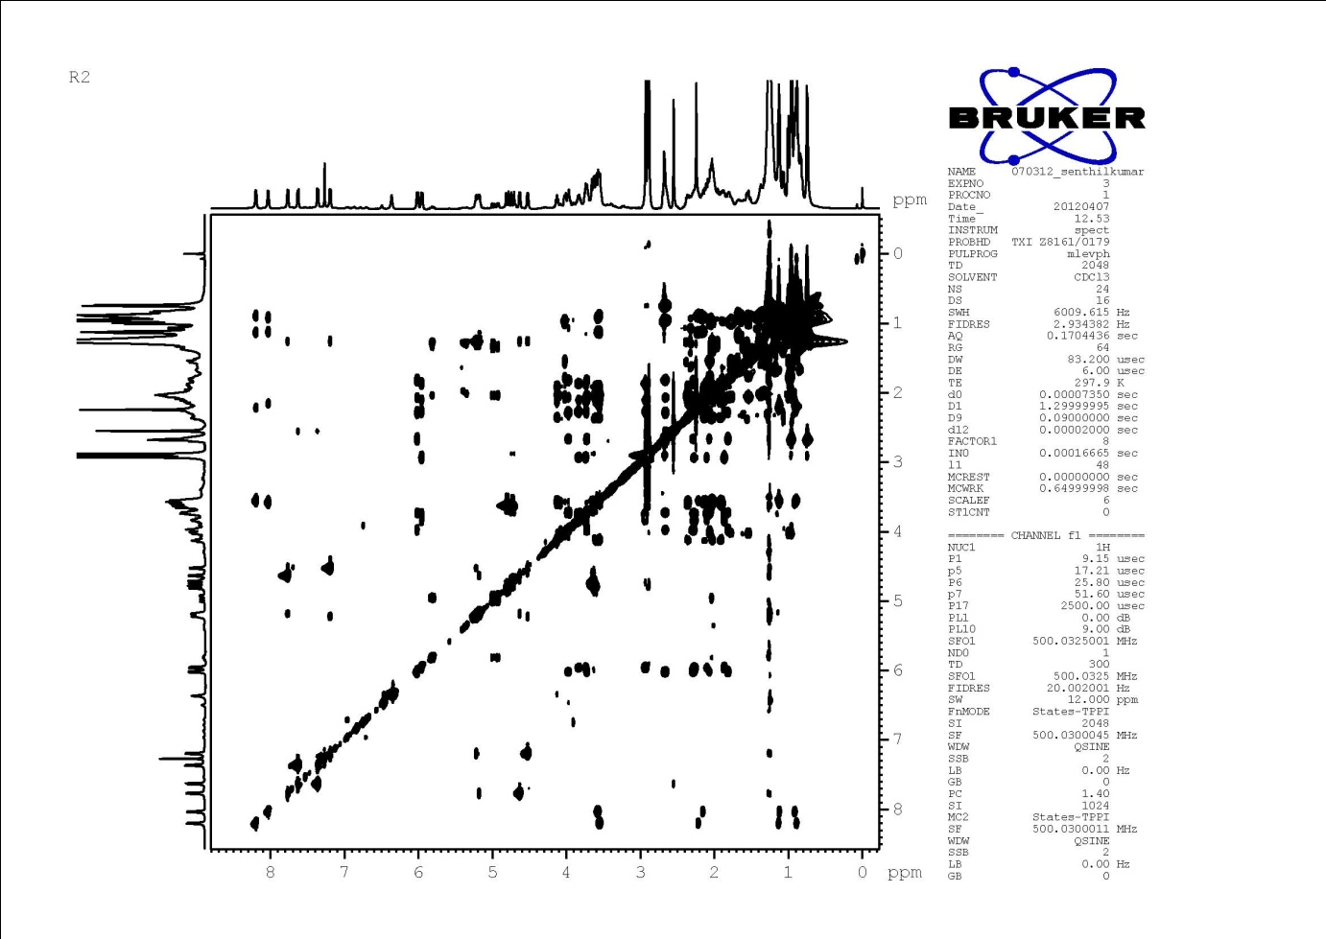

Figure S62. TOCSY (500 MHz) Spectrum of Compound R2
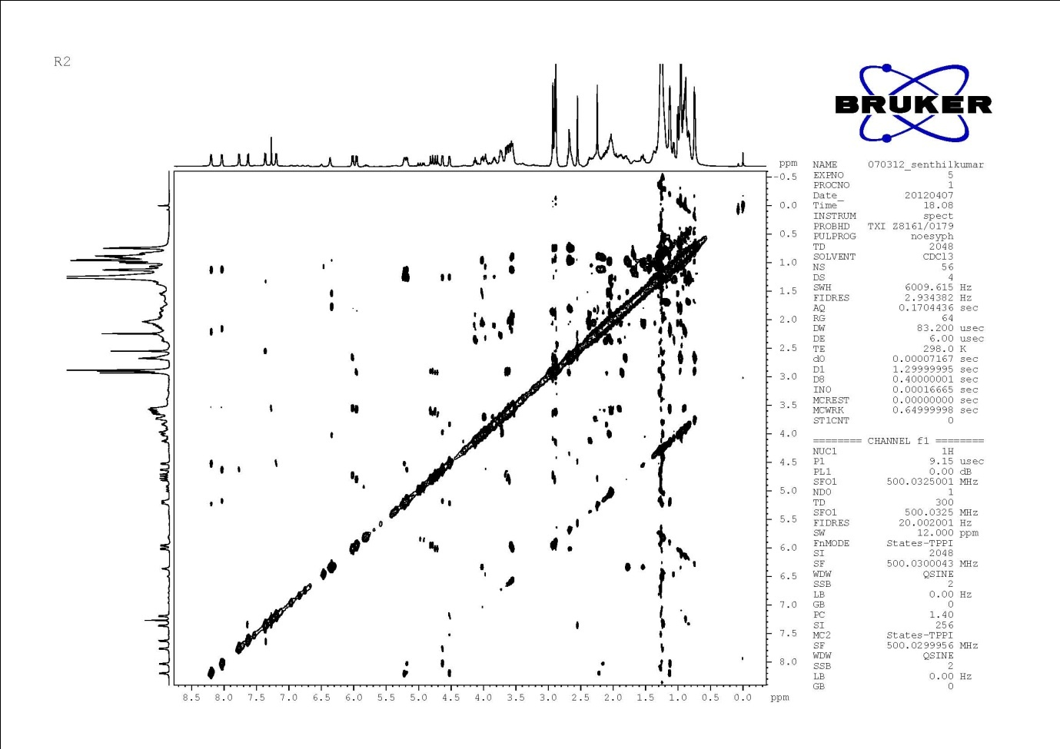

Figure S63. NOESY (500 MHz) Spectrum of Compound R2

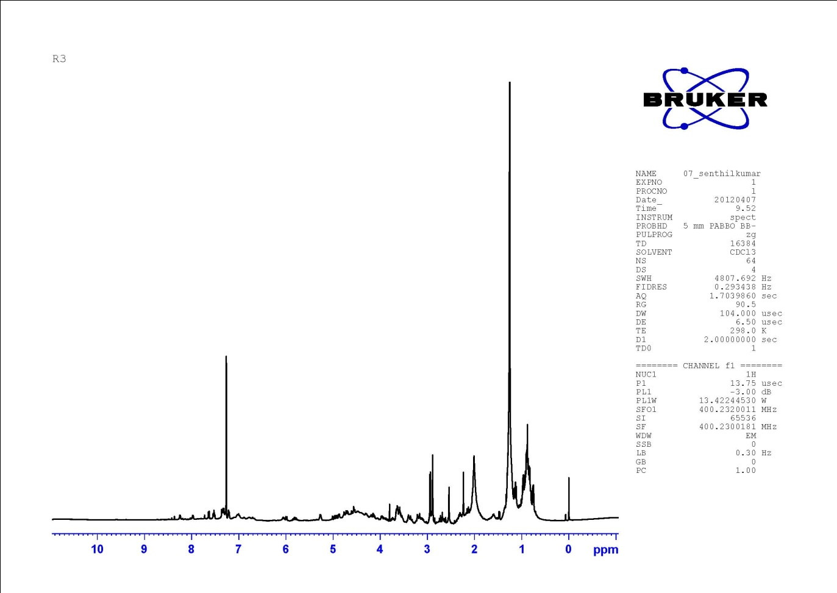
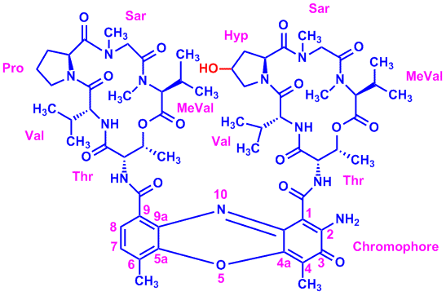

Figure S64. ¹H-NMR (500 MHz, CDCl₃) Spectrum of Compound R3

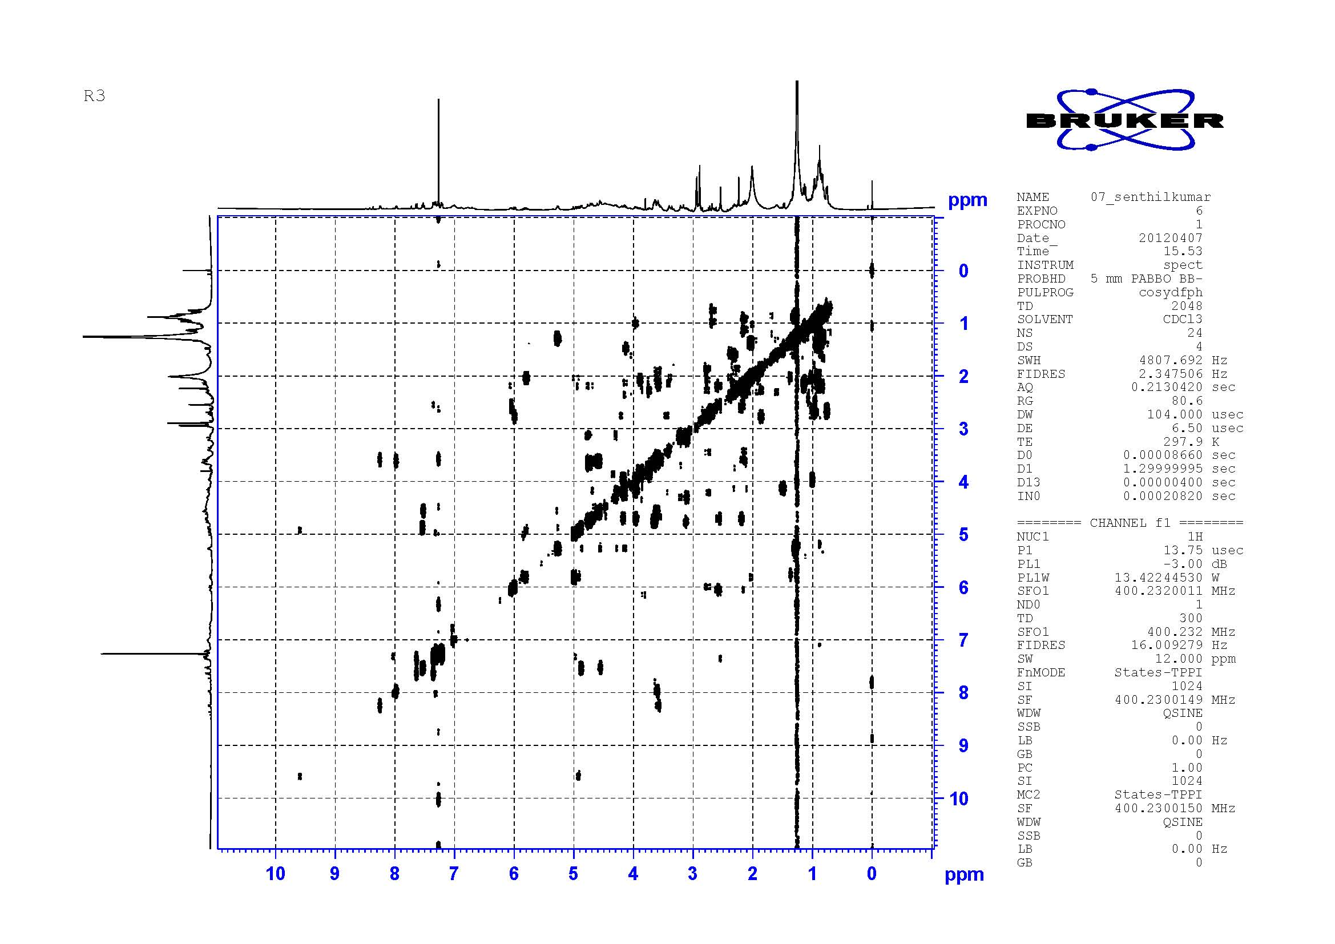

Figure S65. DQF-COSY (500 MHz, CDCl₃) Spectrum of Compound R3
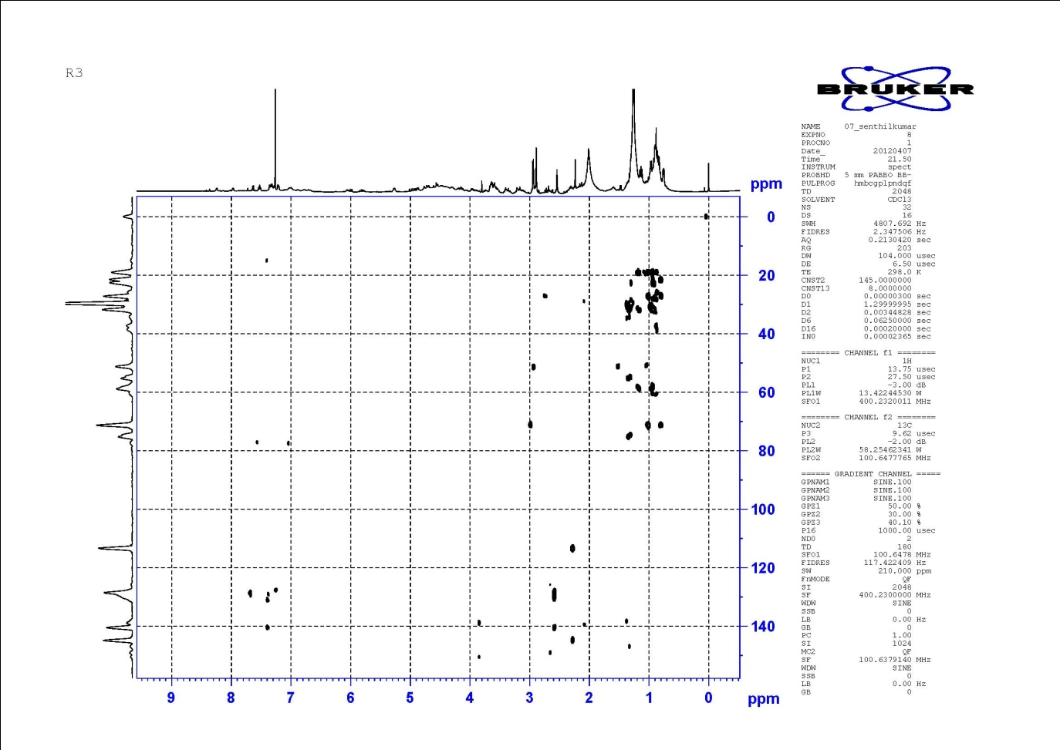
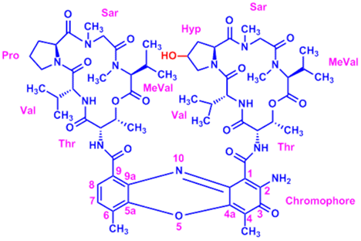

Figure S66. HMBC (500 MHz) Spectrum of Compound R3

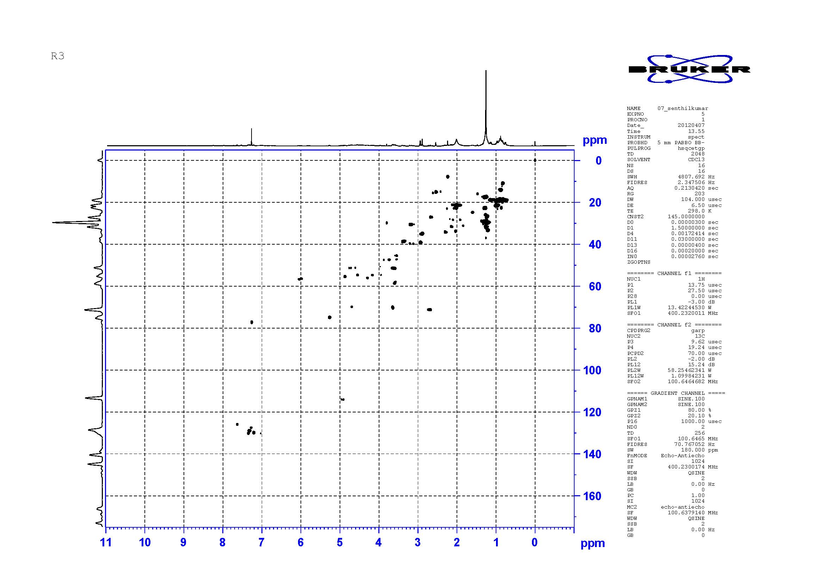

Figure S67. HSQC (500 MHz) Spectrum of Compound R3

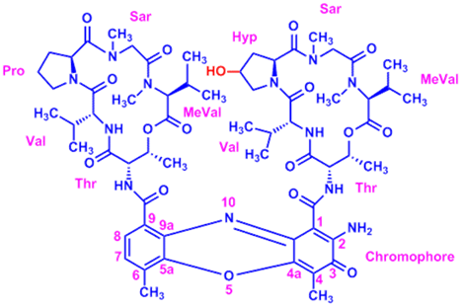
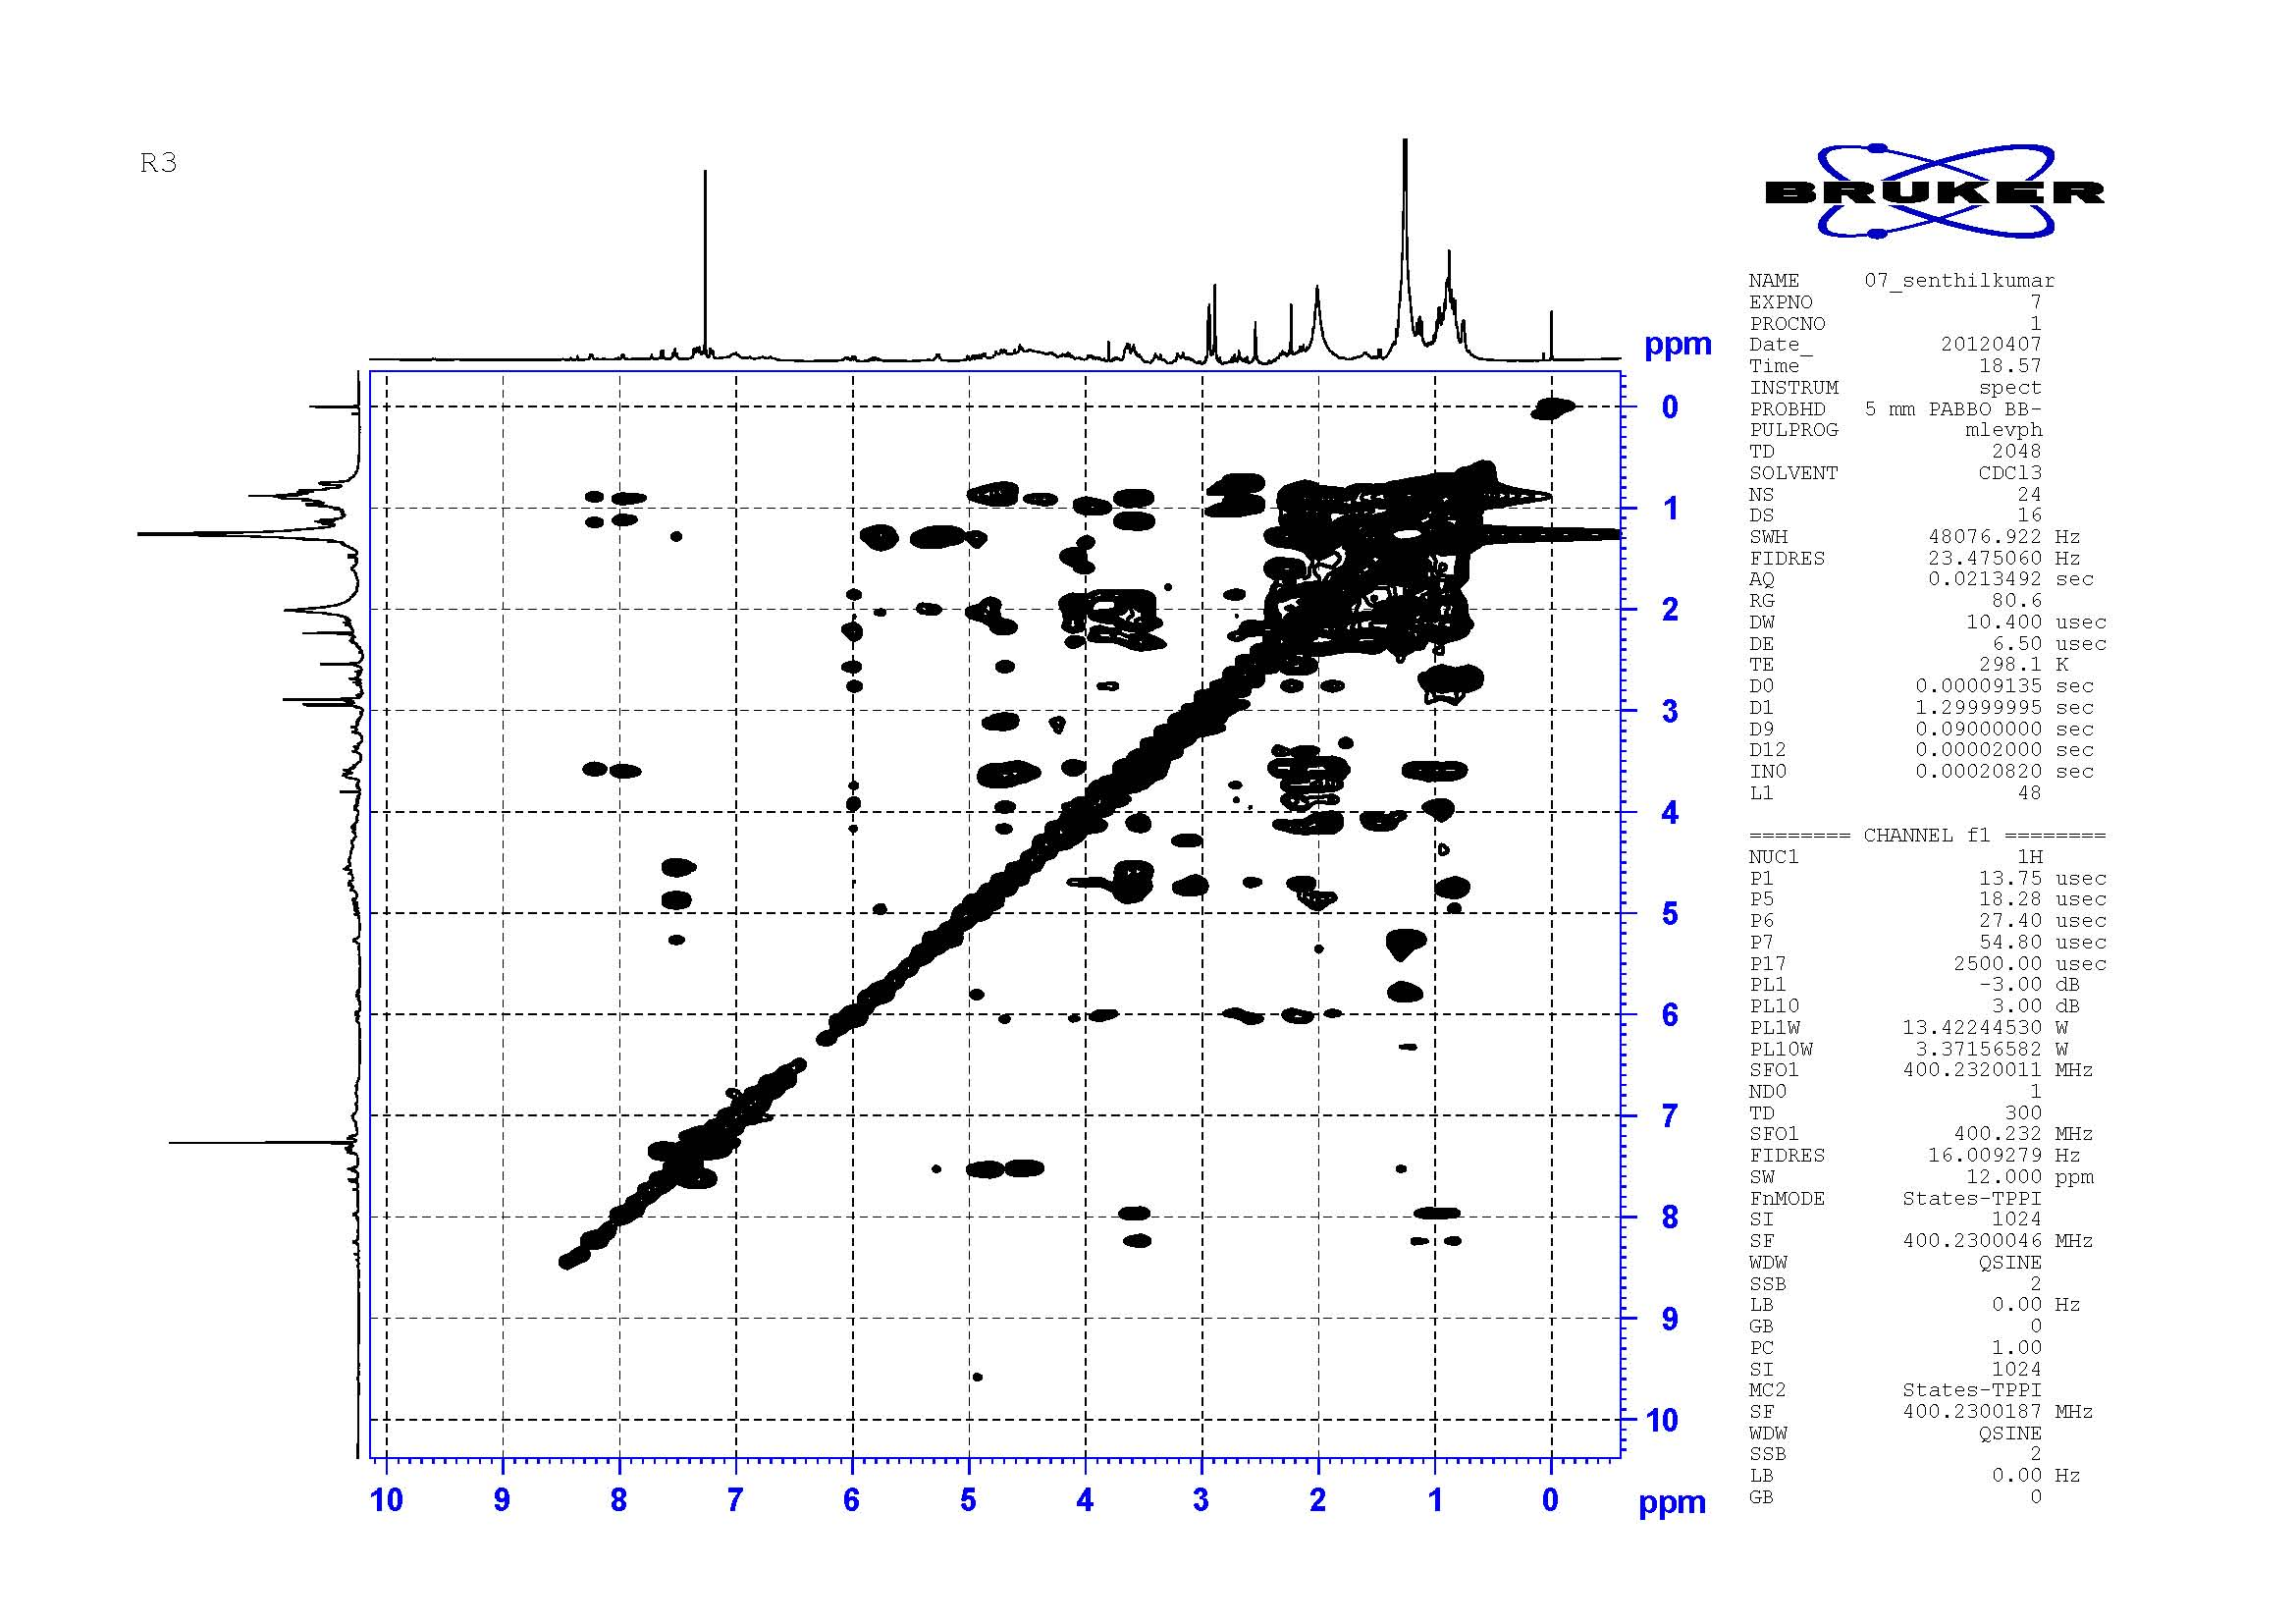

Figure S68. TOCSY (500 MHz, CDCl₃) Spectrum of Compound R3
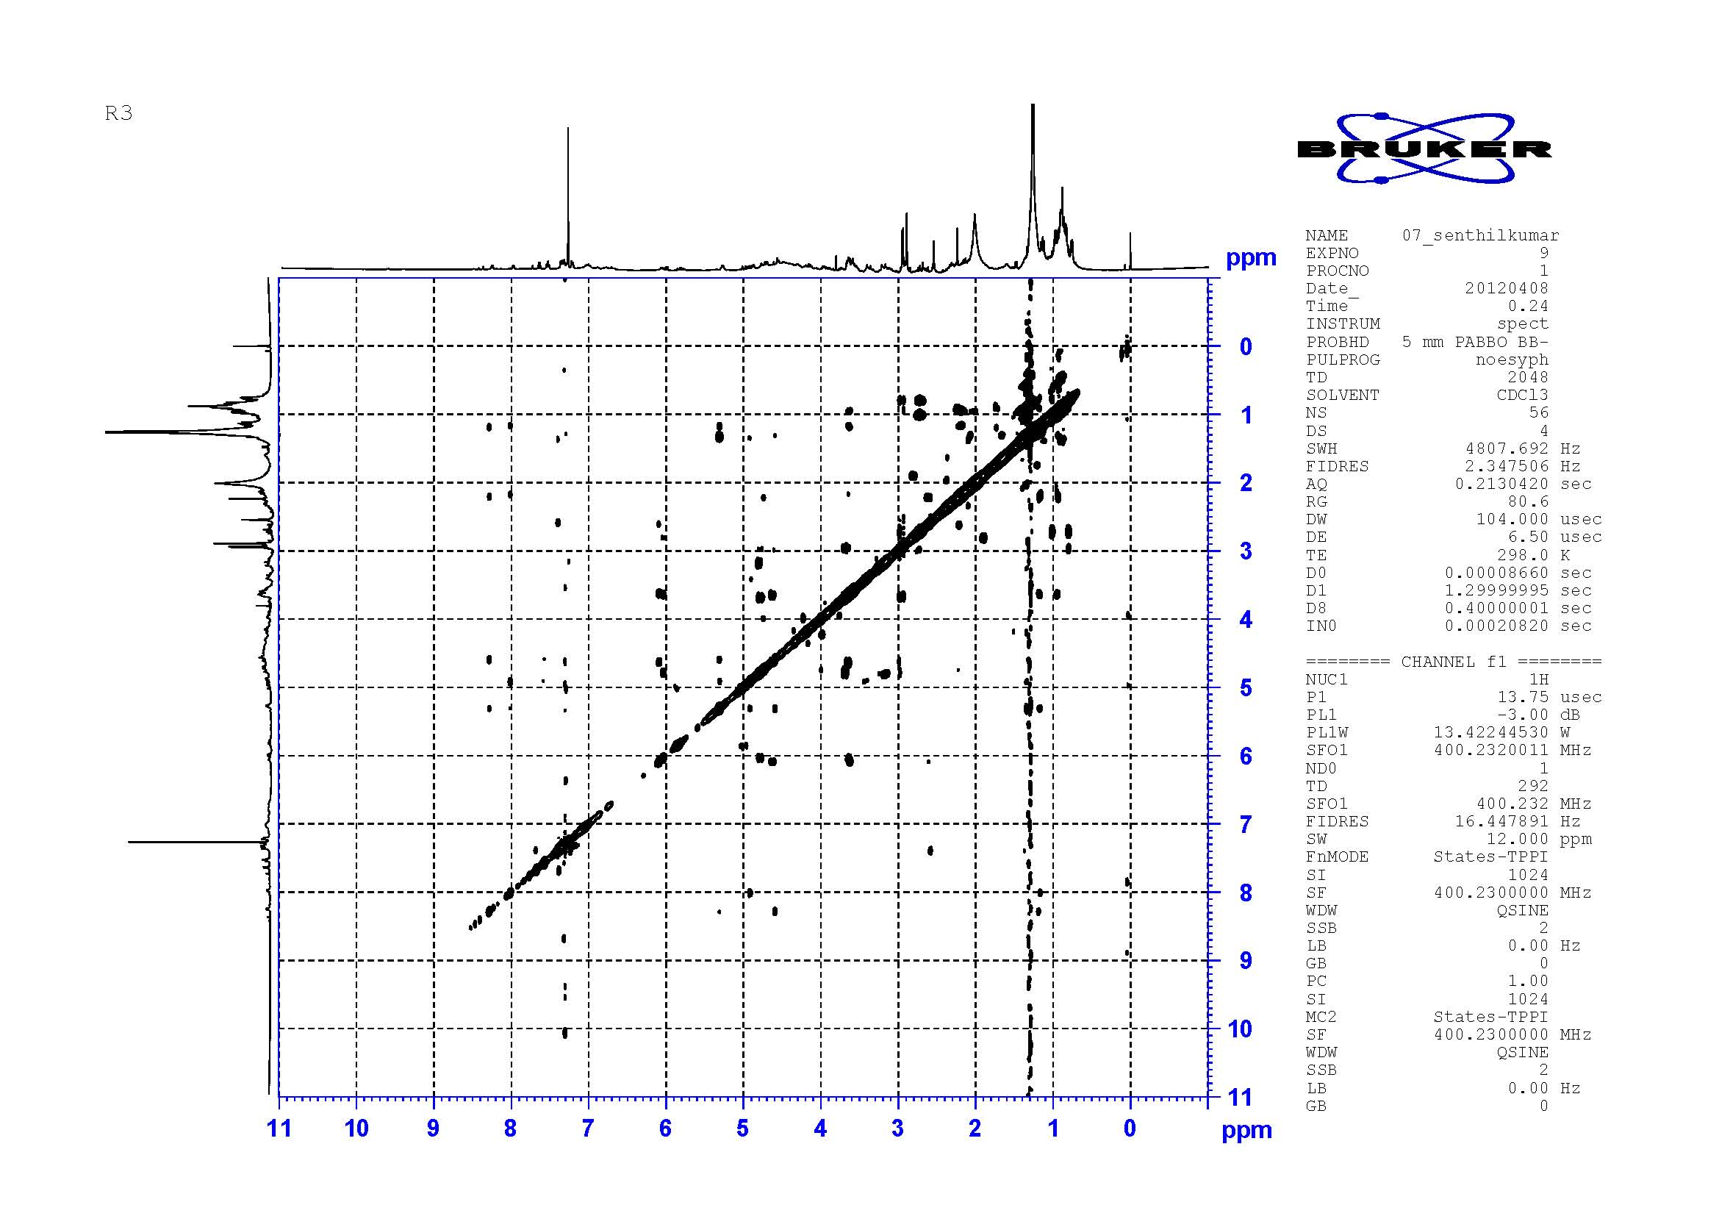

Figure S69. NOESY (500 MHz) Spectrum of Compound R3

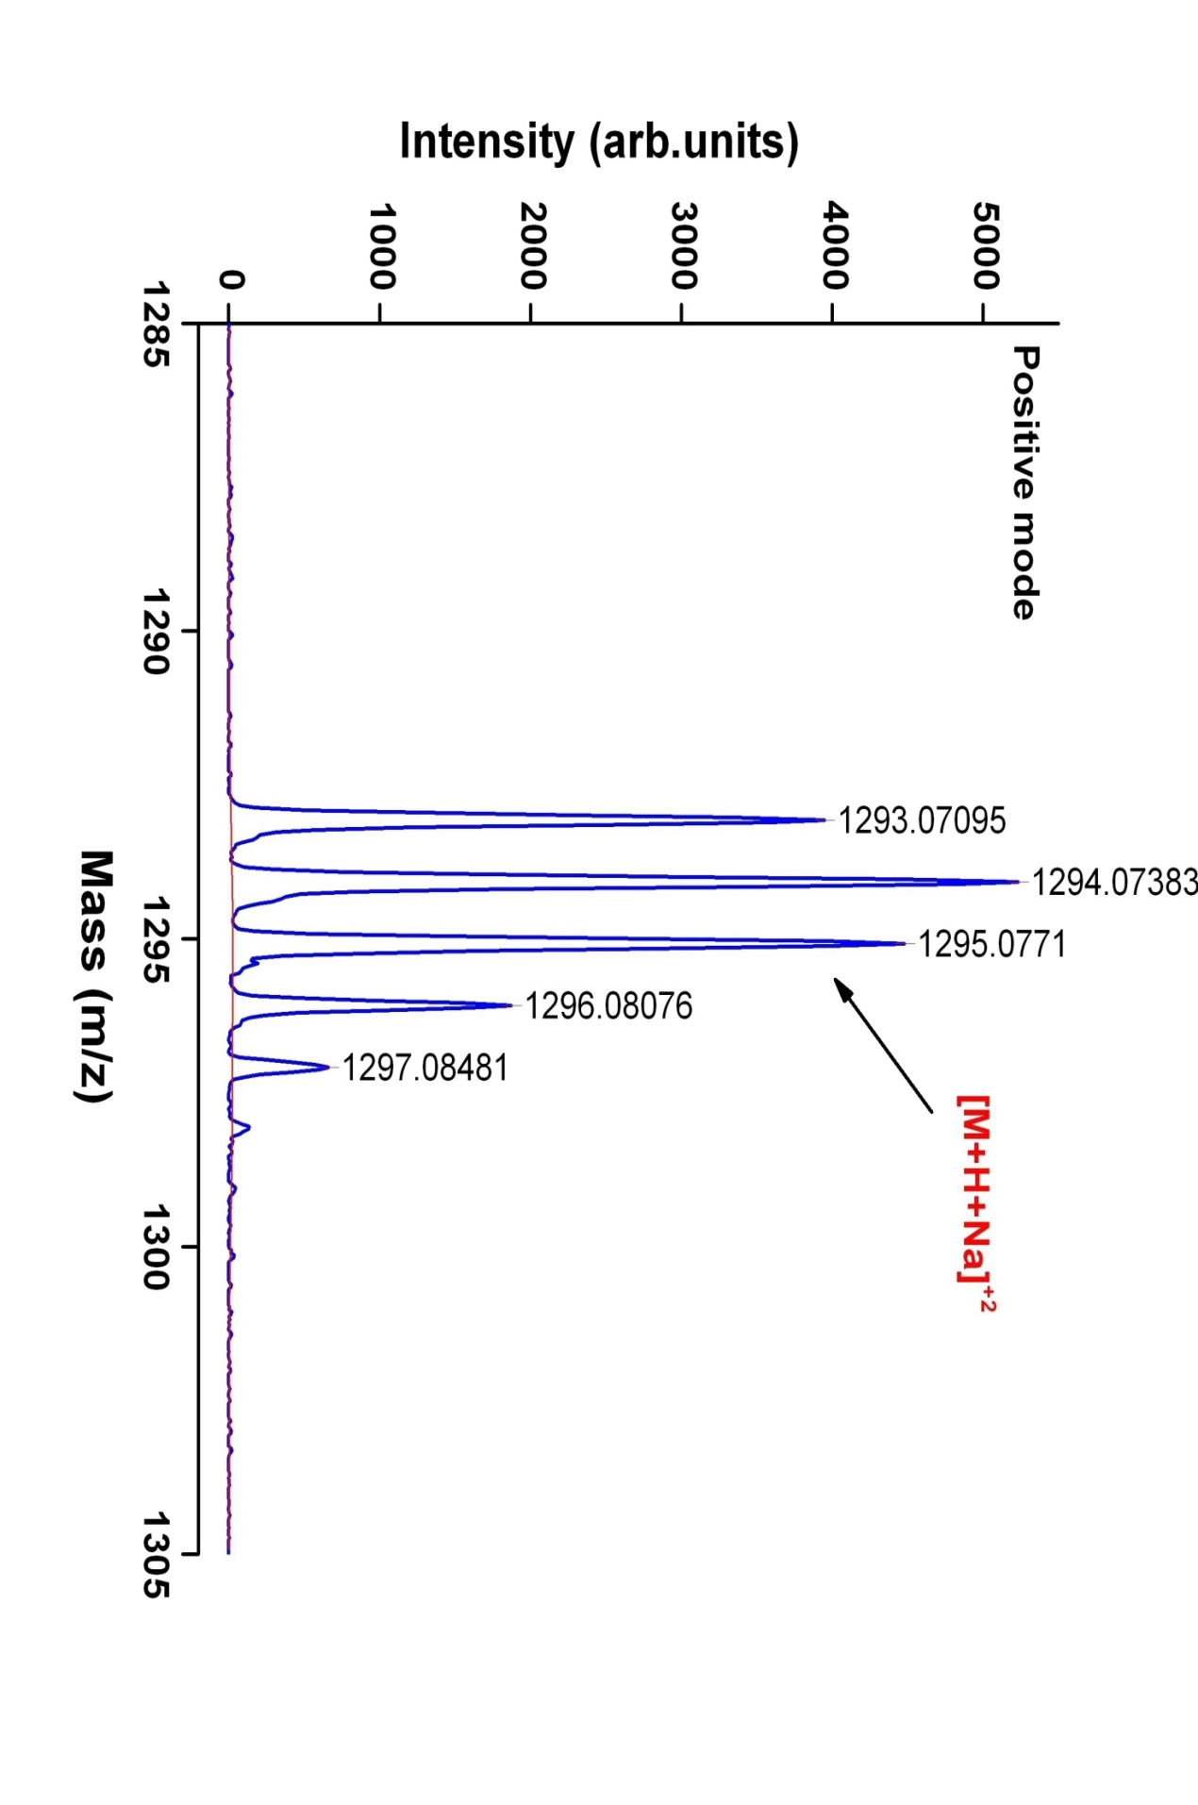

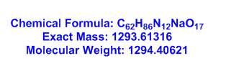

Figure S70. MALDI-TOF MS Spectrum of Transitmycin (R1) (Molecular ion peak) (positive mode)
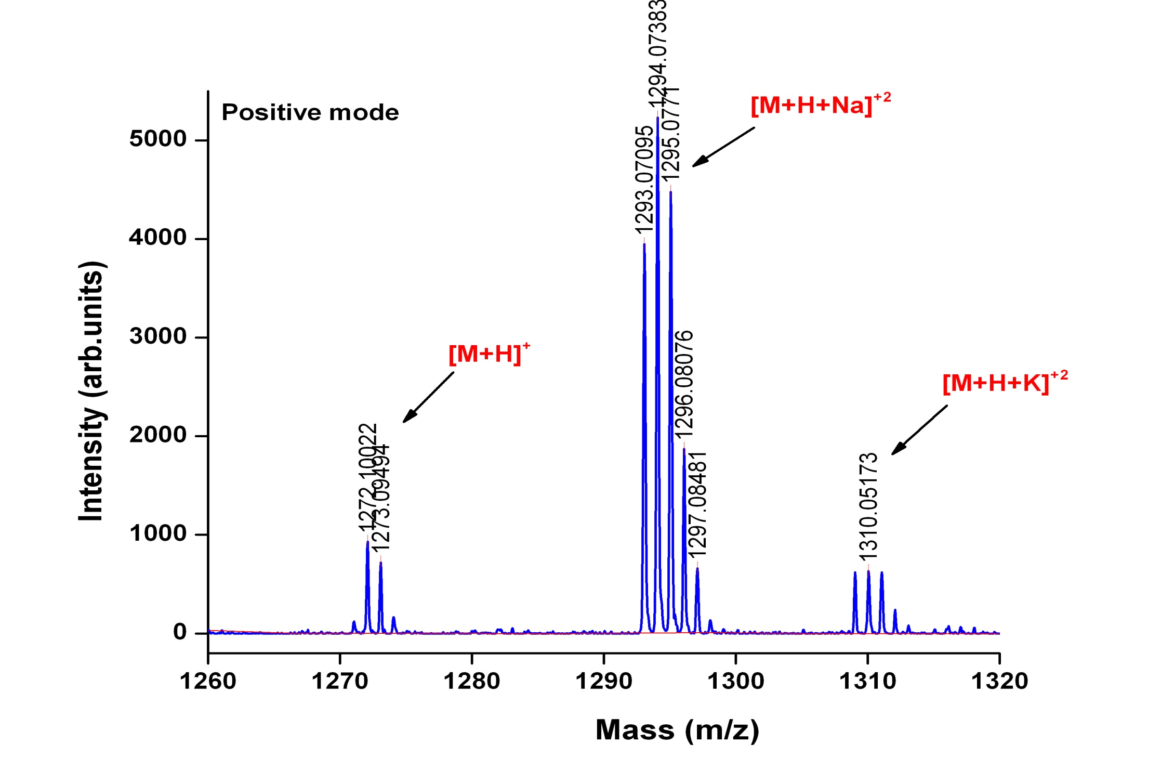

Figure S71. Expansion of MALDI-TOF MS Spectrum of Transitmycin (R1) (Molecular ion peak) (positive mode)
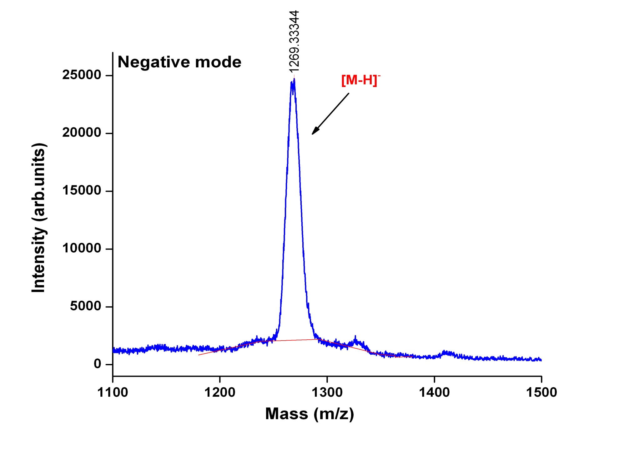
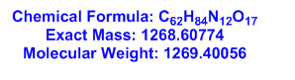

Figure S72. Expansion of MALDI-TOF MS Spectrum of Transitmycin (R1) (Molecular ion peak) (Negative mode)
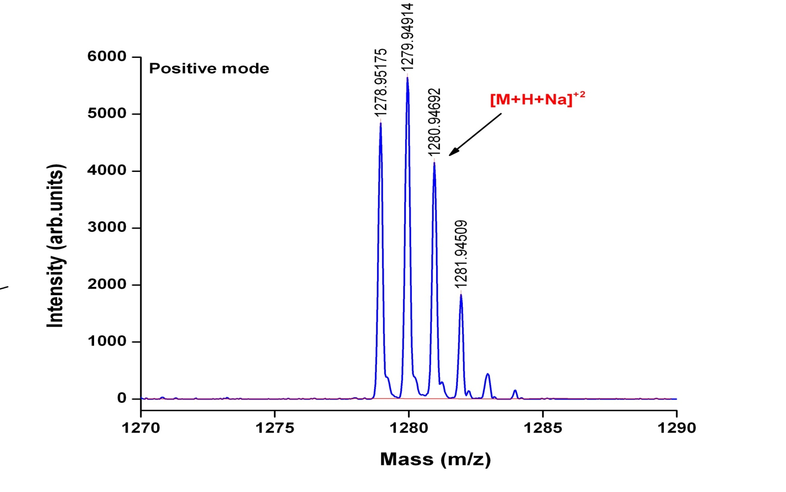

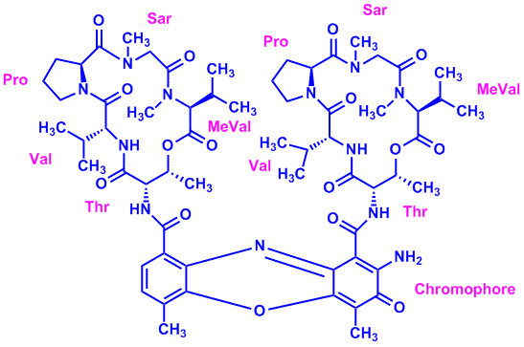

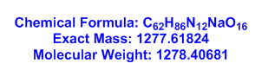

Figure S73. MALDI-TOF MS Spectrum of R2 (Molecular ion peak) (positive mode)

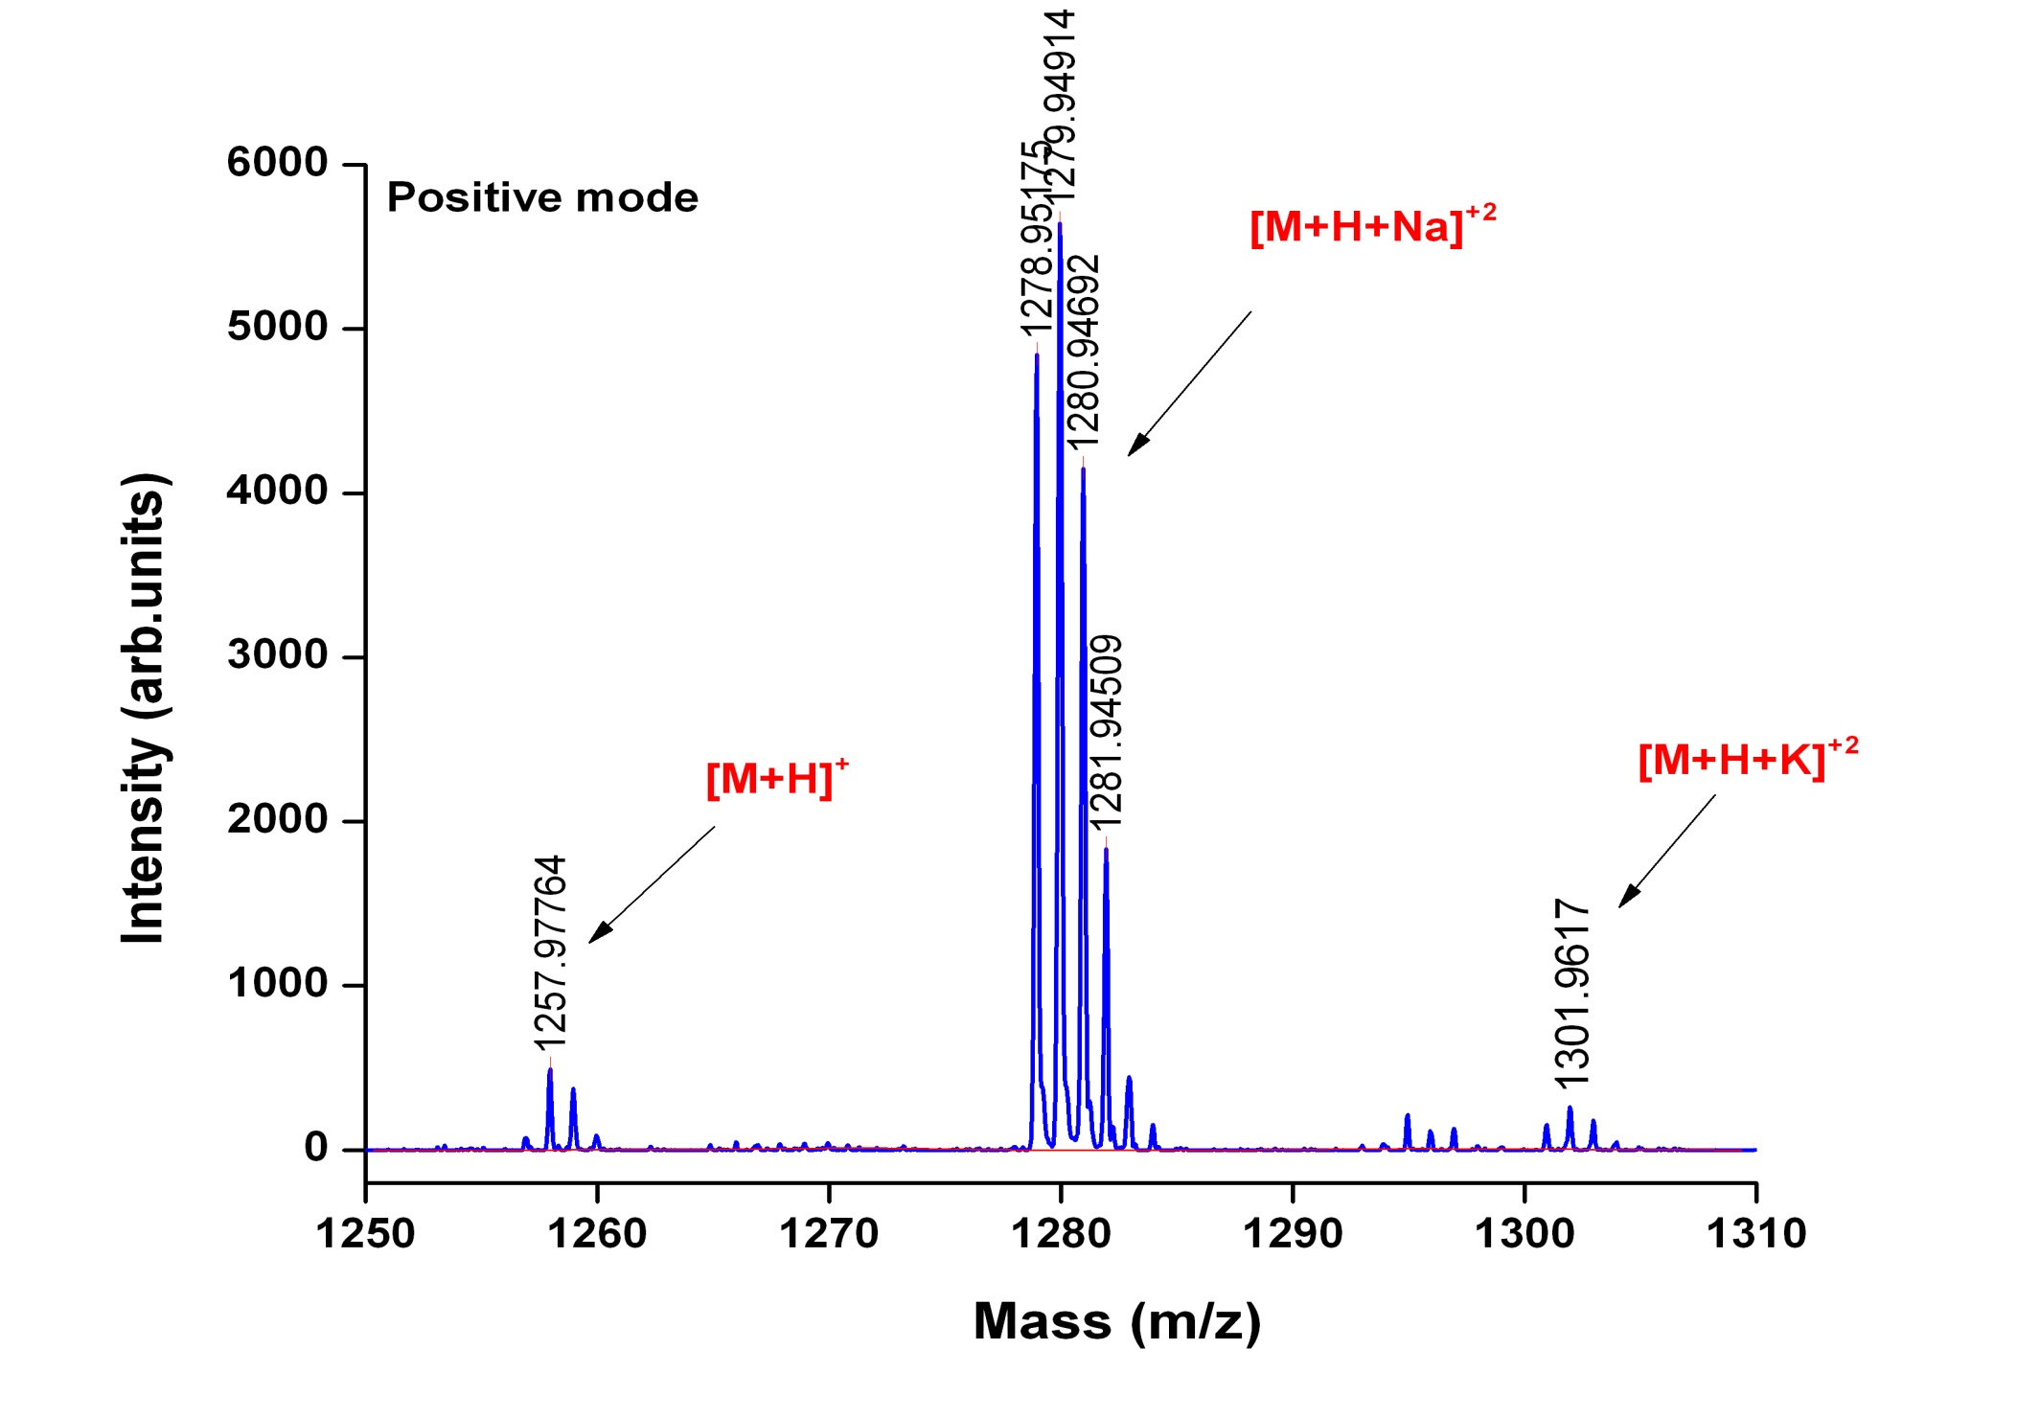

Figure S74. Expansion of MALDI-TOF MS Spectrum of R2 (Molecular ion peak) (positive mode)
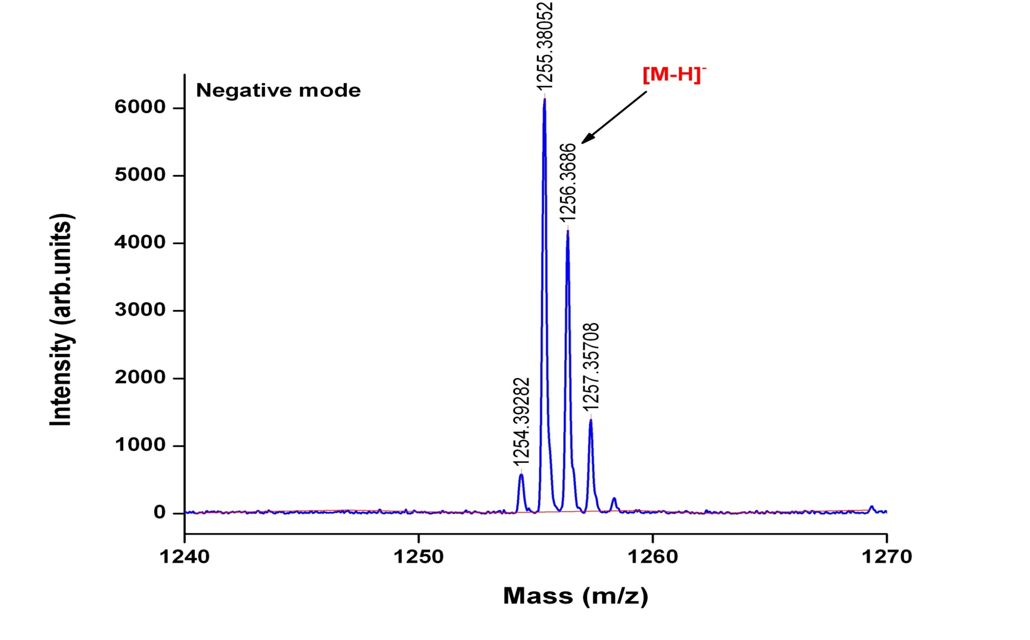

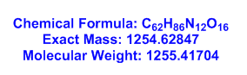

Figure S75. Expansion of MALDI-TOF MS Spectrum of R2 (Molecular ion peak) (Negative mode)
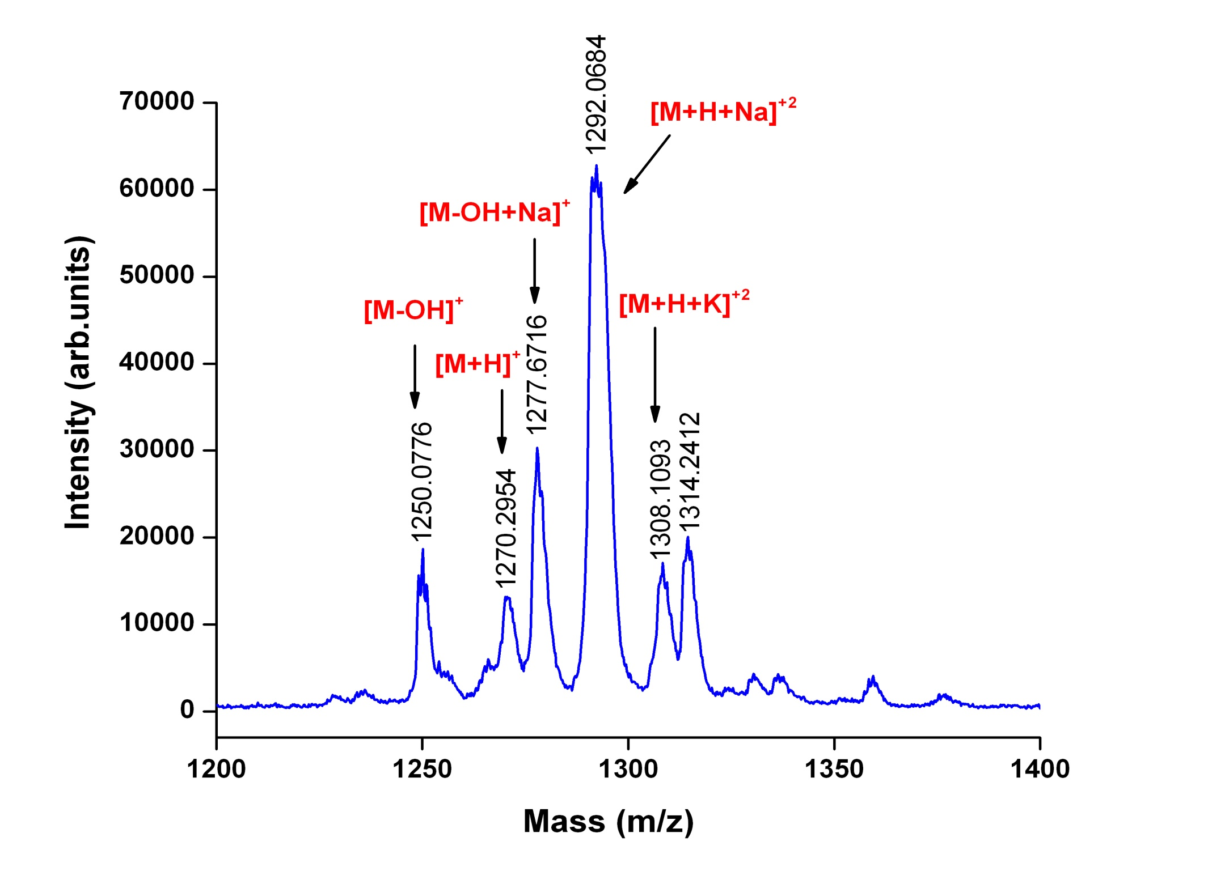
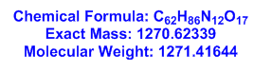
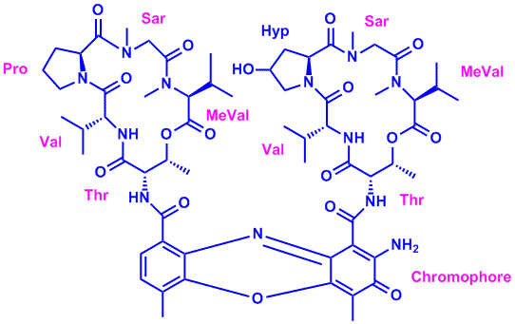

Figure S76. MALDI-TOF MS Spectrum of R3 (Molecular ion peak) (positive mode)
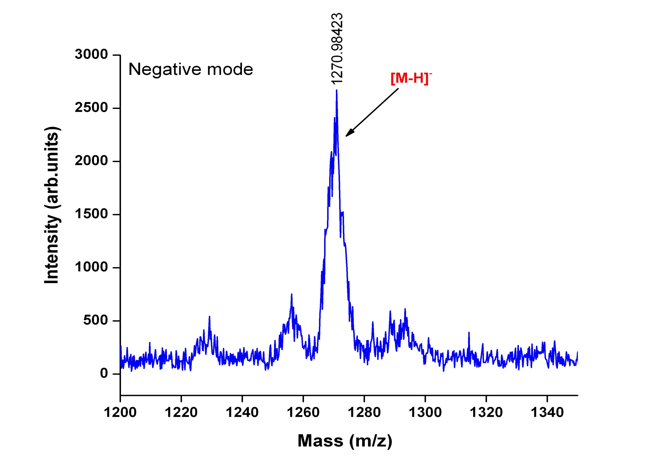

Figure S77. MALDI-TOF MS Spectrum of R3 (Molecular ion peak) (Negative mode)
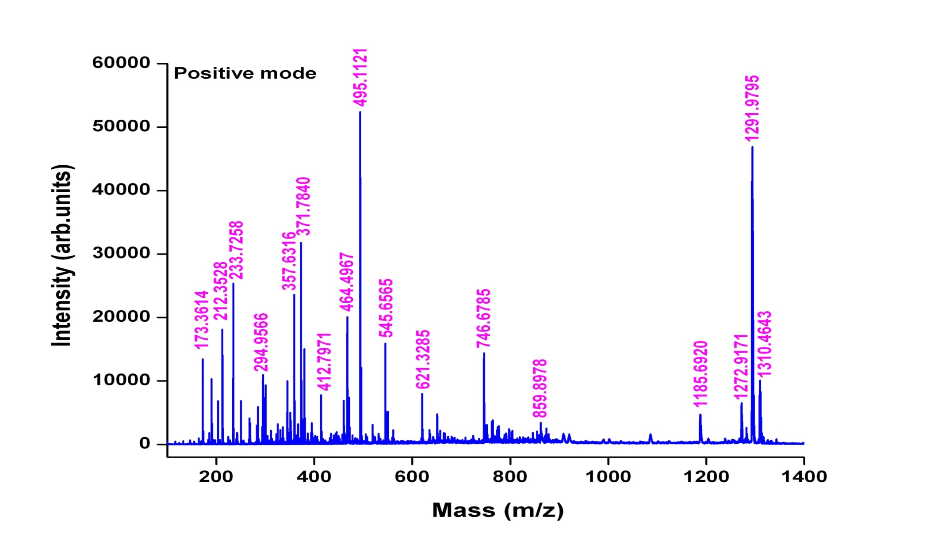

Figure S78. MALDI-TOF MS Spectrum of Transitmycin (R1) (Positive mode)

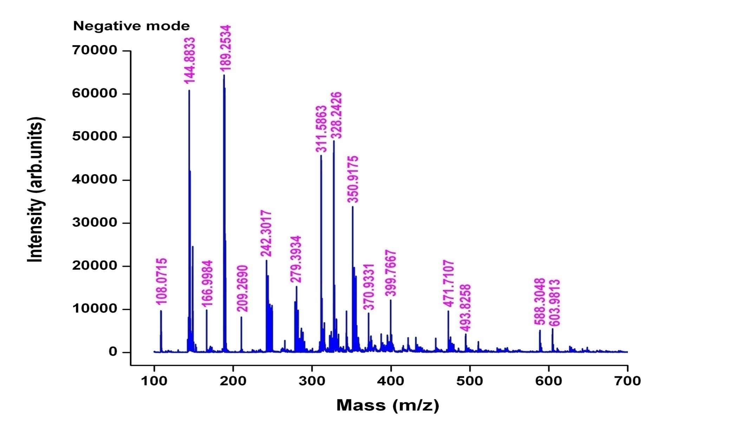

Figure S79. MALDI-TOF MS Spectrum of Transitmycin (R1) (Negative mode)

Table S6. MALDI-TOF MS Spectral Fragmentation of Transitmycin (R1) (Positive mode)
211- β-Ring-Val-Oxo-Pro
233- α -Ring-Val-Pro
294-β-Ring-Oxo-Pro-Sar-NMeVal
295-Chromophore
297- β-Ring-Thr-Val-Oxo-Pro
357-α-Ring-Val-Pro-Sar-MeVal
371-β-Ring-Val-Oxo-Pro-Sar-MeVal
412-β-Ring-Val-Oxo-Pro-Sar-NMeVal
412-α-Ring-Val-Pro-Sar-NMeVal+859 (Y ion)
495-β-Ring-Thr-Val-Oxo-Pro-Sar-NMeVal
496-α-Ring-Thr-Val-Pro-Sar-NMeVal
464 α - Ring-Thr-Val-Oxo-Pro-Sar-NMeVal
746-Y-113 (MeVal)
747- α-Ring-Val-Pro-Sar-NMeVal+Y-MeVal+545.6
1291-495
1291=746-545
1291=651+621
1291=495+775
1291=859+432
1291=920+371
1291=796+495
495= β-Ring-Thr-Val-Oxo-Pro-Sar-NMeVal
495-371=124-23=101 MeVal (β-Ring-Thr-Val-Oxo-Pro-Sar)
371(β-Ring-Thr-Val-Oxo-Pro-Sar)
294 (β-Ring-Thr-Val-Oxo-Pro)

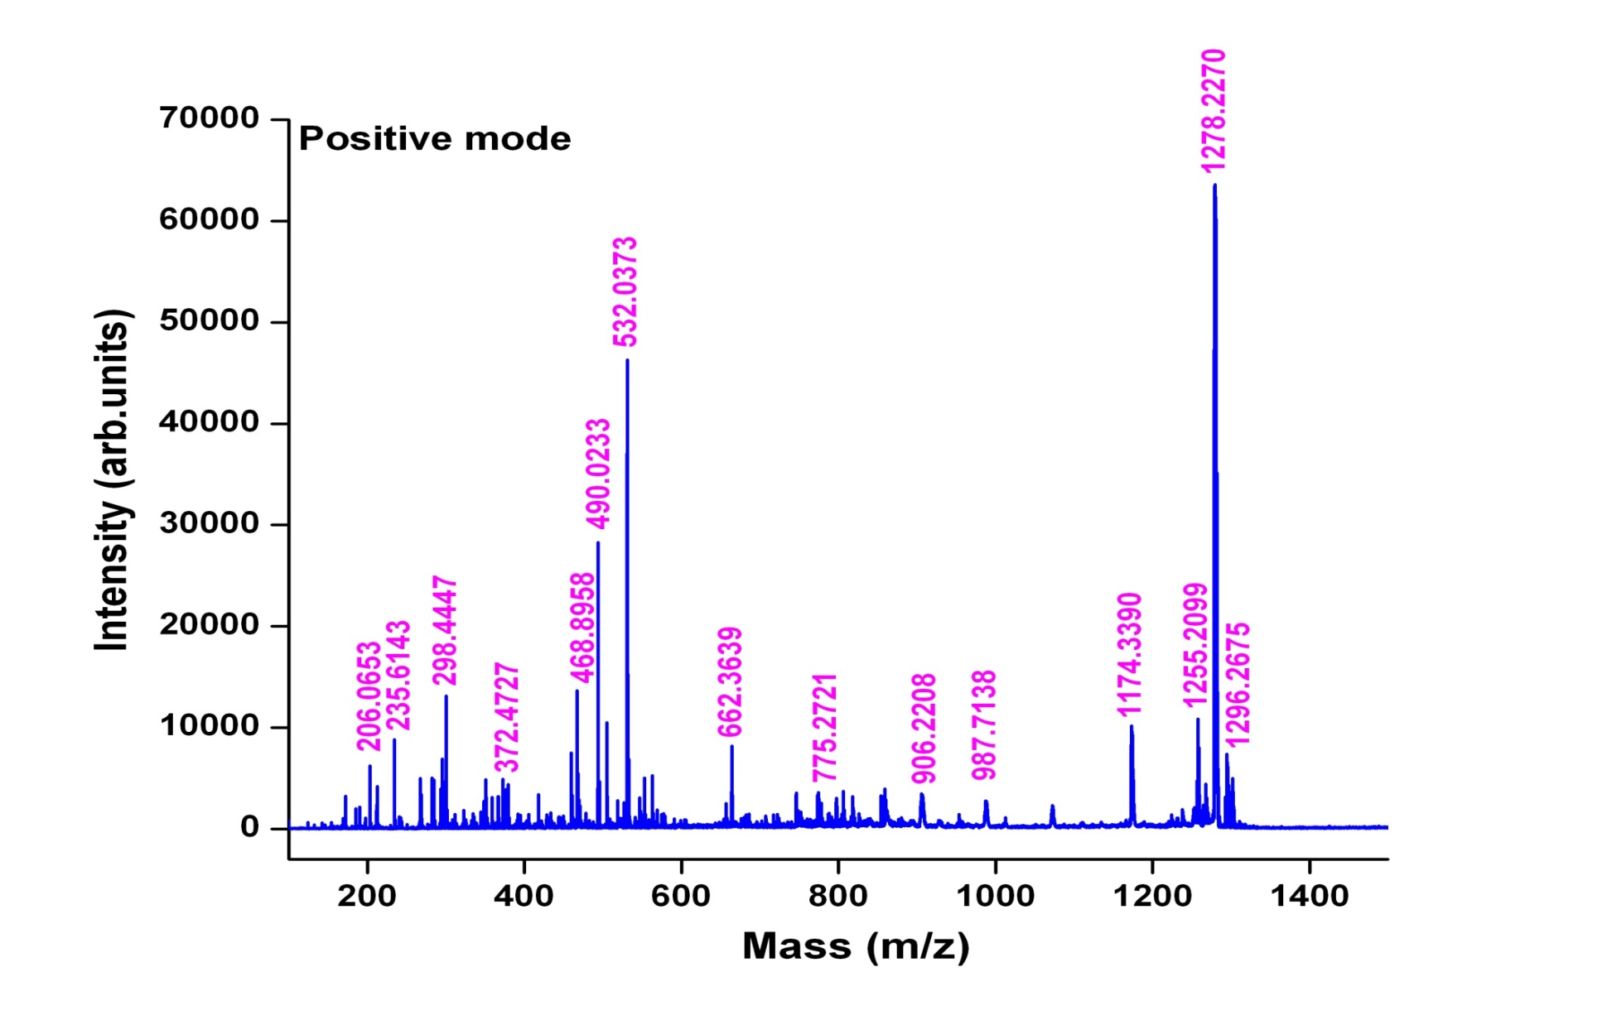

Figure S80. MALDI-TOF MS Spectrum of R2 (Positive mode)
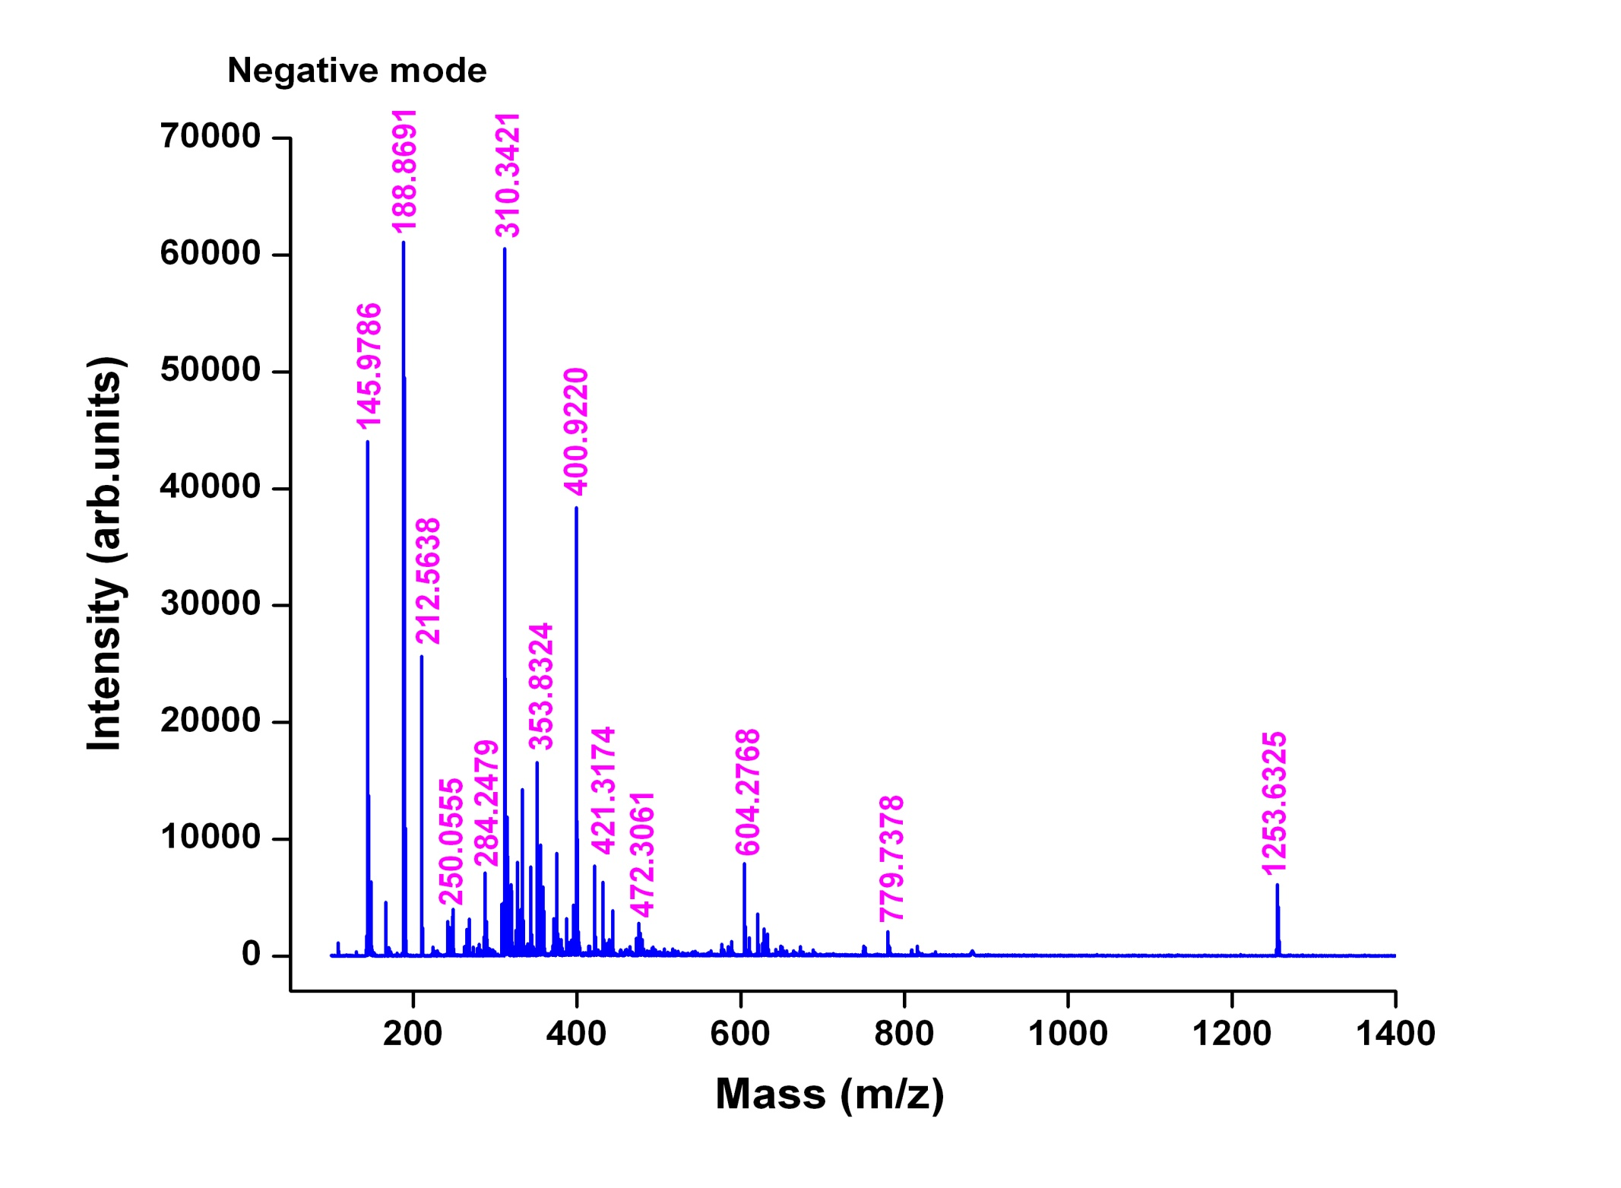

Figure S81. MALDI-TOF MS Spectrum of R2 (Negative mode)
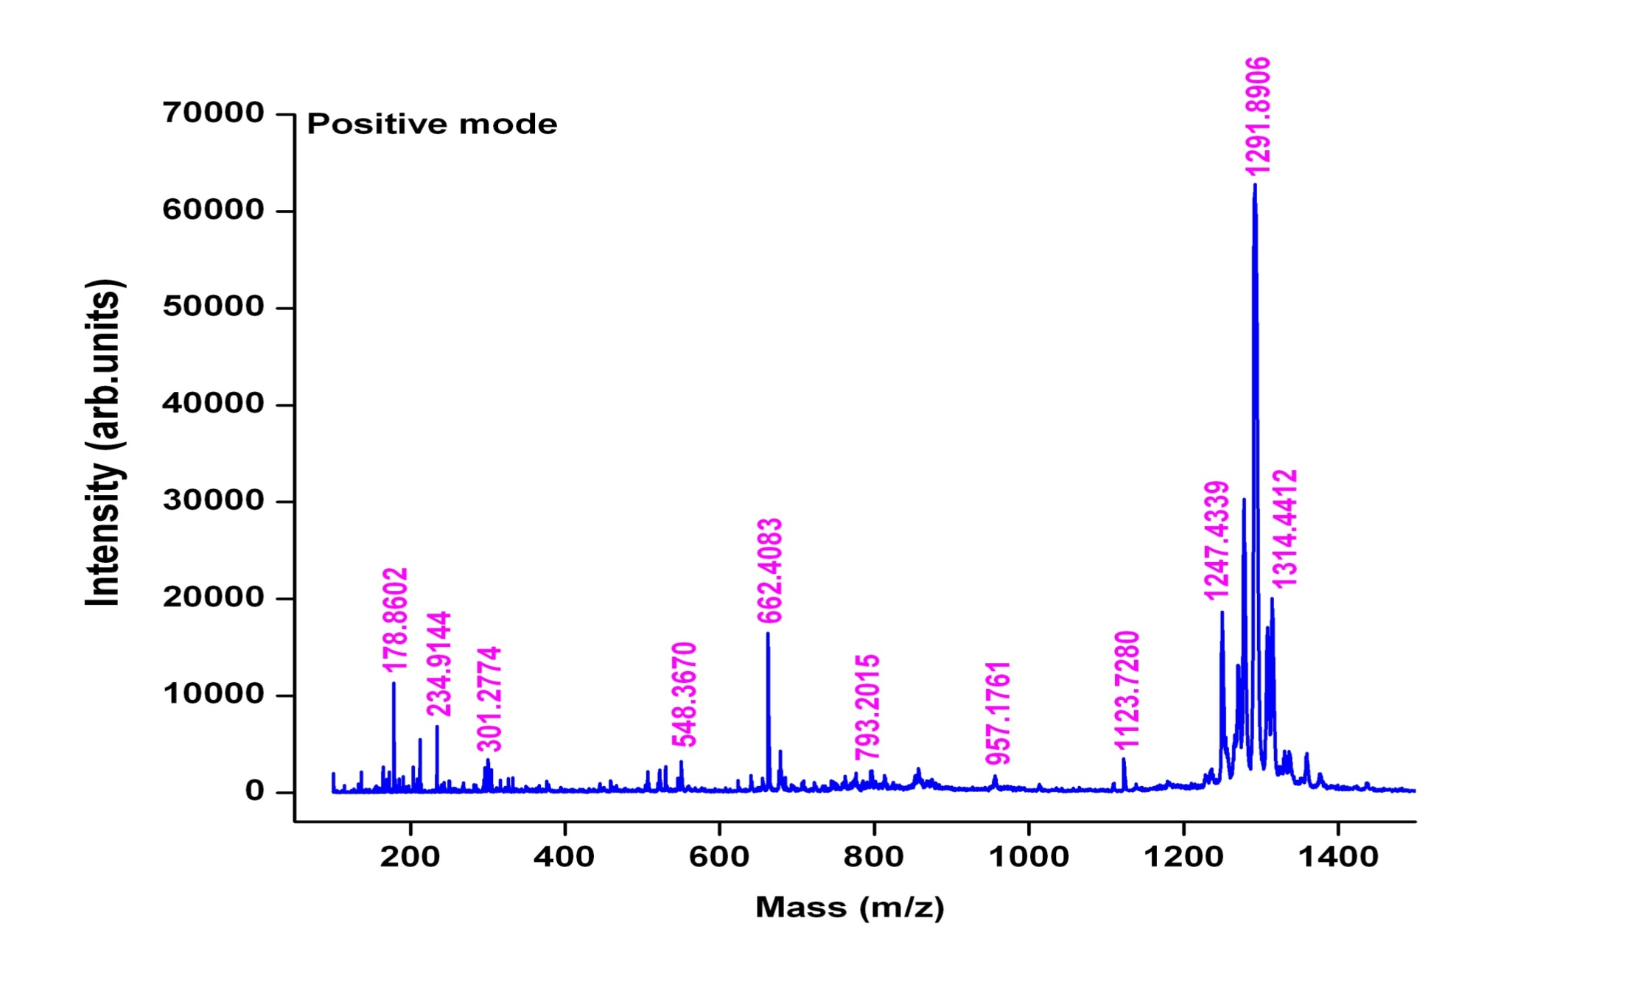

Figure S82. MALDI-TOF MS Spectrum of R3 (Positive mode)
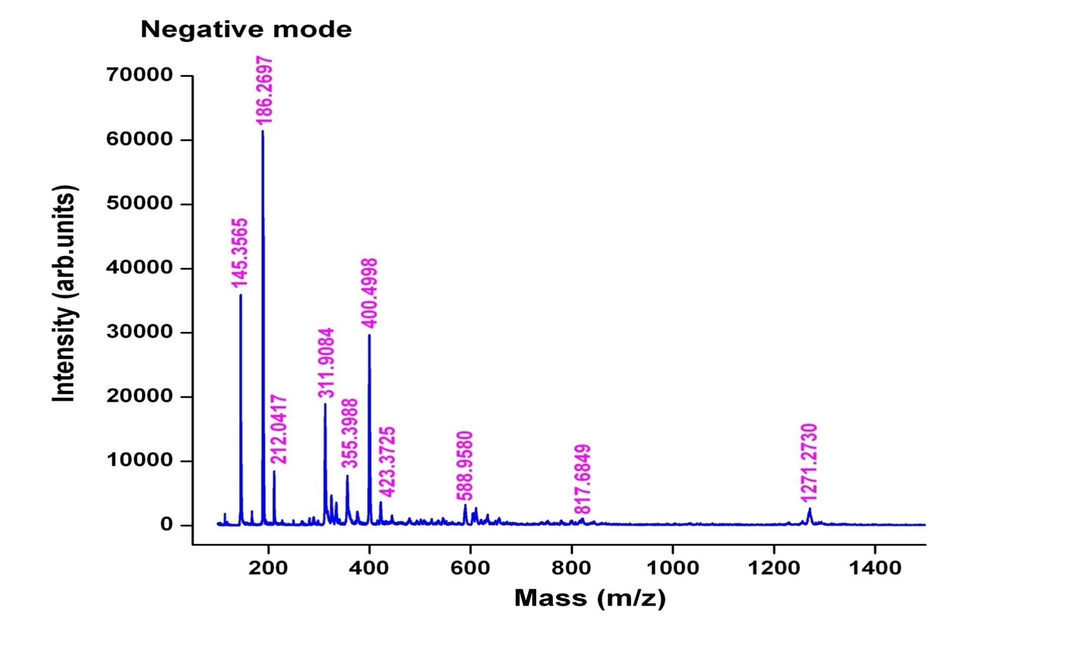

Figure S83. MALDI-TOF MS Spectrum of R3 (Negative mode)
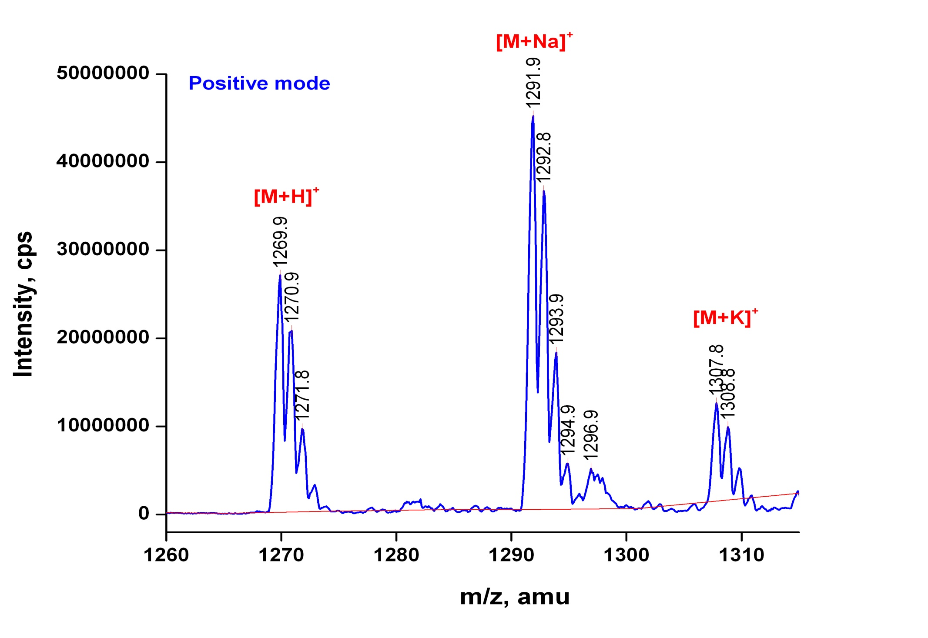

Figure S84. QTRAP MS/MS Transitmycin (R1) (Molecular ion peak) (Positive mode)

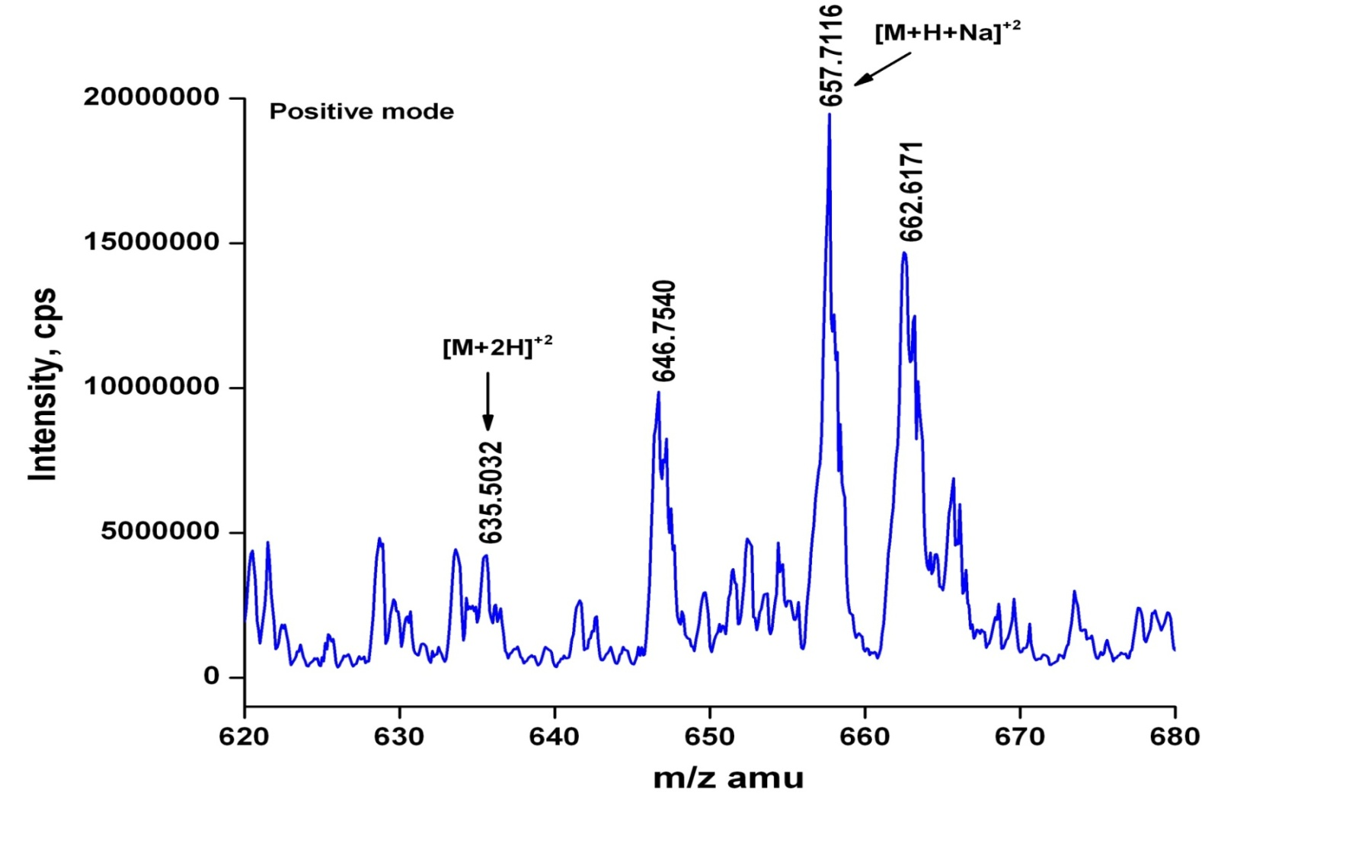

Figure S85 QTRAP MS/MS Transitmycin (R1) (Molecular ion peak [M+H]²⁺ (Positive mode)

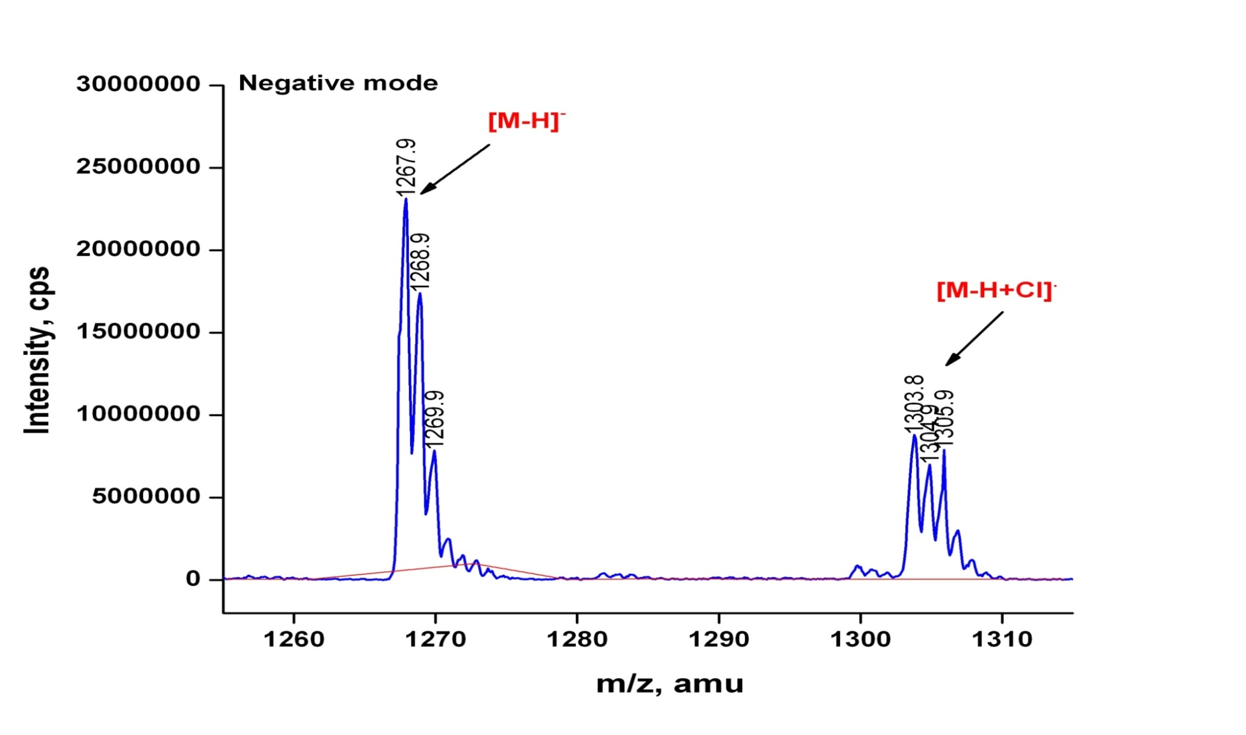

Figure S86. QTRAP MS/MS of Transitmycin (R1) (Molecular ion peak ) (Negative mode)
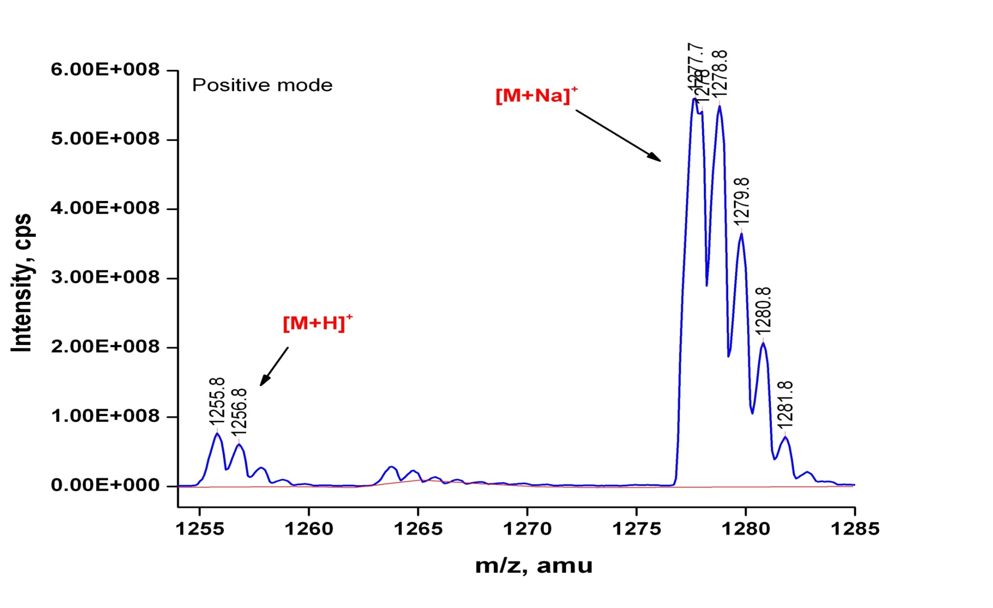

Figure S87. QTRAP MS/MS of R2 (Molecular ion peak) ((Positive mode)
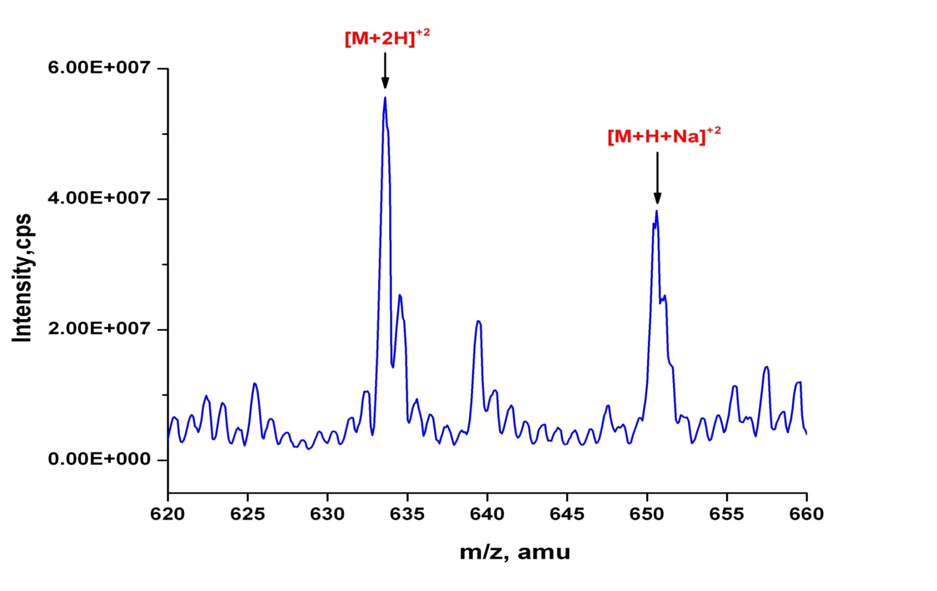

Figure S88. QTRAP MS/MS of R2 [M+H]²⁺ ion peak (Positive mode)
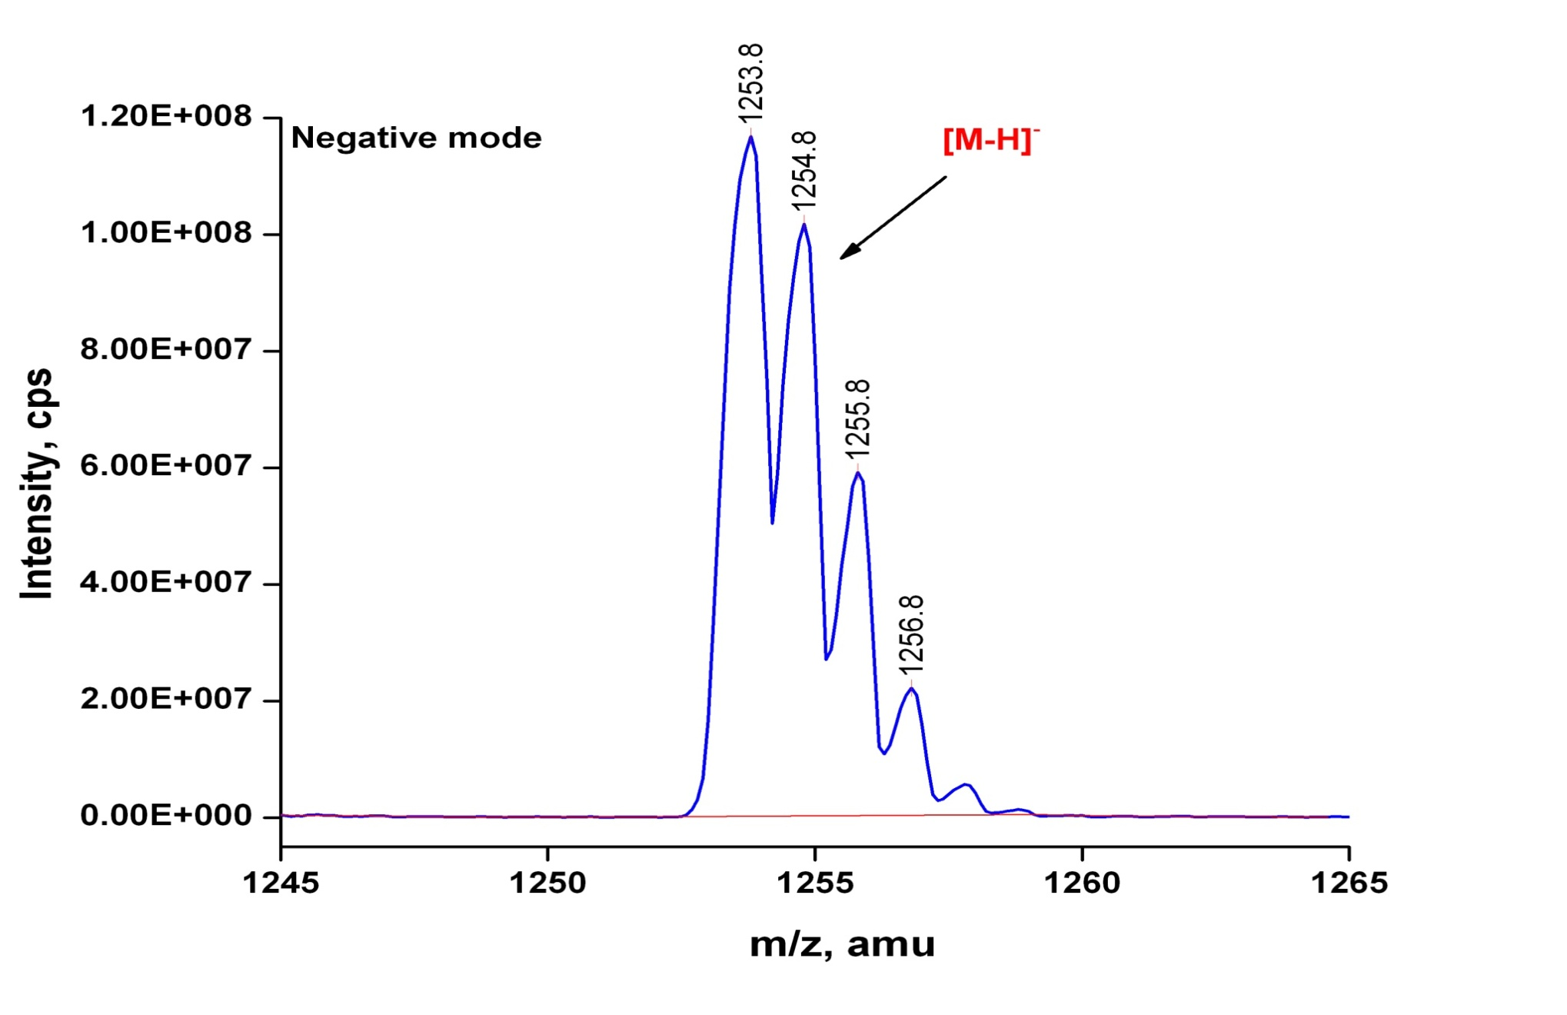

Figure S 89. QTRAP MS/MS of R2 (Molecular ion peak (Positive mode)

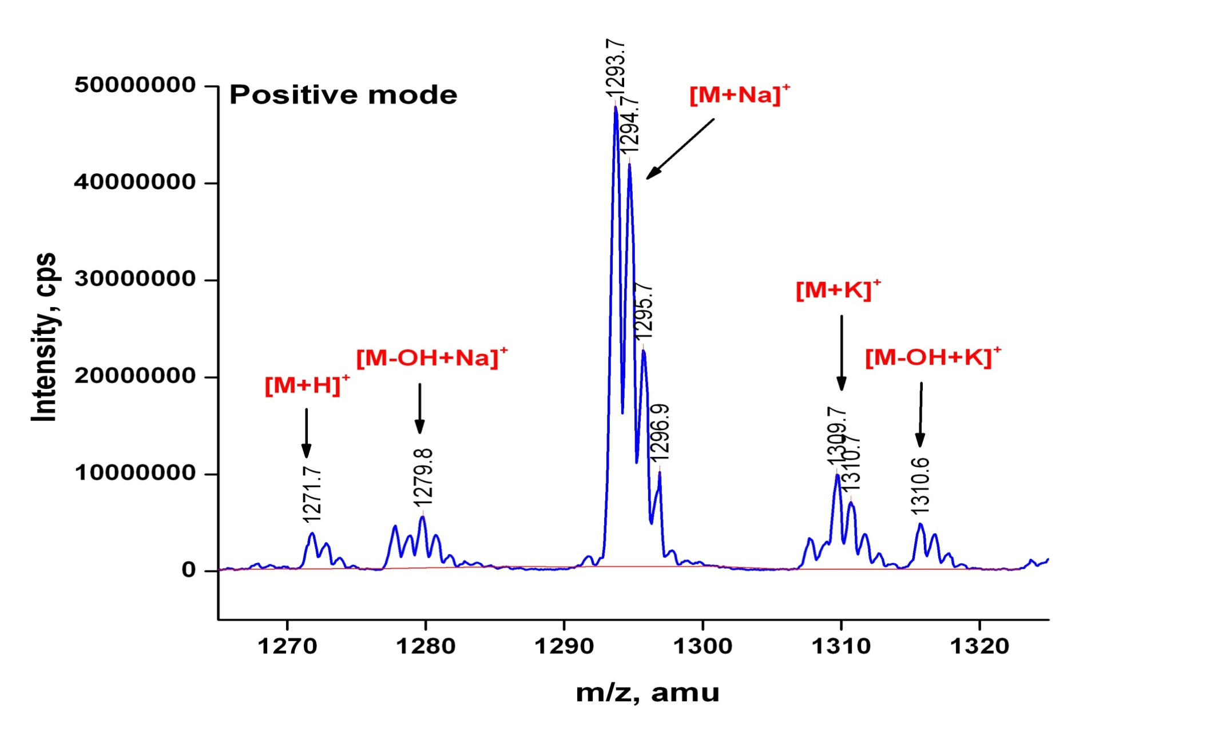

Figure S90. QTRAP MS/MS of R3 Molecular ion peak (Positive mode)

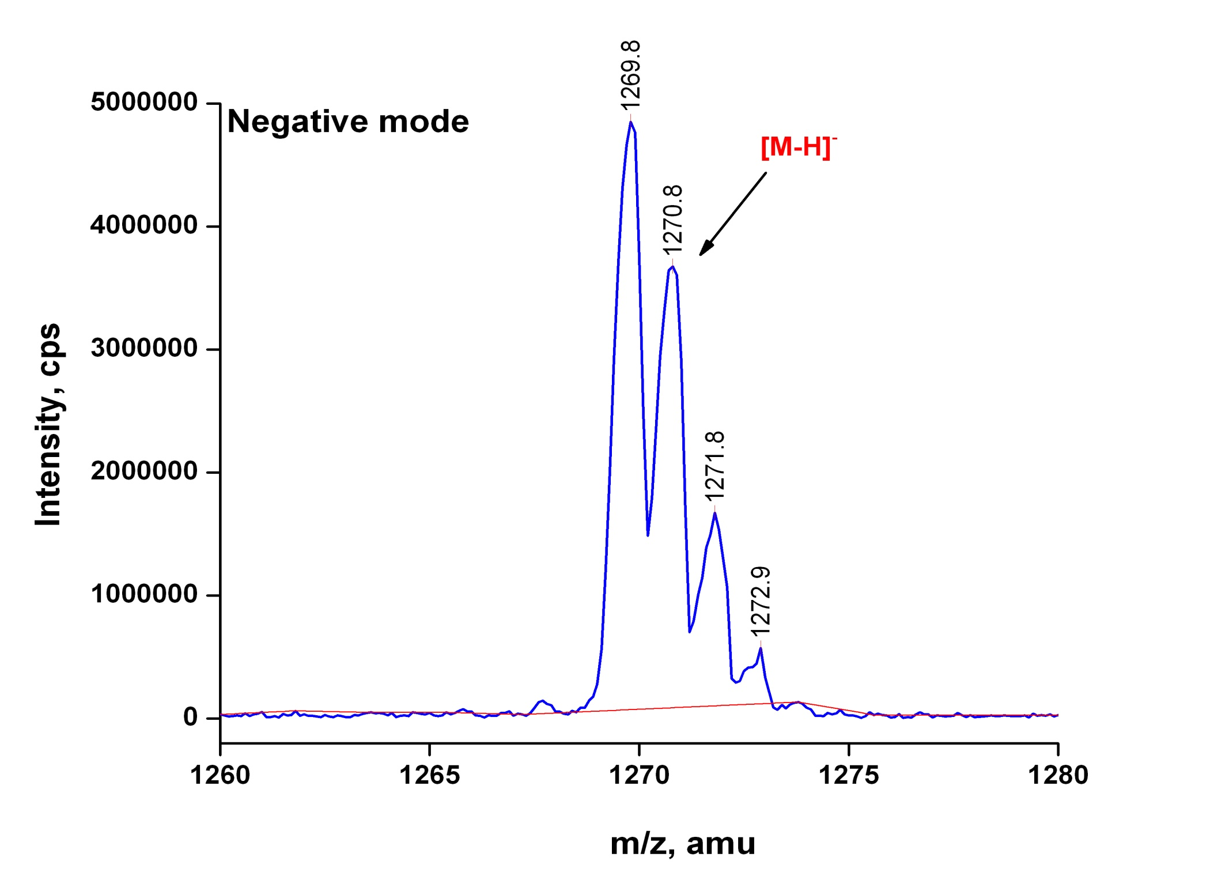

Figure S91. QTRAP MS/MS of R3 (Molecular ion peak (Negative mode)
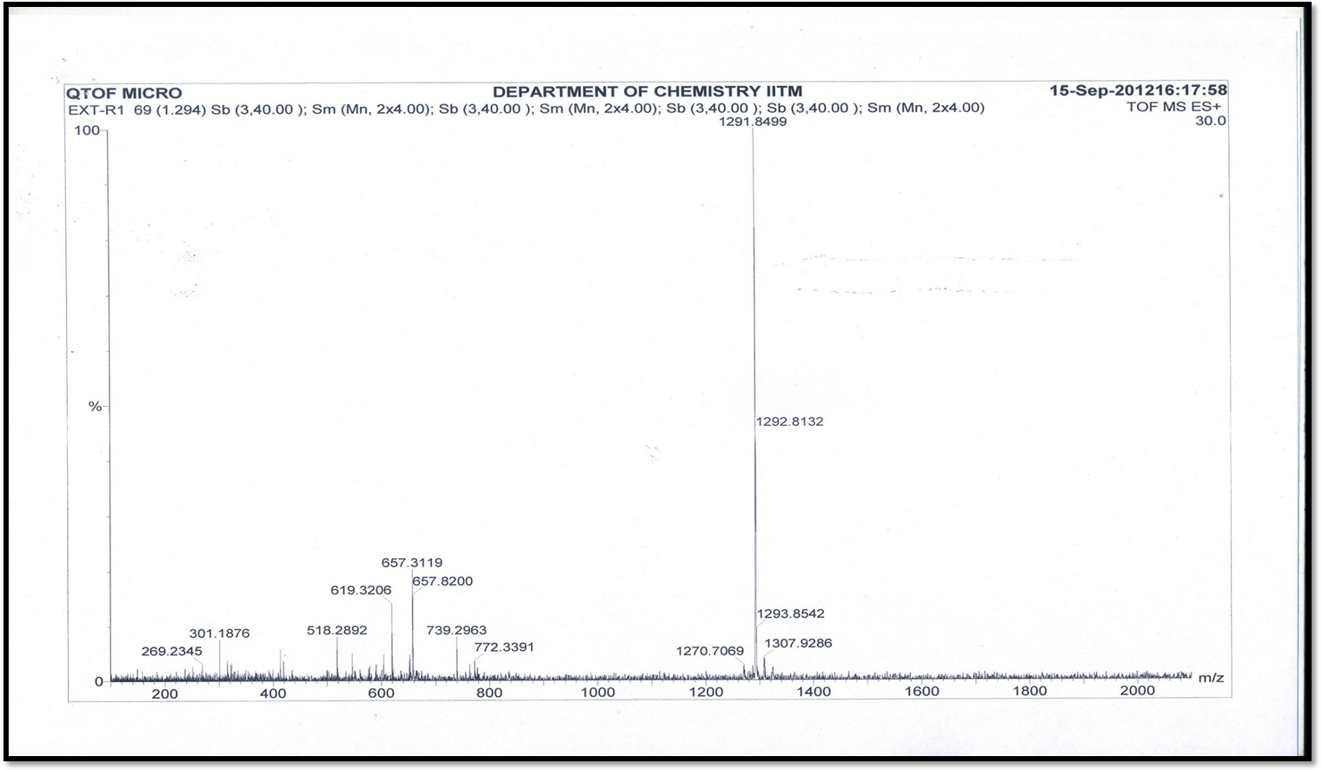
[M + Na]⁺
[M + K]⁺
[M + 2H]²⁺
[M + H]⁺

Figure S92. HR-ESI-MS Spectrum of Transitmycin (R1) (Positive mode)
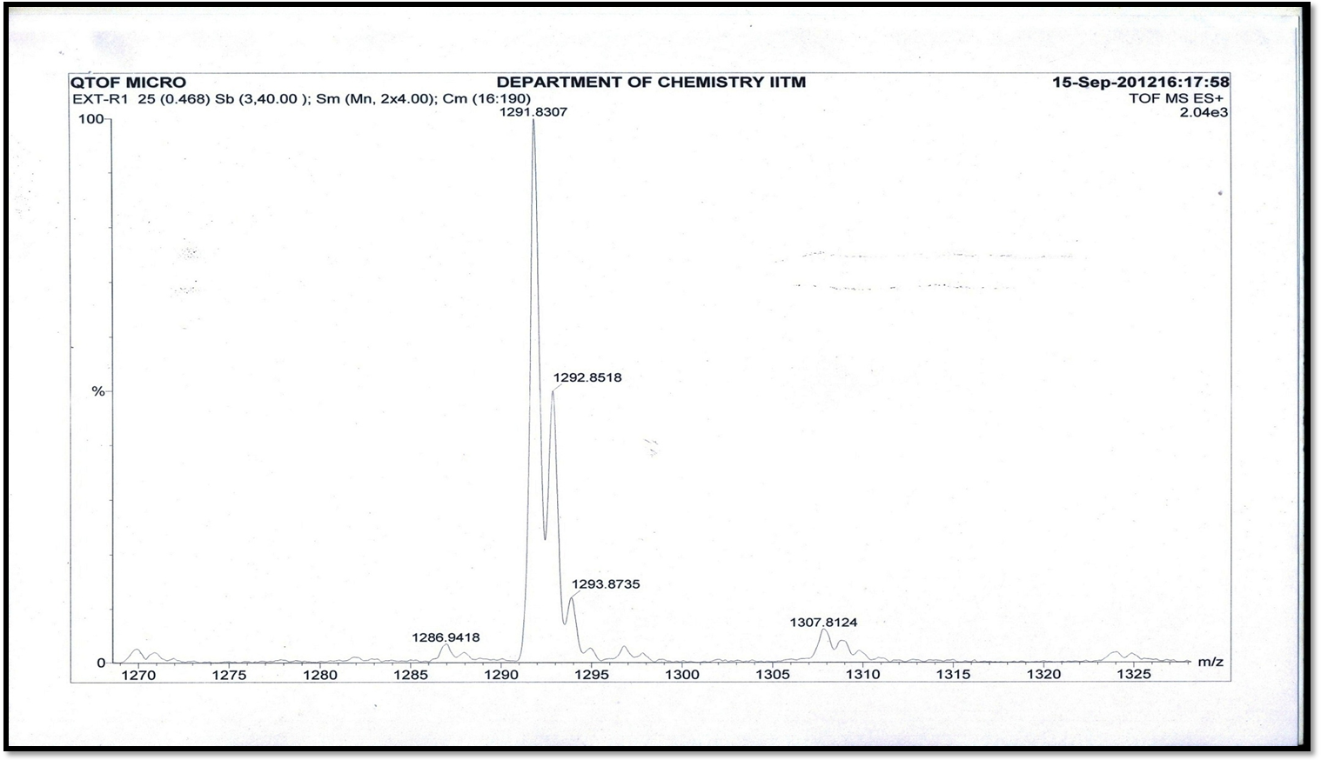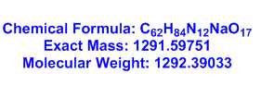
[M + Na]⁺
[M + K]⁺

Figure S93. HR-ESI-MS Spectrum of Transitmycin (R1) (Molecular ion Peak) (Positive mode)
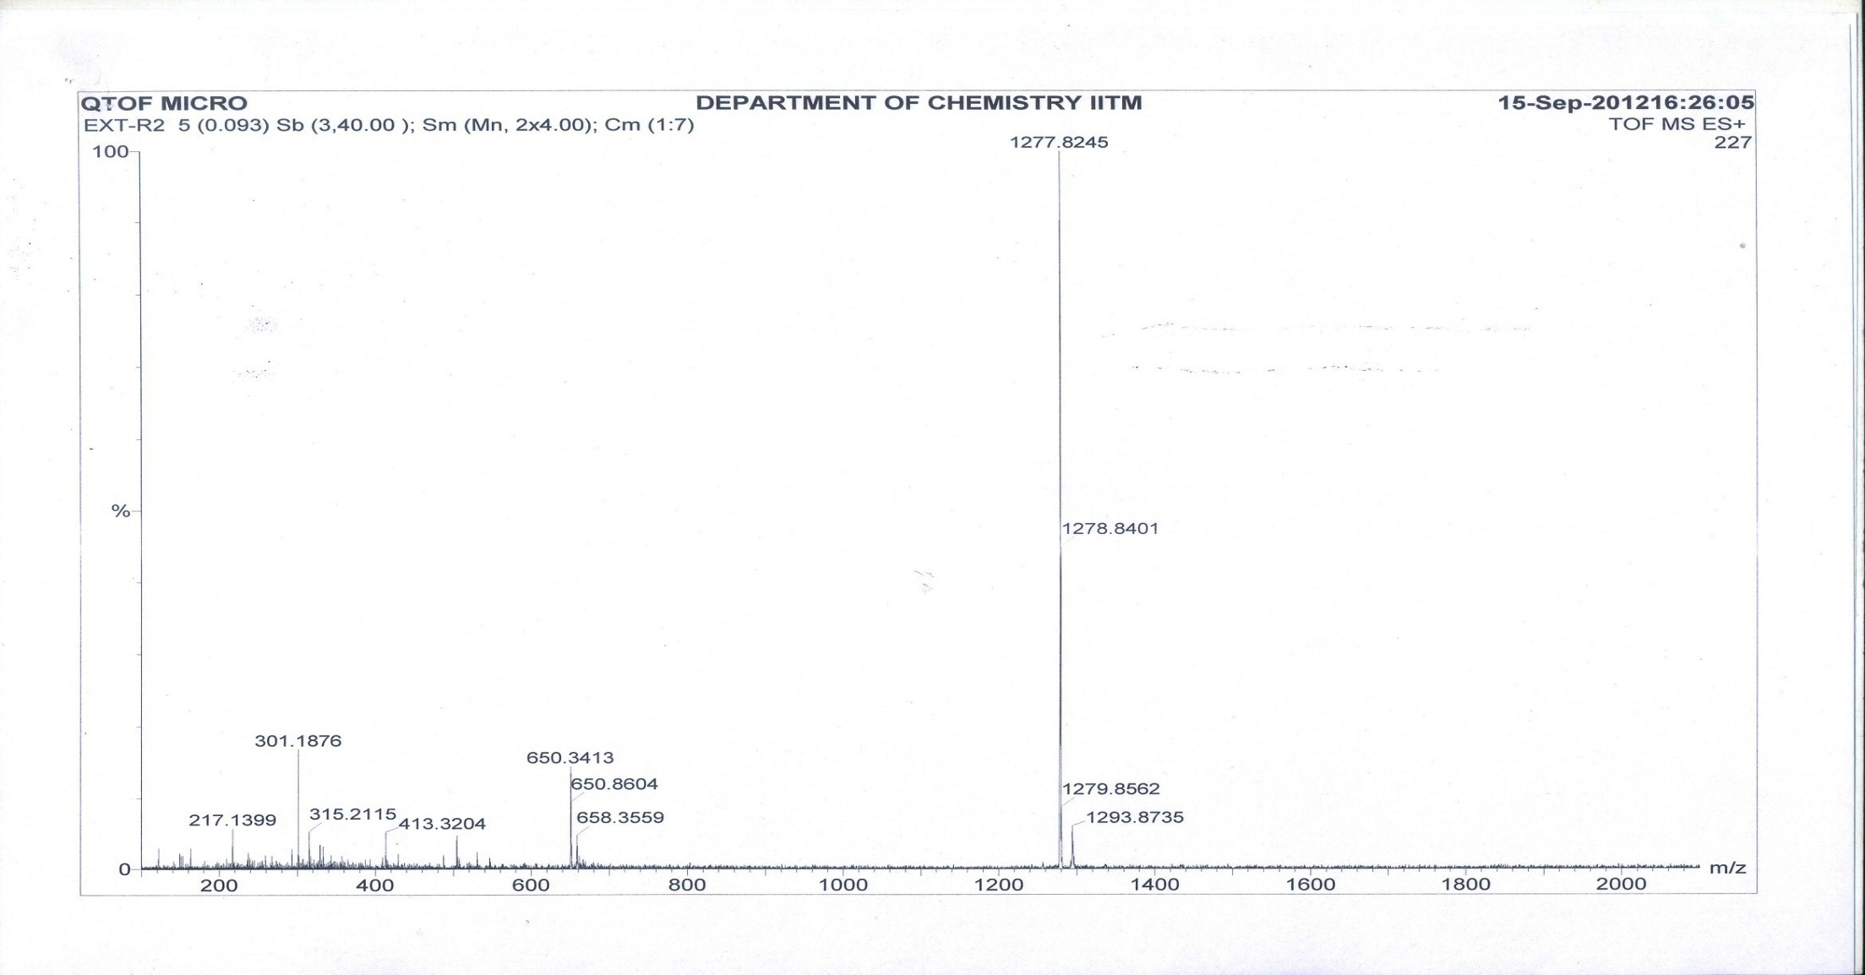
[M+Na]⁺
[M+K]⁺
[M+2H]²⁺

Figure S94. HR-ESI-MS Spectrum of R2 (Positive mode)
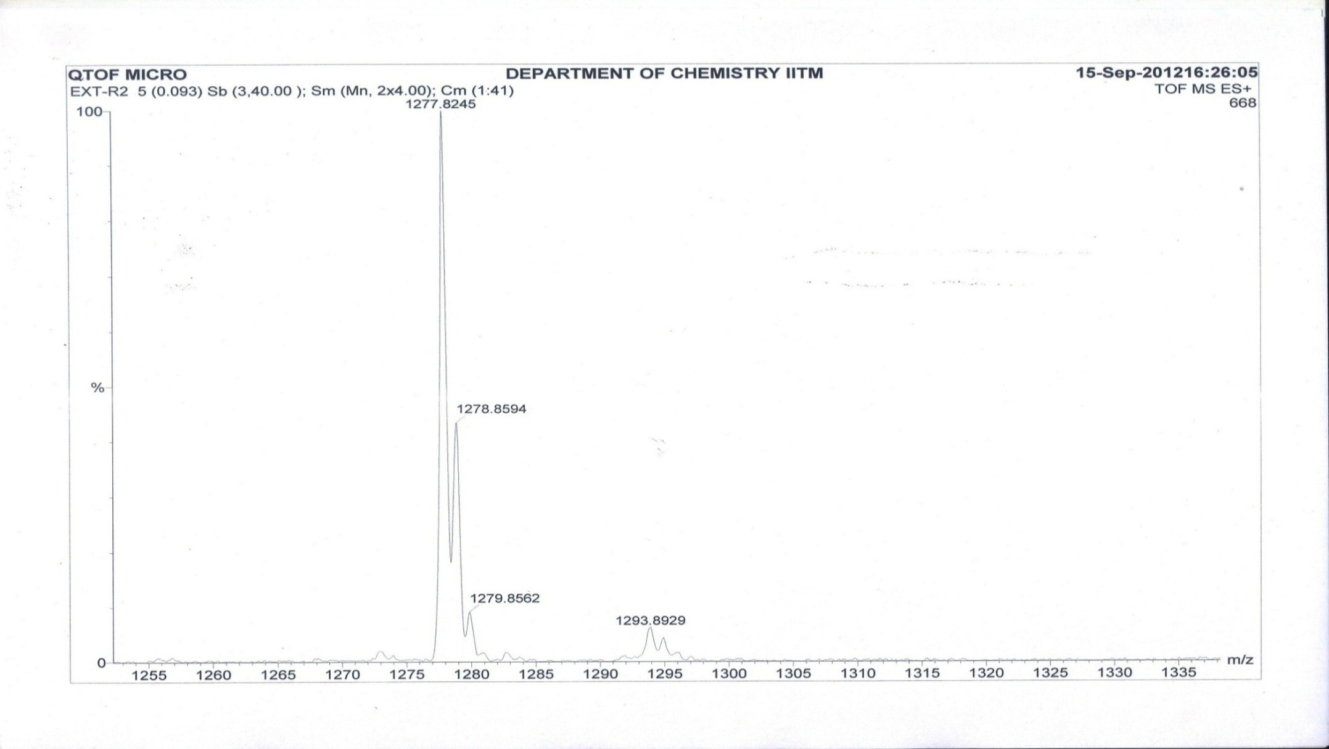
[M+Na]⁺

[M+K]⁺

Figure S95. HR-ESI-MS Spectrum of R2 (Molecular ion Peak) (Positive mode)
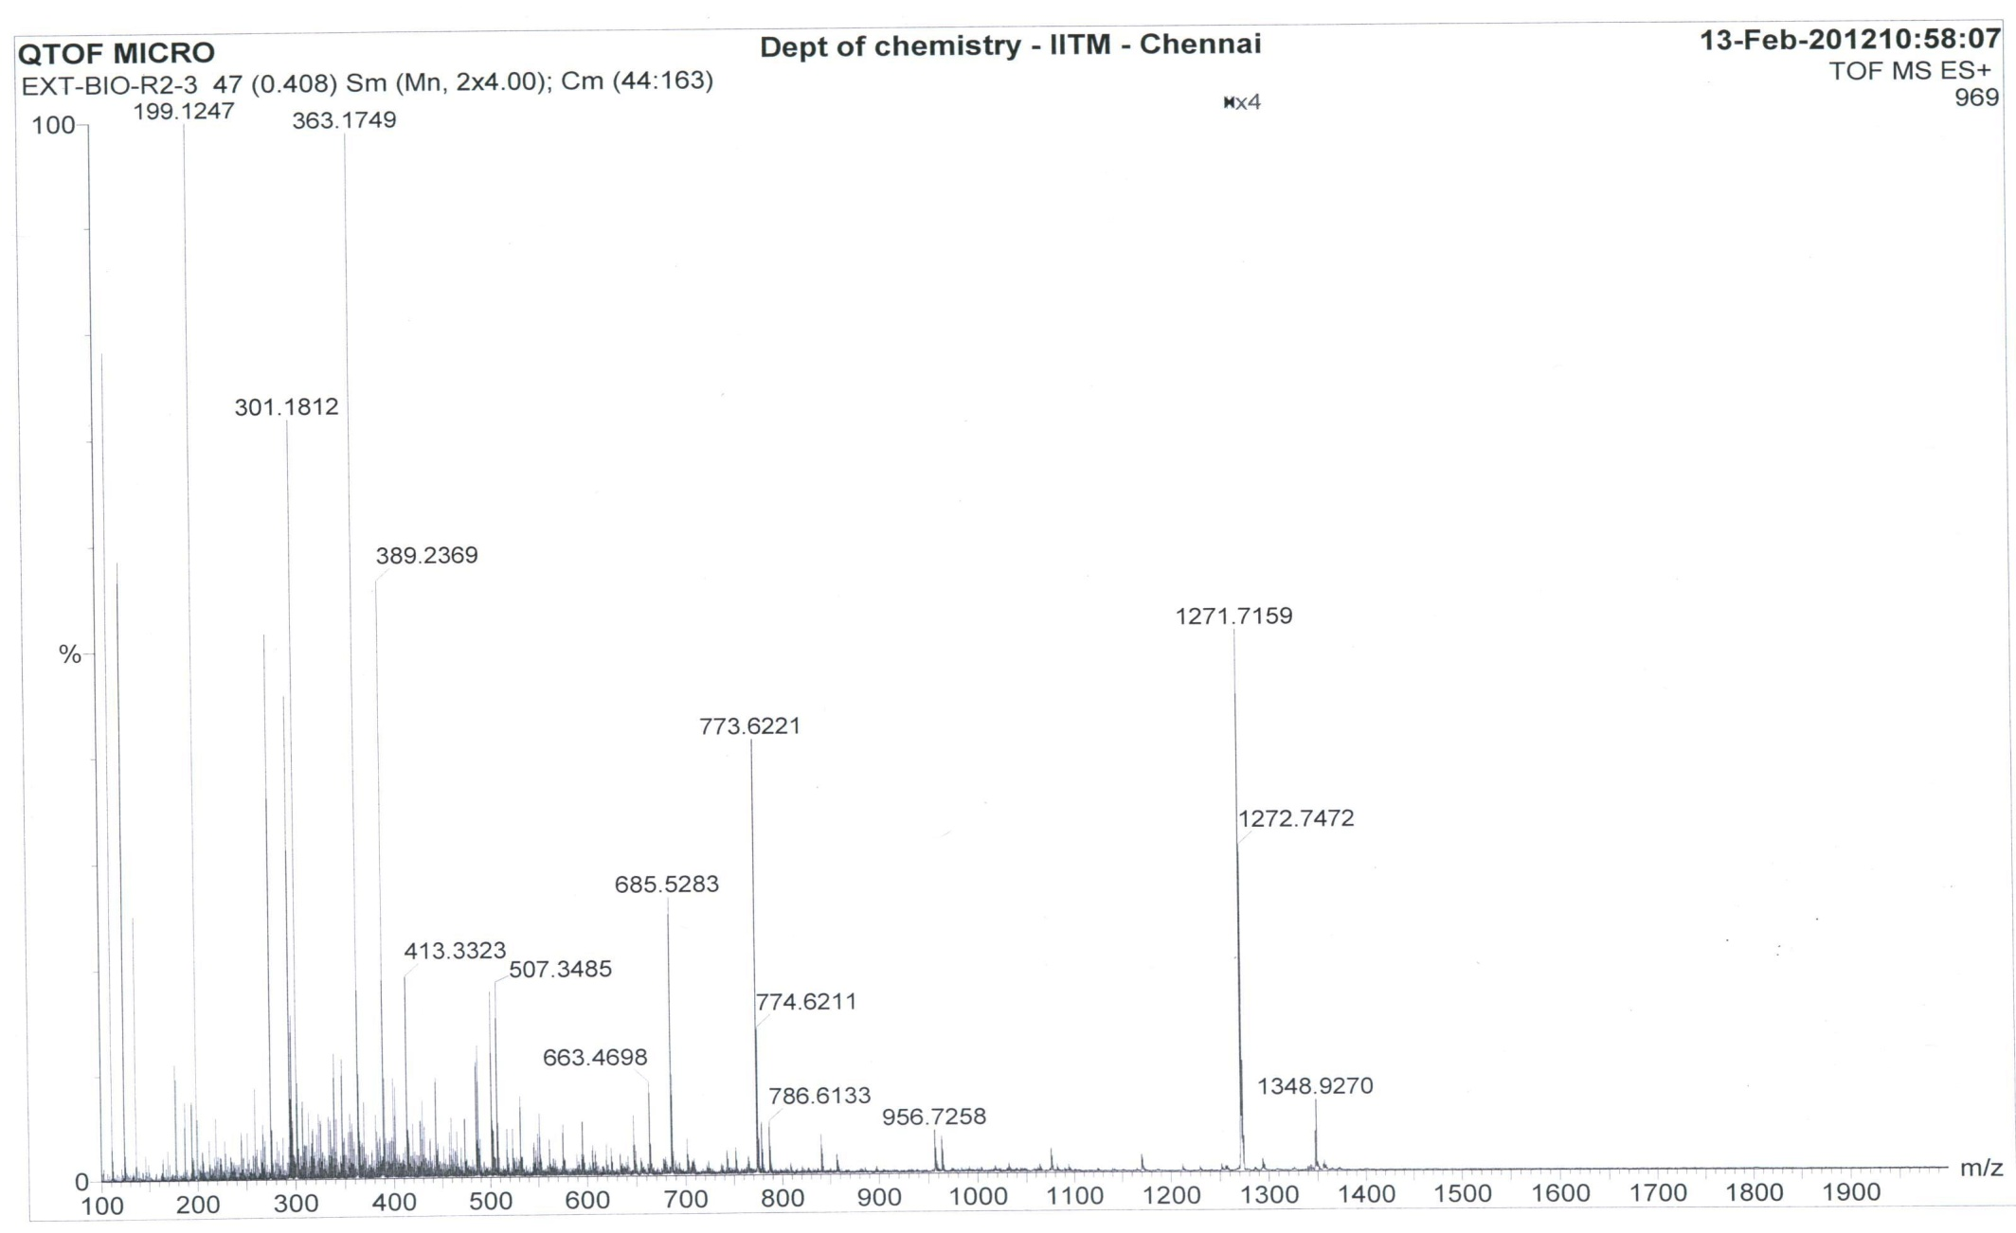

[M+H]⁺

[M+K]⁺

Figure S96. HR-ESI-MS Spectrum of R3 (Positive mode)

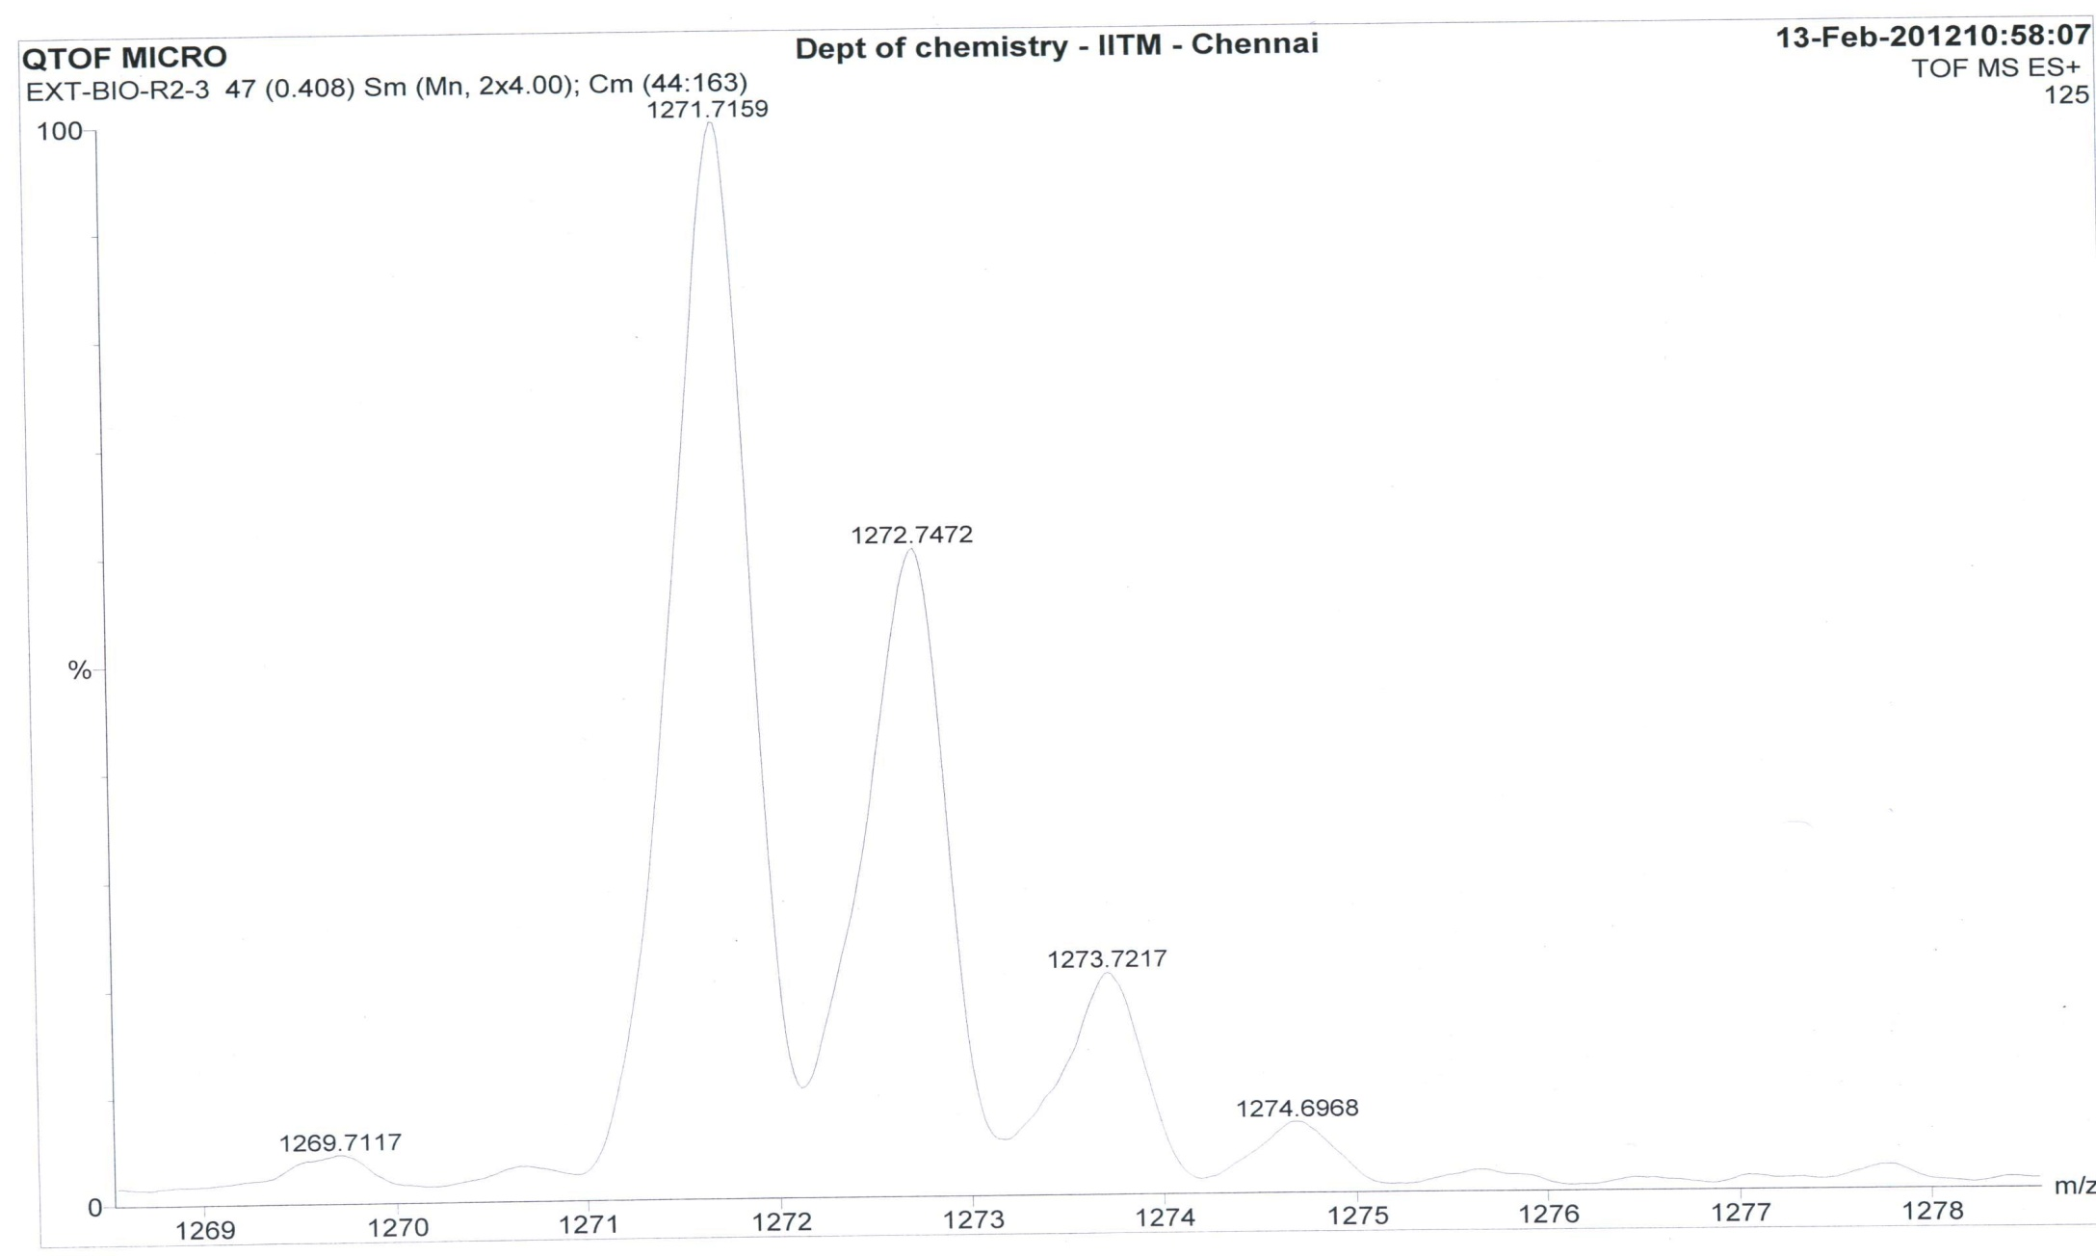

[M+H]⁺

Figure S97. HR-ESI-MS Spectrum of R3 (Molecular ion Peak) (Positive mode)
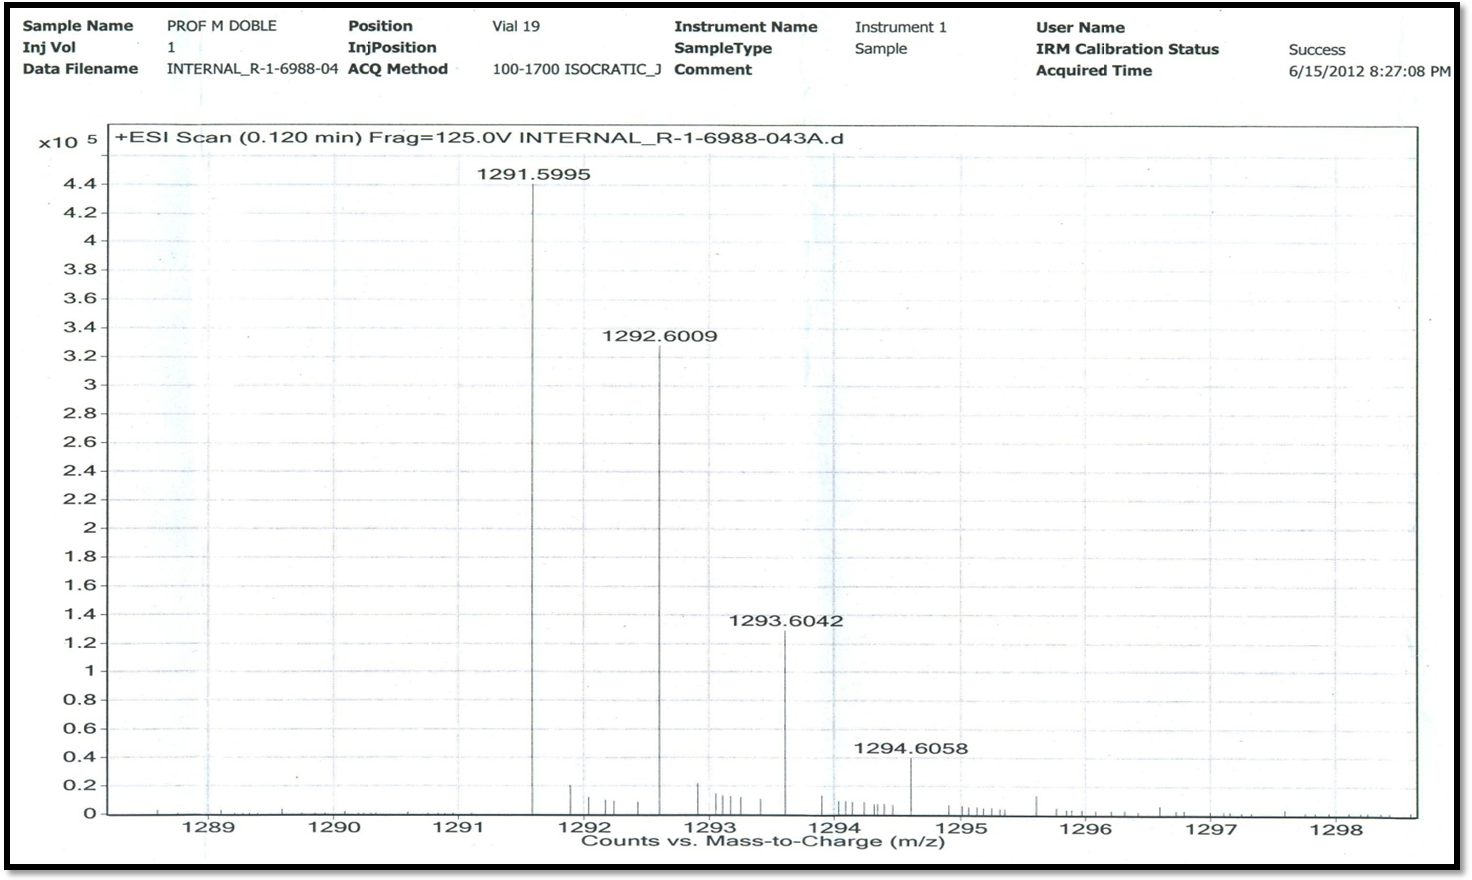
[M + Na]⁺

LC-ESI-MS Spectrum of CompoundR1(Positive mode)

Figure S98. LC-ESI-MS Spectrum of Transitmycin (R1) (Molecular ion peak) (Positive mode)

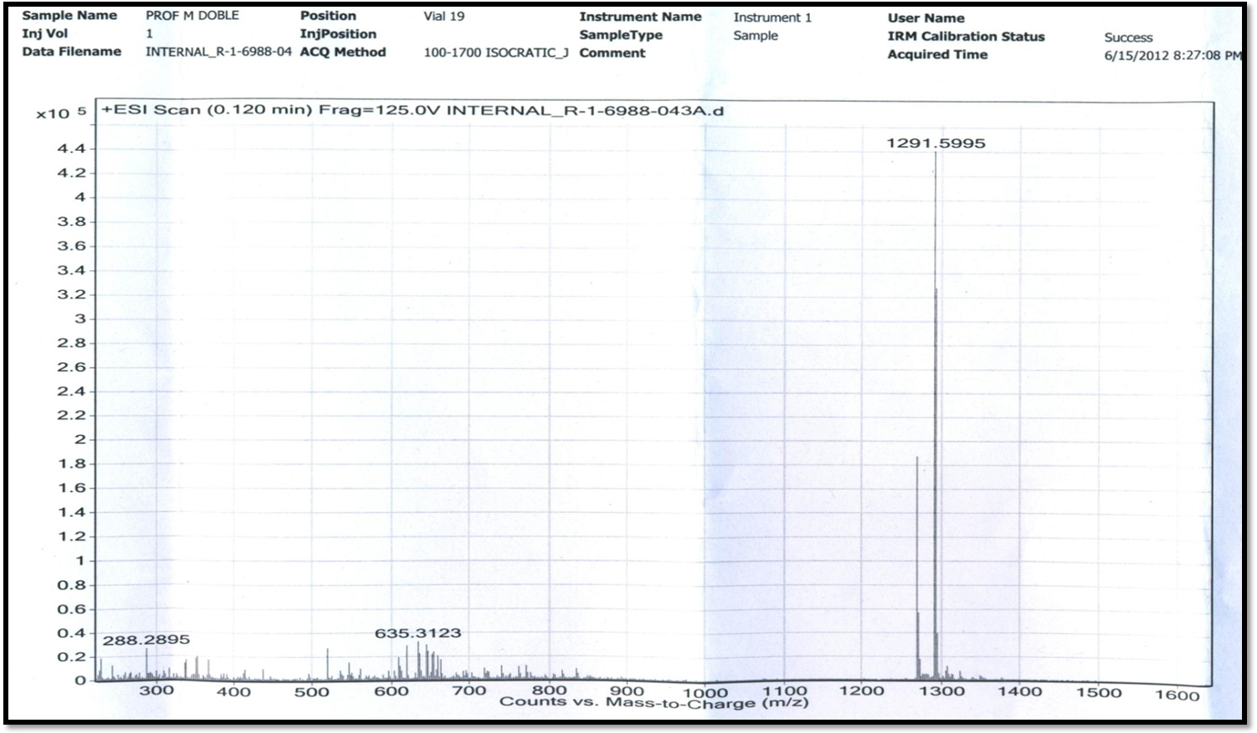
[M + Na]⁺

Figure S99. LC-ESI-MS Spectrum of Transitmycin (R1) (Positive mode)

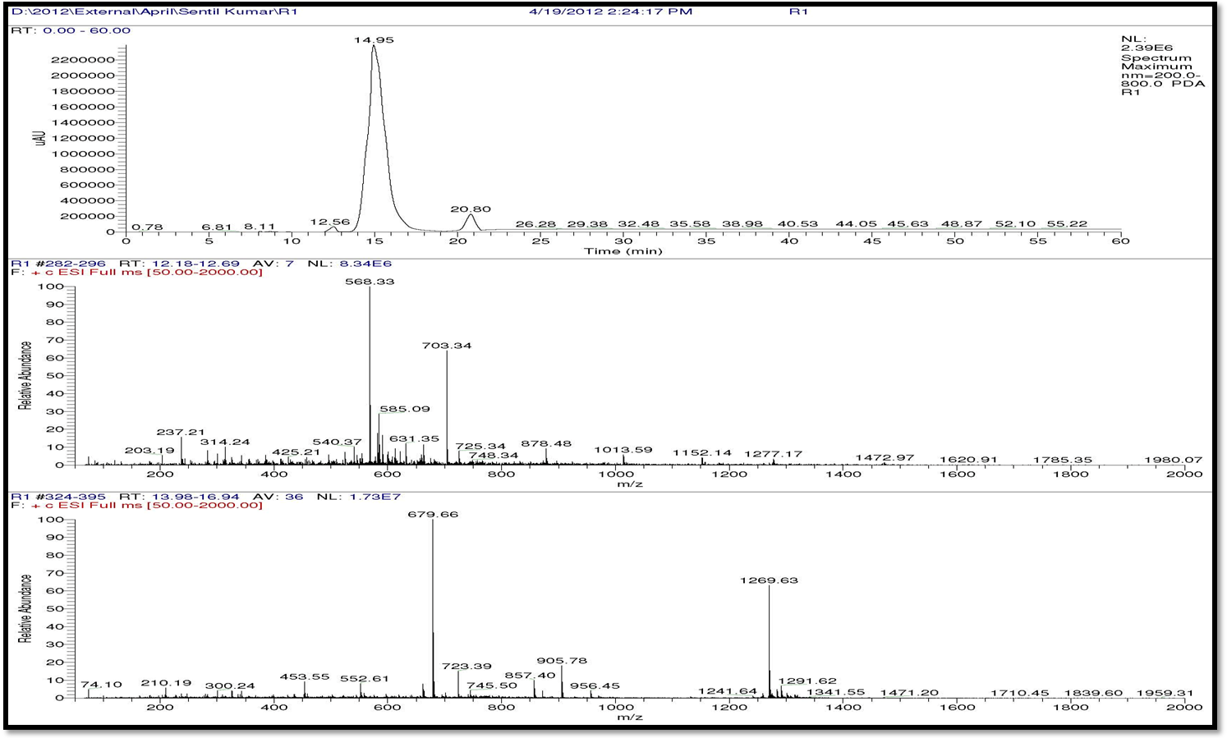
[M + Na]⁺
[M + H]⁺

Figure S100. LC-ESI-MS Spectrum of Trasitmycin (R1) (Positive mode)

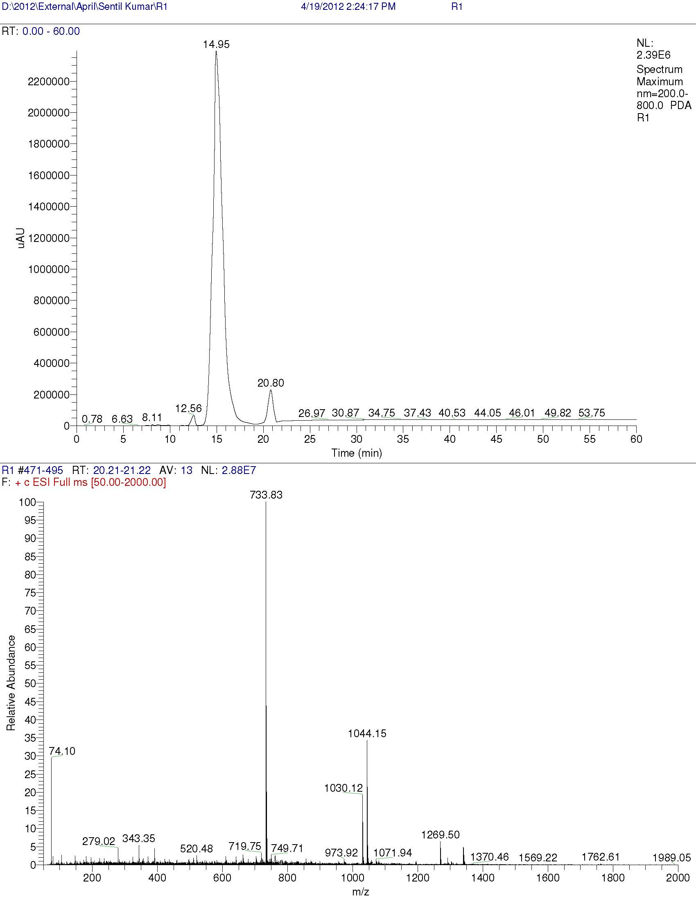

Figure S101. LC-ESI-MS Spectrum of Trasitmycin (R1) (Positive mode)
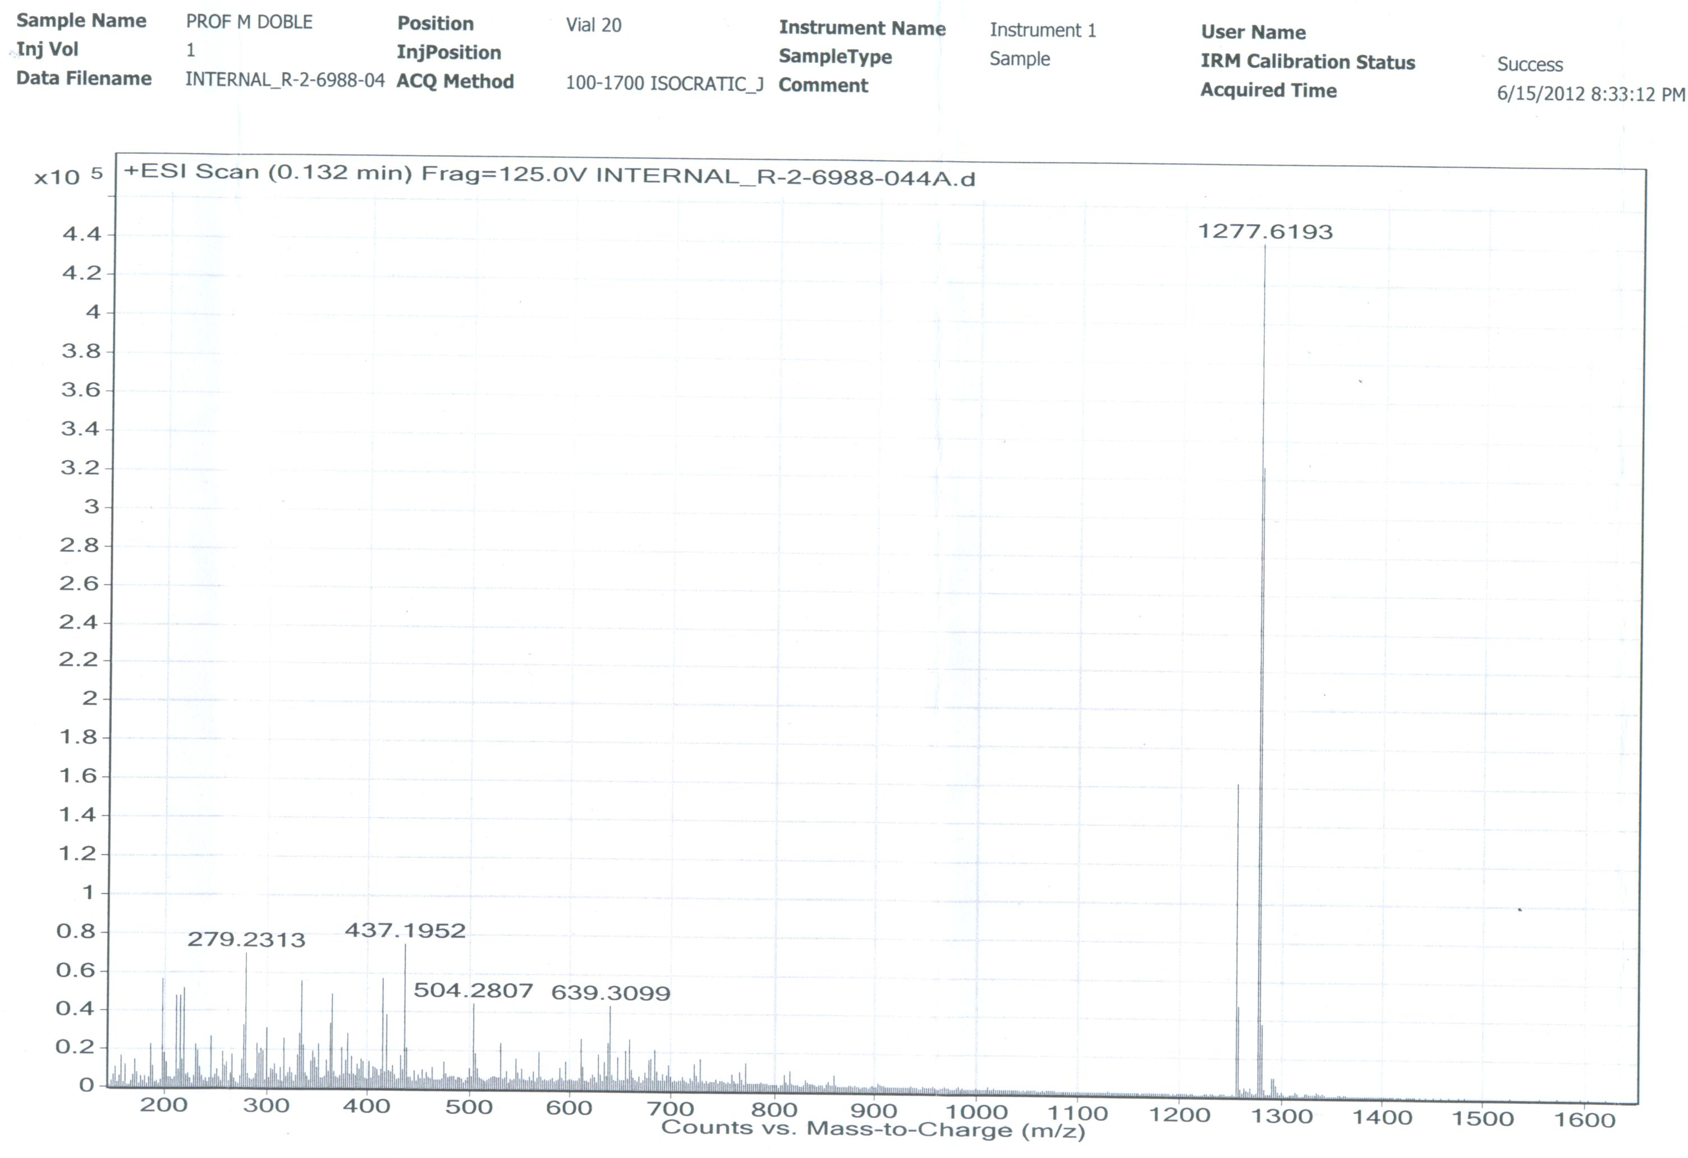

[M+Na]+

Figure S102. LC-ESI-MS Spectrum of R2 (Positive mode)

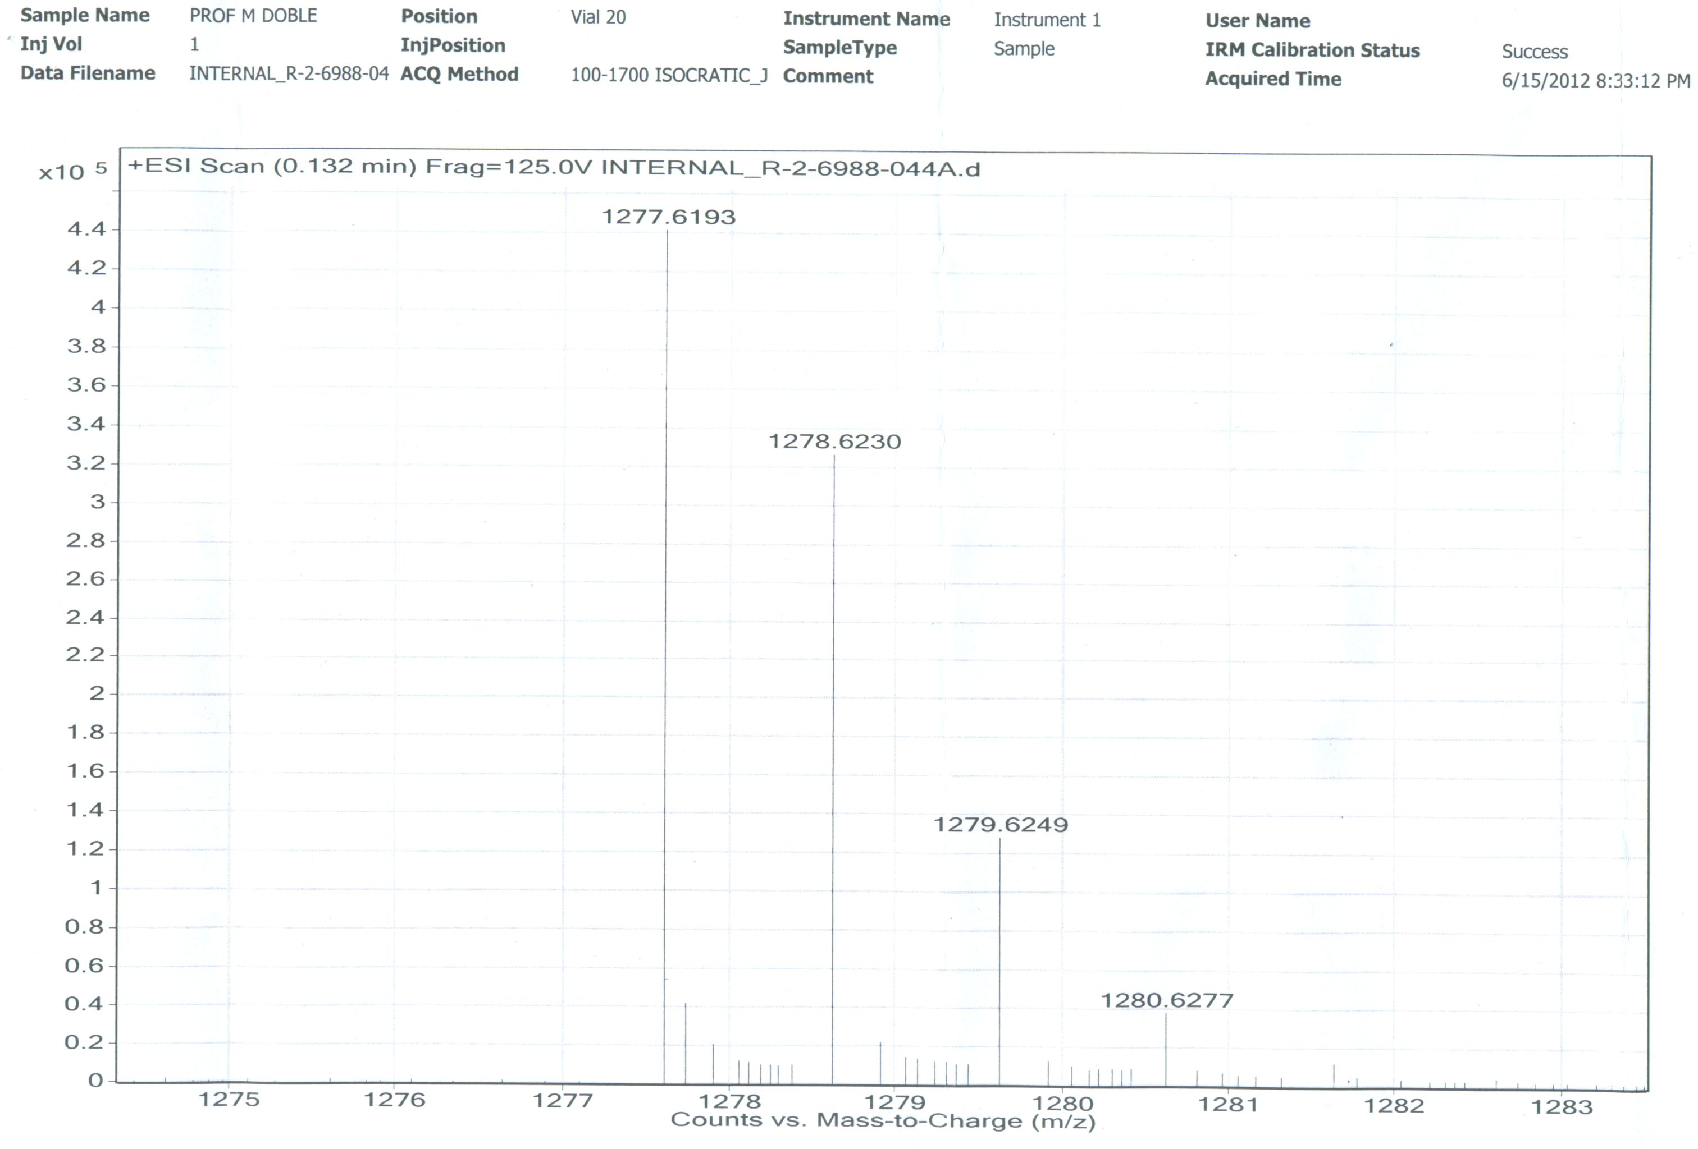
[M+Na]+

Figure S103. LC-ESI-MS Spectrum of R2 (Molecular ion) (Positive mode)
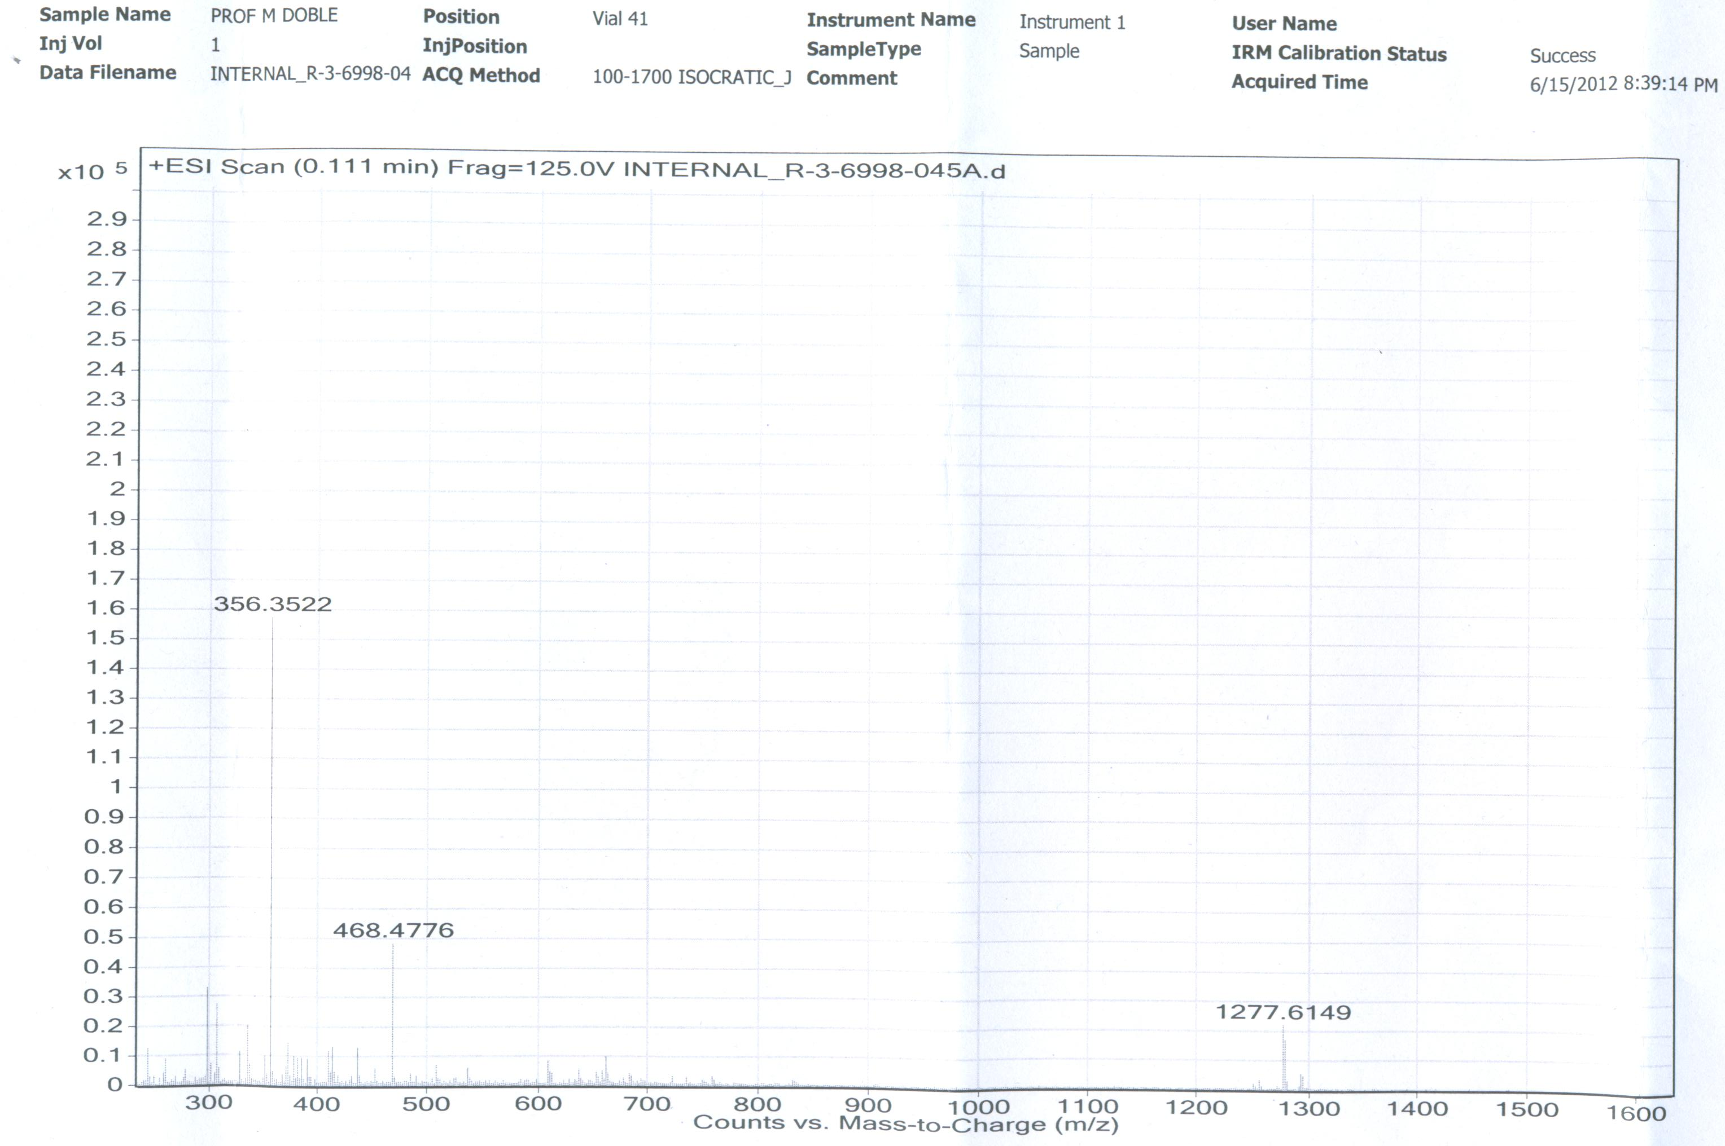

[M-OH+NaH]⁺

Figure S104. LC-ESI-MS Spectrum of R3 (Positive mode)
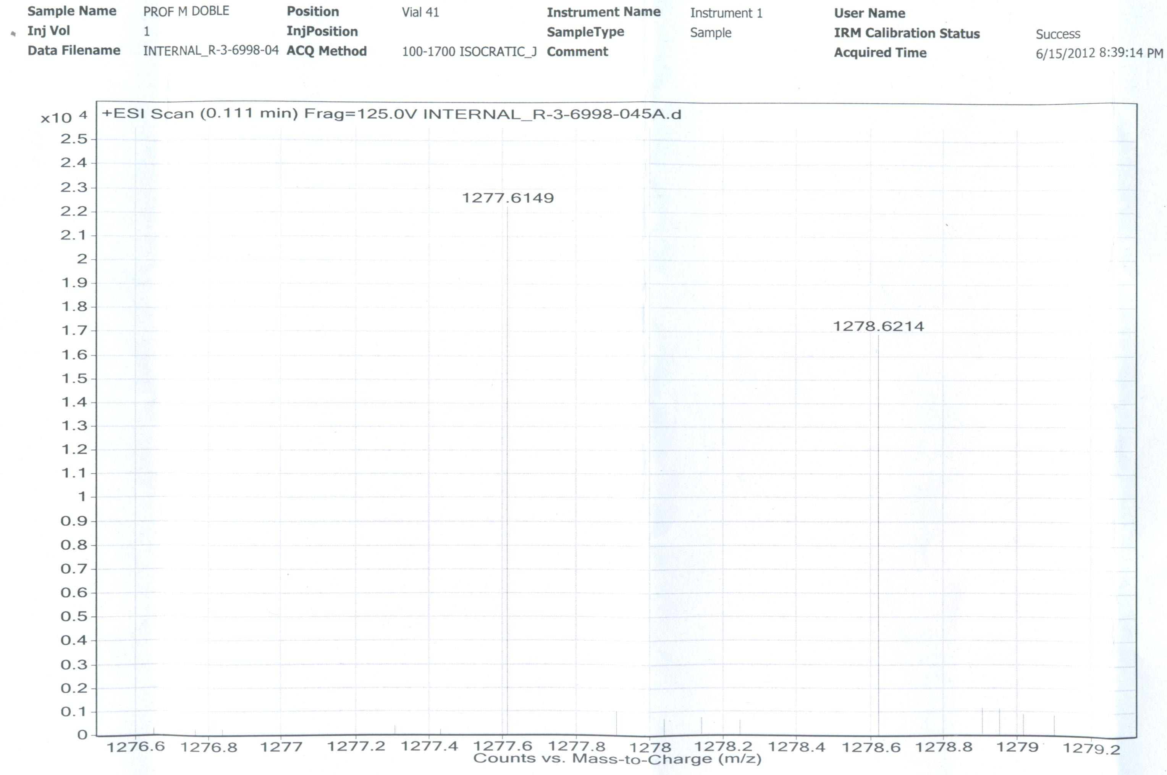
[M-OH+NaH]⁺

Figure S105. LC-ESI-MS Spectrum of R3 (Positive mode)
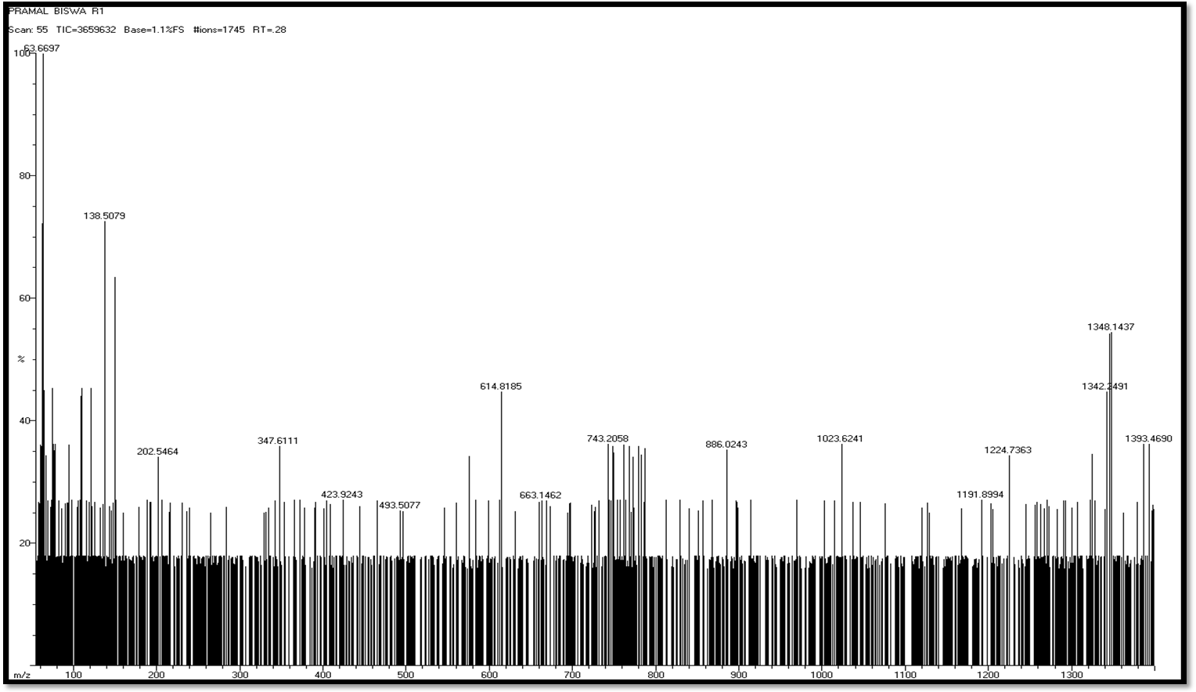

Figure S106. EI-MS Spectrum of Transitmycin (R1) (Positive mode)
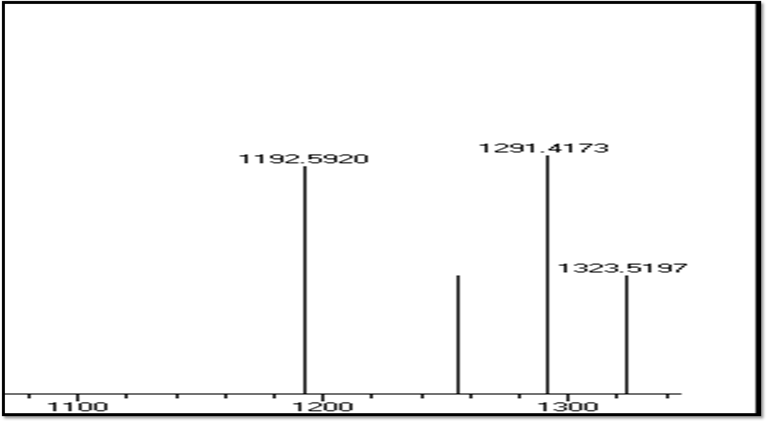
[M+Na]+

Figure S107. EI-MS Spectrum of (R1) (molecular ion peak) (Positive mode)
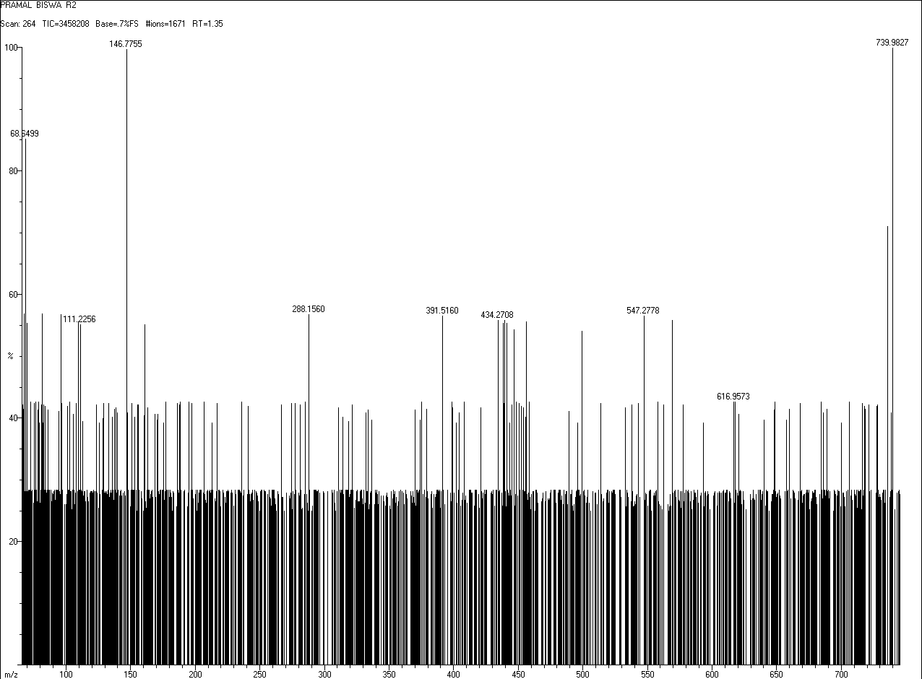

Figure S108. EI-MS Spectrum of (R2) (Positive mode)
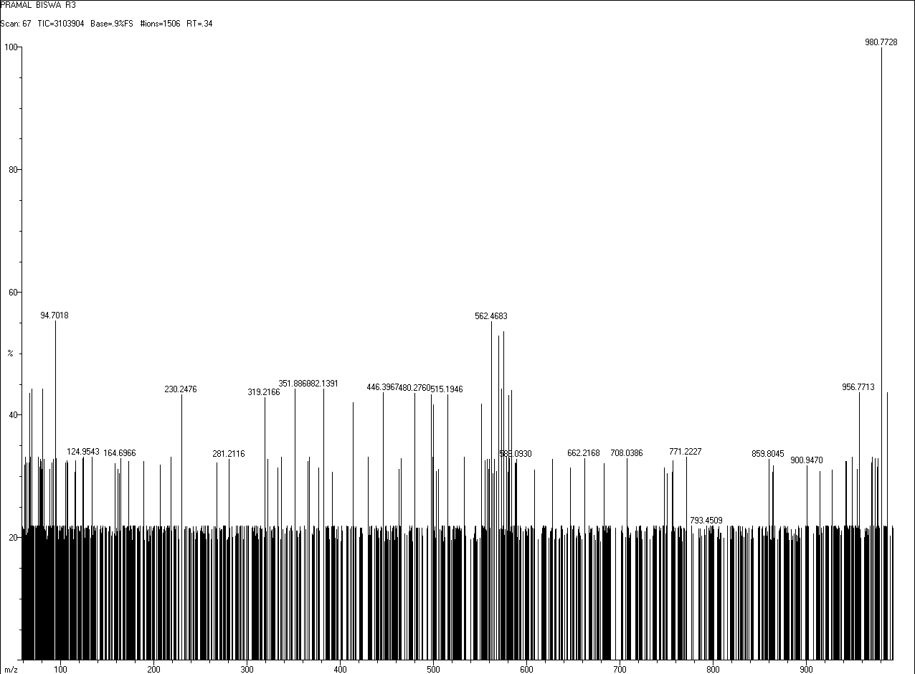

Figure S109 EI-MS Spectrum of (R3) (Positive mode)
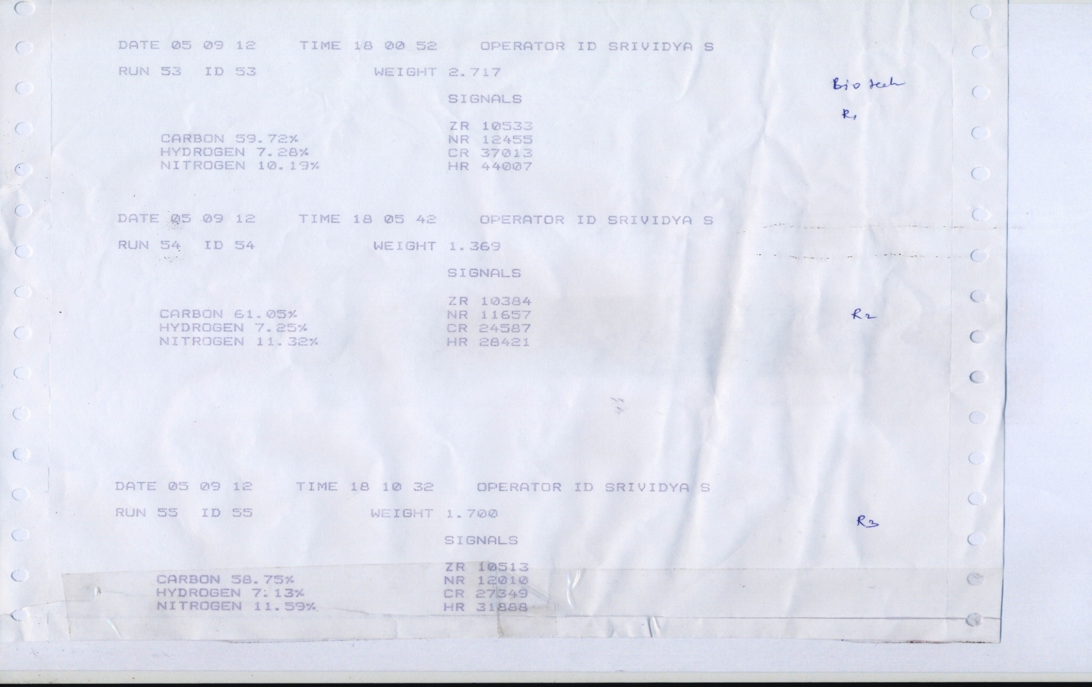

Figure S110. CHN analysis data of Transitmycin (R1), R2, R3

Figure S111. 3200 QTRAP LC/MS/MS Spectrum of Transitmycin (R1) (Negative mode)

Figure S112. 3200 QTRAP LC/MS/MS Spectrum of Transitmycin (R1) (positive mode)

Figure S113. 3200 QTRAP LC/MS/MS Spectrum of Transitmycin (R1) (positive mode mode)

Figure S114. 3200 QTRAP LC/MS/MS Spectrum of Transitmycin (R1) (positive mode)

Figure S115. 3200 QTRAP LC/MS/MS Spectrum of Transitmycin (R1) (positive mode)

Figure S115 a-b Structural characterisation of Transitmycin (R1) obtained by QTRAP LC-MS/MS. b Product ions [MS2] the [M+Na]+ ions Transitmycin (R1) obtained by QTRAP LCMS/MS [MS2] of 1291.6, 1291.6 [M+H]⁺, 1178.5 Loss of H-MeVal-OH, 1065.5 Loss of 2XH-MeVal, 994.2 Loss of Sar-2XH-MeVal-OH, 923.4 Loss of 2XSar-2XH-MeVal-OH, 851.3 Loss of 2XSar-2XH-MeVal-OH, 796.4 Loss of H-Thr-Val-Oxo-Pro-Sar-MeVal-OH, 683.2 Loss of H-Thr-Val-Oxo-Pro-Sar-MeVal-OH + Loss of H-MeVal-OH, 657.5 Loss of H-Val-Pro- Sar-MeVal-OH + Loss of H-Pro- Sar-MeVal-OH, 639.4 Loss of H-Val-Pro- Sar-MeVal-OH + Loss of H-Pro- Sar-MeVal-OH (18), 518.3 Loss of H`-Val-OXO-Pro-Sar-MeVal-OH + Loss of H-Val-Pro- Sar-MeVal-OH, 518.3 Loss of H`-Val-OXO-Pro-Sar-MeVal-OH + Loss of H-Val-Pro- Sar-MeVal-OH, 487.0 Loss of H-Val-OXO-Pro-Sar-MeVal-OH + Loss of H-Val-Pro- Sar-MeVal-OH (32), 443.3 Loss of H-Val-OXO-Pro-Sar-MeVal-OH + Loss of H-Val-Pro- Sar-MeVal-OH (32), 405.3 Loss of H-Val-OXO-Pro-Sar-MeVal-OH + Loss of H-Val-Pro- Sar-MeVal-OH, 334.4 Loss of H-Th-Val-Oxo-Pro-Sar-MeVal-OH + Loss of H-Th-Val-Pro- Sar-MeVal-OH.
Table S7a. Structural characterisation of Transitmycin (R1) obtained by QTRAP LCMS/MS
Product ions of [MS2] the [M+H]⁺ ions of Transitmycin (R1) obtained by QTRAP LCMS/MS
[MS2] of 1269.7
1269.7 = [M+H]⁺
1269.7-313.2 = 956.5 Loss of H-Oxo-Pro-Sar-MeVal-OH
1269.7-412.5 = 857.2 Loss of H-Val-Oxo-Pro-Sar-MeVal-OH
1269.7-612.3 = 657.4 Loss of H-Val-Oxo-Pro-Sar-MeVal-OH + Loss of Sar-MeVal-OH
1269.7-711.3 = 558.4 Loss of H-Val-Oxo-Pro-Sar-MeVal-OH + Loss of Pro- Sar-MeVal-OH
1269.7-739.3 = 530.3 Loss of H-Val-Oxo-Pro-Sar-MeVal-OH + Loss of Pro- Sar-MeVal-OH (-28)
1269.7-810.4 = 459.3 Loss of H-Val-Oxo-Pro-Sar-MeVal-OH + Loss of Val-Pro- Sar-MeVal-OH
1269.7-870.4 = 399.3 Loss of H-Val-Pro- Sar-MeVal-OH
1269.7-969.7 = 300.2 Loss of H-Pro- Sar-MeVal-OH
1269.7-1007.5 = 262.2 Loss of H-Pro- Val-Sar-OH
1269.7-1066.3 = 203.4 Loss of H-Sar-MeVal-OH
1269.7-1100.4 = 169.3 Loss of H-Pro-Sar-OH

Table S7b. Structural characterisation of Transitmycin (R1) obtained by QTRAP LCMS/MS
Product ions of [MS2] the [M+Na]⁺ ions of Transitmycin (R1) obtained by QTRAP LCMS/MS
[MS2] of 1291.6]
1291.6 = [M+H]⁺
1291.6-113.1 = 1178.5 Loss of H-MeVal-OH
1291.6-226.1 = 1065.5 Loss of 2XH-MeVal
1291.6-297.4 = 994.2 Loss of Sar-2XH-MeVal-OH
1291.6-368.2 = 923.4 Loss of 2XSar-2XH-MeVal-OH
1291.6-440.3 = 851.3 Loss of 2XSar-2XH-MeVal-OH
1291.6-495.2 = 796.4 Loss of H-Thr-Val-Oxo-Pro-Sar-MeVal-OH
1291.6- 608.4 = 683.2 Loss of H-Thr-Val-Oxo-Pro-Sar-MeVal-OH + Loss of H-MeVal-OH
1291.6- 634.1 = 657.5 Loss of H-Val-Pro- Sar-MeVal-OH + Loss of H-Pro- Sar-MeVal-OH
1291.6-652.2 = 639.4 Loss of H-Val-Pro- Sar-MeVal-OH + Loss of H-Pro- Sar-MeVal-OH (18)
1291.6-772.7 = 518.3 Loss of H`-Val-OXO-Pro-Sar-MeVal-OH + Loss of H-Val-Pro- Sar-MeVal-OH
1291.6-772.7 = 518.3 Loss of H`-Val-OXO-Pro-Sar-MeVal-OH + Loss of H-Val-Pro- Sar-MeVal-OH
1291.6-804.0 = 487.0 Loss of H-Val-OXO-Pro-Sar-MeVal-OH + Loss of H-Val-Pro- Sar-MeVal-OH (32)
1291.6-848.3 = 443.3 Loss of H-Val-OXO-Pro-Sar-MeVal-OH + Loss of H-Val-Pro- Sar-MeVal-OH (32)
1291.6-886.3 = 405.3 Loss of H-Val-OXO-Pro-Sar-MeVal-OH + Loss of H-Val-Pro- Sar-MeVal-OH
1291.6-957.2 = 334.4 Loss of H-Th-Val-Oxo-Pro-Sar-MeVal-OH + Loss of H-Th-Val-Pro- Sar-MeVal-OH
The Transitmycin A (3.0 mg) dissolved in 6N HCl (1 mL) and heated at 110 ⁰C for 24 h. The solvent was removed under reduced pressure, and the resulting material was subjected to further derivatization. The hydrolysate mixture (3.5 mg) or the amino acid standards (0.5 mg) were dissolved in 0.1 mL of water and treated with 0.2 mL of 1% 1-fluoro-2,4-dinitrophenyl-5-Lalaninamide (FDAA) in acetone and 0.04 mL of 1.0 M sodium bicarbonate. The vials were heated at 50 ⁰C for 90 min, and the contents after cooling at room temperature were neutralized with 1 N HCl. After degassing, an aliquot of the FDAA derivative was diluted in MeOH and purified by chromatography using a RP C-18 column (250 X 4.6 mm) and a linear gradient of acetonitrile and water containing 0.05% trifluoroacetic acid from 20:80 to 50:50 in 20 min and then isocratic. The flow rate was 1 mL/min, and the absorbance detection was at 340 nm. The chromatogram was compared with those of amino acid standards treated in the same conditions. The above same procedure for other two compounds B and C were done.
Transitmycin (R1) (3.0 mg)

6N HCl (1mL) 110 ⁰C 24 h
Hydrolyzed Residue was dissolved in 0.1 mL of distilled water
0.04 mL of 1.0 M sodium bicarbonate 0.2 mL of 1% 1-fluoro-2,4-dinitrophenyl-5- alaninamide (FDAA)
in acetone
10 mg/mL solution
Residue was neutralized with 1 N HCl

Residue was analyzed by, HPLC, LCMS, MALDI-TOF, ESI-MS

Figure S116. Hydrolysis of Amino Acid Residue of Transitmycin (R1), R2, R3
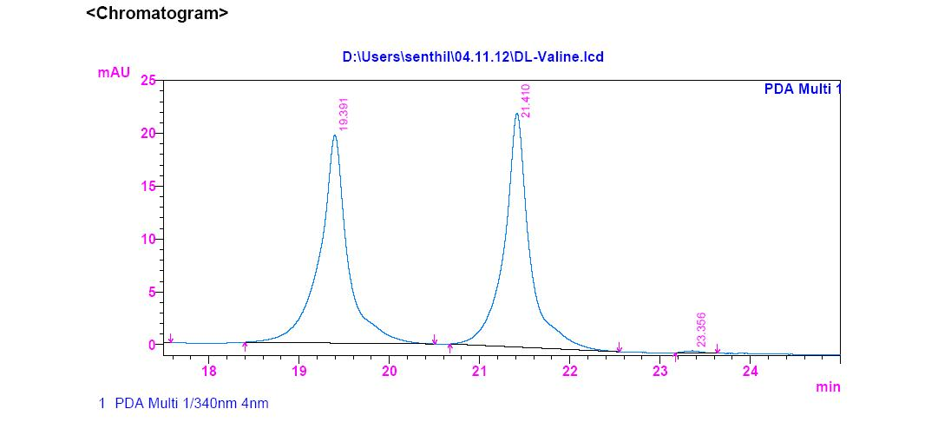
Figure S117a. HPLC analysis of standard L-FDAA-D/L-Valine
(a)
D-Valine
L-Valine

Figure S117 b. HPLC analysis of standard L-FDAA-D-Valine
Figure S117c. HPLC analysis of standard L-FDAA-L-Valine
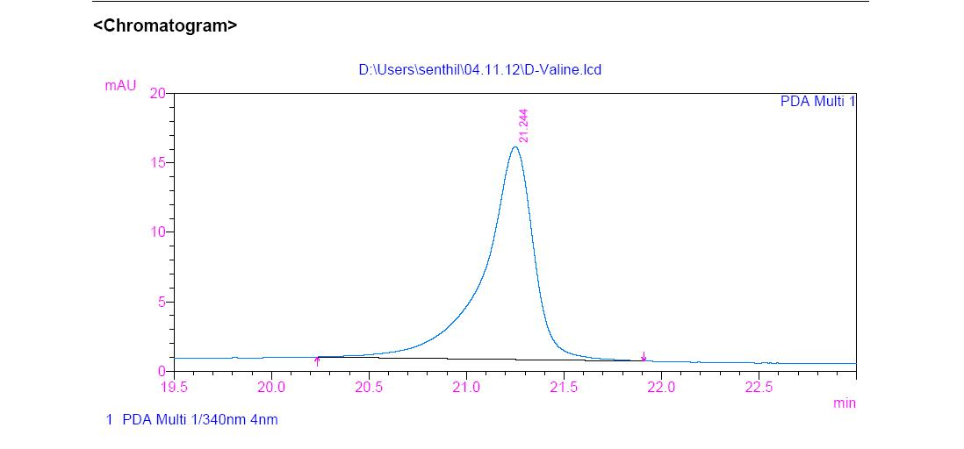
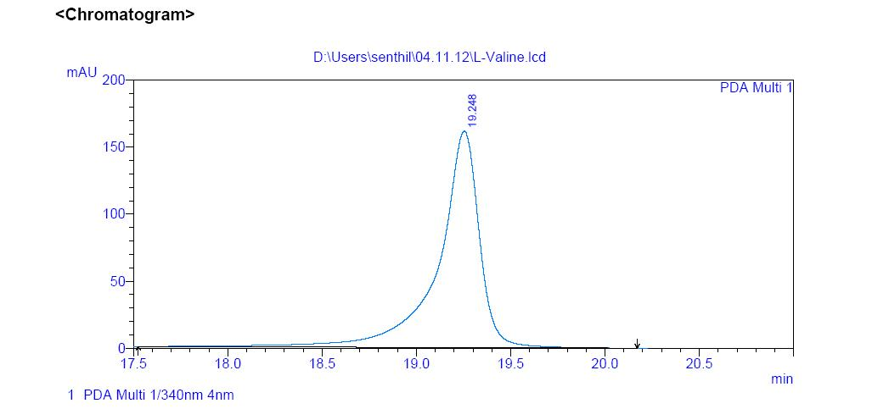
(c)
(b)
Standard L-FDAA-D-Valine
Standard L-FDAA-L-Valine

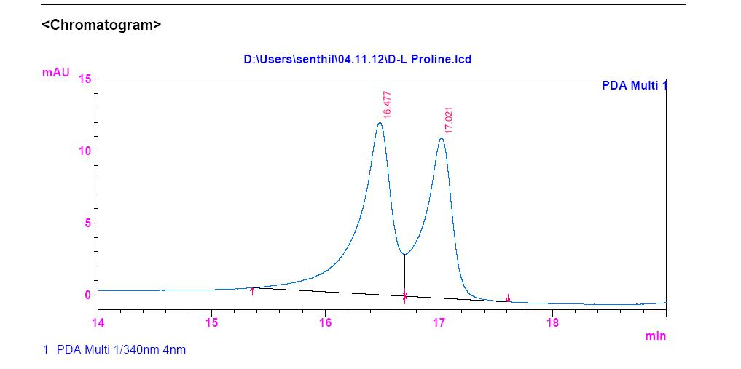
(a)
Figure S118 (a). HPLC analysis of standard L-FDAA-D/L-Proline

D-Proline
L-Proline

Figure S118 (b) HPLC analysis of standard L-FDAA-D-Proline
Figure S118c. HPLC analysis of standard L-FDAA-L-Proline
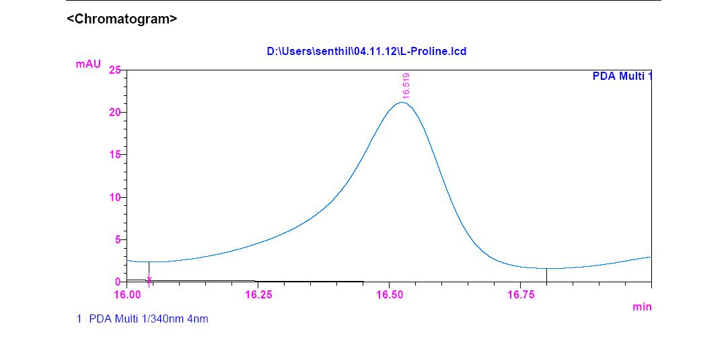
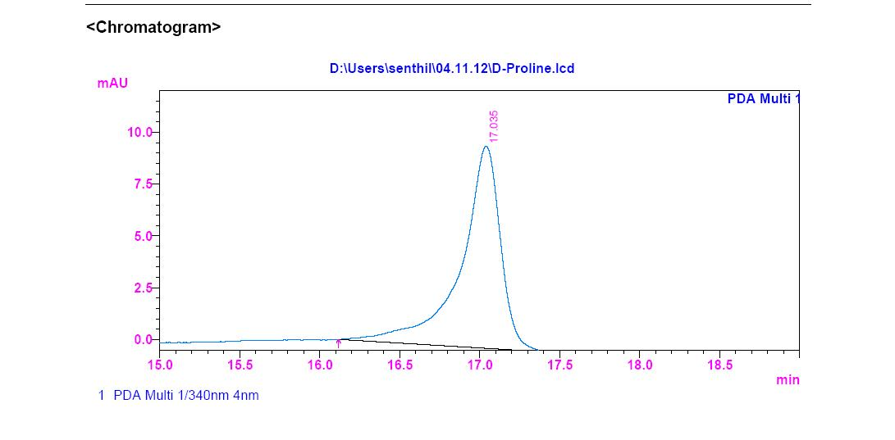
(b)
(c)
Standard L-FDAA-D-Proline
Standard L-FDAA-L-Proline

L-Proline
D-Proline

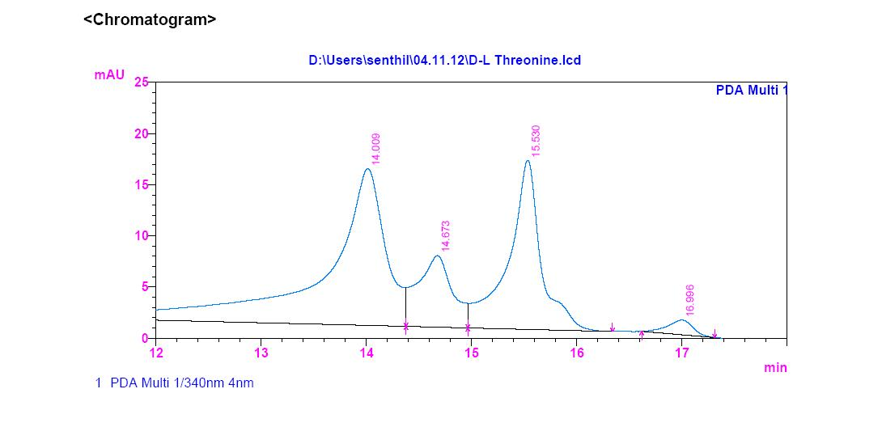
Figure S119a. HPLC analysis of standard L-FDAA-D/L-Threonine
L-Threonine
D-Threonine

Figure S119b. HPLC analysis of standard L-FDAA-D-Threonine
Figure S119c.HPLC analysis of standard L-FDAA-D-Threonine
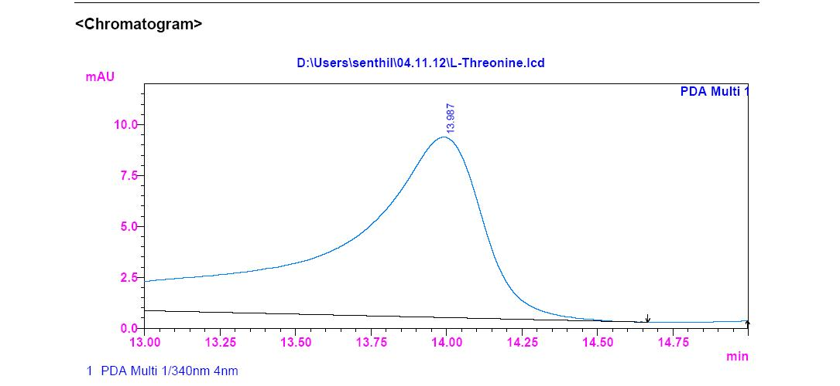
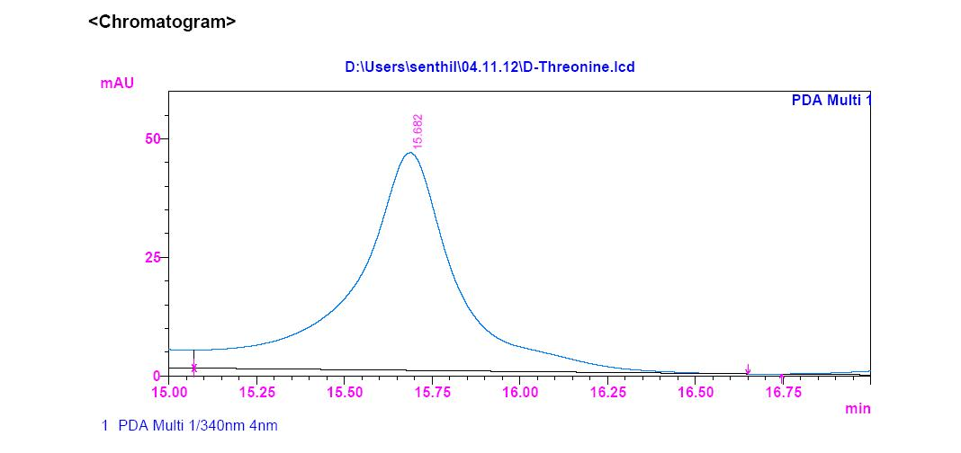
Standard L-FDAA-D-Threonine
Standard L-FDAA-L-Threonine
D-Threonine
L-Threonine

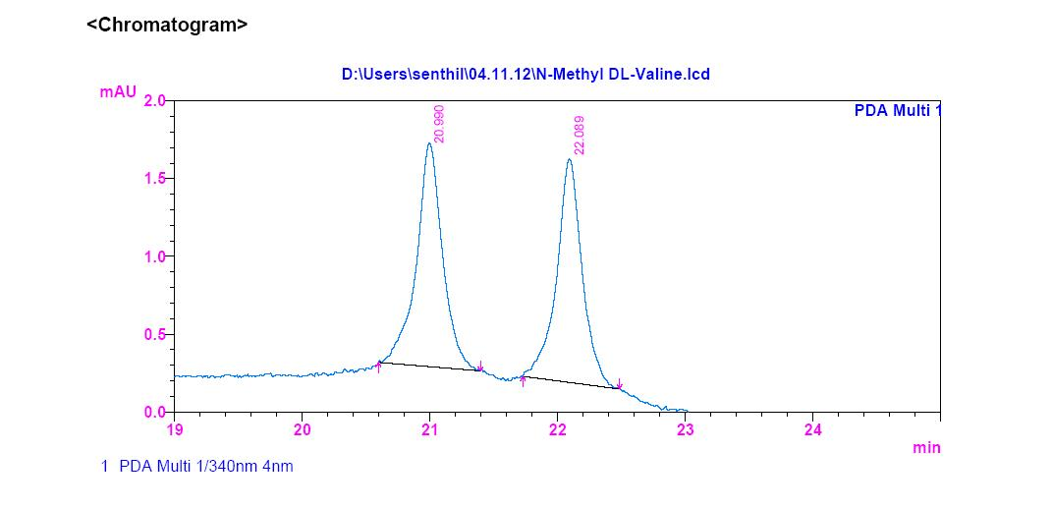
Figure S120a.HPLC analysis of standard L-FDAA-D/L-N-Methyl Valine
(a)
D-Threonine
D-Threonine

Figure S120c.HPLC analysis of standard L-FDAA-D-N-Methyl Valine
Figure S120b. HPLC analysis of standard L-FDAA-D-N-Methyl Valine
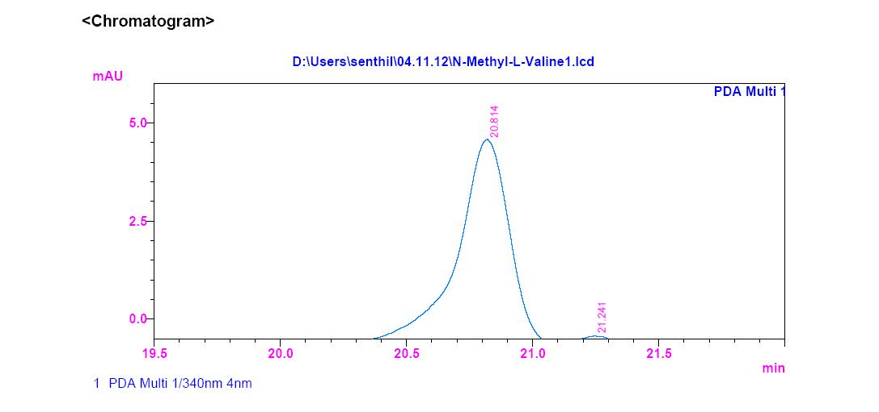
(c)
(b)
Standard L-FDAA-D-N-Methyl Valine
Standard L-FDAA-D-N-Methyl Valine
L-N-Methyl Valine
D-N-Methyl Valine

(a)
(b)
Figure S121b. HPLC analysis of standard L-FDAA-L-Valine
Figure S121a.HPLC analysis of standard L-FDAA-D-Valine
Standard L-FDAA-L-Valine
Standard L-FDAA-D-Valine

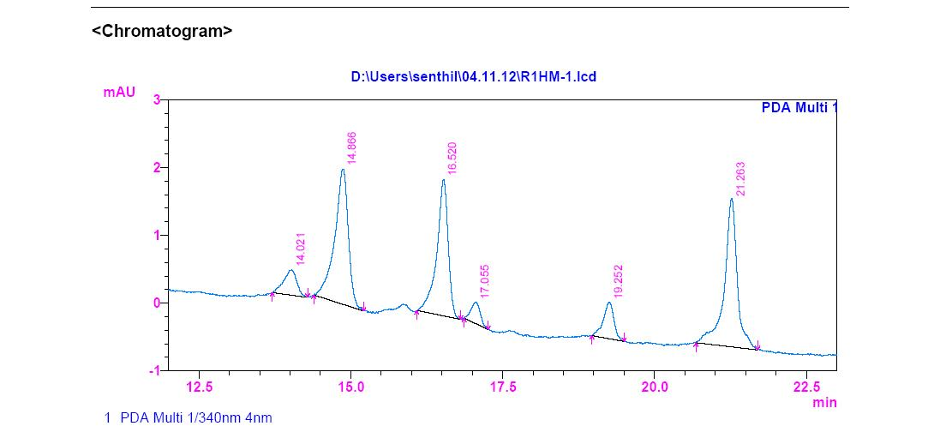
Figure S121C. HPLC Analysis of L-FDAA Derivatives of acid hydrolysates of Transitmycin (R1)
(c)

L-Valine

Figure 122a.HPLC analysis of standard L-FDAA-D-Valine
Figure S122b. HPLC analysis of standard L-FDAA-L-Valine
(b)
(a)
Standard L-FDAA-D-Valine
Standard L-FDAA-L-Valine

Figure S122c. HPLC Analysis of L-FDAA Derivatives of acid hydrolysates of R2
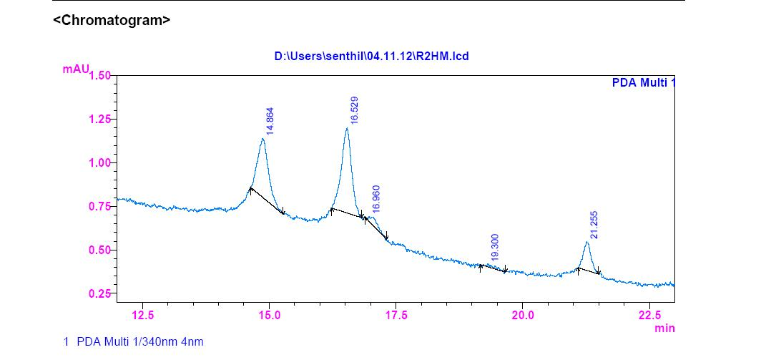
(c)

L-Valine

Figure S123b.HPLC analysis of standard L-FDAA-L-Valine
Figure S123a. HPLC analysis of standard L-FDAA-D-Valine
(a)
(b)
Standard L-FDAA-D-Valine
Standard L-FDAA-L-Valine

Figure S123c. HPLC Analysis of L-FDAA Derivatives of acid hydrolysates of R3
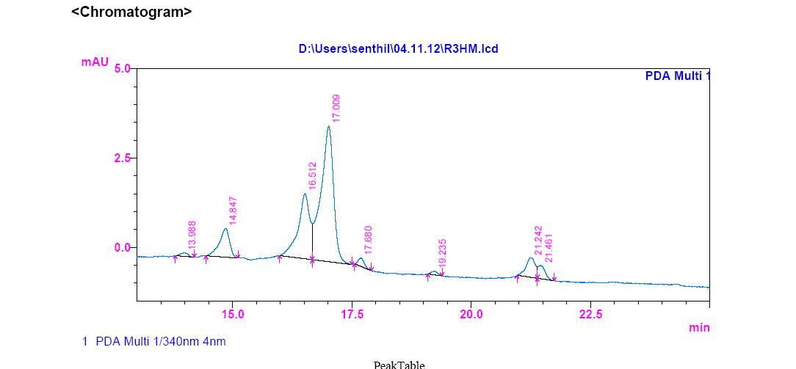
(c)

L-Valine

Figure S124. HPLC Analysis of L-FDAA Derivatives of acid hydrolysates of (R2)

L-Proline
L-Threonine
D-Proline

L-Valine
N-Methyl-L-Valine

Figure S125. HPLC Analysis of L-FDAA Derivatives of acid hydrolysates of R3

D-Proline

L-Proline
L-Threonine
L-Valine
N-Methyl-L-Valine

Table 8a. Analysis of L-FDAA derivates of acid hydrolysate of R2 by HPLC
Amino acids | HPLC retention times  Marfey’s derivatives of standard amino acids |  | HPLC retention time  Marfey derivatives of acid hydrolysate of Transitmycin R2 | Assignment
Amino acids | _{D} | _{L} |  | Assignment
_{Threonine} | _{15.682} | _{13.987} | _{14.000} | _{L}
_{Proline} | _{17.035} | _{16.519} | _{16.529 & 16.960} | _{D & L}
_{Valine} | _{21.244} | _{19.248} | _{19.300} | _{L}
_{N-methyl valine} | _{22.089} | _{20.814} | _{21.255} | _{L}
Table 8b. Analysis of L-FDAA derivatives of acid hydrolysate of R3 by HPLC
Amino acids | HPLC retention times  Marfey’s derivatives of standard amino acids |  | HPLC retention time  Marfeyderivatives of acid hydrolysate of Transitmycin R3 | Assignment
Amino acids | _{D} | _{L} |  | Assignment
_{Threonine} | _{15.682} | _{13.987} | _{13.988} | _{L}
_{Proline} | _{17.035} | _{16.519} | _{16.512 & 17.000} | _{D & L}
_{Valine} | _{21.244} | _{19.248} | _{19.235} | _{L}
_{N-methyl valine} | _{22.089} | _{20.814} | _{21.242} | _{L}
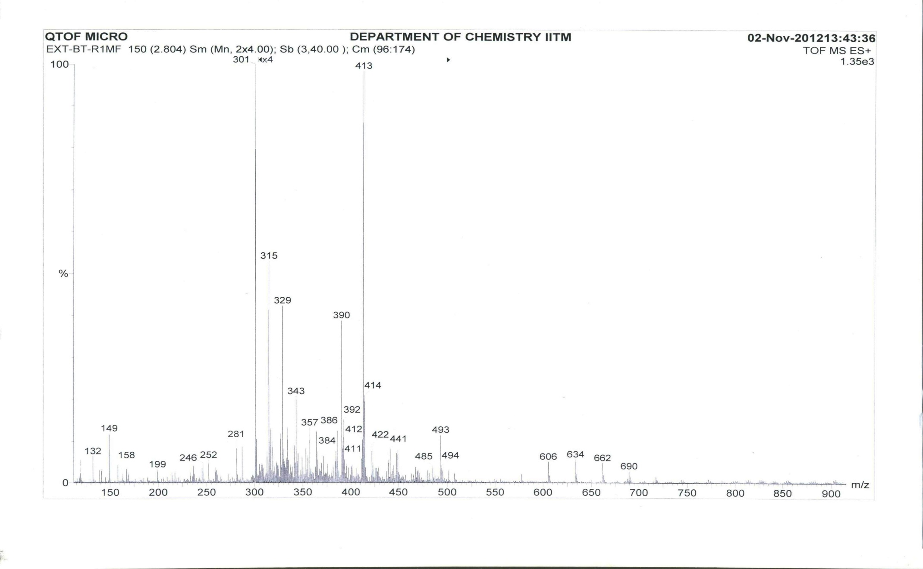

Proline

Valine

Figure S126. ESI- MS Spectrum of Marfey’s Derivatives of Transitmycin (R1) (Positive mode)
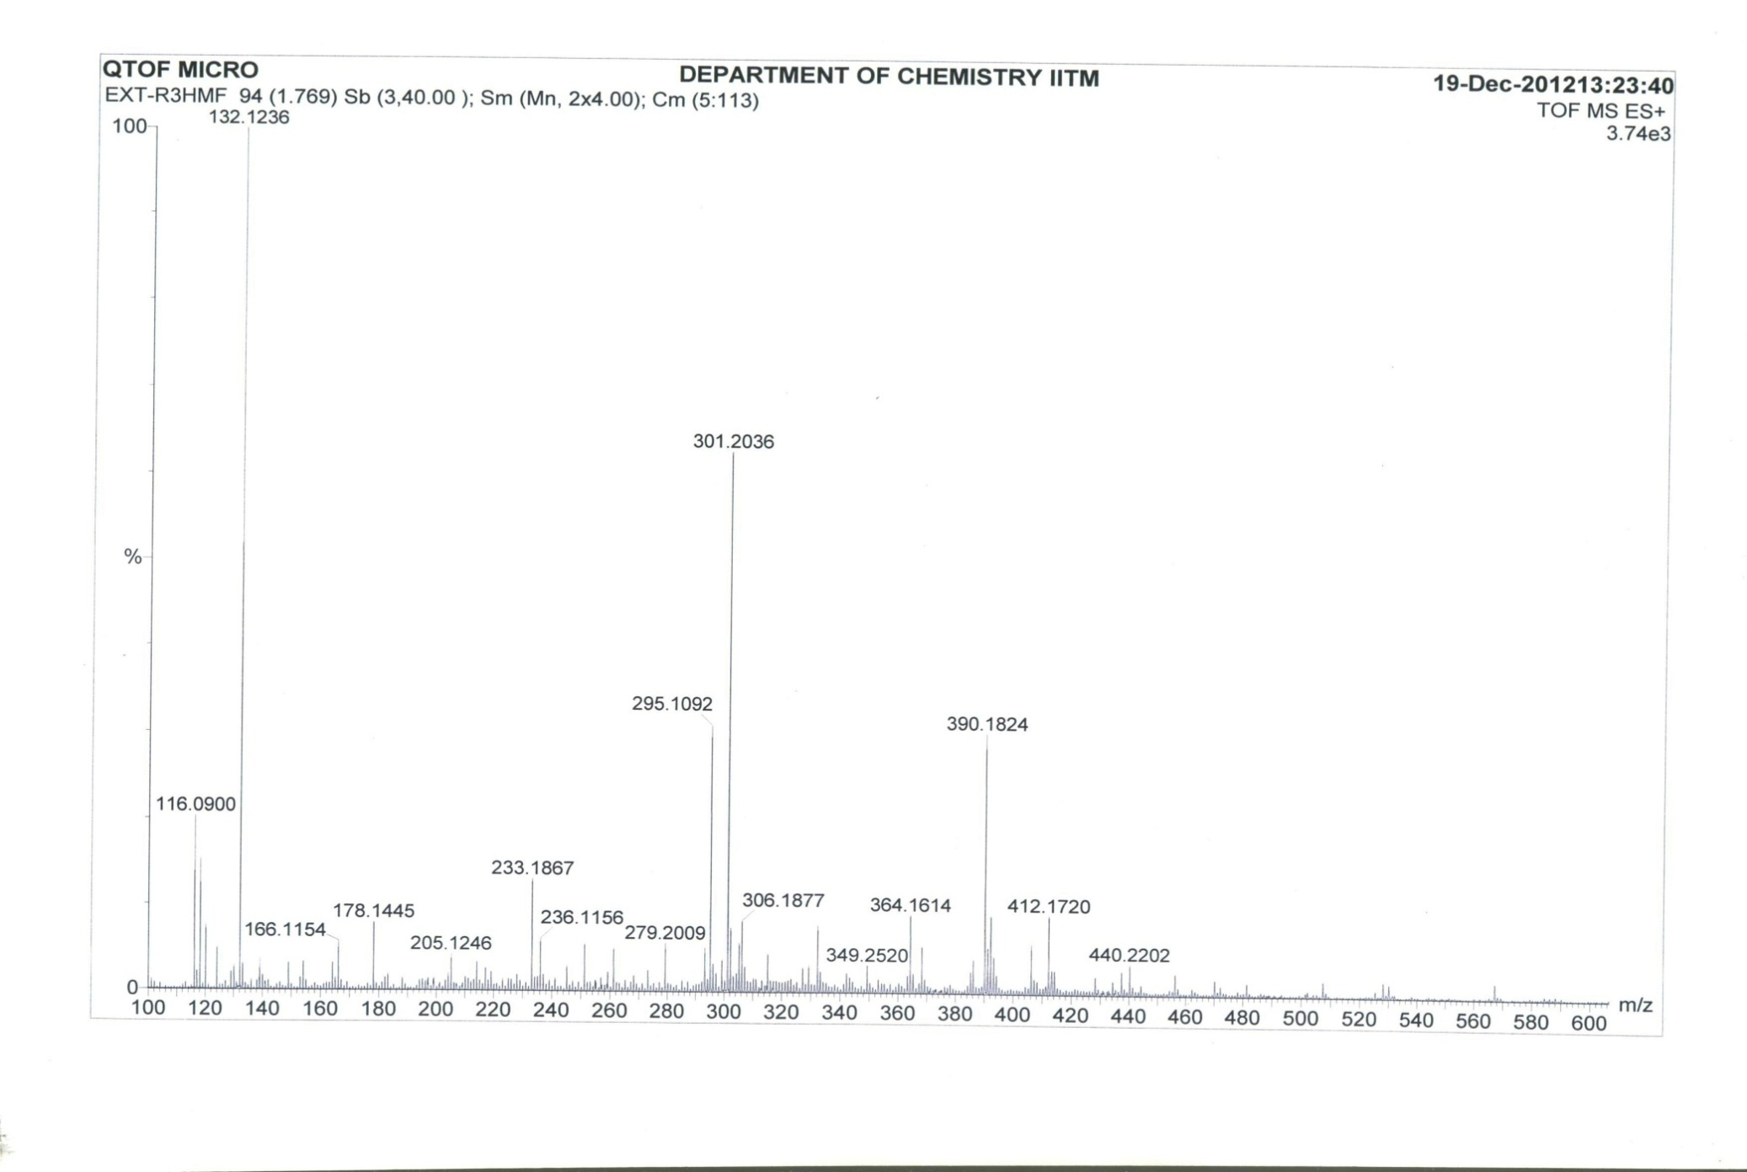

Proline

Valine

Figure S127. ESI- MS Spectrum of Marfey’s Derivatives of Transitmycin (R1) (Positive mode)
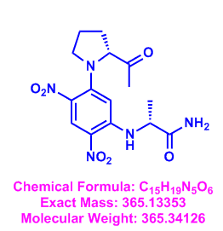
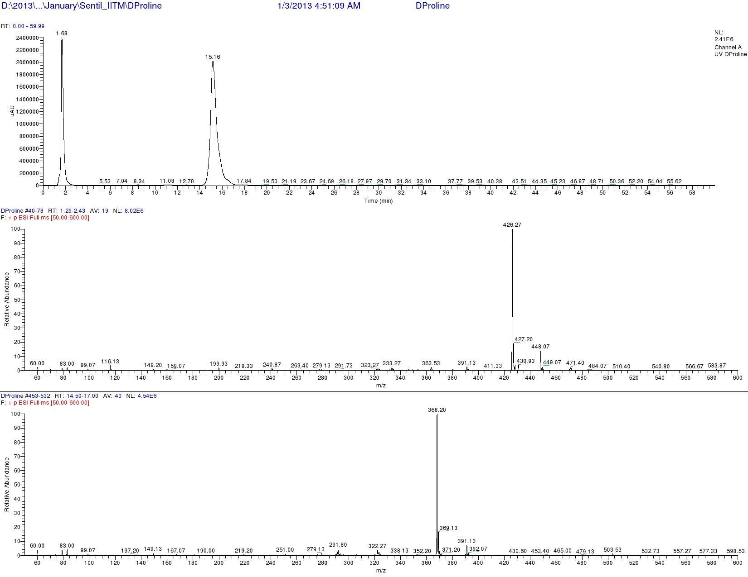

Figure S128. LCMS analysis of Standard L-FDAA-D-Proline (Positive mode)

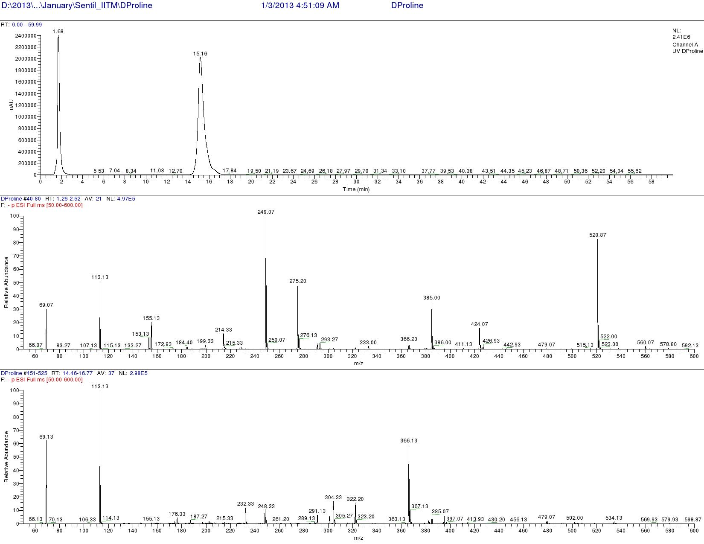

Figure S129. LCMS analysis of Standard L-FDAA-D-Proline (Negative mode)
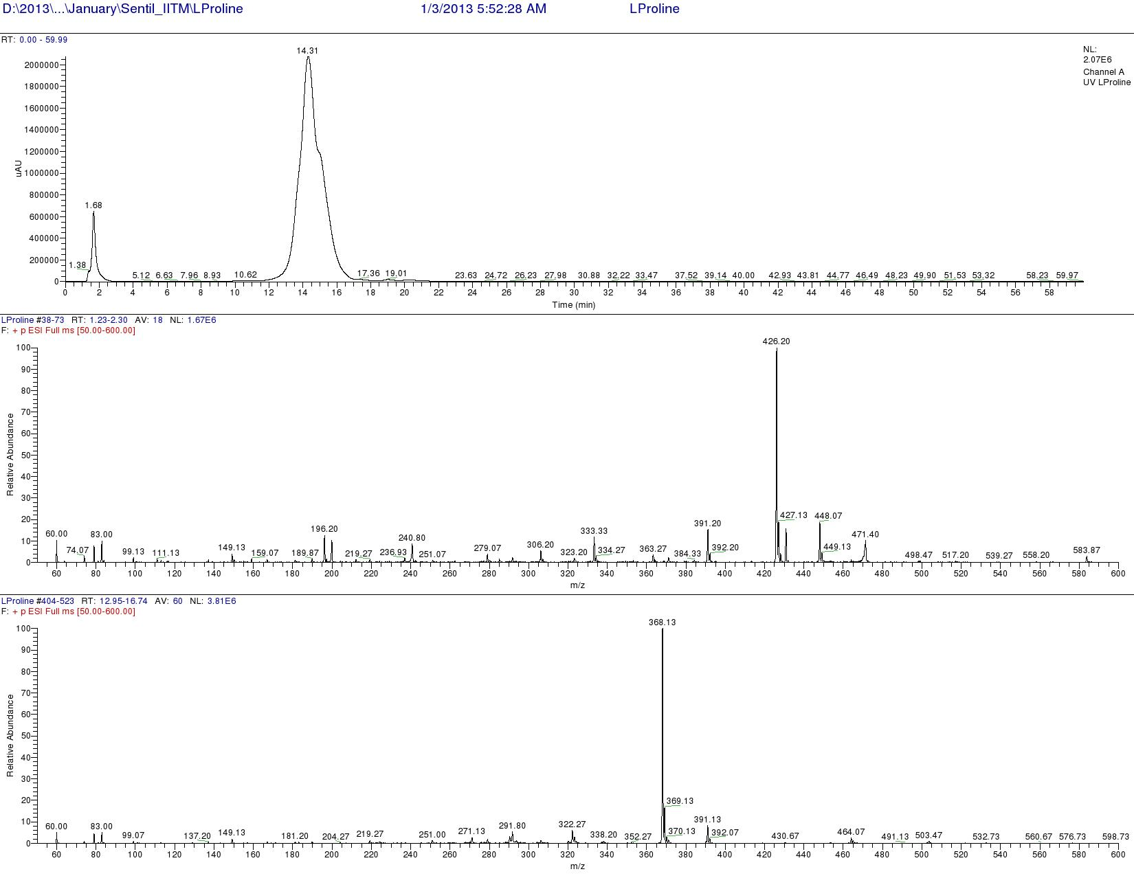
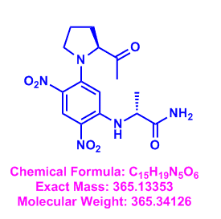

Figure S130 LCMS analysis of Standard L-FDAA-L-Proline (Positive mode)

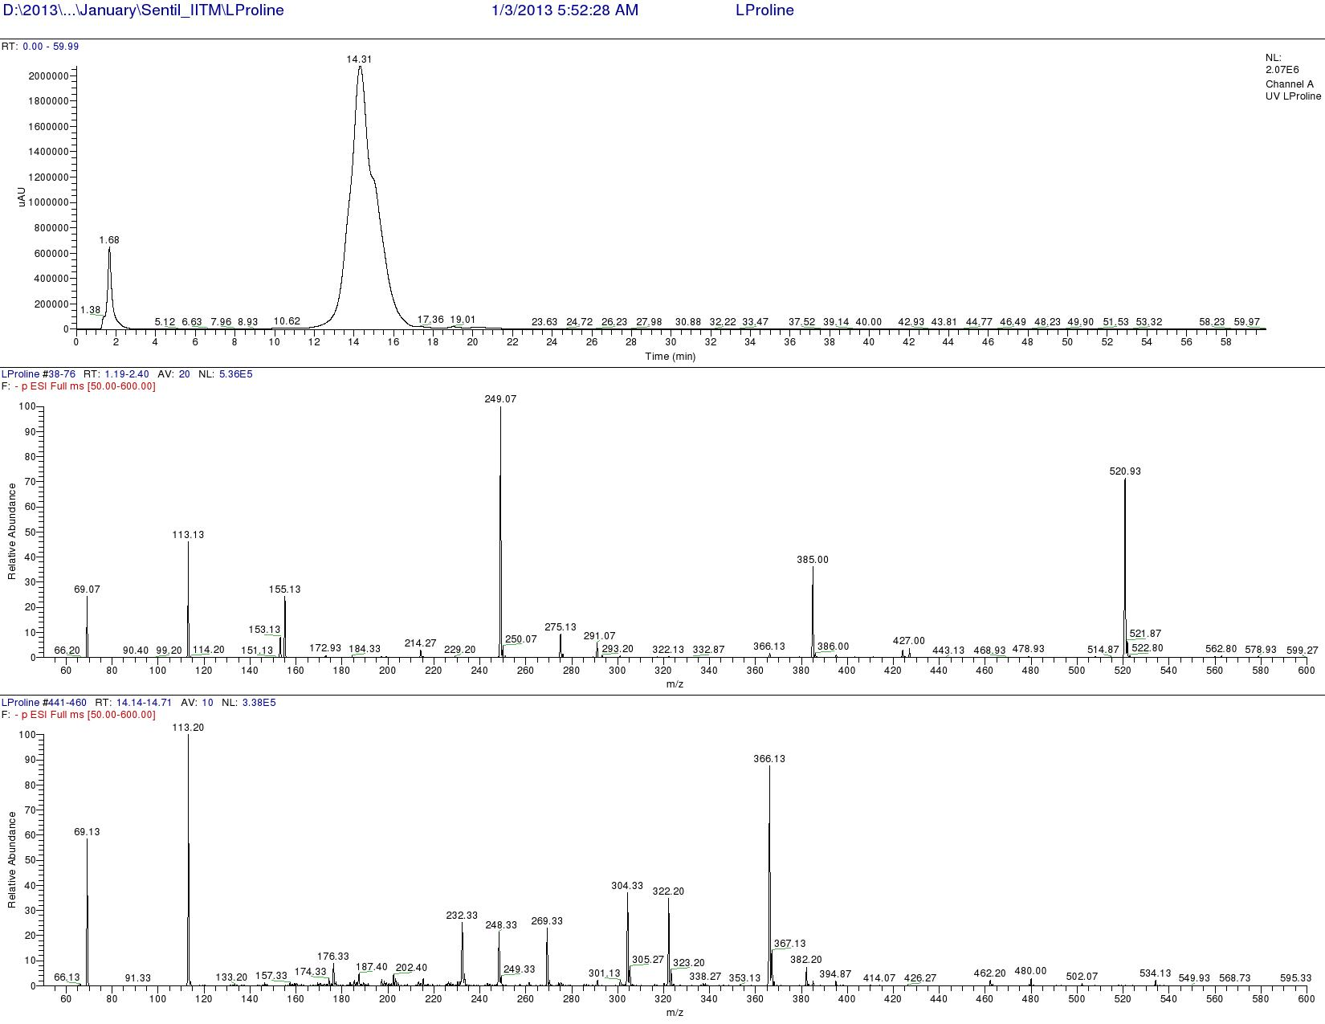

Figure S131. LCMS analysis of Standard L-FDAA-L-Proline (Negative mode)

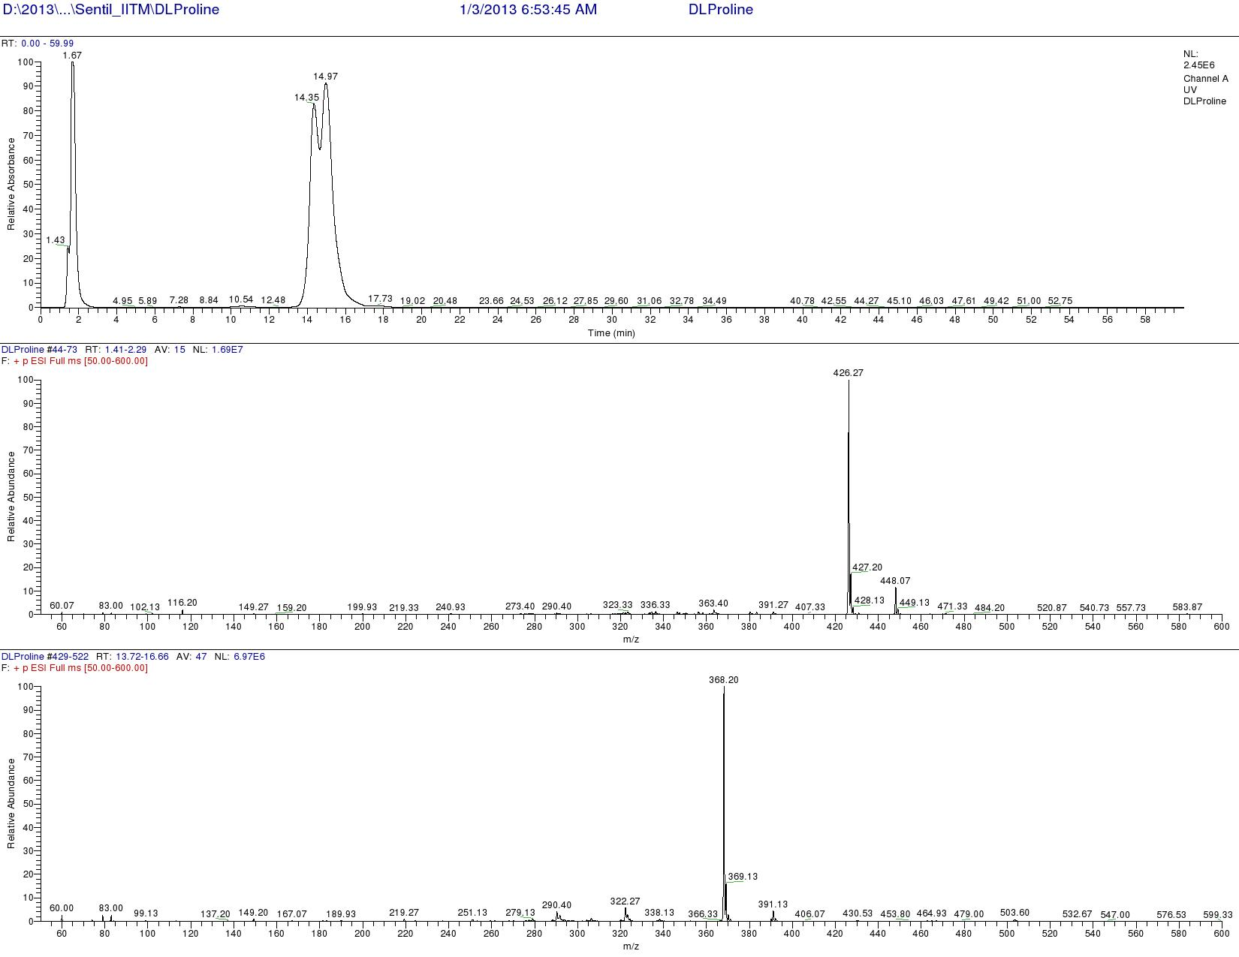

Figure S132. LCMS analysis of Standard L-FDAA-D/L-Proline (Positive mode)

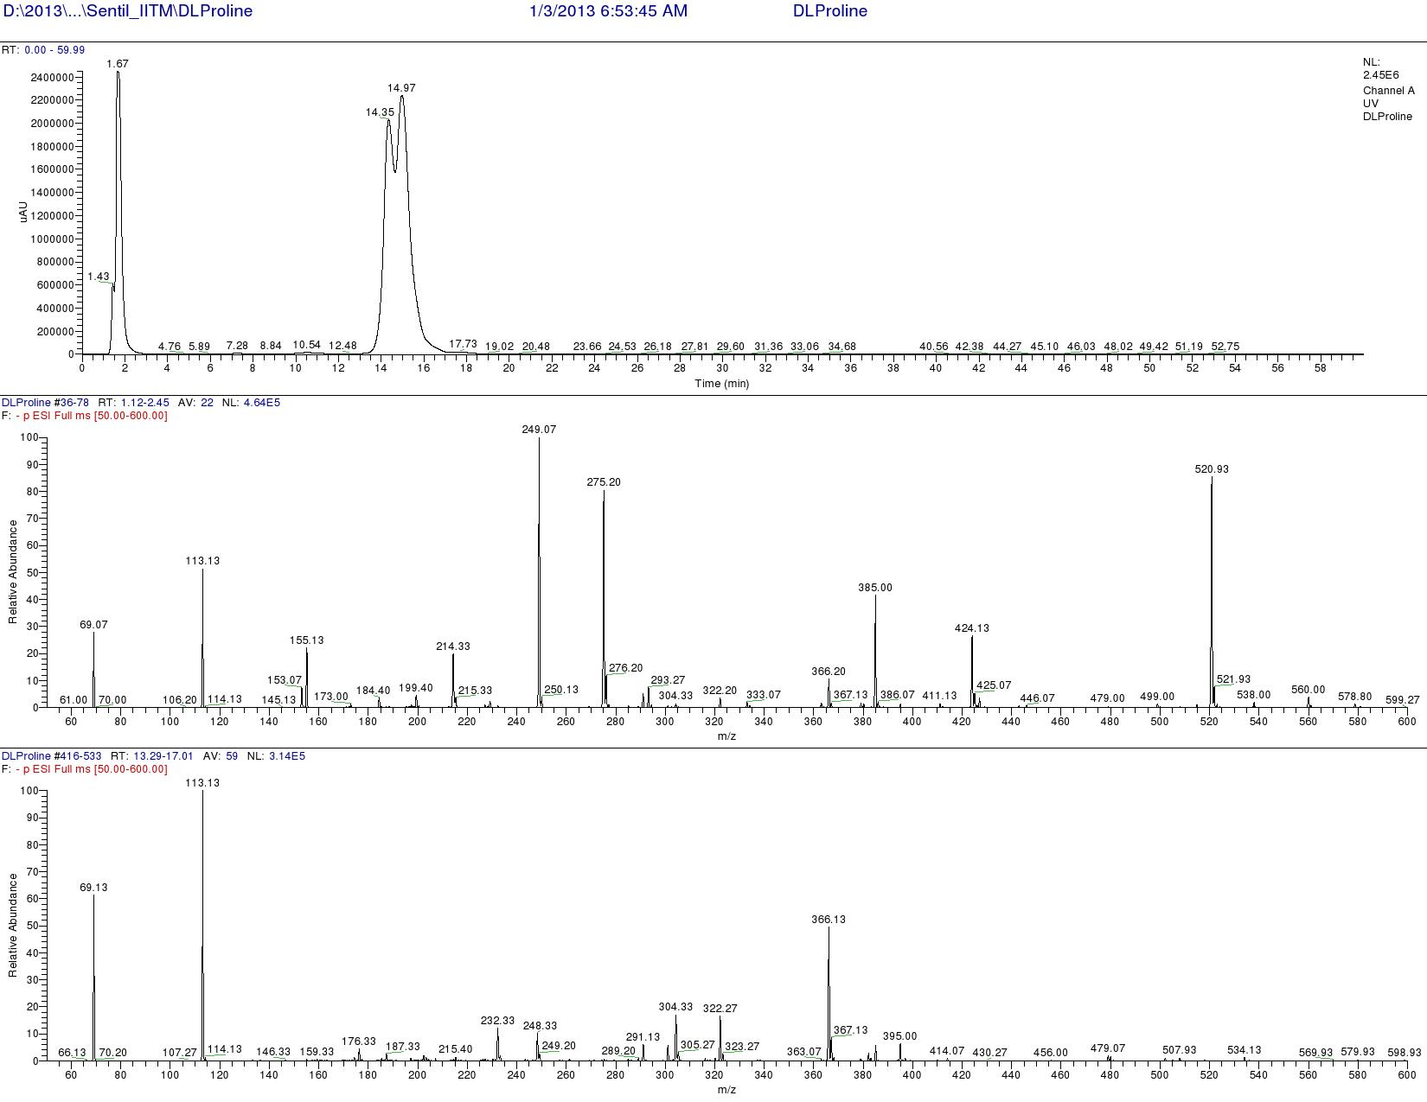

Figure S133. LCMS analysis of Standard L-FDAA-D/L-Proline (Negative mode)
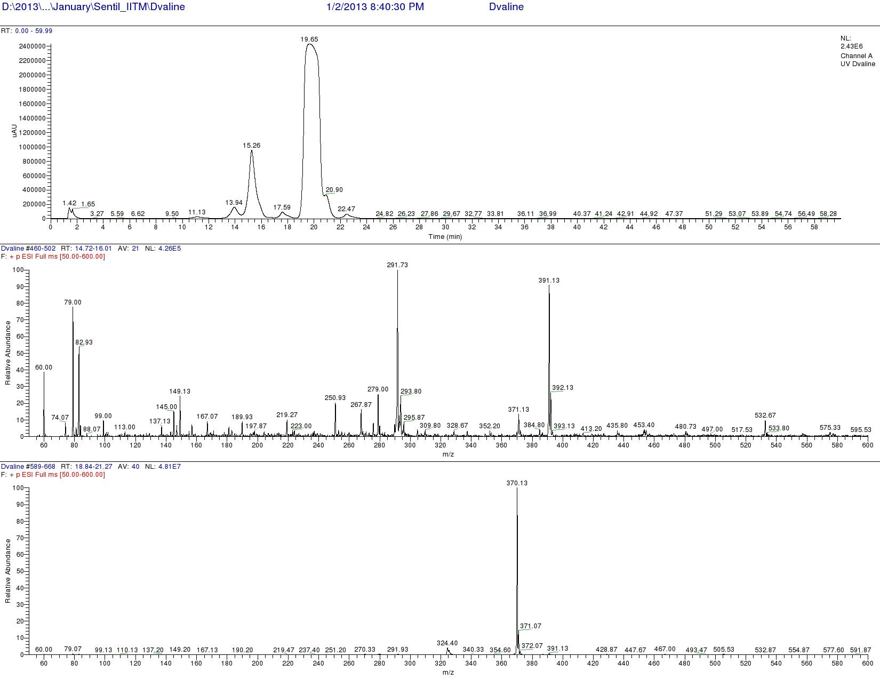
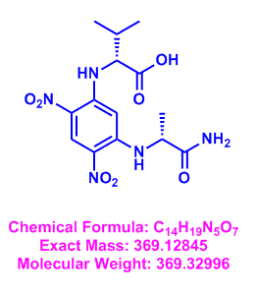

Figure S134.. LCMS analysis of Standard L-FDAA-D-Valine (Positive mode)
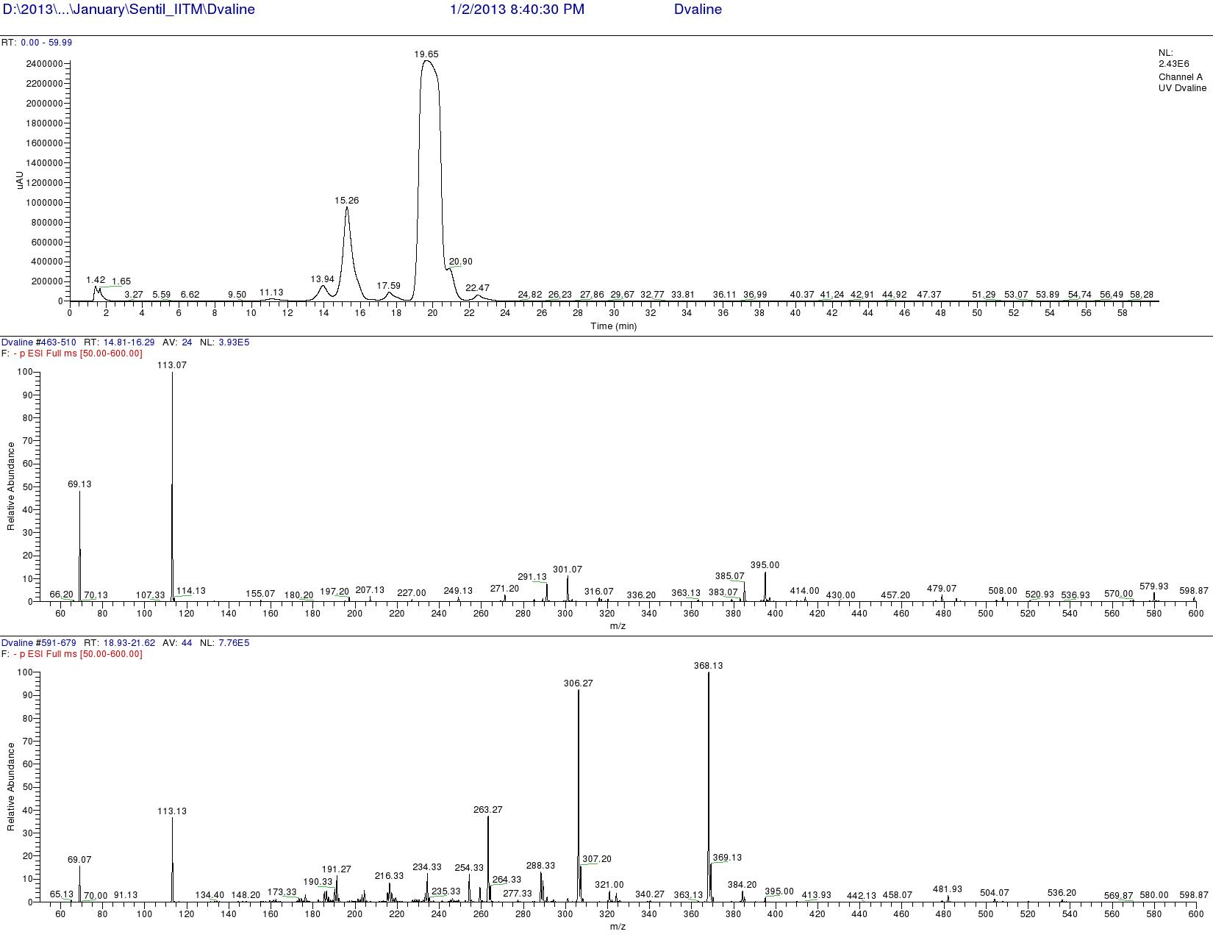

Figure S135. LCMS analysis of Standard L-FDAA-D-Valine (Negative mode)
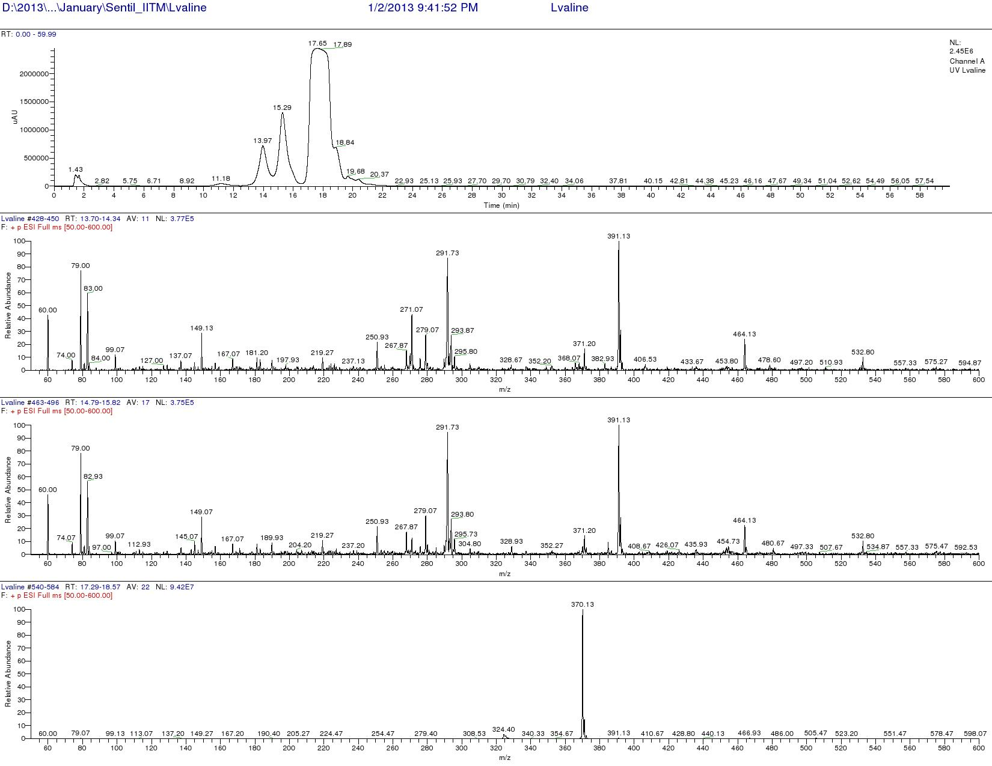
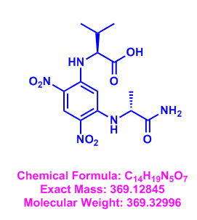

Figure S136. LCMS analysis of Standard L-FDAA-L-Valine (Positive mode)
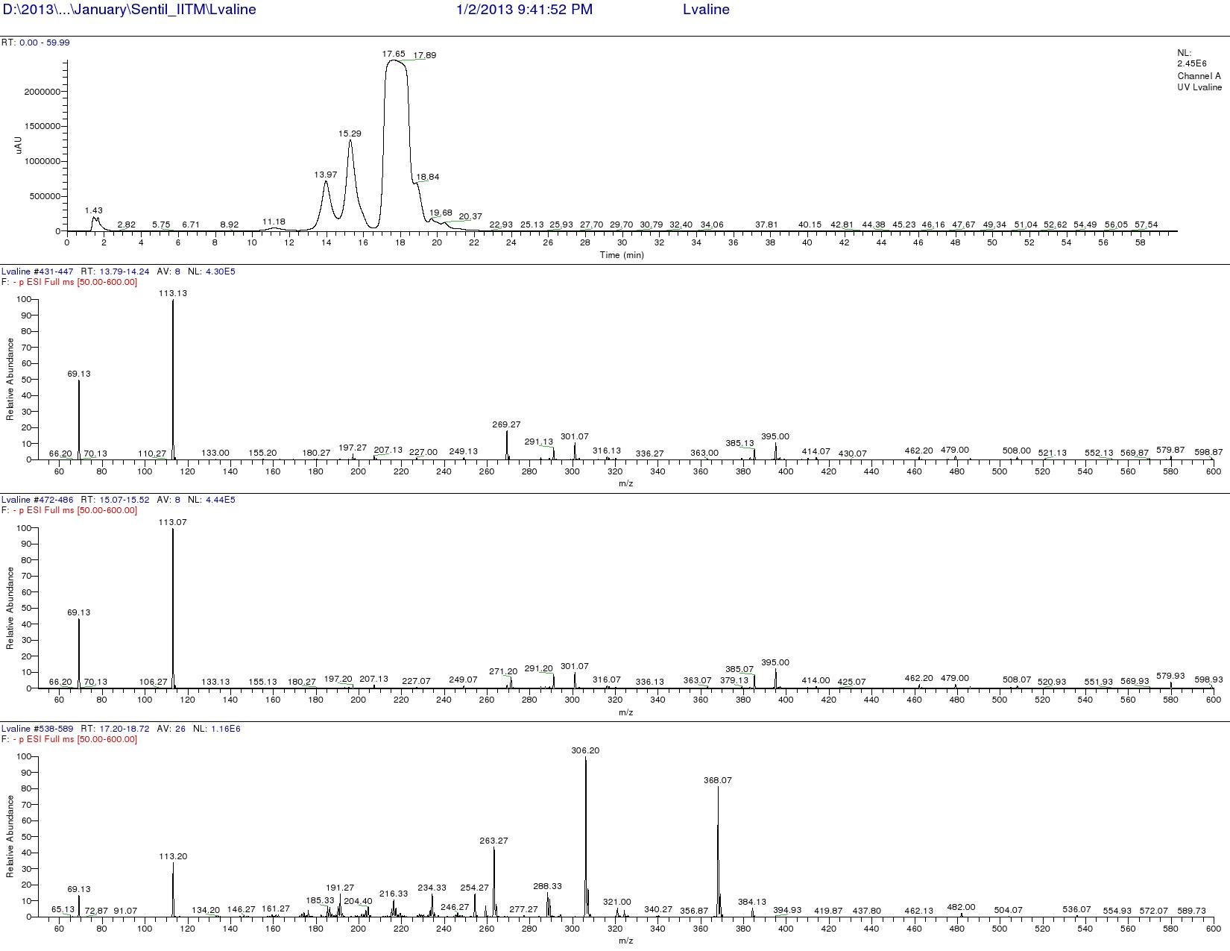

Figure S137. LCMS analysis of Standard L-FDAA-L-Valine (Negative mode)
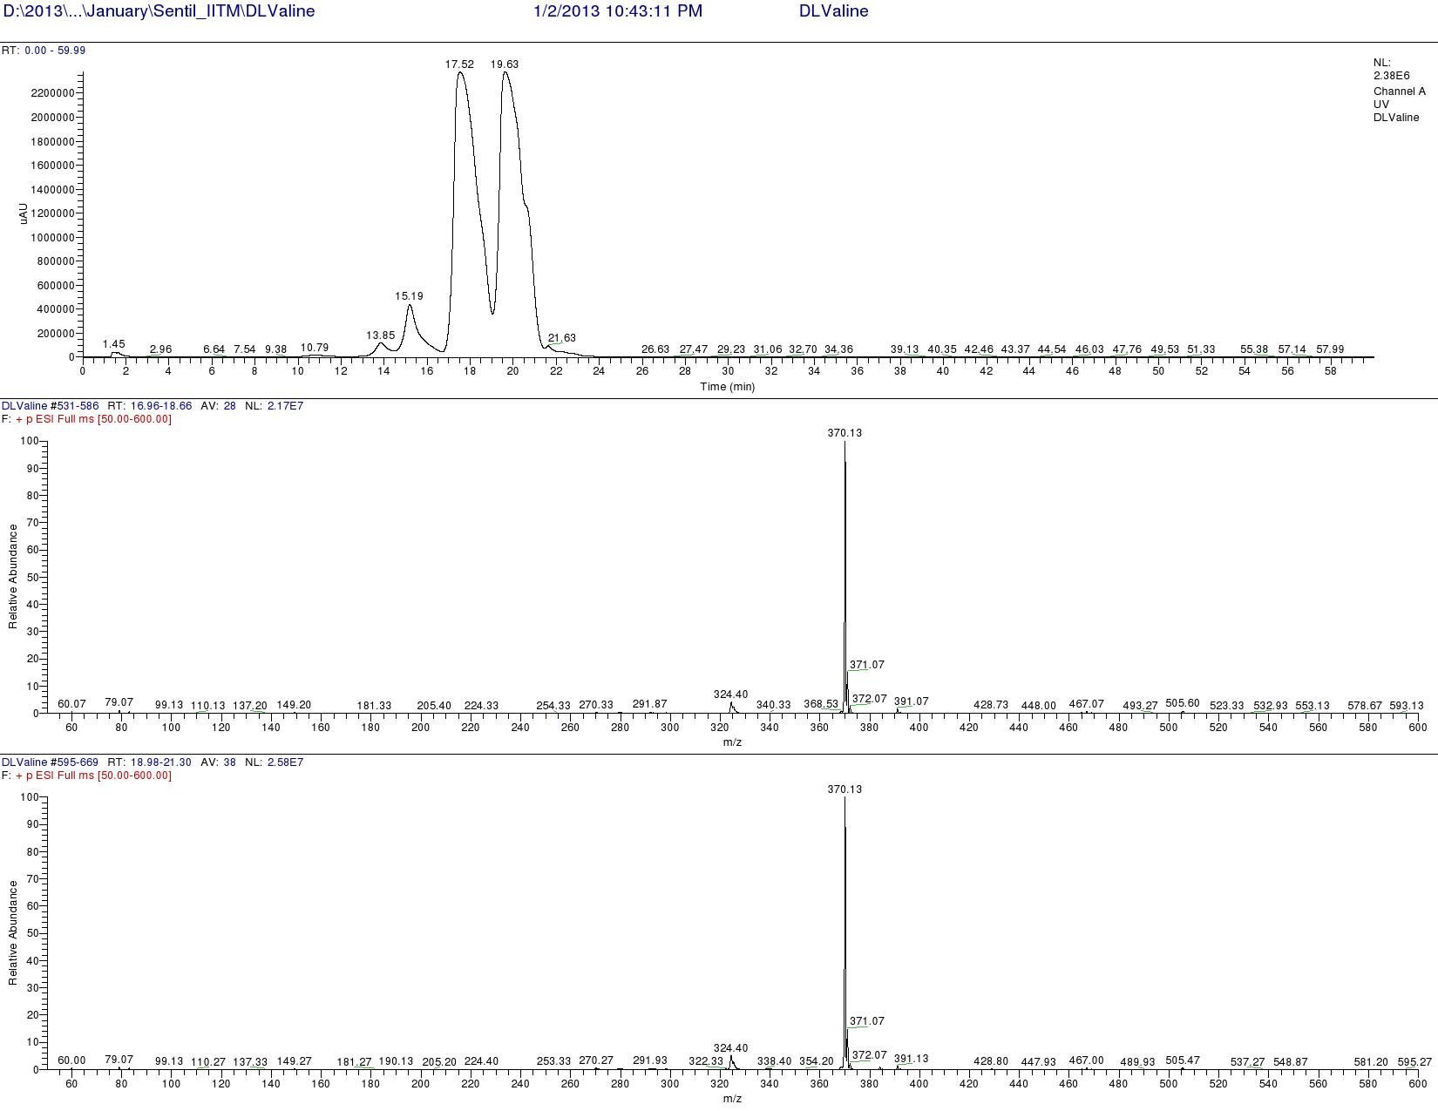

Figure S138. LCMS analysis of Standard L-FDAA-D/L-Valine (Positive mode)

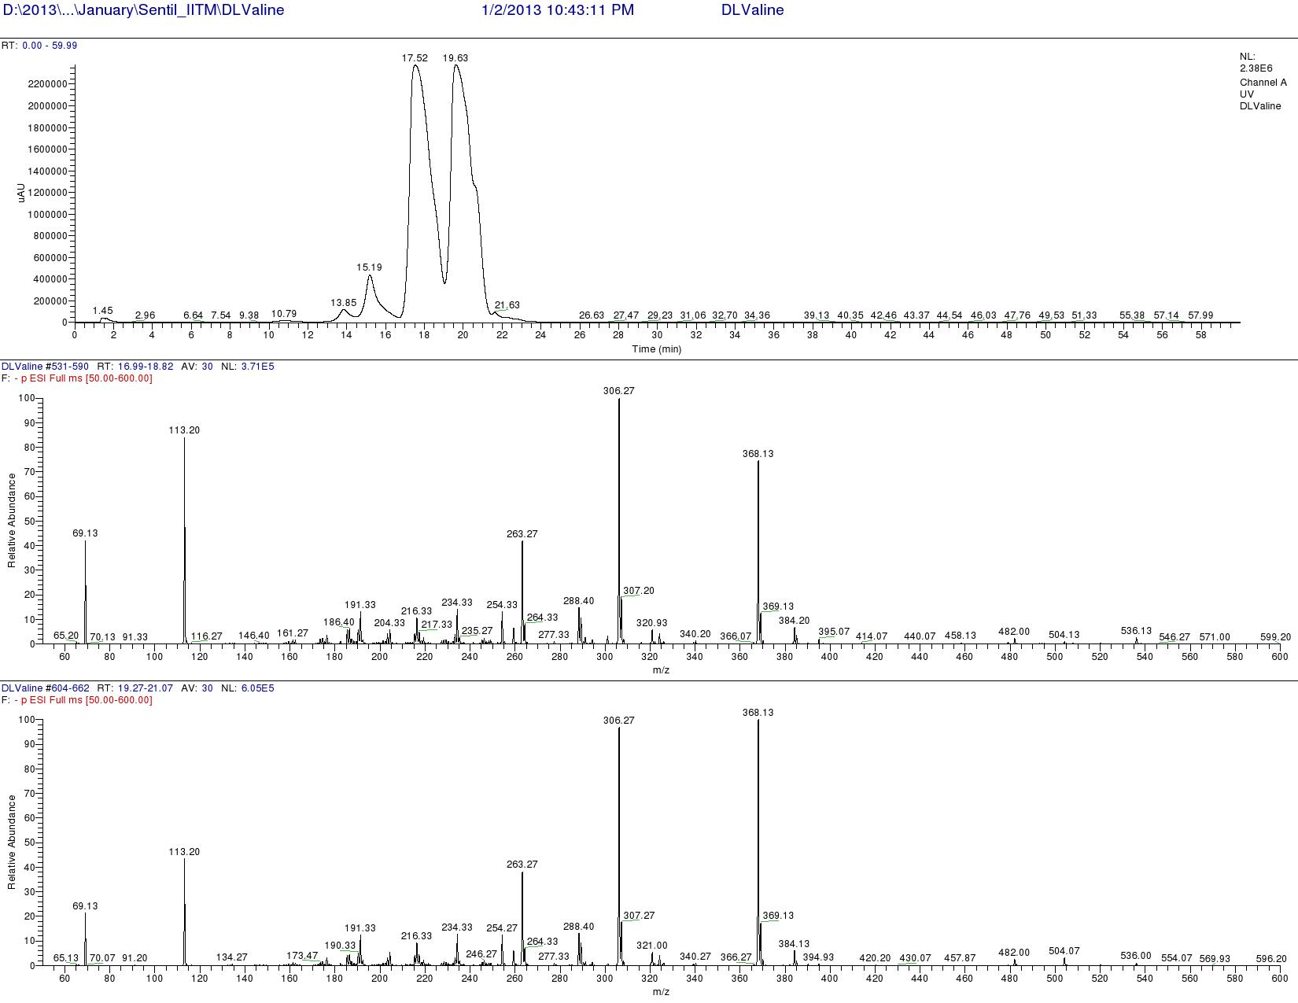

Figure S139. LCMS analysis of Standard L-FDAA-D/L-Valine (Negative mode)
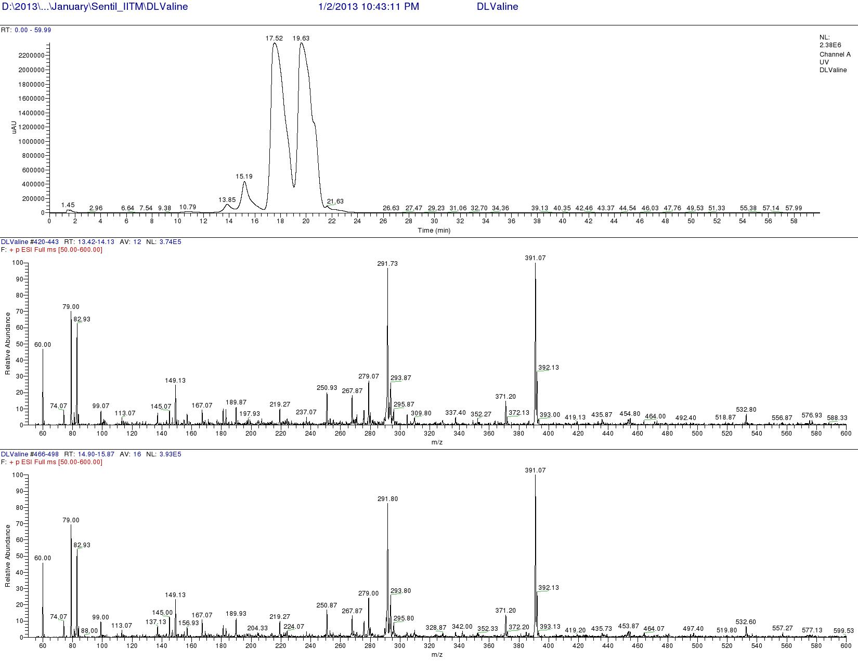

Figure S140. LCMS analysis of Standard L-FDAA-D/L-Valine (Positive mode)
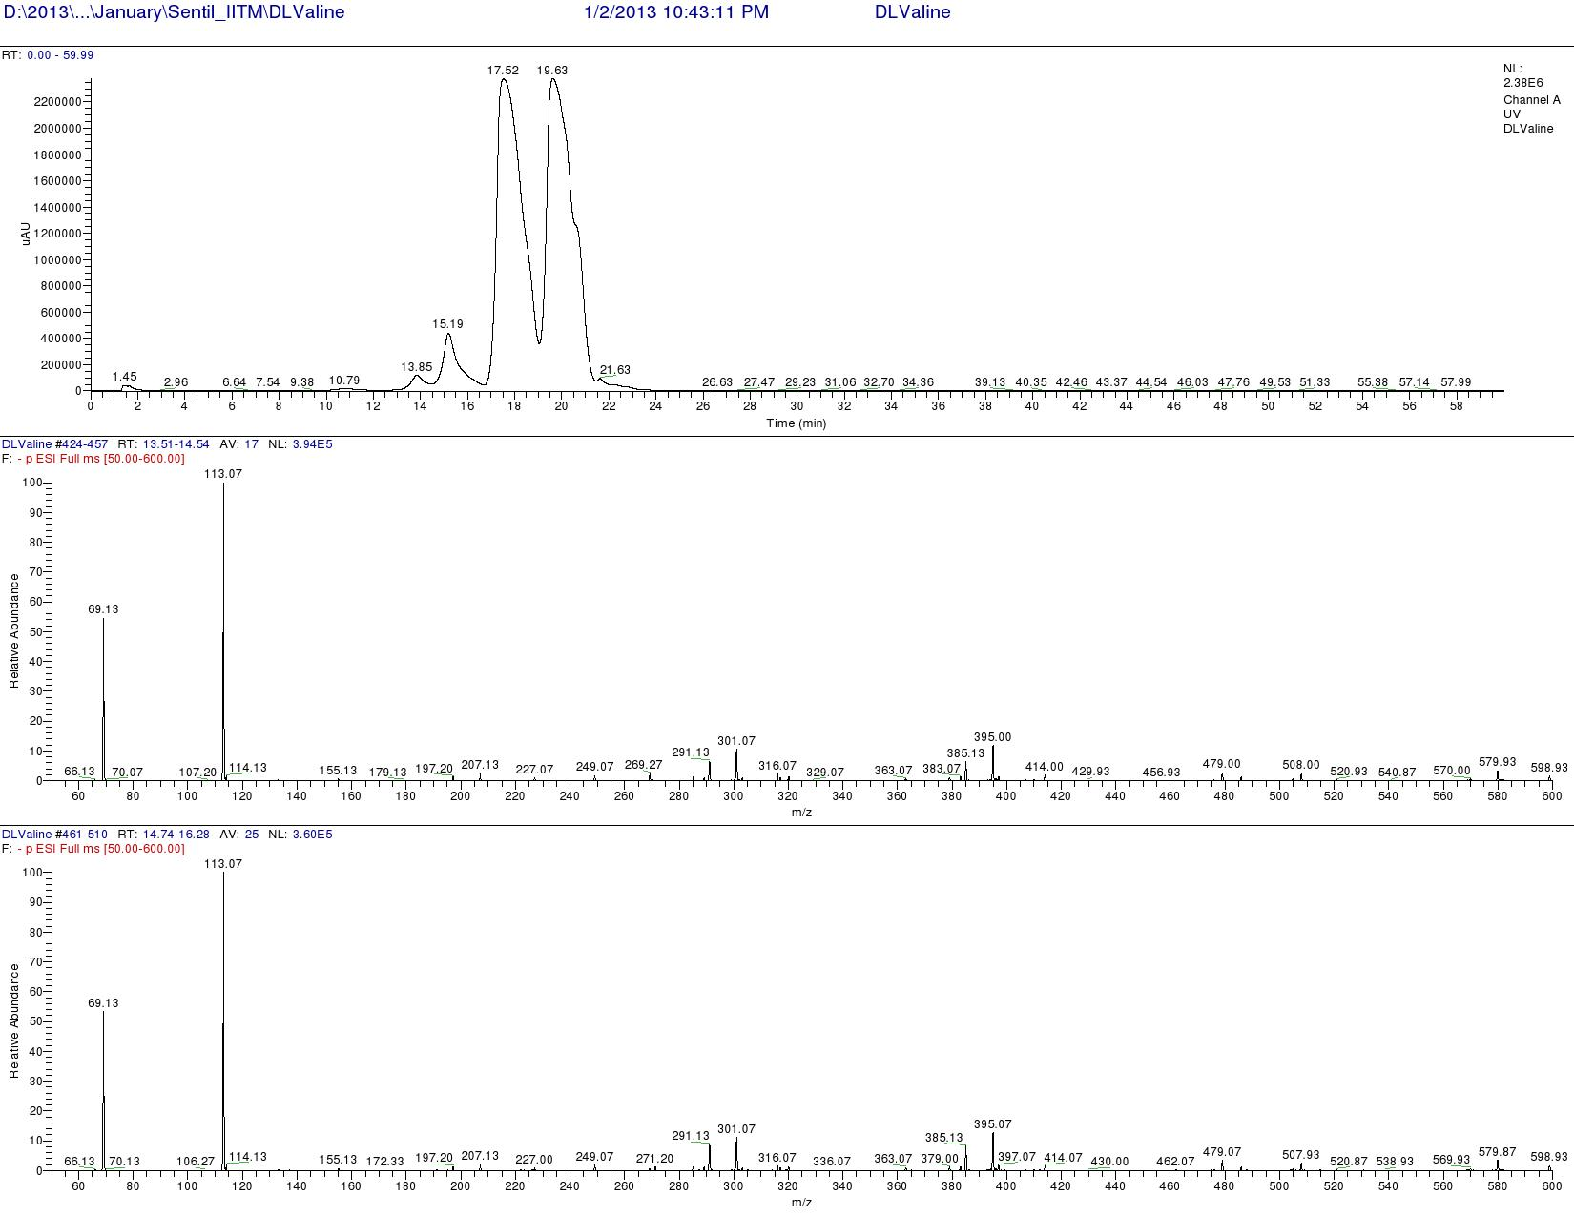

Figure S141. LCMS analysis of Standard L-FDAA-D/L-Valine (Negative mode)
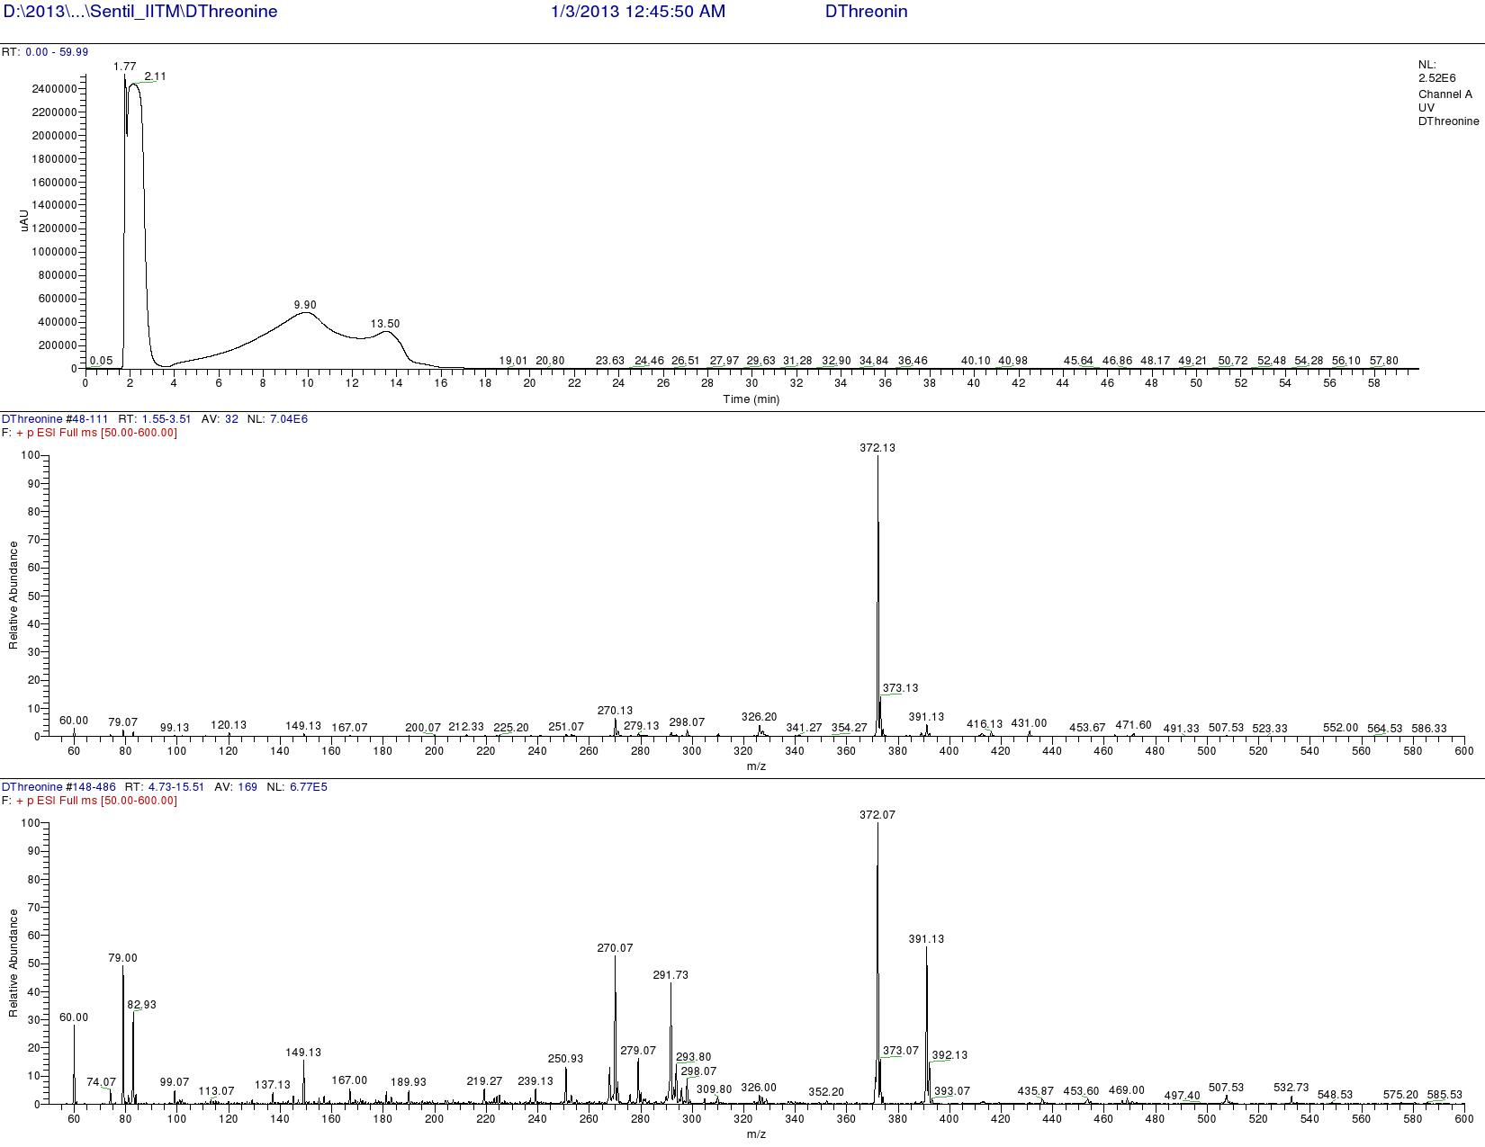

Figure 142. LCMS analysis of Standard L-FDAA-D-Threonine (Positive mode)
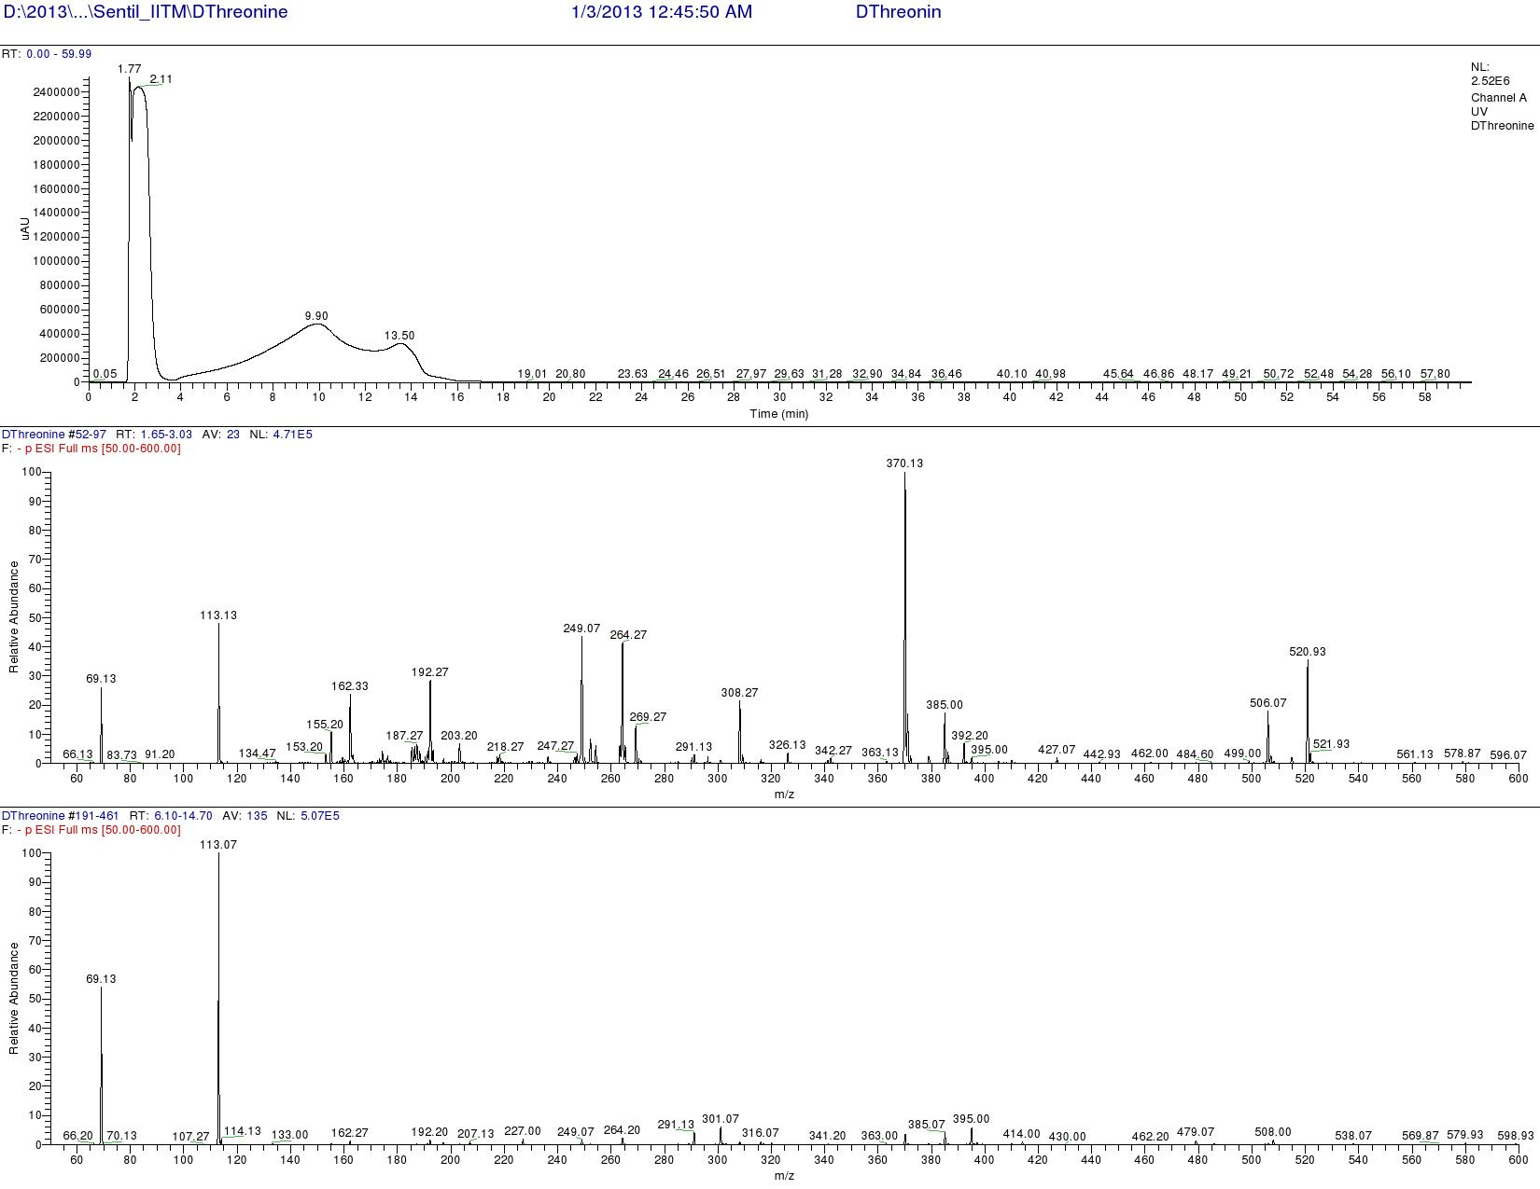
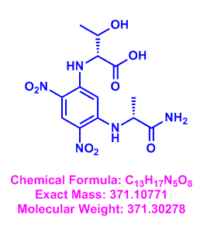

Figure S143. LCMS analysis of Standard L-FDAA-D-Threonine (Negative mode)

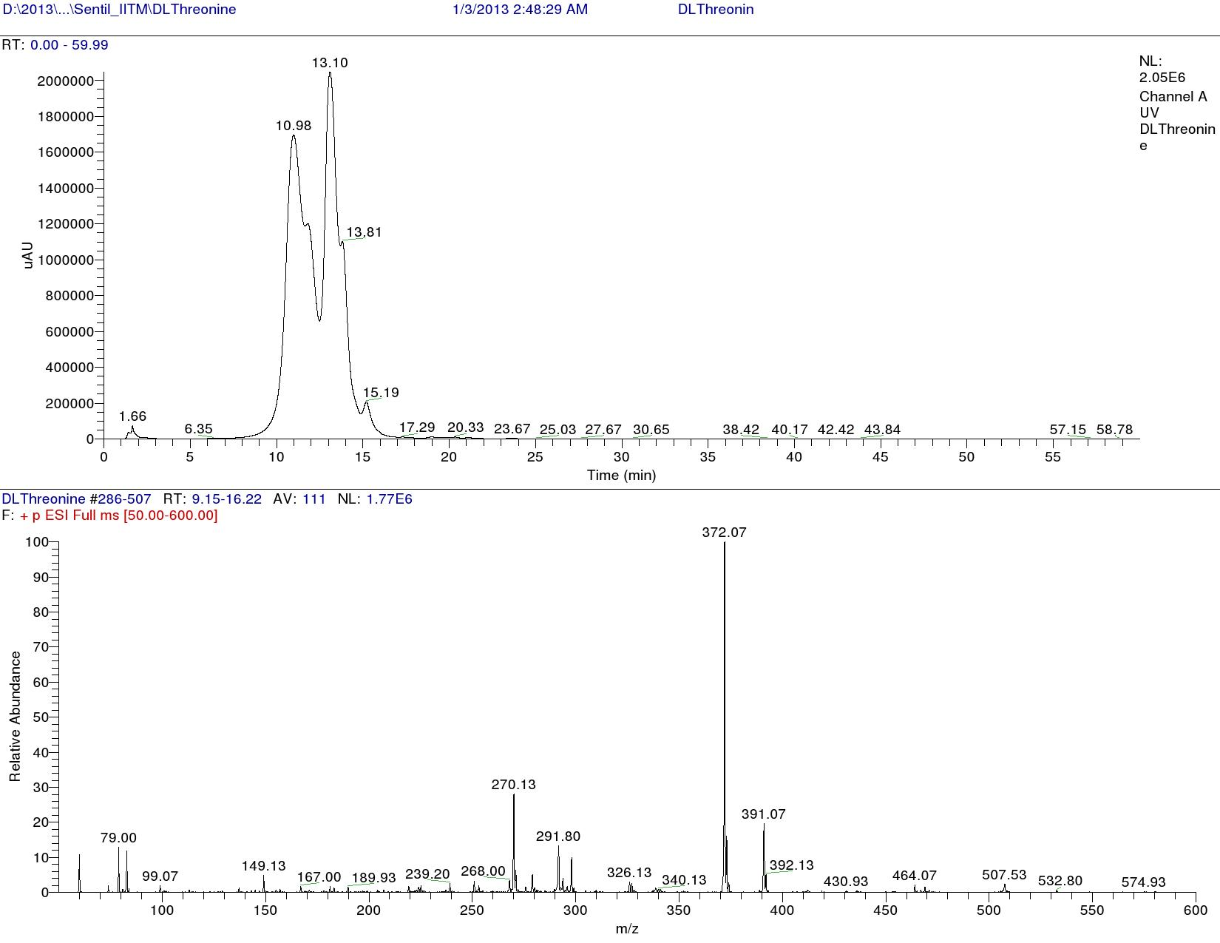

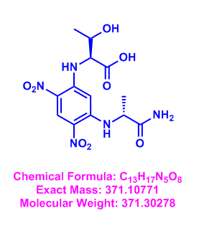

Figure S144. LCMS analysis of Standard L-FDAA-D/L Threonine (Positive mode)

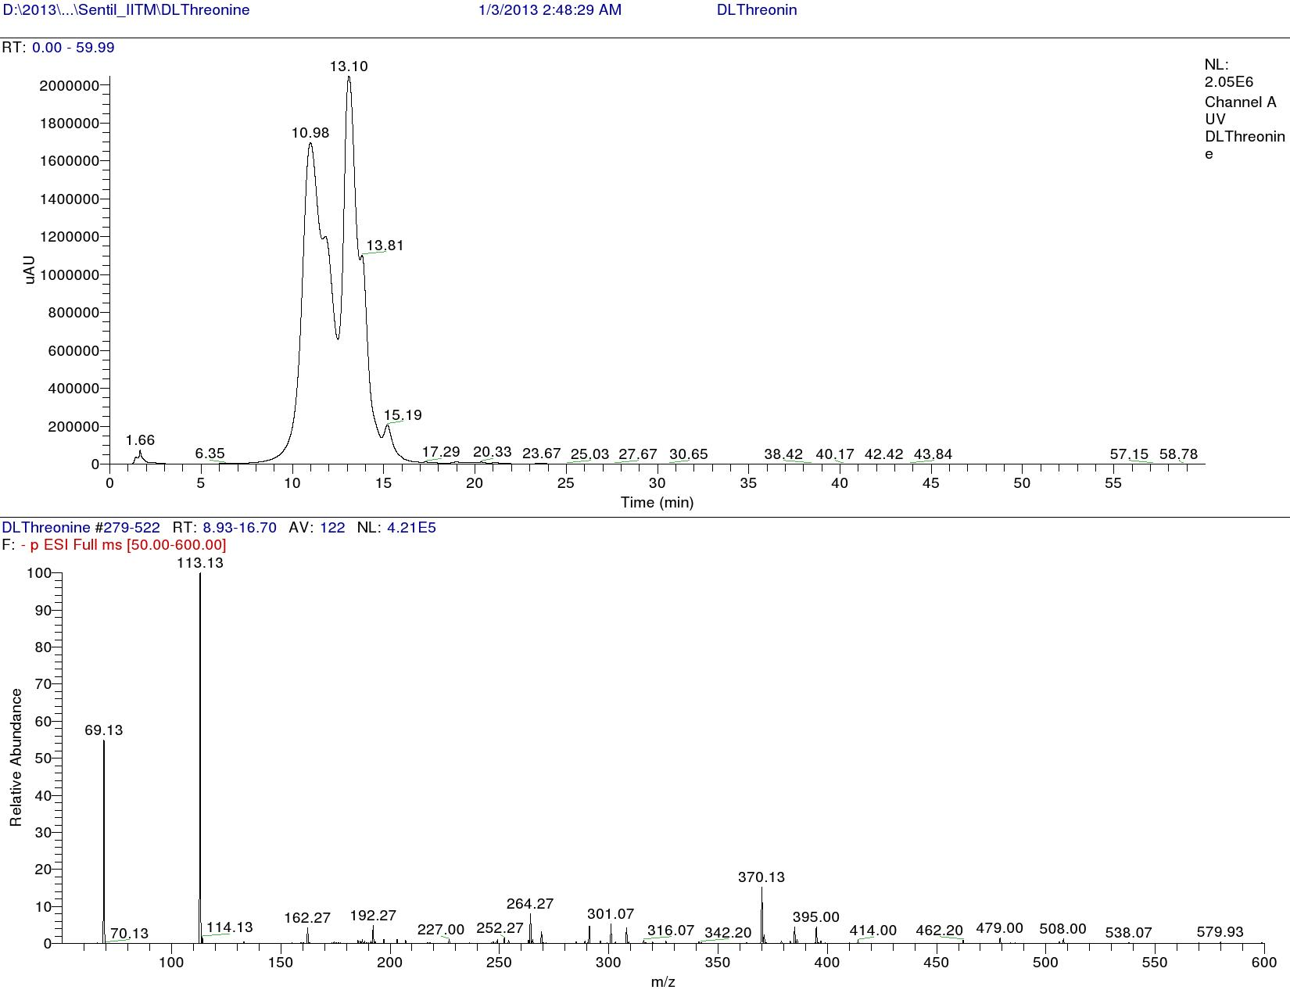

Figure 145. LCMS analysis of Standard L-FDAA-D/L Threonine (Negative mode)
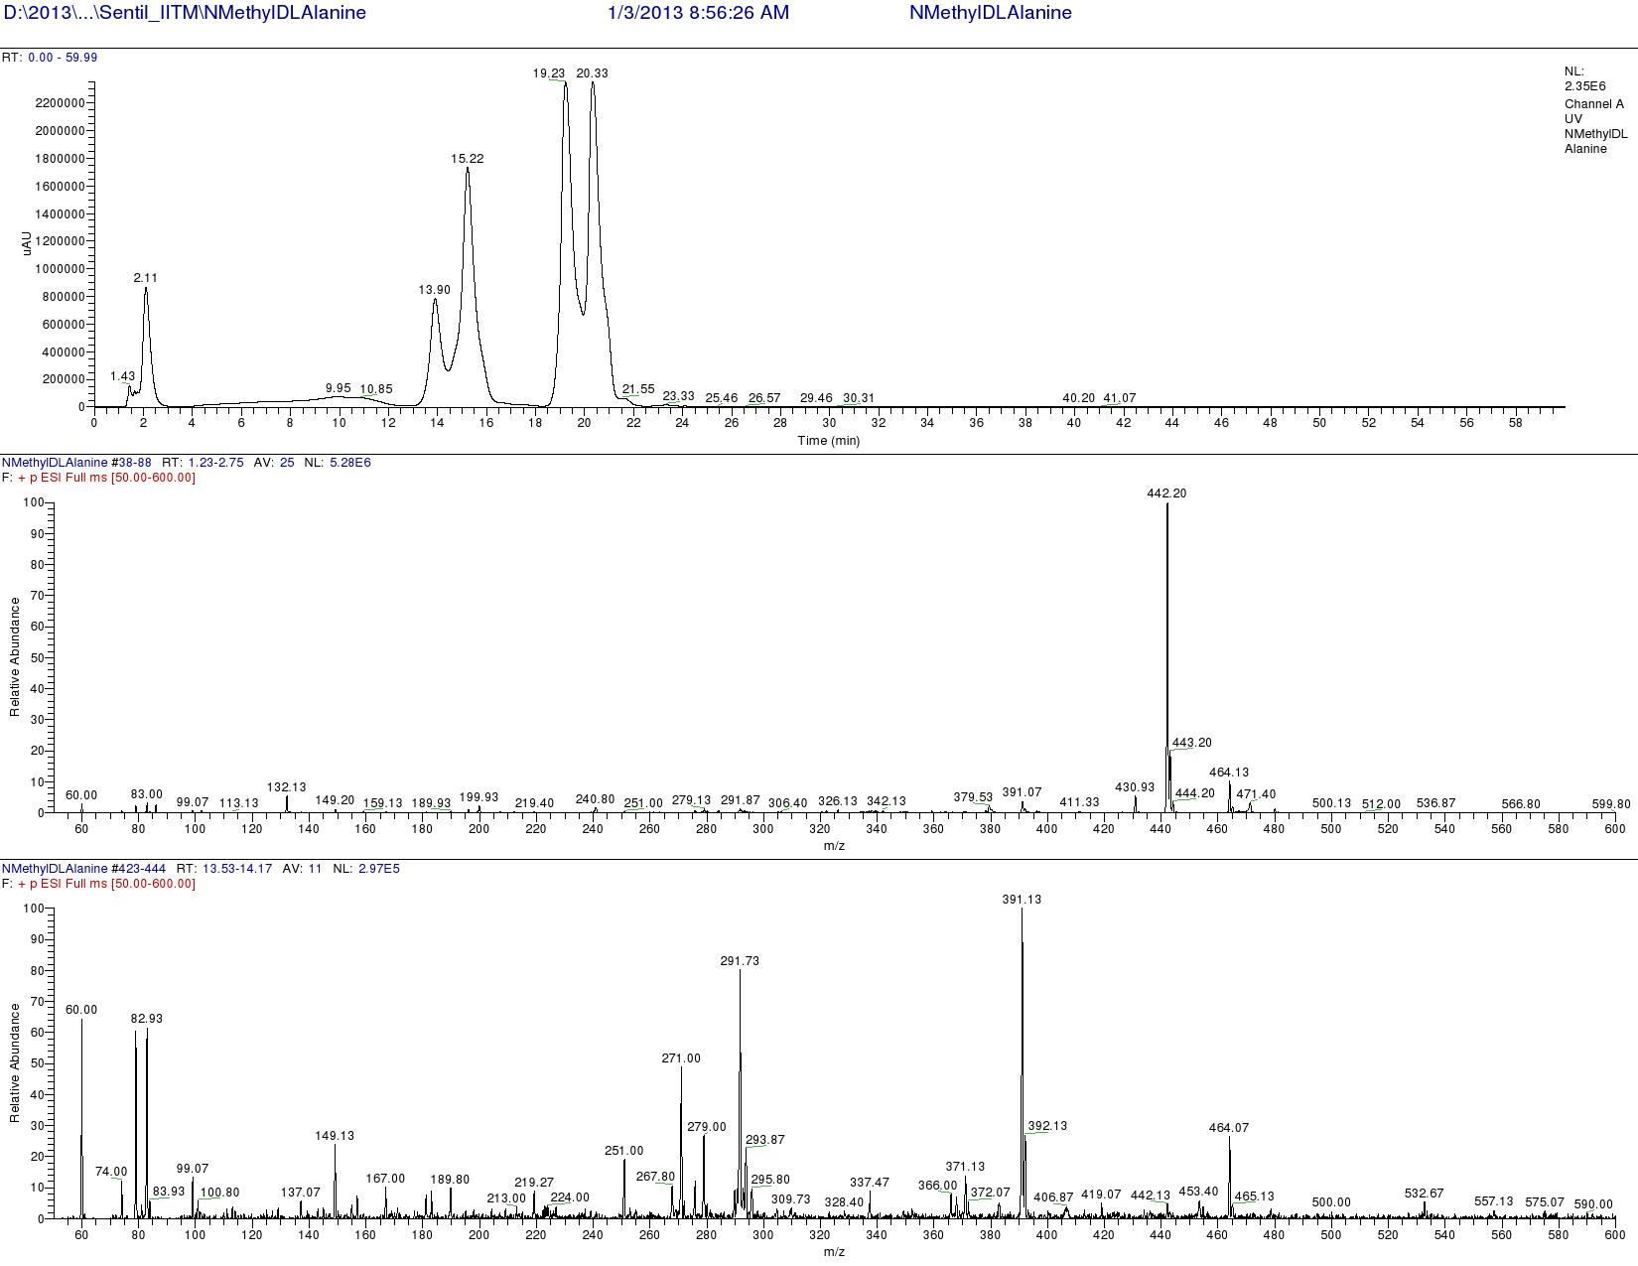

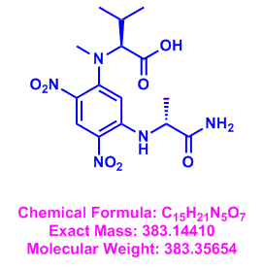

Figure S146. LCMS analysis of Standard L-FDAA-D/L N-Methyl valine (Positive mode)
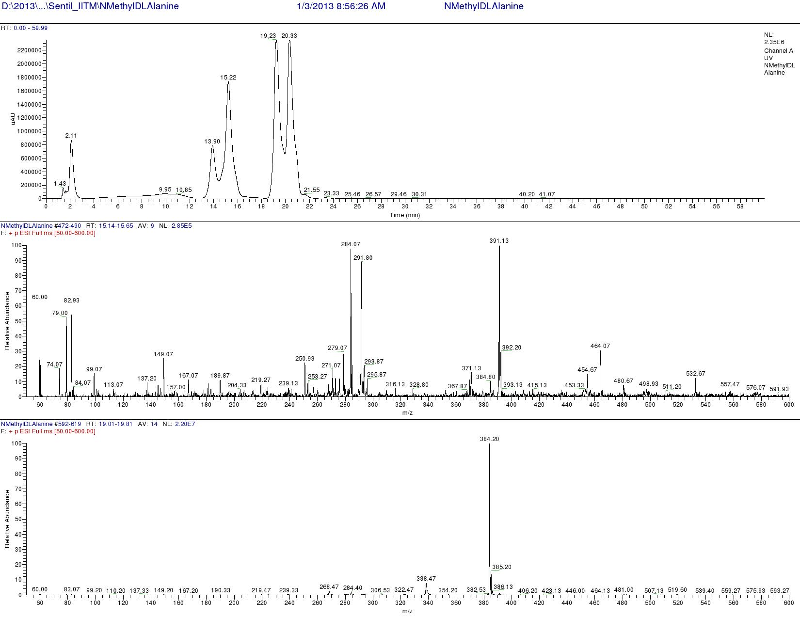

Figure S147. LCMS analysis of Standard L-FDAA-D/L N-Methyl Valine (Positive mode)

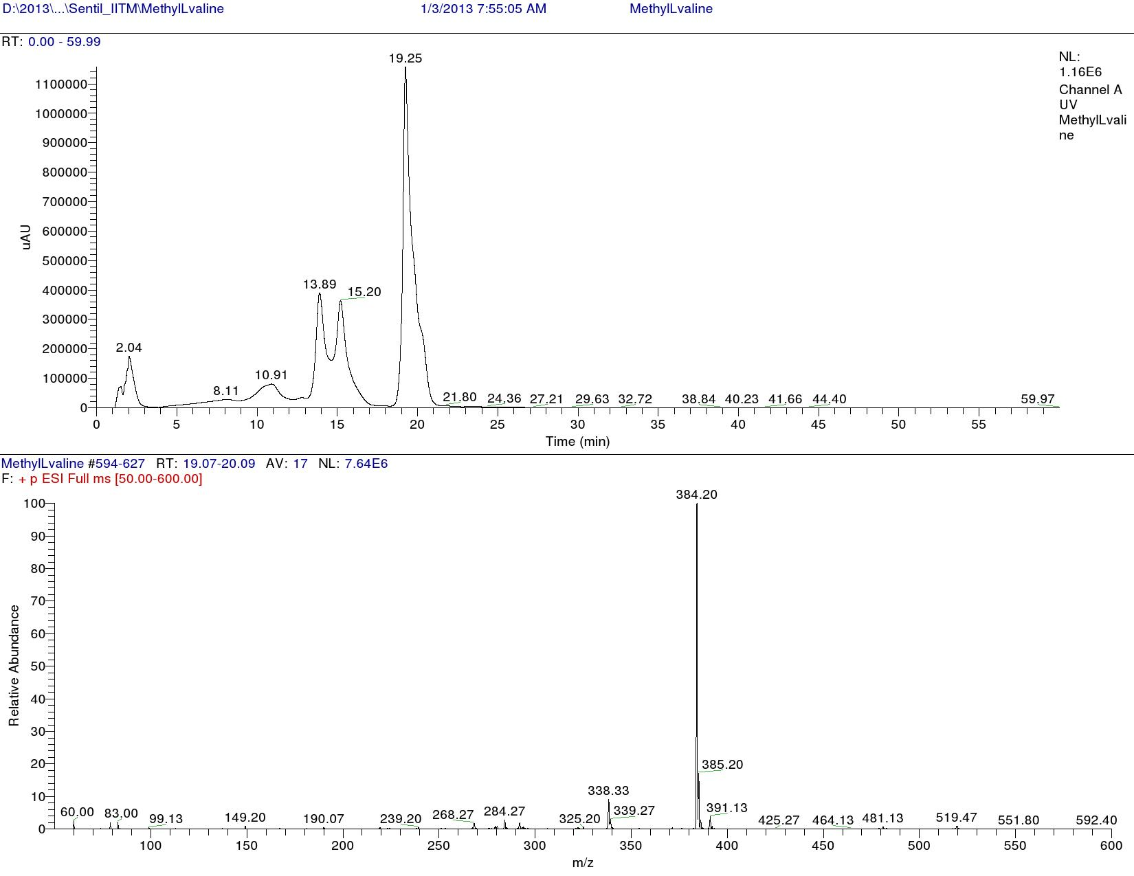

Figure S148. LCMS analysis of Standard L-FDAA-L N-Methyl valine (Positive mode)
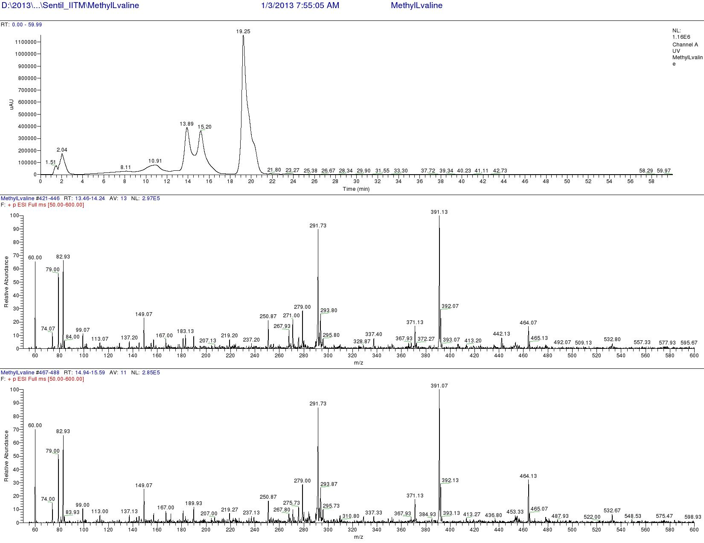

Figure S149. LCMS analysis of Standard L-FDAA-L- N-Methyl valine (Positive mode)
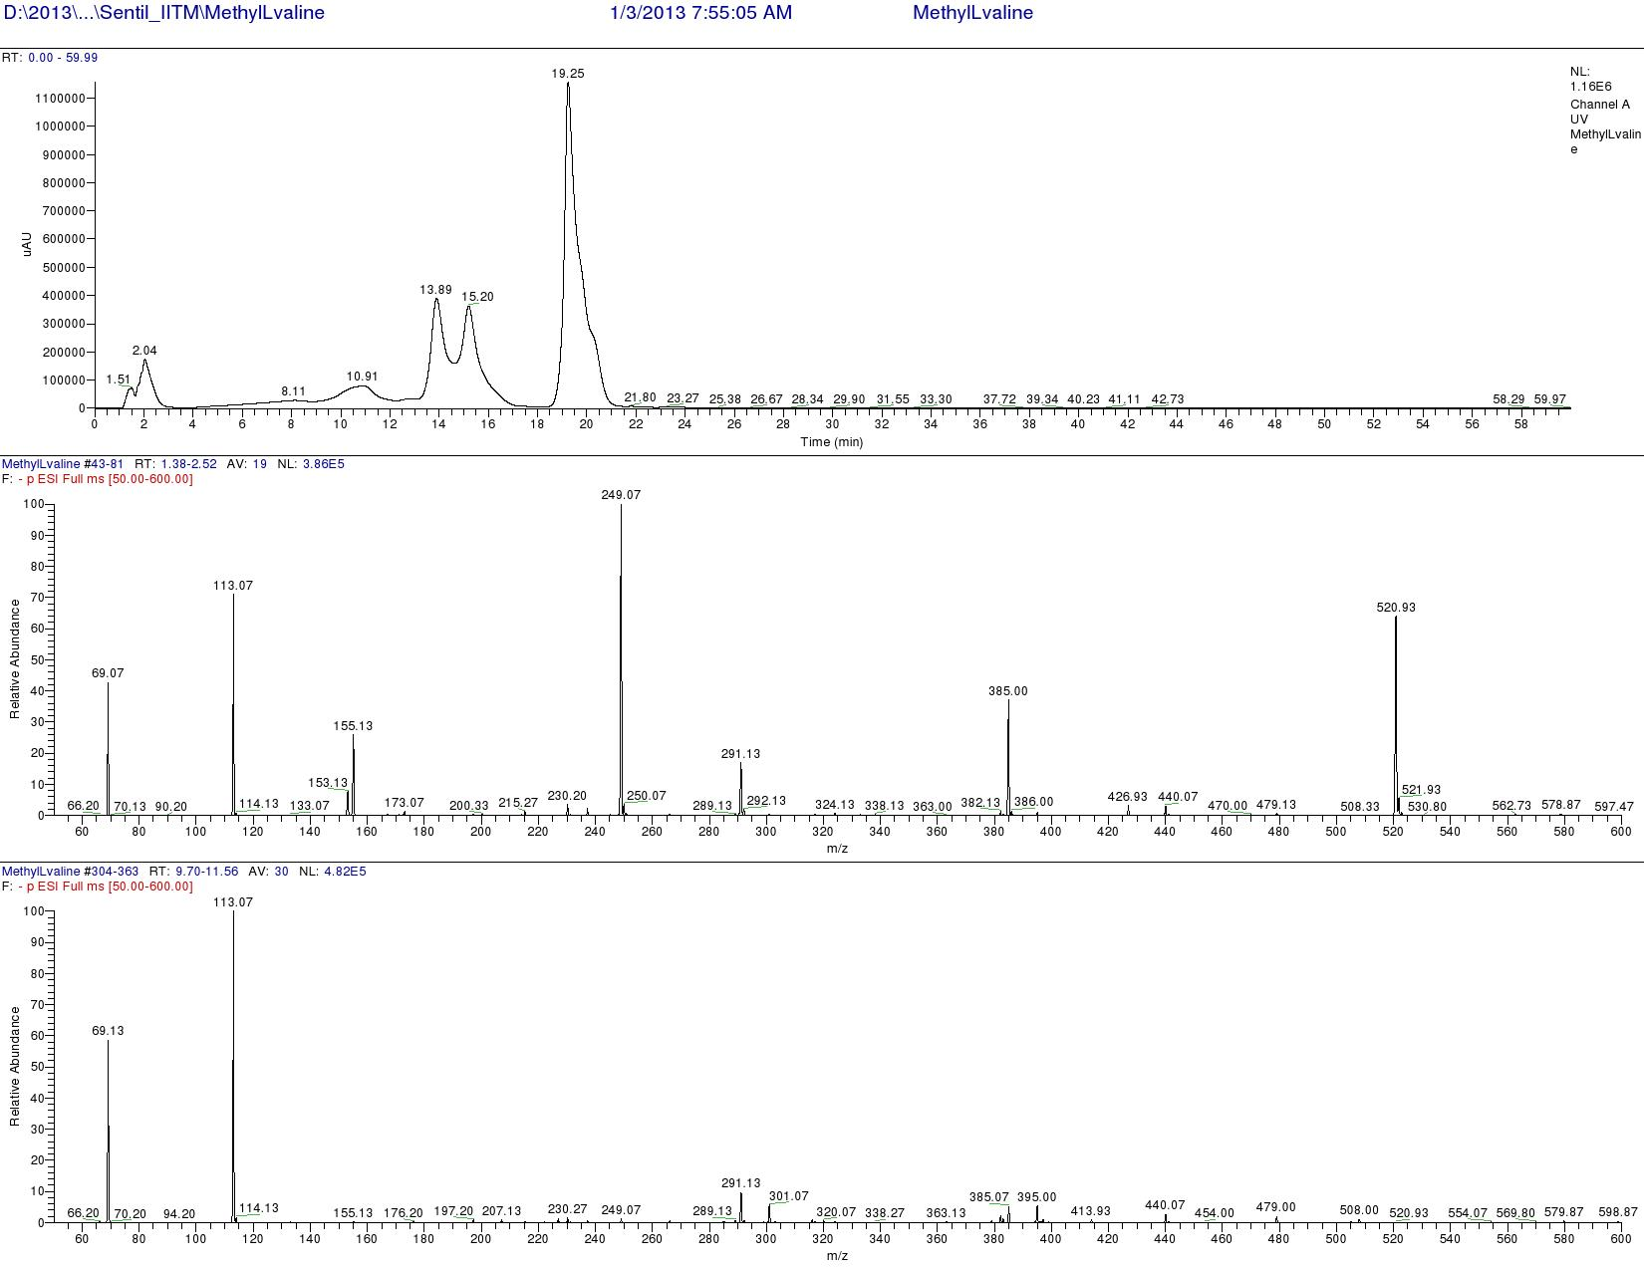

Figure S150. LCMS analysis of Standard L-FDAA-L N-Methyl Valine (Positive mode)
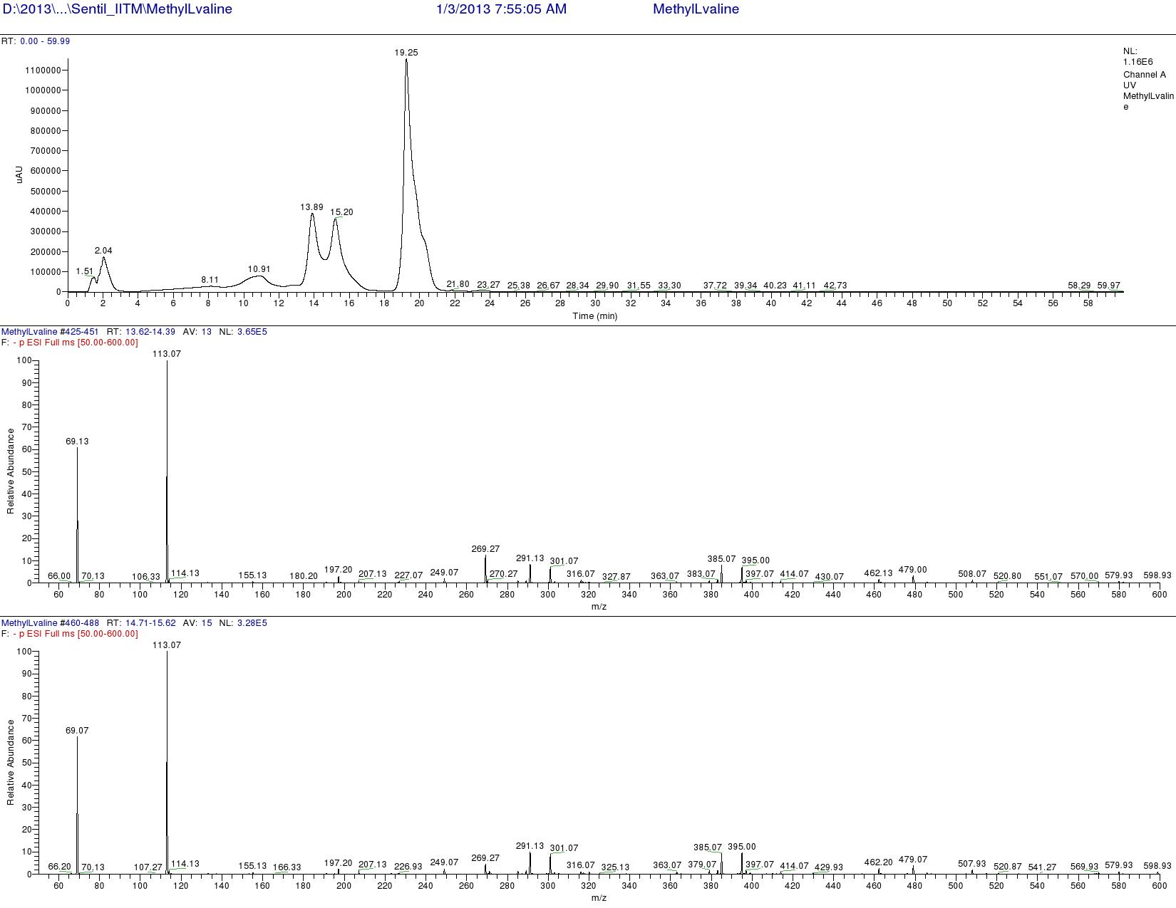

Figure S151. LCMS analysis of Standard L-FDAA-L N-Methyl Valine (Positive mode)
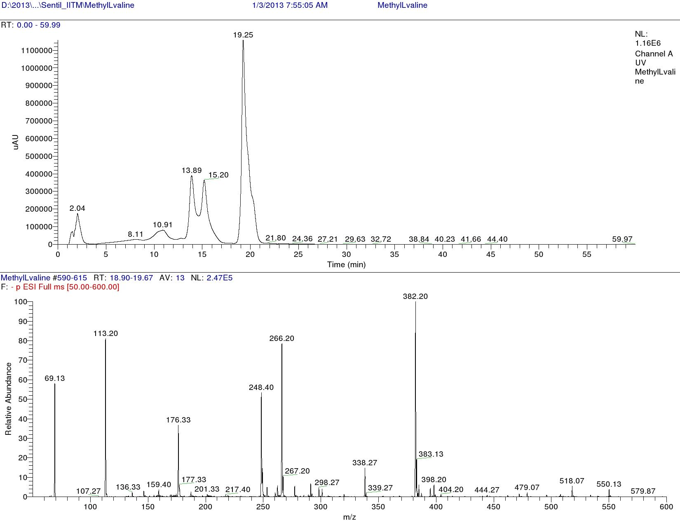

Figure S152. LCMS analysis of Standard L-FDAA-L N-Methyl Valine (Negative mode)

Figure S153. LCMS analysis of Standard L-FDAA-D/L N-Methyl Valine (Positive mode)

Figure S154. LCMS analysis of Standard L-FDAA-L N-Methyl Valine (Positive mode)

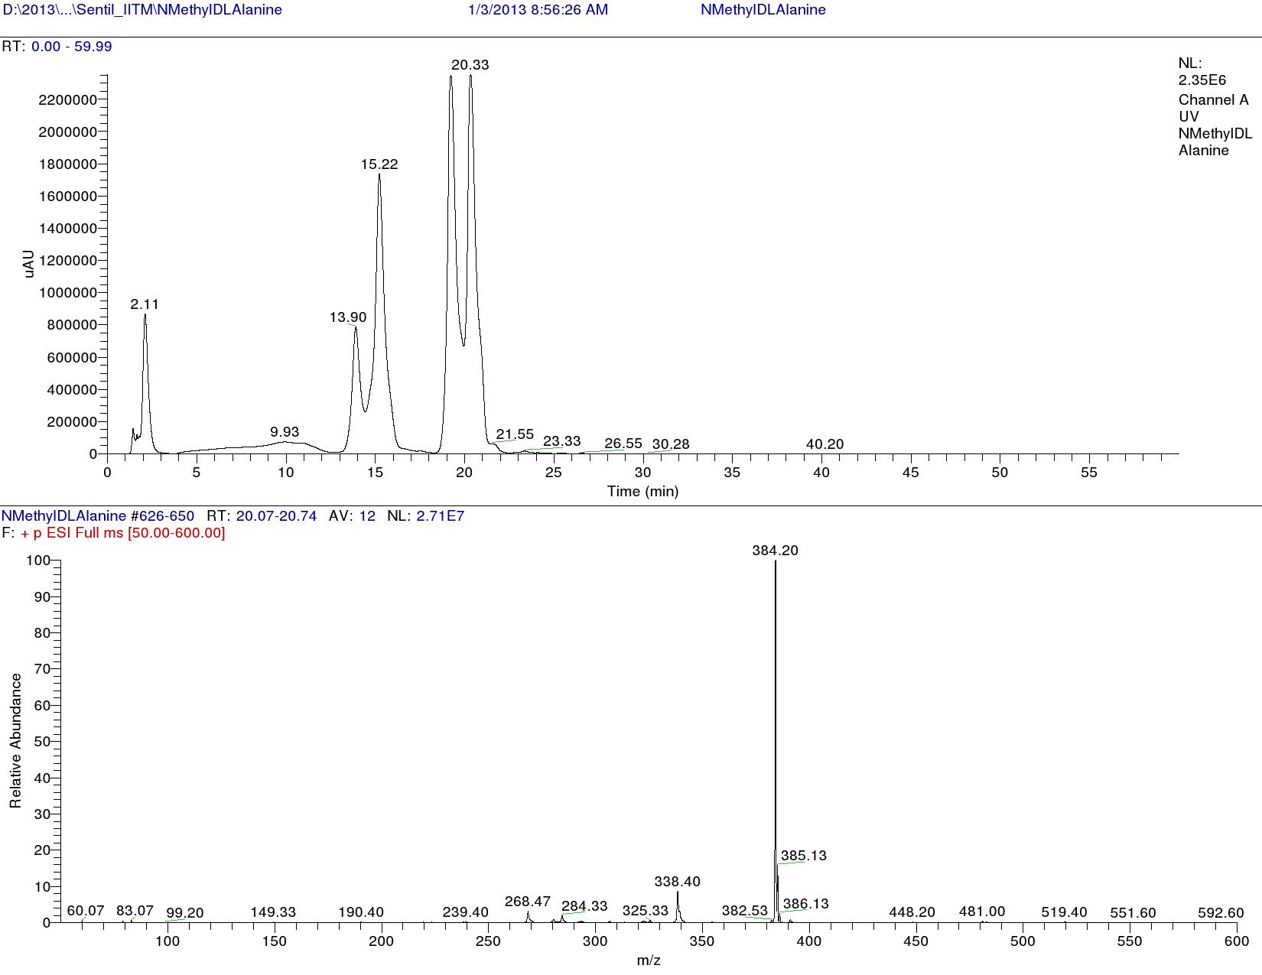

Figure S155. LCMS analysis of Standard L-FDAA-D/L N-Methyl Valine (Positive mode)
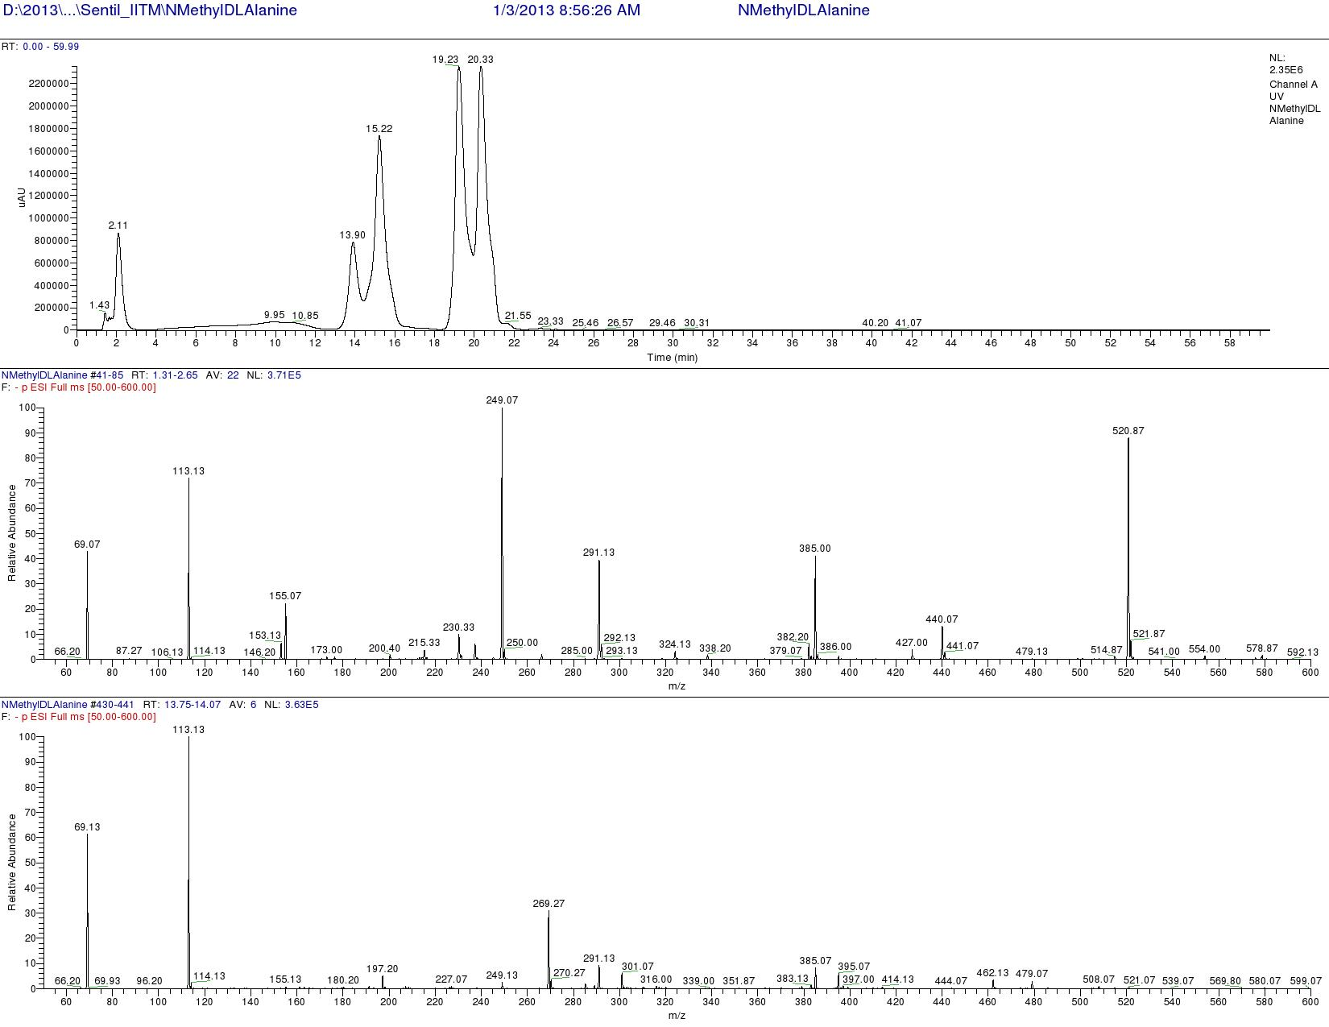

Figure S156. LCMS analysis of Standard L-FDAA-D/L N-Methyl Valine (Negative mode)
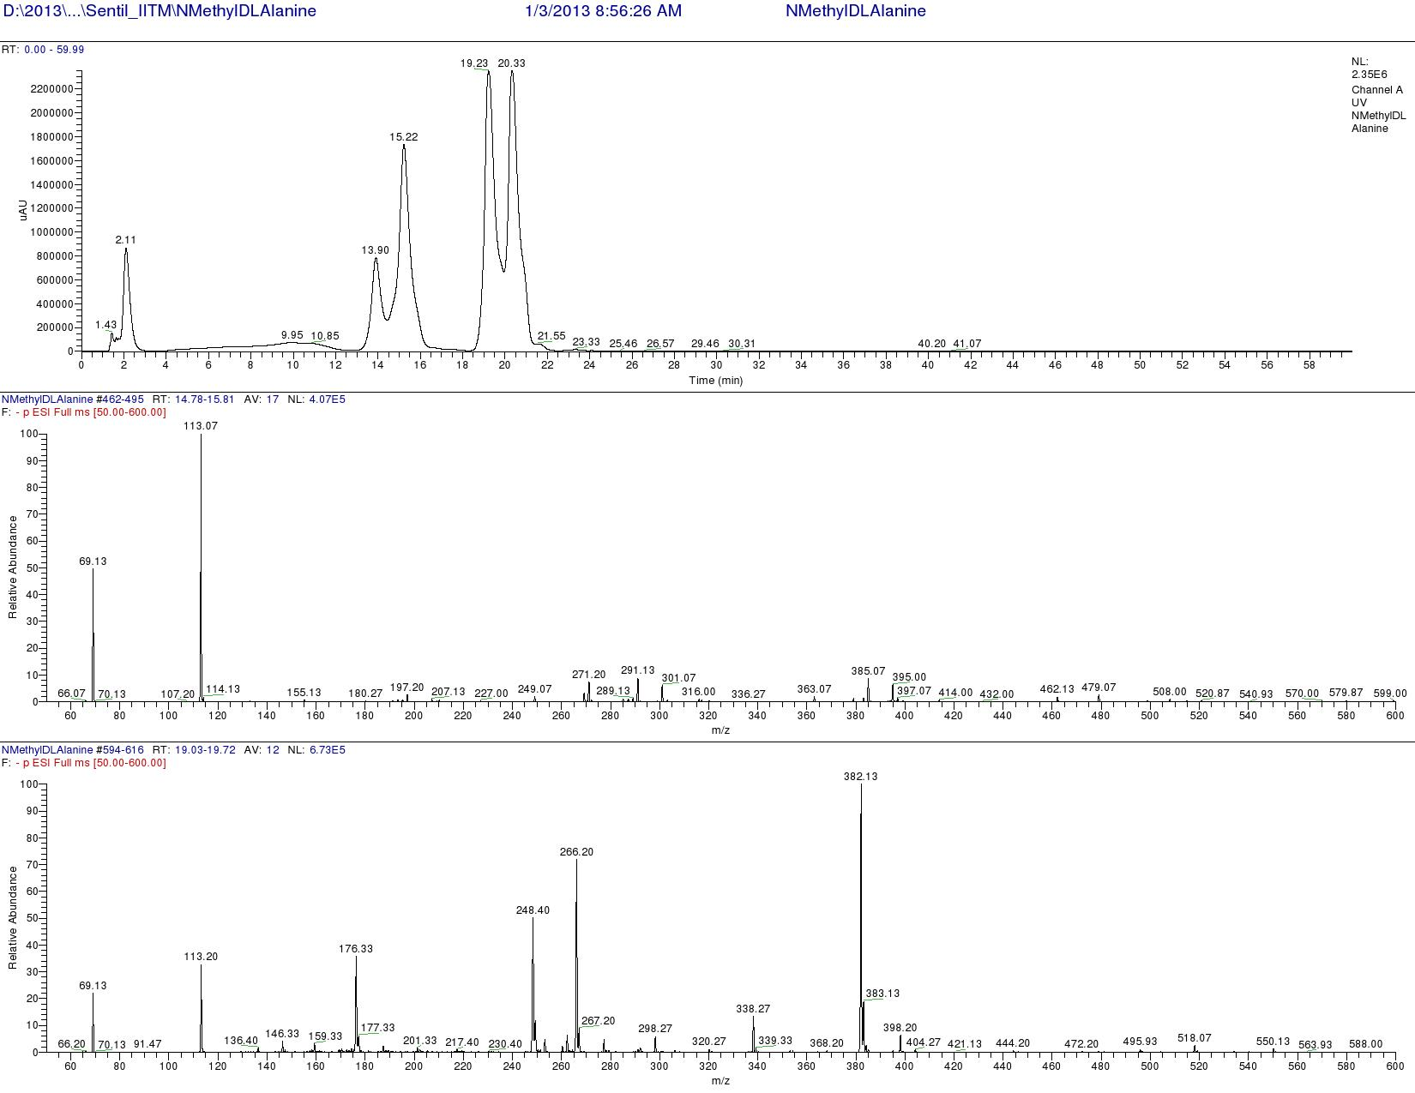

Figure S157. LCMS analysis of Standard L-FDAA-D/L N-Methyl Valine (Negative mode)
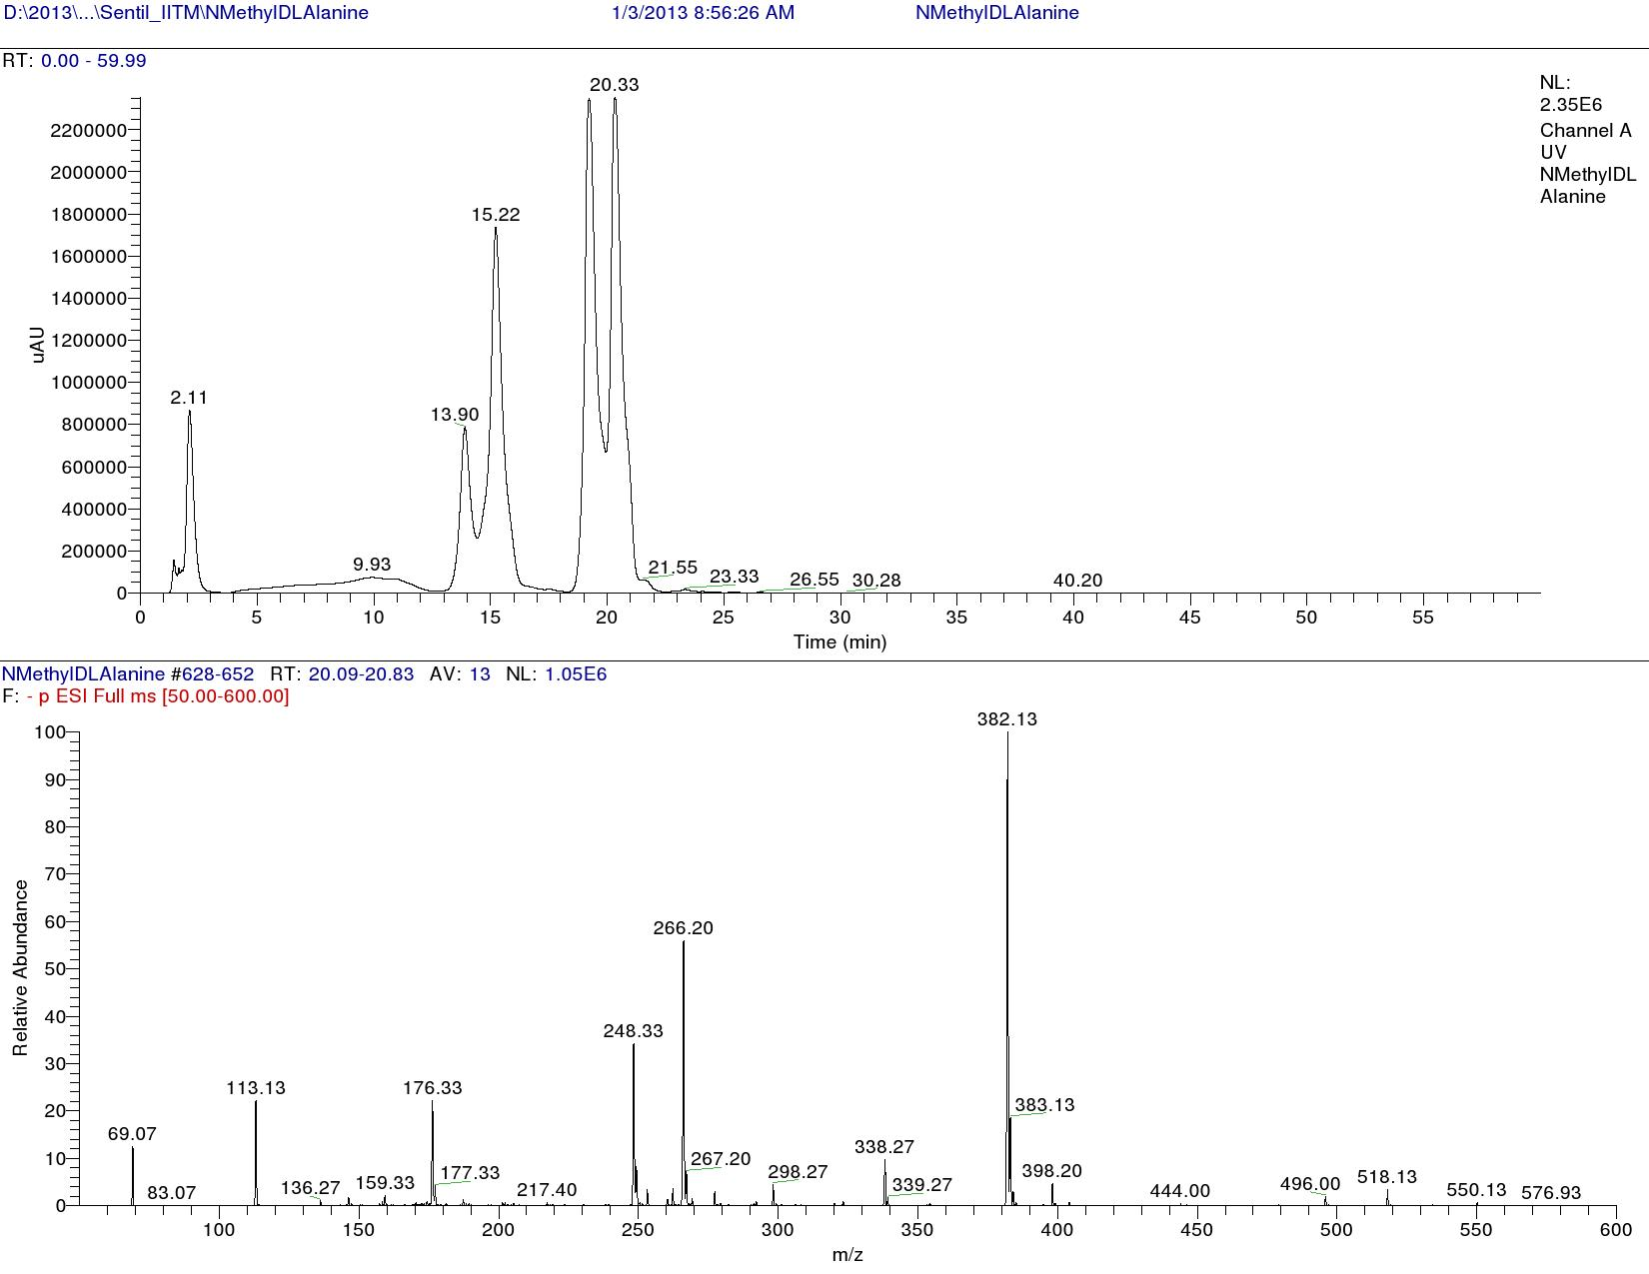

Figure S158. LCMS analysis of Standard L-FDAA-D/L N-Methyl Valine (Negative mode)

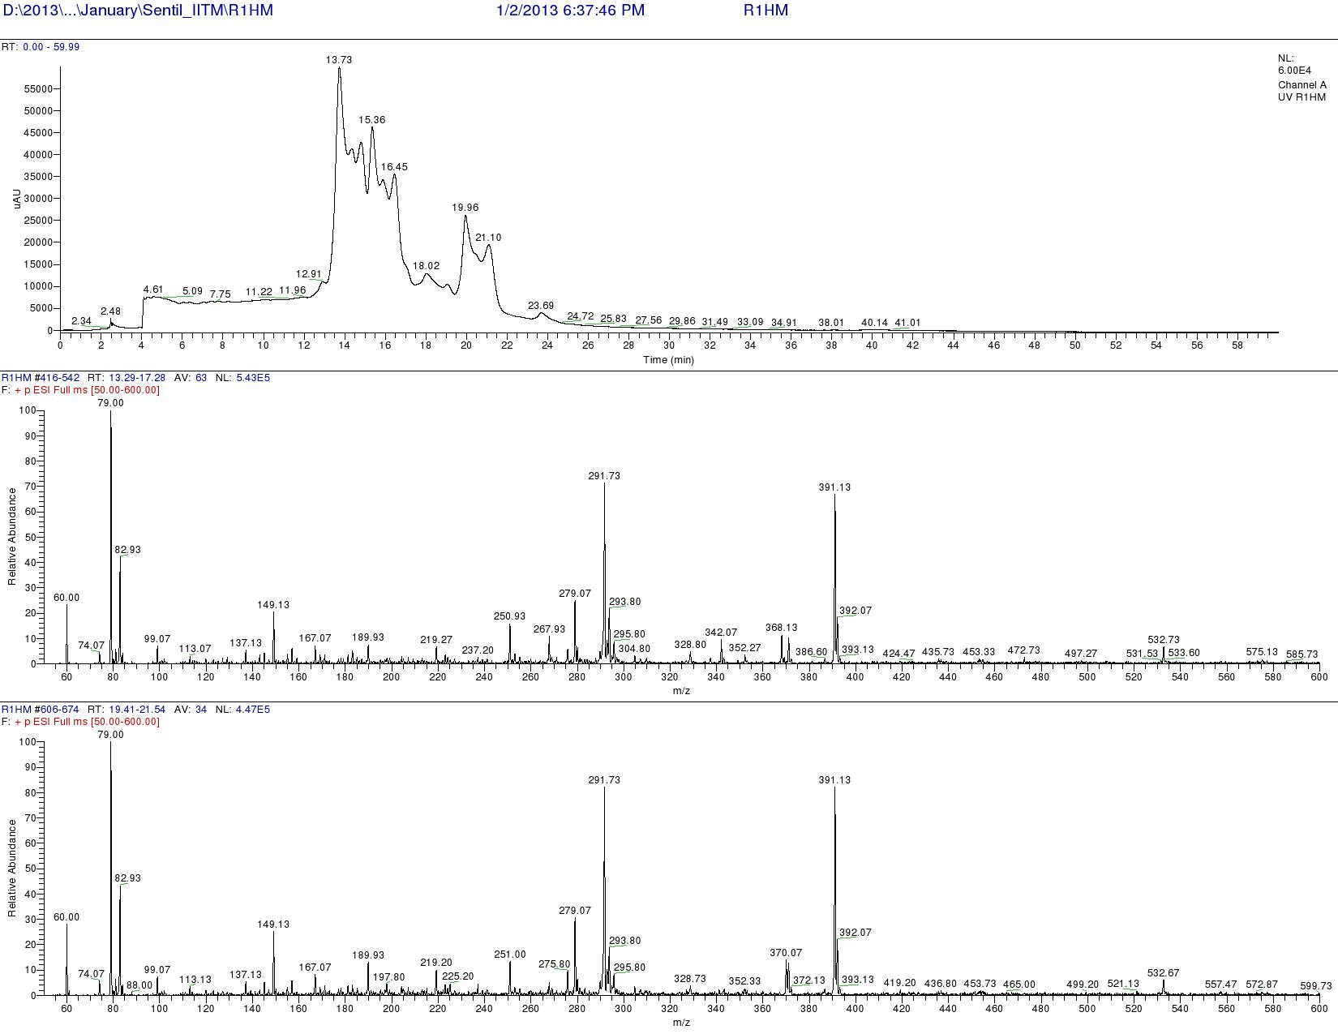

Figure S159. LCMS analysis of L-FDAA derivatives of Transitmycin (R1) ( Positive mode)
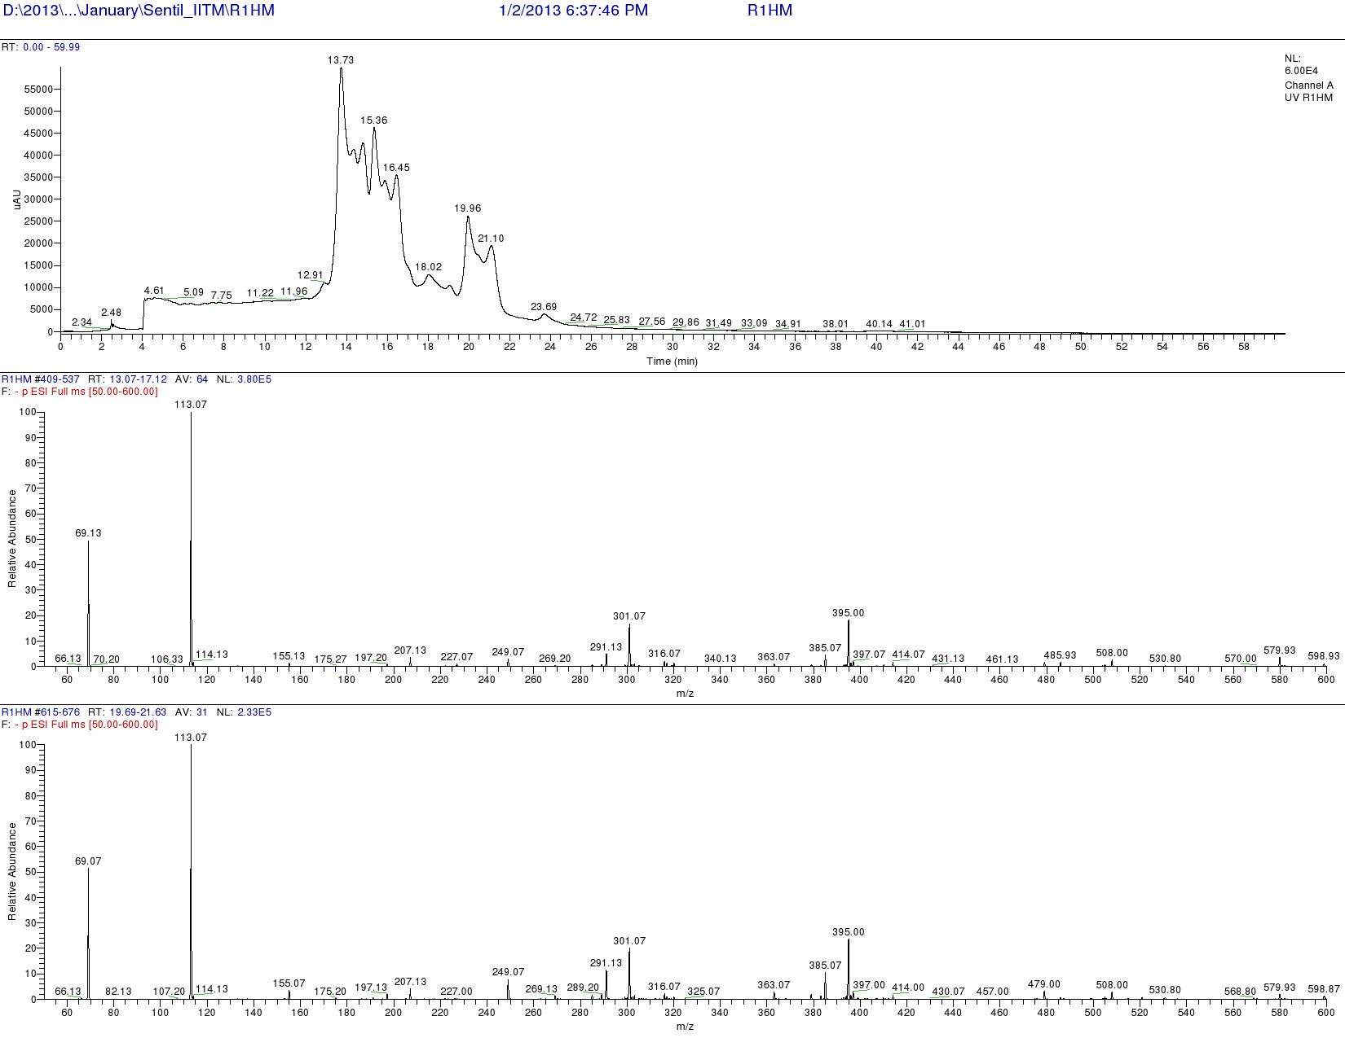

Figure S160. LCMS analysis of L-FDAA derivatives of R1 (Negative mode)
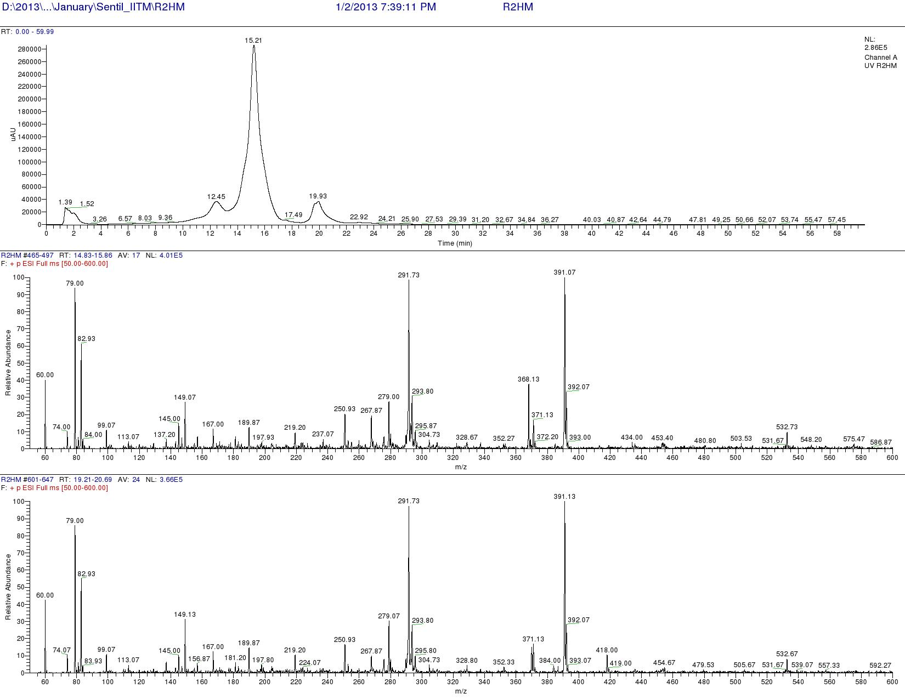

Figure S161. LCMS analysis of L-FDAA derivatives of R3 (Positive mode)
Table S9a. Analysis of L-FDAA derivates of acid hydrolysate of Transitmycin R2 by HPLCMS
Amino acids | LCMS retention times  Marfey’s derivatives of standard amino acids |  | HPLC retention time  Marfey derivatives of acid hydrolysate of Transitmycin R1 | M+H]+  m/z | [M-H]-  m/z | Assignment
Amino acids | D | L |  | Positive mode | Negative mode | Assignment
Threonine | 9.90 | 13.50 | 13.73 | 372.13 | 370.13 | L
Proline | 15.16 | 14.31 | 14.23 &15.36 | 366.13 | 363.07 | D&L
Valine | 19.65 | 17.65 | 18.02 | 370.13 | 368.07 | L
N-methyl valine | 20.33 | 19.25 | 19.96 | 384.20 | 382.20 | L
Table S9b. Analysis of L-FDAA derivates of acid hydrolysate of R3 by HPLCMS
_{Amino acids} | _{LCMS retention times}  Marfey’s derivatives of standard amino acids |  | _{HPLC retention time}  Marfey derivatives of acid hydrolysate of R3  _{minutes} | _{[M+H]+}  _{m/z} | _{[M-H]-}  _{m/z} | _{Assignment}
_{Amino acids} | _{D minutes} | _{L minutes} |  | _{Positive mode} | _{Negative mode} | _{Assignment}
Threonine | 9.90 | 13.50 | 12.45 | 372.13 | 370.13 | L
Proline | 15.16 | 14.31 | 14.25 | 366.13 | 363.07 | D & L
Valine | 19.65 | 17.65 | 17.49 | 370.13 | 368.07 | L
_{N-methyl valine} | _{20.33} | _{19.25} | _{19.93} | _{384.20} | _{382.20} | _{L}
Table S10. Physico-chemical properties of R2

Colour: Red colour amorphous powder

Yield: 100 mg, 10%

m.p: 250-252ºC

TLC: Rf = 0.6 (Ethyl acetate/Methanol, 95:5)

[α]_{D}²⁵: -24º (c = 0.2, MeOH)

Solubility: Soluble in Chloroform, Dichloromethane, Ethyl acetate, Methanol,Ethanol, Acetonitrile,
DMSO, water.Insoluble in Hexane.

UV: (MeOH) λ _{max,} (log ε) 205, (1.25), 240 (0.63), 425 (0.39), 442 (0.42) nm

CD: [MeOH, [nm], (mdeg)]: λ_{max,} (Δε) 195 (+8.8), 210 (-22.0), 240 (+4.3) nm

IR: (KBr), ν_{max}= 3436, 2961, 2924, 2853, 1744, 1650, 1565, 1415, 1204, 1140, 1045, 1019 cm⁻¹

HRESI-MS: m/z(pos.ions) 650.3413 [M+2H]⁺², 1277.8245 [M + Na]⁺ 1293.8735 [M + K]⁺

C₆₂H₈₆N₁₂O₁₆Na [M + Na]⁺ calc. 1277.61824, found. 1277.8245

MALDI-TOF-MS: m/z (pos.ions) 1279.94914 [M + Na+2H]⁺ m/z (neg.ions) 1255.38052[M-H]⁻ [M + Na+2H]⁺ calc. 1279.63424, found. 1279.94914

LCESI-MS: m/z (pos.ions) 1277.8245 [M + Na]⁺ C₆₂H₈₆N₁₂O₁₆Na [M + Na] ⁺ calc. 1277.61824, found. 1277.8245

EI-MS: (70 ev) m/z (pos.ions: 739.9827, 616.9573, 547.2778, 434.2708, 391.5160, 200.1560, 146.7755,
11.2256

CHN: Anal. calcd for C₆₂H₈₆N₁₂O_{16:}C, 59.32; H, 6.90; N, 13.39.
Found: C, 61.05; H, 7.25; N, 11.32.

Table S11. Physico-chemical properties of R3

Colour: Orange colour amorphous powder (50 mg)

Yield: 50 mg, 5%

m.p: 220-222ºC

R_{f:} 0.3 (Ethyl acetate-Methanol 95:5)

Solubility: Soluble in Chloroform, Dichloromethane, Ethyl acetateMethanol, Ethanol, Acetonitrile,
DMSO, water. Insoluble in Hexane

[α]_{D}²⁵: -27 º (c = 0.2, MeOH)

UV (MeOH) λ _{ma x}(log ε) 206 (1.90), 240 (0.69) 424 (0.191), 442.2 (0.19) nm

CD: [MeOH,[nm], (mdeg) ]λ_{max}(Δε) 195 (+24.0), 210 (-21.5), 241 (+1.7)

IR:(KBr),ν_{max} 3415, 2957, 2924, 2853, 1745, 1642, 1583, 1464, 1384, 1193, 1093, 1078 cm⁻¹.

HRESI-MS: m/ z (pos.ions) 663.4698 [M+2H]⁺², 1271.7159 [M + H]⁺

C₆₂H₈₆N₁₂O₁₇ [M + H]⁺ calc. 1277.6312, found. 1271.7159

MALDI-TOF-MS: m/z (pos.ions) 1292.24097 [M + Na]⁺ m/z(neg.ions) 1268.48582[M-H]⁻

C₆₂H₈₆N₁₂O₁₇Na [M + Na]⁺ calc. 1293.61316 found. 1292.24097

LCESI-MS: m/z (pos.ions) 1277.6149 [M-OH+Na+H]⁺ C₆₂H₈₅N₁₂O₁₆ [M – OH+Na+H] ⁺ calc. 1277.61416, found. 1277.6149

EI-MS: (70 ev) m/z (pos.ions): 98, 956.7713, 900, 9470, 859.8045, 771.227, 708.0386, 562.4686,
515.1946, 446.3967, 351.8868, 1\230.2476, 94.2476

CHN: Anal. calcd for C₆₂H₈₆N₁₂O_{17:}C, 58.57; H, 6.82; N, 13.22.
Found: C, 58.75; H, 7.13; N, 11.59.

Supplementary Table 12: Drug resistant profile of the clinical isolates of Mycobacterium tuberculosis used to determine the anti TB activity of Transitmycin. R: Resistant; S: Susceptible. The drug resistant profile was determined by LJ based Proportion sensitivity method.
Culture No. | Isoniazid | Rifampicin | Kanamycin | Ofloxacin
1-49 | S | S | S | S
50 | R | S | S | S
51 | R | S | S | S
52 | S | R | S | S
53 | R | S | S | S
54 | S | S | S | R
55 | R | S | S | S
56 | R | S | S | R
57 | R | S | S | S
58 | R | S | S | S
59 | R | S | R | R
60 | R | R | R | S
61 | S | S | R | S
62 | R | S | S | R
63 | R | S | S | R
64 | R | S | R | R
65 | R | S | S | S
66 | R | S | S | R
67 | R | S | S | R
68 | R | S | R | R
69 | S | S | S | R
70 | S | S | S | R
71 | R | S | S | S
72 | R | S | S | R
73 | R | R | S | S
74 | R | S | S | S
75 | R | R | S | S
76 | R | R | R | S
77 | R | R | S | R
78 | R | R | S | R
79 | R | S | S | S
80 | R | S | S | R
81 | R | S | S | S
82 | R | R | S | S
83 | R | R | S | S
84 | R | R | S | R
85 | R | R | S | S
86 | R | R | S | R
87 | S | R | S | R
88 | R | R | S | S
89 | R | R | S | S
90 | S | R | S | R
91 | S | S | S | R
92 | R | R | S | S
93 | R | R | S | R
94 | S | R | S | R
95 | R | S | S | R
96 | R | R | S | S
97 | R | S | S | R

S - Table 13. Anti-HIV activity of Transitmycin on various HIV-1 subtypes

HIV-1 subtype | IC₅₀ values at various concentration of Transitmycin  (in µg/mL) |  |  |  |  | EC₅₀ Value (µM)
HIV-1 subtype | 0 | 0.01 | 0.1 | 1 | 10 | EC₅₀ Value (µM)
SUB A | 4624.7 ± 348.34 | 2600.31 ± 212.27 | 1413±84.36 | 116.00 ± 13.61 | 133.32 ± 13.33 | 0.263
SUB B | 9123.78 ± 495.29 | 8419.48 ± 549.73 | 7470.78 ± 3208.54 | 4222.52 ± 138.79 | 1693.95±35.38 | 2.347
SUB C | 11652.5 ± 1339.97 | 10962.821± 729.96 | 11005.35±144.9 | 3435.69 ± 75.80 | 578.46 ± 65.77 | 2.167
SUB D | 10170.22 ± 1572 | 10761.7 ± 576.85 | 7405.783±303.46 | 1339.49±287.06 | 306.53± 27.43 | 0.447
SUB E | 3976.34 ± 68.35 | 3726.96±590.53 | 2120.49±155.83 | 970.25 ±38.08 | 258.84 ± 3.87 | 0.78
SUB A/C | 5871.52 ± 51.10 | 5562.45±396.06 | 4654.15 ±262.26 | 589.52 ± 133.80 | 154.45 ±30.20 | 0.685
NEV RES | 3325.76 ± 259.01 | 3636.10 ±743.95 | 3278.46 ±329.16 | 627.37 ±69.58 | 341.00 ±7.88 | 0.771
AZT RES | 3031.83 ± 821.87 | 3040.03±703.81 | 2213.102± 48.17 | 1066.38 ± 17.34 | 786.32 ±37.46 | 0.388

Acknowledgements for Characterisation of Transitmycin
The Chairman, NMR Research Centre, IISC, Bangalore
Dr.A.Mohan, Mr.Venkatesan, Department of Chemistry, IIT Madras
Dr.M.S.Moni, Dr.C. Baby, Mr. R. Bhaskar, SAIF IIT Madras for 2D NMR analysis
Prof. T. Pradeep, AnanyaBaksi, DST Unit of Nano science IIT Madras for QTRAP LC/MS/MS
Prof. T. Pradeep, Mr.Kamalesh, Mr. E. Sundaraj, DST Unit of Nano Science IIT Madras for MALDI-TOF
Mrs.Sunita Prakash, Molecular Biophysics Department, IISC Bangalore for ESI-MS/MS, MALDI TOF-MS/MS
Mrs.Santha, Mr.Thankarasu, Department of Chemistry IIT Madras for Q-TOF-ESI-MS
Mr. Sankar, SAIF, IIT Madras for IR, EI-MS
The Head, SAIF CDRI, Luknow for LC-ESI-MS
Mr.Muralidhar, SID IISC Bangalore LC-ESI-MS
Prof.Anju Chanda, Mr. T.Saravanan, Department of Biotech IIT Madras for Optical Rotation measurement
Mrs.S.Srividya, Department of Chemistry, IIT Madras.
Dr. P.M.Sivakumar, Department of Biotechnology, Indian Institute of Technology Madras, Chennai, Tamilnadu , 600036, India
Dr. Veluchamy Prabhawathi Department of Biotechnology, Indian Institute of Technology Madras, Chennai, Tamilnadu, 600036, India
Supplementary References:

- Xiaoling Wang, Jioji Tabudravu Mostafa Ezzat Rateb, Krystal Joan Annand, Zhiwei Qin, Marcel Jaspars, Zixin Deng, Yi Yband Hai Deng, Identification and characterization of the actinomycin G gene cluster in Streptomyces iakyrus, Mol. BioSyst., 9, 1286—1289. (2013).
- Rebecca H. Wills, Peter B. O’Connor Structural Characterization of Actinomycin D Using Multiple Ion Isolation and Electron Induced Dissociation J. Am. Soc. Mass Spectrom. 25:186Y19, (2014).
- IvanaCrnovci c, Siamak Semsary, Joachim Vater and Ullrich Keller, Biosynthetic rivalry of o-aminophenol-carboxylic acids initiates production of hemi-actinomycins in Streptomyces antibioticus, RSC Adv., 4, 5065 (2014).
- JoachimVater, Ivana Crnovčić, Siamak Semsary and Ullrich Keller MALDI-TOF mass spectrometry, an efficient technique for in situ detection and characterization of actinomycins,J. Mass Spectrom., 49, 210–222 (2014).
- Collisional Activation Decomposition of Actinomycins Using Tandem Mass Spectrometry J. Roboz, E. Nieves and J. F. Holland M. McCamish, C. Smith, BIOMEDICAL AND ENVIRONMENTAL MASS SPECTROMETRY, VOL. 16, 67-70 (1988).
- A. B. Mauger, W. A. Thomas, NMR Studies of Actinomycins Varying at the Proline Sites, ORGANIC MAGNETIC RESONANCE, VOL. 17, NO. 3(1981).
- Darren Thomas, Michael Morris,Jonathan M. Curtis and Robert K. Boyd, Fragmentation Mechanisms of Protonated Actinomycins and Their Use in Structural Determination of Unknown Analogues, JOURNAL OF MASS SPECTROMETRY, VOL. 30, 1111-1125 (1995).
- Jens Bitzer, Martin Streibel, Hans-Jörg Langer, Stephanie Grond, First Y-Type Actinomycins from Streptomyceswith Divergent Structure-Activity Relationships for Antibacterial and Cytotoxic Properties, Org. Biomol. Chem., 7, 444–450. (2009).
- Caixia Chen,Fuhang Song, QianWang,Wael M. Abdel-Mageed, HuiGuo, Chengzhang Fu &WeiyuanHou & Huanqin Dai & Xueting Liu & Na Yang & FengXie & Ke Yu & Ruxian Chen & Lixin Zhang, A marine-derived Streptomyces sp. MS449 produces high yield of actinomycin X2 and actinomycin D with potent anti-tuberculosis activity, Appl Microbiol Biotechnol 95:919–927, (2012).
- Shigehiro Kamitori and FusaoTakusagawa’ Multiple Binding Modes of Anticancer Drug Actinomycin D:X-ray, Molecular Modeling, and Spectroscopic Studies of d (GAAGCTTC)2-Actinomycin D Complexes and Its HostDNA, J. Am. Chem. SOC.,116, 41544165, (1994).
- JensBitzer, Victoria Gesheva, and Axel Zeeck, Actinomycins with Altered Threonine Units in the â-Peptidolactone, J. Nat. Prod., 69, 1153-1157, (2006).
- Xiufang Zhang , Xuewei Ye, Weiyun Chai , Xiao-Yuan Lian, and Zhizhen Zhang, New Metabolites and Bioactive Actinomycins from Marine-Derived Streptomyces sp. ZZ338, Mar. Drugs, 14, 181, (2016).
- Helmut Lackner, Isabel Bahner, Nobuharu Shigematsu Lewis K. Pannell, and Anthony B. Mauger, Structures of Five Components of the Actinomycin Z Complex from Streptomyces fradiae, Two of Which Contain 4-Chlorothreonine, J. Nat. Prod, 63, 352-356, ( 2000).
- . F. Conti, P. DeSantis Conformation of Acitinomycin D Nature, Vol. 227, 19, (1970).

