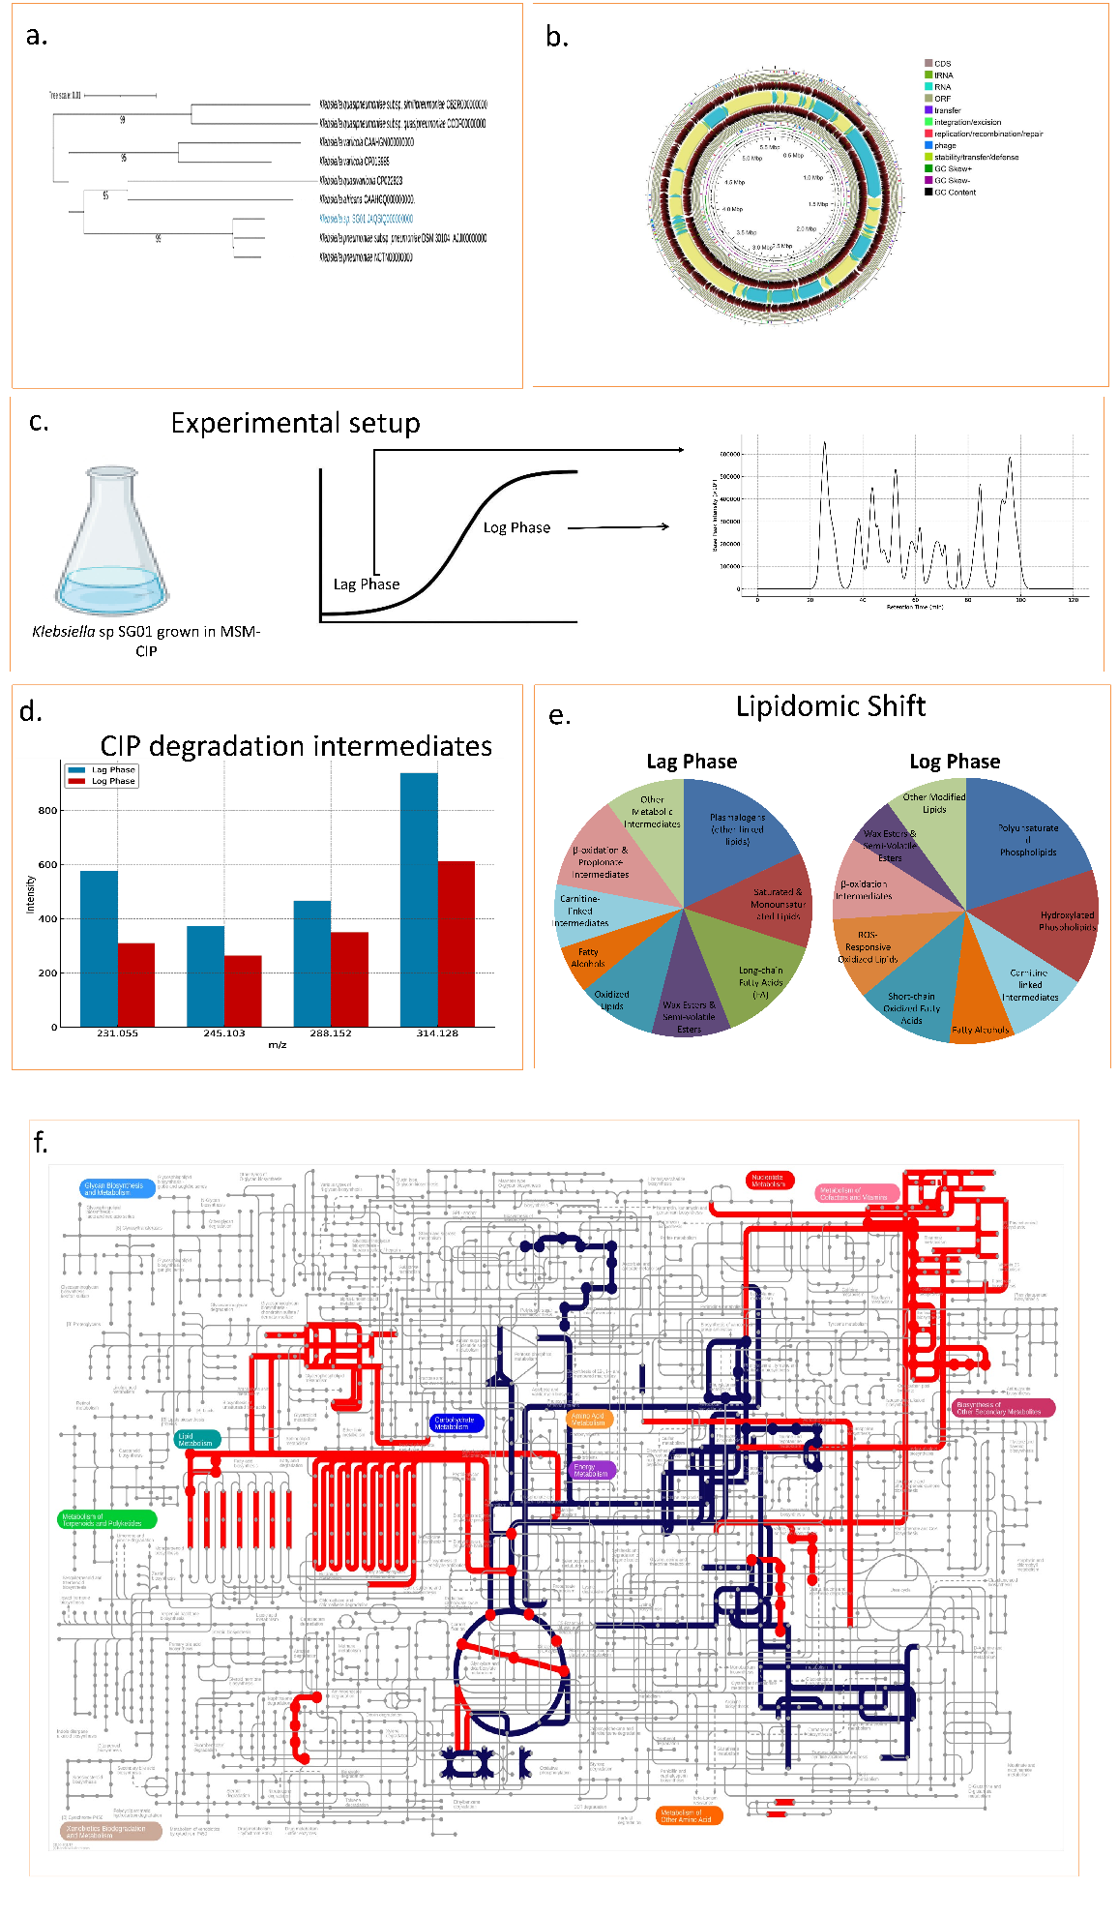
Figure 1 | Integrated multi-omics analysis of adaptation and ciprofloxacin degradation by Klebsiella sp. SG01.
(a) Phylogenetic tree showing the evolutionary placement of Klebsiella sp. SG01 based on whole-genome alignment with closely related taxa.
(b) Circular genome map depicting annotated features, including coding sequences (CDS), non-coding RNAs, GC content, and GC skew.
(c) Schematic representation of the experimental setup for metabolomic analysis. The SG01 strain was grown in minimal salt medium supplemented with ciprofloxacin (MSM-CIP), and samples were collected during lag and log phases for LC–MS-based profiling.
(d) Ciprofloxacin degradation intermediates identified through metabolomics, including hydroxylated, defluorinated, and ring-cleaved metabolites.
(e) Lipidomic shifts inferred from metabolomic data, showing changes in abundance across lipid classes between lag and log phases.
(f) Pathway analysis visualized using iPath; red lines indicate significantly upregulated and blue lines indicate downregulated metabolic pathways in response to ciprofloxacin treatment.
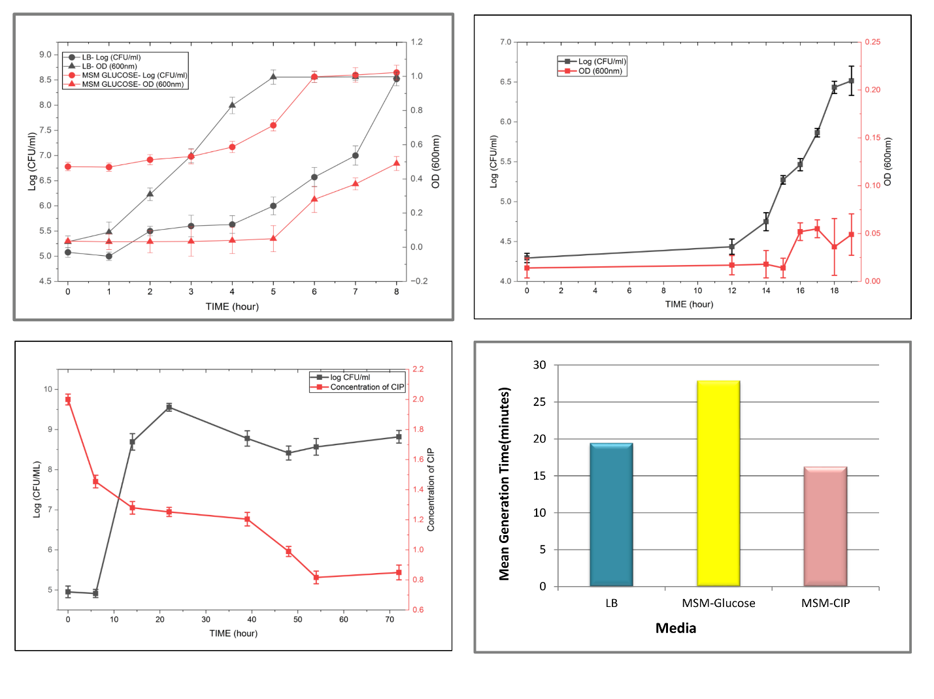
Figure 2 | Growth dynamics of Klebsiella sp. SG01 in different media.
Growth was monitored by colony-forming units per millilitre (CFU/mL) at multiple time points in three biological replicates.
(a) Growth curve in Luria–Bertani (LB) medium.
(b) Growth in minimal salt medium supplemented with glucose (5 g/L).
(c) Growth in MSM supplemented with ciprofloxacin (2 g/L).
(d) Ciprofloxacin degradation measured by UV–visible spectrophotometry in MSM-CIP cultures.
(e) Mean generation time of SG01 in LB, MSM-glucose, and MSM-CIP media.
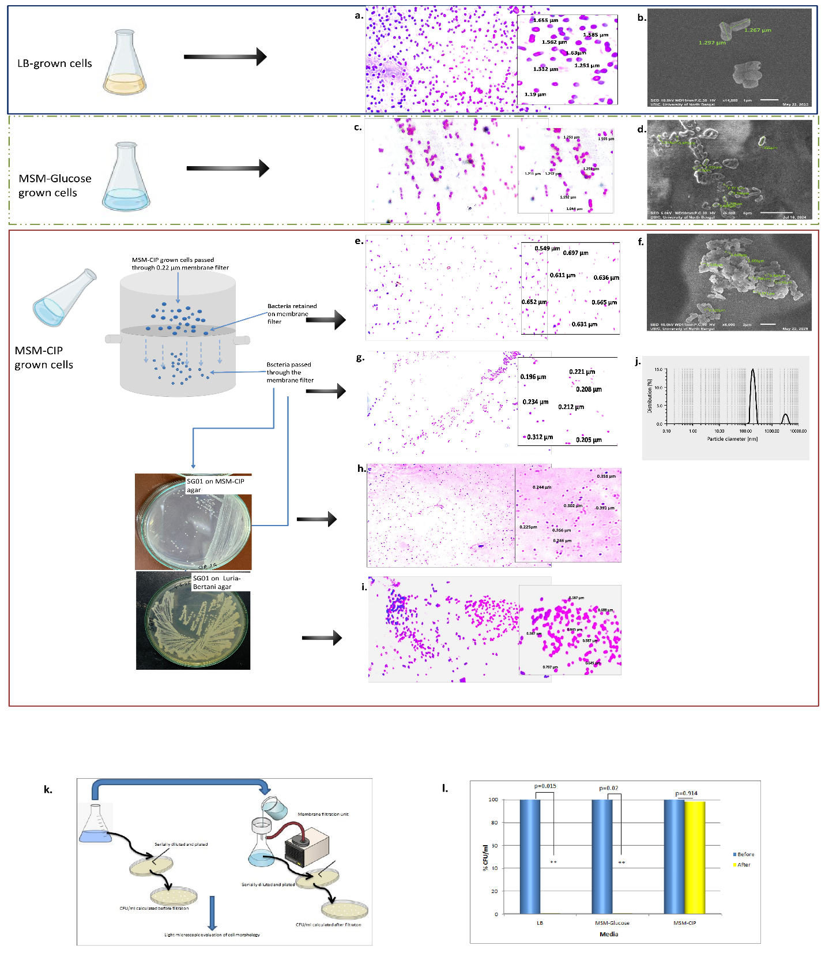
Figure 3 | Morphological changes and filterability of Klebsiella sp. SG01 cells under ciprofloxacin treatment.
(a) Gram stain of Klebsiella sp. SG01 cells grown in LB medium.
(b) Scanning electron microscopy (SEM) image of LB-grown SG01cells showing typical cell morphology.
(c) Gram-stained SG01cells grown in minimal salt medium with glucose, displaying morphology comparable to LB-grown cells.
(d) SEM image of MSM-glucose-grown SG01cells.
(e) Gram-stained SG01 cells grown in MSM-CIP and retained on a 0.22 µm membrane filter.
(f) SEM of MSM-CIP-grown SG01cells showing reduced cell size and altered surface features.
(g) Gram stain of the SG01cells present in the filtrate from MSM-CIP culture, indicating the presence of small, filterable cells.
(h) Gram stain of SG01cells scooped from colonies grown after dilution streaked filtrate on MSM-CIP agar, demonstrating morphologically altered cells.
(i) Gram stain of SG01cells scooped colonies grown after dilution streaked filtrate on LB agar, further demonstrating reversal of cell morphology, from nanometre sized (when grown in MSM-CIP) to micrometre sized cells.
(j) Dynamic light scattering (DLS) analysis of filtrate-derived cells, showing reduced size distribution consistent with gram stain observations.
(k) Schematic of the filtration and plating workflow used to assess filterability.
(l) Quantification of the proportion of cells retained and passed through the filter across growth conditions. A significant difference in cell count was observed between filtered and unfiltered samples for LB and MSM-glucose, but not for MSM-CIP cultures.
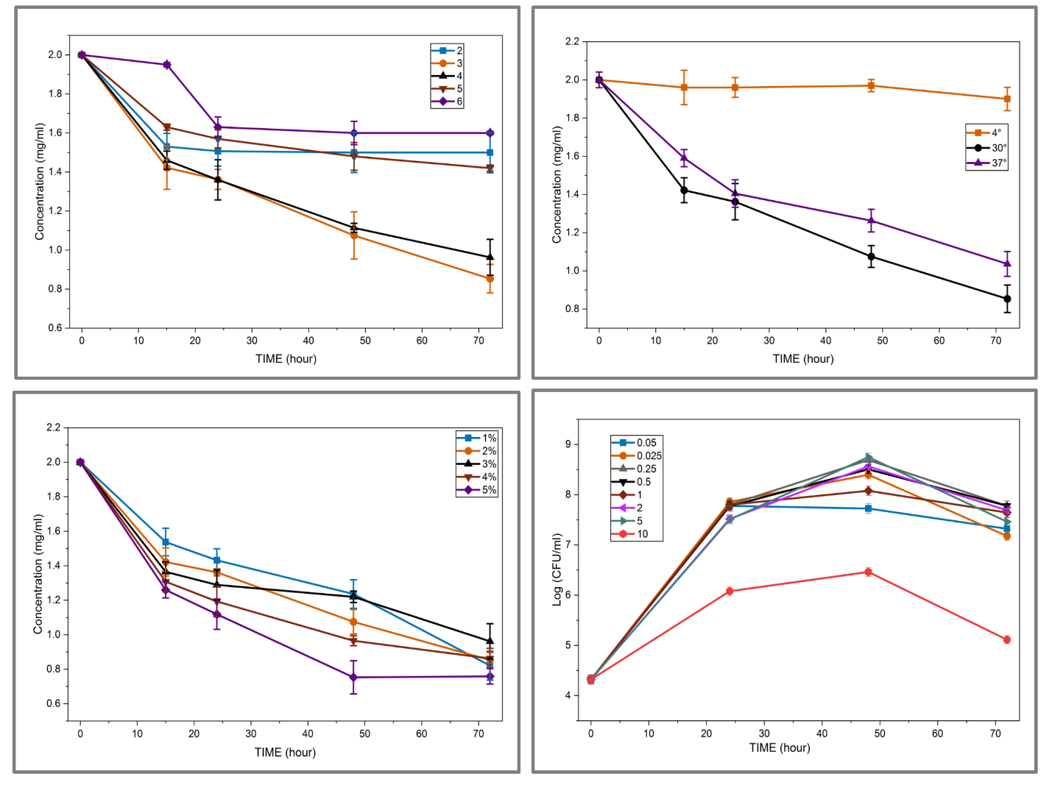
Figure 4. Optimization of ciprofloxacin (CIP) degradation conditions by strain SG01.
(a) Effect of different pH values (2–6) on CIP degradation.
(b) Influence of incubation temperatures (4 °C, 30 °C, 37 °C) on degradation efficiency.
(c) Impact of varying inoculum densities (1–5%) on CIPdegradation.
(d) Bacterial growth (log CFU/ml) over time under different CIP concentrations.
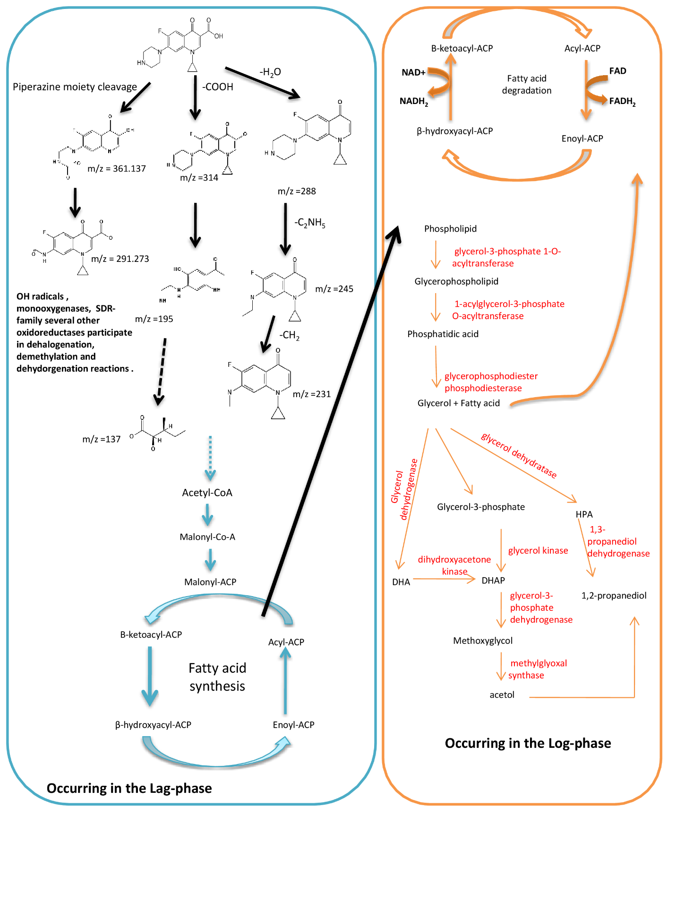
Figure .5. Hypothetical pathway for ciprofloxacin degradation by SG01.
The proposed degradation pathway involves two phases of metabolic activity.
In the lag phase (blue box), ciprofloxacin is initially degraded by hydroxyl radicals, monooxygenases, and short-chain dehydrogenase/reductase (SDR) family oxidoreductases, resulting in dehalogenated, demethylated, and oxidized intermediates.
These intermediates, including acetyl coenzyme A, feed into downstream central metabolic pathways during the log phase (orange box), which involve fatty acid degradation, glycerophospholipid biosynthesis, and carnitine-linked oxidation. Key enzymes include glycerol kinase, methylglyoxal synthase, and 1,3-propanediol dehydrogenase, among others.

