Supplemental material for:

Ciprofloxacin consumption and phenomenal transformation to a culturable nanometer sized bacterium by a Klebsiella strain SG01.
Sriradha Ganguli¹, Ranadhir Chakraborty¹
¹ OMICS Laboratory, Department of Biotechnology, University of North Bengal, Siliguri, West Bengal, India.

Corresponding Author
Corresponding author : Ranadhir Chakraborty (rcnbusiliguri@gmail.com)

Supplementary data. Surface Area (SA) to Volume (V) ratio (SA/V) of SG01 cells grown in MSM-glucose versus SG01 cells grown in MSM-CIP.
Cells grown in media | Mean Height (h) | Mean Radius (r) | SA of cells(μm²) | Volume of the cells (μm³) | SA/V
MSM-glucose | 1.418 μm | 0.707μm | 12.56 | 3.699 | 3.39
MSM-CIP | 0.213 μm | 0.140 μm | 0.4333 | 0.024 | 18.05

For a rod-shaped bacterium, with a radius’ r’ and height ‘h’ {model them as cylinder with two hemispherical caps}:
Volume (V) =$πr^{2 }h+\frac{4}{3}πr^{3}$
Surface area (A) =$2πrh+4πr^{2}$
Therefore,
$$\frac{SA}{V}=\frac{2πrh+4πr^{2}}{πr^{2 }h+\frac{4}{3}πr^{3}}$$
Simplifying the ratio:
$$\frac{SA}{V}= \frac{{(2rh+4r}^{2 })}{r^2 (h+4/3r)}$$
or, $\frac{SA}{V}=\frac{2h}{r\left(h+\frac{4}{3r}\right)}+\frac{4}{h+\frac{4}{3r}}$
or, $\frac{SA}{V}=\frac{2(h+2r)}{r(h+\frac{4}{3r})}$
Alternatively we can express the ratio as:
$\frac{SA}{V}=\frac{2(\frac{h}{r}+2)}{h+\frac{4}{3r}}$
Equation (1)
Putting the values of ‘h’ and ‘r’ obtained from SEM analysis,
For MSM-glucose grown cells, mean h = 1.418 μm and mean r = 0.707 μm
For MSM-CIP grown cells, mean h = 0.213μm and mean r =0.140 μm.
Solving equation (1) for the given values,
For MSM-glucose grown cells, $\frac{SA}{V}=3.39$
For MSM-CIP grown cells, $\frac{SA}{V}=18.05$
Hence, number of times increase in SA/V for MSM-CIP grown cells compared MSM-glucose grown cells = 18.05 ÷ 3.39 = 5.32.

Growth assays in different media.
We conducted growth study of SG01 in glucose without nitrogen source. SG01 could grown in absence of any added nitrogen in the medium by fixing nitrogen. Hence we modified the MSM to the following constituents (g/L): KH₂PO₄, 3.0; NaCl, 5.0; MgSO₄. 7 H₂O, 0.01.

Cell Size Estimation Using ImageJ
To estimate the size of bacterial cells in micrometers (µm) using measurements from oil immersion micrographs analyzed with ImageJ we followed the following steps:

Step 1: Calibration with Stage Micrometer
To convert pixel measurements into micrometer(µm), a stage micrometer was used for image calibration.
The stage micrometer had 10 divisions = 100 µm (i.e., each division is 10 µm).
This scale was imaged under the same magnification i.e., 100X an as the experimental samples.
In the calibration image, the 100 µm span corresponded to 1406 pixels in ImageJ.
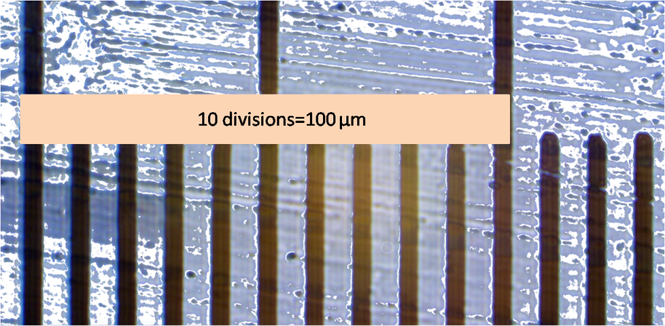
Calibration image

Step 2: Deriving the Pixel-to-Micron Ratio
From the calibration:
- 100 µm=1406 pixels
So,
1 µm = 1406/100 = 14.06 pixels
1 pixel = 1/14.06 = 0.0711 μm
This ratio was used to convert all subsequent pixel-based measurements to micrometers.

Step 3: Cell Size Measurement
Using ImageJ:
Bacterial cells were measured in pixels from oil immersion images.
Each measurement was multiplied by 0.0711 µm/pixel to obtain the actual size in µm.
For example, if a cell measured 22 pixels long:
Cell size=22×0.0711=1.5642 μm
This conversion was applied to all labelled cells.

Table S1. Carbohydrate utilization by SG01 was performed using HiCarbohydrate kits [KB009 TM HiCarbo Kit (KB009A / KB009B1 / KB009C)]
Carbohydrate used in Oxidative/Fermentative Test | Result (Positive/Negative)
LACTOSE | POSITIVE
XYLOSE | POSITIVE
MALTOSE | POSITIVE
FRUCTOSE | POSITIVE
DEXTROSE | POSITIVE
GALACTOSE | POSITIVE
RAFFINOSE | POSITIVE
TREHALOSE | POSITIVE
MELIBIOSE | POSITIVE
SUCROSE | POSITIVE
L-ARABINOSE | POSITIVE
MANNOSE | POSITIVE
INULIN | NEGATIVE
SODIUM GLUCONATE | NEGATIVE
GLYCEROL | POSITIVE
SALICIN | POSITIVE
DULCITOL | NEGATIVE
INOSITOL | POSITIVE
SORBITOL | POSITIVE
MANNITOL | POSITIVE
ADONITOL | POSITIVE
ARABITOL | POSITIVE
ERYTHRITOL | NEGATIVE
ALPHA-MRTHYL-D-GLUCOSIDE | NEGATIVE
RHAMNOSE | POSITIVE
CELLOBIOSE | POSITIVE
MELEZITOSE | NEGATIVE
ALPHA-METHYL-D-MANNNOSIDE | NEGATIVE
XYLITOL | NEGATIVE
ONPG | POSITIVE
ESCULIN | POSITIVE
D-ARABINOSE | POSITIVE
CITRATE | NEGATIVE
MALONATE | POSITIVE
SORBOSE | NEGATIVE

BIOCHEMICAL TEST | RESULT (Positive/Negative)
1.GRAM STAINING | NEGATIVE
2.OXIDASE TEST | NEGATIVE
3.CATALASE TEST | POSITIVE
4.CITRATE TEST | NEGATIVE
5. MR-VP TEST | MR POSITIVE  VP NEGATIVE
6.INDOLE TEST | NEGATIVE
7.UREASE TEST | POSITIVE

Table S2. Biochemical tests of SG01

Table S3. Antibiotic susceptibility test results using disk diffusion methods for SG01.
Antimicrobial category | Antimicrobial agents | Antibiotics abbreviation / Disc concentration(mcg) | Interpretative Criteria for Enterobacteriaceae |  | Average zone diameter in mm
Antimicrobial category | Antimicrobial agents | Antibiotics abbreviation / Disc concentration(mcg) | Sensitive (mm or more) | Resistant (mm or less) | Average zone diameter in mm
Aminoglycoside | Amikacin | AK³⁰ | 18 | 18 | 0
Aminoglycoside | Tobramycin | TOB¹⁰ | 16 | 16 | 10
Aminoglycoside | Gentamycin | GEN¹⁰ | 17 | 17 | 12
Penicillins | Piperacillin-tazobactam | PIT^{100/10} | 20 | 20 | 0
 | Ampicillin | AMP¹⁰ | 14 | 14 | 0
Monobactam | Aztreonam | AT³⁰ | 26 | 21 | 15
Fluoroquinolone | Ciprofloxacin | CIP⁵ | 25 | 22 | 0
 | Ofloxacin | OF⁵ | 24 | 22 | 0
 | Levofloxacin | LE⁵ | 23 | 19 | 0
Carbapenems | Imipenem | IPM¹⁰ | 50 | 19 | 13
 | Doripenem | DOR¹⁰ | 24 | 21 | 12
 | Etrapenem | ETP¹⁰ | 23 | 23 | 15
Tetracycline | Tetracycline | TET³⁰ | NA | NA | 18
 | Tigecycline | TG¹⁵ | 18 | 18 | 19
Polymixin | Colistin | CL¹⁰ | NA | NA | 14
Cephalosporins | Ceftazidime | CAZ³⁰ | 22 | 19 | 14
 | Cefotaxime | CTX³⁰ | 20 | 20 | 11
 | Cefoxitin | CX³⁰ | 19 | 19 | 16

**The MIC (Minimum Inhibitory Concentration) of the isolate SG01 was determined by broth dilution method, it was >10,000μg/ml.
Table S4. Probable identification of the metabolites from LIPIDMAPS, METLIN and HMDB
m/z | Possible Adducts | Most Probable Match | Intensity (Lag Phase) | Intensity (Log Phase) | Product
132.0657043 | M+H; M+2H; M+Na; M+K; M+NH4; M+H-H2O | C5H6O3 [M+NH4]+ | 1159.64 | 686.93 | Acetic acid, oxo-, 2-propenyl ester
173.0802307 | M+H; M+2H; M+Na; M+K; M+NH4; M+H-H2O | C8H12O4 [M+H]+ | 246.53 | 238.94 | Methyl 3-(2-oxooxolan-3-yl)propanoate
185.1162262 | M+H; M+2H; M+Na; M+K; M+NH4; M+H-H2O | C10H18O4 [M+H-H2O]+ | 381.02 | 555.47 | Propan-2-yl 3-(2-methyl-1,3-dioxolan-2-yl)propanoate
290.2690125 | M+H; M+2H; M+Na; M+K; M+NH4; M+H-H2O | C16H32O3 [M+NH4]+ | NA | 2155.94 | (Tetradecyloxy)acetic acid
113.0003281 | M+H; M+2H; M+H-H2O | C3H5KO2 [M+H]+ | 3558.88 | 7438.61 | Potassium propionate (C₃H₅KO₂)
153.1264648 | M+H; M+2H; M+H-H2O | C10H18O2 [M+H-H2O]+ | 516.98 | 359.08 | Propanoyl phosphate
191.10495 | M+2H; M+Na; M+NH4 | C10H16O2Na [M+Na]+ | NA | 219.03 | 2-Hydroxydec-7-yn-5-one
136.0613708 | M+H; M+H-H2O | C4H6O4 [M+NH4]+ | NA | 208.18 | Succinate
177.1123657 | M+H; M+2H | C8H16O4 [M+H]+ | 221.94 | 300.14 | Acetic acid--[(2R,3S)-3-propyloxiran-2-yl]methanol
127.0727692 | M+H | [M+H] | 404.02 | 805.31 | 3-Pentyl hydroperoxide
520.3377075 | M+H-H2O; M+Na; M+2Na-H+ | C29H49NO4Na2 [M+2Na-H]+ | NA | 238.06 | PE(10:0/11:0)[U]; phosphatidylethanolamine
512.3141479 | M+K; M+H-H2O | C29H47NO4K [M+K]+ | NA | 219.04 | Lysophosphatidylethanolamine
481.223114 | M+H; M+2H; M+Na; M+107Ag+ | C25H42O2Ag [M+107Ag]+ | 2138.35 | 7954.93 | Pro Met Pro His
453.2218018 | M+K; M+NH4; M+H-H2O; M+2Na-H+ | C23H36O6Na2 [M+2Na-H]+ | 231.89 | 306.76 | 2H-Indol-2-one, 4-[2-(dipropylamino)ethyl]-1,3-dihydro-7-hydroxy-glucuronide
416.252655 | M+Na; M+2H; M+2Na-H+ | C24H37NO2Na2 [M+2Na-H]+ | NA | 250.5 | PI(14:0/20:4(5Z,8Z,11Z,14Z)); Phosphatidylinosito
401.22995 | M+Na | C22H34O5Na [M+Na]+ | NA | 258.28 | Phe Arg Pro
393.2460327 | M+NH4; M+Li+ | C20H34O7Li [M+Li]+ | NA | 650.86 | Lys Gln Thr
371.23526 | M+H-H2O | C22H36O2K [M+K]+ | 221.12 | 355.92 | 22:4(4Z,7Z,10Z,13E); aPUFA
333.1444092 | M+H; M+2H; M+Na; M+K; M+NH4; M+H-H2O | C17H18FN3O3 | 656.37 | 2206.82 | Modified CIP
194.1178284 | M+NH4; M+H+; M+H-H2O | C11H15NO2 [M+H]+ | 649.47 | 962.22 | (R)-1-(Benzo[d][1,3]dioxol-5-yl)butan-1-amine
231.0553741 | M+H; M+2H; M+Na; M+K; M+NH4; M+H-H2O | C11H7NO4 [M+H]+ | 576.611 | 310.352 | Fragmented CIP (small ring-opened acids)
245.1028137 | M+H; M+2H; M+NH4; M+H-H2O | C13H13NO3 [M+H]+ | 374.143 | 264.227 | Piperazine-cleaved product
288.1516418 | M+H; M+2H; M+NH4; M+H-H2O | C17H19FN3O2 [M+H]+ | 467.025 | 349.5 | Decarboxylated CIP
314.1278687 | M+2H; M+Na; M+K; M+NH4; M+2Na-H+ | C17H17N3O3 [M+H]+ | 938.643 | 612.647 | Defluorinated + oxidized CIP
332.1410828 | M+2H; M+Na; M+K; M+NH4; M+2Na-H+ | C17H18FN3O3 [M+H]+ | 14388.2 | 28877.8 | Ciprofloxacin (parent compound)
348.9025574 | M+2H; M+Na; M+K; M+NH4; M+2Na-H+ | C17H18FN3O4 [M+H]+ | 217.559 | 745.584 | Hydroxy-CIP or Keto-CIP
664.463052 | M+2H; M+Na; M+K; M+NH4; M+2Na-H+ | C17H18FN3O3 + C6H8O6 [M+H]+ | 75506.6 | 94312.3 | Conjugated CIP (e.g., sulfate/glucuronide adduct)
532.3838063 | M+2H; M+Na; M+K; M+NH4; M+2Na-H+ | (C17H18FN3O3)2 [M+H]+ | 27240.6 | 42809.9 | CIP dimer or glutathione-conjugated product
361.137 | M+Na; M+2H | C17H22FN3O4 [M+Na]+ | NA | 261 | Piperazine ring cleavage
291.273 | M+K; M+NH4; M+H-H2O; M+H; M+2H; M+Na | C14H13FN3O4 [M+H]+ | NA | 380.125 | Piperazine modification
195 | M+H; M+2H | C9H13N3O2 [M+H]+ | 218.125 | 577.701 | Quinolone core or ring-cleaved fragment
150 | M+NH4; M+H-H2O; M+H | C5H8O4 [M+H]+ | 761.63 | 662.09 | Fragmented product

Table S5. Putative degradation products of ciprofloxacin identified through LC-MS analysis, along with their corresponding m/z values. Each compound is interpreted based on its structural characteristics and transformation type (e.g., hydroxylation, decarboxylation, dealkylation, defluorination). The proposed identities are supported by literature references reporting similar intermediates formed during chemical, photolytic, or microbial degradation of ciprofloxacin
S.No | m/z | Putative Identity / Fragment | Transformation | Supporting References**
1. | 150.0269 | Small piperazine derivative or amine | Piperazine ring scission | [1],[2]
2. | 195.1228 | Quinolone core fragment | Core cleavage, hydroxylation | [3],[5],[7]
3. | 231.0572 | Oxidized quinolone moiety | Dealkylation + side chain oxidation | [1],[5]
4. | 245.1097 | Desfluoro-CIP derivative | Loss of F + ring opening | [1],[5]
5. | 288.151 | Mono-hydroxylated ciprofloxacin or piperazinyl derivative | Hydroxylation | [5],[6],
6. | 291.2715 | Hydroxylated/oxidized metabolite | Multiple oxidation events | [1]
7. | 314.1309 | CIP derivative with side chain oxidation | Secondary transformation | [1],[6]
8. | 361.1048 | Piperazine ring-cleaved intermediate | Initial major breakdown product | [2],[4],[7]

Table S6. Putative CIP Degradation Products Post m/z 361 (Piperazine Ring Cleaved Intermediate)
S.NO | m/z | Putative Compound / Fragment | Probable Transformation | Supporting References**
1. | 361 | Piperazine ring-cleaved intermediate | Initial ring cleavage | [2],[7]
2. | 306 | Hydroxylated quinolone derivative / decarboxylated product | Oxidation or dealkylation | [2],[7]
3. | 289 | Oxidized piperazine-side product | N-dealkylation / hydroxylation | [3]
4. | 263 | Fragmented and de-fluorinated intermediate | De-fluorination & piperazine side-chain loss | [7]
5. | 262 | Piperazine-free core (CIP without side chain) | Ring scission + decarboxylation | [2],[7]
6. | 247 | Cleaved quinolone ring, defluorinated | Quinoline ring scission | [7]
7. | 195 | Quinolone core fragment | Fluoroquinolone breakdown product | [3] [7]
8. | 161 | Hydroxylated phenyl derivative or aromatic fragment | Oxidation product | [2],[9]
9. | 136 | Small piperazine ring derivative | Advanced side-chain degradation | [2]
10. | 132 | N-methylpiperazine fragment | Piperazine ring scission | [2],[7]
11. | 127 | Ethylenediamine-type or short-chain amine fragment | Final-stage ring-cleaved product | [2],[7]
**List of references
- Feng, B., Zhang, Y., Li, W., Che, G., Liu, C., Jv, A. et al. Efficient photocatalytic removal of ciprofloxacin through in-situ growth of g-C₃N₄ on the surface of clinoptilolite. J. Phys. Chem. Solids 192, 112077 (2024).
- He, F., Ren, H., Li, T., Liu, S. & Zhou, R. Efficient decontamination of ciprofloxacin at neutral pH via visible light assisted Fenton-like process mediated by Fe(III)–GLDA complexation. Chemosphere 289, 133199 (2022).
- Li, L., Liu, J., Zeng, J., Li, J., Liu, Y., Sun, X., Xu, L. & Li, L. Complete degradation and detoxification of ciprofloxacin by a micro-/nanostructured biogenic Mn oxide composite from a highly active Mn²⁺-oxidizing Pseudomonas strain. Nanomaterials 11, 1660 (2021).
- Sheikhmohammadi, A., Asgari, E. & Hashemzadeh, B. Photo-catalytic degradation of ciprofloxacin by UV/ZnO/SO₃ process: performance, kinetic, degradation pathway, energy consumption and total cost of system. Int. J. Environ. Anal. Chem. 103, 5296–5310 (2023).
- Vasconcelos, T.G., Henriques, D.M., König, A., Martins, A.F. & Kümmerer, K. Photo-degradation of the antimicrobial ciprofloxacin at high pH: identification and biodegradability assessment of the primary by-products. Chemosphere 76, 487–493 (2009).
- Zhang, Y., Liu, X., Li, X., Zhang, J., Cao, Y., Su, M. et al. Rapid screening and quantification of multi-class multi-residue veterinary drugs in royal jelly by ultra performance liquid chromatography coupled to quadrupole time-of-flight mass spectrometry. Food Control 60, 667–676 (2016).
- Zhao, X., Li, X., Pei, W., Li, X., Wei, Q. & Liu, W. Characterization, degradation pathway and microbial community of aerobic granular sludge with ciprofloxacin at environmentally relevant concentrations. Biochem. Eng. J. 205, 109255 (2024).

Fig.S1a. Growth study of SG01 in Mineral Salt Media without any carbon source.

Fig. S1b. CIP-consumption capability of Shigella sp AP55.

Fig. S2. Standard Curve of Ciprofloxacin at 315nm. Concentrations of standards used were in the range of 0.002-.02g/L.

Fig.S3. Residual antibacterial activity of the CIP degraded intermediates against sensitive Escherichia coli K12

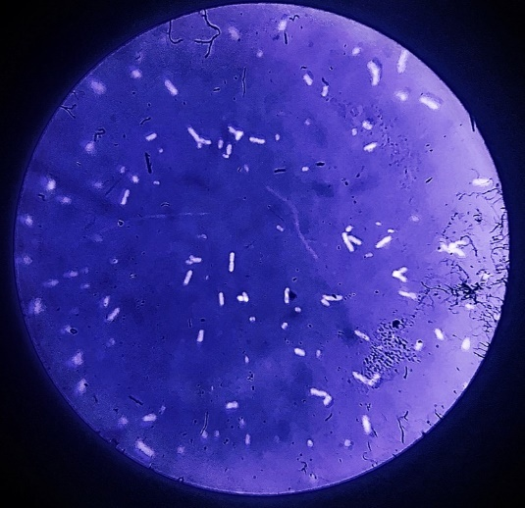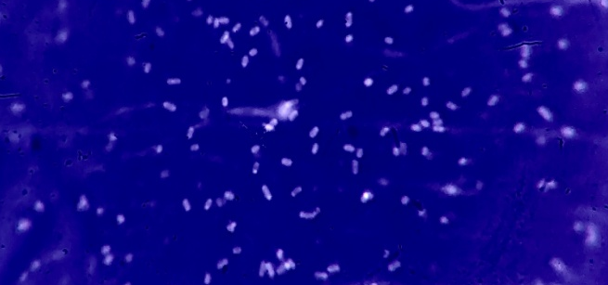
b.
a.
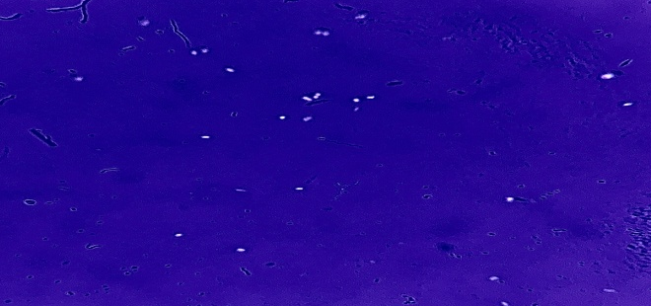
c
Fig S4. Revelation of reduction in cell dimensions from micrometer to nanometer-sized bacterium; a,b,c Negative staining images (light microscopic) of cells grown in LB, MSM-glucose, MSM-CIP;
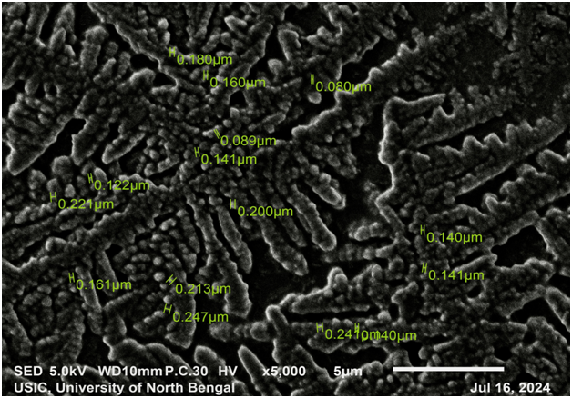
Fig. S5.a
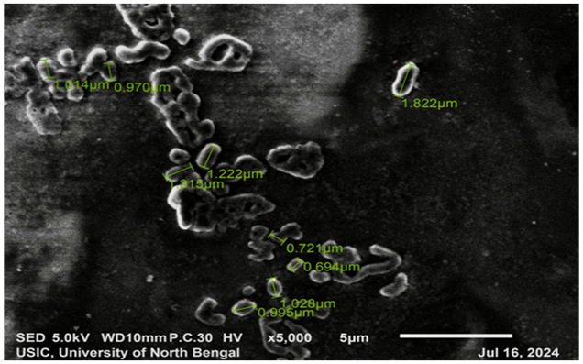
Fig .S5.b
Fig. S5. SEM image of SG01 grown in two different media. a, MSM-CIP. b,MSM-glucose.

Fig.S6. MSM-CIP grown cells were reinoculated into Luria-Bertanni (LB) media. The change in cell size was observed at different intervals. Nanobacteria (0 hour) was stained with Nigrosin while the other figures are Gram-staine
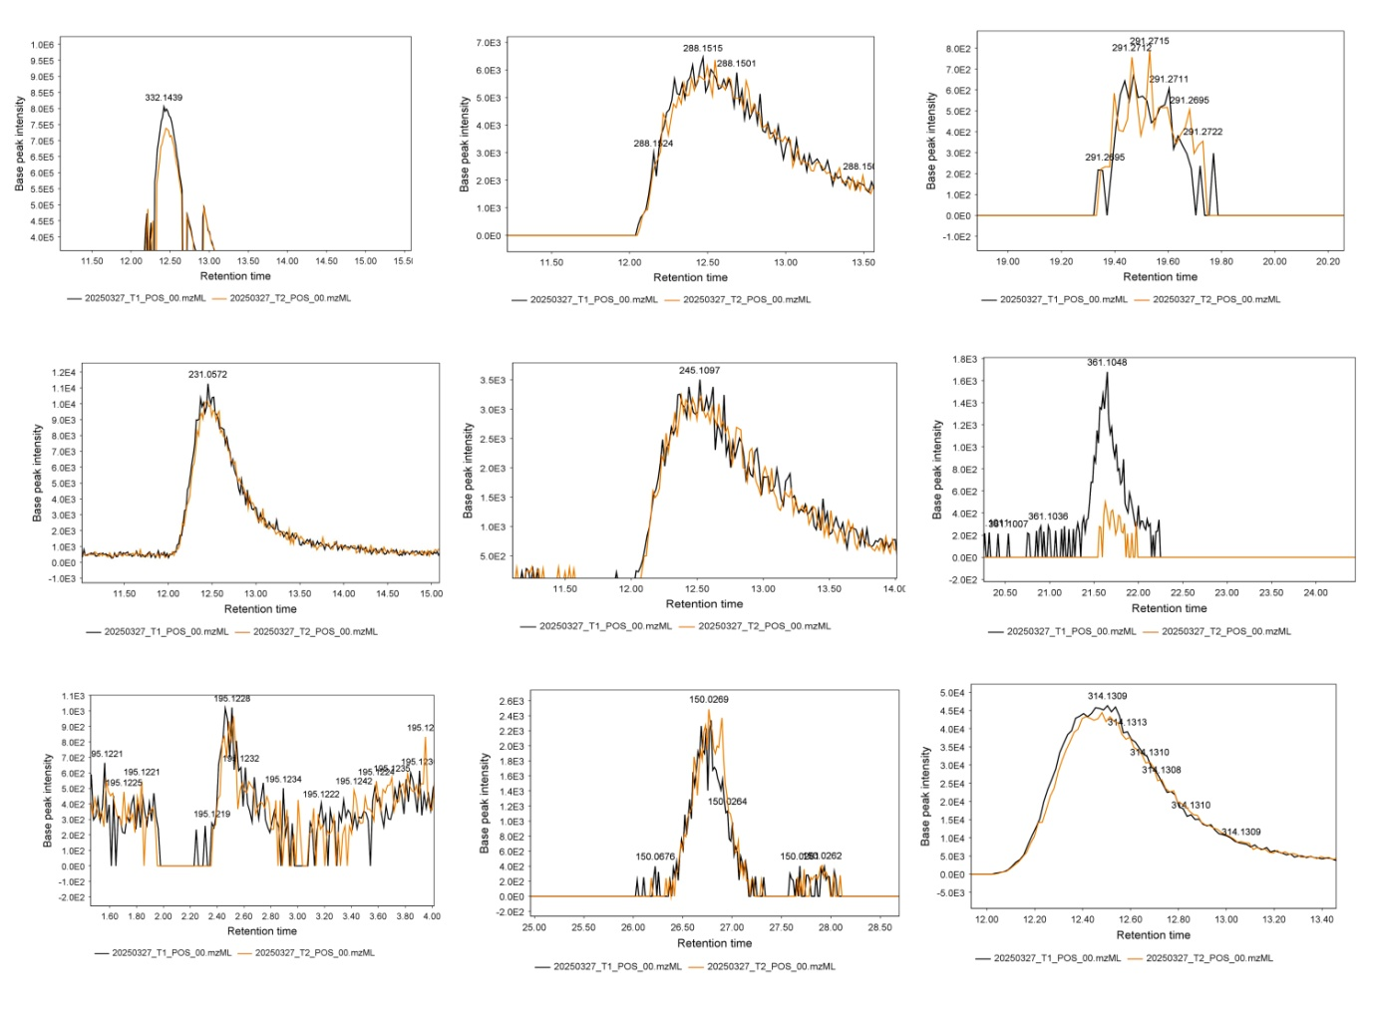

Fig S7a. Extracted Ion Chromatograms (EICs) representing the relative intensities of ciprofloxacin degradation products detected in two experimental conditions: Lag phase (black) and log phase (yellow). Each panel corresponds to a specific m/z value, indicating a putative metabolite derived from the degradation of ciprofloxacin. Retention times (x-axis) and base peak intensities (y-axis) illustrate the presence and abundance of these ions across both conditions.
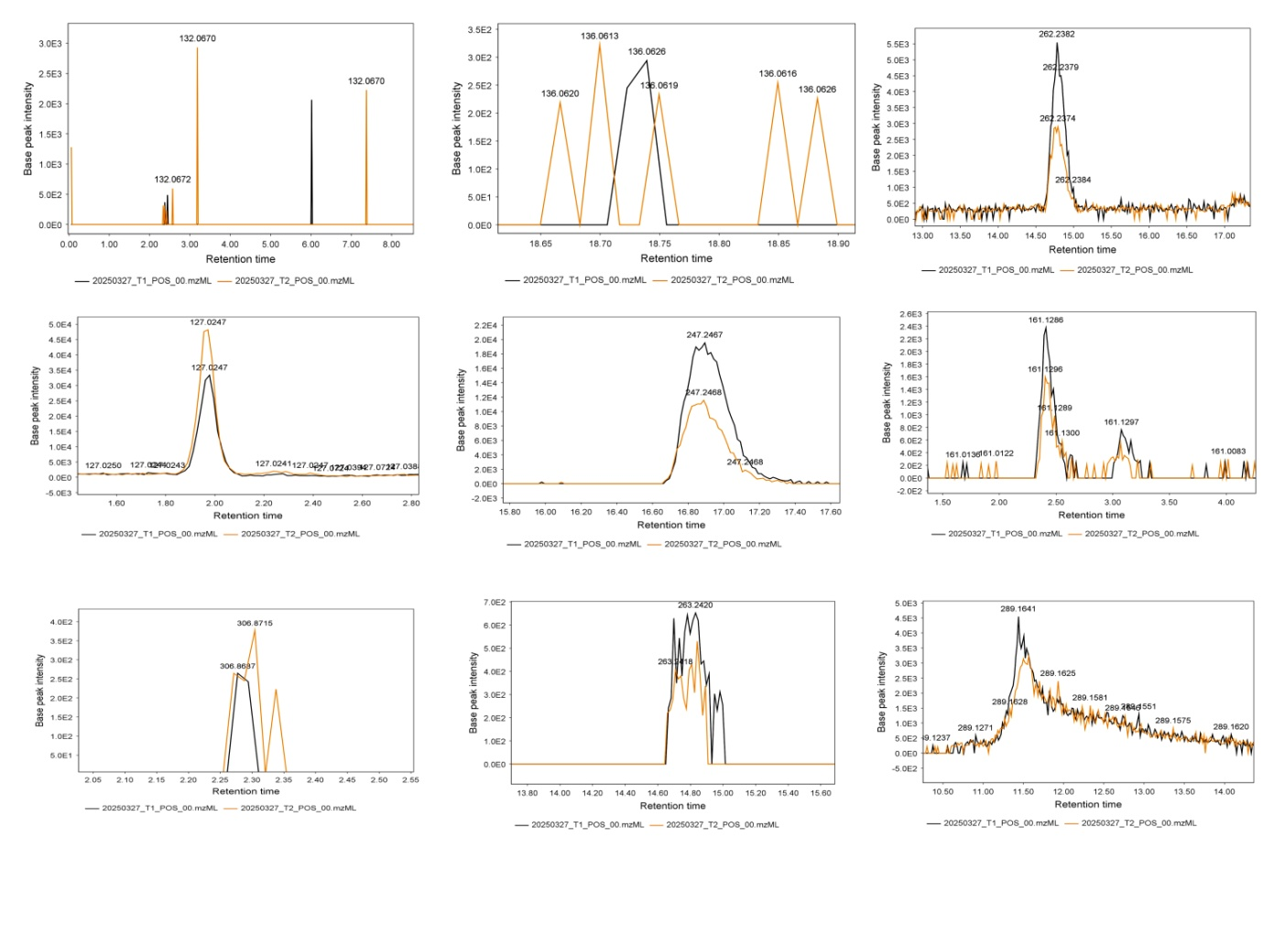
Fig S7b. Extracted Ion Chromatograms (EICs) representing the relative intensities of ciprofloxacin degradation products post piperazine ring cleavage detected in two experimental conditions: Lag phase (black) and log phase (yellow). Each panel corresponds to a specific m/z value, indicating a putative metabolite derived from the degradation of ciprofloxacin. Retention times (x-axis) and base peak intensities (y-axis) illustrate the presence and abundance of these ions across both conditions.
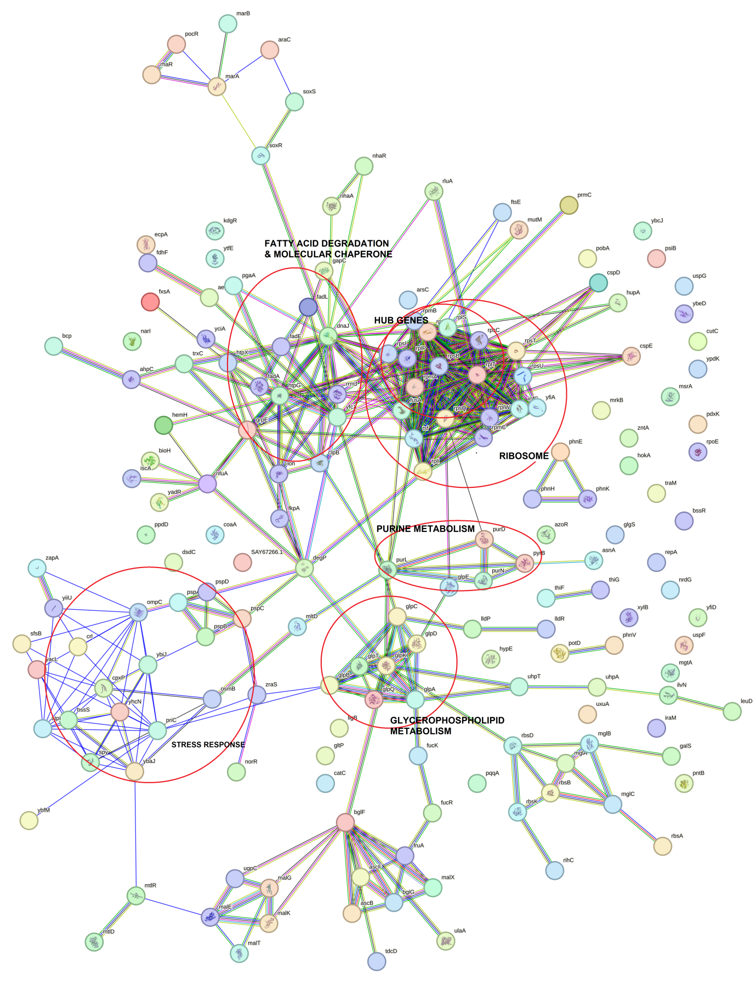

Fig. S8.a
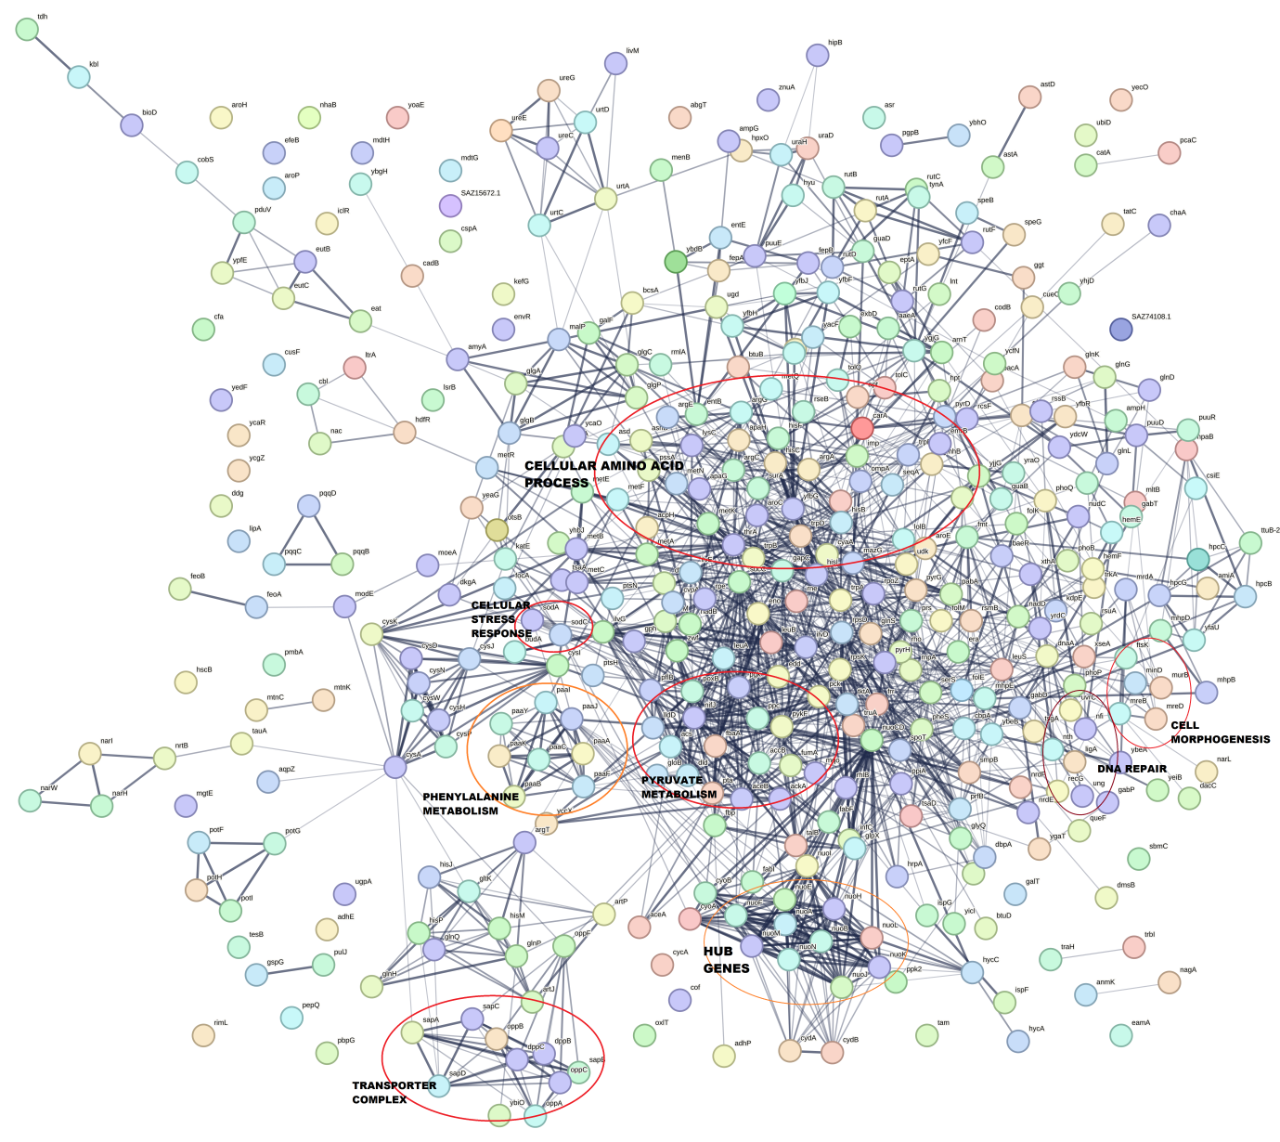
Fig.S8.b.
Fig. S7. PPI network of DEGs, significant metabolic pathways and hub gene clusters highlighted in red circles. a,upregulation. b,downregulation.

