Supplementary Material

Table S1: Site Descriptions, locations and names for stream invertebrate toxicity tests. Only Rock Creek was used for collection of Colobruscoides giganteus for conventional toxicity tests. The other sites were used to collect organisms for rapid toxicity tests which was used (in part) to select C. giganteus.
Collection Site name | Site Description | Latitude and Longitude
Rock Creek | Close to source (<1km); Minimal urban disturbance. No road de-icing salts received | -36.411444, 148.410705
Piper Creek 1 | Close to source (<1km); Minimal urban disturbance. No road de-icing salts received | -36.397574, 148.427295
Piper Creek 2 | Close to source (<1km): Downstream of a road which receives de-icing salts: Downstream of a ski resort | -36.392533, 148.435685
Perisher Creek 1 | Downstream of a ski resort | -36.408833, 148.398011
Perisher Creek 2 | Downstream of a ski resort | -36.402488, 148.411773
Perisher Creek 3 | ~1km downstream of Per2; Downstream of a road which receives de-icing salts | -36.397667, 148.410721

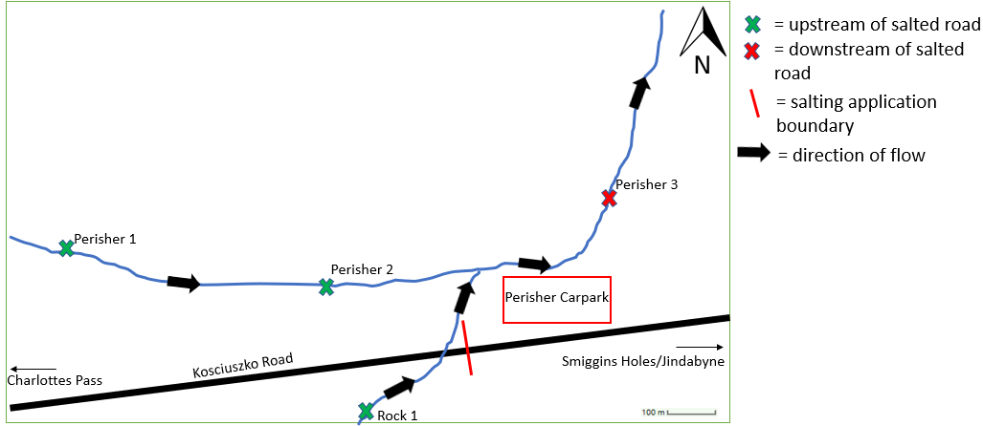
Figure S2: Sketch map of the collection sites (indicated by green and red crosses) near Smiggins Holes carpark area; scale indicates the distance from salted carparks and roads to the creeks of interest.
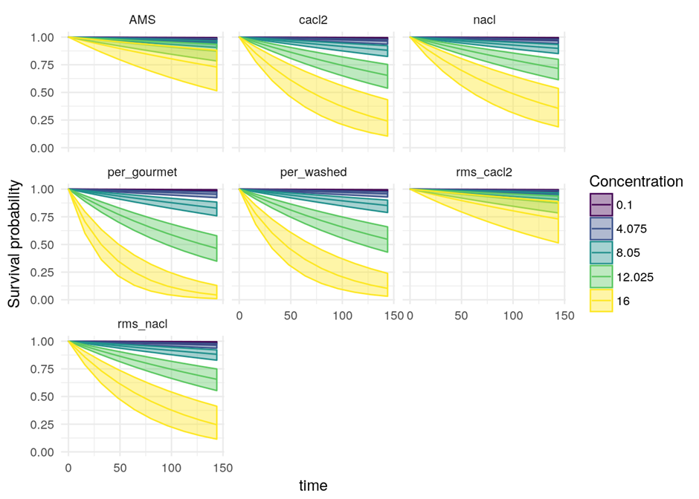
Figure S3: Basic conditional binomial survival model applying survival probability (LC_{x}), concentration (mS/cm) and time (hours) to seven salts tested. Inner line is median estimate and Outer lines indicate 95% credibility intervals.
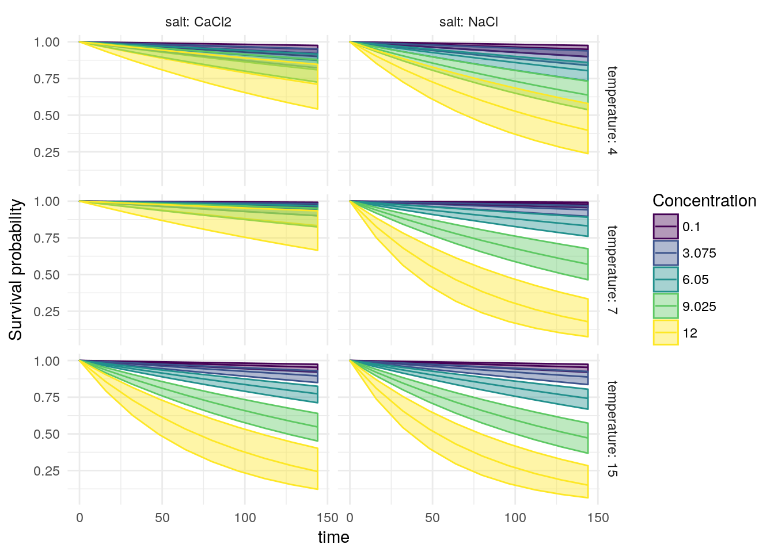
Figure S4: Basic conditional binomial survival model applying survival probability (LC_{x}) values to salt types (CaCl₂ and NaCl) and temperature range (4°C, 7°C, 15°C), outer bars represent 95% credibility intervals. Indicating that NaCl is more toxic than CaCl₂ at 7ºC
Table S2: Classical LCx values for the seven salt experiment (i.e. Experiment 1) including time, mean, median, upper and lower confidence intervals.
LCx | salt | time | mean | median | UpperCI | Lower CI
LC10 | AMS | 24 | 20.06 | 19.4 | 15.9 | 27.85
LC10 | CaCl2 | 24 | 13.43 | 13.38 | 12.24 | 14.95
LC10 | NaCl | 24 | 14.43 | 14.34 | 12.98 | 16.38
LC10 | EGSS | 24 | 11.54 | 11.53 | 10.63 | 12.51
LC10 | EWSS | 24 | 12.24 | 12.21 | 11.18 | 13.42
LC10 | RMS_CaCl2 | 24 | 20.15 | 19.51 | 16.07 | 27.97
LC10 | RMS_NaCl | 24 | 13.45 | 13.41 | 12.32 | 14.84
LC25 | AMS | 24 | 25.01 | 24.15 | 19.59 | 35.26
LC25 | CaCl2 | 24 | 16.73 | 16.63 | 15.3 | 18.7
LC25 | NaCl | 24 | 17.97 | 17.84 | 16.13 | 20.56
LC25 | EGSS | 24 | 14.37 | 14.33 | 13.43 | 15.5
LC25 | EGSS | 24 | 15.24 | 15.18 | 14.07 | 16.71
LC25 | RMS_CaCl2 | 24 | 25.12 | 24.25 | 19.77 | 35.22
LC25 | RMS_NaCl | 24 | 16.75 | 16.69 | 15.34 | 18.56
LC50 | AMS | 24 | 29.37 | 28.34 | 22.79 | 41.93
LC50 | CaCl2 | 24 | 19.63 | 19.52 | 17.84 | 22.11
LC50 | NaCl | 24 | 21.1 | 20.92 | 18.81 | 24.41
LC50 | EGSS | 24 | 16.86 | 16.81 | 15.76 | 18.27
LC50 | EGSS | 24 | 17.89 | 17.8 | 16.51 | 19.71
LC50 | RMS_CaCl2 | 24 | 29.51 | 28.43 | 22.94 | 41.82
LC50 | RMS_NaCl | 24 | 19.67 | 19.57 | 17.91 | 22
LC10 | AMS | 48 | 16.7 | 16.18 | 13.33 | 23.05
LC10 | CaCl2 | 48 | 11.19 | 11.17 | 10.02 | 12.48
LC10 | NaCl | 48 | 12.02 | 11.96 | 10.72 | 13.64
LC10 | EGSS | 48 | 9.61 | 9.61 | 8.66 | 10.57
LC10 | EWSS | 48 | 10.2 | 10.19 | 9.15 | 11.32
LC10 | RMS_CaCl2 | 48 | 16.77 | 16.26 | 13.43 | 23.04
LC10 | RMS_NaCl | 48 | 11.2 | 11.18 | 10.09 | 12.44
LC25 | AMS | 48 | 21.59 | 20.86 | 17.07 | 30.04
LC25 | CaCl2 | 48 | 14.45 | 14.39 | 13.19 | 16.09
LC25 | NaCl | 48 | 15.52 | 15.42 | 13.97 | 17.65
LC25 | EGSS | 48 | 12.41 | 12.39 | 11.51 | 13.41
LC25 | EGSS | 48 | 13.16 | 13.13 | 12.09 | 14.43
LC25 | RMS_CaCl2 | 48 | 21.68 | 20.97 | 17.23 | 30.23
LC25 | RMS_NaCl | 48 | 14.47 | 14.42 | 13.28 | 15.97
LC50 | AMS | 48 | 25.93 | 25.03 | 20.29 | 36.7
LC50 | CaCl2 | 48 | 17.34 | 17.24 | 15.84 | 19.43
LC50 | NaCl | 48 | 18.63 | 18.5 | 16.72 | 21.36
LC50 | EGSS | 48 | 14.89 | 14.85 | 13.93 | 16.08
LC50 | EGSS | 48 | 15.8 | 15.74 | 14.59 | 17.34
LC50 | RMS_CaCl2 | 48 | 26.05 | 25.13 | 20.44 | 36.59
LC50 | RMS_NaCl | 48 | 17.37 | 17.3 | 15.89 | 19.28
LC10 | AMS | 72 | 14.77 | 14.33 | 11.75 | 20.25
LC10 | CaCl2 | 72 | 9.9 | 9.88 | 8.72 | 11.13
LC10 | NaCl | 72 | 10.63 | 10.6 | 9.37 | 12.09
LC10 | EGSS | 72 | 8.51 | 8.51 | 7.5 | 9.51
LC10 | EWSS | 72 | 9.02 | 9.01 | 7.95 | 10.15
LC10 | RMS_CaCl2 | 72 | 14.83 | 14.41 | 11.88 | 20.25
LC10 | RMS_NaCl | 72 | 9.92 | 9.91 | 8.79 | 11.1
LC25 | AMS | 72 | 19.6 | 18.97 | 15.54 | 27.21
LC25 | CaCl2 | 72 | 13.12 | 13.08 | 11.93 | 14.61
LC25 | NaCl | 72 | 14.1 | 14.01 | 12.68 | 16
LC25 | EGSS | 72 | 11.27 | 11.27 | 10.36 | 12.25
LC25 | EWSS | 72 | 11.96 | 11.94 | 10.9 | 13.12
LC25 | RMS_CaCl2 | 72 | 19.69 | 19.07 | 15.71 | 27.32
LC25 | RMS_NaCl | 72 | 13.14 | 13.11 | 12.02 | 14.5
LC50 | AMS | 72 | 23.92 | 23.09 | 18.81 | 33.61
LC50 | CaCl2 | 72 | 16 | 15.92 | 14.64 | 17.85
LC50 | NaCl | 72 | 17.19 | 17.07 | 15.45 | 19.63
LC50 | EGSS | 72 | 13.75 | 13.71 | 12.83 | 14.82
LC50 | EWSS | 72 | 14.58 | 14.53 | 13.45 | 15.99
LC50 | RMS_CaCl2 | 72 | 24.03 | 23.22 | 19.01 | 33.61
LC50 | RMS_NaCl | 72 | 16.03 | 15.97 | 14.7 | 17.73
LC10 | AMS | 96 | 13.42 | 13.07 | 10.67 | 18.29
LC10 | CaCl2 | 96 | 9 | 8.99 | 7.81 | 10.23
LC10 | NaCl | 96 | 9.67 | 9.64 | 8.42 | 11.07
LC10 | EGSS | 96 | 7.74 | 7.74 | 6.7 | 8.78
LC10 | EWSS | 96 | 8.21 | 8.2 | 7.11 | 9.35
LC10 | RMS_CaCl2 | 96 | 13.48 | 13.11 | 10.75 | 18.33
LC10 | RMS_NaCl | 96 | 9.02 | 9.01 | 7.87 | 10.19
LC25 | AMS | 96 | 18.2 | 17.62 | 14.46 | 25.18
LC25 | CaCl2 | 96 | 12.19 | 12.15 | 11.02 | 13.56
LC25 | NaCl | 96 | 13.09 | 13.02 | 11.75 | 14.85
LC25 | EGSS | 96 | 10.47 | 10.46 | 9.56 | 11.44
LC25 | EWSS | 96 | 11.11 | 11.09 | 10.07 | 12.24
LC25 | RMS_CaCl2 | 96 | 18.28 | 17.73 | 14.63 | 25.26
LC25 | RMS_NaCl | 96 | 12.21 | 12.18 | 11.08 | 13.49
LC50 | AMS | 96 | 22.5 | 21.73 | 17.76 | 31.5
LC50 | CaCl2 | 96 | 15.06 | 14.99 | 13.77 | 16.77
LC50 | NaCl | 96 | 16.18 | 16.07 | 14.55 | 18.42
LC50 | EGSS | 96 | 12.93 | 12.91 | 12.02 | 13.96
LC50 | EWSS | 96 | 13.72 | 13.68 | 12.62 | 15.03
LC50 | RMS_CaCl2 | 96 | 22.61 | 21.85 | 17.91 | 31.63
LC50 | RMS_NaCl | 96 | 15.08 | 15.02 | 13.85 | 16.66
LC10 | AMS | 120 | 12.4 | 12.1 | 9.81 | 16.85
LC10 | CaCl2 | 120 | 8.32 | 8.31 | 7.1 | 9.54
LC10 | NaCl | 120 | 8.93 | 8.91 | 7.69 | 10.31
LC10 | EGSS | 120 | 7.15 | 7.15 | 6.08 | 8.21
LC10 | EWSS | 120 | 7.59 | 7.58 | 6.47 | 8.74
LC10 | RMS_CaCl2 | 120 | 12.45 | 12.12 | 9.85 | 16.91
LC10 | RMS_NaCl | 120 | 8.33 | 8.33 | 7.18 | 9.52
LC25 | AMS | 120 | 17.12 | 16.59 | 13.66 | 23.7
LC25 | CaCl2 | 120 | 11.47 | 11.44 | 10.3 | 12.78
LC25 | NaCl | 120 | 12.32 | 12.26 | 11.01 | 13.98
LC25 | EGSS | 120 | 9.85 | 9.85 | 8.92 | 10.81
LC25 | EWSS | 120 | 10.45 | 10.44 | 9.41 | 11.58
LC25 | RMS_CaCl2 | 120 | 17.2 | 16.67 | 13.77 | 23.66
LC25 | RMS_NaCl | 120 | 11.49 | 11.46 | 10.37 | 12.73
LC50 | AMS | 120 | 21.4 | 20.69 | 16.94 | 29.76
LC50 | CaCl2 | 120 | 14.32 | 14.27 | 13.08 | 15.95
LC50 | NaCl | 120 | 15.39 | 15.3 | 13.85 | 17.5
LC50 | EGSS | 120 | 12.31 | 12.28 | 11.41 | 13.3
LC50 | EWSS | 120 | 13.05 | 13.02 | 11.99 | 14.3
LC50 | RMS_CaCl2 | 120 | 21.5 | 20.8 | 17.1 | 29.93
LC50 | RMS_NaCl | 120 | 14.35 | 14.3 | 13.17 | 15.83

Table S3: Classical LCx values NaCl and CaCl₂ at different temperatures (4°C, 7°C and 15°C) (i.e. Experiment 2) including time, mean, median, upper and lower confidence intervals.
LCx | salt | temperature | time | mean | median | UpperCI | LowerCI
LC10 | CaCl2 | 4 | 24 | 18.68 | 16.56 | 12.36 | 35.05
LC10 | NaCl | 4 | 24 | 10.95 | 10.77 | 9.42 | 13.59
LC10 | CaCl2 | 7 | 24 | 21.05 | 18.65 | 13.64 | 38.04
LC10 | NaCl | 7 | 24 | 9.44 | 9.42 | 8.61 | 10.39
LC10 | CaCl2 | 15 | 24 | 9.5 | 9.44 | 8.5 | 10.84
LC10 | NaCl | 15 | 24 | 8.73 | 8.7 | 7.87 | 9.79
LC25 | CaCl2 | 4 | 24 | 25.84 | 22.66 | 16.46 | 49.75
LC25 | NaCl | 4 | 24 | 15.05 | 14.72 | 12.66 | 19.3
LC25 | CaCl2 | 7 | 24 | 27.07 | 23.81 | 17.26 | 50.86
LC25 | NaCl | 7 | 24 | 12.09 | 12.03 | 11.08 | 13.41
LC25 | CaCl2 | 15 | 24 | 12.92 | 12.78 | 11.46 | 15.11
LC25 | NaCl | 15 | 24 | 11.86 | 11.78 | 10.73 | 13.41
LC50 | CaCl2 | 4 | 24 | 32.35 | 28.24 | 20.06 | 63.74
LC50 | NaCl | 4 | 24 | 18.76 | 18.3 | 15.48 | 24.76
LC50 | CaCl2 | 7 | 24 | 32.41 | 28.5 | 20.31 | 61.05
LC50 | NaCl | 7 | 24 | 14.43 | 14.35 | 13.12 | 16.24
LC50 | CaCl2 | 15 | 24 | 16 | 15.81 | 13.97 | 19.05
LC50 | NaCl | 15 | 24 | 14.68 | 14.58 | 13.2 | 16.8
LC10 | CaCl2 | 4 | 48 | 14.08 | 12.62 | 9.52 | 25.82
LC10 | NaCl | 4 | 48 | 8.3 | 8.2 | 7.15 | 9.99
LC10 | CaCl2 | 7 | 48 | 17.01 | 15.19 | 11.21 | 30.21
LC10 | NaCl | 7 | 48 | 7.67 | 7.66 | 6.79 | 8.57
LC10 | CaCl2 | 15 | 48 | 7.28 | 7.25 | 6.45 | 8.26
LC10 | NaCl | 15 | 48 | 6.69 | 6.67 | 5.89 | 7.57
LC25 | CaCl2 | 4 | 48 | 20.86 | 18.41 | 13.67 | 39.26
LC25 | NaCl | 4 | 48 | 12.19 | 11.96 | 10.42 | 15.34
LC25 | CaCl2 | 7 | 48 | 22.9 | 20.24 | 14.76 | 41.85
LC25 | NaCl | 7 | 48 | 10.26 | 10.22 | 9.4 | 11.27
LC25 | CaCl2 | 15 | 48 | 10.54 | 10.45 | 9.45 | 12.1
LC25 | NaCl | 15 | 48 | 9.68 | 9.64 | 8.76 | 10.88
LC50 | CaCl2 | 4 | 48 | 27.21 | 23.83 | 17.21 | 52.58
LC50 | NaCl | 4 | 48 | 15.83 | 15.48 | 13.24 | 20.41
LC50 | CaCl2 | 7 | 48 | 28.19 | 24.81 | 17.89 | 53.11
LC50 | NaCl | 7 | 48 | 12.58 | 12.52 | 11.52 | 13.99
LC50 | CaCl2 | 15 | 48 | 13.56 | 13.42 | 12 | 15.93
LC50 | NaCl | 15 | 48 | 12.46 | 12.37 | 11.26 | 14.14
LC10 | CaCl2 | 4 | 72 | 11.61 | 10.44 | 7.94 | 21.03
LC10 | NaCl | 4 | 72 | 6.87 | 6.82 | 5.85 | 8.2
LC10 | CaCl2 | 7 | 72 | 14.73 | 13.2 | 9.75 | 26.26
LC10 | NaCl | 7 | 72 | 6.66 | 6.65 | 5.74 | 7.6
LC10 | CaCl2 | 15 | 72 | 6.06 | 6.05 | 5.29 | 6.9
LC10 | NaCl | 15 | 72 | 5.57 | 5.57 | 4.81 | 6.38
LC25 | CaCl2 | 4 | 72 | 18.04 | 16.01 | 11.98 | 33.82
LC25 | NaCl | 4 | 72 | 10.58 | 10.41 | 9.12 | 13.07
LC25 | CaCl2 | 7 | 72 | 20.49 | 18.17 | 13.32 | 36.86
LC25 | NaCl | 7 | 72 | 9.2 | 9.18 | 8.36 | 10.13
LC25 | CaCl2 | 15 | 72 | 9.19 | 9.13 | 8.23 | 10.48
LC25 | NaCl | 15 | 72 | 8.44 | 8.42 | 7.59 | 9.47
LC50 | CaCl2 | 4 | 72 | 24.25 | 21.31 | 15.59 | 46.34
LC50 | NaCl | 4 | 72 | 14.14 | 13.84 | 11.96 | 18.08
LC50 | CaCl2 | 7 | 72 | 25.74 | 22.68 | 16.45 | 47.99
LC50 | NaCl | 7 | 72 | 11.51 | 11.46 | 10.56 | 12.73
LC50 | CaCl2 | 15 | 72 | 12.16 | 12.04 | 10.82 | 14.14
LC50 | NaCl | 15 | 72 | 11.17 | 11.1 | 10.12 | 12.6
LC10 | CaCl2 | 4 | 96 | 9.98 | 9.03 | 6.86 | 17.62
LC10 | NaCl | 4 | 96 | 5.92 | 5.88 | 4.97 | 7.06
LC10 | CaCl2 | 7 | 96 | 13.17 | 11.85 | 8.71 | 23.43
LC10 | NaCl | 7 | 96 | 5.96 | 5.95 | 5.03 | 6.94
LC10 | CaCl2 | 15 | 96 | 5.25 | 5.25 | 4.51 | 6.03
LC10 | NaCl | 15 | 96 | 4.83 | 4.82 | 4.09 | 5.6
LC25 | CaCl2 | 4 | 96 | 16.1 | 14.35 | 10.78 | 29.75
LC25 | NaCl | 4 | 96 | 9.46 | 9.33 | 8.19 | 11.55
LC25 | CaCl2 | 7 | 96 | 18.81 | 16.73 | 12.27 | 33.33
LC25 | NaCl | 7 | 96 | 8.46 | 8.45 | 7.6 | 9.37
LC25 | CaCl2 | 15 | 96 | 8.26 | 8.22 | 7.36 | 9.38
LC25 | NaCl | 15 | 96 | 7.59 | 7.56 | 6.77 | 8.52
LC50 | CaCl2 | 4 | 96 | 22.18 | 19.53 | 14.43 | 41.99
LC50 | NaCl | 4 | 96 | 12.95 | 12.69 | 11.04 | 16.44
LC50 | CaCl2 | 7 | 96 | 24.01 | 21.2 | 15.41 | 44.24
LC50 | NaCl | 7 | 96 | 10.75 | 10.71 | 9.86 | 11.82
LC50 | CaCl2 | 15 | 96 | 11.17 | 11.07 | 9.99 | 12.88
LC50 | NaCl | 15 | 96 | 10.26 | 10.21 | 9.3 | 11.55
LC10 | CaCl2 | 4 | 120 | 8.8 | 8.01 | 6.06 | 15.3
LC10 | NaCl | 4 | 120 | 5.23 | 5.2 | 4.32 | 6.3
LC10 | CaCl2 | 7 | 120 | 11.99 | 10.83 | 7.91 | 21.24
LC10 | NaCl | 7 | 120 | 5.44 | 5.42 | 4.49 | 6.45
LC10 | CaCl2 | 15 | 120 | 4.66 | 4.66 | 3.94 | 5.42
LC10 | NaCl | 15 | 120 | 4.29 | 4.28 | 3.57 | 5.05
LC25 | CaCl2 | 4 | 120 | 14.65 | 13.07 | 9.87 | 26.94
LC25 | NaCl | 4 | 120 | 8.63 | 8.52 | 7.45 | 10.42
LC25 | CaCl2 | 7 | 120 | 17.52 | 15.62 | 11.49 | 31.09
LC25 | NaCl | 7 | 120 | 7.89 | 7.88 | 7.02 | 8.79
LC25 | CaCl2 | 15 | 120 | 7.55 | 7.52 | 6.71 | 8.57
LC25 | NaCl | 15 | 120 | 6.94 | 6.92 | 6.14 | 7.84
LC50 | CaCl2 | 4 | 120 | 20.59 | 18.19 | 13.5 | 38.7
LC50 | NaCl | 4 | 120 | 12.04 | 11.82 | 10.3 | 15.12
LC50 | CaCl2 | 7 | 120 | 22.68 | 20.05 | 14.62 | 41.37
LC50 | NaCl | 7 | 120 | 10.16 | 10.13 | 9.3 | 11.16
LC50 | CaCl2 | 15 | 120 | 10.42 | 10.33 | 9.34 | 11.96
LC50 | NaCl | 15 | 120 | 9.57 | 9.52 | 8.66 | 10.75

S4: TKDT model of LCx values for the seven salt experiment (i.e. Experiment 1)
LCx | Time | Mean | Median | Lower CI | Upper CI | Salt Type
10 | 24 | 43.71 | 45.44 | 16.17 | 61.28 | AMS
25 | 24 | 46.83 | 48.62 | 19.92 | 64.26 | AMS
50 | 24 | 50.63 | 52.31 | 23.64 | 68.72 | AMS
10 | 48 | 22.19 | 23.04 | 8.02 | 30.26 | AMS
25 | 48 | 23.25 | 24.10 | 9.68 | 31.32 | AMS
50 | 48 | 24.51 | 25.30 | 11.29 | 32.52 | AMS
10 | 72 | 15.32 | 16.08 | 5.41 | 20.29 | AMS
25 | 72 | 15.93 | 16.62 | 6.46 | 20.82 | AMS
50 | 72 | 16.59 | 17.21 | 7.45 | 21.44 | AMS
10 | 96 | 12.00 | 12.67 | 4.23 | 15.59 | AMS
25 | 96 | 12.35 | 12.99 | 4.77 | 15.84 | AMS
50 | 96 | 12.79 | 13.43 | 5.53 | 16.17 | AMS
10 | 120 | 10.04 | 10.49 | 3.51 | 13.74 | AMS
25 | 120 | 10.29 | 10.75 | 3.90 | 13.82 | AMS
50 | 120 | 10.60 | 11.06 | 4.39 | 14.00 | AMS
10 | 144 | 8.76 | 9.02 | 2.96 | 13.16 | AMS
25 | 144 | 8.95 | 9.20 | 3.29 | 13.18 | AMS
50 | 144 | 9.19 | 9.44 | 3.66 | 13.27 | AMS
10 | 24 | 39.55 | 40.03 | 30.70 | 45.75 | NaCl
25 | 24 | 41.07 | 41.51 | 32.37 | 47.19 | NaCl
50 | 24 | 42.86 | 43.29 | 34.28 | 48.97 | NaCl
10 | 48 | 19.72 | 19.93 | 15.54 | 22.64 | NaCl
25 | 48 | 20.23 | 20.45 | 16.07 | 23.13 | NaCl
50 | 48 | 20.83 | 21.05 | 16.70 | 23.75 | NaCl
10 | 72 | 13.23 | 13.36 | 10.51 | 15.09 | NaCl
25 | 72 | 13.51 | 13.65 | 10.84 | 15.36 | NaCl
50 | 72 | 13.83 | 13.97 | 11.19 | 15.67 | NaCl
10 | 96 | 10.02 | 10.12 | 8.02 | 11.36 | NaCl
25 | 96 | 10.20 | 10.30 | 8.20 | 11.53 | NaCl
50 | 96 | 10.42 | 10.51 | 8.48 | 11.73 | NaCl
10 | 120 | 8.11 | 8.20 | 6.50 | 9.15 | NaCl
25 | 120 | 8.24 | 8.32 | 6.63 | 9.27 | NaCl
50 | 120 | 8.39 | 8.48 | 6.81 | 9.41 | NaCl
10 | 144 | 6.85 | 6.92 | 5.50 | 7.70 | NaCl
25 | 144 | 6.94 | 7.02 | 5.59 | 7.79 | NaCl
50 | 144 | 7.06 | 7.13 | 5.73 | 7.90 | NaCl
10 | 24 | 34.77 | 34.55 | 27.74 | 42.62 | CaCl2
25 | 24 | 35.38 | 35.10 | 28.24 | 43.58 | CaCl2
50 | 24 | 36.09 | 35.77 | 28.73 | 44.67 | CaCl2
10 | 48 | 19.16 | 19.23 | 16.32 | 21.72 | CaCl2
25 | 48 | 19.39 | 19.45 | 16.54 | 22.04 | CaCl2
50 | 48 | 19.64 | 19.68 | 16.78 | 22.37 | CaCl2
10 | 72 | 14.11 | 14.24 | 12.18 | 15.35 | CaCl2
25 | 72 | 14.23 | 14.35 | 12.32 | 15.46 | CaCl2
50 | 72 | 14.38 | 14.50 | 12.54 | 15.58 | CaCl2
10 | 96 | 11.67 | 11.83 | 9.70 | 12.91 | CaCl2
25 | 96 | 11.75 | 11.90 | 9.83 | 12.96 | CaCl2
50 | 96 | 11.85 | 11.99 | 9.99 | 13.03 | CaCl2
10 | 120 | 10.25 | 10.45 | 8.09 | 11.74 | CaCl2
25 | 120 | 10.32 | 10.52 | 8.17 | 11.77 | CaCl2
50 | 120 | 10.39 | 10.59 | 8.29 | 11.82 | CaCl2
10 | 144 | 9.37 | 9.61 | 6.94 | 11.10 | CaCl2
25 | 144 | 9.41 | 9.64 | 6.99 | 11.13 | CaCl2
50 | 144 | 9.47 | 9.70 | 7.08 | 11.16 | CaCl2
10 | 24 | 43.02 | 43.37 | 36.68 | 47.15 | rms_NaCl
25 | 24 | 44.03 | 44.40 | 37.77 | 48.17 | rms_NaCl
50 | 24 | 45.21 | 45.59 | 38.93 | 49.34 | rms_NaCl
10 | 48 | 21.52 | 21.68 | 18.53 | 23.46 | rms_NaCl
25 | 48 | 21.87 | 22.05 | 18.95 | 23.80 | rms_NaCl
50 | 48 | 22.29 | 22.45 | 19.40 | 24.21 | rms_NaCl
10 | 72 | 14.45 | 14.55 | 12.59 | 15.65 | rms_NaCl
25 | 72 | 14.64 | 14.73 | 12.83 | 15.84 | rms_NaCl
50 | 72 | 14.86 | 14.96 | 13.06 | 16.04 | rms_NaCl
10 | 96 | 10.93 | 11.01 | 9.62 | 11.78 | rms_NaCl
25 | 96 | 11.06 | 11.13 | 9.77 | 11.89 | rms_NaCl
50 | 96 | 11.20 | 11.28 | 9.94 | 12.03 | rms_NaCl
10 | 120 | 8.83 | 8.90 | 7.81 | 9.48 | rms_NaCl
25 | 120 | 8.92 | 8.99 | 7.92 | 9.56 | rms_NaCl
50 | 120 | 9.03 | 9.09 | 8.04 | 9.65 | rms_NaCl
10 | 144 | 7.44 | 7.50 | 6.58 | 7.96 | rms_NaCl
25 | 144 | 7.51 | 7.57 | 6.66 | 8.02 | rms_NaCl
50 | 144 | 7.59 | 7.65 | 6.75 | 8.09 | rms_NaCl
10 | 24 | 68.62 | 70.15 | 43.71 | 84.73 | rms_CaCl2
25 | 24 | 70.14 | 71.66 | 45.93 | 85.53 | rms_CaCl2
50 | 24 | 71.75 | 73.32 | 47.48 | 86.52 | rms_CaCl2
10 | 48 | 34.88 | 35.50 | 23.69 | 42.58 | rms_CaCl2
25 | 48 | 35.40 | 36.01 | 24.47 | 42.80 | rms_CaCl2
50 | 48 | 35.98 | 36.56 | 25.26 | 43.12 | rms_CaCl2
10 | 72 | 23.77 | 24.09 | 16.88 | 28.59 | rms_CaCl2
25 | 72 | 24.06 | 24.38 | 17.39 | 28.75 | rms_CaCl2
50 | 72 | 24.35 | 24.68 | 17.81 | 28.87 | rms_CaCl2
10 | 96 | 18.26 | 18.50 | 13.15 | 21.65 | rms_CaCl2
25 | 96 | 18.44 | 18.65 | 13.52 | 21.73 | rms_CaCl2
50 | 96 | 18.64 | 18.86 | 13.83 | 21.83 | rms_CaCl2
10 | 120 | 14.98 | 15.23 | 10.95 | 17.59 | rms_CaCl2
25 | 120 | 15.10 | 15.34 | 11.08 | 17.61 | rms_CaCl2
50 | 120 | 15.24 | 15.47 | 11.32 | 17.71 | rms_CaCl2
10 | 144 | 12.79 | 12.99 | 9.21 | 15.12 | rms_CaCl2
25 | 144 | 12.90 | 13.09 | 9.42 | 15.14 | rms_CaCl2
50 | 144 | 13.01 | 13.19 | 9.69 | 15.19 | rms_CaCl2
10 | 24 | 15.81 | 15.81 | 11.72 | 19.90 | EWSS
25 | 24 | 16.19 | 16.17 | 12.07 | 20.38 | EWSS
50 | 24 | 16.60 | 16.59 | 12.35 | 20.90 | EWSS
10 | 48 | 10.73 | 10.75 | 8.78 | 12.51 | EWSS
25 | 48 | 10.87 | 10.90 | 8.94 | 12.68 | EWSS
50 | 48 | 11.04 | 11.06 | 9.08 | 12.86 | EWSS
10 | 72 | 9.34 | 9.33 | 7.89 | 10.82 | EWSS
25 | 72 | 9.42 | 9.42 | 7.96 | 10.89 | EWSS
50 | 72 | 9.51 | 9.51 | 8.05 | 10.96 | EWSS
10 | 96 | 8.80 | 8.75 | 7.30 | 10.41 | EWSS
25 | 96 | 8.85 | 8.80 | 7.37 | 10.43 | EWSS
50 | 96 | 8.91 | 8.87 | 7.46 | 10.47 | EWSS
10 | 120 | 8.56 | 8.49 | 6.97 | 10.26 | EWSS
25 | 120 | 8.60 | 8.53 | 7.03 | 10.29 | EWSS
50 | 120 | 8.63 | 8.56 | 7.09 | 10.30 | EWSS
10 | 144 | 8.45 | 8.37 | 6.77 | 10.20 | EWSS
25 | 144 | 8.47 | 8.40 | 6.81 | 10.22 | EWSS
50 | 144 | 8.49 | 8.42 | 6.84 | 10.24 | EWSS
10 | 24 | 17.55 | 17.66 | 13.33 | 21.26 | EGSS
25 | 24 | 18.16 | 18.26 | 13.91 | 22.01 | EGSS
50 | 24 | 18.85 | 18.91 | 14.57 | 22.85 | EGSS
10 | 48 | 9.69 | 9.81 | 7.41 | 11.37 | EGSS
25 | 48 | 9.91 | 10.01 | 7.66 | 11.56 | EGSS
50 | 48 | 10.16 | 10.26 | 7.93 | 11.79 | EGSS
10 | 72 | 7.17 | 7.23 | 5.30 | 8.68 | EGSS
25 | 72 | 7.30 | 7.36 | 5.42 | 8.77 | EGSS
50 | 72 | 7.43 | 7.49 | 5.57 | 8.88 | EGSS
10 | 96 | 5.96 | 5.97 | 4.19 | 7.59 | EGSS
25 | 96 | 6.05 | 6.05 | 4.28 | 7.64 | EGSS
50 | 96 | 6.13 | 6.14 | 4.39 | 7.71 | EGSS
10 | 120 | 5.28 | 5.26 | 3.50 | 7.05 | EGSS
25 | 120 | 5.33 | 5.31 | 3.56 | 7.09 | EGSS
50 | 120 | 5.40 | 5.38 | 3.65 | 7.14 | EGSS
10 | 144 | 4.83 | 4.78 | 2.99 | 6.77 | EGSS
25 | 144 | 4.89 | 4.85 | 3.07 | 6.81 | EGSS
50 | 144 | 4.94 | 4.88 | 3.13 | 6.85 | EGSS

S5: TKDT model of LCx results for temperature comparisons of NaCl and CaCl₂
Lower CI | median | Upper CI | Mean | Salt type | Temperature | Time | LCx
40.12 | 51.10 | 66.87 | 51.61 | NaCl | 4 | 24 | 10
23.69 | 34.19 | 44.91 | 34.23 | NaCl | 7 | 24 | 10
33.80 | 38.17 | 41.31 | 38.02 | NaCl | 15 | 24 | 10
54.46 | 81.19 | 145.38 | 86.08 | CaCl2 | 4 | 24 | 10
44.46 | 81.15 | 195.48 | 93.00 | CaCl2 | 7 | 24 | 10
31.11 | 42.15 | 52.67 | 42.06 | CaCl2 | 15 | 24 | 10
15.48 | 18.72 | 22.36 | 18.77 | NaCl | 4 | 48 | 10
11.61 | 14.77 | 18.32 | 14.84 | NaCl | 7 | 48 | 10
16.48 | 18.05 | 19.21 | 17.99 | NaCl | 15 | 48 | 10
19.89 | 26.80 | 41.40 | 27.77 | CaCl2 | 4 | 48 | 10
21.16 | 34.52 | 65.59 | 36.84 | CaCl2 | 7 | 48 | 10
13.09 | 16.15 | 19.16 | 16.12 | CaCl2 | 15 | 48 | 10
9.13 | 10.92 | 12.64 | 10.89 | NaCl | 4 | 72 | 10
8.07 | 9.53 | 11.49 | 9.60 | NaCl | 7 | 72 | 10
10.93 | 11.86 | 12.48 | 11.82 | NaCl | 15 | 72 | 10
11.53 | 14.91 | 21.16 | 15.20 | CaCl2 | 4 | 72 | 10
15.56 | 21.68 | 35.21 | 22.98 | CaCl2 | 7 | 72 | 10
8.40 | 9.75 | 11.20 | 9.77 | CaCl2 | 15 | 72 | 10
6.37 | 7.57 | 8.62 | 7.55 | NaCl | 4 | 96 | 10
6.30 | 7.22 | 8.37 | 7.26 | NaCl | 7 | 96 | 10
8.32 | 8.87 | 9.28 | 8.86 | NaCl | 15 | 96 | 10
7.93 | 10.06 | 13.12 | 10.19 | CaCl2 | 4 | 96 | 10
12.26 | 15.75 | 23.30 | 16.37 | CaCl2 | 7 | 96 | 10
6.08 | 6.96 | 7.80 | 6.95 | CaCl2 | 15 | 96 | 10
4.84 | 5.79 | 6.61 | 5.76 | NaCl | 4 | 120 | 10
5.08 | 5.98 | 6.83 | 5.97 | NaCl | 7 | 120 | 10
6.64 | 7.14 | 7.43 | 7.12 | NaCl | 15 | 120 | 10
5.90 | 7.53 | 9.66 | 7.57 | CaCl2 | 4 | 120 | 10
10.04 | 12.40 | 17.51 | 12.65 | CaCl2 | 7 | 120 | 10
4.68 | 5.45 | 6.10 | 5.44 | CaCl2 | 15 | 120 | 10
3.88 | 4.69 | 5.37 | 4.67 | NaCl | 4 | 144 | 10
4.22 | 5.18 | 6.02 | 5.14 | NaCl | 7 | 144 | 10
5.57 | 6.00 | 6.27 | 5.98 | NaCl | 15 | 144 | 10
4.50 | 6.04 | 7.63 | 6.05 | CaCl2 | 4 | 144 | 10
8.31 | 10.36 | 13.33 | 10.46 | CaCl2 | 7 | 144 | 10
3.81 | 4.51 | 5.14 | 4.50 | CaCl2 | 15 | 144 | 10
71.52 | 96.87 | 138.10 | 98.92 | NaCl | 4 | 24 | 25
34.23 | 51.03 | 74.73 | 51.98 | NaCl | 7 | 24 | 25
39.69 | 44.98 | 50.02 | 44.95 | NaCl | 15 | 24 | 25
104.10 | 174.77 | 366.11 | 191.28 | CaCl2 | 4 | 24 | 25
53.41 | 127.08 | 452.14 | 159.20 | CaCl2 | 7 | 24 | 25
51.34 | 74.60 | 105.74 | 75.53 | CaCl2 | 15 | 24 | 25
24.42 | 31.08 | 41.62 | 31.64 | NaCl | 4 | 48 | 25
15.12 | 20.06 | 25.99 | 20.15 | NaCl | 7 | 48 | 25
18.44 | 20.23 | 21.83 | 20.19 | NaCl | 15 | 48 | 25
34.25 | 51.37 | 96.74 | 54.85 | CaCl2 | 4 | 48 | 25
26.17 | 46.33 | 135.51 | 77.64 | CaCl2 | 7 | 48 | 25
19.12 | 25.35 | 32.50 | 25.38 | CaCl2 | 15 | 48 | 25
13.69 | 16.83 | 21.16 | 16.94 | NaCl | 4 | 72 | 25
10.06 | 12.23 | 14.54 | 12.26 | NaCl | 7 | 72 | 25
12.11 | 13.01 | 13.77 | 12.99 | NaCl | 15 | 72 | 25
18.69 | 26.28 | 45.37 | 27.74 | CaCl2 | 4 | 72 | 25
18.63 | 27.36 | 71.24 | 31.54 | CaCl2 | 7 | 72 | 25
11.58 | 14.12 | 17.25 | 14.20 | CaCl2 | 15 | 72 | 25
9.44 | 11.05 | 13.32 | 11.14 | NaCl | 4 | 96 | 25
7.88 | 8.92 | 10.24 | 8.96 | NaCl | 7 | 96 | 25
9.11 | 9.61 | 10.06 | 9.60 | NaCl | 15 | 96 | 25
12.76 | 16.75 | 27.48 | 17.64 | CaCl2 | 4 | 96 | 25
14.66 | 19.31 | 43.07 | 21.66 | CaCl2 | 7 | 96 | 25
8.42 | 9.63 | 11.32 | 9.69 | CaCl2 | 15 | 96 | 25
7.09 | 8.14 | 9.69 | 8.20 | NaCl | 4 | 120 | 25
6.44 | 7.16 | 7.99 | 7.17 | NaCl | 7 | 120 | 25
7.31 | 7.66 | 7.95 | 7.65 | NaCl | 15 | 120 | 25
9.38 | 11.95 | 18.80 | 12.48 | CaCl2 | 4 | 120 | 25
12.15 | 14.80 | 28.40 | 18.14 | CaCl2 | 7 | 120 | 25
6.51 | 7.26 | 8.29 | 7.30 | CaCl2 | 15 | 120 | 25
5.54 | 6.41 | 7.51 | 6.45 | NaCl | 4 | 144 | 25
5.30 | 6.06 | 6.78 | 6.05 | NaCl | 7 | 144 | 25
6.04 | 6.40 | 6.66 | 6.39 | NaCl | 15 | 144 | 25
7.34 | 9.24 | 13.94 | 9.59 | CaCl2 | 4 | 144 | 25
10.15 | 12.24 | 21.68 | 13.12 | CaCl2 | 7 | 144 | 25
5.24 | 5.88 | 6.62 | 5.89 | CaCl2 | 15 | 144 | 25
134.19 | 194.08 | 300.08 | 199.98 | NaCl | 4 | 24 | 50
53.45 | 84.73 | 138.80 | 87.47 | NaCl | 7 | 24 | 50
48.55 | 56.11 | 67.01 | 56.53 | NaCl | 15 | 24 | 50
206.56 | 385.62 | 846.20 | 423.97 | CaCl2 | 4 | 24 | 50
72.24 | 219.04 | 1109.01 | 316.07 | CaCl2 | 7 | 24 | 50
93.56 | 144.26 | 227.98 | 147.40 | CaCl2 | 15 | 24 | 50
41.48 | 56.36 | 83.38 | 57.83 | NaCl | 4 | 48 | 50
20.89 | 29.43 | 41.70 | 30.08 | NaCl | 7 | 48 | 50
21.40 | 23.70 | 26.74 | 23.79 | NaCl | 15 | 48 | 50
60.79 | 104.61 | 218.63 | 114.12 | CaCl2 | 4 | 48 | 50
33.46 | 70.70 | 334.21 | 102.98 | CaCl2 | 7 | 48 | 50
30.50 | 43.09 | 61.54 | 43.88 | CaCl2 | 15 | 48 | 50
21.91 | 28.42 | 40.19 | 29.07 | NaCl | 4 | 72 | 50
13.35 | 17.00 | 22.38 | 17.22 | NaCl | 7 | 72 | 50
13.67 | 14.78 | 16.13 | 14.82 | NaCl | 15 | 72 | 50
31.92 | 50.64 | 97.40 | 54.25 | CaCl2 | 4 | 72 | 50
22.00 | 37.98 | 132.03 | 48.51 | CaCl2 | 7 | 72 | 50
17.25 | 22.51 | 30.05 | 22.85 | CaCl2 | 15 | 72 | 50
14.38 | 18.00 | 24.62 | 18.38 | NaCl | 4 | 96 | 50
10.00 | 11.87 | 14.49 | 11.99 | NaCl | 7 | 96 | 50
10.15 | 10.74 | 11.48 | 10.76 | NaCl | 15 | 96 | 50
20.51 | 31.42 | 59.12 | 33.68 | CaCl2 | 4 | 96 | 50
17.52 | 26.59 | 88.70 | 53.58 | CaCl2 | 7 | 96 | 50
12.05 | 14.71 | 18.93 | 14.91 | CaCl2 | 15 | 96 | 50
10.55 | 12.69 | 16.73 | 12.93 | NaCl | 4 | 120 | 50
8.18 | 9.19 | 10.83 | 9.26 | NaCl | 7 | 120 | 50
8.09 | 8.45 | 8.92 | 8.47 | NaCl | 15 | 120 | 50
14.62 | 21.47 | 40.41 | 22.89 | CaCl2 | 4 | 120 | 50
14.19 | 19.71 | 59.68 | 23.64 | CaCl2 | 7 | 120 | 50
9.17 | 10.68 | 13.16 | 10.80 | CaCl2 | 15 | 120 | 50
8.16 | 9.71 | 12.77 | 9.88 | NaCl | 4 | 144 | 50
6.81 | 7.57 | 8.65 | 7.61 | NaCl | 7 | 144 | 50
6.71 | 6.99 | 7.35 | 7.00 | NaCl | 15 | 144 | 50
11.28 | 16.05 | 29.54 | 17.08 | CaCl2 | 4 | 144 | 50
12.20 | 15.57 | 45.53 | 19.04 | CaCl2 | 7 | 144 | 50
7.32 | 8.35 | 9.99 | 8.43 | CaCl2 | 15 | 144 | 50

