Supporting Information

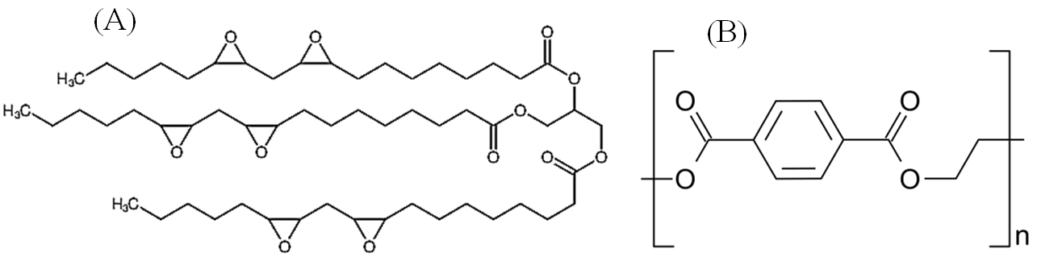
Figure A.1. (A) Structure of epoxidized linolein, a major component of spin-finish epoxidized soybean oil - yellowish viscous liquid [29,34]; (B) the structure of polyethylene terephthalate (PET) [39]

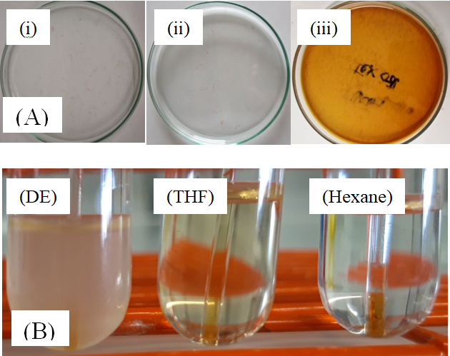
Figure A.2. Spin-finish SF-oil treatment: (A) Degradation of SF-oils by UV treatment and thermal treatment: (i) virgin SF oil, (ii) UV treated SF-oil, (iii) thermally treated SF-oil; and (B) Solubility of treated oil in diethyl ether (DE), tetrahydrofuran (THF), and n-hexane.

Figure A.3. PNaSS GR of PET₂₀₀₉ fabrics at various grafting temperatures: ozonation 10 min at 30ºC, grafting for 1h at 25, 65, 70, 80, 100, 130ºC (n=3).

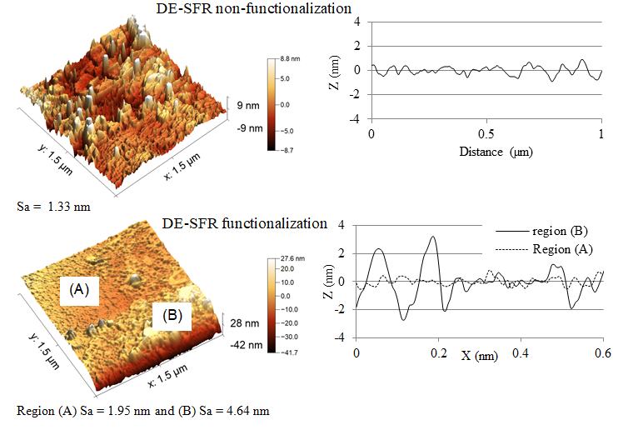
Figure A.4. Topography and roughness of PET₁₉₉₃ fibers after (top) DE SFR and (bottom) after DE-SFR + PNaSS grafting.
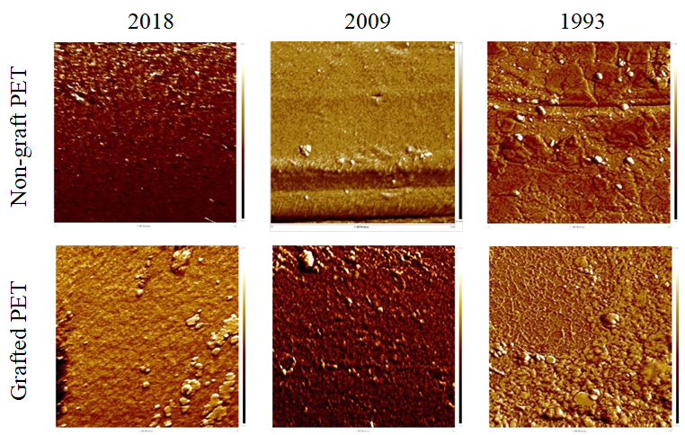
Figure A.5. Surface Young's modulus imaging by Peakforce QNM mapping for spin finish-removed non-grafted and PNaSS-grafted PET fabrics.

Figure A.6 Young’s modulus histogram of PET fibers/fabrics _{1993, 2009, 2018} non-grafted (NG) and PNaSS grafted (G). Force Volume program was used with scanning area 500 nm × 500 nm (scan rate = 0.5 Hz).

