Supplementary information

Supercritical carbon dioxide extraction of astaxanthin from Corynebacterium glutamicum
Jan Seeger¹, Maximilian Zäh², Volker F. Wendisch¹, Christoph Brandenbusch² and Nadja A. Henke^{1,3,*}
¹ Genetics of Prokaryotes, CeBiTec, Bielefeld University, Bielefeld, Germany
² Laboratory of Thermodynamics, TU Dortmund University, Dortmund, Germany
³ Current address: Institute for Process Engineering in Life Sciences, Karlsruhe Institute of Technology (KIT), Karlsruhe, Germany
* Correspondence: nadja.henke@kit.edu

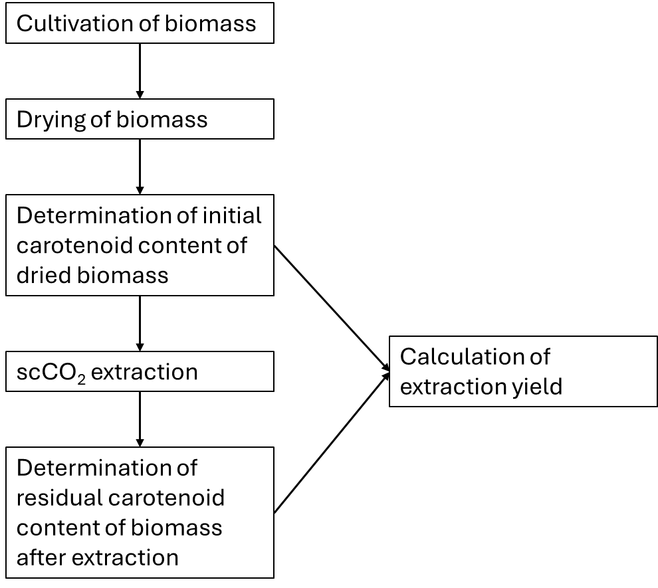
Figure S1: Experimental workflow to determine extraction yield. The carotenoid content of the biomass was determined before and after scCO₂ extraction. Based on that, the extraction yield was calculated.

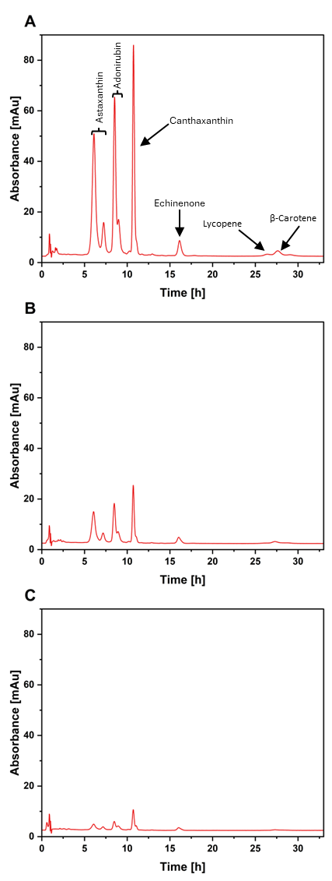
Figure S2: HPLC chromatograms of carotenoid analysis. A: Chromatogram of initial carotenoid content. B: Chromatogram after scCO₂ extraction at 68 °C, 550 bar, 9% (w/w) cosolvent, 0.5 h. C: Chromatogram after scCO₂ extraction at 68 °C, 550 bar, 9% (w/w) cosolvent, 14 h.

Table S1: Parameters for scCO₂ extraction. All extraction parameters and the corresponding extraction yield are given. All measurements, except the one at 68 °C, 550 bar, 0.5 h, 9% (w/w) cosolvent (n = 3, mean ± sd), were performed as single replicates.
Temperature [°C] | Pressure [bar] | Extraction time [h] | Cosolvent  [% (w/w)] | Extraction yield [%]
55 | 550 | 0.5 | - | 6.6
55 | 550 | 0.5 | 4 | 11.5
55 | 550 | 0.5 | 9 | 42.7
50 | 550 | 0.5 | 9 | 41.3
55 | 550 | 0.5 | 9 | 42.7
60 | 550 | 0.5 | 9 | 57.4
68 | 550 | 0.5 | 9 | 67.5 ± 3.7
75 | 550 | 0.5 | 9 | 47.1
50 | 650 | 0.5 | 9 | 61.5
55 | 650 | 0.5 | 9 | 47.0
68 | 650 | 0.5 | 9 | 40.3
75 | 650 | 0.5 | 9 | 44.6
68 | 500 | 0.5 | 9 | 44.7
68 | 450 | 0.5 | 9 | 40.5
68 | 550 | 14 | - | 56.3
68 | 550 | 14 | 9 | 93.3
68 | 550 | 0.5 | - | 16.7

