Informing manure recycling potential with an integrated indicator framework
Yanyu Wang¹, Xin Zhang^{1*}, Sheri Spiegal², Eric A. Davidson¹
¹Appalachian Laboratory, University of Maryland Center for Environmental Science, Frostburg, 21532, MD, USA
²United States Department of Agriculture – Agricultural Research Service (USDA-ARS) Jornada Experimental Range, Las Cruces, NM 88003, USA
* xin.zhang@umces.edu

S.1. Estimates of available manure N metrics

To calculate total manure N and potentially recoverable manure N metrics using coefficients and equations provided by Kellogg et al. (2014)¹, we need to firstly calculate annual average animal unit (AU) based on livestock population inventory and sales data obtained from USDA-NASS². Converting animal headcount to average annual AU depends on the average weight and the time that animals are kept on the farm⁴. The way to estimate average annual AU is shown in equation (1):

 | $${Average annual AU}_{i}=\{\left(\frac{{Inventory}_{i}×1}{{Cycles}_{i}}\right)+\left[\frac{{Sales}_{i}}{{Cycles}_{i}}×\frac{{(Cycles}_{i}-1)}{{Cycles}_{i}} \right]\}×\frac{1}{{animals per AU}_{i}}$$ | (1)

Certain types of livestock were considered to maintain stable population levels and continuous production throughout the year¹. In this study, milk cows, breeding hogs, and breeding turkeys were classified under this category. Therefore, we utilized year-end inventory data exclusively to estimate the average annual AU using the formula presented in equation (2) for these livestock categories.
 | $${Average annual AU}_{i}={inventory}_{i}×\frac{1}{{animals per AU}_{i}}$$ | (2)

S.2. Available manure N and crop N demand metrics in existing studies and proposed framework

S.2.1 available manure N metrics in existing studies
Metrics in Bai et al. (2021)³, Jin et al. (2020)⁴, and Metson et al. (2016)⁵ estimated available manure N as total manure N as excreted by all livestock, including confined and grazing livestock. Therefore, to estimate this metric using the contiguous U.S. as a case study, we used national inventories of animal populations from USDA-NASS² for 2017 and excretion factor following methodology in Kellogg et al. (2014)¹. Akram et al. (2018)⁶ calculated available manure N as the total manure excretion excluding NH₃ volatilization losses during manure storage in Pakistan. To estimate this metric, we followed the methodologies described in the paper by obtaining NH₃ emission factor from Bouwman et al. (1997)⁷ and multiplied it with total manure excretion per livestock type to calculate the metric shown in Table 1 and Fig. 1. Metrics according to Kellogg et al. (2000)⁸ and Spiegal et al. (2020)⁹ are potentially recoverable manure after considering losses during collection, storage, treatment, and transfer processes. We estimated these metrics using recoverability factors provided in Kellogg et al. (2014)¹ and total manure N as excreted by confined livestock.

S.2.2 crop N demand metrics in existing studies
The metric used in Kellogg et al. (2000)⁸ estimates crop N demand as current cropland N inputs, assuming a crop NUE of 70%, and includes the N needs of pastureland. In this study, we assume that recovered manure would only be applied to harvested cropland, so we excluded the pastureland N needs from the metric calculation. While Kellogg et al. (2000)⁸ used a universal crop NUE of 70% to characterize current cropland N inputs, we applied crop-specific NUE values from Zhang et al. (2015)¹⁰ instead, as they provide a more accurate reflection of current NUE levels for different crops. Jin et al. (2020)⁴ and Metson et al. (2016)⁵ estimated crop N demand metrics as N contents in harvested crop products without excluding N sources from fixation, deposition, and irrigation. To estimate these metrics, we used national inventories of crop production from USDA-NASS for 2017² and N contents per crop type from NUGIS¹¹. The metrics used in Akram et al. (2018)⁸ and Spiegal et al. (2020)⁹ estimate crop N demand metrics by adjusting crop N products based on fertilizer application rate per crop type and a universal crop NUE of 50%, respectively. While applying varying factors helps demonstrate different levels of crop N demand metrics across studies, however, both Akram et al. (2018)⁸ and Spiegal et al. (2020)⁹ essentially convey the same fundamental message: they calculated crop N demand metrics that best characterize the current situation of demand. Therefore, we estimated these two metrics at the same level by applying current level of crop-specific NUE from Zhang et al. (2015)¹⁰. Lastly, Bai et al. (2021)³ applied crop-specific uptake factor to reflect demand under balanced fertilization in China. Balanced N fertilization provides N inputs according to the crop N demand, after accounting for certain proportion of N inputs cannot be absorbed by crops (unavoidable losses)¹². Therefore, the balanced fertilization aims at avoiding over-application of fertilizer inputs and decrease risk of N loss into the environment. Therefore, from our interpretation, we estimate the metric in Bai et al. (2021) as cropland N inputs assuming improved NUE of 80%.

S.2.3 Harmonized framework
Of the six studies reviewed, we kept the metric for estimating available manure N in the harmonized framework: potentially recoverable manure N according to Kellogg et al. (2000)⁸ and Spiegal et al. (2020)⁹. As we assume the recovered manure comes from confined livestock, we revised the calculation of metric (total manure N) according to Jin et al. (2020)⁴, Bai et al. (2021)³, and Metson et al. (2016)⁵ to manure as excreted by confined livestock, rather than all livestock. For these two metrics, using the contiguous U.S. as a case study, we refined these estimates by applying excretion and recoverability factors based on the detailed methodology from Kellogg et al. (2014)¹. In the harmonized framework, we did not retain the metric in Akram et al. (2018)⁶ as it does not account for manure N lost through runoff or leaching, as well as manure lost at other stages beyond storage during manure handling. Additionally, we introduced a new metric: “currently applied manure” using farmer survey data from Lim et al. (2023)¹³, detailing manure application rates on crop farms and the proportion of crop acres receiving manure. Incorporating this new metric provides insights into the discrepancy between potentially recoverable manure and currently applied manure.

For crop N demand metrics, we adapted two metrics according to existing studies, while excluding those that incorporate existing N sources, as we argue that N inputs from atmospheric deposition, biological fixation, and irrigation water are not substitutable with manure N. For the two retained metrics: “current N inputs assuming current level of crop NUE excluding existing N sources (fixation, deposition, and irrigation)” and “current crop N inputs assuming improved level of crop NUE excluding N sources”. We refined calculation of these two metrics by updating NUE values based on recent studies and reports. Specifically, we applied current U.S. crop-specific NUE levels from Zhang et al. (2015)¹⁰ to capture differences in NUE across crops. For the improved NUE metric, we adopted a target NUE of 80%, as recommended by the European Nitrogen Expert Panel¹⁴. This target aligns with the desirable NUE range of 50% to 90%, where levels above 90% may lead to soil N mining, and levels below 50% increase the risk of N losses.

S.3. County-level livestock population obtained from USDA-NASS

To identify varying priorities in improving manure recycling on the county scale, we obtained livestock population data in 2017 from USDA-NASS (https://quickstats.nass.usda.gov/)². However, we noted discrepancies between aggregated county-level population and state-level (used for national level analyses), probably related to redaction by NASS² to protect identity of producers at the county level. For example, there are a few counties in the U.S. that have a very high number of layers but few producers, do the data is redated from that county with a (D) (one is in Delaware). Although the state-level numbers are probably more accurate, but it is hard to bootstrap to predict the number per county using the state total.

To better understand how redaction issue of animal population might impact the evaluation of priorities in manure recycling on subnational scale, we compared manure nitrogen excretion per type of confined animal between aggregated county and state data, as shown in equation (3).

 | $${difference in manure excretion}_{i}= {state excretion}_{i}- {aggregate county excretion}_{i}$$ | (3)

In addition, we compared the difference in M2 using aggregated county and state population data (equation (4)) to evaluate the potential underestimations in the number of counties capable of achieving balance and their distribution.

 | $$difference in M2= \sum{{(State-aggregate county manure excretion)}_{i}}× {Recoverability factors}_{i}$$ | (4)

We found that the total amount of produced manure nitrogen by all confined animals is lower by 0.6 Tg N when using aggregated county-level population data compared with state-level, especially found in Kansas, South Carolina, Illinois, Washington, and Maine (Supplementary Fig. 5). This underestimation was also observed across various confined livestock types, especially beef cattle, hog, broilers, and layers (Supplementary Fig. 5 and 6). While there were also occasional higher estimates of manure production for hogs and poultry in some states using aggregated county data compared to state-level data, these differences were minor in comparison to the overall underestimation (Supplementary Fig. 6). This indicates that using aggregated county-level population data generally results in a lower estimate of available manure compared to using state-level data.

This underestimation of total manure excretion using county-level population data could result in fewer counties being identified as having the potential to achieve balance using local available manure nitrogen. For instance, the increased availability of manure nitrogen from minimizing losses during handling (M2) process would be greater with state-level population data across all states except Connecticut, Wisconsin, and West Virginia (Supplementary Fig. 7). This higher M2, derived from corrected population data, could enable New Hampshire to potentially achieve overall balance at state level, thereby allowing more counties within the state to reach balance as depicted in Figure 5 of the main text (Supplementary Fig. 7). Apart from New Hampshire, additional counties in Texas and Arizona would also be identified as potentially reaching balance (Supplementary Fig. 6).

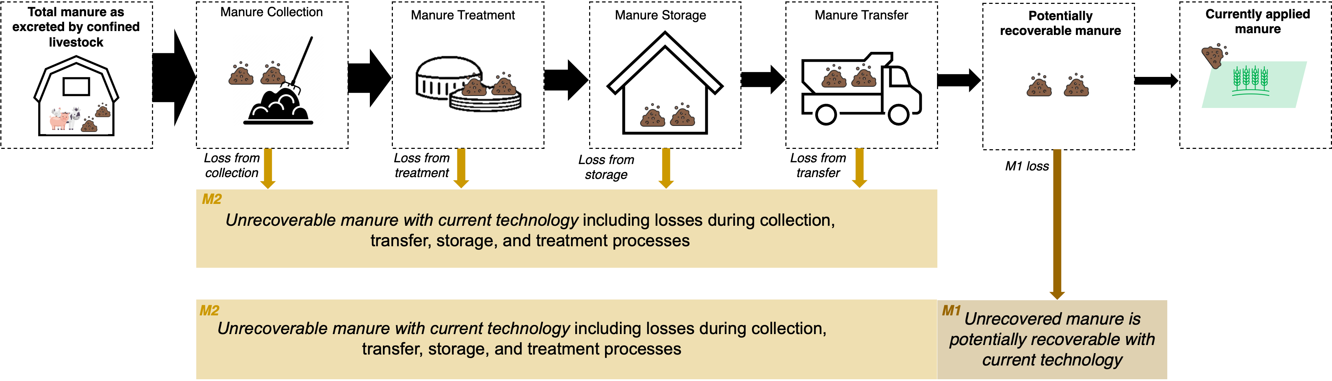
Supplementary Fig. 1. A conceptual diagram depicting the manure loss (M1 and M2) during manure handling. M1 refers to the potential through recovering unrecovered manure with current technologies (defined as the difference between currently applied manure and potentially recoverable manure). M2 represents recovering manure that is currently not considered technically or economically feasible to collect and apply to cropland.

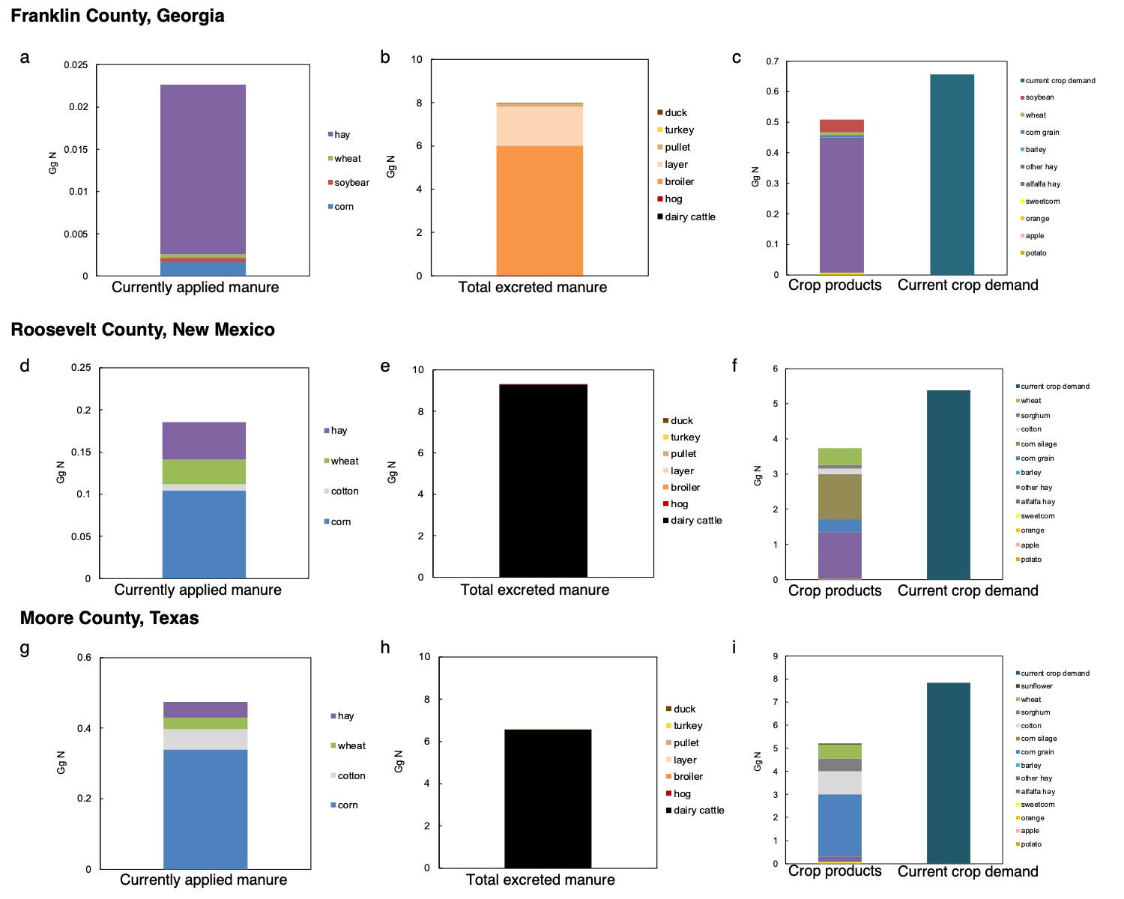
Supplementary Fig. 2. Total excreted manure, currently applied manure, current crop production, and current inputs in the three counties. a-c. Franklin County in Georgia, d-f. Roosevelt County in New Mexico, g-i. Moore County in Texas.

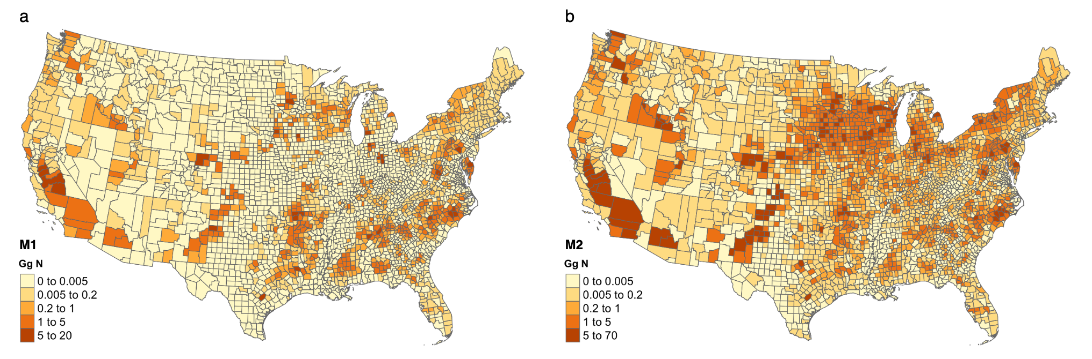
Supplementary Fig. 3. Distribution of unrecovered manure at the county level across the contiguous U.S. in 2017. a. M1, unrecovered manure with current technologies (defined as the difference between currently applied manure and potentially recoverable manure), b. M2, unrecoverable manure during collection, storage, treatment, and transfer processes with current technology.

Supplementary Fig. 4. Distribution of reduced crop N demand (iNUE) through enhancing crop NUE from current level to 80% across the contiguous U.S. in 2017. iNUE refers to the reduced crop N demand from increasing crop nitrogen use efficiency (NUE) from current level (weighted average of. 70%) to 80%.

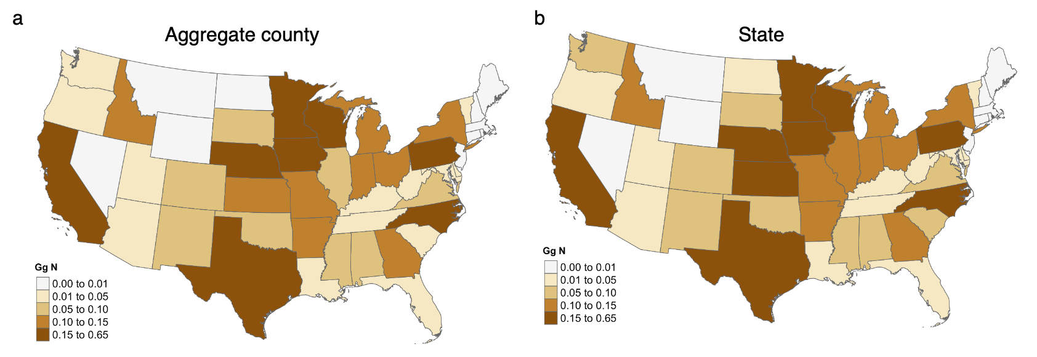
Supplementary Fig. 5. Comparison of total manure N as excreted by all confined animals at state level. a, aggregated county data, b, obtained state-level data from USDA-NASS. Unit is in Gg (10⁶ kg).
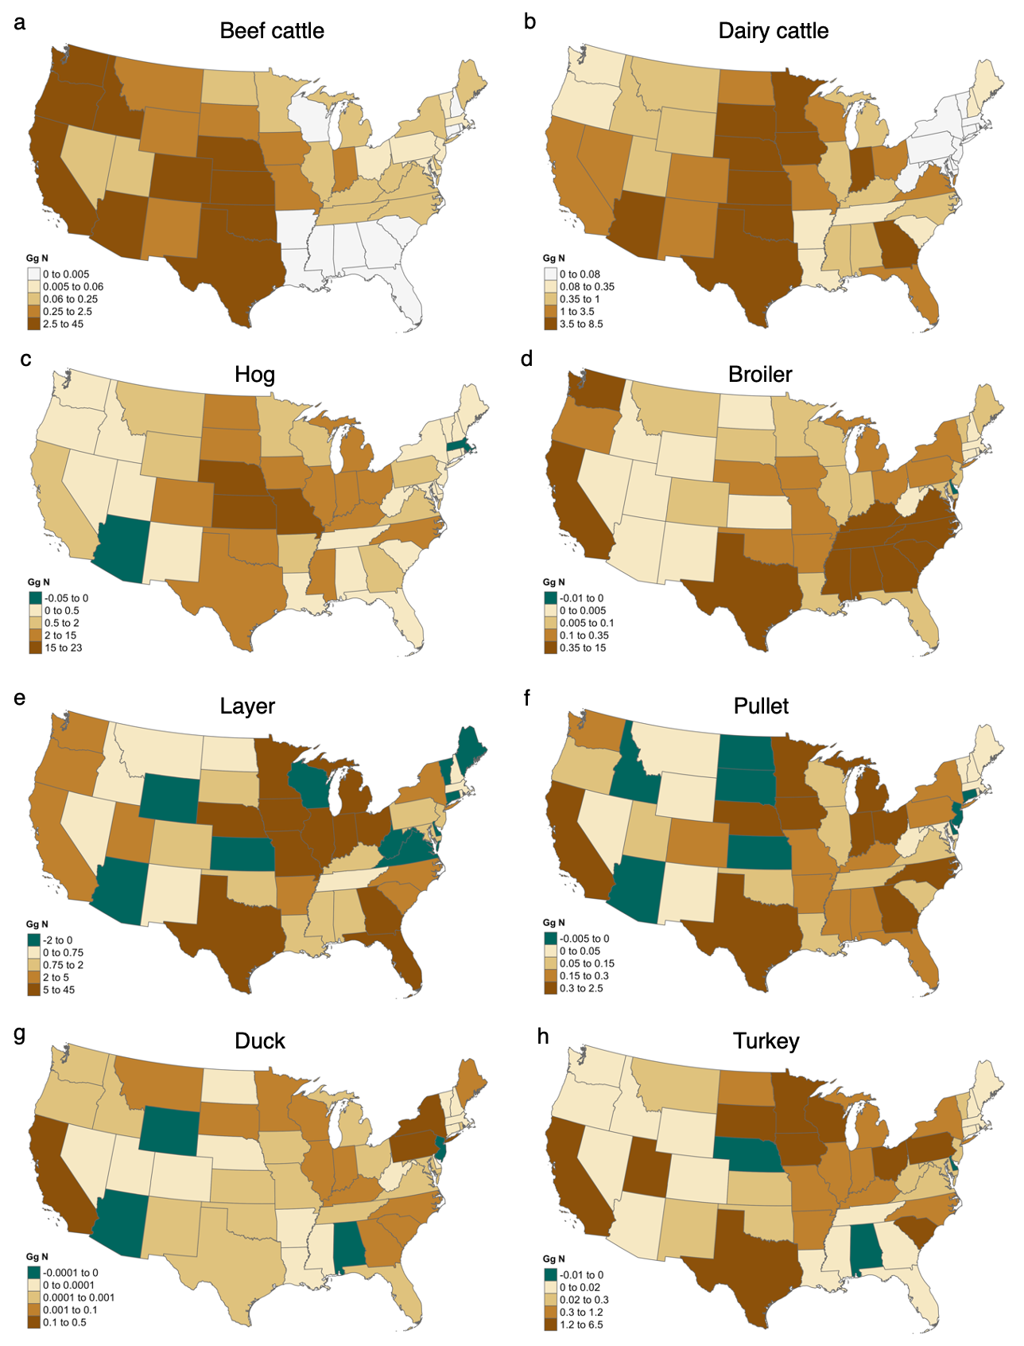
Supplementary Fig. 6. Comparison of manure N as excreted by per type confined livestock between aggregated county and state data at state level. a, beef cattle, b, dairy cattle, c, hog, d, broiler, e, layer, f, pullet, g, duck, h, turkey. Unit is in Gg (10⁶ kg).

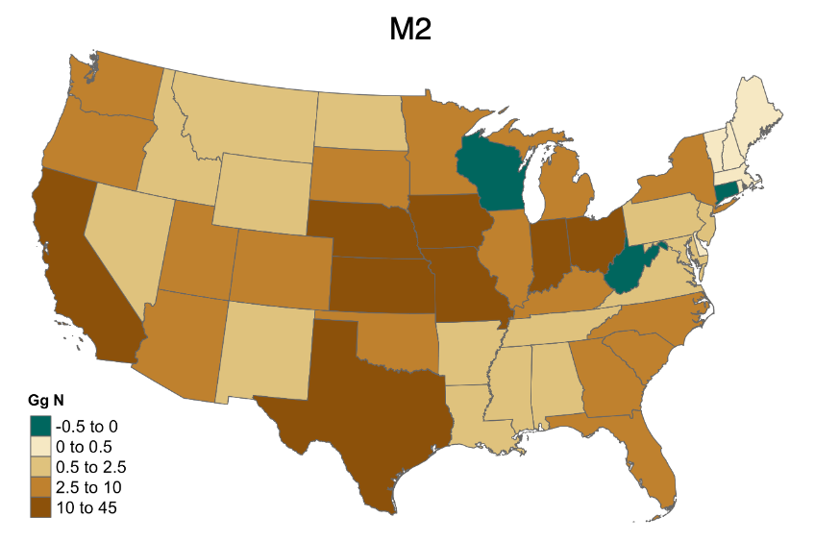
Supplementary Fig. 7. Difference in M2 between aggregated county and state data at state level. Unit is in Gg (10⁶ kg) N. M2 refers to unrecoverable manure during collection, storage, treatment, and transfer processes with current technology.

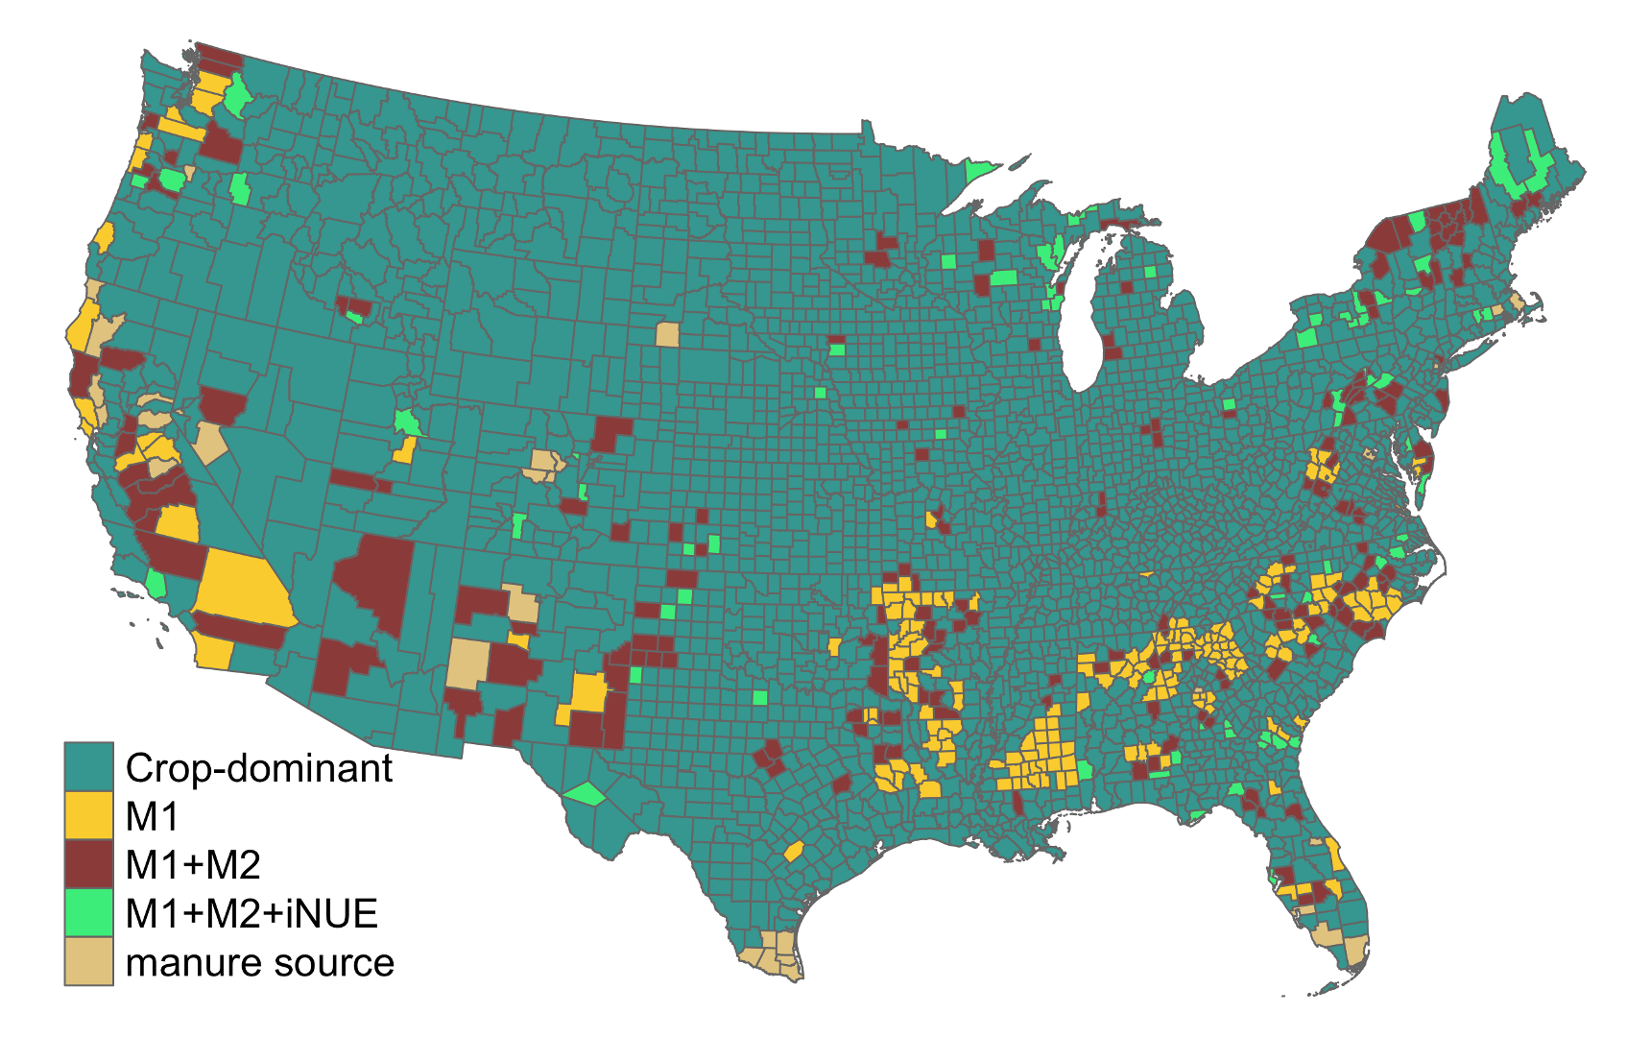
Supplementary Fig. 8. Spatial distribution of different categories of counties with varying priorities in improving manure recycling. "M1" counties are those currently with negative manure surplus but may become positive by minimizing unrecovered manure potential (M1). "M1+M2" counties are those currently with negative manure surplus and remain negative by minimizing unrecovered manure potential (M1), while they become positive by further minimizing manure losses during handling process (M2). "M1+M2+iNUE" counties are those currently with negative manure surplus and remain negative from minimizing both unrecovered manure potential (M1) and manure losses during handling process (M2), while they become positive by improving crop nitrogen use efficiency (NUE) from current level to an average of 80% (iNUE). "Crop-dominant" counties are those currently with negative manure surplus both before and after applying improved manure management (minimizing M1 and M2) and enhanced crop NUE (iNUE). Counties labeled as "manure source" are those with a positive current manure surplus.

Supplementary Table 1. Data on confined livestock inventory, sales, lifecycle, animals per animal unit (AU), and excretion factors¹ utilized to quantify average available manure nitrogen in this study.
Livestock type | Year-end Inventory  2017 | Sales  2017 | Cycles | Animals per AU  2002-2007 | Average annual AU | kg N AU⁻¹ yr⁻¹
Fattened cattle | 15021857 | 24640184 | 2.5 | 1.02 | 11688615 | 58
Milk cow | 9537376 | - | 1 | 0.73 | 13064899 | 118
Breeding hogs | 5572186 | - | 1 | 2.27 | 2454707 | 32
Hogs for slaughter  (Farrow to finish) | - | 234983677 | 2 | 7.4 | 7938638 | 108
Broilers | 1621385205 | 8889084119 | 6 | 382 | 3939334 | 157
Layers | 351792332 | 199893646 | 1 | 293 | 1882887 | 189
Pullets | 124677006 | 213797936 | 2.25 | 350 | 309147 | 100
Breeding turkeys | 103680424 | - | 1 | 50 | 2073608 | 117
Turkeys for slaughter | - | 283022124 | 2 | 59 | 119246 | 100
Ducks | 4840393 | 24411588 | 6 | 286 | 11855 | 162

Supplementary Table 2. Parameters used for estimating potentially recoverable manure and M2 adapted from Kellogg et al. (2014)¹.
Livestock type | Recoverability factors | Proportion of N retained in recoverable manure
Fattened cattle | 0.7871 | 0.4
Milk cow | 0.6844 | 0.25
breeding hogs | 0.8643 | 0.25
Hogs for slaughter | 0.9550 | 0.25
Broilers | 0.9800 | 0.6
Layers | 0.9500 | 0.69
Pullets | 0.9500 | 0.5
Turkey | 0.8267 | 0.5
Ducks | 0.6950 | 0.5
Supplementary Table 3. Manure application rate and manured crop area obtained from Lim et al. (2024)¹², ManureMap Toolbox¹⁵, and Macdonald et al. (2010)¹⁶.
Crop type | Manure application rate(lb/ac) | Manured crop area (acre)
Barley | 76 | 137000
Corn | 92 | 14822000
Wheat | 78 | 908000
Oats | 74 | 358000
Soybeans | 68 | 1884000
Cotton | 83 | 505000
Peanuts | 67 | 203000
Hay | 60 | 1698280

Supplementary Table 4. Different levels of available manure nitrogen by confined animal type. Error of available manure nitrogen estimate represents standard deviation from the mean of excretion factor and recoverability factors per animal type estimated by Monte Carlo simulation (500 runs) based on coefficients from Statistics Netherlands. (2012)¹⁷, Kellogg et al. (2014)¹, Zhang et al. (2021)¹⁸, and 2017 national forage review¹⁹.
Animal type | Amount as excreted in manure (Tg N) | Potentially recovered manure (Tg N) | Manure applied to soils (Tg N) | M2  (Tg N) | M1  (Tg N)
Cattle, dairy | 1.54 ± 0.09 | 0.42 ± 0.05 | 0.8 ± 0.02 | 1.12 ± 0.08 | 0.8 ± 0.1
Cattle, non-dairy | 0.68 ± 0.06 | 0.21 ± 0.02 | 0.8 ± 0.02 | 0.47 ± 0.04 | 0.8 ± 0.1
Hog | 0.94 ± 0.09 | 0.22 ± 0.02 | 0.8 ± 0.02 | 0.72 ± 0.07 | 0.8 ± 0.1
Chickens, broilers | 0.62 ± 0.13 | 0.32 ± 0.07 | 0.8 ± 0.02 | 0.3 ± 0.07 | 0.8 ± 0.1
Chickens, layers | 0.36 ± 0.03 | 0.23 ± 0.02 | 0.8 ± 0.02 | 0.12 ± 0.01 | 0.8 ± 0.1
Chickens, pullet | 0.03 ± 0.006 | 0.01 ± 0.003 | 0.8 ± 0.02 | 0.02 ± 0.003 | 0.8 ± 0.1
Duck | 0.002 ± 0.003 | 0.0008 ± 0.003 | 0.8 ± 0.02 | 0.0016 ± 0.0004 | 0.8 ± 0.1
Turkeys | 0.36 ± 0.05 | 0.16 ± 0.04 | 0.8 ± 0.02 | 0.21 ± 0.04 | 0.8 ± 0.1
Total | 4.5 ± 0.2 | 1.6 ± 0.1 | 0.8 ± 0.02 | 2.9 ± 0.1 | 0.8 ± 0.1

Supplementary Table 5. N budget for 11 crop group in 2015 adapted from Zhang et al. (2015)¹⁰.
Crop group | Fertilizer | Manure | Fixation | Deposition | Removal | NUE
Wheat | 1.4 | 0.4 | 0.3 | 0.2 | 1.2 | 0.50
Rice | 0.3 | 0.03 | 0.05 | 0.01 | 0.2 | 0.44
Maize | 5.0 | 0.8 | 0.6 | 0.4 | 4.8 | 0.71
Other coarse grain | 0.3 | 0.07 | 0 | 0.03 | 0.2 | 0.61
Soybean | 0.1 | 0.6 | 5.5 | 0.4 | 5.5 | 0.83
Oil palm | 0 | 0 | 0 | 0 | 0 | -
Other oil seeds | 0.2 | 0.04 | 0.06 | 0.02 | 0.1 | 0.41
Cotton | 0.3 | 0.06 | 0 | 0.04 | 0.3 | 0.77
Sugar crop | 0.1 | 0.01 | 0.09 | 0.006 | 0.07 | 0.50
Fruit & Vegetables | 0.5 | 0.07 | 0.001 | 0.02 | 0.1 | 0.25
Other crops | 0.02 | 0.05 | 0.1 | 0.02 | 0.2 | 0.85
Units of inputs and outputs are in Tg N.

Supplementary Table 6. Crop products, N content, NUE, and estimates crop demand metrics in the contiguous U.S.
 | N content (%) | Production (Tg) | Total products (Tg N) | NUE | Current N inputs (Tg N) | Crop N inputs with NUE of 80% (Tg N)
alfalfa hay | 2.6 | 49.35 | 1.28 | 0.80 | 1.60 | 1.60
barley | 2.1 | 3.51 | 0.07 | 0.61 | 0.12 | 0.09
canola | 3.8 | 1.38 | 0.05 | 0.41 | 0.13 | 0.07
corn grain | 1.2 | 375.23 | 4.50 | 0.71 | 6.34 | 5.63
corn silage | 0.5 | 109.22 | 0.55 | 0.71 | 0.77 | 0.68
cotton | 6.6 | 4.44 | 0.29 | 0.77 | 0.38 | 0.37
dry beans | 4.5 | 1.54 | 0.07 | 0.50 | 0.14 | 0.09
other hay | 1.5 | 58.00 | 0.87 | 0.80 | 1.09 | 1.09
peanut | 3.5 | 3.20 | 0.11 | 0.41 | 0.27 | 0.14
rice | 1.1 | 8.95 | 0.10 | 0.44 | 0.22 | 0.12
sorghum | 1.3 | 9.01 | 0.12 | 0.61 | 0.19 | 0.15
soybean | 5.4 | 118.55 | 6.40 | 0.83 | 7.71 | 7.71
sugarbeet | 0.2 | 31.84 | 0.06 | 0.50 | 0.13 | 0.08
sugarcane | 0.1 | 30.15 | 0.03 | 0.50 | 0.06 | 0.04
sunflower | 2.7 | 0.94 | 0.03 | 0.41 | 0.06 | 0.03
sweetcorn | 1.4 | 3.85 | 0.05 | 0.25 | 0.22 | 0.07
tobacco | 3.6 | 0.32 | 0.01 | 0.50 | 0.02 | 0.01
wheat | 2.1 | 48.67 | 1.02 | 0.50 | 2.04 | 1.28
orange | 0.44 | 4.62 | 0.02 | 0.25 | 0.08 | 0.03
apple | 0.3 | 5.24 | 0.02 | 0.25 | 0.06 | 0.02
potatoes | 0.256 | 20.45 | 0.05 | 0.50 | 0.10 | 0.07
sum |  | 888.46 | 15.72 |  | 21.75 | 19.35

Supplementary Table 7. Existing N sources from fixation, deposition, and irrigation in the contiguous U.S.
 | Fixation | Deposition | Irrigation | sum
Existing N sources | 7.8 | 0.9 | 0.2 | 8.9

Supplementary Table 8. Comparison of average available manure N metrics using state-level and aggregated county-level population in 2017 obtained from USDA-NASS².
Livestock type | Total manure as excreted by confined livestock (Tg N) |  | Potentially recoverable manure (Tg N) |  | M2 (Tg N)
 | state-level | aggregated county-level | state-level | aggregated county-level | state-level | aggregated county-level
Cattle, dairy | 1.54 | 1.46 | 0.42 | 0.40 | 1.12 | 1.06
Cattle, non-dairy | 0.68 | 0.53 | 0.21 | 0.17 | 0.47 | 0.32
Hog | 0.94 | 0.79 | 0.22 | 0.18 | 0.72 | 0.58
Chickens, broilers | 0.62 | 0.59 | 0.32 | 0.35 | 0.3 | 0.27
Chickens, layers | 0.36 | 0.19 | 0.23 | 0.12 | 0.12 | 0.07
Chickens, pullet | 0.029 | 0.019 | 0.01 | 0.009 | 0.02 | 0.01
Duck | 0.0023 | 0.0015 | 0.0008 | 0.00054 | 0.0016 | 0.00096
Turkeys | 0.36 | 0.33 | 0.16 | 0.14 | 0.21 | 0.19
Total | 4.5 | 3.9 | 1.6 | 1.4 | 2.9 | 2.5

Supplementary Table 9. Average and standard deviation of excretion factors, recoverability factors, and crop harvested nitrogen products used to generate uncertainties in available manure N, crop N demand, and manure surplus based on coefficients from Statistics Netherlands. (2012)¹⁷, Kellogg et al. (2014)¹, Zhang et al. (2021)¹⁸, and 2017 national forage review¹⁹.
Livestock type | Excretion factor |  | Recoverability factor (%)
Livestock type | Average | Standard deviation | Average | Standard deviation
Cattle, dairy | 118.3 | 6.9 | 68.4 | 7.6
Cattle, non-dairy | 58.3 | 5.2 | 78.7 | 2.0
Breeding hog | 32.4 | 3.2 | 86.4 | 17.2
Hog for slaughter | 108.4 | 10.7 | 95.7 | 2.6
Chickens, broilers | 157.2 | 33.9 | 98 | -
Chickens, layers | 189.5 | 15.7 | 95 | -
Chickens, pullet | 100.5 | 21.7 | 95 | -
Duck | 162.3 | 23.7 | 69.5 | 27.6
Breeding turkeys | 116.6 | 15.3 | 82.7 | 18.0
Turkeys for slaughter | 100.4 | 13.2 | 82.7 | 18.0
Crop nitrogen products (Tg) | Average |  | Standard deviation
Crop nitrogen products (Tg) | 15.7 |  | 1.4
Manure N applied on hay (Tg) | Average  0.08 |  | Standard deviation  0.05

References
- Kellogg, R., Moffitt, D. & Gollehon, N. Estimates of Recoverable and Non-Recoverable Manure Nutrients Based on the Census of Agriculture. Nat. Resour. Conserv. Serv. 1–114 (2014).
- USDA-NASS. Quick Stats. https://quickstats.nass.usda.gov/.
- Bai, Z., Fan, X., Jin, X. et al. Relocate 10 billion livestock to reduce harmful nitrogen pollution exposure for 90% of China’s population. Nat Food. 3, 152–160 (2022).
- Jin, X. et al. Spatial planning needed to drastically reduce nitrogen and phosphorus surpluses in China’s agriculture. Environ. Sci. Technol. 4, 11894–11904 (2020).
- Metson, G.S., MacDonald, G.K., Haberman, D., Nesme, T. & Bennett, E.M., Feeding the corn belt: Opportunities for phosphorus recycling in US agriculture. Sci. Total Environ. 542, 1117–1126 (2016).
- Akram, U., Metson, G. S., Quttineh, N. H. & Wennergren, U. (2018). Closing Pakistan’s Yield Gaps Through Nutrient Recycling. Frontiers in Sustainable Food Systems. 2, 1–14 (2018).
- Bouwman, A. F. et al. (1997), A global high-resolution emission inventory for ammonia, Global Biogeochem. Cycles. 11, 561–587 (1997).
- Kellogg, R.L., Lander, C.H., Moffitt, D.C. & Gollehon, N. Manure nutrients relative to the capacity of cropland and pastureland to assimilate nutrients: Spatial and temporal trends for the United States. Proceedings of the Water Environment Federation. 16, 18–157 (2000).
- Spiegal, S. et al. Manuresheds: Advancing nutrient recycling in US agriculture. Agric. Syst. 182, 102813 (2020).
- Zhang, X. et al. Managing nitrogen for sustainable development. Nature. 528, 51–59 (2015).
- IPNI. A Nutrient Use Information System (NuGIS) for the U.S. International Plant Nutrition Institute, Norcross, Georgia. http://nugis.ipni.net/ (2012).
- Velthof, G. L. et al. Integrated Assessment of Nitrogen Losses from Agriculture in EU‐27 using MITERRA‐EUROPE. J. Environ. Qual. 38, 402–417 (2009).
- Lim, T. et al. Increasing the Value of Animal Manure for Farmers. 94 (2023).
- European Nitrogen Expert Panel. (2015). Nitrogen Use Efficiency (NUE) - an indicator for the utilization of nitrogen in agriculture and food systems. Wageningen University, Alterra, PO Box 47, NL-6700 Wageningen, Netherlands.
- ManureMap Toolbox. Agricultural Conservation Planning Framework. https://acpf4watersheds.org/use-the-manuremap-toolbox/
- Macdonald, J. M. & Mcbride, W. D. The Transformation of U. S. Livestock Agriculture Scale, Efficiency, and Risks. United State Department of Agriculture ERS. (2009).
- Statistics Netherlands. Uncertainty analysis of mineral excretion and manure production. (2012).
- Zhang, X. et al. Quantification of global and national nitrogen budgets for crop production. Nat. Food 2, 529–540 (2021).
- 2017 national forage review. https://www.progressivepublish.com/downloads/2018/general/2017-pf-stats-highres.pdf

