Extended data figures and tables for

Early intrinsic plasticity of neocortical engram neurons defines memory formation and precision
Senka Hadzibegovic, Liangying Zhu, Melanie Ginger, Rafael De Sa, Katy le Corf, Maria Gueidão Costa, Yves Le Feuvre, Olivier Nicole, Bruno Bontempi, Andreas Frick

This file includes:

Extended Data Fig. 1 to 8
Tables 1 to 5
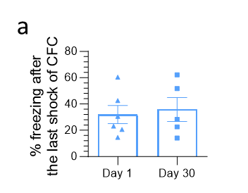
Extended Data Fig. 1. Contextual fear conditioning (CFC) training data related to Fig. 1c and f. a, Freezing behavior, expressed as % freezing, following the last shock of CFC was similar between groups that subsequently underwent retrieval at 1 and 30 days, indicating comparable levels of acquisition (P = 0.74, NS). Data points are individual mice with mean ± SEM. Statistical significance was assessed using the unpaired t-test.

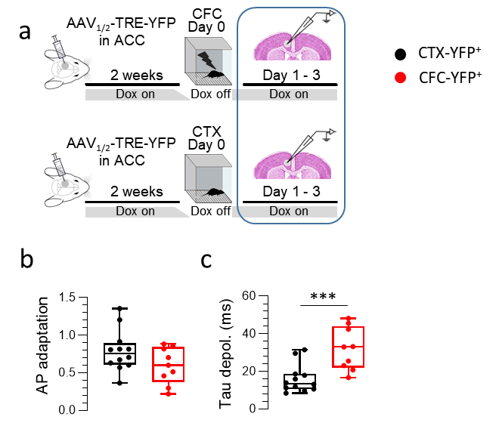

Extended Data Fig. 2. Contextual fear conditioning triggers IE plasticity in ACC nascent engram ensembles. Related to Fig. 2. a, Experimental design: whole-cell patch-clamp recordings were performed from neurons expressing YFP (YFP⁺) 1-3 days post-CFC or post-CTX. b, Trend for reduced AP adaptation in CFC-YFP⁺ neurons (P = 0.108, NS). c, Increase in Tau in CFC-YFP⁺ neurons. Data points are individual cells with median, lower and upper quartiles, and minimum and maximum data values. Statistical significance was assessed using the unpaired t-test, ***P < 0.001.

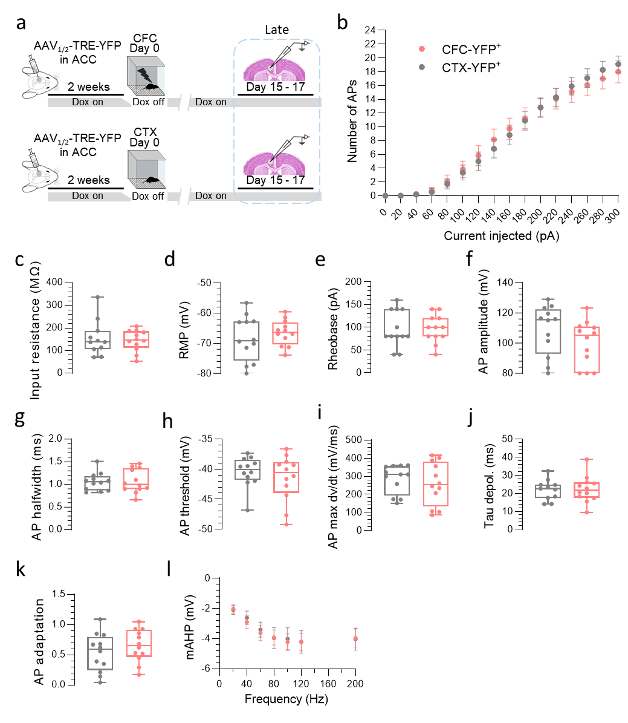

Extended Data Fig. 3. CFC-induced IE plasticity of ACC nascent engram ensembles waned during the late phase of memory consolidation. a, Experimental design: whole-cell patch-clamp recordings were performed from YFP⁺ neurons 15-17 days post-CFC (in red) or post-CTX (in grey). b-l, Analysis for n = 12 YFP⁺ cells (CFC group) and n = 12 YFP⁺ cells (CTX group). No significant difference assessed by unpaired t-tests (c-k) or two-way ANOVA with repeated measures followed by Šídák's multiple comparisons tests (b and l) was found for the following electrophysiological parameters (p > 0.05 for all comparisons, NS): (b) Input resistance, (c) Number of APs as a function of injected current (0-300 pA), (d) RMP, (e) Rheobase, (f) AP amplitude, (g) AP halfwidth, (h) AP threshold, (i) AP max dv/dt, (j) Tau depolarizing, (k) AP adaptation and (l) mAHP from a 5-AP-train at different frequencies. Data points are individual cells with median, lower and upper quartiles, and minimum and maximum data values.

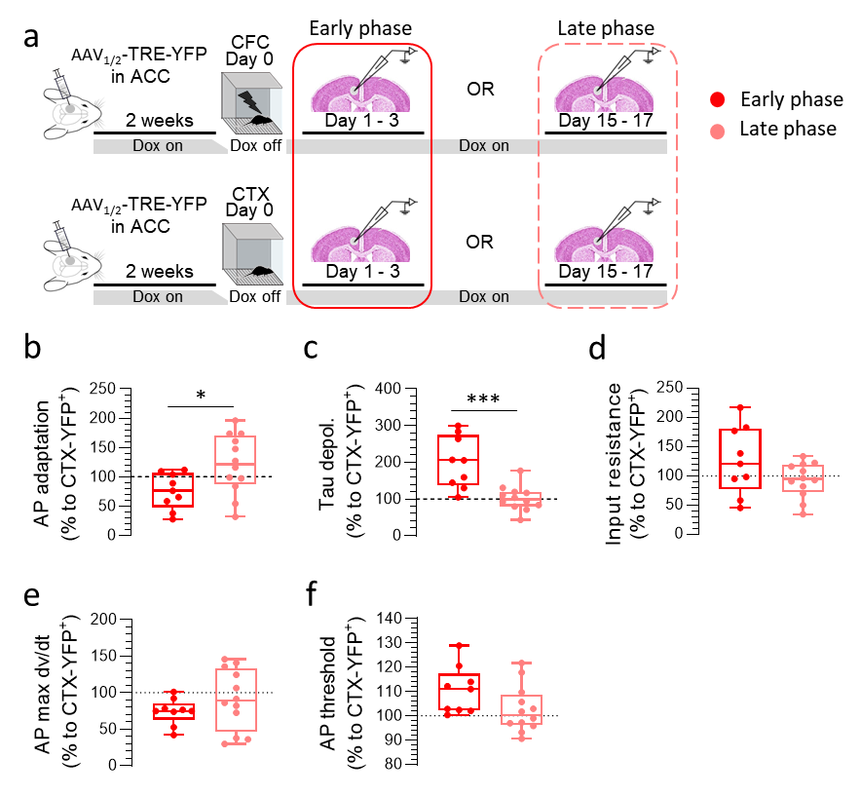

Extended Data Fig. 4. Transient nature of IE plasticity of the ACC engram neurons. Related to Fig. 3. a, Experimental design: whole-cell patch-clamp recordings were performed from tagged (YFP⁺) L5 pyramidal neurons either during early-phase (1-3 days post-CFC) or remote-phase (15-17 days post-CFC) memory consolidation. Data are normalized to values from control cells (CTX-YFP⁺) at the respective memory phases. b-f, Analysis for n = 9 cells (early phase of memory consolidation) and n = 12 cells (remote phase of memory consolidation). Significant differences were found for the AP adaptation (b) and Tau depolarizing (c). No significant difference was observed for input resistance (d), AP max dv/dt (e), and only a trend for an increase in the AP threshold (P = 0.084) during the early phase (f). Data points are individual cells with median, lower and upper quartiles, and minimum and maximum data values. Statistical significance was calculated using the unpaired t-test, *P < 0.05, ***P < 0.001.

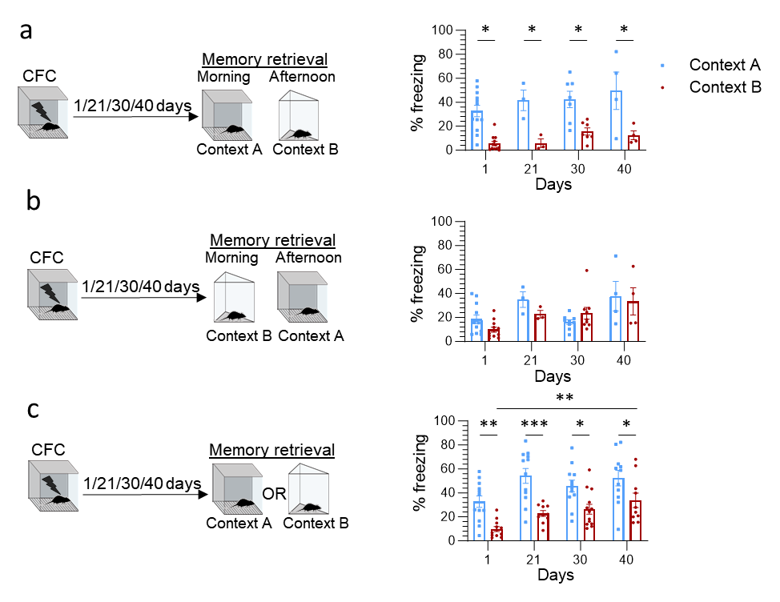

Extended Data Fig. 5. Impact of context exposures on freezing behavior in the other context. a (left), Experimental design. (right), When mice were tested in Context A in the morning session and Context B in the afternoon session, they were able to discriminate between the two contexts across all delays (1, 21, 30, and 40 days post-CFC). b (left), Experimental design. (right), When mice were tested in Context B in the morning session and Context A in the afternoon session, they were not able to discriminate between the two contexts across all delays (1, 21, 30, and 40 days post-CFC). c (left), Experimental design. Mice were tested only in Context A or Context B to avoid the impact of previous exposure. (right), Mice were able to discriminate between contexts across all delays, with significantly increased levels of freezing between day 1 and day 40 for Context B. Data points are individual mice with mean ± SEM. Statistical significance was calculated using two-way ANOVA followed by Tukey/Šídák's multiple comparisons test (a-c), *P < 0.05, **P < 0.01, **** P < 0.0001.

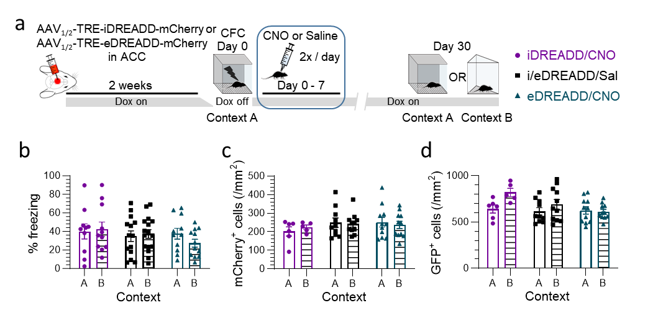

Extended Data Fig. 6. CFC training data, ACC engram labeling during encoding, and retrieval activation following chemogenetic manipulation during the early phase of memory consolidation. a, Experimental design. b, Training data related to Fig. 4c. Results are presented for the three groups (iDREADD/CNO, eDREADD/CNO, i/eDREADD/Sal) as the % of time spent freezing during one minute following the last shock of CFC, showing no difference between groups. c, Density of mCherry⁺ cells does not differ between groups, suggesting that a similar number of engram neurons expressed DREADD. d, Density of GFP⁺ cells indicates an increase in the number of cells that were active during the retrieval in Context B, but no effect of treatment. Data points are individual mice with mean ± SEM. Statistical significance was calculated using two-way ANOVA followed by Tukey/Šídák's multiple comparisons test (b-d).

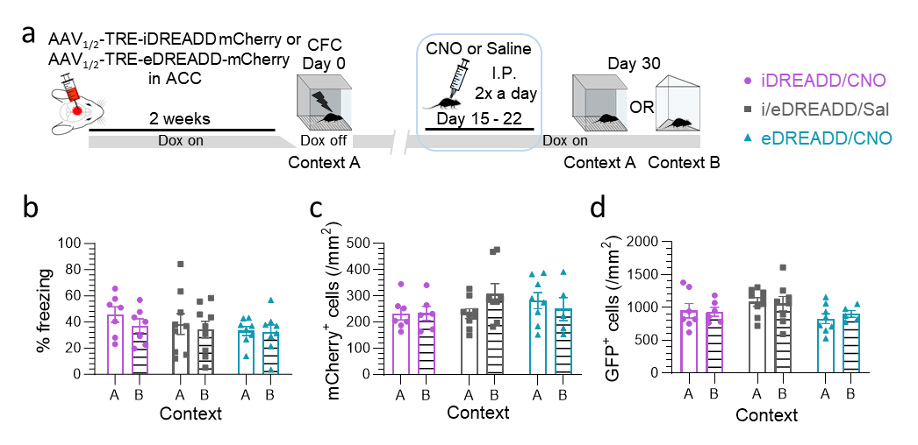

Extended Data Fig. 7. CFC training data, ACC engram labeling during encoding, and retrieval activation following chemogenetic manipulation during the late phase of memory consolidation. a, Experimental design. b, Training data related to Fig. 4g. Results are presented for the three groups (iDREADD/CNO, eDREADD/CNO, i/eDREADD/Sal) as the % of time spent freezing during one minute following the last shock of CFC, showing no difference between groups. c, Density of mCherry⁺ cells does not differ between groups, suggesting that a similar number of engram neurons expressed DREADD. d, Density of GFP⁺ cells is similar across groups, indicating that labeling of neurons active during retrieval was not a confounding factor. Data points are individual mice with mean ± SEM. Statistical significance was calculated using two-way ANOVA followed by Tukey/Šídák's multiple comparisons test (b-d).

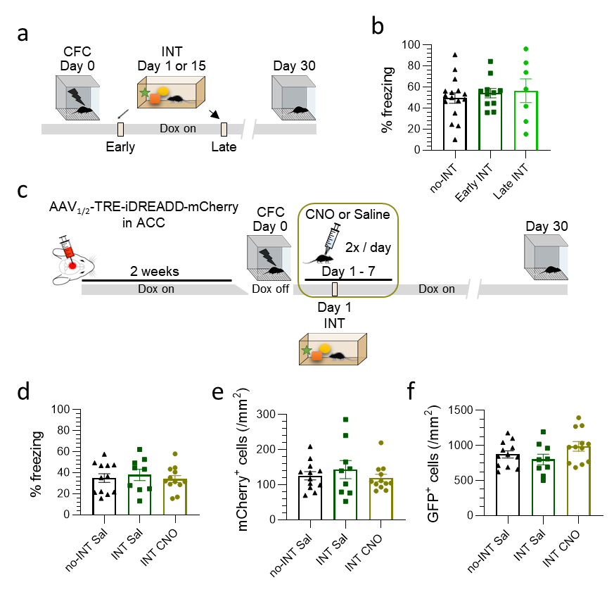

Extended Data Fig. 8. CFC training data and neuronal activation during encoding and retrieval in experiments assessing the effects of interference. a, Experimental design. b, Training data related to Fig. 5a and b. Results are presented for the three groups (no-INT, Early INT, Late INT) as the % of time spent freezing during one minute following the last shock of CFC, showing no difference between groups. c, Experimental design. d, Training data related to Fig. 5c to e. Results are presented for the three groups (no-INT Sal, INT Sal, INT CNO) as the % of time spent freezing during one minute following the last shock of CFC, showing no difference between groups. e, Density of mCherry⁺ cells does not differ between groups, suggesting that a similar number of engram neurons expressed DREADD. f, Density of GFP⁺ cells is similar across groups, indicating that labeling of neurons active during retrieval was not a confounding factor. Data points are individual mice with mean ± SEM. Statistical significance was calculated using two-way ANOVA followed by Tukey/Šídák's multiple comparisons test (b, d-f).

