Supplementary Data: Unmet health-related needs in patients with Crohn’s disease in Belgium: a mixed-methods study

Supplementary Figure 1 - Flow diagram of the respondents participating in the online survey
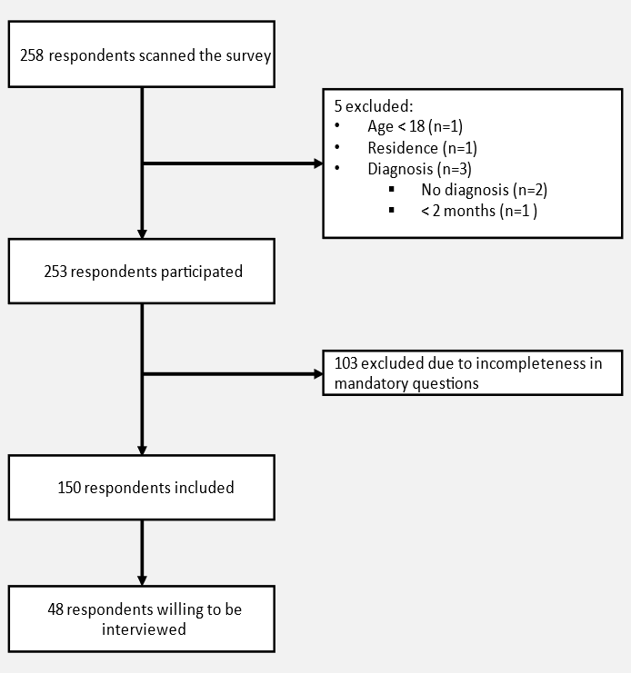

Supplementary Table 1: Interview participants’ characteristics (n=20)
Variable |  | n (%)
Gender
 | Female | 12 (60.0)
 | Male | 8 (40.0)
Age category (years)
 | 20-29 | 2 (10.0)
 | 30-39 | 6 (30.0)
 | 40-49 | 4 (20.0)
 | 50-59 | 4 (20.0)
 | 60-69 | 4 (20.0)
Language
 | French | 13 (65.0)
 | Dutch | 7 (25.0)
Time since diagnosis
 | 2 to 6 months | 1 (5.0)
 | 5 to 10 years | 4 (20.0)
 | > 10 years | 15 (75.0)
Surgery due to CD
 | Yes | 8 (40.0)
 | No | 12 (60.0)

