Supporting Information
Chelating-agent-free incorporation of isolated Ni single-atoms within BEA Zeolite for enhanced biomass hydrogenation
Meng Liu,¹ Caixia Miao,¹ Yumeng Fo,¹ Wenxuan Wang,² Yao Ning,³ Shengqi Chu,⁴ Weiyu Song,¹ Ying Zhang,³ Jian Liu,² Zhijie Wu,^{1,}* and Wenhao Luo,^{2,}*

¹ State Key Laboratory of Heavy Oil Processing and Key Laboratory of Catalysis of CNPC, China University of Petroleum-Beijing, Beijing, 102249, China
E-mail: zhijiewu@cup.edu.cn
² Inner Mongolia Key Laboratory of Rare Earth Catalysis, College of Chemistry and Chemical Engineering, Inner Mongolia University, Hohhot, 010021, China
E-mail: w.luo@imu.edu.cn
³ Department of Materials Science and Engineering, China University of Petroleum-Beijing, Beijing, 102249, China
⁴ Beijing Synchrotron Radiation Facility, Institute of High Energy Physics, Chinese Academy of Sciences, Beijing, 100049, China

This PDF file includes:
Supplementary Fig. 1 to Fig. 19
Supplementary Table 1 to Table 7
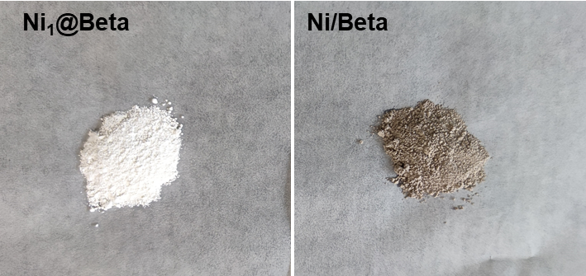
Supplementary Fig. 1: Pictures of Ni₁@Beta and Ni/Beta.
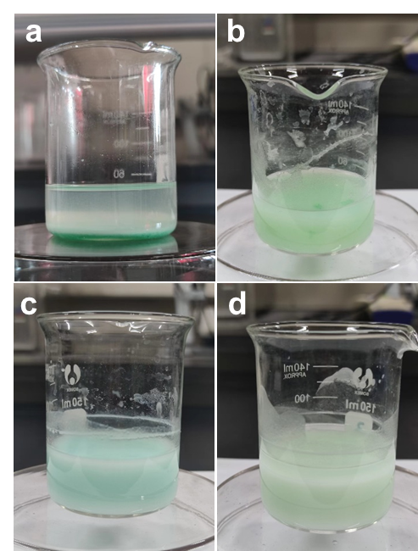
Supplementary Fig. 2: Stability of Ni(NO₃)₂ precursors in alkaline solution. NaOH solutions have the same pH value as the starting alumino-silicate gel of Beta zeolite (a) in the absence of SiO₂ and (b) in the presence of SiO₂. NaOH solutions have the same pH value as solution after nucleation progress (c) in the absence of SiO₂ and (d) in the presence of SiO₂.
As shown in Supplementary Fig. 2a, Ni(NO₃)₂ quickly precipitate as bulk metal hydroxides in the NaOH solution that have the same pH value as the starting alumino-silicate gel for corresponding Beta zeolite. As shown in Supplementary Fig. 2c, Ni metal precursors dispersed in the solutions without formation of bulk precipitates in the NaOH solution that have the same pH value as the nucleation solution for corresponding Beta zeolite. In addition, the addition of SiO₂ result in a more homogeneous distribution of Ni species (Supplementary Fig. 2b. 2d). These results indicate that Ni(NO₃)₂ precursors are unstable in the high pH, and the separating preliminary nucleation step can effectively avoid the formation of bulk nickel hydroxide precipitates during crystallization, enabling the successful incorporation of Ni species into the Beta zeolite.
Supplementary Fig. 3: XRD patterns of Ni₁@Beta and Ni/Beta-HT.

The XRD pattern of Ni/Beta-HT prepared by the in situ one-step hydrothermal synthesis method shows an amorphous SiO₂ structure without peaks characteristic of the BEA structure, implying the failure of metal incorporation.
Supplementary Fig. 4: XRD patterns of Beta zeolite, Ni₁@Beta and Ni/Beta, respectively.
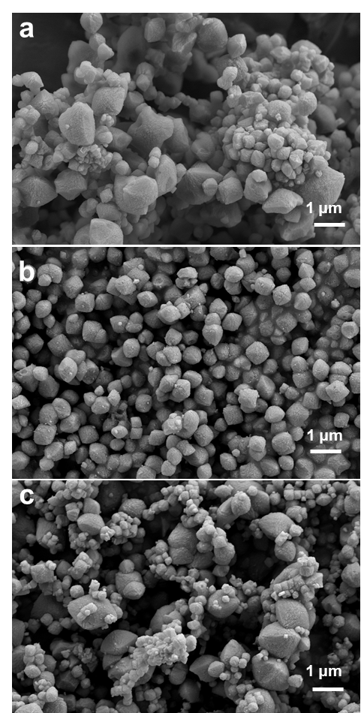
Supplementary Fig. 5: SEM images of (a) Beta, (b) Ni₁@Beta, and (c) Ni/Beta.
Supplementary Fig. 6: N₂ adsorption isotherms for Beta, Ni₁@Beta and Ni/Beta.
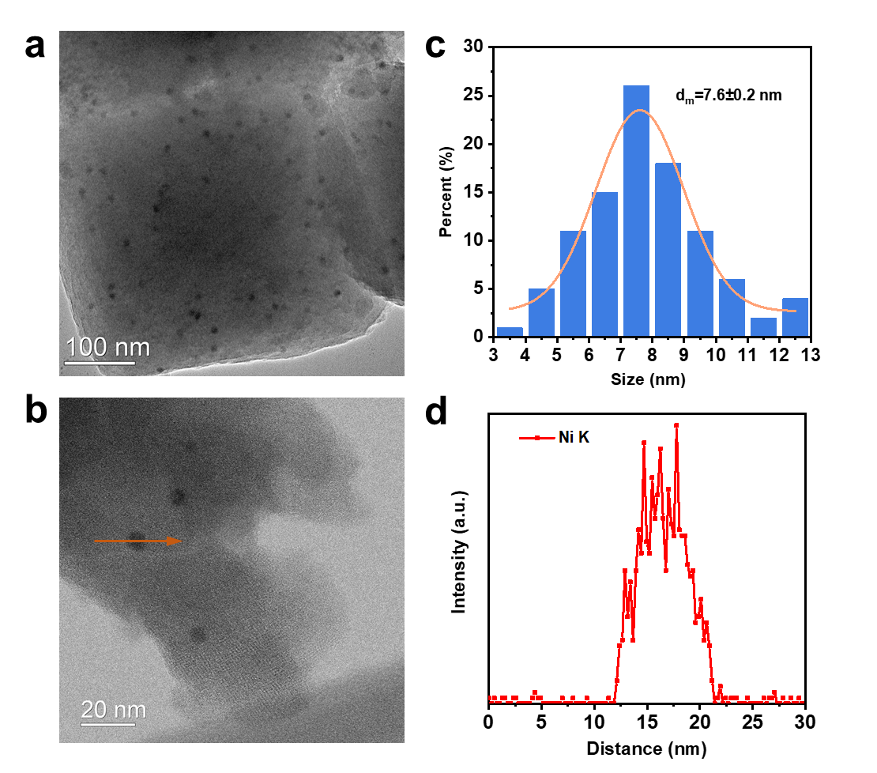
Supplementary Fig. 7: (a, b) TEM images (c) Particle distribution and (d) Elemental mapping for Ni element of Ni/Beta.
Supplementary Fig. 8: H₂-TPD profiles of Ni₁@Beta and Ni/Beta.

The Ni₁@Beta displays a large H₂ desorption peak around 529 ℃, and Ni/Beta has two H₂ desorption peaks locate at ~529 and ~292 ℃, respectively. The high temperature desorbed H₂ can be assigned to the desorption of the spillovered H on Beta zeolite by a reverse process.^{[1,2]} The low temperature desorbed H₂ can be ascribed to hydrogen species weakly chemisorbed on the surface of small Ni species.^{[3]} It has been reported that smaller Ni particles with more surface sites favour more H spillover.^{[4]} Therefore, the results of H₂-TPD prove that the size of Ni particles on Ni₁@Beta are much smaller than that on Ni/Beta.
Supplementary Fig. 9: Ni K-edge EXAFS (points) and the curvefit (line) for Ni₁@Beta and Ni/Beta, shown in shown in k² weighted k-space.
Supplementary Fig. 10: Ni K-edge EXAFS (points) and the curvefit (line), shown in R-space (FT magnitude and imaginary component). The data are k²-weighted and not phase-corrected.
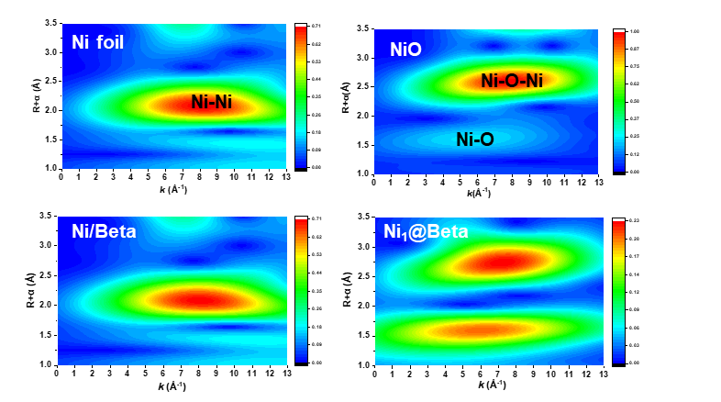
Supplementary Fig. 11: Ni K-edge EXAFS WTs for Ni₁@Beta and Ni/Beta catalysts with comparison to a Ni foil and a NiO reference.
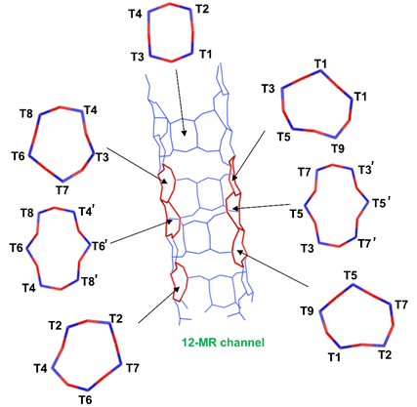
Supplementary Fig. 12: Schematic graphical representation of the nine different T sites in zeolite Beta.
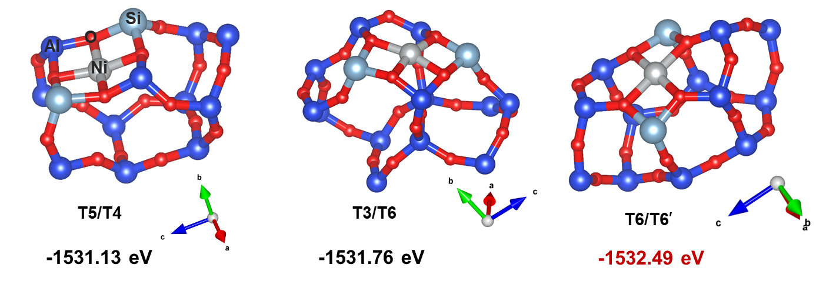
Supplementary Fig. 13: The possible structures of Ni₁@Beta when Ni sits in 4-, 5-, 6-member ring, respectively. The relative energy is shown in eV.

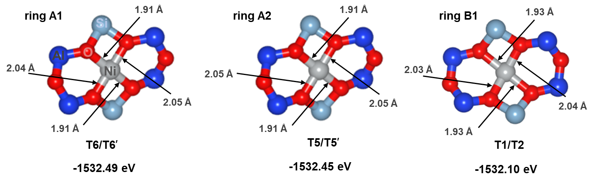
Supplementary Fig. 14: DFT-calculated structures of analogous Ni(II) sites formed in each of the three types of 6-member ring present in BEA.

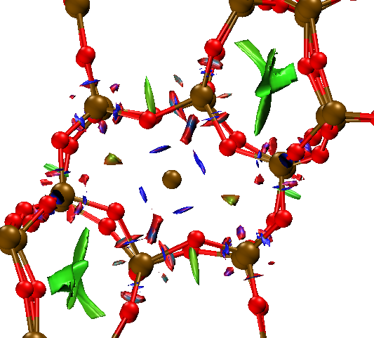
Supplementary Fig. 15: IRI isosurface map of Ni₁@Beta. Blue and green isosurfaces represent the chemical bonding interactions and vdW interactions, respectively.

Supplementary Fig. 16: XRD patterns of spent Ni₁@Beta and spent Ni/Beta. Spent catalysts were the catalysts collected after 5 consecutive runs.
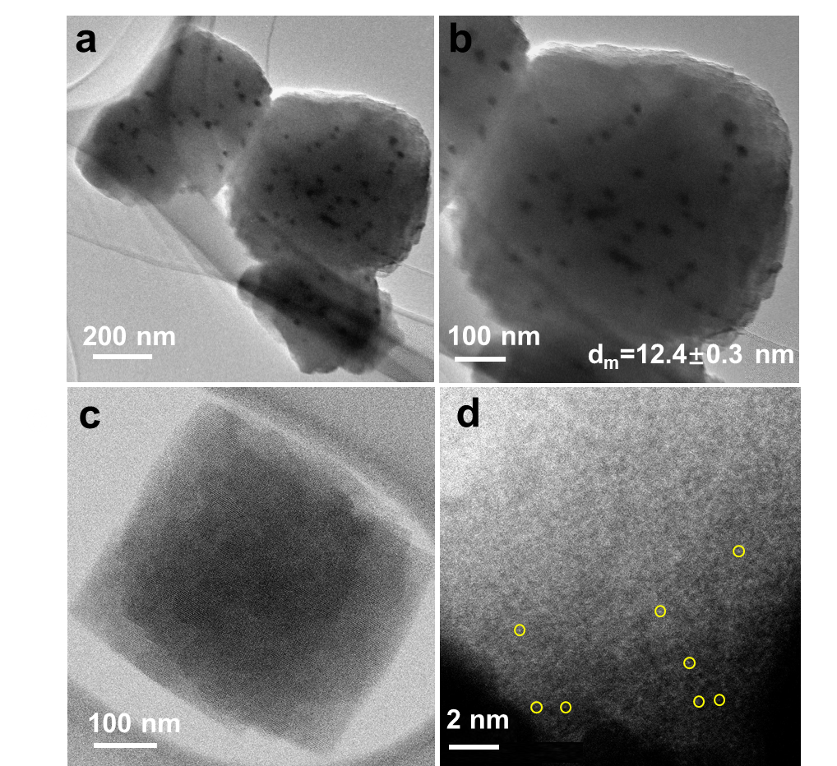
Supplementary Fig. 17: (a, b) TEM images of the spent Ni/Beta. (c) STEM, and (d) AC-HAADF-STEM images of the spent Ni₁@Beta (Isolated Ni atoms are marked in yellow circles). Both spent catalysts were collected after five consecutive runs.
Supplementary Fig. 18: O 1S profiles of Ni₁@Beta and Ni/Beta.
Supplementary Fig. 19: Low temperature FT-IR spectra after CO adsorption on the Beta zeolite at -170 °C.
Supplementary Table 1: Si/Al ratios, metal loadings and relative crystallinity of zeolite samples.
Samples | Si/Alª | Ni loading (wt %)^{b} | Relative  crystallinity (%)^{c}
Beta | 28.3 | -- | 100
Ni₁@Beta | 30.5 | 1.15 | 95
Ni/Beta | 27.8 | 1.10 | 90
Ni/SiO₂ | -- | 1.12 | --
Spent Ni₁@Beta^{d} | 29.6 | 1.13 | 94
Spent Ni/Beta^{e} | 27.1 | 0.74 | 88
ª Determined by XRF;
^{b} Determined by ICP-OES;
^{c} The relative crystallinity was calculated based on the intensity of the 22.4○;
^{d} After five consecutive runs. Reaction conditions: FF mass = 0.3 g, isopropanol mass = 23.56 g, catalyst mass = 0.1 g, P_{H2} = 10 bar, T = 110 °C, t = 1 h, stir = 1000 rpm.
^{e} After five consecutive runs. Reaction conditions: FF mass = 0.3 g, isopropanol mass = 23.56 g, catalyst mass = 0.4 g, P_{H2} = 10 bar, T = 110 °C, t = 1 h, stir = 1000 rpm.

Supplementary Table 2: Textual properties for Beta, Ni₁@Beta and Ni/Beta.
Samples | BET surface area (m²/g)ª |  |  | Volume (cm³/g)ª
Samples | micro | meso | total | micro | meso | total
Beta | 500 | 154 | 654 | 0.25 | 0.04 | 0.29
Ni₁@Beta | 504 | 193 | 697 | 0.27 | 0.05 | 0.32
Ni/Beta | 468 | 134 | 602 | 0.22 | 0.07 | 0.28
ª Specific surface area is obtained by the BET method; the micropore surface area and micropore volume are calculated by the t-plot method; the mesopore volume is calculated by subtracting the micropore volume from the total volume.
Supplementary Table 3: Structural parameters extracted from quantitative EXAFS curve-fitting.ª
Sample | Shell | CN^{b} | R(Å)^{c} | σ²×10²(Å²)^{d} | △E₀(eV)^{e} | R-factor^{f}
Ni foil | Ni-Ni | 12.0 | 2.50 | 0.60 | 7.2 | 0.002
NiO | Ni-O | 6.0 | 2.07 | 0.39 | -2.6 | 0.021
NiO | Ni-O-Ni | 12.0 | 2.95 | 0.50 | -2.6 | 0.021
Ni₁@Beta | Ni-O | 4.0 | 2.05 | 0.71 | -4.5 | 0.015
Ni₁@Beta | Ni-O-Si(Al) | 4.6 | 3.26 | 0.41 | -4.5 | 0.015
Ni/Beta | Ni-O | 2.1 | 2.03 | 0.53 | 6.5 | 0.020
Ni/Beta | Ni-Ni | 7.3 | 2.50 | 0.61 | 6.5 | 0.020
ª The data range used for data fitting in k-space (∆k) and R-space (∆R) are 3-12.4 Å⁻¹ and 1.0-3.0 Å, respectively; S₀² was fixed as 0.80, according to the experimental EXAFS fit of Ni foil reference by fixing CN as the known crystallographic value. The accuracies of the above parameters were estimated as CN, ±20%; R, ±1%; σ², ±20%; ΔE₀, ±20%.
^{b} CN: coordination numbers.
^{c} R: bond distance.
^{d} σ²: Debye-Waller factors.
^{e} ΔE₀: the inner potential correction.
^{f} R factor: goodness of fit.

Supplementary Table 4: Comparison of the energetic of different configurations.
 | T site | Relative Energy (eV)
4-MR | T2/T3 | -1530.43
4-MR | T6/T3 | -1531.13
4-MR | T5/T4 | -1531.13
4-MR | T1/T4 | -1530.80
5-MR | T2/T7 | -1531.56
5-MR | T4/T7 | -1530.75
5-MR | T4/T6 | -1531.56
5-MR | T3/T6 | -1531.76
5-MR | T3/T8 | -1530.92
5-MR | T6/T2 | -1531.56
5-MR | T5/T7 | -1530.53
5-MR | T4/T2 | -1530.95
6-MR | T4/T4’ | -1531.48
6-MR | T6/T6’ | -1532.49
6-MR | T8/T8’ | -1531.31
6-MR | T7/T7’ | -1531.48
6-MR | T5/T5’ | -1532.25
6-MR | T3/T3’ | -1531.22
6-MR | T7/T8 | -1531.24
 | T1/T2 | -1532.10
 | T5/T6 | -1531.24

Supplementary Table 5: Bader charge changes for different atoms in the T6/T6’ model.
Atom | Bader charge change (e)
Ni | -0.962
O100 | 1.448
O104 | 1.462
O59 | 1.464
O55 | 1.443

Supplementary Table 6: Catalytic hydrogenation of furfural with different catalysts.
Entry | Catalyst | TOF (h⁻¹)^{d} | Conversion (%) | Selectivity (%)
 |  |  |  | FAL | THFA | FDA | FIE
1 | Betaª |  | 5.2 | 20.9 | 5.8 | 58.4 | 10.7
2 | Ni/Betaª |  | 57.6 | 72.1 | 13.3 | 7.8 | 5.1
3 | Ni₁@Betaª |  | 93.7 | 91.6 | 3.7 | 2.4 | 1.5
4 | Ni/Beta^{b} |  | 87.1 | 60.8 | 29.1 | 5.2 | 3.6
5 | Ni₁@Beta^{b} |  | 100 | 88.2 | 5.6 | 3.0 | 2.8
6 | Ni/SiO₂ª | 9.8 | 16.6 | 76.4 | 22.0 | 0.4 | 0.3
7 | Ni/Beta^{c} | 37.6 | 20.8 | 77.7 | 9.6 | 6.3 | 5.4
8 | Ni₁@Beta^{c} | 114.1 | 23.1 | 90.4 | 2.5 | 4.2 | 2.7
ª Reaction conditions: FF mass = 0.3 g, isopropanol mass = 23.56 g, catalyst mass = 0.3 g, P_{H2} = 10 bar, T = 110 °C, stir = 1000 rpm, t = 1 h.
^{b} Reaction conditions: FF mass = 0.3 g, isopropanol mass = 23.56 g, catalyst mass = 0.3 g, P_{H2} = 10 bar, T = 110 °C, stir = 1000 rpm, t = 2 h.
^{c} Controlling the reactions at low conversion levels for TOF calculation.
^{d} TOF = (converted moles of FF) / (moles of Ni sites × time (h) ), and TOF values of different catalysts are calculated at low FF conversions.

Supplementary Table 7: Comparison of the catalytic performance of different catalysts in the hydrogenation of furfural to furfuryl alcohol.
Catalyst | P_{H2} (bar) | T (°C) | Solvent | Time (h) | FF conversion (%) | FAL yield (%) | FAL selectivity (%) | TOF  (h⁻¹) | Ref.
Ni/CNª | 10 | 200 | isopropanol | 4 | ~100 | 75 | 75 | 18.5 | 5
Ni/SiO₂ | 34 | 140 | isopropanol | 5 | 67.3 | 33.7 | 50.1 | 7.3 | 6
Ni₃Fe₁/SiO₂ | 34 | 140 | methanol | 3 | 99.5 | 76.7 | 77.1 | 25.9 | 6
Ni-ReOx/TiO₂ | 30 | 130 | dioxane | 3 | ~100 | 31.6 | 31.6 | 29.5 | 7
10%Ni/MgO | 30 | 100 | ethanol | 1 | 11.9 | 3.8 | 32.1 | 3.2 | 8
Ni/TiO₂ | 20 | 140 | isopropanol | 6 | 80 | 70 | 87.5 | 2.6 | 9
Ni/MgAlO | 40 | 140 | ethanol | 3 | ~100 | 25 | 25 | 33.9 | 10
CuNi/MgAlO | 40 | 140 | ethanol | 3 | ~100 | 74 | 74 | 69.5 | 10
Ni/Al₂O₃ | 40 | 140 | water | 4 | ~100 | <38 | <38 | 24.0 | 11
Ni/Ba-Al₂O₃ | 40 | 140 | water | 4 | ~100 | <1 | <1 | 68.0 | 11
Ni₁@Beta | 10 | 110 | isopropanol | 2 | ~100 | 88.2 | 88.2 | 114.1 | This work
ªNitrogen doped hierar chically porous carbon (CN).

References
- Boudjahem, A. G., Monteverdi, S., Mercy, M. & Bettahar, M. M. Study of nickel catalysts supported on silica of low surface area and prepared by reduction of nickel acetate in aqueous hydrazine. J. Catal. 221, 325-334 (2004).
- Wang, Y., Wu, R. & Zhao, Y. Effect of ZrO₂ promoter on structure and catalytic activity of the Ni/SiO₂ catalyst for CO methanation in hydrogen-rich gases. Catal. Today 158, 470-474 (2010).
- Ewald, S., Standl, S. & Hinrichsen, O. Characterization of nickel catalysts with transient methods. Appl. Catal. A, Gen. 549, 93-101 (2018).
- Yang, F. F. et al. Size dependence of vapor phase hydrodeoxygenation of m-cresol on Ni/SiO₂ catalysts. ACS Catal. 8, 1672-1682 (2018).
- Kotbagi, T. V., Gurav, H. R., Nagpure, A. S., Chilukuri, S. V. & Bakker, M. G. Highly efficient nitrogen-doped hierarchically porous carbon supported Ni nanoparticles for the selective hydrogenation of furfural to furfuryl alcohol. RSC Adv. 6, 67662-67668 (2016).
- Jia, P., Lan, X., Li, X. & Wang, T. Highly active and selective NiFe/SiO₂ bimetallic catalyst with optimized solvent effect for the liquid-phase hydrogenation of furfural to furfuryl alcohol. ACS Sustainable Chem. & Eng. 6, 13287-13295 (2018).
- Lin, W. et al. Surface Synergetic Effects of Ni-ReO for promoting the mild hydrogenation of furfural to tetrahydrofurfuryl alcohol. ACS Catal. 13, 11256-11267 (2023).
- Liu, L., Lou, H. & Chen, M. Selective hydrogenation of furfural to tetrahydrofurfuryl alcohol over Ni/CNTs and bimetallic Cu Ni/CNTs catalysts. Int. J. Hydrogen Energy 41, 14721-14731 (2016).
- Zhang, J., Mao, D., Zhang, H. & Wu, D. Improving furfural hydrogenation selectivity by enhanced Ni-TiO₂ electronic interaction. Appl. Catal. A: Gen. 660, 119206-119217 (2023).
- Wu, J. et al. Efficient and versatile CuNi alloy nanocatalysts for the highly selective hydrogenation of furfural. Appl. Catal. B: Environ. 203, 227-236 (2017).
- Yang, Y. et al. Aqueous phase hydrogenation of furfural to tetrahydrofurfuryl alcohol on alkaline earth metal modified Ni/Al₂O₃. RSC Adv. 6, 51221-51228 (2016).

