Physicochemical property and pharmacological activity of exopolysaccharide from endophytic bacterium Bacillus sp. B3 isolated from Polygonatum sibiricum

Yingjuan Song#, Xunlian Zhang#, Kun Li, Xiaoyu Liu, Zhaoxi Liu, Yongheng Rong, Weian Mao, Houcheng Zhang* , Yun Kong*, Min Chen*

The State Key Laboratory of Microbial Technology, National Glycoengineering Research Center, Shandong University, Qingdao, Shandong 266237, China
# these authors contributed equally to this work
*Correspondence: chenmin@sdu.edu.cn ;
kongyun@sdu.edu.cn
zhanghoucheng@sdu.edu.cn

Supporting Information
Table of Contents

Fig.S1 Elution profiles and physicochemical analysis: crude polysaccharide on DEAE-cellulose column (A), fraction on Sephacryl-300 column (B). 2
Fig.S2 The average molecular weight and polydispersity of EPS-B3. 2
Fig.S3 FT-IR spectrum of PSP. 3
Fig.S4 The tumor volume from tumorbearing mouse model treated with PBS, PSP or different concentration EPS-B3. 3
Table S1. The Morphological Analysis of Endophytes from Polygonatum 4
Table S2. Physiological and biochemical characteristics of B3 5
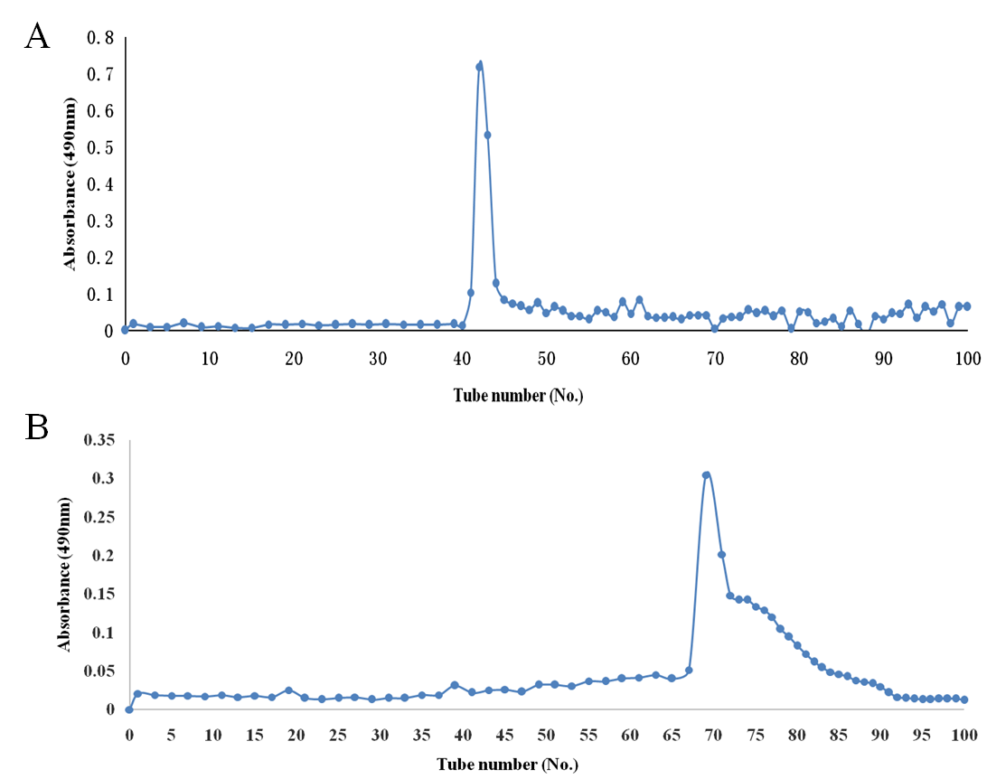
Fig.S1 Elution profiles and physicochemical analysis: (A) crude polysaccharide on DEAE-cellulose column; (B) fraction on Sephacryl-300 column.

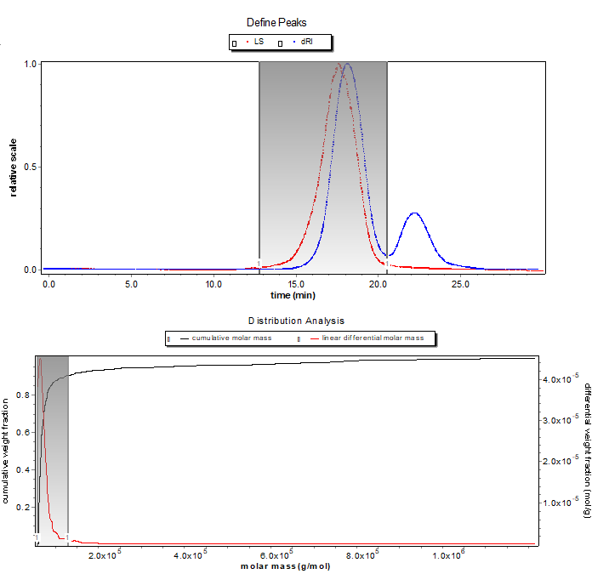
Fig.S2 The average molecular weight and polydispersity of EPS-B3
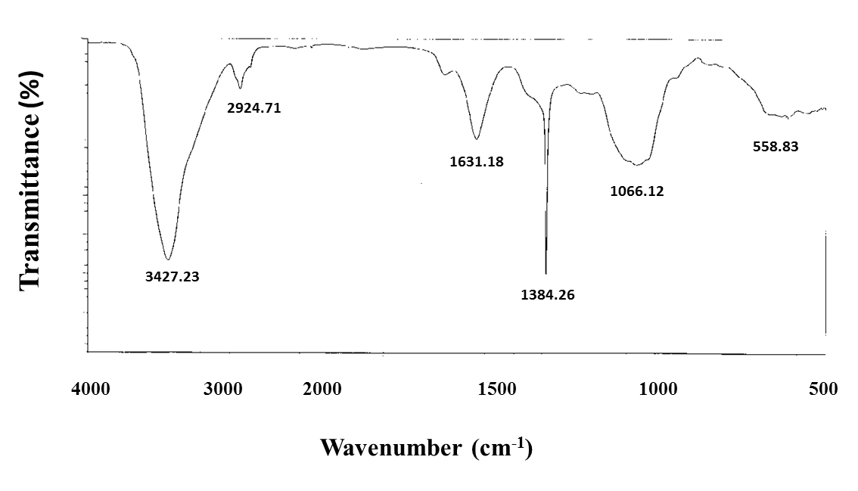Fig.S3 FT-IR spectrum of PSP Fourier-transform infrared (FT-IR) spectrum (500 cm⁻¹ and 4000 cm⁻¹) was used to measure the characteristic of groups of PSP.

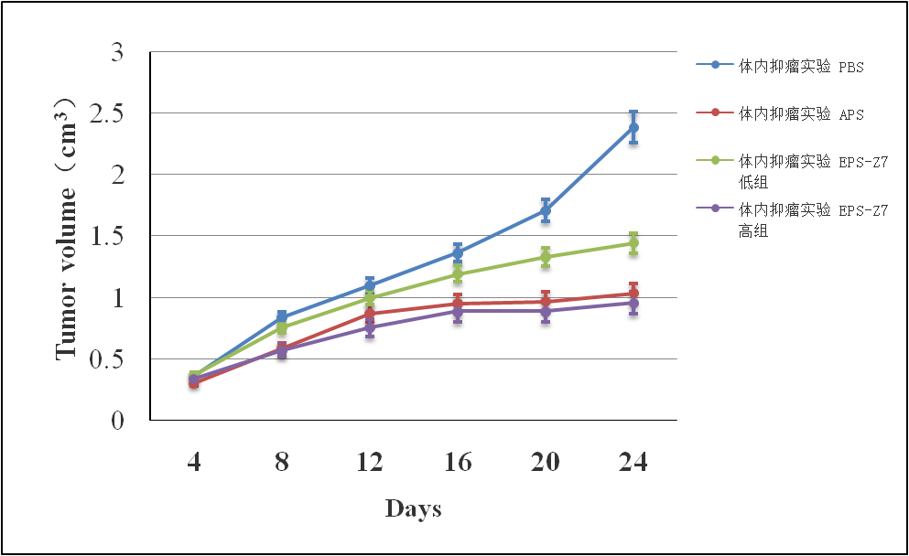
PBS
PSP (100 mg/kg)
EPS-B3 (100 mg/kg)
EPS-B3 (300 mg/kg)
Fig.S4 The tumor volume from tumor bearing mouse model treated with PBS, PSP or different concentration EPS-B3.

TableS1. The Morphological Analysis of Endophytes from Polygonatum
Strains | Colony morphology | Exopolysaccharideproduction (mg / L) | Sugar content（%）
A1 | Largecolonies, tiled, white, dry surface | 170 | 22.3
A2 | Smallercolonies, round, upward bulge, yellow, wet surface | 345 | 26.5
A3 | Smallcolonies, round, uplift, the surface moist | 540 | 42.2
B1 | Larger colonies, protrusions, surface dry, colony opaque edges | 480 | 34.6
B2 | Round colonies, protrusions, small, opaque, moist, drawing | 600 | 43.2
B3 | Round colonies, small, the middle process, moist, adhesive drawing, opaque | 1700 | 67.1

Table S2. Physiological and biochemical characteristics of B3
Characteristics | Results | Characteristics | Results
α-D-glucose | + | Oxidase | -
D-maltose | + | V-P experiment | -
D-mannose | + | Methylred experiment | -
Arabinose | - | L-lysine decarboxylase | -
Mannitol | + | Ornithine decarboxylase | -
Sucrose | + | L-arginine dihydrolase | +
Glucosamine | - | N-acetyl glucosamine acid | -
D-fructose | - | Hydrolysis of urea | -
N-acetylglucosamine | - | Hydrolysis of esculin | -
D-cellobiose | - | Nitrate reduction | +
Inositol | - | Indole test | -
Lactose | - | Citrate utilization | +
Acetate | - | Malonate | +
Liquefied gelatin | -

