Anti-Thermal Quenching in Nd^{III} Molecular Near-Infrared Thermometers Operating at Physiological Temperatures
María José Maldonado,^{[a]} Patricia Farías-Carreño,^{[a]} Yolimar Gil,^{[a]} Andrés Vega,^{[b]} Ricardo Costa de Santana,^{[c]} Daniel Aravena,^{[d]*} Carlos D. S. Brites,^{[e]} Luís D. Carlos,^{[e]} Albano N. Carneiro Neto,^{[e]*} Fiorenzo Vetrone,^{[f]} Pablo Fuentealba*^{[a]}
[a] MSc. M.J. Maldonado, P. Farías-Carreño, Dr. Y. Gil, Prof. P Fuentealba
Facultad de Ciencias Químicas y Farmacéuticas
Universidad de Chile
Olivos 1007, 8380544, Santiago, Chile
E-mail: pfuentealbacastro@ciq.uchile.cl
[b] Prof. A. Vega
Departamento de Ciencias Químicas
Universidad Andrés Bello
Av. República 275, 8370011, Santiago, Chile
[c] Prof. R. C. Santana
Instituto de Física
Universidade Federal de Goiás
Campus Samambaia, 74690-900, Goiânia (GO), Brazil
[d] Prof. Daniel Aravena
Departamento de Materiales, Facultad de Química y Biología
Universidad de Santiago
Santiago 9160000, Chile
E-mail: daniel.aravena.p@usach.cl
[e] Prof. L. D. Carlos, Prof. C. D. S. Brites, Dr. A. N. Carneiro Neto
Phantom-g, CICECO–Aveiro Institute of Materials, Physics Department
University of Aveiro, 3810-193, Aveiro, Portugall
E-mail: albanoneto@ua.pt
[f] Prof. F. Vetrone
Institut National de la Recherche Scientifique, Centre Énergie, Matériaux et Télécommunications
Université du Québec
Varennes (Montréal), Québec, Canada, J3X 1P7
Contents
1. SYNTHESIS OF THE COMPOUNDS 2
2. CHARACTERIZATION 3
2.1. Crystallographic details 3
Figure S1 3
Figure S2 3
Table S1 4
Table S2 4
Table S3 7
Table S4 7
Table S5 7
2.2. Other characterizations 7
Figure S3 8
Figure S4 8
Figure S5 9
Table S6 9
3. THERMOMETRIC PROPERTIES 10
Figure S6 10
Table S7 10
Table S8 11
Table S9 11
Table S10 12
Figure S7 12
Figure S8 13
4. THEORETICAL CALCULATIONS 14
Figure S9 14
Figure S10 15
REFERENCES 16

1. SYNTHESIS OF THE COMPOUNDS
[Nd(L)(NO₃)₃] (1): The synthesis of the mononuclear complex was performed following procedures described in the literature ^{[1–4]}, using the well-known template reaction of 2,6-pyridinedicarbaldehide with ethylenediamine in the presence of neodymium(III) nitrate (Nd(NO₃)₃·6H₂O). In this procedure, to a solution of 1 mmol of the dialdehyde in 7.5 mL of ethanol/acetonitrile (1:1), a solution of 0.5 mmol of neodymium(III) nitrate in 7.5 mL of the same solvent mixture was added. Subsequently, 1 mmol of ethylenediamine was added directly to the reaction solution, which was stirred for 3 h at room temperature. The formed solid was filtered and washed with the same solvent mixture and dried under vacuum. Rhombic shape single crystals, suitable for X-ray diffraction, were obtained after 2 weeks by slow evaporation of the filtered solution. Yield: 64.8%. %exp(calc): C = 31.9 (33.3) N = 18.5 (19.4) H = 3.0 (2.8). IR (cm⁻¹): 1652 (C=N) imine. 1558 (C=N) pyridine; 1450, 1300 and 1030 (bidentate NO₃⁻ )

[(Nd(L))₂(µ-BDC)(NO₃)₂](NO₃)₂·H₂O (2): For the synthesis of the dimeric unit, the obtained mononuclear complex (1) was reacted with 1,4-benzene dicarboxylic acid (H₂BDC), using the following procedure. An aqueous solution of 0.5 mmol of (1) in 4 mL nanopure water was mixed with an aqueous solution of 0.5 mmol of H₂BDC with 1 mmol triethylamine in 4 mL of the same solvent. The reaction mixture was refluxed for 3 h. The obtained solid was filtered, washed with nanopure water, and dried under vacuum. From the residual solution, single crystals with orthorhombic shape were formed within a week. Yield: 42.5 %. % exp(calc): C = 41.3 (43.1) N = 13.3 (13.5) H = 3.9 (3.6). IR (cm⁻¹): 1657 (C=N) imine. 1559 (C=N) pyridine; 1533-1506 (C=O) carboxilate; 1450, 1300 and 1030 (bidentate NO₃⁻ ); 1383 ionic nitrate; 835 (C-H) p-substituted benzene ring.

[(Nd(L))(µ-BTC)(H₂O)]₆·35H₂O (3): For the synthesis of the hexameric unit, a similar procedure was follow as described above; but instead of H₂BDC, 1,3,5-bencenetricarbolxilic acid (H₃BTC) was added as the bridging ligand. Yield: 7.7%. %exp(calc): C = 40.4 (40.9) N = 10.8 (10.6) H = 4.3 (4.4). IR (cm⁻¹): 1657 (C=N) imine. 1607 (C=N) pyridine; 1550-1537 (C=O) carboxilate; 760 (C-H) 1,3,5-substituted benzene ring.

2. CHARACTERIZATION

2.1. Crystallographic details

Figure S1. Stack interactions in the packing structure of 1. Symmetry label: iii: 1.5 - x, 1.5 - y, 2 – z.

Figure S2. Schematic representation of the first coordination sphere of 1Nd (a), 2Nd (b), and the repetitive unit of 6Nd (c).

Table S1. Crystal data and structure refinement details for 1Nd, 2Nd, and 6Nd.
 | 1Nd | 2Nd | 6Nd
CSD Deposit Code | CCDC2284360 | CCDC2284362 | CCDC2295992
FW/uma | 648.65 | 1213.38 [+anions +solvent] | 4126.53 [+ solvent]
Formula | C₁₈H₁₈N₉NdO₉ | C₄₄H₄₀N₁₄Nd₂O₁₀[+anions +solvent] | C₁₆₂H₁₃₈N₃₆Nd₆O₄₂[+solvent]
T / K | 296
Crystal System | Monoclinic | Orthorhombic | Trigonal
Space Group | C2/c | Fddd | R$\overline{3}$:H
a (Å) | 13.0256(4) | 13.9439(6) | 31.8437(6)
b (Å) | 9.8574(4) | 30.2750(15) | 31.8437(6)
c (Å) | 18.6057(8) | 31.0542(15) | 19.8704(9)
  | 90
  | 109.180(2) | 90
  | 90 |  | 120
V (Å ³) | 2256.34(15) | 13109.6 (11) | 17449.5(10)
Z(Z’) | 4(8) | 8(32) | 3(18)
d (g cm⁻³) | 1.909 | 1.230 | 1.178
❍ (mm⁻¹) | 2.37 | 1.62 | 1.38
F(000) | 1284 | 4816 | 6174
 range | 2.3° to 26.0° | 1.9° to 26.0° | 1.3° to 26.0°
hkl range | -16 ≤ h ≤ 16 | -17 ≤ h ≤ 17 | -39 ≤ h ≤ 19
hkl range | -12 ≤ k ≤ 12 | -37 ≤ k ≤ 37 | -38 ≤ k ≤ 39
hkl range | -22 ≤ l ≤ 22 | -38 ≤ l ≤ 38 | -24 ≤ l ≤ 24
N_{tot}, N_{uniq} (R_{int}), N_{obs} | 8392, 2206(0.026), 2081 | 24530, 3205(0.104), 1868 | 20702, 5911(0.029), 4852
Ref. Parameters | 169 | 161 | 378
GOF | 1.10 | 1.15 | 1.09
R1, wR2 (obs) | 0.021, 0.049 | 0.099, 0.325 | 0.039, 0.111
Max. and min  e Å⁻³ | 0.93, -0.73 | 1.52, -0.84 | 0.61, -0.75

Table S2. Selected bond distances and angles for 1Nd, 2Nd, and 6Nd.
1Nd
Nd1—O4^{i} | 2.622(2) | Nd1—N1^{i} | 2.691(2)
Nd1—O4 | 2.622(2) | Nd1—N1 | 2.691(2)
Nd1—N2^{i} | 2.659(2) | Nd1—O2^{i} | 2.694(2)
Nd1—N2 | 2.659(2) | Nd1—O2 | 2.694(2)
Nd1—O1 | 2.660(2) | Nd1—N3 | 2.712(2)
Nd1—O1^{i} | 2.660(2) | Nd1—N3^{i} | 2.712(2)
O4^{i}—Nd1—O4 | 48.42(8) | O1^{i}—Nd1—O2^{i} | 47.15(6)
O4^{i}—Nd1—N2^{i} | 66.17(6) | N1^{i}—Nd1—O2^{i} | 117.74(7)
O4—Nd1—N2^{i} | 110.33(6) | N1—Nd1—O2^{i} | 71.29(7)
O4^{i}—Nd1—N2 | 110.33(6) | O4^{i}—Nd1—O2 | 128.76(7)
O4—Nd1—N2 | 66.17(6) | O4—Nd1—O2 | 125.10(6)
N2^{i}—Nd1—N2 | 176.44(9) | N2^{i}—Nd1—O2 | 112.16(7)
O4^{i}—Nd1—O1 | 123.90(6) | N2—Nd1—O2 | 70.35(6)
O4—Nd1—O1 | 165.98(6) | O1—Nd1—O2 | 47.15(6)
N2^{i}—Nd1—O1 | 69.54(6) | O1^{i}—Nd1—O2 | 64.98(7)
N2—Nd1—O1 | 113.68(6) | N1^{i}—Nd1—O2 | 71.29(7)
O4^{i}—Nd1—O1^{i} | 165.98(6) | N1—Nd1—O2 | 117.74(7)
O4—Nd1—O1^{i} | 123.90(6) | O2^{i}—Nd1—O2 | 97.64(9)
N2^{i}—Nd1—O1^{i} | 113.68(6) | O4^{i}—Nd1—N3 | 68.82(7)
N2—Nd1—O1^{i} | 69.54(6) | O4—Nd1—N3 | 73.85(7)
O1—Nd1—O1^{i} | 66.21(9) | N2^{i}—Nd1—N3 | 61.60(7)
O4^{i}—Nd1—N1^{i} | 64.66(6) | N2—Nd1—N3 | 116.99(7)
O4—Nd1—N1^{i} | 103.16(6) | O1—Nd1—N3 | 116.18(6)
N2^{i}—Nd1—N1^{i} | 60.00(7) | O1^{i}—Nd1—N3 | 98.41(6)
N2—Nd1—N1^{i} | 119.55(7) | N1^{i}—Nd1—N3 | 115.48(7)
O1—Nd1—N1^{i} | 64.15(7) | N1—Nd1—N3 | 59.52(7)
O1^{i}—Nd1—N1^{i} | 128.31(7) | O2^{i}—Nd1—N3 | 61.72(7)
O4^{i}—Nd1—N1 | 103.16(7) | O2—Nd1—N3 | 159.31(7)
O4—Nd1—N1 | 64.66(7) | O4^{i}—Nd1—N3^{i} | 73.85(7)
N2^{i}—Nd1—N1 | 119.55(7) | O4—Nd1—N3^{i} | 68.82(7)
N2—Nd1—N1 | 60.00(7) | N2^{i}—Nd1—N3^{i} | 116.99(7)
O1—Nd1—N1 | 128.31(7) | N2—Nd1—N3^{i} | 61.60(7)
O1^{i}—Nd1—N1 | 64.15(7) | O1—Nd1—N3^{i} | 98.41(6)
N1^{i}—Nd1—N1 | 167.39(9) | O1^{i}—Nd1—N3^{i} | 116.18(6)
O4^{i}—Nd1—O2^{i} | 125.10(6) | N1^{i}—Nd1—N3^{i} | 59.52(7)
O4—Nd1—O2^{i} | 128.76(7) | N1—Nd1—N3^{i} | 115.48(7)
N2^{i}—Nd1—O2^{i} | 70.35(6) | O2^{i}—Nd1—N3^{i} | 159.31(7)
N2—Nd1—O2^{i} | 112.16(7) | O2—Nd1—N3^{i} | 61.72(7)
O1—Nd1—O2^{i} | 64.98(7) | N3—Nd1—N3^{i} | 138.95(10)
Symmetry code: i: -x+1, y, -z+3/2.
2Nd
Nd1—O2 | 2.328(6) | Nd1—N1^{ii} | 2.583(7)
Nd1—O2^{ii} | 2.328(6) | Nd1—N2 | 2.598(7)
Nd1—O1 | 2.444(5) | Nd1—N2^{ii} | 2.598(7)
Nd1—O1^{ii} | 2.444(5) | Nd1—N3^{ii} | 2.652(7)
Nd1—N1 | 2.583(7) | Nd1—N3 | 2.652(7)
O2—Nd1—O2^{ii} | 55.3(4) | O1—Nd1—N2^{ii} | 121.6(2)
O2—Nd1—O1 | 143.4(2) | O1^{ii}—Nd1—N2^{ii} | 73.1(2)
O2^{ii}—Nd1—O1 | 141.6(2) | N1—Nd1—N2^{ii} | 121.7(2)
O2—Nd1—O1^{ii} | 141.6(2) | N1^{ii}—Nd1—N2^{ii} | 62.0(2)
O2^{ii}—Nd1—O1^{ii} | 143.4(2) | N2—Nd1—N2^{ii} | 165.0(3)
O1—Nd1—O1^{ii} | 52.9(3) | O2—Nd1—N3^{ii} | 71.5(2)
O2—Nd1—N1 | 75.4(2) | O2^{ii}—Nd1—N3^{ii} | 106.7(2)
O2^{ii}—Nd1—N1 | 129.7(2) | O1—Nd1—N3^{ii} | 111.43(19)
O1—Nd1—N1 | 75.1(2) | O1^{ii}—Nd1—N3^{ii} | 70.35(18)
O1^{ii}—Nd1—N1 | 82.3(2) | N1—Nd1—N3^{ii} | 61.2(2)
O2—Nd1—N1^{ii} | 129.7(2) | N1^{ii}—Nd1—N3^{ii} | 119.3(2)
O2^{ii}—Nd1—N1^{ii} | 75.5(2) | N2—Nd1—N3^{ii} | 118.8(2)
O1—Nd1—N1^{ii} | 82.3(2) | N2^{ii}—Nd1—N3^{ii} | 60.9(2)
O1^{ii}—Nd1—N1^{ii} | 75.1(2) | O2—Nd1—N3 | 106.7(2)
N1—Nd1—N1^{ii} | 154.7(3) | O2^{ii}—Nd1—N3 | 71.5(2)
O2—Nd1—N2 | 74.1(2) | O1—Nd1—N3 | 70.35(18)
O2^{ii}—Nd1—N2 | 92.4(2) | O1^{ii}—Nd1—N3 | 111.43(19)
O1—Nd1—N2 | 73.1(2) | N1—Nd1—N3 | 119.3(2)
O1^{ii}—Nd1—N2 | 121.6(2) | N1^{ii}—Nd1—N3 | 61.2(2)
N1—Nd1—N2 | 62.0(2) | N2—Nd1—N3 | 60.9(2)
N1^{ii}—Nd1—N2 | 121.7(2) | N2^{ii}—Nd1—N3 | 118.8(2)
O2—Nd1—N2^{ii} | 92.4(2) | N3^{ii}—Nd1—N3 | 178.1(2)
O2^{ii}—Nd1—N2^{ii} | 74.1(2)
Symmetry code: ii: -x-1/4, -y+3/4, z.

6Nd
Nd1—O6^{i} | 2.369(3) | Nd1—N5 | 2.650(5)
Nd1—O7 | 2.522(4) | Nd1—N3 | 2.658(5)
Nd1—O1 | 2.558(3) | Nd1—N1 | 2.665(6)
Nd1—O2 | 2.592(4) | Nd1—N6 | 2.673(5)
Nd1—N2 | 2.617(5) | Nd1—N4 | 2.697(5)
O6^{i}—Nd1—O7 | 66.93(12) | O1—Nd1—N1 | 99.68(15)
O6^{i}—Nd1—O1 | 140.74(13) | O2—Nd1—N1 | 69.97(15)
O7—Nd1—O1 | 138.46(14) | N2—Nd1—N1 | 61.0(2)
O6^{i}—Nd1—O2 | 138.65(13) | N5—Nd1—N1 | 120.33(19)
O7—Nd1—O2 | 138.13(15) | N3—Nd1—N1 | 118.0(2)
O1—Nd1—O2 | 50.40(12) | O6^{i}—Nd1—N6 | 130.09(14)
O6^{i}—Nd1—N2 | 81.01(15) | O7—Nd1—N6 | 68.66(14)
O7—Nd1—N2 | 90.51(17) | O1—Nd1—N6 | 71.01(15)
O1—Nd1—N2 | 119.06(14) | O2—Nd1—N6 | 90.49(16)
O2—Nd1—N2 | 69.11(14) | N2—Nd1—N6 | 121.1(2)
O6^{i}—Nd1—N5 | 88.25(13) | N5—Nd1—N6 | 61.94(18)
O7—Nd1—N5 | 79.25(16) | N3—Nd1—N6 | 155.93(15)
O1—Nd1—N5 | 73.44(13) | N1—Nd1—N6 | 60.1(2)
O2—Nd1—N5 | 123.43(13) | O6^{i}—Nd1—N4 | 68.92(13)
N2—Nd1—N5 | 167.46(15) | O7—Nd1—N4 | 119.32(15)
O6^{i}—Nd1—N3 | 73.15(13) | O1—Nd1—N4 | 71.86(14)
O7—Nd1—N3 | 134.80(14) | O2—Nd1—N4 | 102.42(14)
O1—Nd1—N3 | 86.48(14) | N2—Nd1—N4 | 121.00(18)
O2—Nd1—N3 | 67.99(16) | N5—Nd1—N4 | 59.84(16)
N2—Nd1—N3 | 62.51(19) | N3—Nd1—N4 | 60.68(17)
N5—Nd1—N3 | 120.47(18) | N1—Nd1—N4 | 171.34(14)
O6^{i}—Nd1—N1 | 119.45(14) | N6—Nd1—N4 | 117.16(17)
O7—Nd1—N1 | 68.17(15)
Symmetry code: i: y+1/3, -x+y+2/3, -z+5/3.

Table S3. Continuous Shape Measurement Calculations (CShM) of the first coordination sphere of Nd^{III} in 1Nd, referring to all standard 12 vertices of the polyhedron. The lowest CShM value is highlighted in bold.
Structure [ML12] | 1Nd
Dodecagon | 36.955
Hendecagonal pyramid | 28.839
Decagonal bipyramid | 16.466
Hexagonal prism | 12.932
Hexagonal antiprism | 16.205
Truncated tetrahedron | 12.882
Cuboctahedron | 6.231
Anticuboctahedron J27 | 5.227
Icosahedron | 2.054
Johnson square cupola J4 | 21.900
Johnson elongated pentagonal bipyramid J16 | 2.944
Biaugmented pentagonal prism J53 | 15.421
Sphenomegacorona J88 | 15.738

Table S4. Continuous Shape Measurement Calculations (CShM) of the first coordination sphere of Nd^{III} in 2Nd, referring to all standard 10 vertices of the polyhedron. The lowest CShM value is highlighted in bold.
Structure [ML10] | 2Nd
Decagon | 37.003
Enneagonal pyramid | 25.561
Octagonal bipyramid | 15.568
Pentagonal prism | 11.442
Pentagonal antiprism | 11.297
Bicapped cube J15 | 8.744
Bicapped square antiprism J17 | 4.034
Metabidiminished icosahedron J62 | 6.779
Augmented tridiminished icosahedron J64 | 19.388
Sphenocorona J87 | 2.399
Staggered Dodecahedron (2:6:2) | 2.377
Tetradecahedron (2:6:2) | 1.811
Hexadecahedron (2:6:2) or (1:4:4:1) | 6.336

Table S5. Continuous Shape Measurement Calculations (CShM) of the first coordination sphere of Nd^{III} in 6Nd, referring to all standard 10 vertices of the polyhedron. The lowest CShM value is highlighted in bold.
Structure [ML10] | 6Nd
Decagon | 35.575
Enneagonal pyramid | 24.416
Octagonal bipyramid | 16.480
Pentagonal prism | 11.305
Pentagonal antiprism | 11.022
Bicapped cube J15 | 9.261
Bicapped square antiprism J17 | 4.248
Metabidiminished icosahedron J62 | 6.350
Augmented tridiminished icosahedron J64 | 18.968
Sphenocorona J87 | 2.607
Staggered Dodecahedron (2:6:2) | 2.079
Tetradecahedron (2:6:2) | 1.470
Hexadecahedron (2:6:2) or (1:4:4:1) | 6.766

2.2. Other characterizations
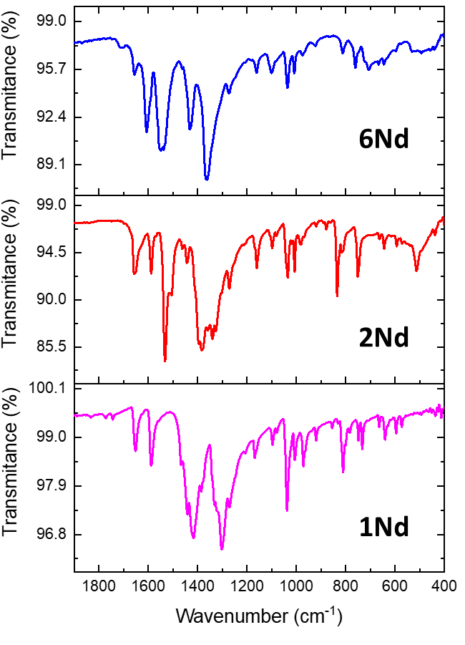
Figure S3. FTIR spectra of the Nd^{III} complexes 1Nd, 2Nd, and 6Nd.

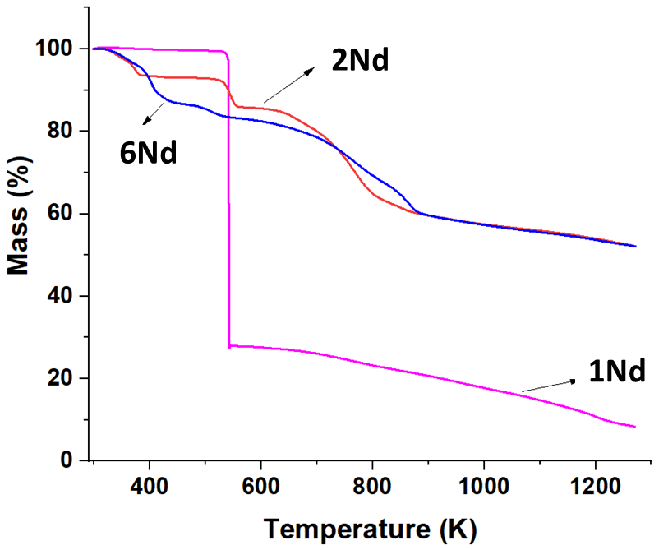
Figure S4. Thermograms of the Nd^{III} complexes 1Nd, 2Nd, and 6Nd.

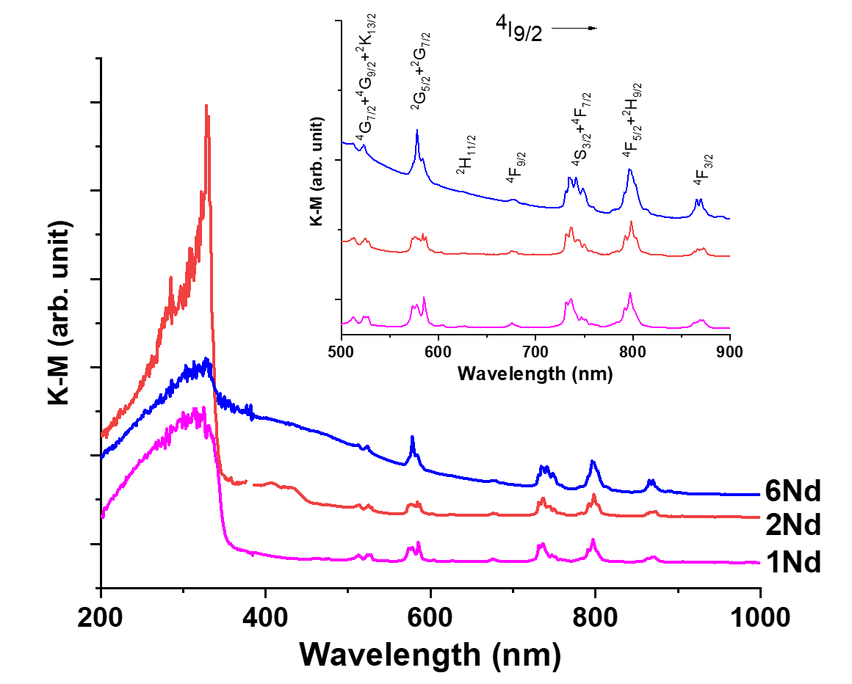
Figure S5. Kubelka-Munk plot for 1Nd, 2Nd, and 6Nd (stacked for clarity of the signals). The principal peaks corresponding to the absorption of the metal centre are shown in the inset.

Table S6. Assign of the transitions observed in absorption spectra.
Wavelength (nm) | Transition
510 – 523 | ⁴I_{9/2} → ⁴G_{7/2} + ⁴G_{9/2} + ²K_{13/2}
578 | ⁴I_{9/2} → ⁴G_{5/2} + ²G_{7/2}
623 | ⁴I_{9/2} → ²H_{11/2}
676 | ⁴I_{9/2} → ⁴F_{9/2}
732 – 738 | ⁴I_{9/2} → ⁴S_{3/2} + ⁴F_{7/2}
795-808 | ⁴I_{9/2} → ⁴F_{5/2} + ²H_{9/2}
866 | ⁴I_{9/2} → ⁴F_{3/2}

3. THERMOMETRIC PROPERTIES

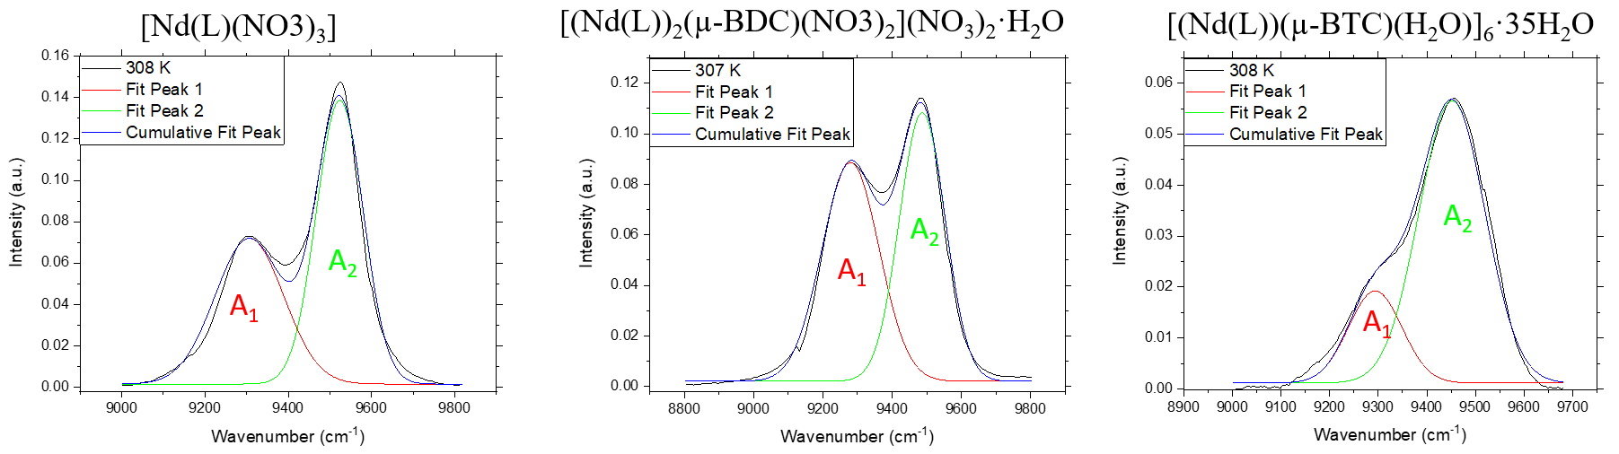
Figure S6. Representative deconvoluted plots for 1Nd (left), 2Nd (center), and for 6Nd (right).

Table S7. Fitted parameters and agreements factors of deconvolutions spectra for 1Nd.
Multiple peaks fitting using a Gaussian-type function: $I\left(λ\right)=I_{0}+\left[A/\left(w\sqrt{π/2}\right)\right]exp(-2{\left[\left(λ-λ_{0}\right)/w\right]}^{2})$
 | Peak 1 ($λ_{0}$ = 9306.6 cm⁻¹) |  |  | Peak 2 ($λ_{0}$ = 9523.8 cm⁻¹) |  |  | goodness of fit
T (K) | $$I_{0}$$  (×10⁻³) | $$w$$ | $$A$$ | $$I_{0}$$  (×10⁻³) | $$w$$ | $$A$$ | χ²  (×10⁻⁵) | R²
293 | 1.6 ± 0.6 | 159 ± 3 | 13.9 ± 0.3 | 1.6 ± 0.6 | 113 ± 1 | 19.2 ± 0.2 | 2.1 | 0.988
297 | 1.5 ± 0.6 | 161 ± 3 | 14.0 ± 0.3 | 1.5 ± 0.6 | 112 ± 1 | 19.0 ± 0.2 | 2.1 | 0.987
302 | 1.2 ± 0.6 | 165 ± 3 | 14.5 ± 0.3 | 1.2 ± 0.6 | 112 ± 1 | 19.3 ± 0.2 | 2.0 | 0.988
307 | 1.5 ± 0.6 | 165 ± 3 | 14.6 ± 0.3 | 1.5 ± 0.6 | 113 ± 1 | 19.4 ± 0.2 | 2.1 | 0.988
312 | 0.8 ± 0.6 | 168 ± 3 | 15.3 ± 0.3 | 0.8 ± 0.6 | 113 ± 1 | 19.8 ± 0.2 | 2.4 | 0.987
317 | 1.4 ± 0.6 | 169 ± 3 | 15.7 ± 0.3 | 1.4 ± 0.6 | 114 ± 1 | 20.4 ± 0.2 | 2.5 | 0.987
322 | 1.3 ± 0.6 | 169 ± 3 | 15.9 ± 0.3 | 1.3 ± 0.6 | 115 ± 1 | 20.5 ± 0.2 | 2.5 | 0.987
327 | 1.6 ± 0.6 | 170 ± 3 | 16.1 ± 0.3 | 1.6 ± 0.6 | 115 ± 1 | 20.8 ± 0.2 | 2.6 | 0.987
332 | 0.7 ± 0.7 | 171 ± 3 | 16.4 ± 0.3 | 0.7 ± 0.7 | 116 ± 1 | 21.0 ± 0.2 | 2.7 | 0.986

Table S8. Fitted parameters and agreements factors of deconvolutions spectra for 2Nd.
Multiple peaks fitting using a Gaussian-type function: $I\left(λ\right)=I_{0}+\left[A/\left(w\sqrt{π/2}\right)\right]exp(-2{\left[\left(λ-λ_{0}\right)/w\right]}^{2})$
 | Peak 1 ($λ_{0}$ = 9280.0 cm⁻¹) |  |  | Peak 2 ($λ_{0}$ = 9487.0 cm⁻¹) |  |  | goodness of fit
T (K) | $$I_{0}$$  (×10⁻³) | $$w$$ | $$A$$ | $$I_{0}$$  (×10⁻³) | $$w$$ | $$A$$ | χ²  (×10⁻⁵) | R²
293 | 1.5 ± 0.3 | 163 ± 2 | 15.9 ± 0.2 | 1.5 ± 0.3 | 130 ± 1 | 16.4 ± 0.2 | 0.48 | 0.996
297 | 1.9 ± 0.3 | 164 ± 2 | 16.6 ± 0.2 | 1.9 ± 0.3 | 130 ± 1 | 16.8 ± 0.2 | 0.54 | 0.996
302 | 2.1 ± 0.3 | 164 ± 2 | 17.2 ± 0.2 | 2.1 ± 0.3 | 131 ± 1 | 17.2 ± 0.2 | 0.56 | 0.996
307 | 2.1 ± 0.3 | 165 ± 2 | 17.9 ± 0.2 | 2.1 ± 0.3 | 132 ± 1 | 17.6 ± 0.2 | 0.64 | 0.996
312 | 2.0 ± 0.3 | 166 ± 2 | 18.3 ± 0.2 | 2.0 ± 0.4 | 132 ± 1 | 17.7 ± 0.2 | 0.69 | 0.996
317 | 2.2 ± 0.3 | 166 ± 2 | 18.8 ± 0.2 | 2.2 ± 0.4 | 133 ± 2 | 18.0 ± 0.2 | 0.77 | 0.995
322 | 2.2 ± 0.4 | 167 ± 2 | 19.2 ± 0.2 | 2.2 ± 0.4 | 134 ± 2 | 18.1 ± 0.2 | 0.79 | 0.995
327 | 2.2 ± 0.4 | 168 ± 2 | 19.5 ± 0.2 | 2.2 ± 0.4 | 135 ± 2 | 18.1 ± 0.2 | 0.84 | 0.995
332 | 2.3 ± 0.4 | 168 ± 2 | 19.5 ± 0.2 | 2.3 ± 0.4 | 136 ± 2 | 18.1 ± 0.2 | 0.83 | 0.995

Table S9. Fitted parameters and agreements factors of deconvolutions spectra for 6Nd.
Multiple peaks fitting using a Gaussian-type function: $I\left(λ\right)=I_{0}+\left[A/\left(w\sqrt{π/2}\right)\right]exp(-2{\left[\left(λ-λ_{0}\right)/w\right]}^{2})$
 | Peak 1 ($λ_{0}$ = 9293.7 cm⁻¹) |  |  | Peak 2 ($λ_{0}$ = 9451.8 cm⁻¹) |  |  | goodness of fit
T (K) | $$I_{0}$$  (×10⁻³) | $$w$$ | $$A$$ | $$I_{0}$$  (×10⁻³) | $$w$$ | $$A$$ | χ²  (×10⁻⁵) | R²
293 | 0.8 ± 0.3 | 96 ± 6 | 1.5 ± 0.1 | 0.8 ± 0.3 | 138 ± 2 | 8.6 ± 0.1 | 0.30 | 0.990
297 | 1.3 ± 0.2 | 103 ± 4 | 2.0 ± 0.1 | 1.3 ± 0.2 | 135 ± 2 | 8.9 ± 0.1 | 0.28 | 0.991
302 | 1.2 ± 0.2 | 108 ± 4 | 2.3 ± 0.1 | 1.2 ± 0.2 | 136 ± 1 | 9.3 ± 0.1 | 0.27 | 0.992
307 | 1.2 ± 0.2 | 110 ± 3 | 2.5 ± 0.1 | 1.2 ± 0.2 | 136 ± 1 | 9.4 ± 0.1 | 0.26 | 0.993
312 | 1.2 ± 0.2 | 113 ± 3 | 2.8 ± 0.1 | 1.2 ± 0.2 | 136 ± 1 | 9.7 ± 0.1 | 0.23 | 0.994
317 | 1.1 ± 0.2 | 117 ± 3 | 3.1 ± 0.1 | 1.1 ± 0.2 | 136 ± 1 | 10.0 ± 0.1 | 0.23 | 0.994
322 | 1.4 ± 0.2 | 120 ± 3 | 3.4 ± 0.1 | 1.4 ± 0.2 | 136 ± 1 | 10.3 ± 0.1 | 0.22 | 0.995
327 | 1.4 ± 0.2 | 124 ± 2 | 3.8 ± 0.1 | 1.4 ± 0.2 | 137 ± 1 | 10.8 ± 0.1 | 0.21 | 0.995
332 | 1.5 ± 0.2 | 127 ± 2 | 4.1 ± 0.1 | 1.5 ± 0.2 | 137 ± 1 | 11.0 ± 0.1 | 0.21 | 0.996

Table S10. LIR data, fitted parameters and goodness of linear fit for 6Nd.

Temp. (K) | A₁ (area) | A₂ (area) | A₁/A₂ | Linear Fit | S_{r}
293 | 1.5 | 8.6 | 0.18 | 0.20 | 2.4
297 | 2.0 | 8.9 | 0.22 | 0.21 | 2.2
302 | 2.3 | 9.3 | 0.25 | 0.24 | 2.0
307 | 2.5 | 9.4 | 0.26 | 0.26 | 1.8
312 | 2.8 | 9.7 | 0.29 | 0.28 | 1.6
317 | 3.1 | 10.0 | 0.31 | 0.31 | 1.5
322 | 3.4 | 10.3 | 0.33 | 0.33 | 1.4
327 | 3.8 | 10.8 | 0.35 | 0.35 | 1.3
332 | 4.1 | 11.0 | 0.37 | 0.38 | 1.2
Linear function y = a + b*x
a | b | χ²  (×10⁻⁴) | R²
-1.16 ± 0.07 | 0.0046 ± 2.4E-4 | 5.8 | 0.991
.

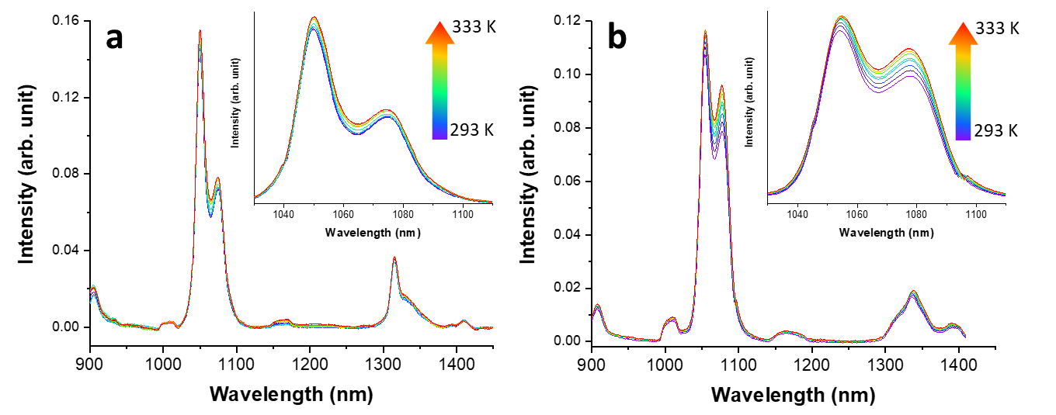
Figure S7. Temperature dependent emission spectra of a) the mononuclear complex [Nd(L)(NO₃)₃] (1Nd), and b) the dinuclear complex [(Nd(L))₂(µ-BDC)(NO₃)₂](NO₃)₂·H₂O (2Nd).

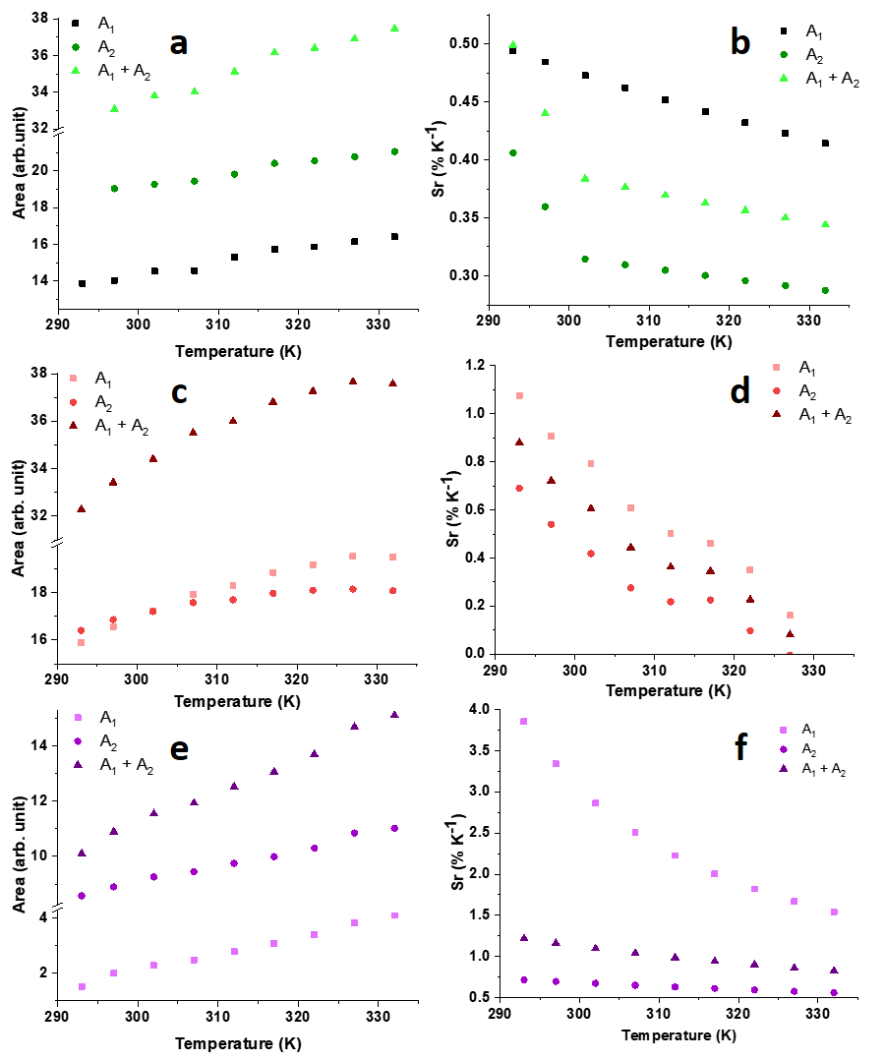
Figure S8. Temperature dependence of the area of the two components of the ⁴F_{3/2}→⁴I_{11/2} transition for a) 1Nd, c) 2Nd, and for e) 6Nd, as well as their respective relative sensitivities (b, d, and f).

4. THEORETICAL CALCULATIONS
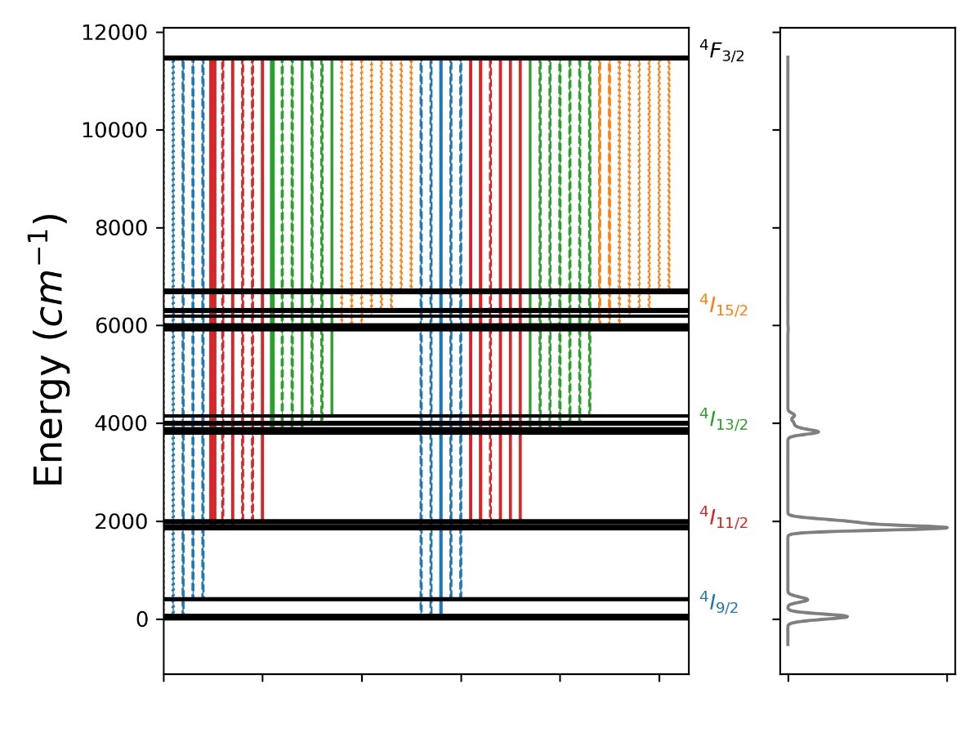
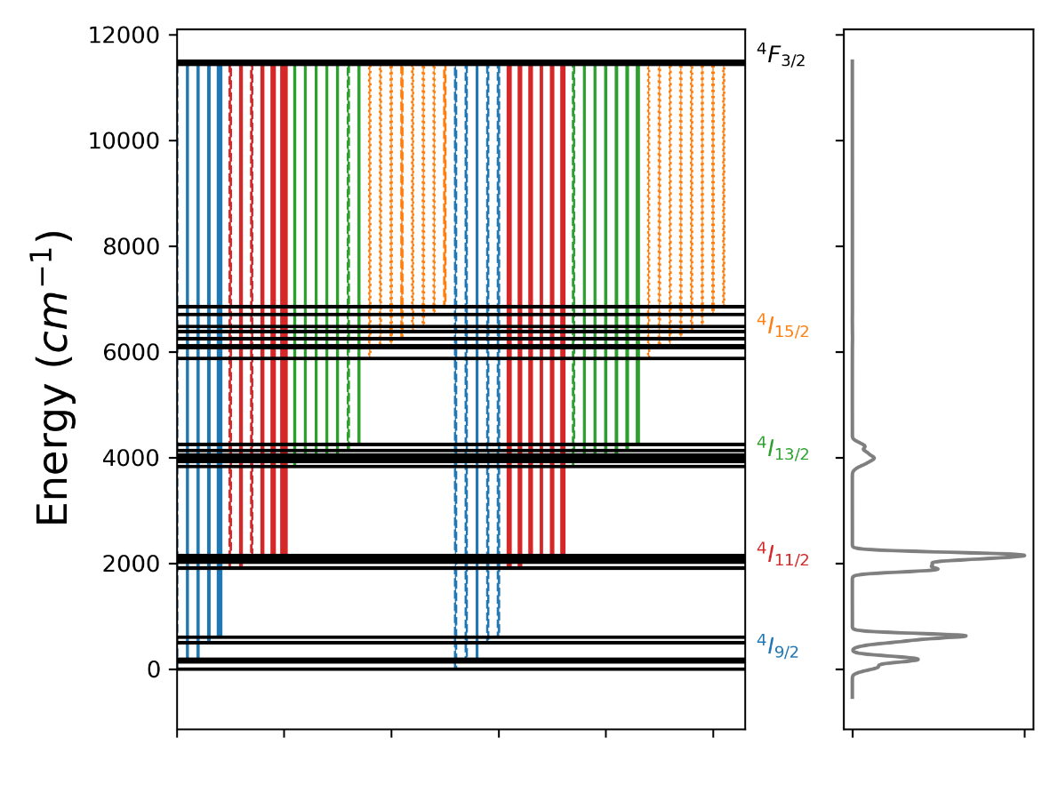
Figure S9. Dieke diagram for 1Nd (top) and 2Nd (bottom). The width of the of the vertical lines are proportional to the oscillator strength (f_{osc}) of the transition while dashed and point-dash lines indicate smaller f_{osc} values (by one or two orders of magnitude relative to the maximum f_{osc}, respectively). The calculated emission spectrum is presented in the right plot.

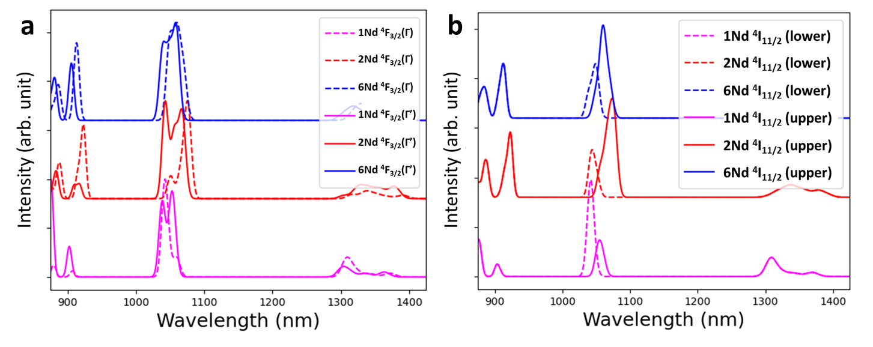
Figure S10. CASSCF(3,12) calculated emission spectrum of 1Nd, 2Nd, and 6Nd decomposed in the contributions of both Kramers’ doublets of a) ⁴F_{3/2} (Γ and Γ’) and b) from the ⁴I_{11/2} multiplet (lower and upper levels).

The emission intensity from a state $\left.\left|J'\right.\right\rangle$ to $\left.\left|J\right.\right\rangle$ can be described by the product of the population ($η_{a}$) and the radiative rate ($A_{rad}$) of the emitting level:
$$I_{a→b}=A_{rad}∙η_{a}$$ | (S1)
where
$$A_{rad}=\frac{32π^{3}{\left(σ_{J^{'}→J}\right)}^{3}}{3ℏ\left(2G+1\right)}\left[\frac{n{\left(n^{2}+2\right)}^{2}}{9}S_{ed}^{J^{'}→J}+n^{3}S_{md}^{J^{'}→J}\right]$$ | (S2)
where $ℏ$ is the reduced Planck’s constant, $G$ is the degeneracy of the emitting level $\left.\left|J'\right.\right\rangle$, $σ_{J^{'}→J}$ is the wavenumber of the $\left.\left|J'\right.\right\rangle →\left.\left|J\right.\right\rangle$ transition (in cm⁻¹), and $n$ is the refractive index of the medium. The quantities $S_{ed}^{J^{'}→J}$ and $S_{md}^{J^{'}→J}$ are the electric and magnetic dipole strengths of the transition, respectively. These quantities can be estimated from the following equations:
$$S_{ed}^{J^{'}→J}=e^{2}\left(\sum_{λ=2,4,6}{Ω_{λ}}{\left|\left\langle J\right.\left\|U^{\left(λ\right)}\right\|\left.J'\right\rangle \right|}^{2}\right)$$ | (S3)
$$S_{md}^{J^{'}→J}={\left(μ_{B}\right)}^{2}{\left|\left\langle J\right.\left\|L+2S\right\|\left.J'\right\rangle \right|}^{2}$$ | (S4)
where $μ_{B}=eℏ/(2m_{e}c)$ is the Bohr magneton ($m_{e}$ is the electron mass and $c$ the speed of light), The matrix elements values ${\left|\left\langle J'\right.\left\|U^{\left(λ\right)}\right\|\left.J'\right\rangle \right|}^{2}$ and ${\left|\left\langle J\right.\left\|L+2S\right\|\left.J'\right\rangle \right|}^{2}$ are tabulated in references ^{[5]} and ^{[6]}, respectively.
According to selection rules, the transition ⁴F_{3/2}→⁴I_{11/2} has $\left|\left\langle J\right.\left\|L+2S\right\|\left.J'\right\rangle \right|=0$ ^{[6]}. Therefore, the magnetic dipole contribution can be ignored.
In this sense, the luminescence intensity ratio (LIR) between two Stark transitions from the ⁴F_{3/2} can be described as:
$$LIR=\frac{A_{rad}(2)∙η_{a}(2)}{A_{rad}(1)∙η_{a}(1)}=\frac{{\left(σ_{2}\right)}^{3}}{{\left(σ_{1}\right)}^{3}}\frac{S_{ed}(2)}{S_{ed}(1)} \frac{η_{a}(Γ)}{η_{a}(Γ')}$$ | (S5)
where the thermal-dependent term is contained in the ratio $η_{a}(Γ)/η_{a}(Γ')$, which can be described by a Boltzmann distribution between Stark levels separations ($δ$ in Figure S9) of the ⁴F_{3/2} level:
$$\frac{η_{a}(Γ)}{η_{a}(Γ')}=e^{-\left(\frac{δ}{k_{B}∙T}\right)}$$ | (S6)
Here, $k_{B}$ is the Boltzmann constant, $T$ is the temperature, and $δ$ represents the energy separation between Stark levels. Thus, the thermometric behavior can be derived by assuming that the dipole strength and the energy of the transition remain unaffected by the temperature changes.
The relative sensitivity ($S_{r}$) can be calculated as:
$$S_{r}=\frac{1}{LIR}\left|\frac{dLIR}{dT}\right|$$ | (S7)

REFERENCES
[1] P. Fuentealba, D. Villagra, Y. Gil, H. Aguilar‐Bolados, R. Costa de Santana, G. Gasparotto, A. Vega, J. Manzur, E. Spodine, Eur. J. Inorg. Chem. 2021, 2021, 4543–4551.
[2] Y. Gil, R. C. de Santana, A. S. S. de Camargo, L. G. Merízio, P. F. Carreño, P. Fuentealba, J. Manzur, E. Spodine, Dalt. Trans. 2023, 52, 3158–3168.
[3] Y. Gil, P. Fuentealba, A. Vega, E. Spodine, D. Aravena, Dalt. Trans. 2020, 49, 17709–17718.
[4] D. S. Kumar, V. Alexander, Inorganica Chim. Acta 1995, 238, 63–71.
[5] W. T. Carnall, H. Crosswhite, H. M. Crosswhite, Energy Level Structure and Transition Probabilities in the Spectra of the Trivalent Lanthanides in LaF₃, Argonne, IL, United States, 1978.
[6] M. Oggianu, V. Mameli, M. A. Hernández-Rodríguez, N. Monni, M. Souto, C. D. S. Brites, C. Cannas, F. Manna, F. Quochi, E. Cadoni, N. Masciocchi, A. N. Carneiro Neto, L. D. Carlos, M. L. Mercuri, Chem. Mater. 2024, 36, 3452–3463.

