The penetration of Human Defensin 5 (HD5) through bacterial outer membrane: Simulation studies
Tadsanee Awang¹ and Prapasiri Pongprayoon^{1,2,3}*

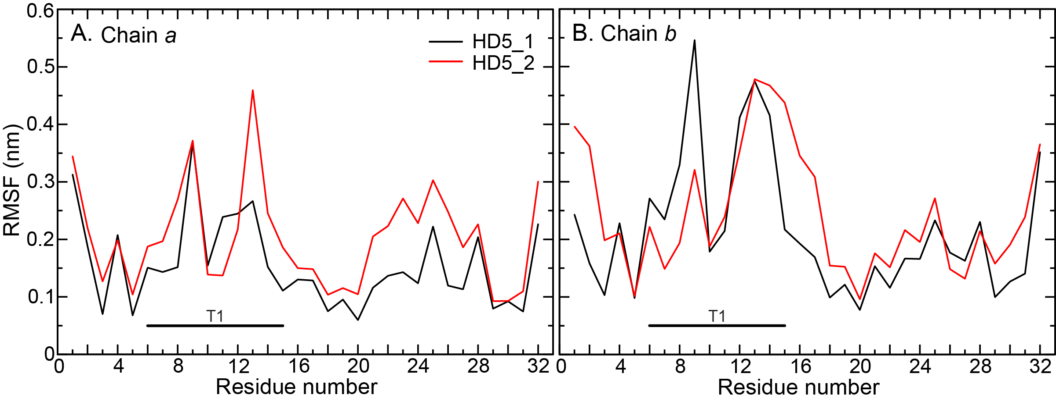
Figure S1 RMSFs of C-alpha atoms of all systems
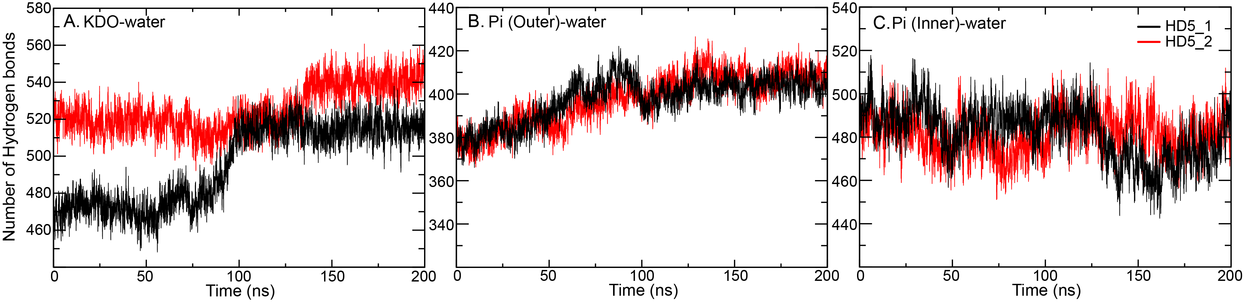
Figure S2. Number of hydrogen bonds of KDO-water, Pi (outer)-water, and Pi (Inner)-water (A)-(C) in all simulations.
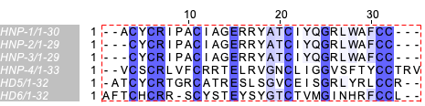
Figure S3 Multiple sequence alignment of all six human alpha-defensins

