Derivation of visual timing-tuned neural responses from early visual stimulus representations

Supplementary Material

Evi Hendrikx¹⁺, Jacob M. Paul¹⁺, M. van Ackooij¹, Nathan van der Stoep¹, Ben M. Harvey¹

⁺ Equal contribution
¹ Experimental Psychology, Helmholtz Institute, Utrecht University, Heidelberglaan 1, Utrecht 3584 CS, Netherlands

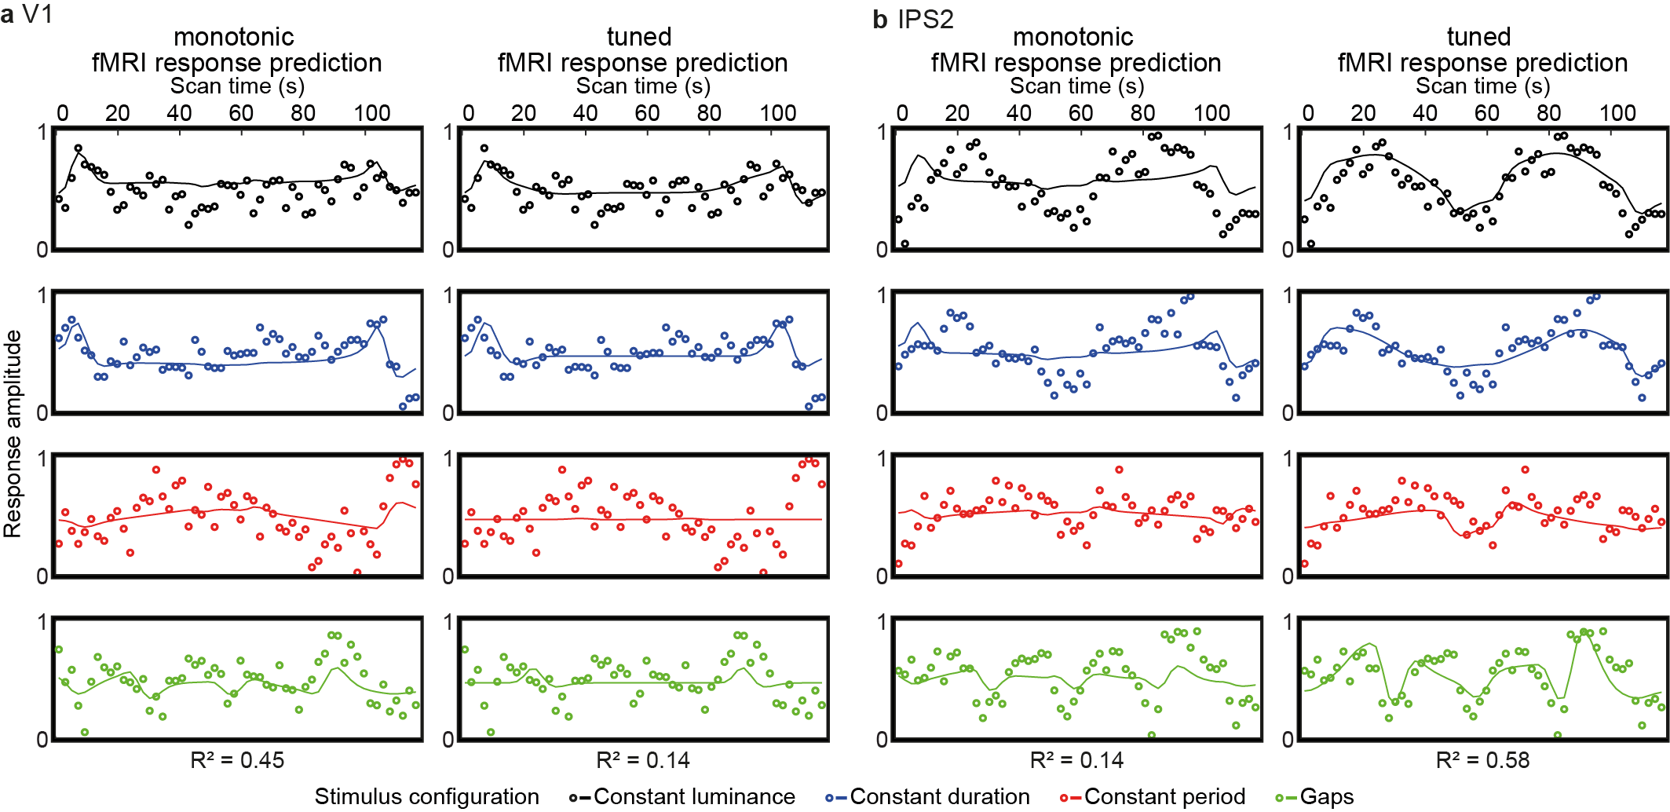
Supplementary Fig. 1 Comparison of monotonic and tuned model fits from representative voxels. Both monotonic and tuned response models were fit to the data from every voxel, and their goodness of fit compared under cross-validated to determine the best fitting response model for each voxel. a For a voxel in V1, the monotonic response model’s predictions (lines, left panel) fit the measured responses (circles) more closely than the tuned response model’s predictions (lines, right panel). b For a voxel in visual field map IPS2, the tuned response model’s predictions (lines, right panel) fit the measured responses (circles) more closely than the monotonic response model’s predictions (lines, left panel).

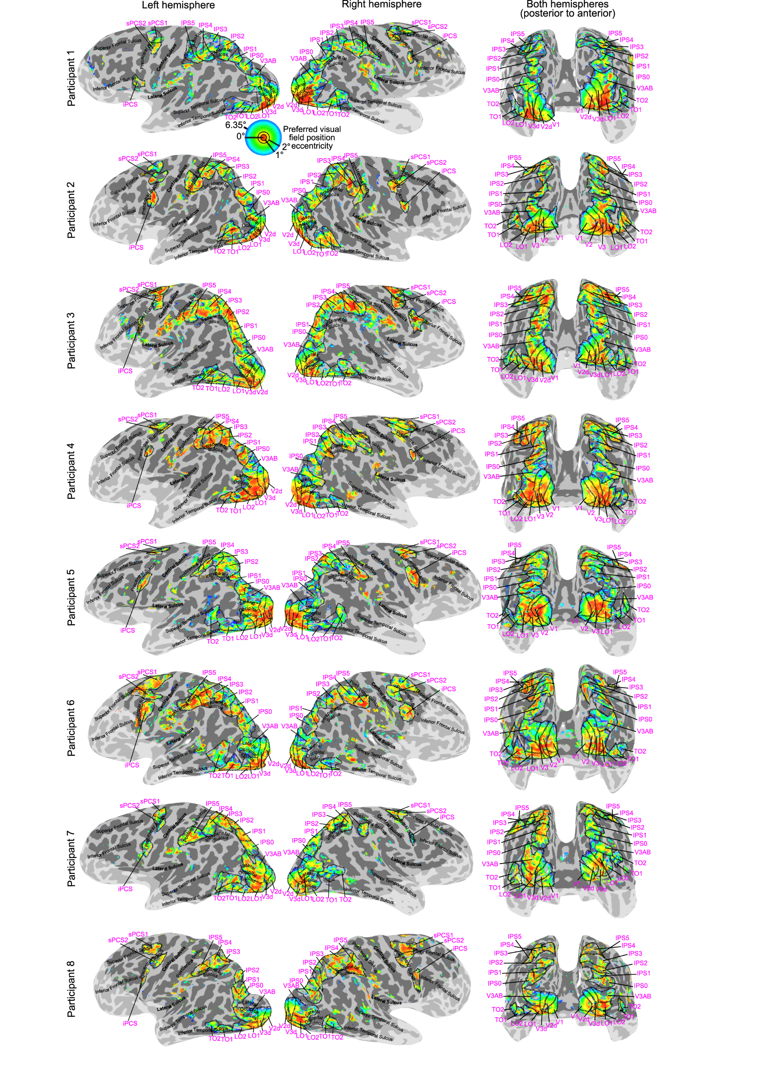
Supplementary Fig. 2 Preferred visual field position eccentricities of voxels throughout the visual field map hierarchy. Eccentricity preferences for voxels with over 0.1 variance explained by the response model. Visual field map borders are shown as black dashed lines, and named in magenta text. The light shaded region is outside the fMRI recording volume.
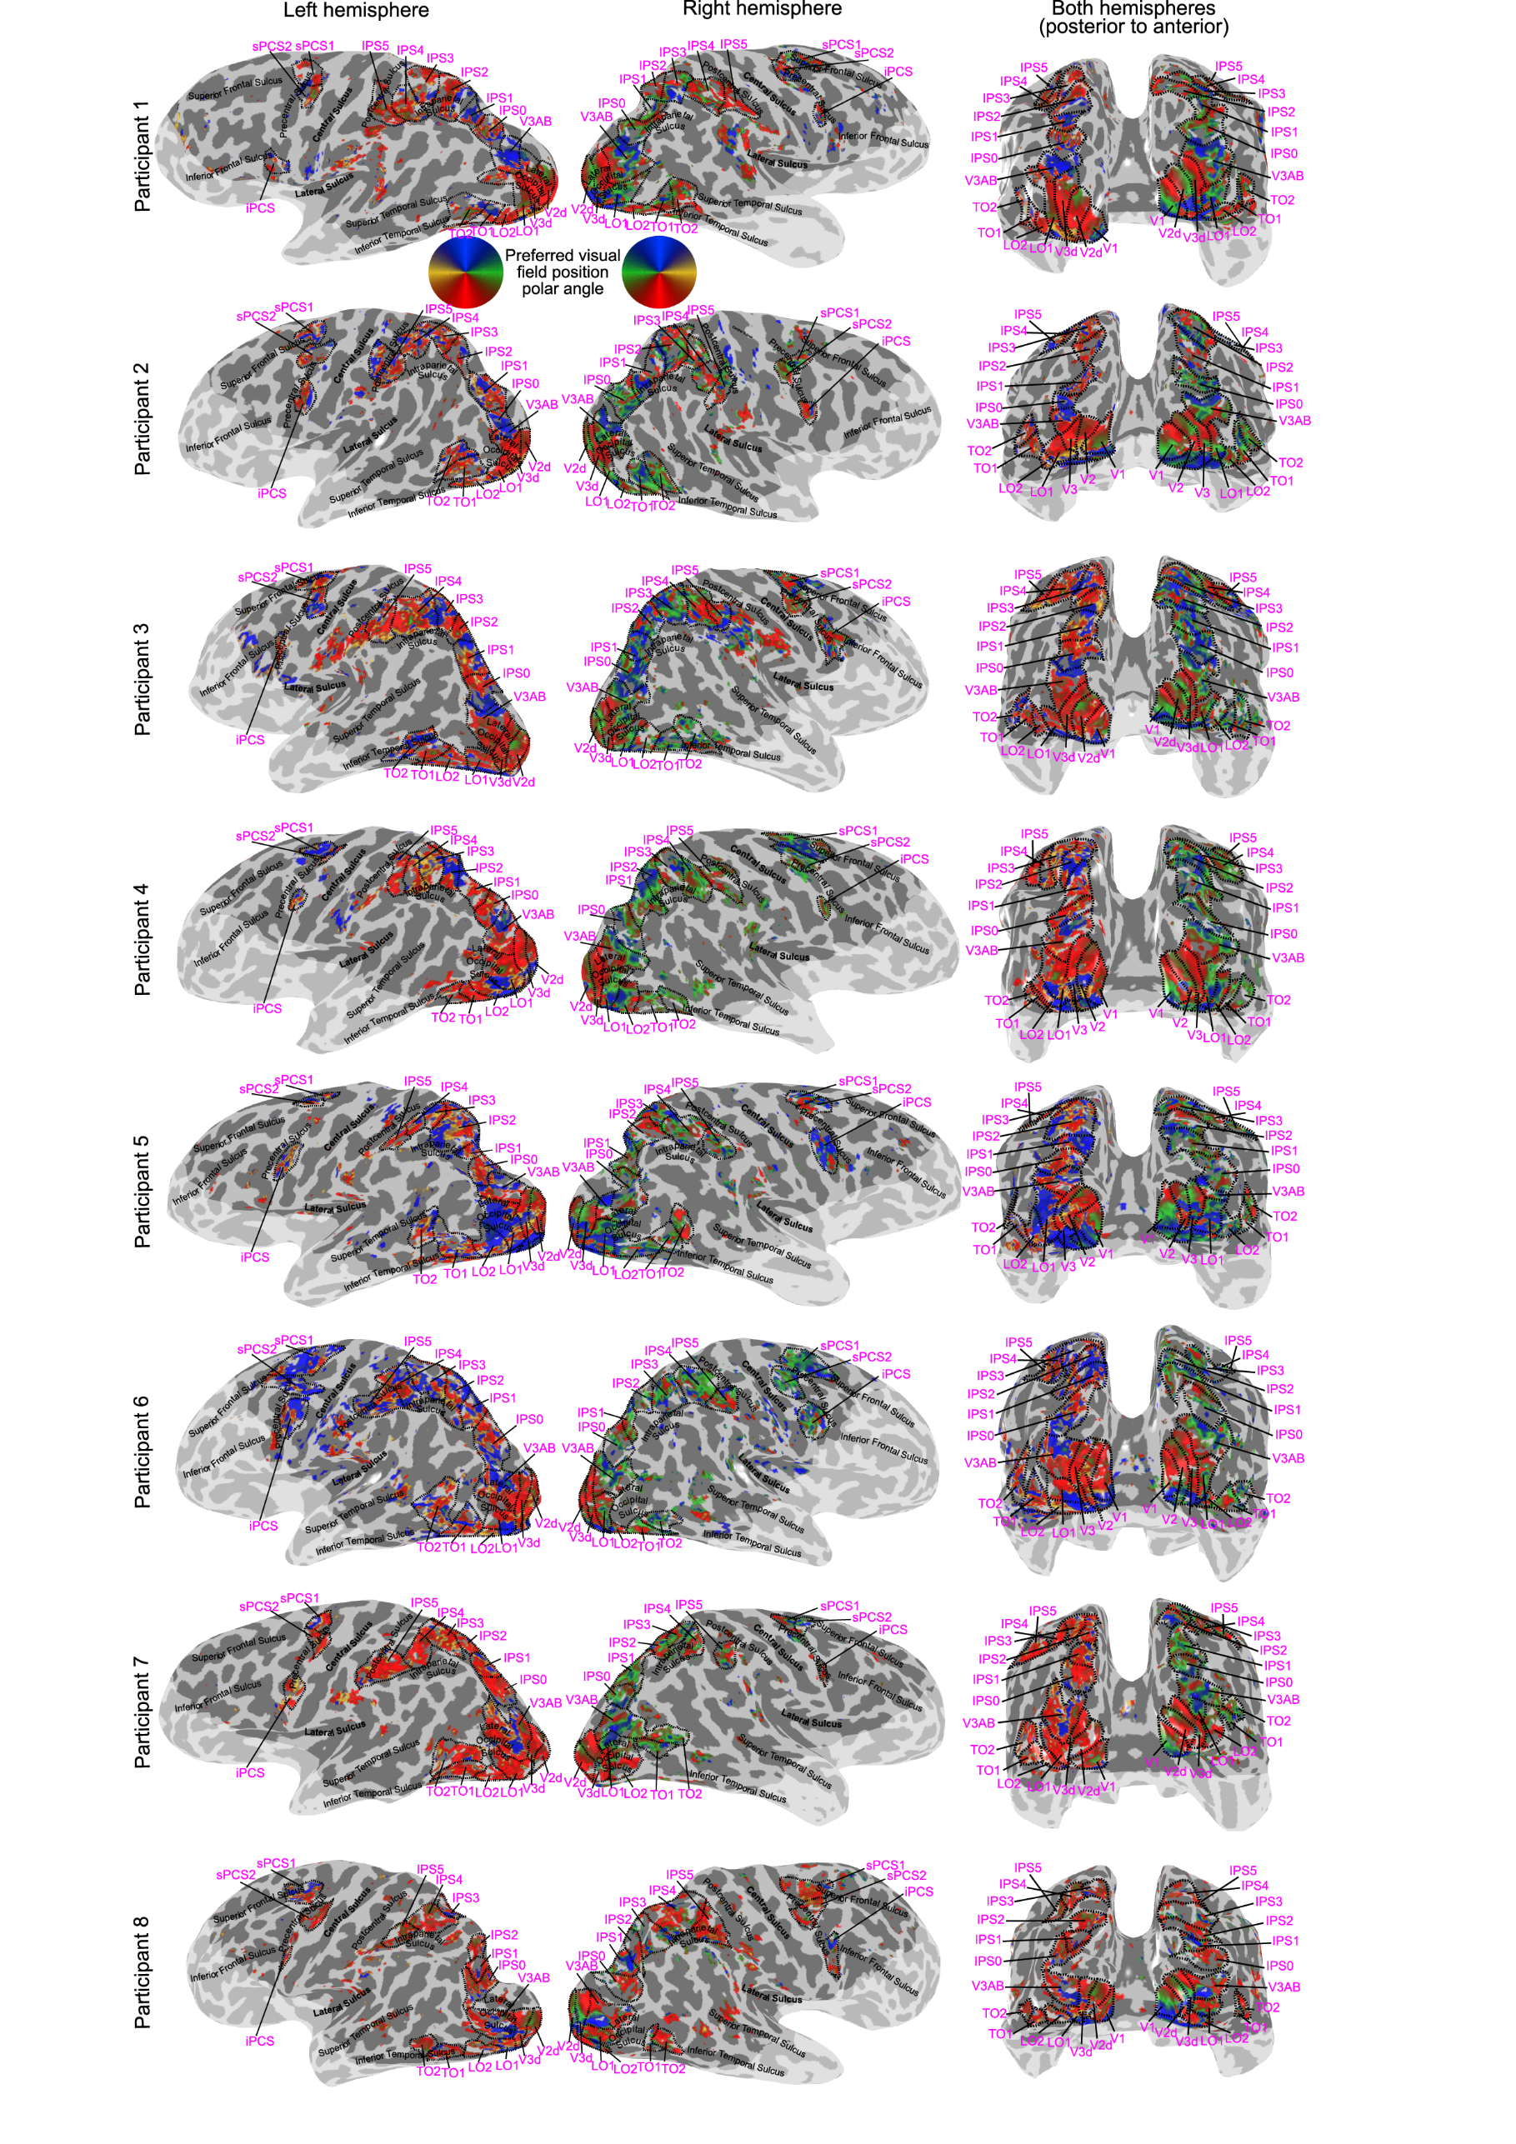
Supplementary Fig. 3 Preferred visual field position angle of voxels throughout the visual field map hierarchy. Polar angle preferences for voxels with over 0.1 variance explained by the response model. Visual field map borders are shown as black dashed lines, and named in magenta text. The light shaded region is outside the fMRI recording volume.

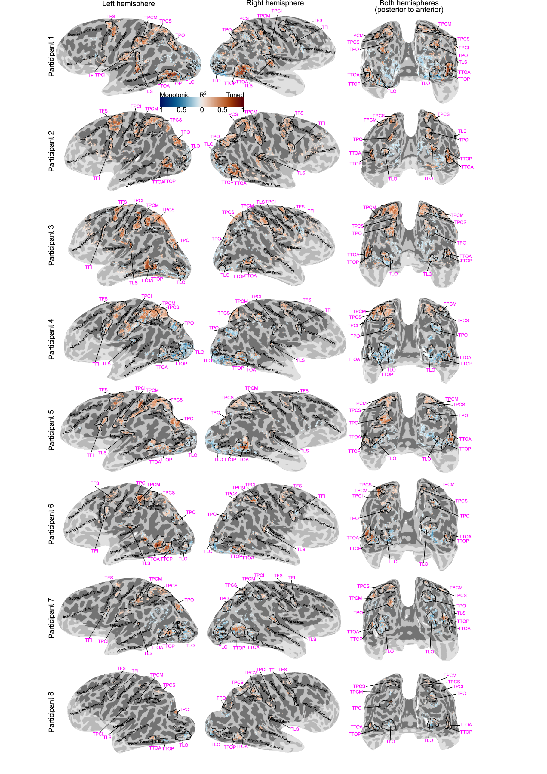
Supplementary Fig. 4 Progressions of the best-performing model of responses to visual event timing. Each voxel is colored (blue or red) showing which response model (monotonic or tuned respectively) predicts recorded responses in cross-validated data best. The intensity of the color shows the variance explained by the best-performing model under cross-validation within each voxel (averaged across both cross-validation splits, for voxels with a variance explained above 0.1 for either model). Timing map borders are shown as black dashed lines, and named in magenta text. The light shaded region is outside the fMRI recording volume.

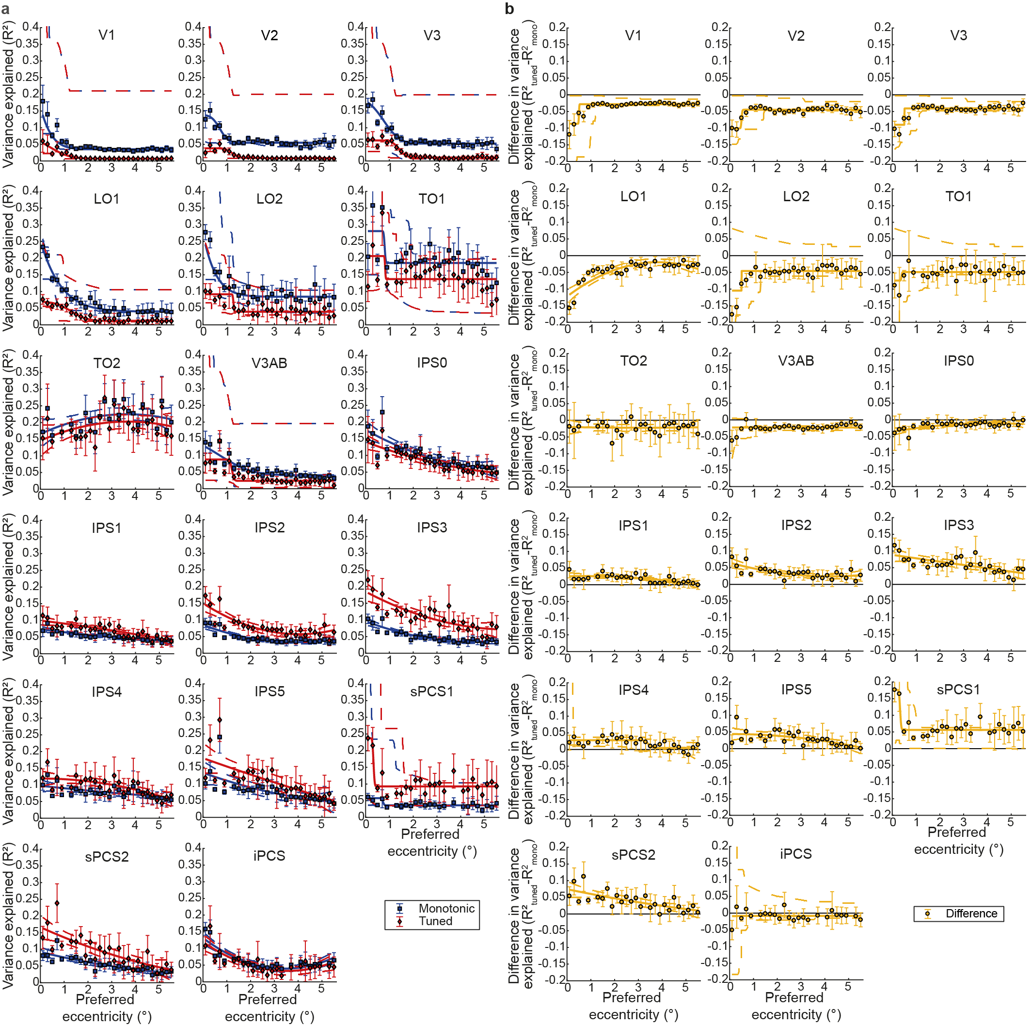
Supplementary Fig. 5 Progression of timing response model fits with preferred visual field eccentricity in all visual field maps. a Early and lateral occipital visual field maps show a sharp decrease of model fits moving away from the retinotopic representation of the stimulus position. This decrease then becomes more gradual where tuned response model fits begin to improve. b The difference between the response model fits (tuned - monotonic) also decreases with eccentricity in the early and lateral occipital visual field maps, but shows no consistent relationship with eccentricity after TO1. Markers show mean variance explained per eccentricity bin, error bars show the standard error of the mean. Solid lines show the best fit to changes with eccentricity, dashed lines are their 95% confidence intervals. Note that the data for these plots are not thresholded at to a variance explained above 0.2, but above 0.

