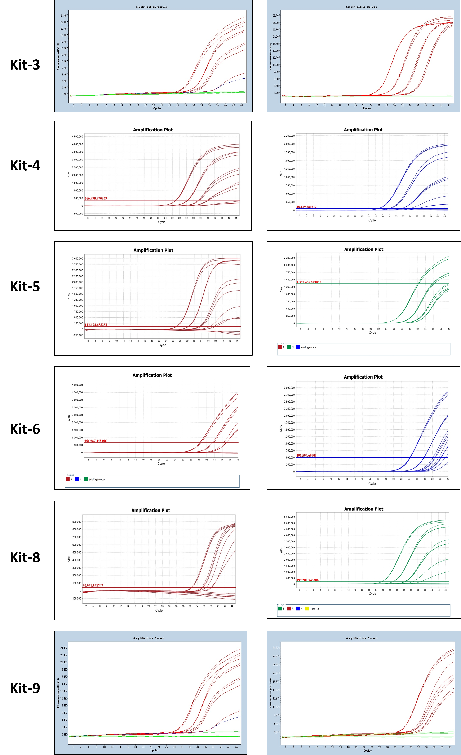

Figure S. The amplification curve of qRT-PCR assays for ORF 1ab and N gene in serial dilutions of the reference material (from S1 to S4) using different commercial kits.

