Supplementary Information

Polymer Matrix Drives Dual Phosphorescence in Dispersed Chromophores
Subhajit Ghosh¹, Rajendra Prasad Nandi¹, Silvano Geremia³, Neal Hickey*³, Abhishek Sirohiwal*², Pakkirisamy Thilagar*¹

Experimental procedures:
Materials:
All the chemicals were purchased from commercial suppliers (Merck, Aldrich, SDFCL, BLDpharm) and used without further purification unless otherwise mentioned. Solvents (THF, DMF, Toluene) were dried with an appropriate drying agent and distilled under an argon atmosphere.
SC-XRD method:
Single crystals for X-ray diffraction were obtained by slow evaporation of dichloromethane and hexane solvent mixtures (1:3) of the compounds. Single crystal X-ray data was collected at the XRD1 beamline of the ELETTRA Synchrotron, Trieste (Italy), using the rotating crystal method with a monochromatic wavelength of 0.7000 Å, and a Dectris Pilatus 2M detector. At first, the single crystals were dipped in cryoprotectant, mounted on a nylon loop, and flash-frozen under a nitrogen stream at 100 K. Data collections at higher temperatures were carried out by slowly ramping the temperature to the chosen setpoint (progressively from 100K to 150 K, 200 K, 225 K, 250 K, 275 K, and 300 K) after stabilizing the corresponding temperature. Diffraction data were indexed and integrated using the XDS package¹, while scaling was performed with XSCALE². The structures were solved using the SHELXT package³; and structure refinement was performed by the full-matrix least-squares (FMLS) method with SHELXL-19/3⁴, operating through the WinGX or ShelXle GUIs^{5,6}.
All the atoms were refined at full occupancy, except for a small number of atoms in the case of BANH2, which exhibited a two-position disorder of the entire molecule in which the two positions are almost precisely superimposed (vide infra). Hydrogen atoms were placed at calculated positions and refined using the riding model. Crystallographic data and final refinement details for the structures are reported in Supplementary Tables 1-3.

Synthesis of 4-(dimesitylboraneyl)-3,5-dimethyl-N-phenylaniline [BANHPh]:

To a solution of 4-(dimesitylboraneyl)-3,5-dimethylaniline [BANH2] (1.5 g, 4.06 mmol, 1 equiv.) in N₂-degassed dry toluene solution, iodobenzene (0.41 ml, 3.65 mmol, 0.9 equiv.), Pd(OAc)₂ (91 mg, 0.41 mmol, 0.1 quiv.), 1,1'-Bis(diphenylphosphino)ferrocene (dppf) (225 mg, 0.41 mmol, 0.1 equiv.) and potassium tert-butoxide (912 mg, 8.1 mmol, 2 equiv.) were added and started heating at 105 °C under inert condition for 20 h. The reaction progress was monitored by TLC. After completion of the reaction, the toluene was removed under reduced pressure conditions, and then the organic crude product was obtained by extracting with dichloromethane solvent. The crude product was purified by column chromatography using ethyl acetate in hexane (2:98) as eluent to afford a light green pure compound. Yield: 1.24g, 68%. ¹H NMR (400 MHz, CDCl₃, 25 °C): δ (ppm)= 7.28 (d, J= 6.1 Hz, 2H), 7.12 (d, J= 6.3 Hz, 2H), 6.95 (t, J= 5.9 Hz, 1H), 6.74 (s, 2H), 6.72 (s, 2H), 6.63 (s, 2H), 5.71 (s, 1H), 2.26 (s, 6H), 2.04 (s, 6H), 1.96 (s, 6H), 1.94 (s, 6H). ¹³C{¹H} NMR (100 MHz, CDCl₃, 25 °C): δ (ppm)= 144.58, 144.27, 142.90, 142.32, 140.42, 140.39, 139.82, 138.78, 129.27, 128.49, 128.41, 121.33, 118.80, 115.75, 23.28, 22.94, 22.71, 21.22. ¹¹B NMR (128 MHz, CDCl₃, 25 °C): δ (ppm)= 76.5. HRMS (ESI/Q-TOF) m/z: [M+H]+ calculated for C₃₂H₃₆BN, 446.3018; found 446.3015.
Synthesis of 4-(dimesitylboraneyl)-N,3,5-trimethyl-N-phenylaniline [BANMePh]:

To a solution of 4-(dimesitylboraneyl)-3,5-dimethyl-N-phenylaniline [BANHPh] (500 mg, 1.12 mmol, 1 equiv.) in dry DMF (7 ml), sodium hydride (40 mg, 1.68 mmol, 1.5 equiv.) was added at 0 °C and stirred for 30 mins at the same temperature under inert condition. Then methyl iodide (191 mg, 1.35 mmol, 1.2 equiv.) was added at 0 °C and allowed for stirring at room temperature for 12 h. After completion of the reaction, the crude organic compound was extracted with dichloromethane. The pure compound was obtained by column chromatography with ethyl acetate in hexane (0.5:99.5) as eluent. Yield: 405 mg, 78%. ¹H NMR (400 MHz, CDCl₃, 25 °C): δ (ppm)= 7.31 (dd, J= 7.5 Hz, 7.4 Hz, 2H), 7.12 (d, J= 7.5 Hz, 2H), 7.03 (t, J= 7.3 Hz, 1H), 6.73 (s, 2H), 6.71 (s, 2H), 6.49 (s, 2H), 3.31 (s, 3H), 2.26 (s, 6H), 2.04 (s, 6H), 1.96 (s, 6H), 1.92 (s, 6H). ¹³C{¹H} NMR (100 MHz, CDCl₃, 25 °C): δ (ppm)= 149.58, 148.53, 144.65, 142.49, 140.41, 140.31, 138.97, 138.67, 129.22, 128.44, 128.36, 122.98, 122.56, 116.80, 39.98, 23.43, 22.98, 22.69, 21.22. ¹¹B NMR (128 MHz, CDCl₃, 25 °C): δ (ppm)= 77.4. HRMS (ESI/Q-TOF) m/z: [M+H]+ calculated for C₃₃H₃₈BN, 460.3131; found 460.3186.

Plots of NMR Spectra and high-resolution mass spectra:
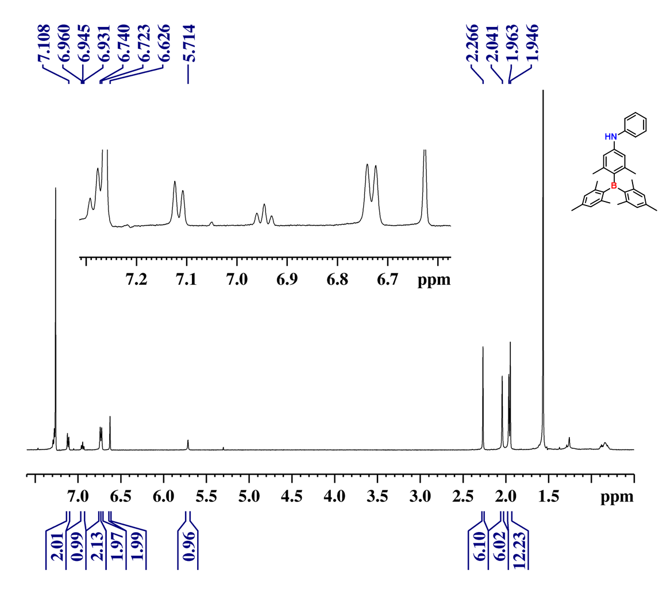
Supplementary Fig. 1| NMR spectrum. ¹H NMR spectrum (CDCl₃, 400MHz) of BANHPh.
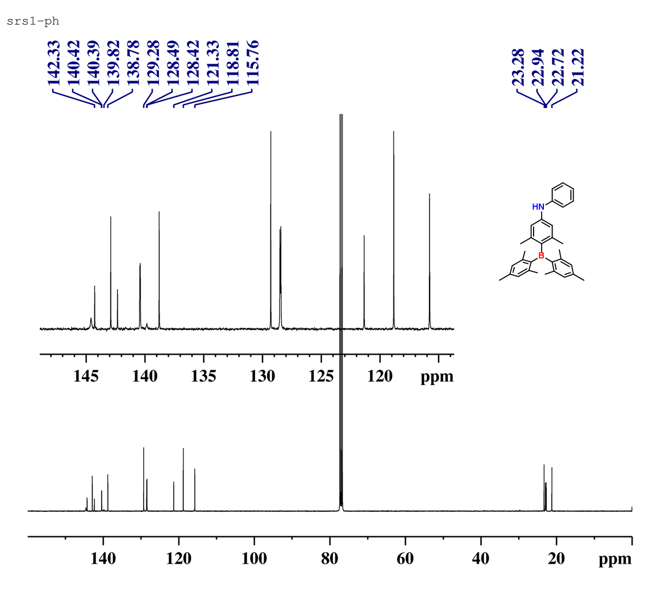
Supplementary Fig. 2| NMR spectrum. ¹³C NMR spectrum (CDCl₃, 100MHz) of BANHPh.
Supplementary Fig. 3| NMR spectrum. ¹¹B NMR spectrum (CDCl₃, 128MHz) of BANHPh.
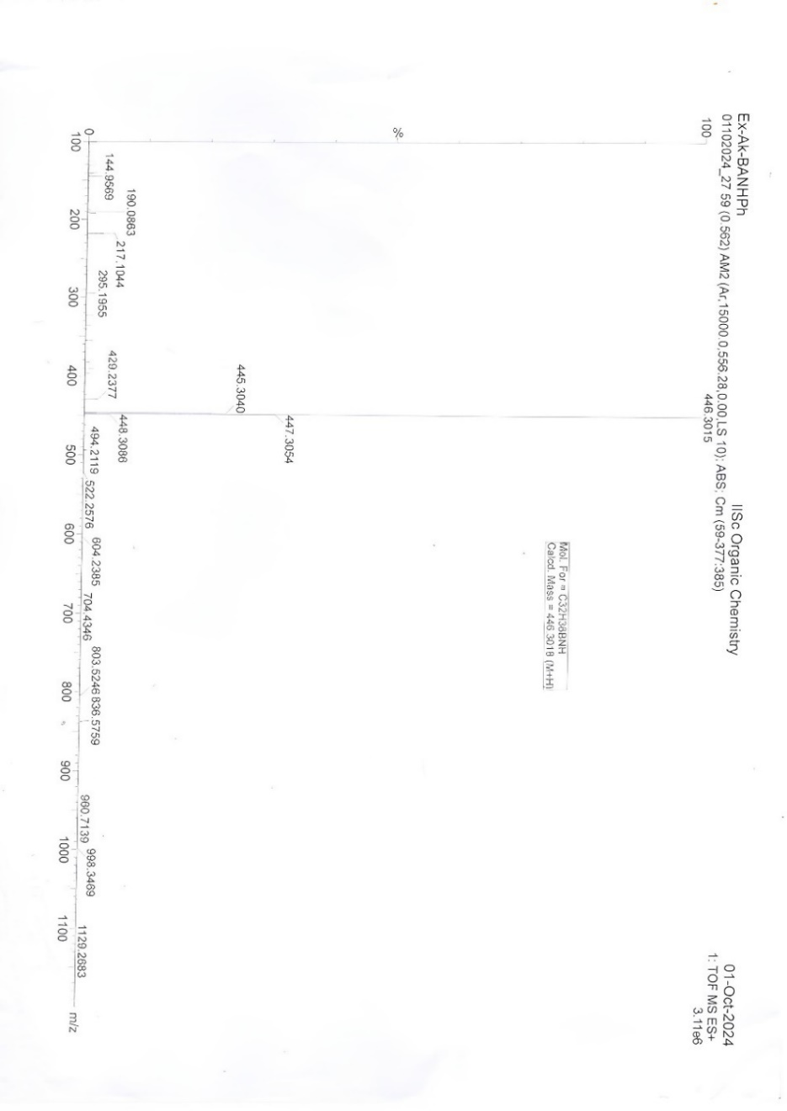
Supplementary Fig. 4| HRMS spectrum. High resolution mass spectrometry (HRMS) of BANHPh.
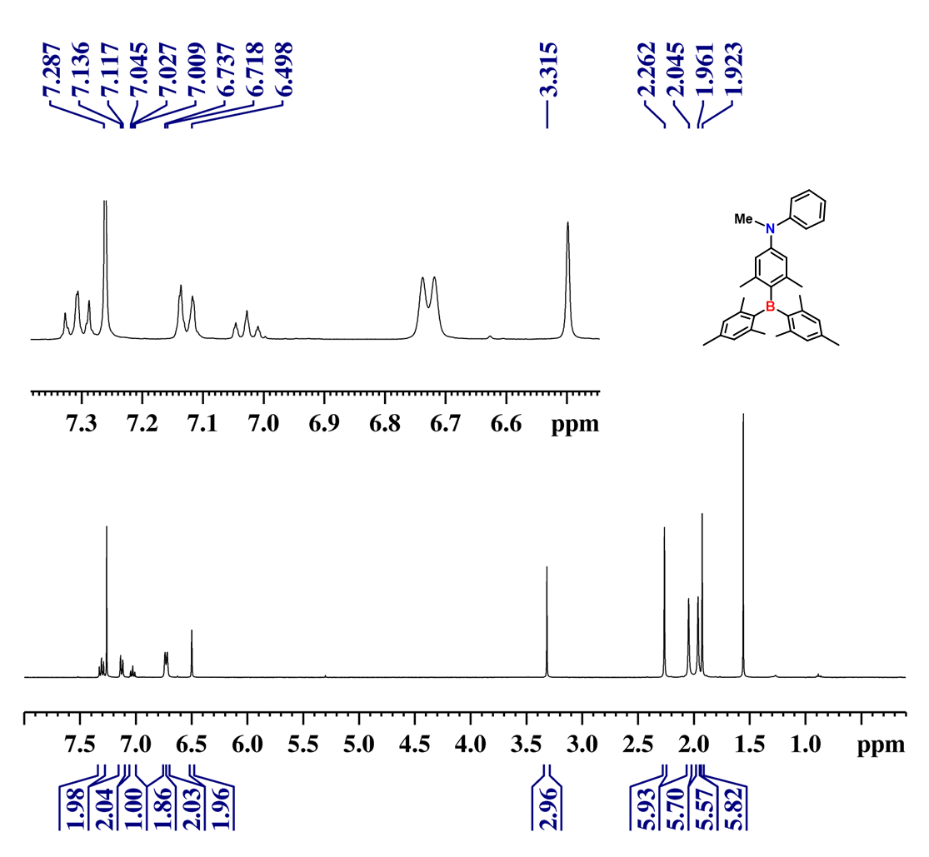
Supplementary Fig. 5| NMR spectrum. ¹H NMR spectrum (CDCl₃, 400MHz) of BANMePh.
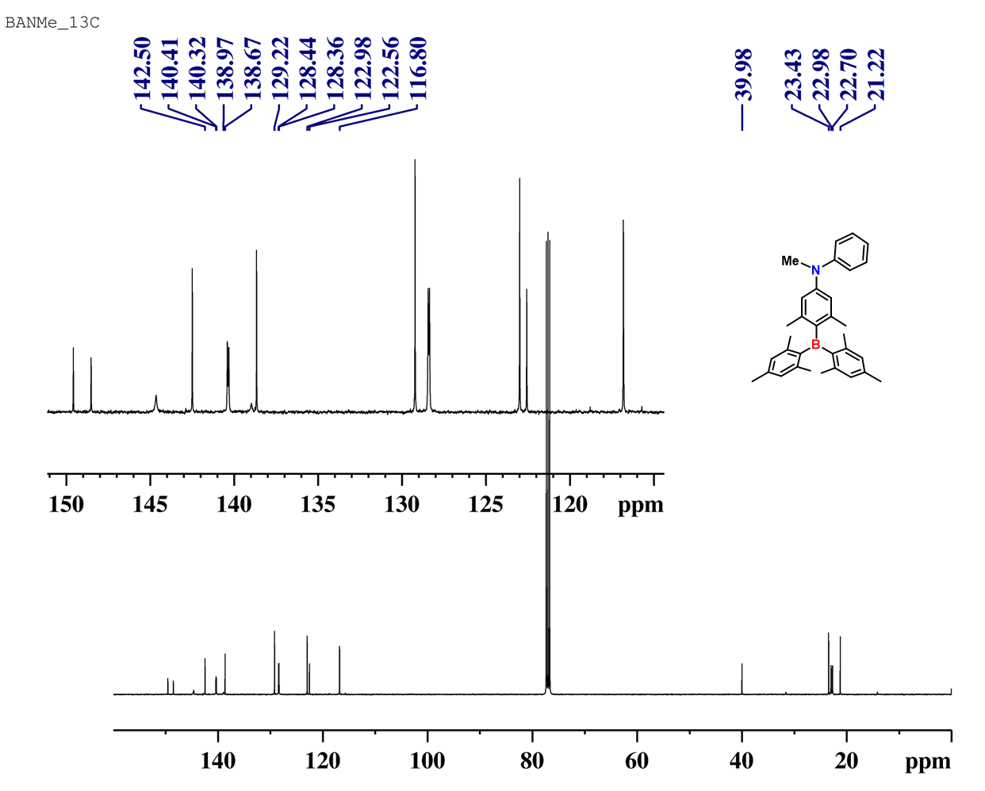
Supplementary Fig. 6| NMR spectrum. ¹³C NMR spectrum (CDCl₃, 100MHz) of BANMePh.

Supplementary Fig. 7| NMR spectrum. ¹¹B NMR spectrum (CDCl₃, 128MHz) of BANMePh.
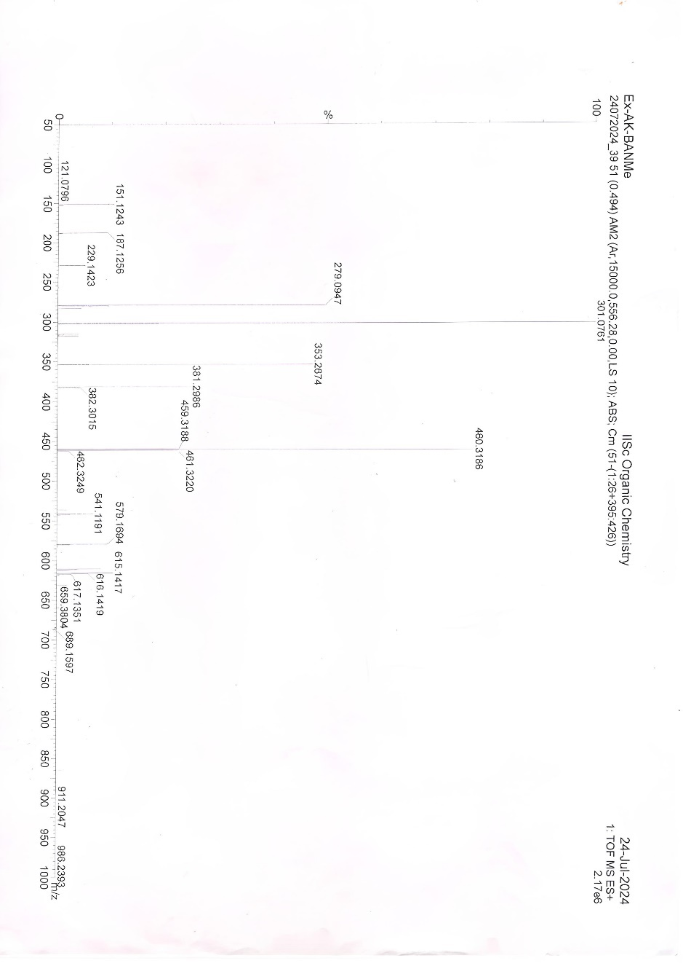
Supplementary Fig. 8| HRMS spectrum. High-resolution mass spectrometry (HRMS) of BANMePh.

X-Ray Crystallographic Investigation
All three molecules crystallized in the centrosymmetric triclinic P -1 space group. BANMePh contains two independent molecules in the asymmetric unit, while BANHPh and BANH2 both contain just one molecule (Supplementary Figure S9). No solvent molecules were present in any of the structures.
BANMePh was refined as a two-component twin with a HKLF 5 dataset. The twin law (-1, 0, 0; 0, -1, 0; 0.690, 0.685, 1), which corresponds to a rotation around the [1 1 3] direct lattice direction, was detected by TwinRotMat. The refined BASF factor varies from 0.13 to 0.10 across the temperature range of 100 K to 300 K.
In the case of BANH2, prolonged exposure to the X-ray beam resulted in a deterioration of the data collected at 275 K, probably due to radiation damage. The data collected at 300 K confirmed the structure, but it has not been included here as the refinement parameters were too poor. BANH2 shows a two-position disorder in which the two positions correspond to the rotation of the entire molecule by 180 ° around a two-fold axis that passes through the central boron atom and the carbon atom of one of the xylyl rings to which the boron atom is attached (Supplementary Figure S9c). This rotation results in the non-hydrogen atomic positions being mapped onto sites occupied by other non-hydrogen atoms and all non-hydrogen atoms of the two-position disorder are therefore superimposed. As the superimposed atoms are predominantly carbon atoms, most of the atoms were refined at full occupancy, with the exception of the nitrogen atom and the methyl carbon at the para position (with respect to the boron atom) of the xylyl group, which does not lie the two-fold rotation axis (Supplementary Figure S9c). These two positions were modeled with both an N and a C atom superimposed at 0.5 occupancies for each. The hydrogen atoms of each of these were refined at 0.5 occupancy. In addition, the hydrogen atoms of the two superimposed methyl carbon atoms on the two-fold rotation axis were also refined as two sets of 3 hydrogen atoms at 0.5 occupancy. The presence of this particular type of disorder could, in fact, indicate that the molecule might have a higher symmetry than P-1; however, on the basis of an analysis of the electron density, we feel that the lower symmetry better corresponds with the data collected.
The main packing interactions for the three crystal structures are shown in Supplementary Figure S10. Analogous packing is observed at all temperatures for the three molecules investigated. For all three structures, the crystal packing is characterized by CH-π or NH-π type interactions. In the case of BANHPh, there are two reciprocal CH-π interactions between the inversion-related molecules in the unit cell. These involve an aromatic CH group of one trimethylphenyl ring (donor) and the xylyl aromatic ring of the inversion-related molecule (acceptor). The CH···centroid distances and C···H···centroid angles are 2.994 Å and 162.58°, respectively. In addition, each molecule shows two more reciprocal NH-π type interactions with another symmetry-related molecule, involving the NH group of each molecule (donor) and the aromatic ring of the trimethylphenyl of an inversion-related molecule (acceptor). The NH···centroid distances and N···H···centroid angles are 2.850 Å and 159.49°, respectively. Thus, each molecule has a CH donor at one trimethylphenyl ring, an NH donor, and two aromatic rings as acceptors (on the xylyl ring and the other trimethylphenyl ring). These interactions repeat in a chain-like fashion parallel to parallel to the b-axis.
For BANMePh, the main interactions involve a CH-π interaction between the two crystallographically independent molecules, involving the CH of a phenyl ring of one independent molecule (donor) and the xylyl aromatic ring of the other (acceptor). The CH···centroid distances and C···H···centroid angles are 2.964 Å and 152.75°. In addition, there is a second interaction CHN interaction between a CH of the amine methyl group of one molecule (donor) and the N atom of the other molecule (CH···N distance 3.111 Å; C···H···N angle 171.39°). The molecules, therefore, are present as dimer-like species in the crystal packing.
In the case of BANH2, there are weaker CH-π or NH-π type interactions between the two inversion-related molecules in the unit cell. The NH-π type interactions shown in Supplementary Figure 10 have an NH···centroid distance and an N···H···centroid angle of 3.268 Å and 157.54°, respectively. However, as discussed above, this only accounts for 50 % of the molecules, and there are even weaker superimposed CH-π interactions (3.427 Å and 129.98°) at the positions the same positions. Similarly, there are overlapped CH-π and NH-π interactions at the other superimposed N/C position (NH···centroid distances 3.218 Å; N···H···centroid angles 168.29°). Like BANHPh, the chains formed through these interactions propagate parallel to the c-axis.
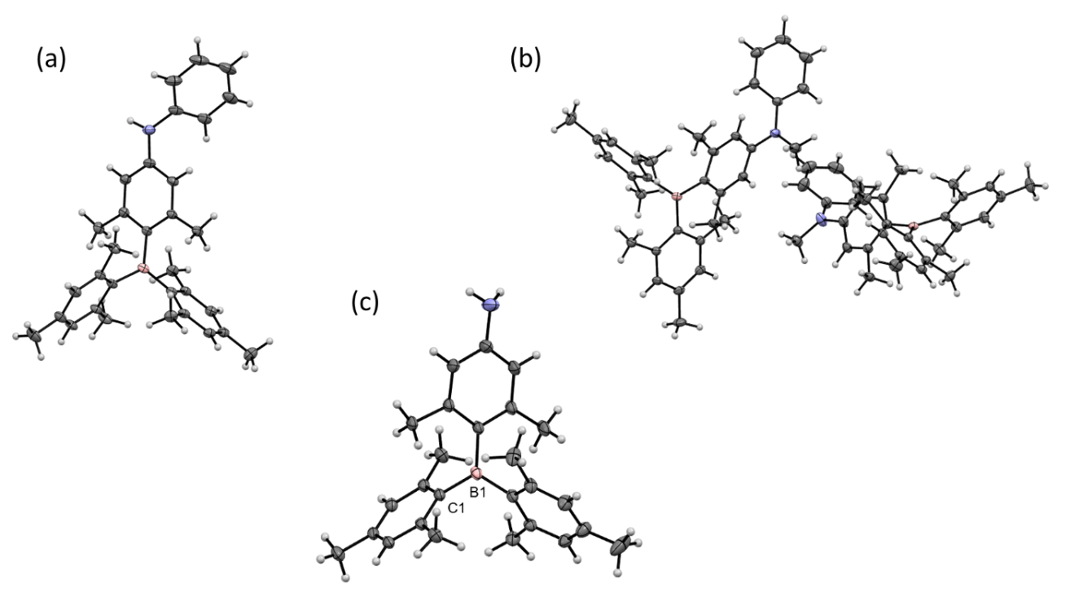
Supplementary Fig. 9| Ortep drawings at 100 K of the asymmetric units of (a) BANHPh, (b) BANMePh, and (c) BANNH2. In the case of BANNH2, for clarity, only one position of the two superimposed disordered positions is shown, and the two-fold axis that generates the second position is indicated by the labeled atoms (ellipsoids at 50% probability).
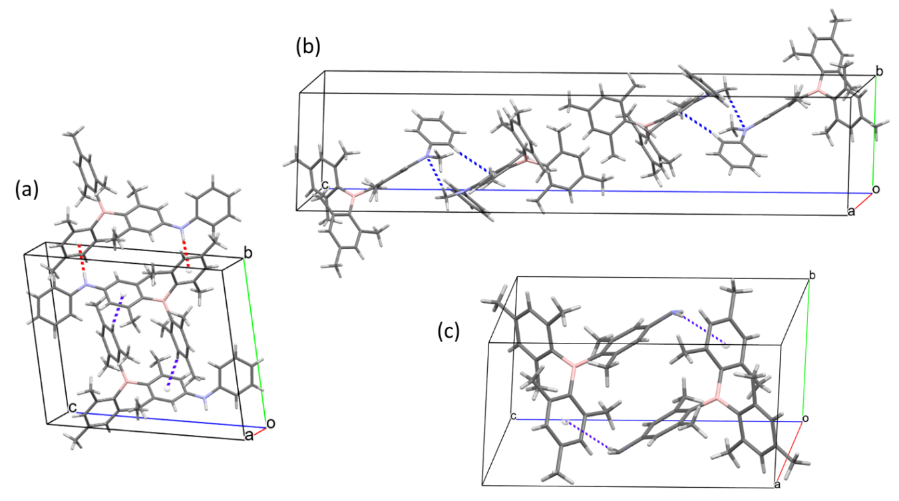
Supplementary Fig. 10| Main packing interactions in the crystal structures of (a) BANHPh at 300 K; (b) BANMePh at 300 K, and (c) BANH2 at 275 K. Dashed lines indicate the interactions between CH or NH moieties and the centroids of facing aromatic rings or, in the case of BANMePh, of an N atom. For clarity, just one position of the disordered BANH2 molecules is shown.

Supplementary Table 1| Crystal data and structure refinements at variable temperatures for BANHPh.
 | C₃₂ H₃₆ B N
Formula weight | 445.43
Wavelength (Ǻ) | 0.700
Crystal system | Triclinic
Space group | P -1
Z | 2
Limiting indices | -10 ≤ h ≤ 10, -15 ≤ k ≤ 17, -20 ≤ l ≤ 20
Parameters | 316
Restraints | 0
Temperature (K) | 100(2) | 150(2) | 200(2) | 225(2) | 250(2) | 275(2) | 300(2)
Unit cell (Ǻ, °)
a | 7.557(1) | 7.574(2) | 7.597(1) | 7.610(3) | 7.623(5) | 7.636(6) | 7.651(1)
b | 12.305(1) | 12.355(1) | 12.414(2) | 12.447(3) | 12.479(3) | 12.510(4) | 12.541(1)
c | 14.279(2) | 14.294(2) | 14.311(1) | 14.321(1) | 14.330(2) | 14.341(2) | 14.351(1)
α | 78.667(6) | 78.624(5) | 78.569(3) | 78.523(4) | 78.472(6) | 78.411(5) | 78.345(7)
β | 81.17(2) | 81.21(2) | 81.24(2) | 81.262(19) | 81.283(17) | 81.315(16) | 81.35(3)
γ | 85.507(8) | 85.482(5) | 85.460(5) | 85.450(17) | 85.418(19) | 85.409(13) | 85.379(7)
Volume (Ǻ³) | 1284.9(3) | 1294.3(3) | 1305.8(3) | 1312.3(7) | 1318.5(9) | 1324.9(12) | 1331.5(3)
ρ _{calcd} (g/cm³) | 1.151 | 1.143 | 1.133 | 1.127 | 1.122 | 1.117 | 1.111
μ (mm^{–1}) | 0.062 | 0.062 | 0.061 | 0.061 | 0.061 | 0.060 | 0.060
F(000) | 480 | 480 | 480 | 480 | 480 | 480 | 480
θ_{min} (°) | 1.447 | 1.984 | 1.977 | 1.973 | 1.442 | 1.441 | 1.960
Θ_{max} (°) | 29.752 | 29.753 | 29.758 | 29.760 | 29.756 | 29.761 | 29.760
Reflections collected | 45379 | 46072 | 46512 | 47107 | 47586 | 35377 | 48268
Independent Reflections  (R_{int}) | 7525  (0.0421) | 7576  (0.0414) | 7634  (0.0413) | 7684  (0.0424) | 7724  (0.0341) | 7557  (0.0329) | 7781  (0.0326)
Reflections  [I>2σ(I)] | 6711 | 6714 | 6591 | 6490 | 6559 | 6155 | 6405
GooF | 1.076 | 1.050 | 1.072 | 1.054 | 1.063 | 1.066 | 1.065
Final R indices  R₁ª  wR2^{b} | 0.0571  0.1575 | 0.0566  0.1643 | 0.0594  0.1734 | 0.0611  0.1825 | 0.0640  0.1897 | 0.0672  0.1960 | 0.0673  0.1983
R indices  (all data)  R₁ª  wR2^{b} | 0.0608  0.1604 | 0.0603  0.1674 | 0.0646  0.1789 | 0.0668  0.1888 | 0.0697  0.1973 | 0.0749  0.2079 | 0.0745  0.2091
Largest Diff. peaks  (e Å⁻³) | 0.539 /  -0.349 | 0.490 /  -0.277 | 0.515 /  -0.275 | 0.509 /  -0.257 | 0.390 /  -0.288 | 0.334 /  -0.301 | 0.341 / -0.283
CCDC code | 2402229 | 2402230 | 2402231 | 2402232 | 2402233 | 2402233 | 2402235
ª R¹ = Σ(|Fo| − |Fc|)/Σ|Fo|. ^{b} wR2 = {Σ[w(|Fo|² − |Fc|²)²]/Σ[w(|Fo|²)²]}^{1/2}

Supplementary Table 2| Crystal data and structure refinements at variable temperatures for BANMePh.
 | C₃₃ H₃₈ B N
Formula weight | 459.96
Wavelength (Ǻ) | 0.700
Crystal system | Triclinic
Space group | P -1
Z | 4
Limiting indices | -11 ≤ h ≤ 11, -11 ≤ k ≤ 11, -9 ≤ l ≤ 56
Parameters | 650
Restraints | 0
Temperature (K) | 100(2) | 150(2) | 200(2) | 225(2) | 250(2) | 275(2) | 300(2)
Unit cell (Ǻ, °)
A | 8.179(5) | 8.207(2) | 8.244(1) | 8.257(1) | 8.269(2) | 8.283(4) | 8.294(4)
B | 8.275(1) | 8.301(1) | 8.334(1) | 8.347(1) | 8.359(1) | 8.374(2) | 8.385(2)
C | 39.568(4) | 39.617(5) | 39.672(4) | 39.737(4) | 39.804(7) | 39.886(4) | 39.943(8)
α | 94.029(3) | 94.029(5) | 94.048(3) | 94.022(3) | 93.991(4) | 93.952(6) | 93.909(5)
β | 94.009(13) | 93.808(9 | 93.624(4) | 93.510(5) | 93.396(12) | 93.28(3) | 93.19(3)
γ | 91.081(8) | 91.044(12) | 90.949(10) | 90.877(7) | 90.809(13) | 90.74(2) | 90.667(17)
Volume (Ǻ³) | 2664.1(15) | 2685.6(8) | 2712.8(4) | 2726.3(3) | 2739.3(9) | 2755.1(16) | 2766.8(15)
ρ _{calcd} (g/cm³) | 1.147 | 1.138 | 1.125 | 1.119 | 1.114 | 1.108 | 1.103
μ (mm^{–1}) | 0.062 | 0.062 | 0.061 | 0.061 | 0.060 | 0.060 | 0.060
F(000) | 994 | 994 | 992 | 992 | 992 | 992 | 992
θ_{min} (°) | 1.019 | 1.017 | 1.016 | 1.014 | 0.506 | 1.010 | 1.008
θ_{max} (°) | 29.756 | 29.769 | 29.783 | 29.786 | 29.768 | 29.801 | 29.767
Reflections collected | 14162 | 15579 | 15710 | 15805 | 15920 | 15929 | 16064
Independent Reflections  (R_{int}) | 14162  (0.0231) | 15579  (0.0285) | 15710  (0.0291) | 15805  (0.0278) | 15920  (0.0289) | 15929  (0.0433) | 16064  (0.0373)
Reflections  [I>2σ(I)] | 12680 | 13435 | 13259 | 12962 | 12398 | 10483 | 10441
GooF | 1.022 | 1.010 | 1.042 | 1.046 | 1.037 | 1.098 | 1.059
Final R indices  R₁ª  wR2^{b} | 0.0570  0.1523 | 0.0565  0.1595 | 0.0590  0.1756 | 0.0607  0.1819 | 0.0620  0.1833 | 0.0730  0.2153 | 0.0652  0.2006
R indices  (all data)  R₁ª  wR2^{b} | 0.0628 0.1579 | 0.0636  0.1665 | 0.0671  0.1857 | 0.0708  0.1953 | 0.0759  0.2009 | 0.1008  0.2457 | 0.0928  0.2266
Largest Diff. peaks  (e Å⁻³) | 0.506 /  -0.251 | 0.387 /  -0.267 | 0.356 /  -0.232 | 0.366 /  -0.208 | 0.384 /  -0.249 | 0.338 /  -0.317 | 0.256 /  -0.179
CCDC code | 2403250 | 2403251 | 2403252 | 2403253 | 2403254 | 2403255 | 2403256
ª R¹ = Σ(|Fo| − |Fc|)/Σ|Fo|. ^{b} wR2 = {Σ[w(|Fo|² − |Fc|²)²]/Σ[w(|Fo|²)²]}^{1/2}
-

Supplementary Table 3| Crystal data and structure refinements at variable temperatures for BANH2.
 | C₂₆ H₃₂ B N
Formula weight | 369.33
Wavelength (Ǻ) | 0.700
Crystal system | Triclinic
Space group | P -1
Z | 2
Limiting indices | -11 ≤ h ≤ 11, -11 ≤ k ≤ 11, -23 ≤ l ≤ 23
Parameters | 278
Restraints | 10
Temperature (K) | 100(2) | 150(2) | 200(2) | 225(2) | 250(2) | 275(2)
Unit cell (Ǻ, °)
A | 8.233(1) | 8.255(1) | 8.279(1) | 8.291(1) | 8.302(1) | 8.318(19)
B | 8.229(1) | 8.250(1) | 8.274(1) | 8.287(1) | 8.299(1) | 8.316(2)
C | 16.469(1) | 16.532(1) | 16.599(1) | 16.635(1) | 16.670(1) | 16.704(8)
α | 102.503(2) | 102.461(2) | 102.387(1) | 102.337(1) | 102.285(1) | 102.276(13)
β | 101.995(7) | 102.031(8) | 102.011(9) | 101.976(10) | 101.932(13) | 101.89(5
γ | 90.200(6) | 90.053(6) | 89.815(5) | 89.665(6) | 89.517(4) | 89.31(5)
Volume (Ǻ³) | 1064.15(8) | 1073.98(11) | 1085.24(11) | 1091.37(14) | 1097.2(2) | 1104(3)
ρ _{calcd} (g/cm³) | 1.153 | 1.142 | 1.130 | 1.124 | 1.118 | 1.111
μ (mm^{–1}) | 0.062 | 0.062 | 0.061 | 0.061 | 0.060 | 0.060
F(000) | 400 | 400 | 400 | 396 | 400 | 400
θ_{min} (°) | 1.277 | 1.272 | 1.263 | 1.263 | 1.259 | 2.466
θ_{max} (°) | 29.747 | 29.757 | 29.757 | 29.757 | 29.765 | 29.842
Reflections collected | 20234 | 20398 | 20743 | 20743 | 20830 | 20750
Independent Reflections  (R_{int}) | 5745  (0.0233) | 5816  (0.0287) | 59000  (0.0298) | 5900  (0.0280) | 5928  (0.0268) | 6027  (0.0385)
Reflections  [I>2σ(I)] | 5566 | 5613 | 5612 | 5578 | 5538 | 5195
GooF | 1.091 | 1.077 | 1.057 | 1.041 | 1.043 | 1.044
Final R indices  R₁ª  wR2^{b} | 0.0521  0.1427 | 0.0534  0.1500 | 0.0546  0.1569 | 0.0558  0.1611 | 0.0563  0.1659 | 0.0603  0.1759
R indices  (all data)  R₁ª  wR2^{b} | 0.0539  0.1476 | 0.0549  0.1529 | 0.0565  0.1611 | 0.0576  0.1640 | 0.0584  0.1686 | 0.0658  0.1836
Largest Diff. peaks  (e Å⁻³) | 0.391 /  -0.328 | 0.337 /  -0.247 | 0.287 /  -0.200 | 0.259 /  -0.207 | 0.279 /  -0.218 | 0.274 /  -0.208
CCDC code | 2403348 | 2403349 | 2403350 | 2403351 | 2403352 | 2403353
ª R¹ = Σ(|Fo| − |Fc|)/Σ|Fo|. ^{b} wR2 = {Σ[w(|Fo|² − |Fc|²)²]/Σ[w(|Fo|²)²]}^{1/2}
-

Supplementary Table 4| Cis torsion angles around N and B atoms at variable temperatures for BANHPh.
Temperature (K) | Angle (°) | Angle (°) | Angle (°) | Angle (°)
 | C₁N₁C₇C₁₂ | H₁N₁C₇C₈ | C₁₄B₁C₁₀C₁₁ | C₂₁B₁C₁₀C₉
100 | 33.44(0.17) | 31.34(0.16) | -54.70(0.13) | -53.68(0.13)
150 | 32.72(0.18) | 30.60(0.17) | -54.47(0.13) | -53.53(0.13)
200 | 32.72(0.18)* | 30.60(0.17) | -54.47(0.13) * | -53.53(0.13)
225 | 30.77(0.21) | 28.71(0.20) | -54.10(0.14) | -53.10(0.14)
250 | 30.28(0.22) | 28.10(0.21) | -53.88(0.14) | -53.03(0.14)
275 | 29.48(0.23) | 27.36(0.22) | -53.69(0.14) | -52.96(0.14)
300 | 28.95(0.24) | 26.62(0.23) | -53.64(0.14) | -52.88(0.14)
* Slightly different on cif

Supplementary Table 5| Trans torsion angles around N and B atoms at variable temperatures for BANHPh.
Temperature (K) | Angle (°) | Angle (°) | Angle (°) | Angle (°)
 | C₁N₁C₇C₈ | H₁N₁C₇C₁₂ | C₁₄B₁C₁₀C₉ | C₂₁B₁C₁₀C₁₁
100 | -148.68(0.11) | -146.54(0.11) | 129.59(0.10) | 122.03(0.10)
150 | -149.40(0.12) | -147.28(0.12) | 129.67(0.10) | 122.33(0.10)
200 | -149.40(0.12)* | -147.28(0.12) | 129.67(0.10) | 122.33(0.10) *
225 | -151.28(0.14) | -149.23(0.14) | 129.96(0.10) | 122.84(0.11)
250 | -151.91(0.14) | -149.72(0.14) | 129.97(0.10) | 123.12(0.11)
275 | -152.65(0.15) | -150.51(0.15) | 130.03(0.11) | 123.32(0.11)
300 | -153.38(0.15) | -151.05(0.15) | 130.08(0.11) | 123.41(0.11)
* Slightly different on cif

Supplementary Table 6| Cis torsion angles around N and B atoms at variable temperatures for BANMePh.
Temperature (K) | Angle (°) | Angle (°) | Angle (°) | Angle (°)
Molecule 1
 | C₁N₁C₇C₈ | C₁₃N₁C₇C₁₂ | C₂₂B₁C₁₀C₉ | C₁₅B₁C₁₀C₁₁
100 | 28.34(0.21) | 9.32(0.22) | -46.62(0.19) | -52.07(0.20)
150 | 28.12(0.20) | 10.24(0.21) | -46.95(0.17) | -52.29(0.18)
200 | 27.34(0.20) | 11.85(0.22) | -46.86(0.16) | -52.35(0.17)
225 | 27.36 (0.21) | 12.51 (0.23) | -46.87 (0.17) | -52.54 (0.18)
250 | 27.24 (0.23) | 13.35 (0.25) | -47.09 (0.19) | -52.40 (0.19)
275 | 26.60 (0.31) | 14.60 (0.34) | -47.09 (0.26) | -52.30 (0.27)
300 | 26.15 (0.28) | 15.82 (0.31) | -47.06 (0.24) | -52.18 (0.24)
Molecule 2
 | C₄₆N₂C₄₀C₄₅ | C₃₄N₂C₄₀C₄₁ | C₄₈B₂C₄₃C₄₂ | C₅₅B₂C₄₃C₄₄
100 | 36.90(0.22) | 15.45(0.23) | -46.36(0.19) | -52.17(0.20)
150 | 35.80(0.22) | 18.59(0.23) | -46.67(0.17) | -52.09(0.17)
200 | 34.13(0.23) | 21.61(0.23) | -46.62(0.17) | -52.23 (0.17)
225 | 34.06 (0.24) | 22.66 (0.24) | -46.66 (0.17) | -52.32 (0.17)
250 | 33.16 (0.26) | 24.11 (0.27) | -46.81 (0.19) | -52.46 (0.19)
275 | 32.47 (0.35) | 24.92 (0.36) | -46.92 (0.25) | -52.36 (0.26)
300 | 31.72 (0.31) | 26.53 (0.32) | -46.30 (0.23) | -52.79 (0.23)

Supplementary Table 7| Trans torsion angles around N and B atoms at variable temperatures for BANMePh.
Temperature  (K) | Angle (°) | Angle (°) | Angle (°) | Angle (°)
Molecule 1
 | C₁N₁C₇C₁₂ | C₁₃N₁C₇C₈ | C₁₅B₁C₁₀C₉ | C₂₂B₁C₁₀C₁₁
100 | -156.54(0.14) | -165.80(0.14) | 128.10(0.14) | 133.21(0.15)
150 | -156.62(0.13) | -165.03(0.14) | 127.81(0.13) | 132.95(0.13)
200 | -157.18(0.13) | -163.62(0.15) | 127.59(0.13) | 133.20(0.13)
225 | -157.32 (0.14) | -162.81 (0.16) | 127.58 (0.13) | 133.01 (0.13)
250 | -157.10 (0.15) | -162.31 (0.18) | 127.43 (0.14) | 133.08 (0.14)
275 | -157.16 (0.21) | -161.63 (0.24) | 127.40 (0.20) | 133.21 (0.20)
300 | -157.00 (0.18) | -161.03 (0.22) | 127.56 (0.18) | 133.20 (0.18)
Molecule 2
 | C₄₆N₂C₄₀C₄₁ | C₃₄N₂C₄₀C₄₅ | C₅₅B₂C₄₃C₄₂ | C₄₈ B₂ C₄₃C₄₄
100 | -147.17(0.15) | -160.48(0.15) | 128.12(0.14) | 133.35(0.15)
150 | -148.34(0.15) | -157.26(0.15) | 127.93(0.13) | 133.31(0.13)
200 | -149.68(0.16) | -154.58(0.16) | 127.89(0.13) | 133.26(0.13)
225 | -149.85(0.16) | -153.42 (0.17) | 127.72 (0.13) | 133.30 (0.13)
250 | 150.10 (0.18) | -152.63 (0.19) | 127.56 (0.14) | 133.17 (0.14)
275 | -150.61 (0.23) | -152.00 (0.25) | 127.54 (0.19) | 133.18 (0.20)
300 | -150.52 (0.21) | -151.23 (0.22) | 127.58 (0.18) | 133.32 (0.18)

Supplementary Fig. 11| PXRD spectra. Powder X-Ray diffraction pattern of pristine solid for BANHPh, BANMePh and BANH2.

Supplementary Fig. 12| PXRD spectra. X-ray diffraction pattern of thin film for BANHPh, BANMePh and BANH2 at 1 wt.% of the compound in PMMA matrix.
Supplementary Fig. 13| Thermogravimetric analysis. TGA curves of single component for (a) BANHPh (b) BANMePh and (c) BANH2 solid recorded under nitrogen atmosphere at a heating rate of 10 °C/min.
Supplementary Fig. 14| Differential scanning calorimetry. DSC trace of (a) BANHPh, (b) BANMePh, and (c) BANH2 solid recorded under nitrogen atmosphere at a heating rate of 10 °C/min.
Supplementary Fig. 15| UV-Vis absorption spectra. Absorbance studies of thin film for (a) 1 wt.% of BANMePh @PMMA, and (b) 1 wt.% of BANH2 @PMMA.
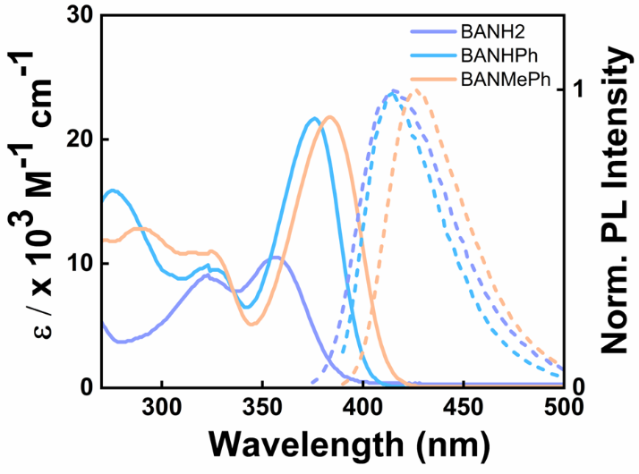
Supplementary Fig. 16| UV-Vis absorption spectra and emission spectra. Absorbance studies (solid line) and steady-state emission studies (broken line) of BANHPh (λ_{ex}= 390 nm), BANMePh (λ_{ex}= 380 nm), and BANH2 (λ_{ex}= 365 nm) in hexane solution (conc. 10 μM).
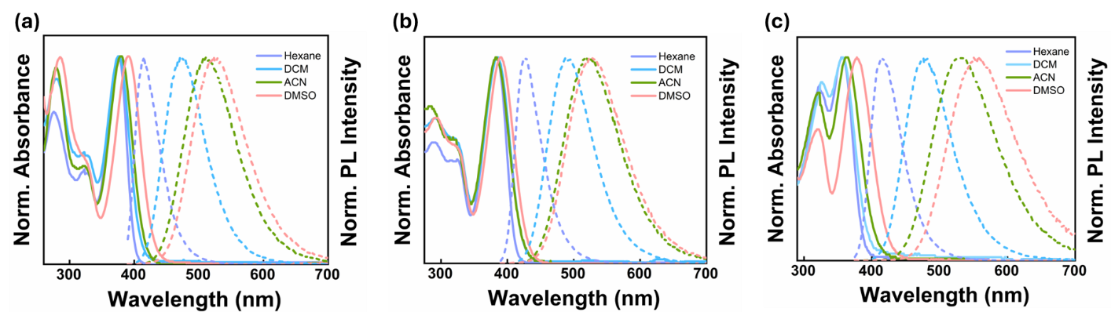
Supplementary Fig. 17| UV-Vis absorption spectra and emission spectra. Absprbance studies (solid line) and steady-state emission studies (broken line) of (a) BANHPh (λ_{ex}= 390 nm), (b) BANMePh (λ_{ex}= 380 nm), and (c) BANH2 (λ_{ex}= 365 nm) in solvents with different dielectric constant (conc. 10 μM).
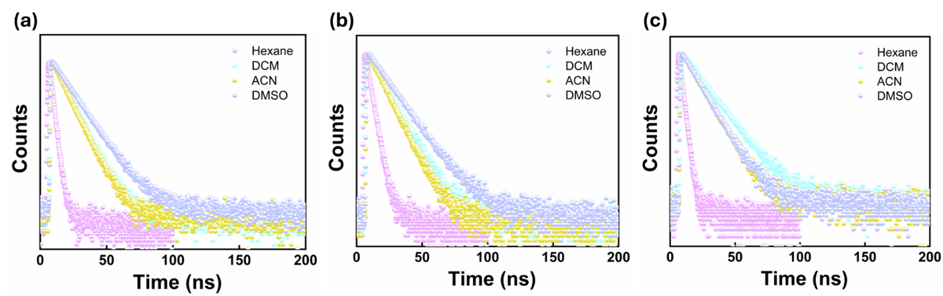
Supplementary Fig. 18| Lifetime decay profiles. Lifetime decay profiles of steady-state emission for (a) BANHPh (λ_{ex}= 375 nm), (b) BANMePh (λ_{ex}= 375 nm), and (c) BANH2 (λ_{ex}= 375 nm) in solvents with different dielectric constants (conc. 10 μM).

Supplementary Table 8| Steady-state PL properties of BANHPh (λ_{ex}= 390 nm), BANMePh (λ_{ex}= 380 nm) and BANH2 (λ_{ex}= 365 nm) in hexane solution (conc. 10 μM).
Compound | λ_{abs}/nm (ɛ /L.mol⁻¹.cm⁻¹) | λ_{em}/nm | τ/ns | Φ_{PL}/% | E_{opt}/ eV
BANHPh | 275 (15789), 323 (9875), 375 (21661) | 415 | 2.7 | 29 | 3.14
BANMePh | 289 (12917), 324 (11035), 383 (12088) | 426 | 3.8 | 34 | 3.06
BANH2 | 323 (86219), 356 (100132) | 415 | 2.6 | 16 | 3.21

Supplementary Table 9| Steady-state PL properties of BANHPh (λ_{ex}= 390 nm), BANMePh (λ_{ex}= 380 nm) and BANH2 (λ_{ex}= 365 nm) in solvents with different dielectric constants (conc. 10 μM).
Compound | Solvents | λ_{abs}/nm (ɛ /L.mol⁻¹.cm⁻¹) | λ_{em}/nm | τ/ns | Φ_{PL}/%
BANHPh | DCM | 279 (17204), 324 (10724), 376 (19454) | 472 | 10 | 81.6
BANHPh | ACN | 279 (13752), 325 (6635), 380 (14799) | 512 | 9.3 | 48.2
BANHPh | DMSO | 285 (22226), 325 (11134), 391 (22227) | 525 | 13.2 | 76.6
BANMePh | DCM | 291 (14049), 322 (12088), 385 (20149) | 490 | 11.6 | 78.3
BANMePh | ACN | 288 (6044), 322 (4770), 385 (8014) | 521 | 10.1 | 44.8
BANMePh | DMSO | 292 (13701), 324 (10944), 390 (19329) | 526 | 14.5 | 54.3
BANH2 | DCM | 326 (88056), 357 (99790) | 477 | 14.4 | 57.2
BANH2 | ACN | 321 (82857), 363 (99915) | 531 | 11 | 21
BANH2 | DMSO | 320 (64555), 378 (99448) | 557 | 11.1 | 20.3

Supplementary Fig. 19| Excitation spectra. Variable temperature excitation spectra of steady-state PL band at 445 nm (bottom), phosphorescence band at 482 nm (middle), and phosphorescence band at 450 nm (top) for 1 wt.% BANHPh @PMMA.
Supplementary Fig. 20| Excitation spectra. Variable temperature excitation spectra of steady-state PL band at 445 nm (bottom), phosphorescence band at 486 nm (middle), and phosphorescence band at 450 nm (top) for 1 wt.% BANMePh @PMMA.
Supplementary Fig. 21| Excitation spectra. Variable temperature excitation spectra of steady-state PL band (bottom), phosphorescence band at 475 nm (middle), and phosphorescence band at 455 nm (top) for 1 wt.% BANH2 @PMMA.
Supplementary Fig. 22| Electronic energy level diagram. Representation of S₁ (298K), T₁^{L} and T₁^{H} energy levels estimated from the steady-state PL and phosphorescence spectra of (a) 1 wt.% BANMePh @PMMA, and (b) 1 wt.% BANH2 @PMMA.
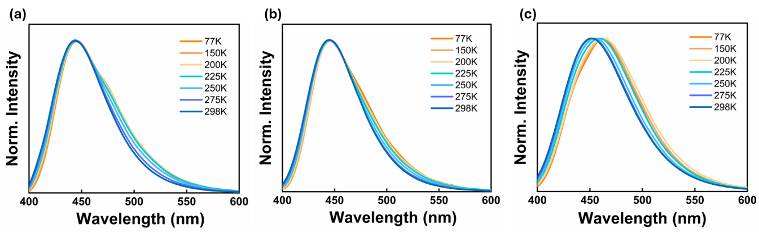
Supplementary Fig. 23| Steady-state PL spectra. Steady-state PL spectra at different temperatures of (a) 1 wt.% BANHPh in PMMA matrix (λ_{ex} =390 nm), (b) 1 wt.% BANMePh in PMMA matrix (λ_{ex} =380 nm), and (c) 1 wt.% BANH2 in PMMA matrix (λ_{ex} =365 nm).
Supplementary Fig. 24| Phosphorescence spectra. Phosphorescence spectra under vacuum and aerobic condition for (a) 1 wt.% BANHPh in PMMA matrix (λ_{ex} =390 nm), (b) 1 wt.% BANMePh in PMMA matrix (λ_{ex} =380 nm), and (c) 1 wt.% BANH2 in PMMA matrix (λ_{ex} =365 nm).
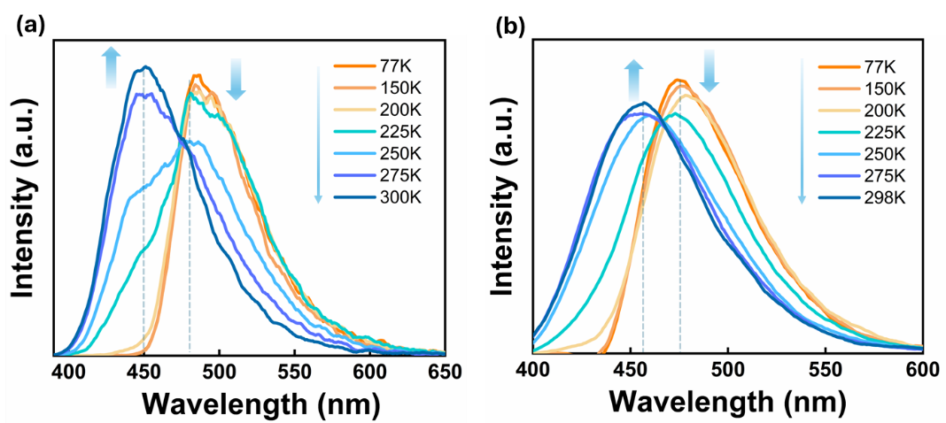
Supplementary Fig. 25| Phosphorescence spectra. Variable temperature phosphorescence spectra (50 μs delay) of (a) 1 wt.% BANMePh in PMMA matrix (λ_{ex} =380 nm), and (b) 1 wt.% BANH2 in PMMA matrix (λ_{ex} =365 nm).
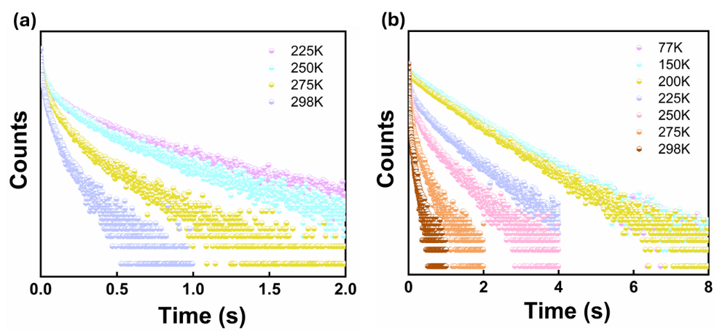
Supplementary Fig. 26| Lifetime decay profile. Variable temperature phosphorescence (50 μs delay) lifetime decay profile of 1 wt.% BANHPh in PMMA matrix for (a) λ_{phos} at 450 nm (λ_{ex} =390 nm), and (b) λ_{phos} at 482 nm (λ_{ex} =390 nm).
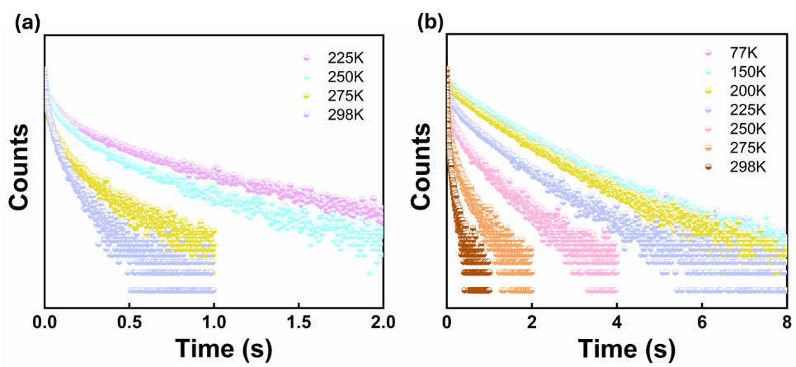
Supplementary Fig. 27| Lifetime decay profile. Variable temperature phosphorescence (50 μs delay) lifetime decay profile of 1 wt.% BANMePh in PMMA matrix for (a) λ_{phos} at 450 nm (λ_{ex} =380 nm), and (b) λ_{phos} at 486 nm (λ_{ex} =380 nm).
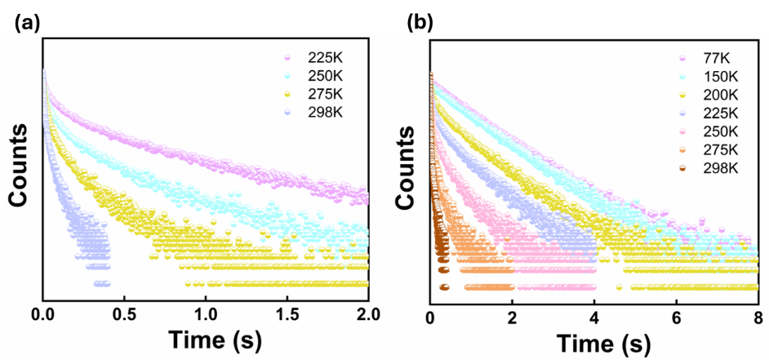
Supplementary Fig. 28| Lifetime decay profile. Variable temperature phosphorescence (50 μs delay) lifetime decay profile of 1 wt.% BANH2 in PMMA matrix for (a) λ_{phos} at 455 nm (λ_{ex} =365 nm), and (b) λ_{phos} at 475 nm (λ_{ex} =365 nm).
Supplementary Fig. 29| Lifetime variation with temperature. Temperature dependent phosphorescence lifetime variation of higher-energy and lower-energy phosphorescence bands for (a) 1 wt.% BANMePh @PMMA, and (b) 1 wt.% BANH2 @PMMA.
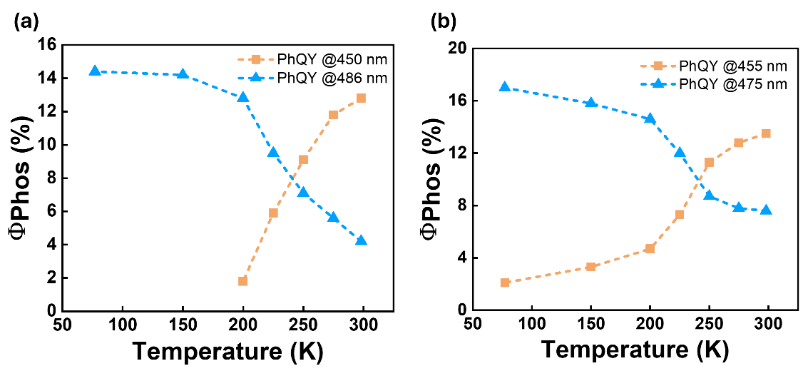
Supplementary Fig. 30| PhQY variation with temperature. Temperature dependent phosphorescence quantum yield variation of higher-energy and lower-energy phosphorescence band for (a) 1 wt.% BANMePh @PMMA, and (b) 1 wt.% BANH2 @PMMA.
Supplementary Fig. 31| Time-resolved phosphorescence spectra. Time-resolved phosphorescence spectra at 225K for 1 wt.% of BANHPh @PMMA matrix (λ_{ex} =390 nm).
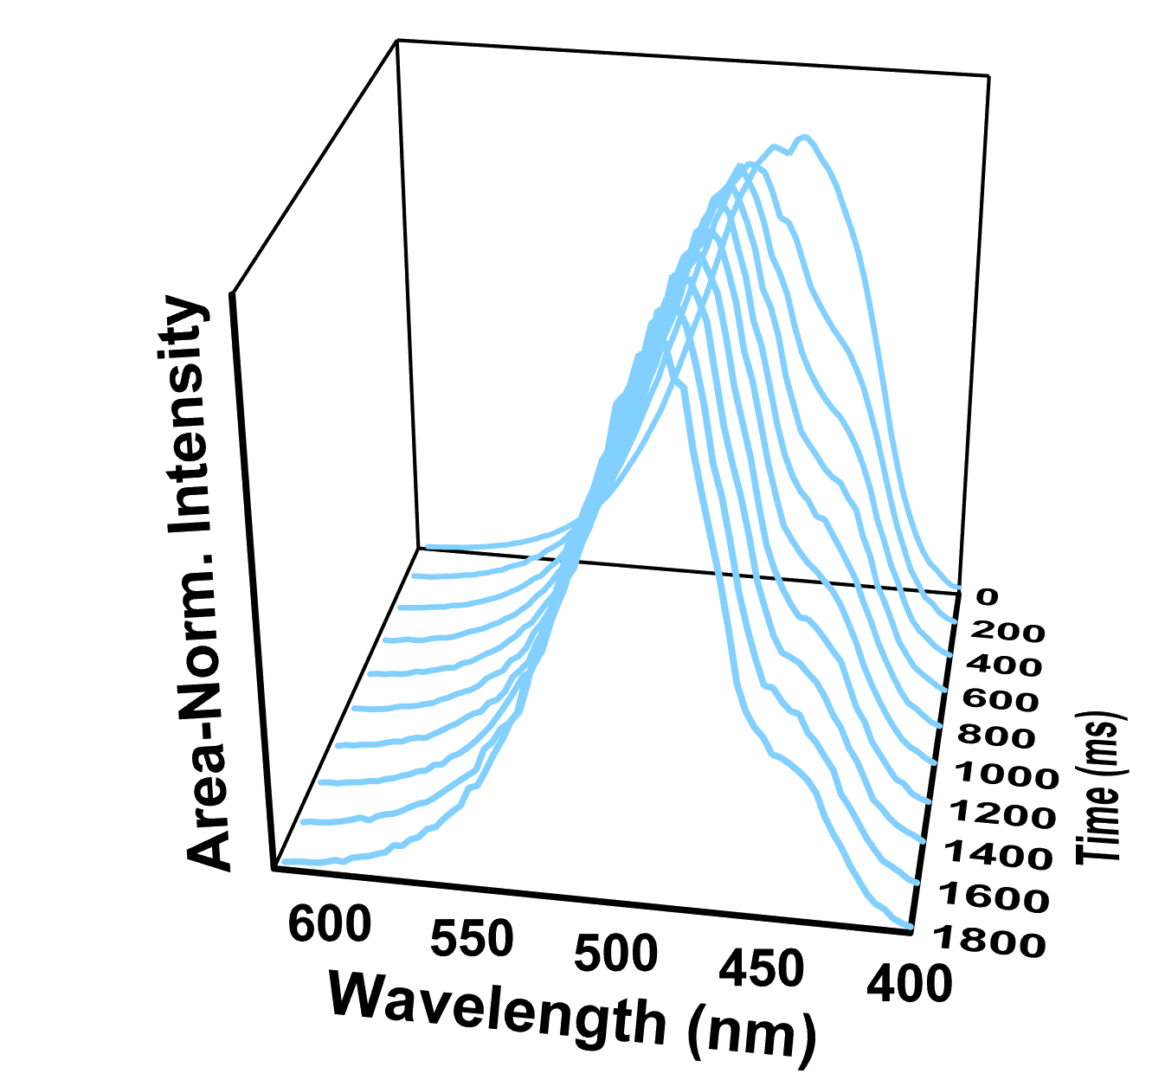
Supplementary Fig. 32| Time-resolved area normalized phosphorescence spectra. Time-resolved area normalized phosphorescence spectra at 225K for 1 wt.% of BANMePh @PMMA matrix (λ_{ex} =380 nm).

Supplementary Fig. 33| Time-resolved phosphorescence spectra. Time-resolved phosphorescence spectra at 225K for 1 wt.% of BANMePh @PMMA matrix (λ_{ex} =380 nm).

Supplementary Table 10| Steady-state emission properties of 1 wt.% of BANHPh in PMMA matrix under vacuum conditions at different temperatures (λ_{ex} =390 nm).
Temperature  /K | τ^{F}_{av}  /ns | Φ^{F}  /% | Φ^{PL}  /% | k_{r}^{F}  /10⁷ s  (S₁→S₀) | k_{nr}^{F}  /10⁷ s
298 | 6.6 | 62.1 | 78.2 | 9.48 | 3.3
275 | 6.7 | 64.2 | 79.5 | 9.51 | 3.1
250 | 6.8 | 65.6 | 79.9 | 9.61 | 2.9
225 | 6.9 | 67.3 | 81.1 | 9.72 | 2.7
200 | 6.9 | 69.1 | 82.9 | 9.91 | 2.5
150 | 7 | 69.8 | 83.2 | 9.96 | 2.4
77 | 7.1 | 71.3 | 84.9 | 10.1 | 2.2

Supplementary Table 11| Phosphorescence lifetime of higher-energy (λ_{em}: 450 nm) and lower-energy (λ_{em}: 482 nm) phosphorescence band for 1 wt.% BANHPh in PMMA matrix under vacuum conditions at different temperatures (λ_{ex} =390 nm).
Temperature  /K | Phosphorescence Lifetime /ms
Temperature  /K | λ₄₅₀ |  |  | λ₄₈₂
Temperature  /K | τ_{A1,} (%) | τ_{A2,} (%) | χ² | τ_{A1,} (%) | τ_{A2,} (%) | χ²
298 | 23 (45) | 103 (55) | 1.2 | 21.1 (45) | 102 (55) | 1.2
275 | 53 (41) | 234 (59) | 1.1 | 54.8 (36) | 254.8 (64) | 1.2
250 | 72.5 (24) | 355 (76) | 1.2 | 129.7 (24) | 582.2 (76) | 1.1
225 | 80.8 (19) | 440.6 (81) | 1.2 | 165.6 (14) | 725.8 (86) | 1.1
200 | -- | -- |  | 519.2 (19) | 1053 (81) | 1.1
150 | -- | -- |  | 572.6 (20) | 1082 (80) | 1.1
77 | -- | -- |  | 586.7 (20) | 1087 (80) | 1.1
* The lifetime for 450 nm phosphorescence band could not be recorded below 200K due to negligible contribution of this band at lower temperatures.
Supplementary Table 12| Phosphorescence properties of 1 wt.% of BANHPh in PMMA matrix under vacuum conditions at different temperatures (λ_{ex} =390 nm).
Temperature  /K | Φ_{Ph}^{Cum}  /% | Φ_{Ph}⁴⁵⁰  /% | Φ_{Ph}⁴⁸²  /% | k_{r}⁴⁵⁰  /s  (T₁^{H}→S₀) | k_{r}⁴⁸²  /s  (T₁^{L}→S₀) | k_{nr}⁴⁵⁰  /s | k_{nr}⁴⁸²  /s
298 | 16.1 | 11.5 | 4.6 | 1.12 | 0.45 | 8.61 | 9.36
275 | 15.3 | 8.7 | 6.6 | 0.37 | 0.25 | 3.87 | 3.67
250 | 14.4 | 6.7 | 7.7 | 0.19 | 0.14 | 2.63 | 1.58
225 | 13.8 | 4.8 | 9 | 0.11 | 0.12 | 2.16 | 1.25
200 | 13.9 | 2.1 | 11.8 | -- | 0.11 | -- | 0.84
150 | 13.4 | -- | 13.4 | -- | 0.13 | -- | 0.80
77 | 13.5 | -- | 13.5 | -- | 0.12 | -- | 0.79
* The rate constant of 450 nm phosphorescence band could not be calculated below 200K due to absence of lifetime value at lower temperatures.
Supplementary Table 13| Steady-state emission properties of 1 wt.% of BANMePh in PMMA matrix under vacuum conditions at different temperatures (λ_{ex} =380 nm).
Temperature  /K | τ^{F}_{av}  /ns | Φ^{F}  /% | Φ^{PL}  /% | k_{r}^{F}  /10⁷ s  (S₁→S₀) | k_{nr}^{F}  /10⁷ s
298 | 6.51 | 69 | 86 | 10.6 | 2.15
275 | 7.03 | 70.2 | 87.6 | 10 | 1.76
250 | 7.11 | 71 | 87.2 | 9.98 | 1.80
225 | 7.12 | 71 | 86.4 | 9.97 | 1.91
200 | 7.19 | 71.6 | 86.3 | 9.95 | 1.92
150 | 7.22 | 70.6 | 84.8 | 9.77 | 2.10
77 | 7.35 | 59 | 73.5 | 8.03 | 3.62

Supplementary Table 14| Phosphorescence lifetime of higher-energy (λ_{em}: 450 nm) and lower-energy (λ_{em}: 486 nm) phosphorescence band for 1 wt.% BANMePh in PMMA matrix under vacuum conditions at different temperatures (λ_{ex} =380 nm).
Temperature  /K | Phosphorescence Lifetime /ms
Temperature  /K | λ₄₅₀ |  |  | λ₄₈₆
Temperature  /K | τ_{A1,} (%) | τ_{A2,} (%) | χ² | τ_{A1,} (%) | τ_{A2,} (%) | χ²
298 | 25.1 (45) | 104 (55) | 1.1 | 24 (45) | 109 (55) | 1.1
275 | 53 (41) | 236 (59) | 1.2 | 48.1 (34) | 284.3 (66) | 1.3
250 | 87.1 (37) | 437.7 (63) | 1.1 | 108 (22) | 617 (78) | 1.2
225 | 114.3 (28) | 587 (72) | 1.2 | 242 (20) | 921 (80) | 1
200 | -- | -- |  | 430 (20) | 1112 (80) | 1.2
150 | -- | -- |  | 584 (31) | 1221 (69) | 1.2
77 | -- | -- |  | 630.2 (33) | 1236 (67) | 1.2
* The lifetime for 450 nm phosphorescence band could not be recorded below 200K due to negligible contribution of this band at lower temperatures.
Supplementary Table 15| Phosphorescence properties of 1 wt.% of BANMePh in PMMA matrix under vacuum conditions at different temperatures (λ_{ex} =380 nm).
Temperature  /K | Φ_{Ph}^{Cum}  /% | Φ_{Ph}⁴⁵⁰  /% | Φ_{Ph}⁴⁸⁶  /% | k_{r}⁴⁵⁰  /s  (T₁^{H}→S₀) | k_{r}⁴⁸⁶  /s  (T₁^{L}→S₀) | k_{nr}⁴⁵⁰  /s | k_{nr}⁴⁸⁶  /s
298 | 17 | 12.8 | 4.2 | 1.23 | 0.38 | 8.42 | 8.79
275 | 17.4 | 11.8 | 5.6 | 0.68 | 0.19 | 5.09 | 3.32
250 | 16.2 | 9.1 | 7.1 | 0.21 | 0.11 | 2.08 | 1.51
225 | 15.4 | 5.9 | 9.5 | 0.09 | 0.10 | 1.6 | 0.98
200 | 14.6 | 1.8 | 12.8 | -- | 0.12 | -- | 0.78
150 | 14.2 | -- | 14.2 | -- | 0.12 | -- | 0.70
77 | 14.4 | -- | 14.4 | -- | 0.11 | -- | 0.69
* The rate constant of 450 nm phosphorescence band could not be calculated below 200K due to absence of lifetime value at lower temperatures.
Supplementary Table 16| Steady-state emission properties of 1 wt.% of BANH2 in PMMA matrix under vacuum conditions at different temperatures (λ_{ex} =365 nm).
Temperature  /K | τ^{F}_{av}  /ns | Φ^{F}  /% | Φ^{PL}  /% | k_{r}^{F}  /10⁷ s  (S₁→S₀) | k_{nr}^{F}  /10⁷ s
298 | 9.9 | 60 | 81.2 | 6.06 | 1.89
275 | 10.4 | 61.9 | 82.5 | 5.95 | 1.68
250 | 10.37 | 62 | 82 | 5.98 | 1.74
225 | 10.4 | 61.7 | 81.1 | 5.93 | 1.82
200 | 10.5 | 61.3 | 80.6 | 5.84 | 1.85
150 | 10.5 | 61 | 80.2 | 5.81 | 1.88
77 | 10.8 | 56 | 75.1 | 5.19 | 2.31

Supplementary Table 17| Phosphorescence lifetime of higher-energy (λ_{em}: 455 nm) and lower-energy (λ_{em}: 475 nm) band in 1 wt.% BANH2 in PMMA matrix under vacuum conditions at different temperatures (λ_{ex} =365 nm).
Temperature  /K | Phosphorescence Lifetime /ms
Temperature  /K | λ₄₅₅ |  |  | λ₄₇₅
Temperature  /K | τ_{A1,} (%) | τ_{A2,} (%) | χ² | τ_{A1,} (%) | τ_{A2,} (%) | χ²
298 | 13 (46) | 60 (54) | 1.3 | 11 (47) | 56 (53) | 1.3
275 | 37.8 (46) | 196 (54) | 1.2 | 38.6 (46) | 206.4 (54) | 1.1
250 | 85.2 (38) | 418.3 (62) | 1.1 | 108 (35) | 503 (65) | 1.1
225 | 118.6 (26) | 635.3 (74) | 1.2 | 121.6 (22) | 675.7 (78) | 1.2
200 | 219 (22) | 808 (78) | 1 | 210.3 (17) | 825.6 (83) | 1.1
150 | -- | -- |  | 496.3 (17) | 932 (83) | 1.2
77 | -- | -- |  | 634 (36) | 1010 (64) | 1.2

Supplementary Table 18| Phosphorescence properties of 1 wt.% of BANH2 in PMMA matrix under vacuum conditions at different temperatures (λ_{ex} =365 nm).
Temperature  /K | Φ_{Ph}^{Cum}  /% | Φ_{Ph}⁴⁵⁵  /% | Φ_{Ph}⁴⁷⁵  /% | k_{r}⁴⁵⁵  /s  (T₂→S₀) | k_{r}⁴⁷⁵  /s  (T₁→S₀) | k_{nr}⁴⁵⁵  /s | k_{nr}⁴⁷⁵  /s
298 | 21.2 | 13.5 | 7.6 | 2.26 | 1.36 | 14.4 | 16.58
275 | 20.6 | 12.8 | 7.8 | 0.65 | 0.38 | 4.45 | 4.47
250 | 20 | 11.3 | 8.7 | 0.27 | 0.17 | 2.12 | 1.82
225 | 19.3 | 7.3 | 12 | 0.11 | 0.18 | 1.46 | 1.30
200 | 19.3 | 4.7 | 14.6 | 0.06 | 0.18 | 1.18 | 1.03
150 | 19.2 | 3.3 | 15.8 | -- | 0.17 | -- | 0.90
77 | 19.1 | 2.1 | 17 | -- | 0.16 | -- | 0.82

Supplementary Fig. 34| Steady-state and phosphorescence spectra. Steady-state PL and phosphorescence (50 μs delay) spectra of (a) 10 wt.% BANHPh in PMMA matrix (λ_{ex} =390 nm), (b) 10 wt.% BANMePh in PMMA matrix (λ_{ex} =380 nm), and (c) 10 wt.% BANH2 in PMMA matrix (λ_{ex} =365 nm).
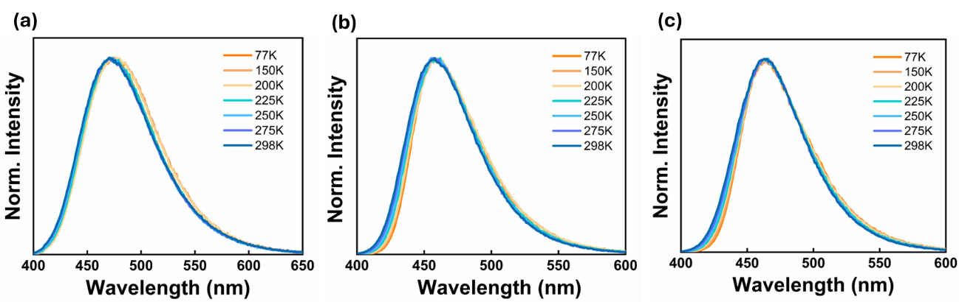
Supplementary Fig. 35| Steady-state PL spectra. Steady-state PL spectra at different temperatures of (a) 10 wt.% BANHPh in PMMA matrix (λ_{ex} = 390 nm), (b) 10 wt.% BANMePh in PMMA matrix (λ_{ex} = 380 nm), and (c) 10 wt.% BANH2 in PMMA matrix (λ_{ex} = 365 nm).
Supplementary Fig. 36| Phosphorescence spectra. Phosphorescence spectra under vacuum and aerobic conditions for (a) 10 wt.% BANHPh in PMMA matrix (λ_{ex} =390 nm), (b) 10 wt.% BANMePh in PMMA matrix (λ_{ex} = 380 nm), and (c) 10 wt.% BANH2 in PMMA matrix (λ_{ex} =365 nm).
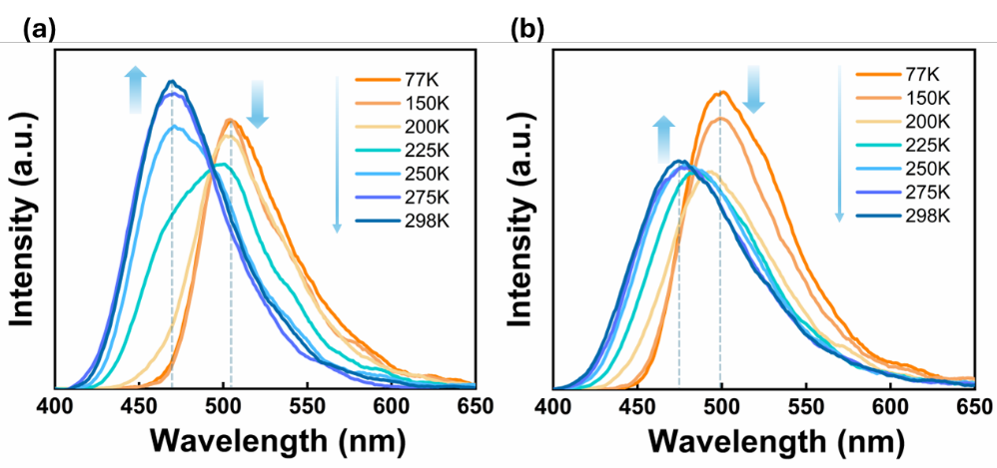
Supplementary Fig. 37| Phosphorescence spectra. Variable temperature phosphorescence spectra (50 μs delay) of (a) 10 wt.% BANMePh in PMMA matrix (λ_{ex} =380 nm), and (b) 10 wt.% BANH2 in PMMA matrix (λ_{ex} =365 nm).
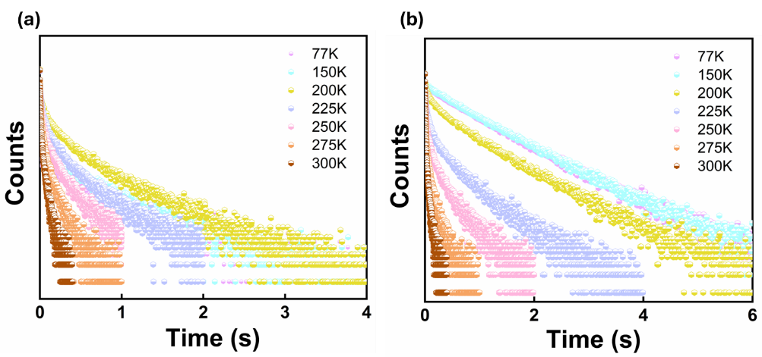
Supplementary Fig. 38| Lifetime decay profile. Variable temperature phosphorescence (50 μs delay) lifetime decay profile of 10 wt.% BANHPh in PMMA matrix for (a) λ_{phos} at 462 nm (λ_{ex} =390 nm), and (b) λ_{phos} at 497 nm (λ_{ex} =390 nm).
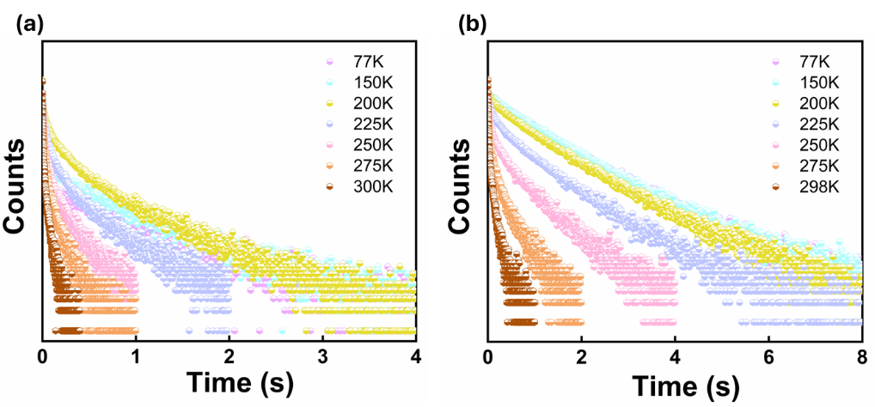
Supplementary Fig. 39| Lifetime decay profile. Variable temperature phosphorescence (50 μs delay) lifetime decay profile of 10 wt.% BANMePh in PMMA matrix for (a) λ_{phos} at 470 nm (λ_{ex} =380 nm), and (b) λ_{phos} at 505 nm (λ_{ex} =380 nm).
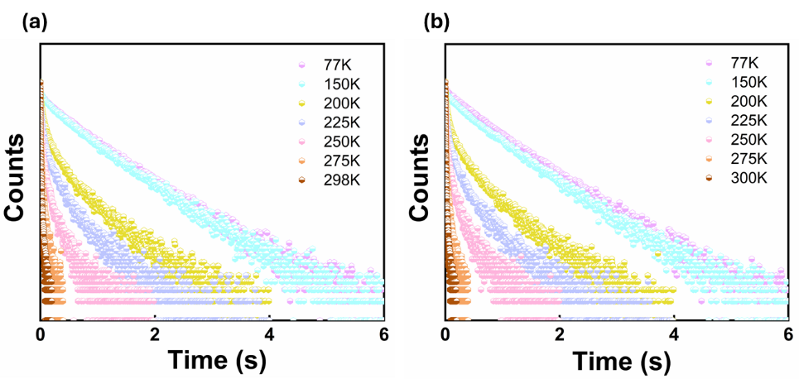
Supplementary Fig. 40| Lifetime decay profile. Variable temperature phosphorescence (50 μs delay) lifetime decay profile of 10 wt.% BANH2 in PMMA matrix for (a) λ_{phos} at 475 nm (λ_{ex} =365 nm), and (b) λ_{phos} at 500 nm (λ_{ex} =365 nm).
Supplementary Table 19| Steady-state PL properties of 10 wt.% of BANHPh in PMMA matrix under vacuum conditions at different temperatures (λ_{ex} =390 nm).
Temperature  /K | τ^{F}_{av}  /ns | Φ^{F}  /% | Φ^{PL}  /% | k_{r}^{F}  /10⁷ s  (S₁→S₀) | k_{nr}^{F}  /10⁷ s
298 | 6.68 | 60.1 | 68.1 | 8.99 | 4.78
77 | 7.14 | 65 | 72.1 | 9.10 | 3.91

Supplementary Table 20| Phosphorescence lifetime of higher-energy (λ_{em}: 462 nm) and lower-energy (λ_{em}: 497 nm) phosphorescence band for 10 wt.% BANHPh in PMMA matrix under vacuum conditions at different temperatures (λ_{ex} =390 nm).
Temperature  /K | Phosphorescence Lifetime /ms
Temperature  /K | λ₄₆₂ |  |  | λ₄₉₇
Temperature  /K | τ_{A1,} (%) | τ_{A2,} (%) | χ² | τ_{A1,} (%) | τ_{A2,} (%) | χ²
298 | 45.1 (48) | 9.2 (42) | 1.1 | 42.4 (57) | 8.1 (43) | 1.2
275 | 105.1 (61) | 20.1 (39) | 1.1 | 110.3 (61) | 19.6 (39) | 1.1
250 | 238.2 (63) | 44.1 (37) | 1.2 | 308 (68) | 56 (32) | 1.2
225 | 345 (70) | 64.2 (30) | 1.3 | 532 (75) | 89 (25) | 1.2
200 | 573 (71) | 130 (29) | 1.2 | 835 (85) | 211 (15) | 1.1
150 | 611 (100) | -- | 1.2 | 947 (84) | 423 (16) | 1.1
77 | 702 (100) | -- | 1.1 | 964 (88) | 469 (18) | 1.2

Supplementary Table 21| Phosphorescence properties of 10 wt.% of BANHPh in PMMA matrix under vacuum conditions at different temperatures (λ_{ex} =390 nm).
Temperature  /K | Φ_{Ph}^{Cum}  /% | Φ_{Ph}⁴⁶²  /% | Φ_{Ph}⁴⁹⁷  /% | k_{r}⁴⁶²  /s  (T₁^{H}→S₀) | k_{r}⁴⁹⁷  /s  (T₁^{L}→S₀) | k_{nr}⁴⁶²  /s | k_{nr}⁴⁹⁷  /s
298 | 8 | 5.6 | 2.3 | 1.25 | 0.56 | 20.9 | 23.0
77 | 7.1 | -- | 7.1 | -- | 0.074 | 1.4 | 0.96

Supplementary Table 22| Steady-state emission properties of 10 wt.% of BANMePh in PMMA matrix under vacuum conditions at different temperatures (λ_{ex} =380 nm).
Temperature  /K | τ^{F}_{av}  /ns | Φ^{F}  /% | Φ^{PL}  /% | k_{r}^{F}  /10⁷ s  (S₁→S₀) | k_{nr}^{F}  /10⁷ s
298 | 9.2 | 74 | 82.5 | 8.04 | 1.90
77 | 9 | 65 | 71.6 | 7.22 | 3.12

Supplementary Table 23|Phosphorescence lifetime of higher-energy (λ_{em}: 470 nm) and lower-energy (λ_{em}: 505 nm) phosphorescence band for 10 wt.% BANMePh in PMMA matrix under vacuum conditions at different temperatures (λ_{ex} =380 nm).
Temperature  /K | Phosphorescence Lifetime /ms
Temperature  /K | λ₄₇₀ |  |  | λ₅₀₅
Temperature  /K | τ_{A1,} (%) | τ_{A2,} (%) | χ² | τ_{A1,} (%) | τ_{A2,} (%) | χ²
298 | 8.1 (45) | 41.6 (55) | 1.1 | 7 (44) | 40 (56) | 1.1
275 | 18.4 (41) | 104 (59) | 1.1 | 19 (41) | 115 (59) | 1.1
250 | 27 (35) | 172 (65) | 1.3 | 39 (33) | 275 (67) | 1.2
225 | 57.2 (33) | 343 (67) | 1.2 | 98 (23) | 610 (77) | 1.2
200 | 127 (33) | 616 (67) | 1.3 | 266 (22) | 932 (78) | 1.1
150 | 164 (11) | 792 (89) | 1.1 | 647 (47) | 1193 (53) | 1.2
77 | 67 (2) | 818 (98) | 1.2 | 700 (53) | 1255 (47) | 1.2

Supplementary Table 24| Phosphorescence properties of 10 wt.% of BANMePh in PMMA matrix under vacuum conditions at different temperatures (λ_{ex} =380 nm).
Temperature  /K | Φ_{Ph}^{Cum}  /% | Φ_{Ph}⁴⁷⁰  /% | Φ_{Ph}⁵⁰⁵  /% | k_{r}⁴⁷⁰  /s  (T₁^{H}→S₀) | k_{r}⁵⁰⁵  /s  (T₁^{L}→S₀) | k_{nr}⁴⁷⁰  /s | k_{nr}⁵⁰⁵  /s
298 | 8.5 | 6.3 | 2.2 | 1.52 | 0.54 | 22.5 | 24.5
77 | 6.9 | -- | 6.9 | -- | 0.055 | 1.2 | 0.74

Supplementary Table 25| Steady-state PL properties of 10 wt.% of BANH2 in PMMA matrix under vacuum conditions at different temperatures (λ_{ex} =365 nm).
Temperature  /K | τ^{F}_{av}  /ns | Φ^{F}  /% | Φ^{PL}  /% | k_{r}^{F}  /10⁷ s  (S₁→S₀) | k_{nr}^{F}  /10⁷ s
298 | 11.1 | 61 | 72.5 | 5.49 | 2.47
77 | 11.3 | 60.7 | 73.9 | 5.37 | 2.31

Supplementary Table 26| Phosphorescence lifetime of higher-energy (λ_{em}: 475 nm) and lower-energy (λ_{em}: 500 nm) phosphorescence band for 10 wt.% BANH2 in PMMA matrix under vacuum conditions at different temperatures (λ_{ex} =365 nm).
Temperature  /K | Phosphorescence Lifetime /ms
Temperature  /K | λ₄₇₅ |  |  | λ₅₀₀
Temperature  /K | τ_{A1,} (%) | τ_{A2,} (%) | χ² | τ_{A1,} (%) | τ_{A2,} (%) | χ²
298 | 4 (52) | 18 (48) | 1.1 | 3.7 (52) | 18 (48) | 1.1
275 | 8 (46) | 43 (54) | 1.2 | 9.4 (48) | 49 (52) | 1.2
250 | 36 (45) | 189 (55) | 1.1 | 38 (45) | 219 (55) | 1.2
225 | 78 (39) | 383 (61) | 1 | 79 (38) | 401 (62) | 1
200 | 103 (34) | 506 (66) | 1.1 | 115 (32) | 526 (68) | 1.2
150 | 234 (16) | 721 (84) | 1 | 215 (12) | 708 (88) | 1
77 | 252 (13) | 735 (87) | 1.1 | 299 (11) | 729 (89) | 1

Supplementary Table 27| Phosphorescence properties of 10 wt.% of BANH2 in PMMA matrix under vacuum conditions at different temperatures (λ_{ex} =365 nm).
Temperature  /K | Φ_{Ph}^{Cum}  /% | Φ_{Ph}⁴⁷⁵  /% | Φ_{Ph}⁵⁰⁰  /% | k_{r}⁴⁷⁵  /s  (T₂→S₀) | k_{r}⁵⁰⁰  /s  (T₁→S₀) | k_{nr}⁴⁷⁵  /s | k_{nr}⁵⁰⁰  /s
298 | 11.5 | 7.7 | 3.8 | 4.21 | 2.13 | 50.4 | 54.1
77 | 13.2 | 1.8 | 11.3 | 0.02 | 0.15 | 1.3 | 1.2

Supplementary Fig. 41| Comparison of steady-state emission spectra. Relative steady-state emission spectra at 298K of (a) 1 wt.% & 10 wt.% BANHPh @PMMA (λ_{ex} =390 nm), (b) 1 wt.% & 10 wt.% BANMePh @PMMA (λ_{ex} =380 nm), and (c) 1 wt.% & 10 wt.% BANH2 @PMMA (λ_{ex} =365 nm).
Supplementary Fig. 42| Comparison of phosphorescence spectra. Relative phosphorescence spectra at 298K and 77K of (a) 1 wt.% & 10 wt.% BANMePh @PMMA (λ_{ex} =380 nm), and (b) 1 wt.% & 10 wt.% BANH2 @PMMA (λ_{ex} =365 nm).
Supplementary Fig. 43| PhQY Histograms. Histograms of total phosphorescence quantum yield at 298K and 77K for (a) 1 wt.% & 10 wt.% BANMePh @PMMA, and (b) 1 wt.% & 10 wt.% BANH2 @PMMA.
Supplementary Fig. 44| Comparison of phosphorescence lifetime decay profile. Comparison of phosphorescence lifetime decay profile at 298K and 77K for (a) 1 wt.% & 10 wt.% BANMePh @PMMA, and (b) 1 wt.% & 10 wt.% BANH2 @PMMA.
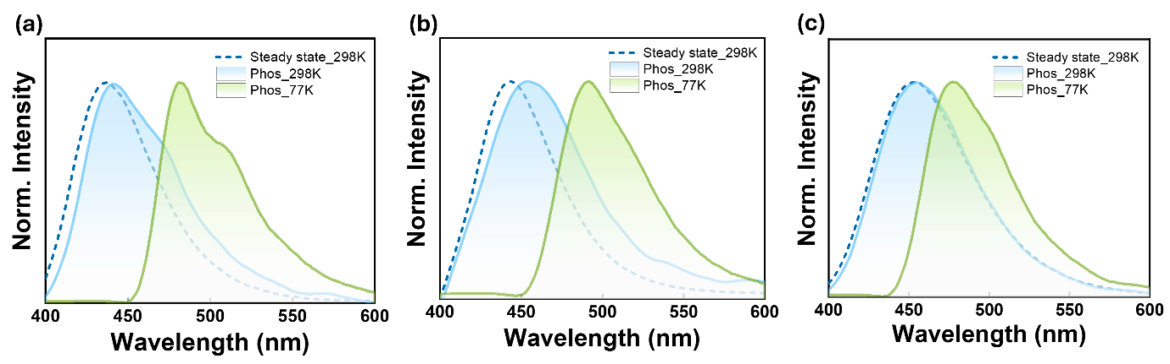
Supplementary Fig. 45| Steady-state and phosphorescence spectra. Steady-state and phosphorescence (50 μs delay) spectra of (a) 1 wt.% BANHPh in PBMA matrix (λ_{ex} =390 nm), (b) 1 wt.% BANMePh in PBMA matrix (λ_{ex} =380 nm)and (b) 1 wt.% BANH2 in PBMA matrix (λ_{ex} =365 nm).
Supplementary Fig. 46| Steady-state PL spectra. Steady-state PL spectra at different temperature of (a) 1 wt.% BANHPh in PBMA matrix (λ_{ex} =390 nm), (b) 1 wt.% BANMePh in PBMA matrix (λ_{ex} =380 nm), and (c) 1 wt.% BANH2 in PBMA matrix (λ_{ex} =365 nm).

Supplementary Fig. 47| Phosphorescence spectra. Variable temperature phosphorescence spectra (50 μs delay) of (a) 1 wt.% BANMePh in PBMA matrix (λ_{ex} =380 nm), and (b) 1 wt.% BANH2 in PBMA matrix (λ_{ex} =365 nm).
Supplementary Fig. 48| Lifetime decay profile. Variable temperature phosphorescence (50 μs delay) lifetime decay profile of 1 wt.% BANHPh in PBMA matrix for (a) λ_{phos} at 445 nm (λ_{ex} =390 nm), and (b) λ_{phos} at 482 nm (λ_{ex} =390 nm).
Supplementary Fig. 49| Lifetime decay profile. Variable temperature phosphorescence (50 μs delay) lifetime decay profile of 1 wt.% BANMePh in PBMA matrix for (a) λ_{phos} at 455 nm (λ_{ex} =380 nm), and (b) λ_{phos} at 490 nm (λ_{ex} =380 nm).
Supplementary Fig. 50| Lifetime decay profile. Variable temperature phosphorescence (50 μs delay) lifetime decay profile of 1 wt.% BANH2 in PBMA matrix for (a) λ_{phos} at 455 nm (λ_{ex} =365 nm), and (b) λ_{phos} at 476 nm (λ_{ex} =365 nm).
Supplementary Table 28| Phosphorescence lifetime of higher-energy (λ_{em}: 445 nm) and lower-energy (λ_{em}: 482 nm) phosphorescence band for 1 wt.% BANHPh in PBMA matrix under vacuum conditions at different temperatures (λ_{ex} =390 nm).
Temperature  /K | Phosphorescence Lifetime /ms
Temperature  /K | λ₄₄₅ |  |  | λ₄₈₂
Temperature  /K | τ_{A1,} (%) | τ_{A2,} (%) | χ² | τ_{A1,} (%) | τ_{A2,} (%) | χ²
298 | 4.7 (25) | 17 (75) | 1 | 5 (28) | 17 (72) | 1
275 | 12 (28) | 45 (72) | 1.1 | 11 (28) | 46 (72) | 1
250 | 22 (28) | 77 (72) | 1 | 26 (29) | 95 (71) | 1
225 | 56 (23) | 210 (77) | 1 | 123 (29) | 323 (71) | 1
200 | -- | -- |  | 259 (13) | 666 (87) | 1.1
150 | -- | -- |  | 489 (25) | 1008 (75) | 1.1
77 | -- | -- |  | 488 (24) | 1010 (76) | 1.2

Supplementary Table 29| Phosphorescence lifetime of higher-energy (λ_{em}: 455 nm) and lower-energy (λ_{em}: 490 nm) phosphorescence band for 1 wt.% BANMePh in PBMA matrix under vacuum conditions at different temperatures (λ_{ex} =380 nm).
Temperature  /K | Phosphorescence Lifetime /ms
Temperature  /K | λ₄₅₅ |  |  | λ₄₉₀
Temperature  /K | τ_{A1,} (%) | τ_{A2,} (%) | χ² | τ_{A1,} (%) | τ_{A2,} (%) | χ²
298 | 7 (32) | 21 (68) | 1 | 7 (36) | 19 (74) | 1.1
275 | 17 (35) | 48 (65) | 1 | 23 (28) | 87 (72) | 1.1
250 | 48 (33) | 168 (66) | 1 | 59 (23) | 215 (77) | 1.2
225 | 90 (28) | 326 (72) | 1 | 144 (19) | 413 (81) | 1.1
200 | -- | -- |  | 636 (52) | 1126 (48) | 1
150 | -- | -- |  | 655 (36) | 1193 (64) | 1.1
77 | -- | -- |  | 667 (37) | 1213 (63) | 1.1

Supplementary Table 30| Phosphorescence lifetime of higher-energy (λ_{em}: 455 nm) and lower-energy (λ_{em}: 475 nm) phosphorescence band for 1 wt.% BANH2 in PBMA matrix under vacuum conditions at different temperatures (λ_{ex} =365 nm).
Temperature  /K | Phosphorescence Lifetime /ms
Temperature  /K | λ₄₅₅ |  |  | λ₄₇₅
Temperature  /K | τ_{A1,} (%) | τ_{A2,} (%) | χ² | τ_{A1,} (%) | τ_{A2,} (%) | χ²
298 | 4 (51) | 10 (49) | 1.1 | 3 (44) | 9 (56) | 1
275 | 10 (40) | 31 (60) | 1 | 8 (43) | 31 (57) | 1.1
250 | 28 (40) | 96 (60) | 1.2 | 25 (40) | 95 (60) | 1.2
225 | 64 (33) | 222 (66) | 1.1 | 83 (30) | 289 (70) | 1
200 | 220 (17) | 633 (83) | 1 | 257 (14) | 683 (86) | 1.1
150 | 347 (7) | 831 (93) | 1.1 | 460 (12) | 853 (88) | 1
77 | 434 (12) | 879 (88) | 1.1 | 537 (21) | 907 (79) | 1.1

Supplementary Fig. 51| Comparison of steady-state emission spectra. Relative steady-state emission spectra at 298K of (a) 1 wt.% BANHPh in PMMA and PBMA matrix (λ_{ex} =390 nm), (b) 1 wt.% BANMePh in PMMA and PBMA matrix (λ_{ex} =380 nm), and (c) 1 wt.% BANH2 in PMMA and PBMA matrix (λ_{ex} =365 nm).
Supplementary Fig. 52| Comparison of phosphorescence spectra. Relative phosphorescence spectra at 298K and 77K of (a) 1 wt.% BANMePh in PMMA and PBMA matrix (λ_{ex} =380 nm), and (b) 1 wt.% BANH2 in PMMA and PBMA matrix (λ_{ex} =365 nm).

Supplementary Fig. 53| Matrix dependent relative intensity of LEP and HEP. Relative intensity of LEP and HEP bands at different temperatures in PMMA and PBMA matrix for (a) 1 wt.% emitter of BANMePh, (b) 1 wt.% emitter of BANH2.
Supplementary Fig. 54| Comparison of phosphorescence lifetime decay profile. Comparison of phosphorescence lifetime decay profile at 298K and 77K for (a) 1 wt.% BANMePh in PMMA and PBMA matrix (λ_{ex} =380 nm), and (b) 1 wt.% BANH2 in PMMA and PBMA matrix (λ_{ex} =365 nm).
Supplementary Fig. 55| Arrhenius plots. (a) Logarithm of down-conversion rate constant (k_{DC}= k_{nr}⁴⁵⁰) versus reciprocal of temperature with activation energies (E_{A}^{DC}), and (b) Logarithm of up-conversion rate constant (k_{UC}= k_{nr}⁴⁸²) versus reciprocal of temperature with activation energies (E_{A}^{UC}) for 1 wt.% BANHPh @PMMA. Activation energy (E_{A}) is calculated by linear fitting of the corresponding points from 225K to 298K. E_{A} is not calculated below 200K for up-conversion process since there is negligible variation in the the k_{nr} value with temperature.
Supplementary Fig. 56| Non-radiative rate constant Vs. temperature plots. (a) Temperature dependence of 450 nm (T₁^{H}) to 486 nm (T₁^{L}) down-conversion rate constant (k_{DC}= k_{nr}⁴⁵⁰), and (b) Temperature dependence of 486 nm (T₁^{L}) to 450 nm (T₁^{H}) up-conversion rate constant (k_{UC}= k_{nr}⁴⁸²) for 1 wt.% BANMePh @PMMA emitter.
Supplementary Fig. 57| Arrhenius plots. (a) Logarithm of down-conversion rate constant (k_{DC}= k_{nr}⁴⁵⁰) versus reciprocal of temperature with activation energies (E_{A}^{DC}), and (b) Logarithm of up-conversion rate constant (k_{UC}= k_{nr}⁴⁸⁶) versus reciprocal of temperature with activation energies (E_{A}^{UC}) for 1 wt.% BANMePh @PMMA. Activation energy is calculated by linear fitting of the corresponding points from 225K to 298K. E_{A} is not calculated below 200K for the up-conversion process since there is negligible variation in the the k_{nr} value with temperature.
Supplementary Fig. 58| Non-radiative rate constant Vs. temperature plots. (a) Temperature dependence of 455 nm (T₂) to 475 nm (T₁) down-conversion rate constant (k_{DC}= k_{nr}⁴⁵⁵), and (b) Temperature dependence of 475 nm (T₁) to 455 nm (T₂) up-conversion rate constant (k_{UC}= k_{nr}⁴⁷⁵) for 1 wt.% BANH2 @PMMA emitter.
Supplementary Fig. 59| Arrhenius plots. (a) Logarithm of down-conversion rate constant (k_{DC}= k_{nr}⁴⁵⁵) versus reciprocal of temperature with activation energies (E_{A}^{DC}), and (b) Logarithm of up-conversion rate constant (k_{UC}= k_{nr}⁴⁷⁵) versus reciprocal of temperature with activation energies (E_{A}^{UC}) for 1 wt.% BANH2 @PMMA. Activation energy is calculated by linear fitting of the corresponding points from 225K to 298K. E_{A} is not calculated below 200K for the up-conversion process since there is negligible variation in the the k_{nr} value with temperature.

Calculation of quantum yield:
Fluorescence quantum yield was determined with an integrating sphere under ambient conditions. The total photoluminescence quantum yield and phosphorescence quantum yield were obtained by following the previous literatures⁷. The steady-state emission spectrum under vacuum conditions is a combination of fluorescence and phosphorescence spectrum. The ratio of fluorescence and phosphorescence quantum yield can be determined from the ratio of segregated areas for fluorescence and phosphorescence bands. The following formulae were used to calculate the quantum yields:
Φ_{PL} = Φ_{FL} х A_{PL} / A_{FL} (1)
Φ_{PH} = Φ_{PL} – Φ_{FL} (2)
Where, Φ_{PL} refers to total photoluminescence quantum yield, Φ_{PH} refers to phosphorescence quantum yield, and Φ_{FL} refers to fluorescence quantum yield. A_{PL} and A_{FL} indicate the integrated areas for the total photoluminescence band measured under vacuum conditions and the integrated areas for the fluorescence band measured under ambient conditions, respectively.
Related equations for calculation of rate constants⁸:
k_{r}^{FL} = Φ_{FL} / τ_{FL} (3)
k_{nr}^{FL} = (1 - Φ_{FL} - Φ_{PH}) / τ_{FL} (4)
τ_{PH} = 1 / (k_{r}^{PH} + k_{nr}^{PH}) (5)
k_{nr}^{PH} = (1 - Φ_{PH}) / τ_{PH} (6)
k_{r}^{PH} = (1 / τ_{PH}) - k_{nr}^{PH} (7)
k_{r}^{FL}= raditive rate constant of fluorescence, k_{nr}^{FL}= non-radiative rate constant from singlet state, k_{r}^{PH}= raditive rate constant of phsophorescence, k_{nr}^{FL}= non-radiative rate constant from triplet state, Φ_{FL}= fluorescence quantum yield, Φ_{PH}= phosphorescence quantum yield, τ_{FL}= fluorescence lifetime, τ_{PH}= phosphorescence lifetime.

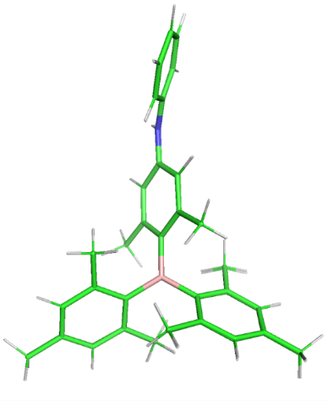
Supplementary Fig. 60| Comparison of quantum chemical methods for geometries. Overlay of optimized geometry of BANHPh using GFN2-XTB and B3LYP/def2-TZVP levels of theory, with a root mean square deviation of 0.0358 Å between the structures.
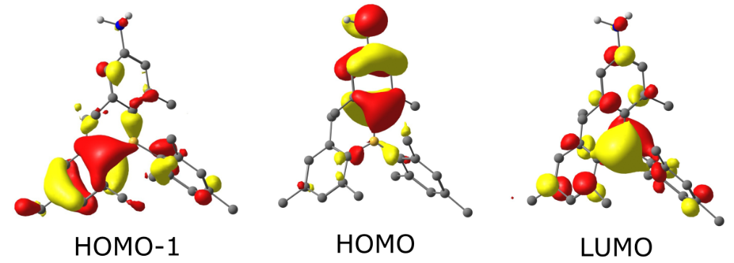
Supplementary Fig. 61| FMO diagrams. Frontier molecular orbitals of BANH2 with yellow and red isosurfaces representing positive and negative phases, respectively.
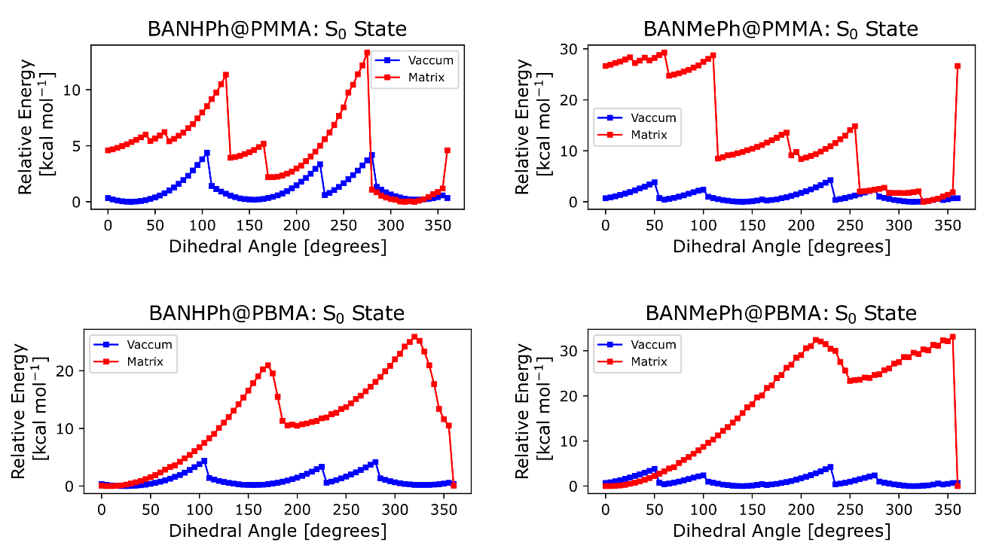
Supplementary Fig. 62| Potential energy scan at S₀ state. Relaxed potential energy scans (S₀ state) of phenyl group rotation, varying the dihedral angle with the xylyl group for BANHPh & BANMePh in PMMA matrix and PBMA matrix, respectively.
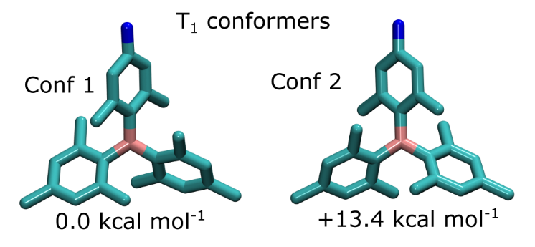
Supplementary Fig. 63| Conformers for BANH2 at T₁ state. Two possible conformers of BANH2@PMMA in the T₁ state, determined using CREST conformational sampling. The energy difference between the two conformers is 13.4 kcal/mol (B3LYP-D4/def2-TZVP level of theory).

Supplementary Table 31| Vertical excitation energies of singlet (S) and triplet (T) excited states for BANHPh (gas-phase) computed using the ADC(2)/def2-TZVP level of theory. The ground state singlet geometry was optimized using the B3LYP/def2-TZVP level of theory. The nature of the excited states in the canonical basis, along with their weights, is also depicted, and the oscillator strength (f) for the singlet excitation is shown. All energy values are in electron volt (eV) units.
State | Energy (eV) | State | Energy (eV)
S₁ | 3.19 H→L 88.1% (f 0.31) | T₁ | 2.92 H→L 80.9%
S₂ | 3.89 H-1 → L 87.4% (f 0.12) | T₂ | 3.49 H-1 → L 77.2%
S₃ | 4.11 H-3 → L 55.1% (f 0.012) | T₃ | 3.62 H-2 →L 66.8%

Supplementary Table 32| Vertical excitation energies of singlet (S) and triplet (T) excited states for BANHPh (gas phase) computed using the ADC(2)/def2-TZVP level of theory. The fully optimized ground state singlet geometry at the GFN2-xTB level was utilized. The nature of the excited states in the canonical basis, along with their weights, is also depicted, and the oscillator strength (f) for the singlet excitation is shown. All energy values are in electron volts (eV).
State | Energy (eV) | State | Energy (eV)
S₁ | 3.161 H→L 87.0% (f 0.30) | T₁ | 2.889 H→L 79.1%
S₂ | 3.781 H-1 → L 86.7% (0.108) | T₂ | 3.453 H-1 → L 78.2%
S₃ | 3.997 H-2 → L 57.0% (f 0.009)  H-3 → L 14.6% | T₃ | 3.606 H-2 →L 66.2%

Supplementary Table 33| Vertical excitation energies of singlet (S) and triplet (T) excited states for BANHPh (with PMMA and PBMA matrices) computed using the ADC(2)/def2-TZVP level of theory. The fully optimized ground state singlet geometry at the GFN2-xTB level, in the presence of an explicit PMMA and PBMA matrix, respectively, was utilized. The PMMA and PBMA matrices are explicitly included using a point-charge description. The nature of the excited states in the canonical basis, along with their weights, is also depicted, and the oscillator strength (f) for the singlet excitation is shown. All energy values are in electron volts (eV).
State | Energy (eV) | State | Energy (eV)
 | PMMA results
S₁ | 3.279 H→L 85.8% (f 0.32) | T₁ | 2.977 H→L 79.1%
S₂ | 3.693 H-1 → L 84.4% (f 0.088) | T₂ | 3.388 H-1 → L 77.3%
S₃ | 3.860 H-2 → L 86.2% (f 0.016) | T₃ | 3.619 H-3 → L 50.0%  H-2 → L 19.6%
 | PBMA results
S₁ | 3.011 H→L 87.9% (f 0.30) | T₁ | 2.797 H→L 81.9%
S₂ | 3.954 H-1 → L 68.6% (f 0.03)  H-2 → L 14.9% | T₂ | 3.615 H-1 → L 69.5%
S₃ | 4.067 H-2 → L 61.6% (f 0.097)  H-1 → L 18.9% | T₃ | 3.733 H-3 → L 59.7%  H-1 → L+1 10.4%

Supplementary Table 34| Spin–orbit coupling matrix elements for the coupling between singlet (S) and triplet (T) excited states of BANHPh, embedded in the PMMA and PBMA matrices, computed using the TD-B3LYP/def2-TZVP level of theory. The PMMA and PBMA matrix is explicitly included using a point-charge description.
With PMMA Matrix | With PBMA Matrix | Without Matrix
S₀-T₁ 0.803 cm⁻¹  S₀-T₂ 0.223 cm⁻¹  S₁-T₁ 0.083 cm⁻¹  S₁-T₂ 0.897 cm⁻¹  S₂-T₁ 1.005 cm⁻¹  S₂-T₂ 0.233 cm⁻¹ | 0.947 cm⁻¹  0.156 cm⁻¹  0.419 cm⁻¹  1.423 cm⁻¹  1.522 cm⁻¹  0.128 cm⁻¹ | S₀-T₁ 0.826 cm⁻¹  S₀-T₂ 0.245 cm⁻¹  S₁-T₁ 0.083 cm⁻¹  S₁-T₂ 0.905 cm⁻¹  S₂-T₁ 1.039 cm⁻¹  S₂-T₂ 0.143 cm⁻¹

Supplementary Table 35| Vertical excitation energies of singlet (S) and triplet (T) excited states for BANMePh (gas phase) computed using the ADC(2)/def2-TZVP level of theory. The fully optimized ground state singlet geometry at the GFN2-xTB level was utilized. The nature of the excited states in the canonical basis, along with their weights, is also depicted, and the oscillator strength (f) for the singlet excitation is shown. All energy values are in electron volts (eV).
State | Energy (eV) | State | Energy (eV)
S₁ | 2.997 (f 0.20) H→L 87.3% | T₁ | 2.806 H→L 80.4%
S₂ | 3.759 (f 0.102) H-1 → L 87.6% | T₂ | 3.415 H-1 → L 75.4%
S₃ | 4.001 (f 0.010) H-3 – L 63.2 % | T₃ | 3.595 H-2 → L 62.8%

Supplementary Table 36| Vertical excitation energies of singlet (S) and triplet (T) excited states for BANMePh (with PMMA and PBMA matrices) computed using the ADC(2)/def2-TZVP level of theory. The fully optimized ground state singlet geometry at the GFN2-xTB level, in the presence of an explicit PMMA and PBMA matrix, respectively, was utilized. The PMMA and PBMA matrices are explicitly included using a point-charge description. The nature of the excited states in the canonical basis, along with their weights, is also depicted, and the oscillator strength (f) for the singlet excitation is shown. All energy values are in electron volts (eV).
State | Energy (eV) | State | Energy (eV)
 | PMMA results
S₁ | 3.184 (f 0.23) H→L 87.9% | T₁ | 2.949 H→L 79.8%
S₂ | 3.753 (0.102) H-1 → L 83.7% | T₂ | 3.389 H-1 → L 78.4%
S₃ | 3.885 (0.013) H-2 → L 84.6% | T₃ | 3.641 H-3 – L 63.9 %
 | PBMA results
S₁ | 2.883 (f 0.27) H→L 89.4% | T₁ | 2.699 H→L 85.5%
S₂ | 3.931 (0.14) H-1 → L 85.8% | T₂ | 3.563 H-1 → L 74.6%
S₃ | 4.046 (0.010) H-4 → L 39.9%  H-2 L 25.4% | T₃ | 3.697 H-2 – L 49.3 %  H-3 L 11.4%

Supplementary Table 37| Spin–orbit coupling matrix elements for the coupling between singlet (S) and triplet (T) excited states of BANMePh, embedded in the PMMA and PBMA matrices, computed using the TD-B3LYP/def2-TZVP level of theory. The PMMA and PBMA matrix is explicitly included using a point-charge description.
With PMMA Matrix | With PBMA Matrix | Without PMMA Matrix
S₀-T₁ 0.996 cm⁻¹  S₀-T₂ 0.291 cm⁻¹  S₁-T₁ 0.063 cm⁻¹  S₁-T₂ 0.823 cm⁻¹  S₂-T₁ 1.040 cm⁻¹  S₂-T₂ 0.243 cm⁻¹ | S₀-T₁ 0.909 cm⁻¹  S₀-T₂ 0.189 cm⁻¹  S₁-T₁ 0.697 cm⁻¹  S₁-T₂ 0.933 cm⁻¹  S₂-T₁ 0.966 cm⁻¹  S₂-T₂ 0.876 cm⁻¹ | S₀-T₁ 1.027 cm⁻¹  S₀-T₂ 0.191 cm⁻¹  S₁-T₁ 0.110 cm⁻¹  S₁-T₂ 0.812 cm⁻¹  S₂-T₁ 0.973 cm⁻¹  S₂-T₂ 0.196 cm⁻¹

Supplementary Table 38| Vertical excitation energies of singlet (S) and triplet (T) excited states for BANH2 (gas phase) computed using the ADC(2)/def2-TZVP level of theory. The fully optimized ground state singlet geometry at the GFN2-xTB level was utilized. The nature of the excited states in the canonical basis, along with their weights, is also depicted, and the oscillator strength (f) for the singlet excitation is shown. All energy values are in electron volts (eV).
State | Energy (eV) | State | Energy (eV)
S₁ | 3.43043 H→L 92.1% | T₁ | 3.12252 H→L 84.3%
S₂ | 3.89824 H-1 → L 86.7% | T₂ | 3.52059 H-1 → L 58.1%  H-3 → L 16.2%
S₃ | 4.02283 H-2 → L 45.9%  H-3 → L 29.9%  H-4 → L 11.3% | T₃ | 3.69420 H-2 – L 32.2 %  H-3 – L 21.4 %  H-1 – L 17.6 %

Supplementary Table 39| Vertical excitation energies of singlet (S) and triplet (T) excited states for BANH2 (with PMMA and PBMA matrices) computed using the ADC(2)/def2-TZVP level of theory. The fully optimized ground state singlet geometry at the GFN2-xTB level, in the presence of an explicit PMMA and PBMA matrix, respectively, was utilized. The PMMA and PBMA matrices is explicitly included using a point-charge description. The nature of the excited states in the canonical basis, along with their weights, is also depicted, and the oscillator strength (f) for the singlet excitation is shown. All energy values are in electron volts (eV).
State | Energy (eV) | State | Energy (eV)
 | PMMA results
S₁ | 3.50444 (f 0.21) H→L 91.7% | T₁ | 3.17740 H→L 83.8%
S₂ | 3.90543 (f 0.11) H-1 → L 71.5%  H-2 → L 12.2% | T₂ | 3.47861 H-1 → L 74.0%
S₃ | 3.93376 (0.034) H-2 → L 73.5% | T₃ | 3.76174 H-3 – L 68.6 %
 | PBMA results
S₁ | 3.136 (f 0.203) H→L 91.6% | T₁ | 2.869 H→L 85.9%
S₂ | 3.939 (f 0.025) H-2 → L 56.1%  H-1 → L 27.8% | T₂ | 3.550 H-1 → L 79.3%
S₃ | 4.000 (f 0.125) H-1 → L 61.1%  H-2 → L 25.2% | T₃ | 3.725 H-3 – L 66.0 %  H-1 – L 13.5 %

Supplementary Table 40| Spin–orbit coupling matrix elements for the coupling between singlet (S) and triplet (T) excited states of BANH2, embedded in the PMMA and PBMA matrices,computed using the TD-B3LYP/def2-TZVP level of theory. The PMMA and PBMA matrices are explicitly included using a point-charge description.
With PMMA Matrix | With PMBA Matrix | Without PMMA Matrix
S₀-T₁ 0.336 cm⁻¹  S₀-T₂ 0.754 cm⁻¹  S₁-T₁ 0.299 cm⁻¹  S₁-T₂ 1.131 cm⁻¹  S₂-T₁ 1.513 cm⁻¹  S₂-T₂ 0.261 cm⁻¹ | S₀-T₁ 0.855 cm⁻¹  S₀-T₂ 0.337 cm⁻¹  S₁-T₁ 0.383 cm⁻¹  S₁-T₂ 1.349 cm⁻¹  S₂-T₁ 1.411 cm⁻¹  S₂-T₂ 0.609 cm⁻¹ | S₀-T₁ 0.446 cm⁻¹  S₀-T₂ 0.744 cm⁻¹  S₁-T₁ 0.356 cm⁻¹  S₁-T₂ 1.285 cm⁻¹  S₂-T₁ 1.505 cm⁻¹  S₂-T₂ 0.225 cm⁻¹

Supplementary References
- Kabsch, W. et al. XDS. Acta Crystallogr. Sect. D Biol. Crystallogr. 66, 125–132 (2010).
- Kabsch, W. et al. Integration, scaling, space-group assignment and post-refinement. Acta Crystallogr. Sect. D Biol. Crystallogr. 66, 133–144 (2010).
- Sheldrick, G. M. et al. SHELXT -Integrated space-group and crystal-structure determination. Acta Crystallogr. Sect. A Found. Crystallogr. 71, 3–8 (2015).
- Sheldrick, G. M. et al. Crystal structure refinement with SHELXL. Acta Crystallogr. C71, 3–8 (2015).
- Farrugia, L. J. et al. WinGX and ORTEP for Windows: An update. J. Appl. Crystallogr. 45, 849–854 (2012).
- Hübschle, C. B. et al. ShelXle: a Qt graphical user interface for SHELXL. J. Appl. Cryst. 44, 1281-1284 (2011).
- Wei, J. et al. Conformation-dependent dynamic organic phosphorescence through thermal energy driven molecular rotations. Nat. Commun. 14, 627 (2023).
- Li, B. et al. Highly efficient organic room-temperature phosphorescent luminophores through tuning triplet states and spin–orbit coupling with incorporation of a secondary group. J. Phys. Chem. Lett. 10, 7141-7147 (2019).

