OUTCOMES OF INDUCTION VERSUS SPONTANEOUS ONSET OF LABOUR AT 40 AND 41 GW: FINDINGS FROM A PROSPECTIVE DATABASE, SRI LANKA

SUPPORTING INFORMATION

Table of Contents
Additional table 1. STROBE Statement—Checklist 2
Additional table 2. Negative outcomes: list of interventions and/or maternal or neonatal complications 4
Additional table 3. Detailed numbers of births with negative outcomes by gestational age and onset of labour 5
Additional table 4. Incidence of maternal and neonatal complications by gestational age and onset of labour 6
Additional figure 1. Trend of cesarean section and vaginal operative delivery 7
Additional table 5. Comparison bewteen IOL at 40 GW vs IOL at 41 GW and SOL: characteristics and outcomes by gestational age and onset of labour 8
Additional figure 2. Comparison bewteen IOL at 40 GW vs IOL at 41 GW and SOL: Births with negative outcomes 10
Additional table 6. Comparison bewteen IOL at 40 GW vs IOL at 41 GW and SOL: Adjusted odds ratios for negative outcomes 11
Additional table 7. Description of women included in sensitivity analysis* only 12
Additional table 8. Sensitivity analysis: adjusted odds ratios for negative outcomes 13

Additional table 1. STROBE Statement—Checklist
STROBE Statement—Checklist of items that should be included in reports of cross-sectional studies
 | Item No | Recommendation | Page
Title and abstract | 1 | (a) Indicate the study’s design with a commonly used term in the title or the abstract | 3
Title and abstract | 1 | (b) Provide in the abstract an informative and balanced summary of what was done and what was found | 3
Introduction
Background/rationale | 2 | Explain the scientific background and rationale for the investigation being reported | 4-5
Objectives | 3 | State specific objectives, including any prespecified hypotheses | 5
Methods
Study design | 4 | Present key elements of study design early in the paper | 6
Setting | 5 | Describe the setting, locations, and relevant dates, including periods of recruitment, exposure, follow-up, and data collection | 6
Participants | 6 | (a) Give the eligibility criteria, and the sources and methods of selection of participants | 6-7
Variables | 7 | Clearly define all outcomes, exposures, predictors, potential confounders, and effect modifiers. Give diagnostic criteria, if applicable | 7
Data sources/ measurement | 8* | For each variable of interest, give sources of data and details of methods of assessment (measurement). Describe comparability of assessment methods if there is more than one group | 6
Bias | 9 | Describe any efforts to address potential sources of bias | 7
Study size | 10 | Explain how the study size was arrived at | 6
Quantitative variables | 11 | Explain how quantitative variables were handled in the analyses. If applicable, describe which groupings were chosen and why | -
Statistical methods | 12 | (a) Describe all statistical methods, including those used to control for confounding | 7
Statistical methods | 12 | (b) Describe any methods used to examine subgroups and interactions | 7
Statistical methods | 12 | (c) Explain how missing data were addressed | 6-7
Statistical methods | 12 | (d) If applicable, describe analytical methods taking account of sampling strategy | 7
Statistical methods | 12 | (e) Describe any sensitivity analyses | 7
Results
Participants | 13* | (a) Report numbers of individuals at each stage of study—eg numbers potentially eligible, examined for eligibility, confirmed eligible, included in the study, completing follow-up, and analysed | 8
Participants | 13* | (b) Give reasons for non-participation at each stage | -
Participants | 13* | (c) Consider use of a flow diagram | 8
Descriptive data | 14* | (a) Give characteristics of study participants (eg demographic, clinical, social) and information on exposures and potential confounders | 9
Descriptive data | 14* | (b) Indicate number of participants with missing data for each variable of interest | 9
Outcome data | 15* | Report numbers of outcome events or summary measures | 10-11
Main results | 16 | (a) Give unadjusted estimates and, if applicable, confounder-adjusted estimates and their precision (eg, 95% confidence interval). Make clear which confounders were adjusted for and why they were included | 11-12
Main results | 16 | (b) Report category boundaries when continuous variables were categorized | 9-12
Main results | 16 | (c) If relevant, consider translating estimates of relative risk into absolute risk for a meaningful time period | -
Other analyses | 17 | Report other analyses done—eg analyses of subgroups and interactions, and sensitivity analyses | 12
Discussion
Key results | 18 | Summarise key results with reference to study objectives | 13
Limitations | 19 | Discuss limitations of the study, taking into account sources of potential bias or imprecision. Discuss both direction and magnitude of any potential bias | 13-14
Interpretation | 20 | Give a cautious overall interpretation of results considering objectives, limitations, multiplicity of analyses, results from similar studies, and other relevant evidence | 14-15
Generalisability | 21 | Discuss the generalisability (external validity) of the study results | 14-15
Other information
Funding | 22 | Give the source of funding and the role of the funders for the present study and, if applicable, for the original study on which the present article is based | 15

*Give information separately for exposed and unexposed groups.

Note: An Explanation and Elaboration article discusses each checklist item and gives methodological background and published examples of transparent reporting. The STROBE checklist is best used in conjunction with this article (freely available on the Web sites of PLoS Medicine at http://www.plosmedicine.org/, Annals of Internal Medicine at http://www.annals.org/, and Epidemiology at http://www.epidem.com/). Information on the STROBE Initiative is available at www.strobe-statement.org.

Additional table 2. Negative outcomes: list of interventions and/or maternal or neonatal complications
Negative outcomes
Maternal complications | Neonatal complications
Abruptio placentae | Apgar ≤5 at 10’
Amniotic fluid embolisms | Asphyxia
Blood transfusion | Jaundice with exchange transfusion
Caesarean section | Major birth trauma
Cord prolapse | Meconium aspiration syndrome
Hysterectomy | Need of feeding support
Intensive Care Unit admission | Neonatal intensive care unit admission
Maternal death | Neonatal length of stay ≥ 10 days
Near miss * | Other complications not further specified
Operative theatre (OT) after delivery | Other infection, fever (no sepsis)
Operative vaginal delivery | Other respiratory conditions
Perineal tears 3rd-4th degree | Perinatal deaths
Postpartum haemorrhage | Phototherapy > 24h
Sepsis or severe infection | Respiratory distress syndrome
Uterine rupture | Seizures, ventricular hemorrhage and other major neurological complications **
 | Semi-intensive care baby unit admission
 | Sepsis
 | Stillbirth
 | Ventilation in delivery room
Definitions: *Near miss: severe disease (severe PPH, severe pre-eclampsia, eclampsia, sepsis, uterine rupture, severe complications of abortion), or critical interventions (admission UTI, intervention radiology, laparotomy, blood transfusion) or organ dysfunction. ** Neurological complications: seizures, ventricular hemorrhage or other severe neurological complications

Additional table 3. Detailed numbers of births with negative outcomes by gestational age and onset of labour
 | IOL at 40 GW  (40+0 to 40+6)  N=456  n (%) | IOL at 41 GW  (41+0 to 41+6)  N=318  n (%) | SOL  (40+0 to 41+6)  N=1585  n (%)
Births with negative outcomes | 215 (47.1) ¹ | 144 (45.2) ² | 428 (27.1)
Caesarean section (CS)  CS and other complications | 116 (25.4) ¹  37/116 (32.0) | 91 (28.6) ²  34/91 (37.4) | 163 (10.3)  66 /163 (40.5)
Operative vaginal delivery (OVD)  OVD and other complications | 32 (7.0)  14/32 (43.8) | 9 (2.8) ³  4/9 (44.5) | 77 (4.9)  28/77 (36.4)
Any other complication  Other maternal complications  Other neonatal complications | 67 (14.7)  17/67 (25.4)  54/67 (80.6) ¹ | 44 (13.8)  25/44 (56.8) ^{2, 3}  25/44(56.8) | 188 (11.9)  63/188 (33.5)  136/188 (72.3)
Notes: ¹ Significant p value (p<0.05) in the comparison IOL at 40 GW vs SOL; ² Significant p value (p<0.05) in the comparison IOL at 41 GW vs SOL; ³ Significant p value (p<0.05) in the comparison IOL at 40 GW vs IOL at 41 GW.
Abbreviations: CS= caesarean section; GW= gestational weeks; IOL= induction of labour; OVD= operative vaginal delivery; SOL= spontaneous onset of labour.

Additional table 4. Incidence of maternal and neonatal complications by gestational age and onset of labour
 | IOL at 40 GW  (40+0 to 40+6)  N=456  n (%) | IOL at 41 GW  (41+0 to 41+6)  N=318  n (%) | SOL  (40+0 to 41+6)  N=1585  n (%)
All maternal complications  CS  Operative vaginal delivery  Other maternal complications (any of the below)  Maternal death  PPH  Minor  Severe or massive *  Near miss **  Blood transfusion  Perineal tears 3rd-4th degree  Sepsis or severe infection  ICU admission  OT admission after delivery  Abruptio placentae  Other complications | 165 (36.2) ¹  116 (25.4) ¹  32 (7.0)  23 (5.0)  0  12 (2.6)  10 (2.2)  2 (0.4)  3 (0.7)  4 (0.9)  5 (1.1)  1 (0.2)  1 (0.2)  0  0  5 (1.1) | 125 (39.3) ²  91 (28.6) ²  9 (2.8) ³  33 (10.4) ^{2, 3}  0  18 (5.7) ^{2, 3}  13 (4.1) ²  5 (1.6)  13 (4.1) ^{2, 3}  4 (1.3)  8 (2.5)  4 (1.3)  1 (0.3)  0  1 (0.3)  4 (1.3) | 303 (19.1)  163 (10.3)  77 (4.9)  87 (5.5)  0  30 (1.9)  16 (1.0)  14 (0.9)  22 (1.4)  16 (1.0)  38 (2.4)  12 (0.8)  7 (0.4)  2 (0.1)  0  6 (0.4)
All neonatal complications  Stillbirth  Perinatal deaths  SCBU admission  Need of feeding support  Other infection, fever (no sepsis)  Neurological complications***  Respiratory distress syndrome  Ventilation in delivery room  Apgar ≤5 at 10’  Meconium aspiration syndrome  Neonatal length of stay ≥ 10 days  NICU admission  Asphyxia  Other respiratory conditions  Phototherapy > 24h  Jaundice with exchange transfusion  Major birth trauma  Sepsis  Other complications | 102 (22.4) ¹  0  1 (0.2)  72 (15.8) ¹  30 (6.6) ¹  23 (5.0) ¹  14 (3.1) ¹  11 (2.4) ¹  11 (2.4)  10 (2.2)  8 (1.8)  5 (1.1)  1 (0.2)  5 (1.1)  4 (0.9)  3 (0.7)  2 (0.4)  0  0  6 (1.3) | 56 (17.6)  1 (0.3)  2 (0.6)  34 (10.7) ³  25 (7.9) ²  9 (2.8)  3 (0.9)  4 (1.3)  4 (1.3)  4 (1.3)  1 (0.3)  3 (0.9)  1 (0.3)  0  0  0  0  0  0  4 (1.3) | 213 (13.4)  0  5 (0.5)  136 (8.6)  62 (3.9)  35 (2.2)  20 (1.3)  15 (0.9)  24 (1.5)  23 (1.5)  20 (1.3)  5 (0.3)  4 (0.3)  9 (0.6)  6 (0.4)  6 (0.4)  4 (0.3)  1 (0.1)  1 (0.1)  8 (0.5)
Definitions: *Severe PPH: ≥1000 mL or any bleeding with hypotension or tachycardia or blood transfusion; Massive PPH: loss of ≥40% of blood volume, blood volume=body weight (kg)/12. **Near miss: severe disease (severe PPH, severe pre-eclampsia, eclampsia, sepsis, uterine rupture, severe complications of abortion), or critical interventions (admission UTI, intervention radiology, laparotomy, blood transfusion) or organ dysfunction. ***Neurological complications: seizures, ventricular hemorrhage or other severe neurological complications.
Notes: ¹ Significant p value (p<0.05) in the comparison IOL at 40 GW vs SOL; ² Significant p value (p<0.05) in the comparison IOL at 41 GW vs SOL; ³ Significant p value (p<0.05) in the comparison IOL at 40 GW vs IOL at 41 GW.
Abbreviations: CS= caesarean section; GW= gestational weeks; ICU: Intensive Care Unit; IOL= induction of labour; NICU=Neonatal intensive care unit; OT= operative theatre; PPH= postpartum haemorrhage; SCBU= Special Care Baby Unit; SOL= spontaneous onset of labour.

Additional figure 1. Trend of cesarean section and vaginal operative delivery
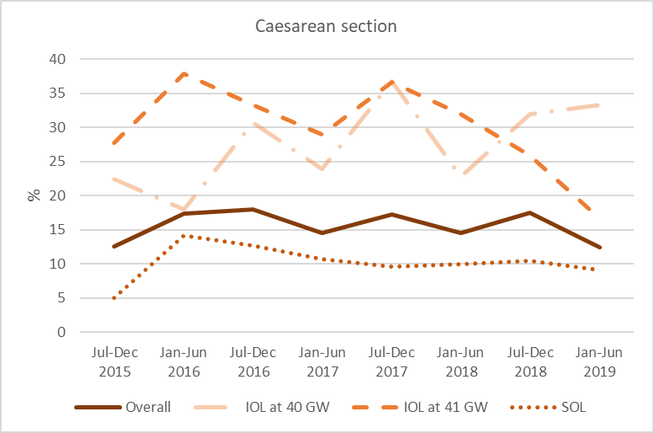
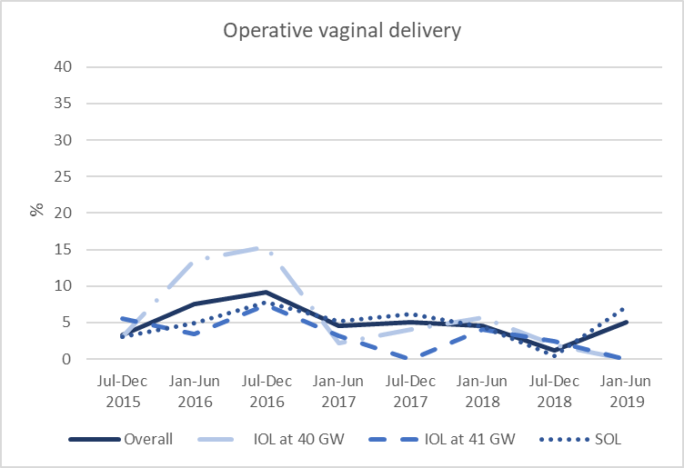
Abbreviations: CS= caesarean section; GW= gestational weeks; IOL= induction of labour; SOL= spontaneous onset of labour.

Additional table 5. Comparison bewteen IOL at 40 GW vs IOL at 41 GW and SOL: characteristics and outcomes by gestational age and onset of labour
 | IOL at 40 GW  N=456  n (%) | IOL at 41 GW and SOL  N=1903  n (%)
Socio-demographic and clinical characteristics
Maternal Age  < 35 years  ≥ 35 years | 401 (87.9)  55 (12.1) | 1714 (90.1)  189 (9.9)
Education  None  Primary  Secondary  Higher  Missing | 1 (0.2)  10 (2.2)  353 (77.4) ¹  91 (20.0) ¹  1 (0.2) | 4 (0.2)  30 (1.6)  1607 (84.4)  257 (13.5)  5 (0.3)
Working status  Working  Housewife  Missing | 81 (17.8)  370 (81.2)  5 (1.1) | 275 (14.5)  1614 (84.8)  14 (0.7)
Marital status  Married  Unmarried  Unmarried living together  Missing | 451 (98.9)  3 (0.6)  1 (0.2)  1 (0.2) | 1875 (98.5)  21 (1.1)  2 (0.1)  5 (0.3)
Parity  0  ≥1 | 260 (57.0) ¹  196 (43.0) ¹ | 952 (50.0)  951 (50.0)
Asian criteria-based BMI ^{α}  Underweight (<18.4)  Normal (18.5-22.9)  Overweight (23-27.4) | 38 (8.2)  312 (68.4)  106 (23.2) | 192 (10.1)  1251 (65.7)  460 (24.2)
Operator delivering care  Nurse  Midwife  House Officer  Mid-level staff  Consultant  Missing | 200 (43.9) ¹  110 (24.1)  4 (0.9)  140 (30.7) ¹  2 (0.4)  0 | 1015 (53.3)  532 (28.0)  28 (1.5)  320 (16.8)  4 (0.2)  4 (0.2)
Weight at birth  <2000  2000 to 2499  2500 to 3499  3500 to 4000  >4000  Missing | 0  13 (2.8)  374 (82.0)  57 (12.5)  11 (2.4) ¹  1 (0.2) | 0  58 (3.0)  1524 (80.1)  295 (15.5)  21 (1.1)  5 (0.3)
Outcomes
Any negative outcomes (any of the below) | 215 (47.1) ¹ | 572 (30.1)
All maternal complications | 165 (36.2) ¹ | 428 (22.5)
CS | 116 (25.4) ¹ | 254 (13.3)
Operative vaginal delivery | 32 (7.0) ¹ | 86 (4.5)
Other maternal complications (any of the below) | 23 (5.0) | 120 (6.3)
Maternal death | 0 | 0
PPH *  Minor  Severe or massive | 12 (2.6)  10 (2.2)  2 (0.4) | 48 (2.5)  29 (1.5)  19 (1.0)
Near miss ** | 3 (0.7) | 35 (1.8)
Blood transfusion | 4 (0.9) | 20 (1.1)
Perineal tears 3rd-4th degree | 5 (1.1) | 46 (2.41)
Sepsis or severe infection | 1 (0.2) | 16 (0.8)
ICU admission | 1 (0.2) | 8 (0.4)
OT after delivery | 0 | 2 (0.1)
Abruptio placentae | 0 | 1 (0.1)
Other complications | 5 (1.1) | 10 (0.5)
All neonatal complications (any of the below) | 102 (22.4) ¹ | 269 (14.1)
Stillbirth | 0 | 1 (0.1)
Perinatal deaths | 1 (0.2) | 4 (0.2)
SCBU admission | 72 (15.8) ¹ | 170 (8.9)
Need of feeding support | 30 (6.6) | 87 (4.6)
Other infection, fever (no sepsis) | 23 (5.0) ¹ | 44 (2.3)
Neurological complications *** | 14 (3.1) ¹ | 23 (1.2)
Respiratory distress syndrome | 11 (2.4) ¹ | 19 (1.0)
Ventilation in delivery room | 11 (2.4) | 28 (1.5)
Apgar ≤5 at 10’ | 10 (2.2) | 27 (1.4)
Meconium aspiration syndrome | 8 (1.8) | 21 (1.1)
Neonatal length of stay ≥ 10 days | 5 (1.1) | 8 (0.4)
Asphyxia | 5 (1.1) | 9 (0.5)
NICU admission | 1 (0.2) | 5 (0.3)
Phototherapy > 24h | 3 (0.7) | 6 (0.3)
Jaundice with exchange transfusion | 2 (0.4) | 4 (0.2)
Other respiratory conditions | 4 (0.9) | 6 (0.3)
Major birth trauma | 0 | 1 (0.1)
Sepsis | 0 | 1 (0.1)
Other complications | 6 (1.3) | 12 (0.6)
Definitions: *Severe PPH: ≥1000 mL or any bleeding with hypotension or tachycardia or blood transfusion; Massive PPH: loss of ≥40% of blood volume, blood volume=body weight (kg)/12. **Near miss: severe disease (severe PPH, severe pre-eclampsia, eclampsia, sepsis, uterine rupture, severe complications of abortion), or critical interventions (admission UTI, intervention radiology, laparotomy, blood transfusion) or organ dysfunction. ***Neurological complications: seizures, ventricular hemorrhage or other severe neurological complications.
Notes: ¹ Significant p value (p<0.05) in the comparison IOL at 40 GW vs IOL at 41 GW and SOL.
Abbreviation: BMI= body mass index; CS= Caesarean section; DVT/PE= Deep venous thrombosis/pulmonary embolism; GW= gestational weeks; ICU: Intensive Care Unit; IOL= Induction of labour; NICU=Neonatal intensive care unit; OT= operative theatre; PPH= Postpartum haemorrhage; SCBU= Special Care Baby Unit;SOL= Spontaneous onset of labour.
Reference: ^{α} WHO Expert Consultation. Appropriate body-mass index for Asian populations and its implications for policy and intervention strategies. Lancet. 2004 Jan 10;363(9403):157-63

Additional figure 2. Comparison bewteen IOL at 40 GW vs IOL at 41 GW and SOL: Births with negative outcomes

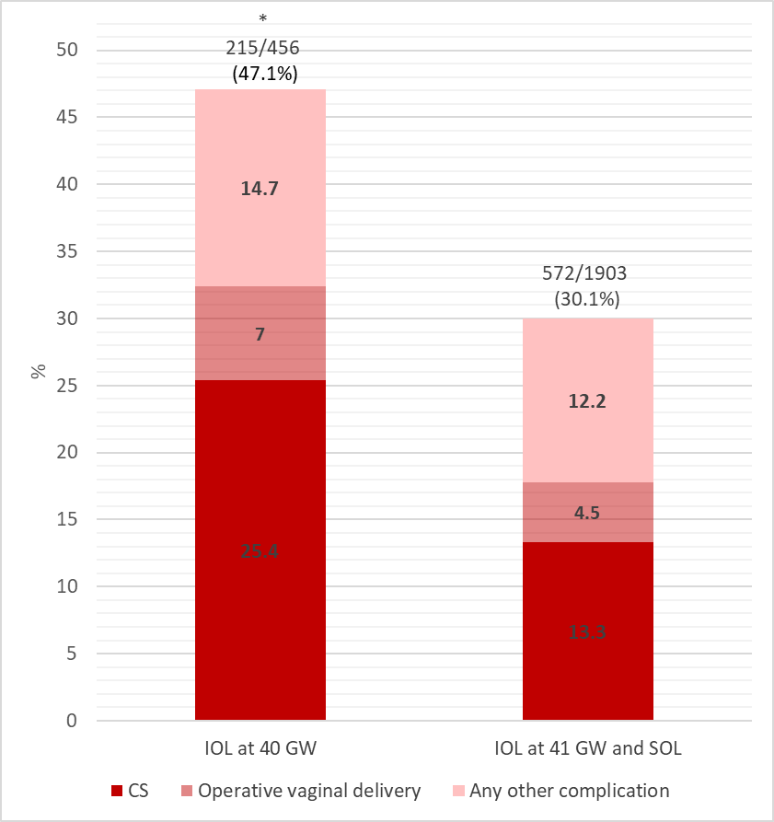
Notes: * Significant p value (p<0.05) in the comparison between the two groups.
Abbreviations: CS = Cesarean section; GW= Gestational weeks; IOL= Induction of labour; SOL= Spontaneous onset of labour.

Additional table 6. Comparison bewteen IOL at 40 GW vs IOL at 41 GW and SOL: Adjusted odds ratios for negative outcomes
 | IOL at 40 GW  N=456  n (%) |  | SOL and IOL at 41 GW  N=1903  n (%)
 | OR (95% CI) | p value
Any negative outcome | 1.95 (1.56-2.44) | <0.001 | Ref
All maternal complications | 1.82 (1.44-2.30) | <0.001 | Ref
CS | 2.09 (1.60-2.74) | <0.001 | Ref
Operative vaginal delivery | 1.42 (0.93-2.19) | 0.111 | Ref
Other maternal complications | 0.77 (0.48-1.22) | 0.265 | Ref
All neonatal complications | 1.58 (1.21-2.06) | <0.001 | Ref
Notes: ORs are adjusted for age, parity, education, BMI and neonatal weight.
Abbreviations: CS= caesarean section; GW= gestational week; IOL= induction of labour; SOL= spontaneous onset of labour.

Additional table 7. Description of women included in sensitivity analysis* only
 | IOL at 41 GW  N=3  n (%) | SOL *  N=1  n (%)
Socio-demographic and clinical characteristics
Age <35 years | 3 (100%) | 1 (100%)
Education  Secondary  Higher | 2 (66.7%)  1 (33.3%) | 0  1 (100%)
Working status  Working  Housewife | 0  3 (100%) | 1 (100%)0
Parity  0  ≥1 | 2 (66.7%)  1 (33.3%) | 1 (100%)  0
Asian criteria-based BMI ^{α}  Normal (18.5-22.9)  Overweight (23-27.4) | 1 (33.3%)  2 (66.7%) | 1 (100%)  0
Neonatal weight at birth (grams)  2500 to 3499  3500 to 4000 | 2 (66.7%)  1 (33.3%) | 0  1 (100%)
Outcomes
Any negative outcomes (any of the below) | 3 (100%) | 1 (100%)
Maternal complications | 3 (100%) | 1 (100%)
CS | 2 (66.7%) | 1 (100%)
Oligohydramnios | 1 (33.3%) | 0
APH | 0 | 1 (100%)
Abruptio placentae | 1 (33.3%) | 0
Neonatal complications | 3 (100%) | 0
Signs of potentially impaired foetal well being * | 2 (66.7%) | 0
Ventilaton in the delivery room | 1 (33.3%) | 0
Notes: * Women after 41GW with hypertensive disorders, chorioamnionitis, oligohydramnios, APH, signs of potentially impaired foetal well being (non-reassuring or pathological cardiotocography, reduced foetal movement, meconium stained amniotic fluid) were included in sensitivity analysis. Only complications with at least one case are shown in the table.
Abbreviations: APH= antepartum haemorrhage; BMI= body mass index; CS= caesarean section; GW= gestational week; IOL= induction of labour; SOL= spontaneous onset of labour.
Reference: α WHO Expert Consultation. Appropriate body-mass index for Asian populations and its implications for policy and intervention strategies. Lancet. 2004 Jan 10;363(9403):157-63

Additional table 8. Sensitivity analysis: adjusted odds ratios for negative outcomes

 | IOL at 40 GW  (40+0 to 40+6)  N=456 |  | IOL at 41 GW  (41+0 to 41+6)  N=321 |  | SOL  (40+0 to 41+6)  N=1586
 | Adj OR (95% CI) | p value | Adj OR (95% CI) | p value
Any negative outcome | 2.20 (1.75-2.77) | <0.001 | 1.94 (1.50-2.52) | <0.001 | Ref
All maternal complications | 2.17 (1.71-2.77) | <0.001 | 2.39 (1.82-3.13) | <0.001 | Ref
CS | 2.73 (2.06-3.63) | <0.001 | 3.06 (2.24-4.16) | <0.001 | Ref
Operative vaginal delivery | 1.27 (0.82-1.98) | 0.281 | 0.47 (0.23-1.96) | 0.039 | Ref
Other maternal complications | 0.87 (0.54-1.40) | 0.567 | 1.84 (1.20-2.81) | 0.005 | Ref
All neonatal complications | 1.63 (1.24-2.14) | <0.001 | 1.23 (0.88-1.71) | 0.213 | Ref
Notes: ORs are adjusted for age, parity, education, BMI and neonatal weight.
Abbreviations: CS= caesarean section; GW= gestational weeks; IOL= induction of labour; SOL= spontaneous onset of labour.

