Supplementary Table 1. Diagnoses defined by the 10th revision of the International Classification of Disease codes
Diagnosis | International Classification of Disease, 10th revision code
Asthma | J45.x, J46.x
Cerebrovascular disease | G45.x, G46.x,, H34.0, I60.x-169.x
Congestive heart failure | I09.9, I11.0, I13.0, I13.2, I25.5, I42.0, I42.5-I42.9, I43.x, I50.x, P29.0
Diabetes | E10.x-E14.x
Hypertension | I10.x-I15.x
Ischemic heart disease | I20.x-I25.x
Liver disease | B15.x-B19.x, K70.x-K77.x, K80.x-K87.x, I85.x, I86.4, I98.2, I98.3, Z94.4
Myocardial infarction | I21.x-I23.x
Other pulmonary disease | I27.x, J40-J47, J60.x – J70.x
Peripheral vascular disease | I70.x, I71.x, I73.1, I73.8, I73.9, I77.1, I79.0, I79.2, K55.1. K55.8, K55.9, Z95.8, Z95.9
Valvular heart disease | A52.0, I05.x-I08.x, I09.1, I09.8, I34.x-I39.x, Q23.0-Q23.3, Z95.2-Z95.4

Supplementary Table 2. Factors associated with the incidence of adult-onset asthma
Variables | Category | N | event  (n, %) | HR | 95% CI | P value
Age | 20-34 | 52048 | 4664(9.0) | Reference
 | 35-49 | 67586 | 6486(9.6) | 1.030 | 0.992-1.069 | 0.127
 | 50-64 | 34402 | 4271(12.4) | 1.290 | 1.238-1.345 | <0.001
 | 65-74 | 5307 | 787(14.8) | 1.515 | 1.404-1.633 | <0.001
 | ≥75 | 1260 | 169(13.4) | 1.509 | 1.294-1.759 | <0.001
Sex | Female | 121515 | 13282(10.9) | Reference
 | Male | 39091 | 3095(7.9) | 0.697 | 0.671-0.725 | < 0.001
BMI (Kg/m²) | <18.5 | 10805 | 1006(9.3) | 0.962 | 0.899-1.029 | 0.257
 | 18.5-19.9 | 20759 | 2000(9.6) | 0.988 | 0.938-1.040 | 0.640
 | 20-22.4 | 51205 | 5087(9.9) | Reference
 | 22.5-24.9 | 44237 | 4595(10.4) | 1.027 | 0.987-1.069 | 0.186
 | ≥25 | 33597 | 3689(11.0) | 1.106 | 1.060-1.154 | <0.001
WC (cm) | Continuous* |  |  | 1.004 | 1.002-1.006 | <0.001
SBP, mmHg | <120 | 95384 | 9825(10.3) | Reference
 | 120-139 | 65219 | 6552(10.1) | 0.959 | 0.927-0.986 | 0.005
DBP, mmHg | <80 | 117353 | 11996(10.2) | Reference
 | 80-89 | 43250 | 4381(10.1) | 0.967 | 0.934-1.001 | 0.055
Alcohol consumption | 0 | 100871 | 10875(10.8) | Reference
(g/week) | ≤140 | 50916 | 4752(9.3) | 0.888 | 0.859-0.919 | <0.001
 | >140 | 8816 | 750(8.5) | 0.795 | 0.738-0.856 | <0.001
Activity (met-min/week) | <500 | 118158 | 1242(10.4) | Reference
 | 500-999 | 31815 | 3058(9.6) | 0.933 | 0.896-0.970 | <0.001
 | ≥1000 | 10630 | 1077(10.1) | 0.966 | 0.908-1.028 | 0.277
Fasting glucose, mg/dL | < 100 | 132874 | 13495(10.2) | Reference
 | 100-125 | 27729 | 2882(10.4) | 1.018 | 0.9578-1.060 | 0.384
Total cholesterol, mg/dL | Continuous*† |  |  | 1.252 | 1.152-1.362 | <0.001
LDL cholesterol, mg/dL | Continuous*† |  |  | 1.099 | 1.050-1.120 | <0.001
HDL cholesterol, mg/dL | Continuous*† |  |  | 0.961 | 0.905-1.019 | 0.184
Triglyceride, mg/dL | Continuous*† |  |  | 1.067 | 1.037-1.099 | <0.001
GGT, U/L | Continuous*† |  |  | 0.999 | 0.972-1.026 | 0.932
*Each clinical characteristics were incorporated in univariate Cox proportional hazard models as continuous variables
†Each clinical characteristics were incorporated in univariate Cox proportional hazard models after a log transformation.
BMI = body mass index; CI = confidence interval; DBP = diastolic blood pressure; FLI = fatty liver index; GGT = γ-glutamyltransferase; HDL = high-density lipoprotein; HR = hazard ratio; LDL = low-density lipoprotein; SBP = systolic blood pressure; WC = waist circumference.

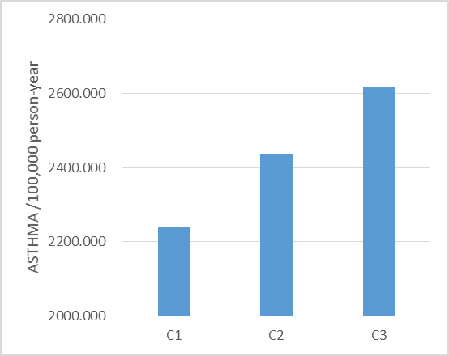
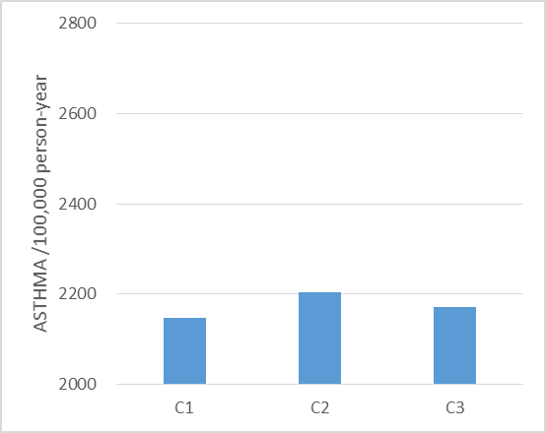
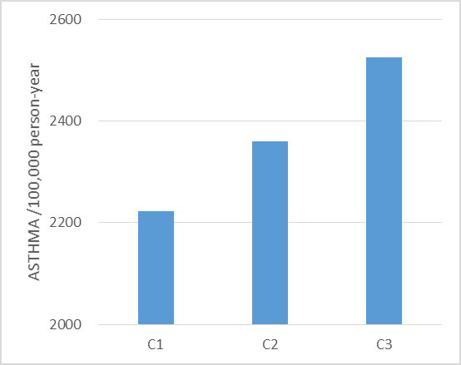
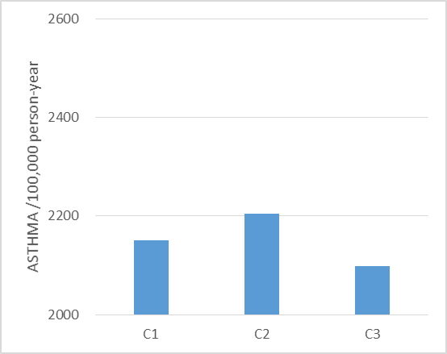
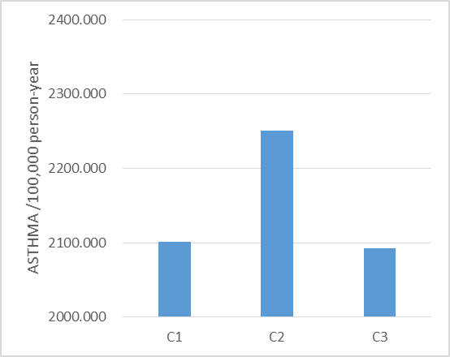
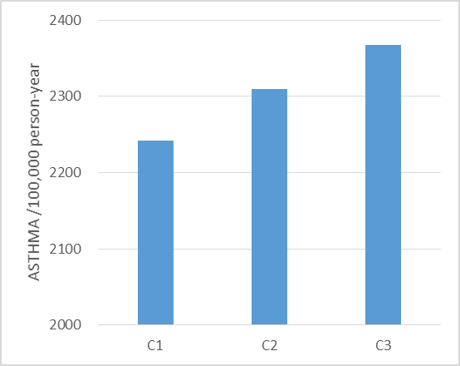
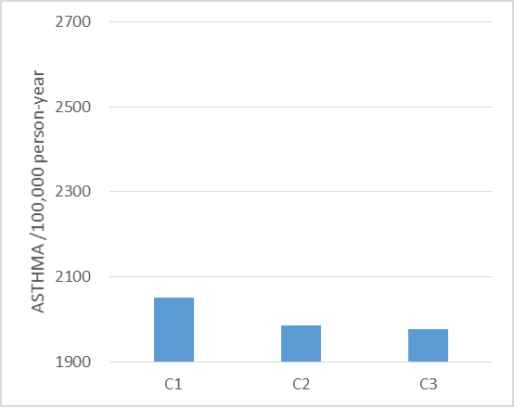
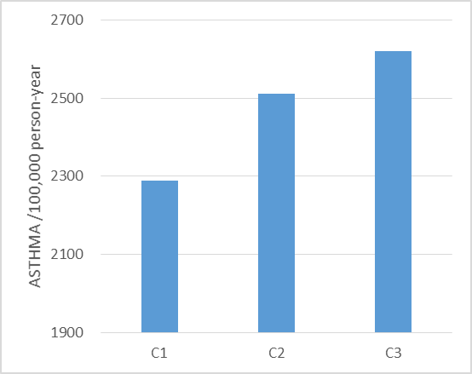
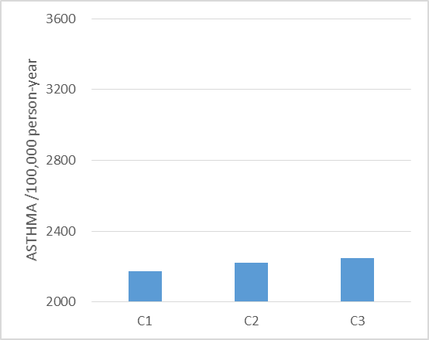
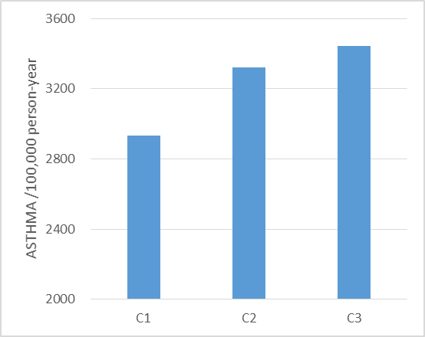
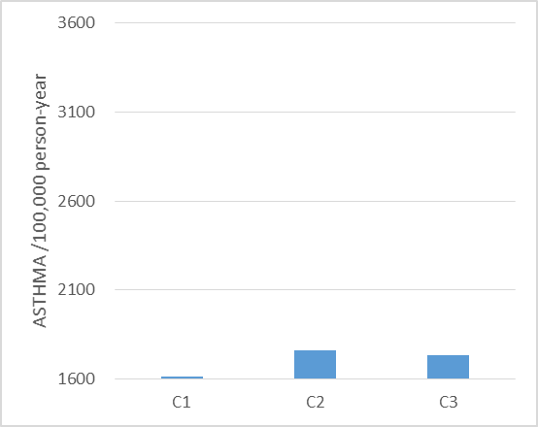
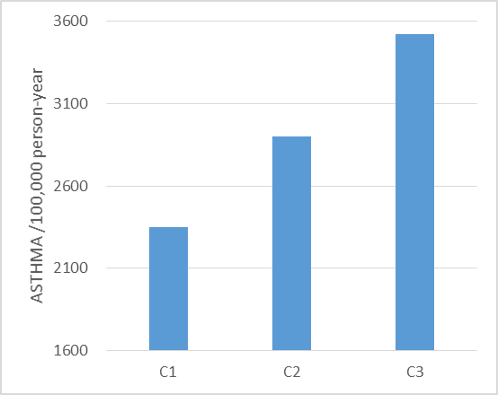
Supplementary Figure 1. Incidence of new onset asthma in various subgroups
20 ≤ AGE < 65
AGE ≥ 65
Male
Female
Drinking (g/wk) = 0
Drinking (g/wk) > 0
Activity (met-min/wk) < 500
Activity (met-min/wk) ≥ 500
Systolic blood pressure, mmHg < 120
Systolic blood pressure, mmHg ≥ 120
Diastolic blood pressure, mmHg ≥ 80
Diastolic blood pressure, mmHg < 80
Fasting glucose, mg/dL < 100
Fasting glucose, mg/dL ≥ 100
