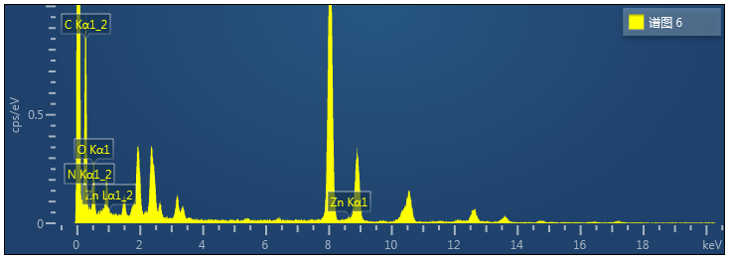

Fig S1 EDS of Zinc in leaves and stem. (a) EDS results show the CNC@PDA@Zn²⁺ in leaves. (b) EDS results show the CNC@PDA@Zn²⁺ in stem.

Fig S2 Response of tobacco plants to exposure to CNC@PDA@Zn²⁺ and (CH₃COO)₂Zn for 7d. (a) Phenotypic images of tobacco upon exposure to CNC@PDA@Zn²⁺ and (CH₃COO)₂Zn. (b)-(f) Root length, fresh weight, dry weight, leaves width and plant height after foliar treatment with CNC@PDA@Zn²⁺ and (CH₃COO)₂Zn. Mean values displayed in each bar followed by different letters are significantly different according to LSD’s multiple range test (p < 0.05).
Fig S3 Different expression genes. (a) Different expression genes in C-Z, C-PZ, C-CN, CN-PZ, Z-PZ different group. (b) DEGs related to Zn²⁺ transport protein family. (c) DEGs related to cellulose-recognizing receptors. C: CK, PZ: CNC@PDA@Zn²⁺, Z: (CH₃COO)₂Zn, CN: CNC.

Fig S4 Effect of CNC@PDA@Zn²⁺ to YoMV infection. (a) antivirus activity of (CH₃COO)₂Zn (44μg/mL) and CNC@PDA@Zn²⁺(1600μg/mL). CK as the control group, the concentration of Zn²⁺ in 44 μg/mL (CH₃COO)₂Zn was the same as the concentration of Zn²⁺ loaded in 1600 μg/mL CNC@PDA@Zn²⁺. (b-C) YoMV expression at 3 dpi and 5 dpi. Mean values displayed in each bar followed by different letters are significantly different according to LSD’s multiple range test (p < 0.05). Vertical bars indicate standard errors (n = 5).

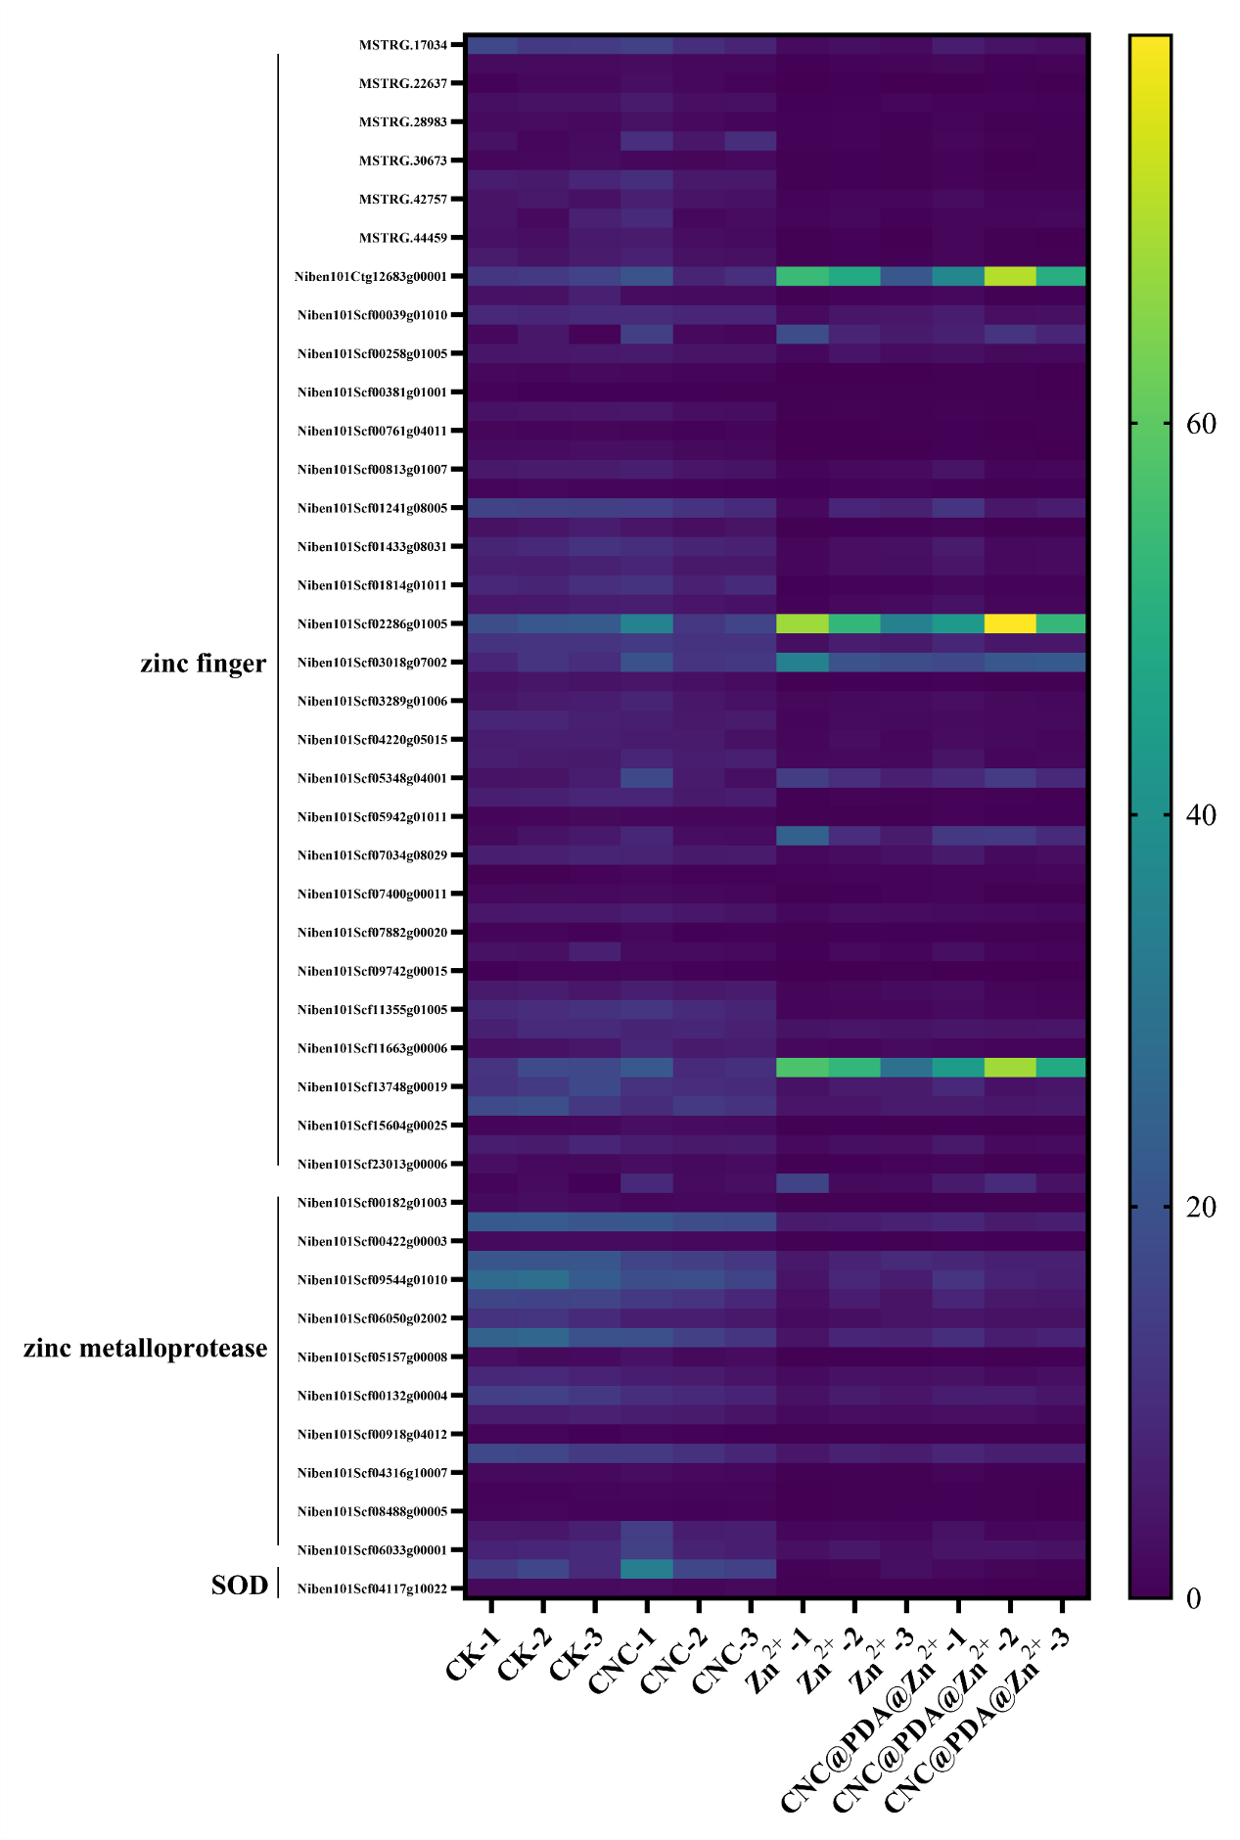Fig S5 Heatmap of zinc finger genes, zinc metaprotease genes, and SOD gene.
Fig S6 (a) Western blot analysis of nsLTP2 protein content. (b) Western blot analysis of nsLTP2^{sp} protein content.

Fig S7 Expression of nsLTP2 after inoculate TMV-GFP at 2 dpi and 6 dpi (The samples of 2 dpi were the inoculated leaves and the samples of 6 dpi were the systemic leaves).
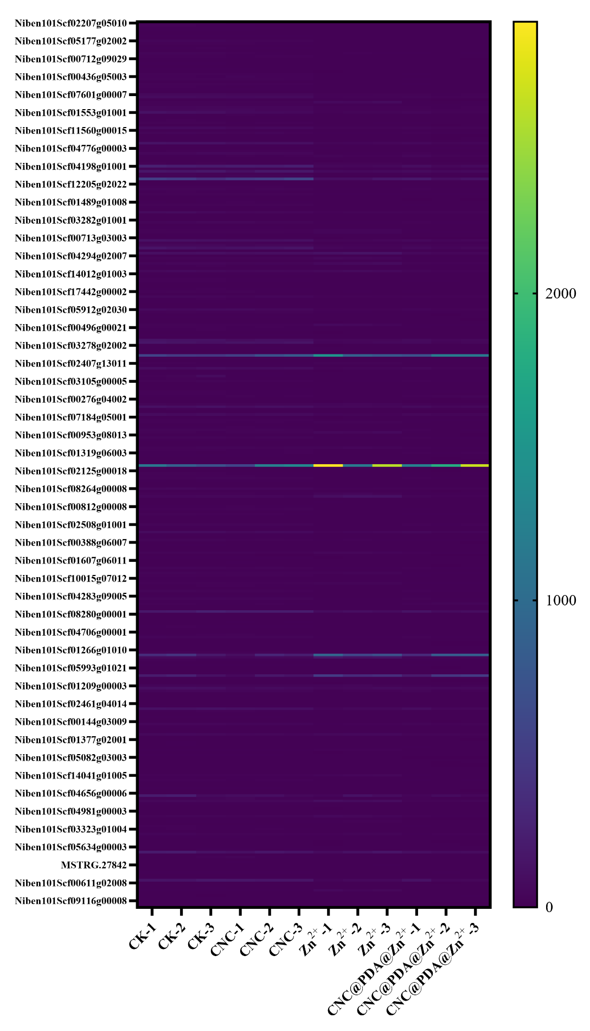
Figure S8: Expression heat map of chloroplast-related genes after CNC@PDA@Zn²⁺ treatment.
Table S1 The mass fraction of Zn²⁺ on CNC@PDA@Zn²⁺

sample |  | Zn  (213.857 nm)/ppm | Weight of Zn²⁺ in 10 mL solution/mg | Weight of CNC in 10 mL solution/mg | Concentration of Zn²⁺ | Weight percent of zinc (wt%)/%
1 |  | 23.36 | 0.2336 | 21.0455 | 0.0111 | 1.109976
2 |  | 23.58 | 0.2358 | 21.6241 | 0.010905 | 1.09045
3 |  | 24.04 | 0.2404 | 22.1421 | 0.010857 | 1.085715
4 |  | 23.88 | 0.2388 | 21.3241 | 0.011199 | 1.11986
5 |  | 24.25 | 0.2425 | 21.3059 | 0.011382 | 1.138182
6 |  | 23.36 | 0.2336 | 21.0455 | 0.0111 | 1.109976

Table S2 Summary of Sequencing Data Statistics and Quality Control
Sample | Raw reads | Clean reads | GC (%) | Q30 (%) | Total mapped reads (%) | Unique Mapped reads (%)
C-1 | 51315686 | 51248582 | 45.33 | 94.52 | 97.98 | 87.85
C-2 | 52753948 | 52691178 | 45.54 | 94.41 | 97.96 | 87.93
C-3 | 47431746 | 47361844 | 45.10 | 94.29 | 97.91 | 88.51
PZ-1 | 45231642 | 45163754 | 45.79 | 94.29 | 97.90 | 87.65
PZ-2 | 55532484 | 55468572 | 46.34 | 94.46 | 97.91 | 87.00
PZ-3 | 47765010 | 47710136 | 46.60 | 94.48 | 98.09 | 86.05
Z-1 | 49842008 | 49789618 | 46.92 | 94.28 | 97.93 | 85.62
Z-2 | 56271726 | 56203736 | 46.29 | 94.16 | 98.08 | 87.40
Z-3 | 42497600 | 42460498 | 47.26 | 94.94 | 98.07 | 85.83
CN-1 | 45519812 | 45460260 | 44.86 | 94.08 | 97.84 | 89.43
CN-2 | 46635806 | 46581580 | 45.67 | 94.44 | 98.08 | 87.50
CN-3 | 49416894 | 49366580 | 45.75 | 94.45 | 97.97 | 87.07
Note: C means CK control, Z means Zn²⁺ control, CNC means CNC-treated plants; PZ means CNC@PDA@Zn²⁺ treated plants

Table S3 Primer sequence used in this work
Primers names | Primer sequence
qNbActin-F |  | 5'-CTTGAAACAGCAAAGACCAGC-3'
qNbActin-R |  | 5'-CATCCTATCAGCAATGCCCG-3'
qNbTMV-MP-F |  | 5'-GACCTGACAAAAATGGAGAAGATCT-3'
qNbTMV-MP-R |  | 5'-GAAAGCGGACAGAAACCCGCTG-3'
qnsLTP2-F |  | 5'- GGTGTTAAGCGTCTGTTGGG -3'
qnsLTP2-R |  | 5'- AGTGGTGGGACTGATCTTGT -3'
qNPR1-F |  | 5'-TAGCGTATTGCGATGCAAAG-3'
qNPR1-R |  | 5'-TAGTGAGCCTCTTGGCGATT-3'
qPR1-F |  | 5'- ATGGTCAATACGGCGAAAAC -3'
qPR1-R |  | 5'- CCTAGCACATCCAACACGAA -3'
qPR2-F |  | 5'- CAACCCGCCCAAAGATAGTA-3'
qPR2-R |  | 5'- TCCAAAAGGGCATCAAAAAG-3'
TRV:PR14-F |  | 5'- GCTCTAGAAGATTGCTTG -3'
TRV:PR14-R |  | 5'- CCGCTCGAGGCATGCAGTTTTGC -3'
pArt27-PR14: eGFP-F |  | 5'-TTGGAGAGGACACGCTCGAGATGGAAATAGCTGGCAAGAT -3'
pArt27-PR14: eGFP -R |  | 5'-CCTCGCCCTTGCTCACCATCTCGAGCTGGACCCTGGAGCAGTCAG -3'
pArt27-PR14: eGFP^{Δsp}-F |  | 5'- TTGGAGAGGACACGCTCGAGATGCTGATGAATTGCGGCCAGG -3'
pArt27-PR14: eGFP^{Δsp}-R |  | 5'- CCTCGCCCTTGCTCACCATCTCGAGCTGGACCCTGGAGCAGTCAG -3'

