Supplementary Information for

Calibration-free NGS Quantitation of Mutations below 0.01% VAF

Peng Dai^{1,6,7}, Lucia Ruojia Wu^{1,7}, Sherry Xi Chen^{1,6}, Michael Xiangjiang Wang¹, Lauren Yuxuan Cheng¹, Jinny Xuemeng Zhang³, Christina Pengying Hao³, Weijie Yao³, Jabra Zarka⁴, Ghayas C. Issa⁴, Lawrence Kwong⁵, David Yu Zhang^{1,2*}

¹ Department of Bioengineering, Rice University, Houston, TX, USA.
² Systems, Synthetic, and Physical Biology, Rice University, Houston, TX, USA.
³ NuProbe USA, Houston, TX, USA.
⁴Department of Leukemia, The University of Texas MD Anderson Cancer Center, Houston, TX, USA.
⁵Department of Translational Molecular Pathology, The University of Texas MD Anderson Cancer Center, Houston, TX, USA.
⁶Present affiliation: NuProbe USA, Houston, TX, USA.
﻿⁷These authors contributed equally: Peng Dai, Lucia Ruojia Wu

*e-mail: dyz1@rice.edu

Supplementary Section 1. Single-plex QBDA
To demonstrate the QBDA, an 18-nt region in tuberculosis rpoB (Rv0667) gene (NC_000962.2_761099:761116) were chosen as the enrichment region. Nine different drug resistance mutations in the enrichment region were picked, including single-base substitution, insertion and deletion. Gene block (gBlock) from Integrated DNA Technologies was synthesized for each mutation, with mutated enrichment region and wild type (WT) sequence flanking around (Figure S1). Tuberculosis laboratory strain H37Rv (ATCC 27294) served as wild type. Nine synthetic gBlocks were quantified and mixed with H37Rv strain for a spike-in reference DNA sample with approximately 1% VAF for each mutation. The gBlocks were first diluted to 10 ng/uL in IDTE following instruction from IDT, then further diluted with Tris EDTA solution with 0.1% tween and 100 ng/uL carrier RNA (Qiagen catalog # 1068337) before mixing with WT DNA. All mutations were simultaneously enriched and accurately quantified (Fig 1b).

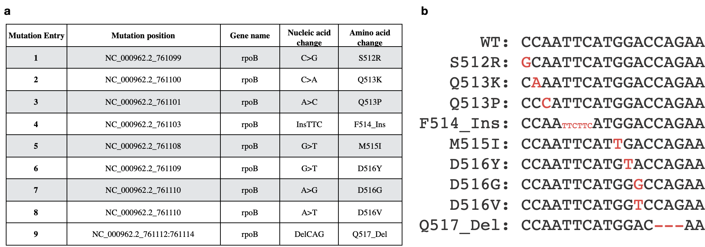
Figure S1. WT and 9 spike-in mutations sequence in enrichment region. The enrichment region is NC_000962.2_761099:761116 in tuberculosis rpoB (Rv0667) gene.

Table S1. Primer sequences for tuberculosis QBDA
BDA_fp | GGCACCAGCCAGCTGAG
Sfp | GGATATTCCTTTCTACTCTTTGACATCATCTATCACTTCGGCACCAGCCAGC
Blocker | CAGCTGAGCCAATTCATGGACCAGAA/iSpC3//iSpC3/AT
Srp | AGACGTGTGCTCTTCCGATCTATCAHHHHHHHHHHHHHHHCCGACAGTCGGCGCTT
Adp_fp | ACACGACGCTCTTCCGATCTGGCACCAGCCAGCTGAG
Universal Forward Primer (Ufp) | CCTATGGTAGTTAAATGTACATTGGATATTCCTTTCTACTCTTTGACATCATCT
Universal Reverse Primer (Urp) | GACTGGAGTTCAGACGTGTGCTCTTCCGATCT

Supplementary Section 2. Multiplex QBDA SNP panel

Figure S2. QBDA quantitation validation in 10-plex SNP panel. a. Information for SNPs covered in 10-plex SNP panel. b. Conversion yield for each amplicon calculated from no enrichment library. c. Quantitation accuracy for 1% spike-in and 0.1% spike-in. Libraries with and without enrichment were compared. d. UMI significantly eliminated errors as demonstrated by the sorted variants observed in reads and UMI. The ten red dots are expected mutations from NA18562 spike-in, and all blue dots are false positive errors. e. Variant enrichment does not lead to higher error rate comparing to no enrichment.

Table S2. Primer sequences for QBDA SNP panel
Provided in supplementary spreadsheet file

Supplementary Section 3. Multiplex QBDA Leukemia panel

Table S3. Mutations covered in QBDA Leukemia panel
Plex number | Gene | Amino Acid Change | Expect nucleic acid change in enrichment region | Expected VAF in mixed reference standard
1 | ABL1 | T315I | 1C>T | 2.5%
2 | ASXL1 | W796C | 4G>T | 2.5%
3 | BCOR | Q1174fs*8 | 2InsT | 35%
4 | CBL | S403F | 6C>T | 2.5%
5 | DNMT3A | R882C | 2G>A | 2.5%
6 | EZH2 | R418Q | 2C>T | 2.5%
7 | FLT3 | D835Y | 14C>A | 2.5%
8 | GATA1 | Q119* | 4C>T | 5%
9 | IDH1 | R132C | 4G>A | 2.5%
10 | IDH2 | R172K | 2C>T | 2.5%
11 | JAK2 | F537-K539>L | 5DelTCACAA | 2.5%
12 | JAK2 | V617F | 2G>T | 2.5%
13 | KRAS | G13D | 1C>T | 20%
14 | NPM1 | W288fs*12 | 2InsCAGA | 2.5%
15 | NRAS | Q61L | 1A>T | 5%
16 | RUNX1 | M267I | 2C>T | 17.5%
17 | SF3B1 | G740E | 9C>T | 2.5%
18 | TET2 | R1261H | 1G>A | 2.5%
19 | TP53 | S241F | 9G>A | 2.5%
20 | IDH2 | R140 | 1C>T | 5%
21 | KIT | D816 | 3A>T | 5%
22 | ETV6 | R369Q | 12G>A | 5%

Table S4. Primer sequences for QBDA Leukemia panel
Provided in supplementary spreadsheet file

3.1 Spike-in positive sample
Mutations 1-19 are present in Myeloid DNA Reference Standard (Horizon Discovery Ltd., Catalog ID: HD829), with VAF between 5%-70% for different mutations. Gblocks from Integrated DNA Technologies were synthesized for mutations 20-22. The diluted gblocks were mixed with Myeloid DNA Reference Standard and NA18562 genomic DNA to yield mixed reference standard for an expected VAF of 2.5%-35% for mutations 1-19, and approximately 5% for mutations 20-22.
The mixed reference standard was diluted with human genomic DNA from healthy people to yield lower VAF samples. For example, 4 ng mixed reference standard was mixed with 1000 ng healthy gDNA to yield a DNA sample with expected mutation VAF between 0.01% and 0.14%.

3.2 Supplement analytical performance: LoD for 1 µg DNA input
The defined LoD threshold is not the same for all types of mutations. We use 0.003% for most types of single-base substitutions, and 0.006% for C>T/G>A and T>C/A>G types of mutations.
This was based on the observations from 10 different healthy PBMC DNA samples (Fig. S3). The most commonly observed mutations are C>T/G>A and T>C/A>G, even after applying the count filter to remove mutation calls with <6 UMI family count. This result indicates that C>T/G>A and T>C/A>G mutations are likely prevalent in polymerase error, DNA damage and/or clonal hematopoiesis-induced variants.
Polymerase error rate varies for different mutations¹. Based on our past experience, PCR and NGS are prone to homopolymer indel errors (i.e. length change of ≥4 nt homopolymers), so we used 0.006% LoD threshold for homopolymer indels. We set LoD at 0.0006% for long indels and complex mutations which have very low chance of PCR or NGS error.

Figure S3: Single-base substitutions classified by type. 10 PBMC gDNA samples from different healthy donors were analyzed using QBDA AML panel (500 ng per library), and the frequency of different types of single-base substitutions are plotted as bar graph. After count filter to remove mutations with < 6 UMI count, mutations in these samples indicate potential DNA damage and/or clonal hematopoiesis.

3.3 Minimum required depth analysis using in silico down-sampling
In order to analyze the minimum required sequencing depth for 0.01% VAF, we sequenced the positive sample in Fig. 2b using QBDA with excess sequencing depth, and performed in silico random down-sampling of NGS reads so that lower sequencing depth can be analyzed. The experimental sequencing depth was 350,000X (7.7 M reads). 20 simulations were performed to randomly sample 1.0 M reads from the original library to generate 45,000X depth libraries. None of the observed UMI counts dropped below 6 in the 20 simulations (i.e. no drop-out); the median UMI counts of 45,000X depth were between 38.6% and 100.0% of the UMI counts of 350,000X depth; only 1 mutation was below 50% (Fig. 2d). Therefore, we conclude that 45,000X depth has similar performance to 350,000X depth, and thus can be used for 0.01% VAF detection. A similar analysis for 23,000X depth (0.5 M reads) also had no drop-out in 20 simulations, with median UMI counts between 15.8% and 96.9% of 350,000X depth (Supplementary Fig. S4). Though 23,000X depth showed <50% conversion yield for 4 amplicons, no drop-out was observed in 20 independent simulations, with median UMI counts between 15.8% and 96.9% of 350,000X depth. 23,000X depth is still acceptable for detection of 0.01% VAF, but will recommend 45,000X depth for accurate quantitation.

Figure S4. In silico down-sampling to 23,000X sequencing depth. The 1X VAF positive sample (500 ng input) was sequenced with 350,000X depth (7.7 M reads). We performed a virtual experiment of 23,000X depth sequencing by random sampling 0.5 M reads from the original library; the median observed UMI counts of 20 independent simulations were plotted against observed UMI counts in the original library. All mutations can be observed at 23,000X depth.

3.4 Clinical MRD analysis

Table S5. Molecular and clinical information for the 10 paired samples from 5 leukemia patients
Provided in supplementary spreadsheet

Table S6. QBDA test results for the 10 paired samples from 5 leukemia patients
Provided in supplementary spreadsheet

Supplementary Section 4. Multiplex QBDA pan-cancer panel
A pan-cancer panel (VarMap™ Pan-Cancer NGS Panel) is developed by NuProbe Inc. based on QBDA technology.

Figure S5. Overview of VarMap™ NGS Pan-cancer Panel. (a) The panel targets somatic mutations across 43 different tissues, focusing on the most common cancer tissues in US. (b) The panel targets a total of 7276 COSMIC variants across 61 genes.

Table S7. List of variants included in the positive control.
Gene | COSMIC ID | Mutation CDS | Mutation AA | Mutation Description
AKT1 | COSM33765 | c.49G>A | p.E17K | Substitution - Missense
EGFR | COSM12382 | c.2239_2248TTAAGAGAAG>C | p.L747_A750>P | Complex - deletion
ERBB2 | COSM436498 | c.2033G>A | p.R678Q | Substitution - Missense
ESR1 | COSM4745827 | c.908A>G | p.K303R | Substitution - Missense
ESR1 | COSM3829320 | c.1138G>C | p.E380Q | Substitution - Missense
GNAQ | COSM404628 | c.286A>T | p.T96S | Substitution - Missense
GNAQ | COSM6304069 | c.175A>C | p.M59L | Substitution - Missense
KIT | COSM1304 | c.1924A>G | p.K642E | Substitution - Missense
MAP2K1 | COSM235614 | c.370C>T | p.P124S | Substitution - Missense
MTOR | COSM4187184 | c.7255G>A | p.E2419K | Substitution - Missense
MTOR | COSM462601 | c.5930C>A | p.T1977K | Substitution - Missense
PDGFRA | COSM736 | c.2525A>T | p.D842V | Substitution - Missense
PIK3CA | COSM773 | c.3129G>T | p.M1043I | Substitution - Missense
RAF1 | COSM181063 | c.770C>T | p.S257L | Substitution - Missense
PTEN | COSM5219 | c.388C>G | p.R130G | Substitution - Missense
PTEN | COSM5154 | c.697C>T | p.R233* | Substitution - Nonsense
TP53 | COSM10660 | c.818G>A | p.R273H | Substitution - Missense
FBXW7 | COSM22975 | c.1513C>T | p.R505C | Substitution - Missense
FBXW7 | COSM22973 | c.1177C>T | p.R393* | Substitution - Nonsense
PTPN11 | COSM14271 | c.1508G>T | p.G503V | Substitution - Missense

Table S8. Pan cancer panel test results for the 16 clinical samples.
Provided in supplementary spreadsheet

Supplementary Section 5. Multiplex QBDA Melanoma panel
We built a melanoma panel covering 22 hotspot regions in 8 genes (Supplementary Fig. S6a and Supplementary Table S9-10). Low input DNA (6-20 ng) is used as input for detecting > 0.1% VAF. 16 FFPE and 7 FF tissue samples from melanoma patients were tested (Fig. 4d, Supplementary Table S11). Co-existence of BRAF V600E and low frequency NRAS Q61K mutations in FFPE5 sample was observed. Although BRAF and NRAS mutations are usually mutually exclusive in melanoma patients, BRAF/NRAS dual mutation may derive from two subclonal populations. In addition, there were recent reports in which BRAF and NRAS co-mutations were observed in the same cell after treated with a BRAF inhibitor². As the patient for FFPE5 was treated with BRAF inhibitor, the co-existence of low frequency NRAS indicated potential resistance mechanism related to NRAS. The quantitation accuracy was validated with gblock spike-in sample (Supplementary Fig. S6b) and confirmed by ddPCR in clinical DNA samples with BRAF/NRAS mutations (Supplementary Fig. S7, Supplementary Table S12). One healthy donor PBMC gDNA sample and three FFPE samples and without BRAF/NRAS mutation by QBDA were also tested by ddPCR, confirming no false negative were made (Supplementary Fig. S8, Supplementary Table S12).
QBDA can tolerate and normalize copy number change for accurate VAF quantitation. BRAF gene in melanoma FFPE12 sample underwent both copy number variation (CNV) and mutation. As demonstrated in Methods Section, the total number of UMI family count for one locus needs to be adjusted by the copy number in genome if CNV occurs. VAF for BRAF V600K mutation was consistent with ddPCR after normalizing the copy number of BRAF gene (Supplementary Fig. S7). Comparing to normal NGS without UMI and variant enrichment, QBDA reduced both false positive and false negative variant calls in the abovementioned 23 clinical samples (Fig. 4e).
To suppress the amplification of a pseudogene covered by amplicon 13 (in PIK3CA), a reverse blocker is added. The reverse blocker sequence is included in the supplementary spreadsheet.
QBDA quantitation results are compared to normal NGS without UMI using the melanoma clinical samples. 10 ng to 50 ng of genomic DNA extracted from FFPE samples were used as input in multiplex PCR using the same set of primers as the melanoma 15-plex BDA panel at 50 nM each. Blockers were not included in the reaction. The following thermocycling protocol was used: 98˚C- 30s; (98˚C- 20s, 63˚C- 2 min, 72˚C- 2 min)x 15; 72˚C- 5 min. The amplicons were purified by column purification. NEBNext ultra II DNA library prep kit for Illumina (NEB # E7645S) was used for library preparation following the kit protocol. NEBNext Multiplex Oligos for Illumina (Dual Index Primers Set 1) (NEB #E7600S) were used for index PCR. Sequencing was done on Illumina MiSeq using the V2 kit. Each sample was sequenced to at least 10,000x coverage.

Table S9. Coverage of Melanoma QBDA panel
Target | Gene | Enrichment Region (GRCh38.p12) | gBlock spike-in & COSMIC ID
1 | MAP2K1 | Chr15: 66435114-66435129 | K57E | COSM5369532
2 | MAP2K1 | Chr15: 66436814-66436830 | C121S | COSM555601
3 | MAP2K1 | Chr15: 66481788-66481804 | E203K | COSM232755
4 | MAP2K2 | Chr19: 4117540-4117558 | F57V | COSM3534171
5 | MAP2K2 | Chr19: 4110573-4110588 | C125S | COSM5855815
6 | MAP2K2 | Chr19: 4101089-4101106 | E207K | COSM5574290
7 | AKT1 | Chr14: 104776700-104776714 | Q79K | COSM159008
8 | AKT3 | Chr1: 243695699-243695726 | E17K | COSM224779
9 | NRAS | Chr1: 114716123-114716137 | G12S | COSM563
10 | NRAS | Chr1: 114713894-114713912 | Q61K | COSM580
11 | KRAS | Chr12: 25245346-25245358 | G12S | COSM517
12 | KRAS | Chr12: 25227328-25227346 | Q61K | COSM87298
13 | PIK3CA | Chr3: 179218291-179218309 | E542K | COSM760
14 | PIK3CA | Chr3: 179234293-179234307 | H1047Y | COSM774
15 | BRAF | Chr7: 140753333-140753353 | V600E | COSM476

Table S10. Primer sequences in QBDA Melanoma panel
Table S11. QBDA test results for the clinical samples from melanoma patients
Provided in supplementary spreadsheet

Figure S6. QBDA Melanoma panel and clinical samples test. a. Melanoma panel coverage.
b. Quantitation accuracy validation using synthetic gBlock spike-in sample with approximately 1% VAF. VAF from QBDA is compared to the expected VAF, which is inferred by UMI-based NGS without mutation enrichment. We observed that VAF for all amplicons are about 1.57-fold higher than the expected VAF, indicating there might be systematic error in input DNA quantitation. To eliminate this systematic bias, all the QBDA VAF in melanoma panel were normalized by a factor of 1.57

Table S12. ddPCR validation summary
 | Sample ID | Mutation in Genome | Amino Acid Change | QBDA  VAF% | VAF% by ddPCR
 |  |  |  |  | NRAS Q61K | BRAF V600
Positive sample  (with mutation at NRAS and/or BRAF) | FFPE5 | Chr1: 114713909 C>A | NRAS (c.181C>A; p.Q61K) | 0.27 | 0.02
Positive sample  (with mutation at NRAS and/or BRAF) |  | Chr7: 140753336 A>T | BRAF(c.1799T>A;p.V600E) | 35.4 |  | 29.48
Positive sample  (with mutation at NRAS and/or BRAF) | FFPE20 | Chr1: 114713909 C>A | NRAS (c.181C>A; p.Q61K) | 16.7 | 31.00
Positive sample  (with mutation at NRAS and/or BRAF) | FFPE12 | Chr7: 140753336_140753337delinsTT | BRAF(c.1798_1799delinsAA;p.V600K) | 64.3* |  | 73.53
Negative sample | FFPE21 | No mutation in BRAF and NRAS called |  |  | 0.00 | 0.00
Negative sample | FFPE24 |  |  |  | 0.00 | 0.00
Negative sample | FFPE10 |  |  |  | 0.00 | 0.00
Negative sample | PBMC gDNA from healthy donor |  |  |  | 0.00

*BRAF Copy number normalized. See figure S7 for details of CNV confirmation and normalization.

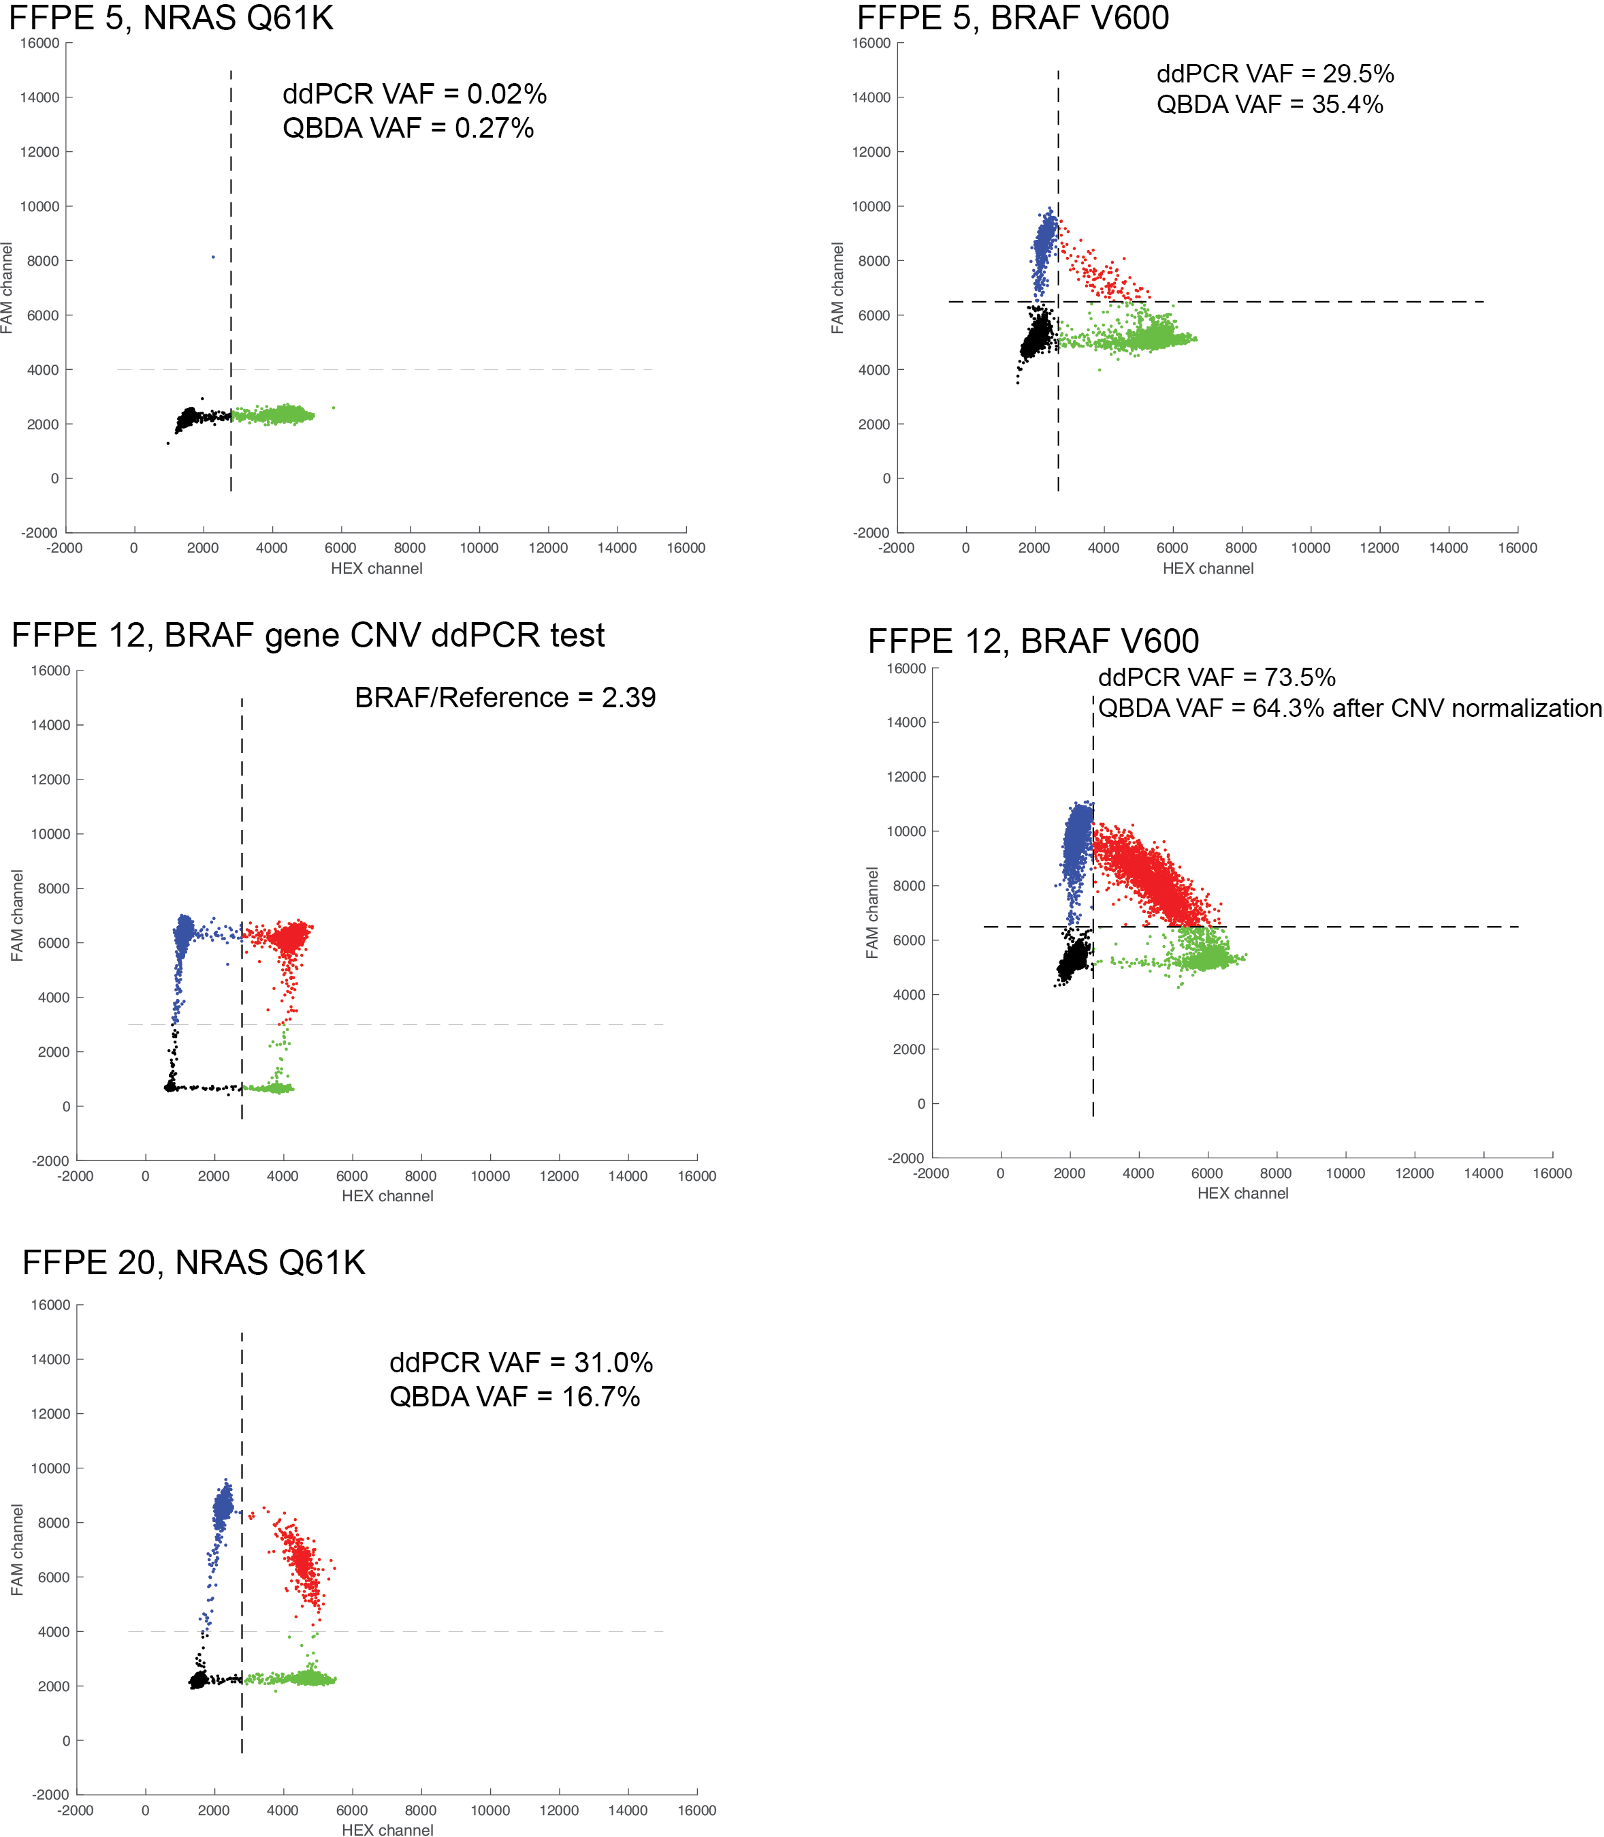
Figure S7. ddPCR validation of observed mutations in BRAF and NRAS. The initial nominal VAF for BRAF V600K mutation in one FFPE sample (sample ID FFPE 12) is over 100%, so we suspect the copy number for BRAF gene is amplified. BRAF CNV is confirmed by BRAF CNV FAM assay using EIF2C1 HEX assay as reference. The total number of UMI family count for BRAF ($M_{t}= 2* w_{input}* c_{genome}*χ*N$) is normalized using N = 2.39. After normalization, VAF from QBDA (64.3%) is consistent with mutation VAF from ddPCR assay (73.5%).
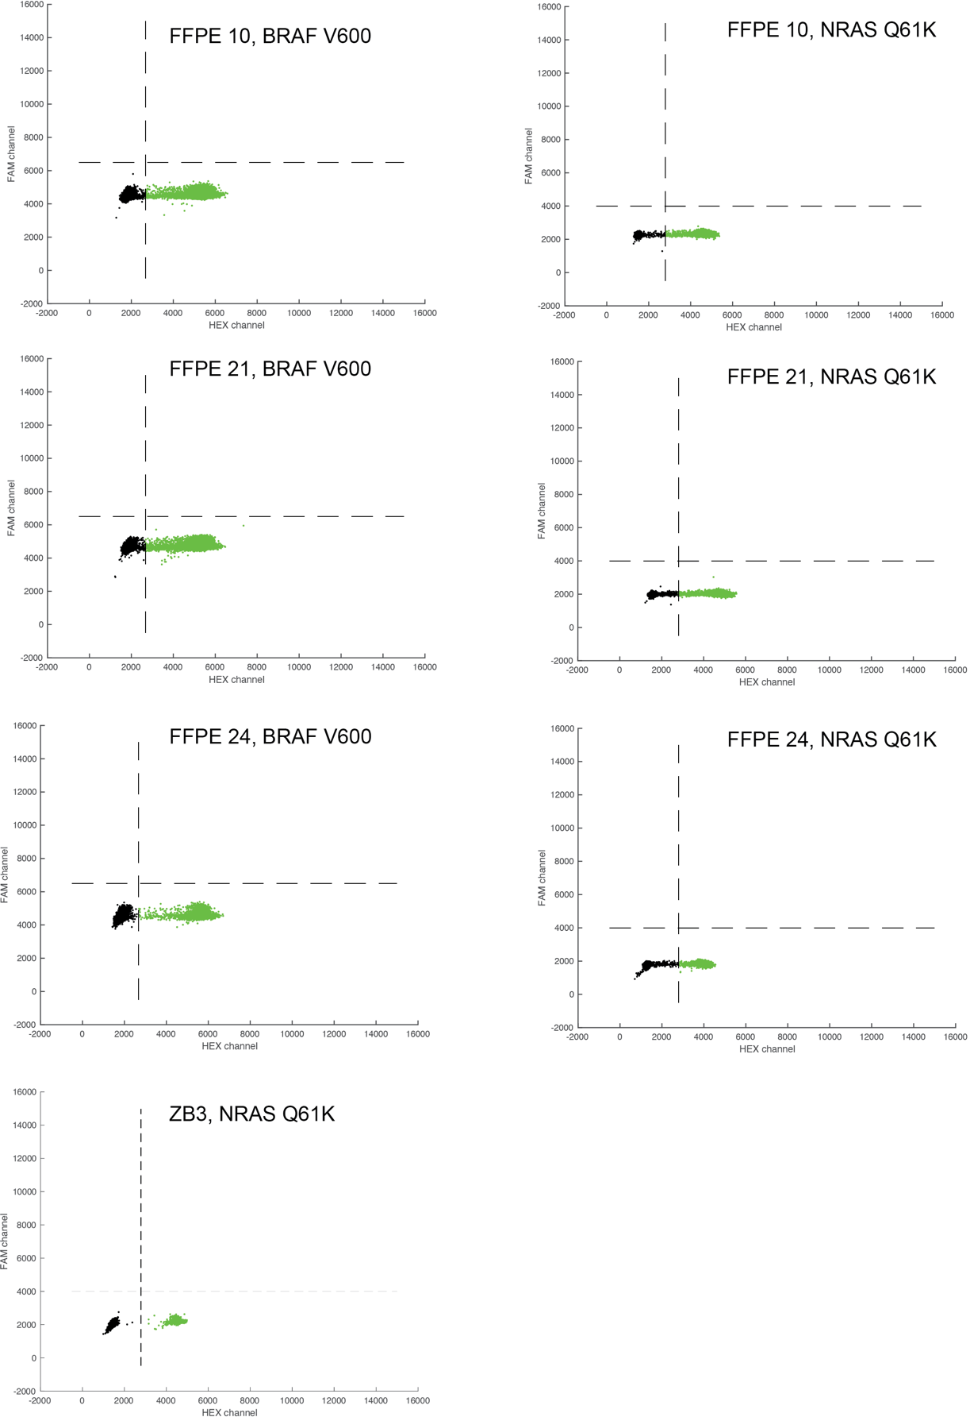
Figure S8. ddPCR validation of QBDA negative samples. One healthy donor PBMC gDNA sample and three FFPE samples and without BRAF/NRAS mutation by QBDA were tested by ddPCR, confirming no false negative were made.
Reference:
1. Potapov, V. & Ong, J. L. Examining sources of error in PCR by single-molecule sequencing. PLoS One 12, 1–19 (2017).
2. Raaijmakers, M. I. G. et al. Co-existence of BRAF and NRAS driver mutations in the same melanoma cells results in heterogeneity of targeted therapy resistance. Oncotarget 7, 77163–77174 (2016).

