Supplementary material

Table S1. STROBE Statement. Checklist of items that should be included in reports of longitudinal studies. 3
Table S2. Characteristics of eMOVI participants that were included vs. excluded from the current analyses. 6
Table S3. Characteristics of eMOVI participants that have at least one week of step data vs. eMOVI participantes that have at least 18 of weeks of step data. 7
Table S4. Mean difference between daily steps indicators by daily steps (complete week) categories and schools. 8
Table S5. Cross-frequency table by categories of daily steps on weekdays and daily steps on weekend, by sex. 9
Table S6. Analysis of covariance of adiposity indicators by categories of mean daily steps on complete week, weekdays, weekends, and percentage of days meeting daily step recommendations in girls. 10
Table S7. Analysis of covariance of adiposity parameters by categories of mean daily steps on complete week, weekdays, weekends, and percentage of days meeting daily step recommendations in boys. 11
Table S8. Multivariable mixed-effects linear regression model of 1,000 steps/day increment (for complete week, weekdays, and weekends) on adiposity parameters, by sex. 12
Table S9. Analysis of covariance of adiposity indicators by categories of mean daily steps on complete week, weekdays, weekends, and percentage of days meeting daily step recommendations controlling age, sex, number of weeks with step data, adherence to mediterranean diet, and maternal education. 13
Table S10. Analysis of covariance of adiposity parameters by categories of mean daily steps in a full week, on weekdays and on weekends, and percentage of days meeting daily step recommendations including subjects with at least 12 weeks of step data (n = 450). 14
Figure. S1. Diagram flow of the study participants in the current study, from the original e-MOVI project. 15
Figure S2. Timetable for data collection. 16
Figure S3. Directed acyclic graph for the causal structure of the relationship between daily steps indicators and body mass index, percentage of body fat, and waist circumference. 17
Figure S4. Mean differences in body mass index, percentage of body fat, and waist circumference according to categories of mean daily steps in a complete week, on weekdays, and on weekend, and percentage of days meeting daily step recommendations, controlling for age, sex, and number of weeks with step data. The line indicates significant differences in the means (p < 0.05). 18
Figure S5. Restricted cubic splines with 95% confidence interval for the association of daily steps and percentage of days meeting daily step recommendations with body mass index (kg/m2) by sex, controlling for age and number of weeks with step data. 19
Figure S6. Restricted cubic splines with 95% confidence interval for the association of daily steps and percentage of days meeting daily step recommendations with percentage of body fat by sex, controlling for age and number of weeks with step data. 20
Figure S7. Restricted cubic splines with 95% confidence interval for the association of daily steps and percentage of days meeting daily step recommendations with waist circumference (cm) by sex, controlling for age and number of weeks with step data. 21
Figure S8. LOESS regression with 95% confidence interval for partial correlation coefficients (r) of daily steps during the complete week with adiposity parameters, controlling for age and sex by number of weeks of follow-up accumulated (1 to 24 weeks). 22
Figure S9. LOESS regression with 95% confidence interval for partial correlation coefficients (r) of daily steps during the complete week with adiposity parameters, controlling for age and sex by number of weeks with step data. 23

Table S1. STROBE Statement. Checklist of items that should be included in reports of longitudinal studies.
 | Item No | Recommendation | Location in the article
Title and abstract | 1 | (a) Indicate the study’s design with a commonly used term in the title or the abstract | Page 1
Title and abstract | 1 | (b) Provide in the abstract an informative and balanced summary of what was done and what was found | Page 1
Introduction
Background/rationale | 2 | Explain the scientific background and rationale for the investigation being reported | 1. Introduction section: paragraph 1-4
Objectives | 3 | State specific objectives, including any prespecified hypotheses | Introduction section: paragraph 5
Methods
Study design | 4 | Present key elements of study design early in the paper | 2.1. Study design and participants section
Setting | 5 | Describe the setting, locations, and relevant dates, including periods of recruitment, exposure, follow-up, and data collection | 2.1. Study design and participants section  2.1. Study variables section  Figure S2
Participants | 6 | (a) Give the eligibility criteria, and the sources and methods of selection of participants | 2.1. Study design and participants section
Variables | 7 | Clearly define all outcomes, exposures, predictors, potential confounders, and effect modifiers. Give diagnostic criteria, if applicable | 2.1. Study variables section
Data sources/ measurement | 8 | For each variable of interest, give sources of data and details of methods of assessment (measurement). Describe comparability of assessment methods if there is more than one group | 2.1. Study variables section
Bias | 9 | Describe any efforts to address potential sources of bias | 2.2.3. Covariates: age, sex, and number of weeks with step data section
Study size | 10 | Explain how the study size was arrived at | 2.1. Study design and participants section, Figure S1
Quantitative variables | 11 | Explain how quantitative variables were handled in the analyses. If applicable, describe which groupings were chosen and why | 2.3. Statistical analysis section: paragraph 1
Statistical methods | 12 | (a) Describe all statistical methods, including those used to control for confounding | 2.3. Statistical analysis section
Statistical methods | 12 | (b) Describe any methods used to examine subgroups and interactions | 2.3. Statistical analysis section: paragraphs 3 and 5
Statistical methods | 12 | (c) Explain how missing data were addressed | 2.1. Study design and participants section, Table S2
Statistical methods | 12 | (d) If applicable, describe analytical methods taking account of sampling strategy | NA
Statistical methods | 12 | (e) Describe any sensitivity analyses | 2.3. Statistical analysis section: paragraph 6
Results
Participants | 13 | (a) Report numbers of individuals at each stage of study—eg numbers potentially eligible, examined for eligibility, confirmed eligible, included in the study, completing follow-up, and analysed | 2.1. Study design and participants section, Figure S1
Participants | 13 | (b) Give reasons for non-participation at each stage | 2.1. Study design and participants section, Figure S1
Participants | 13 | (c) Consider use of a flow diagram | Figure S1
Descriptive data | 14 | (a) Give characteristics of study participants (eg demographic, clinical, social) and information on exposures and potential confounders | 3.1. Descriptive data section, 3.2. Differences in daily steps on weekdays and weekends section, Table 1, Table 3, Figure S3
Descriptive data | 14 | (b) Indicate number of participants with missing data for each variable of interest | 2.1. Study design and participants section, Figure S1
Outcome data | 15 | Report numbers of outcome events or summary measures | Table 1
Main results | 16 | (a) Give unadjusted estimates and, if applicable, confounder-adjusted estimates and their precision (eg, 95% confidence interval). Make clear which confounders were adjusted for and why they were included | 3.3. Association of daily steps indicators with adiposity parameters section, Table 2, Tables S4-S7, Figure 1-3, Figure S4-S6
Main results | 16 | (b) Report category boundaries when continuous variables were categorized | 3.2. Differences in daily steps on weekdays and weekends section, 3.3. Association of daily steps indicators with adiposity parameters: paragraphs 1 and 2, Table 2, Tables S4-S6, Figure 1-3
Main results | 16 | (c) If relevant, consider translating estimates of relative risk into absolute risk for a meaningful time period | NA
Other analyses | 17 | Report other analyses done—eg analyses of subgroups and interactions, and sensitivity analyses | 3.2. Differences in daily steps on weekdays and weekends section, Tables S4-S7, Figure 1-3, Figure S4-S8
Discussion
Key results | 18 | Summarise key results with reference to study objectives | 4. Discussion section: paragraph 1
Limitations | 19 | Discuss limitations of the study, taking into account sources of potential bias or imprecision. Discuss both direction and magnitude of any potential bias | 4. Discussion section: paragraphs 7 and 8
Interpretation | 20 | Give a cautious overall interpretation of results considering objectives, limitations, multiplicity of analyses, results from similar studies, and other relevant evidence | Discussion section: paragraphs 2-6
Generalisability | 21 | Discuss the generalisability (external validity) of the study results | 5. Conclusion section
Other information
Funding | 22 | Give the source of funding and the role of the funders for the present study and, if applicable, for the original study on which the present article is based | Funding section

Table S2. Characteristics of eMOVI participants that were included vs. excluded from the current analyses.
 | Included  (n = 338) | Excludedª  (n = 405) | p-value
Age (years) | 11.04 (10.94, 11.14) | 10.97 (10.88, 11.06) | 0.349
Girls (%) | 55.03 | 44.69 | 0.005
Height (cm) | 147.10 (146.13, 148.07) | 145.79 (144.93, 146.65) | 0.052
Weight (kg) | 41.68 (40.55, 42.81) | 41.08 (40.01, 42.15) | 0.459
Body mass index (kg/m²) | 19.00 (18.64, 19.36) | 19.07 (18.71, 19.43) | 0.781
Body fat (%) | 24.76 (24.09, 25.43) | 24.41 (23.76, 25.06) | 0.466
Waist circumference (cm) | 64.75 (63.74, 65.76) | 64.94 (63.98, 65.90) | 0.795
Data are presented by mean and 95% confidence interval. ª Children who consented to participate in eMOVI project but were excluded due to missing data on mean daily steps (complete week) (n = 389), mean daily weekdays steps (n = 381), and mean daily weekend steps (n = 405).

Table S3. Characteristics of eMOVI participants that have at least one week of step data vs. eMOVI participantes that have at least 18 of weeks of step data.
 | ≥ 1 week and < 18 weeks (n = 318) | ≥ 18 week (n = 338) | p-value
Age (years) | 10.98 (10.87, 11.92) | 11.04 (10.94, 11.14) | 0.524
Girls (%) | 55.03 | 45.91 | 0.020
Height (cm) | 146.11 (145.14, 147.08) | 147.10 (146.13, 148.07) | 0.152
Weight (kg) | 41.25 (40.01, 42.48) | 41.68 (40.55, 42.81) | 0.609
Mean daily steps (complete week) | 11,033 (10,346, 12,520) | 10,823  (10,500, 11,146) | 0.231
Mean daily weekdays steps | 11,284  (10,856, 11,713) | 11,075  (10,750, 11,392) | 0.208
Mean daily weekend steps | 10,544  (10,093, 10,994) | 10,214  (9,860, 10,569) | 0.259
Body mass index (kg/m²) | 18.83 (18.41, 19.26) | 19.00 (18.64, 19.36) | 0.905
Body fat (%) | 24.33 (23.57, 25.09) | 24.76 (24.09, 25.43) | 0.666
Waist circumference (cm) | 65.55 (64.38, 66.72) | 64.75 (63.74, 65.76) | 0.892
Data are presented by mean and 95% confidence interval.

Table S4. Mean difference between daily steps indicators by daily steps (complete week) categories and schools.
 |  | Daily steps (complete week) | Daily weekdays steps | Daily weekends steps | Mean difference between daily weekdays steps and daily weekend steps
Daily steps (complete week) categories | Low <9,000  (n = 105) | 7,595 (7,304, 7,886) | 7,772 (7,539, 8,005) | 6,867 (6,558, 7,176) | 905 (654, 1,155)**
Daily steps (complete week) categories | Medium 9,000-12,000  (n = 119) | 10,777 (10,504, 11,050) | 10,790 (10,617, 10,963) | 9,938 (9,636, 10,240) | 852 ± (516, 1,188)**
Daily steps (complete week) categories | High >12,000  (n = 114) | 14,789 (14,335, 15,242) | 14,386 (14,026, 14,745) | 13,585 (13,148, 14,022) | 801 (423, 1,178)**
Schools | School 1  (n = 46) | 11,403 (10,511, 12,294) | 11,588 (10,695, 12,480) | 10,677 (9,740, 11,613) | 911 (582, 1,239)**
Schools | School 2  (n = 42) | 10,549 (9,690, 11,407) | 10,875 (10,008, 11,741) | 9,716 (8,779, 10,652) | 1,159 (635, 1,682)**
Schools | School 3  (n = 55) | 10,520 (9,634, 11,405) | 10,672 (9,828, 11,515) | 10,256 (9,267, 11,244) | 416 (51, 883)
Schools | School 4  (n = 81) | 10,931 (10,273, 11,588) | 11,153 (10,523, 11,782) | 10,377 (9,634, 11,119) | 776 (393, 1,158)**
Schools | School 5  (n = 59) | 11,321 (10,519, 12,122) | 11,557 (10,753, 12,360) | 10,925 (10,081, 11,768) | 632 (87, 1,176)*
Schools | School 6  (n = 55) | 10,157 (9,475, 10,838) | 10,568 (9,880, 11,255) | 9,163 (8,420, 9,905) | 1,405 (950, 1,859)**
Data are presented by mean and 95% confidence interval.
* p < 0.05 ** p < 0.001

Table S5. Cross-frequency table by categories of daily steps on weekdays and daily steps on weekend, by sex.
Total sample
 |  | Daily weekdays steps
 | Categories | < 9.000 steps/day | 9.000-12.000 steps/day | > 12.000 steps/day | n total
Daily weekend steps | < 9.000 steps/day | 77 | 10 | 0 | 87
Daily weekend steps | 9.000-12.000 steps/day | 48 | 62 | 22 | 132
Daily weekend steps | > 12.000 steps/day | 7 | 31 | 81 | 119
 | n total | 132 | 103 | 103 | 338
Girls
 |  | Daily weekdays steps
 | Categories | < 9.000 steps/day | 9.000-12.000 steps/day | > 12.000 steps/day | n total
Daily weekend steps | < 9.000 steps/day | 61 | 6 | 0 | 67
Daily weekend steps | 9.000-12.000 steps/day | 29 | 38 | 16 | 83
Daily weekend steps | > 12.000 steps/day | 2 | 8 | 26 | 36
 | n total | 92 | 52 | 42 | 186
Boys
 |  | Daily weekdays steps
 | Categories | < 9.000 steps/day | 9.000-12.000 steps/day | > 12.000 steps/day | n total
Daily weekend steps | < 9.000 steps/day | 16 | 4 | 0 | 20
Daily weekend steps | 9.000-12.000 steps/day | 19 | 24 | 6 | 49
Daily weekend steps | > 12.000 steps/day | 5 | 23 | 55 | 83
 | n total | 40 | 51 | 61 | 152
Total sample: observed proportionate agreement: 65.01%; weighted Cohen’s kappa: 0.481
Girls: observed proportionate agreement: 67.20%; weighted Cohen’s kappa: 0.498
Boys: observed proportionate agreement: 62.50%; weighted Cohen’s kappa: 0.412

Table S6. Analysis of covariance of adiposity indicators by categories of mean daily steps on complete week, weekdays, weekends, and percentage of days meeting daily step recommendations in girls.
 |  | n | Body mass index |  | % Body fat |  | Waist circumference
 |  | n | M0 | M1 | M0 | M1 | M0 | M1
Mean daily steps (complete week) categories | Low (L) <9,000 | 80 | 19.37  (18.61, 20.13) | 19.33  (18.56, 20.10) | 27.06  (25.91, 28.21) | 27.02  (25.86, 28.18) | 65.77  (63.61, 67.93) | 65.61  (63.46, 67.76)
Mean daily steps (complete week) categories | Medium (M) 9,000-12,000 | 69 | 19.12  (18.28, 19.96) | 19.23  (18.38, 20.08) | 26.55  (25.32, 27.78) | 26.58  (25.34, 27.82) | 64.24  (62.34, 66.14) | 64.70  (62.80, 66.60)
Mean daily steps (complete week) categories | High (H) >12,000 | 37 | 18.61  (17.48, 19.74) | 18.51  (17.38, 19.64) | 25.66  (24.00, 27.32) | 25.68  (23.99, 27.37) | 62.19  (59.18, 65.20) | 61.67  (58.68, 64.66)
Mean daily steps (complete week) categories | p-value |  | 0.553 | 0.492 | 0.484 | 0.523 | 0.174 | 0.120
Mean daily weekdays steps | Low (L) <9,000 | 67 | 19.48  (18.66, 20.30) | 19.44  (18.62, 20.26) | 27.05  (25.78, 28.32) | 27.02  (25.75, 28.29) | 66.07  (63.82, 68.32) | 65.88  (63.64, 68.12) ^{H}
Mean daily weekdays steps | Medium (M) 9,000-12,000 | 83 | 19.19  (18.48, 19.90) | 19.26  (18.55, 19.97) | 26.86  (25.64, 28.08) | 26.89  (25.66, 28.12) | 64.55  (62.43, 66.67) | 64.91  (62.79, 67.03)
Mean daily weekdays steps | High (H) >12,000 | 36 | 18.33  (17.29, 19.37) | 18.23  (17.19, 19.27) | 25.09  (23.52, 26.66) | 25.08  (23.50, 26.66) | 61.41  (58.84, 63.98) | 60.91  (58.35, 63.47) ^{L}
Mean daily weekdays steps | p-value |  | 0.281 | 0.226 | 0.230 | 0.234 | 0.067 | 0.038
Mean daily weekend steps | Low (L) <9,000 | 92 | 19.52  (18.81, 20.23) | 19.52  (18.79, 20.25) | 27.43  (26.29, 28.57) | 27.44  (26.28, 28.60) | 65.88  (63.61, 68.15) | 65.91  (63.64, 68.18)
Mean daily weekend steps | Medium (M) 9,000-12,000 | 52 | 18.65  (17.66, 19.64) | 18.70  (17.71, 19.69) | 25.8  (24.05, 27.55) | 25.8  (24.05, 27.55) | 63.03  (60.30, 65.76) | 63.26  (60.52, 66.00)
Mean daily weekend steps | High (H) >12,000 | 42 | 18.83  (17.57, 20.09) | 18.77 (17.50, 20.04) | 25.7  (23.63, 27.77) | 25.68  (23.57, 27.79) | 63.19  (60.32, 66.06) | 62.83  (59.93, 65.73)
Mean daily weekend steps | p-value |  | 0.308 | 0.320 | 0.141 | 0.147 | 0.148 | 0.132
% Days meeting daily step recommendations | Low (L) <20% | 76 | 19.66  (18.86, 20.46) ^{M} | 19.59  (18.77, 20.41) ^{M} | 27.55  (26.26, 28.84) | 27.52  (26.10, 28.94) | 66.42  (64.19, 68.65) ^{M} | 66.31  (63.95, 68.67) ^{M}
% Days meeting daily step recommendations | Medium (M) 20-40% | 51 | 18.06  (17.94, 20.18) ^{L} | 18.08  (17.96, 20.20) ^{L} | 25.37  (23.94, 26.80) | 25.37  (23.94, 26.80) | 61.8  (59.09, 64.51) ^{L} | 61.89  (59.20, 64.58) ^{L}
% Days meeting daily step recommendations | High (H) >40% | 57 | 19.39  (18.56, 20.22) | 19.46  (18.58, 20.34) | 26.44  (25.12, 27.76) | 26.48  (25.10, 27.86) | 64.37  (62.00, 66.74) | 64.44  (61.92, 66.96)
% Days meeting daily step recommendations | p-value |  | 0.031 | 0.038 | 0.105 | 0.127 | 0.029 | 0.040
Data are presented as mean and 95% confidence interval. The values in bold indicate statistical significance at p < 0.05. Model 0 (M0): unadjusted data analysis. Model 1 (M1): controlling for age, sex, and number of weeks with step data. Superscript letter indicates statistical significance (p < 0.05) between categories for post-hoc tests using the Bonferroni comparisons.

Table S7. Analysis of covariance of adiposity parameters by categories of mean daily steps on complete week, weekdays, weekends, and percentage of days meeting daily step recommendations in boys.
 |  | n | Body mass index |  | % Body fat |  | Waist circumference
 |  | n | M0 | M1 | M0 | M1 | M0 | M1
Mean daily steps (complete week) categories | Low (L) <9,000 | 25 | 19.43  (18.29, 20.57) | 19.40  (18.26, 20.54) | 24.04  (21.77, 26.31) ^{H} | 24.39  (22.13, 26.65) ^{H} | 67.28  (63.36, 71.20) ^{H} | 67.12  (63.21, 71.03) ^{H}
Mean daily steps (complete week) categories | Medium (M) 9,000-12,000 | 50 | 19.20  (18.34, 20.06) | 19.28  (18.42, 20.14) | 23.76  (22.06, 25.46) | 23.63  (21.95, 25.31) | 66.86  (64.23, 69.49) | 67.17  (64.54, 69.80)
Mean daily steps (complete week) categories | High (H) >12,000 | 77 | 18.43  (17.66, 19.20) | 18.39  (17.62, 19.16) | 21.29  (19.77, 22.81) ^{L} | 21.26  (19.77, 22.75) ^{L} | 63.20  (61.00, 65.40) ^{L} | 63.05  (60.86, 65.24) ^{L}
Mean daily steps (complete week) categories | p-value |  | 0.275 | 0.221 | 0.041 | 0.031 | 0.041 | 0.020
Mean daily weekdays steps | Low (L) <9,000 | 20 | 20.09  (18.47, 21.71) | 20.04  (18.41, 21.67) | 24.46  (21.56, 27.36) | 25.00  (22.10, 27.90) ^{H} | 68.59  (64.60, 72.58) ^{H} | 68.22  (64.21, 72.23)
Mean daily weekdays steps | Medium (M) 9,000-12,000 | 49 | 19.00  (18.84, 19.16) | 19.15  (18.99, 19.31) | 23.81  (22.06, 25.56) | 23.67  (21.92, 25.42) | 66.54  (64.23, 69.49) | 67.09  (64.54, 69.80)
Mean daily weekdays steps | High (H) >12,000 | 83 | 18.45  (17.66, 19.24) | 18.38  (17.59, 19.17) | 21.35  (19.77, 22.93) | 21.30  (19.72, 22.88) ^{L} | 63.35  (61.00, 65.70) ^{L} | 63.13  (60.78, 65.48) ^{L}
Mean daily weekdays steps | p-value |  | 0.123 | 0.102 | 0.032 | 0.019 | 0.031 | 0.018
Mean daily weekend steps | Low (L) <9,000 | 40 | 19.02  (18.81, 19.23) | 19.09 (18.88, 19.30) | 23.55  (21.25, 25.85) | 23.42  (21.12, 25.72) | 65.75  (63.61, 67.89) | 66.04  (63.90, 68.18)
Mean daily weekend steps | Medium (M) 9,000-12,000 | 51 | 19.16  (18.66, 19.66) | 19.19  (18.69, 19.71) | 23.67  (22.05, 25.29) | 23.58  (21.96, 25.20) | 66.77  (64.23, 69.31) | 66.93  (64.39, 69.47)
Mean daily weekend steps | High (H) >12,000 | 61 | 18.47  (17.57, 19.37) | 18.40  (17.50, 19.30) | 20.96  (19.77, 22.15) | 21.12  (19.93, 22.31) | 63.20  (61.00, 65.40) | 62.87  (60.67, 65.07)
Mean daily weekend steps | p-value |  | 0.511 | 0.401 | 0.036 | 0.072 | 0.111 | 0.055
% Days meeting daily step recommendations | Low (L) <20% | 41 | 19.43  (18.29, 20.57) | 19.45  (18.31, 20.59) | 24.07  (21.77, 26.37) ^{H} | 23.94  (21.64, 26.24) ^{H} | 67.7  (63.36, 72.04) ^{H} | 67.82  (63.48, 72.16) ^{H}
% Days meeting daily step recommendations | Medium (M) 20-40% | 52 | 19.10  (18.34, 19.86) | 19.08  (18.32, 19.84) | 23.28  (22.06, 25.50) | 23.32  (22.10, 25.54) | 65.26  (64.23, 69.31) | 65.18  (64.15, 69.21)
% Days meeting daily step recommendations | High (H) >40% | 59 | 18.22  (17.66, 18.78) | 18.22  (17.66, 18.78) | 20.87  (19.77, 22.15) ^{L} | 20.92  (19.82, 22.02) ^{L} | 63.1  (61.00, 65.20) ^{L} | 63.09  (60.99, 65.19) ^{L}
% Days meeting daily step recommendations | p-value |  | 0.155 | 0.156 | 0.025 | 0.030 | 0.052 | 0.044
Data are presented as mean and 95% confidence interval. The values in bold indicate statistical significance at p < 0.05. Model 0 (M0): unadjusted data analysis. Model 1 (M1): controlling for age, sex, and number of weeks with step data. Superscript letter indicates statistical significance (p < 0.05) between categories for post-hoc tests using the Bonferroni comparisons.

Table S8. Multivariable mixed-effects linear regression model of 1,000 steps/day increment (for complete week, weekdays, and weekends) on adiposity parameters, by sex.
 |  |  | Body mass index |  | % Body fat |  | Waist circumference
1,000 steps/day increment |  |  | β ± SD | p-value | β ± SD | p-value | β ± SD | p-value
Complete week | Total sample | M₀ | -0.13 ± 1.14 | 0.026 | -0.52 ± 1.98 | 0.051 | -0.41 ± 3.09 | 0.016
Complete week | Total sample | M₁ | -0.14 ± 1.19 | 0.029 | -0.33 ± 2.06 | 0.004 | -0.51 ± 3.26 | 0.004
Complete week | Girls | M₀ | -0.12 ± 1.06 | 0.212 | -0.21 ± 2.16 | 0.203 | -0.46 ± 3.63 | 0.088
Complete week | Girls | M₁ | -0.12 ± 1.33 | 0.228 | -0.20 ± 2.20 | 0.221 | -0.46 ± 3.60 | 0.084
Complete week | Boys | M₀ | -0.16 ± 1.31 | 0.057 | -0.47 ± 1.95 | 0.004 | -0.57 ± 2.97 | 0.020
Complete week | Boys | M₁ | -0.18 ± 1.07 | 0.043 | -0.48 ± 1.97 | 0.003 | -0.63 ± 3.00 | 0.011
Weekday | Total sample | M₀ | -0.15 ± 1.13 | 0.013 | -0.56 ± 2.00 | <0.001 | -0.46 ± 3.15 | 0.008
Weekday | Total sample | M₁ | -0.17 ± 1.21 | 0.013 | -0.36 ± 2.12 | 0.002 | -0.59 ± 3.35 | 0.001
Weekday | Girls | M₀ | -0.12 ± 1.34 | 0.217 | -0.20 ± 2.21 | 0.214 | -0.46 ± 3.69 | 0.095
Weekday | Girls | M₁ | -0.12 ± 1.35 | 0.220 | -0.20 ± 2.23 | 0.226 | -0.47 ± 3.65 | 0.086
Weekday | Boys | M₀ | -0.20 ± 1.08 | 0.022 | -0.53 ± 2.00 | 0.001 | -0.71 ± 3.05 | 0.005
Weekday | Boys | M₁ | -0.22 ± 1.11 | 0.014 | -0.55 ± 2.05 | 0.001 | -0.78 ± 3.10 | 0.002
Weekend | Total sample | M₀ | -0.09 ± 1.00 | 0.093 | -0.37 ± 1.84 | <0.001 | -0.29 ± 2.82 | 0.061
Weekend | Total sample | M₁ | -0.09 ± 1.04 | 0.102 | -0.23 ± 1.82 | 0.020 | -0.35 ± 2.87 | 0.028
Weekend | Girls | M₀ | -0.12 ± 1.15 | 0.167 | -0.21 ± 1.89 | 0.144 | -0.38 ± 3.16 | 0.107
Weekend | Girls | M₁ | -0.12 ± 1.16 | 0.156 | -0.21 ± 1.93 | 0.148 | -0.41 ± 3.18 | 0.080
Weekend | Boys | M₀ | -0.08 ± 0.93 | 0.321 | -0.29 ± 1.74 | 0.046 | -0.31 ± 3.03 | 0.149
Weekend | Boys | M₁ | -0.08 ± 0.95 | 0.317 | -0.26 ± 1.76 | 0.067 | -0.34 ± 2.67 | 0.124
Data are presented as unstandardised beta coefficient (β) ± standard deviation. The values in bold indicate statistical significance at p < 0.05. Model 0 (M0): unadjusted data analysis. Model 1 (M1): controlling for age, sex (only total sample), and number of weeks with step data.

Table S9. Analysis of covariance of adiposity indicators by categories of mean daily steps on complete week, weekdays, weekends, and percentage of days meeting daily step recommendations controlling age, sex, number of weeks with step data, adherence to mediterranean diet, and maternal education.
 |  | n | Body mass index |  |  | % Body fat |  |  |  |  |  | Waist circumference
 |  | n | M0 | M1 |  |  | M0 |  |  | M1 |  | M0 |  | M1
Mean daily steps (complete week) categories | Low (L) <9,000 | 105 (M0)  55 (M1) | 19.39  (18.73, 20.04) | 19.47  (18.51, 20.42) |  |  | 26.35  (25.17, 27.53) ^{H} |  |  | 26.03  (24.31, 27.76) | 66.13  (64.32, 67.94) ^{H} |  |  | 66.85  (64.27, 69.43)
Mean daily steps (complete week) categories | Medium (M) 9,000-12,000 | 119 (M0)  61 (M1) | 19.15  (18.54, 19.77) | 19.31  (18.43, 20.19) |  |  | 25.38  (24.27, 26.49) ^{H} |  |  | 25.09  (23.51, 26.66) | 65.34  (63.63, 67.04) |  |  | 66.02  (63.64, 68.40)
Mean daily steps (complete week) categories | High (H) >12,000 | 114 (M0)  59 (M1) | 18.49  (17.86, 19.11) | 18.79  (17.87, 19.72) |  |  | 22.66  (21.52, 23.79) ^{L,M} |  |  | 24.20  (22.53, 25.88) | 62.88  (61.14, 64.61) ^{L} |  |  | 62.73  (60.23, 65.23)
Mean daily steps (complete week) categories | p-value |  | 0.124 | 0.593 |  |  | <0.001 |  |  | 0.351 | 0.028 |  |  | 0.066
Mean daily weekdays steps | Low (L) <9,000 | 87 (M0)  43 (M1) | 19.62  (18.91, 20.34) ^{H} | 19.63  (18.55, 20.72) |  |  | 26.45  (25.16, 27.73) ^{H} |  |  | 26.03  (24.09, 27.96) | 66.66  (64.67, 68.64) ^{H} |  |  | 67.29  (64.37, 68.66) ^{H}
Mean daily weekdays steps | Medium (M) 9,000-12,000 | 132 (M0)  69 (M1) | 19.12  (19.54, 19.70) | 19.50  (18.67, 20.33) |  |  | 25.75  (24.70, 29.80) ^{H} |  |  | 25.65  (24.15, 27.14) | 65.28  (63.67, 66.90) |  |  | 66.43  (64.19, 68.66)
Mean daily weekdays steps | High (H) >12,000 | 119 (M0)  63 (M1) | 18.42  (17.81, 19.03) ^{L} | 18.53  (17.64, 19.43) |  |  | 22.44  (21.34, 23.54) ^{L,M} |  |  | 23.82  (22.20, 25.44) | 62.78  (61.08, 64.47) ^{L} |  |  | 62.35  (59.94, 64.77) ^{L}
Mean daily weekdays steps | p-value |  | 0.037 | 0.216 |  |  | <0.001 |  |  | 0.170 | 0.010 |  |  | 0.020
Mean daily weekend steps | Low (L) <9,000 | 132 (M0)  75 (M1) | 19.37  (18.79, 19.95) | 19.42  (18.62, 20.23) |  |  | 26.29  (25.23, 27.35) ^{H} |  |  | 25.89  (24.45, 27.34) | 65.84 (64.22, 67.46) |  |  | 66.92  (64.75, 69.09)
Mean daily weekend steps | Medium (M) 9,000-12,000 | 103 (M0)  50 (M1) | 18.91  (18.24, 19.58) | 19.13  (18.16, 20.11) |  |  | 24.71  (23.51, 25.92) |  |  | 24.96  (23.22, 26.70) | 64.93 (63.08, 66.79) |  |  | 65.02  (62.38, 67.65)
Mean daily weekend steps | High (H) >12,000 | 103 (M0)  50 (M1) | 18.62  (17.96, 19.28) | 18.89  (17.90, 19.87) |  |  | 22.87  (21.67, 24.06) ^{L} |  |  | 24.00  (22.23, 25.76) | 63.19 (61.37, 65.02) |  |  | 62.71  (60.07, 65.35)
Mean daily weekend steps | p-value |  | 0.232 | 0.709 |  |  | <0.001 |  |  | 0.269 | 0.102 |  |  | 0.058
% Days meeting daily step recommendations | Low (L) <20% | 117 (M0)  47 (M1) | 19.58  (18.97, 20.19) | 19.66  (18.66, 20.67) |  |  | 26.36  (25.24, 27.48) ^{M,H} |  |  | 26.53  (24.72, 28.35) | 66.87  (65.17, 68.57) ^{M,H} |  |  | 67.95  (65.24, 70.66) ^{H}
% Days meeting daily step recommendations | Medium (M) 20-40% | 105 (M0)  79 (M1) | 18.58  (17.94, 19.22) | 19.16  (18.38, 19.94) |  |  | 24.32  (23.14, 25.50) ^{L} |  |  | 24.86  (23.48, 26.24) | 63.55  (61.76, 65.34) ^{L} |  |  | 65.10  (63.02, 67.19)
% Days meeting daily step recommendations | High (H) >40% | 116 (M0)  49 (M1) | 18.80  (18.19, 19.41) | 18.77  (17.79, 19.75) |  |  | 23.58  (22.45, 24.71) ^{L} |  |  | 24.07  (22.31, 25.83) | 63.73  (62.03, 65.43) ^{L} |  |  | 62.62  (60.00, 65.25) ^{L}
% Days meeting daily step recommendations | p-value |  | 0.070 |  | 0.455 |  |  | 0.002 | 0.149 |  |  | 0.012 | 0.023
Data are presented as mean and 95% confidence interval. The values in bold indicate statistical significance at p < 0.05. Model 0 (M0): unadjusted data analysis. Model 1 (M1): controlling for age, sex, number of weeks with step data, adherence to mediterranean diet, and maternal education. Superscript letter indicates statistical significance (p < 0.05) between categories for post-hoc tests using the Bonferroni comparisons.

Table S10. Analysis of covariance of adiposity parameters by categories of mean daily steps in a full week, on weekdays and on weekends, and percentage of days meeting daily step recommendations including subjects with at least 12 weeks of step data (n = 450).
 |  | n | Body mass index |  | % Body fat |  | Waist circumference
 |  | n | M0 | M1 | M0 | M1 | M0 | M1
Mean daily steps (complete week) categories | Low (L) <9,000 | 130 | 19.43  (18.84, 20.02) ^{H} | 19.32  (18.71, 19.93) | 26.47  (25.40, 27.54) ^{H} | 25.64  (24.57, 26.72) ^{H} | 66.05  (64.43, 67.67) ^{H} | 66.17  (64.53, 67.82) ^{H}
Mean daily steps (complete week) categories | Medium (M) 9,000-12,000 | 142 | 19.08  (18.51, 19.64) | 19.16  (18.59, 19.72) | 25.03  (24.02, 26.05) ^{H} | 24.98  (23.99, 25.97) ^{H} | 65.20  (63.63, 66.75) | 65.53  (64.00, 67.06) ^{H}
Mean daily steps (complete week) categories | High (H) >12,000 | 178 | 18.42  (17.91, 18.92) ^{L} | 18.43  (17.91, 18.95) | 22.67  (21.76, 23.58) ^{L,M} | 23.32  (22.40, 24.23) ^{L,M} | 62.87  (61.49, 64.25) ^{L} | 62.50  (61.11, 63.92) ^{L,M}
Mean daily steps (complete week) categories | p-value |  | 0.032 | 0.065 | <0.001 | 0.004 | 0.008 | 0.002
Mean daily weekdays steps | Low (L) <9,000 | 118 | 19.61  (18.99, 20.23) ^{H} | 19.54  (18.91, 20.17) ^{H} | 26.50  (25.40, 27.60) ^{H} | 25.77  (24.66, 26.87) ^{H} | 66.57  (64.88, 68.25) ^{H} | 66.76  (65.05, 68.46) ^{H}
Mean daily weekdays steps | Medium (M) 9,000-12,000 | 160 | 19.18  (18.65, 19.71) | 19.26  (18.73, 19.79) ^{H} | 25.54  (24.59, 26.49) ^{H} | 25.36  (24.43, 26.29) ^{H} | 65.36  (63.91, 66.81) ^{H} | 65.78  (64.34, 67.21) ^{H}
Mean daily weekdays steps | High (H) >12,000 | 172 | 18.20  (17.69, 18.71) ^{L} | 18.17  (17.65, 18.70) ^{L,M} | 22.19  (21.27, 23.10) ^{L,M} | 22.86  (21.93, 23.79) ^{L,M} | 62.35  (60.95, 63.75) ^{L,M} | 61.83  (60.41, 63.25) ^{L,M}
Mean daily weekdays steps | p-value |  | 0.001 | 0.002 | <0.001 | <0.001 | <0.001 | <0.001
Mean daily weekend steps | Low (L) <9,000 | 163 | 19.30  (18.77, 19.83) | 19.27  (18.73, 19.80) | 26.05  (25.09, 27.00) ^{H} | 25.41  (24.47, 26.36) ^{H} | 65.66  (64.21, 67.11) ^{H} | 65.89  (64.44, 67.35) ^{H}
Mean daily weekend steps | Medium (M) 9,000-12,000 | 139 | 18.93  (18.36, 19.51) | 19.01  (18.44, 19.58) | 24.72  (23.68, 25.75) ^{H} | 24.89  (23.89, 25.89) ^{H} | 64.90  (63.33, 66.47) | 65.09  (63.55, 66.64)
Mean daily weekend steps | High (H) >12,000 | 148 | 18.48  (17.93, 19.04) | 18.45  (17.89, 19.01) | 22.64  (21.63, 23.64) ^{L,M} | 23.17  (22.18, 24.16) ^{L,M} | 62.92  (61.40, 64.44) ^{L} | 62.48  (60.96, 64.00) ^{L}
Mean daily weekend steps | p-value |  | 0.113 | 0.119 | <0.001 | 0.005 | 0.033 | 0.005
% Days meeting daily step recommendations | Low (L) <20% | 115 | 19.71  (19.08, 20.34) ^{H} | 19.67  (19.05, 20.29) ^{H} | 26.39  (25.24, 27.53)^{M,H} | 26.04  (24.94, 27.14) ^{H} | 67.01  (65.30, 68.72) ^{H} | 67.03  (65.35, 68.72) ^{H}
% Days meeting daily step recommendations | Medium (M) 20-40% | 198 | 18.86  (18.39, 19.34) | 18.89  (18.42, 19.37) | 24.58  (23.71, 25.45) ^{L,H} | 24.58  (23.75, 25.41) | 64.63  (63.32, 65.93) | 64.73  (63.44, 66.01) ^{H}
% Days meeting daily step recommendations | High (H) >40% | 137 | 18.33  (17.76, 18.91) ^{L} | 18.33  (17.75, 18.90) ^{L} | 22.85  (21.80, 23.90) ^{L,M} | 23.14  (22.13, 24.15) ^{L} | 62.30  (60.73, 63.86) ^{L} | 62.13  (60.58, 63.68) ^{L,M}
% Days meeting daily step recommendations | p-value |  | 0.006 | 0.008 | 0.038 | <0.001 | <0.001 | <0.001
Data are presented as mean and 95% confidence interval. The values in bold indicate statistical significance at p < 0.05. Model 0 (M0): unadjusted data analysis. Model 1 (M1): controlling for age, sex, and number of weeks with step data. Superscript letter indicates statistical significance (p < 0.05) between categories for post-hoc tests using the Bonferroni comparisons.

Respondents:
745
Invited for participation:
1,049

Non-respondents:
304 actively refused or did not return the written approval.

Excluded: 407
- 391 had missing data on mean daily steps (complete week).
- 403 had missing data on mean daily weekend steps.
- 383 had missing data on mean daily weekdays steps.

Population for analyses:
338

Figure. S1. Diagram flow of the study participants in the current study, from the original e-MOVI project.

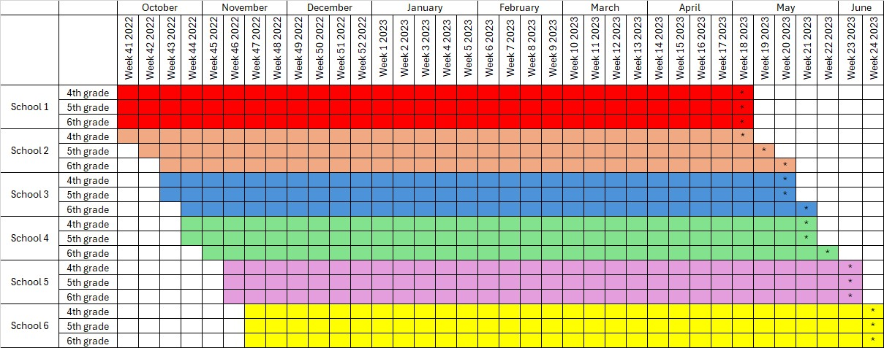
Coloured cells show the follow-up of the daily step data collection.
* Indicates the date of collection of adiposity parameters.

Figure S2. Timetable for data collection.

- Original directed acyclic graph
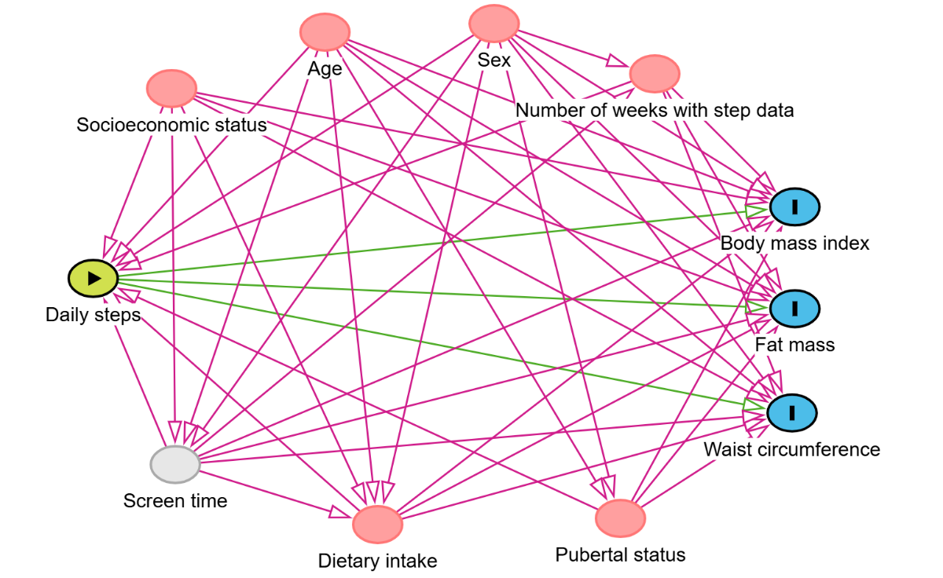
- Directed acyclic graph after adjustment for the covariates available
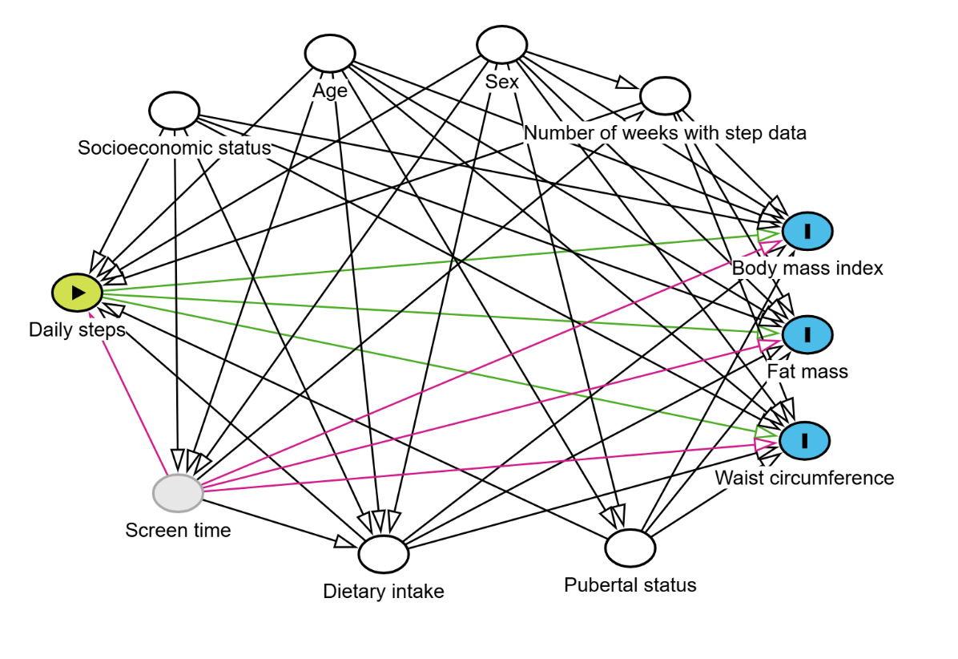
Exposure, Outcome, Ancestor of outcome, Ancestor of exposure and outcome, …. Unavailable variable, Adjusted variable, Causal path, Biasing path, Biasing path closed

Figure S3. Directed acyclic graph for the causal structure of the relationship between daily steps indicators and body mass index, percentage of body fat, and waist circumference.

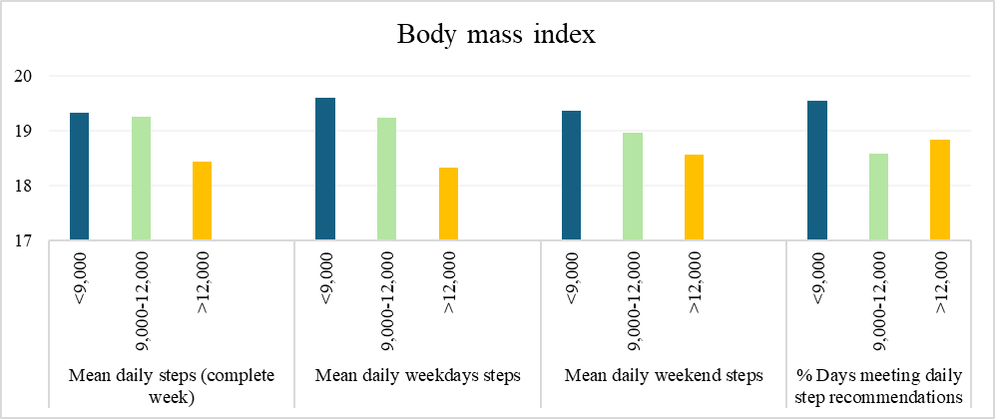S
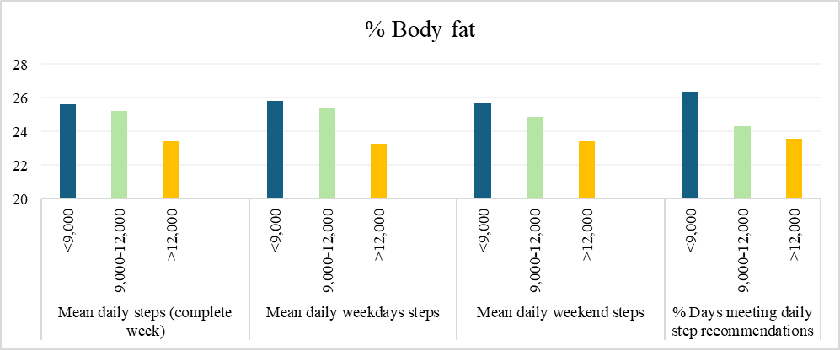
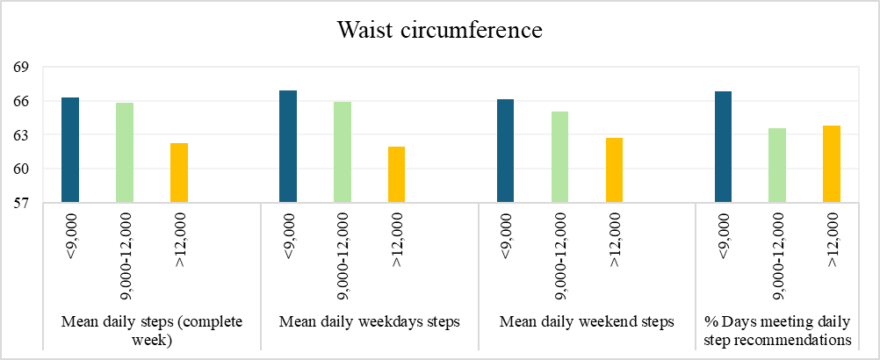

Figure S4. Mean differences in body mass index, percentage of body fat, and waist circumference according to categories of mean daily steps in a complete week, on weekdays, and on weekend, and percentage of days meeting daily step recommendations, controlling for age, sex, and number of weeks with step data. The line indicates significant differences in the means (p < 0.05).

Association with body mass index
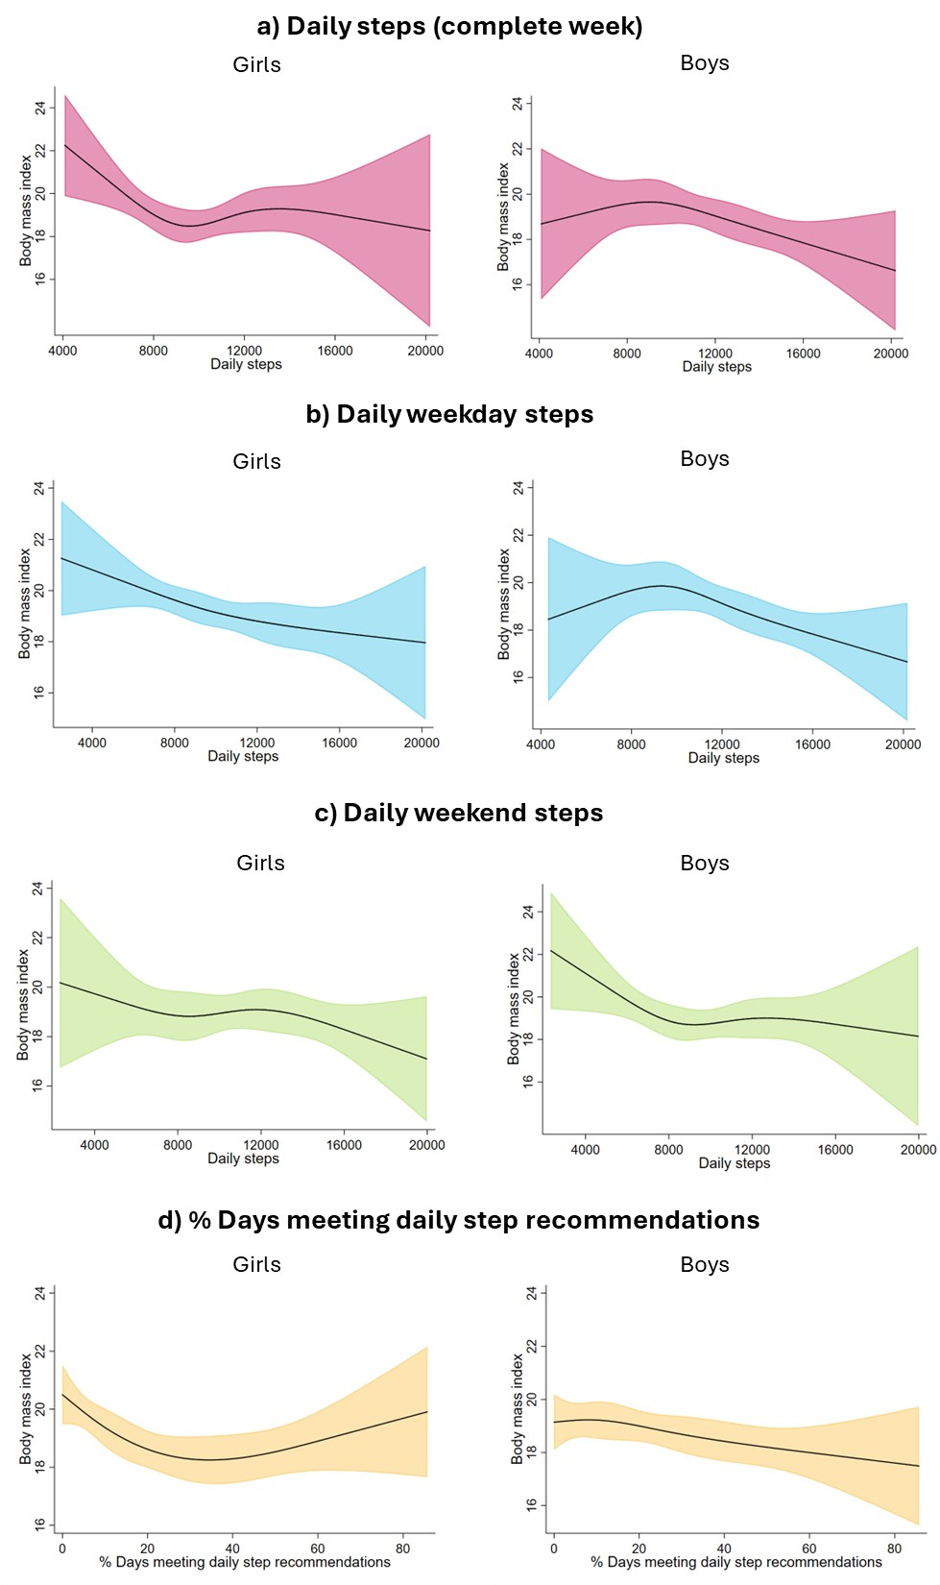

Figure S5. Restricted cubic splines with 95% confidence interval for the association of daily steps and percentage of days meeting daily step recommendations with body mass index (kg/m2) by sex, controlling for age and number of weeks with step data.

Association with percentage of body fat
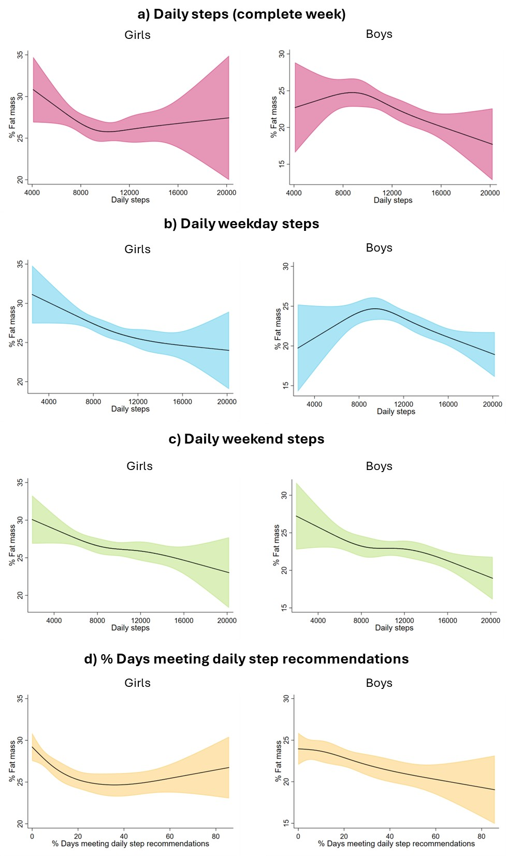

Figure S6. Restricted cubic splines with 95% confidence interval for the association of daily steps and percentage of days meeting daily step recommendations with percentage of body fat by sex, controlling for age and number of weeks with step data.

Association with waist circumference
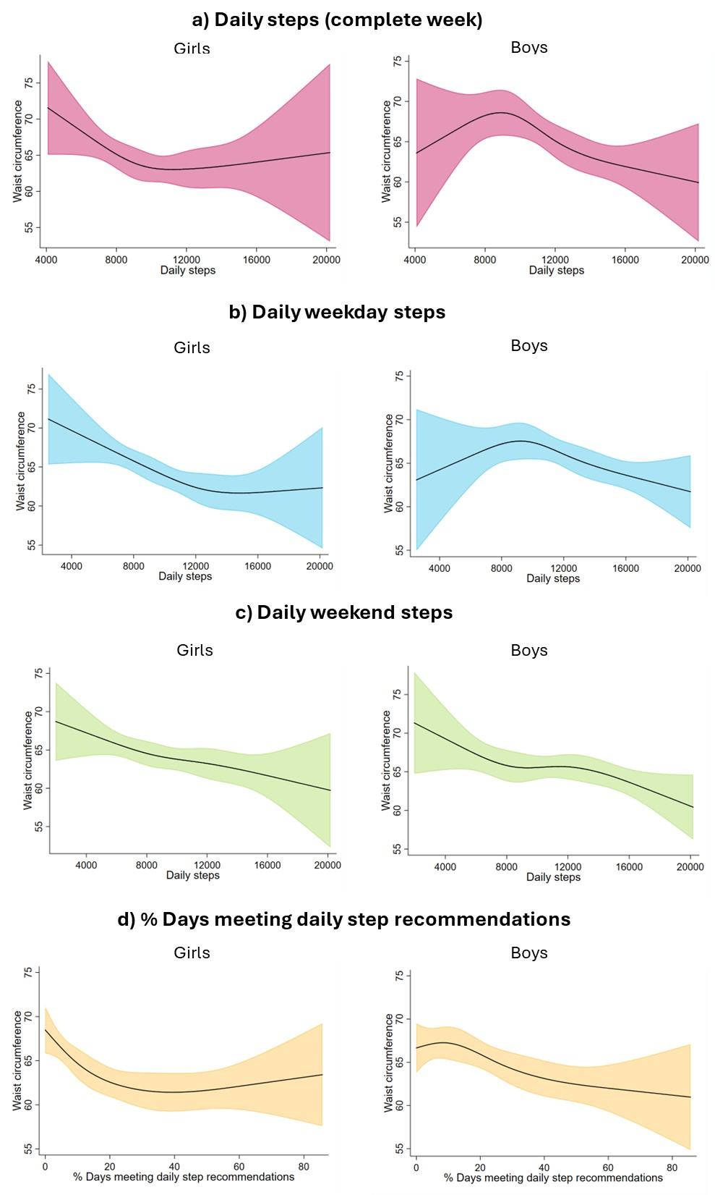

Figure S7. Restricted cubic splines with 95% confidence interval for the association of daily steps and percentage of days meeting daily step recommendations with waist circumference (cm) by sex, controlling for age and number of weeks with step data.

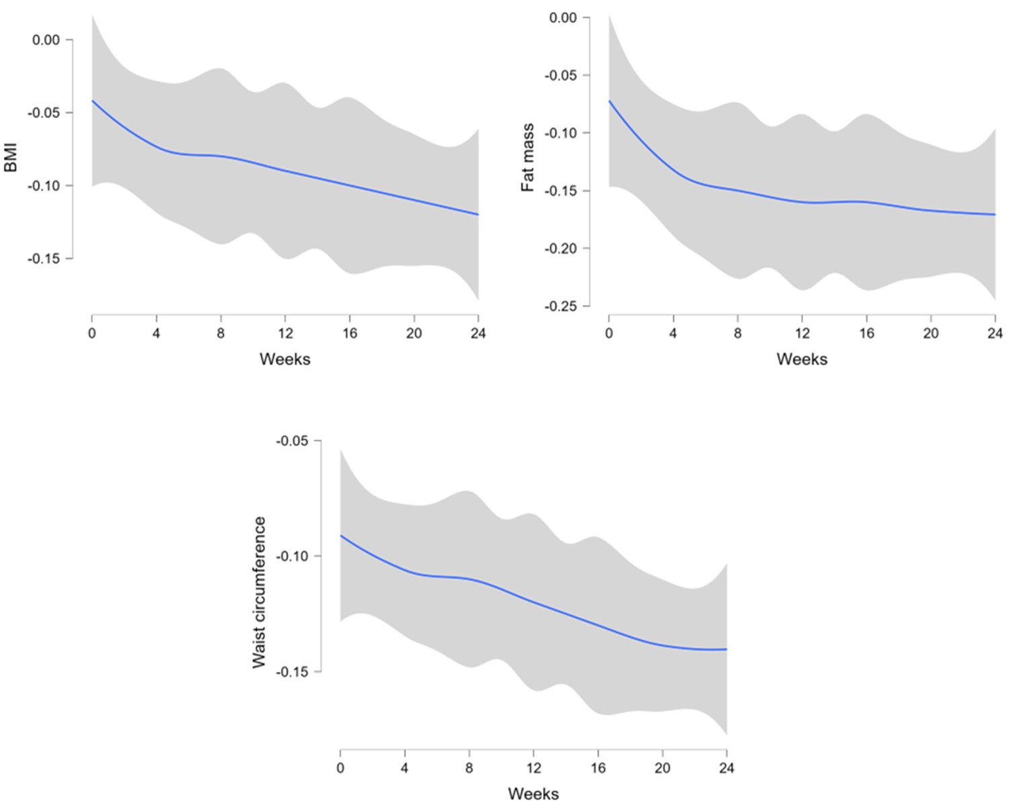

Figure S8. LOESS regression with 95% confidence interval for partial correlation coefficients (r) of daily steps during the complete week with adiposity parameters, controlling for age and sex by number of weeks of follow-up accumulated (1 to 24 weeks).

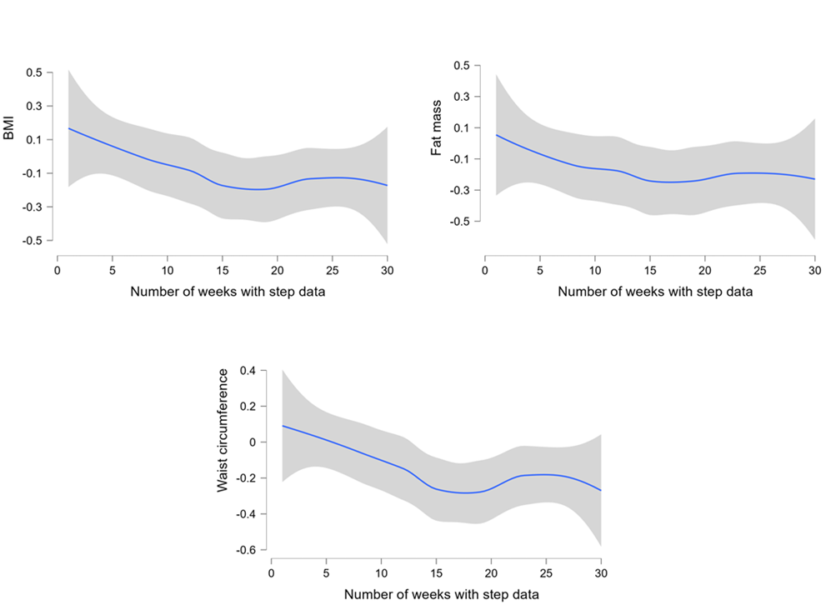

Figure S9. LOESS regression with 95% confidence interval for partial correlation coefficients (r) of daily steps during the complete week with adiposity parameters, controlling for age and sex by number of weeks with step data.

