Urban Forest Quality Corresponds with Soil Microbial Community Composition and Arbuscular Fungi Root Colonization

Lindsay W. Gaimaro^{1,2}, Humberto Castillo Gonzalez³, Stephanie Yarwood^{1*}

¹ Environmental Science and Technology Department, University of Maryland, College Park, MD

² United States Army, Engineer Research Development Center, Cold Regions Research and Engineering Laboratory, Hanover, NH
³ Université de Franche-Comté, CNRS, CHRONO-E (UMR 6249), F-25200 Montbéliard, France

Supplemental
Table S1. Plot information, including the number of tree species, the dominant tree species, and average tree height. Note: fine root samples used to quantify AMF were sampled mainly from Acer trees. Dotted lines separated high-, mid- and low- quality groupings.

Sample Number | Quality  Score | Number of Tree Species | Dominant Tree Genus per plot | Average Tree Height | Tree sampled for AMF
1 | 69.5 | 13 | Quercus | 39.3 | Acer
2 | 72 | 7 | Quercus | 42.4 | Acer
3 | 69.5 | 6 | Liriodendron | 34.2 | Acer
4 | 73.5 | 6 | Quercus | 55.1 | Acer
5 | 71.5 | 8 | Liriodendron | 63.5 | Acer
6 | 69.5 | 8 | Quercus | 51.3 | Fagus
7 | 71 | 6 | Quercus | 50.5 | Acer
8 | 74 | 13 | Liriodendron | 50.1 | Acer
9 | 71.5 | 11 | Quercus | 29.4 | Acer
10 | 70.5 | 7 | Quercus | 46.8 | Acer
11 | 67.5 | 11 | Carya | 48.3 | Acer
12 | 58.5 | 19 | Quercus | 43.2 | Acer
13 | 62 | 11 | Quercus | 27.0 | Acer
14 | 63.5 | 5 | Quercus | 47.1 | Acer
15 | 61.5 | 8 | Acer | 49.9 | Acer
16 | 54.5 | 3 | Acer | 49.8 | Acer
17 | 52.5 | 5 | Platanus | 56.3 | Acer
18 | 64 | 9 | Quercus | 48.7 | Acer
19 | 47.5 | 12 | Quercus | 25.5 | Juglans
20 | 41.5 | 3 | Platanus | 38.5 | Platanus
21 | 42.5 | 1 | Acer | 29.0 | Acer
22 | 39 | 3 | Liriodendron | 68.0 | Acer
23 | 41.5 | 9 | Liriodendron | 50.8 | Acer
24 | 39.5 | 6 | Liriodendron | 49.0 | Acer
25 | 42.5 | 6 | Acer | 24.2 | Acer
26 | 41 | 9 | Acer | 45.2 | Acer

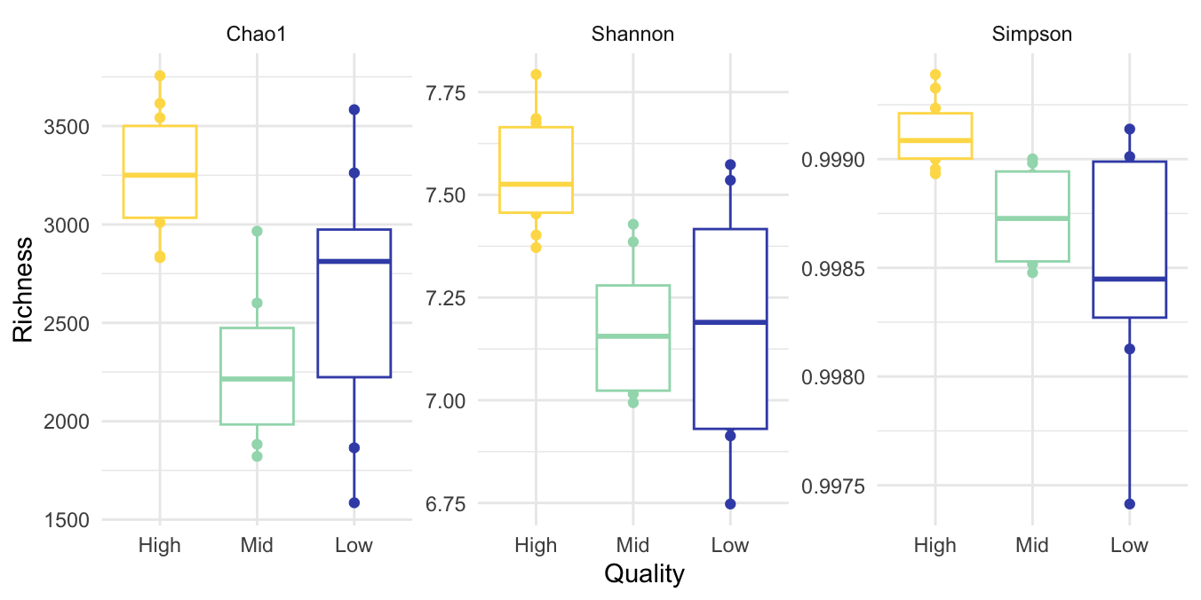

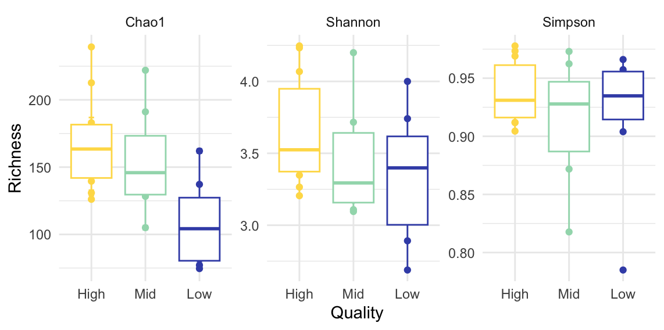
16S

ITS

Figure S1. Alpha diversity indices for 16S rRNA DNA and ITS gene sequences.

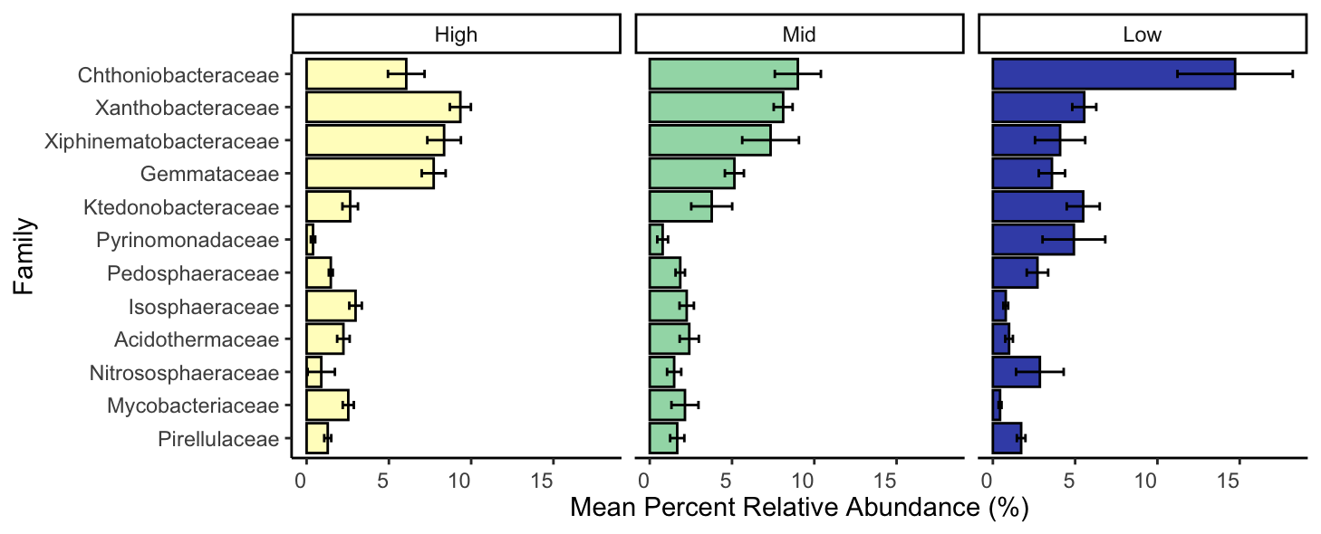

Figure S2. Most abundant putatively identified families based on 16S rRNA gene sequences relative abundance.

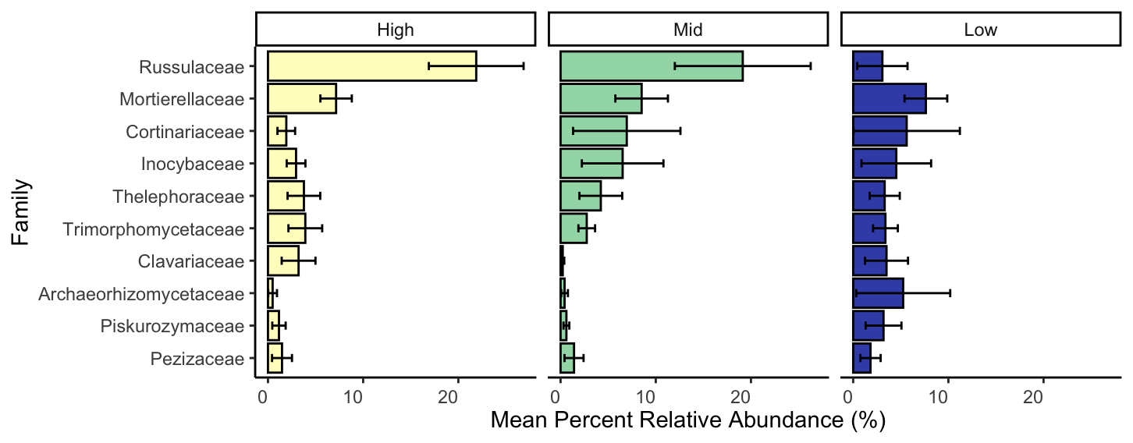

Figure S3. Most abundant putatively identified families based on fungal ITS gene sequences relative abundance.

Target | Primers & References  (Forward / Reverse) |  | Primer sequence | Plasmid Standard Origin | Primers & References  (Forward / Reverse) | Thermocycler Conditions  (Acquisition Step Bolded) | Number of Cycles | Plasmid standard and soil correction efficiency (%) (r² values)
Bacteria and Archaea16S rRNA gene V4 region  Fungal ITS | F515 and R806  ITS1F  ITS 2R |  | GTGCCAGCMGCCGCGGTAA & GACTACVSGGGTATCTAAT  CTTGGTCATTTAGAGGAAGTAA &  CTGCGTTCTTCATCGATGC | Escherichia coli  Haematonecretia haematococca | EUB338  EUB518 ( Caporaso et al, 2010)  ITS1F  ITS 5.8S ( Caporaso et al, 2010) | 95°C for 5 min  95°C for 5 s / 55°C for 15 s / 72°C for 10 s  95°C for 5 min  95°C for 5 s / 55°C for 15 s / 72°C for 10 s | 1  40  1  40 | 99%, soil = 83 %  All r² = 93%  93%, soil = 93%  All r² =99 except  “}\soil r² = 87%
Table S2. Primers used in amplicon sequencing and qPCR, including qPCR reaction conditions and efficiency statistics.

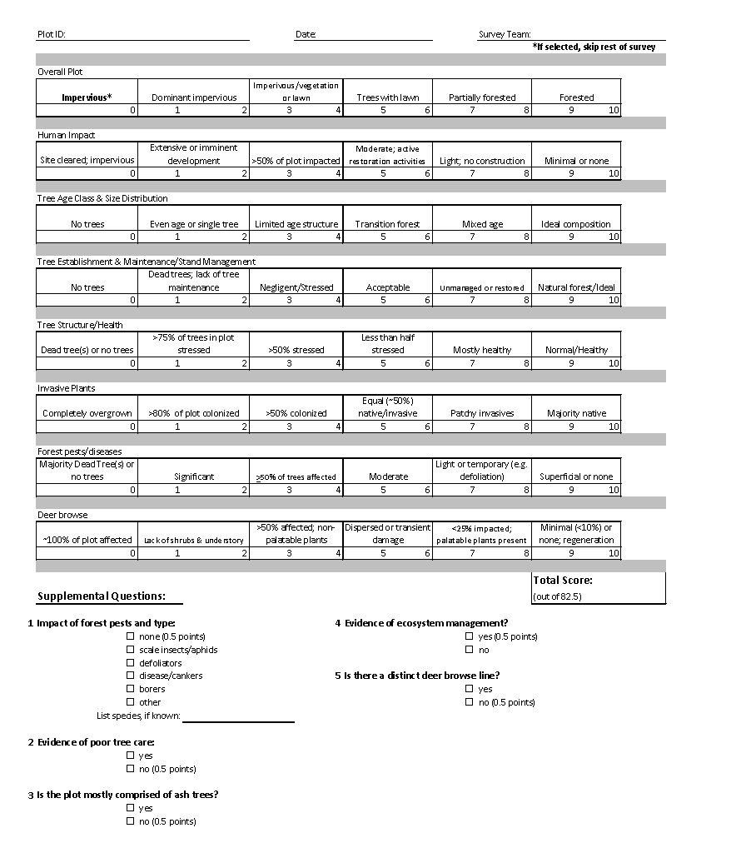
Figure S4. Fairfax plot health variable data sheet created by the Urban Forest Management Division of Fairfax County, VA. Scores from each section are totaled with a max score of 82.5 for each i-Tree Eco plot. A high score in each section is deemed as a higher quality forested stand, less impacted by urbanization.

