Additional file 1

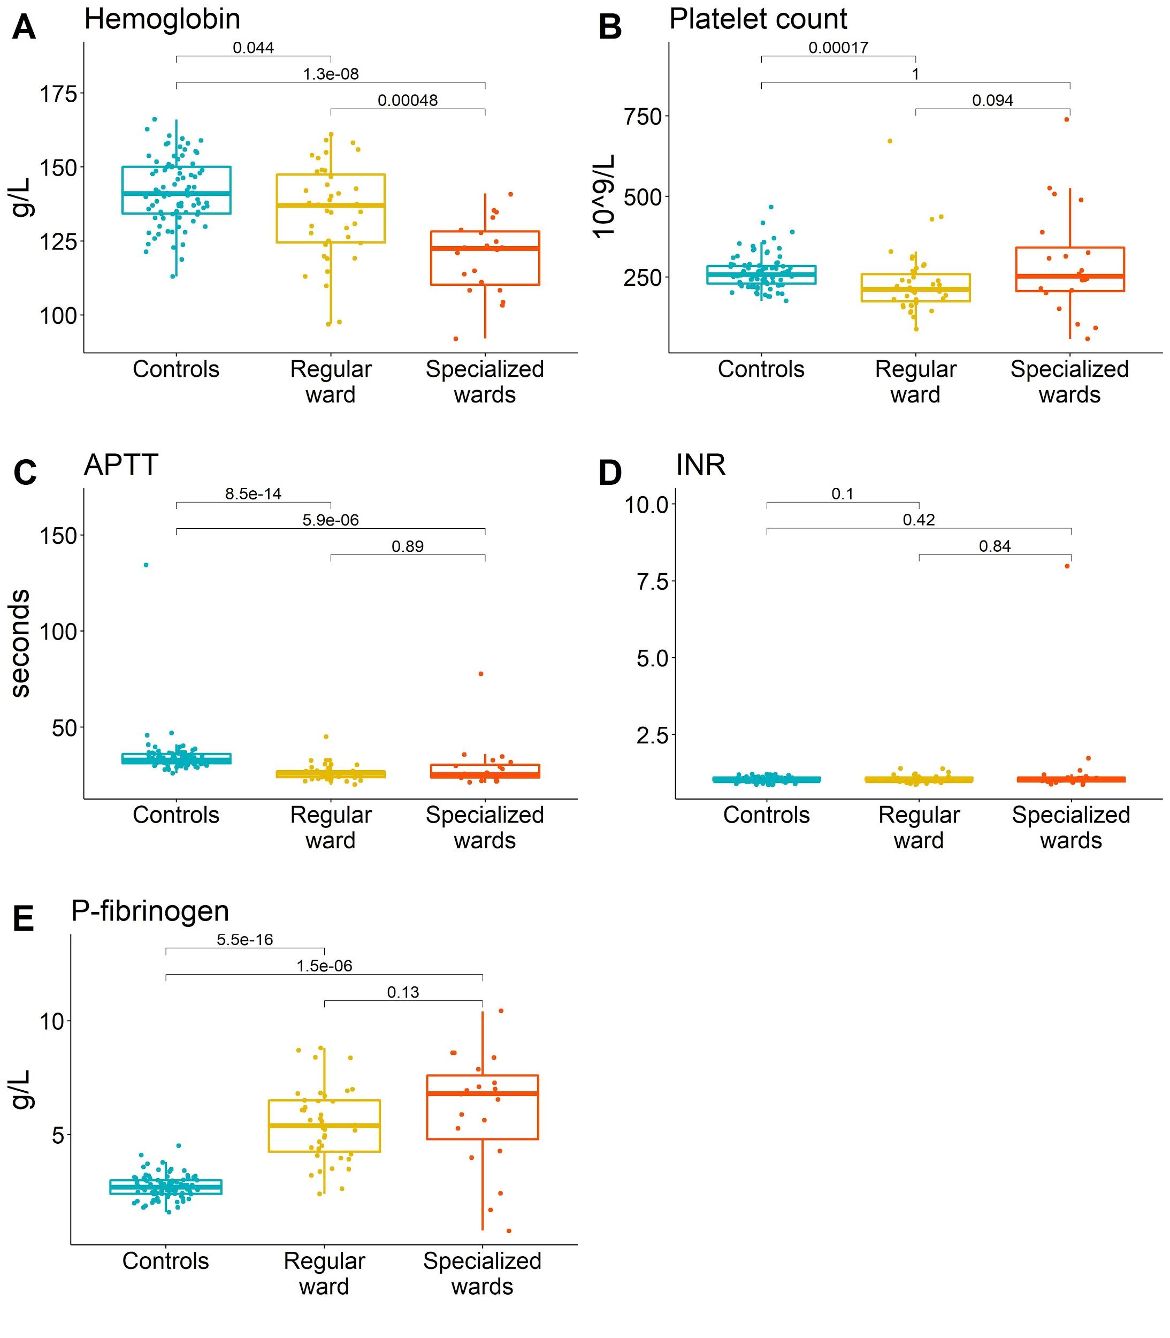

Figure AF1. Visualization of data for blood tests presented in table 2. P-values calculated using two-sided Wilcoxon signed rank test. In A) Hemoglobin; B) Platelet count; C) Activated Partial Thromboplastin Time; D) International Normalized Ratio; E) P-fibrinogen

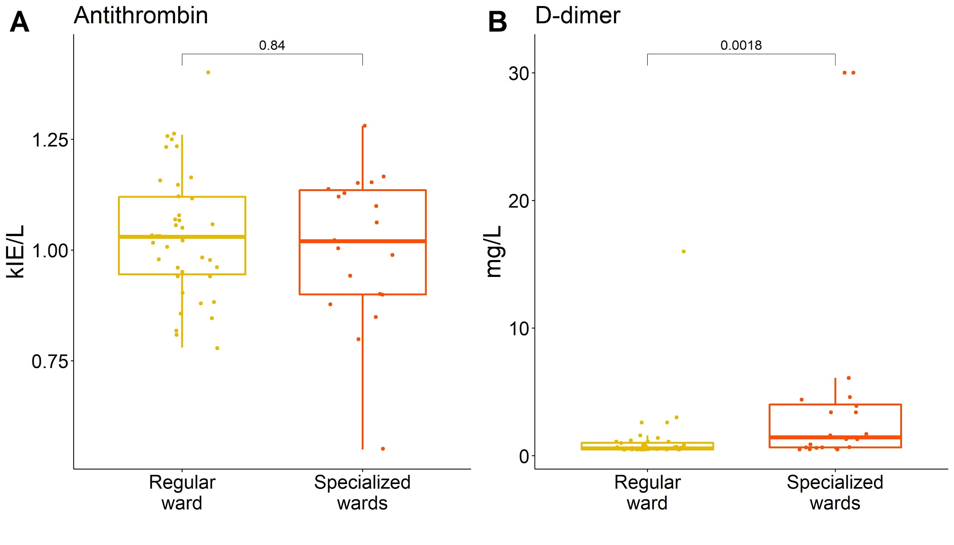

Figure AF2. Visualization of data for blood tests presented in Table 2. For tests presented in this figure no data from healthy controls were available. P-values calculated using two-sided Wilcoxon signed rank test. In A) Antithrombin; B) D-dimer

