Please find below the images and the annotation
This picture is a low power (4x lens, or 40 times magnification) micrograph showing a piece of skin tissue excised down to the depth of the dermis (left side is the epidermis/surface while the right side is the dermis). The black square indicates the abnormality. At this power you can see abnormal proliferation of vascular channels within the superficial dermis

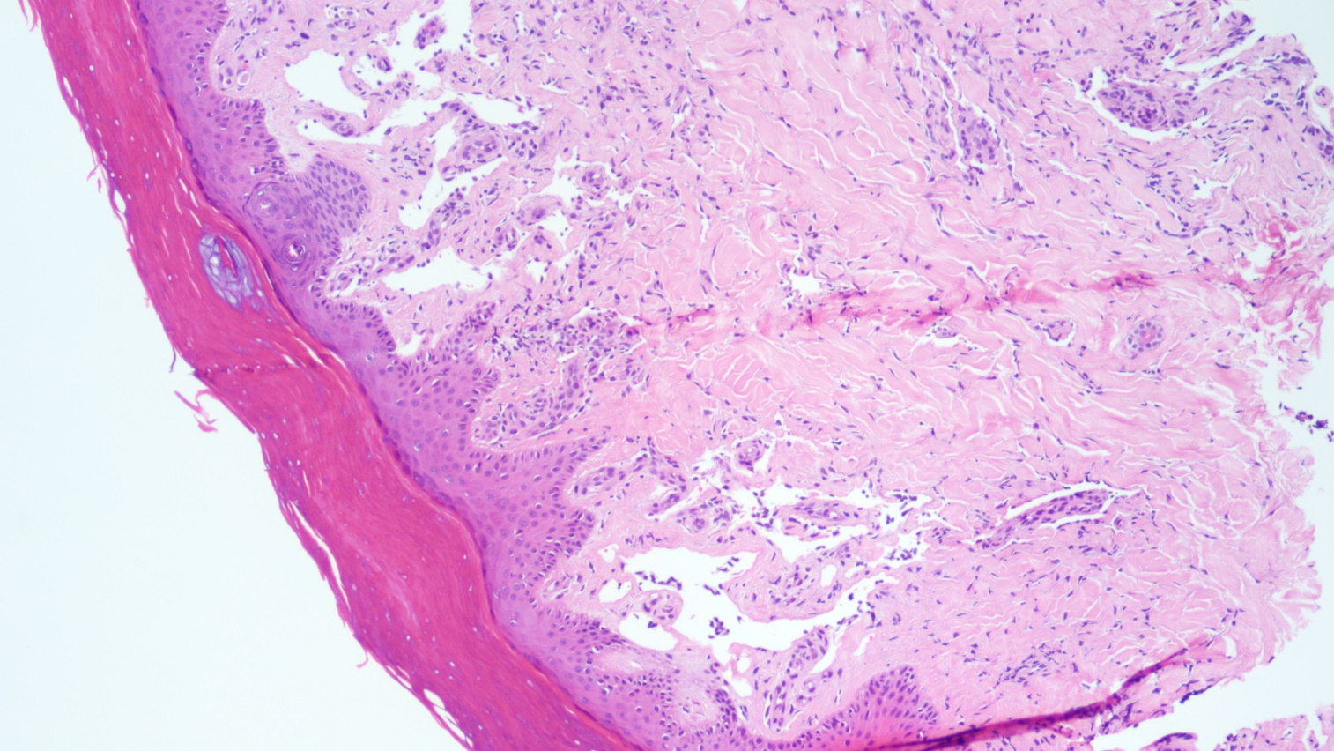
This is a magnified view (10x lens, or 100 times mag) photo of the above photo, again showing irregularly-shaped vascular channels which dissects into the dermal collagen (as indicated by the arrow)
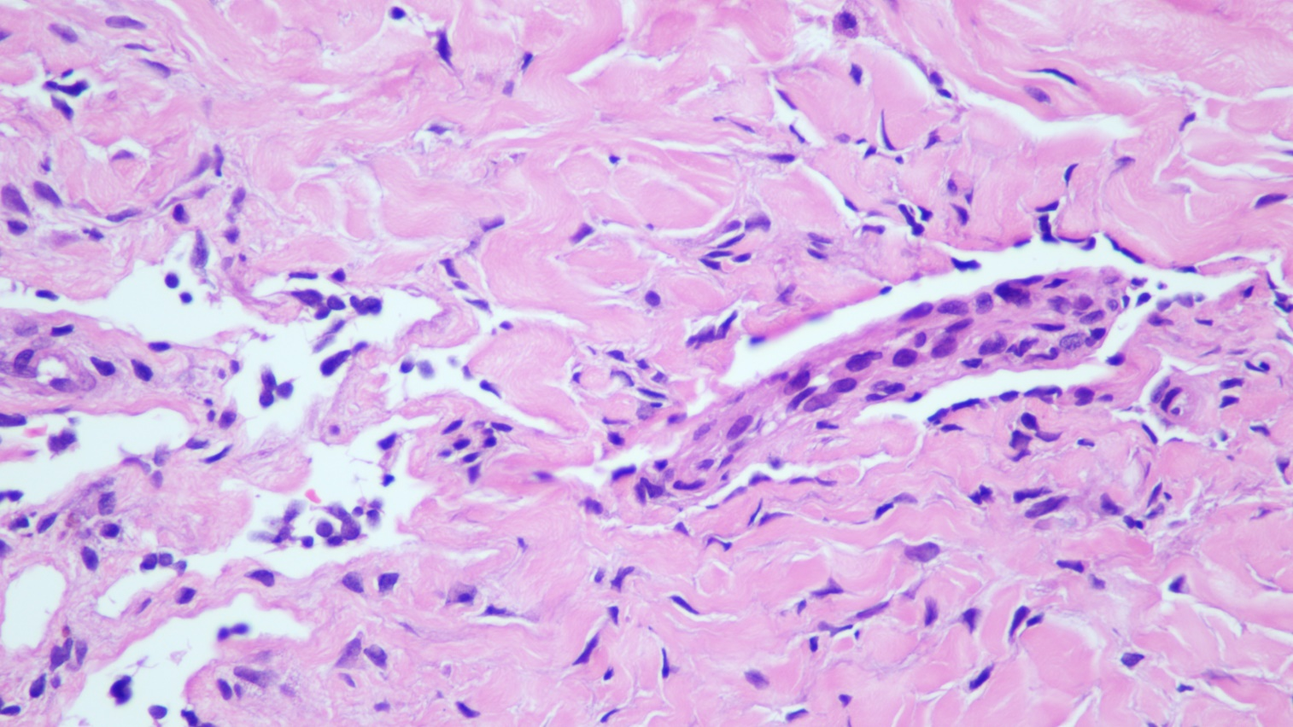
This is an even higher power of the previous photo (20x lens, 200 times mag). What I want to show here are two things, one is the endothelial cells lining these irregularly shaped vascular channels (as indicated by the black arrows) are atypical looking in that they have more hyperchromatic nuclei. Another thing I would like to illustrate is that there’s a very important sign called the promontory sign that is classic to Kaposi sarcoma, though rarely seen, in which the tumor vascular channels partly surround and entrap the native vessels (red arrow).

This is another field of the specimen received, again we can see these abnormal proliferation of vessels within the superficial dermis as indicated by the black square

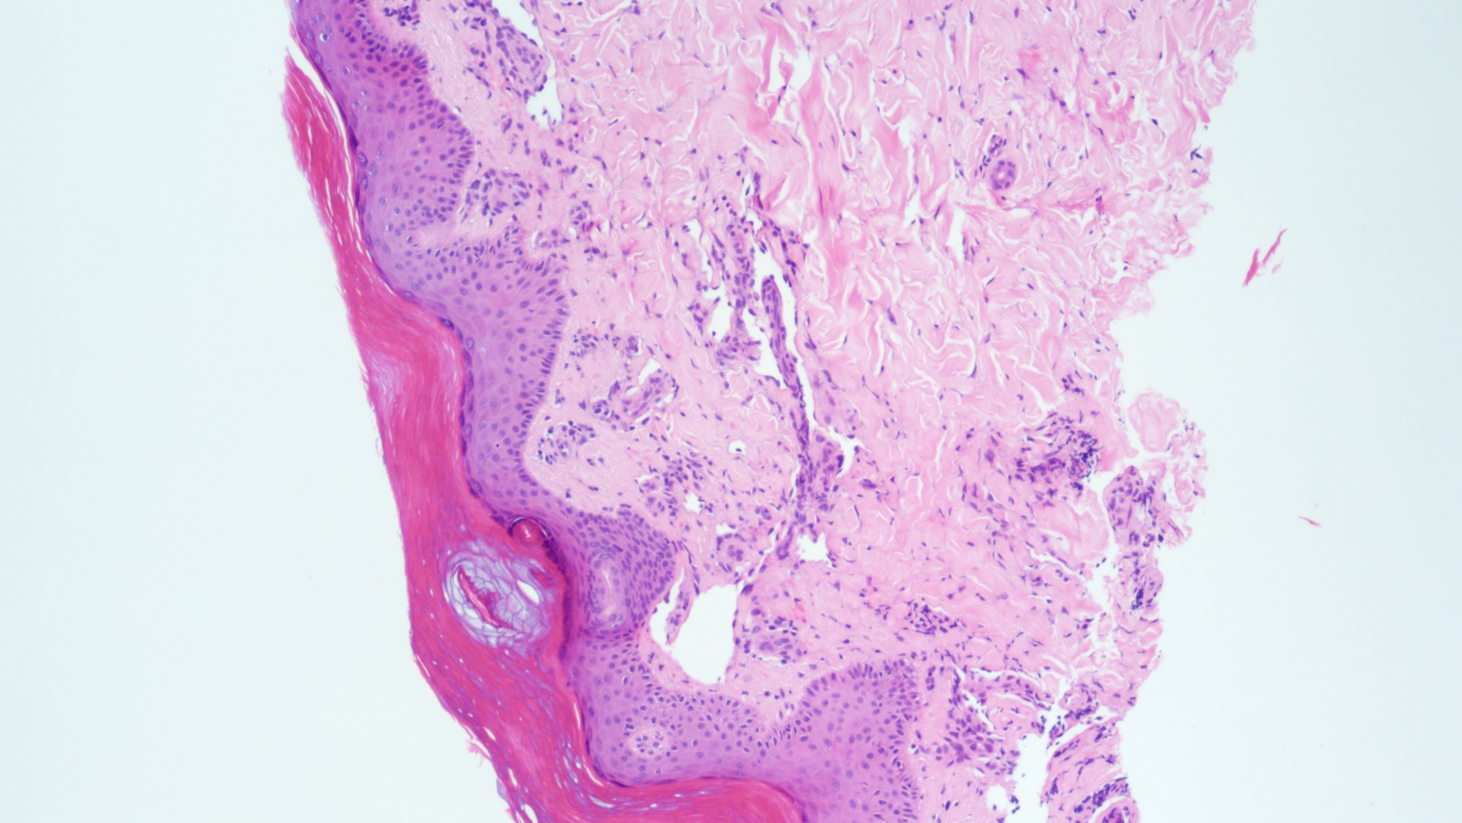
This again shows the promontory sign in which a native vessel is being trapped within the tumor vascular channel
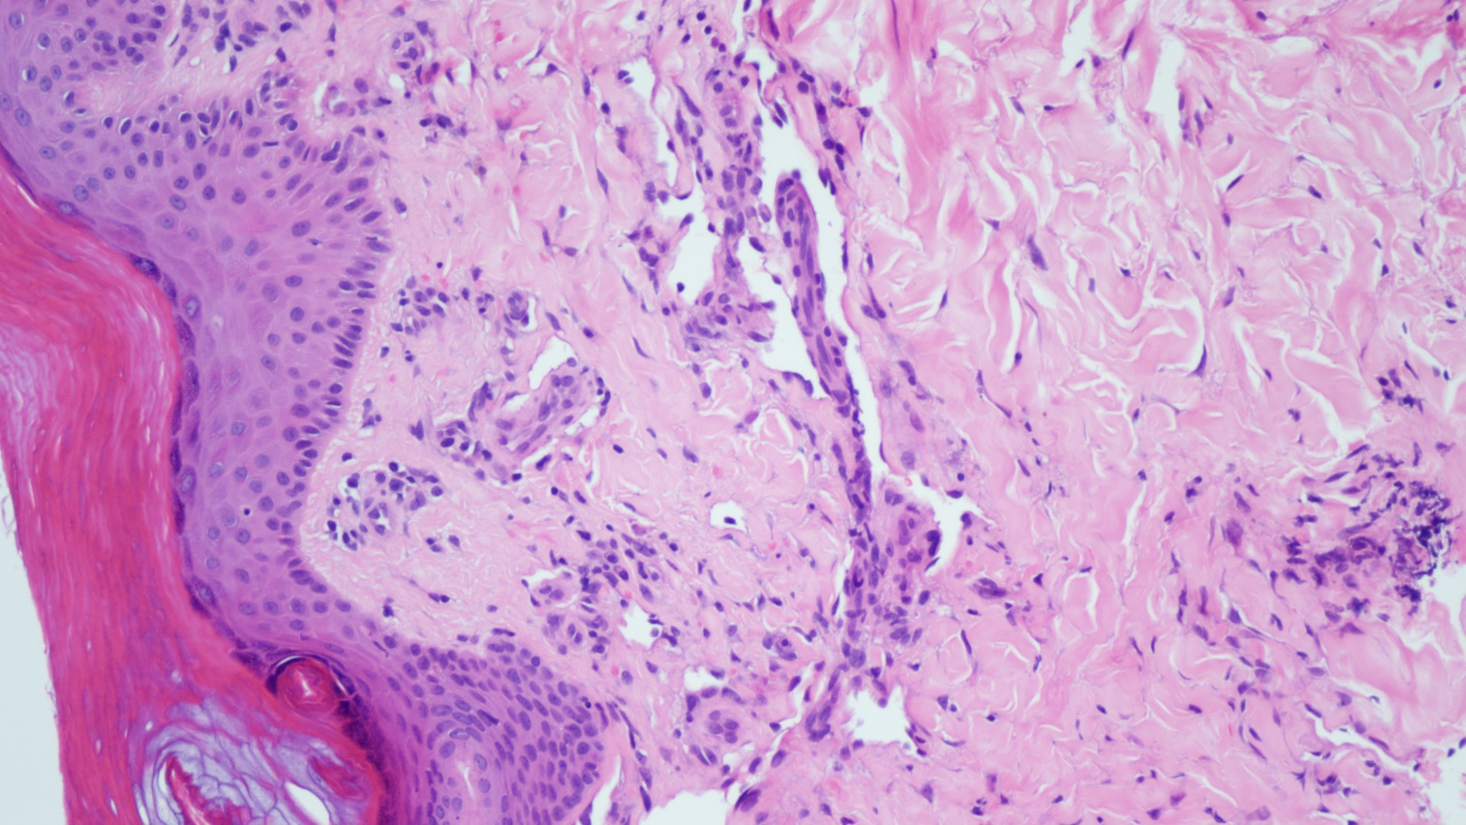
A higher power of the previous photo

This stain is the ERG, a vascular marker that can be used to highlight the endothelial cells. The neoplastic endothelial cells also get highlighted by ERG

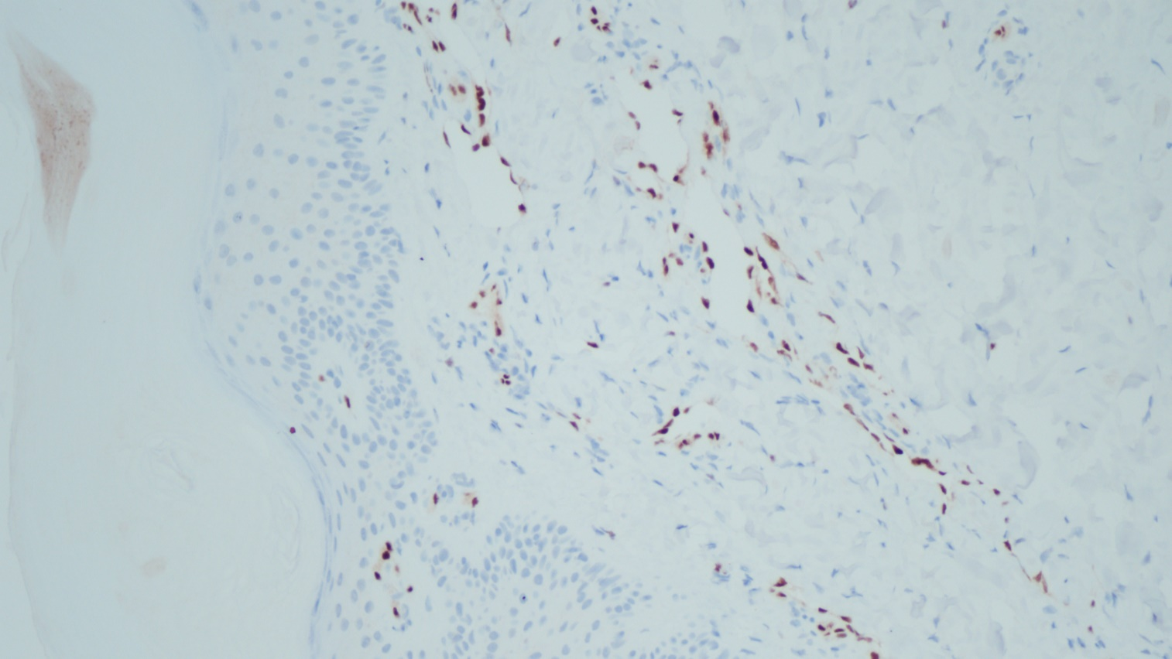
This is a magnified version of the previous field, showing ERG highlighting the neoplastic endothelial cells (you can see the cells surrounds a clear space, which is the lumen of the neoplastic vascular channel)

This is HHV-8 immunostain. We can see in this picture that the endothelial cells are positive for this stain, a phenomenon that can be observed in KS

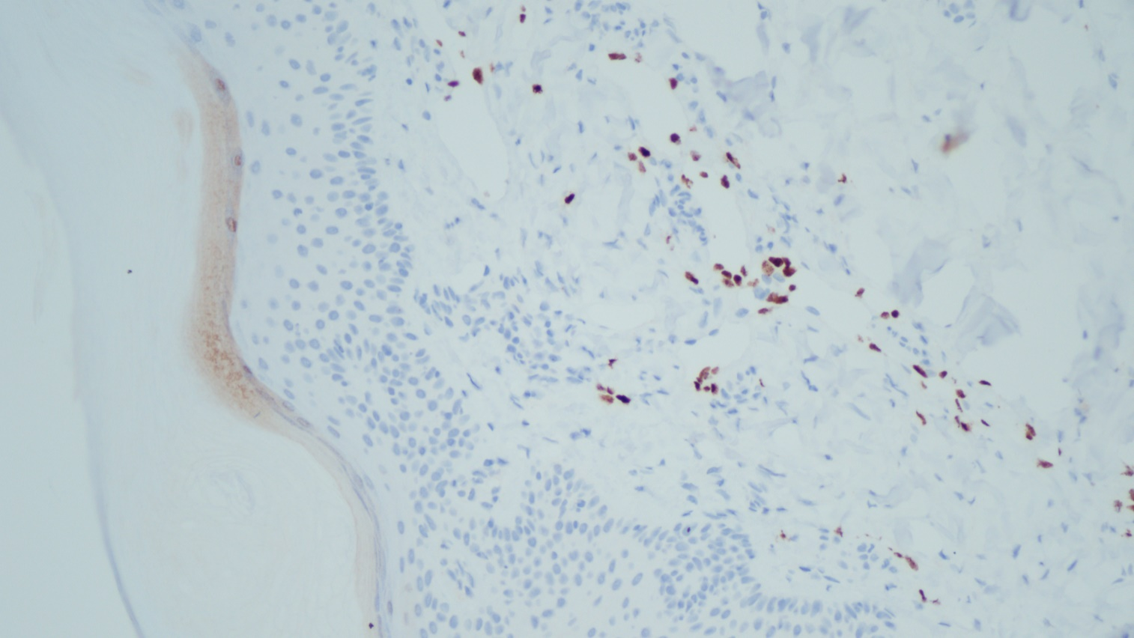
This is a magnified version of the pervious slide, again you can see the neoplastic vascular channels are stained positive for HHV-8

For the writeup:
A micrograph (100x magnification) showing the presence of irregularly-shaped ectatic vascular channels which dissect into dermal collagen (black arrow). Within some of these neoplastic vascular channels, there are entrapped native vessels (red arrow), a histologic feature known as promontory sign and is classic to Kaposi sarcoma.
A higher power (200x magnification) of these abnormal vascular channels (black arrow) and the promontory sign (red arrow).

HHV-8 immunostain highlights the endothelial cells lining the neoplastic vascular channels

