Supporting Information

XA-Novo: an accurate and high-throughput mass spectrometry-based de novo sequencing technology for monoclonal antibodies and antibody mixtures
Yueting Xiong^{1, #, *}, Wenbin Jiang^{1, #}, Jin Xiao^{1, #}, Qingfang Bu¹, Jingyi Wang¹, Zhenjian Jiang², Ling Luo¹, Xiaoqing Chen¹, Yijie Qiu¹, Yangtao Wu¹, Fan Liu¹, Rongshan Yu^{1,3, *}, Ningshao Xia^{1, *}, Quan Yuan^{1, *}
- National Institute for Data Science in Health and Medicine, State Key Laboratory of Vaccines for Infectious Diseases, Xiang An Biomedicine Laboratory, School of Public Health, School of Informatics, Xiamen University, Fujian, 361102, China.
- Department of Pathology, Zhongshan Hospital, Fudan University (Xiamen Branch), Fujian, 361015, China.
- Aginome Scientific, Xiamen, Fujian, 361005, China.

*: To whom correspondence should be addressed. E-mail: ytxiong@xmu.edu.cn, rsyu@xmu.edu.cn, nsxia@xmu.edu.cn, yuanquan@xmu.edu.cn
Fax: +86 0592-2881160; Phone: +86 0592-2881160

Table of content
Supplemental Methods 3
Chemicals and reagents 3
Cell culture and collection 3
Protein purification 3
Desalted by Sep-Pak C18 column 4
Sample preparation based on EasyPept-Micro Kit 4
De Novo LC–MS/MS analysis 4
Verification of molecular weights for light and heavy chains 5
LC-MS analysis of intact light and heavy chains 5
Data analysis 5
Quality control of de novo LC-MS/MS 6
Supplemental Figures 7
Supplemental Tables 17
Table S1. The mean depth of coverage in the CDRs, variable domain, and overall chain for COVID-19 neutralizing antibodies. 17
Table S2. The mean depth of coverage in the CDRs, variable domain, and overall chain for commercial therapeutic antibodies. 17
Table S3. Summary of Intact Mass Analysis. 18
Table S4. The sequence information of COVID-19 neutralizing antibody datasets. 20
Table S5. The sequence information of monoclonal antibody mixture datasets. 20

Supplemental Methods

Chemicals and reagents
Guanidine Hydrochloride (Gu.HCl) and iodoacetamide (IAA) were purchased from Sigma-Aldrich (St. Louis, MO, USA). Dithiothreitol (DTT) was purchased from Inalco (Inalco, USA). Chromatographic-grade trypsin, chymotrypsin, elastase, pepsin, and Asp-N were purchased from Promega (Madison, WI, USA). Sep-Pak C18 Cartridges were purchased from Waters (WAT043345). Acetonitrile (ACN, MS grade), trifluoroacetic acid (TFA, MS grade), formic acid (FA, MS grade), tris-(2-carboxyethyl)-phosphine (TCEP), and Protein Quantification Kit were purchased from Thermo Scientific (St. Louis, MO, USA). Culture media such as Dulbecco's Modified Eagle's Medium (DMEM), penicillin/streptomycin (P/S), fetal bovine serum (FBS), and trypsin-EDTA were from Gibco Life Technologies (New York, USA). Deionized water used in the experiments was prepared by the Milli-Q50SP system (Millipore, Milford, MA).

Cell culture and collection
The human cervical cancer cell line HeLa (CCL-2, ATCC, USA) was cultured at 37°C and 5% CO₂ in DMEM with 10% FBS and 1% penicillin/streptomycin. The culture medium was refreshed every 2-3 days. Cells were harvested at >80% confluency following treatment with 0.25% trypsin-EDTA solution to obtain a cell suspension. Subsequently, the cells were dispersed in a growth medium, and the cell density was measured using an automated cell counter (Cellometer AutoT4, Nexcelom, USA). Afterward, the defined number of cells was washed three times with ice-cold PBS and centrifuged at 1,000 g for 10 min at 4°C. Approximately 5 × 10⁵ cells were then placed into a 1.5 mL protein LoBind tube (Eppendorf, cat. no. 0030108116) and stored at −80°C for future analysis. ExpiCHO-S™ Cells (Thermo Fisher Cat# A29133) were cultured in the ExpiCHO™ Expression System (Thermo Fisher Cat# A29133) at 37°C with 8% CO₂ on an orbital shaker platform. When their density reached 4E6 to 6E6 cells/mL, ExpiCHO-S™ cells were subcultured to a density of 0.3E6 to 0.5E6 cells/mL. The culture medium was refreshed every 3-4 days.

Protein purification
The sequences of the S2P6, SA55, and SA58 used for analysis were obtained directly from published scientific literature. ExpiCHO-S™ cells were transfected using the ExpiFectamine™ CHO Transfection Kit (Thermo Fisher Cat#A29129) following the manufacturer’s recommended protocol. Recombinant proteins with an Fc tag at the N-terminus were then expressed in ExpiCHO-S Cells. The Fc-tag proteins were purified from culture supernatants collected on day 7 after transfection using a Protein A column (Cytiva). The protein was eluted from the column with 70 mM citric acid monohydrate and 20 mM sodium phosphate dibasic dodecahydrate. The eluted fractions were pooled and concentrated using Protein Quantification Kit.

Desalted by Sep-Pak C18 column
1) Place the Sep-Pak C18 column into the waste tube.
2) Wet the column by adding 400 μL of 100% ACN and allow for natural liquid drainage due to gravity.
3) Equilibrate the column by adding 600 μL of 0.1% TFA and allow for natural liquid drainage due to gravity.
4) Add the digested sample to the column and harness gravity for natural liquid drainage.
5) Wash the column by adding 600 μL of 0.1% TFA and allow for natural liquid drainage due to gravity.
6) Transfer the C18 column to the recovery tube. Elute the sample by adding 400 μL of 0.1% TFA in 50% ACN and harness gravity for natural liquid drainage.
7) Then lyophilize to dryness, and store at −20°C or redissolve in 0.1% formic acid (FA) for nano-LC−MS/MS analysis.

Sample preparation based on EasyPept-Micro Kit
EasyPept-Micro Kit sample preparation was conducted following the standard protocol. In brief, a solution was prepared by combining 192 μL of Reagent A with 12 μL of Reagent B. Subsequently, a 200 μg antibody sample was diluted to a final concentration of 1 μg/μL using the AB mixture. This solution was then evenly divided into eight aliquots. Each aliquot was mixed with 1.25 μg of one of the following enzymes: trypsin-kit, trypsin, chymotrypsin, elastase, pepsin, or Asp-N—along with 1 μL of Reagent C to aid mixing and reaction. The enzymatic digestion was carried out at 37°C for 30 min. The supernatant was desalted using Pierce™ C18 Spin Tips Columns (Thermo Fisher Cat#A84850), lyophilized to dryness, and stored at −20°C or redissolved in 0.1% FA for nano-LC−MS/MS analysis.

De Novo LC–MS/MS analysis
The digested peptides were separated using reversed phase chromatography on a Vanquish™ Neo UHPLC (equipped with a column packed with PepMap™ 100 C18, 75 μm×50 cm, 2 μm, Thermo Fisher Scientific, USA) coupled to an Orbitrap Eclipse mass spectrometer. Peptides were eluted over a 70 min gradient from 0 to 35% solvent B (0.1% FA in 80% ACN) at a flow rate of 300 nL/min. Solvent A consisted of 0.1% FA in water. Peptides were acquired in data-dependent acquisition mode (DDA). Full MS1 scans were acquired over the m/z range of 350−2,000 with a resolution of 120,000. MS1 scans utilized standard automatic gain control (AGC) target settings, a maximum injection time of 100 ms, and a microscan value of 1. Top speed mode was employed to select the most intense peaks with charge states of 2−8 for fragmentation. The FAMIS voltage was set to -45 V. Parent ions were selected for secondary fragmentation using the Top Speed mode during each cycle, with a cycle time of 1.5 seconds. The dynamic exclusion time was set to 30 seconds. The precursors underwent fragmented by stepped high-energy collision dissociation (HCD) as well as electron-transfer high-energy collision dissociation (EThcD). The stepped HCD fragmentation involved steps at normalized collision energies (NCE) levels of 27, 35, and 40%. EThcD fragmentation was performed using calibrated charge-dependent electron-transfer dissociation (ETD) parameters and supplemental activation at NCE level of 30%. For both types of fragmentation, MS2 scans were acquired at a 30,000 resolution, a 5E4, AGC target, a 250 ms maximum injection time, and a scan range of the first mass method (100 m/z).

Verification of molecular weights for light and heavy chains
One hundred micrograms of each antibody were dissolved in 95 µL sterile water to achieve a final antibody concentration of up to 1 µg/µL. The antibody mixture was then treated with 50 mM DTT for 45 min at 57°C with shaking at a speed of 950 rpm, followed by ultrafiltration with 500 µL of sterile water at 14,000 g for 10 min. Subsequently, the mixture was subjected to treatment with 2 µL PNGase F (Promega, USA) at 37°C for over 16 h with stirring before being ultra-filtered and transferred to a new vial with the sample concentration around 0.5 µg/µL for LC-MS analysis.

LC-MS analysis of intact light and heavy chains
Intact LCs and HCs were analyzed using an Orbitrap Eclipse mass spectrometer (Thermo Fisher Scientific, USA) coupled to a Vanquish™ Flex UHPLC (Thermo Fisher Scientific, USA). Solvent A was 0.1% FA in water, while solvent B was 0.1% FA in 80% acetonitrile. Peptides were eluted through the analytical column (MAbPacTM RP, 4 μm, 2.1 x 50 mm) at a flow rate of 0.25 mL/min over a 20 min gradient as follows: 0−1 min, 25% B; 1−13 min, 25−32% B; 13−14 min, 32−80% B; 14−16 min, 80% B; 16-16.5min, 80-25% B; and 16.5-20 min, 25% B. The column temperature was set at 80℃.

Data analysis
For the bottom-up analysis, the raw data were searched with PEAKS AB (v.3.0). The mass tolerance in MS was set to 10.0 ppm for the precursor, and the fragment ion mass tolerance to 0.02 Da. Carbamidomethylation of cysteine was considered a fixed modification, while oxidation, deamidation, and pyro-glu from Q were set as variable modifications. For quality control analysis, the raw data of HeLa cell samples were searched with Proteome Discoverer (v.3.1) against the human Swiss-Prot database (20,184 entries), using trypsin as a specific enzyme with a maximum of 4 miss cleavages. The sequence coverage of antibodies was analyzed and intact mass spectra were processed and deconvoluted using BioPharma Finder 5.2 software (Thermo Fisher Scientific, USA), subsequently enabling the comparison of mass information for light and heavy chains. The alignment of antibody sequence information was performed quickly using TBtools-Ⅱ software.
For data visualization, dot plots or bar graphs were constructed using GraphPad Prism 10 software. The graphic and the schematic illustration of the SP-MEGD method were created with BioRender (https://www.biorender.com/). Statistical significance was gauged using the Student’s t-test in GraphPad Prism 10 software. P < 0.05 was considered significant.

Quality control of de novo LC-MS/MS
To assess quantitative precision in our study, we set HeLa samples (quality control, QC) uniformly inserted throughout the experiment to evaluate instrument status and method robustness. Ten HeLa samples were treated in parallel and similar quantifications were obtained, with an average of 8,746 protein groups and 10,627 peptides (Fig. S1a-b).

Supplemental Figures
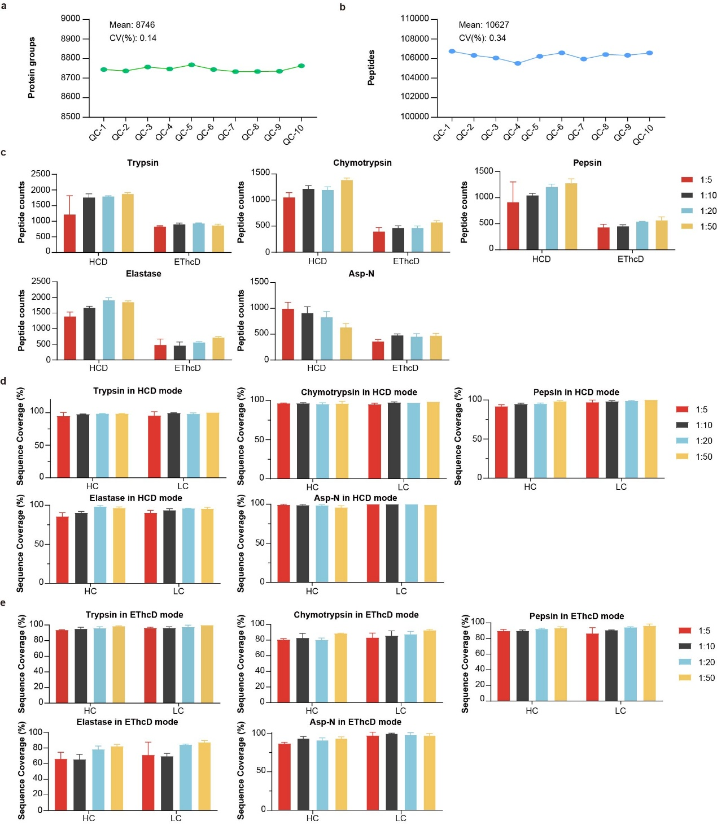
Fig. S1. Data quality evaluation and quantitative statistics of SP-MEGD method.
a. The number of protein groups identified in ten QC samples, with an average identification count of 8,746 and a coefficient of variation of 0.14%. b. The number of peptides identified in QC samples, with an average identification count of 10,627 and a coefficient of variation of 0.34%. c. The peptide identification amounts under different digestion ratios of five enzymes, including 1:5, 1:10, 1:20, and 1:50. The types of enzymes employed in these digestions were trypsin, chymotrypsin, pepsin, elastase, and Asp-N. d. Sequence coverage of S2P6 heavy chain and light chain determined by various sample-to-enyzme digestion ratios in HCD mode, including 1:5, 1:10, 1:20, and 1:50. e. Sequence coverage of S2P6 heavy chain and light chain determined by various sample-to-enzyme digestion ratios in EThcD mode, including 1:5, 1:10, 1:20, and 1:50.

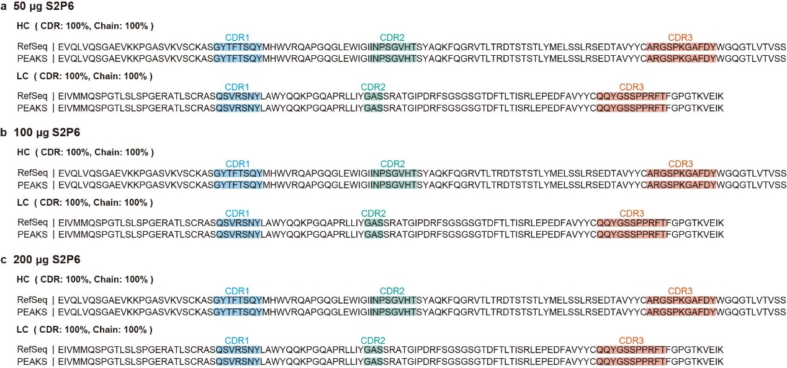
Fig. S2. The assembly results of PEAKS AB for the S2P6 antibodies with quantities ranging from 50 µg to 200 µg.
a-c. The S2P6 antibody, including its CDR regions, exhibited 100% sequence coverage across a range of quantities from 50 µg to 200 µg.

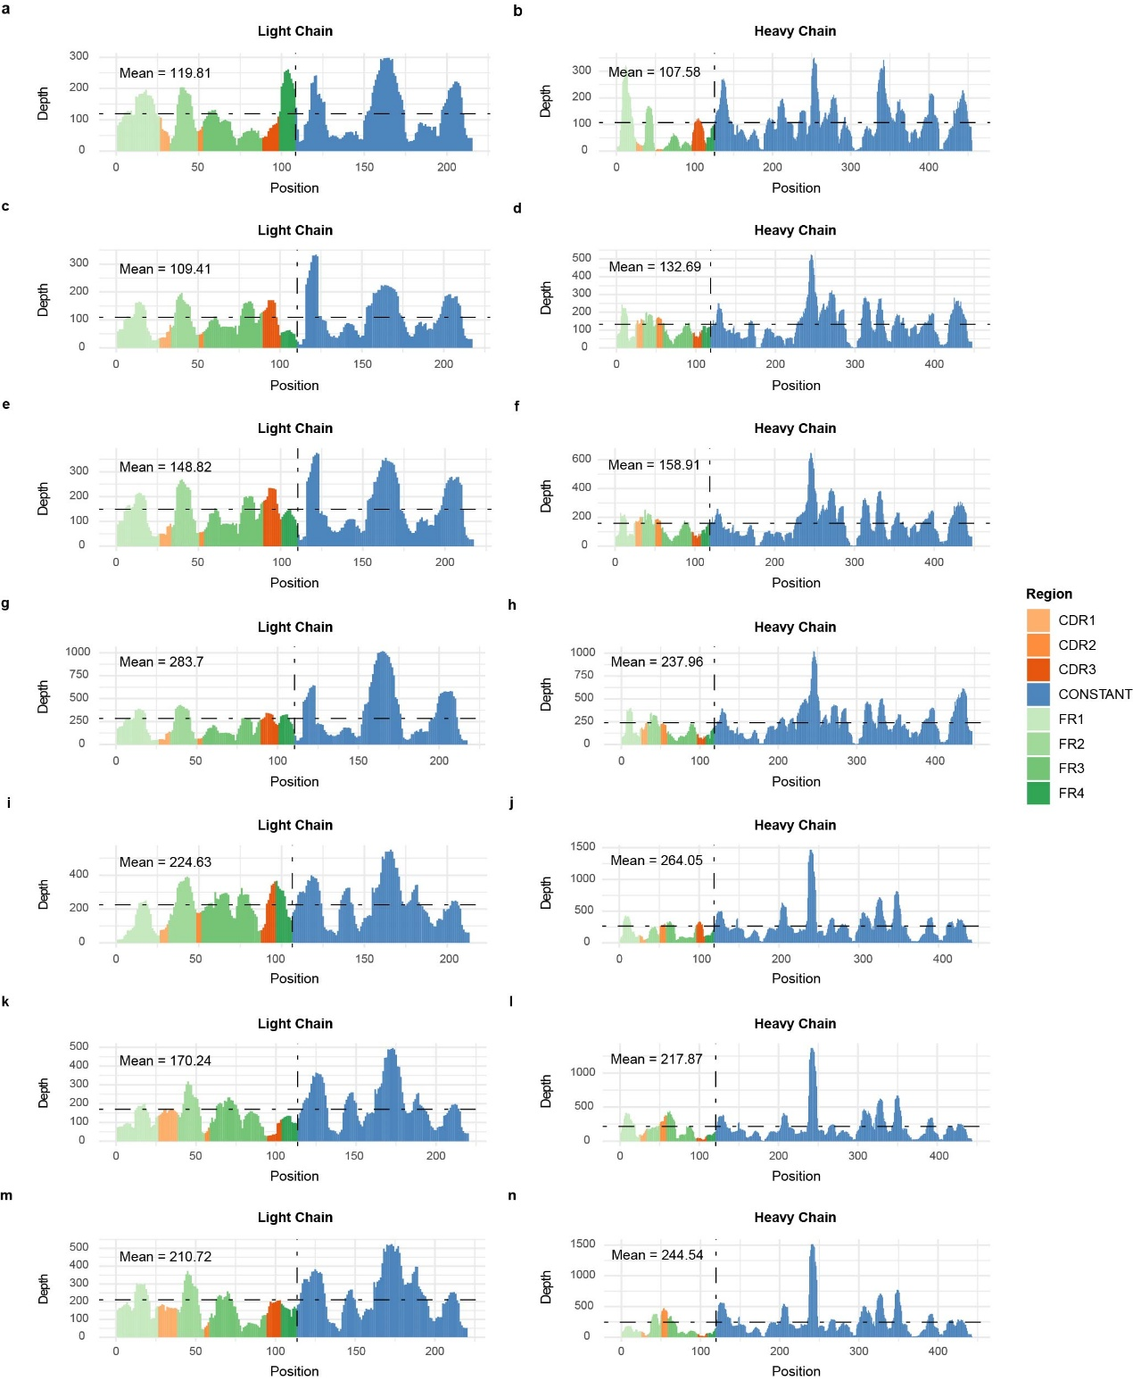
Fig. S3. Coverage and depth analysis of light and heavy chains in COVID-19 neutralizing antibodies.
a-b. SA55 antibody, c-d. 50 µg S2P6 antibody, e-f. 100 µg S2P6 antibody, g-h. 200 µg S2P6 antibody, i-j. 85F7 antibody, k-l. 36H6 antibody, m-n. 2B4 antibody.

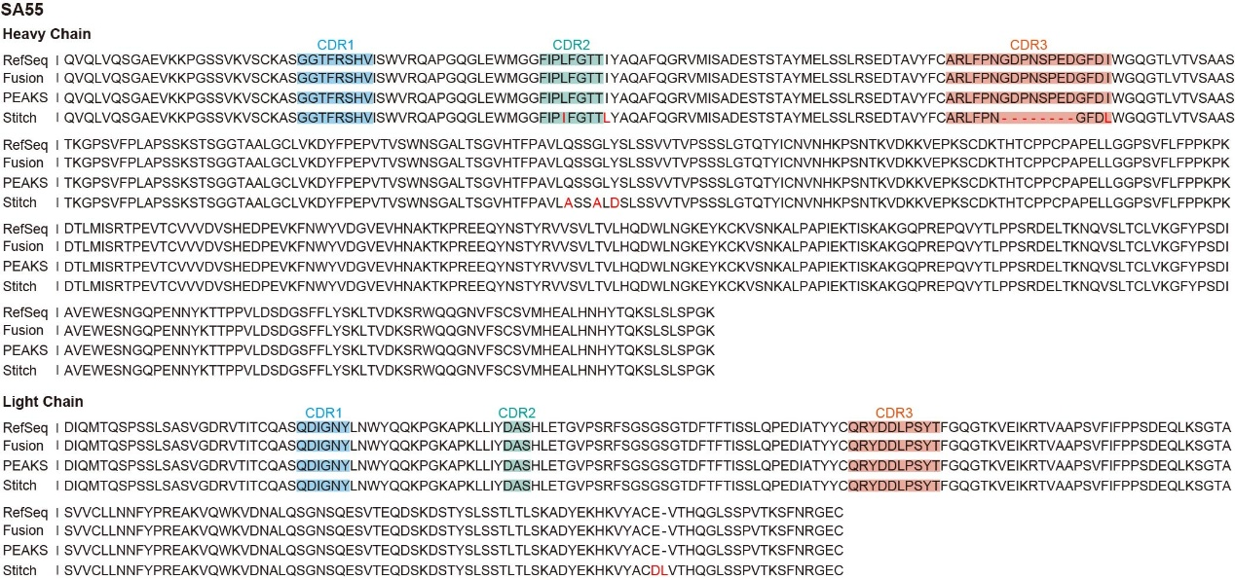
Fig S4. The comparison of the alignment of the SA55 antibody across the Fusion, PEAKS AB, and Stitch algorithms.
Sequence alignment of the output sequences with CDRs annotated and sequence conflicts highlighted by red.
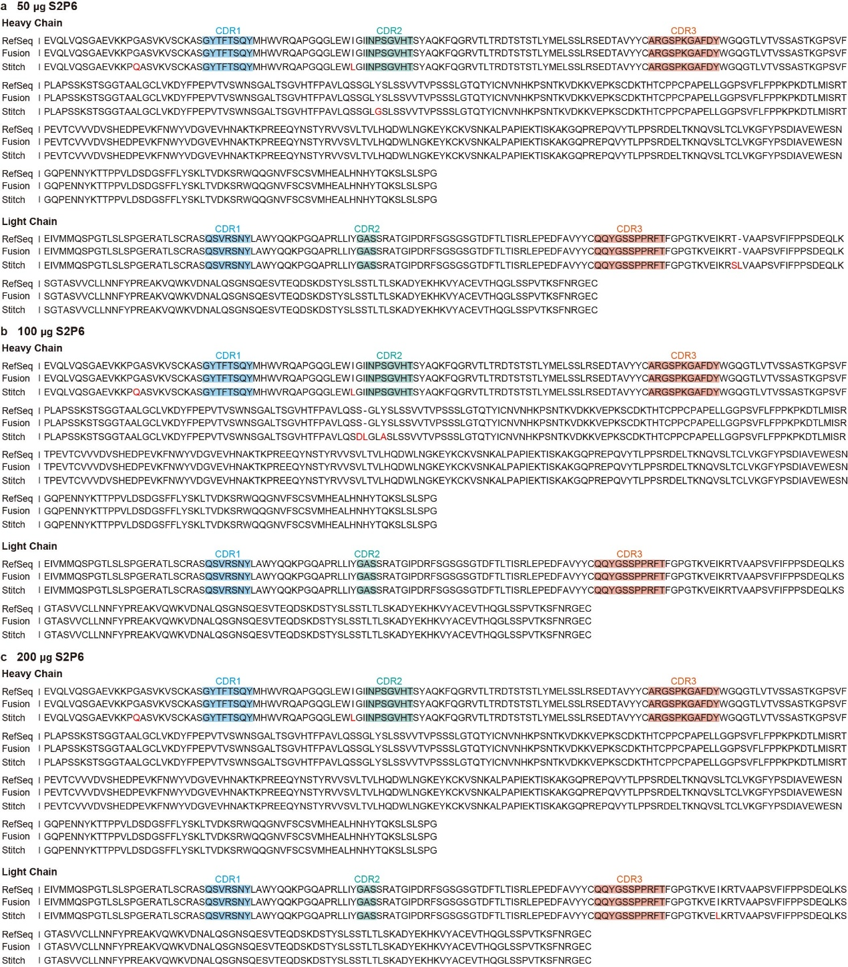
Fig. S5. The comparison of the alignment of the S2P6 antibody across the Fusion, PEAKS AB, and Stitch algorithms.
The S2P6 antibodies with quantities ranging from 50 µg to 200 µg: a. 50 µg S2P6. b. 100 µg S2P6. c. 200 µg S2P6.
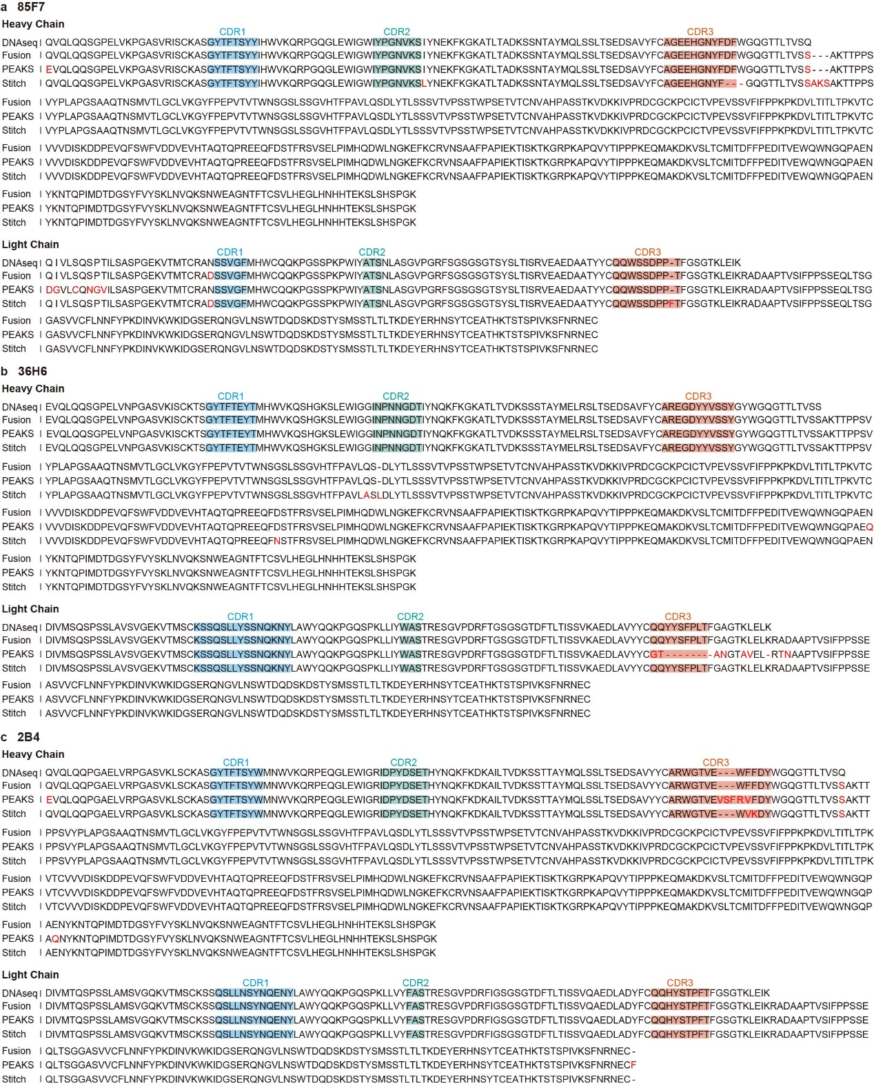
Fig. S6. The comparison of the alignment of the murine COVID-19 neutralizing antibodies across the Fusion, PEAKS AB, and Stitch algorithms.
a. 85F7. b. 36H6. c. 2B4.

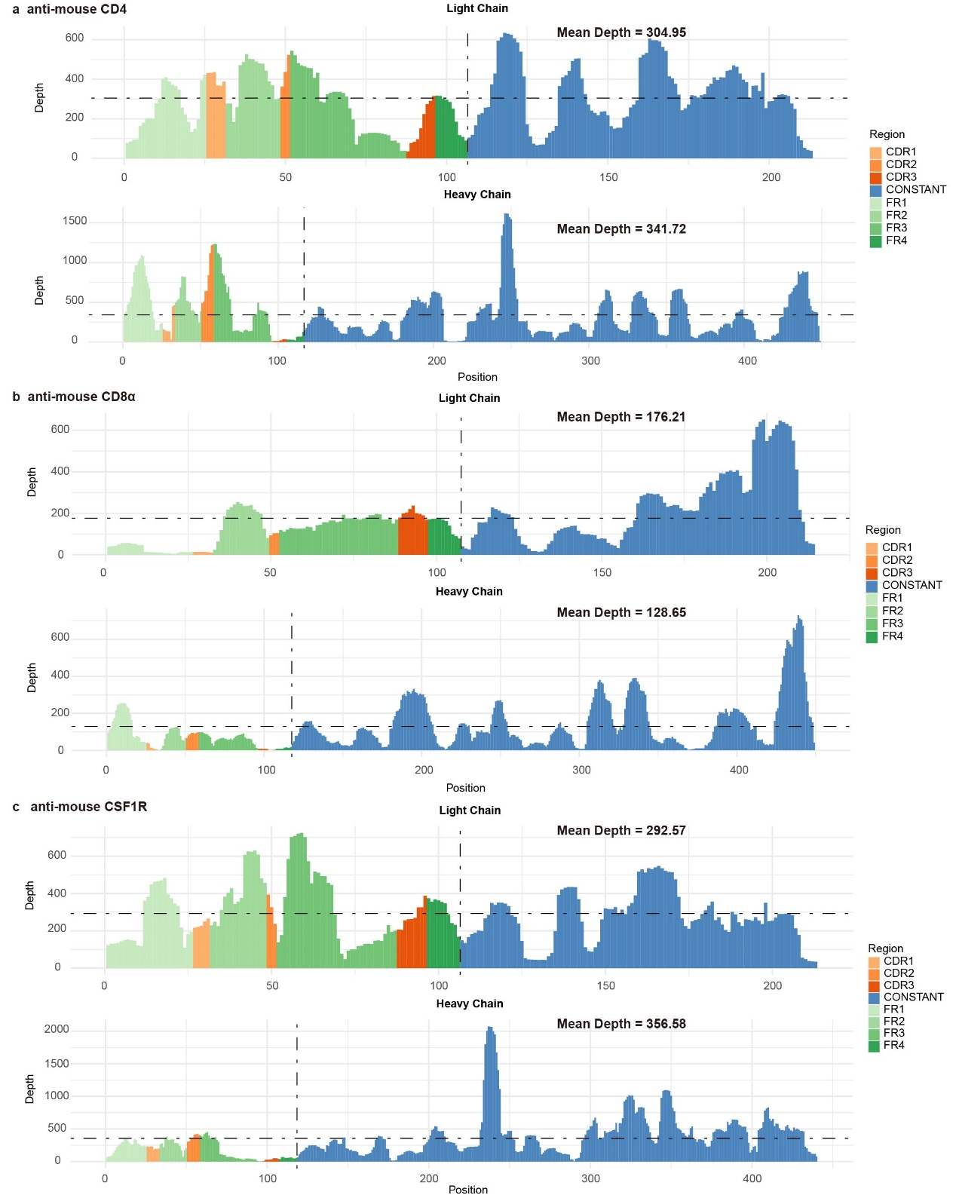
Fig. S7. Coverage and depth analysis of light and heavy chains in three commercial immunotherapeutic monoclonal antibodies.
a. anti-mouse CD4 antibody. b. anti-mouse CD8α antibody. c. anti-mouse CSF1R antibody.

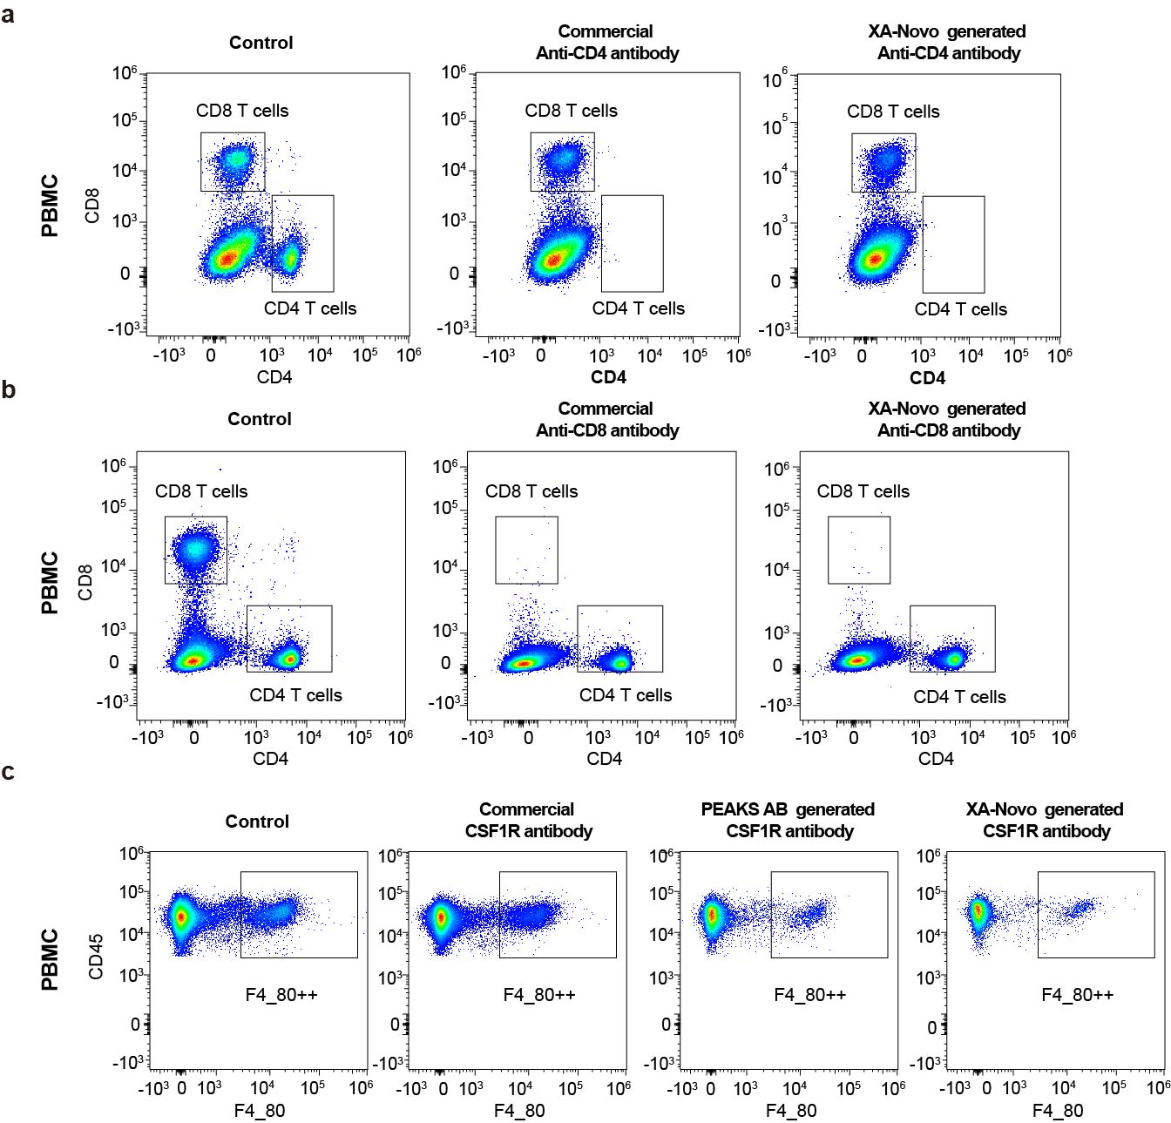
Fig. S8. The biological validation of three recombinant commercial antibodies in blood.
a. anti-mouse CD4 antibody. b. anti-mouse CD8α antibody. c. anti-mouse CSF1R antibody.
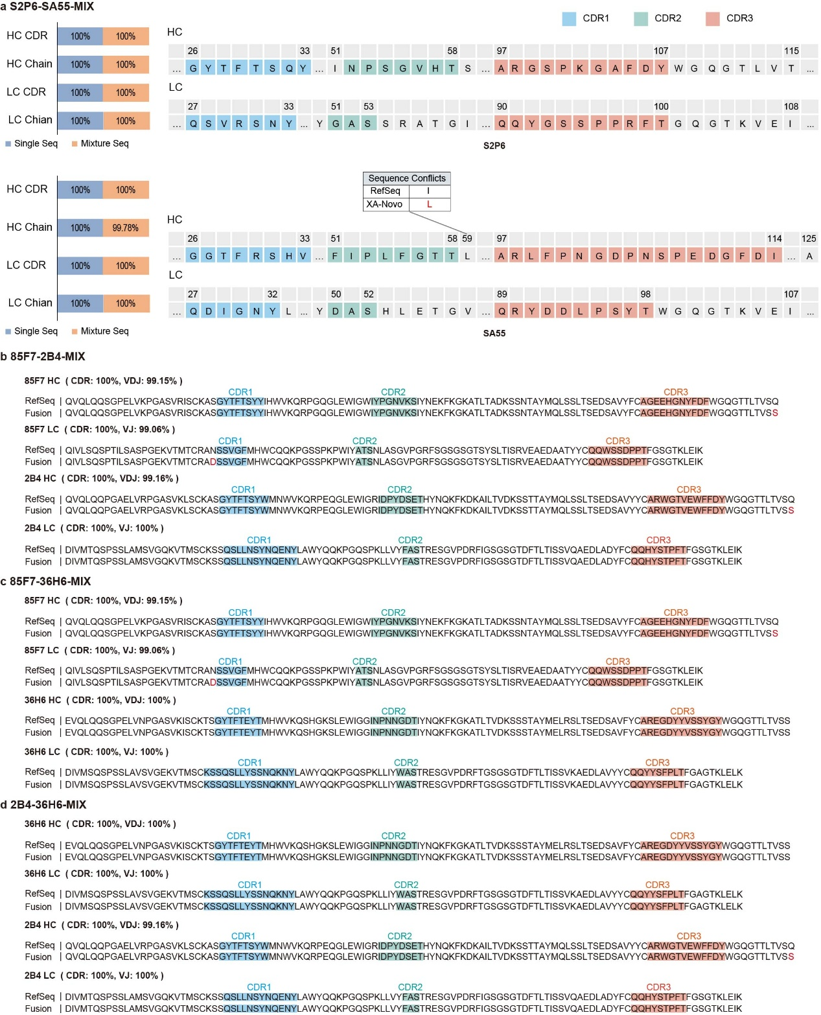
Fig. S9. The application of XA-Novo to the mixture containing two humanized or murine COVID-19 neutralizing antibodies.
The experiment-determined light and heavy chain sequences of an equal mixture of two monoclonal antibodies, were compared to the known sequences with CDRs annotated and sequence conflicts highlighted by red. a. S2P6 and SA55. b. 85F7 and 2B4. c. 85F7 and 36H6. d. 2B4 and 36H6.

Supplemental Tables

Table S1. The mean depth of coverage in the CDRs, variable domain, and overall chain for COVID-19 neutralizing antibodies.
Antibody | Chain | CDR | V-region | Overall chain
SA55 | LC | 70.32 | 114.81 | 119.81
SA55 | HC | 56.12 | 76.67 | 107.58
50 µg S2P6 | LC | 94.29 | 97.97 | 109.41
50 µg S2P6 | HC | 122.59 | 115.93 | 132.69
100 µg S2P6 | LC | 131.29 | 136.29 | 148.82
100 µg S2P6 | HC | 137.74 | 131.81 | 158.91
200 µg S2P6 | LC | 190.86 | 216.49 | 283.70
200 µg S2P6 | HC | 154.33 | 168.44 | 237.96
85F7 | LC | 180.35 | 206.08 | 224.63
85F7 | HC | 212.44 | 187.01 | 264.05
36H6 | LC | 107.58 | 139.29 | 170.24
36H6 | HC | 139.00 | 185.79 | 217.87
2B4 | LC | 164.25 | 175.03 | 210.72
2B4 | HC | 156.36 | 155.79 | 244.54

Table S2. The mean depth of coverage in the CDRs, variable domain, and overall chain for commercial therapeutic antibodies.
Antibody | Chain | CDR | V-region | Overall chain
anti-CD4 | LC | 294.28 | 279.58 | 304.95
anti-CD4 | HC | 340.52 | 425.94 | 341.72
anti-CD8α | LC | 120.56 | 122.01 | 176.21
anti-CD8α | HC | 33.69 | 73.31 | 128.65
anti-CSF1R | LC | 272.65 | 314.19 | 292.57
anti-CSF1R | HC | 187.63 | 188.28 | 356.58

Table S3. Summary of Intact Mass Analysis.
Name | Algorithm | Δ (M - C mass) (Da) | Measured mass (Da) | Calculated mass (Da) | DSB | K-loss | Pyro-Glu
anti-CD4 HC 1 | PEAKS AB | 40.78 | 49,238.11 | 49,197.33 | -10.10 | -128.17 | NA
anti-CD4 HC 2 | Fusion | 2.78 | 49,238.11 | 49,235.33 | -8.08 | -128.17 | NA
anti-CD4 LC 1 | PEAKS AB | -0.32 | 23,297.35 | 23,297.67 | -4.04 | NA | NA
anti-CD4 LC 2 | Fusion | -0.32 | 23,297.35 | 23,297.67 | -4.04 | NA | NA
anti-CD8α HC 1 | PEAKS AB | -355.66 | 49,334.11 | 49,689.77 | -10.10 | -128.17 | NA
anti-CD8α HC 2 | Fusion | 6.78 | 49,334.11 | 49,327.33 | -8.08 | -128.17 | NA
anti-CD8α LC 1 | PEAKS AB | -0.57 | 23,351.22 | 23,351.79 | -4.04 | NA | NA
anti-CD8α LC 2 | Fusion | -0.57 | 23,351.22 | 23,351.79 | -4.04 | NA | NA
anti-CSF1R HC 1 | PEAKS AB | -2011.89 | 47,743.75 | 49,755.64 | -8.08 | -128.17 | NA
anti-CSF1R HC 2 | Fusion | 4.41 | 47,743.75 | 47,739.34 | -8.08 | -128.17 | -17.03
anti-CSF1R LC 1 | PEAKS AB | -0.44 | 23,322.24 | 23,322.68 | -4.04 | NA | NA
anti-CSF1R LC 2 | Fusion | -0.44 | 23,322.24 | 23,322.68 | -4.04 | NA | NA

Table S4. The sequence information of COVID-19 neutralizing antibody datasets.
Antibody | LC / VJ (AA) | HC / VDJ (AA)
SA55 | 215 | 455
50 µg S2P6 | 217 | 447
100 µg S2P6 | 217 | 447
200 µg S2P6 | 217 | 447
85F7 | 106 | 118
36H6 | 113 | 120
2B4 | 113 | 119
Notes: Except for S2P6, which had three different sample quantities, the sample quantity for each antibody was 100 µg.

Table S5. The sequence information of monoclonal antibody mixture datasets.
Mixture | Composition
2-Mix | S2P6-SA55-MIX | 85F7-2B4-MIX | 85F7-36H6-MIX | 85F7-36H6-MIX
3-Mix | S2P6-SA55-SA58-MIX |  | 85F7-2B4-36H6-MIX
Notes: Mixed two or three monoclonal antibodies in equal sample quantities, each 100 µg.

