S1: Test Results of Serology and molecular tests

S1-1- The laboratory finding that significantly changed in CMV positive Patients

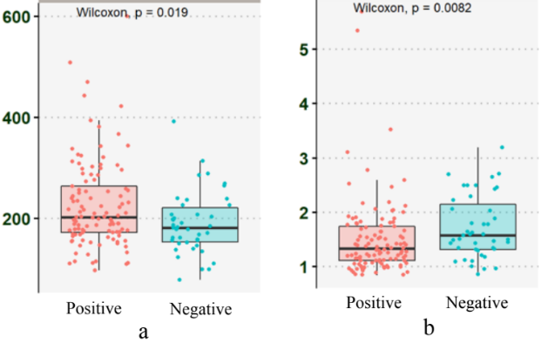
Figure1: Laboratory variables significantly change in the viremia phase of CMV infection. The ‘a’ plot is the level of platelets which significantly reduced and ’b’ plot in increase of serum creatinine.

S1-2-Real-Time PCR test on CMV
CMV quantitative real-time PCR was carried out on 10 μl of extracted materials using the GeneProof Cytomegalovirus PCR Kit according to the manufacturer's instructions (GeneProof CMV PCR kit, Bruno, Czech Republic), in step one plus Real Time PCR machine (Thermofisher Scientific). Each reaction comprised a positive control as well as a negative control.
Before lysis of the samples, internal standard control of GeneProof was added to each specimen for exclusion of false negatives due to nonspecific inhibitors of the PCR reactions. DNA was then eluted using 100 μl of elution buffer, aliquoted and stored in -70◦C.

Figure2: Standard curve of QPCR of CMV infection with 4 standards including 10, 102, 103 and 104 copy/ml

Figure3: Amplification plot of QPCR of CMV infection among case group

Most patients were CMV positive with a viral loads reached 1000 CMV DNA copy/mL of plasma. From 43 positive CMV QPCR, 29, 8, 6 patients’ viral load was <1000, <2000 and > 2000 copy/ml.

