S2- Nested-PCR test on BKV, EBV and HHV6
S2-1- Nested-PCR test on EBV
Following DNA extraction, all samples were thoroughly checked for EBV genome by nested-PCR using specific primers for EBNA-1 (Round 1; Forward: GTAACTTAGGAAGCGTTTCT Reverse: CAATGCAACTTGGACGTTTT, Round 2; Forward: AGCTTCCTGGGATGAGCGT Reverse: TCTTCCCCGTCCTCGTCCAT).
The reaction started with 1 cycle of 95˚C for 5 min, followed by 35 cycles of 30 sec at 95˚C, 30 sec at 55˚C, 1 min and 30 sec at 72, and 1 cycle of 72 for 10 min. The PCR product of the first-round was amplified using Round 2 primers under the same reaction conditions used for the first round. The final products were then visualized by electrophoresis in a 1% agarose gel. The products were then sequenced bidirectionally with inner primers using a BigDye terminator cycle sequencing kit (Applied Biosystems) and a 3,130 genetic analyzer (Applied Biosystems).

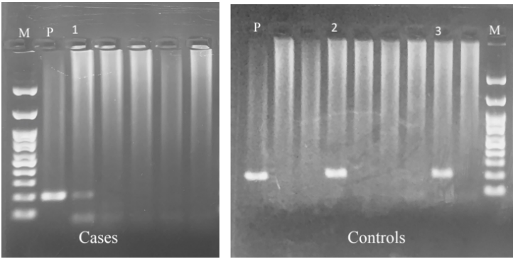
Figure1: Gel electrophoresis of nested-PCR products. P shows positive control, M shows 100bp Size Marker, Track 1,2 and 3 shows EBV infection among case and control groups

From 192 patients, 18 patients had EBV infection and excluded from study.

S2-2- Nested-PCR test on HHV6
The nested-PCR test performed to identify HHV6 infection using specific primers for HHV-6B.
Outer primers: (Forward: 5’ -CGAAGCGGTAAAAACTGCGT-3’), (Reverse: 5’ -CGTAAGCTTGCACAATGCCA-3’)
Inner primers: (Forward: 5’ -ACAAGTTGCCATTTCGGGGA-3’
Revers: 5’ -CGCGGCATTATATCCCGTCT-3’)
The reaction started with 1 cycle of 95˚C for 5 min, followed by 35 cycles of 30 sec at 95˚C, 30 sec at 56˚C, 1 min and 30 sec at 72, and 1 cycle of 72 for 10 min. The PCR product of the first-round was amplified using Round 2 primers under the same reaction conditions used for the first round. The final products were then visualized by electrophoresis in a 1% agarose gel. The products were then sequenced bidirectionally with inner primers using a BigDye terminator cycle sequencing kit (Applied Biosystems) and a 3,130 genetic analyzer (Applied Biosystems).

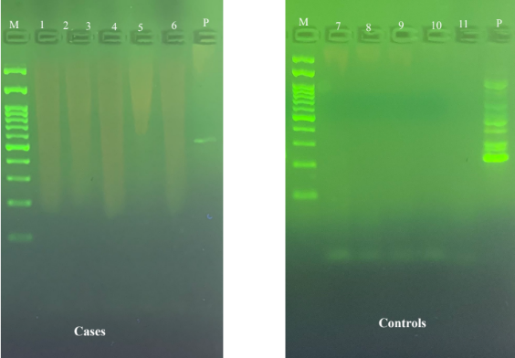
Figure2: Gel electrophoresis of nested-PCR products. P shows positive control, M shows 100bp Size Marker, No HHV6 infection observed among case and control groups.

S2-3- Nested-PCR test on BKV
The outer primer pair 5'AAGTCTTTAGGGTCTTCTAC3' and 5'GTGCCAACC- TATGGAACAGA3' was used to generate a common 176-bp amplicon. For specific detection, we used the common primer 5'AAG- TCTTTAGGGTCTTCTAC3' with 5'GAGTCCTGGTGGAGTT- CC3' to obtain the 149-bp BK virus–specific fragment.
The reaction started with 1 cycle of 95˚C for 5 min, followed by 35 cycles of 30 sec at 95˚C, 30 sec at 55˚C, 1 min and 30 sec at 72, and 1 cycle of 72 for 10 min. The PCR product of the first-round was amplified using Round 2 primers under the same reaction conditions used for the first round. The final products were then visualized by electrophoresis in a 1% agarose gel. The products were then sequenced bidirectionally with inner primers using a BigDye terminator cycle sequencing kit (Applied Biosystems) and a 3,130 genetic analyzer (Applied Biosystems).

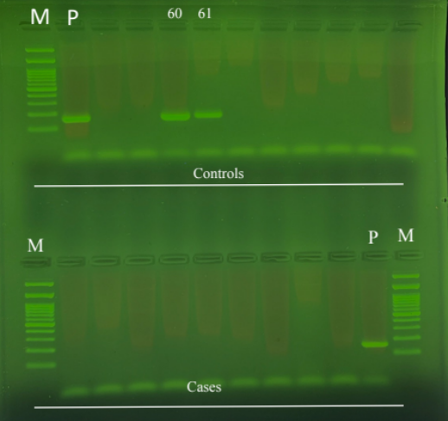
Figure3: Gel electrophoresis of nested-PCR products. P shows positive control, M shows 100bp Size Marker, Track 60,61 and 3 shows BKV infection among control patients.

We detected 19 positive BK virus among candidate patients in the control group and excluded them.

