Table S1 Standard chemical compounds in trials of Electronantennogram responses (EAG) and oviposition bioassays (OB)
Chemical compound | Purity | Source | CAS | Experiment
α-pinene | ≥99% | Sigma Aldrich | 80-56-8 | EAG and OB
β-caryophyllene | ≥99% | Sigma Aldrich | 87-44-5 | EAG and OB
(Z)-4-hexen-1-ol | ≥98% | Sigma Aldrich | 928-92-7 | EAG
(Z)3-hexen-1-ol | ≥98% | Sigma Aldrich | 928-96-1 | EAG and OB
β-terpineol | 98% | Sigma Aldrich | 10482-56-1 | EAG
2-ethyl-1-hexanol | ≥99% | Sigma Aldrich | 104-76-7 | EAG and OB
(E)2-hexenal | ≥98% | Sigma Aldrich | 6728-26-3 | EAG
(Z)-3-hexenal | ≥99% | Sigma Aldrich | 6789-80-6 | EAG
caproaldehyde | ≥99% | Sigma Aldrich | 66-25-1 | EAG and OB
n-dodecane | ≥99% | Sigma Aldrich | 112-40-3 | EAG
Nonadecane | ≥99% | TCI | 629-92-5 | EAG
Eicosane | ≥99% | Aladdin | 2424-92-2 | EAG
Hexacosane | ≥99% | Aladdin | 630-01-3 | EAG
Heptacosane | ≥99% | Aladdin | 62016-79-9 | EAG
m-xylene | ≥99% | Sigma Aldrich | 108-38-3 | EAG
Naphthalene | ≥99% | Sigma-Aldrich | 91-20-3 | EAG and OB

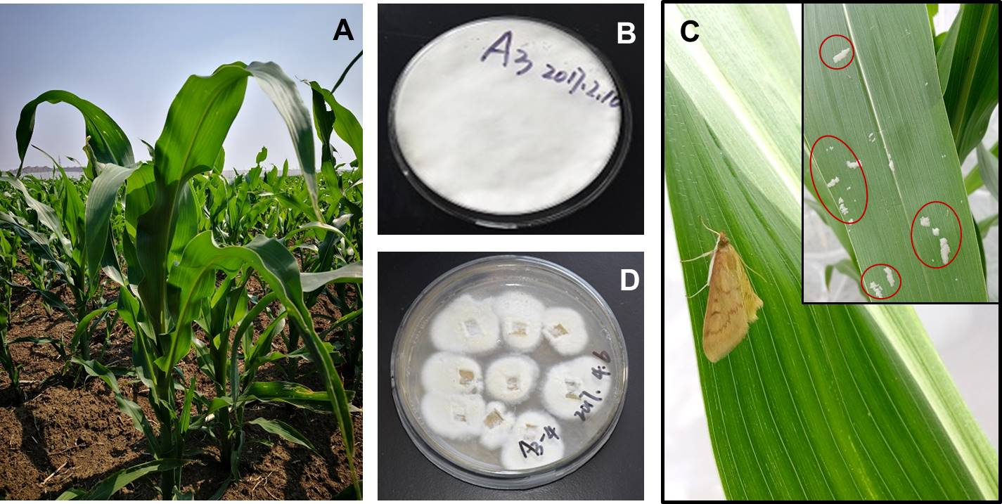
Fig. S1. Study organisms in this experiment. (A) Zea mays, (B) Beauveria bassiana, (C) Ostrinia furnacalis, and the egg masses are circled. (D) B. bassiana isolated from maize leaves, which indicates that B. bassiana infecting maize leaves were verified.

Fig. S2. Maize colonization by Beauveria bassiana (endophytism) in two treatments: maize inoculation with Tween-80 solution (Uninfected); maize inoculation with B. bassiana suspension (Infected) based on 3 plants per pot. Values are means ± SE. (n=60 per treatments). Different letters above bars indicate significant differences between the two treatments (p < 0.05).

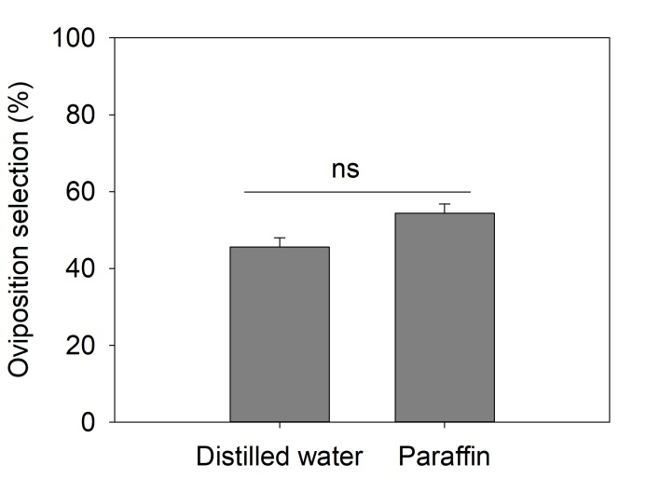
Fig. S3. Oviposition responses of Ostrinia furnacalis females to distilled water (the blank) and paraffin (the solvent). Values are means ± SE. (n=20). ns indicates no significant differences between the number of eggs on the distilled water and the control (paraffin) using χ² tests (p < 0.05).

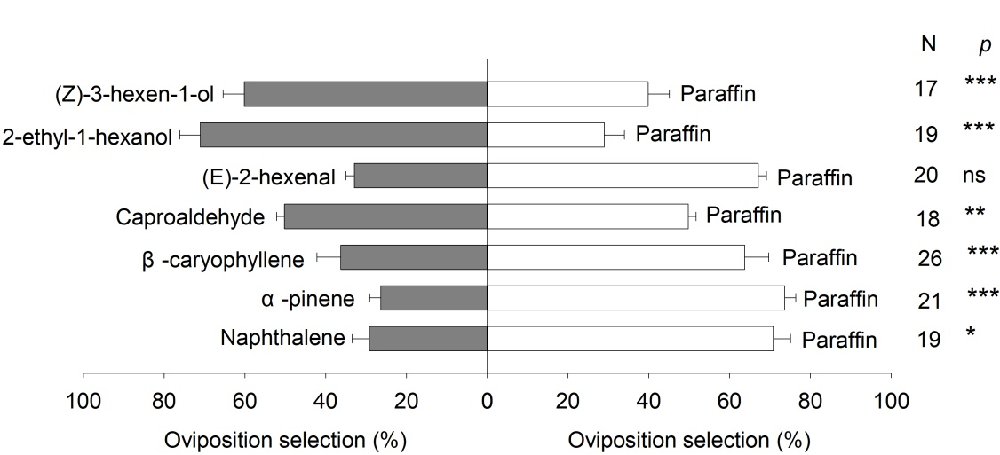
Fig. S4 The number of eggs laid by Ostrinia furnacalis females responds to different compounds and solvent (paraffin). Values are means ± SE, and N is sample size. Asterisk indicates significant differences between the number of eggs on the treated (chemical compounds) and the control (paraffin) using χ² tests (p < 0.05). * 0.05 < p < 0.01; ** 0.01< p < 0.001; *** p < 0.001; ns, no significance.

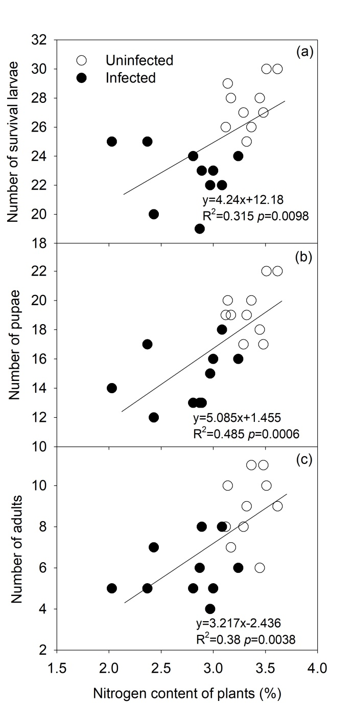
Fig. S5 Relationships between plant nitrogen content and number of survival larvae (a), pupae (b), and adults (c) between uninfected and infected treatments.

Appendix S1 Collection, analysis, and identification of plant volatiles
The SPME samples were obtained by enclosing three maize leaves within Teflon sampling bags with polyperfluoroethylene propylene (70 cm × 50 cm, E-Switch, Du Pont Co, Linden, New Jersey, USA). Volatile samples from these leaves were allowed to accumulate within the airspace of the bag for 30 min to equilibrate before the SPME fiber was inserted into the sampling bag. The SPME fiber was exposed into the equilibrated leaves headspace air for 15 h during the night. During all collection occasions, we collected the volatiles from an empty bag treated in the exact same way as the leaves headspace samples as a control. After scent collection under the greenhouse, SPME units were stored in an oven bag in a refrigerator until analysis.
SPME samples were analyzed by gas chromatography linked to mass spectroscopy (Agilent 5975; Agilent Technologies, Madrid, Spain) with a HP-5 column (30 m × 0.25 mm ID, 0.25 μm film thicknesses; J&W Scientific, Folsom, CA, USA). Helium was used as carrier gas at a constant velocity of 1 ml min⁻¹. The column started at 50 °C for 3 min, and the oven temperature increased at 8°C /min to 260 °C and held for 8 min. Samples were injected in 1-µl aliquots using a splitless injector. Quantifications were made relative to the internal standard using ChemStation software (Agilent Technologies, Wilmington, DE, USA). Identifications of compounds were confirmed by comparing mass spectra and retention times with commercial standards, when available, using the NIST 2008 Mass Spectral Search Program (National Institute of Standards and Technology, Gaithersburg, MD, USA). A commercially available mixture of n-alkane standards (nC9 - nC20, Sigma-Aldrich) was used to calculate the linear retention indices (LRI) of the identified volatile compounds.

