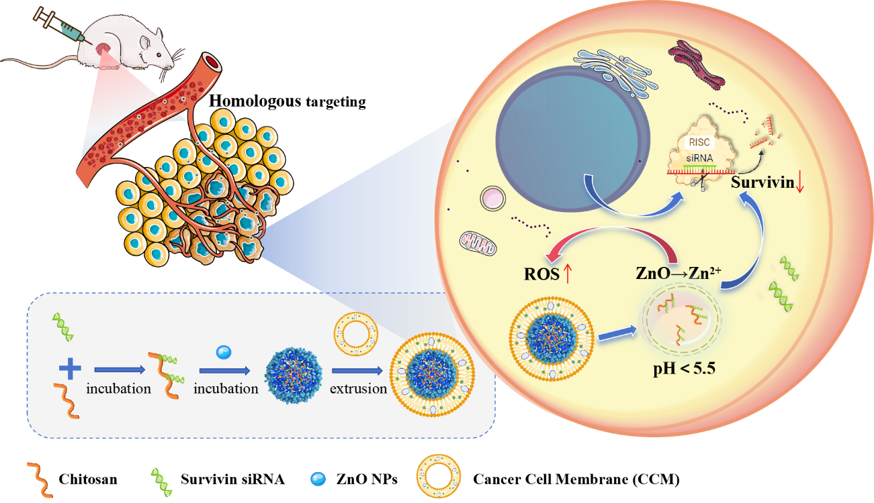
Scheme 1. Schematic illustration of preparation and mechanisms of CCM-CS/ZnO@siSurvivin. CCM-CS/ZnO@siSurvivin accumulated in the tumor through the homologous targeting effect of the coated tumor cell membranes. Upon internalization into lysosomes under acidic conditions, ZnO nanoparticles dissolved into Zn²⁺, facilitating lysosomal escape of siSurvivin and enhancing its survivin protein silencing effect. Meanwhile, the simultaneous release of Zn²⁺ promoted oxidative stress in tumor cells, further inducing an oxidative stress response and achieving a synergistic anti-tumor effect.

