Table S1. Preoperative Baseline Data of Patients Grouped Between the Survivors and Outcomes.
Variables | All patients (%)  175cases | No. of outcomes (%)  54cases | No. of survivors (%)  121cases | P value
Demographical data
Gender |  |  |  | 0.242
Female | 36 (20.57%) | 14 (25.93%) | 22 (18.18%)
Male | 139 (79.43%) | 40 (74.07%) | 99 (81.82%)
Age( years) | 48.87 ± 9.57 | 50.48 ± 9.3 | 48.15 ± 9.65 | 0.051
Risk factors
Smoking |  |  |  | 0.071
No | 70 (40.00%) | 27 (50.00%) | 43 (35.54%)
Yes | 105 (60.00%) | 27 (50.00%) | 78 (64.46%)
BMI | 25.36 ± 3.82 | 25.48 ± 3.66 | 25.31 ± 3.9 | 0.778
HTN |  |  |  | 0.487
No | 55 (31.43%) | 15 (27.78%) | 40 (33.06%)
Yes | 120 (68.57%) | 39 (72.22%) | 81 (66.94%)
DM |  |  |  | 0.503
No | 174 (99.43%) | 54 (100%) | 120 (99.17%)
Yes | 1 (0.57%) | 0 (0%) | 1 (0.83%)
Previous CAD history |  |  |  | 0.894
No | 169 (96.57%) | 52 (96.30%) | 117 (96.69%)
Yes | 6 (3.43%) | 2 (3.70%) | 4 ( 3.31%)
Condition at admission
Phase |  |  |  | 0.069
Acute | 160 (91.43%) | 53 (98.15%) | 107 (88.43%)
Subacute | 11 (6.29%) | 0 (0%) | 11 (9.09%)
Chronic | 4 (2.29) | 1 (1.85%) | 3 (2.48%)
SBP (mmHg) | 140.58 ± 31.39 | 138.2 ± 34.22 | 141.64 ± 30.13 | 0.451
DBP (mmHg) | 80.55 ± 19.82 | 79.41 ± 22.67 | 81.07 ± 18.48 | 0.319
Shock |  |  |  | <0.001
No | 164 (93.71%) | 47 (87.04%) | 117 (96.69%)
Yes | 11 (6.29%) | 7 (12.96%) | 4 (3.31%)
MAP (mmHg) | 100.56 ± 22.06 | 99.01 ± 24.86 | 101.26 ± 20.76 | 0.453
PP (mmHg) | 60.02 ± 21.61 | 58.8 ± 22.74 | 60.57 ± 21.16 | 0.442
Heart rate (b.p.m.) | 83.63 ± 14.35 | 86.15 ± 14.52 | 82.51 ± 14.2 | 0.155
Chest pain |  |  |  | < 0.001
No | 28 (16.00%) | 11 (20.37%) | 17 (14.05%)
Yes | 147(84.00%) | 43 (79.63%) | 104 (85.95%)
Back pain |  |  |  | 0.062
No | 74 (42.29%) | 23 (42.59%) | 51 (42.15%)
Yes | 101 (57.7%) | 31 (57.41%) | 70 (57.85%)
Abdominal pain |  |  |  | <0.001
No | 158 (90.29%) | 44 (81.48%) | 114 (94.21%)
Yes | 17 (9.71%) | 10 (18.52%) | 7 (5.79%)
Altered consciousness |  |  |  | <0.001
No | 168 (96.00%) | 51 (94.44%) | 117 (96.69%)
Yes | 7 (4.00%) | 3 (5.56%) | 4 (3.31%)
ST-segment deviation on ECG |  |  |  | <0.001
No | 117 (66.86%) | 37 (68.52%) | 80 (66.12%)
Yes | 58 (33.14%) | 17 (31.48%) | 41 (33.88%)
Pericardial effusion |  |  |  | 0.444
No | 101 (57.71%) | 22 (40.74%) | 79 (65.29%)
Yes | 74 (42.29%) | 32 (59.26%) | 42 (34.71%)
Pleural effusion |  |  |  | 0.326
No | 91 (52.00%) | 32 (59.26%) | 59 (48.76%)
Yes | 84 (48.00%) | 22 (40.74%) | 62 (51.24%)
Hospital stay
POHS (days) | 19.37 ± 14.4 | 10.77 ± 10.29 | 23.13 ± 14.42 | <0.001
ICUHS (days) | 11.93 ± 9.27 | 9.87 ± 9.89 | 12.85 ± 8.86 | 0.002
Preoperative laboratory results
WBC (×10ˆ9/L) | 12.18 ± 4.39 | 13.74 ± 4.95 | 11.48 ± 3.94 | 0.002
RBC (×10ˆ9/L) | 4.04 ± 1.17 | 3.90 ± 1.20 | 4.10 ± 1.16 | 0.402
ANC (×10ˆ9/L) | 10.43 ± 4.38 | 12.01 ± 4.82 | 9.72 ± 4.0 | 0.001
ALC(×10ˆ9/L) | 0.99 ± 0.52 | 0.93 ± 0.49 | 1.01 ± 0.53 | 0.302
HB (g/L) | 129.37 ± 22.5 | 128.0 ± 22.84 | 129.98 ± 22.42 | 0.593
PLT (×10ˆ9/L) | 168.53 ± 58.31 | 167.04 ± 55.99 | 169.19 ± 59.53 | 0.873
Total Protein (g/L) | 65.19 ± 6.99 | 65.78 ± 6.54 | 64.93 ± 7.19 | 0.339
ALB (g/L) | 33.94 ± 10.79 | 32.85 ± 10.94 | 34.42 ± 10.73 | 0.341
ALT (IU/L) | 45.51 ± 123.23 | 73.98 ± 217.47 | 32.80 ± 24.62 | 0.372
AST (IU/L) | 58.53 ± 169.46 | 103.63 ± 286.93 | 38.40 ± 62.85 | 0.293
Creatinine (μmol/L) | 97.97 ± 57.34 | 121.91 ± 84.29 | 87.28 ± 35.44 | 0.003
BUN (mmol/L), | 8.66 ± 15.74 | 9.38 ± 10.18 | 8.34 ± 17.7 | 0.002
LDH (U/L) | 658.49 ± 965.54 | 898.37 ± 1611.92 | 551.44 ± 408.37 | 0.269
D-dimer (μg/mL) | 10.08 ± 15.59 | 11.85 ± 17.28 | 9.29 ± 14.78 | 0.838
Fibrinogen (g/L) | 3.02 ± 1.68 | 2.98 ± 1.84 | 3.03 ± 1.61 | 0.470
FDP(mg/L) | 40.66 ± 86.86 | 45.47 ± 97.1 | 38.51 ± 82.23 | 0.967
Myoglobin (μg/L) | 226.22 ± 468.6 | 169.56 ± 210.72 | 251.51 ± 544.7 | 0.916
CK-MB (U/L) | 3.86 ± 6.94 | 3.48 ± 4.01 | 4.03 ± 7.91 | 0.391
BNP (pg/mL) | 1014.67 ± 1821.98 | 1114.74 ± 2235.05 | 970.01 ± 1612.64 | 0.544
cTnT (μg/L) | 0.21 ± 0.78 | 0.35 ± 1.15 | 0.15 ± 0.54 | 0.312
SII | 2665.15 ± 3528.34 | 3534.46 ± 5430.65 | 2277.2 ± 2129.28 | 0.011
Intraoperative conditions
Operation time (min) | 552.98 ± 136.17 | 616.19 ± 165.55 | 525.3 ± 111.68 | <0.001
Intraoperative bleeding (ml) | 696.44 ± 760.34 | 1005.27 ± 1151.1 | 558.61 ± 437.01 | <0.001
Transfusion of SRBC (U) | 3.70 ± 3.07 | 4.69 ± 3.45 | 3.26 ± 2.78 | 0.007
Transfusion of Plasma (ml) | 826.41 ± 393.27 | 991.51 ± 435.41 | 752.73 ± 350.41 | <0.001
CPB time (min) | 274.95 ± 68.7 | 299.06 ± 80.09 | 264.19 ± 60.26 | 0.002
ACC time (min) | 161.57 ± 43.46 | 168.84 ± 31.85 | 158.33 ± 47.5 | 0.005
Abbreviations: POHS Postoperative Hospital Stay, ICUHS Intensive Care Unit Hospital Stay, SBP Systolic Blood Pressure, BMI Body Mass Index, HTN Hypertension, DM Diabetes Mellitus, b.p.m. beats per minute, MAP Mean Arterial Pressure, PP pulse pressure, ECG Electrocardiogram, CAD Coronary Artery Disease, WBC White Blood Cell, RBC Red Blood Cell, PLT Platelet, ANC Absolute Neutrophil Count, ALB Albumin, HB Hemoglobin, ALT Alanine Aminotransferase, AST Aspartate Aminotransferase, BUN Blood Urea Nitrogen, LDH Lactate Dehydrogenase, FDP Fibrin/Fibrinogen Degradation Products, CK-MB Creatine Kinase-Muscle/Brain, BNP B-Type Natriuretic Peptide, cTnT Cardiac Troponin T, SII Systemic Immune-Inflammation index, SRBC Suspended Red Blood Cells, CBP Cardiopulmonary Bypass time, ACC Aortic Cross Clamping time.
Notes: ‘outcome’ was defined as the presence of death under investigation.

Table S2. Preoperative Baseline Data of Patients Grouped Between the Training Set and Test Set.

Variables | Test set  35cases | Training set  140cases | P value
Demographical data
Gender |  |  | 0.542
Female | 10(28.57%) | 26(18.57%)
Male | 25(71.43%) | 114(81.43%)
Age( years) | 47.71 ± 10.20 | 49.16 ± 9.43 | 0.710
Risk factors
Smoking |  |  | 0.702
No | 15 (42.86%) | 55 (39.29%)
Yes | 20 (57.14%) | 85 (60.71%)
BMI | 25.54 ± 4.58 | 25.36 ± 3.59 | 0.997
HTN |  |  | 0.224
No | 14 (40.00%) | 41 (29.29%)
Yes | 21 (60.00%) | 99 (70.71%)
Condition at admission
Phase (Acute) |  |  | 0.053
No | 0 | 15 (10.71%)
Yes | 35 (100%) | 125 (89.29%)
SBP (mmHg) | 150.94 ± 29.77 | 138.24 ± 31.41 | 0.058
DBP (mmHg) | 84.94 ± 22.68 | 79.68 ± 19.13 | 0.272
Shock |  |  | 0.353
No | 34 (97.14%) | 130 (92.86%)
Yes | 1 (2.86%) | 10 (7.14%)
MAP (mmHg) | 106.94 ± 23.42 | 99.20 ± 21.62 | 0.119
PP (mmHg) | 66.00 ± 20.15 | 58.56 ± 21.76 | 0.060
Heart rate (b.p.m.) | 84.97 ± 12.11 | 83.35 ± 14.88 | 0.516
Chest pain |  |  | 0.561
No | 5 (14.29%) | 24 (17.14%)
Yes | 30 (85.71%) | 116 (82.86%)
Back pain |  |  | 0.312
No | 15 (42.86%) | 58 (41.43%)
Yes | 20 (57.14%) | 82 (58.57%)
Abdominal pain |  |  | 0.142
No | 34 (97.14%) | 125 (89.29%)
Yes | 1 (2.86%) | 15 (10.71%)
Altered consciousness |  |  | 0.179
No | 35 (100%) | 133 (95.00%)
Yes | 0 (0%) | 7 (5.00%)
ST-segment deviation on ECG |  |  | 0.299
No | 26 (74.29%) | 91 (65.00%)
Yes | 9 (25.71%) | 49 (35.00%)
Pericardial effusion |  |  | 0.109
No | 16 (45.71%) | 85 (60.71%)
Yes | 19 (54.29%) | 55 (39.29%)
Pleural effusion |  |  | 0.652
No | 17 (48.57%) | 74 (52.86%)
Yes | 18 (51.43%) | 66 (47.14%)
Hospital stay
POHS (days) | 16.74 ± 13.56 | 20.02 ± 14.58 | 0.174
ICUHS (days) | 10.29 ± 9.71 | 12.34 ± 9.14 | 0.103
Preoperative laboratory results
WBC (×10ˆ9/L) | 12.03 ± 3.85 | 12.23 ± 4.52 | 0.908
RBC (×10ˆ9/L) | 4.40 ± 0.95 | 3.97 ± 1.19 | 0.112
ANC (×10ˆ9/L) | 10.34 ± 3.89 | 10.46 ± 4.50 | 0.883
ALC(×10ˆ9/L) | 0.90 ± 0.54 | 1.01 ± 0.52 | 0.151
HB (g/L) | 132.17 ± 27.64 | 128.70 ± 21.05 | 0.357
PLT (×10ˆ9/L) | 157.11 ± 47.48 | 171.77 ± 60.17 | 0.185
Total Protein (g/L) | 66.74 ± 7.02 | 64.99 ± 7.02 | 0.222
ALB (g/L) | 36.54 ± 10.08 | 33.54 ± 10.78 | 0.112
ALT (IU/L) | 43.20 ± 76.77 | 46.11 ± 132.54 | 0.920
AST (IU/L) | 57.09 ± 112.80 | 58.87 ± 181.20 | 0.459
Creatinine (μmol/L) | 117.66 ± 95.36 | 93.37 ± 41.92 | 0.285
BUN (mmol/L), | 7.84 ± 5.02 | 8.87 ± 17.43 | 0.400
LDH (U/L) | 583.11 ± 365.91 | 677.54 ± 1064.15 | 0.317
D-dimer (μg/mL) | 8.33 ± 13.32 | 10.50 ± 16.12 | 0.509
Fibrinogen (g/L) | 2.81 ± 1.25 | 3.07 ± 1.77 | 0.753
FDP(mg/L) | 28.41 ± 34.09 | 43.64 ± 95.49 | 0.576
Myoglobin (μg/L) | 190.25 ± 315.92 | 233.50 ± 500.08 | 0.421
CK-MB (U/L) | 4.10 ± 4.98 | 3.82 ± 7.36 | 0.162
BNP (pg/mL) | 1234.13 ± 2902.51 | 958.80 ± 1442.57 | 0.225
cTnT (μg/L) | 0.39 ± 1.19 | 0.17 ± 0.64 | 0.599
SII | 2433.77 ± 1942.91 | 2732.15 ± 3823.14 | 0.656
Intraoperative conditions
Operation time (min) | 558.31 ± 121.24 | 551.38 ± 140.14 | 0.342
Intraoperative bleeding (ml) | 725.33 ± 830.29 | 679.21 ± 736.47 | 0.747
Transfusion of SRBC (U) | 4.24 ± 2.83 | 3.54 ± 3.11 | 0.222
Transfusion of Plasma | 888.71 ± 351.02 | 804.44 ± 393.99 | 0.270
CPB time (min) | 274.63 ± 56.91 | 275.78 ± 72.76 | 0.677
ACC time (min) | 157.14 ± 29.47 | 162.73 ± 46.32 | 0.981

Abbreviations: POHS Postoperative Hospital Stay, ICUHS Intensive Care Unit Hospital Stay, SBP Systolic Blood Pressure, BMI Body Mass Index, HTN Hypertension, b.p.m. beats per minute, MAP Mean Arterial Pressure, PP pulse pressure, ECG Electrocardiogram, CAD Coronary Artery Disease, WBC White Blood Cell, RBC Red Blood Cell, PLT Platelet, ANC Absolute Neutrophil Count, ALB Albumin, HB Hemoglobin, ALT Alanine Aminotransferase, AST Aspartate Aminotransferase, BUN Blood Urea Nitrogen, LDH Lactate Dehydrogenase, FDP Fibrin/Fibrinogen Degradation Products, CK-MB Creatine Kinase-Muscle/Brain, BNP B-Type Natriuretic Peptide, cTnT Cardiac Troponin T, SRBC Suspended Red Blood Cells, CBP Cardiopulmonary Bypass time, ACC Aortic Cross Clamping time.

Figure S1. Bubble Plot of Point-Biserial Correlation Coefficients Between Abdominal Pain and Continuous Variables.
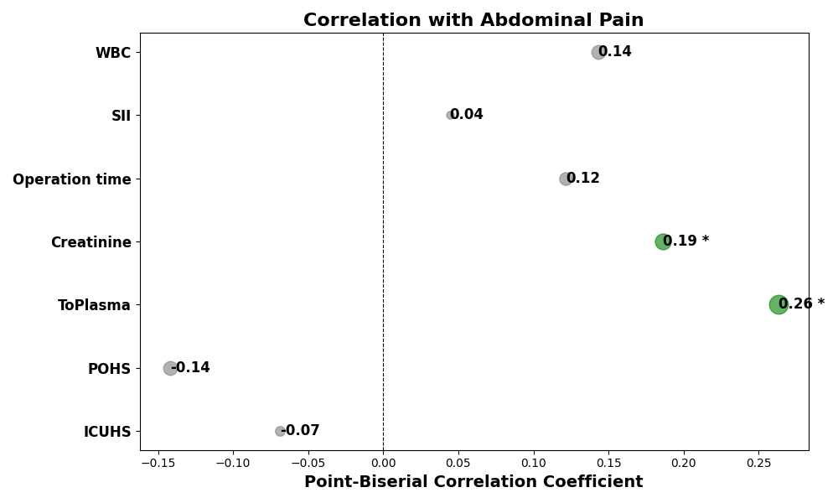
Abbreviations: POHS Postoperative Hospital Stay, ICUHS Intensive Care Unit Hospital Stay, WBC White Blood Cell count.
Note: ‘*’ denotes p<0.05.

Figure S2. Comparison of SVM Model Performance Metrics (Training vs Test set)
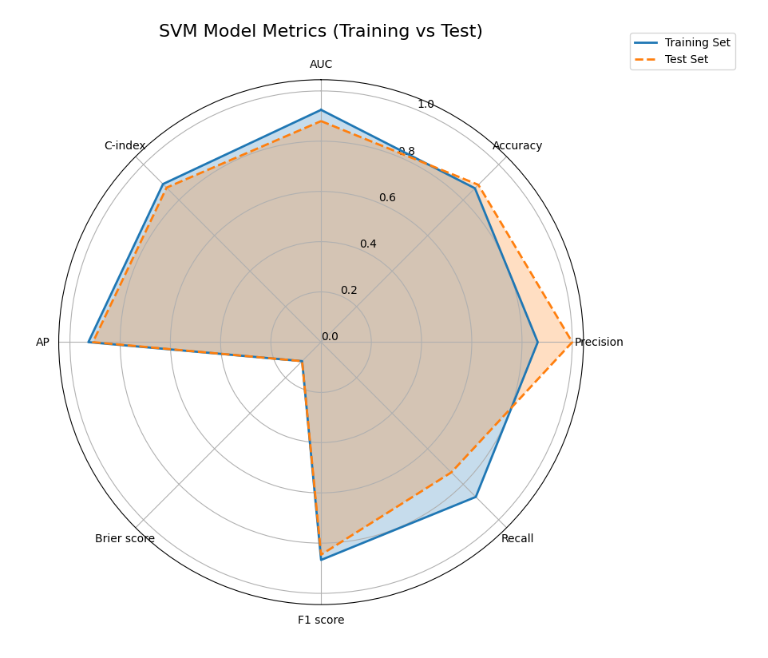
Abbreviations: AUC Area Under the Curve, AP Average Precision, C-Index Concordance Index.

